Case Report

Extrapulmonary Manifestation of Legionella Pneumonia in Pregnancy complicated with Fresh Stillbirth- A Case Report

Abstract

Legionella pneumonia during pregnancy is exceptionally rare however may lead to severe maternal sepsis and fetal compromise. We report a case of a 35-year-old gravida 4 para 3/ G4P3 at 36 weeks gestation who presented with nonspecific symptoms, later developing septic shock and intrauterine fetal demise, with Legionella antigen subsequently confirmed in urine. The patient’s course was complicated with disseminated intravascular coagulopathy/ DIVC and postpartum hemorrhage (PPH), requiring intensive care and multidisciplinary management. Early suspicion, prompt antimicrobial therapy, and coordinated critical care are crucial to improving maternal outcomes in such atypical presentations.

Introduction

Legionella pneumonia is an uncommon but potentially fatal cause of community-acquired pneumonia caused by Legionella pneumophila, accounting for a small proportion of atypical pneumonias in adults. [1, 9, 11] Occurrence during pregnancy is extremely rare, with only a handful of cases described in the literature, some associated with severe maternal morbidity and adverse fetal outcomes. [2, 3, 4, 5, 6, 12] The combination of maternal hypoxemia, sepsis, and circulatory instability can compromise placental perfusion, leading to fetal distress or intrauterine fetal demise. [2, 5, 6] We report a rare case of Legionella pneumonia in pregnancy complicated by fresh stillbirth, underscoring the importance of early suspicion and prompt multidisciplinary intervention in atypical pneumonias during gestation.

Case Presentation

Our patient 35 years old G4P3 at 36w1d period of gestation initially presented with fever, loose stool and vomiting for the past 1 day. Also complaint of regular contraction pain which increases in intensity and frequency however no leaking liquor or show. Otherwise no respiratory illness symptoms including no cough/dyspnea/flu. Upon assessment, the patient was clinically dehydrated, normotensive, tachycardia up to 130 beats per minute, noted temperature spike of. 39.1 degree Celsius and able to satire under room air. Lungs were clear on auscultation. Per abdomen, soft non tender, uterus at 36 weeks size, singleton and noted patient contracting 3 in 10 minutes. Per speculum no evidence of leaking and only minimal whitish discharge. Vaginal examination noted os opening of 2cm.

Initial blood investigation, full Bloodbank counts shows (Complete Blood count shows) leukocytosis with white cell count of 21.67 x 10^9 g/dL (21.67x 10^3/mm^3) or (21.67 x 10^9/L), neutrophils predominate 97.7%, hemoglobin of 10.6g/dL and platelet of 233 x 10^9 g/dL (233x10^3/mm^3). Venous blood gas shows partially compensated metabolic lactatic acidosis with pH 7.33, pCO2 25mmHg, HC03 13.2mmol/L, lactate 5.5 mol/L and base excess -1.3mmol/L. C- reactive protein/CRP raised 6.32 mg/dL (mg/L). Renal profile slightly deranged with urea of 2.7mmol/L normal, creatinine 80umol/L normal, hyponatremia-sodium 133mmol/L and potassium 4.3mmol/L. Serum electrolytes- hypomagnesemia with magnesium of 0.48mmol/L, hypophosphetemia with phosphate of 0.78mmol/L and normal calcium level 2.3mmol/L. Liver function test initially noted raised aspartate transaminase, AST 70U/L, normal level of alanine transaminase 11U/L and alkaline phosphatase, ALP 134U/L, hypoalbuminemia with albumin level of 29g/L and indirect predominant if hyperbilirubinemia, total bilirubin 24.7umol/L, indirect bilirubin 19umol/L and direct bilirubin 5.7umol/L. Blood parameters show maternal sepsis with multiorgan dysfunction. Electrocardiography shows sinus tachycardia with no ischemic changes.
Urinalysis shows ketonuria with urine ketone of 3+.

The patient was initially resuscitated with a total bolus intravenous/IV drip of 1.5litre, taken blood culture and started with IV Cefuroxime. Despite adequate hydration, urine output was minimal. Ongoing cardiotocography/CTG during admission noted sinusoidal pattern (Figure 1). Referral made to anaesthesiology and medical team for evaluation and co-management.

Case posted for emergency lower segment caesarean section in view of pathological CTG indicating fetal distress. Operation was done under general anaesthesia in view of category 1 caesarean section. Delivered baby, grossly well-formed foetus with no anomalies, of birth weight of 3.01kg however no signs of life at birth and baby resuscitation started by neonatology team standby. Despite best resuscitative effort, unable to revive the baby and pronounced death as fresh stillbirth. Intraoperatively complicated with massive postpartum haemorrhage/PPH with estimated blood loss of 2.5litre due to uterine stony and hematoma over the right side of uterus at broad ligament and active sputters from uterine incision site. Pharmacological agents including repeated IV Pitocin 5 Unit bolus, increased IV Pitocin maintenance to 80U/6hours and given intramyometrial Hem abate 250 mcg twice. Hayman compression suture applied and multiple hemostatic sutures applied. Subsequently able to secure bleedings. Intraoperatively noted hemoglobin dropped significantly to 6.7g/dL and coagulopathy with INR 2.1. Transfused total 4 units of packed cell and 1 cycle of disseminated intravascular coagulopathy/ DIVC regime including 4 units of platelet, 4 units of fresh frozen plasma and 6 units of cryoprecipitate. The patient was transferred to the intensive care unit/ ICU for further optimization and monitoring post operative. In ICU, further investigations noted urine legionella tested positive. Chest xray (X-ray) on ICU admission showing pneumonic patches involving bilateral lung fields (Figure 2). The patient was treated as maternal mixed shock of septic shock secondary to legionella pneumonia with extrapulmonary manifestation complicated with multiorgan failure and hemorrhagic shock secondary to massive PPH complicated with DIVC.
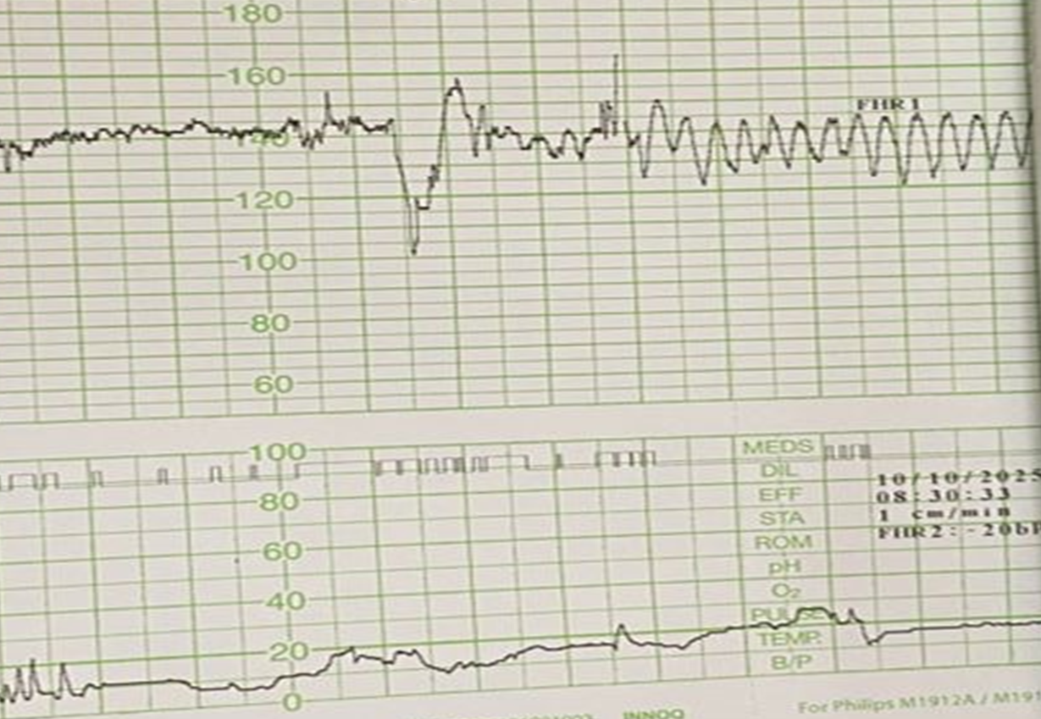
Figure 1 :Cardiotocography shows sinusoidal pattern indicating severe fetal hypoxemia

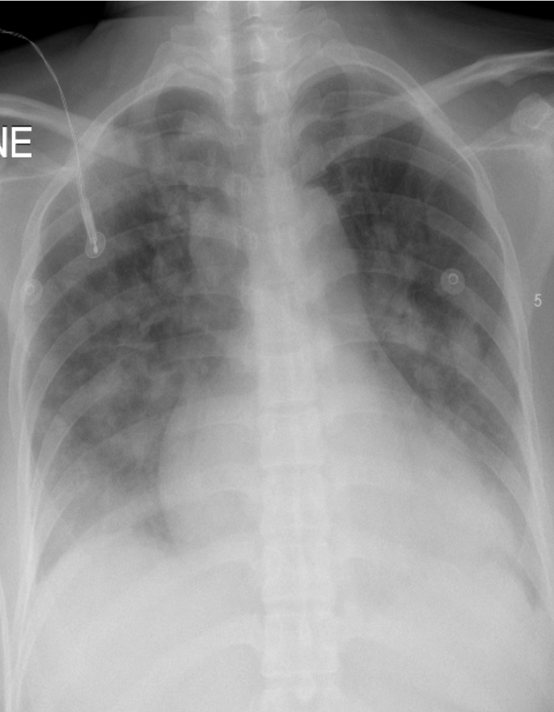

Figure 2: Chest X-ray on admission showing pneumonia patches over the bilateral lung fields.

The patient was admitted in ICU for approximately 2 weeks postoperatively. In terms of ventilation, the patient was able to be extubated to high flow nasal cannula on day 6 post op then to venturi mask and subsequently to room air with serial chest X-ray monitoring which shows the radiological changes of pneumonia. The patient was treated with IV Ceftriaxone and IV Metronidazole for 7 days. IV Azithromycin was given also for 7 days with the aim to complete 2weeks however subsequently changed to IV Levofloxacin for 7 days of 2 weeks completion in view of worsening hepatotoxicity and transaminitis with elevated transaminases where the AST peaked to 210 U/L and ALT peaked to 200 U/L, however upon switching to Levofloxacin noted tremendous decline of transaminitis to normal level. Ultrasound abdomen performed on post op day 6 showing- Acalculous cholecystitis, left perinephric collection along the left mid and upper pole extending to the left iliacus muscle distally and bilateral renal parenchymal disease. The patient was managed non invasively non-invasively with IV antibiotics and repeated ultrasound abdomen post antibiotic completion- resolved left perinephric collection and gallbladder wall thickening and bilateral renal parenchymal disease.

Septic markers further improved white cell reduced from highest 36x10^9 to 15x 10^9 g/dL (unit must be corrected), CRP from 18 mg/dL (mg/L) to 2.18mg/dL (mg/L), blood, urine, high vaginal swab, tracheal aspirate and placenta swab culture resulted in no pathogen isolated. The patient suffered from oliguric to non oliguric acute kidney injury where serum creatinine ranging from 80umol/L to highest peak at 688umol/L and serum urea ranging from 2.4mmol/L peaked to 36.5mmol/L required intermittent hemodialysis and subsequently serum creatinine static at 149-157umol/L and serum urea static at 10mmol/L. However the patient improved from lactic acidosis throughout the stay in IUC. Placenta histopathological examination resulted in acute intervillositis and perivillitis associated with bacterial organisms in the maternal intervillous space, in keeping with underlying maternal sepsis. Echocardiogram performed shows normal chambers sizes with no dilatation, left ventricular/LV ejection fraction of 49%- mild impairment of LV systolic function with no regional wall motion abnormality at rest, no vegetation, pericardial effusion or valvular abnormalities.

The patient was co-managed by maternal fetal medicine/MFM specialist, intensivist, nephrologist and infectious disease specialist. Patient was subsequently discharged post op 3 weeks with outpatient nephrology appointment in chronic kidney disease/CKD clinic for renal function monitoring and CKD retardation program, outpatient echocardiogram appointment 4 months for repeated echocardiogram to assess the LV function and 2 weeks appointment under MFM clinic. The patient was briefed by neonatologist prior discharge on the poor fetal outcome which is probably resulted by the maternal septic shock.

Discussion

Legionella species are gram-negative, facultative intracellular bacteria that cause Legionnaires’ disease (a severe atypical pneumonia) and the milder disease manifestation-Pontiac fever. Transmission occurs primarily via inhalation or aspiration of contaminated water droplets (aerosol) from man-made water systems such as cooling towers, plumbing, and hot tubs. Legionella is an uncommon but important cause of severe community-acquired and hospital-acquired pneumonia. [1, 9, 11]
In pregnancy, the documented occurrence of Legionella is rare and mostly described in case reports and small series, so precise incidence and absolute maternal susceptibility compared with nonpregnant adults are uncertain. Because published data are limited, risk estimates for fetal effects rely on individual reports rather than large cohort studies. [2, 3, 4, 12] Clinical presentation in pregnant patients mirrors that in nonpregnant adults: fever, cough (often nonproductive), dyspnea, myalgia, and gastrointestinal symptoms such as nausea and diarrhea. Extra-pulmonary findings, including electrolyte imbalances, deranged liver enzymes and renal impairment, may point toward atypical pathogens such as Legionella and should prompt early testing in severe pneumonia. [3, 4, 9]
Diagnosis should combine rapid testing with culture or PCR confirmation when possible. The urinary antigen test for L. pneumophila serogroup 1 offers quick and specific results and is widely used; lower respiratory tract culture on selective media remains the reference standard for species identification and epidemiologic typing, while PCR and paired serology increase diagnostic yield. Samples should be obtained early, but empiric therapy must not be delayed in critically ill patients when the index of suspicion is high. [1, 9, 12]
Treatment includes antibiotics with high intracellular penetration and pulmonary concentration. Macrolides (azithromycin or erythromycin) are preferred in pregnancy due to their safety profile and proven efficacy against Legionella. Fluoroquinolones (e.g., levofloxacin, moxifloxacin) are highly effective in nonpregnant adults and often associated with faster defervescence and lower mortality, but they have traditionally been avoided in pregnancy because of theoretical fetal cartilage toxicity. [7, 8, 9, 10] Regarding hepatotoxicity and transaminitis, mild transient elevations of hepatic transaminases can occur with both macrolides and fluoroquinolones. However, macrolides have a slightly higher reported incidence of drug-induced liver enzyme elevation compared with levofloxacin, which rarely causes clinically significant hepatotoxicity. Despite this, azithromycin remains the preferred first-line agent in pregnancy due to its established fetal safety, while levofloxacin is reserved for severe or refractory cases when maternal benefit outweighs potential fetal risks. [7, 8, 9, 10]
Maternal and fetal outcomes depend on disease severity and timeliness of therapy. Most pregnant patients treated promptly with appropriate antibiotics recover fully; however, severe maternal Legionella pneumonia can lead to profound hypoxaemia, sepsis, and systemic inflammatory response, all of which impair uteroplacental perfusion. The resulting fetal hypoxia and metabolic compromise may culminate in fetal distress, preterm delivery, or intrauterine fetal demise, as described in several reported cases. Overwhelming sepsis and coagulation disturbances may lead to endothelial injury and impaired uterine contractility. The resulting uterine atony may be compounded by DIVC or hypoperfusion-related myometrial dysfunction, increasing the risk of postpartum hemorrhage. Therefore, early obstetric involvement, fetal monitoring, and multidisciplinary management are essential. [2, 5, 6] Prevention emphasizes environmental and engineering controls: routine maintenance of water systems, adequate temperature regulation, and prompt investigation of suspected outbreaks are critical to reduce Legionella exposure risk. In healthcare and antenatal settings, heightened vigilance toward water system safety is warranted. [1, 11]
Conclusion and Recommendation
Legionella pneumonia in pregnancy remains a diagnostic and therapeutic challenge due to its rarity and nonspecific presentation. Delayed recognition can rapidly progress to maternal multiorgan dysfunction, uterine atony, and fetal demise. This case emphasizes the importance of maintaining clinical vigilance for atypical pathogens in peripartum sepsis and highlights the value of timely diagnosis and multidisciplinary management to optimize maternal survival.
- Maintain a high index of suspicion for atypical pneumonia, including Legionella, in pregnant women presenting with unexplained fever, sepsis, or gastrointestinal even in the absence of overt pulmonary symptoms.
- Incorporate early diagnostic testing, such as Legionella urinary antigen and chest imaging, to enable prompt initiation of appropriate antibiotic therapy and prevent progression to systemic complications.
- Ensure coordinated multidisciplinary care involving obstetric, infectious disease, and critical care teams to facilitate rapid maternal stabilization and reduce both maternal and fetal morbidity

Conflict of interest
The authors declare that there are no conflicts of interest related to this manuscript.
Informed consent
Both written and verbal informed consent was obtained from the patient (Mdm S) for publication of this report and any accompanying images.

Data Availability
The data supporting the findings of this study are available within the article.

COMPETING INTERESTS DISCLAIMER:
Authors have declared that they have no known competing financial interests OR non-financial interests OR personal relationships that could have appeared to influence the work reported in this paper.

References
1/ CDC. Clinical Guidance for Legionella Infections (2023)
2/ Mosaad-Boktor HK et al. Legionella Pneumonia in Late Pregnancy: Case Report and Literature Review. Case Reports in Infectious Diseases, 2018.
3/ Kleinberg KA et al. Legionella pneumophila Pneumonia in Pregnancy: A Case Report. Infectious Diseases in Obstetrics and Gynecology, 2020
4/ Eisenberg VH et al. Legionnaire’s Disease During Pregnancy: Case Presentation and Review. Obstet Gynecol, 1997.
5/ Vimercati A et al. Legionella Pneumophila Pneumonia and Fetal Demise: A Case Report. J Perinatal Medicine, 2000
6/ Tewari K et al. Septic Shock in Pregnancy Associated with Legionella Pneumonia. Am J Obstet Gynecol, 1997
7/ Laibl VR et al. Management of Respiratory Infections During Pregnancy. Clin Obstet Gynecol, 2005
8/ Antonucci R et al. Use of Azithromycin in Pregnancy: More Doubts than Certainties. J Matern Fetal Neonatal Med, 2022.
9/ Legionella Infection: Treatment & Management. Medscape, updated 2023.
10/ European Respiratory Society. Guidelines for the Management of Adult Lower Respiratory Tract Infections, 2019
11/ CDC. Guidelines for Preventing Health-Care-Associated Legionnaires’ Disease, 2022
12/ Epping G et al. Legionella Pneumophila Pneumonia in a Pregnant Woman: Diagnosis by Urine Antigen and Serology. Infection, 2003.

