Methodological Standardization of Ovum Pick-Up for Stable Oocyte Yield and Morphological Quality in Tharparkar cow DOES THE CONCEPT OF STANDARDIZATION IMPLY A COMPARISON AMONG SEVERAL METHODOLOGIES?? IF NOT, IT SHOULD BE CHANGED.

ABSTRACT
Ovum pick-up (OPU) is widely applied in bovine assisted reproductive technologies; however, procedural variability may influence oocyte recovery efficiency and morphological integrity. The present technical report describes the methodological standardization of OPU parameters in Tharparkar cows. Dominant follicle ablation was performed to synchronize follicular wave emergence, and transvaginal ultrasound-guided aspiration was conducted 4–7 days later using a defined preset comprising an 18-gauge needle, regulated vacuum pressure (80–85 mmHg), controlled flow rate (~15 mL/min), and collection medium maintained at 38.5°C. Follicles measuring 3–9 mm were aspirated under uniform management conditions. A total of 210 follicles were aspirated, yielding 118 oocytes with an overall recovery rate of 56.08 ± 3.27%. The mean number of follicles and oocytes recovered per session was 21.0 ± 0.81 and 11.8 ± 0.87, respectively. Morphological evaluation revealed that 32.09 ± 4.27% and 27.77 ± 3.90% of oocytes were classified as Grade A and Grade B, respectively, resulting in 59.86 ± 3.11% morphologically acceptable oocytes (Grade A+B). The defined OPU preset demonstrated consistent follicular aspiration and preservation of cumulus–oocyte complex integrity under natural conditions. This standardized methodological framework may serve as a practical reference for OPU application in Tharparkar cattle within breed-specific assisted reproductive programs.
Keywords: Bos indicus; dominant follicle ablation; oocyte recovery; ovum pick-up; Tharparkar cattle.
Introduction
Ovum pick-up (OPU) is an established assisted reproductive technique that enables repeated transvaginal ultrasound-guided aspiration of ovarian follicles for in vitro embryo production in cattle. Despite its widespread use, technical parameters such as needle gauge, aspiration pressure, flow rate, ultrasound frequency, follicular selection criteria, and media handling conditions vary considerably across laboratories, potentially influencing oocyte recovery efficiency and cumulus–oocyte complex (COC) integrity (Sahu, 2025). Standardization of procedural variables is therefore essential to ensure reproducibility and consistent oocyte yield. Breed-specific reproductive physiology further necessitates methodological refinement. Tharparkar cattle, an indigenous Bos indicus dairy breed adapted to arid and semi-arid environments, exhibit reproductive performance influenced by genetic and environmental factors (Pilania et al., 2022; Choudhary, Pannu, & Gahlot, 2024; Patel et al., 2024). Early genetic characterization of reproductive traits in this breed documented variability in fertility-related parameters (Majumdar, 1969), while contemporary reviews emphasize structured reproductive management strategies for sustainable genetic improvement (Patel et al., 2024). Recent application of transvaginal OPU in Tharparkar donor cows has demonstrated feasibility of oocyte retrieval and developmental competence assessment in this breed (Donadkar et al., 2024). However, detailed documentation of standardized procedural presets for OPU in Tharparkar cows remains limited. The present technical report describes the methodological standardization of ovum pick-up parameters that yielded consistent oocyte recovery and acceptable morphological quality under defined experimental conditions.
.
Materials and Methods
Experimental Animals
The study was conducted on Tharparkar cows maintained under uniform feeding and management conditions. Animals were selected based on reproductive examination and ultrasonographic assessment of ovarian structures. Estrous cycle stage was determined using real-time transrectal B-mode ultrasonography with a 7.5-MHz probe.
Experimental Design
Dominant follicle ablation (DFA) was performed on follicles ≥ 9 mm to synchronize follicular wave emergence. Ovum pick-up was conducted 4–7 days following DFA under standardized procedural conditions DESCRIBE THE CONDITIONS. The experimental design and OPU schedule are illustrated (Fig. 1 and Fig. 2).
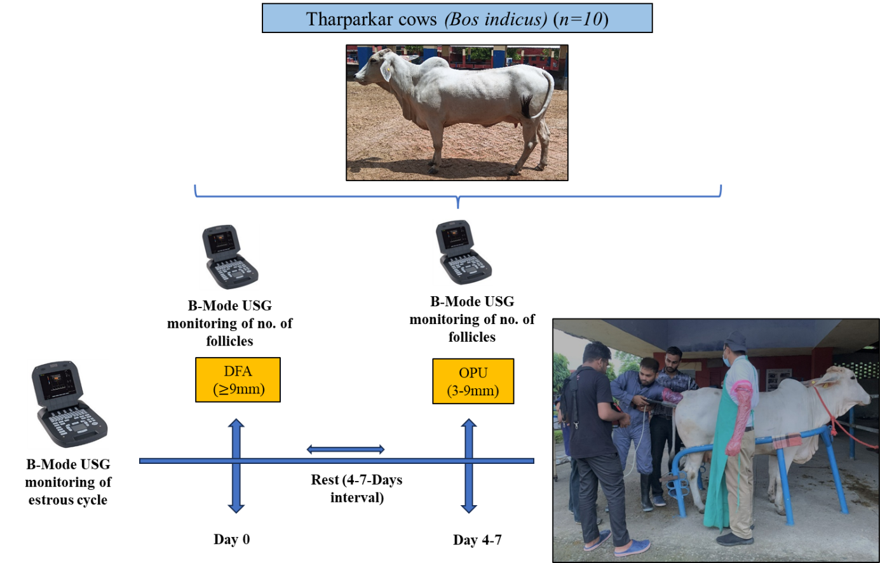

Fig. 1. Schematic representation of the experimental OPU protocol in Tharparkar cows.

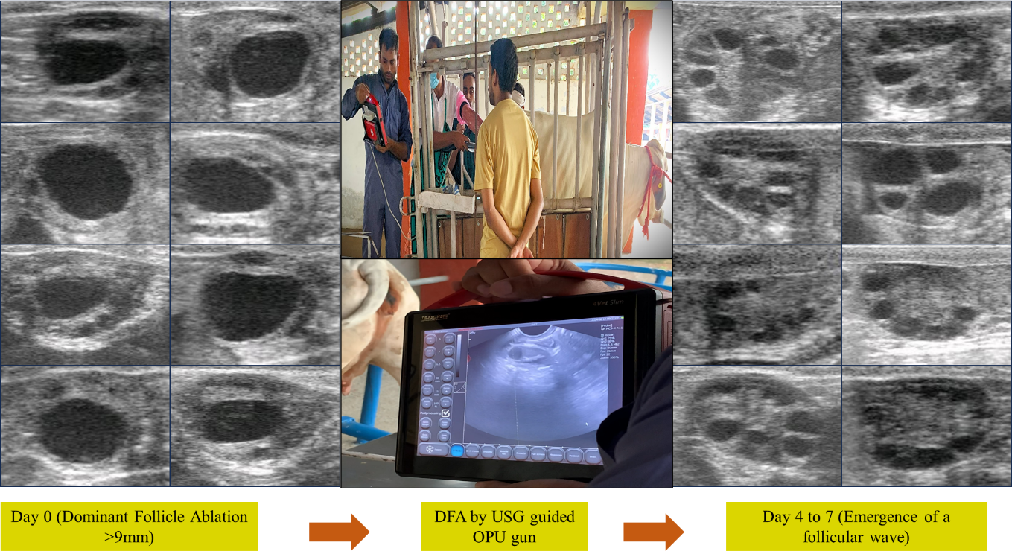

Fig. 2. Schematic representation of the experimental Dominant follicle ablation followed by OPU protocol in Tharparkar cows.

Ultrasound-Guided Ovum Pick-Up Procedure
Animals were restrained in standing position and administered epidural anesthesia using 2% lignocaine (4–5 mL). The perineal region was disinfected using 1% chlorhexidine followed by 70% ethanol. The vagina was rinsed three times by lavage using 0.5% chlorhexidine solution and sterile 0.9% saline. Both ovaries were visualized using a transvaginal ultrasound probe TYPE OF PROBE USED?? equipped with a needle guide (Fig. 2). Follicular aspiration was performed using a disposable 18-gauge needle connected to a regulated vacuum pump system.

Standardized OPU Preset
The preset parameters adopted for all OPU sessions are summarized in Table 1.

Table 1. Standardized OPU preset adopted in Tharparkar cows

Parameter | Value
Needle size | 18 G, disposable
Vacuum pressure | 80–85 mmHg
Flow rate | ~15 mL/min
Ultrasound probe frequency | 6–8 MHz
Follicle size aspirated | 3–9 mm
Dominant follicle | Absent (post-DFA)
Collection media temperature | 38.5°C

All visible follicles measuring 3–9 mm were aspirated into 50-mL collection tubes containing pre-warmed OPU collection medium maintained at physiological temperature.

Oocyte Recovery and Evaluation
Aspirated follicular fluid was filtered using a 75-µm EmCon filter and rinsed with flushing medium. The filtrate was examined in 90-mm Petri dishes under a stereomicroscope for identification of cumulus–oocyte complexes (COCs). Oocytes were graded based on cumulus cell investment and cytoplasmic homogeneity according to established morphological criteria (Demetrio et al., 2021).
Recording of Follicular Population and Recovery Rate
Follicles were recorded on the day of DFA (Day 0) and on the day of OPU (Day 4–7). The following parameters were documented:
- Total follicles aspirated
- Total oocytes recovered
- Oocyte recovery rate (%)
- Mean oocytes recovered per session
- Morphological grade distribution (%)

Recovery rate was calculated as:
Recovery rate (%) = (Number of oocytes recovered / Number of follicles aspirated) × 100. Data were expressed as mean ± standard deviation.

Results
A total of 210 follicles were aspirated from Tharparkar cows during the OPU sessions. From these, 118 oocytes were recovered, resulting in an overall recovery rate of 56.08 ± 3.27%. The mean number of follicles aspirated per session was 21.0 ± 0.81, while the mean number of oocytes recovered per session was 11.8 ± 0.87 (Fig. 3). Morphological evaluation of cumulus–oocyte complexes revealed that 32.09 ± 4.27% of oocytes were classified as Grade A and 27.77 ± 3.90% as Grade B. Lower quality oocytes included 17.15 ± 3.52% Grade C and 23.00 ± 5.24% Grade D. Overall, morphologically acceptable oocytes (Grade A and B combined) constituted 59.86 ± 3.11% of recovered oocytes, whereas 40.13 ± 3.11% were categorized as Grade C and D (Fig. 4 & 5). The standardized OPU preset demonstrated consistent follicular aspiration and maintained satisfactory oocyte morphological integrity across sessions.

Fig. 3. Follicular aspiration, oocyte recovery, and recovery rate in Tharparkar cows

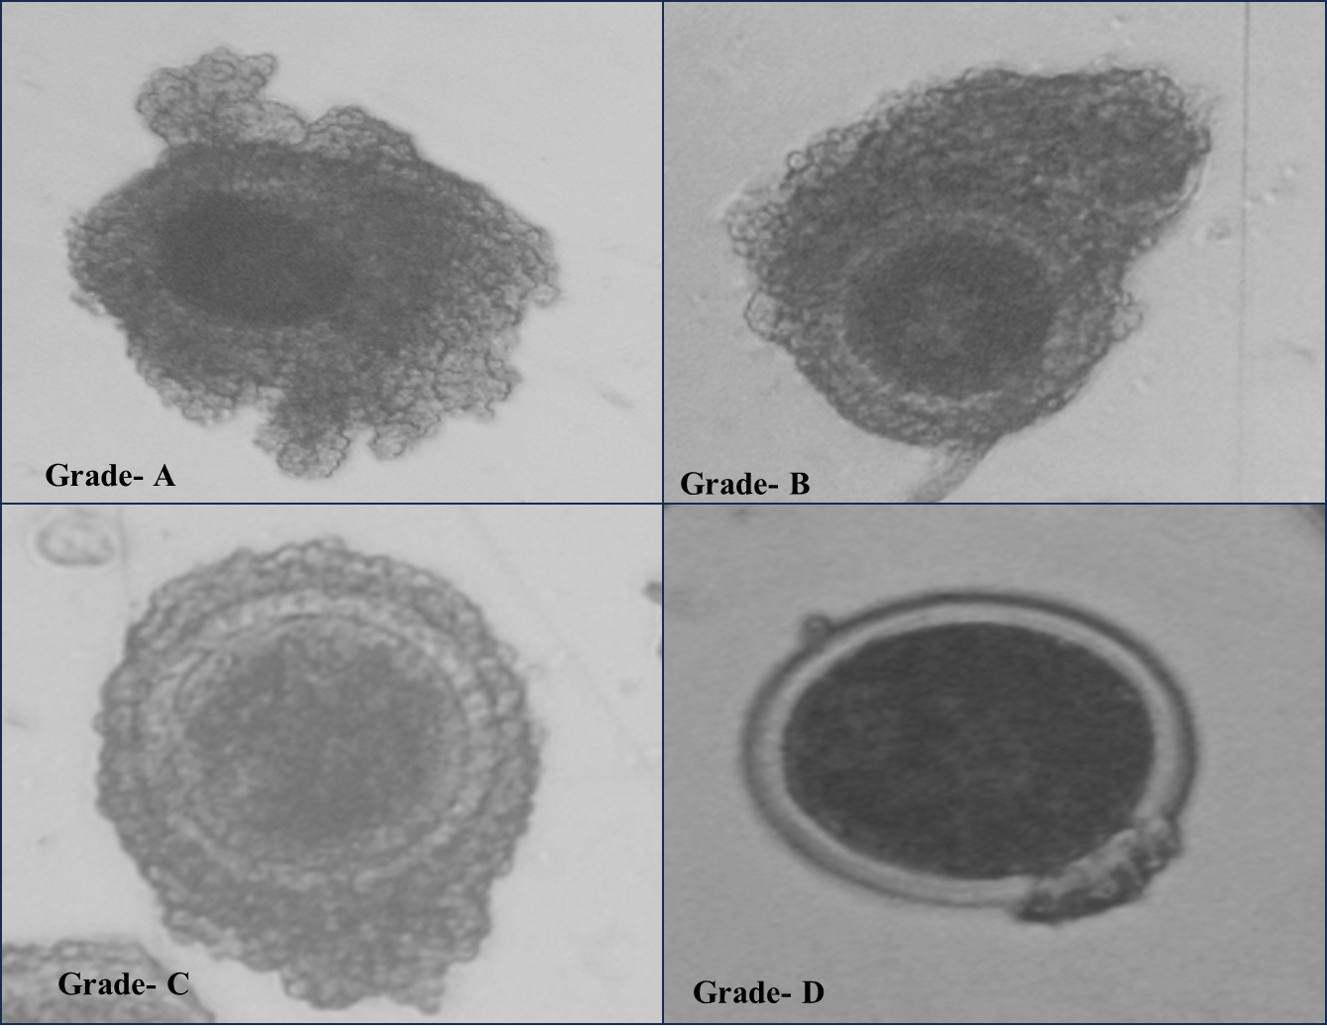

Fig. 4. Different grades of Cumulus oocyte complexes collected from Tharparkar cows

Fig. 5. Percentage recovered oocytes in Tharparkar cows

Discussion
Standardization of ovum pick-up (OPU) parameters is essential for ensuring procedural consistency and maintaining oocyte structural integrity during follicular aspiration. In the present report, the defined preset yielded an overall recovery rate of approximately 56%, with nearly 60% of recovered oocytes classified as morphologically acceptable (Grade A and B). These findings indicate stable follicular aspiration dynamics and preservation of cumulus–oocyte complex integrity under the adopted technical conditions.
Mechanical determinants such as needle gauge and aspiration pressure directly influence recovery efficiency and cumulus preservation (Donadkar et al., 2024). The 18-gauge needle provided sufficient lumen diameter for effective follicular evacuation while minimizing turbulence within the aspiration system. Regulated vacuum pressure (80–85 mmHg) likely reduced excessive shear stress during follicular collapse, thereby preserving cumulus compactness and cytoplasmic homogeneity. Controlled flow rate (~15 mL/min) further contributed to gradual follicular evacuation, reducing abrupt pressure fluctuations that may compromise oocyte morphology. Maintenance of collection media at physiological temperature (38.5°C) supported cellular metabolic stability during handling.
Dominant follicle ablation (DFA) was incorporated prior to OPU to eliminate the suppressive endocrine influence of the dominant follicle. In bovine follicular wave dynamics, the dominant follicle secretes estradiol and inhibin, which exert negative feedback on circulating follicle-stimulating hormone (FSH). Declining FSH concentrations restrict subordinate follicle growth and predispose them to atresia. Ablation of the dominant follicle removes this inhibitory feedback, allowing a transient FSH rise and synchronized recruitment of a new follicular wave. This increases the pool of medium-sized follicles available for aspiration (Saleem et al., 2020; Saleem et al., 2021; Sahu, 2025). The synchronization achieved through DFA likely contributed to the uniform follicular population observed at the time of OPU in the present study.
Breed-specific reproductive characteristics must also be considered when establishing standardized protocols. Historical genetic evaluation of Tharparkar cows documented variability in reproductive traits (Majumdar, 1969), and contemporary field studies have highlighted the influence of genetic and non-genetic factors on reproductive performance in this indigenous Bos indicus breed (Pilania et al., 2022; Choudhary et al., 2024). Structured reproductive and genetic improvement strategies have been emphasized for sustainable utilization of Tharparkar germplasm (Patel et al., 2024). Within this context, development of a reproducible OPU preset tailored to Tharparkar cows contributes to applied reproductive infrastructure for breed-specific assisted reproductive programs.
Transvaginal OPU and assessment of oocyte developmental competence have previously been demonstrated in Tharparkar donor cows (Donadkar et al., 2024). The present methodological documentation complements these findings by defining aspiration pressure, needle specifications, flow dynamics, and follicular selection criteria under non-stimulated conditions. While comparative evaluation of alternative presets was not performed, the observed recovery rate and proportion of morphologically acceptable oocytes indicate that the adopted parameters provide consistent procedural outcomes in Tharparkar cows.
Conclusion
The standardized ovum pick-up preset described in this report yielded consistent oocyte recovery and satisfactory morphological quality in Tharparkar cows under defined experimental conditions. The combination of controlled aspiration pressure (80–85 mmHg), 18-gauge needle usage, regulated flow rate, synchronized follicular wave emergence through dominant follicle ablation, and maintenance of physiological handling conditions provided stable procedural outcomes. This methodological framework may serve as a practical reference for OPU application in Tharparkar cattle and may support breed-specific assisted reproductive programs aimed at genetic conservation and improvement.

Statements and Declarations

Ethics Statement
All experimental procedures were reviewed and approved by the Institutional Animal Ethics Committee (IAEC), ICAR–Indian Veterinary Research Institute (IVRI), Izatnagar (Approval No.: 26-3/2020-21/JD(R)/IAEC).
Conflict of Interest
The authors declare no conflict of interest.
Data Availability
Data supporting the findings of this study are available from the corresponding author upon reasonable request.
References
Choudhary, G., Pannu, U., Gahlot, G. C., & Meena, S. (2019). Effect of Genetic and Non-Genetic Factors on First Lactation Production Traits in Tharparkar Cattle. Int. J. Curr. Microbiol. App. Sci, 8(2), 2160-2164.
Demetrio, D. G. B., Benedetti, E., Demetrio, C. G. B., Fonseca, J., Oliveira, M., Magalhaes, A., & Santos, R. M. D. (2020). How can we improve embryo production and pregnancy outcomes of Holstein embryos produced in vitro?(12 years of practical results at a California dairy farm). Animal reproduction, 17(3), e20200053.
Donadkar, M., Kumar, B., Singh, S. K., Chandra, P., Dangi, P., Gawai, M., Jackson, A., Jasrotia, N., Sharma, S., Chouhan, V., Patra, M. K., & Khan, M. H. (2024). Morpho-molecular evaluation for developmental competence of oocytes retrieved through transvaginal ovum pick-up from FSH-stimulated Tharparkar donor cows (Bos indicus). Zygote, 32(5), 376–385. https://doi.org/10.1017/S0967199424000376
Majumdar, S. C. (1969). Genetic studies on reproductive traits of Tharparkar cows (Master’s thesis). Magadh University, Bihar Veterinary College, Patna.
Patel, A. K., Patel, R. K., & Patil, N. V. (2024). Genetic Improvement of Tharparkar Cattle: A Review. Indian Journal of Animal Research, 58(3).
Pilania, S., Nehara, M., Pannu, U., Meena, R., & Choudhary, G. (2022). Production and reproduction performance of Tharparkar cattle in arid region of Rajasthan. Indian Journal of Dairy Science, 75(5). https://epubs.icar.org.in/index.php/IJDS/article/view/121556
Sahu, U. K. (2025). Uterine haemodynamics, follicular-luteal attributes and developmental competence of OPU-derived oocytes in subclinical endometritic dairy cows (Doctoral dissertation). Indian Veterinary Research Institute.
Saleem, M., Nawaz, M., Yaseen, M., Yousuf, M. R., Bajwa, A. G., & Riaz, A. (2021). Effect of clinical endometritis on follicle growth dynamics, oocyte recovery, oocyte quality, and in vitro developmental competence of oocytes using ovum pick-up in Sahiwal cattle. Reproduction, Fertility and Development, 33(2), 134. https://doi.org/10.1071/RDv33n2Ab54
Saleem, M., Sarwar, Z., Saad, M., Zahoor, I., Ahmad, N., & Riaz, A. (2020). Effect of clinical metritis on oocyte recovery, oocyte quality, and early in vitro developmental competence of embryos in Bos indicus dairy cattle. Reproduction, Fertility and Development, 32(2), 225. https://doi.org/10.1071/RDv32n2Ab193

