Original Research Article

Genetic Diversity Analysis of Myanmar Royal Orchid, Thazin (Bulbophyllum auricomum) Cultivars

.
ABSTRACT

Bulbophyllum auricomum, a fragrant orchid recognized as a royal flower in Myanmar, faces significant threats from habitat loss, illegal trade, and over collection across its limited wild distribution. This study analyzed morphological variation among 59 samples collected from five regions (Dawei/Tanintharyi, Rakhine, Kayin, Putao/Kachin, and Shan States) using 31 quantitative and qualitative traits, alongside SSR marker validation. UPGMA cluster analysis delineated three main groups: Cluster I (29 samples from Dawei (Htawei), Rakhine, Kayin, Putao) showed high genetic similarity and superior commercial traits like flower count and fragrance; Cluster II (Shan Yellow) and Shan (White) formed distinct out groups possibly due to selective breeding for pigmentation and form, despite geographic proximity. Qualitative traits were largely uniform (e.g., 100% linear leaves, fragrant flowers) while polymorphisms in sepal shape and color highlighted cultivar diversity. SSR analysis with 10 Cymbidium markers yielded limited polymorphism, confirming two (KNU-CC-40, KNU-CC-71) with region-specific patterns, underscoring genomic uniformity but subtle differentiation. These patterns reveal local adaptation, gene flow, and anthropogenic influences shaping diversity, informing targeted conservation of wild genetic resources and ex situ propagation of elite cultivars to bolster Myanmar’s orchid bioeconomy. Multivariate approach effective despite resource constraints, advocating integration with molecular tool for breeding and taxonomic refinement.

Keywords: Bulbophyllum auricomum, Genetic Diversity, Morphology, Myanmar Royal Orchid, SSR
1. INTRODUCTION

Orchids represent the second largest family of flowering plants and are distributed worldwide. The Orchidaceae family is taxonomically divided into five subfamilies: Apostasioideae, Cypripedioideae, Vanilloideae, Orchidoideae, and Epidendroideae (Willis, 2017). They are monocotyledonous plants that may grow as epiphytes, terrestrials, or lithophytes. Approximately 70% of orchid species are epiphytic and/or lithophytic, 25% are terrestrial, and about 5% grow in mixed substrates that combine epiphytic, lithophytic, and terrestrial characteristics (Arditti, 1992). Epiphytes are grown on trees, rocks or in leaf litter. Nutrients mainly come from animal droppings and other organic detritus on their supporting surface. Epiphytic orchids are characterized by thick and succulent leaves with thick cell walls, cuticles and small sub-stomatal chamber whereas those of terrestrial species are thin. Orchids are evergreen or deciduous herbaceous perennial.
In recent times, biodiversity loss has emerged as a major global concern. Anthropogenic pressures such as overexploitation, deforestation, and rapid urbanization are causing extensive destruction of natural orchid habitats, resulting in a steady decline of their natural populations (Bazzicalupo et al., 2023). Phelps and Webb (2015) stated that conservation and environmental management frequently depend on official statistics; however, their accuracy and reliability can be questionable, especially regarding sensitive matters like illegal harvesting and trade. Botanical surveys have uncovered a large, previously unreported commercial trade in wild, protected ornamental plants across Thailand, Lao PDR, and Myanmar, with a particular focus on orchids. These findings highlight that illegal trade poses a threat not only to charismatic Southeast Asian mammals, reptiles, and amphibians but also to hundreds of tropical plant species.
Bulbophyllum auricomum is distinguished by its admirable fragrance, which serves as a royal symbol of the species. It is recognized as a national symbol of Myanmar and has traditionally been used to adorn women's hair. Its blooms are often described as exotic and visually appealing. Cultivating B. auricomum can be challenging due to its specific environmental needs. It thrives in bright, indirect light and high humidity, with optimal temperatures ranging between 20°C and 30°C (68°F to 86°F). This species prefers a well-draining orchid medium and requires consistent watering to support healthy growth (Hinsley et al., 2018).
Due to its limited distribution and specific habitat requirements, Bulbophyllum auricomum is at significant risk of extinction in the wild. They constitute one of the most diverse and economically significant plant families worldwide, highly prized by horticulturists and collectors for their aesthetic appeal and cultural relevance. Despite their value, many orchid species are increasingly threatened with extinction due to habitat loss, over-collection, and other human-induced pressures (Sharma & Pathak, 2020). Due to their complex life histories and ecological dependencies, orchids are particularly vulnerable to the impacts of global environmental change. Many species are also at risk from unregulated collection for horticultural, medicinal, or culinary purposes. The scale and intensity of these threats now surpass our capacity to manage them on a species-by-species basis, given the vast diversity within the Orchidaceae family.
Morphological characterization, especially of floral traits, is a fundamental tool in species delimitation, phenotypic evaluation, and germplasm conservation (Singh et al., 2014). When coupled with multivariate statistical techniques such as cluster analysis, it can reveal natural groupings and relationships within a species (Zhou et al., 2011). This approach is especially useful in regions where molecular resources are limited or where in-situ conservation is a priority.
The present study investigates morphological variation in B. auricomum across five geographically distinct regions of Myanmar; Dawei, Rakhine, Kayin, Putao and Shan. The objective is to explore phenotypic diversity and regional clustering patterns, which may provide insight into local adaptation, potential ecotypes, or hidden genetic differentiation. The results may contribute to better conservation planning, orchid breeding programs, and further taxonomic clarification.

2. material and methods
2.1 Sample plant collection
In total 59 Bulbophyllum auricomun plant samples were collected from five geographically distinct regions of Myanmar. Ten samples (Dawei) from Tanintharyi Division, 10 samples (Rakhine) from Rakhine State, five samples (Kayin) from Kayin State, four samples (Putao) from Kachin State and 30 samples from Shan State (Taungyi and Pindaya) were collected, respectively (Figure 1). The names and origins of the samples used in this study were presented in Appendix 1.
Dawei is located at Tannitharyi Division, 14° 11' 13.83" N latitude and 98° 12' 34.32" E longitude. Its elevation is around 17 meters (56 feet) above sea level. Rakhine is located at Rakhine State, elevation of 45 meters (148ft), 17°30' and 21°30' north latitude and 92°10' and 94°50' east longitude. Kayin is located at Kayin State, between 15° 43' N and 18° 48' N latitude and 96° 20' E and 98° 28' E longitude. Putao is located at Kachin State, elevation of 409 meters (1,342 feet), approximately 27.33° N latitude and 97.42° E longitude. Taunggyi is located at Southern Shan State, elevation of 1,436 meters (4,712 feet) above sea level and at 20°47′N 97°01′E. Pandaya is located at Southern Shan State, elevation of 1,178 meters (3,865 feet), 20° 56′ 35″ N and 96° 39′ 45″ E, respectively.
Figure 1. Five geographically distinct regions of Myanmar where Thazin (Bulbophyllum auricomum) sample are collected. (The number in the bracket are the number of samples collected in each regions)
2.2 Data collection
Fourteen qualitative and 17 quantitative characters were collected according to the descriptor of Protection of Plant Varieties and Farmers Rights’ Authority (PPV & FRA) Government of India. The collected data were presented in Appendix 2 and 3.
2.3 Data Analysis
The morphological data were analyzed using Power Marker (version 3.25). The Euclidean Distance was used to construct the distance metric. The clustering was done using the unweighted pair group of arithmetic means (UPGMA) method. The dendrogram was shaped using MEGA-11 imbedded in the Power Marker program.
2.4 Data Validation by DNA analysis
2.4.1 DNA extraction
To check the resulted data, DNA confirmation was carried out. DNA was extracted from young and fresh true leaves of B. auricumun plant samples using modified Cetyltrimethylamoniumbromide (CTAB). The relative purity and concentration of extracted DNA was estimated with NanoDrop ND-1000 (NanoDrop Technologies, Inc., Wilmington, DE, USA). The final concentration of each DNA sample was adjusted to 50 ng/µl.
2.4.2 SSR ‌amplification and gel documentation
Ten SSR markers developed by Moe et al. (2010) were used for PCR analysis (Table 1). PCR amplification was carried out with 10 μl reaction volume containing 50 ng template DNA, 10X Ex Taq buffer (10x Tris with 20 mM MgCl₂), 25 mM dNTPs, 0.5 μl of each primer (10 Pmol), 1 unit of Taq polymerase (Takara) by using Applied Biosystem 2720 thermal cycler. Thermal Cycler programme for PCR comprised 94 ºC for 5 min for initial denaturation, was followed by 35 cycles of 94 ºC for 30s,58-63 ºC for 30s, 72 ºC for 30 s and ending up with 5 min at 72 ºC for the final extension. Annealing temperature was adjusted based on the specific requirement of different primers combinations. All PCR products were loaded by electrophoresis in 3% agarose gel containing 0.5 μg ml⁻¹ of Ethidium Bromide prepared in 0.5 X TBE buffer at a constant voltage of 200 V for approximately 1 hr. The gel was visualized in UV transilluminator and SSR band scores were performed using Bio-Red gel documentation system. The resulted banding patterns were checked by comparing GeneRuler 1kb DNA ladder bands (Thermo Fisher Scientific).
Table 1. Information of 10 simple sequence repeat markers used in this study including repeat motif, expected size range and annealing temperature.
Table 1. Information of 10 simple sequence repeat markers used in this study including repeat motif, expected size range and annealing temperature.
No. | SSR ID | Forward primer sequence | Reverse primer sequence | Repeat motif | Expected  size range | TA(°C)
1 | KNU-CC-01 | CAGAGGTATTGCAGGGGA | CCGTTAGGGATTGGGTTT | (GT)10(GA)14 | 123-181 | 55
2 | KNU-CC-32 | AAAACCTTGATCCTCACAAGA | TGGGTCGACATGATCTGTT | (AG)27 | 114-248 | 55
3 | KNU-CC-34 | GCGGATGCCCACTATACA | GCTCCTCTTTGAGTTTGGG | (AG)13 | 169-243 | 55
4 | KNU-CC-35 | TCTCAGGCAATGCCGTAT | TTTGTGTGTGGCATTCGA | (TC)10,(GT)13 | 119-263 | 52
5 | KNU-CC-40 | AAGCTCTGTCTTCATCCTTCAA | TGGTGTGGAGAGAGGTTTTT | (GA)32 | 140-260 | 55
6 | KNU-CC-43 | TCGCTGCGCCTATACAGT | CTCAGCTGTTGCCTCCAC | (CT)14 | 135-295 | 55
7 | KNU-CC-52 | GAATTTTGCTGTCCGCTG | GGCGTGTTCGTGTTGAAT | (GA)9 | 230-288 | 55
8 | KNU-CC-55 | AAGGTTGCATTTTCCCTCA | ACTAGGTGGGGTCGGCTA | (CAA)14 | 105-312 | 55
9 | KNU-CC-71 | GATTTCAGCCCTCGGAGT | ACTAGGTGGGGTCGGCTA | (CAA)8 | 105-342 | 55
10 | KNU-CC-76 | GAATTTGGCTGGTGGTGA | TTGTCCTCTTGCTCCCAA | (TG)14 | 103-287 | 55
TA(°C) = annealing temperature;

3. results and discussion
3.1 Phylogenetic analysis based on morphological traits
A UPGMA dendrogram was constructed using 31 morphological characters to elucidate genetic relationships among B. auricomum samples collected from six distinct regions of Myanmar. At the regional level, the analysis revealed close clustering of the most prevalent samples from Dawei, Rakhine, and Kayin states, indicative of shared genetic ancestry or gene flow among these populations. The less commonly cultivated Putao accession occupied an intermediate position between this cluster and Shan State samples, suggesting moderate divergence (Figure 1).
Notably, the cultivated varieties from Shan State (Shan Yellow and Shan White) formed a distinct outgroup, separated from all other samples, which may reflect selective breeding pressures or geographic isolation. The minimum genetic distance observed within clusters was 0.05, underscoring low overall differentiation consistent with regional cultivation patterns.
Cluster I comprised 29 samples from Dawei, Rakhine, Kayin, and Putao regions (Figure 2 and Table 2). Within this cluster, Dawei and Rakhine samples formed a tight sub-cluster, reflecting high genetic similarity potentially attributable to shared environmental pressures or common ancestral origins. Kayin samples exhibited moderate affinity to this sub-group, while Putao samples showed greater divergence, consistent with geographic isolation or localized adaptation.
Notably, the Dawei, Rakhine, and Kayin samples despite their genetic proximity represent Myanmar's most commercially valuable B. auricomum cultivars, valued for superior floral attributes including fragrance, morphology, and resilience. These traits drive their dominance in local and regional orchid markets. In contrast, the genetically aligned but less popular Putao variant likely suffers from restricted distribution, reduced ornamental appeal, or limited grower recognition.
Cluster II exclusively contained the Shan Yellow, forming a genetically discrete group characterized by extended branch lengths from wild-type samples (Figure 2). This pronounced divergence suggests intensive anthropogenic selection, particularly for floral pigmentation. The differentiation between Shan Yellow likely stems from targeted propagation strategies preserving distinct ornamental phenotypes.
Cluster III is distinctly separated from all other clusters, indicating that Shan White represents the most divergent accession. Despite the limited geographic distance between Pandaya (Shan Yellow) and Taunggyi (Shan White), a geographical barrier appears to contribute to their genetic differentiation.
The dendrogram thus delineates both genetic structure and socioeconomic patterns in B. auricomum diversity. The genetic cohesion of high-value Dawei-Rakhine-Kayin cultivars underscores their conservation priority, while the distinctiveness of Shan variants necessitates formal cultivar registration and standardized propagation protocols.

Figure 2. UPGMA dendrogram showing genetic relationships among B. auricomum samples from six regions of Myanmar based on 31 morphological characters (regional level).
Figure 3. UPGMA dendrogram showing genetic relationships among 59 B. auricomum samples from six regions of Myanmar based on 30 morphological characters (individual level).
The 59 samples were distributed into three distinct clusters, as presented in Table 2. Cluster I consisted of 29 samples forming a genetically diverse group with several internal sub-clusters and it could be clearly subdivided into two subclusters (IA and IB), with subcluster IA comprising four samples exclusively from Putao. Such diversity was likely a consequence of natural selection and ecological differentiation across Myanmar’s diverse landscapes. Similar patterns of intra-population variability have been reported in epiphytic orchids and were attributed to local adaptation and limited gene flow among fragmented habitats (Zhang et al., 2013; Chung et al., 2014). The relatively close genetic relationship among Dawei, Rakhine, and Kayin samples may reflect common ancestral gene pools or shared pollination syndromes.
Despite their genetic similarity, Dawei, Rakhine, and Kayin varieties are known to be among the most popular and commercially valuable B. auricomum types in Myanmar, widely traded for their aesthetic qualities, such as large flower size, pleasant fragrance, and desirable form (Aung et al., 2022). These varieties dominate local flower markets and are often used in cultural and ceremonial contexts. 1 while genetically related to the high-value groups, are less favored in the orchid trade, possibly due to geographic isolation, reduced market exposure, or less visually striking floral traits.
Cluster II and III, consisting of Shan Yellow and Shan White samples respectively, demonstrated low intra-group genetic variation. This suggested a narrow genetic base likely caused by prolonged vegetative propagation and strong artificial selection for floral color (Teixeira da Silva et al., 2015). The tight clustering among Shan White samples may indicate clonal lineage conservation over time, consistent with practices observed in other ornamental orchids such as Dendrobium and Phalaenopsis (Hsu et al., 2010). The divergence between Shan Yellow and Shan White groups, despite their shared regional origin, points to independent selection pathways, possibly maintained by different propagation sources or cultivar preferences among growers.
At the population level, the regional dendrogram further emphasized the genetic separation between cultivated Shan morphotypes and wild-type samples from other regions. The Shan White group, in particular, formed a long and distinct branch, indicating significant divergence from its wild relatives. These results align with findings in Bulbophyllum and other orchid genera, where selection for flower morphology and pigmentation leads to clear genetic splits among cultivated lines (Zhang et al., 2020; Mondini et al., 2009).
The conservation implications of these results are considerable. On one hand, wild samples from Dawei, Rakhine, and Kayin regions demonstrate valuable genetic diversity that must be preserved for future breeding and ecosystem resilience. On the other hand, the Shan Yellow and Shan White cultivars, though genetically uniform, carry significant horticultural and economic value and thus require protection through ex situ conservation and cultivar registration. In vitro propagation and tissue culture techniques have proven effective in safeguarding endangered and elite orchid lines (Sarasan et al., 2006; Martin & Madassery, 2006). These should be prioritized for both high-value cultivated forms and genetically diverse wild samples.
Moreover, integrating molecular data such as SSRs or SNPs in future studies will provide finer resolution of population structure and lineage divergence. Coupled with ecological niche modeling, such approaches can inform site-specific conservation and guide the reintroduction of threatened populations, especially under increasing habitat pressure and illegal collection (Swarts & Dixon, 2009).
In conclusion, this study highlights the complex genetic landscape of Bulbophyllum auricomum in Myanmar, shaped by both natural ecological factors and long-term human selection. The findings underscore the importance of tailored conservation strategies, sustainable cultivation practices, and the establishment of a national orchid germplasm registry to support biodiversity and bioeconomy development.
Table 2. Cluster membership of B. auricomum based on 31 morphological characters

Cluster | Number | Sub-Cluster | Genotypes | Sources
I | 29 | A | Putao-1, Putao-4, Putao-2, Putao-3 | Kachin
I | 29 | B | Rakhine-1, Rakhine-2, Rakhine 4 | Rakhine
I | 29 | B | Dawei-2, Dawei-6, Kayin-1, Rakhine-7, | Tanintharyi
I | 29 | B | Rakhine-10, Rakhine-3, Rakhine-9, Dawei-8, | Kayin
I | 29 | B | Rakhine-5, Kayin-3, Kayin-5, Kayin-2, | Kayin
I | 29 | B | Kayin-4, Dawei-1, Dawei-3, Dawei-5, | Kayin
I | 29 | B | Dawei-4, Dawei-9, Dawei-10, Rakhine-8 | Kayin
I | 29 | B | Dawei-7, Rakhine-6 | Kayin
II | 10 | A | Shan yellow-6, | Pindaya, Shan
II | 10 | B | Shan yellow-10, Shan yellow-4, Shan yellow 5, | Pindaya, Shan
II | 10 | B | Shan yellow-8, Shan yellow 1, Shan yellow 9, | Pindaya, Shan
II | 10 | B | Shan yellow- 7, Shan yellow-2, Shan yellow 3 | Pindaya, Shan
III | 20 | A | Shan white-2, | Taunggyi, Shan
III | 20 | B | Shan white-4, Shan white-1, Shan white-15, | Taunggyi, Shan
III | 20 | B | Shan white-3, Shan white-5, Shan white-7, | Taunggyi, Shan
III | 20 | B | Shan white-10, Shan white-8, Shan white-6, | Taunggyi, Shan
III | 20 | B | Shan white-16, Shan white-9, Shan white-12, | Taunggyi, Shan
III | 20 | B | Shan white-14, Shan white-11, Shan white-13, | Taunggyi, Shan
III | 20 | B | Shan white-17, Shan white-20, Shan white-18, Shan white-19 | Taunggyi, Shan

3.2 Cluster mean comparison
Mean comparison for each cluster was presented in table 3. The cluster analysis revealed three distinct clusters (I, II, III) of orchid morphotypes based on 17 vegetative and floral characters, with significant mean differences across clusters indicating phenotypic diversity. Cluster I exhibited the largest overall dimensions, particularly in leaf length (9.04 cm), pseudobulb length (24.38 mm), and flower count (31.00), suggesting adaptation for vigorous growth and higher reproductive output. Cluster III shown extremes in root number (33.20) and root length (3.00 cm), while Cluster II balanced intermediate traits like flower longevity (21.08 days) but has notably wide pseudobulbs (33.60 mm).
Table 3. Cluster mean comparison for 16 quantitative characters
Sr. | Characters | Cluster
Sr. | Characters | Unit | I | II | III
1. | No. of leaves | no. | 1.74 | 1.80 | 1.80
2. | Leaf length | cm | 9.04 | 7.51 | 6.91
3. | Leaf width | cm | 1.40 | 1.36 | 1.24
4. | Leaf thickness | mm | 0.95 | 0.49 | 0.488
5. | Pseudobulb length | mm | 24.38 | 18.00 | 12.66
6. | Pseudobulb width | mm | 12.74 | 33.60 | 13.60
7. | Flower longevity (days) | no. | 15.89 | 21.08 | 5.00
8. | Inflorescence length with peduncle | cm | 19.32 | 10.92 | 14.14
9. | Inflorescence length only flower | cm. | 12.50 | 9.36 | 8.52
10. | Distance between flowers | cm | 0.39 | 0.27 | 0.32
11. | Flower width | cm | 2.16 | 1.40 | 1.42
12. | Distance between pseudo-bulb and first flower | cm | 5.95 | 0.84 | 7.74
13. | No. of flowers | no. | 31.00 | 36.80 | 12.60
14. | Length of sepal | cm | 0.80 | 0.54 | 0.52
15. | Width of sepal | cm | 0.28 | 0.18 | 0.32
16. | No. of roots | no. | 27.42 | 19.80 | 33.20
17. | Root length | cm | 2.66 | 2.48 | 3.00

3.3 Frequency distribution of qualitative scores
The uniform traits observed across all 59 genotypes of Bulbophyllum auricomum especially for leaf shape, leaf orientation, leaf attitude/ nature, inflorescence type and flower fragrance indicate a high degree of conservation in core morphological features, likely reflecting selective pressures or shared genetic heritage within Myanmar royal orchid cultivars (Figure 4,5 and 6).
Traits such as linear leaf shape, normal leaf attitude, erect leaf orientation, simple inflorescence, flower fragrance presence, lanceolate lateral sepal shape, uniform dorsal sepal color pattern, absent peduncle anthocyanin, and pseudobulb-bearing habit each at 100% frequency, suggested these characteristics are diagnostic for the species or cultivar group. Such uniformity minimizes environmental plasticity in vegetative and reproductive structures, potentially enhancing adaptability in Myanmar's tropical habitats by optimizing light capture, structural stability, and pollinator attraction through consistent fragrance. This homogeneity aligns with patterns in orchid taxonomy, where stable foliar and inflorescence traits delimit species boundaries amid variable floral displays.
Dorsal sepal shape variation (43.37% lanceolate vs. 57.62% ovate) and color polymorphism (83.05% white vs. 16.95% yellow) highlight intraspecific diversity, possibly driven by allelic variation at key loci or microhabitat differences, enabling niche partitioning or mate signaling. Pseudobulb dimorphism (66.10% ovate absent groove vs. 33.90% circular present groove) correlates inversely, suggesting functional trade-offs: ovate forms may prioritize water storage without grooves for streamlined growth, while grooved circular types could facilitate gas exchange or herbivore defense. These polymorphisms contribute to the observed dissimilarity, underscoring cultivar-level differentiation despite overall uniformity.
The frequency distributions reveal a spectrum of monomorphic to polymorphic traits, informing conservation genetics by identifying fixed markers for authenticity in Myanmar royal orchids and variable ones for breeding programs aimed at hybrid vigor. Future studies integrating quantitative morphometrics or molecular markers could elucidate heritability of these traits, linking phenotypic variation to phylogenetic clades within Bulbophyllum.
Table 4. Frequency distribution for 14 qualitative traits in 59 B.auricomum genotypes

Sr. | Variables | Score | Categories | Frequency | Relative frequency (%)
1. | Leaf shape | 1 | narrow lanceolate | 0 | 0
1. | Leaf shape | 3 | linear | 59 | 100
1. | Leaf shape | 5 | narrow elliptic | 0 | 0
1. | Leaf shape | 7 | elliptic | 0 | 0
2. | Leaf orientation | 1 | erect | 59 | 100
2. | Leaf orientation | 3 | semi erect | 0 | 0
2. | Leaf orientation | 5 | horizontal | 0 | 0
2. | Leaf orientation | 7 | pendulous | 0 | 0
3. | Leaf attitude/ nature | 1 | normal | 59 | 100
3. | Leaf attitude/ nature | 9 | twisting | 0 | 0
4. | Inflorescence type | 3 | Simple raceme | 59 | 100
4. | Inflorescence type | 5 | Panicle | 0 | 0
4. | Inflorescence type | 7 | Compound panicle | 0 | 0
5. | Flower fragrance | 1 | Absent | 0 | 0
5. | Flower fragrance | 9 | present | 59 | 100
6. | Dorsal sepal shape | 1 | Lanceolate | 25 | 43.37
6. | Dorsal sepal shape | 2 | Linear | 0 | 0
6. | Dorsal sepal shape | 3 | Oblong | 0 | 0
6. | Dorsal sepal shape | 4 | Elliptic | 0 | 0
6. | Dorsal sepal shape | 5 | Ovate | 34 | 57.62
6. | Dorsal sepal shape | 6 | obovate | 0 | 0
7. | Lateral sepal shape | 1 | Lanceolate | 59 | 100
7. | Lateral sepal shape | 3 | Ovate | 0 | 0
7. | Lateral sepal shape | 5 | Curving ovate | 0 | 0
7. | Lateral sepal shape | 7 | Obovate | 0 | 0
7. | Lateral sepal shape | 9 | Broad obovate | 0 | 0
8. | Petal twisting | 1 | Absent | 59 | 100
8. | Petal twisting | 9 | present | 0 | 0
9. | Dorsal sepal main colour | 1 | Green | 0 | 0
9. | Dorsal sepal main colour | 2 | White | 49 | 83.05
9. | Dorsal sepal main colour | 3 | Pink | 0 | 0
9. | Dorsal sepal main colour | 4 | Yellow | 10 | 16.95
9. | Dorsal sepal main colour | 5 | Red | 0 | 0
9. | Dorsal sepal main colour | 6 | Purple | 0 | 0
9. | Dorsal sepal main colour | 7 | blue | 0 | 0
10. | Dorsal sepal colour pattern | 1 | Uniform | 59 | 100
10. | Dorsal sepal colour pattern | 2 | Shaded | 0 | 0
10. | Dorsal sepal colour pattern | 3 | Blotched | 0 | 0
10. | Dorsal sepal colour pattern | 4 | brindled | 0 | 0
10. | Dorsal sepal colour pattern | 5 | Striped | 0 | 0
10. | Dorsal sepal colour pattern | 6 | edged | 0 | 0
11. | Peduncle: anthocyanin colouration | 1 | Absent | 59 | 100
11. | Peduncle: anthocyanin colouration | 9 | present | 0 | 0
12. | Pseudobulb shape | 1 | Oblong | 0 | 0
12. | Pseudobulb shape | 3 | Elliptic | 0 | 0
12. | Pseudobulb shape | 5 | circular | 20 | 33.90
12. | Pseudobulb shape | 7 | ovate | 39 | 66.10
13. | Pseudobulb groove | 1 | Absent | 39 | 66.10
13. | Pseudobulb groove | 9 | Present | 20 | 33.90
14. | Plant type | 1 | Without pseudobulb | 0 | 0
14. | Plant type | 9 | With | 59 | 100

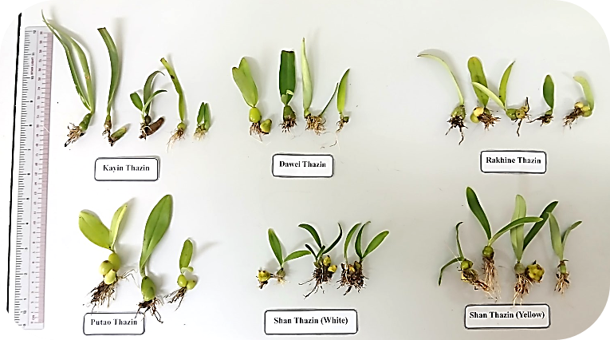
Figure 4. Comparison of plantlets resulted from initial seed culture in in vitro ( Kayin, Dawei, Rakhine) and the last three from ex situ
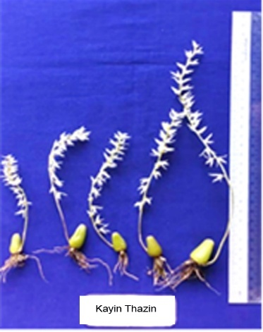 | 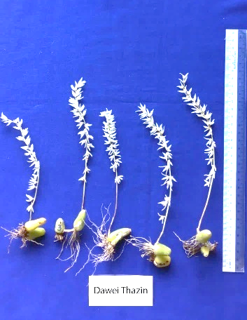 | 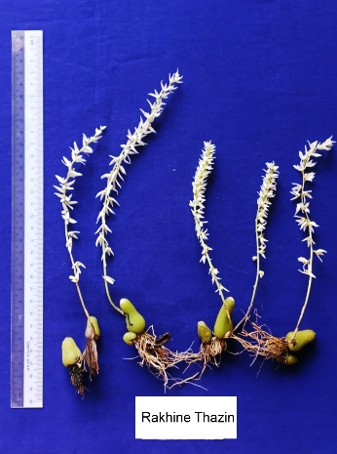
(a) | (b) | (c)
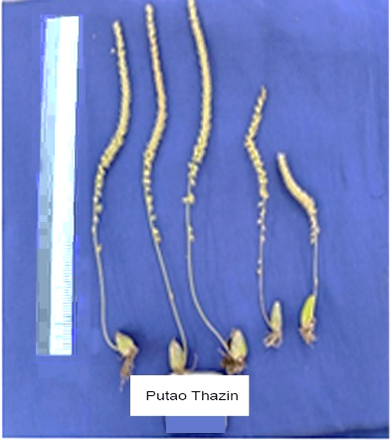 | 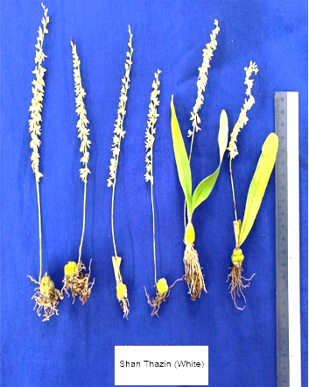 | 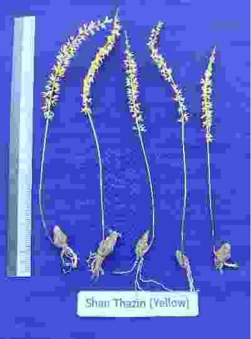
(d) | (e) | (f)
Figure 5. Comparison of flower stalk of (a) Kayin, (b) Dawei, (c) Rakhine, (d) Putao, (e) Shan
White and (f) Shan Yellow.
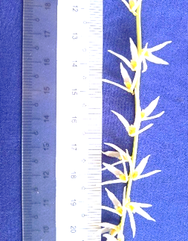 | 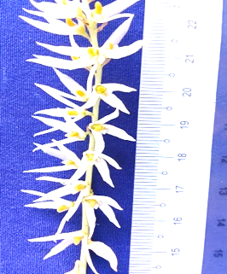 | 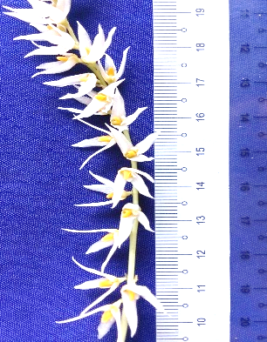
(a) | (b) | (c)
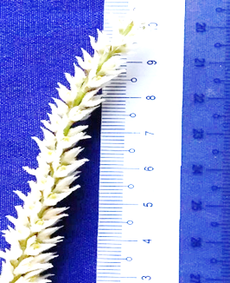 | 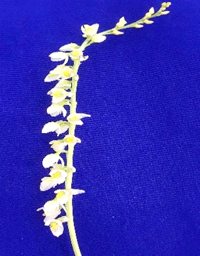 | 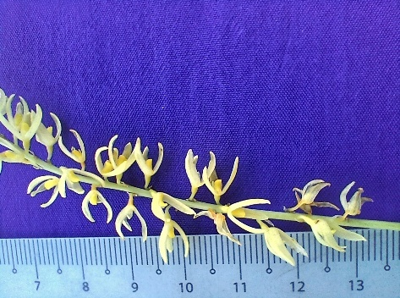
(d) | (e) | (f)
Figure 6. Comparison of florets and flower position of (a) Kayin, (b) Dawei, (c) Rakhine, (d) Putao, (e) Shan White and (f) Shan Yellow.
3.3 SSR Analysis
Simple sequence repeat (SSR) analysis was performed to assess the genetic diversity underlying the observed phenotypic variation among B. auricomum accessions. Of the 10 SSR markers developed for Cymbidium spp., two successfully cross-amplified in B. auricomum. Marker KNU-CC-40 produced monomorphic bands across all accessions (Figure 7), whereas KNU-CC-71 revealed a polymorphic banding pattern. Gel electrophoresis results (Figure 8) showed no amplification products for two Kayin accessions (KY-1 and KY-2) and one Shan White accession (SW-1). Notably, Kayin accession KY-3 exhibited a simpler banding pattern similar to Dawei accession DW-1, which differed from DW-2 and DW-3. Rakhine accession RK-3 displayed a unique band compared to RK-1 and RK-2, while the three Putao accessions shared identical patterns. Surprisingly, Shan White accession SW-3 clustered closely with Shan Yellow accessions (SY-1, SY-2, and SY-3), whereas SW-2 differed from SW-3. These findings indicate that accessions from the same geographic origin, despite phenotypic similarities, possess distinct genetic constitutions. Liu et al., (2014) identified species-specific simple sequence repeat (SSR) markers. Concurrently, Basavaraj et al. (2020) demonstrated that SSR marker analysis effectively distinguished species based on variations in flower color morphology. Than et al., (2011) reported monomorphic fingerprinting patterns across all amplified DNA fragments, indicating genetic homogeneity among regenerated culture clones of B. auricomum and their genomic uniformity with the respective parent plants. To validate current results, higher-resolution methods such as polyacrylamide gel electrophoresis or DNA sequencing are recommended.
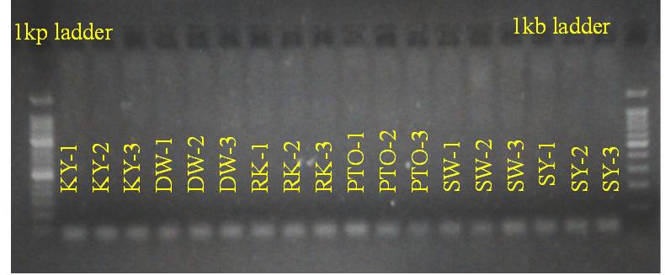
Figure 7. Gel photo of 18 B. auricomum accessions; KY, Kayin; DW, Dawei; RK, Rakhine; PTO, Putao; SW, Shan White and SY, Shan Yellow amplified by KNU-CC-40 at 55 Tm.
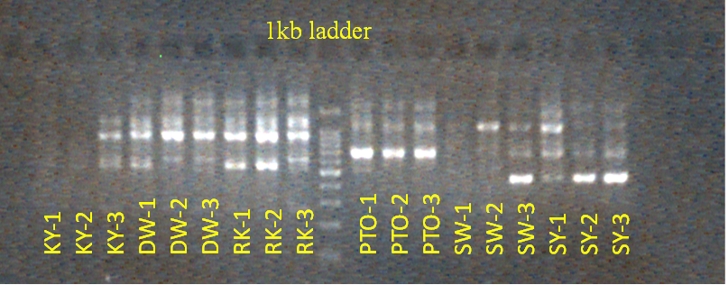
Figure 8. Gel photo of 18 B. auricomum accessions; KY, Kayin; DW, Dawei; RK, Rakhine; PTO, Putao; SW, Shan White and SY, Shan Yellow amplified by KNU-CC-71 at 57 Tm

4. Conclusion
The phylogenetic and molecular analysis of Bulbophyllum auricomum accessions from Myanmar reveal a structured genetic landscape shaped by regional ecology, anthropogenic selection, and limited gene flow, with three distinct UPGMA clusters reflecting both phenotypic uniformity in core traits and divergence in floral and vegetative dimensions. Cluster I, encompassing high market value cultivars from Htawei (Dawei), Rakhine, Kayin, and less market demand cultivar Putao, demonstrates low differentiation (minimum distance 0.05) and robust means for leaf length (9.04 cm), pseudobulb length (24.38 mm), and flower count (31.00), underscoring adaptation for commercial viability through fragrance and resilience. In contrast, Clusters II (Shan Yellow) and III (Shan White) exhibit narrower genetic bases, extended branch lengths, and unique traits like wide pseudobulbs (33.60 mm) and extended root length (3.00 cm), indicative of clonal propagation and color-specific selection. Qualitative trait frequencies confirm monomorphic diagnostics (e.g., 100% linear leaves, fragrant flowers), while polymorphisms in sepal shape and color enable cultivar distinction. SSR analysis with cross-amplifying markers (KNU-CC-40 monomorphic; KNU-CC-71 polymorphic) corroborates phenotypic clusters, revealing accession-specific band patterns (e.g., unique Rakhine RK-3 band, shared Putao profiles) despite geographic proximity, and unexpected overlaps like Shan White SW-3 with Shan Yellow. Integrating SSRs with SNPs, ecological modeling, and germplasm registries will refine management amid habitat threats, ensuring sustainable utilization of this royal orchid's intraspecific diversity.

References

Arditti, J. (1992). Fundamentals of orchid biology. McQuerry Orchid Books.
Aung, M. M., Oo, M. M., & Myint, M. T. (2022). Morphological characterization and flowering behavior of Bulbophyllum auricomum in different ecological zones of Myanmar. Myanmar Journal of Agricultural Sciences, 30(2), 45–58.
Aung, W. T., Bang, K. S., Yoon, S. A., Ko, B., & Bae, J. H. (2022). Effects of different natural extracts and plant growth regulators on plant regeneration and callus induction from pseudobulb explants through in vitro seed germination of endangered orchid Bulbophyllum auricomum Lindl. Journal of Bio Environment Control, 31(2), 133–141.
Basavaraj, B., Nagesha, N., & Jadeyegowda, M. (2020). Molecular characterization of Dendrobium orchid species from the Western Ghat region of Karnataka using RAPD and SSR markers. International Journal of Current Microbiology and Applied Sciences, 9(1), 2157–2169. https://doi.org/10.20546/ijcmas.2020.901.246
Bazzicalupo, M., Calevo, J., Smeriglio, A., & Cornara, L. (2023). Traditional and therapeutic uses and phytochemistry of terrestrial European orchids and implications for conservation. Plants, 12(2), 257. https://doi.org/10.3390/plants12020257
Chung, M. Y., López-Pujol, J., Myeong, Y. H., & Chung, M. G. (2014). Genetic diversity and structure of the endangered orchid Cephalanthera falcata in South Korea: Implications for conservation. Biochemical Systematics and Ecology, 56, 122–130. https://doi.org/10.1016/j.bse.2014.05.007
Hinsley, A., de Boer, H. J., Fay, M. F., Gale, S. W., Gardiner, L. M., Gunasekara, R. S., … Phelps, J. (2018). A review of the trade in orchids and its implications for conservation. Botanical Journal of the Linnean Society, 186(4), 435–455. blog.oup.com+2botanicrealm.com+2reddit.com+2
Hsu, T. C., Kuo, H. C., & Chou, C. H. (2010). Genetic variation in cultivated and wild populations of Dendrobium tosaense revealed by ISSR markers. Scientia Horticulturae, 125(4), 525–530. https://doi.org/10.1016/j.scienta.2010.05.007
Liu, Y. T., Chen, R. K., Lin, S. J., Chen, Y. C., Chin, S. W., Chen, F. C., & Lee, C. Y. (2014). Analysis of sequence diversity through internal transcribed spacers and simple sequence repeats to identify Dendrobium species. Genetics and Molecular Research, 13(2), 2709–2717. https://doi.org/10.4238/2014.April.8.10
Martin, K. P., & Madassery, J. (2006). Rapid in vitro propagation of Dendrobium hybrids through direct shoot formation from foliar explants, and protocorm-like bodies. Scientia Horticulturae, 108(1), 95–99. https://doi.org/10.1016/j.scienta.2006.01.034
Mondini, L., Noorani, A., & Pagnotta, M. A. (2009). Assessing plant genetic diversity by molecular tools. Diversity, 1(1), 19–35. https://doi.org/10.3390/d1010019
Phelps, J., & Webb, E. L. (2015). “Invisible” wildlife trades: Southeast Asia’s undocumented illegal trade in wild ornamental plants. Biological Conservation, 186, 296–305. https://doi.org/10.1016/j.biocon.2015.03.031
Sarasan, V., Cripps, R., Ramsay, M. M., Atherton, C., McMichen, M., Prendergast, G., & Rowntree, J. K. (2006). Conservation of rare and endangered plants using in vitro methods. In Vitro Cellular & Developmental Biology - Plant, 42(3), 206–214. https://doi.org/10.1079/IVP2006769
Sharma, A., & Pathak, P. (2020). The budding potential of orchids in the cosmeceutical sector: Role of orchids in skincare and health. Journal of the Orchid Society of India, 34, 79–85.
Singh, B. P., Virmani, N., Bhargava, O. N., Kishore, N., & Gill, A. (2014). Yuehsienszella (Cambrian Series 2) trilobite from the Parahio Valley, Spiti region (Zanskar–Spiti Sub-Basin), India and its biostratigraphic significance. Journal of the Palaeontological Society of India, 59(1), 81–88.
Swarts, N. D., & Dixon, K. W. (2009). Terrestrial orchid conservation in the age of extinction. Annals of Botany, 104(3), 543–556. https://doi.org/10.1093/aob/mcp025
Teixeira da Silva, J. A., Kerbauy, G. B., Zeng, S., & Chen, Z. L. (2015). Orchid biotechnology: From conservation to transgenic varieties. Biotechnology Advances, 33(6), 1190–1206. https://doi.org/10.1016/j.biotechadv.2015.02.011
Than, M. M. M., Majumder, A., Pal, A., & Jha, S. (2011). Genomic variations among in vitro regenerated Bulbophyllum auricomum Lindl. plants. Nucleus, 54(1), 9–17. https://doi.org/10.1007/s13237-011-0025-1
Willis, K. J. (Ed.). (2017). State of the world’s plants report. Royal Botanic Gardens, Kew.
Zha, X., Luo, J., Wang, J., Wei, Z., & Jiang, S. (2009). Genetic characterization of nine medicinal Dendrobium species using RAPD. African Journal of Biotechnology, 8(10), 2161–2165.
Zhang, J., Wang, Y., Yang, S., & Wang, X. (2020). Genetic diversity and population structure of Bulbophyllum odoratissimum in Yunnan revealed by SSR markers. Plant Systematics and Evolution, 306(5), 1–11. https://doi.org/10.1007/s00606-020-01636-6
Zhang, Y., Zhou, T., Xu, Z., Wang, X., & Wang, J. (2013). Genetic diversity and population structure of an endangered orchid, Paphiopedilum armeniacum, based on AFLP and ISSR markers. Biochemical Systematics and Ecology, 51, 6–13. https://doi.org/10.1016/j.bse.2013.07.007

