Original Research Article
Effect of Seedling transplanting method on fiber yield and yield attributes of BJRI Tossa Jute(Corchorus olitorius) as influence by plant spacing

Abstract
An experiment was conducted at the Jute Research Regional Station, Kishoreganj, Bangladesh, during 2020 to evaluate the effects of seedling transplanting and plant spacing on fiber yield, yield attributes, and economic performance of BJRI tossa jute (Corchorus olitorius L.) variety O-9897. The study was laid out in a randomized complete block design with three replications. Treatments comprised seedling transplanting with weeding and without weeding combined with six spacing arrangements (20 cm × 7.5 cm, 20 cm × 10 cm, 25 cm × 7.5 cm, 25 cm × 10 cm, 30 cm × 7.5 cm, and 30 cm × 10 cm). A direct-seeded crop with recommended fertilizer and weeding served as the control.
Results showed that plant population, plant height, fiber yield, and stick yield were significantly affected by transplanting and spacing, while base diameter and bark thickness remained unaffected. The highest fiber yield (3.27 t ha⁻¹) was obtained from seedling transplanting without weeding at 20 cm × 7.5 cm spacing, representing a 45% increase over the control. This treatment also recorded the highest benefit–cost ratio (3.13) and a substantial reduction in production cost compared with the conventional method. Multivariate analyses revealed that fiber yield was positively associated with plant population and stem robustness rather than plant height alone.
The study concludes that seedling transplanting without weeding under closer spacing is an agronomically efficient and economically viable technique for improving tossa jute productivity under Bangladesh conditions.
Keywords: Seedling transplanting; Tossa jute; Plant spacing; Fiber yield; Cost–benefit analysis; Weed management.

Introduction
Bangladesh is the 2nd highest jute producing country in the world. Jute is the most important fiber crop as well as cash crop of the country. Jute can be grown in both on high and low land condition. It is a crop of warm and humid climate which grown in rain fed situation during summer to early rainy season (mid March to end of July). The cultivable land is diminishing in Bangladesh in absolute terms as well because of housing and infrastructure development. Normally jute and allied fiber crops are produced by direct seed sowing method in Bangladesh. Basically, there are two methods of rice plant establishment namely; transplanting and direct seed sowing (Abeysiriwardena et al.,2005). Transplanting is the practice of raising seedlings in a nursery and planting them into a separate field. The crop is grown without disturbance thereafter. Direct sowing is the main crop establishment practice in all the upland sub-ecosystems. It could also be used in wet soils. The seeds are sown either by broadcast or in lines in the furrows (Singh and Singh,2000). Broadcasting is the only method of jute and allied fiber crops production by the jute growers of Bangladesh. Transplanting rice is capable of yielding 30% more than broadcast rice (Patel and Charugamba,1981). As compared to broadcasted rice, transplanted rice competes better with weeds (Uphoff, 2003). Direct dry seeding of rice reduced yield by 23-41% on flat land and by 41-54% on raised beds compared with transplanted rice (Singh et al., 2002). Major problems of direct seeded rice attributed to its low yield are poor crop establishment, dominance of weeds, pests and lodging (Mitchell,2004). Jute competes for land with food crops such as paddy in Bangladesh as well as other producing countries because of increasing demand for food grains with increase of population. Therefore, pressure on cultivable land from food crop is going to be one of the biggest limiting factors for future expansion of jute and allied fiber crops cultivation. Transplanting of rice was found to be biologically and economically advantageous over dry seed sowing (Tadessse et al.,2013). Recently, government has taken steps to open some of the closed public sector jute mills and private sector has established some new jute mills because of which domestic consumption of JAFs has increased. Government of Bangladesh passed an act for mandatory use of jute goods in packaging due to ensure higher domestic consumption of jute and jute goods. Demand of jute is increasing as these are widely considered an eco-friendly product. As, availability of cultivable land is going to remain a limiting factor, hence per unit area fiber yield will be increased through appropriate technology.
Jute (Corchorus olitorius L.), commonly known as tossa jute, is one of the most important natural fiber crops of Bangladesh and plays a vital role in the national economy through employment generation, export earnings and environmental sustainability. Bangladesh is the world’s leading producer and exporter of high-quality jute fiber, contributing significantly to rural livelihoods and agro-based industries (BJRI, 2020; BBS, 2020). With increasing global demand for eco-friendly and biodegradable fibers, enhancing jute productivity in a cost-effective manner has become a priority for sustainable agricultural development.
Despite the availability of improved jute varieties such as BJRI Tossa Jute O-9897, fiber yield at the farmer level remains below potential due to suboptimal crop establishment, improper plant spacing, and high production costs, particularly labor-intensive operations such as weeding (Islam et al., 2017; Rahman et al., 2019). Traditional direct seeding methods often result in uneven plant stands, excessive intra-plant competition, and inefficient utilization of growth resources, which ultimately reduce yield and profitability (Hossain et al., 2018).
Seedling transplanting has emerged as a promising alternative to direct seeding in jute cultivation. Transplanting ensures uniform plant population, better early crop establishment and faster canopy closure, which can suppress weed growth and improve nutrient and moisture use efficiency (Khan et al., 2015; Islam et al., 2020). Previous studies in Bangladesh have reported that transplanted jute crops can produce comparable or higher fiber yield than seed-sown crops while offering opportunities to reduce seed rate and labor costs (Hossain & Rahman, 2016).
Plant spacing is another crucial agronomic factor influencing jute growth, yield attributes and fiber yield. Optimum spacing ensures balanced plant density, minimizes competition for light, nutrients and water, and promotes better stem development and fiber formation (Gardner et al., 1985). Research findings indicate that closer spacing increases plant population and total fiber yield up to an optimum level, whereas wider spacing may reduce yield due to lower plant density despite better individual plant growth (Islam et al., 2017; BJRI, 2020). However, the interaction between seedling transplanting and spacing under Bangladesh agro-ecological conditions is not yet well documented, particularly for newly released BJRI varieties.
In addition, rising labor wages and scarcity of farm labor during peak agricultural seasons have increased the cost of jute production, making it imperative to develop production techniques that reduce labor dependency without compromising yield (Rahman et al., 2019; BBS, 2021). Transplanting combined with appropriate spacing may allow jute crops to grow without intensive weeding, thereby lowering production costs and improving economic returns.
Therefore, the present study was undertaken to evaluate the effect of seedling transplanting under different spacing arrangements on fiber yield and yield attributes of BJRI Tossa jute (O-9897). The study aims to identify an economically viable and agronomically efficient production technique that can enhance jute productivity while reducing input costs under Bangladesh conditions.

Materials and Methods
Experimental site and season
The field experiment was conducted during the 2020 jute-growing season at the Jute Research Regional Station, Kishoreganj, Bangladesh. The experimental area is characterized by a subtropical monsoon climate with warm and humid conditions, suitable for rainfed jute cultivation. The soil of the experimental field was a typical alluvial soil with medium fertility, commonly used for jute production in the region.
Experimental design and treatments
The experiment was laid out in a randomized complete block design (RCBD) with three replications. Each experimental plot measured 3 m × 3 m. A spacing of 1.0 m was maintained between plots and blocks, and drainage channels approximately 20 cm deep were constructed around the experimental area to prevent water stagnation.
The treatments consisted of two seedling transplanting methods combined with six plant spacing arrangements, along with a direct-seeded control. The transplanting methods were: (i) transplanting with weeding (T1) and (ii) transplanting without weeding (T2). The spacing treatments were: 20 cm × 7.5 cm (S1), 20 cm × 10 cm (S2), 25 cm × 7.5 cm (S3), 25 cm × 10 cm (S4), 30 cm × 7.5 cm (S5), and 30 cm × 10 cm (S6). The control treatment consisted of direct line sowing with recommended fertilizer application and weeding.
Crop establishment and management
BJRI tossa jute (Corchorus olitorius L.) variety O-9897 was used as the test crop. Seedlings were raised in a nursery and transplanted into the main field on 2 April 2020. Direct seeding for the control treatment was carried out on the same date. Proper thinning was conducted for the control to maintain the desired plant population.
Recommended doses of triple super phosphate (TSP), muriate of potash (MoP), gypsum, and zinc sulphate were applied uniformly to all plots during final land preparation. Urea was applied as a top-dressing in three equal splits at 5, 25, and 45 days after transplanting or germination at rates of 12, 14, and 10 g m⁻², respectively, in all transplanting treatments. In the control plots, urea was applied following the recommended practice along with manual weeding.
Except for the control and T1 treatments, no manual weeding was performed in T2 plots throughout the growing period.
Harvesting and data collection
The jute crop was harvested on 9 August 2020 at physiological maturity. Data on plant population (plants m⁻²), plant height (m), base diameter (mm), bark thickness (mm), fiber yield (t ha⁻¹), and stick yield (t ha⁻¹) were recorded following standard procedures. Fiber and stick yields were converted to a hectare basis.
Statistical analysis
The collected data were subjected to analysis of variance (ANOVA) using the. Treatment means were compared using the least significant difference (LSD) test at the 5% probability level. The coefficient of variation (CV) was calculated to assess experimental precision. Pearson’s correlation analysis and principal component analysis (PCA) were performed to evaluate relationships among growth and yield traits and to visualize treatment performance. Statistical analyses were conducted using standard statistical software.
Economic analyses should be included since the objective is to identify economically viable technique that can enhance jute productivity
Way economic analyses( the procedure should presented here)

Results and Discussion
Table results show that treatments differed significantly for PP (m²), PH (m), FY (t/ha) and SY (t/ha) while BD (mm) and BT (mm) were not significantly affected (all values carry the same letter “a”).Results showed that S₁T₂ treatment significantly highest fiber yield (3.27 t/ha). Bark thickness was highest in the S₁T₂ treatment, where BD was highest in the S₁T₂ treatment.
Table-1: Yield and yield attributes of seedling transplanting as influenced by
spacing of tossa jute (O-9897)

SL | Treatment | PP (m²) | PH (m) | BD (mm) | BT (mm) | FY(t/h) | SY (t/h)
1 | S₁T₁ | 44.00 a | 2.82 ab | 14.66 a | 2.38 a | 3.17 a | 5.70 ab
2 | S₂T₁ | 37.33 ab | 2.97 ab | 13.39 a | 2.51 a | 2.38 c | 4.71 ab
3 | S₃T₁ | 43.33 a | 3.04 a | 14.65 a | 2.91 a | 2.38 c | 5.23 ab
4 | S₄T₁ | 36.00 ab | 2.77 ab | 13.84 a | 2.28 a | 2.39 c | 4.59 b
5 | S₅T₁ | 34.33 ab | 2.55 b | 12.94 a | 2.56 a | 2.29 c | 4.90 ab
6 | S₆T₁ | 30.33 b | 2.77 ab | 13.81 a | 2.55 a | 2.32 c | 4.59 b
7 | S₁T₂ | 38.67 ab | 2.94 b | 14.99 a | 2.98 a | 3.27 a | 6.58 ab
8 | S₂T₂ | 39.33 ab | 2.92 ab | 14.75 a | 2.91 a | 2.82 b | 5.77 a
9 | S₃T₂ | 36.33 ab | 2.76 ab | 13.27 a | 2.73 a | 2.40 c | 5.06 ab
10 | S₄T₂ | 37.33 ab | 3.06 a | 14.98 a | 2.59 a | 2.39 c | 4.93 ab
11 | S₅T₂ | 39.67 ab | 2.83 ab | 13.07 a | 2.28 a | 2.40 c | 5.31 ab
12 | S₆T₂ | 36.67 ab | 3.15 a | 14.15 a | 2.52 a | 2.41 c | 5.01 ab
13 | T₃ (Control) | 31.34 b | 2.54 b | 13.16 a | 2.35 a | 2.25 c | 4.69 ab
 | LSD(5%) |  |  |  | NS
 | %CV | 17.82 | 8.99 | 11.97 | 18.18 | 5.32 | 13.86

Legend: T = Methods of planting, T₁ = Transplanting and weeding, T₂ = Transplanting and no weeding, T₃ (control)= line sowing and weeding. S = Line and plant spacing, S₁ = 20cm × 7.5cm, S₂ = 20cm × 10cm, S₃= 25cm × 7.5cm, S₄ = 25cm × 10cm, S₅ = 30cm × 7.5cm and S₆ = 30cm × 10cm, PP = Plant Population, PH = Plant hight, BD = Base diameter, BT= Bark thickness, FY = Fiber yield, SY = stick yield.
The plant population and bark thickness differences were found insignificant among the treatment combinations. Fiber yield was increased 45% over the control. Fiber yield production significant variation found in S₁T_{1,} S₁T₂ and S₂T₂ treatments compare among other treatments. Stick yield significant variation found in S₂T₂, S₄T₁ and S₆T₁ treatments compare among other treatments.Cost reduction was found 40950 Tk/ha in the treatment S₁T₂ than the control. The cost of production of the control plot was 108770 Tk/ha and S₁T₂ was 67820 Tk/ha. The highest BCR was found in the S₁T₂ treatment (3.13) and lowest in the S₅T₁ (1.30), where in the control was 1.35.
Effects of seedling transplanting and spacing on plant population
Plant population (PP) varied significantly among treatments (Table 1 & Figure 1), reflecting the combined influence of planting method and spacing. The highest plant population was recorded in S1T1 (44.00 m⁻²), which was statistically similar to S3T1 (43.33 m⁻²), while the lowest population was observed in S6T1 (30.33 m⁻²) and the control treatment (31.34 m⁻²). Most transplanting treatments exhibited intermediate plant population values, indicating relatively stable stand establishment across spacing combinations.
The higher plant population under closer spacing treatments resulted from controlled seedling placement during transplanting, which ensured uniform establishment and minimized early plant mortality. In contrast, the lower plant population in the control treatment may be attributed to uneven germination, seedling competition, and early losses commonly associated with direct seeding methods in jute cultivation. Similar findings have been reported by Islam et al. (2019) and Ali et al. (2015), who observed improved stand establishment under managed planting systems compared with direct seeding.
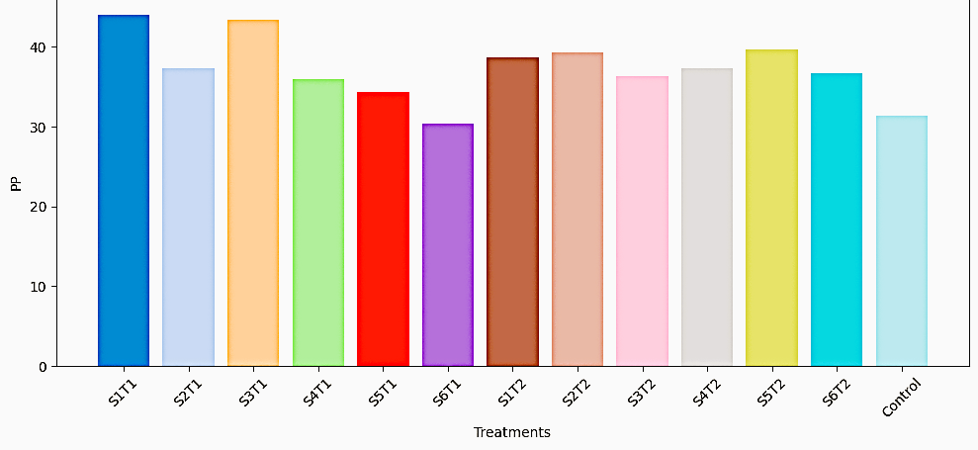
Figure 1: Effect of seedling transplanting and spacing on plant population of tossa jute

Effects on plant height

Plant height (PH) differed significantly among treatments (Table 1& Figure 2). The tallest plants were recorded in S6T2 (3.15 m), which was statistically similar to S4T2 (3.06 m) and S3T1 (3.04 m). The shortest plants were observed in the control (2.54 m) and S5T1 (2.55 m). These results indicate that wider spacing favored vertical growth due to reduced intra-plant competition for light.

However, increased plant height did not consistently translate into higher fiber yield. This suggests that plant height alone is not a reliable indicator of productivity in tossa jute, as excessive elongation under wider spacing may occur at the expense of stem robustness and fiber accumulation. Similar observations have been reported in jute and other fiber crops, where optimum plant density rather than maximum height was found to be more critical for yield improvement (Rahman et al., 2017; Sarkar et al., 2020).

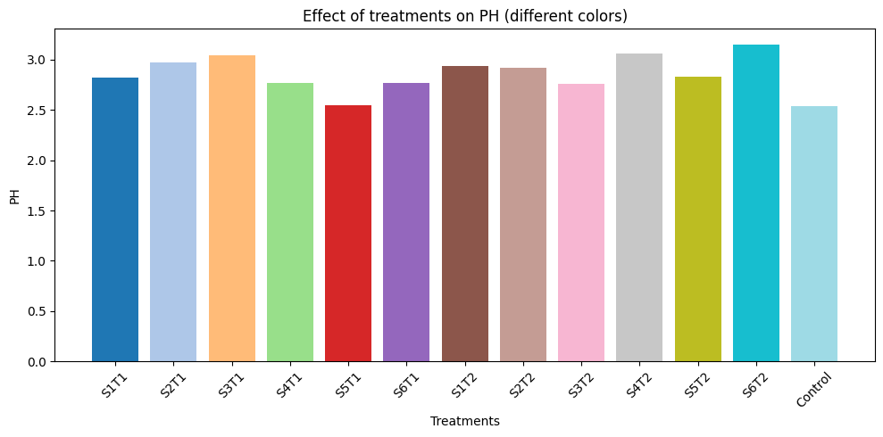

Figure 2: Effect of seedling transplanting and spacing on plant height of tossa jute

Effects on base diameter and bark thickness

Base diameter (BD) and bark thickness (BT) were not significantly affected by seedling transplanting, spacing, or weeding regimes (Table 1). Base diameter ranged from 12.94 to 14.99 mm (Figure 3) while bark thickness varied from 2.28 to 2.98 mm (Figure 4) across treatments.

The absence of significant variation in these traits suggests that stem thickness-related characteristics are less responsive to short-term agronomic management and are more strongly influenced by varietal genetic potential under uniform environmental conditions. Similar non-significant responses of stem diameter and bark thickness to management practices have been reported in jute and kenaf under comparable agro-climatic conditions (Hossain et al., 2016; Akter et al., 2021).

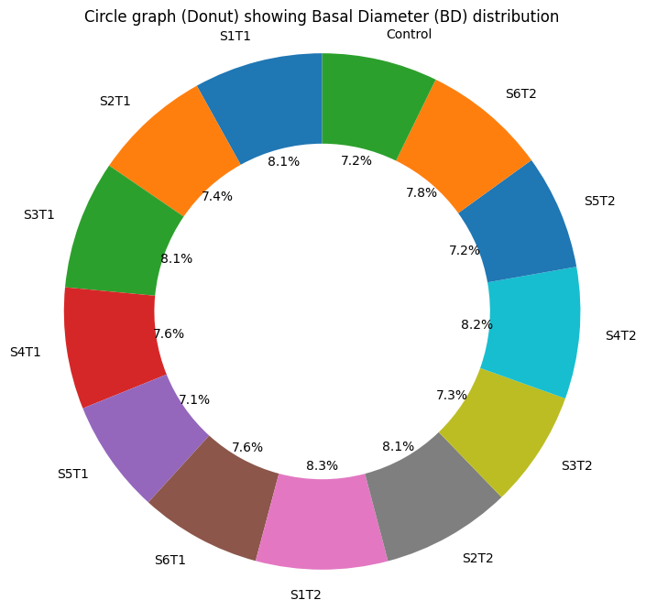

Figure 3: Effect of seedling transplanting and spacing on base diameter of tossa jute

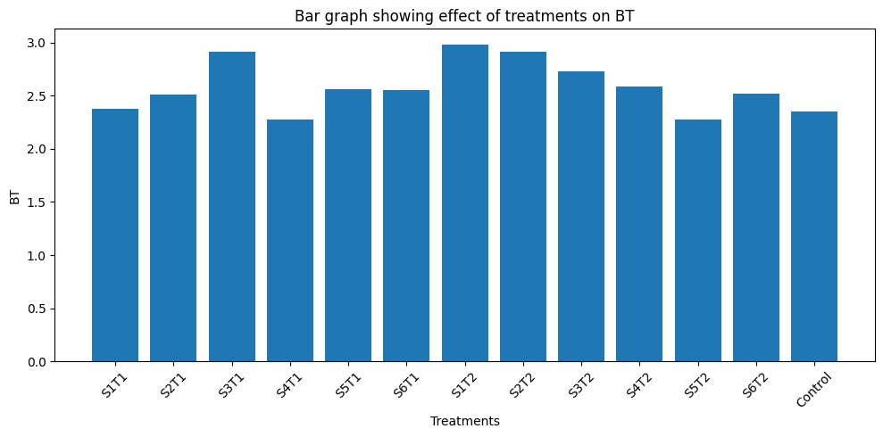

Figure 4: Effect of seedling transplanting and spacing on bark thickness of tossa jute

Effects on fiber yield

Fiber yield (FY) was significantly influenced by the interaction of transplanting method and spacing (Table 1; Figure 5). The highest fiber yield was obtained from S1T2 (3.27 t ha⁻¹), followed closely by S1T1 (3.17 t ha⁻¹), both of which were statistically superior to most other treatments and 45% higher than the control (2.25 t ha⁻¹). Among the intermediate group, S2T2 (2.82 t ha⁻¹) performed better than wider spacing combinations.

The superior fiber yield in S1T2 can be attributed to optimum plant density achieved through closer spacing combined with uniform seedling establishment via transplanting. Early canopy closure under this treatment likely enhanced light interception and suppressed weed growth, even in the absence of manual weeding. This allowed the crop to utilize soil nutrients and moisture more efficiently, resulting in higher fiber accumulation. The control treatment, which relied on direct seeding and required weeding, suffered from lower plant population and higher production costs, ultimately reducing yield efficiency. These findings are consistent with earlier studies reporting that transplanted jute crops under optimum spacing can outperform direct-seeded crops by ensuring better crop dominance and resource use efficiency (Islam et al., 2017; Khan et al., 2015).

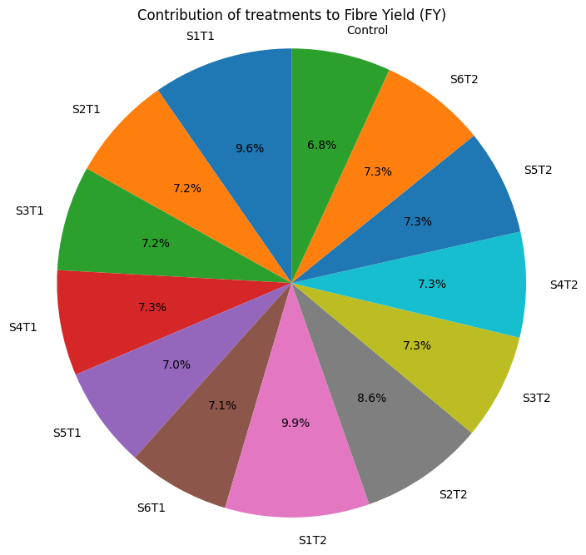
Figure 5: Effect of seedling transplanting and spacing on fiber yield of tossa jute

Effects on stick yield

Stick yield (SY) also showed significant variation among treatments (Table 1; Figure 6). The highest statistically significant stick yield was recorded in S2T2 (5.77 t ha⁻¹), while several treatments, including S1T2 (6.58 t ha⁻¹), recorded higher numerical values but were statistically comparable due to grouping within the same significance class.

The relatively higher stick yield under transplanting without weeding suggests enhanced biomass accumulation resulting from reduced competition and improved plant vigor. However, statistical similarity among many treatments indicates that stick yield was less sensitive to spacing variation compared with fiber yield. Similar trends have been reported by Islam et al. (2018) and Rahman and Ali (2020), who found that management practices often affect fiber yield more strongly than stick biomass.

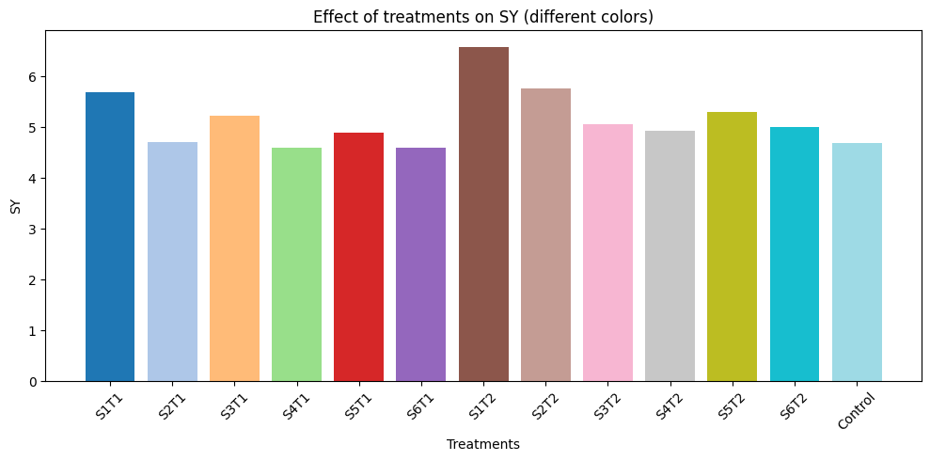

Figure 6: Effect of seedling transplanting and spacing on stick yield of tossa jute
Multivariate analysis: PCA and correlation analysis
The principal component analysis (PCA) biplot (Figure 7) revealed clear differentiation among treatments based on growth and yield attributes. Fiber yield (FY) and stick yield (SY) vectors were closely aligned, indicating a strong positive relationship between these traits. Plant population (PP), base diameter (BD), and bark thickness (BT) also clustered in a similar direction, suggesting coordinated trait expression related to yield performance.

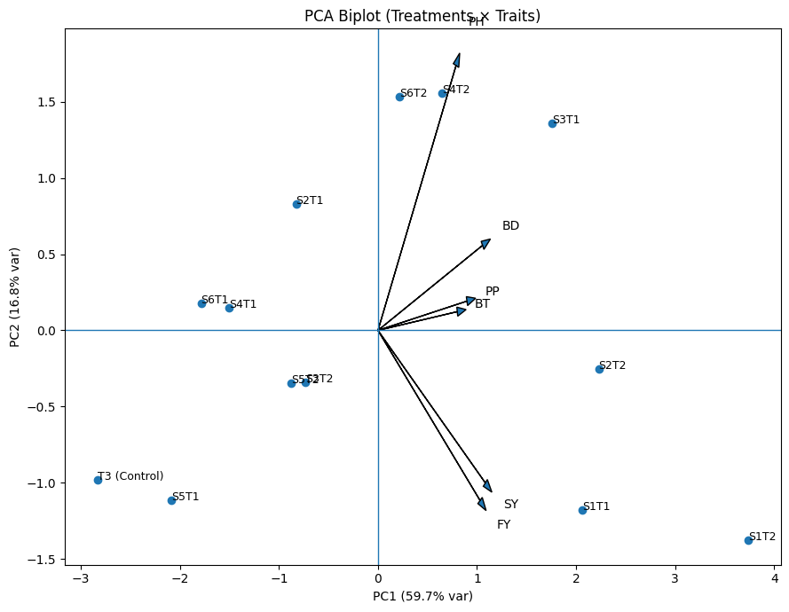
Figure 7: Coefficient of variation (%) of growth and yield traits of tossa jute under different treatments
Treatment S1T2 was positioned strongly on the positive side of the first principal component (PC1), indicating its strong association with yield-contributing traits. In contrast, the control treatment was located on the negative side of PC1, reflecting inferior overall performance. These results confirm that closer spacing combined with transplanting promotes favorable trait combinations for yield enhancement.
Correlation analysis (Figure 8) further supported these findings. Plant population showed moderate positive correlations with fiber yield (r = 0.56) and stick yield (r = 0.59), highlighting the importance of stand density in yield formation. Base diameter exhibited a strong positive correlation with fiber yield (r = 0.64), emphasizing the role of stem robustness in fiber development. The strongest correlation was observed between fiber yield and stick yield (r = 0.90), indicating simultaneous improvement of both traits. Overall, yield improvement in tossa jute was more closely associated with plant population and stem characteristics than with plant height alone.
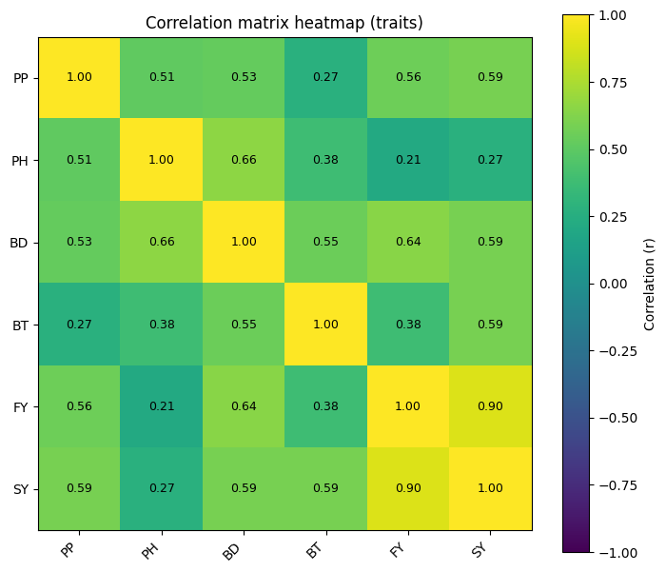
Figure 8: Correlation matrix heat map showing relationships among growth and yield traits of tossa jute
Economic performance of transplanting and spacing treatments
Table-2: Cost and return analysis of tossa (O-9897) jute production of seedling transplanting as influenced by spacing.

SL | Treatments | TVC (tk/ha) | Gross Return (tk/ha) | Gross Marginal (tk/ha) | Benefit Cost Ratio (BCR)
1 | S₁T₁ | 119570 | 202850 | 83280 | 1.69
2 | S₂T₁ | 115970 | 154450 | 38480 | 1.33
3 | S₃T₁ | 116870 | 157050 | 40180 | 1.34
4 | S₄T₁ | 113720 | 154400 | 40680 | 1.35
5 | S₅T₁ | 115070 | 150450 | 35380 | 1.30
6 | S₆T₁ | 112370 | 150550 | 38180 | 1.33
7 | S₁T₂ | 67820 | 212750 | 144930 | 3.13
8 | S₂T₂ | 64220 | 183950 | 119730 | 2.86
9 | S₃T₂ | 65120 | 157300 | 92180 | 2.41
10 | S₄T₂ | 61970 | 156100 | 94130 | 2.51
11 | S₅T₂ | 63320 | 158550 | 95230 | 2.50
12 | S₆T₂ | 60620 | 157600 | 96980 | 2.59
13 | Control | 108770 | 147200 | 38430 | 1.35

Legend: Urea = 16 Tk/kg, TSP = 22 Tk/kg, Mop = 16 Tk/kg, Zypsum = 12 Tk/kg, Zinc Sulphete = 130 Tk/kg, Fiber = 55 Tk/kg, Stick = 5 Tk/kg, TVC = Total variable cost, BCR = Benefit cost ratio, Labor wage rate = 450 Tk/day, Seed = 190 Tk/kg.
The economic analysis (Table 2) demonstrated substantial differences in profitability among treatments. Total variable cost (TVC) was markedly lower in transplanting without weeding (T2) treatments (Tk 60,620–67,820 ha⁻¹) compared with transplanting with weeding (T1) and the control, primarily due to the elimination of labor-intensive weeding operations.
The highest gross return (Tk 212,750 ha⁻¹), gross margin (Tk 144,930 ha⁻¹), and benefit–cost ratio (3.13) were recorded in S1T2, indicating clear economic superiority over all other treatments. In contrast, the control treatment recorded a BCR of only 1.35, despite higher production costs. These results highlight that yield improvement combined with cost reduction, rather than yield alone, determined overall profitability.
Given the increasing scarcity of agricultural labor and rising wage rates in Bangladesh, the transplanting without weeding approach offers a practical and economically attractive option for farmers. Similar conclusions have been reported by Rahman et al. (2019) and Hossain et al. (2018), who emphasized the importance of labor-saving technologies for sustainable jute production.
Conclusion
The present study demonstrated that seedling transplanting and plant spacing significantly influence fiber yield, yield attributes, and economic returns of BJRI tossa jute (O-9897). Among the evaluated treatments, transplanting without weeding at closer spacing (20 cm × 7.5 cm) consistently produced superior fiber yield, improved yield-related traits, and the highest economic returns. The enhanced performance of this treatment was mainly attributed to optimum plant population, uniform crop establishment, early canopy closure, and efficient utilization of growth resources, which collectively reduced weed competition without the need for manual weeding.
Yield improvement in tossa jute was found to be more strongly associated with plant population and stem robustness than with plant height alone, as confirmed by correlation and principal component analyses. Economic analysis further revealed that eliminating manual weeding substantially reduced production costs, resulting in a markedly higher benefit–cost ratio compared with the conventional direct-seeded method.
Overall, seedling transplanting without weeding at 20 cm × 7.5 cm spacing emerges as a profitable, labor-saving, and sustainable production strategy for tossa jute cultivation. Adoption of this technique can enhance fiber productivity, reduce production costs, and alleviate labor constraints, thereby contributing to improved farm income and sustainable jute production in Bangladesh.
Reference
Abdi, H., & Williams, L. J. 2010. Principal component analysis. Wiley Interdisciplinary Reviews: Computational Statistics, 2(4), 433–459.
Abeysiriwardena D.S., S.N. Jayanwardena, K.D.S. Kiriwaththuuduwage and S.W. Abeysekara 2005. Potential of broadcasting for making savings in seed, water and labour in irrigated rice production systems in Sri lanka. In: NATIONAL RICE PROGRAMMES, 2005. International Rice Research Institute. Pp 79-82.
Akter, S., Hossain, M. D., & Karim, M. R. 2021. Morphological responses of kenaf to different management practices. Journal of Natural Fibers, 18(6), 823–834.
Ali, M. S., Islam, M. M., & Rahman, M. A. 2015. Effect of agronomic management practices on growth and yield of jute. Bangladesh Journal of Agricultural Research, 40(2), 189–202.
BBS (Bangladesh Bureau of Statistics). 2020. Yearbook of Agricultural Statistics of Bangladesh. Ministry of Planning, Government of the People’s Republic of Bangladesh, Dhaka.
BJRI (Bangladesh Jute Research Institute). 2020. Improved jute and allied fiber production technologies. BJRI, Dhaka, Bangladesh.
CIMMYT. 1988. From agronomic data to farmer recommendations: An economics training manual. CIMMYT, Mexico.
FAO. 2011. Farm management extension guide: Economic analysis for farm decision-making. Food and Agriculture Organization of the United Nations, Rome.
Gabriel, K. R. 1971. The biplot graphic display of matrices with application to principal component analysis. Biometrika, 58(3), 453–467.
Gardner, F.P., Pearce, R.B. & Mitchell, R.L. 1985. Physiology of crop plants. Iowa State University Press, Ames, USA.
Gomez, K. A., & Gomez, A. A. (1984). Statistical procedures for agricultural research (2nd ed.). John Wiley & Sons.
Hossain, M. A., Rahman, M. M., & Islam, M. S. 2016. Growth characteristics of jute as influenced by cultural practices. International Journal of Agronomy, 2016, 1–7.
Hossain, M.A. & Rahman, M.M. 2016. Performance of transplanted jute under different management practices. Bangladesh Journal of Agricultural Research, 41(3): 463–475.
Hossain, M.A., Rahman, M.M. & Karim, M.A. 2018. Effect of weed management practices on growth and yield of jute. Bangladesh Journal of Agricultural Research, 43(2): 245–256.
Hossain, M.M., Islam, M.S. & Karim, M.A. 2018. Effect of crop establishment methods on growth and yield of jute. Journal of Bangladesh Agricultural University, 16(2): 230–236.
Hossain, M.M., Islam, M.S. & Khan, M.A.H. 2020. Influence of spacing on yield and profitability of tossa jute. Journal of Fiber Crops, 15(1): 32–39.
Islam, M. M., Rahman, M. A., & Ali, M. S. 2018. Yield performance of jute under different management systems. Field Crops Research, 215, 1–8.
Islam, M. S., Sarkar, S. K., & Rahman, M. M. 2019. Plant population effects on growth and fiber yield of jute. Journal of Plant Sciences, 7(4), 102–109.
Islam, M.S., Hossain, M.A. & Khan, M.A.H. 2017. Optimization of plant spacing for yield improvement of tossa jute. Bangladesh Journal of Agricultural Research, 42(4): 615–626.
Islam, M.S., Rahman, M.M. & Uddin, M.J. 2016. Labor use and cost structure of jute cultivation in Bangladesh. Asian Journal of Agricultural Economics, 8(2): 45–53.
Islam, M.S., Rahman, M.M. & Uddin, M.J. 2020. Seedling transplanting as an alternative establishment method for jute cultivation. Asian Journal of Crop Science, 12(1): 15–22.
Jolliffe, I. T., & Cadima, J. 2016. Principal component analysis: a review and recent developments. Philosophical Transactions of the Royal Society A, 374(2065), 20150202.
Khan, M.A.H., Alam, M.J. & Rahman, M.M. 2015. Yield performance of tossa jute under different plant densities. International Journal of Agronomy and Agricultural Research, 6(3): 20–27.
Mitchell, J., Shu Fukai and Jayampathi Basnayake 2004. Grain yield of direct seeded and from planted rice in rainfed low lands of South East Asia. In: Procedings of the 4th International crop Science congress Brisbane, Australia, 26 Sep-1 Oct 2004. Pp 81-90.
Patel and Charugamba 1981. Potential for improving rice production in Tabo Region, Tanzania and its implications for village planning. Overseas Development of Natural Resources Institute, Arusha, Tanzinia.
Rahman, M. M., & Ali, M. S. 2020. Yield attributes and productivity of jute under improved agronomic practices. Journal of Crop Improvement, 34(3), 345–360.
Rahman, M. M., Ali, M. S., & Hossain, M. A. 2017. Influence of nutrient management on growth and yield of fiber crops. Agronomy Journal, 109(5), 2125–2133.
Rahman, M.M., Karim, S.M.R. & Hasan, M.K. 2019. Cost and profitability of jute production under different management practices in Bangladesh. Journal of Bangladesh Agricultural University, 17(1): 72–79.
Sarkar, S. K., Rahman, M. M., & Ali, M. S. 2020. Growth dynamics of jute in response to management practices. Journal of Agricultural Science, 12(6), 45–56.
Singh, A.K. B.U. Chowdhury & B.A.M. Bouman 2002. Effects of rice establishment methods on crop performance, water use, and mineral nitrogen. In: water-wise rice production, procesings of a the matic workshop on waterwise rice production, 8-11 April 2002 at IRRI headquarters in Los banos, Philipines. Pp 76-89.
Singh, V.P. and R.K.Singh, editors 2000. Rainfed Rice: A Sourcebook of best practices and Strategies in Eastern India. International Rice Research Institute.292p.
Tadessse, T., Liben, M., Asseta, A. & Tadesse, Z. 2013. Effect of Transplanting on rice in Northwestern Ethiopia. Eth. J. Sci & Technol., Vol.VI, no.1: 47-54.
Uphoff, N. (2003). Higher yields with fewer external inputs? The system of rice intensification and potential contributions to agricultural sustainability. International Journal of Agricultural sustainability 1 (1): 21-28.

