Optimisation of Drying Temperature and Time for Ackee (Blighia sapida) Aril Flour using Response Surface Methodology

ABSTRACT
The study was conducted to obtain an optimal combination of temperature and time of the drying of ackee aril using Response Surface Methodology (RSM). Ackee aril (Blighia sapida) fruit contains vitamins, minerals and bioactive components. However, it is underutilised due to seasonability, perishability and lack of adequate preservation techniques. Ackee aril was oven-dried at a temperature range (41.89-63.11 ºC) and time range (33.37-78.63 h), which were optimised using Central Composite Design under the Response Surface Method of Design Expert 12.0.1. Proximate and phytochemical (total phenol, flavonoid, total carotenoid, oxalate and phytate) were used as responses. Thirteen Experimental runs were produced by the RSM. The optimised drying condition for the ackee aril was 60 ºC for 72 h. The moisture, ash, fibre, fat, protein and carbohydrate contents of the dried Ackee aril sample at optimised drying condition were 11.995, 3.574, 7.271, 6.053, 29.254 and 41.852%, respectively. Total phenol, flavonoid, total carotenoid, oxalate and phytate were 189.71, 25.31, 0.0787 mg/100g, 8.857 and 0.102%, respectively. The study concluded that ackee aril flour of nutritional quality can be produced at an optimal condition of 60 ºC for 72 h.
Keywords: Ackee aril, Drying, Response Surface Methodology Phytochemical and Proximate

1 INTRODUCTION
Ackee apple (Blighia sapida) is a tree bearing ackee fruit, which is indigenous to West Africa. It is a tropical fruit known for its nutritional content and health benefits, but its shelf life is limited due to its perishable nature. Ackee is a medium-sized tree that belongs to the family Sapindaceae of angiosperms. The leaves are oval in shape, fifteen centimeters long, ending in a point; has a dark green colour and shiny at the upper base (Oloyede et al., 2023). The fruits are of a small pear size, pink to red in colour, oval in shape and marked by three protruding ribs five to six centimeters long, sometimes longer. The black seed is detestable taste. The fruits consist of the pod, pulp and aril covering the seeds and the arils only become edible when the mature fruit opens up spontaneously to reveal the seeds and the fleshy aril (Ojo et al., 2025).
Ackee apple is considered as natural gift because of its potential in using different parts of the tree as wood for furniture, fruits for food and medicines, seeds for oil, fuel and in soap making (Adeosun et al., 2024). It is an underutilised fruit valued for its rich functional potential and nutritional content, particularly in West Africa. Despite its benefits, the highly perishability of the fruit has limited its wider use in food processing and industrial applications (Ojo et al., 2025). Conversion of ackee arils into flour gives a potential approach to shelf-life extension and added value. Drying is a significant process in food processing and agricultural industry for preserving perishable food crops. It acts as a very good method of food and nutrient preservation, as well as a way of increasing value and ultimately profits (Olabinjo et al., 2020). The quality and functionality of dried food products and flours are closely related to the processing methods used, which is achieved through the appropriate selection of drying time and temperature (Abe-Inge et al., 2018; Alam et al., 2023).
Previous studies have examined the effect of drying methods on the physicochemical and functional properties of ackee aril flour and how defatting affects its nutritional composition (Dossou et al., 2014; Olabinjo et al., 2020; Torres-Gallo et al., 2021). The study of Olabinjo and Sama 2023, showed that drying methods can influence the phytochemical profiles and antioxidant activities of dried ackee aril. Furthermore, the investigation of Ojo et al. (2025) on the effect of pretreatment and drying method on drying kinetics of ackee arils gave insight into moisture loss and effect of temperature on drying characteristics. However, there is no research that has determined the combined effect of drying temperature and time on the proximate and phytochemical responses of ackee aril flour using Response Surface Methodology. Response Surface Methodology (RSM) is a statistical tool for optimizing complex processes like food drying. This enables the simultaneous evaluation of multiple factors and their interactions, making it particularly suitable for identifying optimal drying conditions that maximise energy efficiency and product quality (Rahmawati et al., 2020; Madukasi et al., 2025). Thus, this study aim is to optimize drying temperature and time for producing high quality ackee (Blighia sapida) aril flour suitable for food processing application using Response Surface Methodology.
2. MATERIALS AND METHOD
2.1 Material
Ackee arils were obtained from Baba-Ode in Ogbomoso, Oyo State.
2.2 Methods
2.2.1 Preparation of ackee aril flour
The ripe ackee aril were sorted and washed with clean water. The ackee aril were grouped into 13 groups, each with an average weight of 100 g using a digital balance with ± 0.01 g accuracy, and kept for drying. Drying was done using an oven dryer (YIHENG DHG-9240A) based on the temperature and time formulation suggested by RSM. The oven was pre-set at each formulated temperature for one hour to allow the dryer to equilibrate before placing the ackee aril samples. The weighed sample (100 g) was spread on perforated drying trays and placed in the oven. After drying, the dried aril was milled into flour using a hammer mill and the flour produced was defatted due to high fat content. Defatting was done using n-hexane of ratio 1:10 (w/v) of flour/solvent for 24 h. Then, the defatted flour was repeatedly washed with cleaned water to get rid of all excess n-hexane and dried again at 60 °C for 3 h. Afterwards, the dried flour was milled and sieved through a micro sieve of 2 mm pore size (Torres-Gallo et al., 2021). This procedure was repeated for samples under each drying condition.

2.2.2 Optimisation of the drying process of ackee aril flour
Optimisation of the drying of ackee aril flour was carried out based on Response Surface Methodology (RSM) of the Design Expert® software (12.0.1). The design used was Central Composite Design and the selected factors were drying temperature (°C) and drying time (h), while the responses were moisture, ash, fibre, fat, protein, carbohydrate, total phenol, flavonoid, total carotenoid, oxalate and phytate. The drying temperature and time ranges were between 45-60 °C and 40-70 h (Olabinjo and Sama 2023: Torres-Gallo et al., 2021). (Table 1). The responses variables were chosen to evaluate the effect of drying temperature and time and to identify the optimal conditions for production of ackee aril flour. The experimental runs were carried out based on the design matrix generated by the Design-Expert software, which included 11 runs with varying combinations of independent variables.
Table 1: Factors and level used in the experiment
Factors | Units | Lower level | Higher level
Temperature | ºC | 45 | 60
Time | H | 40 | 70

2.3 Analysis
2.3.1 Proximate analysis
Protein, fat, ash, moisture and crude fibre contents of ackee aril flour were determined using the standard procedures of AOAC (2019). Carbohydrate content was determined by differences and analyses were performed in triplicate.
2.3.2 Phytochemical analysis
The procedures described by Ali et al. (2020), Ayo et al. (2020) and Orafa et al. (2023) were used in the determination of phenolic, flavonoid and total carotenoid, respectively. While oxalate and phytate were determined as reported by Ampofo-Asiama (2020) and analysis was performed in triplicate.
2.3.3 Statistical analysis
Data that has been obtained is then processed using Design Expert software. The results obtained were translated into the model of the response function equation to the independent variable chosen for the response and the interaction between responses. In the final stage of the optimisation, the program recommended an optimal combination of the processes. Optimal conditions are chosen by comparing the value of the desirability of each drying condition. The selected combination is the one with the highest desirability value. Standard deviation (Std. Dev), R², Adjusted R² (Adj R²), predicted R² and Predicted Residual Error Sum of Squares (PRESS) were the parameters often tested

3. RESULT AND DISCUSSION
3.1 Effect of drying temperature and time on oven-dried ackee aril flour
The result of responses for the RSM optimisation for varied effects of temperature and time on proximate composition and phytochemicals (responses) of the ackee aril flour are shown in Table 2. Proximate and phytochemical parameters analysed were moisture, ash, crude fibre, crude fat, crude protein, carbohydrate, total phenol, flavonoid, total carotenoid, oxalate and phytate content. According to Adeyeye et al. (2020), lower moisture and higher protein enhanced the functional value of flour products for both human and industrial use. Among the different drying conditions, the drying condition at 60 ºC for 72 h was optimal over others due to its high nutritional profile and minimal antinutrient level. This condition gave 11.995% moisture content, 3.574% ash content, 7.271% crude fibre, 6.052% crude fat, 29.254% crude protein, 41.852% carbohydrate, 189.71mg total phenol, 25.31mg flavonoid, 0.0787mg total carotenoid, 8.857% oxalate and 0.102% phytate (Table 2). This condition enhanced protein concentration and dietary fibre retention compared to what was reported by Torres-Gallo et al. (2021).
The phytate content was 0.102%, which was the lowest among all the conditions, suggesting improved mineral bioavailability. The oxalate content of the optimal drying condition 8.857% was within acceptable dietary limits and does not pose a risk for mineral chelation or kidney stone formation when consumed moderately FAO/WHO. (2019). Although the optimal drying condition had relatively lower levels of total phenol (189.71%), flavonoids (25.31%), and total carotenoids 0.0786 mg/100g) compared to other drying conditions. The nutritional advantages outweighed this, particularly considering the reduction in anti-nutrients. Moreover, these levels still contributed to the antinutrient potential of the flour. Studies by Kunyanga et al. (2018) and Adefegha et al. (2022) highlighted that while phenolics and flavonoids are valuable for their antioxidant properties, protein and phytate levels are more critical for nutrient bioavailability and functionality in food systems. Therefore, the drying condition at 60 ºC for 72 h was optimal condition due to its highest protein and fibre content, lowest phytate content, as well as acceptable moisture content for shelf-life extension and moderate retained bioactive components.

3.2 Model summary statistics of the effect of temperature and time on ackee aril flour
The model summary statistics obtained from the software were generally employed to determine the most suitable model for the responses selected for the study. Consequently, the highest R² (but not aliased), lowest Std. Dev, and the least difference between the Adj and predicted R² (PRESS), measured the stability of the model. The model summary statistic for the optimisation of the responses, as presented in Table 3, indicated that the moisture, ash, crude fat, crude protein, CHO, total phenol, flavonoid, total carotenoid, oxalate and phytatecontent fitted well to quadratic design model, while the crude fibre fitted well to 2FI model. No transformation was done on moisture, ash, crude fat, crude protein, carbohydrate, flavonoid, oxalate and phytate content. However, power transformation was done on crude fibre and total phenol while inverse sqrt transformation was done on the total carotenoid.

Table 2: The result for the responses of the effect of drying temperature and time on ackee aril flour of RSM Optimisation
 | Factor |  | Responses
Run | A: Temperature | B: Time | Moisture content | Ash content | Crude fibre | Crude fat | Crude protein | CHO | Total Phenol | Flavonoid | Total carotenoid | Oxalate | Phytate
 | (ºC) | (h) | (%) | (%) | (%) | (%) | (%) | (%) | (mg/100g) | (mg/100g) | (mg/100g) | (%) | (%)
1 | 52.50 | 78.63 | 12.668 | 4.258 | 7.115 | 6.209 | 27.148 | 42.602 | 189.71 | 25.31 | 0.0787 | 8.857 | 0.102
2 | 63.11 | 56.00 | 11.291 | 4.095 | 6.045 | 6.844 | 29.071 | 42.654 | 228.96( | 28.29 | 0.0823 | 8.670 | 0.211
3 | 52.50 | 56.00 | 15.219 | 4.652 | 6.307 | 5.425 | 23.339 | 45.058 | 259.04 | 34.81 | 0.0876 | 7.205 | 0.171
4 | 60.00 | 72.00 | 11.995 | 3.574 | 7.271 | 6.053 | 29.254 | 41.852 | 237.75 | 31.27 | 0.1012 | 6.650 | 0.207
5 | 41.89 | 56.00 | 14.477 | 4.4346 | 6.713 | 5.521 | 24.496 | 44.447 | 264.76 | 28.36 | 0.2908 | 9.161 | 0.369
6 | 45.00 | 72.00 | 13.317 | 5.739 | 4.995 | 5.183 | 25.168 | 45.598 | 194.48 | 25.21 | 0.0807 | 8.631 | 0.322
7 | 52.50 | 56.00 | 15.219 | 4.652 | 6.307 | 5.425 | 23.339 | 45.058 | 213.61 | 34.15 | 0.2988 | 8.490 | 0.185
8 | 52.50 | 56.00 | 15.219 | 4.652 | 6.307 | 5.425 | 23.339 | 45.058 | 237.75 | 31.27 | 0.1012 | 6.650 | 0.207
9 | 60.00 | 40.00 | 13.753 | 5.086 | 5.225 | 6.034 | 27.723 | 42.178 | 237.75 | 31.27 | 0.1012 | 6.650 | 0.207
10 | 52.50 | 56.00 | 15.219 | 4.652 | 6.307 | 5.425 | 23.339 | 45.058 | 196.9 | 22.70 | 0.0825 | 7.585 | 0.114
11 | 52.50 | 33.37 | 15.605 | 5.672 | 6.517 | 5.138 | 23.530 | 43.537 | 237.75 | 31.27 | 0.1012 | 6.650 | 0.207
12 | 52.50 | 56.00 | 15.219 | 4.625 | 6.307 | 5.425 | 23.339 | 45.058 | 237.75 | 31.27 | 0.1012 | 6.650 | 0.207
13 | 45.00 | 40.00 | 15.515 | 6.406 | 6.288 | 5.676 | 26.763 | 39.352 | 235.42 | 31.37 | 0.1911 | 9.186 | 0.207

Table 3: Model summary statistics for the responses from the RSM Optimisation of dried ackee aril flour
Responses | Sources | Std. Dev. | R² | Adjusted R² | Predicted R | PRESS
Moisture content | Quadratic | 0.2049 | 0.9885 | 0.9803 | 0.9184 | 2.09 | *
Ash content | Quadratic | 0.0380 | 0.9987 | 0.9976 | 0.9821 | 0.1201 | *
Crude fibre | 2FI | 37.63 | 0.8155 | 0.7463 | 0.3500 | 39913.73 | *
Crude fat | Quadratic | 0.1196 | 0.9654 | 0.9366 | 0.4471 | 1.37 | *
Crude protein | Quadratic | 0.2369 | 0.9944 | 0.9898 | 0.9013 | 5.98 | *
Carbohydrate | Quadratic | 0.2543 | 0.9904 | 0.9823 | 0.8190 | 7.29 | *
Total phenol | Quadratic | 6.805E+05 | 0.9788 | 0.9612 | 0.7917 | 2.735E+13 | *
Flavonoid | Quadratic | 0.1913 | 0.9986 | 0.9972 | 0.9165 | 10.80 | *
Carotenoid | Quadratic | 0.0795 | 0.9891 | 0.9782 | 0.5638 | 1.26 | *
Oxalate | Quadratic | 0.3469 | 0.9464 | 0.9017 | 0.2611 | 9.95 | *
Phytate | Quadratic | 0.0003 | 1.0000 | 1.0000 | 0.9997 | 0.0000 | *
*-Suggested; ^-Aliased; Predicted Residual Error Sum of Squares- PRESS
3.3 Moisture content
Moisture content of the dried ackee aril flour ranged from 11.291-15.6055% (Table 2). Both temperature and time significantly influenced the moisture content (Fig. 1). Optimum drying occurred at a moderate temperature and short-to-medium drying time, which effectively reduced moisture content without quality loss. (Doymaz, 2017). The model for the response was quadratic with an R² of 0.9885 (Table 3). The model has an F-value of 120.67 with a P-value (< 0.0001) less than 0.05, indicating that the model terms are significant (Alade et al., 2020). The ANOVA result showed that the temperature and time have a significant effect on moisture content. The lack of fit F-value is not available, which shows that it is insignificant to the fitness of the model (Alade et al., 2020).
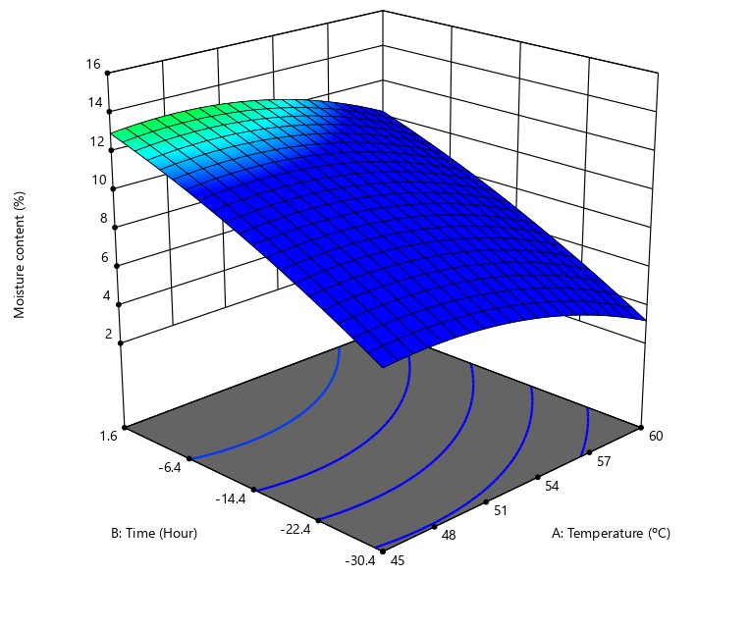
Figure 1: A 3D Graphical combination between temperature and drying time to the moisture content of ackee aril flour
3.4 Ash content.
The ash content ranged from 3.574-6.406 %. Fig. 2 showed that temperature influenced ash content. Prolonged temperature facilitates organic breakdown (Oluwamukomi & Jolayemi, 2019). The model for ash content was quadratic with R² of 0.9987 (Table 3). The Model has an F-value of 926.62 with P-value (<0.0001) less than0.05 indicate that model terms are significant. The ANOVA result shows that temperature and time has significant effect on ash content. The Lack of Fit F-value of 27.71 implies that the Lack of Fit is significant. Significant lack of fit is undesirable.
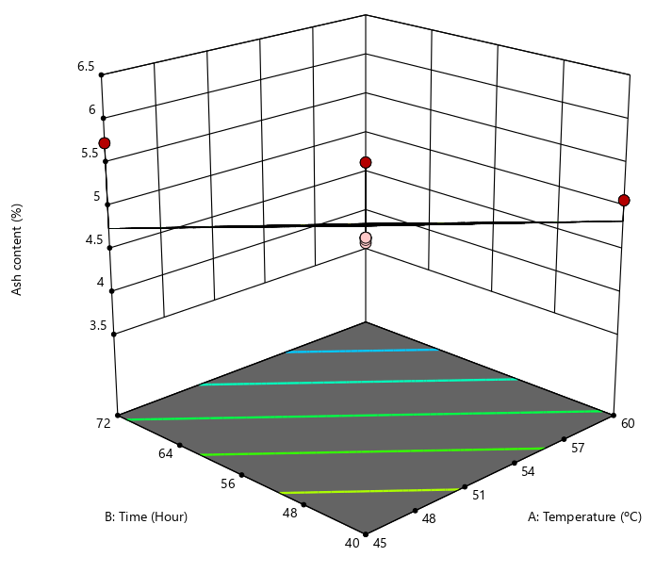
Figure 2: A 3D Graphical combination between temperature and drying time to the ash content of ackee aril flour.
3.5 Crude fibre
Crude fibre ranged from 4.995-7.271 %. An increase in crude fibre as temperature and time increased (Fig. 3). The response with power transformation has a 2F1 model with an R² value of 0.8155. The model has an F-value of 11.79 and P-values (0.0026) less than 0.0500 indicate model terms are significant. ANOVA results show that temperature and time has significant effect on crude fibre. The lack of fit F-value is not available, which shows it is insignificant to the fitness of the model (Alade et al., 2020). The RSM equation for optimisation of crude fibre for ackee aril flour is as follows:
$${(Crude fibre)}^{3} = +6.28 + 0.0335A + 0.1998B + 0.8348AB$$
Where A = Temperature (ºC) and B = Time (h)

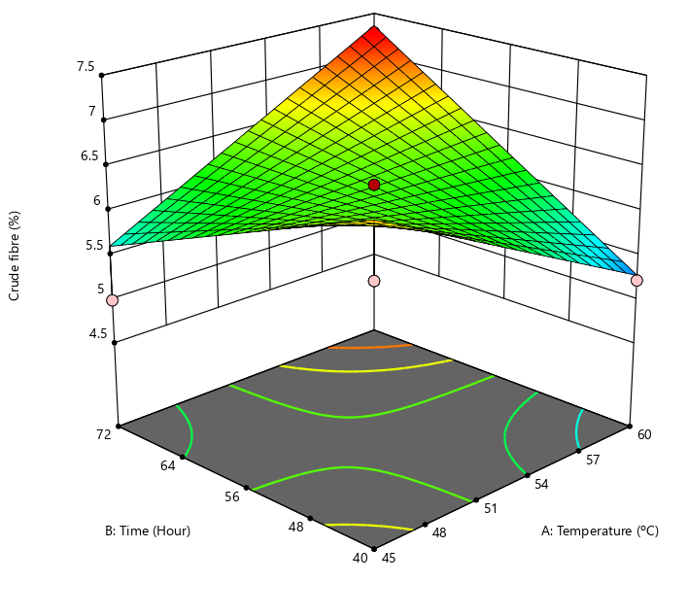
Figure 3: A 3D Graphical combination between temperature and drying time to the crude fibre of ackee aril flour.
3.6 Crude fat
The result for crude fat ranged from 5.138-6.844% %. Fig. 4 showed that as the temperature and time increased, crude fat gradually increases. This indicated that temperature and time significantly influenced the crude fat content. The response has a quadratic model with R² value of 0.9654. The model obtained an F-value of 33.50 with. P-values (0.0003) less than 0.05 indicating that model terms are significant. In this case ANOVA result showed that temperature and time are significant model terms. The lack of fit F-value is not available, which shows it is insignificant to the fitness of the model (Alade et al., 2020).
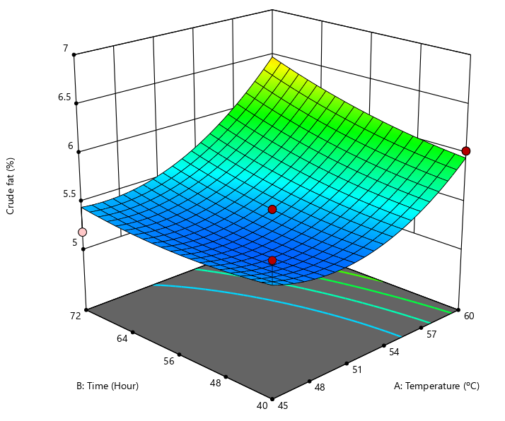
Figure 4: A 3D Graphical combination between temperature and drying time to the crude fat of ackee aril flour.
3.7 Crude protein
The value for crude protein ranged from 23.339-29.254 % (Table 2). Lower levels of both temperature and time, the crude protein content is relatively high (Fig. 5). However, as temperature and time progressed to moderate levels, there is a marked declined in crude protein values, forming a trough in the middle of the surface plot. Thus, at higher levels of both temperature and time, the crude protein content rises again. Reaching values close to or higher than those obtained at the lower extreme conditions. An increase in crude protein is likely due to moisture loss and partial breakdown of structural components, concentrating the crude protein in the samples (Adebowale et al., 2021). The response has quadratic model with R² value of 0.9944. The model obtained an F-value of 214.58 with P-value (0.0001) less than 0.05, indicating that model terms are significant. ANOVA result shows that temperature and time are significant model for crude protein model. The lack of fit F-value is not available, showing an insignificant fitness of the model.
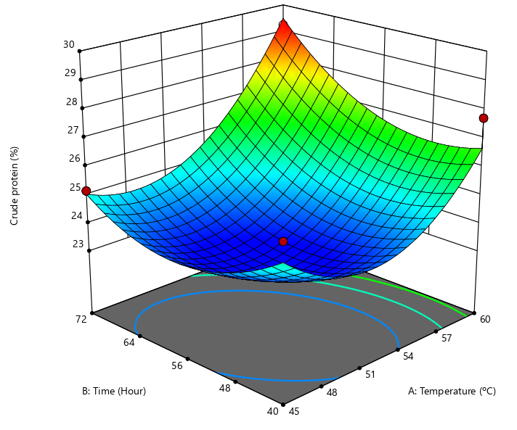
Figure 5: A 3D Graphical combination between temperature and drying time to the crude fat of ackee aril flour.
3.8 Carbohydrate
The result for carbohydrate ranged from 39.352-45.598% (Table 2). At moderate to low temperatures and shorter times, the carbohydrate yield is maximised. While a combination of high temperature and longtime resulted in the lowest carbohydrate value (Fig. 6). Therefore, both higher temperature and time jointly accelerated carbohydrate degradation (Montgomery, 2017). The model for the response is quadratic with R² value of 0.9904. It obtained an F-value of 123.42 with P-values (< 0.0001) less than 0.05 indicate model terms are significant. In this case, temperature and time are significant model terms. The lack of fit F-value is not available, which indicate it insignificancy.
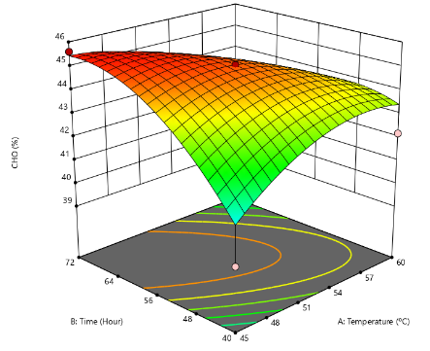

Figure 6: A 3D Graphical combination between temperature and drying time to the carbohydrate of ackee aril flour.
3.9 Total phenol
Total phenol ranged from 189.71-264.76 mg/100g (Table 3). Both temperature and have a significant interactive effect on the phenolic content (Fig. 7). Total phenol responses with power transformation have a quadratic model with R² value of 0.9788. The Model F-value of 55.53 implies the model is significant. The P-value 0.0001 is less than 0.0500 indicate model terms are significant. The model ANOVA result showed that temperature and time are significant model terms. The lack of fit F-value is not available, which shows it is insignificant to the fitness of the model (Alade et al., 2020). The RSM equation for optimisation of total phenol for ackee aril flour is as follows:$(Total Phenol) ³= +1.344E + 07 + 6.846E+05A - 1.184E+06B - 5.030E+06AB - 1.513E+06A² + 6.571E+05 B²$
Where A = Temperature (ºC) and B = Time (h)
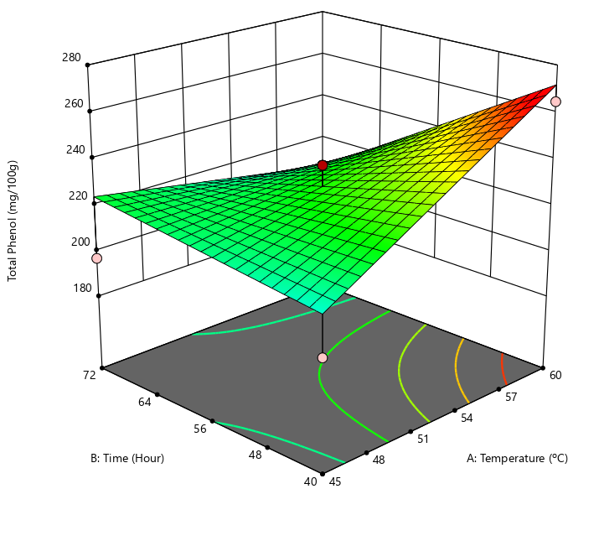
Figure 7: A 3D Graphical combination between temperature and drying time to the total phenol of ackee aril flour.
3.10 Flavonoid
The result for flavonoid ranged 22.70-34.81mg/100 g (Table 2). flavonoid was relatively stable across processing conditions, but extended heating at elevated temperature led to gradual losses (Fig. 8) (Oghenejoboh and Ani, 2021). The model for response is quadratic with R² value of 0.9788. The model gave F-value of 705.92 with P-value of <0.0001). P-values less than 0.05 indicate model terms are significant. The model ANOVA result shows that temperature and time are significant for flavonoid content when drying ackee aril. The lack of fit F-value is not available, which shows it is insignificant to the fitness of the model
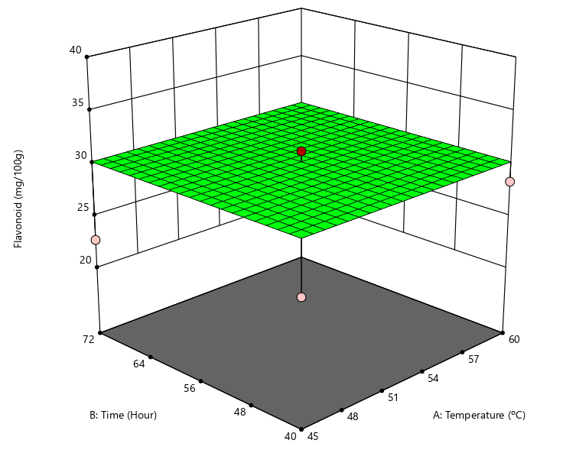
Figure 8: A 3D Graphical combination between temperature and drying time to the flavonoid of ackee aril flour.

3.11 Total carotenoid
Total carotenoid ranged from 0 to 0.0787-0.2988mg/100 g (Table 2). Both temperature and time significantly influenced the carotenoid content (Fig. 9). As the temperature and time increased simultaneously, there was a decrease in carotenoid concentration (Adegunwa et al., 2021). Total carotenoid with Inverse Sqrt has a quadratic model with R² value of 0.9891. The F-value of 90.69 with P-value < 0.0001 obtained for total carotenoid implies that the model is significant. The ANOVA result showed that temperature and time are significant model terms. The lack of fit F-value is not available, which shows it is insignificant to the fitness of the model (Alade et al., 2020). The RSM equation for optimisation of total carotenoid for ackee aril flour is as follows
$1/Sqrt (Total carotenoid) = +3.14 + 0.5414A - 0.4303B + 0.7979AB - 0.2426A² - 0.1549B$²
Where A = Temperature (ºC) and B = Time (h)
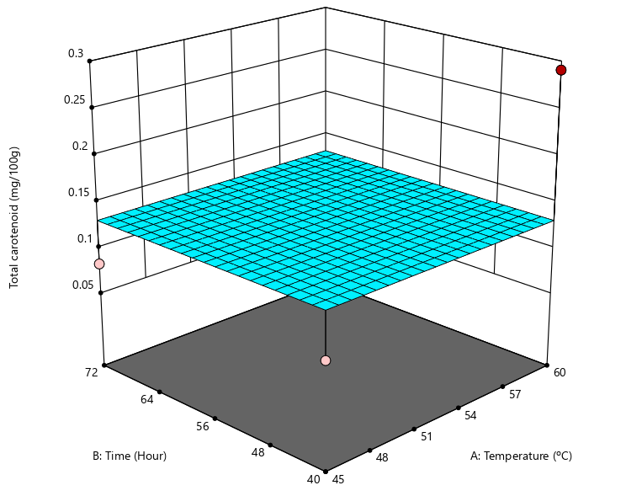
Figure 9: A 3D Graphical combination between temperature and drying time to the total carotenoid of ackee aril flour
3.12 Oxalate
The result for oxalate ranged from 6.650-9.161%% (Table 2). Both temperature and time interact synergistically to influence oxalate concentration (Fig. 10) (Olapade et al., 2022). The response gave a quadratic model with R² value of 0.9464. The F-value of 21.18 with a P-value of 0.0010, of the model obtained implies the model is significant. ANOVA result showed that temperature and time are significant for oxalate when drying ackee aril. The lack of fit F-value is not available, which shows it is insignificant to the fitness of the model.

3.13 Phytate
The result obtained for phytate ranged from 0,102-0.369% (Table 2). Temperature has a strong linear effect on phytate reduction and time also contributed, but the time effect is mildly curvilinear (Fig. 11). Phytate gave a quadratic model with R² value of 1.0000. The model F-value of 151512.85 with -P-value <0.0001 implies the model is significant. The ANOVA result shows that temperature and time are significant model terms. The lack of fit F-value is not available, which shows it is insignificant to the fitness of the model.
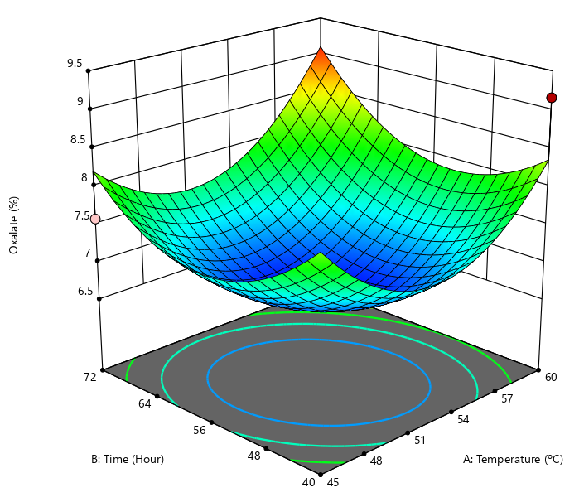
Figure 10: A 3D Graphical combination between temperature and drying time to the oxalate of ackee aril flour.

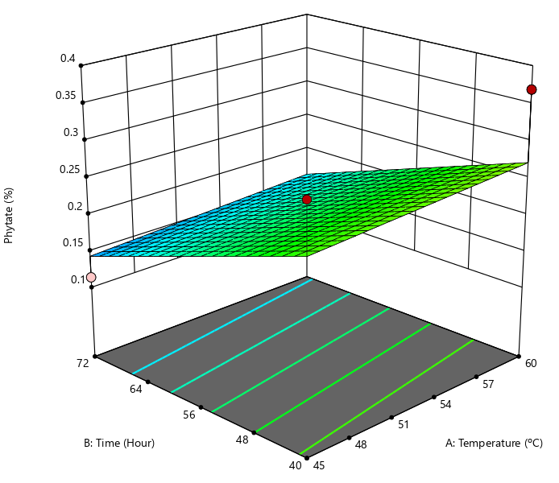
Figure 11: A 3D Graphical combination between temperature and drying time to the phytate of ackee aril flour

4 Conclusion
This study concluded that the use of oven dryer at an optimal condition of (60 ºC for 72 h) gave the preferred result for proximate and photochemical analysis of ackee aril flour. This processing condition improved the nutritional quality of ackee aril flour. Processing of ackee aril at this condition will improve its commercial applications and potential development of value-added products.
Competing Interest Disclaimer
Authors have declared that they have no competing financial interests OR non-financial interests OR personal relationships that could have appeared to influence the work reported in this paper.
References
Adebowale, A. A., Sanni, L. O., Awonorin, S. O., & Adegoke, G. O. (2021). Effect of processing on nutritional composition of selected foods. Journal of Food Science and Technology, 58(3), 567–575.
Adefegha, S. A., Oboh, G., & Oyeleye, S. I. (2022). Effect of processing methods on the phytochemical content and antioxidant activity of plant-based flours. Functional Foods in Health and Disease, 12(1), 23–33. https://doi.org/10.31989/ffhd.v12i1.85I
Adegunwa, M.O. (2021). Effect of drying temperature and time on nutrient retention in biofortified crops. Food Chemistry, 347, 129022.
Adeosun Y.M., Adeoti O., and Oyedele O. A. (2024). An Investigation into the Fuel Properties of Ackee Apple (Blighia sapida) Seeds Oil. Asian Journal of Research in Biosciences. 6(2), 211-216.
Adeyeye, A., Oyewole, O. B., & Oladiji, A. T. (2020). Nutritional and functional properties of wheat flour fortified with protein-rich sources. Journal of Food Composition and Analysis, 89, 103470. https://doi.org/10.1016/j.jfca.2020.103470
Ajayi A.M, Ayodele E.O., Ben-Azu B., Aderibigbe A.O., Umukoro S. (2019). Evaluation of neurotoxicity and hepatotoxicity effects of acute and sub-acute oral administration of unripe ackee (Blighia sapida) fruit extract. Toxicology Reports 6:656–665.
Alade. A.O., Arinkola, A.O., Afolabi, T.J., Adegbola, A.A., Oloyed, O.G., and Odiasa, P.O. (2020). D-Optimal sOptimisation of Microwaved Assisted Synthesis of Moruga Olefera Pod Activated Carbon andApplication to Methylene Blue Adsorption, International Journal of Engineering, 18(3), 187-203.
Alam, M., Biswas, M., Meahadi, M., & Hossain, F. (2023). Heliyon Quality attributes of the developed banana flour : Effects of drying methods. Heliyon, 9(7), e18312. https://doi.org/10.1016/j.heliyon.2023.e18312
Ampofo-Asiama J., Zebede A.A., Abakah B., Quaye B. (2020). Effect of Different Processing Methods on the Quality of Ackee Fruit Arils. European Journal of Nutrition & Food Safety.12(2): 79-84,
AOAC. (2019). Official methods of analysis of AOAC International (21st ed.). AOAC International. ISBN: 978-0-935584-89-9.
Ayo, J. A., Thomas, J. E., and Gidado, I. Y. (2020). Nutritional, functional, and sensory evaluation of composite breads produced from wheat and underutilised tropical flours. Nigerian Food Journal, 38(1), 12–22.
Dossou V.M., Agbenorhevi J.K., Combey S., Afi-Koryoe. S. (2014). Ackee (Blighia sapida) Fruit Arils: Nutritional, Phytochemicals and Antioxidant Properties. International Journal of Nutrition and Food Sciences. 3(6),534-537.
FAO/WHO. (2019). Codex Alimentarius: General standard for food additives and food composition. FAO/WHO Joint Food Standards Programme
Madukasi, A. H., Onyenanu, I. U., Oghenekaro, P. O., Nzenwa, C. C., & Madu, K. E. (2025). Optimization of the Drying Parameters for Plantain Chips using a Locally Made Tray Dryer : A Study on Drying Efficiency and Drying Rate Modeling using RSM. Journal of Food Technology & Nutrition Science.7(2), 1–10
Ojo J. A., Ogunlakin G. O. and Olajire A. S. (2025). Effect of Pretreatment and Drying Method on Drying Kinetics of Ackee ( Blighia sapida ) Arils. LAUTECH Journal of Engineering and Technology 19(4), 65–78.
Olabinjo O. O. (2020). Influence of Drying Temperature on Nutritional and Bioactive Compounds of (Blighia sapida) Ackee Apple Seeds. Food Science and Nutrition Technology, Vol (5), 2574-2701.
Olabinjo O.O. and Sama M.O. (2023). Evaluating the Effects of Drying Temperatures on the Nutritional and Bioactive Quality of Ackee Aril Apples. Turkish Journal of Agricultural Engineering Research (TURKAGER), 4(2): 289-300
Olapade, O.A. (2022). Processing methods and their effect on Oxalate reduction in tubers and legume flour. Journal of Food Biochemistry, 45(6), e13716.
Oloyede, G. K., Onocha, P. A., Ikiroma, T. R. and Olusola, O. W. (2023). Variation in chemical composition, insecticidal and antioxidant activities of essential oils from the leaves, stem barks, and roots of Blighia unijugata (Baker) and B. sapida (K. D. Koenig). International Journal of Plant-Based Pharmaceuticals, 3(1): 10-17.
Oluwamukomi, M.O., and Jolayemi, O.S. (2019). Influence of thermal processing on the mineral composition and functional properties of composite flour blends. International Journal of Food Science, 2019, 1-8
Orafa, P. N., Ogundele, O. O., Ayo, J. A., & Zephaniah, A. (2023). Quality Evaluation of Acha-Based Biscuits Incorporated with Defatted Melon Seed Cotyledon. Asian Journal of Food Research and Nutrition, 2(4), 695-707.
Rahmawati, R., Hunaefi, D., 1Basriman, I., Saputra, D., Apriliani, A.A. and Jenie, B.S.L. (2020). Optimisation of Temperature and Drying Time of Indigenous Cocktail Yeast Mold Culture using Response Surface Methodology (RSM). Food Research 4 (2) 389 – 395
Torres-Gallo R., Durán R., García-Camargo J., Morales O., Acevedo D., and Tirado D.F. (2021). Pasting and Dough Rheological Properties of Ackee (Blighia sapida) Aril Flour: A Contribution to the Search for Wheat Flour Substitutes. International Journal of Food Science, 1(1), 1-7.

