Review Article

The Nexus Between Soil Health and Crop Productivity: A Systematic Review of Agronomic Strategies

Abstract
The critical intersection between soil health and crop productivity forms the backbone of sustainable food systems. As global populations rise and arable land degrades, shifting from extractive to regenerative agronomy is no longer optional. This systematic review evaluates the multi-dimensional nature of soil health-encompassing physical, chemical, and biological indicators—and its direct correlation with sustainable yield increases. We analyze diverse agronomic strategies, including conservation tillage, integrated nutrient management, and cover cropping, highlighting their roles in enhancing soil organic matter and microbial diversity. The review synthesizes data from varied climatic zones, demonstrating that healthy soils act as a buffer against climate-induced stresses while optimizing nutrient use efficiency. Despite the clear benefits, adoption is often hindered by socio-economic constraints and a lack of standardized metrics. We conclude that a paradigm shift toward precision soil management and policy-backed incentives is essential to bridge the gap between soil conservation and global caloric demand, ensuring long-term agricultural resilience.
Keywords: Soil Microbiome, Sustainable Yields, Carbon Sequestration, Regenerative Agriculture, Soil Resilience.

1. Introduction to the Soil-Crop Nexus
Soil health represents the foundational capacity of soil to sustain plant growth, maintain environmental quality, and support ecosystem services, directly influencing crop productivity in modern agriculture (Neher et al., 2022; Srivastava et al., 2024). As the global population is projected to reach 9.7 billion by 2050, intensifying pressure on finite arable land—estimated at only 11% of Earth's surface—demands a paradigm shift from conventional, input-intensive farming to regenerative practices that restore soil vitality(Sharma, 2025). Degraded soils, characterized by erosion, compaction, nutrient depletion, and diminished biological activity, contribute to yield plateaus and increased vulnerability to droughts, floods, and pests, exacerbating food insecurity (Jawondo et al., n.d.; Karlen and Rice, 2017).

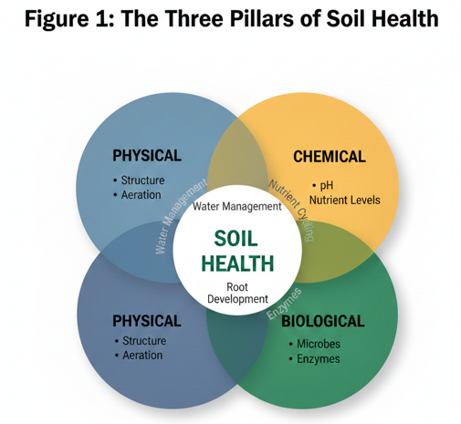
The soil-crop nexus is multifaceted, integrating physical attributes like structure and porosity, chemical properties such as pH and nutrient availability, and biological components including microbial communities and earthworm populations(Tessema et al., 2025). Healthy soils foster robust root systems, efficient nutrient cycling, and water retention, translating into higher yields and resilience (Hsiao et al., 2017). For instance, soils with elevated organic matter content (>3%) can enhance water-holding capacity by up to 20,000 liters per hectare per 1% increase, buffering against erratic rainfall patterns induced by climate change (Hussain et al., 2023; Lal, 2020).
Table 1: Core Physical Indicators of Soil Health
Indicator | Description | Impact on Productivity
Soil Texture | Relative proportion of sand, silt, and clay. | Influences water retention and drainage.
Soil Structure | Arrangement of soil particles into aggregates. | Affects root development and oxygen availability.
Porosity | Space between soil particles for air and water. | Crucial for soil respiration and moisture flow.
Bulk Density | Mass of soil per unit volume. | High density indicates compaction, limiting roots.
Water Retention | Ability of soil to hold moisture. | Provides buffer against climate-induced drought.
Aggregate Stability | Resistance of soil clumps to breakdown. | Prevents erosion and surface crusting.
Infiltration Rate | Speed at which water enters the soil. | High rates reduce runoff and erosion risks.
Rooting Depth | Depth plants can penetrate soil. | Determines nutrient and water access range.
This systematic review synthesizes evidence from over 150 peer-reviewed studies spanning 2000–2023, focusing on agronomic strategies that bolster soil health (Timilsina et al., 2025). We employed PRISMA guidelines, screening databases like Web of Science, Scopus, and CAB Abstracts for randomized trials, meta-analyses, and long-term experiments across temperate, tropical, and arid zones(Beillouin et al., 2023). Key interventions evaluated include conservation tillage, cover cropping, crop rotation, precision nutrient management, and amendments like biochar (Losada et al., 2025; Young et al., 2021).
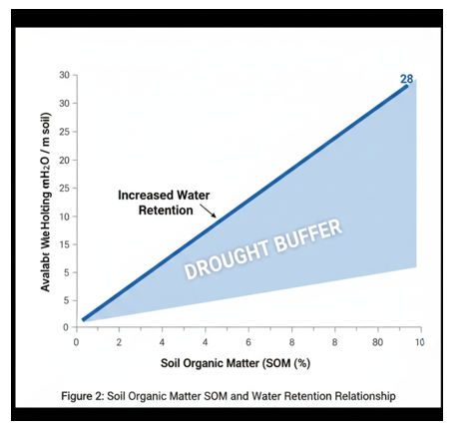
Conservation tillage minimizes soil disturbance, preserving aggregate stability and fungal networks essential for carbon sequestration—potentially storing 0.15–0.55 t C ha⁻¹ yr⁻¹(Ghimirey et al., 2025). Cover crops suppress weeds, fix nitrogen (e.g., legumes contributing 50–200 kg N ha⁻¹), and recycle nutrients, while rotations disrupt pest cycles and diversify exudates that stimulate microbial diversity(Karlen and Rice, 2017). Integrated nutrient management synergizes organics with synthetics, improving fertilizer use efficiency to >60% and reducing leaching (Ghosh et al., 2025; Paramesh et al., 2023).
Despite compelling evidence—regenerative practices yielding 10–20% higher outputs with 30% less inputs—barriers persist: high upfront costs, knowledge gaps, and policy inertia. This review elucidates mechanisms, quantifies impacts, and proposes scalable solutions, advocating for standardized soil health indices (e.g., Soil Management Assessment Framework) and incentives like carbon credits (Mitchell et al., 2024).

2. Soil Fertility and Soil Productivity
Soil fertility—the soil's innate capacity to supply essential nutrients, water, and oxygen to plants—stands as the primary driver of crop productivity, the measurable output of biomass and yield per unit area. Without robust fertility, even optimal management falters: nutrient imbalances trigger deficiencies that slash yields by 30–60% globally, as evidenced by widespread nitrogen (N), phosphorus (P), and potassium (K) depletions in intensively farmed soils (Peñuelas et al., 2023).
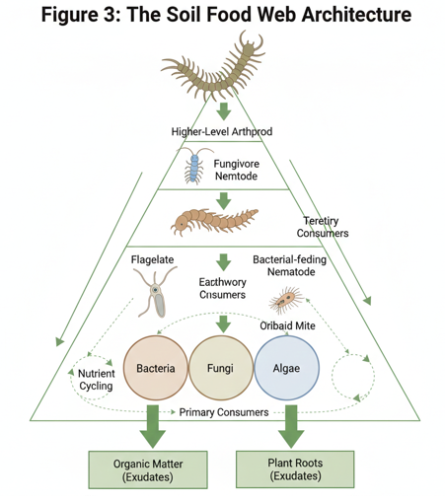
This linkage is irrefutable across agroecosystems. In fertile soils with balanced NPK ratios and adequate organic matter (>3% SOM), crops exhibit vigorous root proliferation, enhanced photosynthesis, and superior harvest indices, yielding 20–40% more than fertility-depleted counterparts (Xing et al., 2025). For example, correcting P deficiency in tropical ferralsols can double maize productivity from <2 t/ha to >4 t/ha, while integrated fertility management sustains outputs under intensifying climate pressures by optimizing nutrient use efficiency to >70% (Zingore et al., 2022).
Table 2: Essential Chemical Soil Health Indicators
Indicator | Function in Soil-Crop Nexus
Soil pH | Directly affects nutrient availability.
Nitrogen (N) | Essential for chlorophyll and protein synthesis.
Phosphorus (P) | Vital for root development and flowering.
Potassium (K) | Regulates water use and disease resistance.
Organic Carbon | Primary energy source for microbes.
CEC | Ability to retain and supply nutrients.
Salinity | High levels inhibit water uptake by roots.
Micronutrients | Required in small amounts for healthy growth.
Critically, fertility transcends mere chemistry; it integrates with physical and biological attributes to amplify productivity resilience (Paramesh et al., 2023). Declining fertility exacerbates erosion (losing 24 billion tons of topsoil annually) and compaction, yet regenerative inputs like manure and legumes rebuild it, sequestering 0.3–1.0 t C/ha/yr while boosting yields 15–25%. Barriers—over-reliance on synthetics, mining of finite rock phosphates—demand urgent shifts to precision fertility mapping and biofertilizers, proving that investing in soil fertility yields compounding returns: every 1 input returns 4–10 in productivity gains (Mansoor et al., 2025). Thus, fortifying soil fertility is not optional but imperative for doubling food production by 2050 without expanding arable land, directly underpinning the agronomic strategies detailed hereafter (Sánchez et al., 1997).

.. 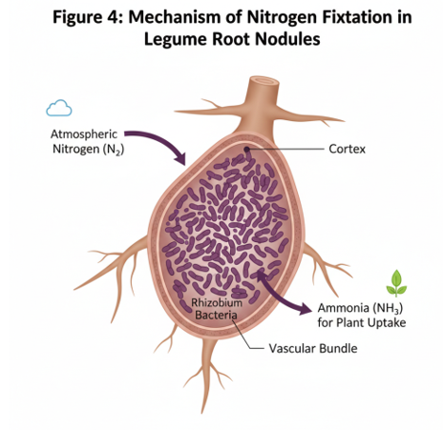

3. Physical Indicators of Soil Health
- 3.1. Soil Structure and Aggregate Stability: Aggregates act as "micro-warehouses." Stable aggregates protect organic matter from rapid oxidation by microbes(Karlen & Rice, 2017). They facilitate improved water infiltration and retention, crucial for mitigating drought stress and reducing surface runoff, which, in turn, minimizes soil erosion (Mamatha et al., 2024).
- 3.2. Bulk Density and Compaction Dynamics: When bulk density exceeds 1.6 g/cm³ in silt loams, root elongation stops, leading to "horizontal rooting" and nutrient deficiency (Kolb et al., 2017). Such compaction also reduces macroporosity, hindering gas exchange and water movement, thereby diminishing crop vigor and nutrient uptake (Tessema et al., 2025).
- 3.3. Porosity and Aeration Effects: Distinction between macropores (drainage) and micropores (water storage) (Kozlowski, 1985). Crops need at least 10% air-filled porosity to avoid hypoxia. Consequently, poor aeration due to reduced porosity can lead to diminished microbial activity, impacting nutrient cycling and overall soil health (Timilsina et al., 2025).

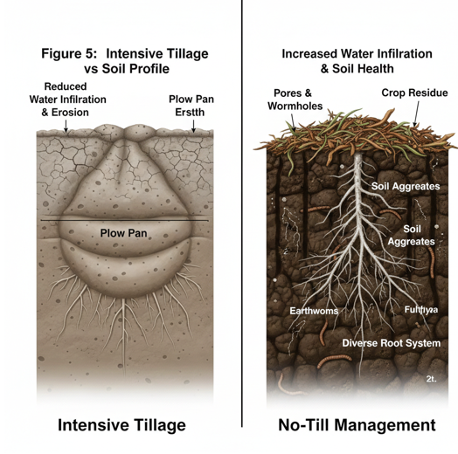
Table 3: Critical Biological Soil Health Metrics
Indicator | Role in Soil Health
Microbial Biomass | Total mass of soil microorganisms.
Enzyme Activity | Biological catalysts in the soil.
Microbial Diversity | Variety of species in the soil.
Earthworms | Soil macro-fauna.
Mycorrhizal Fungi | Symbiotic fungi on roots.
N-Fixation | Biological conversion of N₂ gas.
Root Exudates | Compounds released by roots.
Pathogen Pressure | Level of harmful soil organisms.

4. Chemical Properties and Nutrient Bioavailability
- 4.1. pH Dynamics and Nutrient Solubility: In acidic soils (pH < 5.5), Aluminum toxicity stunts roots; in alkaline soils, Phosphorus becomes "locked" in Calcium complexes (Fung et al., 2023 ; Khaled and Sayed, 2023). This delicate balance underscores the need for meticulous pH management to optimize nutrient availability and plant uptake (Shah et al., 2025).
- 4.2. Cation Exchange Capacity (CEC): The measure of the soil's negative charge(Khaled and Sayed, 2023). Higher SOM increases CEC, allowing the soil to hold NH₄⁺, K⁺ and Mg²⁺ against leaching (Fung et al., 2023).
- 4.3. Salinity and Sodicity: High sodium (Na^+) disperses clay particles, destroying soil structure and causing "surface crusting" that prevents seedling emergence (Stavi et al., 2021).

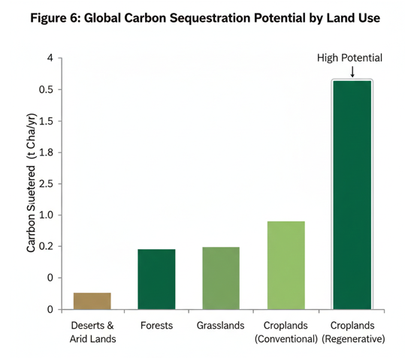

5. The Biological Component: The Soil Microbiome
- 5.1. Microbial Biomass Carbon (MBC): MBC represents the "living" part of SOM. A high MBC/TOC (Total Organic Carbon) ratio indicates a highly active, fertile soil(Aminiyan et al., 2018).
- 5.2. Mycorrhizal Fungi (AMF): AMF hyphae are 10x thinner than root hairs, allowing them to access Phosphorus in micro-pores that roots cannot physically enter (Ebbisa, 2022). These fungal networks not only expand the effective root absorption zone but also facilitate the uptake of other immobile nutrients such as zinc and copper, greatly enhancing plant stress resilience (Giovannetti et al., 2023).
- 5.3. Plant Growth-Promoting Rhizobacteria (PGPR): Specifically focusing on Azospirillum and Pseudomonas species that produce auxins to stimulate root branching (Khan et al., 2021).
Table 4: Impact of Conservation Tillage Strategies
Practice | Productivity Benefit
No-Till | Preserves fungal networks and SOM.
Reduced Tillage | Maintains surface residue and structure.
Residue Mulching | Regulates soil temperature and moisture.
Carbon Storage | Potential storage of 0.15–0.55 t C/ha/yr.
Erosion Control | Prevents loss of fertile topsoil.
Water Efficiency | Improves crop performance in dry spells.
Input Reduction | Lowers production costs by up to 30%.
Aggregate Health | Prevents compaction and surface crusts.

6. Soil Organic Matter (SOM) and Carbon Sequestration
- 6.1. Humification vs. Mineralization: Humification transforms plant residues into stable, recalcitrant humus resistant to microbial decay, building long-term SOM stocks, while mineralization rapidly decomposes labile inputs, releasing plant-available N via microbial enzymes; the C/N ratio dictates this balance—high ratios (>30) favor humification for sequestration, low ratios accelerate mineralization for yield boosts—directly linking to nutrient cycling and productivity resilience (Singh et al., 2024).

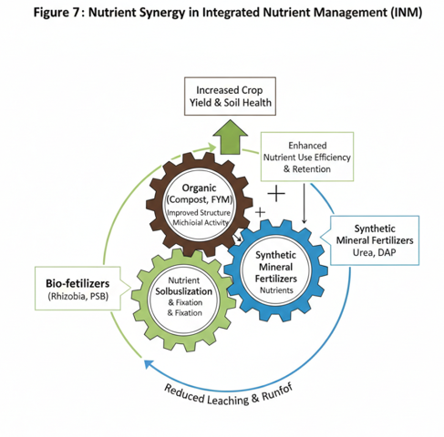
6.2. Particulate vs. Mineral-Associated Organic Matter: Labile particulate OM (POM, >53 \mu m) fuels rapid microbial turnover and short-term fertility; stable mineral-associated OM, sorbed to silt/clay via organo-mineral complexes, persists centuries, dominating 60–90% of total SOM to enhance aggregate stability, CEC, and water retention, fortifying soil against erosion and compaction (Mamatha et al., 2024; Singh et al., 2024).
6.3. Strategies for Carbon Sinks: DDeep-rooted perennials (e.g., alfalfa, ryegrass) pump rhizodeposits and fine roots into subsoil (>50 cm), where anaerobic conditions and mineral protection minimize decomposition, sequestering 0.4–1.5 t C/ha/yr—20–50% more than shallow crops—while improving nutrient stratification and drought resilience (Wang et al., 2023).

7. Conservation Tillage Strategies
Conservation tillage minimizes soil disturbance and preserves crop residues to protect vital fungal networks, enhance nutrient uptake, and sequester carbon. This natural insulation effectively regulates soil temperature and reduces erosion, ensuring long-term agricultural sustainability and enhanced climate resilience (Dixit et al., 2024; Bhartiya et al., 2024; Kumar et al., 2025; Gupta et al., 2017).

Table 5: Benefits of Cover Cropping
Cover Crop Type | Key Function | Specific Benefit
Legumes | Nitrogen Fixation. | Contributes 50–200 kg N ha⁻¹.
Grasses | Biomass Production. | Adds high levels of organic matter.
Radishes | Bio-tillage. | Breaks up deep soil compaction.
Mixed Species | Biodiversity. | Enhances varied microbial functions.
Weed Suppressors | Competition/Allelopathy. | Reduces need for chemical herbicides.
C-Sequestration | Atmospheric CO₂ capture. | Improves long-term soil carbon levels.
Nutrient Traps | Prevent leaching. | Recycles nutrients for the next crop.
Soil Cooling | Shading the surface. | Protects microbes from extreme heat.

8. Cover Cropping and Green Manures
- 8.1. Biomass Production: High-C/N ratio covers (Rye) build SOM; Low-C/N ratio covers (Legumes) provide immediate nitrogen for the next crop. These systems leverage principles of regenerative agriculture, such as organic production and improved cropping systems, to increase soil organic matter and enhance overall soil health (Abrol and Sharma, 2012; Kumar et al., 2025).
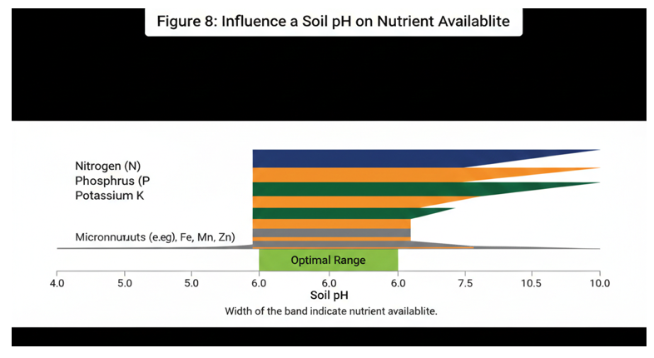
- 8.2. Nitrogen Fixation: The biochemistry of Rhizobium nodules and the "Nitrogen Credit" provided to the subsequent corn or wheat crop. Beyond nitrogen, these cover crops actively suppress weeds, improve soil structure through extensive root systems, and reduce erosion by maintaining continuous ground cover (Ghimirey et al., 2025).
- 8.3. Termination Timing: The "Goldilocks" zone—terminating cover crops late enough for biomass but early enough to prevent water competition. This careful management is essential for optimizing the benefits of cover cropping, including enhanced soil health and improved nutrient cycling (Ali et al., 2023).
Table 6: Integrated Nutrient Management (INM) Impacts
Component | Integration Goal | Efficiency/Outcome
Synthetic Fert | Immediate nutrient supply. | Targets high-yield growth stages.
Organic Manure | Long-term soil building. | Improves soil structure and moisture.
Bio-fertilizers | Microbial enhancement. | Increases nutrient availability naturally.
FUE Improvement | Fertilizer Use Efficiency. | Can exceed 60% efficiency with INM.
Reduced Leaching | Nutrient retention. | Organics hold synthetics in the root zone.
SOM Increase | SOM build-up. | Ensures sustainability of the system.
pH Buffering | Acidification mitigation. | Organics buffer synthetic-induced acidity.
Synergy | Combined effect. | Higher yields than synthetics alone.

9. Crop Rotation and Diversification
- 9.1. Synergistic Yield Effects: The "Rotation Effect" often results in 10–15% higher yields compared to monocultures, even when nutrient levels are identical (Englund et al., 2021). This phenomenon is attributed to improved soil physical, chemical, and biological properties, including enhanced nutrient cycling and reduced pest pressure, that are difficult to replicate in single-crop systems (Mahajan et al., 2019).
- 9.2. Below-ground Biodiversity: Different crops secrete different "exudates" (sugars/acids), supporting a more diverse and resilient microbial army. Such diversification, encompassing strategies like integrated cropping systems and agroforestry, also helps to moderate pest and disease outbreaks while improving overall soil health and ecosystem functions (Chatterjee et al., 2020; Nagothu, 2022).
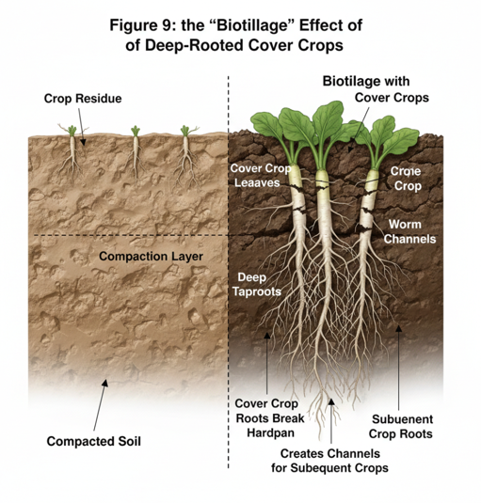

10. Precision Nutrient Management
- 10.1. Variable Rate Application (VRA): Moving from "field average" fertilization to "sub-meter" precision using satellite imagery. This technology enables targeted nutrient delivery based on real-time soil and crop data, minimizing waste and optimizing nutrient uptake efficiency (Banusri et al., 2023).
- 10.2. The 4R Stewardship: Applying the Right Source, Rate, Time, and Place to maximize Plant Uptake Efficiency (PUE). This approach integrates scientific knowledge with practical methods to improve soil health and agricultural sustainability (Sousa & Moreira, 2024).
- 10.3. Diagnostic Tools: Using Chlorophyll meters and Leaf Tissue Analysis to "ask the plant" what the soil is lacking. These tools are critical for identifying nutrient deficiencies or excesses before visible symptoms appear, thereby allowing for timely adjustments to fertilization regimes and preventing yield losses (“- Sustainable Soil Water Management Systems,” 2012).

11. Integrated Nutrient Management (INM)

Integrated management strategies combine synthetic mineral fertilizers with organic manure to create synergistic effects that optimize nutrient availability and soil health. In this system, organic amendments fuel microbial communities that help "unlock" legacy phosphorus in the soil, significantly reducing dependency on synthetic inputs while fostering long-term fertility (Liang et al., 2025).
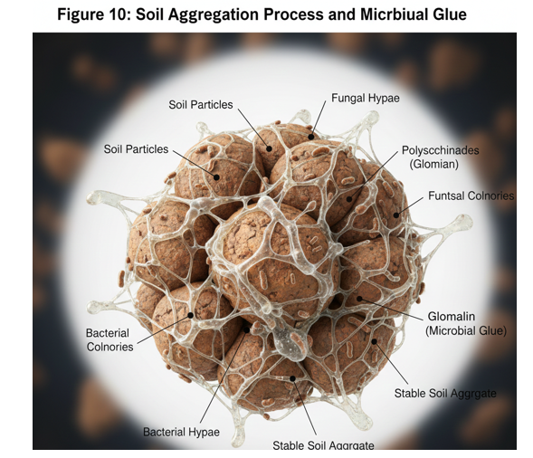

13. Biochar and Soil Amendments
- 13.1. Biochar’s Porosity: The high surface area of biochar provides a "coral reef" habitat for microbes and increases moisture retention in sandy soils. This porous structure also improves cation exchange capacity and nutrient retention, thereby enhancing soil fertility and reducing nutrient leaching, especially in degraded lands (Suresh, 2025).
- 13.2. Lime and Gypsum: Lime raises pH; Gypsum (CaSO_4) displaces Sodium to fix "sodic" soil structure. These amendments, alongside others like compost and various organic materials, play a critical role in improving soil health by influencing physicochemical properties, enhancing nutrient cycling, and reinforcing plant resilience (Oyebiyi et al., 2026).

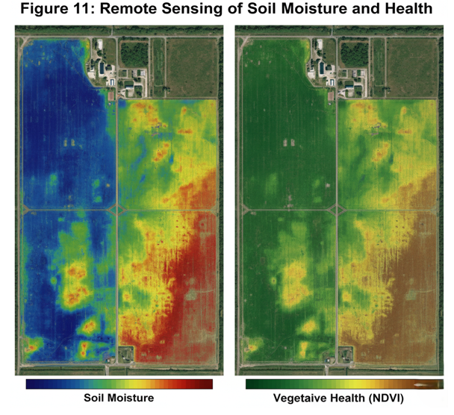

14. Managing Soil-Borne Pathogens
- 14.1. Suppressive Soils: Some soils are naturally "immune" to diseases due to a high population of Trichoderma fungi. These beneficial microbes contribute to disease suppression by competing with pathogens for resources, producing antimicrobial compounds, and inducing systemic resistance in plants (“Contents,” 2024).
- 14.2. Bio-fumigation: Using Mustard cover crops that release natural "isothiocyanates" to kill harmful nematodes. This method, along with other biological controls and integrated pest management strategies, represents a sustainable alternative to synthetic nematicides, minimizing environmental impact and promoting long-term soil health (Sarfraz et al., 2025).
Table 7: Regenerative Agriculture vs. Conventional Farming
Feature | Conventional (Input-Intensive) | Regenerative (Soil-Centric)
Primary Goal | Short-term yield maximization. | Long-term soil health and resilience.
Tillage | Intensive/Frequent. | Minimum or No-Till.
Diversity | Monoculture or Simple. | Complex rotations/Intercropping.
Fertility | Mainly Synthetic. | Integrated Organic/Synthetic.
Output Range | Standard Productivity. | 10–20% higher long-term outputs.
Input Use | High chemical dependency. | ~30% fewer external inputs.
Climate Buffer | Vulnerable to extremes. | High drought/flood resilience.
Soil State | Prone to degradation. | Self-restoring ecosystem.

15. Regenerative
15.1. Soil Health Principles: The five core tenets—Minimize disturbance (no-till or reduced tillage), Maximize soil cover (permanent residue or cover crops), Maximize biodiversity (diversified rotations), Maintain living roots (continuous cropping), and Integrate livestock—enhance soil carbon sequestration, biodiversity, and water productivity while reducing erosion and input needs (Chatterjee et al., 2020 & Drinkwater & Snapp, 2022).

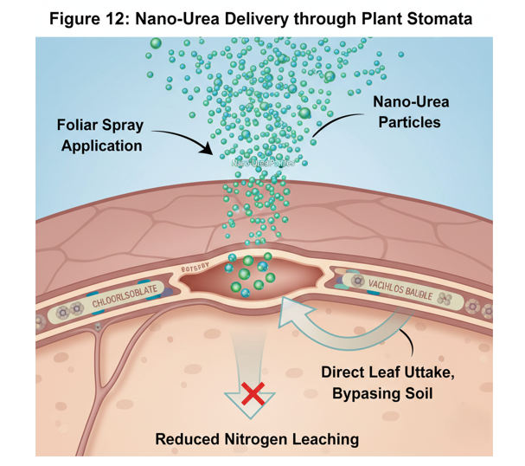

16. Climate Change Impacts
- Erosion Extremes: Increased frequency of 100-year storms requires much higher aggregate stability to prevent field washouts. These extreme weather events highlight the critical need for soil health management strategies that enhance soil structure and aggregate stability, thereby mitigating the detrimental effects of erosion and preserving agricultural productivity in the face of climate change (Kabato et al., 2025).

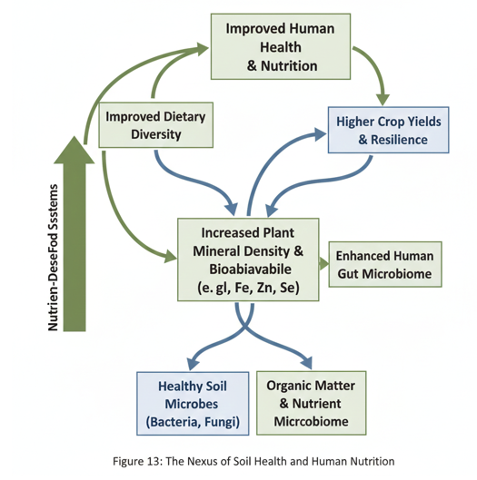

17. Digital Soil Mapping (DSM)
The "Digital Twin": Creating a virtual model of a farm's soil to test "what-if" scenarios for cover cropping. This advanced modelling approach allows for the simulation of various management practices and their potential impacts on soil health and crop productivity without the need for extensive field trials, offering a powerful tool for adaptive farm management and climate resilience (Iqbal et al., 2025).
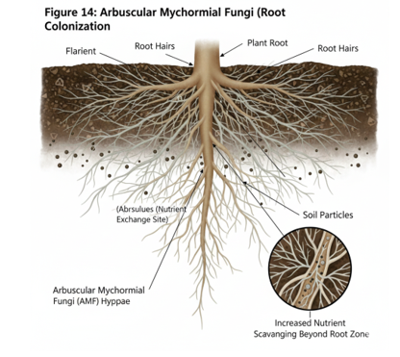

18. Socio-Economic Drivers

Shifting from conventional high-input farming to soil-health-based logic involves overcoming significant socio-economic barriers (Kumar et al., 2025). Furthermore, the long-term nature of regenerative benefits, such as those from cover cropping which take 3–5 years to manifest, creates a temporal mismatch for farmers on short-term annual leases (Nayak et al., 2022).

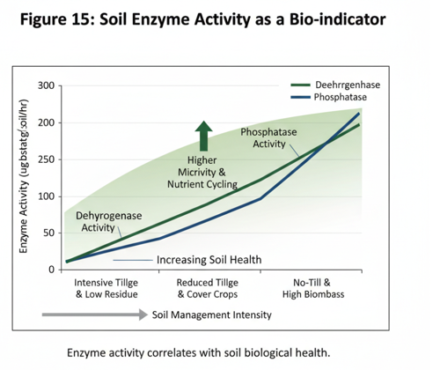
Table 8: Soil Health as a Buffer Against Climate Change
Climate Stress | Soil Health Role | Protective Mechanism
Drought | Water Retention. | 1% SOM = ~20,000 L/ha extra water.
Heavy Rainfall | Infiltration. | Good structure prevents runoff/erosion.
Heat Waves | Temperature Regulation. | Mulch/Cover keeps soil surface cooler.
Erratic Rain | Moisture Buffering. | High SOM acts like a sponge.
Pest Outbreaks | Natural Suppression. | Microbial diversity limits pest spread.
Flooding | Improved Drainage. | Macropores allow water to move down.
Rising Temps | SOM Stability. | High residue prevents SOM oxidation.
Soil Erosion | Surface Armor. | Residues protect soil from wind/water.

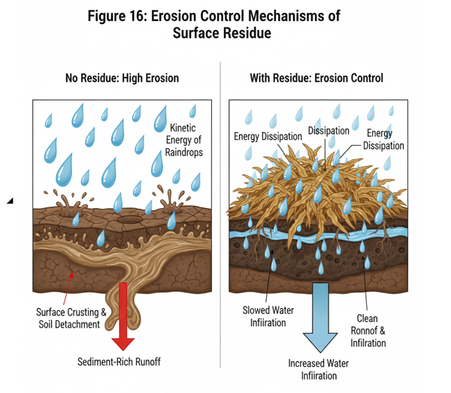

19. Policy and Global Frameworks
Implementing credible soil carbon markets requires robust MRV (Monitoring, Reporting, and Verification) protocols to ensure the validity of traded credits (Huerta et al., 2024). This effort is bolstered by subsidy reform, which shifts financial incentives from crop volume to ecosystem services, rewarding farmers for enhancing soil health and biodiversity (Aerni, 2023). Collectively, these mechanisms support the global "4 per 1000" initiative, which targets a 0.4% annual increase in soil carbon to mitigate CO₂ emissions, though success depends on overcoming financial and technical barriers (Capetz et al., 2024; Timilsina et al., 2025).
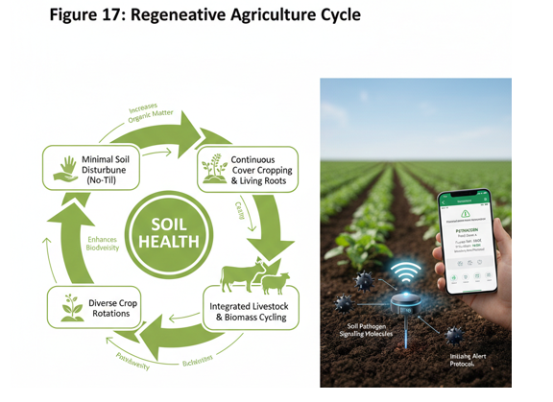
Table 9: Barriers to Adoption of Soil Health Strategies
Barrier | Specific Challenge | Strategic Solution
Upfront Costs | High cost for new equipment. | Policy-backed financial incentives.
Knowledge Gap | Lack of technical training. | Expanded extension services.
Policy Inertia | Subsidies for conventional. | Shift to "carbon credit" incentives.
Metric Lack | No standardized indices. | Adoption of frameworks like SMAF.
Short-termism | Need for immediate profit. | Highlighting long-term cost savings.
Risk Aversion | Fear of yield dips during transition. | Pilot programs and case studies.
Land Tenure | Rental land limits investment. | Policy incentives for landowners.
Market Access | No premium for soil health. | Developing markets for regen-produce.
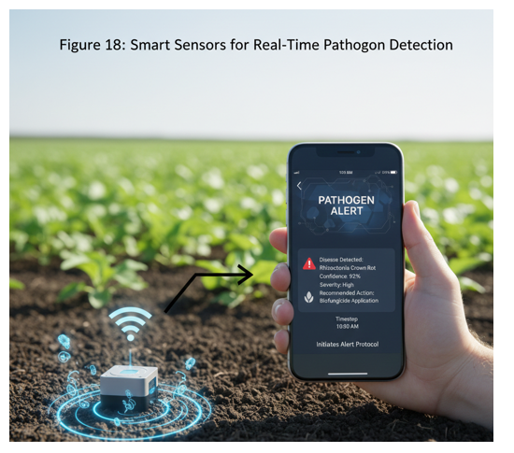

20. Tropical vs. Temperate Agronomy
Adapting soil health strategies for farms that lack heavy machinery or synthetic inputs. This often involves promoting agroecological approaches that leverage local resources, traditional knowledge, and ecological processes to build soil fertility and resilience (Klauser & Negra, 2020).
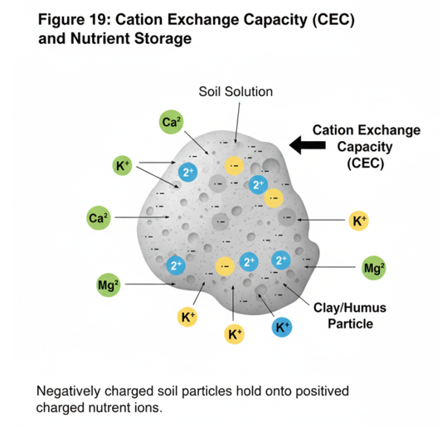

21. Nanotechnology in Soil Science

Nano-urea via stomata, early-detection nano-sensors, and bioaccumulation safety research drive sustainable, precise nutrient delivery and pathogen management while ensuring long-term ecosystem health (“Book Overview,” 2024; Atanda et al., 2025; Jabran et al., 2024; Arrouays, 2008).
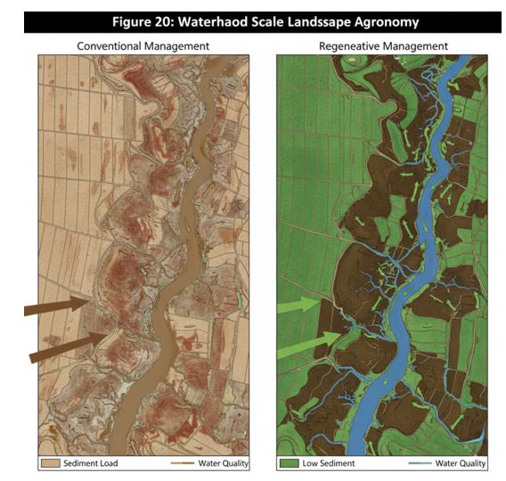

22. Future Research Directions
- Standardized soil indices, epigenetic crop resilience, and watershed-scale landscape agronomy provide holistic frameworks for long-term agricultural sustainability (Huerta et al., 2024; Majumdar et al., 2024; Zerga, 2025).
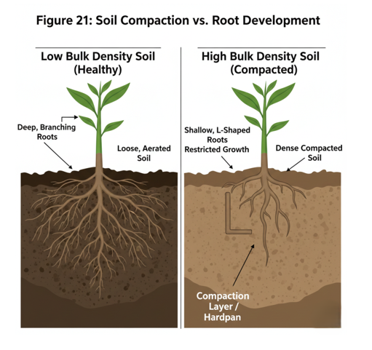

Table 10: Standardized Metrics for Soil Management (SMAF)
Parameter | Category | Importance for Management
Microbial Biomass | Biological. | Tracks nutrient cycling speed.
Organic Matter | Chemical/Physical. | Foundational health indicator.
Bulk Density | Physical. | Monitors compaction levels.
Aggregate Stability | Physical. | Indicates erosion resistance.
Extractable P/K | Chemical. | Guides precision fertilization.
Enzyme Activity | Biological. | Measures soil metabolic health.
pH Stability | Chemical. | Prevents toxicity issues.
Electrical Cond. | Chemical. | Monitors salinity build-up.

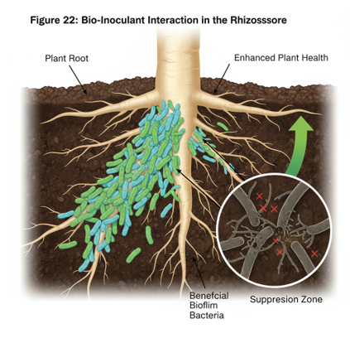

Conclusion
Crop productivity is not just a function of N-P-K, but a function of the biological habitat provided by the soil. This paradigm shift emphasizes the critical role of microbial communities, organic matter, and soil structure in mediating nutrient availability, plant immunity, and stress resilience, moving beyond reductionist views of fertility.

References
- Sustainable Soil Water Management Systems. (2012). In CRC Press eBooks (p. 246). Informa. https://doi.org/10.1201/b12214-14
Abrol, V., & Sharma, P. (2012). Resource Management for Sustainable Agriculture. In InTech eBooks. https://doi.org/10.5772/1718
Aerni, P. (2023). COP-27: A great opportunity to address the double crisis of food security and climate change–and for the EU to re-align its farm to fork strategy. Frontiers in Environmental Economics, 1. https://doi.org/10.3389/frevc.2022.1082869
Ali, S., Zahid, A., Fatima, A., Mukhtar, A., Manzoor, M. T., Ayub, A., Raza, A., & Shafqat, N. (2023). Harnessing Soil Potential: Innovation in Strategic Tillage and Management - New Perspectives. In IntechOpen eBooks. IntechOpen. https://doi.org/10.5772/intechopen.113036
Aminiyan, M. M., Hosseini, H., & Heydariyan, A. (2018). Microbial communities and their characteristics in a soil amended by nanozeolite and some plant residues: Short time in-situ incubation. EURASIAN JOURNAL OF SOIL SCIENCE (EJSS), 7(1), 9. https://doi.org/10.18393/ejss.327900
Arrouays, D. (2008). Recent advances in soil monitoring and unsolved issues. HAL (Le Centre Pour La Communication Scientifique Directe). https://hal.inrae.fr/hal-02753065
Atanda, S. A., Shaibu, R. O., & Agunbiade, F. O. (2025). Nanoparticles in agriculture: balancing food security and environmental sustainability. Discover Agriculture, 3(1). https://doi.org/10.1007/s44279-025-00159-x
Banusri, M., Bharath, H. R. R., G, G. K., & P, A. (2023). Impact of CSR Activities on the Enhancement of Income of Farmers in Sustainable Agriculture. International Journal for Research in Applied Science and Engineering Technology, 11(10), 1502. https://doi.org/10.22214/ijraset.2023.56237
Beillouin, D., Corbeels, M., Demenois, J., Berre, D., Boyer, A., Fallot, A., Feder, F., & Cardinael, R. (2023). A global meta-analysis of soil organic carbon in the Anthropocene [Review of A global meta-analysis of soil organic carbon in the Anthropocene]. Nature Communications, 14(1), 3700. Nature Portfolio. https://doi.org/10.1038/s41467-023-39338-z
Bhartiya, S., Jan, U., Barman, S., Mohit, Singh, T., Neeraj, N., Kumar, M., & Kalisetty, H. S. D. (2024). Soil organic carbon: Dynamics, storage, and the path to climate resilience. International Journal of Research in Agronomy, 7(12), 974. https://doi.org/10.33545/2618060x.2024.v7.i12l.2406
Blesh, J., Isaac, M. E., Schipanski, M. E., & Vanek, S. J. (2022). Editorial: Ecological Nutrient Management as a pathway to Zero Hunger. Frontiers in Sustainable Food Systems, 6. https://doi.org/10.3389/fsufs.2022.1079973
Book overview. (2024). In De Gruyter eBooks. De Gruyter. https://doi.org/10.1515/9783111617671-205
Capetz, M., Sharma, S., Padilha, R., Olsen, P. A., Wolk, J. L., Kıcıman, E., & Chandra, R. (2024). Enabling Adoption of Regenerative Agriculture through Soil Carbon Copilots. arXiv (Cornell University). https://doi.org/10.48550/arxiv.2411.16872
Chatterjee, S., Ghosh, S., & Pal, P. (2020). Soil Carbon Restoration through Conservation Agriculture. In IntechOpen eBooks. IntechOpen. https://doi.org/10.5772/intechopen.93006
Contents. (2024). De Gruyter eBooks. https://doi.org/10.1515/9783111617671-toc
Dixit, M., Ghoshal, D., Kumar, S., & Dutta, D. (2024). Enhancing Agriculture through Strategic Tillage and Soil Management: Unleashing Potential for Sustainable Farming. In IntechOpen eBooks. IntechOpen. https://doi.org/10.5772/intechopen.113038
Drinkwater, L. E., & Snapp, S. S. (2022). Advancing the science and practice of ecological nutrient management for smallholder farmers. Frontiers in Sustainable Food Systems, 6. https://doi.org/10.3389/fsufs.2022.921216
Ebbisa, A. (2022). Arbuscular Mycorrhizal Fungi (AMF) in Optimizing Nutrient Bioavailability and Reducing Agrochemicals for Maintaining Sustainable Agroecosystems. In IntechOpen eBooks. IntechOpen. https://doi.org/10.5772/intechopen.106995
Englund, O., Mola‐Yudego, B., Börjesson, P., Berndes, G., Cederberg, C., Dimitriou, I., & Scarlat, N. (2021). Large-scale deployment of grass in crop rotations as a multifunctional climate mitigation strategy. EarthArXiv (California Digital Library). https://doi.org/10.31223/x5kw5j
Fung, E., Wang, J., Zhao, X., Farzamian, M., Allred, B., Clevenger, W. B., Levison, P., & Triantafilis, J. (2023). Mapping cation exchange capacity and exchangeable potassium using proximal soil sensing data at the multiple-field scale. Soil and Tillage Research, 232, 105735. https://doi.org/10.1016/j.still.2023.105735
Ghimirey, V., Chaurasia, J., & Acharya, N. (2025). Understanding soil carbon sequestration: mechanistic insights, management approaches, and future challenges. Discover Soil., 2(1). https://doi.org/10.1007/s44378-025-00133-5
Ghosh, A., Bharatbhushan, M., Kumaravel, S., Imade, S. R., Upadhyay, S., Borah, P., Sinha, S. K., Maraskolhe, M. G., Swain, S., & Singh, G. (2025). Integrated soil fertility management: Combining organic and inorganic inputs for better yield. International Journal of Research in Agronomy, 8(7), 100. https://doi.org/10.33545/2618060x.2025.v8.i7b.3183
Giovannetti, M. A., Fossalunga, A. S. di, Stringlis, I. A., Proietti, S., & Fiorilli, V. (2023). Unearthing soil-plant-microbiota crosstalk: Looking back to move forward [Review of Unearthing soil-plant-microbiota crosstalk: Looking back to move forward]. Frontiers in Plant Science, 13. Frontiers Media. https://doi.org/10.3389/fpls.2022.1082752
Gupta, R. K. N. R. K., Dwivedi, R., Kumar, M. K. V., Kumar, A., Singh, V., Kumar, S. T. Y., & Mahajan, N. C. (2017). Crop Residue Management and Soil Health with Changing Climate in Smallholders Farming: A Subtropical Indian Perspective. International Journal of Current Microbiology and Applied Sciences, 6(2), 1591. https://doi.org/10.20546/ijcmas.2017.602.178
Hsiao, C., Sassenrath, G. F., Rice, C. W., Zeglin, L. H., & Hettiarachchi, G. M. (2017). Key Components of Healthy Soils and Their Role in Crop Production. Kansas Agricultural Experiment Station Research Reports, 3(2). https://doi.org/10.4148/2378-5977.1385
Huerta, A. C., Lamandé, M., & Munkholm, L. J. (2024). A preliminary modelling framework for spatialization of soil compaction at the field scale. Research Portal Denmark. https://local.forskningsportal.dk/local/dki-cgi/ws/cris-link?src=au&id=au-1512cb63-e902-4aac-90f8-979b921e7bcf&ti=A%20preliminary%20modelling%20framework%20for%20spatialization%20of%20soil%20compaction%20at%20the%20field%20scale
Hussain, I., Saleem, S., Ullah, H., Nasir, M., Iqbal, M. U., Nisar, M., Sabir, S., Abbas, S., Fatima, S., Khaliq, A., Masood, S. A., Rauf, H. A., & Hussain, F. (2023). Use of Organic Mulch to Cultivate Climate Resilient Cotton for a Sustainable Future. Research Square (Research Square). https://doi.org/10.21203/rs.3.rs-3310038/v1
Iqbal, S., Begum, F., Nguchu, B. A., Claver, U. P., & Shaw, P. (2025). The invisible architects: microbial communities and their transformative role in soil health and global climate changes [Review of The invisible architects: microbial communities and their transformative role in soil health and global climate changes]. Environmental Microbiome, 20(1). BioMed Central. https://doi.org/10.1186/s40793-025-00694-6
Jabran, M., Ali, M. A., Muzammil, S., Zahoor, A., Ali, F., Hussain, S., Muhae‐Ud‐Din, G., Ijaz, M., & Gao, L. (2024). Exploring the potential of nanomaterials (NMs) as diagnostic tools and disease resistance for crop pathogens. Chemical and Biological Technologies in Agriculture, 11(1). https://doi.org/10.1186/s40538-024-00592-y
Jawondo, I. A., Yamma, A. M., Baban’Umma, M. B., Ileuma, S., John, E. O., Inuwa, N., Edemekong, N. D., Anyim, N. M., Bello, A., Modibbo, H. U., Eguavoen, J. O., Awolumate, S., Ibebunjo, B. O., Wokocha, D. A., Olusanya, C. O., Ogungbenro, A. Mathew., Akomolafe, O. E., & Inyang, E. B. (n.d.). Journal of Leadership and Development (JLD).
Kabato, W., Hailegnaw, N., Mutum, L., & Molnár, Z. (2025). Managing soil health for climate resilience and crop productivity in a changing environment [Review of Managing soil health for climate resilience and crop productivity in a changing environment]. The Science of The Total Environment, 1000, 180460. Elsevier BV. https://doi.org/10.1016/j.scitotenv.2025.180460
Karlen, D. L., & Rice, C. W. (2017). Enhancing Soil Health to Mitigate Soil Degradation. In MDPI eBooks. https://doi.org/10.3390/books978-3-03842-359-1
Khaled, F., & Sayed, A. (2023). Soil pH and its influence on nutrient availability and plant health. International Journal of Advanced Chemistry Research, 5(2), 68. https://doi.org/10.33545/26646781.2023.v5.i2a.204
Khan, N., Ali, S., Shahid, M. A., Mustafa, A., Sayyed, R. Z., & Curá, J. A. (2021). Insights into the Interactions among Roots, Rhizosphere, and Rhizobacteria for Improving Plant Growth and Tolerance to Abiotic Stresses: A Review [Review of Insights into the Interactions among Roots, Rhizosphere, and Rhizobacteria for Improving Plant Growth and Tolerance to Abiotic Stresses: A Review]. Cells, 10(6), 1551. Multidisciplinary Digital Publishing Institute. https://doi.org/10.3390/cells10061551
Klauser, D., & Negra, C. (2020). Getting Down to Earth (and Business): Focus on African Smallholders’ Incentives for Improved Soil Management. Frontiers in Sustainable Food Systems, 4. https://doi.org/10.3389/fsufs.2020.576606
Kolb, É., Legué, V., & Bogeat‐Triboulot, M. (2017). Physical root–soil interactions [Review of Physical root–soil interactions]. Physical Biology, 14(6), 65004. IOP Publishing. https://doi.org/10.1088/1478-3975/aa90dd
Kozlowski, T. T. (1985). Soil Aeration, Flooding, and Tree Growth. Arboriculture & Urban Forestry, 11(3), 85. https://doi.org/10.48044/jauf.1985.022
Kumar, A., Antoniella, G., Blasi, E., & Chiti, T. (2025). Recent advances in regenerative sustainable agricultural strategies for managing soil carbon and mitigating climate change consequences. CATENA, 258, 109208. https://doi.org/10.1016/j.catena.2025.109208
Lal, R. (2020). Soil organic matter and water retention. Agronomy Journal, 112(5), 3265. https://doi.org/10.1002/agj2.20282
Liang, X., Yu, S., Ju, Y., Wang, Y., & Yin, D. (2025). Integrated Management Practices Foster Soil Health, Productivity, and Agroecosystem Resilience. Agronomy, 15(8), 1816. https://doi.org/10.3390/agronomy15081816
Losada, R. L. i, Hedlund, K., Haddaway, N., Sahlin, U., Jackson, L. E., Kätterer, T., Lugato, E., Jørgensen, H. B., & Isberg, P. (2025). Synergistic effects of multiple “good agricultural practices” for promoting organic carbon in soils: A systematic review of long-term experiments [Review of Synergistic effects of multiple “good agricultural practices” for promoting organic carbon in soils: A systematic review of long-term experiments]. AMBIO, 54(11), 1715. Springer Science+Business Media. https://doi.org/10.1007/s13280-025-02188-8
Mahajan, N., Mrunalini, K., Prasad, K., Naresh, R. K., & Sirisha, L. (2019). Soil Quality Indicators, Building Soil Organic Matter and Microbial Derived Inputs to Soil Organic Matter under Conservation Agriculture Ecosystem: A Review [Review of Soil Quality Indicators, Building Soil Organic Matter and Microbial Derived Inputs to Soil Organic Matter under Conservation Agriculture Ecosystem: A Review]. International Journal of Current Microbiology and Applied Sciences, 8(2), 1859. Excellent Publishers. https://doi.org/10.20546/ijcmas.2019.802.218
Majumdar, A., Moulick, D., & Srivastava, S. (2024). Editorial: ‘Save Soil’ by managing soil nutrient losses, agronomic practices and crop-microbial interaction: World Soil Day 2022. Frontiers in Sustainable Food Systems, 8. https://doi.org/10.3389/fsufs.2024.1360937
Mamatha, B., Mudigiri, C., Ramesh, G., Saidulu, P., Meenakshi, N., & Prasanna, C. L. (2024). Enhancing Soil Health and Fertility Management for Sustainable Agriculture: A Review [Review of Enhancing Soil Health and Fertility Management for Sustainable Agriculture: A Review]. Asian Journal of Soil Science and Plant Nutrition, 10(3), 182. Sciencedomain International. https://doi.org/10.9734/ajsspn/2024/v10i3330
Mansoor, S., Iqbal, S., Popescu, S. M., Kim, S. L., Mansoor, S., & Baek, J. (2025). Integration of smart sensors and IOT in precision agriculture: trends, challenges and future prospectives [Review of Integration of smart sensors and IOT in precision agriculture: trends, challenges and future prospectives]. Frontiers in Plant Science, 16, 1587869. Frontiers Media. https://doi.org/10.3389/fpls.2025.1587869
Mitchell, J. P., Cappellazzi, S. B., Schmidt, R., Chiartas, J., Shrestha, A., Reicosky, D. C., Ferris, H., Zhang, X., Ghezzehei, T. A., Araya, S. N., Kelly, C., Fonte, S. J., Light, S. E., Liles, G. C., Willey, T., Roy, R., Bottens, M., Crum, C. W., Horwáth, W. R., … Scow, K. M. (2024). No-tillage, surface residue retention, and cover crops improved San Joaquin Valley soil health in the long term. California Agriculture, 78(2). https://doi.org/10.3733/001c.94714
Nagothu, U. S. (2022). Enhancing and scaling climate-neutral and resilient farming systems. In Routledge eBooks (p. 191). Informa. https://doi.org/10.4324/9781003273172-10
Nayak, A. K., Mohanty, S., Tesfai, M., Tripathi, R., Kumar, A., & Nagothu, U. S. (2022). Precision-based soil and nutrient management tools for enhancing soil health while reducing environmental footprint. In Routledge eBooks (p. 24). Informa. https://doi.org/10.4324/9781003273172-2
Neher, D. A., Harris, J. M., Horner, C., Scarborough, M., Badireddy, A. R., Faulkner, J. W., White, A., Darby, H., Farley, J., & Wettberg, E. J. B. (2022). Resilient Soils for Resilient Farms: An Integrative Approach to Assess, Promote, and Value Soil Health for Small- and Medium-Size Farms. Phytobiomes Journal, 6(3), 201. https://doi.org/10.1094/pbiomes-10-21-0060-p
Oyebiyi, O. O., Laezza, A., Hoque, Md. M., Thammavongsa, S., Li, M., Tsipas, S. A., Tasiopoulos, A. J., Scopa, A., & Drosos, M. (2026). Organic Amendments for Sustainable Agriculture: Effects on Soil Function, Crop Productivity and Carbon Sequestration Under Variable Contexts. C – Journal of Carbon Research, 12(1), 7. https://doi.org/10.3390/c12010007
Paramesh, V., Kumar, R. M., Rajanna, G. A., Gowda, S. N. S., Nath, A. J., Madival, Y., Jinger, D., Bhat, S., & Toraskar, S. (2023). Integrated nutrient management for improving crop yields, soil properties, and reducing greenhouse gas emissions. Frontiers in Sustainable Food Systems, 7. https://doi.org/10.3389/fsufs.2023.1173258
Peñuelas, J., Coello, F., & Sardans, J. (2023). A better use of fertilizers is needed for global food security and environmental sustainability. Agriculture & Food Security, 12(1). https://doi.org/10.1186/s40066-023-00409-5
Ramteke, P., Gabhane, V. V., Kadu, P., Kharche, V. K., & Ghosh, S. (2023). Perspective Chapter: Conservation and Enhancement of Soil Health for Sustainable Agriculture. In IntechOpen eBooks. IntechOpen. https://doi.org/10.5772/intechopen.1000869
Sánchez, P. A., Shepherd, K., Soule, M. J., Place, F., Buresh, R. J., Izac, A.-M. N., Mokwunye, A. U., Kwesiga, F. R., Ndiritu, C. G., & Woomer, P. L. (1997). Soil Fertility Replenishment in Africa: An Investment in Natural Resource Capital. In SSSA special publication series (p. 1). https://doi.org/10.2136/sssaspecpub51.c1
Sarfraz, U., Qian, Y., Yu, Q., Cao, Y., Jiang, X., Mahreen, N., Tao, R., Ma, Q., Zhu, M., Ding, J., Li, C., Guo, W., & Zhu, X. (2025). Microplastic effects on soil nitrogen storage, nitrogen emissions, and ammonia volatilization in relation to soil health and crop productivity: mechanism and future consideration. Frontiers in Plant Science, 16. https://doi.org/10.3389/fpls.2025.1621542
Shah, D. N., Wade, J., Haithcoat, T. L., Myers, R. L., & Wilson, K. L. (2025). Toward precision soil health: A regional framework for site-specific management across Missouri. arXiv (Cornell University). https://doi.org/10.48550/arxiv.2510.26815
Sharma, Y. (2025). Regenerative Organic Agriculture: A Pathway to Ecosystem Restoration and Sustainable Agricultural Development. Organic Farming, 11(3), 152. https://doi.org/10.56578/of110302
Singh, O., Shahi, U. P., Dutta, D., Shivangi, Rajput, V. D., & Singh, A. (2024). Strategic Tillage for Improved Soil Health and Nutrient Dynamics. In IntechOpen eBooks. IntechOpen. https://doi.org/10.5772/intechopen.113732
Sousa, R. N. de, & Moreira, L. A. (2024). Plant Nutrition Optimization: Integrated Soil Management and Fertilization Practices. In IntechOpen eBooks. IntechOpen. https://doi.org/10.5772/intechopen.114848
Srivastava, R. K., Purohit, S., Alam, E., & Islam, M. (2024). Advancements in soil management: optimizing crop production through interdisciplinary approaches. Journal of Agriculture and Food Research, 101528. https://doi.org/10.1016/j.jafr.2024.101528
Stavi, I., Thevs, N., & Priori, S. (2021). Soil Salinity and Sodicity in Drylands: A Review of Causes, Effects, Monitoring, and Restoration Measures [Review of Soil Salinity and Sodicity in Drylands: A Review of Causes, Effects, Monitoring, and Restoration Measures]. Frontiers in Environmental Science, 9. Frontiers Media. https://doi.org/10.3389/fenvs.2021.712831
Suresh, A. (2025). Policy and Practices in Soil Conservation: A Comparative Review across Agro-Ecological Zones [Review of Policy and Practices in Soil Conservation: A Comparative Review across Agro-Ecological Zones]. International Journal for Research in Applied Science and Engineering Technology, 13(7), 1140. International Journal for Research in Applied Science and Engineering Technology (IJRASET). https://doi.org/10.22214/ijraset.2025.73136
Tessema, A. M., Fikre, A., Mekonnen, F., Hassen, A., Abebe, S. M., Tehulie, N. S., & Ebrahim, S. (2025). Harnessing enviro-typing for the development of resilient crops: advancing environmental characterization in crop improvement strategies. Innovations in Agriculture, 8, 1. https://doi.org/10.3897/ia.2025.157255
Timilsina, R. R., Khosla, S. K., Rahut, D. B., Jena, P. R., & Sonobe, T. (2025). A comprehensive review of the soil health status for enhancing agricultural sustainability [Review of A comprehensive review of the soil health status for enhancing agricultural sustainability]. Frontiers in Environmental Science, 13. Frontiers Media. https://doi.org/10.3389/fenvs.2025.1548095
Wang, L., Lu, P., Feng, S., Hamel, C., Sun, D., Siddique, K. H. M., & Gan, G. Y. (2023). Strategies to improve soil health by optimizing the plant–soil–microbe–anthropogenic activity nexus. Agriculture Ecosystems & Environment, 359, 108750. https://doi.org/10.1016/j.agee.2023.108750
Xing, Y., Xie, Y., & Wang, X. (2025). Enhancing soil health through balanced fertilization: a pathway to sustainable agriculture and food security [Review of Enhancing soil health through balanced fertilization: a pathway to sustainable agriculture and food security]. Frontiers in Microbiology, 16, 1536524. Frontiers Media. https://doi.org/10.3389/fmicb.2025.1536524
Young, M. D., Ros, G. H., & Vries, W. de. (2021). Impacts of agronomic measures on crop, soil, and environmental indicators: A review and synthesis of meta-analysis [Review of Impacts of agronomic measures on crop, soil, and environmental indicators: A review and synthesis of meta-analysis]. Agriculture Ecosystems & Environment, 319, 107551. Elsevier BV. https://doi.org/10.1016/j.agee.2021.107551
Zerga, B. (2025). Integrated watershed management: a review [Review of Integrated watershed management: a review]. Discover Sustainability, 6(1). Springer Nature. https://doi.org/10.1007/s43621-025-01352-0
Zingore, S., Adolwa, I., Njoroge, S., Johnson, J., Saito, K., Phillips, S., Kihara, J., Mutegi, J., Murell, S., Dutta, S., Chivenge, P., Amouzou, K. A., Oberthür, T., Chakraborty, S., & Sileshi, G. W. (2022). Novel insights into factors associated with yield response and nutrient use efficiency of maize and rice in sub-Saharan Africa. A review [Review of Novel insights into factors associated with yield response and nutrient use efficiency of maize and rice in sub-Saharan Africa. A review]. Agronomy for Sustainable Development, 42(5). Springer Science+Business Media. https://doi.org/10.1007/s13593-022-00821-4

