Case report

Surgical Management of Vaginal Leiomyoma Obstructing the Urination in a Crossbred Cow

Abstract:
Vaginal tumors are uncommon in cattle compared to other domestic animals, with leiomyomas being extremely rare. Leiomyomas are benign smooth muscle neoplasms, well-encapsulated, and histologically characterized by spindle-shaped cells with cigar-shaped nuclei and minimal mitotic activity. The present study describes the clinical presentation, surgical management, and histopathological findings of a vaginal leiomyoma obstructing the urethral opening in a crossbred cow. A five-year-old cow was presented with a history of progressive vaginal swelling, straining, and difficulty in urination for two months. Clinical examination revealed a firm, well-circumscribed, pedunculated mass projecting into the vaginal lumen. Cytological examination of impression smears demonstrated spindle-shaped cells with oval to elongated nuclei, suggestive of leiomyoma. Surgery was performed under sedation with butorphanol and caudal epidural anaesthesia using 2% lignocaine hydrochloride. The mass was exteriorized, ligated at the base with absorbable suture material, and excised. Postoperative therapy included antibiotics, anti-inflammatory drugs, and daily antiseptic dressing. The cow recovered uneventfully, resuming normal urination and defecation within two days, with complete healing observed by 10 days. Follow-up for six months revealed no recurrence. Histopathological examination of the excised tumour confirmed leiomyoma, showing well-circumscribed fascicles of smooth muscle cells arranged in whorled and interlacing patterns with cigar-shaped nuclei, abundant eosinophilic cytoplasm, and absence of cellular atypia or mitotic activity. The case highlights the successful diagnosis and surgical management of a rare vaginal leiomyoma in cattle obstructing normal urination.
Keywords: Cattle, Vaginal tumour, Leiomyoma, Urethral obstruction and Surgical management
Introduction:
Vaginal tumors in bovines are uncommon compared to those in other species. Vaginal tumour include fibromas, fibrosarcomas, leiomyomas, hemangiomas, lymphosarcomas, and carcinomas (Singh et al., 2019). Malignant tumours such as squamous cell carcinoma and adenocarcinoma occur more frequently observed than benign neoplasms (Jubb et al., 2016). Vaginal leiomyoma, a benign tumour originating from smooth muscle cells, is most often reported in the uterus, cervix, or vagina of humans and small animals (Kennedy et al., 1998). However, it is extremely rare in cattle. In a tumour survey conducted in farm animals, out of 20 vaginal tumors, seven were fibromas, seven lipomas, three fibromyomas, two leiomyomas, and one fibropapilloma (Timurkaan et al., 2009).
Leiomyomas are typically slow-growing, well-encapsulated, and firm in nature. Neoplastic cells usually exhibit elongated, cigar-shaped nuclei with eosinophilic cytoplasm and indistinct cell borders, while mitotic activity is generally rare (Foster, 2017). These features help distinguish leiomyomas from other spindle-cell tumours such as fibromas, fibrosarcomas, or leiomyosarcomas. Clinically, affected animals may show signs such as vaginal swelling, dysuria, difficulty in defecation, or interference with normal parturition (Sharma et al., 2010). Occasionally, the tumour may protrude through the vulva. The present study reports the diagnosis and successful surgical management of a vaginal leiomyoma causing obstruction to normal urination in a cow.
Case presentation
A clinical case of vaginal leiomyoma (Fig.1A) in a crossbred cow was presented to the Department of Veterinary Surgery and Radiology, Bihar Veterinary College, Patna. The animal had a two-month history of progressive vaginal swelling, associated with straining and difficulty in urination. Clinical examination revealed a firm, well-circumscribed, pedunculated mass projecting into the vaginal lumen. Per-vaginal palpation indicated that the growth was non-invasive and arose from the vaginal wall. Touch impression smears showed clusters and bundles of elongated, spindle-shaped cells with oval to cigar-shaped nuclei and moderate pale cytoplasm, suggestive of leiomyoma. Physiological parameters, including temperature, heart rate, and respiratory rate, were within normal limits. Based on physical, clinical, and cytological findings, the case was tentatively diagnosed as vaginal leiomyoma, and surgical management was planned. The study on surgical case was conducted with informed owner consent, and all procedures followed standard clinical and ethical guidelines of the Bihar Veterinary College, Bihar Animal Sciences University, Patna.
Surgery was performed under sedation and caudal epidural anaesthesia. Sedation was achieved using butorphanol (0.05 mg/kg body weight IV), and 2% lignocaine hydrochloride was administered at the sacrococcygeal space for epidural anaesthesia. The cow was restrained in a standing position, and the perineal and vaginal regions were aseptically prepared. The animal was catheterized (Fig. 1B) to prevent iatrogenic urethral injury. The vaginal mass was exteriorized with gentle traction (Fig. 1C). Two temporary sutures, placed dorsally and ventrally at the base (Fig. 2A), facilitated space creation and controlled bleeding. An elliptical incision was made at the base (Fig.2B). The leiomyoma was carefully excised in a layer-by-layer manner to ensure complete removal. Haemorrhage was carefully controlled throughout the procedure using absorbable suture materials and gentle pressure (Fig. 2C). The base of the tumour was ligated using absorbable polyglactin 910 (No. 1) (Fig. 3A). Finally, the mass was carefully excised (Fig 3 B). The excised tissue was preserved in 10% neutral buffered formalin and submitted for histopathology. Postoperatively, the cow received amoxicillin-sulbactam (7 mg/kg IM for five days) and meloxicam (0.2 mg/kg IM for three days). Daily antiseptic dressing of the vulvar region with povidone-iodine was advised for one week. The owner was instructed to monitor for recurrence or postoperative complications.
Discussion
The animal resumed normal urination and defecation within two days of surgical intervention (Fig. 3C). Complete healing of the surgical wound was observed by 10 days’ post-surgery, and no signs of recurrence were noted during a six-month follow-up. Histopathological examination of the excised mass revealed features consistent with leiomyoma. At low magnification (H&E, 4×), the sections showed multiple well-circumscribed fascicles of spindle-shaped smooth muscle cells arranged in characteristic whorled and interlacing patterns (Fig. 4A). The tumour cells possessed uniform, elongated, blunt-ended (“cigar-shaped”) nuclei with abundant eosinophilic cytoplasm, and the fascicles were surrounded by compressed connective tissue stroma. Areas of hyalinization and vascular proliferation, commonly associated with leiomyomas, were also observed. At higher magnification (H&E, 10×), the tumour displayed interlacing bundles of well-differentiated smooth muscle cells with elongated, uniform nuclei arranged in a whorled pattern. Importantly, no evidence of cellular atypia, abnormal mitotic figures, or necrosis was observed (Fig. 4B). These histological features confirmed the diagnosis of a benign vaginal leiomyoma.
The incidence of leiomyomas of the genital tract is higher in females compared to males (Meuten, 2002). Initially, leiomyomas are soft and fleshy but become firm over time due to the development of stromal connective tissue within the tumor (Sharma et al., 2012). Steroid hormones, particularly estrogens, may contribute to leiomyoma development, whereas progestogens exert an inhibitory effect. Other factors, such as pregnancy, abscesses, adhesions, mummified or macerated foetuses, and tuberculosis, may also play a role in the development of vaginal leiomyomas (Youngquist and, Threlfall, 2007). In the present case, the animal exhibited clinical signs of straining, dysuria, and a firm vaginal mass, consistent with previous reports (Sharma et al., 2010). Per-vaginal examination, along with cytological findings of spindle-shaped cells with elongated, cigar-shaped nuclei, aided in making a tentative diagnosis prior to surgical intervention.
Histopathology provided a definitive diagnosis. Classical features of leiomyoma including well-circumscribed fascicles of smooth muscle cells arranged in whorled and interlacing bundles with uniform, blunt-ended nuclei and absence of mitotic activity or necrosis were observed, consistent with earlier findings (Jubb et al., 2016). Areas of hyalinization and vascular proliferation, also noted in this case, are frequently reported in leiomyomas and are considered degenerative changes rather than indicators of malignancy (Foster, 2017). Thus, the combination of clinical examination, cytological impressions, and histopathology provides an accurate diagnosis. Surgical excision is considered the treatment of choice for vaginal leiomyomas due to their localized and encapsulated nature. In the present case, the leiomyoma was completely removed, and no recurrence was observed. A favourable prognosis is usually associated with benign smooth muscle tumours following complete excision (Goldschmidt et al., 200210).
Conclusion:
Vaginal leiomyoma in cows is an extremely rare condition. A tentative diagnosis can be made on the basis of clinical and cytological findings and confirmatory diagnosis by histopathological examination. Surgical excision under epidural anaesthesia provides a safe and successful management of vaginal leiomyoma.

Reference:
Foster, R. A. (2017). Female reproductive system. In M. G. Maxie (Ed.), Jubb, Kennedy, and Palmer’s Pathology of Domestic Animals (6th ed., pp. 358–464). Elsevier.
Goldschmidt, M. H., & Hendrick, M. J. (2002). Tumors of the skin and soft tissues. In D. J. Meuten (Ed.), Tumors in Domestic Animals (4th ed., pp. 45–118). Iowa State Press.
Jubb, K. V. F., Kennedy, P. C., & Palmer, N. (2016). Pathology of Domestic Animals (6th ed.). Elsevier.
Kennedy, P. C., Cullen, J. M., Edwards, J. F., Goldschmidt, M. H., Larsen, S., Munson, L., et al. (1998). Histological classification of genital system tumors of domestic animals. WHO/Armed Forces Institute of Pathology.
Meuten, J. D. (2002). Tumors in Domestic Animals (4th ed., p. 334). Blackwell Publishing Company / Iowa State Press.
Sharma, A., Kumar, A., Imran, S., Sood, P., & Asrani, R. K. (2012). Ultrasonographic, surgical, and histopathological findings of a uterine leiomyoma in a cow. Case Reports in Veterinary Medicine, 2012, 536204.
Sharma, A., Singh, K., & Kumar, P. (2010). Surgical management of vaginal tumors in cattle. Indian Veterinary Journal, 87(10), 1020–1021.
Singh, B., Kumar, R., Singh, N., Saurabh, & Sharma, P. (2019). Management of infertility associated with vaginal leiomyoma in a crossbred cow: A case report. Multilogic Science, 2019, 143–144.
Timurkaan, N., Aydin, M., Yilmaz, F., & Cevik, A. (2009). Vaginal fibroleiomyoma in a cow: A case report. Veterinary Medicine, 54(3), 138–141.
Youngquist, R. S., & Threlfall, W. R. (2007). Current Therapy in Large Animal Theriogenology (2nd ed., p. 386). Saunders.
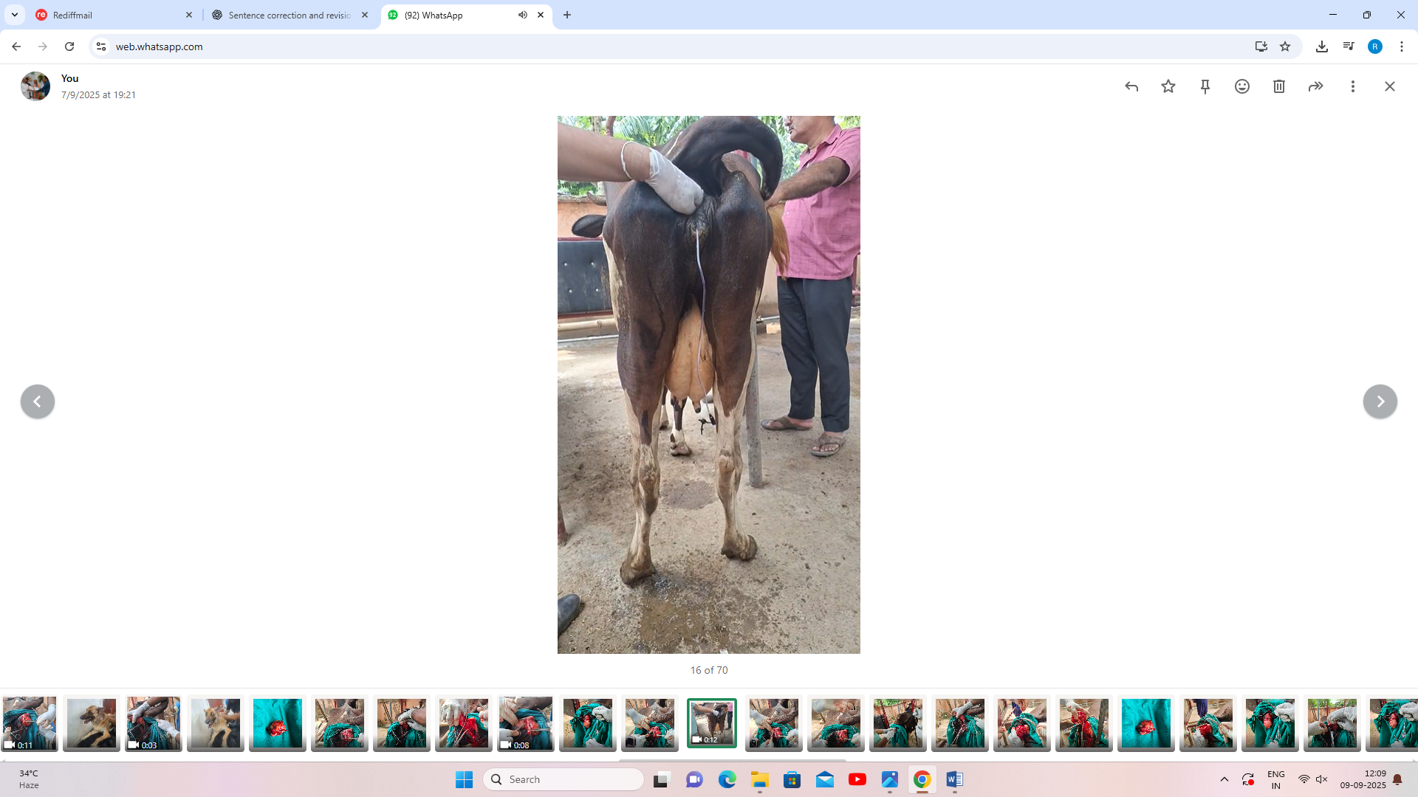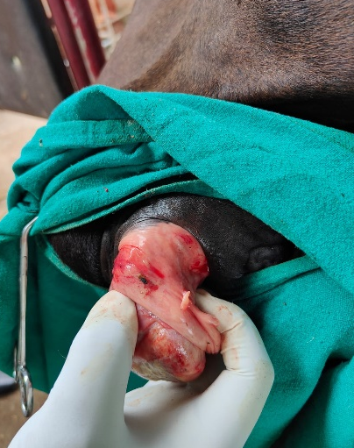
Fig. 1 A Fig.1 B Fig. 1 C Fig. 1A. Clinical case of leiomyoma, 1B. Catheterization 1C. Exteriorization of leiomyomas 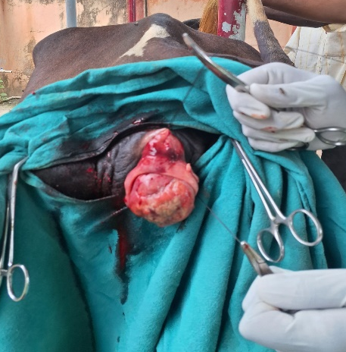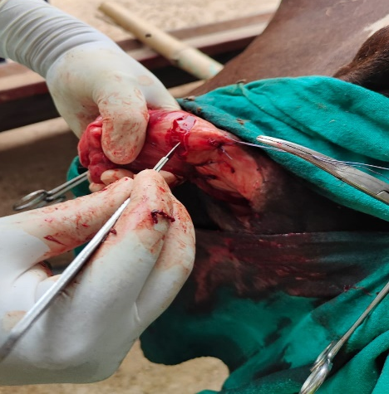 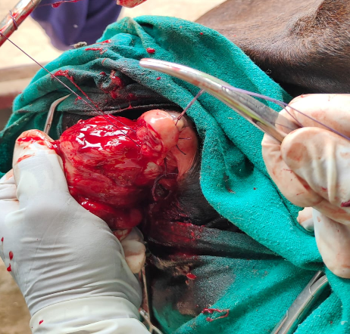
Fig. 2A Fig.2B Fig. 2C
Fig. 2A. Placement of temporary suture 2B. Elliptical incision 2C. Controlling the haemorrage
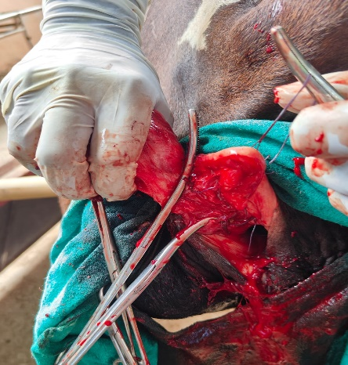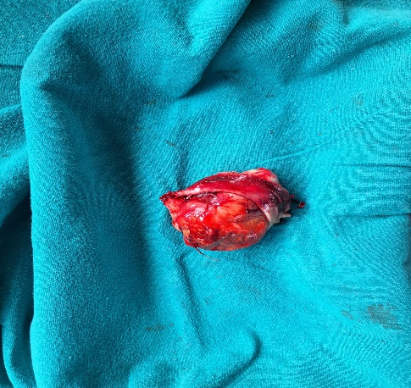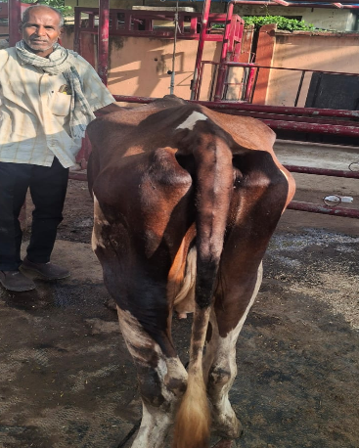
Fig. 3 A Fig. 3B Fig. 3C
Fig. 3A.Excision of tumour Fig.2B. Excise leiomyomas Fig. 3C. Recovery after surgery
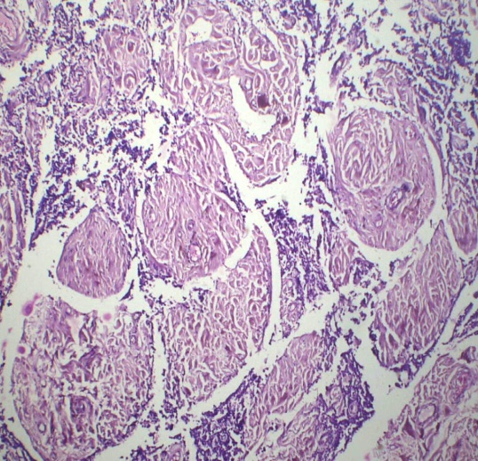
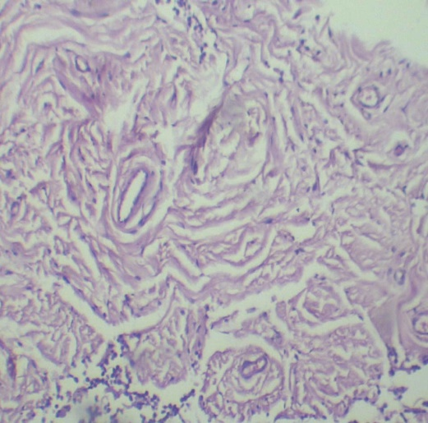

Fig. 4A Histological section (H&E, 4x) Fig. 4B. Histological section (H&E, 10x)

