Review Article

Assessing the Capacity and Management effectiveness of Extension Personnel: A Global Systematic Review and Bibliometric Analysis

Abstract
Extension personnel serve as vital intermediaries between research institutions and farming communities, and understanding the scientific production surrounding their training, capacity-building, and performance is essential for improving agricultural outcomes. The study applied the PRISMA methodology for a systematic literature review and employed R-studio for bibliometric analysis to examine global research trends on the capacity management of extension personnel, with particular attention to their role in agricultural development and knowledge dissemination. The study examined the literature published between 2020 and 2025. Well-screened data were obtained from the Scopus database with inclusion as well as exclusion criteria results of 65 relevant studies being reviewed. The annual scientific production analysis indicates fluctuating research activity, with a notable peak in 2021 followed by a gradual decline. This suggests that while scholarly interest in extension capacity remains significant, research may be shifting toward more specialized or applied approaches. Citation analysis reveals Ghana and Belgium as the most influential contributors, followed by the United States, South Africa, India, and Nigeria. This distribution highlights both developed and developing countries as key drivers of discourse, reflecting the global recognition of extension services in addressing agricultural and climate challenges. Keyword and thematic analyses further highlight “capacity building,” “adaptation,” and “sustainability” as central concepts, reinforcing the relevance of professional training and institutional support. Overall, the findings demonstrate that strengthening extension personnel capacity is critical to bridging knowledge gaps, enhancing farmer decision-making, and fostering sustainable agricultural development. Future research should emphasize cross-country collaboration, context-specific training, and innovative extension strategies to meet evolving global challenges.

Keywords: Extension personnel, Agricultural extension, Bibliometric analysis, Capacity building, Management effectiveness, ICTs usage.

Introduction
Agricultural extension personnel play a pivotal role in rural development, functioning as agents of change who bridge the gap between researches, policy, and farming practice (Nair et al. 2023). They not only disseminate innovations but also facilitate knowledge exchange, promote sustainable farming, and empower rural communities. The effectiveness of extension systems largely depends on the capacity, management, and performance of these professionals (Bereir, 2022).
Capacity refers to the knowledge, technical proficiency, communication, facilitation, and managerial skills that enable extension workers to respond to complex farming challenges. In pluralistic extension systems, where services are delivered by public agencies, private companies, and non-governmental organizations personnel must also demonstrate adaptability, collaborative ability, and competence in emerging technologies. Studies consistently highlight that capacity gaps at the individual, organizational, and enabling environment levels limit the effectiveness of extension service delivery (Swanson & Rajalahti, 2010; Davis, 2016). Capacity building is not a one-off intervention but a continuous process involving regular needs assessments, tailored training, and ongoing professional development (Washburn et al., 2022). Effective capacity development extends beyond technical training to include areas such as negotiation, conflict resolution, ICT integration, and organizational management. These competencies are critical in addressing evolving agricultural demands, including climate change adaptation, value chain development, and improved market linkages (Rivera and Qamar, 2019; Bereir, 2022). Without sustained investment in human resource development, extension systems risk becoming outdated and less responsive to farmer needs.
Management effectiveness is equally important in shaping extension outcomes. It determines how well resources, infrastructure, and personnel are mobilized for maximum impact. Sound management involves strategic planning, resource allocation, accountability mechanisms, supervision, and performance incentives. Research from regions such as Nigeria, India, and Bangladesh indicates that gaps in management such as inadequate funding, lack of operational support, weak monitoring systems, and limited professional incentives significantly undermine service delivery (Benge et al, 2020; Alam and Kijima, 2024). The managerial functions of planning, organizing, directing, and supervising directly influence not only staff motivation but also the quality of interactions between extension personnel and farmers (Tafida et al., 2024). Performance management tools, such as results-based management, benchmarking, and participatory monitoring, are increasingly recommended to improve efficiency and farmer-oriented service delivery (Olagunju et al. 2024). However, adoption remains inconsistent, particularly in resource-constrained contexts where weak coordination and fragmented institutional structures persist. International agencies, including FAO and GFRAS, advocate reforms that integrate performance management into extension systems through certification, continuous education, and infrastructure investments to ensure accountability and sustainability (FAO, 2021; GFRAS, 2019).
The role of extension personnel is also evolving. Traditional models of technology transfer are giving way to facilitative approaches that emphasize co-learning, farmer participation, and innovation brokering within agricultural innovation systems. Extension professionals are now expected to link farmers with markets, credit, information systems, and climate-resilient practices in addition to providing technical advice. Case studies from South Asia and Sub-Saharan Africa demonstrate the growing importance of competency frameworks, incentive structures, and career progression pathways to sustain motivation and improve service outcomes (Sulaiman & Davis, 2012; Mwangi, 2018). Despite these advancements, systemic challenges continue to constrain extension services. An aging workforce, gender imbalances, limited recruitment of new personnel, and fragmented coordination structures remain widespread issues. Moreover, the dynamic agricultural environment shaped by globalization, climate change, and socio-economic transitions, demands that extension systems become more adaptive and innovative. The integration of ICTs, stakeholder mapping, and continuous professional learning are emerging strategies that can revitalize extension services, enhance accountability, and promote the professionalization of extension workers.
In this context, conducting a systematic literature review (SLR) on the capacity, management, and performance of extension personnel is timely and necessary. Such a review will provide a comprehensive understanding of the current state of extension systems, identify gaps in knowledge and practice, and highlight best practices for strengthening extension services globally. Ultimately, the findings can inform policy, training frameworks, and institutional reforms aimed at making agricultural extension more responsive, inclusive, and impactful in achieving sustainable rural development. A systematic review combined with a Bibliometric analysis of existing literature offers valuable insights into the role of capacity and management effectiveness of extension personnel (Linnenluecke et al., 2020; Matić and Sunjka, 2022). Systematic reviews synthesize relevant studies to identify trends, best practices and knowledge gaps, while Bibliometric analysis quantitatively maps the academic landscape, uncovering influential publications, authors and research themes (Verma et al., 2024). Together these methods provide a holistic understanding of the current knowledge base and serve as essential tools for guiding future research, policy development and practical applications. Bibliometric analyses demonstrate a role of extension personnel in agricultural extension systems with prominent topics including capacity building, work performance and management effectiveness. These methods have proven crucial for identifying emerging research trends and setting directions for future investigations.
This study aims to critically evaluate the contribution of extension personnel in agricultural extension systems globally. By identifying patterns in scholarly research and providing a synthesis of findings, this paper seeks to:
- Highlight the global research trends focused on capacity and management effectiveness of extension personnel.
- Which journals were the most frequently cited in the references and which authors received the most citations within the selected literature contributing to the discussion of capacity and management effectiveness of extension personnel?
- Which keywords, thematic groups and technical developments are most commonly mentioned in the chosen literature?
Through this effort, the study aspires to inform stakeholders like researchers, policymakers, practitioners and funding agencies about the comprehensive understanding of the current state of extension systems, identify gaps in knowledge and practice, and highlight best practices for strengthening extension services globally. Ultimately, the findings can inform policy, training frameworks, and institutional reforms aimed at making agricultural extension more responsive, inclusive, and impactful in achieving sustainable rural development.

Material and Methods
The study employed a systematic literature review approach to address the research questions, with the primary aim of critically evaluating relevant literature on the topic. This method facilitates the identification of diverse global and national capacity and management studies related to extension personnel (William et al. 2021). It also highlights gaps in the literature and suggests areas for further research advancements. The approach utilizes a systematic, replicable and transparent process for reviewing and synthesizing literature ensuring minimal bias in the analysis. (Sadeghi et al., 2024; Mengist et al., 2020). This enhances readers' confidence in understanding the current state of knowledge related to the research questions (Wright et al. 2007). When applied rigorously and with minimal errors, the methodology provides reliable findings and conclusions that can guide decision-makers and scientific practitioners in their actions.
Relevant literature within the selected theme was meticulously identified, evaluated and synthesized through a rigorous systematic process. (Xiao et al., 2019; Linnenluecke et al., 2020; Yeritsyan et al., 2024). The systematic literature review techniques given forth by and were logically combined to produce the scientific articles for the study to recover pertinent articles for achieving the study’s objective (Wright et al. 2007; William et al. 2021). Their methods include (a) choosing a topic and developing research questions, (b) creating research protocols, including researcher-specific inclusion and exclusion criteria as well as an additional eligibility criterion, (c) searching for and identifying articles from scientific and widely accepted electronic databases, (d) evaluating and reviewing the articles and (e) extracting data and presenting the findings. The study employed the PRISMA (Preferred Reporting Items for Systematic Review and Meta-Analyses) (Figure 1) framework (Misra and Mention, 2022) to conduct a Systematic Literature Review examining the capacity and management effectiveness of extension personnel.
Identification of studies via Scopus database

Identification

Studies identified from database searches
Search equation #1 (n= 60)
Search equation #2 (n= 179)
Search equation #3 (n= 57)

Records excluded based on the inclusion/exclusion criteria (n= 191)

Record obtained according to the inclusion/exclusion criteria (n= 105)

Screening
Records excluded after screening title and abstract (n=33)

Records found after screening the title and abstract (n= 72)

Duplicate documents excluded (n=7)
Included

Studies included in Bibliometric analysis (n= 65)

Figure 1. PRISMA flow diagram: Outlining the process of identifying and screening sources

Defining the Research Problem:
The study investigates the capacity and management effectiveness of Extension personnel for effective agricultural extension systems. Building on three key research questions, it examines their capacity needs assessment and their work performance and effectiveness in managing agricultural extension systems. This analysis aims to provide valuable insights for future research and intervention design.
Search strategy:
The literature search focused on identifying relevant and recent emerging studies through Scopus databases from 2020-2025, which is widely recognized as one of the leading article search engines, approved by experts and offers more extensive coverage compared to other platforms. This study employed three distinct search equations to comprehensively explore the capacity and management effectiveness of extension personnel. The first equation (Table 1) focused on the capacity needs and development of extension personnel. The second equation (Table 2) focused on their performance and effectiveness on service delivery to farmers. The third equation (Table 3) focused on the performance evaluation, role, challenges, monitoring and evaluation of extension personnel for effective agricultural extension systems.
The search string incorporated diverse variations of keywords, Boolean operators, and truncation symbols to ensure the retrieval of relevant and robust results for subsequent analysis. The criteria applied for the inclusion and exclusion process after the execution of the search equations are presented in Table 4.

Table 1: The first search equation
Keywords used for searching in Scopus Database | Results found | Results found after filtration
“Agricultural Extension” OR “ Extension Personnel”  AND  “Capacity Building” OR “Capacity Development” OR “Capacity needs” | 60 | 17

Table 2: The second search equation
Keywords used for searching in Scopus Database | Results found | Results found after filtration
“Agricultural Extension” OR “ Extension Personnel”  AND  “Performance” OR “effectiveness” OR “service delivery” | 179 | 40

Table 3: The third search equation
Keywords used for searching in Scopus Database | Results found | Results found after filtration
“Agricultural Extension” OR “ Extension Personnel” OR “extension agents”  AND  “performance evaluation” OR “monitoring” OR “evaluation” | 57 | 15

Table 4: Inclusion and Exclusion criteria
Criteria | Inclusion | Exclusion
Time period | 2020 - 2025 | Before 2020
Subject area | Agricultural and Biological Sciences and Social Sciences | Business Management and Accounting, Economics, Econometrics and Finance Molecular Biology, Medicine, Environmental Science, Energy, Nursing, Mathematics, Computer Science, Biochemistry, Chemical Engineering, Genetics, Chemistry, Earth and Planetary Sciences, Immunology and Microbiology, Decision Sciences, Health Professions and Engineering, Multidisciplinary and Material Science
Document Type | Article and Conference papers | Book Chapters, Popular Articles, Reviews, Books
Language | English | Other than English
Source type | Journal and Conference proceedings | Books, Book series
Access type | Open Access | Restricted Access

Analysis of Search Results
In general, the effectiveness of a systematic review depends upon strict procedures, transparent reporting, and the use of scientific techniques to prevent biases and errors. The researchers effectively enhanced the systematic literature review by incorporating Bibliometric analysis to draw insightful conclusions about the current topic in this field. For Bibliometric analysis, R-studio software was used to analyse the trend of global aspect of research studies related to capacity and management effectiveness of extension personnel.

Results
The chosen articles for this review were studied across the span of 2020 to 2025, sourced from a diverse pool of 38 journals. The sixty five documents selected for this review exhibit an average citation rate of 6.985 per document. Cumulatively, these research papers cite a total of 2223 references.

Global trend of research studies: Bibliometric analysis
- Thematic map:
The bibliometric mapping generated from the Scopus database revealed distinct clusters of research themes associated with agricultural extension and the management of extension personnel. The thematic map positioned the themes across four quadrants based on their relevance (centrality) and level of development (density). These quadrants include motor themes, niche themes, basic themes, and emerging or declining themes, each reflecting the current state of research and its implications for extension capacity and personnel management.
Motor Themes
The upper-right quadrant of the map highlighted motor themes, which represent both well-developed and highly relevant topics in the field. The dominant clusters included “agricultural extension,” “agriculture,” and “farmers,” underscoring the centrality of extension services in bridging innovations with farming communities. Closely related clusters such as “work performance,” “competency,” and “extension agent” indicated that the literature strongly emphasizes the skills, knowledge, and professional competencies required of extension personnel. Another important cluster within this quadrant was “ICT, smallholder, and crop production,” which suggests that the integration of digital tools into extension practice is now a mainstream research area. These results demonstrate that performance effectiveness, digital capacity, and farmer-centered outcomes form the backbone of current extension research.
Niche Themes
In the upper-left quadrant, the analysis identified niche themes, which are highly specialized but less connected to the broader field. Key clusters included “performance, teamwork, in-service training, interview schedule,” and “constraints.” These themes indicate a concentration of studies on internal organizational processes such as teamwork dynamics, training interventions, and barriers to personnel effectiveness. While these topics are less central to the global discourse on agricultural extension, they provide methodological and managerial depth by addressing the micro-level challenges faced by extension agents within their institutions. Thus, these themes highlight the importance of continuous professional training and the mitigation of organizational constraints for strengthening personnel capacity.
Basic Themes
The lower-right quadrant revealed basic themes, which are highly relevant to the field but underdeveloped in terms of internal cohesion. Notable clusters included “extension agents,” “extension services,” and “adoption.” These topics are foundational to extension studies but remain conceptually fragmented, suggesting a need for more systematic theoretical and empirical exploration. Related clusters such as “capacity building” and “extension” highlight the centrality of human resource development, though the literature still lacks a comprehensive framework for assessing capacity-building interventions. Additionally, “Covid-19” appeared as a relevant but shallow theme, reflecting its recent emergence as a contextual challenge to extension delivery. Collectively, the basic themes underscore the necessity for more integrated studies on adoption processes, capacity-building mechanisms, and the resilience of extension services under external shocks.
Emerging or Declining Themes
The lower-left quadrant comprised emerging or declining themes, which were both less developed and less central. Among these were “professional development, work-life balance, smallholder farmers, constraints, confirmatory factor analysis, climate change, and Nigeria.” While some of these may represent declining foci, others such as climate change and professional development point toward emerging areas of inquiry that are likely to gain more importance in the near future. For instance, climate change adaptation and its implications for extension service delivery is a rapidly growing concern, while attention to work-life balance reflects a more recent interest in personnel wellbeing and retention. Similarly, country-specific studies (e.g., Nigeria) and methodological approaches (e.g., confirmatory factor analysis) suggest the diversification of research in terms of context and analytical rigor.

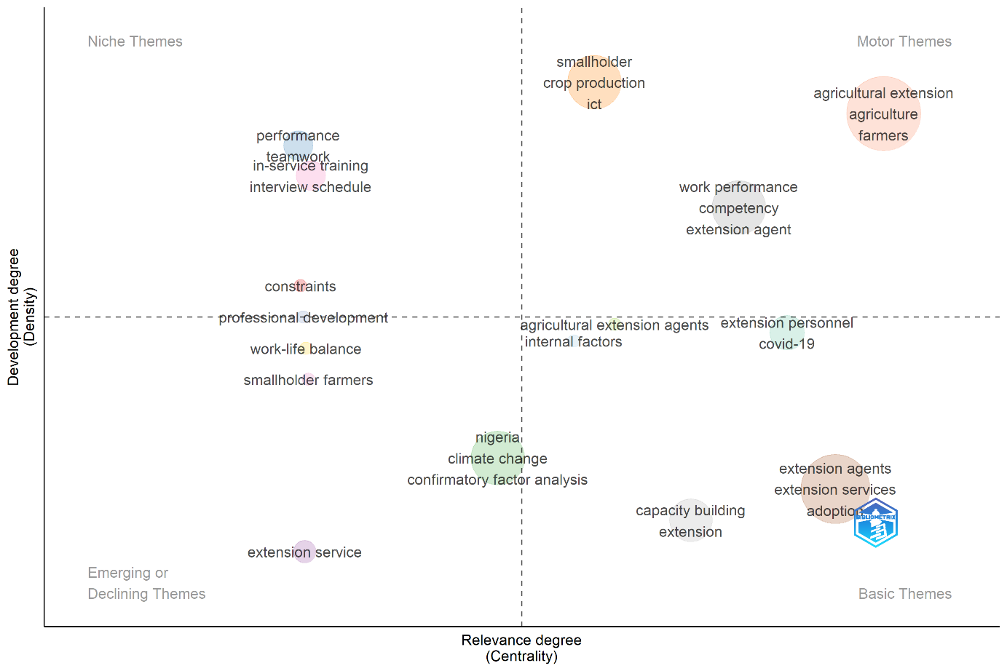
Figure 2: Global research studies thematic map

- Word cloud:
The word cloud illustrated the most frequently occurring keywords in the literature on agricultural extension and extension personnel. Larger terms such as “extension agents,” “agricultural extension,” and “capacity building” indicated the core focus on the roles, competencies, and development of extension workers as intermediaries between research institutions and farming communities. Related terms like “work performance” and “extension services” emphasized growing interest in evaluating personnel effectiveness, service delivery, and institutional strengthening. Country-specific keywords such as “Nigeria” and “Ghana” highlighted the regional concentration of research in sub-Saharan Africa, where strengthening extension capacity is crucial for smallholder farming and food security. Emerging themes included “climate change,” “ICT,” and “technology adoption,” reflecting attention to resilience and the digital transformation of extension services. The presence of “Covid-19 training” signals an interest in how global crises reshape extension delivery. In addition to technical and contextual themes, the word cloud also pointed to organizational dimensions such as “professional development,” “human resource development,” “work-life balance,” and “constraints.” These highlighted the importance of staff wellbeing, motivation, and supportive institutional environments in ensuring effective extension performance.

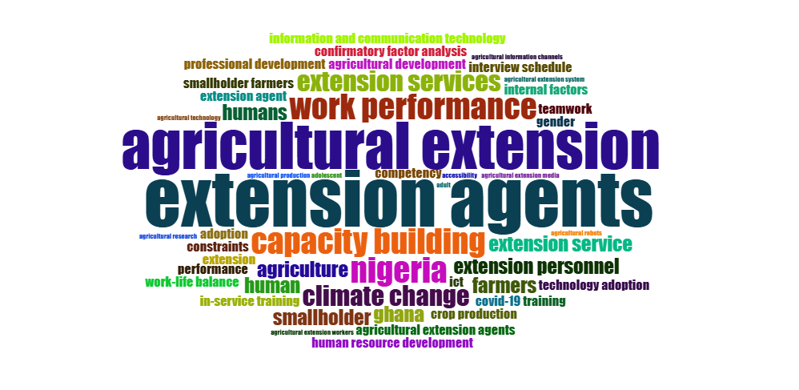
Figure 3: Research keywords word cloud

- Evaluation of global trending research topics:
The trend topic analysis revealed the changing focus of research on agricultural extension and personnel management between 2020 and 2025. The most prominent and persistent keywords include “agricultural extension,” “extension agents,” “capacity building,” “work performance,” and “Nigeria.” Each of these terms represents critical research themes, though their prominence and duration differ. Agricultural extension emerged as a dominant and continuous topic, spanning multiple years and reaching its highest frequency in the most recent period. This reflects its role as the overarching concept around which other themes revolve. Extension agents also appeared consistently, with high frequency, highlighting their central role in scholarly discussions on human resource capacity and service delivery. Capacity building surfaced as a shorter-term but relevant theme, suggesting a growing interest in interventions aimed at strengthening personnel competencies. Work performance appeared more recently (post-2022), indicating a shift toward evaluating extension outcomes in terms of measurable personnel performance. Nigeria emerged as a country-specific research hotspot, pointing to a significant concentration of empirical studies within the sub-Saharan African context.

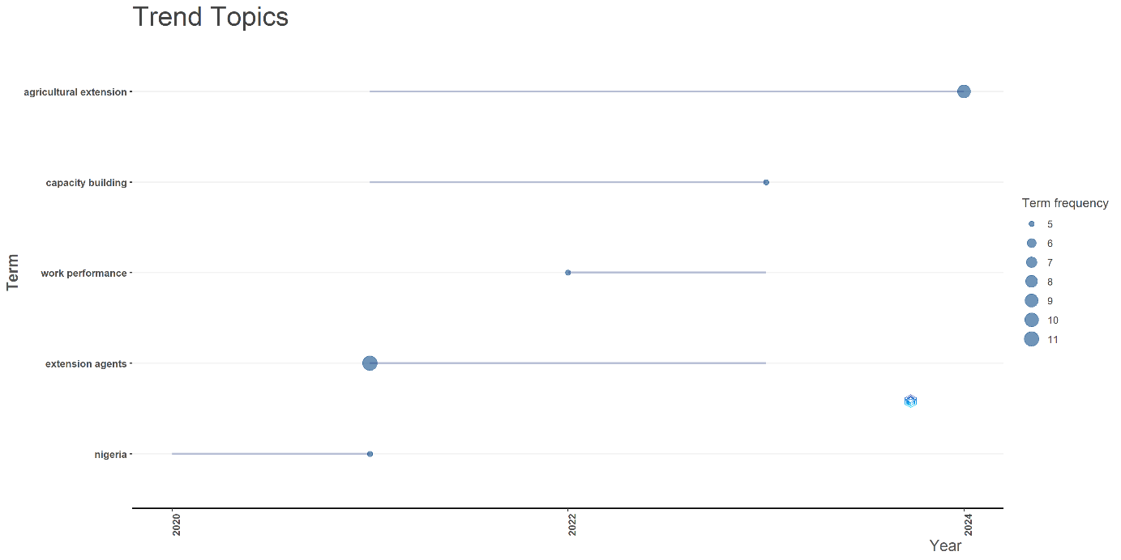

Figure 4: Evaluation of global trend research topic

- Most relevant sources
The analysis of publication sources revealed that research on agricultural extension and personnel management is disseminated across a variety of specialized journals, though a few dominate the field. The Journal of Agricultural Extension emerged as the most relevant outlet, contributing 10 documents, making it the leading platform for publishing work in this area. The Sarhad Journal of Agriculture followed closely with 7 documents, while the IOP Conference Series: Earth and Environmental Science and the Indian Journal of Extension Education contributed 6 and 4 documents, respectively. Other notable sources included the Journal of Extension (3 documents), the Journal of Agricultural Education and Extension (2 documents), and the Pertanika Journal of Science and Technology (2 documents). A smaller but significant number of contributions came from multidisciplinary and regional journals such as the African Journal of Food, Agriculture, Nutrition and Development, Agriculture (Switzerland), and AIP Conference Proceedings (each with 1 document).
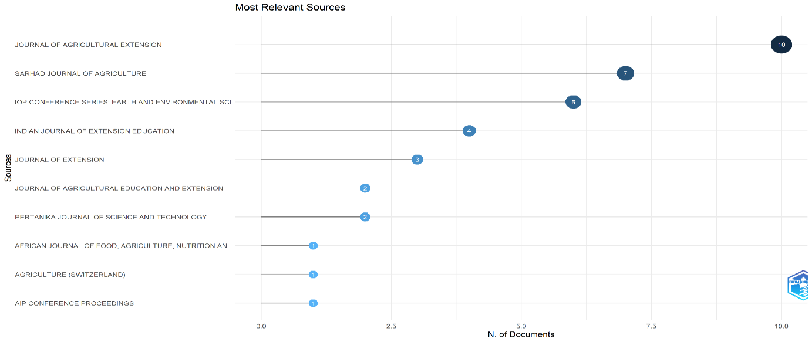

Figure 5: Most relevant sources

- Annual research studies production:
The annual scientific production trend shows fluctuations in the number of publications between 2020 and 2025. The output began with 8 articles in 2020, followed by a sharp increase in 2021, peaking at 18 articles. However, this was followed by a significant decline in 2022, with only 8 publications. A moderate recovery occurred in 2023 and 2024, with 12 publications each year, before declining again in 2025 to the lowest point (7 articles). The production trend suggests that research on agricultural extension and personnel capacity experienced a burst of scholarly attention in 2021, possibly reflecting heightened global concerns about agricultural resilience and extension services during the Covid-19 pandemic. The sharp decline in 2022 may indicate a temporary redirection of research efforts or funding constraints. The rebound in 2023 and 2024 reflects a renewed interest in extension-related issues, likely driven by the growing emphasis on capacity building, work performance, and technology adoption as seen in the thematic and trend analyses. The decline in 2025 could suggest either a saturation of research in certain areas or a shift of focus toward emerging issues such as climate change adaptation and digital extension systems. Overall, the pattern indicates that while the field continues to attract attention, research production remains cyclical, influenced by global challenges and regional priorities.

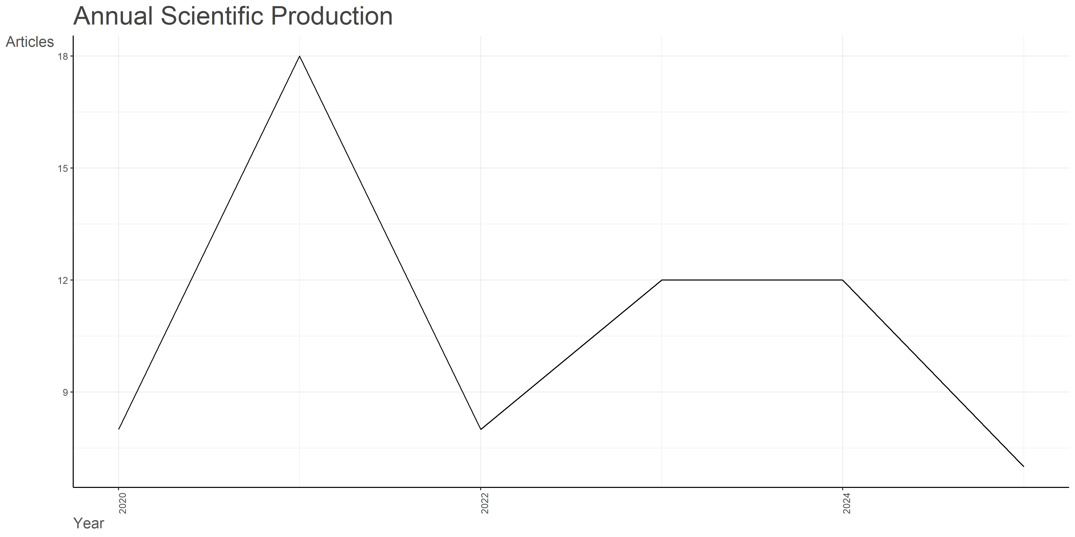
Figure 6: Global annual research studies production

- Global citation ranking
The analysis of citation impact by country shows that Ghana holds the highest citation count with 177 citations, followed by Belgium with 95 citations. The USA (27 citations) and South Africa (24 citations) also demonstrate notable influence, while India (20 citations), Nigeria (20 citations), and Saudi Arabia (19 citations) make up the next tier of highly cited countries. Other contributing nations such as Israel (6), Malaysia (5), and Indonesia (4) recorded comparatively fewer citations. The findings suggest that Ghana and Belgium dominate scholarly influence in agricultural extension research, likely due to strong institutional involvement and collaborative networks that enhance citation visibility. The presence of the USA and South Africa in the top ranks reflects their active role in agricultural innovation and rural development research. The balanced citation contributions from India, Nigeria, and Saudi Arabia highlight the growing regional interest in agricultural extension, particularly in contexts where food security and sustainable practices are urgent priorities. In contrast, countries such as Malaysia, Israel, and Indonesia show lower citation counts, possibly due to either a smaller volume of publications or less international collaboration. Overall, the citation distribution underscores the global but uneven research influence, with a few countries leading the discourse while others are emerging contributors.
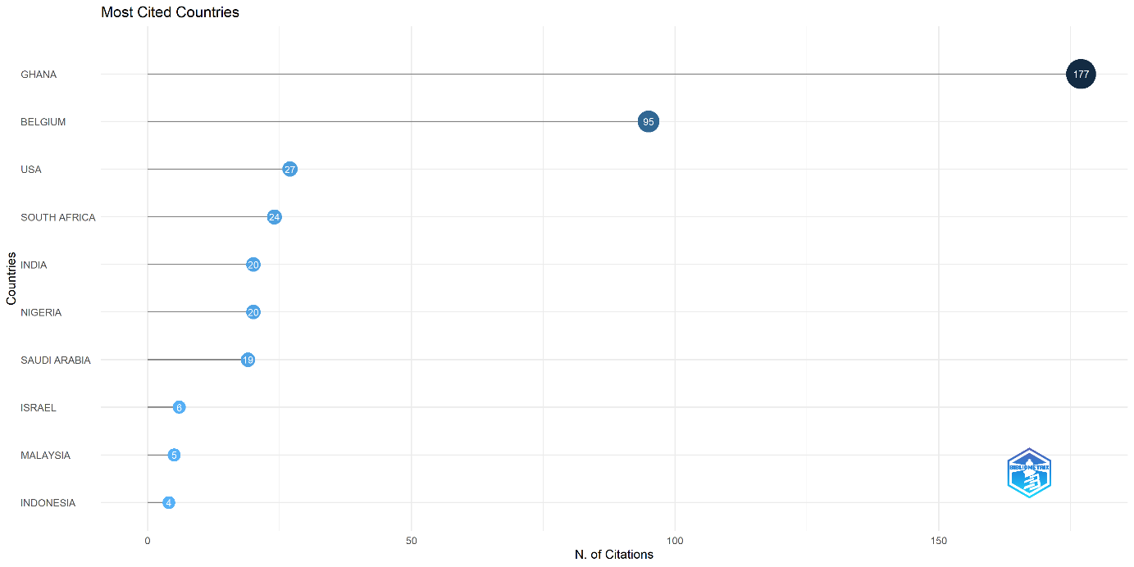
Figure 7: Country wise global citation ranking

- Most global cited documents
The citation analysis highlights Antwi-Agyei (2021) published in Climate Risk Management as the most influential work, with 173 global citations, far surpassing all other documents. The second most cited study is Van Campenhout (2021) in the American Journal of Agricultural Economics, which received 95 citations. Other notable contributions include Oyinbo (2020) with 25 citations, and both Alzahrani (2023) and Olorunfemi (2020) with 19 citations each. A set of publications, such as Washburn (2022) with 11 citations, Bhattacharyya (2021) with 10 citations, and Robertson (2021) with 9 citations, have moderate visibility. Meanwhile, Mustapha (2022) and Benge (2020) recorded 7 citations each, reflecting comparatively lower but still relevant recognition. The findings show that the research landscape is dominated by a small number of highly cited studies, particularly those addressing climate risk management, agricultural economics, and resilience in farming systems. The prominence of Antwi-Agyei’s and Van Campenhout’s works suggests that scholarship linking climate change, risk mitigation, and agricultural livelihoods resonates strongly with the academic community.
Mid-tier cited documents (Oyinbo, Alzahrani, Olorunfemi) indicate an expanding interest in agricultural education, extension services, and sustainable practices. These studies may not have reached the global visibility of the top two but play an important role in shaping regional and thematic discourse. The lower-cited works, although less visible internationally, contribute to emerging areas such as public health intersections, farmer partnerships, and behavioral studies. Collectively, the distribution of citations reflects a concentration of influence in climate and economics-related research, while other subfields remain underexplored but growing in relevance.
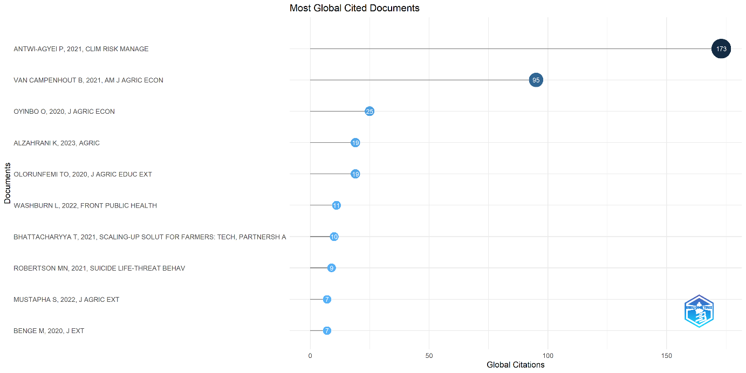
Figure 8: Most global cited documents

Discussion
The thematic structure identified in this study provides valuable insights into the current research landscape on agricultural extension and the management of extension personnel. The motor themes illustrate that extension agents’ competency, ICT utilization, and farmer engagement are well-established areas driving scholarly attention. These align closely with global priorities for enhancing agricultural productivity and ensuring effective knowledge transfer. The niche themes reveal that internal human resource practices such as teamwork, in-service training, and overcoming institutional constraints are receiving focused but relatively isolated attention. While these may not dominate global discourse, they are vital for strengthening personnel management systems, especially in contexts where resource limitations and institutional inefficiencies constrain extension effectiveness. The basic themes highlight a paradox: although topics like capacity building and service adoption are central to extension work, they remain underdeveloped. This suggests that future research should prioritize developing coherent models and evidence-based frameworks for assessing and improving capacity-building interventions. Furthermore, the presence of Covid-19 as a basic theme reflects the urgency of rethinking extension service delivery under crisis conditions. Finally, the emerging or declining themes provide signals of future directions. Issues such as climate change adaptation, personnel wellbeing, and context-specific analyses (e.g., Nigeria) are gaining recognition and may evolve into mainstream areas of inquiry. These themes emphasize the growing awareness of external pressures and internal organizational needs that affect extension personnel capacity and management effectiveness. Overall, the results suggest that while the foundations of extension research remain strong, there is a pressing need to deepen work on capacity-building strategies, integrate resilience perspectives, and address personnel wellbeing. Such focus will ensure that extension systems remain robust, adaptive, and effective in responding to both current and future agricultural challenges.
The dominance of the Journal of Agricultural Extension highlights its position as the central hub for scholarship on extension services, personnel capacity, and related themes. Its consistent output indicates that it is a primary outlet for both conceptual and applied studies in this domain. The prominence of the Sarhad Journal of Agriculture and the Indian Journal of Extension Education suggests strong contributions from Asia, reflecting regional engagement in extension research and its importance to agricultural development in these contexts. The presence of the IOP Conference Series: Earth and Environmental Science indicates that extension-related studies are also being positioned within broader discussions of environmental and sustainability issues. Similarly, outlets such as the Journal of Agricultural Education and Extension and Journal of Extension reinforce the academic focus on the professional training, educational roles, and organizational capacity of extension personnel. The contributions from multidisciplinary and regional journals (e.g., African Journal of Food, Agriculture, Nutrition and Development) reflect the context-specific nature of extension research, particularly in Africa where agricultural extension remains critical for smallholder farming and food security. Meanwhile, the inclusion of outlets like Agriculture (Switzerland) suggests that extension-related issues are not only of concern in developing contexts but are also relevant in global agricultural discussions.

Conclusion
The bibliometric analysis provides valuable insights into the evolving discourse on the capacity management of extension personnel and its role in strengthening agricultural systems. The annual scientific production reveals fluctuations in research attention, with a peak in 2021 followed by a gradual decline. This suggests that while capacity development of extension workers remains an important theme, scholarly focus may be diversifying into specialized subfields such as digital extension tools, climate resilience, and farmer empowerment. Such a shift emphasizes the need for continuous investment in knowledge-building initiatives that can enhance extension services in line with emerging challenges. The citation analysis highlights the significant contributions of countries such as Ghana and Belgium, which lead in global recognition, alongside the USA, South Africa, India, and Nigeria. The prominence of both developed and developing nations suggests that capacity management is a universal concern, though its focus and application vary by context. For developing countries, the emphasis is often on scaling up training and infrastructure to address gaps in extension delivery, while developed nations may focus more on innovation and technology-driven approaches. This diversity of contributions reinforces the importance of cross-country collaboration and knowledge exchange in advancing extension capacity. At the document level, highly cited works underscore critical areas such as climate risk management, agricultural economics, and extension education. These themes reflect the interdisciplinary responsibilities of extension personnel, who must not only provide technical knowledge but also support farmers in managing risks, adapting to climate change, and adopting sustainable practices. The recurrence of keywords such as “capacity building,” “adaptation,” and “sustainability” further underscores that effective capacity management is not limited to skill development but also involves institutional strengthening, resource allocation, and policy support.
Taken together, the findings suggest that capacity management of extension personnel is a cornerstone for advancing agricultural development and resilience. By investing in systematic training, fostering innovation, and strengthening institutional frameworks, extension systems can better equip personnel to address complex and evolving farmer needs. Future research and practice should therefore prioritize integrated approaches that combine technical skills, soft competencies, and digital innovations to enhance the effectiveness and sustainability of extension services.

Data availability
Data involved in this review paper will be available upon reasonable request to the corresponding author.
Declaring of conflicting interests
The authors declared no potential conflicts of interest with respect to the research, authorship, and/or publication of this review paper.

References

- Alam M.R. and Kijima Y. 2024. Incentives to Improve Government Agricultural Extension Agent Performance: A Randomized Controlled Trial in Bangladesh. Economic Development and Cultural Change 72(3): 1295-1316 10.1086/723492.
- Anshuman J., Kaur R., Rampal V.K. and Jayasingh D.K. 2024. Factors Affecting Training Effectiveness of Extension Personnel in PAMETI, Punjab. Indian Journal of Extension Education, 60(4): 73-76. DOI 10.48165/IJEE.2024.60413.
- Antwi-Agyei P. and Stringer L.C. 2021. Improving the effectiveness of agricultural extension services in supporting farmers to adapt to climate change: Insights from Northeastern Ghana. Climate Risk Management 32: 100304 DOI 10.1016/j.crm.2021.100304
- Anugwa I.Q., Babu S.C., Agwu E.A. and Madukwe M.C. 2024. Building Organizational Resilience of Public Extension System during Pandemic in Enugu State, Nigeria. Journal of Agricultural Extension, 28(2): 85-97. DOI 10.4314/jae.v28i2.8
- Bereir A.M. 2022. Evaluation of Agricultural Research, Extension and Farmers Linkages: A case study from Gezira State, Sudan. International Journal of Agricultural Science, Research and Technology in Extension and Education Systems, 12(2): 111-117.
- Dewi Y.A., Bahru B.A. and Zeller M. 2025. Performance of agricultural extension agents in Indonesia: evidence from a nationally representative survey. Journal of Agricultural Education and Extension, 31(4): 527-553. DOI 10.1080/1389224X.2024.2407178.
- Farida I., Sumardjo S., Fatchiya A. and Tjitropranoto P. 2024. The gap between extension agents' interests and needs towards agricultural extension media. AIP Conference Proceedings, 3048(1): 20036. DOI 10.1063/5.0202072.
- Linnenluecke, M.K., Marrone, M. and Singh, A.K. 2020. Conducting systematic literature reviews and bibliometric analyses. Australian Journal of Management, 45(2), pp.175-194.
- McKenzie, J.E., Bossuyt, P.M., Boutron, I., Hoffmann, T.C., Mulrow, C.D., Shamseer, L., Tetzlaff, J.M., Akl, E.A., Brennan, S.E., Chou, R. and Glanville, J. 2021. The PRISMA 2020 statement: an updated guideline for reporting systematic reviews. Bmj, 372(71), pp.1-9.
- Mittal V., Binkadakatti J. and Sathyanarayana K. 2023. Role of capacity building, extension and services in tasar sector. Journal of Environmental Biology, 44(3): 524-532. DOI 10.22438/jeb/44/3(SI)/JEB-15
- Mustapha S., Man N., Shah J.A., Kamarulzaman N.H. and Tafida A.A. 2021. Factors Influencing the Adoption of ICTs in Extension Service Delivery among the Extension Agents in North-East, Nigeria. Sarhad Journal of Agriculture, 38(1): 149-159. DOI 10.17582/journal.sja/2022/38.1.149.159.
- Nair N.B., Jahagirdar K.A., Angadi J.G. and Meena M.S. 2023. Professional Competence of Extension Personnel in Karnataka State of India. Indian Journal of Extension Education, 59(2): 79-83. DOI 10.48165/IJEE.2023.59217
- Nawaz A., Khan M.Z., Ullah R., Nawab K. and Pervaiz U. 2020. Investigation of Professional Competency Level and Training Needs of Field Assistants in Khyber Pakhtunkhwa. Sarhad Journal of Agriculture, 36(3): 867- 874. DOI 10.17582/journal.sja/2020/36.3.867.874
- Olagunju O., Hassan S., Samad M.Y.A. and Kasin R. 2021. Enhancing work performance of extension agents among cocoa farmers in Malaysia: The influence of human resource development skills. Walailak Journal of Science and Technology, 18(5): 1-15 DOI 10.48048/wjst.2021.8985.
- Olorunfemi O.D. and Oladele O.I. 2021. Determinants of professionalisation of extension service delivery: A confirmatory factor analysis approach. South African Journal of Agricultural Extension, 49(3):123-135. DOI 10.17159/2413-3221/2021/v49n3a12967.
- Olorunfemi O.D., Oladele O.I. and Olorunfemi T.O. 2021. Perceived Effects of Professionalization of Extension Services by Public and Private Agents in South West Nigeria. Journal of Agricultural Extension 25(1): 59-72. DOI 10.4314/jae.v25i1.7.
- Olorunfemi T.O., Olorunfemi O.D. and Oladele O.I. 2020. Borich needs model analysis of extension agents’ competence on climate smart agricultural initiatives in South West Nigeria. Journal of Agricultural Education and Extension, 26(1): 59-73. DOI 10.1080/1389224X.2019.1693406
- Otoo J., Musah R., Olita T., Ireland K.B. and Zerihun A. 2024. Knowledge and perception of cereal farmers and extension agents on fungicide use in northern Ghana. Pest Management Science, 80(9): 4207-4215. DOI 10.1002/ps.8124.
- Patil S.V. and Sharma A. 2021. Prioritisation of training needs of extension personnel in brackishwater shrimp aquaculture of Maharashtra, India. Indian Journal of Fisheries, 68(4): 135-141. DOI 10.21077/ijf.2021.68.4.105451-15
- Rabbi M.F., Liza Z.A. and Rahman M.S. 2023. Capability Enhancement of Agricultural Extension Personnel through ICT Interventions and its Economic Impact in Bangladesh. Economic Affairs (New Delhi), 68(4): 1937-1945. DOI 10.46852/0424-2513.4.2023.5.
- Rivera, W. M., & Qamar, M. K. (2003). Agricultural extension, rural development and the food security challenge. Food and Agriculture Organization of the United Nations.
- Sadeghi, R., Khajeh, A.M.B.K. and Pasban, M. 2024. A systematic literature review on supply chain approaches. Journal of Modelling in Management. DOI 10.1108/JM2-04-2021-0089.
- Swanson, B. E., & Rajalahti, R. (2010). Strengthening agricultural extension and advisory systems: Procedures for assessing, transforming, and evaluating extension systems (Agriculture and Rural Development Discussion Paper No. 45). World Bank.
- Tafida I., Bulus T.V. and Nazifi B. 2024. Strengths, Weaknesses, Opportunities and Threats to Extension Service Delivery in Kaduna State, Nigeria. Journal of Agricultural Extension, 28(1): 29-36. DOI 10.4314/jae.v28i1.4
- Tian X., Xu P., Liu X. and Xu X. 2025. The impact of digital information treatment on the evaluation of service performance of agricultural extension agents. Information Development, 41(2): 496-511. DOI 10.1177/02666669231173003.
- Washburn L., Norman-Burgdolf H., Jones N., Kennedy L.E. and Jarvandi S. 2022. Exploring Extension Agent Capacity and Readiness to Adopt Policy, Systems and Environmental Change Approaches. Frontiers in Public Health, 10: 856788. DOI 10.3389/fpubh.2022.856788.
- Wright, R. W., Brand, R. A, Dunn, W. and Spindler, K. P. 2007. How to write a systematic review, Clinical Orthopaedics and Related Research, 455: 23-29. DOI: 10.1097/BLO.0b013e31802c9098.
- Williams R. I., Clark, L. A. Clark, W. R. and Raffo, D. M. 2021. Re-examining systematic literature review in management research: Additional benefits and execution protocols, European management journal, 39(4): 521-533. https://doi.org/10.1016/j.emj.2020.09.007.
- Verma, N., Dhiman, B., Singh, V., Kaur, J., Guleria, S. and Singh, T. 2024. Exploring the global landscape of work-life balance research: A bibliometric and thematic analysis. Heliyon, 10(11).
- Xiao, Y. and Watson, M. 2019. Guidance on Conducting a Systematic Literature Review. Journal of Planning Education and Research, 39(1), 93-112. https://doi.org/10.1177/0739456X17723971

