The Molecular Science of Fragrances: Chemistry and Synthesis

.
ABSTRACT

This mini-review explores key milestones in fragrance chemistry. It focuses on musk, woody, and sandalwood scents, along with new fragrance precursors. After the brief history of perfumes, the whole spectrum of the evolution of musk odorants from nitro musks to modern compounds like Cyclomusk® and Moxalone® is discussed. It also highlights the concept of synthetic sandalwood fragrances and introduces innovative fragrance precursors and concepts like "anti-perfumes" that showcase the role of science and serendipity in fragrance development.

Keywords : Fragrance Precursors, Musks, Ionones, Odorants, Sandalwood.

1. INTRODUCTION

Fragrances are the combination of science and art; where chemists become creators and where molecules make memories. They give pleasure to billions of people around the world who use and enjoy fragrance every day - from the fresh, sparkling shower gel in the morning to the scented candle-lit dinners. Even shopping is accompanied by scents and when the people reach out for personal and homecare products, they very often have the choice between different fragrances variants of the same brand [1]. Fragrance chemistry focuses on the chemical compounds responsible for scents and their use in industries like perfumes, cosmetics and household products. The use of perfumes has a long history: In biblical times people sacrificed ‘through smoke’-per fumum -the treasure of nature to please the Gods.Dates back to ancient civilizations, natural substances such as resins, flowers and spices were used for rituals, personal adornment and medical purposes. After Napolean Bonaparte had ordained by decree in 1810 that manufactures and vendors had to make a distinction between pharmaceuticals and perfumes, eaux de Colognes were no longer drunk. The new perfumes, made only from natural ingredients like essential oils, became more refined over time. They turned into luxury items for kings, queens and wealthy people. In the late 19th century, synthethic ingredients were introduced, starting modern perfumery and giving perfumers more scents to work with.[1]
The first perfume maker on record was a woman chemist named Tapputi. Stories of the inventor of perfume have been found on a clay tablet from Mesopotamia, suggesting that perfume was invented by Tapputi sometime during the second millennium BC.Fragrance was of great importance in Egyptian high society.They made perfume by distilling natural ingredients with non-scented oils.The most popular scents were floral,woodsy and fruity.Great Egyptian leaders like Queen Cleopatra and Queen Hatshepsut used fragrances to scent their bodies,quarters,baths and even took perfume with them to the grave [2].
The ancient Persians were no less enchanted by fragrance .They ruled the perfume traders for hundreds of years.They are credited as the inventors of non-oil based perfume.Persian kings often had their own “signature scents”that their companions and relatives were not allowed to use.While Europeans turned their backs on perfumes for some time,other cultures enjoyed them regularly.For instance,perfume was at the heart of sacred Indian Tantric rituals,used in ceremonies and in their temples.The Chinese also used perfume for disinfection and purity as they believed that perfume could help rid a room of disease[2].In 1882,Paul Parquet created ‘Fougere Royale’ around an accord composed of coumarin,oakmoss,geranium and bergamot and with its launch by Houbigant the new era commenced. Perfumes changed a lot over time. Scientists discovered new scents, which helped create famous perfumes. ‘Shalimar’ (1919) had vanilla, resins, and floral notes, making it a classic oriental fragrance. ‘Chypre’ (1917) introduced a new perfume style with leathery scents, which became more popular later.
As fashion grew, perfumes became more creative. After World War 2 , people had more money, and perfumes became easier to buy. They were even added to everyday products.Today, perfumes are common and sold everywhere. Most people own different perfumes and choose one based on their mood. In the past, perfumes were rare and special, and women often used the same scent for years. Now, both men and women enjoy many different fragrances according to their daily mood.The fragrance industry, situated in between the petrochemical and the pharmaceutical industry, has been growing over the last hundred years to an estimated market size of 7000 Mio CHF. While the production scale of fragrance compounds is closer to that of pharmaceuticals, the product prices are closer to those of the bulk-chemical industry. Some ingredients, namely those with an extremely low odor threshold, are produced in kilogram quantities only. At the other end, some perfumery ingredients, mainly for use in detergents and homecare products, are produced in quantities of up to 10000 t/a, e.g. linalool(8000-10000 t/a), 2-phenylethanol(7000-9000 t/a), benzyl acetate (7000-9000 t/a), Galaxolide® (7000-8000 t/a),Lilial (5000-6000 t/a), Hedione® (4000-5000 t/a) and Iso E Super®(2500-3000 t/year)[1]. We aim to highlight key milestones of the most important fragrance notes, providing insight into the development of fragrance chemistry, the driving forces behind its evolution, and potential future trends in the industry [1].

2.Timelines of Odor Notes

2.1. Musks
Musk is a class of aromatic substances commonly used as base notes in perfumery. They include glandular secretions from animals such as the musk deer, numerous plants emitting similar fragrances and artificial substances with similar odors. Musk was a name originally given to a substance with a strong odor obtained from a gland of the musk deer. The substance has been used as a popular perfume fixative since ancient times and is one of the most expensive animal products in the world. Since deer musk requires killing an endangered animal, most musk fragrances today are synthetic, known as “white musk”. They are classified into three types: aromatic nitro musks, polycyclic musks and macrocyclic musk compounds. The first two are widely used in cosmetics and detergents but have raised health and environmental concerns, leading to restrictions. Macrocyclic musks are considered safer and are expected to replace them. [3]
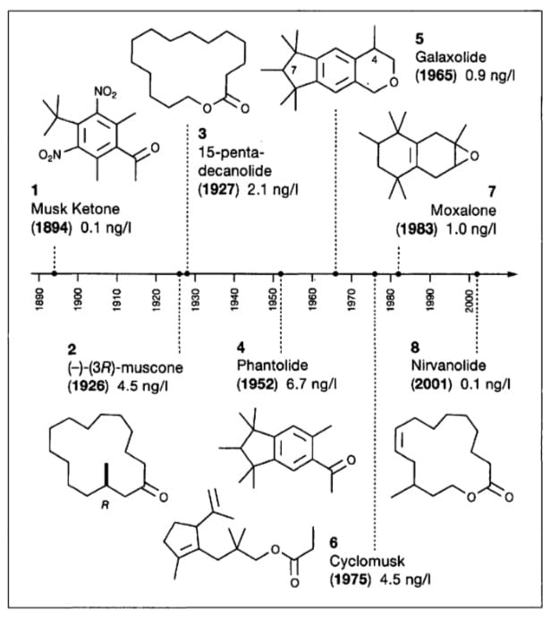
Figure 1:The Musk Timeline

Musk is often associated with religious significance. In Islam, musk is considered to be the most fragrant of the scents. It was widely used by the Islamic prophet Muhammad and his companions. Alexander the Great is also said to have perspired with the odor of musk. Popular scents in Arab Muslim tradition include jasmine, amber, musk and oud (agarwood) [4]. Musk has been used to attract wild animals, including in man-made perfume mixtures. For example, in 2018 Indian authorities used the perfume Obsession by Calvin Klein to attract and thus trap a wild tiger that had attacked and killed more than a dozen humans.
2.2. Ionone/Woody odorants
Empress Josephine’s wedding dress was embroided with violets for her marriage with Napoleon, 'crystallized violets' sprinkled with castor sugar are a delicacy, and violet petals have been used in cosmetic formulations and were spread amongst the laundry of those who could afford it. Today, with all the affordable violet-smelling toilet soaps available, one easily forgets that violet flower oil was the most expensive of all essential oils - at the times when it was still economic to
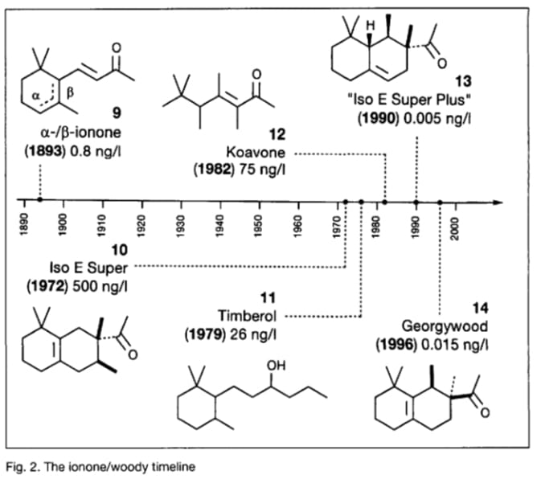
be produced, For the production of one kilogram of this oil 33000 kg of violet blossoms for ca, 2.50 German gold mark per kilogram were needed. That makes 82500 German gold marks for material costs alone per kilogram of the oil, much more than even the most precious musk grains. This high price was the reason that a synthetic violet odorant was highest on the agenda of the young fragrance industry [1].

Figure 2: The Ionone/woody timeline

Violet flower oil was too expensive to be used for isolation and structure elucidation with traditional techniques. Therefore assuming the same odour principles,the similarly smelling but much cheaper oil was used for the investigations named orris root oil.Via its phenylhydrazone, Tiemann and Kruger isolated the odorous principle irone and (incorrectly) determined its molecular formula by elemental analysis as C₁₃H₂₀O.This incorrect elemental analysis together with some oxidative degradation products let them believe that irone could be a base-catalyzed condensation product of acetone with citral. But the product of this reaction possessed 'a strange but not very characteristic odor'; however, when they cleaned the glassware with diluted sulfuric acid, Tiemanns nose detected the typical scent of violets in bloom. What they had actually discovered was ionone (9), and because of the similar smell and their incorrect elemental analysis of the earlier isolated irone, they concluded that the latter compound must be a double-bond isomer of the synthesized ionone (9). The correct constitution of the irones, homologs of the ion ones (9), was not established until more than 50 years later, in 1947, by Naves et al. of Givaudan, and independently by Ruzicka and co-workers at Firmenich.[1]. Ionone is a ketone compound composed of 13 carbons with a monocyclic terpenoid backbone. The term ionone derived from “iona” (Greek for violet) referring to the violet scent and “ketone” in relation to its structure [5].

Several isomeric ionones exist in Nature, including α-ionone, β-ionone and others. Ionones are found as secondary plant metabolism products that share mevalonic acid as a common precursor. They are widely present in fruits and vegetables comprising β-carotene and are found in plant oils, for example oils from Petunia hybrida, Boronia megastigma Nees and especially Viola odorata. It can be found in cow’s milk where is passively transferred after consumption of alfalfa pasture. α-Ionone and β-ionone are 3-buten-2-ones substituted by 2,6,6-trimethyl-2-cyclohexen-1-yl and 2,6,6-trimethyl-1-cyclohexen-1-yl groups respectively, at position 4 . The ionone stereoisomers, α-ionone and β-ionone, are pale yellow-to-yellow liquids with a woody floral scent. However, the former has an extra honey olfactory aspect. α-Ionone and β-ionone share similar physicochemical properties. They are both soluble in most fixed oils, alcohol and propylene glycol but insoluble/very slightly soluble in glycerin/water, respectively [5].

2.3. Sandalwood Synthetics
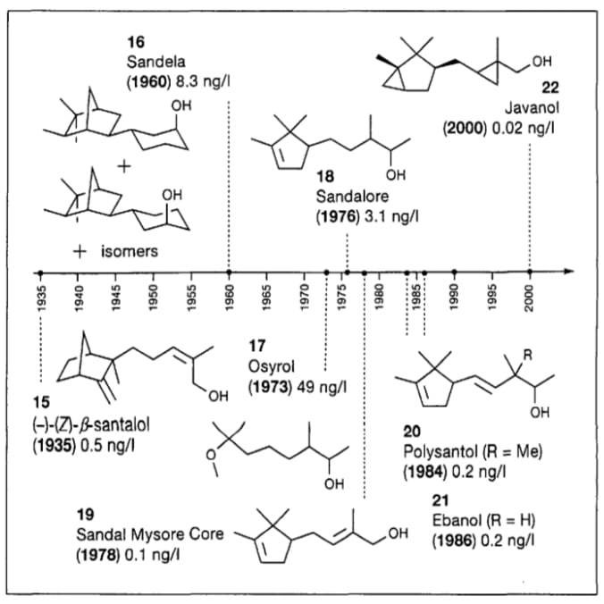
SANDALWOOD (Santalum album L.) is a prized gift of the plant kingdom woven into the culture and heritage of India. It is one of the most valuable trees in the world. The natural distribution of sandalwood extends from 30°N to 40°S from Indonesia in the east to Juan Fernandez Islands (Chile) in the west and from Hawaiian Archipelago in the north to New Zealand in the south. It is a small to medium-sized hemiparasitic tree, distributed rather widely in India. The populations are more concentrated in the southern region, especially Karnataka, Tamil Nadu and Kerala. For more than 5000 years, India has been the traditional leader of sandalwood oil production for perfumery and pharmaceuticals. The aroma of the oil and the wood is esteemed by people belonging to three major religions of the world – Hinduism, Buddhism and Islam. According to Vamana Purana, the wood is recommended for worshipping God Shiva. Goddess Lakshmi is believed to reside in the sandalwood tree (Brahma Vaivarta Purana)[6].
Figure 3: The Sandalwood timeline
There are many synthetic sandalwood molecules, but they are no substitute for natural sandalwood. They are used to boost natural sandalwood and should be handled with caution. Among the synthetic sandalwood molecules, we can mention: Polysantol, Sandalore, Sandella, Ebanol. Sandalwood contains 230 molecules, but not all of them are fragrant. Sandalwood can now be fractionated and only the interesting fractions kept. Santalol, terpenes, beta-caryophyllene, santalines, bergamotol are the main components of sandalwood.Good quality sandalwood should contain at least 90% of santalol.
Traditionally more associated with men's fragrances, sandalwood is now used in women's fragrances to add a woody note or to reinforce certain powdery notes. It is most often found in woody, orientals or fern fragrances. It is sometimes used to accompany floral notes such as iris for example: Sandalwood can be used as a main note, but it can be used in all olfactory families with different effects, it is even used with fresh notes. It was beautifully worked in Chanel's Bois Noir, later called Egoïste. In Guerlain's Samsara, it was used in an overdose for the first time in perfumery. Almost 20% of the formula is enhanced with other sandalwood notes such as polysantol and associated with jasmine and ylang-ylang.[7].

3.Art and Science of Perfume Formulation
Perfume formulation is a delicate blend of artistry and science,where creativity meets chemistry to create captivating scents that delight the senses.Behind every bottle of perfume lies a meticulous process of selecting,combining and balancing fragrance ingredients to achieve a harmonious olfactory composition.This guide offers a detailed exploration of the formulation of perfumes,shedding light on the key ingredients,techniques and considerations involved in crafting exquisite fragrances.
3.1.Understanding perfume ingredients:
At the heart of perfume formulation are fragrance ingredients ,which impart distant scents and contribute to the overall olfactory profile of the perfume.These ingredients can be derived from natural sources,such as essential oils and plant extracts, or synthesized in laboratories to mimic natural aromas.Common fragrance ingredients include:
- Essential oils: Extracted from plant materials through distillation or cold pressing,essential oils are aromatic compounds that provide fragrances with natural scents.Examples include lavender, rose, sandalwood and citrus oils.
- Synthetic Aroma Chemicals: Synthetic fragrance compounds are created through chemical synthesis to replicate the scents of natural materials or to achieve novel olfactory effects.These aroma chemicals offer a wide range of olfactory profiles,from floral and fruity to woody and musky.
- Absolutes and Extracts: Absolutes and extracts are highly concentrated aromatic material obtained through solvent extraction or enfleurage methods. They capture the pure essence of botanicals and are prized for their intensity and complexity. Examples include jasmine absolute, vanilla extract and tonka bean absolute.
- Fixatives and Modifiers: Fixatives are ingredients that help stabilize the fragrance, prolong its longevity and enhance its diffusion on the skin. Common fixatives include resins, balsams and synthetic musk’s. Modifiers are used to adjust the overall character of the fragrance, balancing its intensity, sweetness or freshness [8].

2. material and methods

- Collection of plant samples: Lavender (Lavandula angustifolia) flowers and leaves were collected from Egerton University main campus,Njoro,Kenya. The flowers and leaves were separately washed with running tap water and finally with distilled water to sterilize them.[9]
- Extraction of essential oils: A sample of 400g of fresh lavender flowers and leaves was separately loaded into 2-Litre round bottom flask containing 1.5 liters of water and placed on a heating mantle having a power rating of 450 watt and timed. The samples were boiled with water which helps to release the oil held within the matrix of the flowers and leaves. The volatile oils evaporated along with the water into the condenser connected to the flask at 100ºC and atmospheric pressure. The condensed steam and oils were collected in a separating funnel where the essential oil and water were separated. The water was drained off gently and the oils were separately collected in a 10ml measuring cylinder and measured. The measurement was taken at an interval of 20minutes for 180minutes. The cumulative volume of the oil was measured and recorded. The traces of water in the essential oils were removed by adding 1 gram of magnesium sulfate in the oil as a drying agent after which the yield obtained was calculated using the formula given below (Seid et al., 2014)[10];
Yield of essential oil (%) =amount of essential oil obtained(g) *100 (1)
number of raw materials used(g)
- Determination of essential oil constituents: In order to identify the chemical constituents of the essential oils and therefore determine their quality, the extracted essential oil samples were analyzed using Gas Chromatography Mass Spectrometry (GC-MS) Agilent 6890 gas chromatography instrument coupled to an Agilent 5973 mass spectrometer and an Agilent Chem. The following operating parameters were used for the essential oil sample: capillary GC column HP-5MS 5% phenylmethyl siloxane\(30 x 0.25mm i.d. x 0.25 mm film thickness), a carrier gas Helium (flow rate 1.2mL min-1) and a split-less injection mode. Injector temperature was 250°C; Oven temperature was set initially at 50°C and then raised to 250°C at 10°C min-1 rate till the end of the analysis. The eluted analyses detected using (5973 network) mass selective detector and Electron Impact ionization (EID) was carried out at 70 eV.
- Making of perfumes: The essential oils from flowers and leaves were separately blended together according to a formula given by Andrea et al.[11]. The oils were mixed with varying proportions of methanol, ethanol and formaldehyde to develop the scent. The perfume was aged for 4 months,after which the quality was determined as high or low based on standards described by Chouitah et al.[12].
- Data Analysis: Data was presented using frequency tables. The relationship between time and yield of essential oils was determined using Pearson correlation. The differences in yield of essential oils and the percentage of compounds in the flowers and leaves were calculated using t-test. All the data analysis procedures were carried out using Statistical Package for Social Sciences (SPSS) version 17.0 software.

Table 1:Yield of Essential Oil extracted from flowers and leaves of the lavender plant

Figure 4: GC-MS analysis of eucalyptus leave oil extracted using different methods

Figure 5: Quality of perfume from flowers and leaves of lavender plant after addition of other ingredients

3. results and discussion

Extraction of Essential Oils: The percentage yield of essential oils varied from 4.5 after the sampled were heated for 180 minutes to 0.5 after heating for 20 minutes in flowers (Table 1). On the other hand, the percentage yield in leaves ranged from 3.5 after the samples were heated for 180 minutes to 0.1 after heating for 20 minutes. The weights of the plant samples, volume of distilled water and the heating temperature were maintained constant at 400g, 1.5 L, 100oC respectively. There was a relationship between heating time and yield of essential oils from flowers (r=1) and leaves (r=0.99). Conversely, there was no significant difference in the amount of essential oils produced by flowers and leaves (P=0.08).
Constituents of essential oils: The percentage composition of myrcene in flowers was 4.02 and in leaves 4.30, nerol (20.00, 24.99), citral (16.09, 15.06), limonene oxide (0.20, 0.91), cineole (10.29, 11.02), berbenol (2.10, 1.56) and oleic acid (25.76, 24.86) (Figure 4). There was no significant difference in the percentage composition of the different compounds in the essential oil extract from flowers and leaves (P= 0.46).
Making of perfumes: The addition of a mixture of methanol and formaldehyde to the scented products gave perfume of the highest quality (Figure 5). In addition, addition of methanol yielded a product of high quality. However, a mixture of ethanol and formaldehyde gave low quality product just like the addition of ethanol alone.
- Sustainability in Fragrance Chemistry
With increasing awareness around environmental impact, the fragrance industry is moving toward more sustainable practices. This includes the use of green chemistry techniques to create synthetic molecules that mimic natural scents without depleting natural resources. Additionally, many fragrance houses are opting for biodegradable ingredients and ethically sourced natural oils to meet consumer demand for eco-friendly products. The future of fragrance chemistry lies in striking a balance between innovation and environmental responsibility [13].
- The Future of Fragrance Chemistry: AI and Biotechnology
The future of fragrance creation is set to be transformed by emerging technologies like artificial intelligence (AI) and biotechnology. AI algorithms can analyze vast databases of fragrance compounds and consumer preferences to predict new scent combinations with high precision. Meanwhile, biotechnology is being used to create bio-identical fragrance molecules that replicate natural scents without harming the environment. These innovations allow perfumers to push the boundaries of creativity while ensuring sustainability, and they also pave the way for custom-tailored fragrances based on individual preferences and skin chemistry [13]-[21].

4. Conclusion

Over the past 150 years, the fragrance industry has experienced a continuous interplay of scientific discoveries and innovation which enabled the creation of a multi-billion industry. This has encompassed advances in new molecule discovery, characterization techniques, manufacturing processes, and controlled release technologies[14]. This progress has been fueled by the development and diversification of consumer goods, accompanied by the utilization of novel formulation and packaging materials, presenting scientists in the fragrance industry with an ever-expanding arena of challenges and opportunities. Historically, research and innovation in the realm of scent and consumer goods have relied, to some extent, on empirical approaches. Some of the greatest inventions in the field are owed to sheer serendipity. We believe serendipity will keep playing an important role in the future, as perfumery embodies both artistry and science. We are currently witnessing a growing integration of artificial intelligence (AI) into very diverse aspects of scent innovation, such as new molecule discovery, raw material procurement, and consumer understanding .Looking ahead, we anticipate that societal demands for a better sustainable footprint of consumer products, the integration of digital technologies into our homes, lives, and product usage, and the rise of e-commerce will provide fresh impetus for innovation in the scent industry. These factors will drive the utilization of materials with an enhanced sustainability/circularity profile and the creation of novel products and services for household and personal hygiene/grooming segments with scent playing a central role in enhancing consumer experience [15].

References

- Gautschi Markus, Bajgrowicz Jerzy A. and Kraft Philip (2001).
- Serras Leanna (2021) The Fascinating History of Perfume.
- Rimkus, Gerhard G. (ED); Sommer Cornelia (2004).
- Aloum Lujain,Alefishat Eman,Adem Abdu,Petroianu Georg (2020) Kumar Arun A.N., Joshi Geeta and Ram Mohan H.V. (Sandalwood:History,uses, present status and the future) www.sylvaine-delacourte.com
- Nimbalkar Janvi M., Dr. Ahmed Sana “Scents that endure: Exploring the longevity of perfumes” (2024), www.ijnrd.org
- Waithaka Njenga Paul,Gathuru Eliud Mugu, Githaiga Benson Muriuki,Kwoko Jane Mbithe (Making of perfumes from essential oils extracted from lavender plant collected from Egerton Universitym,Main Campus Njoro, Kenya) (13th December ,2016)
- Seid, Y., Manoharan,J. and Omprakash, S. (2014). Extraction of essential oil from Eucalyptus leaves as Antibacterial Application on Cotton Woven Fabric. International Journal of Bacteriology, Virology and Immunology
- Andrea, C., Massimo,E. and Andrea, O. (2013). Supercritical Fluid Extraction of Plant Flavors and Fragrances. Molecules
- Chouitah, O., Meddah, B. and Aoues, A. (2011). Chemical composition and Antimicrobial Activities of the essential oil from Glycyrrhiza glabra leaves, Jeobp
- BMV Fragrances (2023) M.Yudov, “Calone” can be found under www.fragrantica.com (02 June 2023)
- David R.P. Olivier and Doro France Eur.J.Org.Chem. (2023)
- Chemoinformatics and big data analytics: Revolutionizing chemical research-A review: https://doi.org/10.1063/5.0221539
- CHARACTERIZATION OF AN ENTOMOPHAGOUS MEDICINAL FUNGUS CORDYCEPS SINENSIS (BERK.) SACC. OF UTTARAKHAND, INDIA https://thebioscan.com/index.php/pub/article/view/2282
- Role of Soil Amendments in Dissipation of Chlorpyriphos in Mollisols: https://www.indianjournals.com/article/prj-22-2-009
- Governance Frameworks for Smart Systems https://doi.org/10.1007/978-3-031-76152-2_11
- Groundwater Contamination in Bathinda, India: A Case Study in the Malwa Region https://www.taylorfrancis.com/chapters/edit/10.1201/9781032665443-76/groundwater-contamination-bathinda-india-case-study-malwa-region-rajni-verma-tanu-nimisha-singh
- Effect of soil–solarization integrated with organic amendments and bio agents on population dynamics of soil microbial populations https://thebioscan.com/index.php/pub/article/view/259
- Future Directions in Computational Intelligence: Anticipating the Next Wave: https://doi.org/10.1007/978-3-031-96871-6_3
- Revolutionizing Mental Healthcare with Generative Deep Learning Techniques for Enhanced Diagnosis and Treatment: https://doi.org/10.1007/978-3-031-91147-7_17
- Physio-Chemical Analysis on Assesment of Ground water in Malwa region https://www.thepharmajournal.com/archives/?year=2023&vol=12&issue=1&ArticleId=18344
- Vegetable Grafting: Surgical tool for yield enhancement and nematode resistance under vegetable production systems https://www.thepharmajournal.com/archives/?year=2023&vol=12&issue=1&ArticleId=18324

