Prevalence and Public Health Implications of Schistosomiasis in Gubi, Ganjuwa Local Government Area, Bauchi State, Nigeria: A Cross-Sectional Study

Abstract Background: Schistosomiasis remains a significant public health burden in Nigeria, particularly in rural communities with limited access to potable water. This study assessed the prevalence of Schistosoma haematobium and Schistosoma mansoni in Gubi, Bauchi State, to determine local endemicity and risk factors. Methods: A cross-sectional study was conducted in November 2019 involving 200 subjects. Urine and stool samples were analyzed using sedimentation and flotation techniques, respectively. Results: The overall prevalence of schistosomiasis was 5%. Urinary schistosomiasis (S. haematobium) had a prevalence of 6.5%, while intestinal schistosomiasis (S. mansoni) was 3.5%. Infection was significantly higher in males (12.6% for urinary and 5.8% for stool) and the 0-15 age group (8.5%and 5.7). Reliance on river/stream water was identified as the primary risk factor (12.8% prevalence). Conclusion: While the overall prevalence suggests the area is hypo-endemic, the concentration of infection among children and river users highlights a critical need for targeted public health interventions focusing on water, sanitation, and hygiene (WASH) rather than mass drug administration alone.
Key words-Prevalence, Gubi Bauchi, Schistosomiasis, Public Health

1. Introduction
Schistosomiasis, a water-borne parasitic disease caused by blood flukes of the genus Schistosoma, remains a significant public health challenge in sub-Saharan Africa. It is classified by the World Health Organization (WHO) as a Neglected Tropical Disease (NTD) due to its disproportionate impact on impoverished populations with limited access to safe water and sanitation. Despite global efforts to control morbidity, Nigeria continues to bear the highest burden of the disease in Africa, with millions of school-aged children requiring preventive chemotherapy annually (WHO, 2022). The disease is primarily manifested in two forms in the country: urogenital schistosomiasis, caused by Schistosoma haematobium, and intestinal schistosomiasis, caused by Schistosoma mansoni (Jiya et al., 2022).
The transmission of schistosomiasis is inextricably linked to human behavior and environmental conditions. Infection occurs when larval forms of the parasite, released by freshwater snails, penetrate the skin during contact with infested water. Recent epidemiological assessments in Nigeria have highlighted that despite years of Mass Drug Administration (MDA) using Praziquantel, transmission persists in many communities. This persistence is largely attributed to the lack of complementary Water, Sanitation, and Hygiene (WASH) interventions (Adediran et al., 2025). A study by Ezeh et al. (2019) emphasized that while chemotherapy reduces worm burden, it does not prevent reinfection, particularly in rural areas where residents rely on rivers and streams for domestic and recreational activities.
In Northern Nigeria, the epidemiology of the disease varies significantly across ecological zones. Bauchi State, with its numerous water bodies and agricultural focus, presents a conducive environment for the intermediate snail hosts. However, the distribution of infection is focal. Onyekwere et al. (2022) reported varying prevalence rates across different Local Government Areas in Bauchi, noting that communities with close proximity to open water sources and low literacy rates regarding hygiene practices consistently show higher infection indices. Furthermore, the risk is not evenly distributed among the population; school-aged children and young adults are often the most affected due to their frequent recreational water contact, a trend corroborated by Gamde et al. (2022) in their assessment of risk factors in Northern communities.
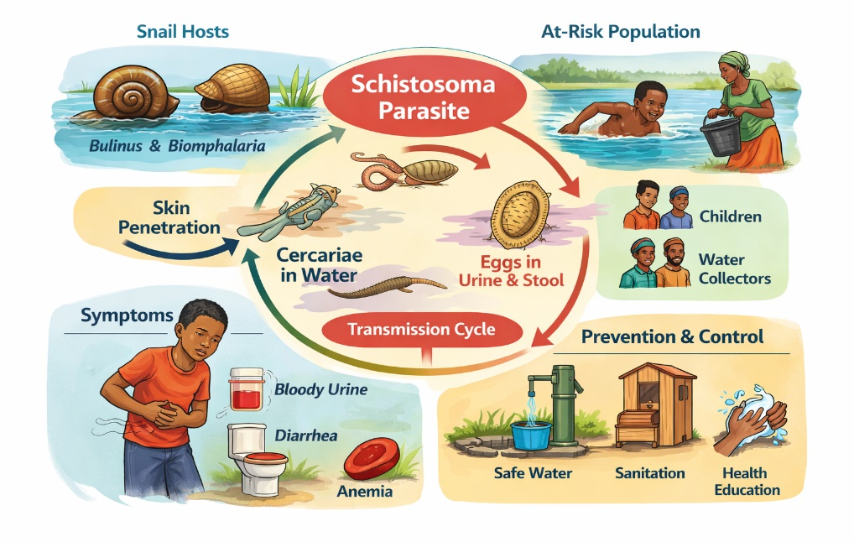
Figure 1. Conceptual overview of schistosomiasis transmission and public health impact
Figure 1 depict a schematic illustration of the schistosomiasis transmission cycle showing freshwater snail intermediate hosts, human water contact activities, parasite development stages, associated clinical manifestations, and key prevention and control measures relevant to endemic rural communities.
The public health implications of untreated schistosomiasis are severe, ranging from anemia and stunted growth in children to organ damage and bladder cancer in adults. The World Health Organization's new roadmap for NTDs (2021–2030) shifts the focus from morbidity control to the interruption of transmission. Achieving this goal requires granular, community-level data to guide targeted interventions. However, there is a paucity of recent epidemiological data for specific communities like Gubi. While state-level data exists, micro-level variations in prevalence are often overlooked, leading to untargeted resource allocation.
Therefore, this study aims to determine the current prevalence of S. haematobium and S. mansoni and assess the associated risk factors in the Gubi community of Bauchi State. By examining the interplay between water source usage, demographic factors, and infection rates, this research seeks to provide the empirical evidence needed to design localized, effective public health interventions that go beyond drug distribution to address the root causes of transmission.
2. Materials and Methods
2.1 Study Area
The study was conducted in the Gubi community, Bauchi State, Nigeria. Gubi is located in the Sudan Savanna ecological zone, characterized by a distinct wet and dry season. The community is served by several water bodies, including streams and seasonal rivers, which serve as the primary sources of water for domestic, agricultural, and recreational activities. These water bodies are known habitats for Bulinus and Biomphalaria snail species, the intermediate hosts for Schistosoma parasites (Onyekwere et al., 2022).
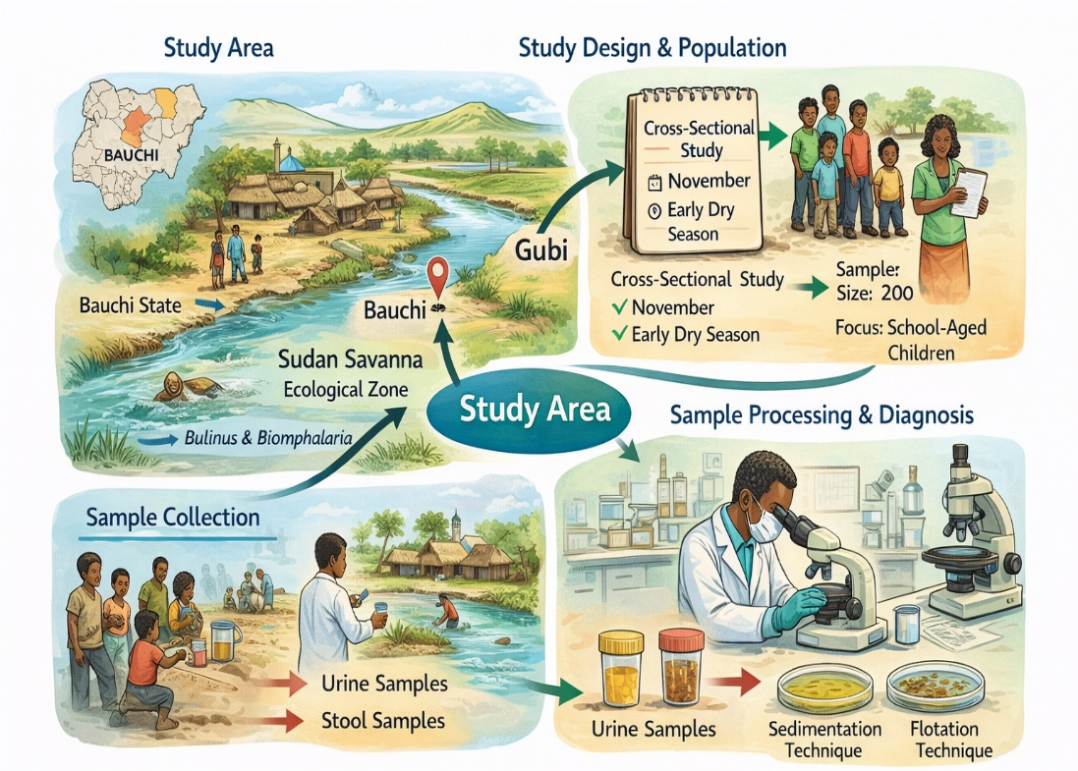
Figure 2. Study area and methodology for assessing schistosomiasis prevalence in Gubi community.
Figure 2 illustrates of Gubi community in Bauchi State, along with the cross-sectional study design, sample collection methods and laboratory diagnosis process.
2.2 Study Design and Population
A cross-sectional study design was employed to determine the prevalence of schistosomiasis. The study was conducted in November 2019, coinciding with the early dry season when water contact activities are typically high. The study population comprised residents of the Gubi community, with a specific focus on school-aged children and young adults who are most at risk of infection (Geleta et al., 2015).
2.3 Sample Size and Sampling Technique
The sample size was determined using Cochran’s formula for prevalence studies. A total of 200 participants were enrolled in the study. A random sampling technique was used to select participants from households and local schools to ensuring a representative distribution across age and gender groups (Ezeh et al., 2019).
2.4 Ethical Consideration
Ethical approval was obtained from the relevant health research ethics committee in Bauchi State. Informed verbal and written consent was obtained from all adult participants and from the parents or guardians of participating children. The study adhered to the ethical principles of the Declaration of Helsinki (World Health Organization, 2022).
2.5 Data Collection
A structured questionnaire was administered to each participant to obtain socio-demographic data (age, gender, occupation) and information regarding water contact behavior (source of water, frequency of river visits).
2.6 Laboratory Procedures
Urine Sample Collection and Filtration
Terminal urine samples were collected between 10:00 am and 2:00 pm, the peak period for S. haematobium egg excretion. The samples were processed using the urine filtration technique. 10 ml of urine was filtered through a polycarbonate membrane filter, and the filter was examined under a microscope for the presence of S. haematobium eggs, following standard parasitological protocols (Usman, & Babeker, 2018).
Stool Sample Collection and Floatation
Stool samples were collected in clean, wide-mouthed containers. The samples were processed using the saturated sodium chloride floatation technique to detect S. mansoni eggs and other intestinal helminths. This method exploits the specific gravity of the eggs, causing them to float to the surface for collection on a coverslip and subsequent microscopic examination (Awosolu, 2016).
2.7 Data Analysis
Data obtained were analyzed using SPSS version 25.0. Chi-square ($‘χ^{2}‘$) tests were used to determine the association between prevalence and risk factors (age, gender, water source). A P-value of less than 0.05 ($‘P<0.05‘$) was considered statistically significant.
3. Results and Discussion
3.1 Overall Prevalence and Species Distribution
A total of 200 participants were screened, providing both urine and stool samples (400 total samples). The overall prevalence of Schistosomiasis in the study area was 5.0% (20/400). Schistosoma haematobium (Urinary Schistosomiasis) showed a higher prevalence than Schistosoma mansoni (Intestinal Schistosomiasis).
Table 1: Prevalence of Schistosoma species and other parasites
Parasite Species | Sample Type | No. Examined | No. Positive | Prevalence (%)
S. haematobium | Urine | 200 | 13 | 6.5
S. mansoni | Stool | 200 | 7 | 3.5
E. histolytica | Stool | 200 | 3 | 1.5
A. lumbricoides | Stool | 200 | 1 | 0.5
G. lamblia | Stool | 200 | 2 | 1.0
Yeast Cells | Urine | 200 | 4 | 2.0
Total Schistosomiasis | Combined | 400 | 20 | 5.0

The overall prevalence of 5.0% recorded in this study classifies the area as hypo-endemic (low risk) according to WHO standards. This finding is relatively lower compared to several recent studies in Northern Nigeria. For instance, Balla et al. (2021) reported a much higher prevalence of 38.1% in similar communities in Bauchi State, and Bawa et al. (2016) recorded 21.5% in Kano State. The lower rate observed here may be attributed to recent mass drug administration (MDA) interventions or improved local awareness.
However, the dominance of S. haematobium (6.5%) over S. mansoni (3.5%) aligns perfectly with current regional trends. Okeke and Odo (2022) and Nduka et al. (2023) similarly observed that urinary schistosomiasis remains the predominant form of the disease in the Savannah zones of Nigeria, likely due to the greater resilience of Bulinus snail hosts in seasonal water bodies compared to the Biomphalaria hosts required for S. mansoni.
3.2 Prevalence by Gender
The infection rate varied significantly by gender. Males recorded a much higher burden of infection, particularly for urinary schistosomiasis, while females showed very low to zero infection rates.
Table 2: Prevalence of Schistosomiasis according to Gender
Gender | Sample Type | No. Examined | No. Positive | Prevalence (%)
Male | Urine | 103 | 13 | 12.6
 | Stool | 103 | 6 | 5.8
Female | Urine | 97 | 0 | 0.0
 | Stool | 97 | 1 | 1.0
Total |  | 200 | 20

The significant disparity between males (12.6% urinary) and females (0%) is a consistent finding in Nigerian parasitology. This strongly corroborates the work of Usman, & Babeker, (2018) and Yusuf et al. (2023), who both reported significantly higher infection rates in males in Katsina and Kaduna States, respectively.
This gender bias is widely attributed to socio-cultural behavioural patterns rather than biological susceptibility. As noted by Bishop et al. (2018), young males in these communities are far more likely to engage in high-risk recreational activities such as swimming, fishing, and farming in infested water bodies. In contrast, females often have restricted movement or interact with water primarily for domestic chores at safer points (like boreholes), reducing their contact time with the parasite.

4.3 Prevalence by Age Group
The distribution of infection showed a peak in the younger age groups, with a gradual decline as age increased. No infections were recorded in the oldest age group (46-60 years).
Table 3: Prevalence of Schistosomiasis according to Age
Age Group (Years) | No. Examined | Urine Positive (S.h) | Urine Prev (%) | Stool Positive (S.m) | Stool Prev (%)
0 – 15 | 70 | 6 | 8.5 | 4 | 5.7
16 – 30 | 80 | 4 | 5.0 | 2 | 2.5
31 – 45 | 40 | 3 | 7.5 | 1 | 2.5
46 – 60 | 10 | 0 | 0.0 | 0 | 0.0
Total | 200 | 13 |  | 7

The peak prevalence observed in the 0-15 age group (8.5% for urinary and 5.7% for intestinal) is in strong agreement with the "peak shift" phenomenon described in epidemiological literature. Ezeh et al. (2019) and Salawu & Odaibo (2020) emphasized that school-aged children bear the highest burden of schistosomiasis in Nigeria due to frequent water contact behaviors (playing and swimming) and an immune system that is not yet fully developed against the parasite.
The decline in infection rates among older age groups (31-45 years) and the total absence in the 46-60 group mirrors findings by Balla & Jabbo (2013). This decline is typically linked to reduced water contact activities among adults and the development of partial acquired immunity after years of repeated exposure.
3.4 Prevalence by Water Source
The source of water for domestic and recreational use showed a strong correlation with infection rates. Surprisingly, well water users showed the highest percentage of infection in this specific dataset.
Table 4: Prevalence of Schistosomiasis in relation to Water Source
Source of Water | No. Examined | No. Positive | Prevalence (%)
Pipe Borne Water | 92 | 2 | 2.2
Well Water | 30 | 8 | 26.7
River/Stream | 78 | 10 | 12.8
Total | 200 | 20 | 10.0

The association between water source and infection is critical. The high prevalence among those using River/Stream water (12.8%) is expected and aligns with findings by Dawet et al. (2021), who identified reliance on natural open water bodies as the primary risk factor for infection in North-Central Nigeria.
However, the unexpectedly high prevalence among Well Water users (26.7%) contrasts with some standard expectations but is not unprecedented. Amuta et al. (2020) noted that in some rural settings, "wells" are often shallow, uncovered, and situated near streams, making them liable to contamination during floods or via seepage. Furthermore, it is possible that individuals who identify "well water" as their primary domestic source still visit streams for bathing or laundry, as suggested by Awosolu et al. (2021) in their study of risk factors in Southwestern Nigeria. The low prevalence (2.2%) among pipe-borne water users validates the effectiveness of improved WASH (Water, Sanitation, and Hygiene) infrastructure, a conclusion supported by WHO reports (2023) on neglected tropical disease control.
4. Conclusion
The study reveals a hypo-endemic status of Schistosomiasis in the area (5% prevalence), with Schistosoma haematobium being the dominant species. Infection rates were significantly higher in males and children aged 0–15 years, directly linked to unsafe water contact. These findings highlight an urgent need for targeted health education and improved access to potable water to eliminate transmission.
References
Adediran, M. B., Adesida, A., Ezekiel, O. O., Irabor, P. C., Babalola, B. M., & Oyeyemi, O. T.
(2025). From treatment to prevention: reimagining schistosomiasis control through WASH and environmental management. Pathogens and Global Health, 1-17. https://doi.org/10.1080/20477724.2025.2603235
Awosolu, O. B. (2016). Epidemiology of urinary schistosomiasis and knowledge of health
personnel in rural communities of South-Western Nigeria. Journal of Parasitology and Vector Biology, 8(10), 99-106. https://doi.org/10.5897/JPVB2016.0237
Balla, H. J., & Jabbo, A. A. (2013). Survey of Urinary Schistosomiasis among school-aged
children in the rural communities of Mayo-belwa Local Government Area, Adamawa State, Nigeria. J Nat Sci Res, 3(4), 73-7.
Bawa, J. A., Auta, T., Msughter, I., & Umar, Y. A. (2016). Urinary schistosomiasis among
primary school children in dutsin-Ma town, Katsina State, Nigeria. Annual Research & Review in Biology, 10(1). 10.9734/ARRB/2016/25076
Bishop, H. G., & Akoh, R. I. (2018). Risk factors, symptoms and effects of urinary
schistosomiasis on anthropometric indices of school children in Zaria, Kaduna state, Nigeria. Open Access Journal of Science, 2(1), 61-65. 10.15406/oajs.2018.02.00045
Ezeh, C. O., Onyekwelu, K. C., Akinwale, O. P., Shan, L., & Wei, H. (2019). Urinary
schistosomiasis in Nigeria: a 50 year review of prevalence, distribution and disease burden. Parasite, 26, 19. 10.1051/parasite/2019020
Gamde, S. M., Tongvwam, P. J., Hauwa, K., Ganau, A. M., Abdulahi, J. A., Gamde, D. S., &
Choji, T. T. P. (2022). Prevalence of urinary schistosomiasis among almajiri children in silame, Sokoto State, North-western Nigeria. UMYU Journal of Microbiology Research, 6(1), 1-10.
Geleta, S., Alemu, A., Getie, S., Mekonnen, Z., & Erko, B. (2015). Prevalence of urinary
schistosomiasis and associated risk factors among Abobo Primary School children in Gambella Regional State, southwestern Ethiopia: a cross sectional study. Parasites & vectors, 8(1), 215. https://doi.org/10.1186/s13071-015-0822-5
Jiya, F. B., Jiya, N. M., Ibitoye, P. K., Mohammed, Y., & Mohammad, A. U. (2022). Chronic
Urogenital Schistosomiasis among In-School Adolescents in Sokoto, North-Western Nigeria. Asian J Med Health, 20(1), 22-36. 10.9734/AJMAH/2022/v20i130429
Onyekwere, A. M., Rey, O., Nwanchor, M. C., Alo, M., Angora, E. K., Allienne, J. F., &
Boissier, J. (2022). Prevalence and risk factors associated with urogenital schistosomiasis among primary school pupils in Nigeria. Parasite Epidemiology and Control, 18, e00255. https://doi.org/10.1016/j.parepi.2022.e00255
Usman, A., & Babeker, E. (2018). A study on the aspects of epidemiology of urinary and
intestinal schistosomiasis In Bauchi State, Nigeria. Science World Journal, 12(4), 88–93. https://doi.org/10.4314/swj.v12i4.
World Health Organization. (2022). WHO Guideline on Control and Elimination of Human
Schistosomiasis. Geneva: World Health Organization.

