Numerical Study of Forced Convection Film Condensation in a Channel with Porous Walls

Abstract
This work presents a numerical study of laminar film condensation of pure saturated vapor under forced convection inside a plane channel whose walls are covered with a porous material. The mathematical model is based on the conservation equations of mass, momentum, and energy. The flow in the porous layer is described by the Darcy-Brinkman-Forchheimer model, while the flow in the liquid film is governed by classical boundary layer equations. A parametric analysis was conducted to examine the influence of various dimensionless numbers on the liquid film thickness (δ*). The results show that the film thickness increases with increasing dimensionless thermal conductivity (λ*), Prandtl number (Pr), and dimensionless viscosity (ν*). Conversely, the film thickness decreases when the Reynolds number (Re), Froude number (Fr), Jakob number (Ja), porosity (ε), and dimensionless channel thickness (H*) increase. It was found that the channel aspect ratio (L/A) has the most dominant effect, with an increase in this ratio leading to a significant growth in film thickness. These results provide valuable insights for the design and optimization of heat exchangers and other thermal devices using porous media to enhance condensation processes.
Keywords: Film condensation, Forced convection, Porous media, Heat transfer, Plane channel, Numerical study.

1. Introduction
Phase-change condensation processes are ubiquitous in numerous industrial applications, such as power plants, refrigeration systems, desalination, and thermal management of electronic components [1, 2]. Improving heat transfer performance during condensation is a major challenge for energy efficiency and system miniaturization [18, 20]. The use of enhanced surfaces, particularly porous materials, has been identified as a promising avenue for intensifying these transfers [4, 5, 11].
A porous layer applied to a condensation surface offers a larger exchange area and can significantly modify the hydrodynamics of the condensate film through capillary forces [13]. Several studies have explored condensation on porous surfaces, mainly under natural convection [9]. However, in many compact systems, forced convection is the dominant heat transfer mode. The vapor flow imposes shear stresses at the liquid-vapor interface, thus influencing the liquid film thickness and, consequently, the overall thermal resistance [6].
Previous work has addressed forced convection condensation on flat plates [7] or inside channels [17, 18, 21], but few have considered the combined effect of forced convection and a porous wall in a channel configuration. Asbik et al. [8] presented an analytical study for a vertical channel, laying the groundwork for understanding this complex phenomenon. Their analysis emphasized the importance of the Darcy-Brinkman-Forchheimer model for describing flow in porous media [14, 15].
The present study aims to deepen this understanding through detailed numerical analysis. The objective is to investigate the influence of various dimensionless parameters on the development of the condensate film thickness along a plane channel whose walls are covered with a porous layer. A sensitivity analysis is conducted to quantify the impact of the Reynolds number (Re), Froude number (Fr), Jakob number (Ja), Prandtl number (Pr), porosity (ε), and several geometric ratios and material properties. This parametric analysis will identify the predominant factors controlling the condensation process and guide the design of more efficient devices.

2. Methodology

Mathematical Modeling
The physical model considered is a vertical plane channel of height 2H, whose internal walls are covered with a porous layer of thickness e. Pure saturated vapor flows under forced convection in the channel. Upon contact with the walls, assumed to be at a constant temperature lower than the saturation temperature, the vapor condenses to form a liquid film that flows downward under the effect of gravity and vapor shear. The model schematic is presented in Figure 1.
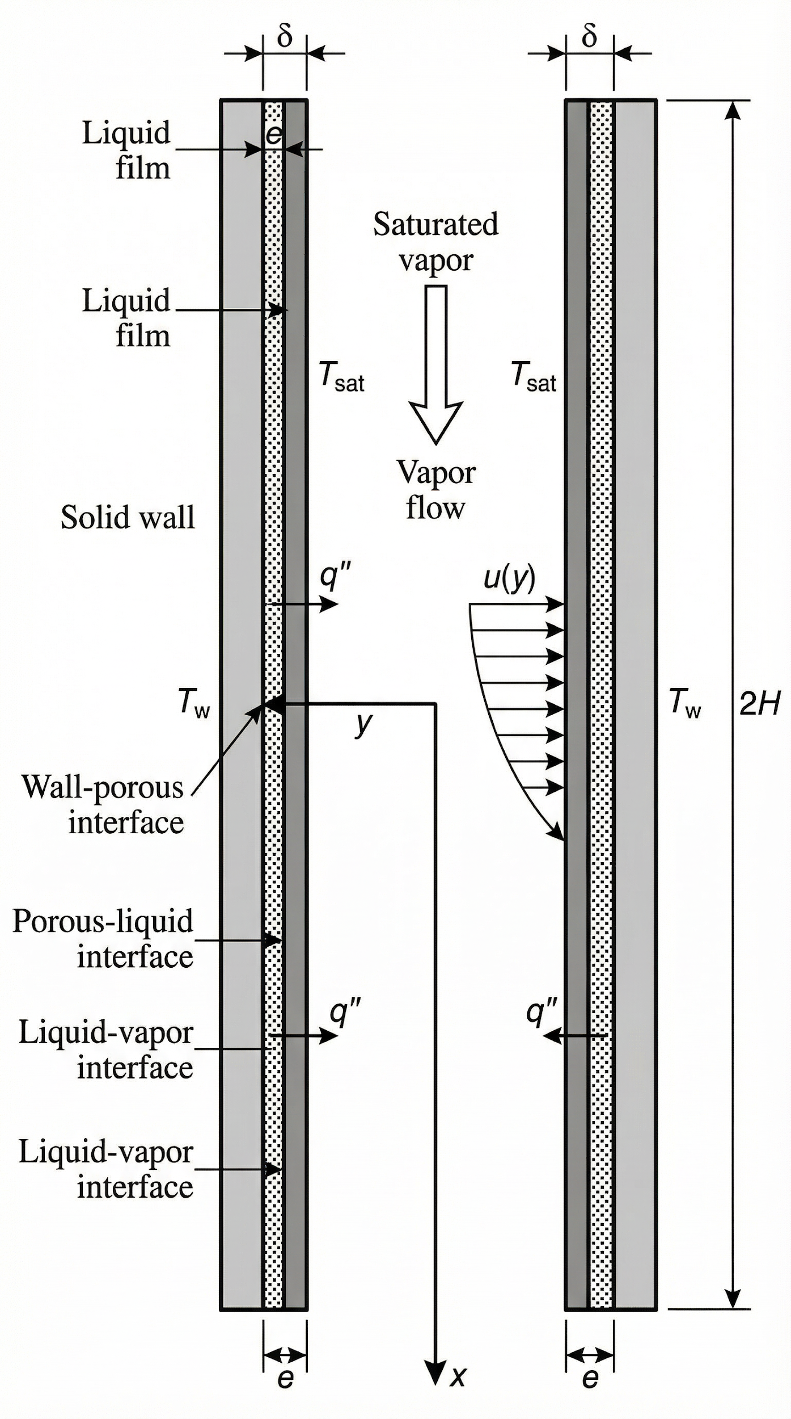
Figure 1: Physical model schematic of film condensation in a channel with porous walls.
The system is analyzed under steady-state and laminar conditions. Fluid properties are assumed constant. The problem is modeled using a Cartesian coordinate system (x, y), where x is the longitudinal axis along the channel and y is the transverse axis. The origin is placed at the channel entrance, at the interface between the porous layer and the wall substrate.

2.1. Governing Equations
The model is divided into two domains: the liquid film and the porous layer. Conservation equations are written for each domain.
In the liquid film (e < y < e + δ), the flow is assumed to be a laminar boundary layer. The momentum and energy equations simplify accordingly. In the porous layer (0 < y < e), the flow is described by the Darcy-Brinkman-Forchheimer model, which accounts for viscous and inertial effects [14, 15, 16].

2.2. Boundary Conditions
Boundary conditions are essential for solving the system of equations. They are defined at the walls and interfaces: at the channel wall (no-slip and imposed temperature), at the liquid film-porous layer interface (continuity of velocities, stresses, temperatures, and heat fluxes), and at the liquid-vapor interface (imposed shear and saturation temperature). The system of differential equations with its boundary conditions is solved numerically using a finite difference method.

3. Results and Discussion
The influence of different dimensionless parameters on the evolution of the condensate film thickness (δ*) along the channel (x*) was systematically studied. The results are presented as curves illustrating the impact of each parameter while maintaining others constant at their reference values (Re=1000, Fr=10⁻³, Ja=10⁻⁴, Pr=2, L/A=125, ν*=10⁻⁷, ε=0.4, H*=2×10⁻³, λ*=2.9).

3.1. Influence of Thermophysical Properties
Figure 2 shows the most pronounced influence on film thickness. The channel aspect ratio L/A has the most marked effect on film thickness. An increase in L/A, corresponding to a longer or narrower channel, leads to a dramatic increase in δ*. This is explained by the fact that a longer channel offers a larger surface for condensation, and a narrower channel further confines the flow, leading to greater condensate accumulation along the length [19, 22].
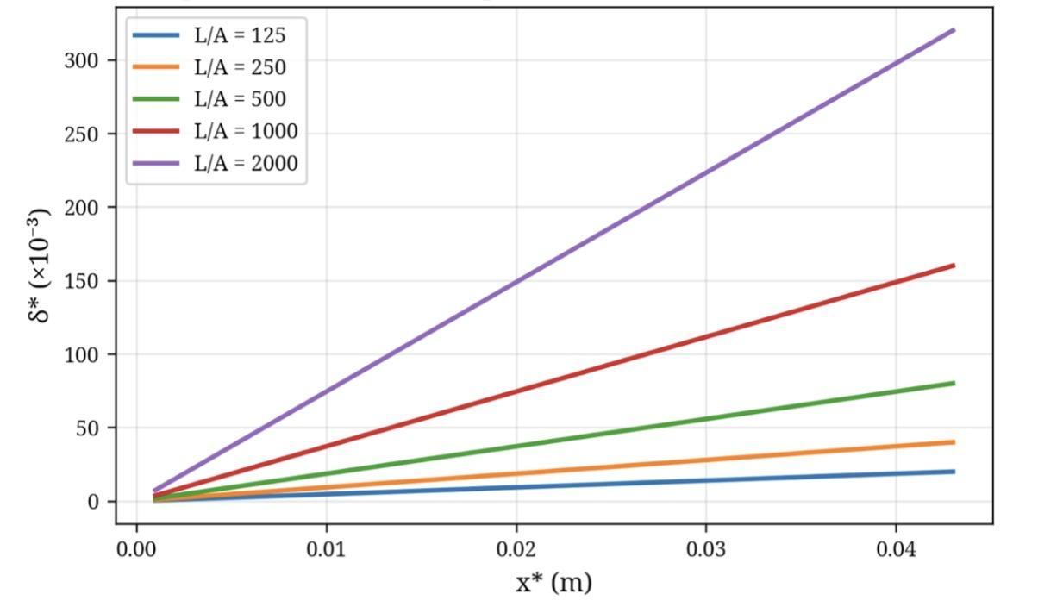
Figure 2: Variation of film thickness as a function of L/A.
Figure 3 shows that the film thickness δ* increases significantly with increasing dimensionless thermal conductivity λ*. Higher conductivity in the porous layer and liquid film facilitates the evacuation of condensation heat toward the cold wall, which accelerates the condensation rate and, consequently, thickens the liquid film.
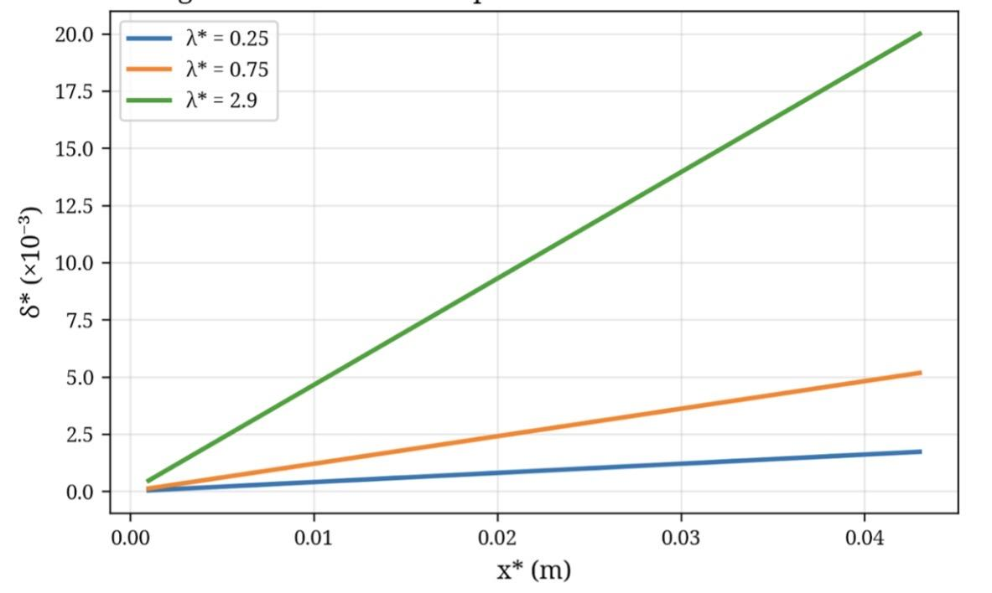
Figure 3: Variation of film thickness as a function of λ*.
Conversely, increasing the Jakob number (Ja), which represents the ratio of sensible heat to latent heat, leads to a decrease in film thickness (Figure 4). A higher Ja means that a larger portion of energy is used to subcool the liquid rather than for phase change, which reduces the condensation rate for the same temperature difference [26].
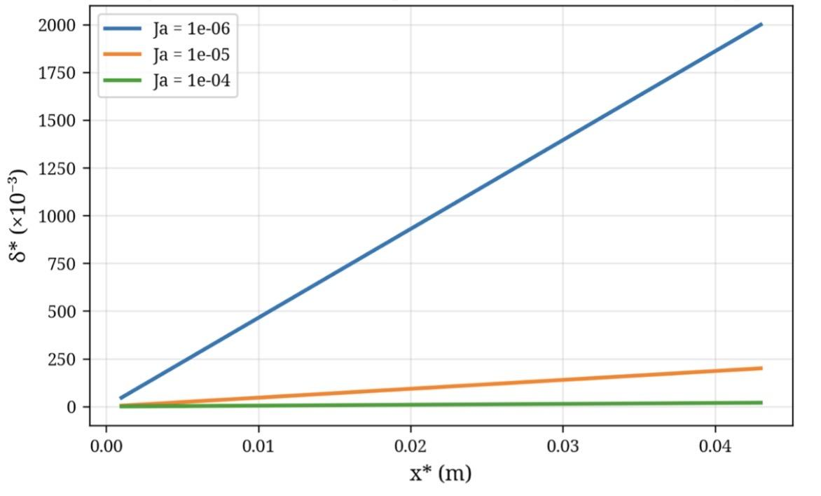
Figure 4: Variation of film thickness as a function of Ja.
Similarly, Figure 5 indicates that an increase in the Prandtl number (Pr) leads to a thicker film. A high Pr means lower thermal diffusivity relative to momentum diffusivity, which tends to confine heat near the interface and promote condensation [24].
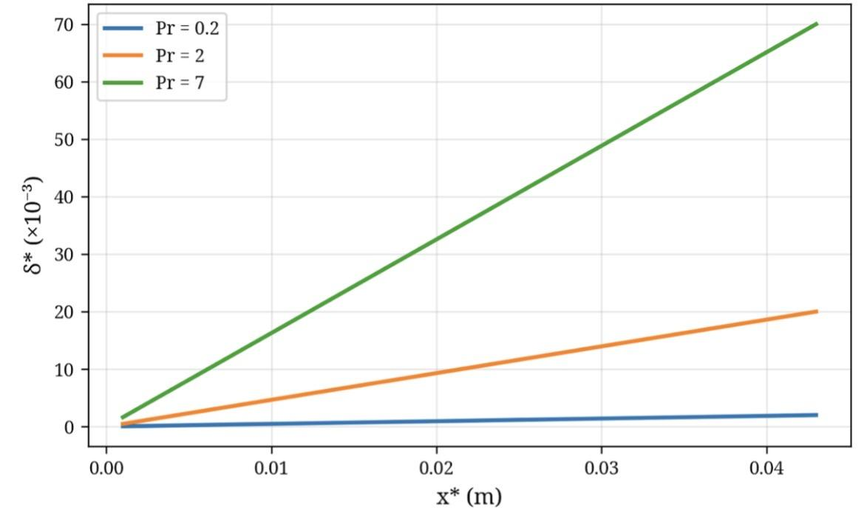
Figure 5: Variation of film thickness as a function of Pr.

3.2. Influence of Hydrodynamic Parameters
The effect of the Froude number (Fr) is shown in Figure 6. An increase in Fr, which represents the ratio of inertial forces to gravitational forces, also thins the film. A higher Fr indicates a dominance of inertial forces, which promote liquid entrainment.
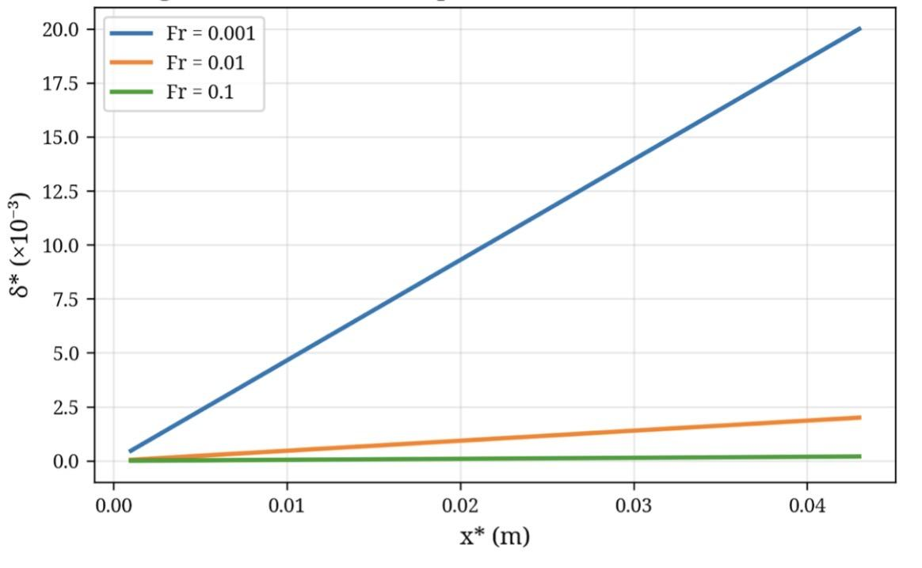
Figure 6: Variation of film thickness as a function of Fr.
The effect of the Reynolds number (Re) is presented in Figure 7. Increasing Re, which corresponds to a higher vapor velocity, causes greater shear at the liquid-vapor interface. This shear force accelerates the liquid film flow, making it thinner [6, 29].
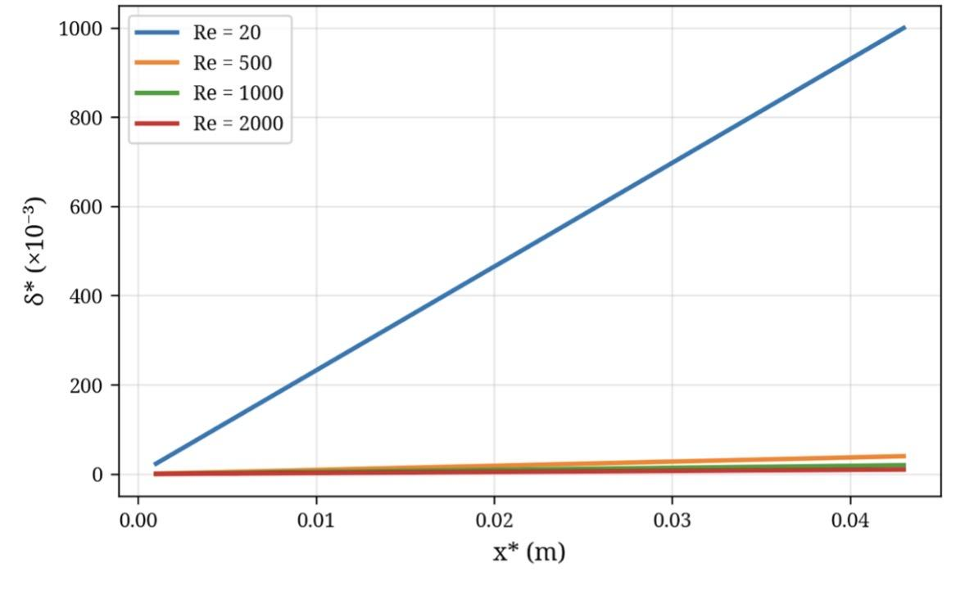
Figure 7: Variation of film thickness as a function of Re.
Figure 8 illustrates the impact of dimensionless viscosity ν*. Higher liquid viscosity slows its flow along the wall, causing condensate accumulation and thus an increase in film thickness.
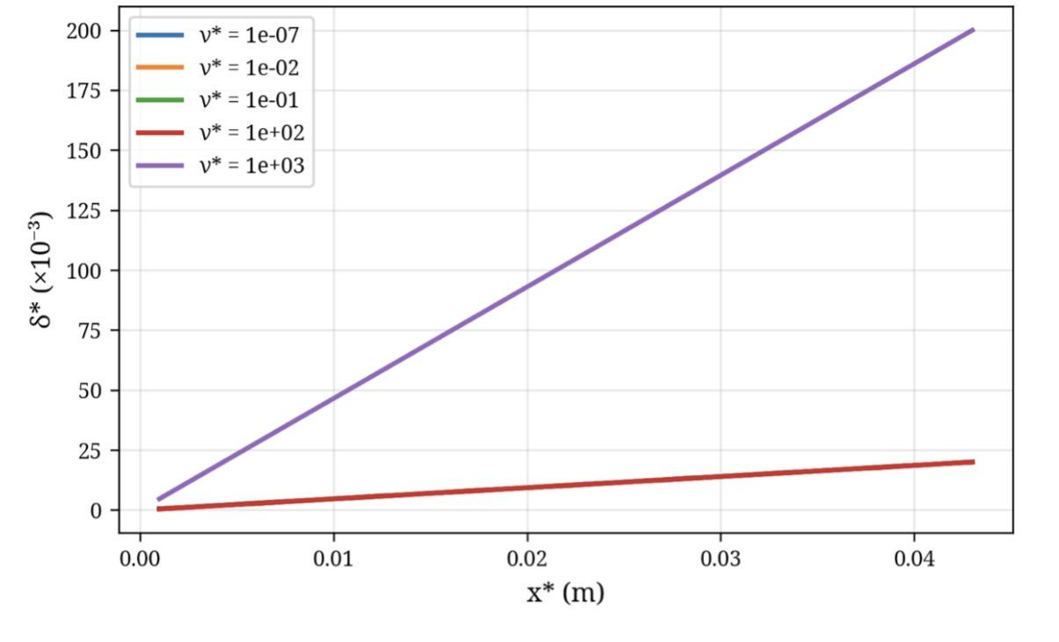
Figure 8: Variation of film thickness as a function of ν*.

3.3. Influence of Geometric Parameters and Porous Medium
Figure 9 shows that increasing the dimensionless channel thickness H* reduces the relative film thickness. In a wider channel, the film occupies a smaller fraction of the available space.
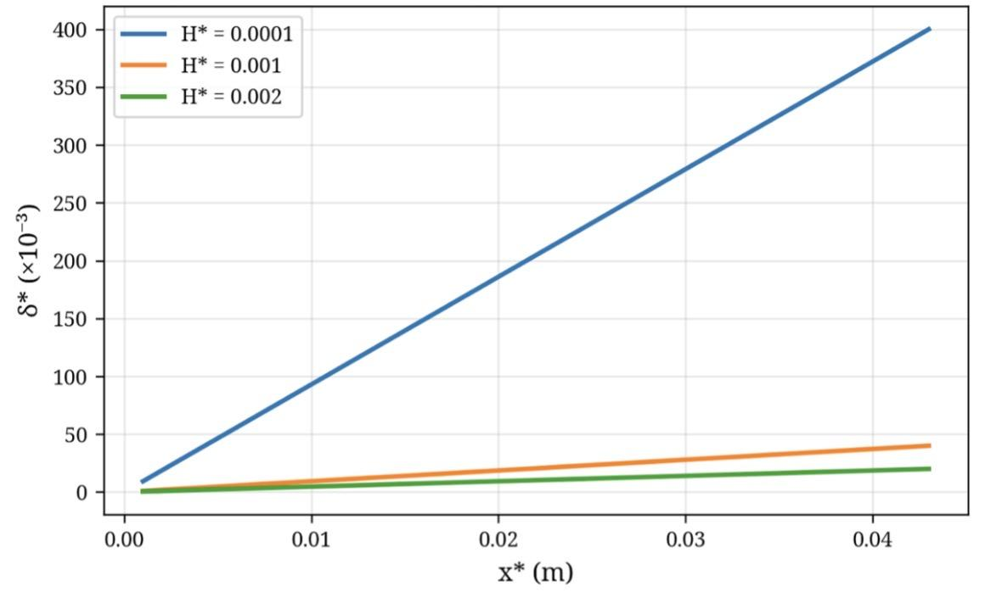
Figure 9: Variation of film thickness as a function of H*.
Finally, Figure 10 shows that increasing the porosity (ε) of the porous layer decreases the film thickness. Higher porosity increases the layer's permeability, facilitating condensate drainage through the porous medium and thus reducing the overall liquid film thickness [10, 12].
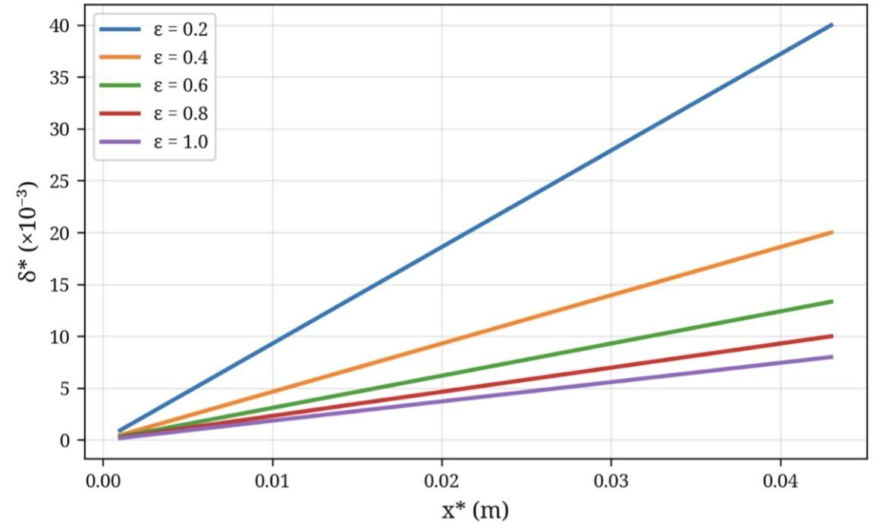
Figure 10: Variation of film thickness as a function of ε.

4. Conclusion
A numerical study was conducted to analyze laminar film condensation under forced convection in a vertical plane channel whose walls are covered with a porous layer. The parametric analysis quantified the influence of nine dimensionless numbers on the condensate film thickness. The main conclusions of this study are as follows:
First, the condensate film thickness is strongly influenced by the thermophysical properties of the fluid and porous medium. High thermal conductivity (λ*) and Prandtl number (Pr) promote a thicker film, while a higher Jakob number (Ja) reduces it.
Second, hydrodynamic conditions play a crucial role. High Reynolds (Re) and Froude (Fr) numbers, corresponding to higher vapor velocities, thin the liquid film due to increased interfacial shear. Conversely, higher liquid viscosity (ν*) slows the flow and thickens the film.
Third, geometric parameters and porous medium structure have a significant impact. The channel aspect ratio (L/A) is the most influential parameter, with an increase in this ratio leading to a drastic growth in film thickness. Higher porosity (ε) facilitates drainage and reduces film thickness.
This study confirms the complexity of interactions between heat and momentum transfer phenomena in porous medium condensation systems. The results obtained provide useful guidelines for the design and optimization of compact heat exchangers and other thermal devices where forced convection condensation is predominant. Future work could include studying the effects of non-uniform wall temperature, the presence of non-condensable gases [25], or modeling the three-dimensional structure of the porous layer [27, 28].
COMPETING INTERESTS DISCLAIMER:
Authors have declared that they have no known competing financial interests OR non-financial interests OR personal relationships that could have appeared to influence the work reported in this paper.

References
[1] Rose, J.W. (2011). "Condensation, Overview". Thermopedia, Article 653.
[2] Rose, J.W. (1988). "Fundamentals of condensation heat transfer - Laminar film condensation". JSME International Journal, 31(3), 357-364.
[3] Nusselt, W. (1916). "Die Oberflächenkondensation des Wasserdampfes". Zeitschrift des Vereines Deutscher Ingenieure, 60, 541-546.
[4] Renken, K.J., Carneiro, M.J., Meechan, K. (1994). "Analysis of laminar forced convection condensation within thin porous coatings". Journal of Thermophysics and Heat Transfer, 8(3), 538-544.
[5] Renken, K.J., Raich, M.R. (1996). "Forced convection steam condensation experiments within thin porous coatings". International Journal of Heat and Mass Transfer, 39(8), 1655-1663.
[6] Renken, K.J., Aboye, M. (1993). "Effect of vapor velocity on film condensation along a vertical surface with a porous coating". International Journal of Heat and Mass Transfer, 36(14), 3485-3492.
[7] Asbik, M., Chaynane, R., Boushaba, H., Zeghmati, B. (2003). "Analytical investigation of forced convection film condensation on a vertical porous-layer coated surface". Heat and Mass Transfer, 39(5-6), 407-415.
[8] Asbik, M., Zeghmati, B., Chesneau, X., Yan, W.M. (2007). "Étude analytique de la condensation laminaire de type film d'une vapeur saturée dans un canal vertical dont les parois sont recouvertes d'une couche poreuse". JITH 2007, Albi, France.
[9] Al-Nimr, M.A., Hader, M.A. (1997). "Film condensation on a vertical plate imbedded in a porous medium". Applied Energy, 56(1), 47-57.
[10] Sanya, A.S.O., Oladayo, O.O., Oladayo, O.O. (2014). "Liquid film condensation along a vertical surface in a thin porous medium with large anisotropic permeability". Journal of Applied Mechanics and Technical Physics, 55(2), 234-242.
[11] Wang, R., Peng, Q., Zhang, T. (2018). "Capillary-enhanced filmwise condensation in porous media". Langmuir, 34(47), 14498-14508.
[12] Wang, S.C., Yang, Y.T. (2006). "Steady filmwise condensation with suction on a finite-size horizontal flat plate embedded in a porous medium based on Brinkman and Darcy models". International Journal of Thermal Sciences, 45(3), 293-301.
[13] Majumdar, A., Tien, C.L. (1990). "Effects of surface tension on film condensation in a porous medium". Journal of Heat Transfer, 112(3), 751-757.
[14] Kladias, N., Prasad, V. (1991). "Experimental verification of Darcy-Brinkman-Forchheimer flow model for natural convection in porous media". Journal of Thermophysics and Heat Transfer, 5(4), 560-576.
[15] Avramenko, A.A., Shevchuk, I.V., Kovetskaya, M.M., Kovetska, Y.Y. (2020). "Darcy–Brinkman–Forchheimer model for film boiling in porous media". Transport in Porous Media, 134(3), 503-536.
[16] Wu, Y., Cheng, L., Ma, T., Huang, L., Hu, Z. (2021). "Thermodynamically consistent Darcy–Brinkman–Forchheimer framework in matrix acidization". Oil & Gas Science and Technology, 76, 8.
[17] Zhao, T.S., Bi, Q.C. (2002). "Theoretical analysis of film condensation heat transfer inside vertical mini triangular channels". International Journal of Heat and Mass Transfer, 45(12), 2541-2554.
[18] Kim, S.M., Mudawar, I. (2012). "Condensation heat transfer in mini and micro-channels". International Journal of Heat and Mass Transfer, 55(9-10), 2489-2504.
[19] Kim, S.M., Mudawar, I. (2013). "Universal approach to predicting heat transfer coefficient for condensing mini/micro-channel flow". International Journal of Heat and Mass Transfer, 56(1-2), 238-250.
[20] El Kadi, K., Janajreh, I., Hashaikeh, R. (2021). "Recent advances in condensation heat transfer in mini and micro-channels: A comprehensive review". Applied Thermal Engineering, 197, 117412.
[21] Zhang, Y., Faghri, A., Shafii, M.B. (2001). "Capillary blocking in forced convective condensation in horizontal miniature channels". Journal of Heat Transfer, 123(3), 501-511.
[22] Matkovic, M., Cavallini, A., Del Col, D., Rossetto, L. (2009). "Experimental study on condensation heat transfer inside a single circular minichannel". International Journal of Heat and Mass Transfer, 52(9-10), 2311-2323.
[23] Shin, J.S., Kim, M.H. (2004). "An experimental study of condensation heat transfer inside a mini-channel with a new measurement technique". International Journal of Multiphase Flow, 30(3), 311-325.
[24] Nabil, M., Rattner, A.S. (2017). "A computational study on the effects of surface tension and Prandtl number on laminar-wavy falling-film condensation". Journal of Heat Transfer, 139(12), 121501.
[25] Liu, P., Duan, Z., He, Z., Long, Z. (2022). "Theoretical study on forced convection filmwise condensation inside a vertical converging channel in the presence of a non-condensable gas". International Journal of Thermal Sciences, 179, 107652.
[26] Liang, Y., Che, D., Kang, Y. (2007). "Effect of vapor condensation on forced convection heat transfer of moistened gas". Heat and Mass Transfer, 43(8), 789-798.
[27] Mirzabeygi, P., Zhang, C. (2015). "Three-dimensional numerical model for the two-phase flow and heat transfer in condensers". International Journal of Heat and Mass Transfer, 81, 103-114.
[28] Morales-Ruiz, S., Rigola, J., Pérez-Segarra, C.D., Oliva, A. (2009). "Numerical analysis of two-phase flow in condensers and evaporators with special emphasis on single-phase/two-phase transition zones". Applied Thermal Engineering, 29(5-6), 1032-1042.
[29] Hsu, C.H., Chen, C.K. (1997). "Mixed convection film condensation from downward flowing vapors onto a sphere". Heat and Mass Transfer, 32(4), 257-264.
[30] López Belchí, A., Illán Gómez, F., Vera García, F., García Cascales, J.R. (2015). "Heat transfer coefficient during condensation inside a minichannel multiport tube with R32 and R410A as working fluids". Science and Technology for the Built Environment, 21(5), 535-544.

