Enhanced Performance of Dye-Sensitized Solar Cells Using Natural Dye Mixtures and Mesoporous TiO₂ Photoelectrodes

Abstract
In this study, dye-sensitized solar cells (DSSCs) were fabricated using natural dyes extracted from blackberry, spinach, and red cabbage as eco-friendly photosensitizers. The optical properties of the extracted dyes were investigated using UV–visible spectroscopy, and their photovoltaic performance was evaluated using two different photoelectrodes: commercial TiO₂ and laboratory-prepared mesoporous TiO₂. The photoelectrodes were deposited onto fluorine-doped tin oxide (FTO) substrates via electrophoretic deposition, while platinum counter electrodes were prepared by spin coating.
The photovoltaic characteristics of the assembled DSSCs were examined under simulated solar illumination using a liquid iodine-based electrolyte. The results demonstrate that cells based on mesoporous TiO₂ photoelectrodes exhibited superior performance compared to those employing commercial TiO₂, owing to their enhanced surface area and improved dye adsorption. Among the investigated dyes, the mixed natural dye (blackberry, spinach, and red cabbage) achieved the highest power conversion efficiency of 1.4%, with an open-circuit voltage of 0.76 V, a short-circuit current density of 2.93 mA·cm⁻², and a fill factor of 62.98%. In comparison, the DSSC sensitized with blackberry dye alone reached an efficiency of 0.72%.
These findings confirm that combining natural dyes with mesoporous TiO₂ photoelectrodes significantly enhances light harvesting and charge transport in DSSCs. The present work highlights the potential of low-cost, environmentally friendly materials for sustainable solar energy applications.
Keywords: Dye-sensitized solar cells, Natural dyes, Mesoporous photoelectrodes, Photovoltaic performance, Renewable energy.

- Introduction
Dye-Sensitized Solar Cell (DSSC) is a third-generation solar cell, consisting of a semiconductor electrode, a sensitizer, an electrolyte, and a counter electrode (Wei, 2010; Onah et al., 2024). As the world intensifies its pursuit of sustainable energy solutions, DSSCs stand out as pivotal contributors to the global energy transition, especially within the framework of the United Nations’ Sustainable Development Goals (SDGs) for 2030 (Maiaugree et al., 2015; Nurfani et al., 2025). This work aims to verify the use of various plant extracts as a natural dye inducer to improve the performance efficiency of DSSCs associated with the interaction between the dye and the TiO2 surface. Natural dyes have become more popular as an alternative to expensive and rare organic catalysts due to their low cost, non-toxicity, high performance, abundant supply of raw materials, various colours, and eco-friendly nature (Shukor et al., 2023; Dragonetti & Colombo, 2021; Saud et al., 2024; Bera et al., 2021; Khedr et al., 2025).
During preparation of the cells, we used two types of titanium dioxide: the commercial TiO2 and laboratory–prepared meso-TiO2 as photoelectrode and the platinum as counter electrode.
Additionally, the photoelectrode was prepared by Electrophoretic Deposition (EPD) method that used to deposit the TiO2 layer on the FTO glass, and the counter electrode was prepared from Chloroplatinic Acid through thin layers of platinum which were deposited on the glass slides using the spin–coating method. Also, we studied the optical and structural properties of titanium dioxide powder.
We collected the cells by using a liquid electrolyte, i.e., an iodine solution and tested them under illumination and in the dark then studied their electrical properties and obtained their characteristic curves. In the cell of meso- TiO2 with mix dye we got the highest value and curve of current density compared to the other cell, which is about 2.93 mA/cm2 with values of VOC = 0.76V (the open circuit voltage), FF = 62.98% (the fill factor) and the power conversion efficiency η = 1.4%. The other highest value of the power conversion efficiency was also in meso-TiO2 photoelectrode cell with blackberry dye; it equals η = 0.72 with values VOC = 0.64V, Jsc =2.29 mA/cm2, FF = 49.1%.

2. Methodology

2.1 Materials:
Blackberry, spinach leaves, and red cabbage were used as dyes in this study.
Methanol, acetic acid, and distilled water (MilliQ, Millipore, Inc.).
FTO conductive glass (sheet resistance: 12-14Ω), potassium iodide, iodine (Alfa Aesar, ethylene glycol, Chloroplatinic acid hexahydrate, Isopropanol, and acetone.
TiO2-commercial is produced by the ACROS ORGANICS company, (n-dodecylamine, DDA, and Pluronic F127), tetrabutyl titanate (TBOT).

2.2 Extraction of the Natural Dyes.

A) from Blackberry: berries were extracted according to the following procedure: 100g of blackberry were crushed with a pestle, then dissolved in 50 ml of (pure methanol / acetic acid / distilled water) according to the highest center (11/1/11). After that, it is preserved using a Buchner funnel (the filtering process is repeated twice) and keep it in an opaque bottle, away from light, at a temperature of 8 ° C until then use ^{[1]}.
B) from Spinach and Red cabbage:
(a) 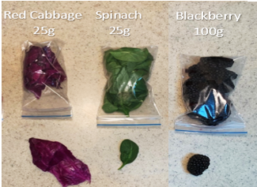 (b) 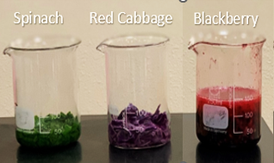(c) 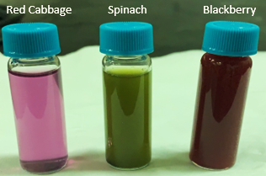
Figure 1: (a) The Quantity of fruits and leaves during preparation before extraction. (b) Fruits and leaves during extraction. (c) the red cabbage, spinach and blackberry dyes after extraction is completed.

The dye was extracted from the spinach leaves by following the following procedure: wash 25g green spinach leaves well with distilled water, then cut small pieces, and leave to dry. Then it was immersed in 25 ml of pure methanol and left for one day. After that, use a Buchner funnel and keep it in an opaque bottle, away from light, at a temperature of 8° C until then use. With the same steps, we extracted the dye from the leaves of red cabbage ^{[1]}.

2.3 Preparation of samples.

2.3.1 Liquid Electrolyte preparation:
2.07g potassium iodide and 0.19g iodine are added to 25ml ethylene glycol. The mixture moves for 15 minutes until homogeneous, then will obtain a solution rich in iodine ions (I⁻/I ⁺) representing the oxidation and resistivity pair on which the cell relies.

2.3.2 Counter-electrode preparation with platinum layer:

0.65g of Chloroplatinic acid hexahydrate was mixed at 50mM concentration in 25ml of isopropanol solution and stirred in the mixture for 30 minutes, the layer was then deposited on the FTO glass by dip coating in a rotating dipping manner at 1000rpm and for the 30s and acceleration 33m/s2 then thermally treated at 450 °C for 30 minutes (average 5° per minute) Then that made a mirror layer of platinum. The process repeats so that three layers are deposited. The glass is then kept clean until it is used for cell assembly.

2.3.3 Photo electrodes preparation
To prepare the photoelectrodes, the mesoporous nanosphere was loaded on (FTO) substrate via the electrophoretic deposition (EPD) method; iodine (0.01g, Alfa Aesar) and 0.02g meso-TiO2 ultrasonically dispersed in acetone (25 mL) for one hour, also for TiO2 commercial, 0.02g TiO2 commercial and iodine (0.01g, Alfa Aesar) ultrasonically dispersed in acetone (25 mL) for one hour. The EPD method was employed by dropping two FTO parallel electrodes into a glass cell with a distance of 1 cm and applying a voltage of +10 V for 10min. On the negative side of the electrode were uploaded the nanoparticles and then washing, drying, and calcination at 350 °C for one hour in the air. Then it's left to cool and immerse in the mix of dyes (red cabbage + spinach +blackberry) and blackberry dye as shown in figure2.
(a) 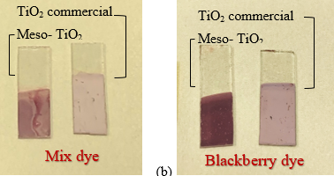 (b)
Figure 2: the glasses after being immersed in dyes, (a) Mix dye { red cabbage + spinach + blackberry } (b) blackberry dye, with thin films by meso-TiO₂ and by TiO₂ commercial.

2.4 Collecting the dye-sensitized solar cell:
The dye-sensitized solar cell was prepared in the following order:
(FTO / Tio2 layer / natural dye / IODINE / Pt / FTO)
Where the TiO₂ layer is either meso-TiO2 or TiO2 commercial.
A drop of Iodine electrolyte solution is placed on the photoelectrode after drying. The counter electrode (platinum) is placed oppositely to cover the titanium dioxide layer, leaving a small distance from both electrodes to connect the output wires as in Figure3.
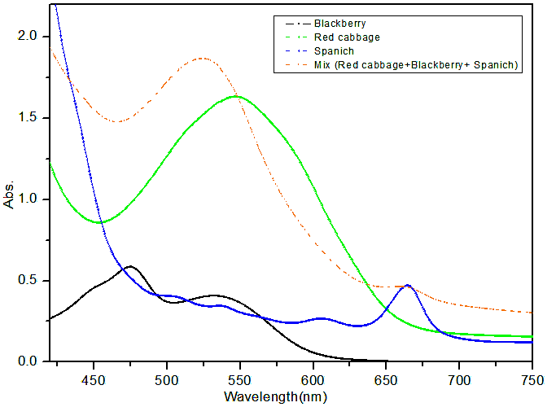
Figure 45: UV-vis results for the dyes.

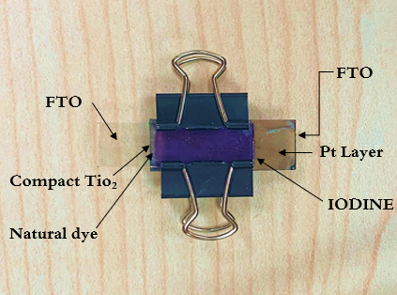
Figure 3: The dye-sensitized solar cell after assembly.

- Results and Discussion

Figure 4 present optical measurement using UV-vis spectroscopy of the prepared dye solution. The absorption spectra display the being of characteristic absorption peaks into the visible field.
For the Blackberry dye, the absorbance is good within the range λ=460nm – 560nm, with a maximum absorption peak at λ=528nm. and for the dye extracted from Spinach The absorbance is good within the range λ=590nm – 670nm with two absorption peaks, the maximum absorption peak at the wavelength λ=6700nm and another peak at wavelength λ=615nm. And about the dye extracted from Red Cabbage absorbance is good within the range λ=480nm – 600nm, with a maximum absorption peak at λ=550nm. Finally, dye mix extracted from Red Cabbage, Spinach, and Blackberry has a maximum absorption peak at the wavelength λ=530nm.

Figure5 shows the platinum layers in FTO glass that the glasses slide substrate was fully covered by platinum, which was agglomerated, and have spherical and irregular-shaped particles.
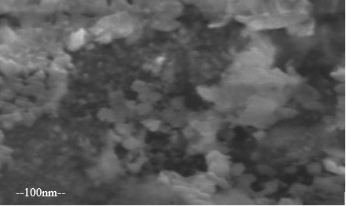
Figure 54: SEM Image Platinum Pt with magnification=100K (by spin coating method.

J-V curve of the cells with blackberry BB dye.

Figure6 curve1 shows the measurement of the current density (J-V) under illumination the highest value of the power conversion efficiency η = 0.72% and the good values are attributed to the cell with blackberry dye and meso-TiO2.

From these curves we can extract the values of Voc; Jsc and FF they are: 0.64V; 2.29 mA/cm2; 49.1% respectively for cell with meso-TiO2 and BB dye, and 0.56V; 1.78mA/cm2; 50.6% respectively for cell with TiO2 commercial and BB dye.

J-V curve of the cells with meso-TiO₂ and different dyes (BB and mix dye).

Figure6 curve2 shows the J-V curves of cells under illumination.The dye mixture cell (blackberry + spinach + red cabbage) showed the highest value and curve of current density compared the all cells which we prepared, is about η = 1.4% for the power conversion efficiency and values ​​of Voc = 0.76V, Jsc = 2.93mA/cm2, FF = 62.98%. The other cell with blackberry dye shows a power conversion efficiency η = 0.72% and values ​​for Voc = 0.64V, Isc = 2.29 mA/cm2, FF = 49.1%. Thus, the advantage of the dye mixture cell well appears, which has high efficiency and good value for Fill Factor.

In the dark state, figure7 curve1 shows J-V curves for cells with blackberry dye where (a) meso-TiO2 (b) TiO2 commercial, and figure7 curve2 shows J-V curves for cells with meso-TiO2 (a) indicate to BB dye and (b) indicate to the mix dye. The curves in the figures explain dye-sensitized solar cells which take a shape typical of a semiconductor diode.

Solar conversion efficiency measurement :

Can be estimated the solar conversion efficiency (η) of a DSSC by using the conversion efficiency formula [2]:
$η=\frac{P_{max}}{P_{in} }$ (1)
Where Pmax and Pin denote the maximum output power and the input power, respectively.
The fill factor (FF) of a DSSC can be estimated using the formula ^{[2]}:

$FF=\frac{P_{max} }{V_{OC}×J_{SC}}$ $×100$ = $\frac{J_{m} ×V_{m} }{V_{OC}×J_{SC}}$ $×100$ (2)

Referring to the previous curves for J-V values, FF was calculated by finding the required parameters and then using equation (2) shown in table1.

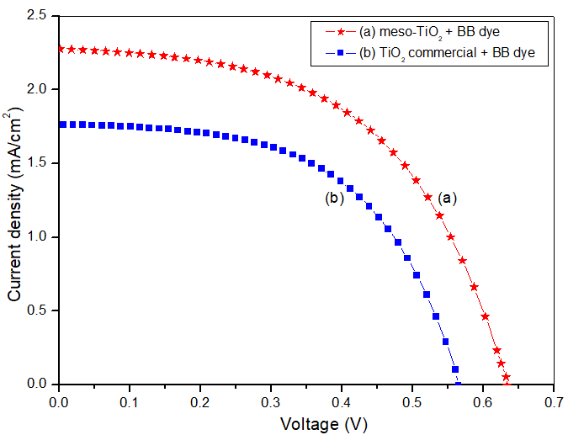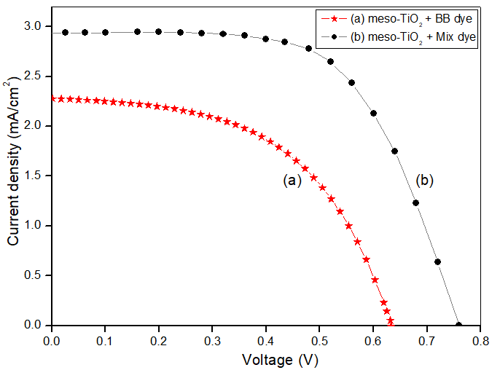
Curve 1
Curve 2
Figure 6: J-V curve1 (a) meso-TiO₂ (b) TiO₂ commercial for Cells with blackberry dye under illumination, J-V curve2 under illumination for cells with meso-TiO₂ (a) BB dye (b) mix dye.

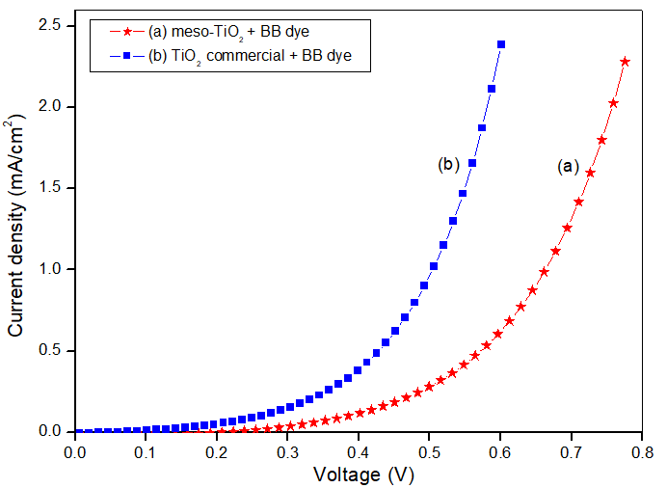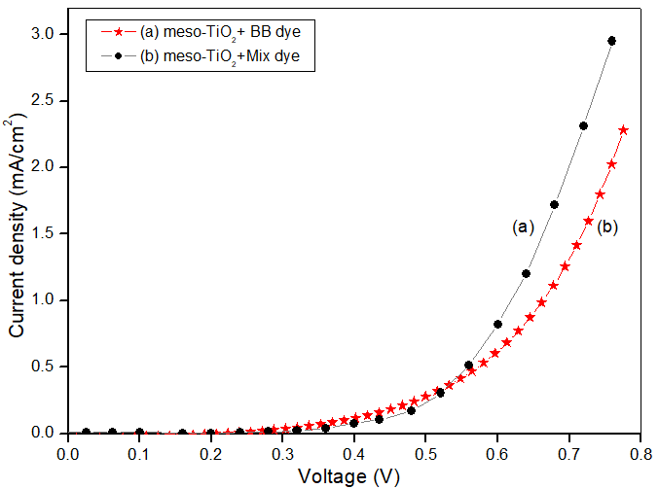
Curve 2
Curve 1
Figure 7: J-V curve 1 (a) meso-TiO₂ (b) TiO₂ commercial for cells with blackberry dye in dark, J-V curve 2 in the dark for cells with meso-TiO₂ (a) BB dye (b) mix dye.

Table 1: Calculate Fill Factor of the cells.
Cell | I_{m}(A) | V_{m}(V) | I_{sc}(mA/cm²) | V_{oc}(V) | FF(%)
Mix dye + meso-TiO₂ | 2.75 | 0.51 | 2.93 | 0.76 | 62.98
BB dye + meso-TiO₂ | 2 | 0.36 | 2.29 | 0.64 | 49.1
BB dye + TiO₂ commercial | 1.68 | 0.3 | 1.78 | 0.56 | 50.6

Where Voc is the open-circuit voltage and Jsc is the short-circuit current denity. Can be calculated the solar conversion efficiency of a DSSC by [2]:

$η=\frac{P_{max}}{P_{in} }=\frac{V_{OC} ×J_{SC}× FF}{P_{in} }$ (3)

The standard input power in the sun simulator is one sun which equals 100mW/cm2, which is the incident light power density ($P_{in} /A)$, A is the cell area we measured it was 1cm2 >> Pin =100mW.
Table 2 summarizes the specification of prepared DSSC (VOC, JSC, FF, η ), which were made with different types of photo-electrode by using different natural dyes. After that DSSC solar cells were assembled and then tested.

Table 2: Results of the cells under illumination.
cell | Cell Measurement
cell | J_{SC}  (mA.cm⁻²) | V_{OC} (V) | FF (%) |  | η (%)
Mix Dye (M) "meso-TiO₂" | 2.93 | 0.76 | 62.98 | 1.4
Blackberry dye (BB) "meso-TiO₂" | 2.29 | 0.64 | 49.1 | 0.72
Blackberry dye (BB) "commercial" | 1.78 | 0.56 | 50.6 | 0.5

In conclusion, we can say that the power conversion efficiency results have validated the measurements and analyses obtained from BET and XRD. Since the nanopores nature of the meso-TiO2 films gave excellent results compatible with the previous values, it gave a perfectly homogeneous and deposited TiO2 thin film on the FTO glass. Thus, it helped to increase the absorption of the dye in the photoelectrode and, consequently, the light absorption. The interaction with the liquid electrolyte has increased as well. We also note that the mixture of dyes is preferred over the blackberry dye, as it gave a power conversion efficiency twice that of the blackberry cell. As for commercial TiO2, the nature of its bulk surface has weakened its efficiency in the work of solar cells and thus the decreased power conversion efficiency in them.
Cell measurements were also taken two days later; the cells showed poor results compared to fresh cells, and the power conversion efficiency results were decreased.

According to a quantum efficiency (QE) analysis these measurements were taken two days after cell preparation, the wavelength range was 350-800 nm.

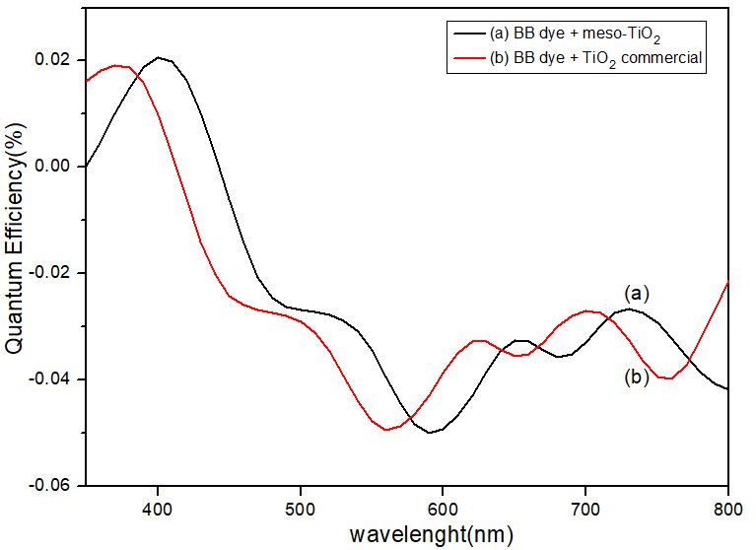
Figure 8: Quantum Efficiency curve for cells with blackberry dye and meso-TiO₂ and TiO₂ commercial.
In Figure8 we observe the highest QE value in curve (a) for the sample of meso-TiO2 with BB dye which appeared to the peak is (0.02) at a wavelength of 410nm. And in (b) curve for the TiO2 commercial sample with BB dye we find the peak (0.019%) at a wavelength around 390 nm.

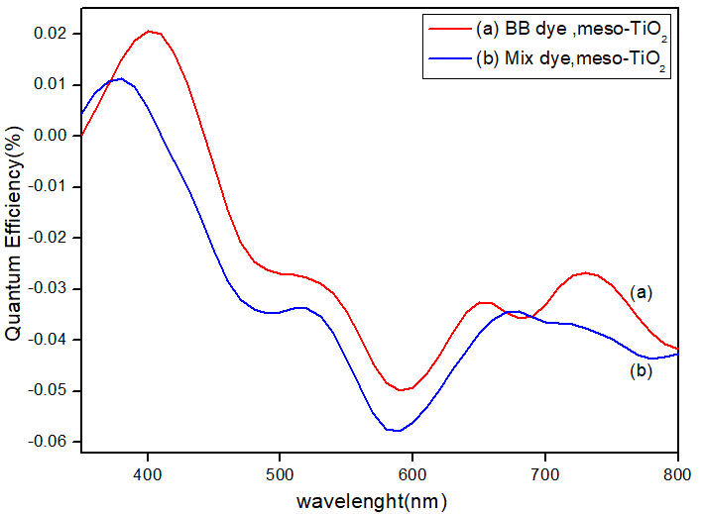
Figure 9: Quantum Efficiency curve for cells with meso-TiO2 and different dyes.

As shown in figure9 in the curve (a), which explain BB sample; we found that the highest QE value is (0.02%) at the wavelength of 410 nm. And curve (b) shown the QE of the mix dye cell sample significantly increased to reach (0.01%) at a wavelength of ~390nm.

This QE result proves one major disadvantage of Dye Sensitized Solar Cells, i.e the decrease of efficiency after a period of preparation [3]. For our cells, the reason may be attributed to the weight of the dye, as we noticed during work that the blackberry dye was heavier than the mixture dye, and therefore it might give us higher values after two days due to its heavy and its adsorption power on the TiO2 layer. Also, the dehydration of the electrolyte after a period of being placed on the cell causes reduced in the efficiency of the cell.

4. Conclusion
A group of natural dyes was used in this work to prepare dye-sensitized solar cells that have excellent absorption in the visible region. The curves J-V under illumination and in the dark showed good results and excellent values for the parameters of the solar cell; compared to what was published in similar works ^{[3,4]}. Regarding the dye type, the mixture dye cell (blackberry + spinach + red cabbage) gave the highest value for the current density under illumination; compared to the other prepared solar cells, which was around 2.93 mA/cm², and the highest curve with this value was V_{oc} = 0.76V,
FF = 62.98%, and the power conversion efficiency was η = 1.4%. Regarding the photoelectrode type, the meso- TiO₂ photoelectrode cell with blackberry dye comparing the TiO₂ commercial photoelectrode cell with the same dye also gave the highest value for the current density of around 2.29 mA/cm² with these values: V_{oc} = 0.64V, FF = 49.1% and the power conversion efficiency η = 0.72%.

COMPETING INTERESTS DISCLAIMER:
Authors have declared that they have no known competing financial interests OR non-financial interests OR personal relationships that could have appeared to influence the work reported in this paper.

6. References
- Louai Yousef Khoder., “Preparation and Characterization of a polymer Dye Sensitized Solar Cell”, Journal of Materials Science, 2016.

- A.Smets, K.Jäger, O.Isabella, R.V. Swaaij, M.Zeman,."Solar energy"., Cambridge, England (2016).

- Hiromasa Nishikiori., “Dye-Sensitized Solar Cells (DSSCs) Based on Extracted Natural Dyes”, Journal of Nanomaterials, 2019.

- DeSilva et al., “Broad absorption natural dye (Mondo-Grass berry) for dye sensitized solar cell”, Journal of Materials Science: Materials in Electronics, 2017.

- Wei, D. (2010). Dye Sensitized Solar Cells. International Journal of Molecular Sciences, 11(3), 1103-1113. https://doi.org/10.3390/ijms11031103
- Onah, E. H., Lethole, N. L., & Mukumba, P. (2024). Luminescent Materials for Dye-Sensitized Solar Cells: Advances and Directions. Applied Sciences, 14(20), 9202. https://doi.org/10.3390/app14209202
- Shukor, N. I. A., Chan, K.-Y., Thien, G. S. H., Yeoh, M.-E., Low, P.-L., Devaraj, N. K., Ng, Z.-N., & Yap, B. K. (2023). A Green Approach to Natural Dyes in Dye-Sensitized Solar Cells. Sensors, 23(20), 8412. https://doi.org/10.3390/s23208412
- Dragonetti, C., & Colombo, A. (2021). Recent Advances in Dye-Sensitized Solar Cells. Molecules, 26(9), 2461. https://doi.org/10.3390/molecules26092461
- Saud, P. S., Bist, A., Kim, A. A., Yousef, A., Abutaleb, A., Park, M., ... & Pant, B. (2024). Dye-sensitized solar cells: fundamentals, recent progress, and optoelectrical properties improvement strategies. Optical Materials, 150, 115242.
- Bera, S., Sengupta, D., Roy, S., & Mukherjee, K. (2021). Research into dye-sensitized solar cells: a review highlighting progress in India. Journal of Physics: Energy, 3(3), 032013.
- Khedr, N., Hussein, A., Ebrahim, S., & Elshaer, A. M. (2025). Natural pigment dyes as eco-friendly sensitizers for dye-sensitized solar cells. Journal of Materials Science: Materials in Electronics, 36(19), 1-16.
- Maiaugree, W., Lowpa, S., Towannang, M., Rutphonsan, P., Tangtrakarn, A., Pimanpang, S., ... & Amornkitbamrung, V. (2015). A dye sensitized solar cell using natural counter electrode and natural dye derived from mangosteen peel waste. Scientific reports, 5(1), 15230.
- Nurfani, E., Salsabila, H., Bakhtiar, D. I., Sipahutar, W. S., Ghifari, M. A., Asri, R., ... & Kurniawan, R. (2025). Effect of Mixed Ratios of Mangosteen Peel (Garcinia mangostana L.) and Grass Jelly Leaf (Cyclea barbata L. Miers) Natural Dyes on the Performance of Dye-Sensitized Solar Cells (DSSC). arXiv preprint arXiv:2509.26622.

