Optimization of a Building's Interior Temperature and Sensitive Air-Conditioning Loads Using the BLT-Parpaing Hollow Double Wall

Abstract
The aim of this study was to optimize the interior temperature and sensitive air-conditioning loads of a building with hollow breeze-block walls, using the BLT-hollow breeze-block double wall. To achieve this, the methodology consisted in determining the thermal properties of the materials and simulating the building in reference and optimized situations using KoZiBu software. For the KoZiBu simulation, the building was first described by subdividing it into thermal zones, determining the input data for walls and openings, recording internal loads and defining occupancy profiles. The results show that temperatures inside the BL-hollow breeze-block double-wall building drop by an average of 2 to 2.6°C depending on the room, with a maximum drop of 4.1°C in February in room 2, compared with those inside the hollow breeze-block building. The difference in air-conditioning loads results in energy savings of 24.06% over the year. However, in order to promote the use of the double wall, it would be advisable to compare the savings achieved with the additional cost of adding the BLT.

Key words : bioclimatic design, optimization, simulation, temperature, air-conditioning loads.

- INTRODUCTION
The building sector is one of the world's biggest energy consumers, accounting for around 32% of annual global consumption [1]. Apart from the increasing scarcity of energy, the need for energy-efficient buildings is now more pressing than ever. As Burkina Faso has a hot, dry tropical climate, air-conditioning needs are high, which increases the demand for electricity, which is not fully covered by production. It is estimated that the energy consumption of public and private buildings and the tertiary sector in sub-Saharan Africa is between 250 and 450 kWh/m²/year, depending on the number of floors. Depending on the building, HVAC systems account for 50 to 70% of electricity consumption in buildings [2]. Building energy consumption in the public sector, particularly for the operation of air conditioning equipment (air conditioners, fans, etc.) in 2012, is estimated at 30,000 MWh/year, at an estimated financial cost of 3.4 billion FCFA/year [3]. This situation leads to over-billing, over-consumption of energy in buildings and irregularities in the supply of electricity. In December 2015, the national electrification rate was 18.3% (urban 59.88%, rural 3.06%) [4]. AMADOU OUMAROU Fati et al. [5] present a passive approach to reducing a building's energy demand by optimizing the thermal envelope using thermal simulations with different building materials. Four materials are studied: compressed earth, laterite, raw material and hollow cement, used in Burkina Faso. The COMSOL tool is used to analyze the internal temperature and cooling demand of a classroom in a hot, dry climate. The results show that the use of local materials can save around 4 kW of energy, making it a viable option for improving thermal comfort and reducing energy consumption. A. Compaoré et al. [6] present a numerical model of heat transfer in a habitat with compressed earth block walls. The transfer equations are solved using an implicit finite-difference method and the Gauss algorithm coupled with an iterative procedure. The study examines the influence of air change rate, wall thickness and material type on internal and wall temperatures. The results show that habitats built with local materials maintain lower temperatures than those built with cement blocks. Increasing wall thickness improves thermal inertia and temperature time lag. However, over-ventilation of a home with high thermal inertia can reduce its performance during hot periods. Indeed, saving energy is one of the ways to help reduce the risks of climate change to which our planet is exposed. What's more, it would be wise to propose new constructions based on materials that take into account the thermal comfort of occupants, thereby reducing electricity bills. The various building materials studied include adobe or banco, cut laterite blocks (BLT), compressed earth blocks (BTC) and cement blocks. Numerous analyses and simulations were carried out to characterize these materials. The results of these analyses enable us to find the optimum formulation for each material, which best reconciles the technical aspects with good thermal resistance, a convincing criterion when choosing a material for construction.
Given the relevance of this topic, research work has been carried out on building materials, including: E. Malbila [7] carried out an experimental analysis of heat transfer in two houses built with cement breezeblock and cut laterite blocks (BLT). The results show that the use of BLTs makes it possible to approach thermal comfort in the building by combining natural ventilation by thermal draught and without increased use of air-conditioning; this helps to reduce energy consumption. E. Ouédraogo et al [8] carried out an experimental study to characterize local materials used in building construction. These materials are Compressed Earth Blocks (CEB) stabilized with cement and/or paper. These composite materials used for building envelopes are highly water-stable. The results of measurements of mechanical and thermophysical properties showed a discrepancy. The compressive and tensile strengths of earth-cement and earth-cement-paper blocks are similar, and around twice as high as those of earth-paper and three times as high as those of earth. The thermophysical property values of materials incorporating paper (cellulose) show an improvement in their thermal insulation performance.
Cement breezeblocks are mechanically strong and moisture-resistant. They are generally manufactured on site and are highly appreciated for their ease of installation. A. Kemajou et al [9] explore ways of improving thermal comfort in homes by using suitable building materials, while integrating socio-cultural considerations. By comparing traditional materials (wood, mud brick, rammed earth) with modern materials (cement breeze block) using simulations with Pléiades+Comfie software, the results show that traditional materials offer better thermal performance, especially in specific climates. Traditional housing, better adapted to local climatic constraints, achieves a good level of thermal comfort by optimizing the shape, orientation and size of openings in the home. A. Kaboré [8] carried out hygrothermal modeling of a concrete building envelope. His aim was to find an alternative to traditional construction by integrating new materials with a low ecological footprint to improve the hygrothermal performance of the building envelope. Hence the interest in carrying out a study of the thermal performance of hemp concrete as a material, and above all its integration and hygrothermal behavior in the envelope studied.
In addition, a certain degree of thermal comfort can be achieved by lowering indoor temperatures, which in turn can lead to energy savings in buildings, if architectural design and the choice of building materials take into account the thermal behavior of buildings to minimize the need for air-conditioning. Burkina Faso has enormous potential in local materials (BLT, BTC, BTM or adobe, etc.). Several studies have been carried out on the contribution of local materials to thermal comfort, but few on the combination of materials in double-walled buildings. With this in mind, we propose to study the influence of the BLT-hollow breeze-block double wall on a building in a hot, dry tropical climate such as Burkina Faso, to achieve a certain level of thermal comfort in the indoor environment. The overall aim is to optimize the indoor temperature and sensitive air-conditioning loads of the reference building.
- MATERIALS AND METHODS
2.1 KoZiBu model description and material properties
2.1.1 KoZiBu software
KoZiBu is a simulation software package for dynamic analysis of a building's thermal and water performance. In addition, it is designed to carry out studies of heating and cooling, air conditioning and ventilation, and the choice of insulation materials. KoZiBu's main objective is to predict energy consumption and the amplitude of temperature and humidity variations. KoZiBu can be used to estimate the heating or air-conditioning power required to maintain a given setpoint, or to determine temperature trends when the heating or air-conditioning system is insufficient. Humidity is treated in the same way. KoZiBu is based on the assembly of simple bricks to form a complex building with its equipment. Using the graphical interface, the user builds a model of his building using basic elements (air volumes, walls, windows). The user can add internal loads and control elements to the building model, and then perform thermal calculations [10].
2.1.2 Materials properties
Table 1 below summarizes the composition and properties of the different types of walls and openings considered for the building in the reference situation [11, 12, 13].

Table 1 : Thermo-physical properties of materials under reference conditions in hollow breezeblock and openings
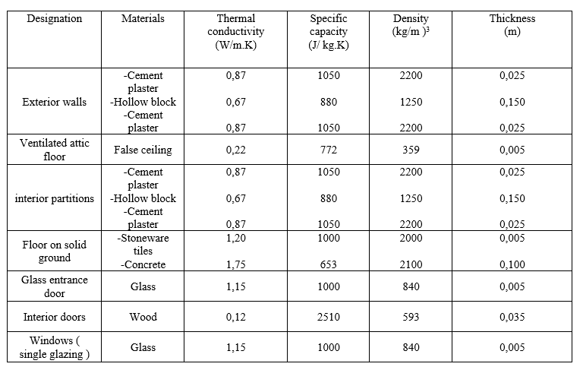

Table 2 summarizes the composition and properties of the different types of walls and openings that
were considered for the building in the optimized situation. The optimization of walls and openings in the optimized building, as summarized in Table 2, consisted in improving thermal and energy performance to increase the building's overall efficiency. This optimization involved
- Improved thermal insulation ;
- Reduced thermal transmittance (U-value) ;
- Increased air tightness ;
- Optimization of glazing and openings ;
- Installation of solar protection systems ;
- Natural light management.
In summary, optimization involved a series of measures to improve insulation, solar gain management, airtightness and the use of natural light to enhance the building's energy efficiency and thermal comfort. [11, 12, 13].

Table 2 : Thermo-physical properties of materials in optimized conditions
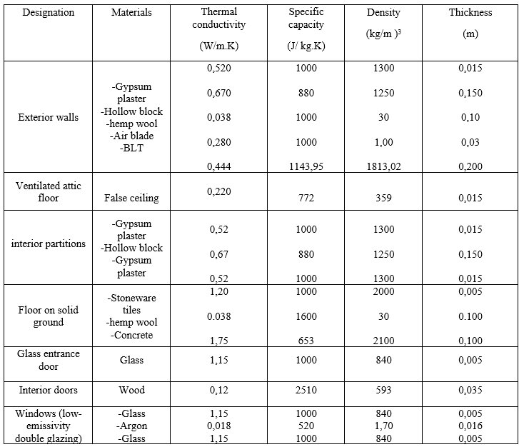

Table 3 shows the thermal resistance of the materials used [11, 12, 13].
Table 3 : Thermal resistance of materials used
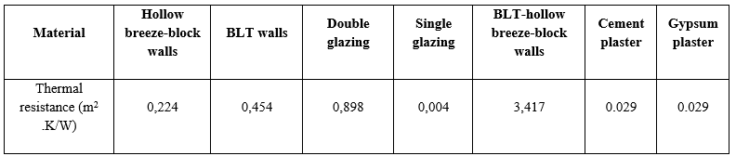

We've already noted that BLT-hollow breeze-block walls have a higher thermal resistance than simple BLT or hollow breeze-block walls. Double glazing also has a higher thermal resistance than single glazing.
2.2 Modeling the house with KoZiBu
2.2.1 Building description
The study we're carrying out concerns a residential dwelling with a surface area of 81.09 m² and a volume of 195.978 m3, with its main facade facing east. It's a F3 building with two bedrooms, a living room, a hallway, a shower room, a kitchen and a storeroom.
Uninsulated exterior walls are 15 cm thick hollow breeze-block for all materials ; partitions are 15 cm thick hollow breeze-block. The low floor is 10 cm thick concrete, covered with 5 cm thick tiles. The roof is made of aluminium-zinc sheet metal, with a ventilated roof space below.
The interior doors are wooden, the exterior glazed in metal. Windows are single-glazed, 5 mm thick, with iron frames. False ceiling height is 2.90 m. Average floor temperature in Ouagadougou : 26°C.
2.2.2 Multi-zone modeling
In order to model the building more precisely according to its use, each room is modeled by a single thermal zone. In our case, we have subdivided the building into six (6) zones, thus determining their dimensions for description in KoZiBu :
Zone 1 : Living room ;
Zone 2 : Kitchen ;
Zone 3 : Bedroom 1 ;
Zone 4 : Bedroom 2 ;
Zone 5 : Store ;
Zone 6 : Powder room.
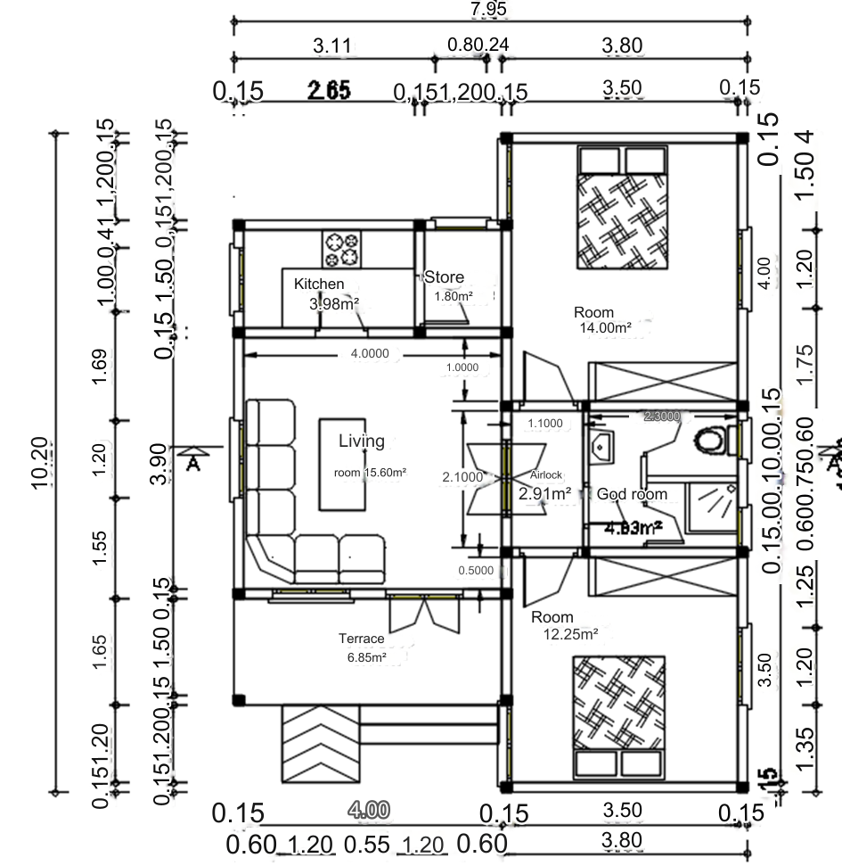

West
North
South
East

Figure 1 : Plan of typical F3 building
2.2.3 Meteorological data
As the building is located in the city of Ouagadougou, METEONORM meteorological data for this city are used for the simulation.
2.2.4 Internal loads and control devices
We assume that the air conditioner is switched on when the indoor temperature rises above 26°C with a relative humidity of 50%. Ventilation and infiltration are set at one volume per hour. Weekday and weekend occupancy scenarios have been created for the bedrooms and living room. The number of occupants is 4 for the living room and 2 per bedroom. For lighting, a total of 06 9W/m2 fluorescent lamps are used in the building. The living room is equipped with a 64W television and a 60W Canal+ decoder, a 70W refrigerator and two 80W laptops, each with a duty cycle of 100%.
- RESULTS AND DISCUSSION
3.1 Comparison of maximum indoor temperatures
- Evaluation of maximum indoor temperature curves
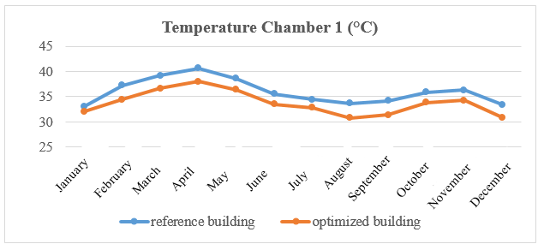

Figure 2 : Maximum indoor temperature curves for room 1 of the building in the reference and optimized situations.
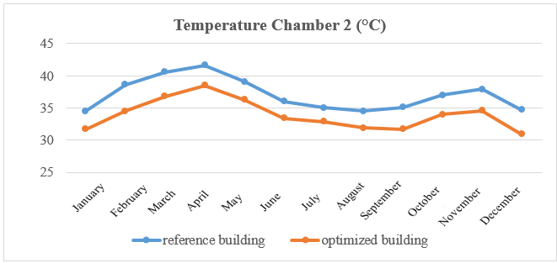

Figure 3 : Maximum indoor temperature curve for room 2 of the building in the reference and optimized situations.
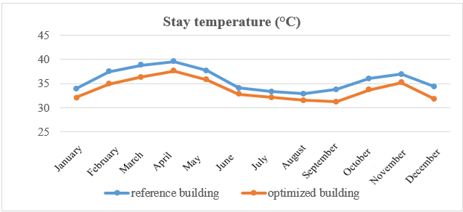

Figure 4 : Maximum indoor temperature curve for the building's living areas in the reference and optimized situations.
The figures above show the curves for maximum monthly indoor temperatures in bedroom 1, bedroom 2 and the living room of the building in the reference situation and also in the optimized situation.
These curves show a drop in indoor temperature in the optimized building compared with the reference building, especially in chamber 2, where the variation in indoor temperature is greater. In particular, we note temperature peaks of 41.60°C in the reference building and 38.50°C in the optimized building for the month of April, the hottest month of the year in Burkina Faso. This can be explained by the fact that the hollow breezeblocks in the reference building store more heat during the day, due to the absence of thermal insulation and a wall providing protection from the elements. As a result, the heat stored during the day by the air trapped in the hollow walls is released into the room at night, raising the interior temperature. Hence the importance of BLT and thermal insulation in the design of the double wall, which reduced the heat stored in the hollow breezeblocks of the optimized building, resulting in a lower interior temperature. Double glazing also helped to improve the building's insulation in the optimized situation.
- Evaluation of temperature differences inside the building.
Table 4. Maximum indoor temperature difference between the reference and optimized building situations.
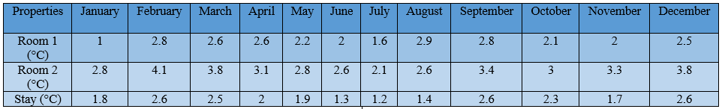

Table 5. Table showing the average difference in maximum indoor temperatures between the building in the reference situation and in the optimized situation.
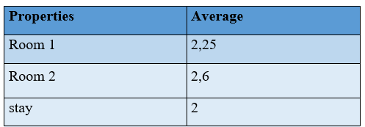

The tables above show the maximum indoor temperature variations for room 1, room 2 and the building's living room in the reference and optimized situations.
In the first table, we can see that the indoor temperature in room 2 dropped by 4.1°C in February. This shows that building optimization is more effective in this month and in this part of the building, which achieves better temperature reductions than the others. As for the second table, we can see that over the year, the average difference in indoor temperature is greater in room 2. We can therefore conclude that optimization has a greater impact in room 2, and this could be explained by the fact that the orientation of its walls and openings adds to optimization through the use of double walls.
3.2 Sensitive loads, latent loads and total air-conditioning loads
The figures below compare the building's sensible air-conditioning loads and total air-conditioning loads in the reference and optimized situations.

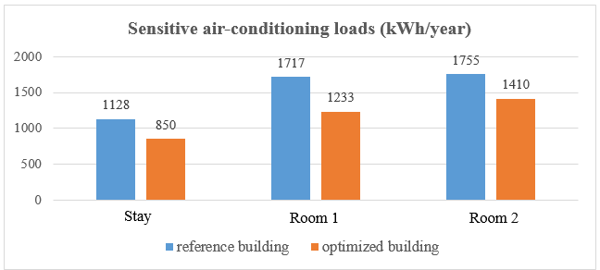

Figure 5 : Diagram of sensitive air-conditioning loads in kWh/year
The sensitive air-conditioning load values obtained for the building in the reference situation are higher than those in the optimized situation. We note that loads are higher in room 2, which could be explained by the higher temperatures in this part of the building. However, this does not detract from the fact that we can see a reduction in these loads by optimizing the reference building with the BLT-hollow block double wall, which retains the coolness due to air-conditioning and reduces sensitive air-conditioning loads.
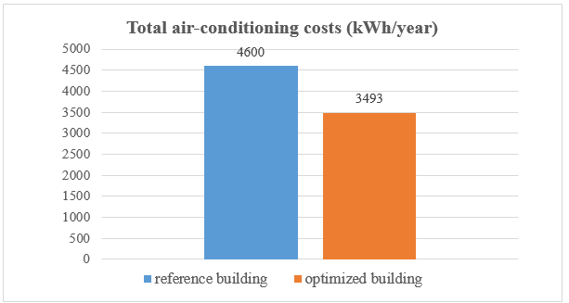

Figure 6 : Total air-conditioning load diagram for the building in reference and optimized situations.
Figure 6 shows that total air-conditioning loads in the reference situation are much higher than in the optimized situation. The difference in air-conditioning loads between the building in the reference situation and in the optimized situation is 1107 kWh per year, or approximately 24.06%.
- CONCLUSION
This study demonstrated the significant impact of architectural optimization on the thermal and energy performance of a building in a Sahelian climate, particularly in the city of Ouagadougou. Using KoZiBu simulation software, we were able to model and analyze the effects of various design strategies on indoor temperatures and cooling energy requirements.
Optimization by using the BLT-hollow breeze-block double wall showed promising results, with a notable average reduction in maximum interior temperatures : 2.25°C in bedroom 1, 2.6°C in bedroom 2 and 2°C in the living room. These temperature reductions are particularly significant in a hot climate like that of Ouagadougou, where thermal comfort is a major issue for the well-being of occupants.
Optimization has also led to a substantial reduction in the energy required for air conditioning, with a 24.06% reduction in sensitive loads. This translates into a reduction in the building's energy consumption, contributing to a more sustainable and economical use of energy resources. This reduction in air-conditioning demand not only cuts energy costs, but also reduces the building's carbon footprint, bringing construction practices into line with sustainable development objectives.

COMPETING INTERESTS DISCLAIMER:
Authors have declared that they have no known competing financial interests OR non-financial interests OR personal relationships that could have appeared to influence the work reported in this paper.

REFERENCE
- Energy efficiency in buildings in the Mediterranean, Henri-Luc. Director of Plan Bleu, El Habib El Andaloussi. In charge of Energy at Plan Bleu.
- Energy Management Unit- Burkina Faso. Implementation of a curative and preventive maintenance program for the Burkinabé administration's electrical equipment. Ouagadougou-Burkina Faso, 2010.
- P. Y. Gagnon and P. H. Nfaoui, “Renewable energies: Distributed and community production”, article, pp. 3–5, 2013.
- Sector policy letter from the Ministry of Energy [Burkina Faso], October 2016
- AMADOU OUMAROU Fati, Ramchandra BHANDARI, MAMADOU Lewamy, KY Thierry S.M, OUEDRAOGO Souleymane, Rabani Adamou, COMPAORÉ Abdoulaye, BATHIEBO Dieudonné Joseph « Determination and Evaluation of the Cooling Load of a Building Made by Different Local Material of Construction » IRA-International Journal of Applied Sciences ISSN 2455-4499 ; Vol.15, Issue 01 (Q1 2020).
- Abdoulaye Compaore, Boureima Dianda, Gilbert Nana, D. Joseph Bathiebo, Belkacem Zeghmati, Xavier Chesneau and Stéphane Abide « Modeling of Heat Transfer in a Habitat Built in Local Materials in Dry Tropical Climate » Physical Science International Journal, 17(1) : 1-11, 2018 ; Article no.PSIJ.38931 ISSN: 2348-0130
- Etienne MALBILA, “Comparative experimental and numerical studies of the hygrothermal performances of two houses built from cut lateritic block and concrete block : highlighting the influence of thermal inertia on thermal comfort in a dry tropical climate”. Single doctoral thesis, Ouaga 1 Joseph KI-ZERBO University, 2018.
- Emmanuel Ouedraogo, Ousmane Coulibaly, Abdoulaye Ouedraogo, Adamah Messan, “Mechanical and Thermophysical Properties of Cement and/or Paper (Cellulose) Stabilized Compressed Clay Bricks”, vol. 2, p. 68‑76, 2015.
- Alexis Kemajou, Léopold Mba “Construction materials and thermal comfort in hot zones. Application to the case of Cameroonian climatic regions”, Revue des Energies Renewables Vol. 14 No. 2 (2011) 239 – 248.
- Aguérata KABORE, “Hygrothermal modeling of the building envelope with hemp material”, l’école technol. great. As required. partial to obtaining master's degree with mem. conc. energ. renewable eff. Msca Energy, Jan. 2020.
- Institute of Energy and the Environment of the Francophonie (IEPF), PRISME Works, Energy efficiency of air conditioning in tropical regions, Thermal Assessment. Volume 1 : Design of new buildings, http://www.iepf.org, 2002.
- Institute of Energy and the Environment of the Francophonie (IEPF), PRISME Works, Energy efficiency of air conditioning in tropical regions, Thermal Assessment. Volume 2 : operation of existing installations, ISBN : 2-89481-010-5, http://www.iepf.org, 2002.
- Institute of Energy and the Environment of the Francophonie (IEPF) 2006, PRISME Technical Sheets, Energy quality codes for buildings.w

