TO STUDY OF THE CATHODOLUMINESENCE PROPERTIES OF SIO₂:PR³⁺ AND ZNO.SIO₂:PR³⁺ NANOPOWDER PHOSPHORS AND INVESTIGATED THE DEPENDENCE OF LUMINESCENCE PROPERTIES

Abstract
The present study focused on the luminescence behavior of trivalent rare earth ions in sol-gel derived SiO₂ and ZnO co-doped SiO₂:Pr³⁺ nanophosphors, with the aim of understanding their cathodoluminescence (CL) characteristics under varying synthesis and experimental conditions.The research specifically investigated the dependence of luminescence properties of SiO₂:Pr³⁺ on dopant concentration, annealing temperature, and ZnO incorporation. Additionally, the influence of concentration, beam voltage, and current on the CL intensity of SiO₂:Pr³ was examined.The materials were synthesized using the sol-gel method, which offered controlled morphology and homogeneity in the formation of nanostructures. The synthesized samples were characterized using X-ray diffraction (XRD) for structural analysis, scanning electron microscopy (SEM) for surface morphology, optical absorption and emission properties. the study also analyzed luminescence degradation machanisms in SiO₂:Pr³⁺, ZnO.SiO₂:Pr³⁺
Keyword;
ZnO nanoparticles; Different synthesis methods; Temperature dependence luminescence intensity; Emission for different excitation wavelength
Introduction;
A thorough comprehension of the primary characteristics of Pr³⁺ has been achieved because to the extensive research on this ion. Pr³⁺ has a wide spectrum of efficient emission colours, from blue to green to orange to red and even near infrared (NIR), depending on the host matrix.[1-5] Numerous hosts, such as glasses and crystals, have been investigated for the Pr³⁺ ion. The most promising phosphors for use in FED technology are those that are both thermally stable and have a high luminous efficiency. The phosphors degrade at high current densities under sustained electron irradiation, which impacts FED performance and restricts their commercialization.[6-15] Particularly, it has been discovered that sulphide-based phosphors, which are extensively utilized in display technology, undergo a dramatic degradation when subjected to extended electron beam bombardment. Contrarily, it has been found that oxide-based phosphors exhibit better chemical and thermodynamic stability when subjected to high vacuum pressures, higher temperatures, and current densities.[16-21] So, there has been a recent uptick in studies looking at oxide phosphors as a potential alternative to sulphide-based phosphors in low voltage FEDs.[21-25]
The CL characteristics of ZnO, SiO₂, and SiO₂:Pr³⁺ are covered in this study. The mechanisms behind the degradation of the CL intensity of SiO₂:Pr³⁺ phosphor powders are covered. We are investigating the potential of these phosphors for use in low voltage field emission displays.

Methodology
Experimental Study;
Sample Preparation by Sol-Gel Method
- ZnO Nanocrystals
The last twenty years have seen research into ways to prepare colloidal solutions of ZnO nanoparticles in alcohols. A solution of ZnO nanocrystals was prepared by dissolving 0.459 g of Zn(CH₃COO)₂.2H₂O in 30 ml of boiling 100% ethanol, stirring for approximately 1 hour to create a clear solution, and then cooling it in ice water. A 0.2 g solution of Nao in 10 ml of 100% ethanol was dissolved in an ultrasonic bath set at room temperature. The mixture was chilled in ice water before being added dropwise to the Zn²⁺ ethanol suspension while vigorously stirring. The subsequent transparent sol was allowed to sit at room temperature for one day to facilitate nanoparticle nucleation and development. After that, it was centrifuged and washed with heptane multiple times to eliminate any undesirable Na⁺ and CH₃COO⁻ ions. Either re-dispersion in ethanol or drying in an oven at 90ºC for 2 hours was used to get the ZnO precipitate.
- SiO₂:Pr³⁺ and ZnO.SiO₂:Pr³⁺ phosphor powders
As a catalyst, nitric acid (HNO₃), tetraethyl orthosilicate (TEOS), de-ionized water, ethanol, and Pr (NO)₃.6H₂O were used to prepare Pr³⁺ doped SiO₂ samples by a sol-gel procedure. After 1 hour of stirring at room temperature, a clear solution was obtained by adding 1 mole% of Pr (NO) _{3.}6H₂O dissolved in 5 ml of ethanol. The combination, which included 0.05 mol of TEOS, 0.1 mol of H₂O, 0.1 mol of ethanol, and 0.145 mol of dilute nitric acid, was then agitated for 30 minutes. Two portions of the resulting SiO₂:Pr³⁺ (1 mol %) sol were separated. A petri dish was used to dry the first portion, and then, after vigorously swirling at room temperature for one hour, the second portion was mixed with an ethanol mixture containing 1 mol% of ZnO nanoparticles. After eight days of room temperature drying, the gels were crushed with a mortar and pestle and subjected to a two-hour heat treatment in ambient air at 600°C.
Result And Discussion
Sample structure (XRD)
According to the famous quartzite hexagonal structure of zinc oxide, Figure 1 displays the XRD patterns of both the nanoparticles and the conventional micro particle powders of zinc oxide. The lower particle sizes are responsible for the broadening of the ZnO diffraction peaks. The ZnO nanoparticles had an average crystallite size of about 4 nm, as determined using Scherer's equation. Annealing SiO₂ at 600ºC for 2 hours did not change its amorphous state, regardless of whether Pr³⁺ and ZnO nanoparticles were present or not (see figure 2). The low Pr³⁺ and ZnO nanoparticle concentrations, as well as the significant amorphous scattering background from the SiO₂ matrix, are likely to blame for this. Furthermore, this would suggest that the ZnO and Pr³⁺ ions are evenly distributed throughout the SiO₂ matrix and maintained their tiny size even after annealing. Using EDS, we were able to confirm th
at the phosphor powders (not shown) included Pr³⁺ and ZnO nanoparticles.
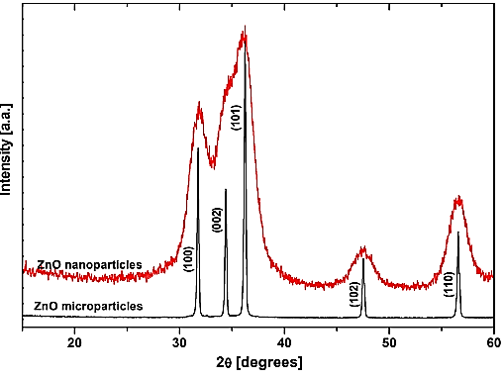
Figure 1: XRD patterns of the ZnO nanoparticles and micro particles.
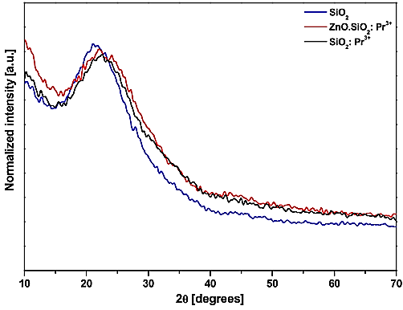
Figure 2: XRD patterns of SiO₂ nanoparticles, SiO₂:Pr³⁺ and ZnO.SiO₂:Pr³⁺ nanophosphor powders calcined at 600ºC for 2hrs.
Sample morphology (FESEM)
Figures 3 (a), (b), and (c) show fragment morphologies of ZnO, SiO₂, and SiO₂:Pr³+ particles in the field of view of a field emission scanning electron microscope. Nanopowders of SiO₂:Pr³⁺ were calcined at 600°C for 2 hours. The pictures showed that the particles were clumped together and mainly round, with a typical size of about 20 to 30 nanometers.
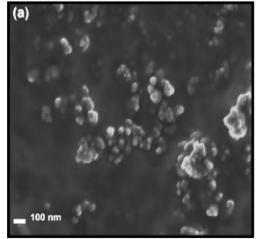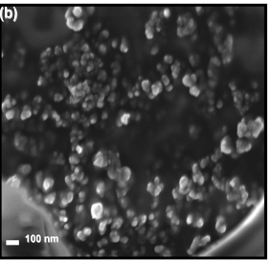
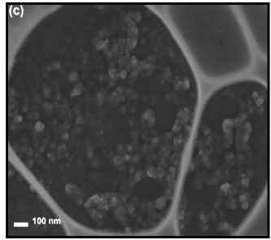
Figure 3: HRSEM images of (a) SiO₂, (b) Pr³⁺ doped SiO₂, and ZnO.SiO₂:Pr³⁺ nanophosphor powders.
Thermal Analysis, TGA
In figure 4, we can see the TGA curves of ZnO.SiO₂:Pr³⁺, SiO₂:Pr³⁺, and SiO₂:Pr³⁺. At temperatures ranging from 50 to 130 degrees Celsius, the first signs of weight loss appeared, which were likely caused by the dissolution of physically adsorbed water and ethanol. The second temperature-dependent weight loss, which occurs between 250 and 600°C, is due to the oxidation of remaining organics and the relaxing of the silica network. Until stable phases were produced at temperatures of 900ºC or above, the weight loss decreased with increasing temperature beyond 600ºC. Approximately 19%, 25%, and 22% of the total weight was lost by SiO₂, SiO₂:Pr³⁺ and ZnO.SiO₂:Pr³⁺ respectively. Samples doped with Pr³⁺and/or ZnO showed a more rapid rate of weight loss. This may be because adding 1 mol% of Pr³⁺ and 1 mol% of ZnO nanoparticles to the SiO₂ matrix increases the surface area and pore volume of the gels.
Total weight loss increased as the Pr³⁺ content did (i.e., 22% for SiO₂, 29% for SiO₂:Pr³⁺ (5 wt %), and 32% for SiO₂:Pr³⁺ (10 wt %), according to the researchers). Microporous and composed of an abundance of internal silane groups, the gels are an inevitable byproduct. As the gel is heated, its pores progressively close and transform into a pore-free material, much like silica gels. Researchers found that densified gels froth at high temperatures due to steam, which is produced when hydrogen-bonded silane groups release water to form Si-O-Si bonds.
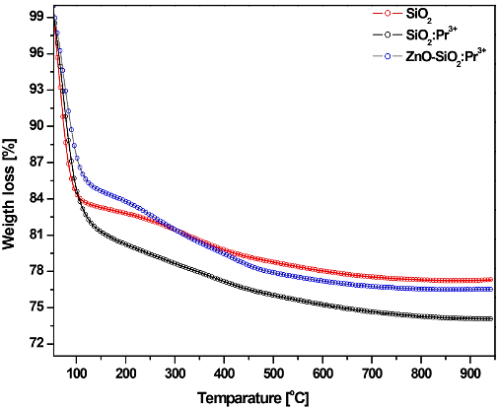
Figure 4: TGA curves of un-doped SiO₂, SiO₂:Pr³⁺ and ZnO.SiO₂:Pr³⁺ phosphor gels. The samples were heated from 50ºC to 950ºC in N₂ atmosphere at a heating rate of 10^{oC}/min.
Optical absorption and emission properties
To compare Pr³⁺ doped and un-doped SiO₂, figure 5 displays their optical absorption spectra. In the ultraviolet-visible spectrum, the Pr³⁺ doped SiO₂ showed four bands, each corresponding to a different excited state of the Pr³⁺ ions, beginning with the ground state ³H₄. Intra- configurational electric dipole transitions of the Pr³⁺ are attributed to these absorption bands, which are ³H₄→³P _{(J = 0, 1, 2),} ¹I₆, and ¹D₂ ⁴f₂. These agree with the findings of other researchers quite a bit.
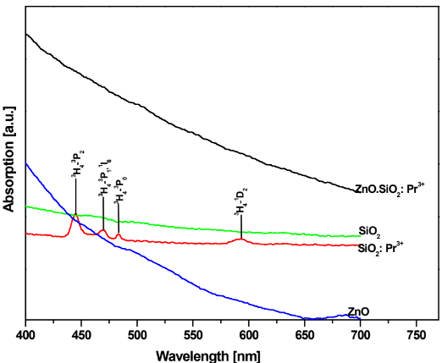
Figure 5: UV-VIS absorption spectra of SiO₂, ZnO, and SiO₂: Pr^{3+,} and ZnO.SiO₂: Pr^{3+.}
Figure 6 displays the PL emission spectra obtained after excitation at 325 nm from ZnO nanoparticles and ZnO micro particles dispersed in ethanol. A greenish-hued emission at 517 nm was detected from ZnO nanoparticles, which was attributed to the recombination of delocalized electrons at deeply confined holes and singly occupied oxygen vacancies. Consistent with the findings of the researchers, this emission is red-shifted from the 470 nm emission of ZnO micro particle defects. Furthermore, at 517 nm, the green emission from ZnO nanoparticles was more pronounced than that from ZnO particles that were micron-sized. This is because the surface area-volume ratio increases with smaller particles, which may lead to a higher density of surface defect states in ZnO.
In both the micro and nanoscale ZnO particles, there was direct bandgap emission at 380 nm and 365 nm, respectively, which may have resulted from exciton center recombination. However, the blue-shifted emission from the nanoscale ZnO particles occurred at lower wavelengths and higher energies. One possible explanation for this behavior is that the quantum confinement of charge carriers in the smaller particles causes the bandgap of the ZnO nanoparticles to broaden.
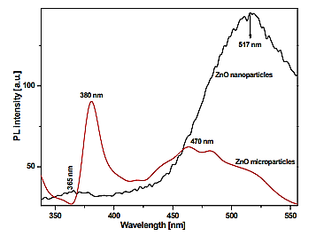
Figure 6: PL emission spectra of ZnO nanoparticles and ZnO micro particles.
Silica, SiO₂:Pr³⁺, and zinc oxide CL spectra. Figure 7 displays SiO₂:Pr³⁺ nanophosphor powders in a high vacuum chamber with a base pressure of approximately 1.6 x 10⁻⁸ Torr, driven by 2 kV electrons at a current density of 20 µA. The emission peak of SiO₂ was observed at 445 nm in the CL spectra. The charge transfer between the O and Si atoms or structural flaws in the SiO₂ network could be the cause of this peak.
Both SiO₂:Pr³⁺ and ZnO exhibited the distinctive emission peaks, with the highest emission at 614 nm, which are thought to be linked to Pr³⁺ transitions. Silica gel samples containing phosphoric acid. The ³P₀ and ¹D₂ transitions to the ³H _{(J = 6, 5, 4)} and ³F _{(J = 2, 3, 4}) levels, which are all located in the 4f² intra-configuration of the Pr³⁺ ions, are the ones responsible for this emission. Associated with the ³P₀→³H₄ transition are the initial two peaks at 488 nm and 510 nm. When Pr³⁺ is doped in ZrO₂, the researchers observed three distinct aspects of this transition. The ³P₀→³H₆ transition is attributed to the dominating emission at 614 nm, which is followed by a wide emission peak. At 590 nm, 635 nm, and 661 nm, the shoulders represent the transitions from ¹D₂ to ³H₄, ¹D₂ to ³H₅, and ³P₀ to ³F₂, respectively.
In agreement with the peak assignments, researchers have acquired fluorescence spectra from tellurite glasses doped with Pr³⁺. In Pr³⁺ doped glasses, researchers also observed that the two transitions, (³P₀→³H₆) and ¹D₂→³H₄, overlapped. We found that the excited state of the ³P₀ level decayed quicker than the ¹D₂ level, which helps to explain the overlap of the two emission transitions, by measuring the decay durations of the excited states of the two levels. This indicates that the light is emanating from the ¹D₂ level. Scientists discovered that the ³P₀ excited state degraded more slowly than the ¹D₂. The decay times of the excited states of rare earth elements vary from host to host, with the phonon energies of the host lattice having a considerable impact on these decay times. This could explain why there are variances in these decay durations.
According to the researcher, the lack of luminescence from ¹D₂ is due to the huge energy difference (~ 3858.5 cm-1) between ³P₀ and ¹D₂, which causes a little multiphoton non-radiative relaxation from ³P₀ to ¹D₂. This investigation did not include the measurement of decay lifetimes. The ¹D₂ → ³F₄ transition is attributed to the last peak in the near-infrared region, which is located at 995 nm. Having said that, the author's observation of the peak position is incorrect. The emission spectra of ZnO.SiO₂:Pr³⁺ did not reveal any flaws emitted by ZnO nanoparticles at 517 nm. Both ZnO and SiO₂:Pr³⁺ showed a consistent main emission peak at 614 nm for Pr^{3+.}samples of SiO₂:Pr^{3+.}
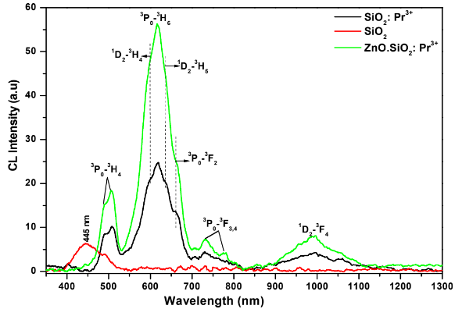
Figure 7: CL spectra of un-doped SiO₂, SiO₂:Pr³⁺ and ZnO.SiO₂:Pr³⁺ irradiated with 2 kV, 20 µA beams of electrons in a high vacuum chamber containing 1.6 x 10⁻⁸ Torr.
Further evidence that the ZnO nanoparticles were evenly distributed throughout the SiO₂ matrix and that their integration did not alter the radiative process of Pr³⁺ is provided by this. There was a noticeable reduction in the blue radiation emitted by the host SiO₂. It appears that energy was transmitted from the ZnO nanoparticles to the Pr³⁺ ions, since the CL intensity of the 614 nm peak increased after their inclusion.
Phosphors' ability to transmit energy from donors to acceptors has been recognized for quite some time. In this process, an interaction (e.g., an exchange or multipole-multipole interaction) takes place between two luminescent centers, A and D, which are separated by a distance R. Take ZnO.SiO₂:Pr³⁺ as an example; it's a narrow-line absorber that transfers energy from the broad-band emitter, ZnO nanoparticles, to the narrow-line receiver, Pr³⁺.The author states that this type of operation can only take place for neighboring nodes in the host lattice. In order for the energy transfer process to take place between the ZnO and Pr³⁺ donors, the distance R between them must be less than the critical distance Rc. This critical distance is the distance at which the emission of ZnO takes precedence over the transfer of energy. This indicates that the distance required for energy transfer to occur is sufficiently short for a 1 mol% ZnO nanoparticle embedded in SiO₂ with a 1 mol% Pr^{3+.} Figure 8 shows, schematically, the energy levels that correspond to the propagation of energy from ZnO nanoparticles to Pr³⁺ and, possibly, radiative transitions that are localized within the Pr³⁺ ion. It is possible that the bandgap absorption and relaxation to the defects states of ZnO fill the defects states in the ZnO bandgap, which explains why the energy transfer mechanism enhances CL intensity at 614 nm with ZnO integration. Photoemission from ZnO and total photo capture by Pr³⁺ result in the energy being transported to the ³P₀ state of the Pr³⁺ ion, potentially through phonon-mediated mechanisms. As a result, the observed enhanced Pr³⁺ emission is not surprising.
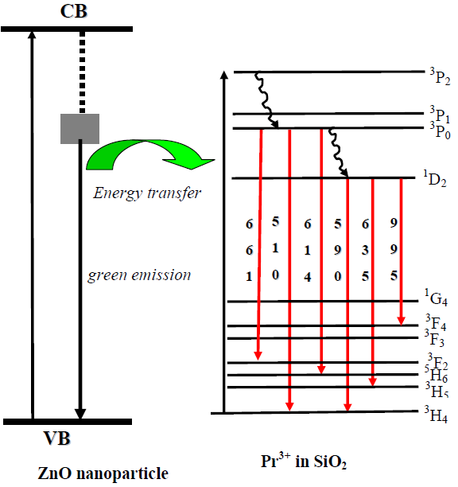
Figure 8: Schematic representation of energy levels diagram depicting mechanism of energy transfer from ZnO nanoparticles and possible transitions in Pr³⁺ doped in SiO₂.
Figure 9 displays the CL spectra of SiO₂:Pr³⁺ nanophosphor powders that were exposed to high vacuum in a chamber with a base pressure of approximately 1.6 x 10⁻⁸ Torri, using accelerating beam voltages ranging from 1 to 5 kV and a current density of 8.5 µA. The figure clearly shows that the CL intensity of the main emission peak at 614 nm reduced at 5 kV after constantly growing from 1 to 5 kV. The CL intensity reached its maximum at 4 kV. Figure 10 shows the CL intensity vs various accelerating voltages, making this point very evident.
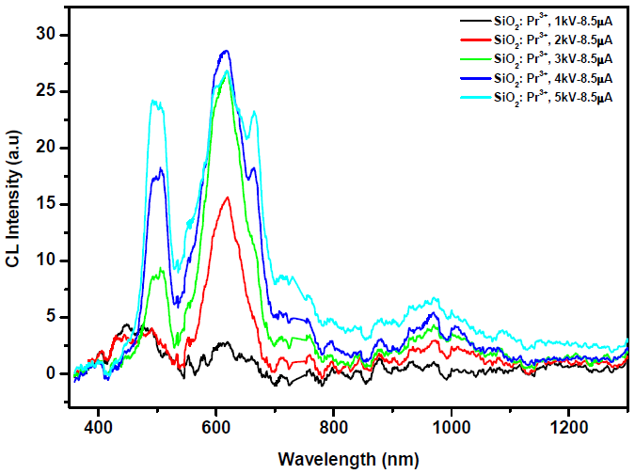
Figure 9: CL spectra of SiO₂:Pr³⁺ irradiated with (1-5 kV), 8.5 µA beam of electrons in a high vacuum chamber containing a base pressure of ~ 1.6 x 10⁻⁸ Torr.
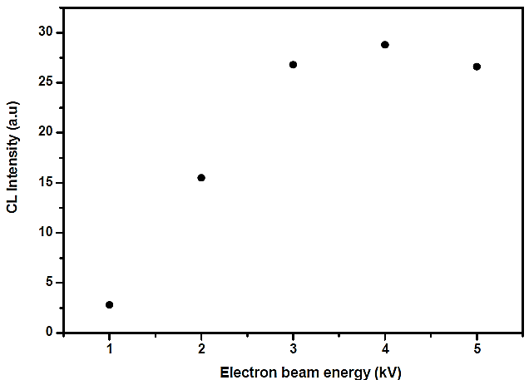
Figure 10: Maximum CL intensity of SiO₂:Pr³⁺ 614 nm emission peak as a function of accelerating voltage
Various accelerating beam voltages (1 to 5 kV) and currents (8.5 µA) were used to irradiate ZnO.SiO₂:Pr³⁺ nanophosphor powders in a high vacuum chamber with a base pressure of approximately 1.6 x 10⁻⁸ Torr, as shown in Figure 11. See figure 12 for an illustration of how the CL intensity of the 614 nm peak from ZnO.SiO₂:Pr³⁺ grew from 1 to 3 kV and then decreased at 4 and 5 kV. This proves beyond a reasonable doubt that Pr³⁺ received energy from ZnO.
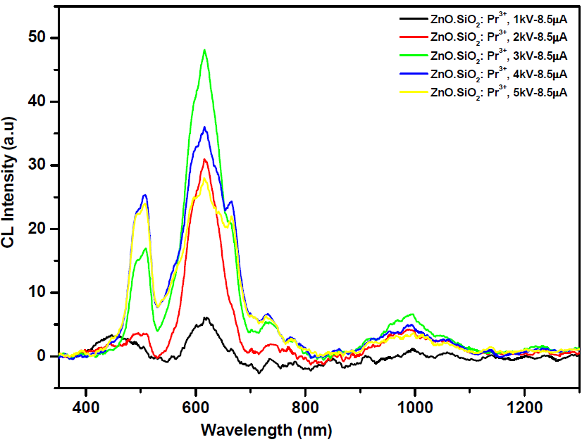
Figure 11: CL spectra of ZnO.SiO₂:Pr³⁺ irradiated with (1-5 kV), 8.5 µA beam of electrons in a high vacuum chamber containing a base pressure of ~1.6 x 10⁻⁸ Torr.
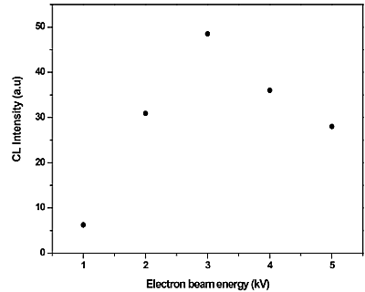
Figure 12: Maximum CL intensity of ZnO.SiO₂:Pr³⁺ 614 nm emission peak at different electron beam voltages.
The correlation between the electron beam energy and the CL intensity is similar to that of the electron impact ionization cross-section for atoms. As the electron's energy increases, the intensity will rise, but then fall again as the electron interacts with the atom. At higher energies, the drop is more pronounced than anticipated; nonetheless, local heating under the beam and quenching caused by charge are not ruled out. One possible explanation for the observed drop in CL intensity of the major emission peak at 614 nm from both phosphors (SiO₂:Pr³⁺ and ZnO.SiO₂:Pr³⁺) as the beam voltage increases is thermal quenching, which happens at high temperatures. An increase in the beam voltage causes thermal quenching to happen because it raises temperature via local heating by energetic electrons.
When an activator ion is subjected to thermal quenching, the energy is transferred from the ion to the atoms around it through high-temperature thermal vibrations. This causes non-radiative recombination, which in turn depletes the excess energy as phonons in the host lattice. The configuration coordinate model elucidates the thermal quenching mechanism.
CL degradation
The CL spectra of the ZnO.SiO₂:Pr³⁺ phosphor and the SiO₂:Pr³⁺ phosphor, both before and after electron bombardment, are displayed in figure 13 (a) and (b), respectively, under conditions of 2 kV irradiation, 20 µA current, and an O₂ pressure of 1 x 10⁻⁷ Torr backfilled from a vacuum base pressure of 1.6 x 10⁻⁸ Torr. The CL intensity of the 614 nm peak was entirely eliminated by 2kV electron bombardment, as demonstrated in figures 13 (a) and (b).
Figure 4 shows the Auger spectra of the SiO₂:Pr³⁺ and ZnO.SiO₂:Pr³⁺ phosphors both before and after degradation. The peaks for Si (79 eV), C (267 eV), and O (505 eV), respectively, were disclosed in (a) and (b). Prolonged electron bombardment of SiO₂ resulted in a decrease of Auger peak intensity of Si and O and a full disappearance of adventitious C. The researcher also made a comparable finding. The Auger peak intensities of Si and O were found to be decreasing, and a new Auger peak at around 92 eV, linked to elemental Si, was observed, according to the researchers. The elemental Si in the SiO₂ combination can be found to shift from a higher energy of 92 eV to a lower energy of 75–80 eV, according to the researchers. This shift is explained by a change in the density of states and by relaxation effects. A small change of the Si peak towards higher energy was noted in the present investigation. The electron bombardment caused the extra peaks of Si0_{x} (0<x<2) to emerge, which is responsible for the shift in the shape of the Si peak before and after degradation. Extra SiO_{x} peaks were verified by XPS.
The Auger peak-to-peak heights (APPH's) of Si, O, and C changed as a result of SiO₂:Pr³⁺ and ZnO, as shown in Figure 14 (a) and (b).at 2 keV, 20A electron bombardment with O₂ backfilled from a vacuum base pressure of 1.6 x 10⁻⁸ Torr, and the CL intensity as a function of coulomb dose for SiO2:Pr³⁺ phosphors, respectively. Figures 15 (a) and (b) show that the surface concentration of adventitious C is extremely low. The peak intensity of O was reduced by the electron bombardment, whereas that of Si and C was practically unaltered. The reduction in CL intensity caused by electron bombardment was also noted in SiO₂:Pr³⁺ and ZnO. Phosphors of SiO₂:Pr^{3+,} as shown in figures 14 (a) and (b). This finding confirmed the hypothesis that a drop in CL intensity is correlated with a drop in Auger peak intensity from O. This may be because O is absorbed from the surface when SiO₂ is electron-beam dissociated, as suggested in earlier studies.
Scientists believe that electron-stimulated surface chemical reactions (ESSCR) were responsible for the O₂ desorption from the surface. According to reports, Si-O bonds are broken and free oxygen ions are produced as a result of a reaction with dissociated species (e.g., C, H, or O) from vacuum ambient gases (e.g., H₂O, O₂, and CO₂) with sustained electron bombardment. By causing the inclusion of O is o-electronic traps in the near surface region, the ESSCR mechanism can also lead to a decrease in the activators' radiative efficiency. It is possible that the formation of an oxygen-deficient surface dead layer of SiO_{x}, where x < 2, is due to the desorption of oxygen, as the new Auger peak associated with elemental Si at 92 eV in the Auger spectra after an electron of 27⁰C/cm² was not observed in the current results, which are in agreement with the data reported.
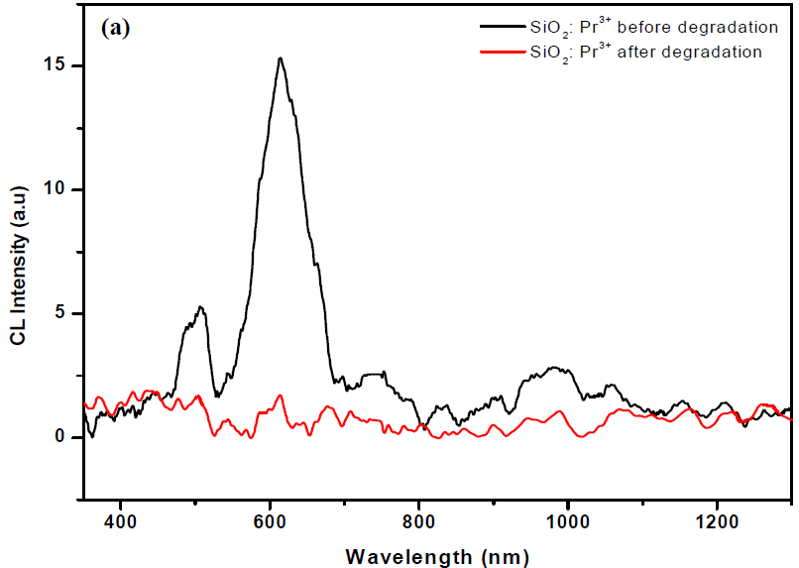
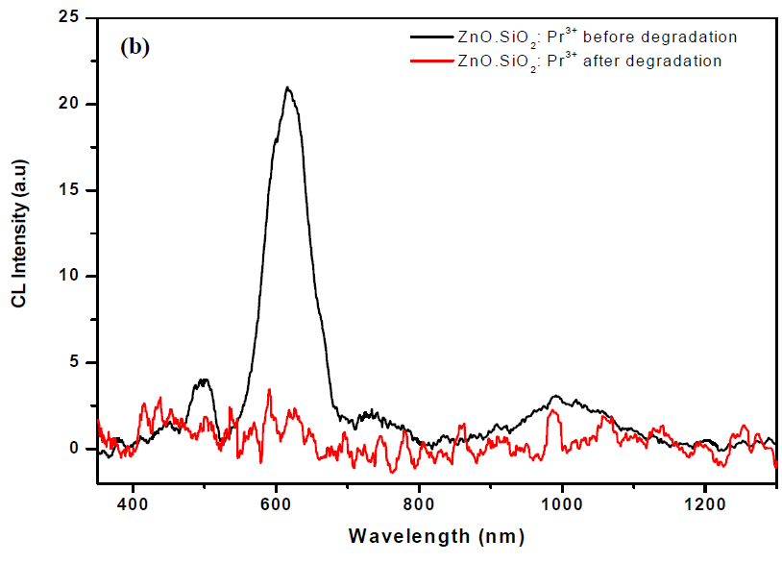
Figure 13: CL spectra of (a) SiO₂:Pr³⁺ and (b) ZnO.SiO₂:Pr³⁺ before and after electron bombardment by 2 kV, 20 µA in 1 x 10⁻⁷ Torr of O₂.
So, it's not unreasonable to assume that the surface SiO_{x} dead layer is the primary cause of the SiO₂:Pr³⁺ and ZnO CL intensity reduction. Luminaires (SiO₂:Pr³⁺).
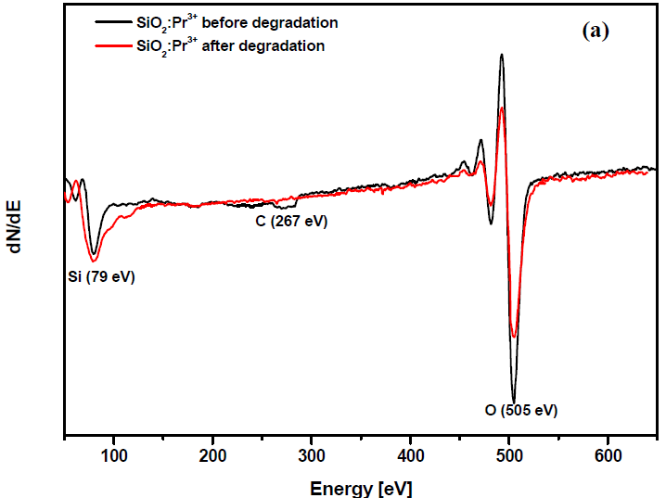
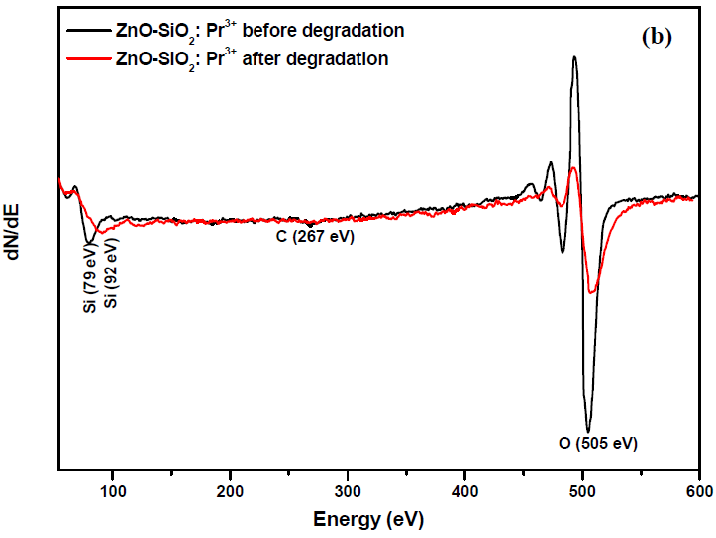
Figure 14: AES spectra of (a) SiO₂:Pr³⁺ and (b) ZnO.SiO₂:Pr³⁺ before and after degradation at 2 kV, 20 µA, in 1 x 10⁻⁷ Torr of O₂
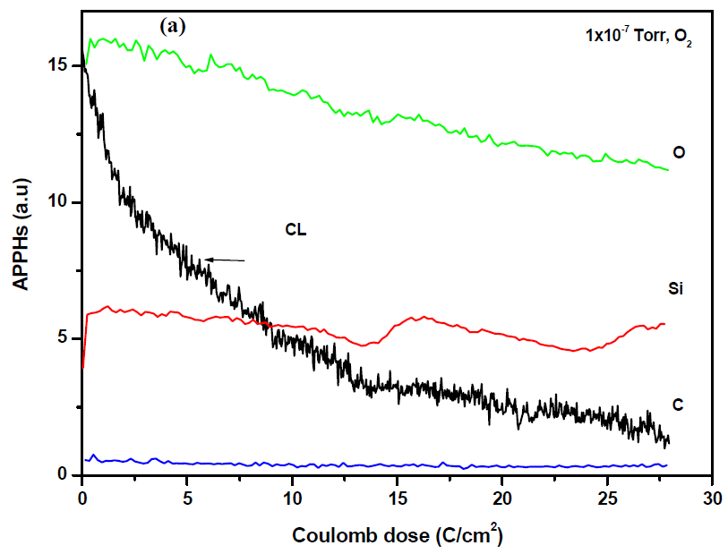
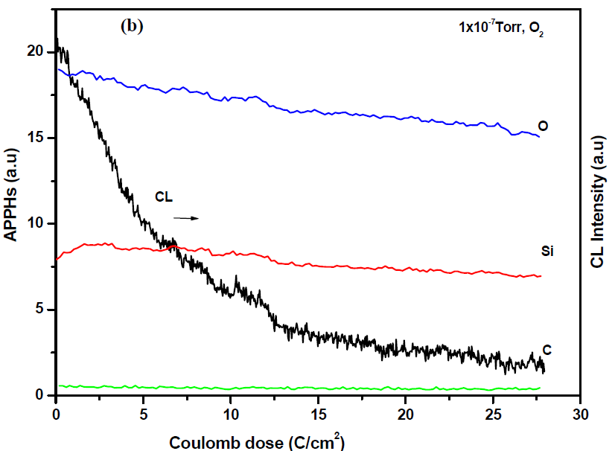
Figure 15: AES peak-to-peak heights of (a) SiO₂:Pr³⁺ and (b) ZnO.SiO₂:Pr³⁺ at 2 kV, 20 µ A, in 1 x 10⁻⁷ Torr of O₂ as a function of electron dose.
The sol gel approach was used to successfully insert ZnO nanoparticles into Pr³⁺ doped SiO₂ nanophosphor, with an estimated average crystallite size of approximately 4 nm according to Scherer's equation. The ³P₀→³H₆ transition of Pr³⁺ was responsible for the enhanced red emission at 614 nm that was seen in ZnO.SiO₂:Pr^{3+.} The non-radiative energy transfer from ZnO to Pr³⁺ entirely eliminated the green fluorescence at around 530 nm. Both ZnO.SiO₂:Pr³⁺ and SiO₂:Pr³⁺ showed that the CL intensity was affected by the beam voltage. Discussion centered on the process by which the CL intensity of ZnO.SiO₂:Pr³⁺ and SiO₂:Pr³⁺ phosphor powders degrades.
Conclusion;
the study of ZnO incorporation into SiO₂:Pr³⁺ revealed that ZnO plays a crucial role in modifying the luminescence characteristics of the host matrix by acting both as an energy transfer mediator and as a structural modifier. The ZnO nanoparticles embedded within the SiO₂ matrix facilitate enhanced defect-mediated recombination processes, which in turn augment the CL emission intensity of the Pr³⁺ ions. It was observed that the luminescence behavior is highly dependent on the. Pr³⁺ ion concentration, with an optimal concentration leading to maximum emission intensity, beyond which concentration quenching effects set in due to cross-relaxation and non-radiative processes. Similarly, annealing temperature significantly influenced the luminescence efficiency by modifying the structural ordering of the SiO₂ matrix, reducing the concentration of non-radiative defect sites, and promoting better incorporation of Pr³⁺ ions into the network. At lower annealing temperatures, the CL and PL intensities were weaker due to high defect densities and poor crystallinity, whereas optimal annealing promoted stronger luminescence without inducing phase segregation or clustering of dopant ions. ZnO incorporation further amplified the CL efficiency through exciton–dopant interactions, confirming that a hybrid ZnO·SiO₂:Pr³⁺ system is more favorable for high-intensity emissions compared to pure SiO₂:Pr³⁺.

COMPETING INTERESTS DISCLAIMER:
Authors have declared that they have no known competing financial interests OR non-financial interests OR personal relationships that could have appeared to influence the work reported in this paper.

Reference;
- Rai V.K., Kumar K., Rai S. B, Luminescence investigation of trivalent rare earth ions in sol-gel derived SiO₂:Pr³⁺ Solid State Electron. Opt. Mater. 29 (2009) 873-878
- Blasse G., Grabmaier B.C., Luminescent Materials, Springer:Verlag, Berlin (2014)
- G. Blasse and B. C. Grabmaier, Luminescent Materials. Springer, Berlin (2014).
- Justel T., Nikol H. and Ronda C., New developments in the field of luminescent materials for lighting and displays. Angew. Chem. Int. Ed. 37, 3085 (2018).
- Alivisatos p., Biotechnol Nat. The use of nanocrystals in biological detection. 22, 47 (2004).
- Niemeyer C.M., biotechnology meets materials science, Angew. Chem. Int. Ed. 40, 4128 (2001).
- Shimomura Y. and Kijima N.,Formation mechanisms and control method of aluminum-contaning impurity in high temperature spray pyrolysis of Y₂O₃:Eu³⁺ phosphor. Electrochem.Solid State 7, H18 (2004).
- Zhang K., Pradhan A.K., Loutts G.B., Enhanced luminescence and size effects of Y₂O₃:Eu³⁺ nanoparticles and ceramics revealed by x Rays and raman scattering. J. Opt. Soc. Am. B 21, (2004)1804.
- R. Schmechel, M. Kennedy, H. von Seggern, H. Winkler, M. Kolbe, R. A. Fischer, X. M. Li, A. Benker, M. Winterer and H. Hahn, J. Appl. Phys. 89, (2001)1679.
- Blasse G. and grabmaier B.C., luminescent material. Spring:Berlin(2014)
- Pinel E., Boutnaud P., using a structural criterion for the selection of red emitting oxide based compounds containing Pr^{3+.}J. Alloys compd. 374(2004) 165-168
- Balda P., Voda M., M.visible luminescence in KPb₂Cl₅:Pr³⁺ crystal.S j. Lumin. 97(2002) 190-197
- Gusowski M.A., Ryba-Romanowski W.,luminescence and energy transfer in K₃GdF₆:Pr³⁺ j. Alloys compd. 438(2007) 72-76
- O. M. Ntwaeabor, and p. H. Hollowy, j. Nanotechnol. 16(2005) 865-868
- Liu X., Lin J. synthesis and luminescent properties of LaInO₃ : RE³⁺ (RE=Sm,Pr and Tb) nanocrystalline phosphor for field emission displays. solid state sci 11(2009) 2030-2036
- Tan S., Yang P., preparation, characterization and luminescent properties of spherical CaTiO₃ : Pr³⁺ phosphor by spray pyrolysis. solid state sci. 12(2010) 624-629
- Bang J., Yang H., Enhanced luminescence of SiO₂: Eu³⁺ by energy transfer from ZnO nanoparticles . j. Chem. Phys. 123(2005) 084709
- Hunt C.E., Chakhovskoi A.G. phosphor challenge for field emission flat panel displays. J. Vac. Sci. Technol. B 15 (2017) 516.
- Jiang Y.D., Zhang F., synthesis and properties of Sr₂CeO₄ blue emission powder phosphor for field emission displays. Appl. Phys. Lett. 74 (2019) 1677.
- Lee R.Y., Zhang F.L., investigation of Ce-doped silicates for low voltage field emission displays. J. Vac. Sci. Technol. B 16 (2018) 855.
- Gwak J.-K., Park S.H., synthesis and modification of red oxide phosphors for low voltage excitation. J. Vac. Sci. Technol. B 18 (2000) 1101.
- S. Thomas, acoustic densitometer with results for polyethylene oxide. j. Appl. Phys. 45[1] (2014)
- Kumawat Ashok, Chattopadhyay saikat, band gap engineering relationship with luminescence in rare earth elements doped ZnO : An overview. jun 2022 material technology 37(1).
- Mustaffa Nur Amalina, Electeospun light emitting Tm³⁺ doped SiO₂-HfO₂ nanofiber for photonic applications. journal of luminescence 1 may 2023.
- Mihail secu., Corina secu. Optical properties of transparent rare doped sol-gel derived nano glass ceramics. material (Basel) 14 nov 2021 (22):6871

