Case report

Epibulbar Dermoid Cyst As An Ocular Manifestation Of The Rare Goldenhar Syndrome: From Diagnosis To Treatment-A Case Report

ABSTRACT

AIMS
The objective of this case presentation is to disseminate knowledge about Goldenhar syndrome, a rare condition, in order to facilitate its recognition and encourage early diagnosis and management.

INTRODUCTION
Goldenhar syndrome is a rare condition that causes a defect in the development of structures derived from the first and second branchial arches manifesting as ocular, auricular, and vertebral abnormalities, hence the other designation of the syndrome by the oculo-auriculo-vertebral dysplasia.
In this report, we present the case of a four-year-old girl referred to the ophthalmology department of Mohammed VI University Hospital, Marrakech, Morocco with the chief complaint of a left ocular excrescence which turned out to be a limbal dermoid cyst in the context of Goldenhar syndrome, which was subsequently treated surgically.

CASE PRESENTATION
We report the case of a four-year-old girl whose chief complaint was a excrescence on her left eye present since birth and which, according to her parents, had gradually grown larger over the years. On ophthalmic examination, we observed a large rounded mass straddling the temporal limbus of the left eye, the appearance of which was consistent with that of a dermoid cyst. The lesion was further characterized by B-mode ultrasound and Magnetic Resonance Imaging. Evaluation of systemic malformations revealed the bilateral presence of multiple preauricular appendages. The overall clinical picture was consistent with a dermoid cyst within the context of Goldenhar syndrome. We opted for a surgical approach consisting of an excision in toto of the cyst, combined with an amniotic membrane graft to cover the resulting defect. The anatomopathological examination confirmed the dermoid nature of the cyst.

DISCUSSION
Goldenhar syndrome, or oculo-auriculo-vertebral dysplasia, is a rare pathologic entity affecting the development of structures derived from the first and second branchial arches. The exact etiology of the syndrome is not known but presumed multifactorial. The diagnosis of Goldenhar syndrome is clinical based on characteristic facial phenotype. It is well known for its classic triad of mandibular hypoplasia with facial asymmetry, oculo-auricular malformations and vertebral abnormalities. Classic ocular abnormalities include epibulbar dermoids, occurring in up to 92% of patients, microphthalmia and coloboma. Regarding the treatment of epibulbar dermoids, it aims to prevent amblyopia caused by direct obstruction of the visual axis by the cyst or by induced astigmatism, and/or for aesthetic reasons

CONCLUSION
Goldenhar syndrome is a rare disease entity with a broad spectrum of manifestations. Its management pursues functional and/or aesthetic objectives within a multidisciplinary approach.
Recognizing this disease allows for early diagnosis and treatment, which has a positive impact on the quality of life of these patients.

KEY WORDS
Goldenhar syndrome; Oculo-auriculo-vertebral dysplasia; Epibulbar dermoid cyst

1. INTRODUCTION
Goldenhar syndrome is a rare condition, first described by Maurice Goldenhar in 1952.
This condition causes a defect in the development of structures derived from the first and second branchial arches manifesting as ocular, auricular, and vertebral abnormalities, hence the other designation of the syndrome by the oculo-auriculo-vertebral dysplasia (Bekibele et al. 2005; Ashokan et al. 2014).

In this report, we present the case of a four-year-old girl referred to the ophthalmology department of Mohammed VI University Hospital, Marrakech, Morocco with the chief complaint of a left ocular excrescence which turned out to be a limbal dermoid cyst in the context of Goldenhar syndrome, which was subsequently treated surgically.

2. CASE PRESENTATION
We report the case of a four-year-old girl referred to the ophthalmology department of Mohammed VI University Hospital, Marrakech, Morocco with the chief complaint of a left ocular excrescence. This mass was present since birth and which, according to her parents, gradually grown larger over the years. The parents were not related and no similar family history was reported. The pregnancy had been uneventful, with a full-term vaginal delivery without complications.

On ophthalmic examination, the visual acuity was not quantifiable as the patient was not cooperative. No strabismus was noted. On examination of the left eye, a large, rounded mass was observed, straddling the temporal limbus and extending medially over the cornea while sparing the visual axis, and laterally over the temporal bulbar conjunctiva (Fig. 1). Few follicles were observed within the lesion, making the overall appearance consistent with a limbic dermoid cyst. The remain of the cornea was clear. The anterior chamber was quiet and deep and the crystalline lens was transparent. The fundus examination was unremarkable. The examination of the right eye was unremarkable.

We realized a B-mode ultrasound of the left eye that showed a cystic appearance of the mass without invasion of the anterior chamber (Fig.2). A further characterization was done by an oculo-orbital Magnetic Resonance Imaging (MRI) that individualized a pre-limbic formation on the left eye, well limited, measuring 8.5 x 4.8 x 14 mm, in T1 hypersignal and T2 hypersignal, not enhanced after injection of contrast.

We also carried out a thorough evaluation for systemic malformations. The facial examination revealed the bilateral presence of multiple preauricular appendages, prompting a consultation with an otolaryngologist (Fig. 3). The results of this consultation were normal, particularly with regard to hearing function, with the exception of multiple preauricular tragi. The remainder of the clinical examination, as well as abdominal and cardiac ultrasounds and chest and spine X-rays, revealed nothing abnormal.

The overall clinical picture was consistent with a dermoid cyst in the context of Goldenhar syndrome.

The treatment strategy was carried out in a multidisciplinary manner. From an ophthalmological point of view, we opted for a surgical approach consisting of an excision in toto of the cyst, combined with an amniotic membrane graft to cover the resulting defect (Fig.4). The anatomopathological examination confirmed the dermoid nature of the cyst.

Patient has been kept on regular follow-up and observation with very satisfactory post-operative results.

3. DISCUSSION
Goldenhar syndrome, or oculo-auriculo-vertebral dysplasia, is a rare pathologic entity affecting the development of structures derived from the first and second branchial arches (Bekibele et al. 2005; Ashokan et al. 2014).

The exact etiology of the syndrome is not known but presumed multifactorial. The disease is generally sporadic but some cases of positive family histories suggests autosomal dominant or recessive inheritance (Gorlin et al. 1963). The teratogenic effects of drugs such as retinoic acid, tamoxifen, and alcohol have also been implicated in interfering with neural crest cell formation (Das et al. 2008; Jayaprakasan et al. 2023).

The diagnosis of Goldenhar syndrome is clinical based on characteristic facial phenotype. It is well known for its classic triad of mandibular hypoplasia with facial asymmetry, oculo-auricular malformations and vertebral abnormalities (Ashokan et al. 2014; Malta et al. 2020).
Classic ocular abnormalities include epibulbar dermoids, occurring in up to 92% of patients, microphthalmia and coloboma. Otorhinolaryngologic features include preauricular tragi, hearing loss, low implantation of the auricular pavilion. Micrognathia and vertebral anomalies such as scoliosis or hemivertebrae may also be observed (Schmitzer et al. 2018). The abnormalities are mostly unilateral in 85% of the cases (Bhuyan et al. 2016).

Other systemic features may be found in approximately 50% of patients encompassing extremities anomalies, congenital heart disease and growth retardation (Bhuyan et al. 2016). The association of Goldenhar syndrome with Turner syndrome and glaucoma is also rarely reported (Rao et al. 2005).

Regarding the treatment of Goldenhar syndrome, therapeutic options vary according to age and systemic manifestations, with functional and/or aesthetic objectives.
The treatment of epibulbar dermoids aims to prevent amblyopia caused by direct obstruction of the visual axis by the cyst or by induced astigmatism, and/or for aesthetic reasons (Pirouzian 2013; Malta et al. 2020).

4. CONCLUSION
Goldenhar syndrome is a rare disease entity with a broad spectrum of manifestations. Its management pursues functional and/or aesthetic objectives within a multidisciplinary approach.
Recognizing this disease allows for early diagnosis and treatment, which has a positive impact on the quality of life of these patients.

CONSENT
As per university standards, patient written consent has been collected and preserved by the authors.

ETHICAL APPROVAL
As per international standards or university standards written ethical approval has been collected and preserved by the authors.

DISCLAIMER (ARTIFICIAL INTELLIGENCE)
Authors hereby declare that NO generative AI technologies such as Large Language Models (ChatGPT , COPILOT , etc.) and text-to-image generators have been used during the writing or editing of this manuscript.

COMPETING INTERESTS
Authors have declared that no competing interests exist.

REFERENCES
Ashokan, C. Seethalakshmi, Arathi Sreenivasan, and Gopal K. Saraswathy. 2014. “Goldenhar Syndrome - Review with Case Series.” Journal of Clinical and Diagnostic Research : JCDR 8 (4): ZD17–19.
Bekibele, Co, Sa Ademola, Sd Amanor-Boadu, Ee Akang, and Ko Ojemakinde. 2005. “Goldenhar Syndrome: A Case Report and Literature Review.” West African Journal of Medicine 24 (1): 77–80.
Bhuyan, Ruchi, Abhishek Ranjan Pati, Sanat Kumar Bhuyan, and Bikash Bishwadarshee Nayak. 2016. “Goldenhar Syndrome: A Rare Case Report.” Journal of Oral and Maxillofacial Pathology : JOMFP 20 (2): 328. https://doi.org/10.4103/0973-029X.185907.
Das, Amitava, Biswarup Ray, Debabrata Das, and Somnath Das. 2008. “A Case of Goldenhar-Gorlin Syndrome with Unusual Association of Hypoplastic Thumb.” Indian Journal of Ophthalmology 56 (2): 150–52.
Gorlin, Robert J., Kenneth L. Jue, Ull Jacobsen, and Ernst Goldschmidt. 1963. “Oculoauriculovertebral Dysplasia.” The Journal of Pediatrics 63 (5): 991–99.
Jayaprakasan, Srilakshmi K., Muhammad Daniyal Waheed, Saima Batool, Jorge Pimentel Campillo, Maymona E. Nageye, and Shaniah S. Holder. 2023. “Goldenhar Syndrome: An Atypical Presentation With Developmental and Speech Delay.” Cureus 15 (3): e36225.
Malta, Pio Guilherme, da Silva Rezende Aline Vilani, Cordeiro Frederico de Miranda, Ibrahim Larissa Fouad, Curi Cláudio Castro, and Moura Érica Borgatti. 2020. “Goldenhar Syndrome: The Importance of an Ophthalmological Approach.” Romanian Journal of Ophthalmology 64 (4): 444–48.
Pirouzian, Amir. 2013. “Management of Pediatric Corneal Limbal Dermoids.” Clinical Ophthalmology (Auckland, N.Z.) 7: 607–14.
Rao, VasudevAnand, Subashini Kaliaperumal, Thanikachalam Subramanyan, KotapalliRamachandra Rao, and Rajesh Bhargavan. 2005. “Goldenhar′s Sequence with Associated Juvenile Glaucoma in Turner′s Syndrome.” Indian Journal of Ophthalmology 53 (4): 267.
Schmitzer, Speranţa, Miruna Burcel, Dana Dăscălescu, and Ioana Claudia Popteanu. 2018. “Goldenhar Syndrome - Ophthalmologist’s Perspective.” Romanian Journal of Ophthalmology 62 (2): 96–104.

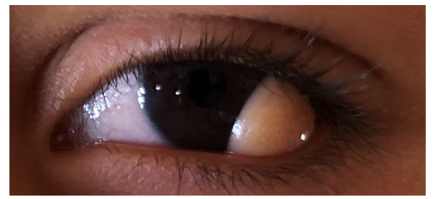

Fig. 1. Limbal dermoid cyst of the left eye

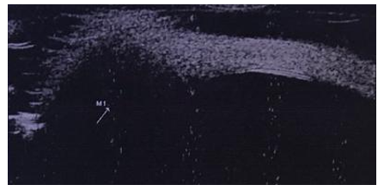

Fig.2. B-mode ultrasound of the dermoid cyst
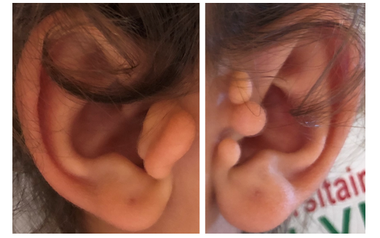

Fig. 3. Bilateral preauricular tragi

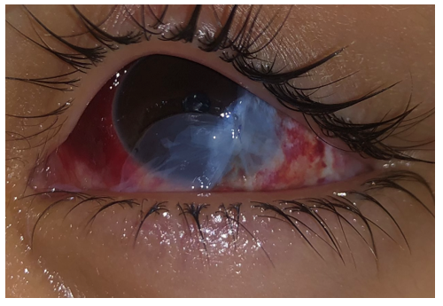

Fig.4. Postoperative photograph showing the amniotic membrane graft covering the surgical site after the excision of the dermoid cyst

