Original Research Article
Prevalence, Incidence, Survival, Susceptibility and Antibiotic Resistance of Aeromonas hydrophila isolated from Local Fish Market in and Around Salem, India

Abstract
Aeromonas hydrophila is a widespread opportunistic pathogen commonly associated with aquatic environments and is responsible for infections in fish and other aquatic organisms. This study investigated the prevalence, survival ability and antibiotic resistance of A. hydrophila isolated from local fish markets in and around Salem, Tamil Nadu. The bacterium was detected in 33.29% of fish samples, indicating a significant level of contamination, while 20% of Musca domestica (housefly) samples (1/5), also tested positive, suggesting their role as potential mechanical vectors. Antibiotic susceptibility profiling revealed that the potential isolate (CS1) showed resistant to ampicillin, amoxyclav, cephalexin, cefazolin, methicillin, oxacillin and vancomycin, indicating the presence of multidrug resistant strains. Survival studies showed that A. hydrophila could adhere to and persist on commonly used market surfaces such as stainless steel, wood, iron and thermocol. It also exhibited tolerance to a wide range of pH and temperature conditions. Experiments with common Indian cooking ingredients demonstrated varying inhibitory effects and several disinfectants and antiseptics were effective against the isolates. These findings highlight A. hydrophila contamination as a potential public health threat and emphasize the need for improved hygiene and handling practices in fish markets.
Keywords: Aeromonas hydrophila, Fish, Musca domestica, Survival, inhibitory effects
1. Introduction
Aeromonas hydrophila is a Gram-negative, facultative anaerobic, rod-shaped species with a monotrichous flagellated bacteria (Kaur et al., 2024) and it is a common pathogen found in various aquatic environments, including freshwater, wastewater and coastal regions (Chen et al., 2021). It is a widespread pathogen that causes infections in aquatic animals, particularly fish. They are commonly found in meats from poultry, aquatic animals, as well as in raw milk, vegetables and fresh water (Stratev et al., 2016). They can survive in food items like uncooked, ready-to-eat, re-contaminated and food that has been washed with contaminated water. These bacteria may be serious health risks associated with their inclusion in food items (Lee et al., 2023). Their presence in preserved food products suggests that they can thrive under preservation conditions and produce toxins. Consequently, they pose a public health risk as foodborne pathogens (Kim et al., 2022).
A. hydrophilla is an opportunistic pathogen, as it can be transmitted through contaminated water and foods, causing gastrointestinal and wound infections in immunocompromised individuals, leading to a higher risk of disease in those populations (Fernández-Bravo et al., 2020; and Casabianca et al., 2015). It produces a variety of toxins, such as extracellular nuclease, acyltransferase, phospholipase, hemolysin, elastase, aerolysin and cytotoxic enterotoxins (Bakiyev, et al., 2022). Additionally, it can produce a biofilm for biotic or abiotic surfaces, which contributes to its resistance against antibiotics (Liu et al., 2020). However, the overuse and improper use of antibiotics cause drug residues to accumulate the animals and the environment and also encourage the growth of antibiotic-resistant and multidrug-resistant bacteria (Odeyemi et al., 2016; Khor et al., 2018). A. hydrophila strains are resistant to several common antibiotics such as ampicillin, penicillin and tetracycline (Pal et al., 2020).
Fish is a valuable food source due to its delicious taste, easy digestion and high nutritional value. It is more common and less expensive than other animal protein sources. It is also one of the fastest growing food production sectors, which could play a big role in eradicating hunger, malnutrition and nutrient-deprivation globally (Mohanty et al., 2019). A. hydrophila can enter fish markets through contaminated people, equipment and water. Once introduced, it can survive on fish handlers’ hands, knives, chopping boards and fish surfaces, spread during handling and processing (Igbinosa et al., 2012).
Other ways, Musca domestica or House flies are commonly found within human activity areas such as hospitals, food markets, slaughterhouses, restaurants, poultry and livestock farms. They constitute a significant nuisance not only due to their presence because they are carriers on their body surfaces and act like potential vectors of many pathogenic microorganisms including bacteria, viruses, fungi, protozoa and parasitic worms (Sarwar et al., 2015; Nayduch et al., 2017). It can also serve as a mechanical carrier of A. hydrophila, contributing to its environmental spread and possible transmission to humans or animals (Adesewa et al., 2024). A higher proportion of bacteria (74%) was recovered from the internal parts of the flies, whereas only 26% originated from their external surfaces (Gioia et al., 2022).
Salem is a landlocked district in the state of Tamil Nadu. On the South Indian coasts, fish and crustaceans are caught and transported to Salem. Some fishery farms in and around Salem transport fish to markets and retail shops. The study examined the prevalence of this organism in fish samples that were collected from local areas in and around the fish markets of Salem District, Tamil Nadu. Hence, this study was aimed at investigating the source of cross-contamination in retail outlets and characterizing their survival capacity on different types of wood, metal, thermocol and fish samples. Further, the potential role of houseflies in the epidemiology of this pathogen was investigated by examining the prevalence of A. hydrophila, disinfectants and antiseptic agents. The antibacterial activity of the A. hydrophila strains were also carried out and the resistant pattern has also been investigated.
2. Materials and Methods
2.1 Sample collection
The study was carried out on the fish and houseflies collected from fish retail markets of Salem City of Tamil Nadu, India. The samples were collected between 7.00 AM and 9.00 AM for a period of one month during the winter seasons. The samples after received to the laboratory, small pieces of fish intestine were placed in alkaline peptone water (APW). A sterile cotton swab was used to wipe the fish's gills and body's exterior surfaces (Fig. 1). After transferring the swabs to 6 ml of APW, it was incubated for 24 h at 37°C (Rajakumar et al., 2012). Whole houseflies (Musca domestica) were dipped into screw-cap bottles containing 6 ml of APW (Fig. 2) to transfer the bacterial load into APW and incubated at 37°C for 24 h (Nayduch et al., 2001).
2.2 Isolation and identification of A. hydrophila
The enriched cultures were streaked on Starch Ampicillin Agar (SAA) plates and incubated at 37˚C for 24 h (Palumbo et al., 1985). To identify amylase producing colonies, the plates were treated with 5 mL of iodine solution, after which clear zones around colonies indicated positive isolates. These selected cultures were then purified by streaking them multiple times on nutrient agar and kept in nutrient agar slants for further studies. The confirmation of isolated A. hydrophila strains were further examined using Gram staining, the motility test and the oxidase test.
2.3 Antibacterial sensitivity test
Antibacterial susceptibility testing was performed using the kirby-Bauer disk diffusion technique on Muller Hinton agar plates. A total of 11 colonies isolated from fish retail shops were tested against 14 standard antibiotics. The antibiotics used were Ampicillin (10 mcg), Amoxyclav (30 mcg), Amikacin (30 mcg), Ceftazidine (30 mcg), Csphalothin (30 mcg), Cefazolin (30 mcg), Kanamycin (30 mcg), Methicillin (5 mcg), Nalidixic Acid (30 mcg), Neomycin (30 mcg), Oxacillin (10 mcg), Streptomycin (10 mcg), Sulphafurazole (300 mcg) and Vancomycin (30 mcg). The antibiotic susceptibility patterns were determined using the zone sizes which were then interpreted, according to the NCCLS standard (NCCLS 2002). The strain CS1 showed a high level of antimicrobial resistance and not sensitive to any of the tested antibiotics, as mentioned in the results. Hence, this strain was selected for further experiments.
2.4 Influence of pH on the growth of A. hydrophila (CS1)
The effect of pH on the growth of A. hydrophila (CS1) was investigated using nutrient broth adjusted to pH values between 3.0 and 12.0. The desired pH levels were obtained by adding 1.0 M HCl or 1.0 M NaOH. Each culture tube was inoculated with an overnight grown A. hydrophila (CS1) culture and incubated at 37°C for 24 h. After incubation, bacterial growth was evaluated by determining the optical density at 600 nm with a spectrophotometer (Li et al., 2017).
2.5 Survival of A. hydrophila (CS1) on fish meat at various temperatures
In this study, muscle pieces of fish meat (Oreochromis spp.) about 6g were used to prepare three sets of samples namely, one unsterilized and two sterilized at 121°C under pressure heat. The bacterium A. hydrophila (CS1), isolated from a fish sample was employed throughout the survival study. The isolate was cultured in nutrient broth at 37°C for 18 h to obtain an enriched inoculum. Subsequently, about 1 ml of the culture was inoculated into each portion of fish meat and incubated at 30, 10 and 4°C for 72 h. At 24 h intervals, 1 g of meat was aseptically collected and homogenized. Pour plate technique was performed using starch agar (SAA) medium and the plates were incubated at 37 °C for 24 h. After incubation, approximately 5 ml of Lugol’s iodine solution was added to each plate. Colonies exhibiting amylase activity appeared yellow to honey colored and oxidase positive colonies were also identified.
2.6 Survival of A. hydrophila (CS1) on stainless steel, wood, iron and thermocol pieces
Cross contamination of A. hydrophila in retail fish markets may occurs when processing and other retail operations. The transformation of fish pathogen might be due to improper maintenance of fish meat, surfaces, workers, often exacerbated by poor hygiene, inadequate cold chain management and shared equipment. From the retail fish market, high risk practices include using the same cutting boards, knives or contaminated ice for raw and cooked items. Based on these circumstances, a laboratory test has been carried out for survival of A. hydrophila (CS1) on stainless steel, wood, iron and thermocol pieces. In this study, pieces of stainless steel, wood, iron and thermocol, each measuring 2.5 cm by 3 cm were prepared and sterilized at 121°C under 15 Lbs pressure. These materials were selected based on their common use in fish retail shops, including items such as balances, chopping boards, knives and transport and storage equipment. The strain A. hydrophila (CS1) was cultivated in nutrient broth at 37°C for 18 h. About 1 ml of the culture sample was taken and spread evenly over the surface of each material using a sterile cotton swap, ensuring complete coverage. The materials were then incubated at 30°C for 48 h. At 8 h intervals, the materials were removed and washed thoroughly with sterile distilled water. The pour plate method was employed to count the number of A. hydrophila colonies using SAA medium.
2.7 Survival of A. hydrophila (CS1) in fish meat under traditional cooking ingredients
A total of 6g of unsterilized fish meat samples (Oreochromis spp.) were collected and inoculated with A. hydrophila (CS1). The samples were then incubated at 37°C for 4 hours. A readymade mixture of fish curry cooking ingredients, which included 1g each of salt, turmeric powder, tamarind, garlic paste and ginger paste was prepared. These ingredients were combined with sterile distilled water until a sticky consistency was achieved.
The resulting mixture was applied to each meat sample under aseptic conditions and allowed to air dry in a sterile chamber for one hour. Following this, the samples were incubated at 30°C for 72 hours. At 24-hour intervals, 1g of each meat sample was taken and homogenized under aseptic conditions. The pour plate technique was then employed using SAA and the plates were incubated at 37°C for 24 hours. After this incubation period, approximately 5 ml of Lugol’s iodine solution was applied to the plates.
2.8 Susceptibility of A. hydrophila in various disinfectants and antiseptic agents
The antibacterial activity of various chemical agents was determined using the disc diffusion method on Soyabean Casein Digest Agar (Tryptone Soya Agar). The surface of each plate was inoculated with bacterial cultures of A. hydrophlla using a sterile cotton swab dipped into a bacterial suspension adjusted to the 0.5 McFarland standards. The inoculation was done by streaking the swab horizontally, vertically and around the edge to ensure uniform growth. Sterile paper discs were immersed in different chemical solutions - phenol (1:40), Lysol (1:50), bleaching powder (1:100), ethyl alcohol (70%), hydrogen peroxide (40%), formaldehyde (8%), iodine (1:20), crystal violet (1:20), Dettol (1:30) - and one control disc soaked in sterile water. Each disc was gently pressed to ensure proper contact with the agar surface. The plates were inverted and incubated at 37°C for 24 to 48 hours. After incubation, the antibacterial effect of each chemical was evaluated by observing and measuring the diameter of the clear zones of inhibition around the discs.
3. Results
3.1 Incidence of A. hydrophila in fish samples during the study period
In the present study, a total of 12 isolates of A. hydrophila were recovered from the collected 48 samples (Table 1). Of these 11 isolates originated from the fish samples obtained from retail markets, while only 1 isolate was detected from Musca Domestica. The presence of A. hydrophila in both fish and houseflies indicates a possible link between aquatic products and the surrounding environment, suggesting that M. domestica may function as a potential mechanical carrier of the bacterium. Among the fish isolates, the incidence rates varied according to body parts, with 14.48% recovered from the body surface, 8.33% from the gill surface and 10.48% from the intestinal region. The prevalence and incidence of Aeromonas hydrophila in the collected fish samples is summarized in Table 2 and Table 3. The isolate from M. domestica was obtained from the external body surface of the fly. These results collectively emphasize the possible involvement of houseflies in the dissemination of A. hydrophila in fish-handling environments. The prevalence and incidence of Aeromonas hydrophila in the collected fish samples is summarized in Table 4.
3.2 Antibacterial sensitivity test
The results of the antibacterial sensitivity test for A. hydrophila isolates obtained from fish retail shops and M. domestica are summarized in Table 5. All isolates exhibited moderated resistance to the following antibiotics: ampicillin, amoxicillin, cephalothin, cefazolin, methicillin, oxacillin and vancomycin. In contrast, the lowest resistance rate was observed against streptomycin, neomycin and nalidixic acid, at 6.25%. Antibiotics such as amikacin, ceftazidime, kanamycin and sulfamethoxazole demonstrated high efficacy, showing susceptibility in over 90% of the tested isolates. These findings indicate that A. hydrophila isolates from fish retail environments possess multidrug resistance, particularly to β-lactam antibiotics, while still being sensitive to certain aminoglycosides and sulfonamides.
Strain CS1 showed a high level of antimicrobial resistance and no sensitivity to any tested antibiotics. Hence, this strain was selected for further experiments.
3.3 Influence of pH on the Growth of A. hydrophila
The optical density (OD) measurements were recorded to assess the influence of different pH levels on the growth of A. hydrophila (CS1). The findings revealed that A. hydrophila (CS1) exhibited optimal growth within the pH range of 5 to 8, as shown in figure 3.
3.4 Survival of A. hydrophila (CS1) on fish meat at various temperatures
The survival of A. hydrophila in fish (Oreochromis spp.) samples was examined at three different temperatures - 30°C, 10°C and 4°C and the results are presented. The experiment was conducted over a period of 3 days using fish samples inoculated with A. hydrophila (CS1). In fish meat, the bacterial cell count increased significantly on day 1 and day 2 but showed a marked decrease by day 3 across all temperature conditions. Furthermore, the growth of A. hydrophila was found to be higher in sterilized fish samples compared to unsterileized ones at all tested temperatures. A comparative analysis of bacterial growth between sterilized and unsterilized fish samples is presented in Table 7 and 8.
3.5 Survival of A. hydrophila (CS1) on Stainless steel, Wood, Iron and Thermocol pieces
The survival study of A. hydrophila (CS1) on stainless steel, wood, iron and thermocol surfaces revealed that the bacterium was capable of adhering to commonly used materials such as knives, chopping boards, weighing balances and thermocol boxes. This experiment was conducted using materials typically found in fish retail shops, at different time intervals (8, 16, 32, 40 and 48 hours) with an inoculum concentration of 1 ml, as shown in figure 4.
During the initial stages, the bacterial population was relatively low; however, it increased significantly, reaching a Too Numerous to Count (TNTC) level after 48 hours on the thermocol surface and the results are presented in Table 9. In contrast, bacterial growth on other materials such as wood, stainless steel and iron showed a decline after 48 hours of incubation.
3.6 Survival of A. hydrophila (CS1) in fish meat under traditional cooking ingredients
The survival of A. hydrophila (CS1) in fish meat samples (Oreochromis spp.) was evaluated after incorporation with A. hydrophila (CS1) and various Indian traditional cooking ingredients and the results are given in Table 10. The study demonstrated an overall increase in bacterial growth across all treated samples. Among the different treatments, the tamarind-infused fish sample showed the highest bacterial growth after 72 hours, whereas the salt-infused fish sample exhibited a noticeable reduction in growth over the same period. The experiment included six different ingredients combined with A. hydrophila (CS1), as illustrated in figure 5.
3.7 Susceptibility of A. hydrophila in various disinfectants and antiseptic agents
The susceptibility of A. hydrophila strains isolated from fish retail shops to various disinfectants and antiseptic agents was assessed and the results are presented in Table 11. The findings indicated that most chemical agents tested were ineffective against the isolates. However, ethyl alcohol and hydrogen peroxide exhibited strong antibacterial activity against the test organism.
4. Discussion
In the present study, A. hydrophila was detected in 33.29% of fish samples collected from local markets, with 16/48 samples tested positive. Although this prevalence was lower than that reported by Tartor et al. (2021), Nhinh et al. (2021) and Morshdy et al. (2022), who documented contamination rates of 50, 46.4 and 38%, respectively, it exceeded the findings of Suresh et al. (2023), Adah et al. (2021) and Zaher et al. (2021), who reported rates ranging from 19.2% to 27%. These variations among studies may arise from differences in sampling procedures, environmental and seasonal factors, handling conditions and methodological approaches used for bacterial detection. The relatively higher incidence of A. hydrophila observed in the current investigation likely reflects unhygienic practices, cross-contamination during handling and the use of untreated or contaminated water in retail fish markets (Kaur et al., 2024). These outcomes underline the necessity for improved hygienic standards, proper handling and processing protocols and routine microbiological monitoring in fish retail environments. Considering the pathogen’s virulence potential and its increasing resistance to antimicrobial agents, the presence of A. hydrophila in market fish poses a public health concern that warrants further investigation.
Approximately 20% prevalence of A. hydrophila was also recorded in housefly samples, indicating the possibility of houseflies functioning as mechanical vectors in its transmission. This observation aligns with the reports of Lin et al. (2024), McGaughey et al. (2009) and Gupta et al. (2012), who similarly described houseflies as potential carriers contributing to bacterial dissemination.
Antibiotic resistance testing on A. hydrophila strains collected from fish markets revealed that all isolates were resistant to ampicillin, amoxyclav, cephalexin, cefazolin, methicillin, oxacillin and vancomycin. The lowest resistance was observed for neomycin, nalidixic acid and streptomycin (6.25%). More than 90% of the strains were sensitive to amikacin, ceftazidime, kanamycin and sulphafurazole. Total resistance to ampicillin has also been documented by Thaotumpitak et al. (2023), while partial resistance was noted to oxytetracycline, tetracycline, trimethoprim and oxolinic acid. Kaur et al. (2024) similarly reported notable resistance, with the highest levels against chloramphenicol, followed by amikacin and gentamicin. Borella et al. (2020) reported widespread resistance to cloxacillin, spiramycin and tilmicosin, with antimicrobial resistance frequencies above 95% for tylosin, penicillin and sulfadiazine. In contrast, resistance below 10% was observed for danofloxacin, enrofloxacin, flumequine, ceftiofur, aminosidine, colistin, doxycycline, gentamicin, marbofloxacin and florfenicol.
To evaluate the influence of pH on bacterial development, A. hydrophila was exposed to pH levels ranging from 3 to 12. The organism demonstrated optimal growth within the pH range of 5 - 8, with particularly enhanced growth at 28°C under pH 6.5 and 7.2 conditions, suggesting its capability to withstand a wide pH spectrum (Lambert and Bildas, 2007). These findings are in agreement with earlier studies, which reported a decline in growth under alkaline conditions (Janda and Abbott, 2010). The ability of A. hydrophila to survive in acidic environments contributes to its environmental persistence and pathogenicity, as evidenced by survival between pH 5.0 and 9.0 (Awan et al., 2018).
A survival study was conducted to assess the effect of temperature on the growth of A. hydrophila in fish samples stored at 30°C, 10°C and 4°C. The results indicated that bacterial growth was highest at 30°C, with a greater increase observed in cleaned fish compared to uncleaned samples. However, the organism was also capable of surviving and multiplying at lower temperatures. In a similar study by Kim et al. (2022), bacterial counts were observed to progressively increase during storage at 5°C, 8°C and 11°C, reaching 1-4.8 log CFU/g at 5°C and 6.8-8.7 log CFU/g at 8°C and 11°C after seven days. These results confirm that A. hydrophila can grow across a broad temperature range, including standard refrigeration conditions (5 - 11°C), suggesting that contamination during storage and transportation can facilitate bacterial persistence and potential spoilage (Chihib et al., 2005; Daskalov et al., 2006; Jahid et al., 2014).
Another study examined the adhesion ability of A. hydrophila to different surface materials, including thermocol and stainless steel. Cell attachment is a complex process influenced by microbial characteristics, environmental conditions and the physicochemical properties of the surface (Bechet et al., 2003; Elhariry et al., 2011). Aeromonas species are known to attach to both biotic and abiotic surfaces (Assanta et al., 1998). In the present study, A. hydrophila adhered readily to all tested surfaces after short exposure periods of 1 to 4 hours at both 4°C and 20°C. Attachment was more pronounced on thermocol than on stainless steel, indicating that surface texture and hydrophobicity may influence adhesion efficiency. These observations align with Eliwi et al. (2014), who reported that adhesion to surfaces such as stainless steel, copper and polybutylene varied with contact time and temperature. Overall, the results suggest that A. hydrophila can establish initial attachment under a wide range of conditions, contributing to its persistence in processing and storage environments.
The effect of common Indian cooking ingredients such as fish curry mix, salt, turmeric, tamarind, garlic paste and ginger paste on the growth of A. hydrophila applied to fish samples was also evaluated. The bacterium survived on masala-coated fish blocks even after 72 hours of storage at 30°C, indicating that these ingredients did not completely eliminate bacterial presence. Although all tested ingredients are known to possess antimicrobial properties (Muniruzzaman et al., 2004; Sahu et al., 2008), in this study, their combination within the paste resulted in low concentrations of active compounds, potentially reducing overall inhibitory activity (Pianetti et al., 2009; Tril et al., 2014; Abdel-Tawwab et al., 2017). Consequently, the mixture may have provided nutrients that supported limited bacterial survival or growth. In contrast, some individual ingredients demonstrated greater bacterial reduction, suggesting variable antimicrobial effectiveness.
A separate test was performed to determine the effectiveness of disinfectants and antiseptics against A. hydrophila isolated from fish markets. Alcohol-based disinfectants and hydrogen peroxide were highly effective, while several other chemical agents failed to inhibit bacterial growth. Sodium hypochlorite (0.5, 1 and 1.5 %) and hydrogen peroxide (5, 10 and 15 %) were also tested on bacteria attached to polyethylene fragments under both static and shaking water conditions and their application significantly reduced bacterial counts. Goñi-Urriza et al. (2000) reported complete inactivation of 138 Aeromonas strains upon exposure to 50 ppm chlorine, cetylpyridinium chloride, peracetic acid and 1600 ppm glutaraldehyde, demonstrating high susceptibility to commonly used disinfectants. Similarly, Wanja et al. (2020) found A. hydrophila to be fully sensitive to hydrogen peroxide and formalin but resistant to sodium hypochlorite at recommended user dilutions. Park et al. (2012) further showed that combining sodium hypochlorite with gamma irradiation or vitamin B₁ effectively controlled A. hydrophila, suggesting potential applications for improving seafood safety.
5. Conclusion
Aeromonas hydrophila is an emerging foodborne pathogen of increasing public health concern. Its significance has grown due to its widespread presence in aquatic environments, its diverse virulence factors and its ability to proliferate even at low temperatures. Although traditional Indian cooking practices such as boiling and the use of antimicrobial spices may inactivate the bacterium, the heat-stable toxins produced by A. hydrophila can persist in food and pose health risks.
DISCLAIMER (ARTIFICIAL INTELLIGENCE)
Authors hereby declare that no generative AI technologies such as large language models and text-to-image generators have been used during the writing or editing of this manuscript.
COMPETING INTERESTS
Authors have declared that no competing interests exist.
References
- Kaur, S., Kaur, H., Kaur, B., Kumar, B.N., Tyagi, A., Singh, P., Dubey, S. & Munang'andu, H.M. (2024). Isolating pathogenic multidrug-resistant Aeromonas hydrophila from diseased fish and assessing the effectiveness of a novel lytic Aeromonas veronii bacteriophage (AVP3) for biocontrol. Microbial Pathogenesis, 196, p.106914.
https://doi.org/10.1016/j.micpath.2024.106914
- Chen, J.S., Hsu, G.J., Hsu, B.M., Yang, P.Y., Kuo, Y.J., Wang, J.L., Hussain, B. & Huang, S.W. (2021). Prevalence, virulence-gene profiles, antimicrobial resistance and genetic diversity of human pathogenic Aeromonas spp. from shellfish and aquatic environments. Environmental Pollution, 287, p.117361.
https://doi.org/10.1016/j.envpol.2021.117361
- Stratev, D. & Odeyemi, O.A. (2016). Antimicrobial resistance of Aeromonas hydrophila isolated from different food sources: A mini-review. Journal of infection and public health, 9(5), pp.535-544.
https://doi.org/10.1016/j.jiph.2015.10.006
- Lee, H.J., Tokle, I.F., Lunestad, B.T., Lerfall, J., Hoel, S. & Jakobsen, A.N. (2023). The effect of food processing factors on the growth kinetics of Aeromonas strains isolated from ready-to-eat seafood. International Journal of Food Microbiology, 384, p.109985.
https://doi.org/10.1016/j.ijfoodmicro.2022.109985
- Kim, J.Y., Jeon, E.B., Song, M.G., Park, S.H. & Park, S.Y. (2022). Development of predictive growth models of Aeromonas hydrophila on raw tuna Thunnus orientalis as a function of storage temperatures. Lwt, 156, p.113052.
https://doi.org/10.1016/j.lwt.2021.113052
- Fernández-Bravo, A. & Figueras, M.J. (2020). An update on the genus Aeromonas: taxonomy, epidemiology and pathogenicity. Microorganisms, 8(1), p.129.
https://doi.org/10.3390/microorganisms8010129
- Casabianca, A., Orlandi, C., Barbieri, F., Sabatini, L., Di Cesare, A., Sisti, D., Pasquaroli, S., Magnani, M. & Citterio, B. (2015). Effect of starvation on survival and virulence expression of Aeromonas hydrophila from different sources. Archives of Microbiology, 197(3), pp.431-438.
https://doi.org/10.1007/s00203-014-1074-z
- Bakiyev, S., Smekenov, I., Zharkova, I., Kobegenova, S., Sergaliyev, N., Absatirov, G. & Bissenbaev, A. (2022). Isolation, identification and characterization of pathogenic Aeromonas hydrophila from critically endangered Acipenser baerii. Aquaculture Reports, 26, p.101293.
https://doi.org/10.1016/j.aqrep.2022.101293
- Liu, J., Gao, S., Dong, Y., Lu, C. & Liu, Y. (2020). Isolation and characterization of bacteriophages against virulent Aeromonas hydrophila. BMC microbiology, 20(1), p.141.
- Fernández-Bravo, A. & Figueras, M.J. (2020). An update on the genus Aeromonas: taxonomy, epidemiology and pathogenicity. Microorganisms, 8(1), p.129.
https://doi.org/10.1186/s12866-020-01811-w
- Khor, W.C., Puah, S.M., Koh, T.H., Tan, J.A.M.A., Puthucheary, S.D. & Chua, K.H. (2018). Comparison of clinical isolates of Aeromonas from Singapore and Malaysia with regard to molecular identification, virulence and antimicrobial profiles. Microbial Drug Resistance, 24(4), pp.469-478.
https://doi.org/10.1089/mdr.2017.0083
- Pal, M., Ayele, Y. & Durglishvili, N. (2020). Emerging role of Aeromonas hydrophila as a foodborne pathogen of public health concern. EC Microbiol, 16, pp.55-58.
- Mohanty, B.P., Mahanty, A., Ganguly, S., Mitra, T., Karunakaran, D. & Anandan, R. (2019). Nutritional composition of food fishes and their importance in providing food and nutritional security. Food chemistry, 293, pp.561-570.
https://doi.org/10.1016/j.foodchem.2017.11.039
- Igbinosa, I.H., Igumbor, E.U., Aghdasi, F., Tom, M. & Okoh, A.I. (2012). Emerging Aeromonas species infections and their significance in public health. The Scientific World Journal, 2012(1), p.625023.
https://doi.org/10.1100/2012/625023
- Nayduch, D. & Burrus, R.G. (2017). Flourishing in filth: house fly–microbe interactions across life history. Annals of the Entomological Society of America, 110(1), pp.6-18.
https://doi.org/10.1093/aesa/saw083
- Sarwar, M. (2015). Insect vectors involving in mechanical transmission of human pathogens for serious diseases. International Journal of Bioinformatics and Biomedical Engineering, 1(3), pp.300-306.
- Adesewa, A.Z., Fatima, O., Dauda, O.G. & Aremu, H.K. (2024). Bacterial communities of the Musca domestica housefly in different urban habitats and their antimicrobial susceptibility profiles. African Journal of Pure and Applied Sciences, 5(1).
https://doi.org/10.33886/ajpas.v5i1.492
- Gioia, G., Freeman, J., Sipka, A., Santisteban, C., Wieland, M., Gallardo, V.A., Monistero, V., Scott, J.G. & Moroni, P. (2022). Pathogens associated with houseflies from different areas within a New York State dairy. JDS communications, 3(4), pp.285-290.
https://doi.org/10.3168/jdsc.2021-0200
- Rajakumar, S., Ayyasamy, P.M., Shanthi, K., Song, Y.C. & Lakshmanaperumalsamy, P. (2012). Incidence, Survival and Antibiotic Resistance of Aeromonas hydrophila Isolated From Lamb and Chicken Meat Retail Outlets. Journal of Current Perspectives in Applied Microbiology, 2278, p.1250.
- Nayduch, D., Honko, A., Noblet, G.P. & Stutzenberger, F. (2001). Detection of Aeromonas caviae in the common housefly Musca domestica by culture and polymerase chain reaction. Epidemiology & Infection, 127(3), pp.561-566. 127(3), pp.561-566.
https://doi.org/10.1017/S0950268801006240
- Palumbo, S.A., Maxino, F., Williams, A.C., Buchanan, R.L. & Thayer, D.W. (1985). Starch-ampicillin agar for the quantitative detection of Aeromonas hydrophila. Applied and Environmental Microbiology, 50(4), pp.1027-1030.
https://doi.org/10.1128/aem.50.4.1027-1030.1985
- Li, Q., Wu, Y., Lu, H., Wu, X., Chen, S., Song, N., Yang, Y.W. & Gao, H. (2017). Construction of supramolecular nanoassembly for responsive bacterial elimination and effective bacterial detection. ACS applied materials & interfaces, 9(11), pp.10180-10189.
https://doi.org/10.1021/acsami.7b00873
- Tartor, Y.H., El-Naenaeey, E.S.Y., Abdallah, H.M., Samir, M., Yassen, M.M. & Abdelwahab, A.M. (2021). Virulotyping and genetic diversity of Aeromonas hydrophila isolated from Nile tilapia (Oreochromis niloticus) in aquaculture farms in Egypt. Aquaculture, 541, p.736781.
https://doi.org/10.1016/j.aquaculture.2021.736781
- Nhinh, D.T., Le, D.V., Van, K.V., Huong Giang, N.T., Dang, L.T. & Hoai, T.D. (2021). Prevalence, virulence gene distribution and alarming the multidrug resistance of Aeromonas hydrophila associated with disease outbreaks in freshwater aquaculture. Antibiotics, 10(5), p.532.
https://doi.org/10.3390/antibiotics10050532
- Morshdy, A.E.M., Abdelhameed, N.S.A., El Bayomi, R.M. & Abdallah, K. (2022). Prevalence of antibiotic resistant Aeromonas and molecular identification of Aeromonas hydrophila isolated from some marketed Fish in Egypt. Journal of Advanced Veterinary Research, 12(6), pp.717-721.
- Suresh, K. & Pillai, D. (2023). Prevalence and characterization of virulence-associated genes and antimicrobial resistance in Aeromonas hydrophila from freshwater finfish farms in Andhra Pradesh, India. Biologia, 78(10), pp.2931-2939.
https://doi.org/10.1007/s11756-023-01454-y
- Adah, A.D., Saidu, L., Oniye, S.J., Kazeem, H.M. & Adah, S.A. (2021). Prevalence and risk factors associated with Aeromonas hydrophila infection in Clarias gariepinus and pond water from fish farms in Kaduna State, Nigeria. Jordan Journal of Biological Sciences, 14(3), pp.477-484.
https://doi.org/10.54319/jjbs/140313
- Zaher, H.A., Nofal, M.I., Hendam, B.M., Elshaer, M.M., Alothaim, A.S. & Eraqi, M.M. (2021). Prevalence and antibiogram of Vibrio parahaemolyticus and Aeromonas hydrophila in the flesh of Nile tilapia, with special reference to their virulence genes detected using multiplex PCR technique. Antibiotics, 10(6), p.654.
https://doi.org/10.3390/antibiotics10060654
- Lin, C., Liu, J., Yuan, Y., Yu, S., Feng, L., Gu, Y., Lu, X., Liu, J., Li, H., Hu, C. & Liu, H. (2024). Unveiling the hidden dangers: enteropathogens carried by flies in Pudong New Area. BMC Infectious Diseases, 24(1), p.569.
https://doi.org/10.1186/s12879-024-09448-0
- Mcgaughey, J. and Nayduch, D. (2009). Temporal and spatial fate of GFP-expressing motile and nonmotile Aeromonas hydrophila in the house fly digestive tract. Journal of Medical Entomology, 46(1), pp.123-130.
https://doi.org/10.1603/033.046.0116
- Gupta, A.K., Nayduch, D., Verma, P., Shah, B., Ghate, H.V., Patole, M.S. & Shouche, Y.S. (2012). Phylogenetic characterization of bacteria in the gut of house flies (M usca domestica L.). FEMS microbiology ecology, 79(3), pp.581-593.
https://doi.org/10.1111/j.1574-6941.2011.01248.x
- Lambert, R.J. & Bidlas, E. (2007). An investigation of the gamma hypothesis: a predictive modelling study of the effect of combined inhibitors (salt, pH and weak acids) on the growth of Aeromonas hydrophila. International journal of food microbiology, 115(1), pp.12-28.
https://doi.org/10.1016/j.ijfoodmicro.2006.10.011
- Janda, J.M. & Abbott, S.L. (2010). The genus Aeromonas: taxonomy, pathogenicity and infection. Clinical microbiology reviews, 23(1), pp.35-73.
https://doi.org/10.1128/cmr.00039-09
- Awan, F., Dong, Y., Wang, N., Liu, J., Ma, K. & Liu, Y. (2018). The fight for invincibility: environmental stress response mechanisms and Aeromonas hydrophila. Microbial pathogenesis, 116, pp.135-145.
https://doi.org/10.1016/j.micpath.2018.01.023
- Kim, J.Y., Jeon, E.B., Song, M.G., Park, S.H. & Park, S.Y. (2022). Development of predictive growth models of Aeromonas hydrophila on raw tuna Thunnus orientalis as a function of storage temperatures. Lwt, 156, p.113052.
https://doi.org/10.1016/j.lwt.2021.113052
- Chihib, N.E., Tierny, Y., Mary, P. & Hornez, J.P. (2005). Adaptational changes in cellular fatty acid branching and unsaturation of Aeromonas species as a response to growth temperature and salinity. International journal of food microbiology, 102(1), pp.113-119.
https://doi.org/10.1016/j.ijfoodmicro.2004.12.005
- Jahid, I.K., Han, N. & Ha, S.D. (2014). Inactivation kinetics of cold oxygen plasma depend on incubation conditions of Aeromonas hydrophila biofilm on lettuce. Food Research International, 55, pp.181-189.
https://doi.org/10.1016/j.foodres.2013.11.005
- Daskalov, H. (2006). The importance of Aeromonas hydrophila in food safety. Food control, 17(6), pp.474-483.
https://doi.org/10.1016/j.foodcont.2005.02.009
- Bechet, M. & Blondeau, R. (2003). Factors associated with the adherence and biofilm formation by Aeromonas caviae on glass surfaces. Journal of applied microbiology, 94(6), pp.1072-1078.
https://doi.org/10.1046/j.1365-2672.2003.01931.x
- Elhariry, H.M., 2011. Biofilm formation by Aeromonas hydrophila on green-leafy vegetables: cabbage and lettuce. Foodborne Pathogens and Disease, 8(1), pp.125-131.
https://doi.org/10.1089/fpd.2010.0642
- Assanta, M.A., Roy, D. & Montpetit, D., 1998. Adhesion of Aeromonas hydrophila to water distribution system pipes after different contact times. Journal of food protection, 61(10), pp.1321-1329.
https://doi.org/10.4315/0362-028X-61.10.1321
- Eliwi, S., Musleh, R. & Sabah, M., 2014. Study adhesion ability of of Aeromonas hydrophila strains isolated from raw and drinking water in Baghdad city. Iraqi Journal of Science, 55(1), pp.70-83.
- Muniruzzaman, M.A. & Chowdhury, M.B.R., 2004. Sensitivity of fish pathogenic bacteria to various medicinal herbs. Bangladesh Journal of Veterinary Medicine, 2(1), pp.75-82.
https://doi.org/10.3329/bjvm.v2i1.1941
- Sahu, S., Das, B.K., Mishra, B.K., Pradhan, J., Samal, S.K. & Sarangi, N., 2008. Effect of dietary Curcuma longa on enzymatic and immunological profiles of rohu, Labeo rohita (Ham.), infected with Aeromonas hydrophila. Aquaculture Research, 39(16), pp.1720-1730.
https://doi.org/10.1111/j.1365-2109.2008.02048.x
- Pianetti, A., Battistelli, M., Citterio, B., Parlani, C., Falcieri, E. & Bruscolini, F., 2009. Morphological changes of Aeromonas hydrophila in response to osmotic stress. Micron, 40(4), pp.426-433.
https://doi.org/10.1016/j.micron.2009.01.006
- Abdel‐Tawwab, M. & Abbass, F.E., 2017. Turmeric powder, Curcuma longa L., in common carp, Cyprinus carpio L., diets: growth performance, innate immunity and challenge against pathogenic Aeromonas hydrophila infection. Journal of the World Aquaculture Society, 48(2), pp.303-312.
https://doi.org/10.1111/jwas.12349
- Tril, U., Fernández-López, J., Álvarez, J.Á.P. & Viuda-Martos, M., 2014. Chemical, physicochemical, technological, antibacterial and antioxidant properties of rich-fibre powder extract obtained from tamarind (Tamarindus indica L.). Industrial crops and products, 55, pp.155-162.
https://doi.org/10.1016/j.indcrop.2014.01.047
- Goñi-Urriza, M., Pineau, L., Capdepuy, M., Roques, C., Caumette, P. & Quentin, C., 2000. Antimicrobial resistance of mesophilic Aeromonas spp. isolated from two European rivers. Journal of Antimicrobial Chemotherapy, 46(2), pp.297-301.
https://doi.org/10.1093/jac/46.2.297
- Wanja, D.W., Mbuthia, P.G., Waruiru, R.M., Bebora, L.C., Ngowi, H.A. & Nyaga, P.N., 2020. Antibiotic and disinfectant susceptibility patterns of bacteria isolated from farmed fish in Kirinyaga County, Kenya. International Journal of Microbiology, 2020(1), p.8897338.
https://doi.org/10.1155/2020/8897338
- Park, S.Y., Kim, B.Y., Song, H.H. & Ha, S.D., 2012. The synergistic effects of combined NaOCl, gamma irradiation and vitamin B1 on populations of Aeromonas hydrophila in squid. Food Control, 27(1), pp.194-199.
https://doi.org/10.1016/j.foodcont.2012.03.015
- Thaotumpitak, V., Sripradite, J., Atwill, E.R. & Jeamsripong, S., 2023. Emergence of colistin resistance and characterization of antimicrobial resistance and virulence factors of Aeromonas hydrophila, Salmonella spp. and Vibrio cholerae isolated from hybrid red tilapia cage culture. PeerJ, 11, p.e14896.
DOI:10.7717/peerj.14896
- Borella, L., Salogni, C., Vitale, N., Scali, F., Moretti, V.M., Pasquali, P. & Alborali, G.L., 2020. Motile aeromonads from farmed and wild freshwater fish in northern Italy: An evaluation of antimicrobial activity and multidrug resistance during 2013 and 2016. Acta Veterinaria Scandinavica, 62(1), p.6.
https://doi.org/10.1186/s13028-020-0504-y

Table 1. Sample collecting sites
S. No | Sample collecting sites | No of samples
1 | Salem Junction | 9
2 | Mettur | 9
3 | Old bus stand | 3
4 | Pudhu road | 6
5 | Hasthampatti | 6
6 | Four roads | 6
7 | Karuppur | 9
 | Total | 48

Table 2. Prevalence of A. hydrophila in fish samples during the study period
Name of the fishes | No of samples | Prevalence (%)
Oreochromis spp  Ompok spp  Xenentodon cancila  Piarachus brachypormus  Labeo rohita  Labeo catla  Sardinella fimbriata  Channa striata  Sphyraena sphyraena  Etroplus suratensis  Total | 15  3  3  3  3  3  3  3  6  6  48 | 10.41 (5 +ve)  2.08 (1 +ve)  2.08 (1 +ve)  2.08 (1 +ve)  2.08 (1 +ve)  2.08 (1 +ve)  2.08 (1 +ve)  4.16 (2 +ve)  2.08 (1 +ve)  4.16 (2 +ve)  33.29 (48 +ve)

Table 3. Incidence of A. hydrophila in fish samples during the study period
Fish samples | No of samples | Prevalence (%)
Body surface  Gill surface  Intestine  Total | 16  16  16  48 | 14.58 (7 +ve)  8.33 (4 +ve)  10.41 (5 +ve)  33.32 (48 +ve)

Table 4. Incidence of Aeromonas hydrophila in housefly samples
Name of the housefly | No of samples | Prevalence (%)
Musca domestica  Total | 5  5 | 20 (1 +ve)  20 (5 +ve)

Table 5. Antibacterial sensitivity test
Antibiotics | CSBS | TBS | TG3I1 | TG | SBS | TG3I | TG3I2 | CSI | SG | TG4B | SI
Ampicillin  (10 mcg) | R | R | R | S | S | R | R | R | R | R | R
Amoxyclav (30 mcg) | R | R | R | R | S | S | R | R | R | R | R
Amikacin (30 mcg) | I | S | I | S | S | S | S | R | S | S | S
Ceftazidine (30 mcg) | I | I | R | R | R | R | R | R | I | R | R
Csphalothin (30 mcg) | R | R | R | S | S | R | R | I | R | R | R
Cefazolin (30 mcg) | R | R | R | S | S | R | R | R | R | R | R
Kanamycin (30 mcg) | S | I | S | S | S | R | R | R | S | R | S
Methicillin (5 mcg) | R | R | S | R | R | R | S | R | I | R | R
Nalidixic Acid (30 mcg) | S | S | I | S | S | R | R | R | S | R | R
Neomycin (30 mcg) | I | R | I | I | S | I | I | R | I | S | S
Oxacillin (10 mcg) | R | R | R | R | R | R | R | R | R | R | R
Streptomycin (10 mcg) | I | I | S | R | S | S | S | R | R | S | S
Sulphafurazole (300 mcg) | S | S | I | S | S | S | S | I | S | S | I
Vancomycin (30 mcg) | R | R | I | S | S | R | R | R | R |  | R
(S –Sensitive, I – Intermediate, R – Resistance)
Table 6. Survival of Aeromonas hydrophila (CSI) on fish meat at various temperatures
Fish samples | Temperatures | Dilution | Day 1 | Day 2 | Day 3
Unsterilized fish | 30˚C | 10⁻²  10⁻³  10⁻⁴ | 326  43  0 | TNTC  TNTC  297 | 93  0  0
Sterilized fish | 30˚C | 10⁻²  10⁻³  10⁻⁴ | TNTC  2  1 | TNTC  TNTC  600 | TNTC  273  102
Unsterilized fish | 10˚C | 10⁻²  10⁻³  10⁻⁴ | 14  1  0 | TNTC  TNTC  304 | TNTC  312  53
Sterilized fish | 10˚C | 10⁻²  10⁻³  10⁻⁴ | 50  2  0 | TNTC  TNTC  600 | TNTC  85  14
Unsterilized fish | 4˚C | 10⁻²  10⁻³  10⁻⁴ | 0  15  0 | 1  0  0 | 12  0  0
Sterilized fish | 4˚C | 10⁻²  10⁻³  10⁻⁴ | 32  60  0 | 17  0  0 | 0  0  0
(TNTC – Too Numerous To Count, TFTC – Too Few To Count)

Table 7. Survival of Aeromonas hydrophila (CSI) on sterilized fish meat at various temperatures
Fish samples | Temperatures | Dilution | Day 1 | Day 2 | Day 3
Sterilized fish | 30˚C | 10⁻²  10⁻³  10⁻⁴ | TNTC  2  1 | TNTC  TNTC  600 | TNTC  273  102
Sterilized fish | 10˚C | 10⁻²  10⁻³  10⁻⁴ | 50  2  0 | TNTC  TNTC  600 | TNTC  85  14
Sterilized fish | 4˚C | 10⁻²  10⁻³  10⁻⁴ | 32  60  0 | 17  0  0 | 0  0  0

(TNTC – Too Numerous To Count, TFTC – Too Few To Count)
Table 8. Survival of Aeromonas hydrophila (CSI) on unsterilized fish meat at various temperatures
Fish sample | Temperatures | Dilution | Day 1 | Day 2 | Day 3
Unsterilized fish | 30˚C | 10⁻²  10⁻³  10⁻⁴ | 326  43  1 | TNTC  TNTC  297 | 93  0  0
Unsterilized fish | 10˚C | 10⁻²  10⁻³  10⁻⁴ | 14  1  0 | TNTC  TNTC  600 | TNTC  312  53
Unsterilized fish | 4˚C | 10⁻²  10⁻³  10⁻⁴ | 0  15  0 | 1  0  0 | 12  0  0

(TNTC – Too Numerous To Count, TFTC – Too Few To Count)

Table 9. Survival of Aeromonas hydrophila (CSI) on Stainless steel, Wood, Iron and Thermocol pieces
Materials name | Dilution | 8  hrs | 16  hrs | 24  hrs | 32  hrs | 40  hrs | 48  hrs
Thermocol | 10⁻¹ | TNTC | TNTC | TNTC | TNTC | TNTC | TNTC
Stainless steel | 10⁻¹ | 290 | 300 | 173 | TNTC | 1 | 0
Wood | 10⁻¹ | 250 | 234 | 168 | 0 | 0 | 0
Iron | 10⁻¹ | 37 | 23 | 1 | 0 | 0 | 0

(TNTC – Too Numerous To Count, TFTC – Too Few To Count)

Table 10. Survival of Aeromonas hydrophila (CSI) in fish meat under traditional cooking ingredients
Materials name | Dilution | Day 1 | Day 2 | Day 3
Unsterilized fish with salt | 10⁻¹  10⁻²  10⁻³ | TNTC  TNTC  TNTC | 350  298  296 | 306  200  5
Unsterilized fish with garlic | 10⁻¹  10⁻²  10⁻³ | TNTC  TNTC  TNTC | TNTC  TNTC  TNTC | 480  401  300
Unsterilized fish with turmeric | 10⁻¹  10⁻²  10⁻³ | TNTC  TNTC  TNTC | TNTC  TNTC  TNTC | 667  520  340
Unsterilized fish with tamarind | 10⁻¹  10⁻²  10⁻³ | TNTC  TNTC  TNTC | TNTC  TNTC  TNTC | 650  610  450
Unsterilized fish with fish masala | 10⁻¹  10⁻²  10⁻³ | TNTC  TNTC  TNTC | TNTC  TNTC  TNTC | 633  521  435
Unsterilized fish with ginger | 10⁻¹  10⁻²  10⁻³ | TNTC  TNTC  TNTC | TNTC  TNTC  TNTC | 680  523  385
Unsterilized fish with test organism only | 10⁻¹  10⁻²  10⁻³ | TNTC  TNTC  TNTC | TNTC  TNTC  TNTC | 460  401  357

(TNTC – Too Numerous To Count, TFTC – Too Few To Count)

Table 11. Susceptibility of Aeromonas hydrophila in various disinfects & antiseptic agents
Zone of inhibition (mm)
Disinfectant & Antiseptic | CSBS | SG | CSI | TG3I2 | TG4B
Phenol (1:40) | _ | _ | _ | _ | _
Bleaching powder (1:100) | _ | _ | _ | _ | _
Lysol (1:40) | 5 | 6 | _ | _ | _
Ethyl alcohol (70%) | 33 | 24 | 21 | 23 | 20
Hydrogen peroxide (30%) | 18 | 15 | 12 | 11 | 11
Formaldehyde (8%) | _ | _ | _ | _ | _
Iodine (1:10) | 8 | 6 | 5 | 5 | 5
Crystal violet (1:10) | 6 | 6 | 8 | _ | _
Dettol (1:20) | 5 | 7 | _ | _ | _

Fig.1. Sample collection
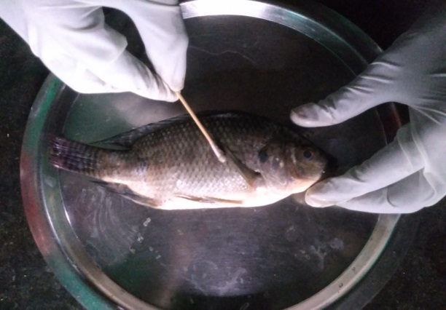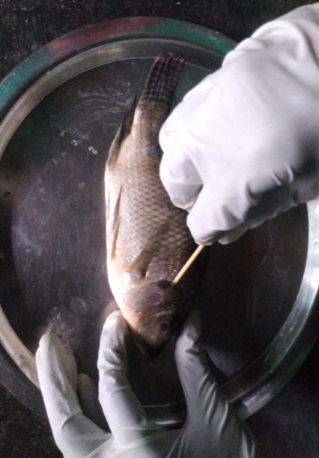
- Body surface B. Gill surface

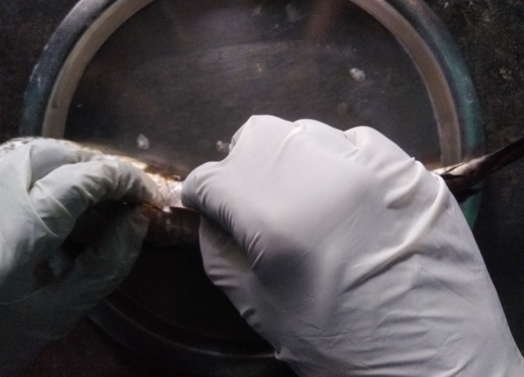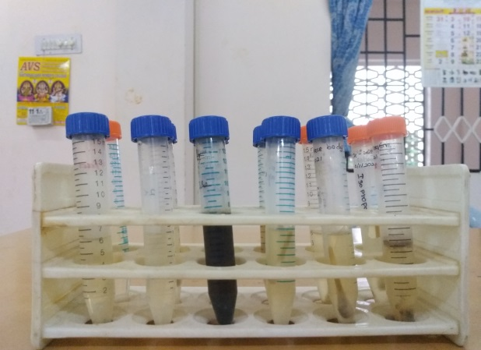
C. Intestine D. APW
Fig.2. Sample collection (houseflies)
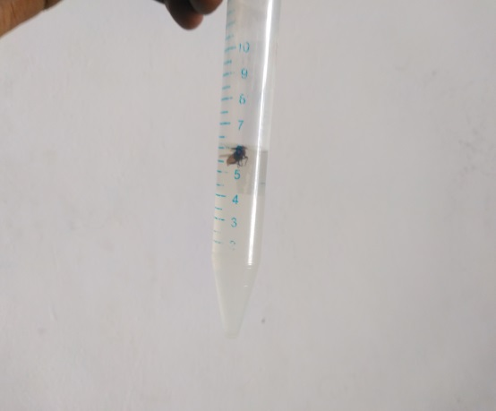
A. APW

Fig.3. Influence of pH on the Growth of Aeromonas hydrophila 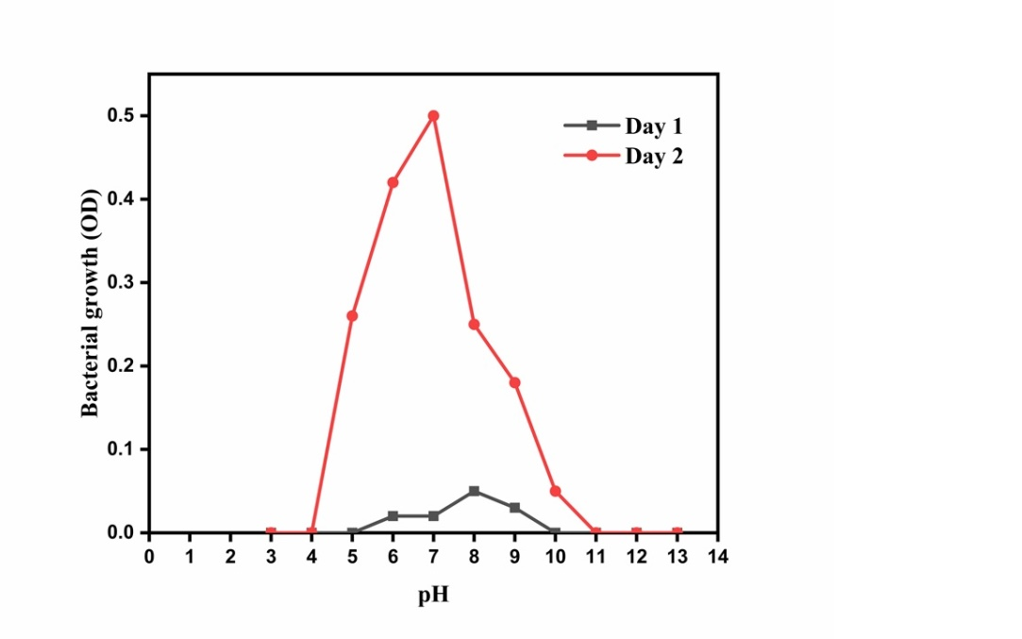
Fig.4. Survival of Aeromonas hydrophila (CSI) on Stainless steel, Wood, Iron and Thermocol pieces
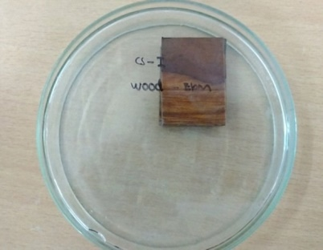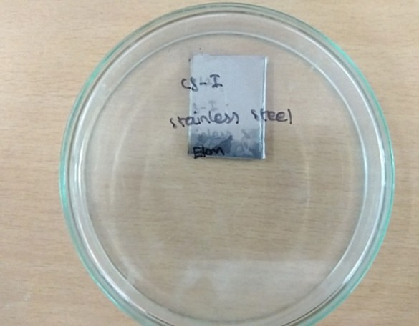
- Wood inoculated with CSI B. Stainless steel inoculated with CSI
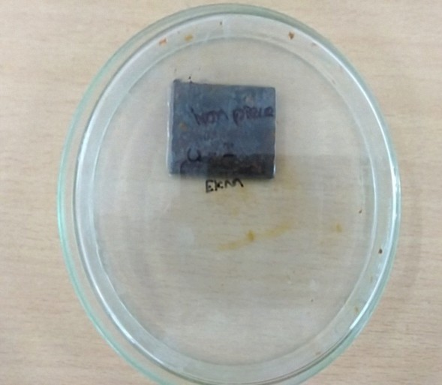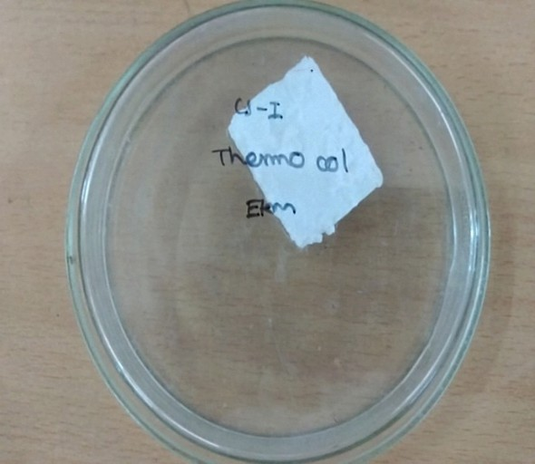
C. Iron inoculated with CSI D. Thermocol inoculated with CSI
Fig.5. Survival of Aeromonas hydrophila (CSI) in fish meat under traditional cooking ingredients
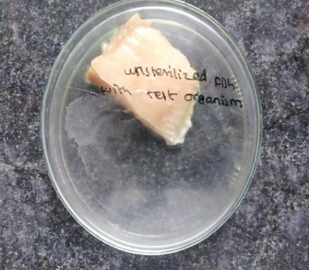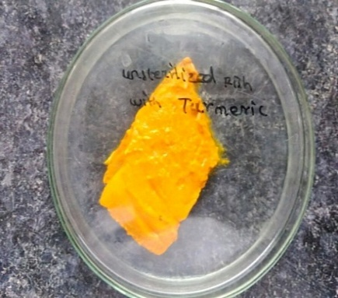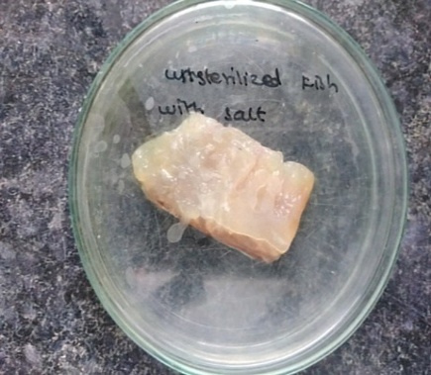
- Test organism B. Turmeric C. Salt
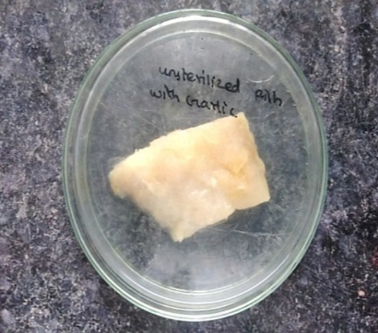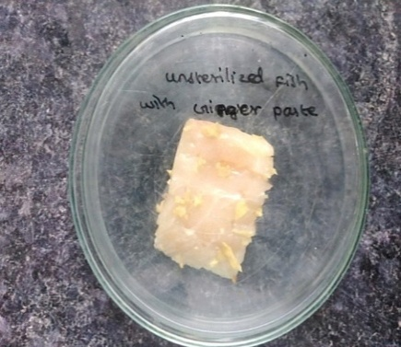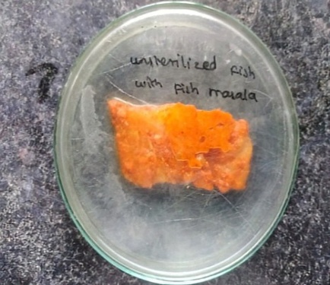
- Garlic E. Ginger Paste F. Fish Masala
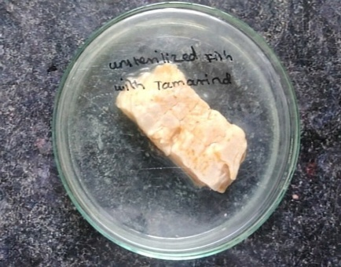
G. Tamarind

