Case Report
Lynxacarus radovskyi infestation in Persian cat in Bhubaneswar, India – A case report

.
ABSTRACT

A persian cat was presented to Teaching Veterinary Clinical Complex, College of Veterinary Science & Animal Husbandry, Odisha University of Agriculture and Technology, Bhubaneswar with constant itching and crust formation on the skin. The fur coat appeared fine, but skin had pruritis with crust formation and papules. Upon microscopic examinations the presence of Lynxacarus radovskyi cat fur mite was confirmed. The cat was successfully treated with Selamectin spot on. It is the first report of occurrence of this mite in the state of Odisha.

Keywords: cat fur mite, Persian cat, skin scrapping, crust

INTRODUCTION

Mites are ectoparasites to domestic animals and pets worldwide. They are cause of several skin ailments and is transmitted by direct contact. Lynxacarus radovskyi known as the cat fur mite belonging to genus, Lynxacarus was first described by Radord in 1951 from samples collected from a lynx cat in USA. Infestation of Lynxacarus radovskyi in persian cats was first found in Hawaiian Islands (Tenoiro, 1974). Several mites reported in Persian cats in other parts of the country include mainly Cheyletiella blakei ( Sarma 2019), Notoedres cati (Ramesh et al 2025). L.radovskyi has been mainly reported in tropical and sub-tropical climate like Hawaii (Tenoiro, 1974), Australia (Bowman,1978), Fiji (Munro,1979), Florida (Greve,1981), New Zealand (Heath, 1999), Philippines (Moya,2004) and Malyasia (Han,2014) as well as in South India (Jayanthy, 2017). As Bhubaneswar also has tropical climate but no cases of L. radovskyi in cats were ever reported. These mites are found clinging on the fur, where the eggs are also found to be attached and so it is called cat fur mite., is highly contagious to cats and zoonotic in nature.

CASE PRESENTATION
An 8-year-old female Persian cat was presented to TVCC, College of Veterinary Science & Animal Husbandry, Bhubaneswar from the city outskirts with a complaint of itching. Upon physical examination of the cat, signs of itching, crust formation on the skin with salt and pepper appearance on the hairs were found. Skin scrappings with hair were collected and was further investigated at the clinical laboratory of department of Veterinary Parasitology, College of Veterinary Science & Animal Husbandry, OUAT, Bhubaneswar. Upon digestion of hair samples and skin scrappings with KOH and examination under low power microscope, the presence of cat fur mite Lynxacarus radovskyi clinging onto the hairs was revealed. Further studies of the mite under the microscope were conducted to identify the structure of the mite and confirm the the identity of the mite present. Lynxacarosis causes clinical signs ranging from asymptomatic to miliary dermatitis, hypotrichosis, alopecia, irritation and moth eaten appearance of the coat. It was found that the Persian breed of cat has higher susceptibility to lynxacarosis attributed to the good coat conditions enabling the survival of mite in tropical conditions of Odisha. The mite was studied under micrometry to measure its dimensions. The other pet animals (Persian cat & Indian spinz dog) at the pet owners house were also examined for skin scrapping and hair sample. They both tested positive for L. radovskyi. Selamectin spot on (0.5ml) was used for the treatment for the both cats at the owner’s home.

discussion

The clinical examination revealed the presence of danders giving a pepper salt appearance to the hair coat of the infested cat and microscopical examinations confirmed the presence of the mite L. radovskyi. The mites were clasping the hair strands in the hair and skin samples (Fig 1). The body of the mite was heavily striated, cylindrical and elongated, laterally compressed and dorsally arched with propodosomal plates (Fig 2). The head was ventrally directed and along with the modified legs which allow them to clasp and travel along hair shafts of the cats. Infestation of these mites may be subclinical and has also been associated with itching, irritability, hair loss, increased hair balls, granular or dandruff like materials looking like as salt and pepper appearance of hair coat (Foley, 1991). The micrometry revealed the dimension of the mite to be of length 295.5 µm & breadth 116.6 µm. In India instances of cat fur mite have been reported from Chennai (Jayanthy, 2017), Kannur (Preena,2018) and Puducherry (Thiruselvame,2021). The infested cats were administered with Selamec (selemactin) spot @ 0.5 ml and the dog was treated with 0.5 ml Ivermectin injection. The parasite is reportedly susceptible to commonly used parasiticides (Clare et al., 2004) like Selamectin (Blot,2003;), Fipronil (Preena et al., 2019), Ivermectin (Rohini et al, 2020). The skin scrapping examination after one week revealed absence of any mite infestation implying successful treatment. This is the first report of the mite from Odisha.

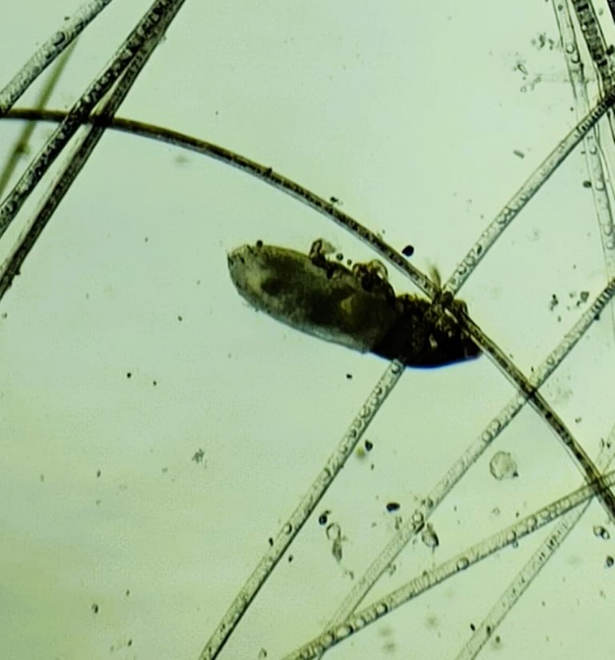

Fig. 1. Lynxacarus radovskyi mite clasping the hair strands

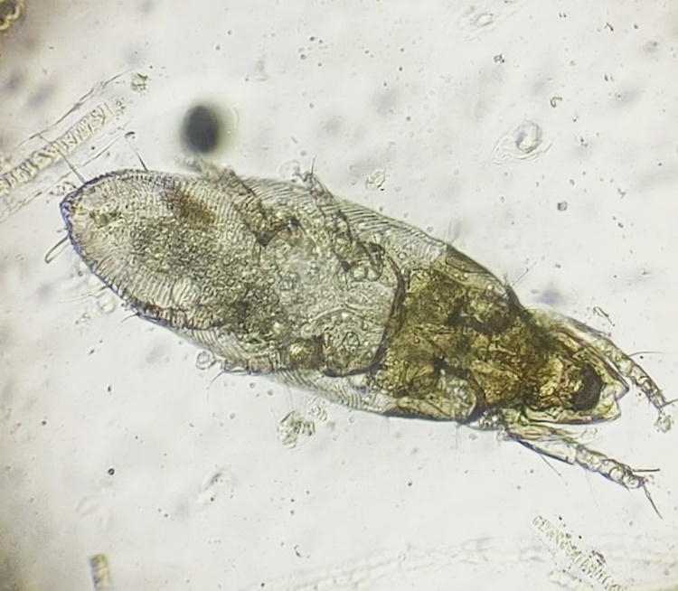

Fig. 2 : Morphological features of Lynxacarus radovskyi

4. Conclusion

The case report entails the presence of the fur mite in cat with possible transmission to dogs and the successful treatment with suitable acaricides. The mite primarily affects cats, but future studies on the transmission dynamics can be explored for better prevention and control strategies.

.

References

Blot, C., Kodjo, A., Reynaud, M.C., Bourdoiseau, G.(2003) Efficacy of selamectin administered topically in the treatment of feline otoacariosis. Vet Parasitol. 112(3):241-247.
Bowman, W.L., Domrow R (1978) The cat fur-mite (Lynxacarus radovskyi) in Australia. Aust Vet J 54:403–404
Clare, F., Mello, R. M. L. C., Bastos, T. V., Lessa, C. and Conceição, L. G., 2004. P‐30 Use of fipronil for treatment of Lynxacarus radovskyi in outdoor cats in Rio de Janeiro (Brazil). Vet. Dermatol.,15:50
Foley, R. H. (1991) An epizootic of a rare fur mite in an island’s cat population. Feline Pract.: 19(3): 17-19.
Greve, J.H., Gerrish, R.R. (1981) Fur mites (Lynxacarus) from cats in Florida. Feline Pract 11:28–30
Han, H.S. (2014) A survey of prevalence of Lynxacarus radovskyi in cats in Malaysia. Vet Dermatol 25:1. doi:10.1111/vde.12177
Jayanthy, C., Nagarajan, B. and Latha, B.R. (2017) Cat fur mite Lynxacarus radovskyi in India. J. Parasitic Diseases, 41(4):1102-1104.
Lakshmanan, B., Chirayath, D., Dhivyabharathi, R., Vipin, T. P. and Ajithkumar, S. 2019. Control of Lynxacarus radovskyi infestation in persian cats in Kerala: A Case Study. Indian Vet. J. 96(7): 61-62.
Moya, G.C. et al (2004) Occurence of Lynxacarus radovskyi (Tenorio, 1974) in cats in Batong Malate, Los Batong Malate, Los Banos, Laguna. Philipp J Vet Med 41:105–108
Munro, R. (1979) Lynxacarus in cats in Fiji. Aust Vet J 55:90 Romeiro ET et al (2007) Infestation by Lynxacarus radovskyi (Tenorio, 1974) in domestic cats in metropolitan Region of Recife, Pernambuco, Brazil. Rev Bras Parasitol Vet 16:159–162
Nichols, A.J. and Heath, A. (2017). Discovery of the feline fur mite Lynxacarus radovskyi in a New Zealand resident cat. New Zealand Vet. J., 66(1):1-7.
Preena, P., Dilna, K.P., Kumar, K.V., Padmaraj, P.K., Kumar, V.R., Muraleedharan, K., Babu, M.P. and Mathew, D.P. (2018). Cat fur mite, Lynxacarus radovskyi in Persian cats of Kannur district, Kerala. Vet. Parasitol. 32(2): 92-94.
Radhika, R., Mohan, N. and John A.(2018) Infestation with the cat fur mite, Lynxacarus radovskyi Tenorio, 1974 (Acarina: Astigmata: Listrophoridae) in Persian cats of Thrissur, Kerala. In: Proceedings of 10th Kerala Veterinary Science Congress. November 10-11, 2018, Kannur. p:294-295.
Ramesh, S., Hemalatha, P., Balakumar, A., Preetha, S and Latha., B.R. (2025) Notoedric mange in a Persian cat: A case report. International Journal of Veterinary Sciences and Animal Husbandry 2025; 10(1): 18-20
Rohini, B.G., Shyma, V.H. and Pillai, U.N. (2020) Lynxacarus radovskyi infestation in a Persian cat: A case report. Indian J. Vet. Med., 40(2):30-31.
Sarma, K. (2019). An unusual case of Cheyletiellosis in a Persian cat and its therapeutic management. Journal of Parasitic Diseases. https://doi.org/10.1007/S12639-019-01115-5
Tenorio, J.M. (1974) A new species of Lynxacarus (Acarina: Astigmata: Listrophoridae) from Felis catus in the Hawaiian Islands. J Med Entomol 11:599–604
Thiruselvame, P., R. Sreekrishnan Mathivathani, C. (2021) A Case Report on, the Cat Fur Mite Lynxacarus radovskyi in Puducherry, India. Int.J.Curr.Microbiol.App.Sci. 10(03): 1563- 1565.

