Short Communication

IPM package against soil insect pests of potato: an integrated, ecofriendly and need-based approach

.
ABSTRACT

Potato cultivation in North-East India is significantly affected by many soil-borne insect pests like cutworms, white grubs and oriental army ants, resulting in significant yield and economic losses. Incidence of these pests are apparent both in the hills and the plains of the region. Potato growers mostly combat these pests with the help of synthetic insecticides; however, excessive reliance on these insecticides has resulted in ecological imbalance, health hazards and unsustainable pest management practices, particularly in the organically inclined Northeastern region. To address this issue, a long-term research initiative was undertaken to develop and validate an Integrated Pest Management package for potato. This eco-friendly and economically viable package integrates cultural, physical, biological, indigenous and need-based chemical practices which effectively reduces pest-induced losses, minimizes pesticide misuse and promotes sustainable and profitable potato production in NE India.

Keywords: Cutworm, ecofriendly, oriental army ants, subterranean, white grubs

1. INTRODUCTION

Among the food crops, potato ranked 4th, valued for its simple cultivation practices and significant nutritional and economic importance. The crop is commercially grown in India since 18th century (Luthra et al., 2020) after its introduction by Portuguese or British traders (Singh and Rana, 2014). FAO, 2024 estimated the global potato production asm375 million tonnes in 2022 of which India contributes 56 million tonnes. Almost all the states of India grow potato commercially and based on the commercial cultivation India is divided in to seven potato growing zones (Singh et al., 2023). The subtropical climatic conditions of North-East India (NE India) favour potato cultivation throughout the year, forming a significant part of the prevailing cropping systems and the dietary food habits of the people in this region. However, various biotic and abiotic factors are responsible for low production and productivity of potato, of which insect pests are of major concern. In India, approximately 10-12 per cent of the total potato tuber production are lost annually due to insect pest damage, which accounts for Rupees 60 billion (Kishore and Misra, 2001). More than 100 species of insects are being reported to be associated with the crop, which severely affect the commercial value (Chandel et al. 2022). The potato-growing belt of the Northeastern region suffers severe infestation due to various soil insect pests, of which cutworms, white grubs, and oriental army ants are the major ones causing extensive damage to the potato crop (Fig. 1), both in hills and plains (Bhattacharyya & Dutta, 2014). The black cutworm, Agrotis ipsilon has been reported from almost all potato growing regions of NE India and the larvae cause 53.5 to 57.5 % of plant and 34.6 to 40.1% of tuber damage in Assam (Borah et al. 2009; Bhattacharyya et al. 2010). Field surveys conducted during 2005-2009 also revealed that an atypical white grub, Lepidiota mansueta, had appeared as an extremely severe key pest of potato in Majuli, Assam, with the extent of damage ranging between 42-48% (Bhattacharyya et al. 2015). The other economically important white grub species causing moderate to high levels of tuber damage in potato are L. albistigma, Apogonia sp., Adoretus sp. and Anomala sp. Among the soil insects, oriental army ants (Dorylus orientalis) have long been considered as a persistent subterranean pest and can seriously damage vegetable crops, including potato, French bean, many cole crops and ornamental plants (Devi & Bhattacharyya, 2022). This subterranean social insect occurs in a wide range of habitats, including cultivated land throughout the Northeast, but chronically flood-prone potato-growing areas are comparatively free from their incidence (Devi et al. 2021). Endemically few locations of NE India also experienced the infestation of mole crickets (Gryllotalpa africana) and field crickets (Brachytrupes portentosus) on potato seedlings and tubers (Bhattacharyya et al., 2016).

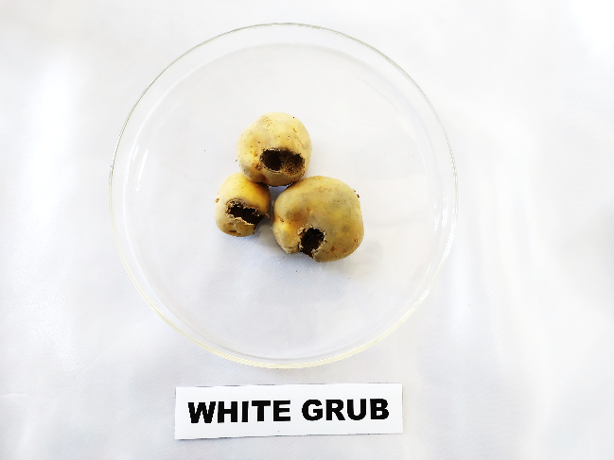 | 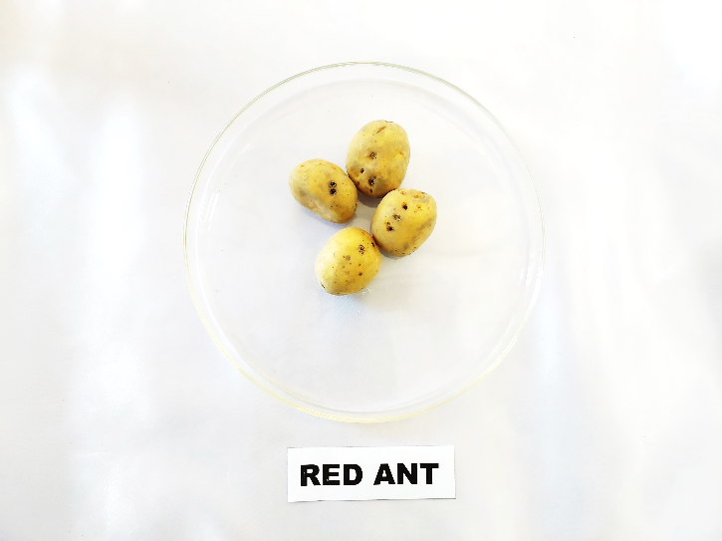 | 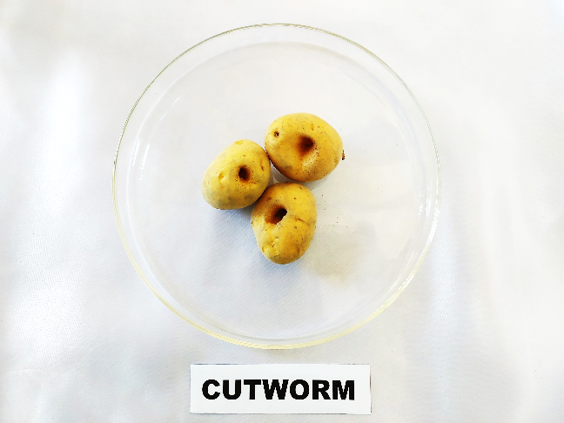
i) white grub | ii) Oriental army ant | iii) Cutworm
Fig. 1. Typical tuber damage symptoms by major soil insect pests

The contribution of insecticides to enhance potato production by reducing pest damage cannot be denied; however, synthetic pesticides have caused unprecedented ecological damage and induced serious health hazards (Bhattacharyya et al. 2023). Indiscriminate use of those insecticides and their residues in the soil and plant system poses hazardous effects on the consumers and the environment. Considering the ill effects of synthetic insecticides, there is an urgent need to search for safe, eco-friendly as well as viable economical means of insect pest management in potato production. Earlier, most of the potato growers of NE India have either used conventional organophosphate (OP) insecticides or followed some ITKs to suppress the pest population and the whole approach was not found to be environmentally sustainable and economically viable. Furthermore, considering the present pest management scenario, there is an urgent need to embrace organic pest management strategies instead of chemocentric approaches since the Northeastern region is known as the ‘Organic Hub’ of the country. Therefore, a long-term concerted research initiative was taken under the aegis of All India Network Project on Soil Arthropod Pests, Assam Agricultural University, Jorhat as well as through students research programme during 2013-2025 to develop and validate certain proven technologies to minimize the significant yield losses caused by various soil insect pests in potato (Bhattacharyya et al. 2014; 2022; Pujari et al., 2016; Deka et al. 2018; Devi & Bhattacharyya, 2022; Devi et al. 2022; Anonymous, 2023; Dumala et al. 2023; Anonymous, 2025).

2. DETAILS ABOUT THE IPM PACKAGE

The Integrated Pest Management (IPM) package offers a comprehensive, environmentally benign and economically viable strategy for managing soil-dwelling insect pests of potato through the judicious integration of cultural, physical, biological, indigenous and chemical control measures. Potato, being a shallow-rooted crop with subterranean economic parts, is particularly vulnerable to soil insect pests such as white grubs, cutworms, oriental army ants, mole crickets etc. which cause direct damage to tubers and roots, resulting in substantial yield and quality losses. Excessive reliance on chemical insecticides not only leads to pest resistance and residue issues but also disrupts soil biodiversity. Hence, the present IPM strategy emphasizes preventive and eco-friendly practices, with chemical control used only as a supportive component, ensuring sustainable pest management in potato cultivation.

2.1. Cultural Practice: Cultural practices form the foundation of the IPM strategy by creating unfavorable conditions for soil insect pests while promoting healthy crop establishment. Tillage operations should preferably be conducted using tractors during the month of October/November to ensure proper soil preparation. This practice leads to kill the soil borne insects through desiccation due to sunlight. Immediately after ploughing, bird perches @ 50 numbers per hectare should be installed to enhance the activity of insectivorous birds for natural pest regulation. High ridges of at least 10 cm height should be prepared to reduce the activity of cutworms as well as to facilitate better crop establishment through proper drainage. Proper irrigation should also be provided during the first and second earthing-up operations which generally carried out at 25 and 60 days after sowing, respectively.

2.2. Physical and Mechanical Practice: Farmers participatory approach should be encouraged in the potato growing villages for the mass collection and destruction of white grub beetles or cutworm moths through light trap and hand scouting throughout the growing season. Light traps should be operated during evening hours, preferably between 6:00 and 7:30 PM, coinciding with peak activity of adult moths and beetles. Collected insects should be destroyed immediately to prevent further reproduction. Regular hand scouting during the crop season helps in early detection of pest incidence and facilitates timely mechanical removal, thereby preventing population buildup.

2.3. Biological Practice and Plant-based products: Biological control measures are central to sustainable IPM and contribute to long-term pest suppression while maintaining soil health. Metarhizium anisopliae talc formulation mixed with farmyard manure (FYM) at a ratio of 1:100 should be applied after the first and second earthing-up operations, i.e., at 25 and 60 days after sowing against all the soil borne insect pests. Alternatively soil drenching with jatropha oil at 5 ml per liter of water may also be undertaken during the earthing up operations. Additionally, pre-sowing furrow application of mustard oil cake or wood ash @ 150 kg/ ha or panchagavya at 3% concentration (30 ml/ liter of water) should be adopted to suppress soil-borne pests as well as to enhance the soil health.

2.4. Indigenous Technical Knowledge: Indigenous Technical Knowledge (ITK) provides cost-effective and locally adaptable solutions for pest management. Deliberate placing of plant debris such as dry grasses, straw, crop residues or weeds in the field during the evening hours, preferably near the base of plants or along crop rows at night as hiding places for cutworm larvae and their mechanical destruction at every 10 days interval from the date of planting is found very effective.

2.5. Chemical control practice: Chemical management is recommended only as a need-based component within the IPM framework. Seed furrow drenching with clothianidin 50 WDG @ 120 g active ingredient per hectare (1 g per 2 liters of water) prior to tuber planting provides early-season protection against soil-dwelling insect pests. This targeted application minimizes pesticide use and reduces non-target effects. In addition, foliar application of imidacloprid 17.8 SL @ 1.5 ml per liter of water during evening hours (16:30–17:30 hrs) on host trees adjacent to potato fields effectively targets foliage-feeding adult white grub beetles. This practice reduces oviposition pressure and subsequent larval infestation in the main crop thereby preventing future outbreaks.
3. Conclusion

This proven Integrated Pest Management (IPM) package for potato, which has been duly incorporated into the “AAU–Package of Practices, 2025,” provides a scientifically validated and holistic framework for the effective management of major insect pests affecting potato cultivation. The package emphasizes the strategic integration of preventive, cultural, biological, mechanical and need-based chemical control measures, thereby ensuring pest suppression in an economically viable and ecologically sound manner. By prioritizing monitoring, threshold-based interventions and the use of eco-friendly inputs, this IPM package significantly reduces reliance on indiscriminate and prophylactic pesticide applications, which are often associated with pest resistance, resurgence and environmental contamination. Adoption of this IPM package has demonstrated substantial potential in minimizing pest-induced yield losses while simultaneously improving tuber quality and overall crop health. The judicious use of pesticides recommended under this framework not only lowers production costs but also safeguards beneficial organisms, soil health and biodiversity within the potato agroecosystem. Furthermore, reduced pesticide residues contribute to enhanced food safety and market acceptability, aligning potato production with emerging consumer and regulatory demands for sustainable agricultural practices.

COMPETING INTERESTS DISCLAIMER:
Authors have declared that they have no known competing financial interests OR non-financial interests OR personal relationships that could have appeared to influence the work reported in this paper.

References

Anonymous. Package of practices for Rabi crops. Assam Agricultural University, Jorhat, Assam; 2023. p. 80–85.
Anonymous. QRT Report 2013–2023. AINP on Soil Arthropod Pests, Department of Entomology, Assam Agricultural University, Jorhat, Assam; 2025. p. 11–12.
Bhattacharyya B, Bhagawati S, Das PPG, Devi EB. Effect of physic nut oil against potato cutworm, Agrotis ipsilon. J Entomol Res. 2022; 46(1):73–76.
Bhattacharyya B, Bhuyan U, Borah P, Pujari D. Seasonal incidence of cutworm, Agrotis ipsilon (Hfn.) in potato (Solanum tuberosum L.) raised from true potato seed. Indian J Appl Entomol. 2010; 24(1):58–62.
Bhattacharyya B, Dutta SK, Mishra H, Bhagawati S, Bhattacharjee S. Handbook on insect pests of potato and their management. Jorhat, Assam, India: Directorate of Research (Agriculture), Assam Agricultural University; 2016.
Bhattacharyya B, Dutta SK. White grubs as emerging pests in the North Eastern region of India and their management. In: Proceedings of the National Symposium on Entomology as a Science and IPM as a Technology: The Way Forward; 2014 Nov 14–15; Passighat, Arunachal Pradesh, India. CAU; p. 88–119.
Bhattacharyya B, Gogoi I, Das PPG, Kalita B. Management of agricultural insect pests for sustainable agriculture and environment. In: Farooq M, Gogoi N, Pisante M, editors. Sustainable Agriculture and the Environment. United States: Academic Press, Elsevier; 2023. p. 177–178.
Bhattacharyya B, Pujari D, Bhuyan U, Baruah AALH. Management of potato cutworm, Agrotis ipsilon (Hufnagel) in Assam. Pestic Res J. 2014; 26(1):82–85.
Bhattacharyya B, Pujari D, Bhuyan U, Handique G, Baruah AALH, Dutta SK, et al. Seasonal life cycle and biology of Lepidiota mansueta (Coleoptera: Scarabaeidae): a serious root-feeding pest in India. Appl Entomol Zool. 2015; 50(4):435–442.
Borah P, Bhattacharyya B, Hazarika LK, Bhuyan U. Integrated management of Agrotis ipsilon Hufnagel in potato crop raised from true potato seed (TPS). Pestic Res J. 2009; 21:1–4.
Chandel RS, Chandla VK, Verma KS, Pathania M. Insect pests of potato in India: biology and management. In: Alyokhin A, Rondon SI, Gao Y, editors. Insect Pests of Potato: Global Perspectives on Biology and Management. 2nd ed. Academic Press; 2022. p. 371–400.
Deka N, Barman U, Bhattacharyya B. Farmers’ attitudes towards group approach on management of white grub (Lepidiota mansueta). Int J Curr Microbiol Appl Sci. 2018; 7(3):465–471.
Devi EB, Bhattacharyya B, Bhagawati S. Evaluation of some IPM modules against red ant, Dorylus orientalis Westwood in potato. Indian J Entomol. 2022; 84(1):140–144.
Devi EB, Bhattacharyya B, Bhagawati S. Population dynamics of red ant Dorylus orientalis in potato grown under flood-free and flood-prone conditions. Indian J Entomol. 2021; 84(4):942–946.
Devi EB, Bhattacharyya B. Ecofriendly management modules of red ant, Dorylus orientalis Westwood in French bean. J Entomol Res. 2022; 46:1017–1021.
Food and Agriculture Organization (FAO). World Food and Agriculture – Statistical Yearbook 2024. Rome, Italy; 2024.
Kishore R, Misra SS. Field evaluation of synthetic insecticides and neem cake for the management of cutworm, Agrotis ipsilon (Hfn.), damaging potatoes in different agro-climatic zones of India. J Entomol Res. 2001; 25:31–35.
Luthra SK, Gupta VK, Tiwari JK, Kumar V, Bhardwaj V, Sood S, et al. Potato breeding in India. CPRI Technical Bulletin No. 74 (Revised). Shimla, Himachal Pradesh, India: ICAR–Central Potato Research Institute; 2020. p. 214.
Singh BP, Rana RK. History of potato and its emerging problems in India. In: Souvenir – National Seminar on Emerging Problems in Potato; 2014; Shimla, India. p. 7–21.
Singh HP, Singh B, Kumar R. Approaches to sustaining potato production in India. Technical Bulletin. New Delhi, India: Confederation of Horticulture Associations of India; 2023.
Pujari D, Bhattacharyya B, Mishra H, Gogoi D, Bhagawati S. Field evaluation of some insecticides against white grub, Lepidiota mansueta B. (Coleoptera: Scarabaeidae) on potato (Solanum tuberosum) in Assam, India. Appl Biol Res. 2017; 19(1):89–93.

