A STUDY ON FLOOD SUSCEPTIBILITY ZONES IN ERNAKULAM DISTRICT, KERALA, INDIA USING THE FREQUENCY RATIO MODEL
Abstract:
Flooding is one of the most frequent and destructive natural hazards affecting the low-lying coastal regions of Kerala, particularly Ernakulam District, which experiences recurrent flood events during the southwest monsoon. The present study aims to delineate flood susceptibility zones in Ernakulam District, Kerala, India, using the Frequency Ratio (FR) model integrated with Geographic Information System (GIS) techniques. A flood inventory was prepared using historical flood records and satellite-based data, while six flood-conditioning factors—geology, land use/land cover (LU/LC), soil, drainage density, rainfall, and slope—were selected based on their relevance to flood occurrence. Each factor was classified and weighted using the Frequency Ratio approach to evaluate its relative contribution to flooding.
The results indicate that built-up areas exhibit the highest flood susceptibility (FR = 4.65), highlighting the impact of rapid urbanisation and increased impervious surfaces. In contrast, forest areas show minimal flood influence (FR = 0.17), emphasizing their role in runoff regulation. The factor ranking reveals that geology (FR = 7.73) is the most influential parameter, followed by LU/LC (FR = 6.90) and soil (FR = 6.58), while slope (FR = 1.60) has comparatively lower control over flood occurrence. Based on the weighted overlay of all factors, the study area was classified into different flood susceptibility zones ranging from low to very high. The findings demonstrate that the Frequency Ratio model is an effective and reliable tool for flood susceptibility assessment in data-scarce regions. The generated flood susceptibility map can support disaster risk reduction, urban planning, and sustainable flood management strategies, contributing to improved resilience against future flood events in Ernakulam District.
Keywords: Geographic Information System (GIS), Remote Sensing, Frequency ratio,
Vulnerable zones.

1. Introduction:
High concentration rainfall in a region frequently leads to flooding in the downstream areas. Floods occur after the overflow of waters inundates land (Merz et al. 2010). Natural disasters, like floods, cause huge damages to natural and human resources (Youssef et al. 2011). Flood Control and prevention are required to decrease the potential damage to natural resources, agriculture, transportation, etc. (Billa et al. 2006). Therefore, flood susceptibility is an important mission for early warning systems and emergency services for the prevention and mitigation of future floods (Tehrany et al. 2015). There are quite a few inclusive tools available and used by many research organizations worldwide. Remote sensing and GIS techniques recommend an appropriate platform to control and examine all relevant information to easily demarcate the hazard zones (Khan et al. 2008; Saha et al. 2005; Wang et al. 2013; Pourghasemi et al. 2014). RS and GIS techniques are used widely to identify and assess flood-related damages (Pradhan et al. 2014; Patel and Srivastava 2013) caused by extreme rain in a catchment area or sea wave surges in the coastal regions. One of the very common statistical-based methods is the Frequency Ratio (FR) model which has been run in the ArcGIS platform to prepare the Flood Susceptibility Mapping for the study area. The main perception of this method is to find out the relationship between the past flood and their causative factors which influence the occurrences of Flood in the region.

In the present study area, Ernakulam District in Kerala, severe flood events have been recorded, particularly during the 2018 extreme monsoon season, which was triggered by prolonged and intense rainfall across the district. Continuous heavy rainfall over several days led to the overflow of major rivers such as the Periyar, Muvattupuzha, and Chalakudy, resulting in widespread inundation of low-lying and coastal areas. Large parts of the district experienced flooding due to high rainfall intensity, reservoir releases, and poor drainage conditions, causing significant damage to life, infrastructure, and agriculture. Flood-affected areas were identified using satellite imageries and secondary flood inventory data, which indicate that flood occurrence in the district is strongly influenced by low elevation, gentle slope, high drainage density, proximity to rivers, land use/land cover changes, soil characteristics, and rapid urbanisation. In addition to extreme rainfall, factors such as clay-rich alluvial soils, encroachment of floodplains, and reduced natural drainage capacity have further increased flood susceptibility in Ernakulam District.
2. Aim :
This study aims to delineate flood susceptibility zones in Ernakulam District using the Frequency Ratio Model to support effective flood risk management and mitigation planning.
3. Data base and Methodology:
The study was based on secondary data. The Survey of India Toposheet (SOI) at the scale of
1:50,000 is used to create a base map and Drainage map. The Indian Satellite Remote sensing
data for 1990 Landsat 5 (TM), 2017 Landsat 7 (ETM+) C1 is used to create Landuse landcover map. The SRTM images are used to create an Elevation map. Climatic data for the period of 2014-2018 is acquired from IMD. The Census of India Handbook for the year 1991, 2001 and 2011 is used for accessing the population data. The data required to flood is collected from Kerala State Disaster Management Authority.

The impact of the flood occurrence in the district is identified by creating Flood Vulnerability
Zones of the district by using Frequency Ratio Modelling. The Frequency Ratio Model is a
statistical-based approach that has been applied to evaluate flood susceptibility in the present
study. Also, satellite imagery, in particular, LANDSAT and ASTER DEM were the base to
create used to create the various thematic maps especially land use/land cover, Relief, Slope,
Drainage Density, Rainfall, Soil, and Geology. In addition to that, this objective implements an efficient methodology for the identification of vulnerable zone to flood hazards and the spatial extension of diseases pattern in the study area.

4. Study area:
Ernakulam district spread over an area of 3,068 square km. It covers 7.9 percent of the land area of Kerala state. The latitudinal and longitudinal extension of Ernakulam district is 9º47' and 10º18' north latitudes and 76º9' and 77º 6' east longitudes. It measures 38 km North-South and 48 km east-west. It is bordered on the east by Idukki district, north by Thrissur district, west by Lakshadweep Sea and south by Kottayam and Alappuzha districts. The district is having a coastline of about 30km.

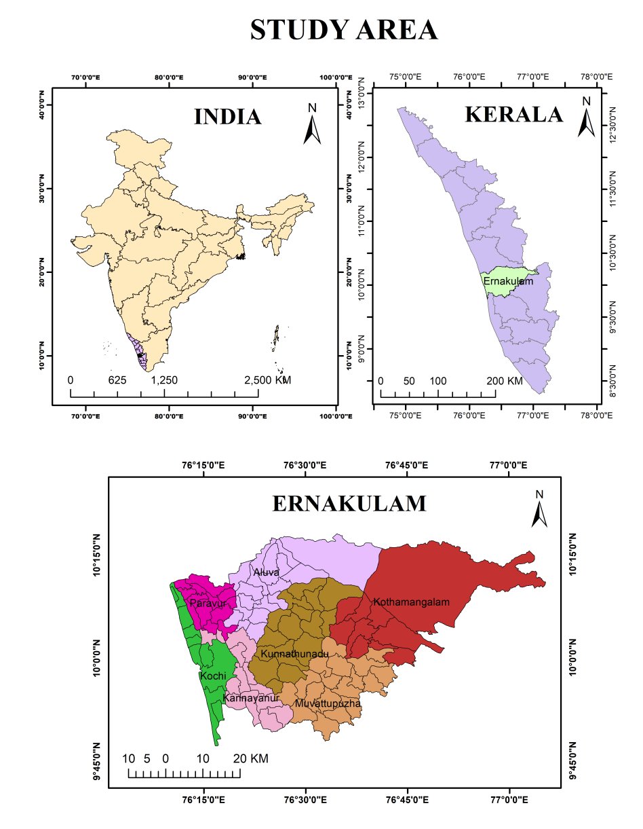
Figure 1 Study area
Ernakulam district is drained by River Periyar and its tributaries in the north and Muvattupuzha River in the south. This region lies on the southwestern coast of Kerala and experiences heavy rainfall from South-West Monsoon and North-East Monsoon. The district is divided into three physiographic zones as the midland region in the east, the coastal plains in the west, and the easternmost part of the area is steep to very steep hills. The coastal plain, a low lying area, with a maximum elevation of 10m towards the eastern part. This region is characterized by backwater bodies, marshy lands, sandy flats, and alluvial plains responsible for flooding during the monsoon period. The midland area has an undulating topography with low hills and narrow valleys. The hills are usually covered with laterite soils, and the valleys are alleviated. This region has a very gentle to moderate slope from east to west.

5. Results and Discussion:
5.1 Relationship between Slope and Floods:
Slope:
The slope angle is one of the main factors for the assessment of slope stability (Lee and Min, 2001). To study the Flood Susceptibility, the slope angle is very normally used so that the flood-prone area is correlated with the decreasing slope angle. It is the product of the mean slope in each pixel and is measured as a percentage (%) of the elevation change to the corresponding horizontal displacement. The slope is the main product of the elevation and gives information on the surface runoff and water concentration in a basin. Generally, the smaller the slope, the more vulnerable the flood area. In this study, the slope angle has been classified into five classes such as 0°-1°., 1°-3°, 3°-5°, 5°-7°, and 7°-9°. Table 1 shows that the majority of flood-prone areas have fallen under the 0°-1° followed by 1°-2.

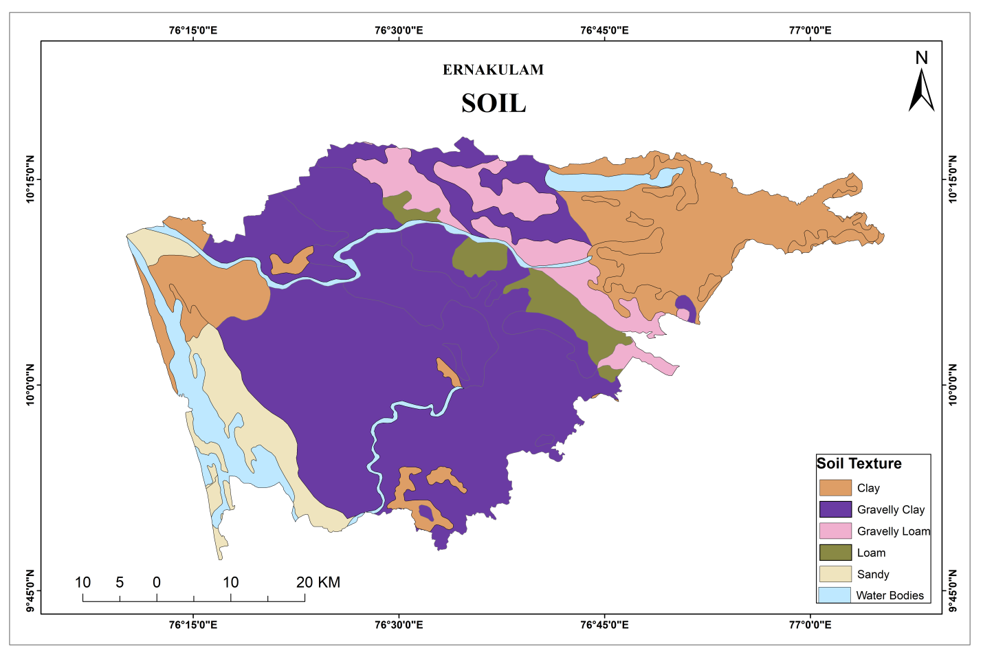
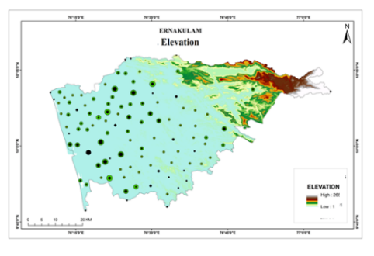
Figure 2 Slope
Figure 3 Soil

Slope | Flood Occurrence | Flood occurrence % | Pixel Domain | Pixel Domain % | Frequency Ratio
0-1 | 42 | 95.45 | 2117786 | 71.05291058 | 1.343429068
1 to 3 | 2 | 4.54 | 513747 | 17.2365006 | 0.263710985
3 to 5 | 0 | 0 | 220375 | 7.393705109 | 0
5 to 7 | 0 | 0 | 91125 | 3.057294966 | 0
7 to 9 | 0 | 0 | 37543 | 1.259588751 | 0
From the Frequency Ratio table (1) shows the Frequency Ratio of Flood occurrence based on slope. In this table, the slope category of 1°-2°shows the maximum areas of 42 out of 44 which are 95.45 percent. The frequency ratio of the slope has been calculated with the percentage of flood-prone areas occurrence divided by the percentage of pixel domain which is 71.05 percent and the Frequency ratio is 1.34. Likewise, the frequency ratio for all the other slope classes has been calculated.

5.2 Soil
The soil is another important causative factor for the occurrence of the flood in the study area. Based on the rock formation of the study area, the soil has been classified into five classes such as Gravelly clay, gravelly loam, clay, loam, and sandy.

Table 1 Frequency Ratio of Flood prone areas based on Slope

From the Frequency Ratio table (2) shows the Frequency Ratio of Flood prone areas based on soil types. In this table, the soil type Gravelly clay covers the maximum number of

Flood-prone areas of 15 out of 44 which is 53.1047 percent, Clay soil of 12 with 22.2702 percent, Loam soil with 10 with 10.8186 percent, and sandy soil with 7 with 6.0705 percent. The highest frequency ratio is for the sandy soil type has been calculated with the percentage of 6.0705 and the Flood occurrence divided by the percentage of pixel domain which is 2.6207. the lowest Frequency Ratio for gravelly loam soil as 0. Likewise, the frequency ratio of all the other soil types has been calculated.
Table 2 Frequency Ratio of Flood prone areas based on Soil
Soil | Flood Occurrence | Flood occurrence % | Pixel Domain | Pixel Domain % | Frequency Ratio
gravelly clay | 15 | 34.09090909 | 30198 | 53.10472171 | 0.64195627
gravelly loam | 0 | 0 | 4399 | 7.735865647 | 0
clay | 12 | 27.27272727 | 12664 | 22.27028928 | 1.224623844
loam | 10 | 22.72727273 | 6152 | 10.81860547 | 2.100758068
sandy | 7 | 15.90909091 | 3452 | 6.070517893 | 2.620713947

5.3 Drainage Density
Another important factor is the Drainage density. Based on Natural break (Jenks) method, the drainage density layer has been classified into five classes such as 0-1 km/km²which covered 12352 pixels, 1-3 km/km² which covered 16425, 3-5 km/km² covered 6782, 5-7 km/km² 2559 and 7-9 km/km² 379. From the table it shows that the flood-prone areas have fallen under 3-5 km/km² of 45.45 percent, followed by 1-3 km/km² of 31.81 percent, 5-7 km/km² of 15.90 percent, 0-1 km/km2 of 6.81 percent and 7-9 km/km² of 0 percent.
Table (3) shows the Frequency Ratio of flood occurrence based on drainage density. In this table, 3-5 km/km²density class shows the areas with a maximum number of flood occurrences of 20 out of total flood 44 which is 45.45 percentage. The frequency ratio of the drainage density has been calculated with the percentage of flood occurrence divided by the percentage of pixel domain which is 2.58. Likewise, the frequency ratio of all the other density classes has been calculated.

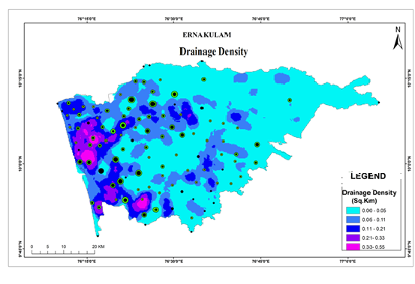
Figure 4 Drainage Density

Table 3 Table Frequency Ratio of Flood prone areas based on Drainage Density
Drainage Density | Flood Occurrence | Flood occurrence % | Pixel Domain | Pixel Domain % | Frequency Ratio
0-1 | 3 | 6.818181818 | 12352 | 32.08561706 | 0.212499632
1 to 3 | 14 | 31.81818182 | 16425 | 42.66566226 | 0.745756192
3 to 5 | 20 | 45.45454545 | 6782 | 17.61695717 | 2.580158709
5 to 7 | 7 | 15.90909091 | 2559 | 6.647271216 | 2.393326584
7 to 9 | 0 | 0 | 379 | 0.984492298 | 0

5.4 Rainfall
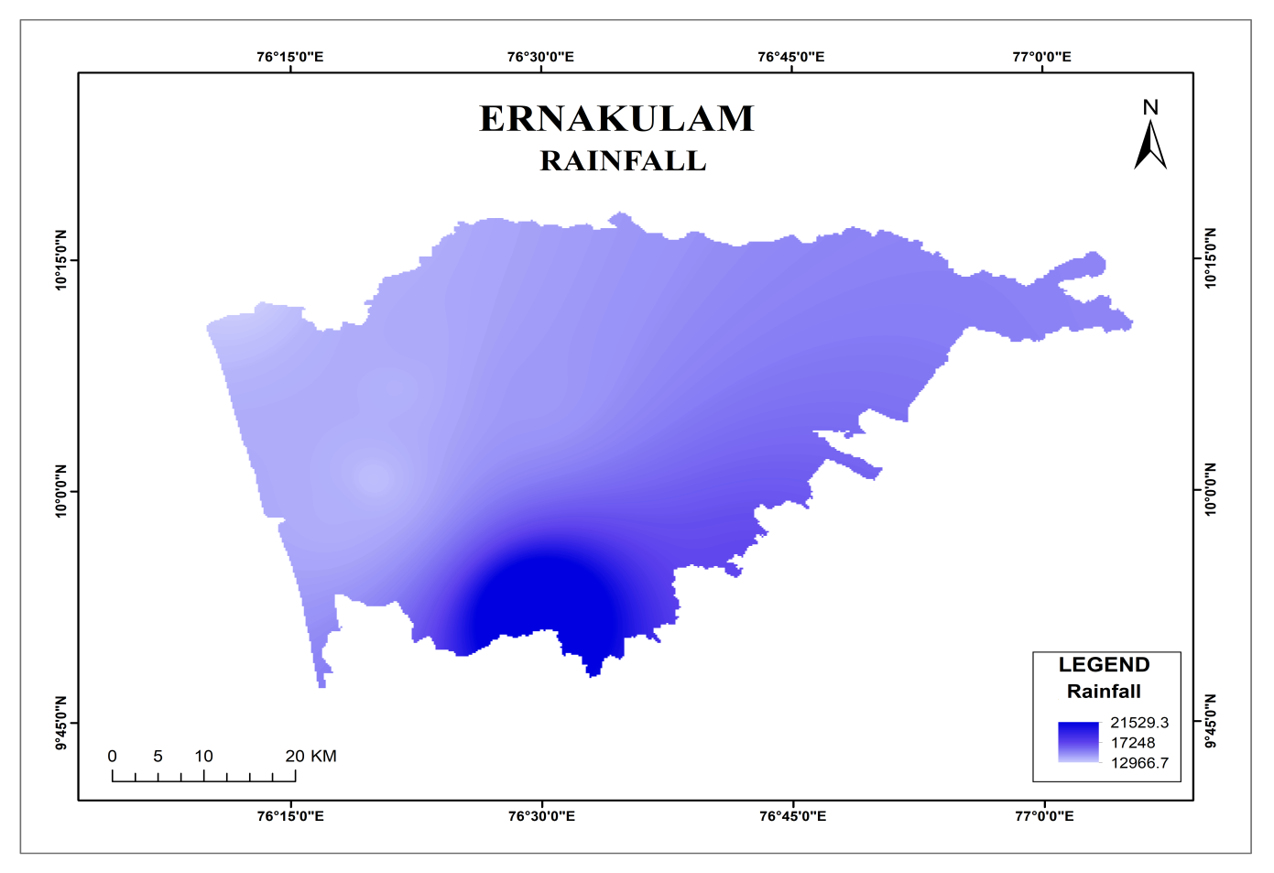
The main factor required for flood vulnerability assessment is rainfall. The enormity of flood completely depends on this factor. Based on the review of literature it was identified that the huge amount of rainfall in a very short period is an affordable condition for the existence of flood hazards. Thus the flood level can be accomplished with the amount of rainfall experienced for a particular area. In Ernakulam district, the rainfall can be experienced in both pre-monsoon and post-monsoon seasons rather higher in southwest monsoon from June to September. The intense rainfall in this period results in the condition of the flood. The coastal region experiences heavy rainfall, which tends to flood in that region.
Figure 5 Climate

The Rainfall layer has been classified into five classes such as 1-2 which covered 26940 pixels, 2-3 which covered 18360, 3-5 covered 8574, 5-7 2874 and 7-9 1816. From the table, it shows that the flood-prone areas have fallen under 1-2 of 65.90 percent, followed by 3-5 of 13.63 percent, 2-3 of 11.36 percent, 7-9 of 9.09 percent and 5-7 of 0 percent.
Table 4 Table Frequency Ratio of Flood prone areas based on Rainfall
Rainfall | Flood Occurrence | Flood occurrence % | Pixel Domain | Pixel Domain % | Frequency Ratio
1 to 2 | 29 | 65.90909091 | 26940 | 46.00095622 | 1.43277654
2 to 3 | 5 | 11.36363636 | 18360 | 31.3503176 | 0.362472767
3 to 5 | 6 | 13.63636364 | 8574 | 14.64039342 | 0.931420574
5 to 7 | 0 | 0 | 2874 | 4.907451677 | 0
7 to 9 | 4 | 9.090909091 | 1816 | 3.100881087 | 2.931718062

Table (4) shows the Frequency Ratio of flood occurrence based on rainfall. In this table, the 7-9 class shows the areas with 4 out of total 44 which is 9.09 percentage. The frequency ratio of the Rainfall class 7-9 has been calculated with the percentage of flood occurrence divided by the percentage of pixel domain which is 2.93. Likewise, the frequency ratio of all the other density classes has been calculated.
5.5 Geology
Lithology or rock type is one of the most important contributing factors to the flood. Based on the materials of the rock, the lithology of the stud area has been classified into ten categories such as Charnockite group of rocks which covered 28,963 pixels, Migmatite Complex which is covered 6,786, Sand and Silt cover 7,594, Penisular Gneissic Complex covers 9,975, Basic Rocks covers 1,800 Pegmatite/Aplite/Quartz vein covers 6, Alkaline rocks cover 10, Khondalite Group of rocks covers 183, Sandstone and clay with lignite cover 54, and Laterite with 134 pixels (table 5). The table shows that the majority of flood has occurred under Sand and silt, followed by the Charnockite group of rocks, Migmatite Complex, Peninsular Gneissic Complex, and Basic Rocks
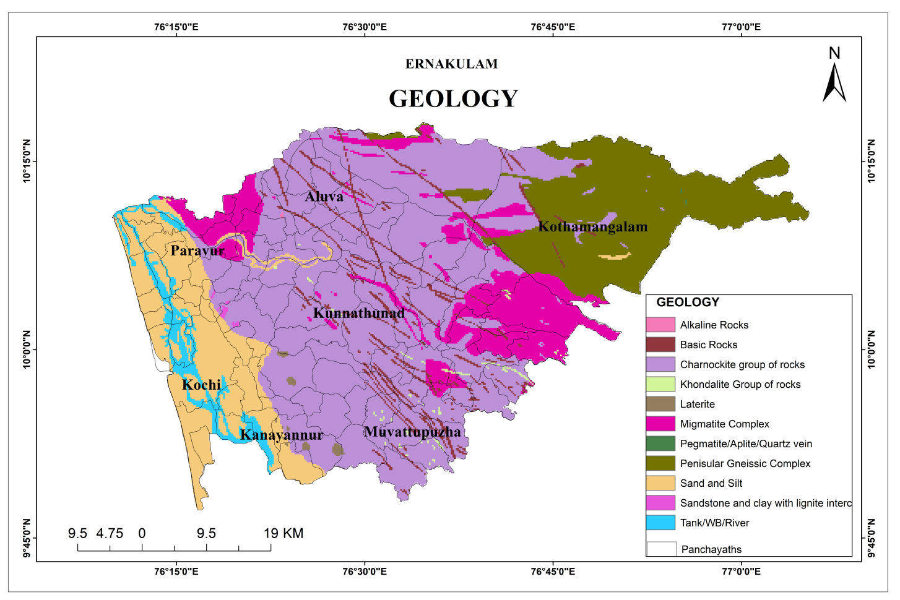
From the Frequency Ratio table (5) shows the Frequency Ratio of flood occurrence based on Geology. In this table, the rock type Sand and Siltshows the maximum number of landslides of 19 out of total landslides 44 which is 13.27 percent. The frequency ratio of the Geology rock type sand and silt has been calculated with the percentage of landslide occurrence divided by the percentage of pixel domain which is 3.25. Likewise, the frequency ratio of all the other rock types has been calculated.
Figure 6 Geology

Table 5 Frequency Ratio of Flood prone areas based on Geology
Rock Type | Flood Occurrence | Flood occurrence % | Pixel Domain | Pixel Domain % | Frequency Ratio
Charnockite group of rocks | 17 | 38.63636364 | 28963 | 50.63195986 | 0.763082522
Migmatite Complex | 3 | 6.818181818 | 6786 | 11.86301418 | 0.574742786
Sand and Silt | 19 | 43.18181818 | 7594 | 13.27552751 | 3.252738406
Penisular Gneissic Complex | 1 | 2.272727273 | 9975 | 17.43789661 | 0.13033265
Basic Rocks | 1 | 2.272727273 | 1800 | 3.146688111 | 0.722260101
Pegmatite/Aplite/Quartz vein | 0 | 0 | 6 | 0.01048896 | 0
Alkaline Rocks | 0 | 0 | 10 | 0.017481601 | 0
Khondalite Group of rocks | 0 | 0 | 183 | 0.319913291 | 0
Sandstone and clay with lignite interc | 0 | 0 | 54 | 0.094400643 | 0
Laterite | 0 | 0 | 131 | 0.229008968 | 0

5.6 Land use/Land Cover
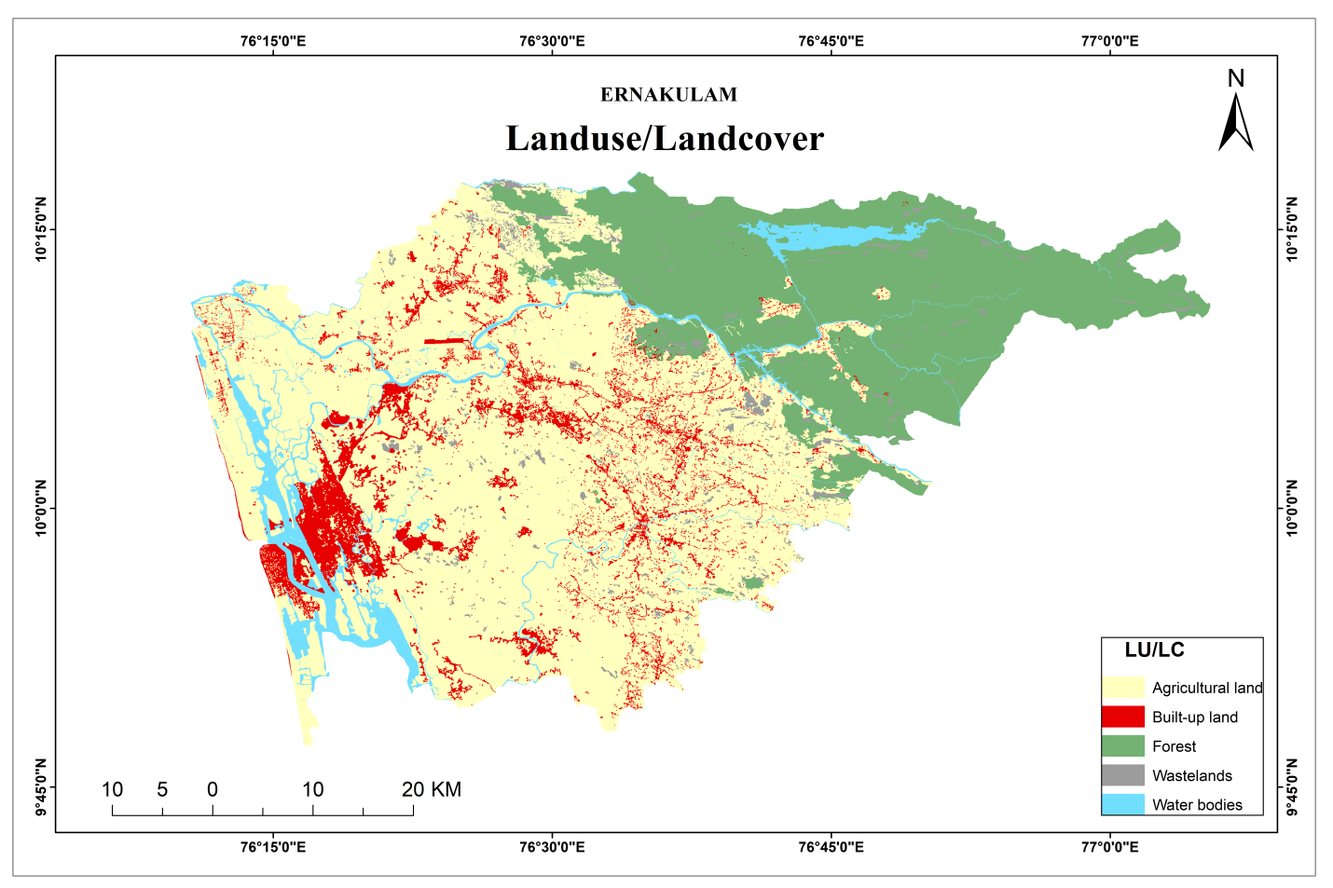
Land use /land cover changes have become the most important issue for the past 10 years in the study area. Since the last two decades, most of the forest cover area converted into the built-up land due to the pressure of urbanization and these changes leads to the occurrence of flood in the district. In the following table, the LU/LC class has been classified into five classes, such as water bodies, forest, agricultural land, Wastelands, and Built-up-land.
Figure 7 Landuse/Landcover

The Land use land cover has been classified into five classes such as water bodies which covered 3,310 pixels, forest which covered 15,493, Agricultural land covered 32,707, Wasteland covered 1,177 and Built-up land covers 4,472 pixels. From the table, it shows that the flood-prone areas have fallen under agricultural land of 52.27 percent, followed by Built-up land of 36.36 percent, water bodies of 6.81 percent, Forest of 4.54 percent and wasteland of 0 percent.
Table 6 Frequency Ratio of Flood prone areas based on LU/LC
LU/LC |  | Flood Occurrence | Flood occurrence % | Pixel Domain | Pixel Domain % | Frequency Ratio
Water bodies |  | 3 | 6.818181818 | 3310 | 5.790864081 | 1.177403186
Forest |  | 2 | 4.545454545 | 15493 | 27.10509281 | 0.167697435
Agricultural land |  | 23 | 52.27272727 | 32707 | 57.22108504 | 0.913522126
Wastelands |  | 0 | 0 | 1177 | 2.059168285 | 0
Built-up land |  | 16 | 36.36363636 | 4472 | 7.823789779 | 4.647828915

Table 7 Rank of Flood Factors based on the Frequency Ratio Method
Rank | Factor | FR Value
1 | Geology | 7.73
2 | LU/LC | 6.90
3 | Soil | 6.58
4 | Drainage Density | 5.93
5 | Rainfall | 5.65
6 | Slope | 1.60
Table (7) shows the Frequency Ratio of flood occurrence based on LU/LC. In this table, the Built-up land shows the areas with 16 out of total 44 which is 36.36 percent. The frequency ratio of the Built-up area has been calculated with the percentage of flood occurrence divided by the percentage of pixel domain which is 4.65. Likewise, the frequency ratio of all the other density classes has been calculated.

Flood Susceptibility Zones
Flood Susceptibility Zonation Map (FSZM) which has been prepared by the incorporation of six contributing factors by applying the Frequency Ratio (FR) Method on the GIS platform. All the thematic layers such as slope, geology, rainfall, land use/ land cover, soil texture, and drainage density of the study area have been converted into a raster layer with a 0.21*0.21 meter cell size. With the help of the Spatial Analyst Tool, the reclassification has been done to find out the pixel value for each layer. FR method is a kind of prediction model which is based on the calculation of flood occurred percentage and area percentage value. After getting FR value of all the raster layers, have been assigned into Weighed Sum method in Spatial Analyst Tool on the GIS platform (ArcGIS 10.3).
Thus, the ranking of each subclass of all causative factors was generated based on the FR values as shown in Table 8 FR value ranges from 0 to 7.73 in the study area. Considered FR values indicate as weak (< 1) to strong (> 1) concerning flood occurrence (Lee et al. 2012). Finally, based on the FR model in, the flood possibility database was developed. FR value in the model varied from 1.6. to 7.73. The greater value indicates a higher chance to flood occurrence. The created database was reclassified into five (5) different flood susceptibility zones, namely very low, low, moderate, high, and very high susceptibility zones (Fig 8).
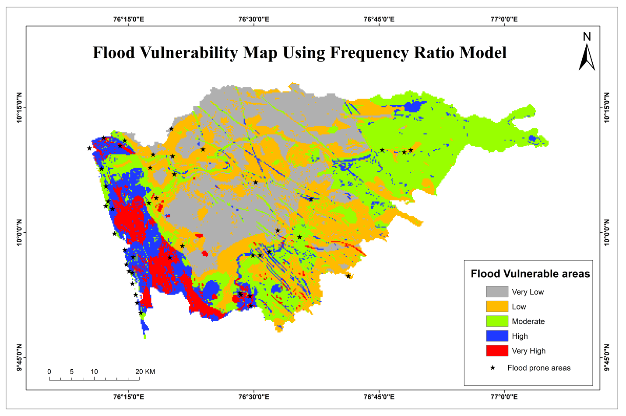
Figure.8 Flood Vulnerability Map
The result indicates that about 775 kilometre² area is demarcated as very high, 843.7 kilometre² as high zone, 929.1 kilometer² as moderate zone, 178.31 kilometre² as low zone covers and 178.31 kilometre² as very low zone (table 8). Flood vulnerable zone High to very high zones is mostly located along the Western part of the study area (Fig 8). The high to very high flood susceptibility zones are categorized with higher runoff, poorly drained soil, alluvial deposits, braided flood plain, lower slope, and lower elevation and closer to the main river, which are the significant conditioning factors for flood susceptibility mapping using the FR model.

Table 8 Flood Susceptibility Class and Flood Density (Frequency Ratio- FR Method)

Vulnerability zones | Flood Occurrence | Flood occurrence % | Pixel Domain | Pixel Domain % | area_sqkm (A) | Density (FO/A)
Very High | 1 | 2.27 | 14413 | 25.55 | 775.76 | 0.001
High | 12 | 27.27 | 15677 | 27.80 | 843.7 | 0.014
Moderate | 16 | 36.36 | 17263 | 30.61 | 929.1 | 0.017
Low | 10 | 22.72 | 5724 | 10.15 | 308.08 | 0.032
Very Low | 5 | 11.36 | 3313 | 5.87 | 178.31 | 0.028
Total of High & Very High | 13 | 29.54 | 30090 | 53.36 | 1619.46 | 0.015

Figure 6 Percentage of Flood with Area in each FVZ
Finally, based on the study an impact analysis was done to identify the risk towards the local community in this region. About 9 Panchayaths (20.9%) are situated in the very high flood vulnerable zone and 14 Panchyaths of 51.1% in the high flood vulnerable zone. A total population of 1,37,292 is living in those vulnerable zones need special consideration from different levels of governments to take suitable actions to prevent and mitigate future flood occurrence.

6. Conclusion
In this study successfully applied the Frequency Ratio (FR) model to evaluate and delineate flood susceptibility zones in Ernakulam District, Kerala, using multiple flood-conditioning factors. The analysis of land use/land cover (LU/LC) clearly indicates that built-up areas exhibit the highest flood susceptibility, highlighting the strong influence of rapid urbanisation, inadequate drainage systems and impervious surfaces, on flood occurrence. Overall, the Frequency Ratio model proved to be an effective and reliable approach for identifying flood-susceptible areas in the study region. To reduce future flood risk, the findings highlight the urgent need for sustainable land-use planning, floodplain management, controlled urban expansion, and improved drainage infrastructure. The flood susceptibility map created can serve as a valuable decision-support tool for planners, disaster management authorities, and policymakers in implementing targeted flood mitigation and climate-resilient development strategies in Ernakulam District.
References:
- Billa, L., Mansor, S., & Mahmud, A.R. (2004). Spatial information technology in flood early warning systems: An overview of theory, application and latest developments in Malaysia. Disaster Prevention and Management, 13(5), 356-363.
- Khan, F., Kanwal, S., Alamri, S., & Mumtaz, B. (2020). Hyperparameter optimization of classifiers, using an artificial immune network and its application to software bug prediction. IEEE Access, 8, 20954–20964.
- Merz, B., Kreibich, H., Schwarze, R., and Thieken, A.: Review article "Assessment of economic flood damage", Nat. Hazards Earth Syst. Sci., 10, 1697–1724, https://doi.org/10.5194/nhess-10-1697-2010, 2010.
- Pradhan, B. (2010). Landslide susceptibility mapping of a catchment area using frequency ratio, fuzzy logic and multivariate logistic regression approaches. Journal of the Indian Society of Remote Sensing, 38(2), 301–320.
- Saaty, R.W. 1987. “The Analytic Hierarchy Process—what it is and how it is used.” Mathl Modelling 9, no. 3–5: 161–176.
- Saha, A.K., R.P. Gupta, I. Sarkar, M.K. Arora, and E. Csaplovics. 2005. “An Approach for GISBased Statistical Landslide Susceptibility Zonation—with a Case Study in the Himalayas.” Landslides 2: 61–69. https://doi.org/10.1007/s10346-004-0039-8.
- Tan, Q., M. Bai, P. Zhou, J. Hu, and X. Qin. 2020. “Geological Hazard Risk Assessment of Line Landslide Based on Remotely Sensed Data and GIS.” Measurement 169: 10. https://doi.org/10.1016/j.measurement.2020.108370.
- Tehrany, M. S., Pradhan, B., & Jebur, M. N. (2013). Spatial prediction of flood susceptible areas using rule based decision tree (dt) and a novel ensemble bivariate and multivariate statistical models in Gis. Journal of Hydrology, 504, 69–79.
- Wang, G. and K. Sassa. 2009. “Seismic Loading Impacts on Excess Pore-Water Pressure Maintain Landslide Triggered Flowslides.” Earth Surface Processes and Landforms 34: 232–241. https://doi.org/10.1002/esp.1708.
- Youssef, A.M., et al. (2016) Analysis on Causes of Flash Flood in Jeddah City (Kingdom of Saudi Arabia) of 2009 and 2011 using Multi-Sensor Remote Sensing Data and GIS. Geomatics, Natural Hazards and Risk, 7, 1018-1042.
https://doi.org/10.1080/19475705.2015.1012750

