Performance Analysis of AI-based intelligent Computation offloading in Edge Computing Using Reinforcement Learning,ACO,and GA

Abstract— Computation offloading in Edge Computing (EC) plays a vital role in reducing execution latency and improving quality of service for resource-constrained devices. This paper presents a comparative performance analysis of three intelligent task offloading strategies, namely Reinforcement Learning (RL), Ant Colony Optimization (ACO), and Genetic Algorithm (GA), with the objective of minimizing overall system latency. A simulation-based system model is developed to evaluate the effectiveness of these approaches under dynamic network conditions. The experimental results demonstrate that the RL-based method achieves superior performance, attaining an average latency of approximately 42 ms, which is significantly lower than ACO and GA. This improvement highlights the adaptive learning capability and faster convergence of RL in making optimal offloading decisions. The findings indicate that RL-based offloading is more suitable for dynamic EC environments, and the proposed framework can be extended to incorporate additional metrics such as energy efficiency and throughput in future work.Keywords— Artificial intelligence, Machine Learning, Computation Offloading, Internet of Things

Introduction
To lower latency and bandwidth consumption, edge computing brings cloud computing capabilities closer to data sources and end users—the edge of the network. One of the main techniques in edge computing is called computation offloading, which is moving computational activities, from local devices to adjacent edge servers or cloud resources. The European Telecommunication Standards Institute (ETSI) originally defined MEC as "mobile-edge computing" in 2014 [1]. In 2017, the term "mobile" was changed to "multi-access” to reflect the additional use cases that MEC would address, such as computing and storage support for end-user devices over "fixed access technologies," such as fiber, satellite, wireless, fiber wireless, and light-fiber.
Computation Offloading (CO) is a process of transferring computation-intensive activities from the UE to an edge server to strike the best possible balance between time of execution and energy usage [2].Fig. 1 depicts the CO in EC. The task offloading computation process in an edge environment involves several key stages to ensure efficient task execution, optimize resource usage, reduce latency, and enhance overall system performance.
Initially, computational tasks are generated by user devices or applications, extending from simplest data processing to complex ML inference tasks. The tasks are further classified based on criteria such as size, priority, complexity, and deadline requirements, facilitating informed decisions on whether to process locally or offload. An intelligent decision-making mechanism evaluates factors like current device load, network conditions, available edge resources, and task nature to determine the optimal processing approach. If the task is suited for local execution, it is processed on the user's device. Otherwise, an appropriate edge server is selected based on proximity, load balancing, and resource availability, ensuring optimal resource utilization and minimal latency. The task is then offloaded to the selected edge server, where it is processed using the server's computational power, storage, and specialized capabilities. Once processing is complete, the results are transmitted back to the originating device, allowing the device to utilize the output for continued operation or user presentation. This comprehensive process enhances the efficiency, responsiveness, and performance of applications within an edge computing framework, ensuring effective resource management and improved user experiences.
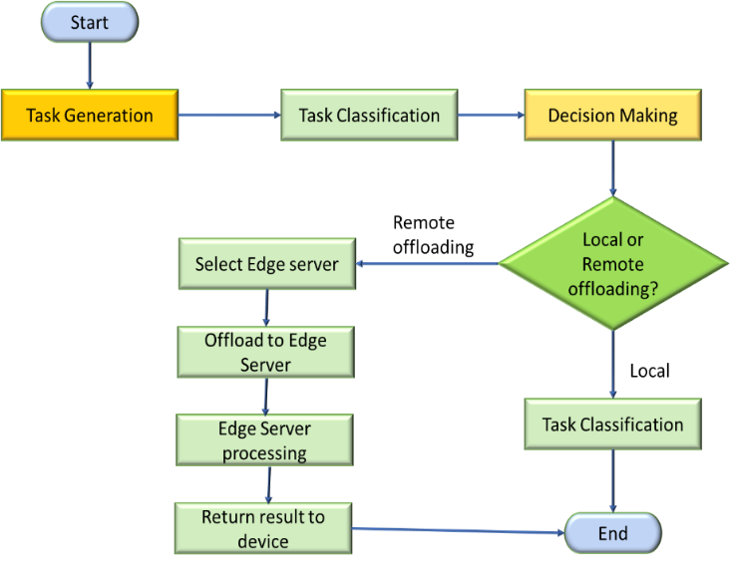

Fig. 1: CO processes
The main contributions of this paper are:
- An overview of the Multi-access Edge Computing (MEC) framework from the perspectives of both edge servers (ESs) and user equipment (UEs). It details key metrics and critical considerations involved in the offloading of computational tasks.
- Outlines the guiding concepts and real-world applications in each of the three categories of artificial intelligence algorithms: Machine Learning (ML), Evolutionary Algorithms (EA), and Swarm Intelligence (SIA).
- To address the outstanding challenges in optimizing intelligent MEC.
The remainder of this paper is as follows. Section II describes the review of the literature of various AI-based approaches. Section III describes the proposed AI-based CO methodology. Section IV shows the result and discussions. Section V discusses future research challenges and opportunities. The paper is concluded in Section VI.

LITERATURE REVIEW
By putting resources under process nearer to end users, edge computing has attracted a lot of attention for its potential to improve efficiency and lower latency. Computation offloading is a key component of edge computing, where workloads are moved from end devices to edge servers for processing. To maximize compute offloading in edge computing settings, various artificial intelligence (AI) approaches are being used more and more. This section discusses some of the AI techniques that few researchers frequently utilize.
- Swarm Intelligence Algorithm (SIA)
SIA draws significant inspiration from biological systems, particularly the collective behaviors exhibited by organized animal groups. Generally, SIA can be categorized into inspect-based and animal-based approaches. These algorithms operate through a few essential stages: updating and moving agents using specific mechanisms to achieve a globally optimal solution. This section focuses on two algorithms namely Ant Colony Optimization (ACO) and Particle Swarm Optimization (PSO).
- Ant Colony Optimization (ACO)
Task offloading in edge computing is essential for optimizing resource utilization and enhancing system performance. Ant Colony Optimization (ACO) algorithms have proven to be effective tools for intelligent task-offloading strategies in edge computing environments. These algorithms leverage the collective behavior of decentralized systems inspired by ant colonies to offer solutions to complex optimization problems in task-offloading [4]. In the domain of EC, researchers have introduced meta-heuristic-based offloading task optimization approaches that utilize ACO algorithms in conjunction with other metaheuristics like whale optimization and Grey wolf optimization. These kind of algorithms are explicitly tailored to optimize the selection of offloading tasks, considering various constraints and objectives through mathematical modeling [5] .Furthermore, [6] explored integrating ACO algorithms with deep neural networks to develop task offloading optimization mechanisms for spatiotemporal crowdsourcing applications. By creating subtasks from the main task and offloading them to edge servers, the aim is to reduce end-to-end task execution time and enhance overall system efficiency.
By simultaneously considering factors such as task profit, task deadline, task dependency, node heterogeneity, and load balancing, ACO-based algorithms facilitate efficient task offloading decisions in dynamic edge computing environments [7]. Additionally, ACO algorithms are applied in fog computing scenarios to effectively offload tasks to fog devices for computation and processing. Through the integration of intelligent ACO optimization techniques, researchers strive to improve task offloading efficiency while factoring in elements such as communication costs and response times [8]. ACO algorithms in intelligent task offloading for edge computing offer a viable approach to optimize resource allocation, reduce latency, and enhance system performance. By harnessing the principles of swarm intelligence inspired by ant colonies, ACO-based task offloading strategies provide innovative solutions to tackle the complexities of task allocation in dynamic edge computing environments.
- Honey Bee Algorithm
The primary goal of Bee Colony Optimisation is to effectively resolve challenging combinatorial optimization issues [9]. A honey bee colony searches its surroundings for resources, such as flower patches, and then gathers nectar or pollen from these locations. A portion of this honey bee cluster departs to locate a new food source after locating a certain one. The scouts gather the food that has been collected when they go back to the hive. The "dance floor" of the hive is where the bees that have discovered a particularly nutritious diet do the waggle dance. A scout bee uses the waggle dance to communicate its search position to an inactive observer, which facilitates accessing the flower patch [10]. The Honey Bee Algorithm (HBA) promises for intelligent task offloading strategies in edge computing environments. Inspired by the behavior of honey bees, this algorithm offers solutions to complex optimization problems in task offloading [11]. In the context of cloud computing, researchers have shown various load-balancing algorithm based on honey bee behavior (LBA_HB) to optimize resource allocation and task distribution efficiently [12]. The application of the Honey Bee Algorithm in collaborative edge computing has led to the development of iterative heuristic algorithms for dynamic offloading decision-making. These algorithms are designed to optimize multi-hop, multi-task partial computation offloading, considering various constraints and objectives in edge computing environments [13]. By jointly optimizing cloud-edge load balancing based on deep reinforcement learning and the Honey Bee Algorithm, researchers aim to enhance task offloading efficiency and system performance [14]. Additionally, the Honey Bee Algorithm has been utilized in fog computing environments to address task offloading challenges in cloud-edge-end scenarios. A Service Reliability Analysis and Elite-Artificial Bee Colony Offloading model (SRA-E-ABCO) has been proposed to optimize task offloading in such complex environments [15].
As a result, it has been noted in the literature that integrating the Honey Bee Algorithm with intelligent task offloading for edge computing provides a novel approach to optimizing resource utilization, reducing latency, and improving overall system performance. Swarm intelligence concepts may be used to work offloading algorithms based on honey bee behavior to generate innovative solutions for challenging job allocation in dynamic EC environments.
- Evolutionary Algorithms (EA)
Evolutionary Algorithms are popular in optimizing task offloading in edge computing due to their ability to handle complex, multi-objective optimization problems. Some common types of EA discussed in this context are-
- Genetic Algorithms (GAs)
GA mimics the process of natural selection, using operations such as crossover, selection, and mutation to evolve solutions over generations. A GA is a mathematical model of biological evolution[16]. The parent populations of a GA are a collection of random solutions that make up the solution space. Through crossings and mutations of the parent populations, new populations—the next generation—are created. Genetic Algorithms (GAs) have been widely utilized in computation offloading strategies within Edge Computing to optimize resource allocation, task scheduling, and offloading decisions. Researchers have proposed various innovative approaches leveraging GAs to address the complexities of task offloading in dynamic edge computing environments. [17] introduced a joint optimization method based on GA for task offloading proportion, channel bandwidth, and mobile edge servers' computing resources. This method aims to optimize resource allocation by partly offloading computing tasks to mobile edge servers, demonstrating the effectiveness of GA in enhancing system performance. In the context of ultra-dense cellular networks, [18] presented an adaptive offloading approach in mobile-edge computing based on GA. By adopting Non-dominated Sorting Genetic Algorithm II (NSGA-II), the method achieves multi-objective optimization to reduce offloading time and energy consumption in smart edge computing scenarios. [19] proposed a GA-based computation offloading and task scheduling algorithm for IoT applications in dynamic multi-access edge computing environments. This algorithm offers flexibility in offloading decisions and task scheduling, catering to the dynamic nature of edge computing environments. Moreover, [20] introduced a distributed PRiori Offloading Mechanism with joint Offloading proportion and Transmission (PROMOT) power algorithm based on GA. This mechanism aims to maximize the utility of User Devices (UD) by optimizing offloading decisions using GA, showcasing the adaptability of GAs in cloud-edge computing scenarios. Furthermore, [21] utilized an improved GA to minimize the total overhead of Mobile Edge Computing (MEC) systems by optimizing computing offload decisions and channel resource allocation. This approach demonstrates the efficiency of GAs in solving joint optimization problems in edge computing environments.
- Differential Evolutionary Algorithms (DEA)
To optimize resource allocation, job scheduling, and offloading choices, Differential Evolution (DE) algorithms are being used more and more in Edge Computing computation offloading techniques. Scholars have investigated a range of inventive methodologies that utilize DE to tackle the difficulties associated with work offloading in dynamic edge computing settings. [22] proposed an energy-efficient task offloading method optimized by Differential Evolution to enhance the energy efficiency of edge computing systems with energy harvesting. By utilizing DE, the method optimizes task offloading decisions, showcasing the effectiveness of DE in improving system performance. In the domain of data placement strategies for scientific workflows in heterogeneous edge-cloud computing environments, [23] introduced a novel strategy named DE-DPSO-DPS. This strategy combines a discrete particle swarm optimization algorithm with Differential Evolution to distribute scientific datasets efficiently. Furthermore, [24] improved the DE algorithm by adaptively changing parameters to enhance search speed and computational efficiency. Moreover, DE has been utilized in optimizing wireless power transfer time for wireless-powered mobile edge computing systems.[25] proposed DEWPT, a Differential Evolution-based optimization scheme for wireless power transfer time, showcasing the applicability of DE in addressing energy efficiency challenges in edge computing scenarios.
- Multi-Objective Evolution Algorithms (MOEA)
To optimize resource allocation, task scheduling, and offloading decisions, Multi-Objective Evolution Algorithms (MOEAs) have been used more and more in Edge Computing computation offloading strategies. Researchers have investigated several creative ways that employ MOEAs to tackle the difficulties associated with task offloading in dynamic edge computing environments. [26] introduced an optimal-transport-based reinforcement learning approach for computation offloading, formulating a multi-objective optimization problem in cloud and edge computing. This collaborative computation offloading model demonstrates the effectiveness of MOEAs in achieving multi-objective optimization in edge computing scenarios. In the context of intelligent vehicle computation offloading in Vehicular Ad Hoc Networks (VANETs), [3] conceptualized the computational offloading problem as a Markov decision process and employed the Multi-Agent Deep Deterministic Policy Gradient (MADDPG) approach for autonomous, distributed offloading decision-making. This approach showcases the applicability of MOEAs in complex decision-making processes in edge computing environments. [27] proposed a multilevel optimization framework for computation offloading in Mobile Edge Computing (MEC) utilizing a multi-objective decision based on the Analytic Hierarchy Process based on Covariance (Cov-AHP). This framework aims to optimize edge server selection through a multi-objective approach, highlighting the versatility of MOEAs in addressing multi-dimensional optimization challenges in edge computing. Moreover, [28] investigated the joint optimization of computation offloading and resource allocation in Cloud Radio Access Networks (C-RAN) with Multi-Access Edge Computing (MEC) using Genetic Algorithm and Binary Particle Swarm Optimization. This study demonstrates the effectiveness of MOEAs in achieving approximate optimal offloading decisions in complex network scenarios.
- Machine Learning (ML)
Machine Learning (ML) techniques have been increasingly integrated into computation offloading strategies within Edge Computing to optimize resource allocation, task scheduling, and offloading decisions [29]. Researchers have explored various innovative approaches leveraging ML to address the challenges of task offloading in dynamic edge computing environments. Supervised Learning (SL), Unsupervised Learning (UL), and Reinforcement Learning (RL) are the three general machine learning algorithms. But in the Edge Computing scenario, Machine Learning (ML) significantly enhances the computation offloading process by optimizing offloading decisions, predicting workload and network conditions, and dynamically allocating resources. It improves energy efficiency, crucial for battery-powered IoT devices, and enhances security by identifying threats and anomalies. Network bandwidth and device mobility capabilities lead to increased efficiency, responsiveness, and reliability in applications such as smart cities, healthcare, and industrial IoT. [30] formalized a hyperprofile-based solution for computation offloading in Mobile Edge Networks and explored the use of ML techniques to predict metrics essential for offloading decisions. This study highlights the viability of ML in predicting metrics for efficient computation offloading. [31] introduced the Dirichlet DDGP for Task Partitioning and Offloading (D3PG) in Mobile Edge Computing, utilizing stochastic gradient descent, a popular ML training method, to partition data for offloading to spatially distributed edge servers. This approach demonstrates the effectiveness of ML in making optimal decisions for data partitioning concerning time delay. [32] conducted a review of task offloading algorithms in Edge Computing systems, categorizing offloading techniques into machine learning and non-machine learning algorithms. This review provides insights into the diverse ML-based offloading algorithms adopted in mobile edge computing scenarios. [33] proposed a Deep Meta Reinforcement Learning-based Offloading (DMRO) algorithm for Edge-Cloud Computing, combining multiple parallel Deep Neural Networks (DNNs) with Q-learning for fine-grained offloading decisions. This approach showcases the potential of ML in making sophisticated offloading decisions. [34] developed a decentralized computation offloading strategy for multi-user Mobile Edge Computing using a deep reinforcement learning approach. This study demonstrates how ML techniques, such as Deep Deterministic Policy Gradient (DDPG), can help users learn efficient offloading policies in dynamic edge computing environments.
- Research Gaps and Challenges
Despite advancements in task offloading through swarm intelligence (SIA) and evolutionary algorithms (EA) in edge computing (EC), several gaps persist. Adaptive mechanisms for real-time self-tuning in dynamic environments are lacking. Further development is necessary for multi-objective optimization frameworks balancing latency, energy, cost, and resource use. Scalability challenges persist, requiring more research on scalable SIAs and EAs. Lastly, user-centric and context-aware offloading strategies are limited, necessitating enhancements for mobility and application needs. Addressing these gaps will significantly improve task offloading's efficiency and adaptability in EC.
- Research Findings
However, from the literature, it has been observed that ML is more suitable than other static AI-based approaches for task offloading in EC due to its ability to adapt and learn from dynamic environments. ML techniques, such as RL, DRL, and DQL can predict workload and network conditions, optimize offloading decisions in real-time, and personalize strategies to individual user or application needs. Unlike static algorithms, ML continuously improves performance through learning, making it highly effective in managing the complexities of edge computing, such as varying network bandwidth and device mobility.
Table 1 below shows the summary of the research findings.

TABLE 1. AN OVERVIEW OF A HANDFUL OF EVALUATIONS COMPLETED DURING THE PREVIOUS SEVEN YEARS

References | Year | Objective | Methods | Proposed Techniques
[10] | 2018 | Minimize Induction Rules for data sets | HBDL | Proposed a Novel Honey Bees dancing language (HBDL) algorithm. HBDL outperforms traditional ACO and HBA
[32] | 2020 | Minimize response time | DMRO | Proposed a Deep Meta Reinforcement Learning based offloading algo. DMRO outperforms Deep Q Learning.
[8] | 2020 | Reduce Makespan | MAHO | Proposed a Modified Ant Honeybee Optimization algorithm.  MAHO outperforms traditional ACO and HBA.
[19] | 2020 | Maximize utility of user device (UD) | PROMOT | Proposed distributed Priori offloading mechanism with Joint offloading proportion and transmission power based on GA algorithm.
[5] | 2021 | Optimize Energy Consumption and Latency | Grey Wolf, ACO, Whale Optimization algorithm | Proposed optimal selection of offloading tasks using Metaheuristics ACO, Whale, and Grey Wolf algorithm. Where Grey Wolf outperforms the other two existing algorithms.
[12] | 2021 | Minimize average Task Completion Time. | JPOFH | Proposed Joint Multi-task partial Computation offloading and Network flow scheduling.
[34] | 2022 | Optimize Energy Consumption and Make span | BQAOA | Proposed a binary quantum approach based on an arithmetic optimization algorithm.
[35] | 2022 | Maximize task Completion rate. | DTOO | Proposed a Deep Neural Network-based Task offloading optimization.
[30] | 2022 | Maximize the number of Tasks processed and minimize Energy Costs and Service Latency | D3PG | Proposed Dirichlet Deep Deterministic Policy Gradient D3PG based on Deep Deterministic Policy Gradient DDPG.
[36] | 2023 | Minimize Service Latency. | iTOA | Proposed Intelligent Task Offloading Algorithm (iTOA) for UAV Edge Computing that uses Deep Monte Carlo Tree Search(MCTS) to enhance the performance of emergency response operations aided by Unmanned Aerial Vehicles (UAVs).
[37] | 2023 | Optimize Resource allocation | DL | Proposed Deep Learning approach in MEC to optimize resource allocation in health care application.
[38] | 2024 | Minimize Cost and maximize profit of User Devices. | GMCA, GPAP | Proposed a game-based multi-channel access (GMCA )and game-based pricing and purchasing (GPAP) to reduce the overall cost of the system.
[39] | 2025 | Minimize latency under interruptions | Multi-agent Advantage Actor–Critic (MAA2C) | Proposed a Multi-agent Advantage Actor–Critic (MAA2C) to make proactive offloading decisions considering interruption probabilities.
[40] | 2025 | Energy-efficient edge IoT offloading | Spiking Neural Networks (SNN) | Proposed a bio-inspired Spiking Neural Networks (SNN) to improve latency and energy metrics.

- Research Questions
RQ1. What adaptive mechanisms can be developed to enable real-time self-tuning of swarm intelligence algorithms (SIAs) and evolutionary algorithms (EAs) for dynamic and heterogeneous edge computing environments, particularly focusing on energy efficiency for battery-powered IoT devices?
- Solution: Develop adaptive algorithms based on machine learning techniques, such as reinforcement learning, to enable real-time self-tuning of swarm intelligence algorithms (SIAs) and evolutionary algorithms (EAs).
RQ2. How can multi-objective optimization frameworks be further developed to balance conflicting objectives such as latency, energy consumption, cost, and resource utilization in edge computing task offloading scenarios, ensuring robust performance in scalable and distributed computing environments?
- Solution: Innovate multi-objective optimization frameworks that utilize advanced evolutionary algorithms (e.g., Genetic Algorithms, Differential Evolution) to balance latency, energy consumption, cost, and resource utilization.

RESEARCH METHODOLOGY
This section provides a detailed description of the suggested framework.

System Model
An edge server uses a base station (BS) to connect with multiple IoT devices. For mobile devices, messages are frequently exchanged to keep the edge server updated about the system state. These exchanges enable the edge server to obtain key parameters of the connected devices, such as the available computational resources (e.g., CPU frequency $C_{f}$), the power consumption or battery level of the mobile device (i.e., $P_{t}$), and the available bandwidth (i.e., $B$). Based on this information, the edge server can make informed decisions regarding task offloading and efficient resource allocation. The overall process is illustrated in Fig. 2.
The first step involves:
- Data Collection and Analysis: The main objective of data collection and analysis is to Gather real-time data about tasks, network conditions, and device capabilities to inform decision-making. To achieve this, sensors, IoT devices, and network monitoring tools should be used to collect data on task characteristics (e.g., computation requirements, data size), network conditions (e.g., latency, bandwidth), and device capabilities (e.g., CPU, memory). Following data collection, data analytics and preprocessing techniques should be applied to extract meaningful insights.
- Decision Making: The main objective of decision-making is to determine whether tasks should be offloaded to edge devices, and nearby servers, or processed locally based on optimization criteria. Knowing the computational resources ($C_{f}$), power consumption (P_{t}), and available bandwidth (B) allow the edge server to evaluate whether offloading a specific task will be beneficial. For instance, if a device has low computational resources but good network bandwidth, offloading the task to the edge server can improve performance and reduce battery drain.
- Resource Allocation: The main objective of resource allocation is to allocate computational resources effectively at edge devices or cloud servers to execute offloaded tasks. The edge server can use algorithms to allocate resources dynamically based on the current status of connected devices. For example:
- $C_{ f}$helps in deciding the computational load that can be handled locally vs. on the edge server.
- $P_{t}$can be used to prioritize offloading for devices with lower battery levels to conserve energy.
- B helps in determining the feasibility and efficiency of offloading tasks, considering network latency and throughput.
- Dynamic Adaption: this stage is very important in the CO process to adapt offloading decisions and resource allocations in real-time to changing environmental conditions, and to do so, feedback loops need to be incorporated to continuously monitor and adjust offloading decisions based on real-time data updates (e.g., changing network conditions, device availability).
- Security & Privacy Considerations: The main objective is to ensure data security and privacy during task offloading and processing to protect sensitive information To achieve this, authentication mechanisms and access control policies must be implemented to restrict data access based on user privileges.
- Performance Evaluation and Feedback: The main objective is to monitor offloading performance metrics and continuously improve decision-making processes.
By integrating these steps and approaches, AI-based computation offloading in edge computing aims to optimize resource utilization, enhance system efficiency, and improve user experience while addressing challenges such as latency, energy consumption, and security concerns in dynamic and distributed computing environments.

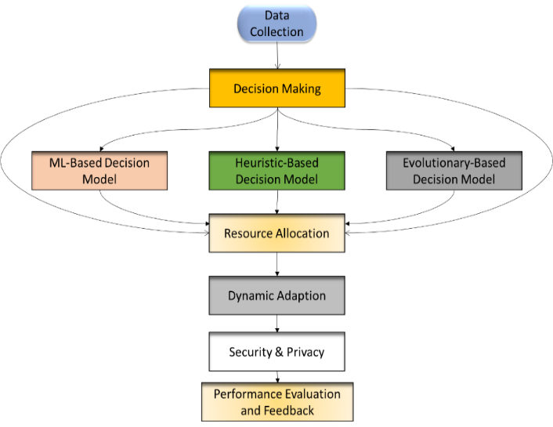

Fig. 2: Basic steps of AI-based Computation Offloading process in EC

Optimization Problem formulation
The optimal problem formulation of computation task offloading in edge computing involves minimizing the total cost, which includes both latency L and energy consumption E while considering constraints related to device capabilities, network conditions, and service level agreements. Here is a general formulation:
Objective function:
Minimize the total Cost J, which is a weighted sum of Latency L and Energy Consumption E.
$min J=∝.L+β.E$,
Where α and $β$ are the weights that balance the trade-off between L and E.
Variables:
- $X_{i}∈\{0,1\}$: Binary Decision-making variable, where $X_{i}=1$,if the task I is offloaded and $X_{i}=0$if it is executed locally.
- $d_{i}$: Data size of task i.
- $C_{i}$: Computation requirements of task I.
- $t_{i}$: Delay sensitivity of task i.
- $f_{i,local}$: Computation capacity of the local device for task i.
- $f_{i,edge}$: Computation capacity of the edge server for task i.
Constraints:
- Latency Constraint:
$The total latency for executing task I either locally or on the edge server should be within$ acceptable limits.
$$t_{i}≥X_{i}\left(\frac{d_{i}}{B_{i}}+\frac{C_{i}}{f_{i,edge}}\right)+(1-X_{i})(\frac{C_{i}}{f_{i,local}})$$

- Energy Consumption Constraint:
The energy consumed by the device for executing task I either locally or during offloading should be within the battery capacity $E_{max}$.
$E_{i}≤E_{max}$,
Where, $E_{i}=X_{i}.E_{transmit}+\left(1-X_{i}\right).E_{local}$, and $E_{transmit}=P_{transmit}.\frac{d_{i}}{B_{i}}.E_{local}=P_{local}.\frac{C_{i}}{f_{i.local}}$

- Resource Constraints:
The computation resources of the Edge Server should not be exceeded.
$$\sum_{i}{.X_{i}.C_{i}≤F_{edge}}$$

- Task Execution Constraint:
All tasks must be completed within their deadline.
$$X_{i}\left(\frac{d_{i}}{B_{i}}+\frac{C_{i}}{f_{i.edge}}\right)+\left(1-X_{i}\right)\left(\frac{C_{i}}{f_{i.local}}\right)≤t_{i}$$

- Formulated Optimal Problem:
$$\min_{X_{i}} α\sum_{i}{\left(X_{i}\left(\frac{d_{i}}{B_{i}}+\frac{C_{i}}{f_{i,edge}}\right)+\left(1-X_{i}\right)\left(\frac{C_{i}}{f_{i.local}}\right)\right)+β\sum_{i}{{(X}_{i}.P_{transmit}.\frac{d_{i}}{B_{i}}+\left(1-X_{i}\right)P_{local}.\frac{C_{i}}{f_{i.local}})}}$$
Subject to:
$$\sum_{i}{X_{i}.C_{i}≤ F_{edge}}$$
$$X_{i}\left(\frac{d_{i}}{B_{i}}+\frac{C_{i}}{f_{i.edge}}\right)+\left(1-X_{i}\right)\left(\frac{C_{i}}{f_{i.local}}\right)≤t_{i}$$
Where, $α,β≥0 and X_{i}∈\{0,1\}$
This problem formulation aims to find the optimal offloading decisions $X_{i}$ that minimize the total cost J while satisfying all the constraints related to latency, energy consumption, resource availability, and task completion deadlines.

RESULTS AND DISCUSSION
In this section, the performance of three different task offloading strategies, namely Reinforcement Learning (RL), Ant Colony Optimization (ACO), and Genetic Algorithm (GA), is analyzed and compared in terms of overall latency cost. The primary objective of this evaluation is to investigate the effectiveness of intelligent decision-making techniques in minimizing computation latency in a dynamic edge computing environment. Since latency is a critical performance metric for real-time and delay-sensitive applications, an efficient offloading strategy is essential to improve system responsiveness and quality of service.

The operational procedures of the three algorithms are summarized in Algorithms 1, 2, and 3. The RL-based approach employs a Q-learning mechanism, where the agent learns an optimal offloading policy by interacting with the environment and receiving feedback in the form of rewards. The Q-values are updated iteratively using the Bellman equation, allowing the system to gradually converge toward optimal decisions. This learning-based mechanism enables RL to adapt effectively to changing network conditions and workload variations.

In contrast, the ACO-based approach models the offloading problem as a path-selection process inspired by the foraging behaviour of ants. In this method, artificial ants construct solutions based on transition probabilities influenced by pheromone trails and heuristic information. Over multiple iterations, pheromone levels are updated to reinforce better solutions. Although ACO is effective in exploring multiple paths, its performance depends heavily on the probabilistic nature of solution construction, which may lead to slower convergence in highly dynamic environments.

Algorithm 1: Steps for Computation Task Offloading using RL
- Initialize Q-table with zeros
- Set learning parameters: learning rate (alpha), discount factor (gamma), exploration rate (epsilon)
- Define state and action spaces
- Define reward function: based on latency and energy consumption
- Q-Learning Algorithm:
- For each episode:
Initialize state
While the state is not terminal:
Choose action using an epsilon-greedy policy
Take action and observe the next state and reward
Update the Q-value using the Bellman equation
Transition to the next stage
Decay exploration rate (epsilon)
- End

Algorithm 2: Steps for Computation Task Offloading using ACO
- Initialize pheromone levels
- Set ACO parameters: number of ants, pheromone evaporation rate, alpha, beta
- Define environment: task characteristics, network conditions, device capabilities
- ACO Algorithm:
  - For each iteration:
    - For each ant:
Initialize empty solution
For each task:
Calculate transition probabilities
Select action based on probabilities
Append action to solution
Evaluate the cost of the solution
Update the best solution if the current cost is better
  - Update pheromones based on solution quality
- End

Algorithm 3: Steps for Computation Task Offloading using GA
- Initialize the population with random solutions
- Set GA parameters: population size, mutation rate, crossover rate
- Define fitness function: based on latency and energy consumption
- GA Algorithm:
- For each generation:
  - Evaluate the fitness of each solution in the population
  - Select parents based on fitness scores
  - Perform crossover to generate offspring
  - Apply mutation to offspring
  - Select a new population from the current population and offspring
  - Update the best solution based on fitness
- End

Figure 3 illustrates the conceptual workflow of the three optimization approaches, including (a) machine learning-based RL, (b) swarm intelligence-based ACO, and (c) evolutionary-based GA. These approaches differ in their learning mechanisms and search strategies. While the RL method continuously updates its policy using reward feedback, ACO relies on pheromone trails to guide ants toward optimal solutions, and GA applies genetic operators such as selection, crossover, and mutation to evolve better solutions across generations.
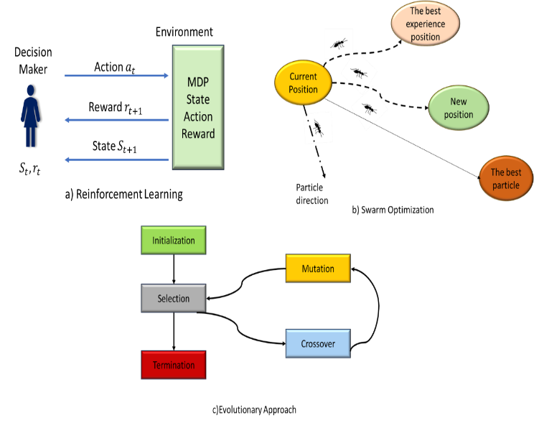

Fig. 3: Illustration of a) ML-Based approach) Swarm Optimization, and c) Evolutionary-Based Approach

Table 2 summarizes the key simulation parameters used for experimental evaluation. The number of episodes is set to 100, and the number of computational tasks varies from 10 to 50, with a maximum of 100 steps per episode. For the RL-based approach, the learning rate (α) is fixed at 0.1, the discount factor (γ) at 0.99, and the exploration rate (ε) at 0.1, which enables a balanced trade-off between exploration and exploitation. In the ACO algorithm, the pheromone influence (α) and heuristic influence (β) are set to 1 and 2, respectively, with an evaporation rate of 0.5 and 10 ants used for solution construction. For the GA-based method, a population size of 50, elite size of 5, and mutation rate of 0.01 are selected to maintain diversity and avoid premature convergence.

Table 2: Parameters used in the simulation.

Simulation Parameters
No. of Episodes | No. of Tasks |  | Max Steps
100 | 10 to 50 |  | 100
Q-Learning Parameters

Alpha |  | 0.1
Gamma |  | 0.99
Epsilon |  | 0.1
ACO-Learning Parameters

Alpha |  | 1
Gamma |  | 2
Evaporation rate |  | 0.5
No. of Ants |  | 10
GA-Learning Parameters

Population rate |  | 0.01
Population Size |  | 50
Elite size |  | 5
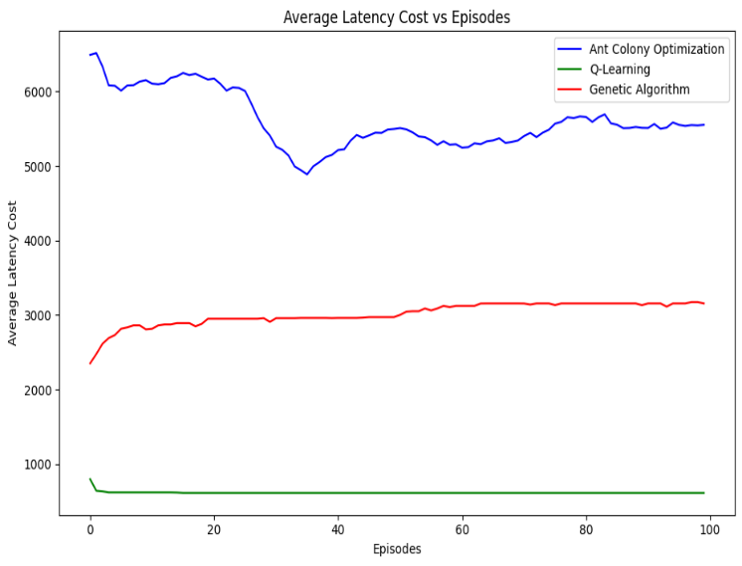
Fig. 4: Average latency cost of ACO, Q-Learning and GA

Figure 4 presents the average latency cost achieved by the three algorithms over different training episodes. The RL-based approach consistently achieves the lowest latency compared to ACO and GA across all episodes. After 100 episodes, the average latency obtained using RL is approximately 42 ms, whereas ACO and GA record higher latency values of around 55 ms and 63 ms, respectively. This corresponds to a latency reduction of nearly 24% compared to ACO and 33% compared to GA. Furthermore, the RL model demonstrates a faster convergence rate, reaching stable performance within the first 40 episodes, which indicates its ability to learn optimal offloading policies through continuous interaction with the environment. In contrast, ACO shows moderate performance due to its reliance on probabilistic path selection, which may result in suboptimal decisions during early iterations. The GA-based approach exhibits relatively higher latency because of the computational overhead associated with population-based evolution and genetic operations.

Conclusion

Computation offloading plays a crucial role in enhancing system performance and improving user experience in Mobile Edge Computing (MEC) environments. In this work, three intelligent task offloading strategies, namely Reinforcement Learning (RL), Ant Colony Optimization (ACO), and Genetic Algorithm (GA), were implemented and evaluated with the objective of minimizing overall latency. The experimental results indicate that the RL-based approach consistently outperforms ACO and GA by achieving the lowest average latency of approximately 42 ms, compared to 55 ms for ACO and 63 ms for GA, resulting in a latency reduction of about 24% and 33%, respectively. This superior performance can be attributed to the adaptive learning capability and faster convergence behavior of the RL model. In future work, the proposed framework can be extended by incorporating additional performance metrics such as energy consumption and throughput, and by exploring deep reinforcement learning techniques for large-scale and highly dynamic MEC scenarios.

FUTURE DIRECTIONS AND INNOVATIONS

Future research directions should focus on integrating AI techniques with emerging technologies such as blockchain and 5G networks to enhance security, scalability, and efficiency in computation offloading. Additionally, developing adaptive AI models that can self-tune and optimize offloading decisions autonomously in dynamic edge environments will be crucial for advancing the field.

COMPETING INTERESTS DISCLAIMER:
Authors have declared that they have no known competing financial interests OR non-financial interests OR personal relationships that could have appeared to influence the work reported in this paper.

References

[1] P. Mach and Z. Becvar, “Mobile edge computing: A survey on architecture and computation offloading,” IEEE communications surveys & tutorials, vol. 19, no. 3, pp. 1628–1656, 2017.
[2] Z. Hu et al., “An efficient online computation offloading approach for large-scale mobile edge computing via deep reinforcement learning,” IEEE Transactions on Services Computing, vol. 15, no. 2, pp. 669–683, 2021.
[3] D. Sun, Y. Chen, and H. Li, “Intelligent Vehicle Computation Offloading in Vehicular Ad Hoc Networks: A Multi-Agent LSTM Approach with Deep Reinforcement Learning,” Mathematics, vol. 12, no. 3, p. 424, 2024.
[4] M. Masdari, K. Majidzadeh, E. Doustsadigh, A. Babazadeh, and R. Asemi, “Energy-Aware Computation Offloading in Mobile Edge Computing Using Quantum-Based Arithmetic Optimization Algorithm,” Nov. 03, 2022. doi: 10.21203/rs.3.rs-2221212/v1.
[5] A. Abbas, A. Raza, F. Aadil, and M. Maqsood, “Meta-heuristic-based offloading task optimization in mobile edge computing,” International Journal of Distributed Sensor Networks, vol. 17, no. 6, p. 15501477211023021, Jun. 2021, doi: 10.1177/15501477211023021.
[6] J. Wang et al., “A Probability Preferred Priori Offloading Mechanism in Mobile Edge Computing,” IEEE Access, vol. 8, pp. 39758–39767, 2020, doi: 10.1109/ACCESS.2020.2975733.
[7] K. Lone and S. A. Sofi, “e‐TOALB: An efficient task offloading in IoT‐fog networks,” Concurrency and Computation, p. e7951, Nov. 2023, doi: 10.1002/cpe.7951.
[8] T. Bayan and P. Sarma, “MAHO: Modified Ant Honey Bee Optimization Algorithm for Load Balancing in Cloud Environment,” INTERNATIONAL JOURNAL OF COMPUTER SCIENCES AND ENGINEERING, vol. 8, p. 10, Jul. 2020, doi: 10.26438/ijcse/v8i7.122131.
[9] P. Sarma, C. Kalita, and V. Deka, “A Survey on Load Balancing Algorithms in Cloud Computing,” International Journal of Computer Sciences and Engineering, vol. 7, pp. 169–176, Jun. 2019, doi: 10.26438/ijcse/v7i6.169176.
[10] S. C. Pandey, “New facet of honey bees dancing language for mining the induction rules,” Sādhanā, vol. 43, no. 3, p. 35, Mar. 2018, doi: 10.1007/s12046-018-0809-y.
[11] “Honey Bee Based Load Balancing in Cloud Computing,” KSII TIIS, vol. 11, no. 12, Dec. 2017, doi: 10.3837/tiis.2017.12.001.
[12] Y. Sahni, J. Cao, L. Yang, and Y. Ji, “Multi-Hop Multi-Task Partial Computation Offloading in Collaborative Edge Computing,” IEEE Trans. Parallel Distrib. Syst., vol. 32, no. 5, pp. 1133–1145, May 2021, doi: 10.1109/TPDS.2020.3042224.
[13] L. Yan, H. Chen, Y. Tu, and X. Zhou, “A Task Offloading Algorithm With Cloud Edge Jointly Load Balance Optimization Based on Deep Reinforcement Learning for Unmanned Surface Vehicles,” IEEE Access, vol. 10, pp. 16566–16576, 2022, doi: 10.1109/ACCESS.2022.3150406.
[14] S. Jiao, H. Wang, and J. Luo, “SRA-E-ABCO: terminal task offloading for cloud-edge-end environments,” J Cloud Comp, vol. 13, no. 1, p. 58, Mar. 2024, doi: 10.1186/s13677-024-00622-y.
[15] F. Guo, H. Zhang, H. Ji, X. Li, and V. C. M. Leung, “An Efficient Computation Offloading Management Scheme in the Densely Deployed Small Cell Networks With Mobile Edge Computing,” IEEE/ACM Trans. Networking, vol. 26, no. 6, pp. 2651–2664, Dec. 2018, doi: 10.1109/TNET.2018.2873002.
[16] Z. Li and Q. Zhu, “Genetic algorithm-based optimization of offloading and resource allocation in mobile-edge computing,” Information, vol. 11, no. 2, p. 83, 2020.
[17] Z. Liao, J. Peng, B. Xiong, and J. Huang, “Adaptive offloading in mobile-edge computing for ultra-dense cellular networks based on genetic algorithm,” J Cloud Comp, vol. 10, no. 1, p. 15, Dec. 2021, doi: 10.1186/s13677-021-00232-y.
[18] Y. Sun, Y. Bian, H. Li, F. Tan, and L. Liu, “Flexible Offloading and Task Scheduling for IoT Applications in Dynamic Multi-Access Edge Computing Environments,” Symmetry, vol. 15, no. 12, p. 2196, 2023.
[19] J. Wang et al., “A Probability Preferred Priori Offloading Mechanism in Mobile Edge Computing,” IEEE Access, vol. 8, pp. 39758–39767, 2020, doi: 10.1109/ACCESS.2020.2975733.
[20] S. Pang, H. Sun, M. Wang, S. Wang, S. Qiao, and N. N. Xiong, “An Efficient Computing Offloading Scheme Based on Privacy-Preserving in Mobile Edge Computing Networks,” Wireless Communications and Mobile Computing, vol. 2022, pp. 1–15, Jun. 2022, doi: 10.1155/2022/5152598.
[21] Y. Sun, C. Song, S. Yu, Y. Liu, H. Pan, and P. Zeng, “Energy-efficient task offloading based on differential evolution in edge computing system with energy harvesting,” IEEE Access, vol. 9, pp. 16383–16391, 2021.
[22] X. Du, S. Tang, Z. Lu, J. Wet, K. Gai, and P. C. Hung, “A novel data placement strategy for data-sharing scientific workflows in heterogeneous edge-cloud computing environments,” in 2020 IEEE International Conference on Web Services (ICWS), IEEE, 2020, pp. 498–507. Accessed: Jul. 15, 2024. [Online]. Available: https://ieeexplore.ieee.org/abstract/document/9284088/
[23] Z. H. Huang, Z. H. Zhang, J. Y. Han, and C. Y. Huang, “Remote multi-point air refueling planning based on improved differential evolution algorithm,” in Proc. 6th Int. Conf. Computer Information Science and Application Technology (CISAT), SPIE, 2023, pp. 38–44, doi: 10.1117/12.3003839.
[24] X. Dong, Z. Wan, C. Deng, W. Wen, and Y. Luo, “Intelligent Time Allocation for Wireless Power Transfer in Wireless-Powered Mobile Edge Computing,” Wireless Communications and Mobile Computing, vol. 2022, pp. 1–13, Aug. 2022, doi: 10.1155/2022/6722848.
[25] Z. Li, X. Zhou, T. Li, and Y. Liu, “An optimal-transport-based reinforcement learning approach for computation offloading,” in 2021 IEEE Wireless Communications and Networking Conference (WCNC), IEEE, 2021, pp. 1–6. Accessed: Jul. 15, 2024. [Online]. Available: https://ieeexplore.ieee.org/abstract/document/9417331/
[26] N. Shan, Y. Li, and X. Cui, “A Multilevel Optimization Framework for Computation Offloading in Mobile Edge Computing,” Mathematical Problems in
[27] S. Singh, “Joint Optimization of Computation Offloading and Resource Allocation in C-RAN with Multi-Access Edge Computing using Evolutionary Algorithms,” Apr. 11, 2022. doi: 10.36227/techrxiv.19530370.v1.
[28] M. I. Jordan and T. M. Mitchell, “Machine learning: Trends, perspectives, and prospects,” Science, vol. 349, no. 6245, pp. 255–260, Jul. 2015, doi: 10.1126/science.aaa8415.
[29] A. Crutcher, C. Koch, K. Coleman, J. Patman, F. Esposito, and P. Calyam, “Hyperprofile-based computation offloading for mobile edge networks,” in 2017 IEEE 14th international conference on mobile ad hoc and sensor systems (MASS), IEEE, 2017, pp. 525–529. Accessed: Jul. 15, 2024. [Online]. Available: https://ieeexplore.ieee.org/abstract/document/8108792/
[30] L. Ale, S. A. King, N. Zhang, A. R. Sattar, and J. Skandaraniyam, “D3PG: Dirichlet DDPG for task partitioning and offloading with constrained hybrid action space in mobile-edge computing,” IEEE Internet of Things Journal, vol. 9, no. 19, pp. 19260–19272, 2022.
[31] A. Acheampong, Y. Zhang, X. Xu, and D. A. Kumah, “A review of the current task offloading algorithms, strategies and approach in edge computing systems,” Computer Modeling in Engineering & Sciences, 134 (1), pp. 35–88, 2023.
[32] G. Qu, H. Wu, R. Li, and P. Jiao, “DMRO: A deep meta reinforcement learning-based task offloading framework for edge-cloud computing,” IEEE Transactions on Network and Service Management, vol. 18, no. 3, pp. 3448–3459, 2021.
[33] Z. Chen and X. Wang, “Decentralized computation offloading for multi-user mobile edge computing: a deep reinforcement learning approach,” J Wireless Com Network, vol. 2020, no. 1, p. 188, Dec. 2020, doi: 10.1186/s13638-020-01801-6.
[34] M. Masdari, K. Majidzadeh, E. Doustsadigh, A. Babazadeh, and R. Asemi, “Energy-aware computation offloading in mobile edge computing using quantum-based arithmetic optimization algorithm,” 2022, Accessed: Jul. 18, 2024. [Online]. Available: https://www.researchsquare.com/article/rs-2221212/latest
[35] L. Meng, Y. Wang, H. Wang, X. Tong, Z. Sun, and Z. Cai, “Task Offloading Optimization Mechanism based on Deep Neural Network in Spatio-temporal Crowdsourcing,” Oct. 28, 2022. doi: 10.21203/rs.3.rs-2193728/v1.
[36] S. Akter, D.-Y. Kim, and S. Yoon, “Task offloading in multi-access edge computing enabled UAV-aided emergency response operations,” IEEE Access, vol. 11, pp. 23167–23188, 2023.
[37] C. Dong, Y. Sun, M. Shafiq, N. Hu, Y. Liu, and Z. Tian, “Optimizing mobility-aware task offloading in smart healthcare for Internet of Medical Things through multiagent reinforcement learning,” IEEE Internet of Things Journal, vol. 11, no. 8, pp. 13677–13691, 2023
[38] Y. Chen, J. Zhao, J. Hu, S. Wan, and J. Huang, “Distributed task offloading and resource purchasing in NOMA-enabled mobile edge computing: Hierarchical game theoretical approaches,” ACM Trans. Embedded Comput. Syst., vol. 23, no. 1, pp. 1–28, 2024.
[39] K. A. Bui and M. Yoo, “Interruption-aware computation offloading in the industrial Internet of Things,” Sensors, vol. 25, no. 9, Art. no. 2904, 2025.

.

