Original Research Article

Maize-Derived Endophytic Bacillus subtilis Induces Lethal and Sublethal Effects in the Fall Armyworm, Spodoptera frugiperda

ABSTRACT
Aims: To assess the lethal and sublethal effects of maize-associated bacterial endophytes against Spodoptera frugiperda under laboratory conditions and to identify the most effective isolate through molecular characterization for its potential in biological control.
Study Design: Completely randomized laboratory experiment with eight endophytic isolates and an untreated control.
Place and Duration of Study: MRC, ARI, Department of Plant Pathology, PJTAU during 2025.
Methodology: Eight maize endophytic bacterial isolates (ESB-1 to ESB-8) were tested on second-instar larvae of S. frugiperda using in vitro bioassays. Observations included larval mortality, relative growth rate, efficiency of conversion of ingested food, feeding deterrence index, pupation, adult emergence, and developmental duration. Data were subjected to one-way ANOVA and compared with control. The superior isolate was identified by 16S rRNA sequencing and BLAST analysis.
Results: Treatments differed significantly for all parameters (p < 0.05). Isolate ESB-8 caused maximum larval mortality (50.88 ± 0.57%) over control (5.00 ± 0.14%). It recorded the lowest growth rate (0.15 ± 0.005) and food conversion efficiency (8.58 ± 0.52) with highest feeding deterrence (42.96 ± 1.69%). ESB-8 markedly reduced pupation (52.93 ± 4.14%) and adult emergence (55.96 ± 6.61%) and extended larval (17.20 ± 1.47 days) and pupal periods (9.43 ± 0.69 days). Isolates ESB-1, ESB-2 and ESB-6 showed negligible effects. The effective isolate ESB-8 was identified as Bacillus subtilis (GenBank: PV876730).
Conclusion: The endophytic isolate Bacillus subtilis (ESB-8) demonstrated pronounced toxic and growth-disrupting effects on S. frugiperda and represents a viable biopesticide for development of eco-friendly pest management strategies in maize.
Keywords:
Spodoptera frugiperda, maize endophytes, Bacillus subtilis, biological control, feeding deterrence index, developmental duration

- INTRODUCTION
Maize (Zea mays L.) is one of the most versatile cereal crops, valued globally for its wide adaptability, high genetic yield potential, and multifaceted uses as food, feed, and industrial raw material. In India, maize ranks as the third most important cereal crop after rice and wheat, contributing approximately 10% to the total food grain production (APEDA, 2019). Beyond its role in food and fodder security, maize serves as a key input for starch, oil, ethanol, and biofuel industries, underscoring its economic and strategic importance in both developing and developed agricultural systems (Swati et al., 2024; Togola et al., 2025). Despite its importance, maize productivity is increasingly constrained by biotic stresses, among which insect pests represent a major challenge. The fall armyworm (Spodoptera frugiperda J.E. Smith; Lepidoptera: Noctuidae) has emerged as one of the most destructive invasive pests threatening maize cultivation worldwide. This polyphagous insect attacks more than 80 plant species, including maize, cotton, rice, sorghum, soybean, tomato, potato, onion, beans, and cabbage, causing severe economic losses across diverse agroecosystems (Day et al., 2017). In maize, FAW infestation can lead to yield losses of up to 70%, particularly when plants are attacked during early growth stages (Hruska, 2019). The pest damages all crop stages, from seedling emergence to ear development, by feeding on leaves, whorls, tassels, and cobs, resulting in substantial reductions in photosynthetic capacity and grain yield (Sisay et al., 2019).
Originally native to the Americas, S. frugiperda was first reported in Africa in 2016 and subsequently spread rapidly across sub-Saharan Africa, Asia, and the Indian subcontinent. In India, FAW was first detected in 2018 and has since spread to all major maize-growing regions, drastically altering the pest scenario and posing a serious threat to national maize productivity (Prasanna et al., 2018; Suby et al., 2020). Unmanaged infestations typically result in yield losses ranging from 20-50%, with higher losses reported under favorable climatic conditions (Anjorin et al., 2021; Matova et al., 2020). The pest’s cryptic feeding behaviour and its habit of pupating 3-5 cm below the soil surface further complicate management by allowing larvae to escape contact insecticides (De Groote et al., 2020; Thirawut et al., 2023). Climate change has further intensified the FAW problem by expanding its geographical range, increasing reproductive potential, and prolonging survival under warmer temperatures and erratic rainfall patterns (Yan et al., 2022; Zanzana et al., 2024; Mir et al., 2024). These factors collectively exacerbate pest pressure in tropical and subtropical regions, including major maize belts in India.
Current management of FAW relies predominantly on chemical insecticides, including anthranilic diamides, avermectins, and spinosyns, which have been registered in India for emergency use based on their novel modes of action. However, their effectiveness against mature larvae is often limited due to the concealed feeding habit of FAW within maize whorls. Moreover, indiscriminate and repeated use of insecticides has resulted in resistance development, environmental contamination, and adverse effects on non-target organisms, including natural enemies and pollinators (Koskey et al., 2021; Chandrakumara et al., 2022; Srinivas et al., 2022; Yao et al., 2023; Sangaraju et al., 2024; Pereira et al., 2024; Verma et al., 2024; Tyagi et al., 2024). Alarmingly, FAW has already evolved resistance to several chemical insecticides as well as transgenic Bt-maize in different parts of the world, raising serious concerns about the long-term sustainability of chemical-based control strategies (Prasanna et al., 2018).
In this context, biological control approaches have gained renewed attention as environmentally benign and sustainable alternatives for FAW management. Entomopathogens and plant-associated microorganisms play a vital role as natural population regulators of insect pests. Microbial agents such as Bacillus thuringiensis, Pseudomonas putida, and Trichoderma spp. have demonstrated promising potential for insect suppression along with plant growth promotion (Irsad et al., 2023). B. thuringiensis, a spore-forming Gram-positive bacterium, produces insecticidal crystal (Cry and Cyt) proteins that disrupt the larval midgut epithelium, leading to feeding cessation and mortality (Ma et al., 2023). Similarly, Trichoderma spp. not only act as biopesticides but also enhance plant vigor by inducing systemic resistance and improving nutrient acquisition (Sood et al., 2020; Lanzuise et al., 2022; Waleed et al., 2024).
Among these microbial associates, endophytic microorganisms which colonize internal plant tissues without causing harm which offer unique advantages by providing sustained, systemic protection against insect pests while simultaneously promoting plant growth. However, information on maize-derived bacterial endophytes and their role in suppressing FAW under Indian agroecological conditions remains limited. The present study was undertaken to evaluate their potential as eco-friendly and locally adaptable biocontrol agents against Spodoptera frugiperda

- MATERIAL AND METHODS
2.1 Isolation of bacterial endophytes
Stem samples collected from different parts of Telangana (supplementary file) were surface sterilized using a modified protocol of Hallmann et al (1997). Tissues were washed thoroughly, treated with Tween 80, and sequentially surface disinfected with 80% ethanol, 4% sodium hypochlorite, and 70% ethanol, followed by multiple rinses with sterile distilled water. Bacterial endophytes were isolated by direct plating of sterilized tissue segments and by plating homogenized internal tissues on nutrient agar and tryptic soy agar, with incubation at 30 ± 2 °C for 24-48 h. The efficacy of surface sterilization was confirmed by plating the final rinse water, which showed no microbial growth (Schulz et al., 1998).
2.2 Bioassay of inoculated plants against fall armyworm Spodoptera frugiperda
Larvae of S. frugiperda were collected from maize fields at the Maize Research Center, Agricultural Research Institute, Hyderabad, Telangana and reared on a Kabuli gram-based semi-synthetic diet under controlled conditions (27 ± 1 °C, 70 ± 5% RH, 14:10 h L:D photoperiod) following standard rearing procedures described by Gopalakrishnan and Kalia (2022). Adults were maintained in mating jars (20 × 15 cm) with 10% honey solution and blotting paper for oviposition. Egg masses were collected daily, and second instars were used for bioassays.
The bioefficacy of maize-derived bacterial endophytes was evaluated using a. Leaf bits (≈ 1 inch²) were collected from endophyte-inoculated maize plants and untreated controls at 14 days after inoculation. The efficacy of bacterial endophytes against S. frugiperda was assessed in leaf bioassays using multiple biological parameters viz., larval mortality (%), relative growth rate (RGR), efficiency of conversion of ingested food (ECI), feeding deterrence index (FDI), pupation (%) and adult emergence (%). These indices provided a comprehensive evaluation of both lethal and sublethal effects on larval feeding, growth, and developmental success. Each treatment was replicated three times with 10 larvae per replication. Leaf material was replaced daily, larval mortality was recorded for 10 days, and surviving larvae were individually weighed to assess treatment effects on biological parameters of S. frugiperda.
Larval Mortality (%)
$$Mortality (\%)=\frac{Number of dead larvae}{Total number of larvae}×100$$

Relative Growth Rate (RGR)
$$RGR=\frac{W2-W1}{t×W1}$$
Where: W₁ = Initial larval weight (mg); W₂ = Final larval weight (mg); t = Duration of feeding period (days)

Efficiency of Conversion of Ingested food (ECI)
$$ECI \left(\%\right)=\frac{Weight gain of larva \left(mg\right)}{Food ingested (mg)}×100$$
Feeding Deterrence Index (FDI)
$$FDI (\%)=\frac{C-T}{C+T}×100$$
Where: C = Amount of food consumed in control; T = Amount of food consumed in treatment
Pupation (%)
$$Pupation (\%)=\frac{Number of larvae pupated}{Total number of larvae}×100$$
Adult Emergence (%)
$$Adult Emergence (\%)=\frac{Number of adults emerged}{Total number of pupae}×100$$
2.3 Biochemical and molecular characterisation of bacterial endophytes
Plant growth-promoting activities of bacterial endophytes were assessed through qualitative and quantitative assays. Siderophore production was determined on Chrome Azurol S agar following Schwyn and Neilands (1987), where yellow-orange halos around colonies indicated positive reaction. Phosphate solubilization was evaluated on Pikovskaya’s agar with clear zone formation as per Pikovskaya (1948). HCN production was detected using glycine-amended nutrient agar and alkaline picrate paper method of Castric and Castric (1983). Ammonia production was assessed in peptone water using Nessler’s reagent according to Gupta and Pandey (2019). IAA production was quantified colorimetrically at 530 nm using Salkowski reagent following Gordon and Weber (1951). Proteolytic and amylolytic activities were examined on gelatin agar and starch agar plates respectively based on substrate hydrolysis, while pectinase activity was detected on PSAM medium using Gram’s iodine staining as described by Oumer and Abate (2018). Biochemical confirmation of potential isolates including indole test was performed following standard protocols of Borkar (2018).
Molecular characterization of selected bacterial endophytes was carried out by amplifying the 16S rRNA gene following the standard protocol described by Weisburg et al. (1991) with minor modifications. Genomic DNA was extracted using a CTAB-based method, and PCR amplification was performed using universal primers 27F (5′-AGAGTTTGATCCTGGCTCAG-3′) and 1492R (5′-TACGGYTACCTTGTTACGACTT-3′) in a 25 µL reaction mixture. The PCR conditions consisted of initial denaturation at 96 °C for 4 min, followed by 35 cycles of denaturation at 94 °C for 40 s, annealing at 57 °C for 1 min, extension at 72 °C for 80 s, and a final extension at 72 °C for 10 min. Amplified PCR products (~1.5 kb) were confirmed by agarose gel electrophoresis and sequenced via sanger sequencing. The obtained sequences were compared with reference sequences available in the NCBI GenBank database using the BLASTn algorithm for taxonomic identification, and the confirmed sequences were submitted to GenBank.
2.4 Statistical Analysis
Data were subjected to one-way analysis of variance (ANOVA) using SPSS version 22.0 (IBM Corp., USA) with a sample size of n = 30, and treatment means were compared at a significance level of p ≤ 0.05. Duncan’s Multiple Range Test (DMRT) was deployed for post-hoc separation of means and treatments sharing different letters were considered significantly different.
- RESULTS
3.1 Effect of maize-derived bacterial endophytes on larval mortality
Larval mortality of S. frugiperda varied significantly among the different maize-derived bacterial endophyte treatments (one-way ANOVA; F = 578; df = 8; p < .05). Among all tested isolates, ESB-8 emerged as the most effective endophyte which was recorded with the highest larval mortality (50.88±0.57), which was significantly greater than the control (5±0.14) as well as all other endophytic treatments. The pronounced larvicidal effect of ESB-8 indicates its strong pathogenic or toxic influence on S. frugiperda larvae. In contrast, ESB-6 (12.28±0.57) was the least effective isolate, as the larval mortality observed under this treatment did not differ significantly from the control, suggesting a negligible lethal effect (Fig. 1).
3.2 Effect on relative growth rate (RGR) of larvae
The relative growth rate (RGR) of S. frugiperda larvae was significantly affected by maize-derived bacterial endophytes (F = 6.33; df = 8; p < .05). ESB-8 caused the maximum suppression of larval growth, as evidenced by the lowest RGR (0.15± 0.005) among all treatments, indicating severe impairment of nutrient assimilation and physiological growth processes. Conversely, ESB-2 recorded RGR (0.19±0.004) confirming its least effectiveness in restricting larval growth (Fig. 2). The remaining isolates produced moderate reductions in RGR, reflecting variable but less pronounced growth-retarding effects.
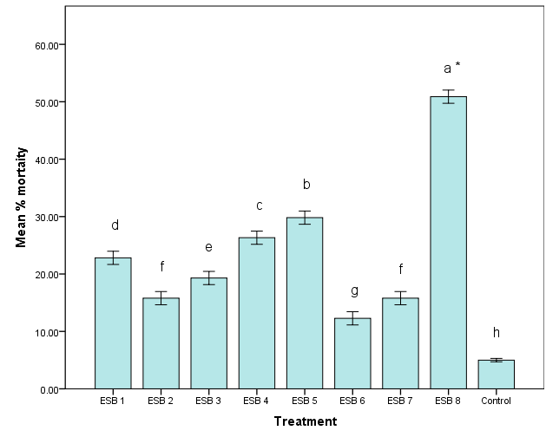
Fig. 1. Effect of maize-derived bacterial endophytes on larval mortality of S. frugiperda under in vitro conditions (one-way ANOVA, n=30, p = .05, DMRT was used for treatment comparison. Different letters indicate significant differences among treatments)
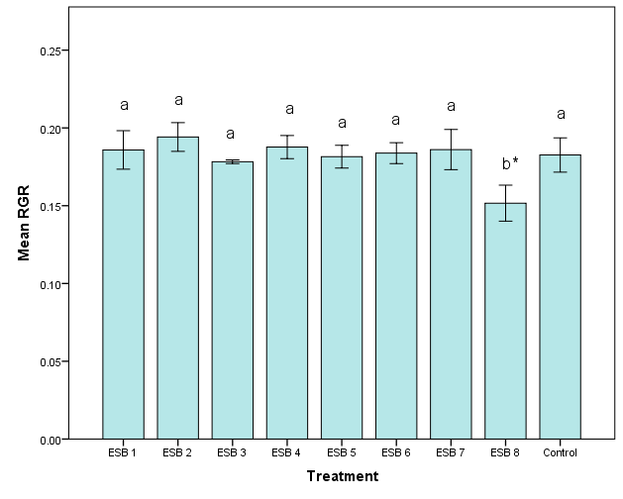
Fig. 2. Effect of maize-derived bacterial endophytes on relative growth rate (RGR) of S. frugiperda larvae under in vitro conditions (one-way ANOVA, n=30, p = .05, DMRT was used for treatment comparison. Different letters indicate significant differences among treatments)
3.3 Effect on ECI and feeding deterrence
Significant differences were recorded among treatments for both Efficiency of Conversion of Ingested food (F = 6.88; df = 8; p < .05) and Feeding Deterrence Index (F = 12.79; df = 8; p < .05). ESB-8 was the most effective isolate, showing the lowest ECI (8.58±0.52), indicating poor conversion of ingested food into biomass along with the highest FDI (42.96±1.69) reflecting strong feeding deterrent activity. This dual effect highlights the capacity of ESB-8 to disrupt both feeding behaviour and digestive efficiency of larvae. In contrast, ESB-6 and ESB-1 exhibited the highest ECI (15.31± 1.27) and the lowest FDI (6.48±2.15) compared to the control (ECI= 12.02±0.17) and other endophytes, demonstrating minimal interference with larval feeding and food utilization, and was therefore categorized as the least effective endophytes (Fig. 3). Other isolates showed intermediate responses, causing partial reduction in ECI and moderate feeding deterrence.
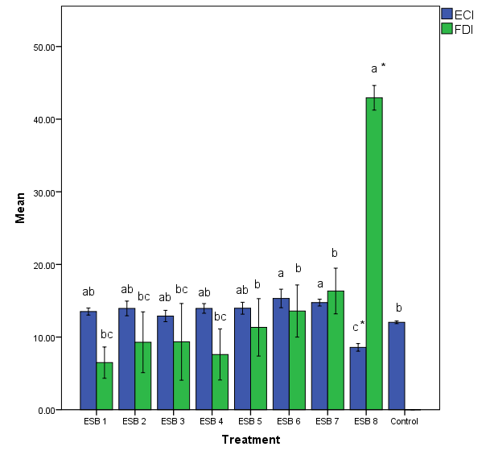
Fig. 3. Effect of maize-derived bacterial endophytes on S. frugiperda larvae’s Efficiency of Conversion of Ingested food (ECI) and Feeding Deterrence Index (FDI) (one-way ANOVA, n=30, p = .05, DMRT was used for treatment comparison. Different letters indicate significant differences among treatments)
3.4 Effect on pupation and adult emergence
Pupation and adult emergence of S. frugiperda were significantly influenced by endophytic bacterial treatments (Pupation: F = 4.37; df = 8; p < .05, adult emergence: F = 6.62; df = 8; p < .05). ESB-8 resulted in the lowest pupation (52.93±4.14) and adult emergence (55.96±6.61) indicating a strong disruption of post-larval development and successful metamorphosis. The reduced transition from larva to pupa and adult under ESB-8 treatment suggests persistent and cumulative physiological stress. In contrast, ESB-1 and ESB-2 showed pupation (88.13±7.03) and adult emergence rates (78.40±1.59) comparable to the control confirming their limited impact on insect development (Fig. 4). Other endophytes produced moderate reductions, indicating partial developmental inhibition.
3.5 Effect on larval and pupal developmental periods
Significant variation in larval and pupal developmental durations was observed among treatments (larval duration: F = 2.78; df = 8; p = .03, pupal duration: F = 2.83; df = 8; p = .03). ESB-8 significantly prolonged both larval (17.20±1.47) and pupal (9.43±0.69) developmental periods compared to the control (13.76±0.31 and 5.81±0.12 respectively) suggesting strong sub lethal effects that delayed normal growth and development. Such prolongation is indicative of physiological stress and metabolic disruption induced by the endophyte. Conversely, ESB-4 and ESB-1 did not significantly alter both larval (11.36±0.33) and pupal duration (6.83± 0.68) respectively maintaining developmental timelines similar to the control and thereby representing the least effective isolates (Fig. 5). Other treatments caused moderate delays in development.

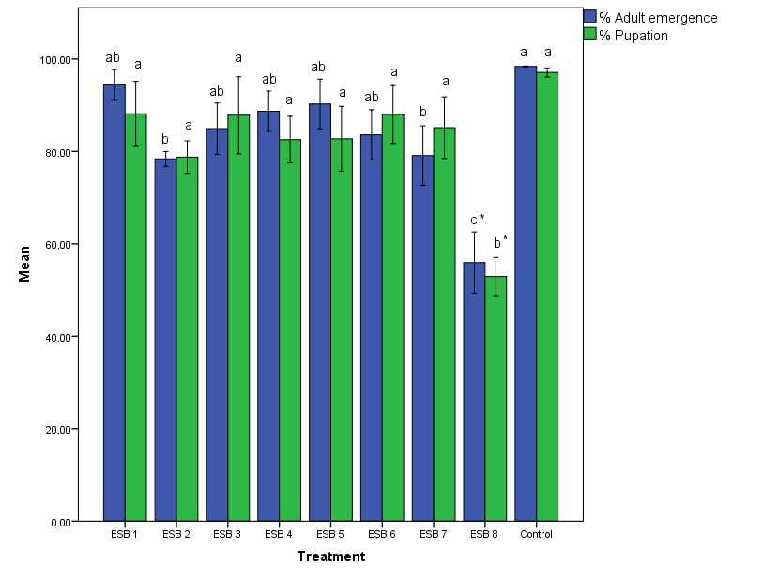
Fig. 4. Effect of maize-derived bacterial endophytes on pupation and adult emergence of S. frugiperda (one-way ANOVA, n=30, p = .05, DMRT was used for treatment comparison. Different letters indicate significant differences among treatments)

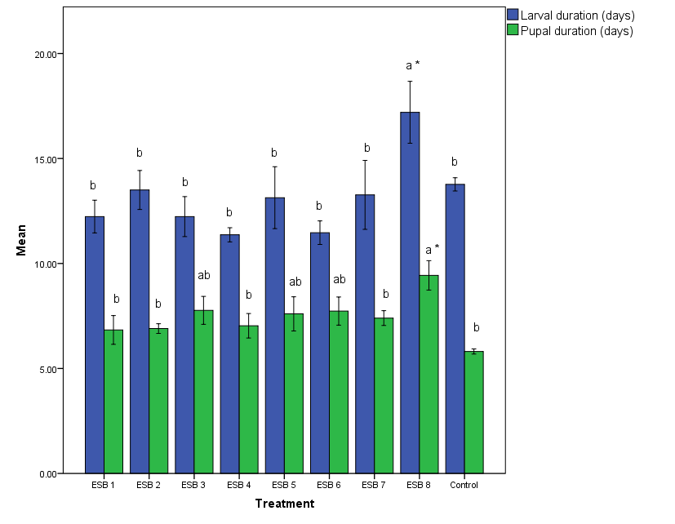
Fig. 5. Effect of maize-derived bacterial endophytes on larval and pupal developmental periods of S. frugiperda (one-way ANOVA, n=30, p = .05, DMRT was used for treatment comparison. Different letters indicate significant differences among treatments)
3.6 Biochemical traits and molecular characterisation endophytes
Considerable variability was observed among the maize-associated bacterial endophytes for plant growth-promoting and enzymatic traits. Siderophore production was detected in isolates ESB-2, ESB-5, ESB-6 and ESB-8, whereas strong HCN production (+++) was recorded in ESB-8followed by moderate activity in ESB-3 and ESB-6. Ammonia production was prominent in ESB-4 and ESB-8, while phosphate solubilization was observed only in ESB-2 and ESB-5. IAA production ranged from 3.97 to 14.29 μg ml⁻¹, with the highest level in ESB-8 (14.29 μg ml⁻¹) followed by ESB-7 (8.86 μg ml⁻¹) and ESB-4 (8.76 μg ml⁻¹). Enzymatic profiling revealed strong pectolytic activity in ESB-3 and ESB-8, whereas amylolytic activity was notable in ESB-5 and ESB-2. Potassium solubilization was evident in ESB-1, ESB-2, ESB-4 and ESB-6, with ESB-6 showing comparatively higher intensity. Proteolytic activity was highest in ESB-3 (+++), followed by ESB-8 and ESB-4 (Table 1). Overall, isolate ESB-8 exhibited multiple beneficial traits including high IAA production, strong HCN, ammonia, pectolytic and proteolytic activities, indicating its superior plant growth–promoting and biocontrol potential.
Molecular characterization of the most effective endophytic isolate, ESB-8, was carried out using 16S rRNA gene sequencing. Sequence analysis revealed that ESB-8 showed a high level of similarity with Bacillus subtilis. The nucleotide sequence of ESB-8 was successfully deposited in the NCBI GenBank database under the accession number PV876730, confirming its taxonomic identity as B. subtilis.
Table 1. Biochemical characterization of bacterial endophytes associated with maize
Isolate ID | 1 | 2 | 3 | 4 | 5 | 6 | 7 | 8 | 9
ESB 1 | - | - | + | - | 4.95 | + | - | + | -
ESB 2 | + | - | - | + | 3.97 | - | + | + | -
ESB 3 | - | ++ | - | - | 7.92 | ++ | - | - | +++
ESB 4 | - | - | ++ | - | 8.76 | - | - | + | +
ESB 5 | + | - | - | + | 4.06 | - | ++ | - | -
ESB 6 | + | + | - | - | 6.98 | + | - | ++ | -
ESB 7 | - | - | + | - | 8.86 | - | - | - | +
ESB 8 | + | +++ | ++ | - | 14.29 | ++ | + | - | ++

1. Siderophore production; 2. HCN production; 3. Ammonia production; 4. Phosphate solubilisation; 5. IAA production (μg/ml); 6. Pectolytic activity; 7. Amylolytic activity; 8. Potassium solubilisation; 9. Proteolytic activity

- DISCUSSION
The present study identifies the maize-derived endophyte Bacillus subtilis as a broadly active biological agent against S. frugiperda, acting through a combination of lethal and sublethal mechanisms. This multi-modal activity comprising increased mortality, feeding deterrence, reduced food-to-biomass conversion, slowed growth, and impaired metamorphosis implies that B. subtilis does not act solely as an acute toxin but rather induces systemic physiological and behavioral disruption in the insect. Such a composite effect increases the likelihood of durable pest suppression because survivors are less fit, reproduce less successfully, and become more vulnerable to environmental mortality factors and natural enemies (Ruiu, 2018). Bacillus-produced secondary metabolites such as cyclic lipopeptides which include surfactins, iturins and fengycins and extracellular enzymes consisting of chitinases and proteases in causing both direct toxicity and digestive impairment. Recent genomic-chemical studies and bioassays have demonstrated that surfactins and other lipopeptides produced by Bacillus spp. exhibit insecticidal or aphidicidal activity and can act synergistically with iturins/fengycins to increase lethality (Liu et al., 2024; Xia et al., 2024; Diniz et al., 2024). In parallel, several studies of B. velezensis and related Bacillus strains have reported chitinase/protease-mediated cuticle and gut damage that rapidly reduce larval viability. The combination of membrane-active lipopeptides and cuticle-digesting enzymes plausibly explains the pattern in our results where larvae showed both feeding cessation/antifeedant responses and reduced food conversion efficiency (ECI), consistent with midgut damage and enzyme inhibition documented elsewhere (Muthusamy et al., 2024; Liu et al., 2024; Assié et al., 2002).
Behavioral responses like feeding deterrence appear to be an important component of the observed damage reduction. Lipopeptides can act as contact or gustatory deterrents and also modify host plant palatability when delivered endophytically or via plant colonization (Ongena & Jacques, 2008). The marked increase in FDI in our trials thus both reduces immediate tissue loss and compounds nutritional stress, lowering growth rates and ECI even when mortality is incomplete which is a strategy that is ecologically favourable for integrated pest management (Ruiu, 2018; Liu et al., 2024). Our observation of prolonged larval and pupal durations and reduced rates of pupation/adult emergence indicates durable sublethal effects that extend beyond the initial exposure window. These developmental disruptions have been reported previously after microbial exposures and are linked to decreased reproductive potential and altered phenology which outcomes depressing population growth in subsequent generations. Recent transcriptomic and metabolomic analyses of insect responses to surfactin and related compounds suggest oxidative stress, suppression of detoxification pathways, and disruption of neuro-endocrine signalling among likely mechanisms for developmental delay (Xia et al., 2024). An important translational advantage in our work is the endophytic origin of the effective isolate. Endophytic B. subtilis strains have two practical benefits: ability to colonize and persist inside plant tissues, potentially delivering insecticidal metabolites systemically; and plant-growth promoting traits (phytohormone production and induced resistance) that can mitigate yield loss from herbivory (Sorokan et al., 2021). Field-oriented studies have already shown that endophytic Bacillus strains can reduce pest pressure while sometimes enhancing crop vigour, suggesting that endophyte-based approaches may reduce spray frequency and pesticide load in agroecosystems (Muthusamy et al., 2024; Nihorimbere et al., 2024).
Although the maize-derived Bacillus subtilis isolate demonstrated strong lethal and sublethal effects against S. frugiperda, the specific bioactive compounds responsible for these responses remain unidentified. Previous studies indicate that Bacillus spp. commonly produce cyclic lipopeptides such as surfactins, fengycins, and iturins, often acting synergistically with hydrolytic enzymes to disrupt insect physiology. Detailed chemical characterization using techniques such as LC-MS/MS or UPLC-QTOF, together with bioassays of purified metabolites and functional validation through targeted gene-disruption approaches (e.g., srfA), would help clarify the mechanisms underlying the observed bioactivity. The efficacy demonstrated under laboratory and greenhouse conditions may not fully reflect field performance, where environmental variability, microbial competition, and host plant factors can influence persistence and activity. Semi-field and multi-location field evaluations are therefore essential to assess endophytic colonization dynamics, in planta persistence of bioactive compounds, and compatibility with standard agronomic practices. In parallel, assessments of non-target effects on beneficial arthropods and soil microbial communities are necessary to ensure ecological safety, particularly where endophytic inoculation strategies are envisaged. From an applied perspective, formulation and delivery approaches will play a critical role in determining practical utility. While live endophytic inoculants offer the advantage of sustained in-plant activity, cell-free metabolite-based products may provide alternative routes with different regulatory and persistence profiles. Exploring integration of B. subtilis with other biological control agents or botanicals could further enhance efficacy and reduce resistance risks within integrated pest management systems.
- CONCLUSION
The maize-derived endophytic isolate B. subtilis exhibited strong lethal and sublethal effects against S. frugiperda which was disrupting feeding behavior, growth, and metamorphosis through likely action of lipopeptides and hydrolytic enzymes. Its multi-modal impact suggests durable pest suppression beyond acute toxicity, making survivors less fit and reproductively compromised. The endophytic nature of the isolate offers added advantages of in-plant persistence and potential plant growth promotion. Further chemical characterization and field validation are required to translate this isolate into a reliable biopesticide. Overall, B. subtilis represents a promising eco-compatible component for integrated management of fall armyworm in maize.
REFERENCES
Agricultural and Processed Food Products Export Development Authority (2019). APEDA 2018–19 report. Ministry of Commerce and Industry, Government of India. https://apeda.gov.in
Anjorin, F. B., Odeyemi, O. O., Akinbode, O. A., & Kareem, K. T. (2022). Fall armyworm infestation: maize yield depression and physiological basis of tolerance. Journal of Plant Protection Research, 62(1), 12-21. https://doi.org/10.24425/jppr.2022.140294
Assié, L. K., Deleu, M., Arnaud, L., Paquot, M., Thonart, P., & Haubruge, E. (2002). Insecticide activity of surfactins and iturins. Meded Rijksuniversiteit Gent, 67(3), 647-655.
Borkar, S.G. (2018). Biochemical tests used in identification of bacteria. In S.G. Borkar- Laboratory techniques in plant bacteriology. CRC Press. 93-109.
Castric, K.F. & Castric, P.A. (1983). Method for rapid detection of cyanogenic bacteria. Applied and Environmental Microbiology. 45 (2): 701-702
Chandrakumara, K., Kirankumar, G. N., Srinivas, K., Kumar, A., & Hadimani, B. (2022). Cyantraniliprole toxicity to Indian honey bees. The Pharma Innovation Journal, 11(11), 556-558.
Day, R., Abrahams, P., Bateman, M., Beale, T., Clottey, V., Cock, M., Colmenarez, Y., Corniani, N., Early, R., Godwin, J., Gomez, J., Moreno, P. J., Murphy, S. T., Mensah, B. O., Phiri, N., Pratt, C., Silvestri, S., & Witt, A. (2017). Fall armyworm: impacts and implications for Africa. Outlooks on Pest Management, 28, 196-201. https://doi.org/10.1564/v28_oct_02
De Groote, H., Kimenju, S. C., Munyua, B., Palmas, S., Kassie, M., & Bruce, A. (2020). Spread and impact of fall armyworm in maize production areas of Kenya. Agriculture, Ecosystems & Environment, 292, 106804. https://doi.org/10.1016/j.agee.2019.106804
Diniz, G. F. D., Figueiredo, J. E. F., & Santos, V. L. (2024). Characterization of lipopeptides from Bacillus. Frontiers in Microbiology, 15, 1443327. https://doi.org/10.3389/fmicb.2024.1443327
Gopalakrishnan, R., & Kalia, V. K. (2022). Biology of Spodoptera frugiperda on different hosts. Pest Management Science, 78(5), 2043-2051. https://doi.org/10.1002/ps.6830
Gordon, S.A. & Weber, R.P. (1951). Colorimetric estimation of indoleacetic acid. Plant physiology. 26 (1): 192.
Gupta, S. & Pandey, S. (2019). ACC deaminase producing bacteria with multifarious plant growth promoting traits alleviates salinity stress in French bean (Phaseolus vulgaris) plants. Frontiers in Microbiology. 10: 1506.
Hallmann, J., Quadt-Hallmann, A., Mahaffee, W. F., & Kloepper, J. W. (1997). Bacterial endophytes in agricultural crops. Canadian Journal of Microbiology, 43(10), 895-914. https://doi.org/10.1139/m97-131
Harrison, R. D., Thierfelder, C., Baudron, F., Chinwada, P., Midega, C., Schaffner, U., & van den Berg, J. (2019). Agro-ecological options for fall armyworm management. Journal of Environmental Management, 243, 318-330. https://doi.org/10.1016/j.jenvman.2019.05.011
Hruska, A. J. (2019). Fall armyworm (Spodoptera frugiperda) management by smallholders. CAB Reviews, 14, 1-11. https://doi.org/10.1079/PAVSNNR201914043
Irsad, M., Shahid, M., & Rizvi, P. Q. (2023). Entomopathogen-based biopesticides. Frontiers in Microbiology, 14, 1208237. https://doi.org/10.3389/fmicb.2023.1208237
Koskey, G., Mburu, S. W., Awino, R., Njeru, E. M., & Maingi, J. M. (2021). Potential use of beneficial microorganisms. Frontiers in Sustainable Food Systems, 5, 606308. https://doi.org/10.3389/fsufs.2021.606308
Liu, Q., Zhang, L. (2024). Lipopeptides from Bacillus velezensis. BMC Microbiology, 24, 231. https://doi.org/10.1186/s12866-024-03378-2
Matova, P. M., Kamutando, C. N., Magorokosho, C., Kutywayo, D., Gutsa, F., & Labuschagne, M. (2020). Fall-armyworm invasion and control practices in Sub-Saharan Africa. Crop Science, 60(6), 2951-2970. https://doi.org/10.1002/csc2.20317
Mir, W., Manda, P., & Das, R. (2024). Pesticide resistance in insects. International Journal of Agricultural and Food Science, 6(2), 121-127. https://doi.org/10.33545/2664844X.2024.v6.i2b.215
Muthusamy, J., Unni, P. K. S., & Senthil-Nathan, S. (2024). Biocontrol effect of Bacillus subtilis. Agronomy, 14(2), 310. https://doi.org/10.3390/agronomy14020310
Nihorimbere, G., Alleluya, V. K., & Ongena, M. (2024). Bacillus-based biocontrol in Africa. Frontiers in Plant Science, 15, 1349357. https://doi.org/10.3389/fpls.2024.1349357
Ongena, M., & Jacques, P. (2008). Bacillus lipopeptides. Trends in Microbiology, 16(3), 115-125. https://doi.org/10.1016/j.tim.2007.12.009
Oumer, O.J. & Abate, D. (2018). Screening and molecular identification of pectinase producing microbes from coffee pulp. BioMed research international.
Pereira, V., Figueira, O., & Castilho, P. C. (2024). Flavonoids as insecticides in crop protection. Plants, 13(6), 776. https://doi.org/10.3390/plants13060776
Pikovskaya, R.I. (1948). Mobilization of phosphorous in soil connection with the vital activity of some microbial species. Microbiologiya. 17: 362-370
Prasanna, B. M. (Ed.). (2018). Host plant resistance to fall armyworm. In Fall armyworm in Africa: a guide for integrated pest management (1st ed., pp. 45-62). CIMMYT, Mexico. https://doi.org/10.1007/s00122-022-04073-4
Ruiu, L. (2018). Microbial biopesticides in agroecosystems. Agronomy, 8(11), 235. https://doi.org/10.3390/agronomy8110235
Sangaraju, R., Kumar, K., Huynh, R., & Sinha, N. (2024). Pesticide effects on human health. IntechOpen. https://doi.org/10.5772/intechopen.1006807
Schwyn, B & Neilands, J.B. (1987). Universal chemical assay for the detection and determination of siderophores. Analytical biochemistry. 160 (1): 47-56.
Sisay, B., Simiyu, J., Mendesil, E., Likhayo, P., Ayalew, G., Mohamed, S., Subramanian, S., & Tefera, T. (2019). Fall armyworm, Spodoptera frugiperda infestations in East Africa: assessment of damage and parasitism. Insects, 10, 195. https://doi.org/10.3390/insects10070195
Sorokan, A., Veselova, S., & Benkovskaya, G. (2021). Endophytic Bacillus subtilis improves potato growth. Plants, 10(5), 923. https://doi.org/10.3390/plants10050923
Srinivas, K., Raghuraman, M., Kumar, G. N., Kumar, S. T., & Kumar, E. U. (2022). Management of paddy yellow stem borer with flonicamid. Pesticide Research Journal, 1, 93-96.
Suby, S. B., Soujanya, P. L., Yadava, P., Patil, J., Subaharan, K., Prasad, G. S., & Rakshit, S. (2020). Invasion of fall armyworm in India: nature, distribution, management and potential impact. Current Science, 119, 44-51. https://doi.org/10.18520/cs/v119/i1/44-51
Swati, P., Rasane, P., Kaur, J., Kaur, S., Ercisli, S., Assouguem, A., Ullah, R., Alqahtani, A., & Singh, J. (2024). The nutritional, phytochemical composition, and utilisation of different parts of maize: A comparative analysis. Open Agriculture, 9(1), 20220358. https://doi.org/10.1515/opag-2022-0358
Thirawut, S., Sutjaritthammajariyangkun, W., & Rukkasikorn, A. (2023). Pesticide susceptibility monitoring of fall armyworms. CABI Agriculture and Bioscience, 4, 19. https://doi.org/10.1186/s43170-023-00160-8
Togola, A., Beyene, Y., Bocco, R., Tepa-Yotto, G., Gowda, M., Too, A., & Boddupalli, P. (2025). Fall armyworm (Spodoptera frugiperda) in Africa: insights into biology, ecology and impact on staple crops, food systems and management approaches. Frontiers in Agronomy, 7, 1538198. https://doi.org/10.3389/fagro.2025.1538198
Tyagi, A., Tamang, L., & Vishwakarma, G. (2024). Biocontrol agents as sustainable approach. Horticulturae, 10(8), 805. https://doi.org/10.3390/horticulturae10080805
Verma, M. L., Kumar, A., & Lichtfouse, E. (2024). Microbial production of biopesticides. Sustainability, 16(17), 7496. https://doi.org/10.3390/su16177496
Weisburg, W. G., Barns, S. M., Pelletier, D. A., & Lane, D. J. (1991). 16S ribosomal DNA amplification. Journal of Bacteriology, 173(2), 697-703. https://doi.org/10.1128/jb.173.2.697-703.1991
Xia, M., Munir, S., & Wu, Y. (2024). Surfactins from Bacillus subtilis. Pest Management Science, 80(2), 333-340. https://doi.org/10.1002/ps.7759
Yan, X. R., Wang, Z. Y., Feng, S. Q., Zhao, Z. H., & Li, Z. H. (2022). Impact of temperature change on fall armyworm. Insects, 13(11), 981. https://doi.org/10.3390/insects13110981
Yao, X., Kaixuan, Z., Mengyu, Z., & Jie, C. (2023). Trichoderma and its role in biological control. Frontiers in Microbiology, 14, 1160551. https://doi.org/10.3389/fmicb.2023.1160551
Zanzana, K., Dannon, E. A., & Sinzogan, A. A. (2024). Fall armyworm management in a changing climate. Egyptian Journal of Biological Pest Control, 34, 54. https://doi.org/10.1186/s41938-024-00814-3

Table 2. Endophytic bacterial isolates collected from the stem portions of the plant

S.No | Isolate code | Plant variety | Village | District | Latitude | Longitude | Stage of the plant
1 | ESB 1 | DHM 182 | Pochampad | Nirmal | 18.9797°N | 78.3278°E | V10-V11
2 | ESB 2 | DHM 144 | Nagulamallial | Karimnagar | 18.4781°N | 79.1481°E | V8-V9
3 | ESB 3 | PFSR 104 | MRC, ARI | Hyderabad | 17.3101°N | 78.3949°E | V7-V9
4 | ESB 4 | Pioneer 3567 | Kallur | Nirmal | 19.0981°N | 78.3356°E | V4-V6
5 | ESB 5 | BML 106 | MRC, ARI | Hyderabad | 17.3101°N | 78.3949°E | V6-V8
6 | ESB 6 | DKC 817 | Madhira | Khammam | 16.9231°N | 80.3625°E | V10-V11
7 | ESB 7 | Advanta 731 | Pochampad | Nirmal | 18.9797°N | 78.3278°E | V11-V12
12 | ESB 12 | DHM 206 | Lolam | Nirmal | 19.1014°N | 78.2539°E | V6-V8

Table 3 Morphological and colony characters of bacterial endophytic isolates collected from root different maize genotypes

S.No | Isolate ID | Colony colour | Colony shape | Colony size | Optical property | Elevation | Margin | Texture | Cell shape | Motility | Gram  staining reaction
1 | ESB 1 | Cream | Filamentous | Medium | Opaque | Flat | Entire | Mucoid | Rod | Motile | Gram −
2 | ESB 2 | White | Circular | Medium | Translucent | Flat | Lobate | Smooth | Rod | Motile | Gram −
3 | ESB 3 | Cream | Circular | Small | Opaque | Convex | Entire | Smooth | Rod | Non-motile | Gram +
4 | ESB 4 | Yellowish | Circular | Medium | Opaque | Flat | Entire | Mucoid | Rod | Motile | Gram −
5 | ESB 5 | White | Irregular | Large | Opaque | Flat | Undulate | Mucoid | Rod | Motile | Gram −
6 | ESB 6 | Cream | Circular | Medium | Opaque | Convex | Filiform | Smooth | Coccus | Non-motile | Gram −
7 | ESB 7 | White | Circular | Small | Translucent | Raised | Entire | Mucoid | Rod | Motile | Gram −
12 | ESB 12 | Translucent | Irregular | Large | Translucent | Flat | Undulate | Mucoid | Rod | Motile | Gram −

