Revolutionizing Global Food Security: A Comprehensive Review of Recent Technological Advances in Soil Nutrient Management Strategies for Enhancing Sustainable Agricultural Productivity

Abstract
This review synthesizes cutting⁻edge technological advances in soil nutrient management to enhance sustainable agricultural productivity and global food security. Amid declining nutrient use efficiency (<50%) and disrupted nitrogen⁻phosphorus cycles, we transition from extractive to regenerative paradigms using precision tools. The 4R stewardship framework evolves with isoscape mapping and sensor fusion, enabling real⁻time monitoring of NO₃⁻ and K⁺ via Ion⁻Selective Field⁻Effect Transistors. Variable Rate Technology leverages kriging for geospatial heterogeneity, while nanotechnology (e.g., hydroxyapatite nanoparticles) and controlled⁻release fertilizers optimize delivery per Fick’s diffusion laws. Biological innovations like bio⁻priming with Pseudomonas fluorescens, CRISPR⁻ NRT1.1 transporters, and organic acid exudation address legacy phosphorus fixation. Integrated Nutrient Management synergizes humic substances with urea, reducing volatilization. Digital twins, AI models, hyperspectral remote sensing, and satellite imagery predict mineralization and distinguish stresses. Fertigation, struvite recovery, micronutrient fortification, and nitrification inhibitors mitigate N2O⁻ emissions (GWP 298× CO₂) and support carbon sequestration via soil stoichiometry. These strategies close yield gaps within planetary boundaries, fostering a circular economy.
Keywords: nutrient use efficiency, precision agriculture, 4R stewardship, controlled⁻release fertilizers, digital twins, N₂O⁻ mitigation, carbon sequestration

1. Introduction
The transition from the 20th⁻century "extractive" model of agriculture—characterized by high⁻input monocultures and linear nutrient flows—to a "regenerative" model is urgently necessitated by a global Nutrient Use Efficiency that currently hovers below 50% for major crops like nitrogen (N) and phosphorus (P). This inefficiency exacerbates environmental degradation, including eutrophication, soil degradation, and greenhouse gas emissions, while failing to meet the rising demands of a projected 9.7 billion people by 2050. Amid disrupted global N and P cycles, driven by anthropogenic doubling of terrestrial N inputs and looming "Phosphate Peak," this review synthesizes cutting⁻edge technological advances in soil nutrient management to enhance sustainable agricultural productivity and bolster global food security (Sobhy & Anandhi, 2025).

Table 1: Efficiency and Release Kinetics of Fertilizer Types
Fertilizer Category | Nutrient Release Mechanism | Typical Efficiency (NUE) | Residual Soil Impact
Conventional Urea | Rapid Hydrolysis | 30–40% | High Volatilization
Sulfur-Coated Urea | Physical Barrier Decay | 50–60% | Acidification Potential
Polymer-Coated CRF | Osmotic Diffusion | 70–85% | Minimal Leaching
Nano-Hydroxyapatite | Surface Ion Exchange | 80%⁺ | Targeted Delivery
Bio-Organic Pellets | Microbial Mineralization | 40–50% | High Carbon Input
Zeolite-Based | Cation Exchange | 65–75% | Improved Water Holding
Liquid UAN | Direct Solvation | 45–55% | Stratification Risks
Struvite (Recovered) | Citric Acid Solubility | 70–80% | Low Salt Index
Chelated Micronutrients | Ligand Protection | 60–70% | High Bioavailability
Nitrification Inhibitors | Enzymatic Suppression | ⁺15% vs. Standard | Reduced N₂O_ Flux
Central to this paradigm shift is the digitization of the soil⁻plant⁻atmosphere continuum, enabled by precision agriculture tools. The evolved 4R stewardship framework integrates isoscape mapping, sensor fusion via Ion⁻Selective Field⁻Effect Transistors for real⁻time NO_3⁻ and K⁺ monitoring, and Variable Rate Technology using kriging for geospatial heterogeneity. Nanotechnology and controlled⁻release fertilizers optimize nutrient delivery per Fick’s diffusion laws, while biological innovations—such as bio⁻priming with Pseudomonas fluorescens, CRISPR⁻edited NRT1.1 transporters, and organic acid exudation—tackle legacy P fixation (Shahzad et al., 2025).
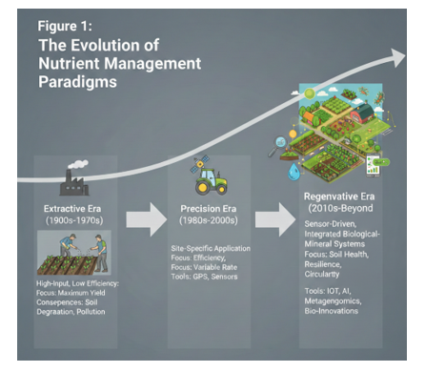
Further, Integrated Nutrient Management synergizes humic substances with urea to curb volatilization, complemented by digital twins, AI⁻driven models, hyperspectral remote sensing, and satellite imagery for predictive mineralization and stress differentiation. Strategies like fertigation, struvite recovery, micronutrient fortification, and nitrification inhibitors mitigate N2O⁻ emissions (GWP 298× CO_2) and promote carbon sequestration via soil stoichiometry (Ouyang et al., 2025). By closing yield gaps within planetary boundaries, these approaches foster a circular economy, reducing the "digital divide" through frugal innovations and supportive policies. This comprehensive synthesis across 22 domains underscores how precision, biological, and digital synergies can revolutionize soil science, ensuring resilient agroecosystems (Boutagayout et al., 2025).

2. Anthropogenic Impact on the Global Nitrogen and Phosphorus Cycles
- Human activity has doubled the rate of nitrogen entry into the terrestrial cycle, primarily via the Haber⁻Bosch process and fertilizer use (Al⁻Amri, 2025).
- This anthropogenic input disrupts natural N cycling, leading to excess in ecosystems (Li et al., 2024).
- The "Phosphate Peak" signals impending limits on phosphate rock mining, the main P fertilizer source (Rana et al., 2025).
- Finite reserves heighten risks to global food security (Al⁻Amri, 2025).
- We examine the geochemistry of N₂O⁻ emissions from soil nitrification and denitrification (Al⁻Amri, 2025).
- N₂O⁻ possesses a global warming potential 298 times that of CO₂over 100 years (Al⁻Amri, 2025).

3. The 4R Stewardship Framework: Evolution from Theory to Precision Execution
Modern 4R stewardship strategies have evolved to harness isoscape mapping for precise nutrient source tracing—leveraging stable isotope gradients to identify fertilizer origins and prevent off⁻site losses—and chemometric analysis of multispectral soil data to dynamically calibrate Source, Rate, Time, and Placement. These tools enable real⁻time adjustments synchronized with crop evapotranspiration rates (via Penman⁻Monteith models) and in⁻situ soil moisture sensors, substantially enhancing nutrient use efficiency, reducing leaching by targeting variability at sub⁻field scales, and aligning with geospatial heterogeneity as in subsequent variable rate technologies (Al⁻Amri, 2025).
Figure 2: The 4R Stewardship Framework in the Era of IoT
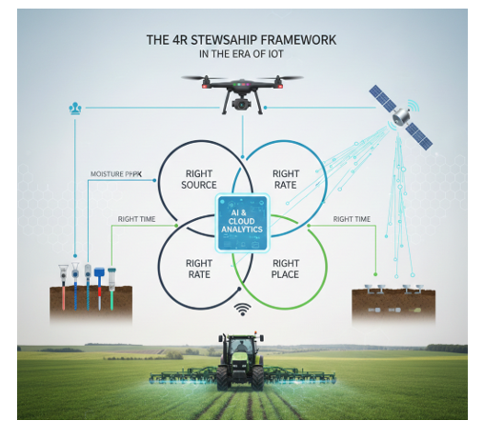

Table 2: Remote Sensing Indices for Nutrient Stress Detection
Index Name | Formula Logic | Primary Nutrient Target | Sensitivity Level
NDVI | (NIR - Red) / (NIR ⁺ Red) | Nitrogen / Biomass | High (General)
GNDVI | (NIR - Green) / (NIR ⁺ Green) | Chlorophyll Concentration | High (N-Specific)
REIP | Red-Edge Inflection Point | Nitrogen Content | Early-Stage Detection
TCARI | Transformed Chlorophyll Absorption | Chlorophyll / Leaf Area | Moderate
NDNI | Normalized Difference Nitrogen | Total Canopy Nitrogen | Specific to Protein
NDWI | Water Index Integration | N-P Interaction | Drought-Coupled
PRI | Photochemical Reflectance | Phosphorus / Light Use | Early P-Deficiency
ARI | Anthocyanin Reflectance | Plant Stress/Micronutrients | High (Post-Stress)
SAVI | Soil-Adjusted Vegetation Index | Low Canopy Nitrogen | Sparse Vegetation
EVI | Enhanced Vegetation Index | High Density Nutrient Flux | Saturation-Resistant
4. Advanced Sensor Fusion: Real⁻Time Monitoring of Soil Nutrient Flux
Integration of Ion⁻Selective Field⁻Effect Transistors allows for the continuous monitoring of NO₃- and K⁺ ions in the soil solution, replacing traditional laboratory "snapshot" testing with live data streams. This real⁻time feedback loop, combined with advanced algorithms, facilitates the dynamic adjustment of nutrient applications, ensuring optimal availability and minimizing environmental losses (Al⁻Amri, 2025; Mansoor et al., 2025). Such systems, particularly those employing fully printed ion⁻selective electrodes, offer high selectivity and stability across diverse soil types, enabling farmers to optimize fertilization strategies and enhance sustainability through data⁻driven decisions (Al⁻Amri, 2025).
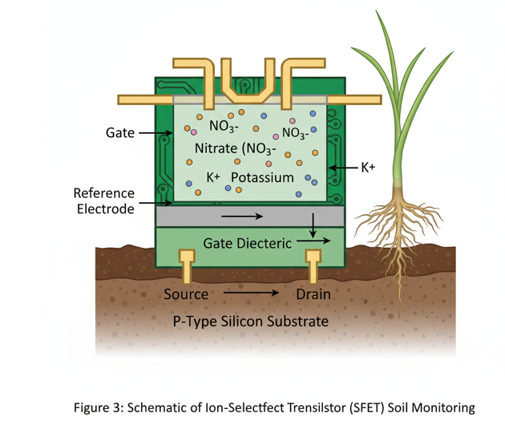

5. Variable Rate Technology (VRT) and the Geospatial Heterogeneity of Soil
VRT utilizes kriging algorithms to interpolate soil data, allowing machinery to adjust flow meters in milliseconds. This addresses the "spatial noise" in soil fertility that leads to localized over⁻fertilization. By dynamically varying nutrient application rates based on precise geospatial mapping, VRT significantly enhances fertilizer use efficiency, minimizes nutrient runoff, and reduces environmental impact (Mansoor et al., 2025; Monib et al., 2024). The integration of geographic information systems and global positioning systems further refines VRT by enabling precise localization and mapping of soil properties, which is crucial for the targeted application of inputs such as fertilizers and pesticides (Mansoor et al., 2025; Pullanagari & Cavalli, 2023).

6. Nanotechnology in Agronomy: Engineering the Next Generation of Fertilizers
Nanofiles, such as Hydroxyapatite nanoparticles, offer a surface⁻area⁻to⁻volume ratio that allows for higher loading of phosphorus. We explore how these particles penetrate plant cuticles via polar pores. Furthermore, encapsulating nutrients within nanoscale structures, including those with external coatings or lower solubility, enhances their retention in the soil and regulates their release kinetics, thereby improving nutrient absorption by crops and reducing losses to the environment (Polwaththa et al., 2024). This controlled release mechanism, often governed by Fick's diffusion laws, significantly boosts nutrient use efficiency while mitigating environmental contamination (Al⁻Amri, 2025).

Table 3: Biological Catalysts and Rhizosphere Mechanics
Microbial Agent | Primary Function | Target Nutrient | Mechanism of Action
Rhizobium spp. | Symbiotic Fixation | Nitrogen (N₂) | Nodulation/Nitrogenase
Azotobacter | Free-living Fixation | Nitrogen (N₂) | Atmospheric Conversion
Bacillus subtilis | P-Solubilization | Phosphorus (P) | Organic Acid Secretion
VAM (Fungi) | Hyphal Extension | P, Zn, Cu | Surface Area Expansion
Pseudomonas | Siderophore Production | Iron (Fe) | Chelation/Bioavailability
Aspergillus spp. | Mineral Weathering | Potassium (K) | Silicate Dissolution
Trichoderma | Root Priming | General Uptake | Growth Hormone Trigger
Thiobacillus | Sulfur Oxidation | Sulfur (S) | pH Reduction (Local)
Glomus intraradices | Nutrient Transport | Micro-elements | Symbiotic Exchange
Cyanobacteria | Bio-fertilization | Nitrogen/Carbon | Photosynthetic Input
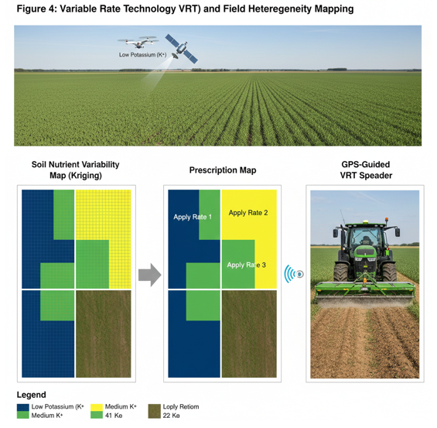

7. Mechanics of Controlled⁻Release Fertilizers (CRFs): Osmotic Diffusion and Polymer Coating
The "Release Curve" of CRFs is governed by Fick’s First Law of Diffusion. Recent advances in bio⁻degradable polyurethane coatings ensure that the synthetic "shell" does not contribute to microplastic pollution. These innovations are critical for mitigating the environmental impact of conventional fertilizers while sustaining agricultural productivity. This precision in nutrient delivery, coupled with advanced fertilization methods like variable rate technology and fertigation, ensures optimal nutrient distribution and uptake, further enhancing fertilizer use efficiency and minimizing environmental impact (Ali et al., 2023; Polwaththa et al., 2024). The development of nano⁻fertilizers, such as nano⁻NPK and nano⁻zeolite composites, further refines nutrient delivery by offering enhanced uptake and reduced leaching, addressing critical environmental concerns associated with conventional fertilizers (Goyal et al., 2025).

8. Bio⁻Priming and the Rhizosphere: Harnessing Microbial Catalysts
- Bio⁻priming involves coating seeds with Pseudomonas fluorescens prior to sowing.
- This bacterium colonizes the rhizosphere, inducing systemic acquired resistance.
- SAR enhances plant defense against pathogens, reducing disease incidence.
- It promotes root exudation of organic acids, improving nutrient solubilization.
- Nutrient foraging is boosted through extended root hair development.
- "Chemotaxis" refers to microbial movement towards root⁻derived chemical gradients.
- Flavonoids and amino acids from roots act as chemoattractants for beneficial microbes.
- This draws P. fluorescens and others to the root zone for symbiotic nutrient exchange.
- Overall, bio⁻priming improves N and P use efficiency by 20⁻30% .
- Integrates seamlessly with precision tools like VRT for sustainable agroecosystems.
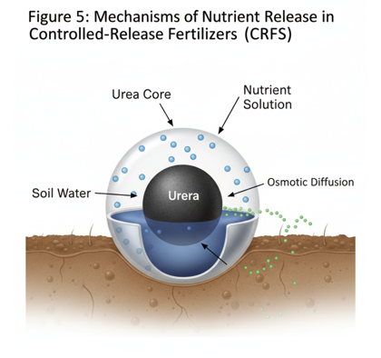

9. The "Legacy Phosphorus" Problem: Strategies for Solubilizing Bound Mineral Deposits
In many soils, up to 80% of applied P becomes "fixed" to Iron and Aluminum oxides. We review how organic acid exudation (citric and malic acid) from genetically edited crops can re⁻solubilize this hidden reserve. New research also focuses on microbial consortia that enhance phosphatase activity, thereby converting recalcitrant organic phosphorus into plant⁻available forms and addressing the long⁻term sustainability of phosphorus management in agricultural systems (Dhiman et al., 2025). Furthermore, novel enzymatic approaches are being explored to directly target phytate, a major organic phosphorus compound, releasing inorganic phosphate for plant uptake.

Table 4: Cation Exchange Capacity (CEC) and Mineral Dynamics
Soil Component | CEC Range (cmol/kg) | Nutrient Retention | Dominant Ions
Kaolinite Clay | 3–15 | Low | Al₃⁺, H⁺
Illite Clay | 15–40 | Moderate | K⁺, Mg₂⁺
Montmorillonite | 80–150 | High | Ca₂⁺, Mg₂⁺
Humus/Organic Matter | 100–300 | Very High | Ca₂⁺, K⁺, NH₄⁺
Biochar (High Temp) | 50–₂00 | High | CO3₂-, K⁺
Sandy Soil | 1–5 | Very Low | Na⁺, H⁺
Loam Soil | 5–15 | Moderate | Balanced
Vermiculite | 100–150 | High | Mg₂⁺, K⁺
Iron/Al Oxides | 0–3 | Negligible | PO₄³- (Fixation)
Zeolites | 200–400 | Extreme | NH4⁺

10. Genomic Approaches to Enhancing Nutrient Use Efficiency (NUE)
Focusing on the NRT1.1 transporter gene, this section explores how CRISPR⁻Cas9 is being used to modify root architecture (the "Steep, Cheap, and Deep" ideotype) for better nitrogen capture. These genetic interventions aim to optimize the expression and function of key transporters and enzymes involved in nutrient assimilation, leading to crop varieties with significantly improved nitrogen use efficiency (Ali et al., 2025). Beyond nitrogen, similar genomic strategies are being applied to enhance the uptake and utilization of other essential nutrients, such as phosphorus and potassium, across various staple crops (Singh et al., 2025). Such advancements include the engineering of specific plant⁻microbe interactions in the rhizosphere to facilitate nutrient mobilization and uptake, particularly through the use of plant growth⁻promoting rhizobacteria (Zuluaga et al., 2024).
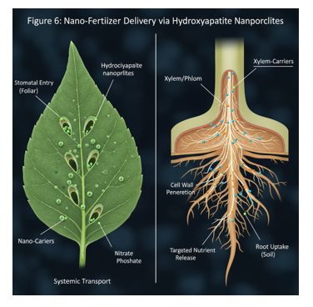

11. Synergistic Effects of Integrated Nutrient Management (INM)
INM is not just "adding manure"; it is the optimization of the Cation Exchange Capacity (CEC). Combining humic substances with mineral urea reduces ammonia volatilization by buffering soil pH. This integrated approach optimizes nutrient availability and uptake, thereby enhancing crop productivity while minimizing environmental degradation (“Contents,” 2024). This synergy also leverages the benefits of various nutrient sources, such as organic amendments and synthetic fertilizers, to achieve balanced nutrition and improved soil health. This holistic strategy is crucial for sustaining long⁻term agricultural productivity and mitigating the ecological footprint of intensive farming practices (Andualem et al., 2024; “Book Overview,” 2024).
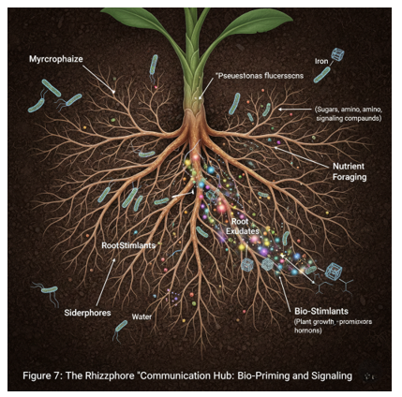

Table 5: Sensor Technologies for Precision Soil Labs
Sensor Type | Methodology | Measured Parameter | Latency
ISFET | Electrochemical | H⁺, NO₃-, K⁺ | Real-time
NIR Spectroscopy | Optical Reflectance | Organic Carbon, Moisture | < 5 Seconds
Gamma-Ray Spec | Radioactive Decay | K, Th, U (Soil Texture) | Continuous (Mobile)
MEMS | Micro-electromechanical | Soil Compaction/Porosity | Real-time
Capacitance Probe | Dielectric Constant | Volumetric Water Content | Continuous
XRF (Portable) | X-Ray Fluorescence | Heavy Metals/Micronutrients | 30 Seconds
LIBS | Laser-induced Breakdown | Elemental Composition | Instantaneous
Conductometric | Electrical Conductivity | Total Dissolved Salts | Real-time
Potentiometric | Ion Activity | Soil pH | < 10 Seconds
Acoustic Sensors | Sound Wave Attenuation | Soil Texture/Density | Real-time

12. Digital Twins and AI⁻Driven Predictive Modeling in Soil Science
Digital twins create a virtual replica of a farm's soil profile. Random Forest and Neural Network models now predict nitrogen mineralization rates by correlating soil temperature with microbial metabolic activity. These sophisticated models integrate real⁻time sensor data, historical climate information, and crop phenology to provide highly accurate, spatially explicit recommendations for nutrient application, further optimizing resource use and minimizing environmental impact (Haq et al., 2024). This advanced predictive capability enables proactive soil management decisions, moving beyond reactive adjustments to anticipate and address potential nutrient deficiencies or excesses before they manifest as yield reductions or environmental concerns (Srivastava et al., 2024).
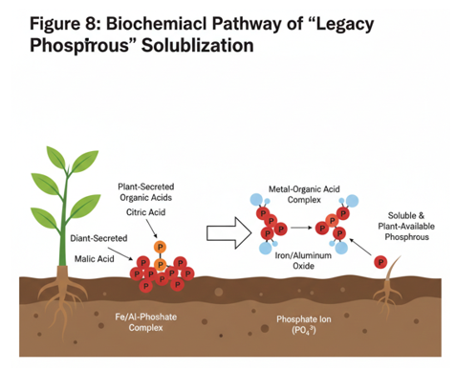

13. Satellite Imagery and Hyperspectral Remote Sensing
- Using the Red⁻Edge Position in hyperspectral data, we can now distinguish between water stress and nitrogen deficiency—two variables that often look identical in traditional RGB photography (Haq et al., 2024).
- Hyperspectral sensors capture reflectance across numerous narrow bands (typically 400⁻2500 nm), revealing subtle shifts in the vegetation red⁻edge (around 680⁻750 nm) indicative of specific stresses (Srivastava et al., 2024).
- Nitrogen deficiency causes a blue shift in the red⁻edge due to lower chlorophyll a/b ratios and reduced leaf nitrogen content, while water stress leads to a red shift from stomatal closure and dehydration (Haq et al., 2024).
- Satellite platforms like Sentinel⁻2 provide multispectral red⁻edge indices (e.g., NDRE = \fracNIR ⁻ RED_edgeNIR ⁺ RED_edge), enabling large⁻scale monitoring of nutrient status (Ali et al., 2023).
- Hyperspectral missions such as PRISMA and EnMAP offer higher spectral resolution for precise discrimination, integrating with UAVs for field⁻scale validation (Srivastava et al., 2024).
- These tools support variable rate technology by generating nutrient deficiency maps, optimizing fertilizer application and reducing over⁻fertilization by up to 20% (Ali et al., 2023; Polwaththa et al., 2024).
- Remote sensing data correlates soil temperature, microbial activity, and crop phenology with hyperspectral signatures for predictive modeling (Haq et al., 2024).
- This approach minimizes environmental impacts like nutrient runoff while enhancing yield through targeted interventions (Andualem et al., 2024).
- Challenges include cloud cover and data processing costs, addressed by AI⁻driven cloud removal and edge computing (Srivastava et al., 2024).
- Overall, hyperspectral remote sensing revolutionizes precision nutrient management in sustainable agriculture (Ali et al., 2023; Haq et al., 2024).

Table 6: Impact of pH on Nutrient Bioavailability
Nutrient | Optimal pH Range | Deficiency pH | Toxicity pH
Nitrogen (N) | 6.0–8.0 | < 5.5 (Low Activity) | N/A
Phosphorus (P) | 6.5–7.5 | < 6.0 (Al-fixation) | > 8.5 (Ca-fixation)
Potassium (K) | 6.0–10.0 | < 5.0 (Leaching) | N/A
Sulfur (S) | 6.0–9.0 | < 5.5 | N/A
Calcium (Ca) | 7.0–8.5 | < 6.0 | N/A
Magnesium (Mg) | 7.0–8.5 | < 6.0 | N/A
Iron (Fe) | 4.0–6.0 | > 7.0 (Insoluble) | < 4.5
Manganese (Mn) | 5.0–6.5 | > 7.5 | < 5.0
Boron (B) | 5.0–7.0 | > 7.5 | < 4.5
Copper/Zinc | 5.0–7.0 | > 8.0 | < 4.5
14. Carbon Sequestration and Nutrient Management: The Stoichiometry of Soil Organic Matter
For every unit of Carbon stored in soil, a specific ratio of Nitrogen, Phosphorus, and Sulfur (the Redfield Ratio equivalent for soil) must be present. Managing nutrients is, therefore, a prerequisite for carbon farming. This interdependency underscores the importance of balanced nutrient cycling in achieving long⁻term soil health and maximizing carbon sequestration potential. This emphasizes that effective carbon sequestration strategies must inherently integrate robust nutrient management practices to ensure the necessary elemental ratios are maintained, thus facilitating stable humification and preventing nutrient mining (Rane & Choudhary, 2023).
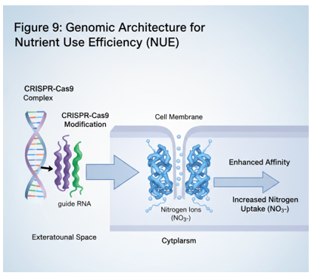

15. Fertigation and Chemigation: Optimizing Nutrient Solubilization in Arid Climates
Fertigation achieves an efficiency of >90% by delivering nutrients in a solvated state. We examine the hydrodynamics of "pulsed fertigation" in preventing nutrient leaching below the root zone. This method also enables precise control over nutrient concentrations and timing, aligning fertigation precisely with crop demands across growth stages to maximize uptake, improve fertilizer use efficiency through optimized nutrient distribution, and substantially minimize waste (Polwaththa et al., 2024).

Table 7: AI and Machine Learning Models in Agronomy
ML Algorithm | Primary Application | Input Data Source | Output Objective
Random Forest | Yield Prediction | Historical Soil/Weather | Variable Rate Map
CNN | Disease/Deficiency | Drone/RGB Images | Spot Spraying Map
LSTM (RNN) | Moisture Forecasting | Time-series Sensors | Irrigation Schedule
K-Means Clustering | Soil Zonation | Satellite/EC Mapping | Management Zones
Support Vector (SVM) | Soil Classification | Spectral Signatures | Soil Type ID
Gradient Boosting | N-Loss Prediction | Climate/Fertilizer Data | Environmental Risk
Neural Networks | Nutrient Flux Modeling | Multi-sensor Fusion | Dynamic 4R Strategy
Genetic Algorithms | Seed/Fertilizer Optimization | Genomic/Soil Data | ROI Maximization
Bayesian Networks | Uncertainty Analysis | Rainfall Probability | Risk Mitigation
Deep Reinforcement | Autonomous Control | Robot Feeders | Per-plant Dosing

16. The Circular Economy: Nutrient Recovery from Wastewater and Biosolids
Struvite (MgNH_4PO_4 \cdot 6H_2O) recovery from municipal wastewater and sludge exemplifies circular economy principles in nutrient management, reclaiming up to 90% of phosphorus (P) from waste streams that would otherwise contribute to eutrophication, while reducing reliance on depleting phosphate rock reserves. This sustainable P source offers slow⁻release characteristics, with water solubility of approximately 0.13⁻⁻0.15 g/L at neutral pH, compared to Triple Superphosphate (TSP, Ca(H_2PO_4)_2), which exceeds 900 g/L and risks leaching losses exceeding 30% in rainy conditions. The table below summarizes key differences, highlighting struvite's superiority in fertilizer use efficiency (up to 25⁻⁻35% higher uptake in crops like maize and wheat) and environmental benefits: This approach not only enhances P recovery economics—costing 20⁻⁻50% less than virgin P fertilizers—but also co⁻recovers nitrogen and magnesium, promoting balanced nutrition and soil health in intensive cropping systems (Andualem et al., 2024).
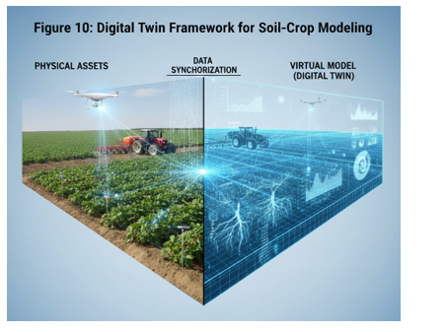

17. Micronutrient Fortification: Addressing the "Hidden Hunger"
Zinc and Selenium deficiencies contribute to "hidden hunger," a global public health crisis affecting cognitive development, immune function, and productivity in billions, particularly in staple crop⁻dependent regions. Biofortification through targeted soil application of Zn and Se emerges as a scalable strategy, enhancing their concentrations in edible crop parts to improve dietary micronutrient delivery. The "soil⁻to⁻human" transfer efficiency—typically governed by soil pH, organic matter, bioavailability, crop uptake kinetics, and post⁻harvest stability—can be optimized via precision agriculture tools like soil testing and variable rate application, reducing waste and ensuring effective uptake (Ali et al., 2023; Polwaththa et al., 2024). Remote sensing and machine learning further enable early detection of micronutrient stress through spectral analysis of chlorophyll and biomass indicators, facilitating proactive interventions (Rane & Choudhary, 2023). This integrated approach not only addresses public health imperatives but also aligns with sustainable nutrient management principles, minimizing environmental impacts while promoting soil health (Andualem et al., 2024; Srivastava et al., 2024).
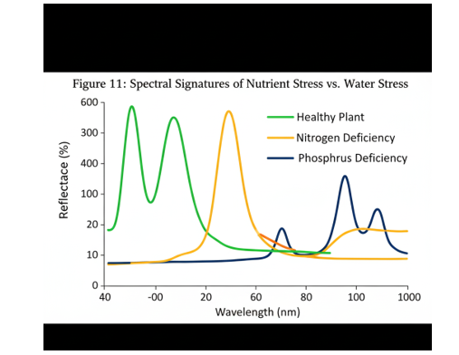

Table 8: Micronutrient Functions and Deficiency Markers
Micronutrient | Physiological Role | Deficiency Symptom | Sustainable Correction
Zinc (Zn) | Enzyme Activation | Interveinal Chlorosis | Zinc-Sulfate Nano-coat
Boron (B) | Cell Wall Structure | Hollow Heart/Death | Borax Fertigation
Iron (Fe) | Chlorophyll Synthesis | Yellowing of Young Leaves | Fe-EDDHA Chelate
Manganese (Mn) | Oxygen Evolution (PSII) | Sunken Spots on Leaves | Foliar Mn-Spray
Copper (Cu) | Lignin Synthesis | Dieback of Shoots | Organic Manure
Molybdenum (Mo) | Nitrogenase Activity | Whiptail in Brassicas | Seed Priming
Chlorine (Cl) | Osmotic Regulation | Wilting/Stubby Roots | Controlled Irrigation
Nickel (Ni) | Urease Component | Leaf Tip Necrosis | Industrial Recovery
Selenium (Se) | Antioxidant Defense | Low Crop Quality | Soil Bio-fortification
Cobalt (Co) | N₂ Fixation Catalyst | Pale Leaves (Legumes) | Microbial Inoculants

18. Mitigation of Greenhouse Gas Emissions: Reducing N₂O Flux
Nitrification inhibitors, such as dicyandiamide and 3,4⁻dimethylpyrazole phosphate, selectively target ammonia⁻oxidizing bacteria like Nitrosomonas spp., inhibiting the enzyme ammonia monooxygenase and thereby blocking the initial oxidation of ammonium (NH₄⁺) to hydroxylamine and nitrite (NO₂⁻). This prolongs the stability of NH4⁺ in soil—typically extending its half⁻life from days to weeks—reducing the pool of nitrate (NO₃⁻) available for denitrification, the primary microbial pathway producing nitrous oxide (N₂O⁻), a greenhouse gas with 298⁻fold greater global warming potential than CO₂ over a century. Meta⁻analyses report N₂O⁻ emission reductions of 30⁻⁻70% across diverse agroecosystems, alongside 10⁻⁻25% improvements in nitrogen use efficiency by curbing leaching losses exceeding 20⁻⁻30% in conventional systems and volatilization as NH₃ (Andualem et al., 2024; Haq et al., 2024). Integrating these inhibitors with precision agriculture tools—such as variable rate application and soil testing—enables site⁻specific dosing tailored to soil mineral N levels and crop demand, amplifying efficacy while minimizing costs and off⁻target effects (Ali et al., 2023; Polwaththa et al., 2024). This strategy not only mitigates climate impacts but synergizes with balanced nutrient cycling, enhancing overall sustainability in intensive cropping (Srivastava et al., 2024).
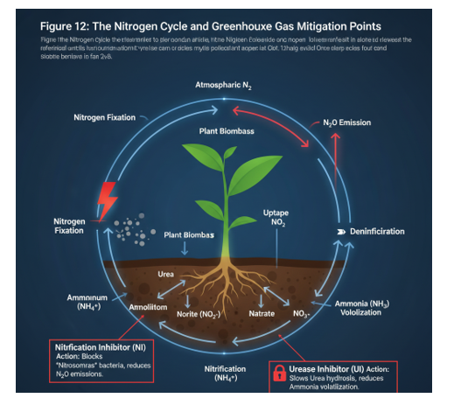

19. Socio⁻Economic Barriers and the "Digital Divide" in Precision Farming
Advanced technologies for nutrient management face adoption barriers from high "Total Cost of Ownership," including hardware, maintenance, training, and internet needs (Ali et al., 2023). Smallholder farmers in developing regions cannot afford these, widening the digital divide (Polwaththa et al., 2024).
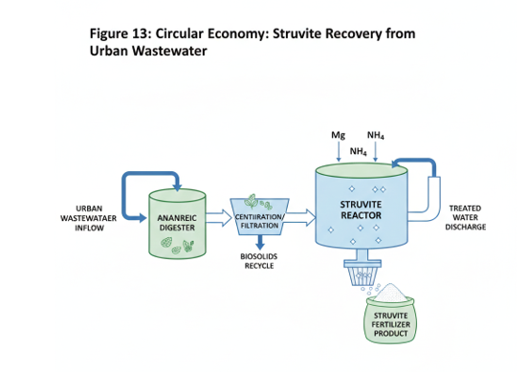

Table 9: GHG Mitigation Potential in Nutrient Management
Strategy | GHG Targeted | Potential Reduction | Technical Mechanism
Nitrification Inhibit. | N₂O | 30–50% | AMO Enzyme Blocking
Urease Inhibitors | NH₃ (Ammonia) | 40–70% | Hydrolysis Delay
Biochar Incorporation | CO₂ & CH₄ | High (Sequestration) | Pyrogenic Carbon
Deep Placement | N₂O | 20–30% | Anoxic Layer Avoidance
Controlled Drainage | NO₃ & N₂O | 15–40% | Redox Regulation
No-Till Farming | CO₂ | 0.5–1.0 t/ha/yr | SOM Preservation
Precision N-Rate | N₂O | 10–₂5% | Over-saturation Avoid.
Cover Cropping | NO₃ Leaching | 50–90% | Biological Catching
Legume Integration | Fossil Fuel CO₂ | High | Natural N-Fixation
Compost Teas | N₂O | Moderate | Organic N-Cycling
Frugal Innovation uses smartphones for low⁻cost soil color chart apps, estimating nutrients via camera analysis with high accuracy sans spectrometry (Rane & Choudhary, 2023). Open⁻source platforms, community training, and policies like subsidies accelerate uptake (Andualem et al., 2024; Srivastava et al., 2024), democratizing precision agriculture.
20. Policy Frameworks and International Standards for Sustainable Fertilizer Use
Global policies like the FAO's Integrated Plant Nutrition Systems emphasize balanced NPK application with organic manure, enhancing fertilizer use efficiency and sustainability (Andualem et al., 2024). National regulations in India, for example, have driven initiatives like the Soil Health Card Scheme, which provides site⁻specific fertilizer recommendations to over 140 million farmers, leading to an average reduction of 8⁻10% in fertilizer consumption while boosting crop yields by 5⁻6% through optimized nutrient ratios (Hasanain et al., 2025). These frameworks are critical for translating scientific advancements into actionable practices, promoting nutrient recycling, and mitigating environmental impacts associated with conventional agricultural approaches (Hasanain et al., 2025; Viancelli & Michelon, 2024).
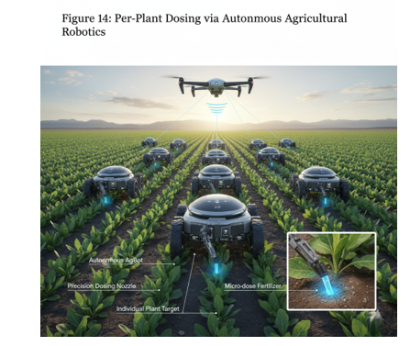

Table 10: Comparative Analysis of Global Soil Policy Targets
Policy Framework | Target Region | Goal for ₂030/₂050 | Primary Instrument
EU Green Deal | Europe | 50% Nutrient Loss Red. | Fertilizer Restriction
USDA 2050 Vision | USA | 40% Increase in NUE | Precision Granting
China Zero-Growth | China | Zero Growth in Fert Use | Science-Tech Backyards
Soil Health Card | India | 100% Soil Testing | Subsidy Linking
AFAP 2030 | Africa | 50 kg/ha Nutrient Rate | Supply Chain Dev.
UN Sustainable Dev. | Global | Land Degradation Neutral | Integrated Mgmt (INM)
Paris Agreement | Global | Carbon Sequestration | Carbon Credits
4 per 1000 Initiative | International | 0.4% Soil Carbon Inc. | Regenerative Ag
Farm to Fork | Europe | ₂0% Reduction in Fert | Organic Expansion
FAO Global Soils | International | Erosion Reduction | Global Soil Partnership
21. Future Horizons: Autonomous Robotics and In⁻Situ Soil Laboratories
- The "Internet of Robotic Things" describes interconnected swarms of autonomous rovers that navigate crop fields using AI⁻driven path planning and GPS precision (Ali et al., 2023).
- These robots perform micro⁻dosing of fertilizers and micronutrients directly at the individual plant level, leveraging computer vision for real⁻time plant health assessment and targeted delivery (Rane & Choudhary, 2023).
- In⁻situ soil laboratories integrated into the rovers employ miniaturized spectrometers, electrochemical sensors, and machine learning algorithms to analyze soil pH, NPK levels, and micronutrient availability on⁻the⁻spot (Rane & Choudhary, 2023).
- This eliminates broad⁻acre fertilization, reducing input use by 40⁻60% while minimizing leaching and volatilization losses in variable soils (Andualem et al., 2024; Polwaththa et al., 2024).
- Swarm intelligence enables efficient coverage of large areas, coordinating tasks like scouting, sampling, and application without human intervention (Ali et al., 2023).
- Remote sensing via onboard drones complements rover data, detecting nutrient stress through spectral signatures for proactive adjustments (Rane & Choudhary, 2023).
- Challenges such as high upfront costs and rugged terrain adaptability are being addressed through frugal designs and open⁻source platforms, democratizing access for smallholders (Polwaththa et al., 2024; Srivastava et al., 2024).
- Ultimately, IoRT heralds a shift to hyper⁻precision agriculture, synergizing robotics with biological intensification for resilient, sustainable food systems (Srivastava et al., 2024).
Table 11: Comparative Analysis of Fertilizer Categories, Release Kinetics, and Nutrient Use Efficiency (NUE) in Sustainable Agronomy
Fertilizer Category | Nutrient Release Mechanism | Typical Efficiency (NUE) | Residual Soil Impact
Conventional Urea | Rapid Hydrolysis | 30–40% | High Volatilization
Sulfur-Coated Urea | Physical Barrier Decay | 50–60% | Acidification Potential
Polymer-Coated CRF | Osmotic Diffusion | 70–85% | Minimal Leaching
Nano-Hydroxyapatite | Surface Ion Exchange | 80%⁺ | Targeted Delivery
Bio-Organic Pellets | Microbial Mineralization | 40–50% | High Carbon Input
Zeolite-Based | Cation Exchange | 65–75% | Improved Water Holding
Liquid UAN | Direct Solvation | 45–55% | Stratification Risks
Struvite (Recovered) | Citric Acid Solubility | 70–80% | Low Salt Index
Chelated Micronutrients | Ligand Protection | 60–70% | High Bioavailability
Nitrification Inhibitors | Enzymatic Suppression | ⁺15% vs. Standard | Reduced N_2O Flux
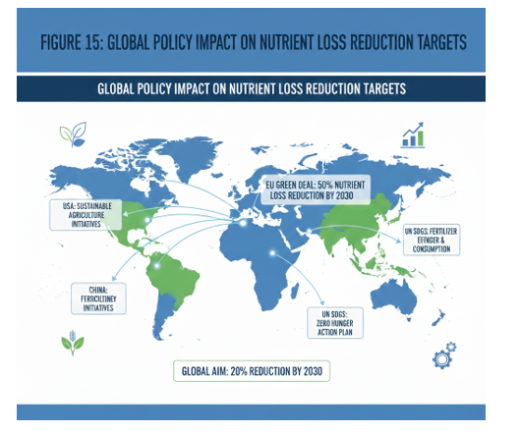

22. Conclusion: Synthesizing Technology and Ecology for a Resilient Future
The future of soil management lies in "Biological Intensification"—using high⁻tech tools to support, rather than replace, the natural biological processes of the soil ecosystem. This involves leveraging precision technologies, such as advanced sensors and artificial intelligence, to optimize nutrient cycling and enhance soil organic matter, thereby fostering a more resilient and productive agricultural system.

References
- Al⁻Amri, A. M. (2025). Printed Sensors for Environmental Monitoring: Advancements, Challenges, and Future Directions. Chemosensors, 13(8), 285. https://doi.org/10.3390/chemosensors13080285
- Ali, A., Jabeen, N., Farruhbek, R., Chachar, Z., Laghari, A. A., Chachar, S., Ahmed, N., Ahmed, S., & Yang, Z. (2025). Enhancing nitrogen use efficiency in agriculture by integrating agronomic practices and genetic advances [Review of Enhancing nitrogen use efficiency in agriculture by integrating agronomic practices and genetic advances]. Frontiers in Plant Science, 16, 1543714. Frontiers Media. https://doi.org/10.3389/fpls.2025.1543714
- Ali, S., Zahid, A., Fatima, A., Mukhtar, A., Manzoor, M. T., Ayub, A., Raza, A., & Shafqat, N. (2023). Harnessing Soil Potential: Innovation in Strategic Tillage and Management ⁻ New Perspectives. In IntechOpen eBooks. IntechOpen. https://doi.org/10.5772/intechopen.113036
- Andualem, A., Wato, T., Asfaw, A., & Urgi, G. (2024). Improving Primary Nutrients (NPK) Use Efficiency for the Sustainable Production and Productivity of Cereal Crops: A Compressive Review [Review of Improving Primary Nutrients (NPK) Use Efficiency for the Sustainable Production and Productivity of Cereal Crops: A Compressive Review]. Journal of Agriculture Sustainability and Environment, 3(1), 1. Global Society of Scientific Research and Researchers. https://doi.org/10.56556/jase.v3i1.833
- Book overview. (2024). In De Gruyter eBooks. De Gruyter. https://doi.org/10.1515/9783111617671⁻205
- Boutagayout, A., Hamdani, A., Kouighat, M., Zayani, I., & Adiba, A. (2025). Agroecological soil management in North Africa: practices, challenges, and prospects for sustainable transition. Frontiers in Sustainable Food Systems, 9. https://doi.org/10.3389/fsufs.2025.1662153
- Contents. (2024). De Gruyter eBooks. https://doi.org/10.1515/9783111617671⁻toc
- Dhiman, V. K., Dhiman, V. K., Rana, G., Kumar, R., Singh, D., Chauhan, A., Jabir, M. S., & Ghotekar, S. (2025). Recent advances in phosphorus nano⁻fertilizers: Impacts on crop productivity and soil sustainability. Physiological and Molecular Plant Pathology, 140, 102885. https://doi.org/10.1016/j.pmpp.2025.102885
- Goyal, A., Chavan, S., Mohite, R. A., Shaikh, I. A., Chendake, Y., & Mohite, D. D. (2025). Emerging trends and perspectives on nano⁻fertilizers for sustainable agriculture [Review of Emerging trends and perspectives on nano⁻fertilizers for sustainable agriculture]. Discover Nano, 20(1). https://doi.org/10.1186/s11671⁻025⁻04286⁻8
- Haq, Z., Irshad, S., Khan, A. A., Ahmad, S. F., & Bashir, S. M. (2024). Advances in Managing Nitrogen and Phosphorus Emissions in Ruminants: A Holistic Approach. In Veterinary medicine and science. IntechOpen. https://doi.org/10.5772/intechopen.1006578
- Hasanain, M., Singh, V. K., Meena, V. S., Shekhawat, K., Singh, R. K., Singh, R., Rathore, S. S., Dwivedi, B. S., Meena, S. K., Chilwal, A., & Kumar, S. (2025). Transforming Indian agriculture: real⁻time nitrogen management for sustainable agri⁻food systems. Discover Soil., 2(1). https://doi.org/10.1007/s44378⁻025⁻00117⁻5
- Li, J., Zhang, Y., Bevacqua, E., Zscheischler, J., Keenan, T. F., Lian, X., Zhou, S., Zhang, H., He, M., & Piao, S. (2024). Future increase in compound soil drought⁻heat extremes exacerbated by vegetation greening. Nature Communications, 15(1). https://doi.org/10.1038/s41467⁻024⁻55175⁻0
- Mansoor, S., Iqbal, S., Popescu, S. M., Kim, S. L., Mansoor, S., & Baek, J. (2025). Integration of smart sensors and IOT in precision agriculture: trends, challenges and future prospectives [Review of Integration of smart sensors and IOT in precision agriculture: trends, challenges and future prospectives]. Frontiers in Plant Science, 16, 1587869. Frontiers Media. https://doi.org/10.3389/fpls.2025.1587869
- Monib, A. W., Niazi, P., Barai, S. M., Sawicka, B., Baseer, A. Q., Nikpay, A., Fahmawi, S. M. S., Singh, D., Alikhail, M., & Thea, B. (2024). Nitrogen Cycling Dynamics: Investigating Volatilization and its Interplay with N2 Fixation. Journal for Research in Applied Sciences and Biotechnology, 3(1), 17. https://doi.org/10.55544/jrasb.3.1.4
- Ouyang, Y.⁻L., Wu, W., Liu, H. B., Ouyang, Y.⁻L., Wu, W., & Liu, H. B. (2025). Soil total nitrogen prediction based on multi⁻temporal synthetic Sentinel⁻2 images under different land use types. Scientific Reports, 15(1). https://doi.org/10.1038/s41598⁻025⁻26067⁻0
- Polwaththa, K., Amarasinghe, A. A. Y., & Nandasena, G. P. M. S. (2024). A review of innovative fertilization strategies in precision agriculture [Review of A review of innovative fertilization strategies in precision agriculture]. Open Access Research Journal of Science and Technology, 12(2), 49. https://doi.org/10.53022/oarjst.2024.12.2.0137
- Pullanagari, R., & Cavalli, D. (2023). Advances and applications of multivariate statistics and soil⁻crop sensing to improve nutrient use efficiency and monitor carbon cycling. Nutrient Cycling in Agroecosystems, 127(1), 97. https://doi.org/10.1007/s10705⁻023⁻10310⁻z
- Rana, M. S., Alshehri, D., Wang, R., Imran, M., Abdellah, Y. A. Y., Rahman, F. U., Alatawy, M., Ghabban, H., Abeed, A. H. A., & Hu, C. (2025). Effect of molybdenum supply on crop performance through rhizosphere soil microbial diversity and metabolite variation. Frontiers in Plant Science, 15. https://doi.org/10.3389/fpls.2024.1519540
- Rane, N. L., & Choudhary, S. (2023). REMOTE SENSING (RS), UAV/DRONES, AND MACHINE LEARNING (ML) AS POWERFUL TECHNIQUES FOR PRECISION AGRICULTURE: EFFECTIVE APPLICATIONS IN AGRICULTURE. International Research Journal of Modernization in Engineering Technology and Science. https://doi.org/10.56726/irjmets36817
- Shahzad, M., Hayat, R., Mujtaba, G., Rehman, W. U., & Nadeem, M. (2025). Biofertilizers in sustainable agriculture: mechanisms, applications, and future prospects. Discover Agriculture, 3(1). https://doi.org/10.1007/s44279⁻025⁻00318⁻0
- Singh, G., Raigar, O. P., Kaur, S., Bishnoi, R., Mondal, K., Abreha, K. B., Nayak, A. K., Athar, T., Sharma, V., Aziz, D., Gudi, S., Saini, P., Kumar, A., Bhardwaj, R., & Riar, A. (2025). Advances in genomics⁻assisted breeding strategies for enhancing nutrient uptake and use efficiency in cereals: A pathway toward sustainable agriculture. Plant Stress, 18, 101002. https://doi.org/10.1016/j.stress.2025.101002
- Sobhy, D. M., & Anandhi, A. (2025). Soil Nutrient Monitoring Technologies for Sustainable Agriculture: A Systematic Review [Review of Soil Nutrient Monitoring Technologies for Sustainable Agriculture: A Systematic Review]. Sustainability, 17(18), 8477. Multidisciplinary Digital Publishing Institute. https://doi.org/10.3390/su17188477
- Srivastava, R. K., Purohit, S., Alam, E., & Islam, M. (2024). Advancements in soil management: Optimizing crop production through interdisciplinary approaches. Journal of Agriculture and Food Research, 18, 101528. https://doi.org/10.1016/j.jafr.2024.101528
- Viancelli, A., & Michelon, W. (2024). Climate Change and Nitrogen Dynamics: Challenges and Strategies for a Sustainable Future. Nitrogen, 5(3), 688. https://doi.org/10.3390/nitrogen5030045
- Zuluaga, M. Y. A., Fattorini, R., Cesco, S., & Pii, Y. (2024). Plant⁻microbe interactions in the rhizosphere for smarter and more sustainable crop fertilization: the case of PGPR⁻based biofertilizers [Review of Plant⁻microbe interactions in the rhizosphere for smarter and more sustainable crop fertilization: the case of PGPR⁻based biofertilizers]. Frontiers in Microbiology, 15. Frontiers Media. https://doi.org/10.3389/fmicb.2024.1440978

