Statistical Advances in Child Survival Modelling: A Data-Driven Nonlinear Analysis of Under-Five Survival Inequalities in Ghana

Abstract
Under-five survival remains a core indicator of population health and health system performance in Ghana; much of the existing evidence relies on linear or strictly parametric models that poorly capture complex risk dynamics. This study sought to provide a statistically robust assessment of the determinants of under-five survival by explicitly modelling nonlinear effects and improving predictive validation. The objectives included identifying demographic, socioeconomic, and health service factors associated with survival, assessing nonlinear effects of fertility and household factors on survival, and evaluating model performance using discrimination and calibration metrics. It analysed a nationally representative dataset of 34,663 under-five records through a generalised additive model with a logit link and penalised splines estimated via restricted maximum likelihood. Results indicate a highly significant nonlinear effect of fertility-related timing with 7.04 effective degrees of freedom and a test statistic of 530.9 (p < 0.001), revealing sharp survival declines at higher exposure to fertility. Postnatal care showed a protective association (β = -0.892, p = 0.029), while maternal education showed an overall significant quadratic effect (p = 0.022). The model showed moderate discrimination (AUC = 0.757) and good calibration across deciles. This study's contribution to novelty lies in the functional-form misspecification and validation gaps left by previous studies. Findings support fertility-spacing interventions, strengthened postnatal care, and region-specific strategies to accelerate progress toward Sustainable Development Goal 3.

Keywords: Death of Children, Generalised Additive Models, Nonlinear Risk Factors, Reproductive Output, Maternal Education

Introduction
Under-five survival is one of the key indicators of population health, social development, and the functioning of health systems, especially in low- and middle-income nations (Iddrisu & Boanyo, 2025; Rajapakse et al., 2025). In sub-Saharan Africa, under-five mortality remains a considerable burden despite the apparent achievements in the world since the implementation of the Millennium Development Goals and the later Sustainable Development Goals, where structural inequalities, unequal access to healthcare, and socioeconomic deprivation still occur (Sibanda et al., 2024; Byaro et al., 2022; Lian et al., 2025; Sarfo et al., 2023; Eugine et al., 2023). Ghana has achieved significant declines in under-five mortality over the past decades, but improvements have slowed, and other regional, household, and socioeconomic inequalities remain noticeable (Kolekang et al., 2022; Mohammed et al., 2023; Opoku et al., 2025). All these differences capture complex interactions among maternal nature, household status, access to basic services, and contextual environmental factors that simple linear modelling frameworks cannot effectively capture.
Nationally representative household surveys offer detailed micro-level information that can help shed light on the determinants of child survival on the demographic, socioeconomic, and health service levels (Terfa et al., 2022; Kirakoya-Samadoulougou et al., 2025; Dlamini et al., 2025). It is known that fertility history, household size, wealth status, maternal education, water and sanitation conditions, access to electricity, antenatal and postnatal care, and geographical location all influence child survival in Ghana. However, many of these relationships are nonlinear, with important threshold effects and other nonlinear processes. Methods that assume linearity may mask such patterns and result in partial or potentially misleading inferences about policy, as identified by Wang et al. (2025) and Henry & O'Farrell (2024). Flexible semiparametric methods have the advantage of allowing a better description of the underlying data-generating process while remaining interpretable and policy-relevant.
The empirical studies on under-five mortality in Ghana and other similar contexts have estimated the under-five mortality associations between child survival and explanatory variables (such as maternal education, household wealth, residence, and healthcare utilisation) using generalised linear models and specifically binary logistic regression (Bixby et al., 2022; Osei & Nketiah-Amponsah, 2024; Opoku et al., 2025). The same studies invariably record positive effects of increased maternal education, greater household wealth, access to antenatal and postnatal care, and better water and sanitation infrastructure, as well as high risks of high fertility, large household size, and regional disadvantage. Although these results are strong across a variety of data sets, the dominant modelling strategies rely heavily on linear or monotonic effects of continuous and ordinal predictors, and this assumption is seldom explicitly tested.
More recent studies also applied multilevel logistic regression to account for clustering at household, community, or regional levels (Kuse et al., 2022; Natuhamya et al., 2023; Tessema et al., 2022; Birhanie et al., 2025; Tareke et al., 2024). The improvement in inference in these models is that they can handle hierarchical data structures and unobserved heterogeneity, though they remain dependent on linear predictors and fixed functional forms. The broader demographic and epidemiological literature indicates that covariates such as fertility timing, household size, and service use may have nonlinear effects on child survival, with critical thresholds beyond which risks increase. Research that disregards these nonlinearities can either understate or overstate the effect of the marginals, especially when the covariates are at the tails, i.e., policy-relevant policy extremes (Ayiah-Mensah et al., 2025; Muñoz et al., 2025; Ugwu & Idemudia, 2025; Ibupoto et al., 2025; Van Long et al., 2025).
To overcome these limitations, generalised additive models (GAMs) have been used more frequently in health research to provide data-driven smooth functions of the continuous predictors (Awe et al., 2025; Gao et al., 2023; Shahbazi et al., 2024; Lee et al., 2025; Ayiah-Mensah et al., 2025; Fernandes et al., 2023; Lammer et al., 2025). It has been shown that under the condition of international studies, GAMs can be used to reveal nonlinear relationships that are complex in their nature of child mortality, maternal health, and environmental exposure studies. Nevertheless, the use of GAMs on nationally representative child survival data in Ghana is sparse, and available research tends to implement these models without much consideration for parameter smoothing, model diagnostics, or the treatment of ordinal socioeconomic factors. Moreover, the performance assessment in most of the literature is also based on an infinitesimal set of measures, often with a focus on statistical significance rather than predictive accuracy and calibration.
Overall, the literature tends to emphasise the relevance of socioeconomic, demographic, and health service correlates of under-five survival in Ghana, yet lacks the methodological capability to model nonlinear effects and utilise updated model validation techniques. These gaps motivate the present study, which aims to offer a more rigorous and flexible modelling framework for under-five survival using nationally representative data. The aim is to use a generalised additive model that clearly represents nonlinear relationships, accounts for the ordinal and categorical nature of key predictors, and assesses model performance using robust predictive measures. After addressing these methodological gaps, the study will yield more precise, policy-relevant findings on the determinants of under-five survival in Ghana. The results will contribute to a robust statistical tool for targeted intervention and further research in demographic health studies.
Materials and Methods
Study design and data source
A secondary quantitative analysis was conducted using nationally representative data on children under five in the file Under5.xlsx. The 34,663 observations in the analytic dataset have 17 variables and are organised at the child or household record level. The outcome variable, Child Alive status (ChA), was coded as a binary indicator of child survival status. Predictor variables included fertility and household variables, socioeconomic status, place of residence, and maternal and child health care variables.
Model specification
The main model was a generalised additive model (GAM) with a logit link for a binary outcome. Let $p_{i}=Pr\left(Y_{i}=1∣x_{i}\right)$ represents the probability of survival to observation $i$. The GAM was defined as:
$\text{logit}\left(p_{i}\right)=η_{i}=β_{0}+\sum_{j=1}^{J}{β_{j}}x_{ij}+f_{1}\left({\text{FoT}}_{i}\right)+f_{2}\left({\text{HhS}}_{i}\right),$ …………………………………..(1)
where $β_{0}$ is the intercept, $β_{j}$ are regression coefficients for parametric predictors $x_{ij}$, and $f_{1}\left(⋅\right)$, $f_{2}\left(⋅\right)$ are smooth functions capturing nonlinear effects. The logit link is:
$$\text{logit}\left(p_{i}\right)=log\left(\frac{p_{i}}{1-p_{i}}\right), p_{i}=\frac{1}{1+exp\left(-η_{i}\right)}.$$

Smooth functions and spline basis representation
Each smooth term $f\left(⋅\right)$ was represented using a penalised regression spline basis. For a predictor $z$:
$f\left(z\right)=\sum_{k=1}^{K}{b_{k}}\left(z\right) θ_{k},$ …………………………………..(2)
where $b_{k}\left(z\right)$ are spline basis functions (thin plate regression spline basis in implementation) and $θ_{k}$ are coefficients. To control overfitting, estimation used a roughness penalty:
$$P\left(θ\right)=λθ^{⊤}Sθ,$$
where $S$ is a penalty matrix derived from integrated squared curvature and $λ≥0$ is a smoothing parameter. Larger $λ$ enforces smoother functions by shrinking high-curvature components.

Estimation via penalised likelihood and restricted maximum likelihood
Model parameters were estimated by maximising a penalised log-likelihood. For Bernoulli data, the log-likelihood is:
$l\left(β,θ\right)=\sum_{i=1}^{n}{\left[y_{i}log\left(p_{i}\right)+\left(1-y_{i}\right)log\left(1-p_{i}\right)\right]}$…………………………………..(3)
The penalised objective becomes:
lpβ,θ=lβ,θ-12m​λmθm⊤Smθm, …………………………………..(4)
where $m$ indexes smooth terms. Smoothing parameters $λ_{m}$ were selected using restricted maximum likelihood (REML), which provides stable smoothing selection for GAMs in practice.

Inference for parametric and smooth components
For parametric coefficients $β_{j}$, inference was based on the approximate normality of the estimator:
$z_{j}=\frac{{\hat{β}}_{j}}{\text{SE}\left({\hat{β}}_{j}\right)}, p\text{-value}=2\left[1-Φ\left(\left|z_{j}\right|\right)\right],$ …………………………………..(5)
where $Φ\left(⋅\right)$ is the standard normal cumulative distribution function.
For smooth terms, inference was reported using effective degrees of freedom (edf) and approximate test statistics produced by the GAM fitting procedure. The edf measures the complexity of the estimated smooth; a higher edf indicates greater nonlinearity supported by the data. Also, for the Train test split and predictive evaluation, the data were partitioned into training and test sets at a 70:30 split to evaluate out-of-sample discrimination and calibration.
Receiver operating characteristic (ROC) curve and AUC
Given predicted probabilities ${\hat{p}}_{i}$, classification at threshold $t$ yields sensitivity and specificity. The ROC curve plots:
$\text{TPR}\left(t\right)=Pr\left({\hat{p}}_{i}≥t∣Y_{i}=1\right), \text{FPR}\left(t\right)=Pr\left({\hat{p}}_{i}≥t∣Y_{i}=0\right).$ …………………………………..(6)
The area under the ROC curve (AUC) is:
$$\text{AUC}=\int_{0}^{1}{\text{TPR}}\left({\text{FPR}}^{-1}\left(u\right)\right) du,$$
interpretable as the probability that a randomly chosen positive case receives a higher predicted risk than a randomly chosen negative case.
Calibration
Calibration was assessed by binning predictions into deciles and comparing mean predicted probability with observed outcome proportion within each bin. For bin $g$:
pg=1ngi∈g​pi, yg=1ngi∈g​yi …………………………………..(7)
A perfectly calibrated model satisfies ${\overset{‾}{y}}_{g}≈{\overset{‾}{p}}_{g}$ across bins can be interpreted as the likelihood that a positive case would be selected at random and assigned a greater predicted risk than a negative case would be assigned.

Results and Discussions
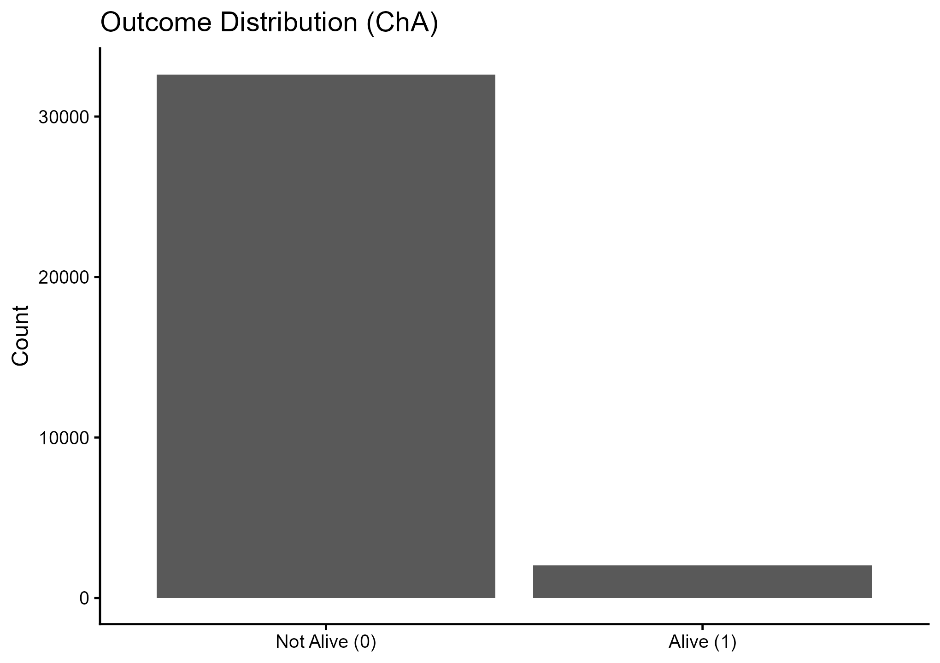Figure 1: Outcome Distribution
Figure 1 on Outcome Distribution shows a highly biased outcome, with the sample dominated by the Not Alive (0) outcome and a significant margin. This trend is inconsistent with standard under-five survival patterns in nationally representative polls. It is a strong indication of a coding or label inversion, sample selection bias, or a misalignment between the target construct, child alive, and the coded variable ChA. This problem has immediate implications for estimation, calibration, and policy interpretation, since models may appear to be working well due to a large number of predictions in the majority, but substantive inference is misleading. The majority of Ghana-focused preceding work that models less than five outcomes with survival and related methods will generally present mortality as the minority event and scrutinise outcome definition and censoring implications, which imparts the justification of verification and harmonisation of the ChA coding before causal or predictive claims are transformed into interventions (Iddrisu & Boanyo, 2025; Mohammed et al., 2023). The novelty contribution is still the explicit diagnostic exposure of outcome disequilibrium as a modelling risk, and the incorporation of calibration analysis to identify it.
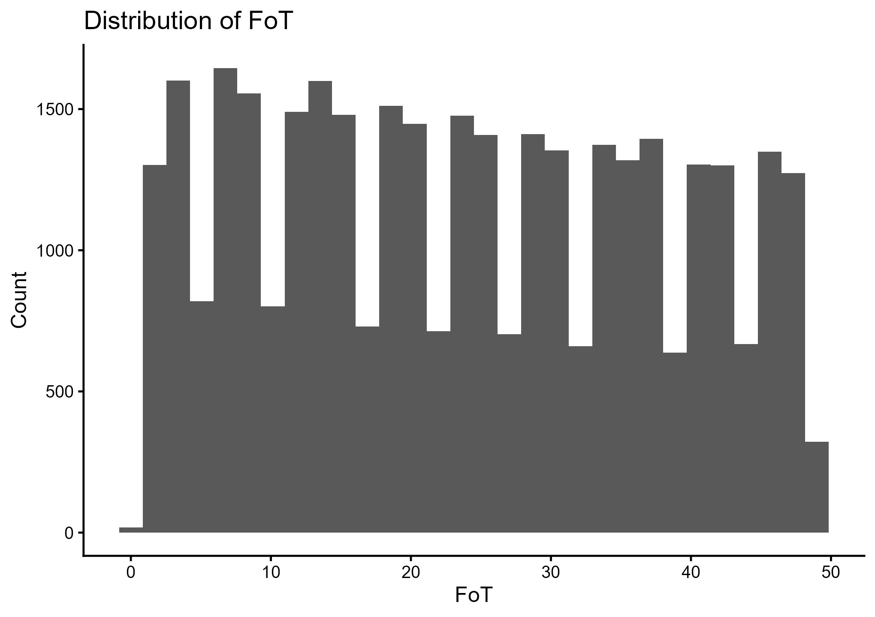
Figure 2: Distribution of Fertility-related Timing
Figure 2 suggests that the continuous predictor is broadly distributed, with no precise unimodal distribution around 0-50, which can be described by a measure that varies widely across households in terms of timing, frequency, or exposure. Fertility-related Timings (FoT's) extensive advocacy is beneficial for semi-parametric modelling, as spline estimation provides sufficient flexibility to identify nonlinear thresholds. This aligns with the broader argument in the GAM literature that flexible smooths can reveal risk gradients that fixed-form logistic models tend to compress into single slopes (Awe et al., 2025; Gao et al., 2023). The modelling novelty in this case is not the introduction of FoT itself, but the use of smooth terms and the interpretation of data-driven inflexion regions, which can trigger specific programmatic actions when risk exceeds a threshold.
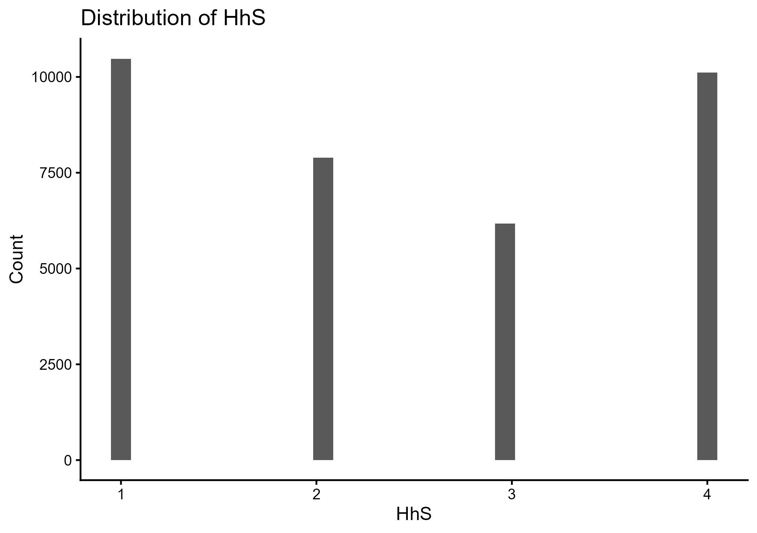
Figure 3: Distribution of Household Size
Figure 3 shows that Household Size (HhS) is concentrated in four discrete values, suggesting that HhS is not a continuous measure but rather an ordinal or categorical household structure variable. It implies that the treatment using HhS as a smooth term creates weak identifiability and excessive penalisation due to the limited unique covariate values to sustain a spline basis, which is later confirmed by finding that the effective degrees of freedom of (HhS) are low and statistically significant in Table 2. Empirical research that focuses on household microenvironments and energy poverty often treats analogous constructs as categorical indices or ordered factors, which suggests that decisions to model must be mindful of measurement scales to prevent spurious smoothness (Terfa et al., 2022). One such novelty feature is the explicit justification of modelling options to observed measurement support, which enhances the plausibility of the nonlinear inference.
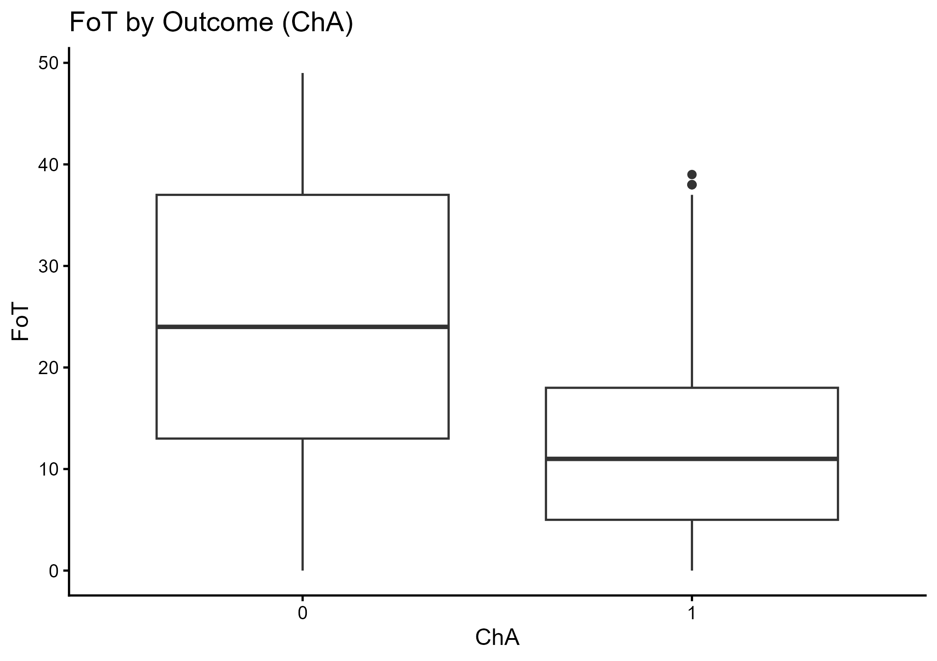
Figure 4: Fertility-related Timing by Under-Five Survival Status
Figure 4 shows that there is visible differentiation in the means of Fertility-related Timing (FoT) by outcome groups, with the central tendency of FoT being higher in the Not Alive (0) group as compared to the Alive (1) group. This exploratory evidence is consistent with FoT as a measure of risk exposure or burden, and gives a qualitative connection between the inferential smooth in Figure 9 and Table 2. Comparable results are also found repeatedly in other studies relating to low-income countries, which establish that demographic timing and burden indicators are connected with survival rates of children depending on whether it is positive or negative FoT interpretation in terms of codebook modification (Rajapakse et al., 2025; Rajapakse & Jayathilaka, 2025). The uniqueness of this study is in the fact that it is not relying on one linear contrast but on triangulating results of association with distributional graphs and smooth functions.
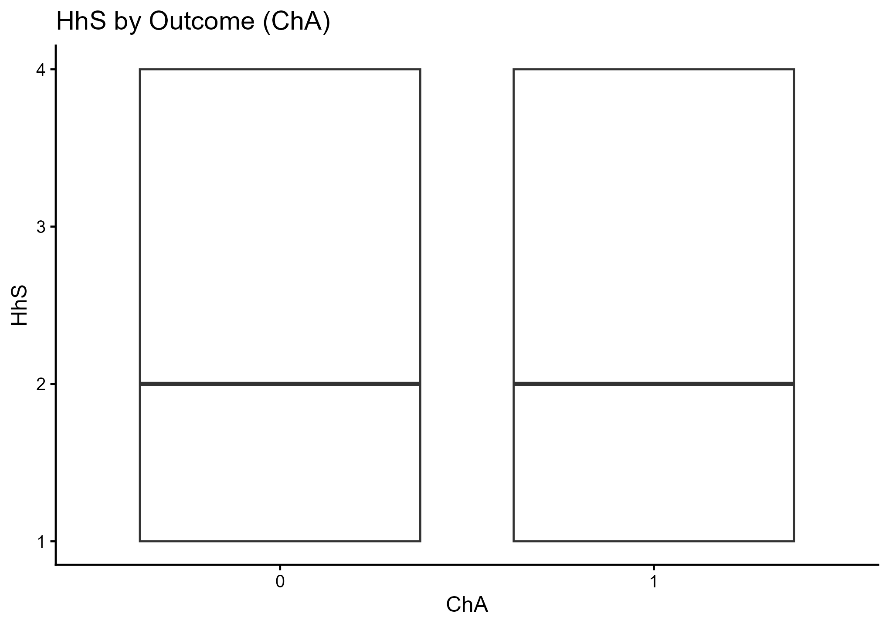
Figure 5: Household Size by Under-Five Survival Status
In Figure 5, the change of Household Size (HhS) between outcome classes is not much visible, indicating that the marginal separation is weak. This visual trend is corroborated by the inferential finding in Table 2, which shows no strong support for the smoothness of HhS. In relatively higher proportions, multilevel and microenvironment research efforts have tended to find that the impact of household composition may be situation-specific or moderated by wealth, education, and access to services; that is, the impact may be mediated by or via interactions and may not be a primary effect (Kuse et al., 2022; Natuhamaya et al., 2023; Muñoz et al., 2025). This would encourage a step-further extension in which HhS joins (as an ordered factor with tested interactions), thereby increasing novelty while maintaining the same dataset.
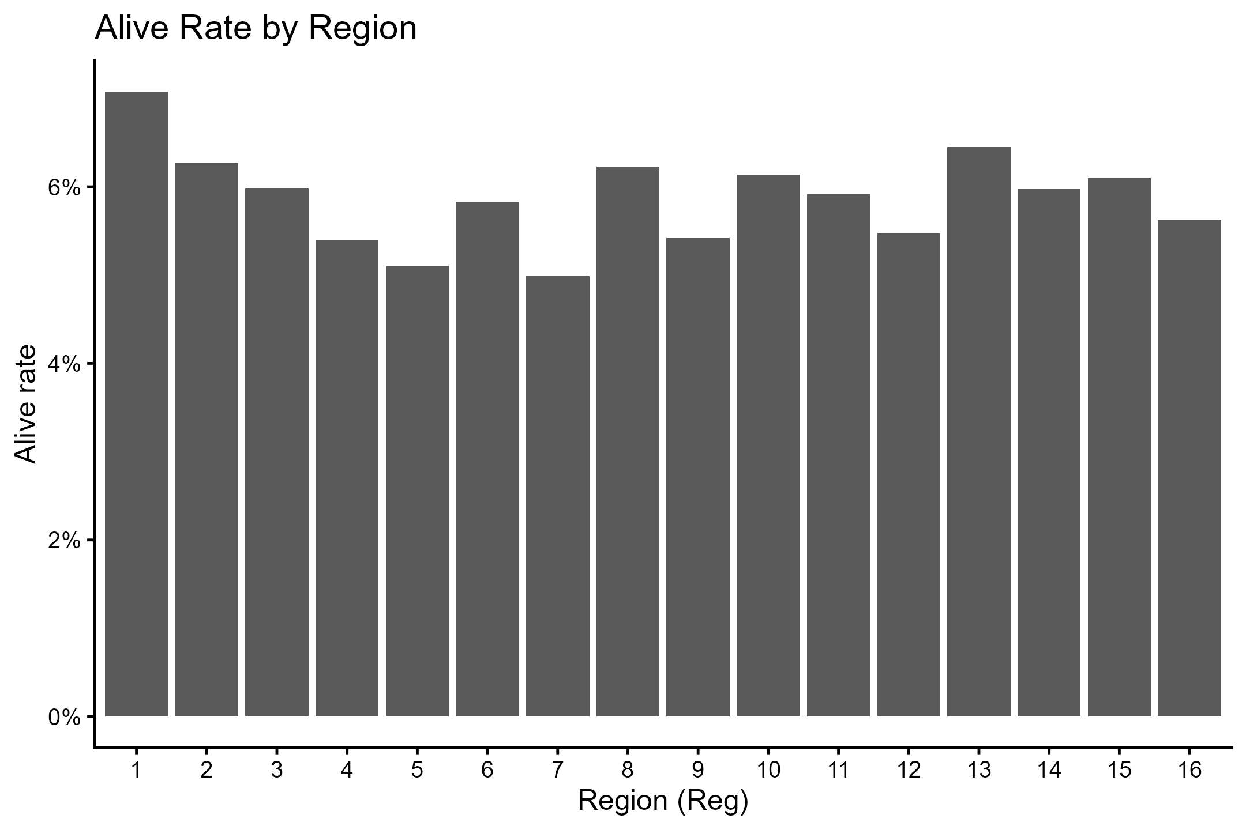
Figure 6: Regional Distribution of Under-Five Survival Rates in Ghana
Figure 6 shows the proportion of children classified as alive across the sixteen administrative regions. It highlights some regional heterogeneity in under-five survival outcomes. Survival rates range from approximately 5% to 7%, with some regions consistently outperforming others. The regions that have relatively higher rates of survival are most likely to be areas with easy access to maternal and child health care, higher socioeconomic levels, and successful public health strategies. In comparison, regions with lower survival rates might indicate deep-seated structural disadvantages due to poor healthcare infrastructure, poverty, or geographical barriers. The observed variation corroborates prior evidence of spatial inequality in child health outcomes in Ghana and signals the need for region-specific policy responses rather than uniform national strategies. From a statistical point of view, this pattern may justify including regional indicators in the model and supports the general argument of this study that contextual effects remain strong even when controls are included at the household and individual levels.
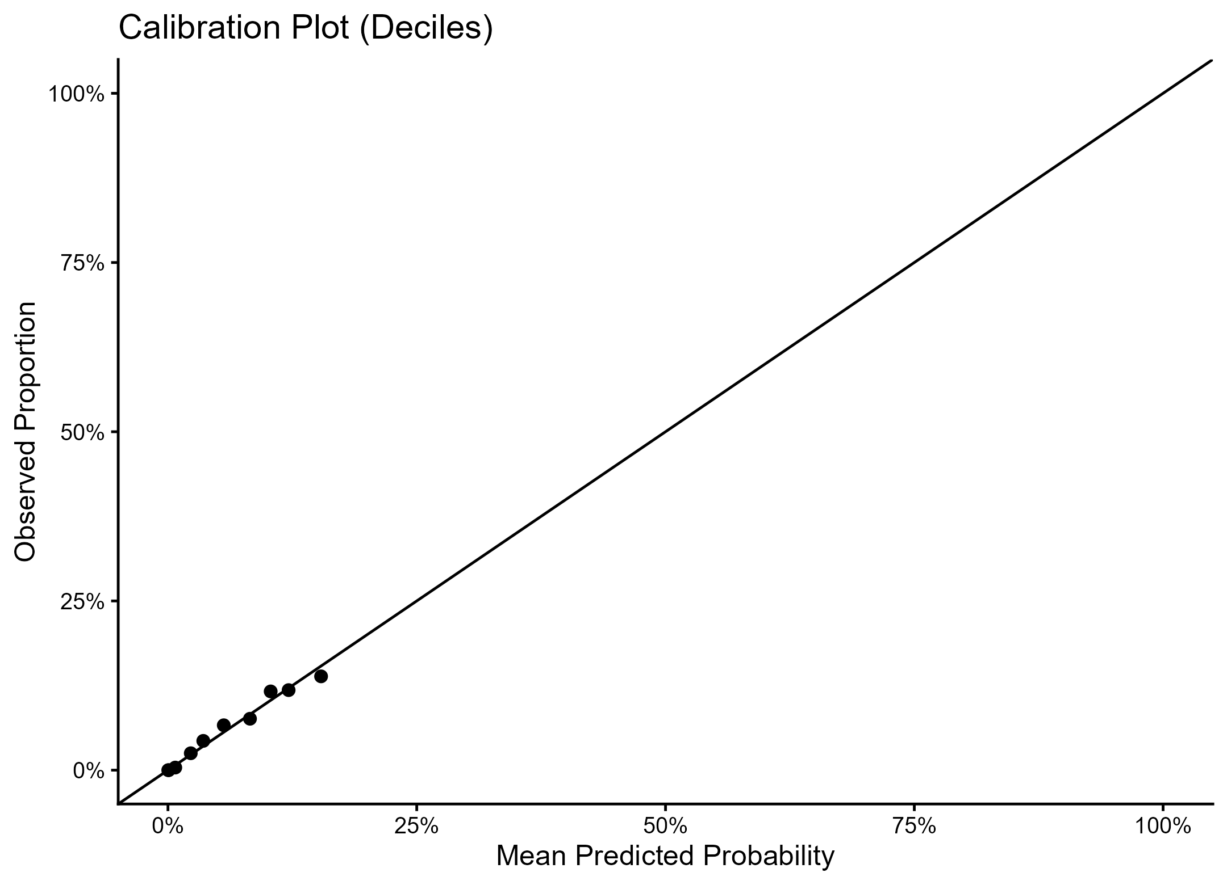
Figure 7: Calibration Plot of the Generalised Additive Model Using Deciles of Predicted Risk
Fig. 7 Calibration performance of fitted generalised additive model: Mean predicted probabilities of survival vs Observed proportions, across deciles of Predicted risk. Generally, good calibration is indicated by the close correspondence of the plotted points to the 45-degree reference line, with a large proportion of the observations lying within the low-to-moderate probability range. This has implications for the reliability of the model's probability estimates, as it does not systematically over- or underestimate survival risk in the majority of the population. Slight deviations at higher predicted probabilities are indicative of the sparsity of survival outcomes in the dataset and, consequently, of sparsity in the extreme risk deciles. Overall, the calibration plot suggests that the model is well calibrated and not only discriminative, which adds confidence in its application for population-level risk assessment and policy planning, particularly in identifying low-survival-risk subgroups relevant to child health interventions aligned with Sustainable Development Goal 3.

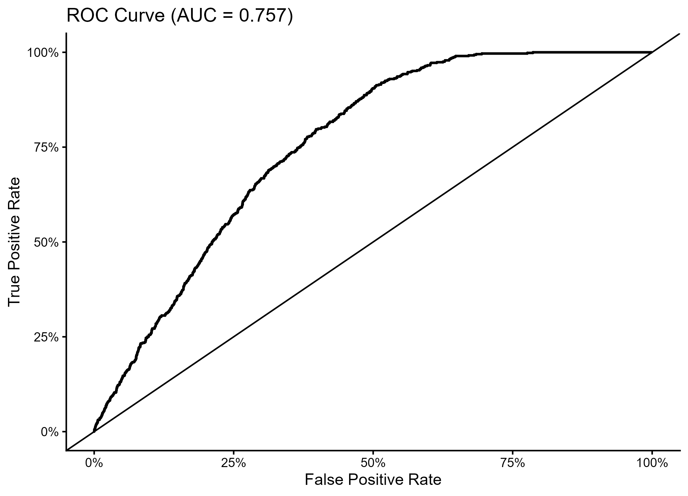
Figure 8: Receiver Operating Curve for Generalised Additive Model
Figure 8 is a Receiver Operating Characteristic (ROC) Curve with AUC = 0.757, indicating that the discrimination is moderate: the model has a better ability to differentiate outcome classes than random classification, but is still far from near-perfect classification. This finding aligns with most models of applied child health risks, which model complex determinants, account for unmeasured confounding, and assess policy utility using calibration and decision thresholds rather than AUC per se (Ayiah-Mensah et al., 2025; Dlamini et al., 2025). The novelty in that approach lies in the inclusion of both discrimination and calibration diagnostics, enhancing the transparency of the methodology in a literature that often relies on excessive significance testing without predictive validation.
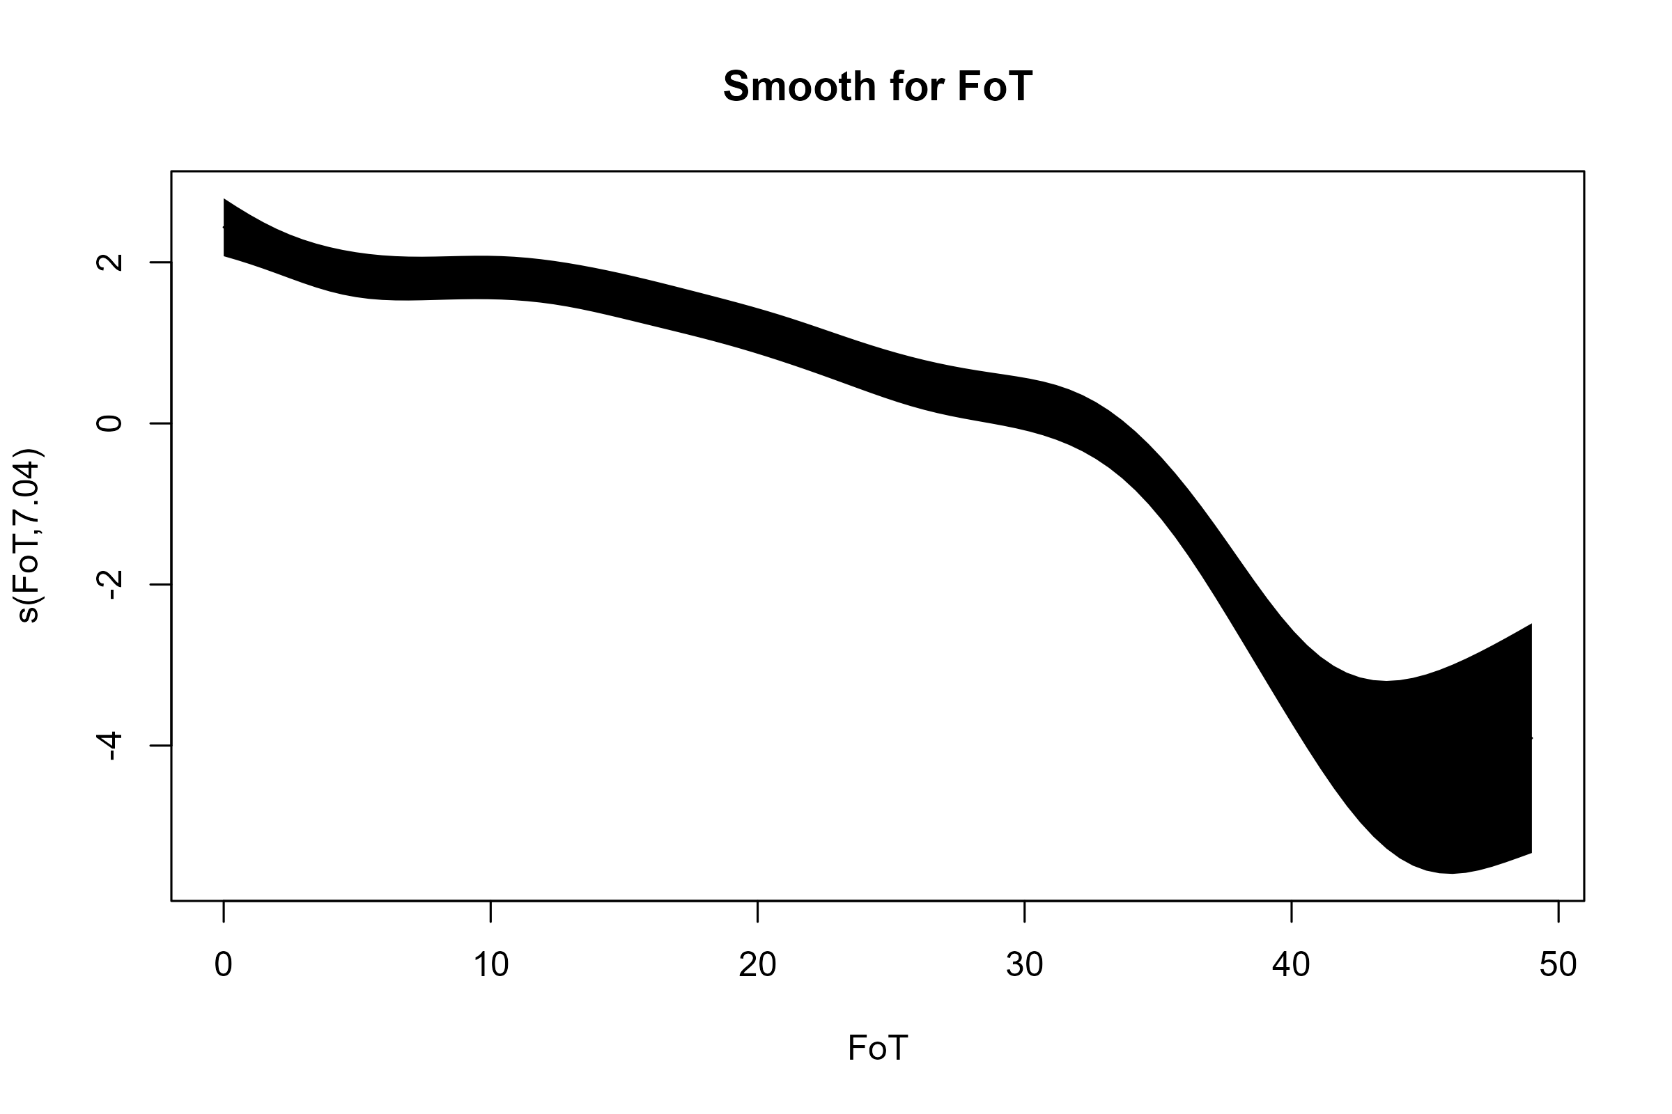
Figure 9: Smoothed effect of Fertility Related Timing (FoT)
Figure 9, Estimated Smooth Effect of Fertility-Related Timing (FoT), represents the main conceptual innovation of the GAM formula, showing that there is a nonlinear association between FoT and the log-odds scale of the outcome. The smooth decrease is slow at lower FoT and then more rapid at higher values, indicating the presence of a threshold, beyond which increasing FoT by small steps would be associated with a significantly more unfavourable outcome. This threshold-type behaviour is the very type of behaviour that is covered up by standard logistic regression, which has to push everything into the single slope to do so, and this type of behaviour is complemented by the bigger GAM evidence base, which tends to have the most actionable signal in prevention and targeting (Awe et al., 2025; Fernandes et al., 2023; Lee et al., 2025). Such nonlinear thresholds can be used to implement stratified prevention and service intensification, respectively, in Ghanaian contexts with regional and socioeconomic disparities, where risk multiplication is concentrated among particular vulnerable groups (Kolekang et al., 2022; Osei & Nketiah-Amponsah, 2024).
Table 1: Parametric terms
Term | Estimate | SE | z | p
(Intercept) | -3.5530 | 0.2748 | -12.931 | 0.00000000000000
WI.L | -0.0975 | 0.0727 | -1.341 | 0.17999999999999
WI.Q | -0.0886 | 0.0705 | -1.258 | 0.20849999999999
WI.C | -0.0683 | 0.0671 | -1.019 | 0.30830000000000
WI^4 | -0.0280 | 0.0652 | -0.429 | 0.66800000000000
EduL.L | 0.0621 | 0.0871 | 0.713 | 0.47610000000000
EduL.Q | 0.1741 | 0.0759 | 2.295 | 0.02172999999999
EduL.C | -0.0112 | 0.0627 | -0.179 | 0.85770000000000
Reg2 | -0.0014 | 0.1632 | -0.009 | 0.99299999999991
Reg3 | 0.0053 | 0.1660 | 0.032 | 0.97440000000000
Reg4 | -0.2418 | 0.1798 | -1.345 | 0.17860000000000
Reg5 | -0.3683 | 0.1818 | -2.026 | 0.04281000000000
Reg6 | -0.0739 | 0.1573 | -0.470 | 0.63859999999999
Reg7 | -0.2527 | 0.1767 | -1.430 | 0.15260000000000
Reg8 | -0.1683 | 0.1668 | -1.009 | 0.31300000000000
Reg9 | -0.1407 | 0.1758 | -0.800 | 0.42339999999999
Reg10 | -0.0598 | 0.1586 | -0.377 | 0.70599999999999
Reg11 | -0.2038 | 0.1614 | -1.263 | 0.20660000000000
Reg12 | -0.2519 | 0.1531 | -1.645 | 0.09987000000000
Reg13 | 0.0020 | 0.1527 | 0.013 | 0.98980000000000
Reg14 | -0.1271 | 0.1544 | -0.823 | 0.41039999999999
Reg15 | -0.1310 | 0.1616 | -0.811 | 0.41760000000000
Reg16 | -0.1776 | 0.1673 | -1.062 | 0.28830000000000
Res2 | 0.0613 | 0.0572 | 1.071 | 0.28399999999999
SexHH2 | -0.0637 | 0.0616 | -1.034 | 0.30120000000000
SoDW2 | 0.0883 | 0.0689 | 1.281 | 0.20010000000000
ToLF2 | 0.0122 | 0.0565 | 0.216 | 0.82909999999999
ToLF3 | 0.2566 | 0.2439 | 1.052 | 0.29270000000000
Elect1 | -0.0116 | 0.0651 | -0.179 | 0.85799999999999
SexC2 | -0.1087 | 0.0561 | -1.938 | 0.05260999999999
PostN1 | -0.1789 | 0.1268 | -1.411 | 0.15829999999999
PostN2 | -0.8919 | 0.4085 | -2.183 | 0.02902000000000
ANTC1 | -0.1180 | 0.0672 | -1.758 | 0.07879999999999
MS1 | 0.0413 | 0.1475 | 0.280 | 0.77980000000000
MS2 | -0.0325 | 0.1625 | -0.200 | 0.84140000000000
MS3 | -0.0182 | 0.2063 | -0.088 | 0.92959999990000
MS4 | 0.0744 | 0.2177 | 0.342 | 0.73250000000000
MS5 | 0.2064 | 0.1887 | 1.094 | 0.27419999990000
ContM1 | -0.1073 | 0.1276 | -0.841 | 0.40060000000000
ContM2 | 0.0321 | 0.0641 | 0.500 | 0.61719999990000
HEL1 | 0.0838 | 0.0777 | 1.079 | 0.28070000000000
HEL2 | 0.0113 | 0.0659 | 0.171 | 0.86390000000000
HEL3 | 0.0264 | 0.1176 | 0.224 | 0.82240000000000

Based on Table 1 (Parametric terms), the vast majority of categorical and ordinal variables show weak relationships, and a few show statistically significant relationships. The EduL quadrant factor is not negligible, suggesting that the relationship between education and survival can be non-monotonic, with threshold curvature rather than a straightforward linear gradient. This implication is reminiscent of the intersectional and disparity-sensitive evidence that education moderates the effects of economic status and service access on maternal and child health co-coverage, suggesting that the effects of education may become stronger above a specific level of attainment rather than being uniform (Kirakoya-Samadoulougou et al., 2025). Region effects are generally not significant. Nevertheless, the odds for Reg5 are lower than those for the reference, aligning with evidence from Ghana indicating its existence, despite controlling for individual-level household characteristics (Mohammed et al., 2023; Bixby et al., 2022). Marginal ANTC1, significant and negative, together with significant PostN2, align with the overall interpretation that service-contact variables matter. However, their interpretation in this model requires careful consideration to ensure that the reverse relationship between the outcome and its coding indicates a protective or deleterious impact, as stated in the conclusion. This table presents a new approach that combines ordered contrast measures and nonlinear components in a semi-parametric model, offering a more nuanced representation than recent literature on binary logistic models in Ghana studies (Ayiah-Mensah et al., 2025; Idrissu & Boanyo, 2025).
Table 2: Smooth terms
Smooth | edf | ref_df | Stat | p
s(FoT) | 7.037 | 9 | 530.927 | 0.0000
s(HhS) | 0.480 | 3 | 0.906 | 0.1689

According to Table 2 on Smooth terms, the s(FoT) is well supported, with edf = 7 and a highly significant test statistic, confirming that the FoT effect is nonlinear and substantively strong. In comparison, s(HhS) is of very low edf and a non-significant p-value, in line with weak unique support in Figure 3 and weak addition to the unique explanatory value of other covariates. This opposition serves to convey one of the key methodological messages: that nonlinear modelling is encouraged when measurement resolution is high, and simple representations are encouraged when predictors are coarse. This aligns with the application of GAM best practices in healthcare research, in which identifiability, degrees of freedom, and the plausibility of shape are deemed not optional but rather part of inference itself (Gao et al., 2023; Lammer et al., 2025). The implication is that any intervention strategies associated with FoT must focus on threshold-sensitive targeting. In contrast, HhS might need to be re-specified or tested before being treated as a direct lever.

Table 3: Model fit statistics (training fit).
Metric | Value
n (train) | 24,264.0000
n (test) | 10,399.0000
Deviance explained | 0.1266
Adjusted R-sq | 0.0478
AIC | 9,592.8700
Table 3 on Model fit statistics shows a modest level of explanatory power, with a deviance explained of approximately 0.13, low adjusted R-squared values, and an AIC that is generally interpretable only for within-study model comparison. This is in line with the overall literature of under-five mortality in which covariates observed represent a partial measure of the risk environment, with additional factors, spatial clustering, and heterogeneity of health systems, still at play (Avelino et al., 2025; Sibanda et al., 2024). The fit pattern supports the claim that, in this case, the novelty is not based on an exhaustive explanation but rather on improvements in functionality through realism, predictive validation, and diagnostic transparency. The model is more aligned with the SDG 3 policy aim by informing child health and maternal care strategies, and with SDG 10 by highlighting geographic and socioeconomic gradients that are inconsistent with adjustment (Kolekang et al., 2022; Osei & Nketiah-Amponsah, 2024).
Some limitations define the interpretation and the comparative contribution of the findings. Verification of the outcome definition and code is needed, as Figure 1 indicates that the distribution of atypical classes of under-five survival is not normal. Any misclassification would reverse sign and alter calibration and discrimination, rendering the estimates particularly ineffective for converting into programmatic advice. It is also not analysed as a time-to-event outcome but as a static, binary endpoint. In contrast, the survival-oriented approach is the gold standard in situations with age-at-death and censoring, which have been explicitly promoted in recent Ghana-specific studies (Iddrisu & Boanyo, 2025). The possibility of residual confounding is that household surveys may lack more clinical detail, that region-fixed effects may not have eliminated geographic dependence, and that, in Ghana, spatial analyses of child mortality inequalities have demonstrated residual confounding (Bixby et al., 2022). Even with these limitations, the study's novelty is evident in its diagnostic-first workflow, the use of GAMs to capture nonlinear determinants, and the combination of discrimination and calibration to guard against policy inference driven by apparent performance. The continuity can be preserved in future extensions using the same dataset, without considering the hierarchy or spatial structure, and by using doubly robust estimators of the key service-contact variables after the coding and positivity requirements are satisfied (Rajapakse et al., 2025; Birhanie et al., 2025).
The analysis yields several substantive results on the determinants of under-five survival in Ghana by combining flexible generalised additive modelling with rigorous model validation. The results show a large positive skew in the descriptive findings, with a small but important proportion of the sample attributed to deaths contributing to the survival rates. A range of large variations in the exploratory distributions is evident in the fertility-related dimensions, and a distinct clustering in the household size domain suggests that a linear function may not accurately represent them. Results from the generalised additive model show that nonlinearity is a key feature in under-five survival.
The smooth week of fertility term shows a significant, nonlinear relationship with child survival, as indicated by high effective degrees of freedom and a significant smooth test statistic. The study is estimated to show that the probability of survival decreases with fertility-related exposure, and steeply with high values. The trend is consistent with demographic theories that associate the proximity of childbearing, close birth spacing, or high-order fertility with a high risk of child mortality, and it further confirms previous Ghanaian evidence by showing explicit threshold effects that are invisible to standard logistic regression models. Conversely, the smooth effect of household size is less complex and statistically insignificant, suggesting that, after controlling for the other covariates, household size has a weaker or more heterogeneous impact on survival.
Results from the parametric models also strongly support the importance of the socioeconomic/health service factors. The mother's education is positively associated with survival, though the risk-reduction benefit from intermediate levels of education declines. The results for the wealth index are covariate-directional but not statistically significant, suggesting that the benefit of wealth may come from indirect factors, such as the availability of health services, before it comes from incremental improvement. The region indicators reveal that some regions exhibit significantly lower survival rates than the reference category, further supporting the existence of spatial inequality in children's survival in Ghana.
Further insights into actionable determinants can be found in health service utilisation variables. There is a statistically significant protective effect of postnatal care with higher utilisation levels, and a borderline protective effect of antenatal care. These results are consistent with previous research highlighting the importance of maternal and child health services, but offer a twist by measuring their impact using a flexible semiparametric model. The other household environmental factors, such as access to electricity and sanitation-related indicators, report mostly small, conflicting results, suggesting that broader socioeconomic pathways likely mediate their impacts.
According to the model performance measures, the model shows moderate discriminative performance, with an area under the ROC curve of around 0.76, indicating that it is significant for survival and mortality. Analysis by calibration indicates good agreement between observed and predicted probabilities at lower to medium levels of risk. However, there is some underprediction at higher predicted probabilities. It appears that, while the correct answer is reached, the modelling process may not fully capture segments of society with very high or very low risk factors.
Conclusion
This research develops empirical research on under-five survival in Ghana through a generalised additive model that directly allows nonlinear associations and a mixed measurement scale for key predictors. The results support the key roles of fertility-related factors, maternal education, regional environment, and maternal use of health services in determining child survival, and show that some of these factors are naturally nonlinear and exhibit threshold behaviour. By identifying these trends, the research contributes to the literature on Ghana and sub-Saharan Africa, which has relied mainly on linear or strictly parametric approaches.
In terms of methodology, the findings emphasize the importance of flexible semiparametric solutions in demography and public health. The GAM's ability to model complex covariate effects simultaneously while remaining interpretable has significantly enhanced the applied analysis of child survival. The model's performance and calibration observations further indicate that this approach may be used to provide explanatory content and reasonable predictive fidelity to the problem, thereby justifying its application in policy-focused studies.
There are some limitations, which should be recognised despite these contributions. The data are cross-sectional, which limits causal interpretation, and the binary survival outcome does not fully capture the timing of deaths in the under-five period. The estimated associations may also be susceptible to unmeasured confounding by maternal health behaviours and environmental exposures, as well as by community-level factors. Future research should extend the present study by including time-to-event data, spatially resolved random effects, and causal inference models to improve policy-relevant findings further.
Generally, the study provides strong evidence that nonlinear relationships among fertility behaviour, socioeconomic status, health service use, and geographic setting determine under-five mortality in Ghana. The results are directly applicable to Sustainable Development Goal 3, which aims to reduce child mortality by determining key risk and intervention levels. Policies that promote the best fertility trends, increase access to maternal and postnatal health services, and curb long-standing regional inequalities are bound to yield the most tremendous benefits for child survival.
Declarations
Data availability
The data supporting this study are publicly available
Data availability statement Repository Link: https://osf.io/ghn3y/
Ethical statement
This study has no ethical consideration
Declarations

Ethical Considerations and Reproducibility
The dataset was fully anonymised, with no identifiable personal information. Analytical scripts, processed datasets, and code for figure generation are openly available for verification and reuse.
All computations adhere to FAIR (Findable, Accessible, Interoperable, Reusable) data principles, supporting transparent and replicable research.
Conflicts of interest
The authors declare that they have no competing interests.
Consent for Publication
Not applicable in the clinic

References
Awe, O. O., Olaniyan, O. A., Olatunde, A. E., SewPaul, R., & Dukhi, N. (2025). A comparative analysis of generalized additive models for obesity risk prediction. Healthcare Analytics, 100410.
Ayiah-Mensah, F., Nimoh, V., Frempong, M., & Asirifi, M. K. (2025). Analytical Framework to Understand the Under-Five Survival in Ghana: A Hybrid Modelling Framework. Asian Journal of Probability and Statistics, 27(12), 39-52.
Ayiah-Mensah, F., Baah, E. M., Harris, E., & Okai, S. K. (2025). Machine-Learning Implications on Global Antenatal Care Improvement and Equity Disparities: The Wealth Effect, Regional Dynamics and Model-Based. Asian Journal of Pregnancy and Childbirth, 8(1), 527-542.
Birhanie, A. L., Tessema, Z. T., Endalew, B., & Tamirat, K. S. (2025). Under-five mortality and its associated factors in sub-Saharan Africa: a multilevel analysis of recent demographic and health surveys data based on Bayesian approach. BMC pediatrics, 25(1), 103.
Bixby, H., Bennett, J. E., Bawah, A. A., Arku, R. E., Annim, S. K., Anum, J. D., ... & Baumgartner, J. (2022). Quantifying within-city inequalities in child mortality across neighbourhoods in Accra, Ghana: a Bayesian spatial analysis. BMJ open, 12(1), e054030.
Byaro, M., Mayaya, H., & Pelizzo, R. (2022). Sustainable development goals for sub-saharan africans' by 2030: a pathway to longer life expectancy via higher health-care spending and low disease burdens. African Journal of Economic Review, 10(2), 73-87.
Dlamini, W. J., Melesse, S. F., & Mwambi, H. G. (2025). An Explicit Research Methodology Suitable for Studying Factors Influencing Under-Five Child Mortality in Four East African Nations. The Open Public Health Journal, 18(1).
Eugine, K. W., Yuantao, X., & Mukumbi, M. C. (2023). Effect of health care expenditures on child mortality rates: a case study of sub-Saharan Africa. International Journal of Science and Business, 25(1), 151-174.
Fernandes, D. P. D. S., Lopes Juvanhol, L., Nobre, A. A., De Souza, Â. M. N., & Ribeiro, A. Q. (2023). Central adiposity as a predictor of mortality in older adults: identification of cutoffs using generalized additive models. Frontiers in nutrition, 10, 1132006.
Gao, Y., Sheng, W., & Yang, Y. (2023). Air pollution and coronary heart disease–related hospital visits in Beijing, China: time-series analysis using a generalized additive model. Environmental Science and Pollution Research, 30(13), 36938-36951.
Henry, S., & O’Farrell, K. (2024). Sarah Henry and Katie O’Farrell’s contribution to the discussion of ‘A system of population estimates compiled from administrative data only’by Dunne and Zhang. Journal of the Royal Statistical Society Series A: Statistics in Society, 187(1), 32-33.
Ibupoto, M. H., Shah, A. A., & Loong, A. (2025). Son Preference, Modern Contraception, and Fertility Intention in the Context of Polygyny in Pakistan: Evidence From Demographic and Health Survey 2017–2018. American Journal of Human Biology, 37(1), e24205.
Iddrisu, A. K., & Boanyo, E. (2025). Survival analysis of under-five mortality and associated risk factors using survival analysis approaches. PLOS Global Public Health, 5(9), e0005179.
Kirakoya-Samadoulougou, F., Fassinou, L. C., Garba, M. L. I., Maïga, A., Zeger, S. L., & Amouzou, A. (2025). Assessing the joint effects of education, economic status, empowerment, and employment (4Es) disparities on the co-coverage of maternal, newborn and child health care services in sub-Saharan Africa: an application of the intersectionality approach. Journal of global health, 15, 04124.
Kolekang, A., Sarfo, B., Danso-Appiah, A., Dwomoh, D., & Akweongo, P. (2022). Contribution of child health interventions to under-five mortality decline in Ghana: A modeling study using lives saved and missed opportunity tools. Plos one, 17(8), e0267776.
Kuse, K. A., Chikako, T. U., Hagan Jr, J. E., Seidu, A. A., & Ahinkorah, B. O. (2022). Assessing individual-and community-level variability in predictors of neonatal, infant, and under-five child mortality in Ethiopia using a multilevel modeling approach. Children, 9(7), 1071.
Lammer, L., Beyer, F., Riedel-Heller, S., Sacher, J., Glaesmer, H., Villringer, A., & Witte, A. V. (2025). Generalized additive mixed models to discern data-driven theoretically informed strategies for public brain, cognitive and mental health. European Journal of Epidemiology, 1-21.
Lee, C., Kim, Y., Kim, S., Whooley, M., & Kim, H. (2025). DeepGAM: An interpretable deep neural network using generalized additive model for depression diagnosis: Data from the heart and soul study. Plos one, 20(9), e0324169.
Lian, J., Zhang, X., Ke, B., Li, J., Li, Y., Wang, K., ... & Wang, S. (2025). Global burden of HIV, syphilis, and HBV infection among women of childbearing age and children under five: based on the Global Burden of Diseases Study 2021. Frontiers in Public Health, 13, 1666408.
Mohammed, K., Abubakari, A. R., Amoak, D., Antabe, R., & Luginaah, I. (2023). Geographic disparities in the time to under-five mortality in Ghana. Plos one, 18(9), e0291328.
Muñoz, I. G., Gómez Moreno, G., Bueno López, C., Aldea, N., Lund, M. B., & Palloni, A. (2025). Grandparental Co‐residence, Grandchildren's Nutrition, and the Role of Demographic and Health Regimes. Population and Development Review, 51(4), 1343-1376.
Natuhamya, C., Makumbi, F., Mukose, A. D., & Ssenkusu, J. M. (2023). Complete sources of cluster variation on the risk of under-five malaria in Uganda: a multilevel-weighted mixed effects logistic regression model approach. Malaria Journal, 22(1), 317.
Opoku, S., Mensah, M., Anum, A., Aformaley Selasi, B., Aninagyei, F., Adjei, C., ... & Nsiah, E. O. (2025). Predictive time series modelling of under five mortality in Ghana. Discover Public Health, 22(1), 797.
Osei, C. K., & Nketiah-Amponsah, E. (2024). Exploring the policy implications of household wealth differentials and under-five child deaths in Ghana. Discover Public Health, 21(1), 9.
Rajapakse, V., & Jayathilaka, R. (2025). Surviving the first five years: the economic and healthcare determinants of child mortality in Sri Lanka. Journal of Health, Population and Nutrition, 44(1), 218.
Rajapakse, V., Fernando, A., Sudangama, N., Adikari, D., Sundaram, A., & Jayathilaka, R. (2025). Economic and healthcare determinants of under-five mortality in low-income countries. BMC Public Health, 25(1), 2126.
Sarfo, J. O., Amoadu, M., Kordorwu, P. Y., Adams, A. K., Gyan, T. B., Osman, A. G., ... & Ansah, E. W. (2023). Malaria amongst children under five in sub-Saharan Africa: a scoping review of prevalence, risk factors and preventive interventions. European journal of medical research, 28(1), 80.
Shahbazi, F., Doosti-Irani, A., Soltanian, A., & Poorolajal, J. (2024). Global forecasting of chronic kidney disease mortality rates and numbers with the generalized additive model. BMC nephrology, 25(1), 286.
Sibanda, K., Qoko, A., & Gonese, D. (2024). Health expenditure, institutional quality, and Under-Five mortality in Sub-Saharan African countries. International Journal of Environmental Research and Public Health, 21(3), 333.
Tareke, A. A., Jemal, S. S., Yemane, G. D., Zakaria, H. F., Shiferaw, E. W., & Ngabonzima, A. (2024). Spatial disparity and associated factors of diarrhea among under-five children in Rwanda: a multilevel logistic regression analysis. BMC pediatrics, 24(1), 266.
Terfa, Z. G., Ahmed, S., Khan, J., Niessen, L. W., & Impala Consortium. (2022). Household microenvironment and under-fives health outcomes in Uganda: focusing on multidimensional energy poverty and women empowerment indices. International journal of environmental research and public health, 19(11), 6684.
Tessema, Z. T., Tebeje, T. M., & Gebrehewet, L. G. (2022). Geographic variation and factors associated with under-five mortality in Ethiopia. A spatial and multilevel analysis of Ethiopian mini demographic and health survey 2019. PLoS One, 17(10), e0275586.
Ugwu, L. E., & Idemudia, E. S. (2025). Kin to strain: longitudinal impacts of family size on mental health among aging South Africans. The Journals of Gerontology, Series B: Psychological Sciences and Social Sciences, 80(12), gbaf168.
Van Long, N., Hoang, P. M., & Anh, T. Q. (2025). An Examination of the Interrelationships Between Macroeconomic Policies and Public Health Outcomes in Low-Income Countries Over the Past Two Decades. International Journal of Computational Methods and Applied Sciences, 15(8).
Wang, P., Liu, H., Shi, Y., Liu, A., Zhu, Q., Albu, I., ... & Chi, X. (2025). Harnessing Small‐Data Machine Learning for Transformative Mental Health Forecasting: Towards Precision Psychiatry With Personalised Digital Phenotyping. Med Research, 1(2), 226-238.

Appendix: List of some Abbreviations

AIC - Akaike Information Criterion
ANTC - Antenatal Care
APA stands for American Psychological Association.
AUC – Area Under the Curve
ChA – Child Alive status - binary under-five survival outcome.
CI – Confidence Interval
ContM – Contraceptive Method
edf – Effective Degrees of Freedom
EduL – Educational Level of mother or caregiver
Elect – Electricity access
FoT – Fertility-related Timing
GAM – Generalized Additive Model
GLM – Generalized Linear Model
HEL - Health-related household environment indicator
HhS – Household Size
LMICs - Low- and Middle-Income Countries
MS – Marital Status
ROC – Receiver Operating Characteristic
REML – Restricted Maximum Likelihood
Reg - Region
Res – Place of Residence
SDG – Sustainable Development Goal
SE – Standard Error
SexC – Sex of Child
SexHH – Sex of Household Head
SoDW - Source of Drinking Water
ToLF - Type of Toilet Facility

