Original Research Article

Rheological Behavior of Pharmaceutical Grade Cellulose Ethers and Its Impact on Excipient Selection in Drug Formulations

ABSTRACT
Background & Scope: Pharmaceutical-grade cellulose ethers, such as hydroxypropyl methylcellulose (HPMC) and hydroxypropyl cellulose (HPC), are widely used as excipients due to their effects on viscosity, mechanical strength, hydration behavior, and drug release performance. In formulation development, excipient selection is commonly based on nominal viscosity grades; however, steady shear viscosity alone does not adequately describe the time-dependent and deformation-sensitive behavior that governs critical quality attributes and in-process performance.

Methodology: A comprehensive rheological evaluation of multiple HPMC and HPC grades obtained from different manufacturers was performed by preparing different concentrations of polymeric dispersions using steady shear and oscillatory rheometry. Flow curves, amplitude sweeps, and frequency sweep analyses were conducted to characterize viscosity, viscoelastic behavior, and structural response under varying deformation conditions.

Results & Discussion: All cellulose ether samples exhibited non-Newtonian, shear-thinning behavior. Distinct differences in viscoelastic properties were observed between polymer types and grades. HPMC demonstrated molecular weight- and concentration-dependent transitions toward elastic-dominated, gel-like behavior, while HPC remained predominantly viscous-dominated under comparable experimental conditions. The observed differences in rheological behavior highlight the limitations of relying solely on nominal viscosity grades for excipient selection. Advanced rheological parameters, particularly viscoelastic characteristics, provide deeper insight into polymer structure–property relationships and their impact on formulation performance.

Conclusion: This study underscores the importance of comprehensive rheological profiling beyond steady shear viscosity to support rational excipient selection and the design of robust pharmaceutical formulations involving cellulose ether polymers.

Key Words: Rheology; Cellulose ethers; Hydroxypropyl methylcellulose; Hydroxypropyl cellulose; Viscosity.

ABBREVIATIONS
HPMC : hydroxypropyl methylcellulose
HPC : hydroxypropyl cellulose
LVR : linear viscoelastic region
LOD : Loss on Drying
DSC : differential scanning calorimetry
CPP : Critical Process Parameters
HP content : hydroxypropyl content
BD : Bulk density
TD : Tapped density
CI : Carr’s Index
HR : Hauser’s Ratio
AR : Angle of repose

- INTRODUCTION

Rheology is the science concerned with the deformation and flow behavior of materials under applied stress or strain and provides critical insight into the structural and dynamic properties of complex systems. Depending on their molecular architecture and intermolecular interactions, materials may exhibit purely viscous behavior, purely elastic behavior, or a combination of both, referred to as viscoelasticity. Viscous materials behave as ideal liquids, undergoing irreversible deformation and dissipating applied energy as heat, with flow governed by Newton’s law of viscosity, whereas elastic materials behave as ideal solids that store mechanical energy and fully recover their original shape upon stress removal in accordance with Hooke’s law (Within the elastic /linear region of a material, the deformation is directly proportional to the applied force). (Gurt A et al., 2024; Palem CR et al., 2025; Ricarte RG et al., 2024).

Most polymeric excipients used in pharmaceutical formulations display viscoelastic behavior, exhibiting both liquid-like and solid-like responses depending on the applied deformation, time scale, and temperature. Oscillatory rheological techniques enable quantitative characterization of such systems through parameters including storage modulus (G′), which reflects elastic energy storage; loss modulus (G″), which represents viscous energy dissipation; and complex viscosity (η*), describing the overall resistance to deformation under dynamic conditions. The damping factor (tan δ = G″/G′) provides insight into the relative dominance of viscous or elastic behavior, while the linear viscoelastic region (LVR) defines the strain range over which the polymer microstructure remains intact and undisturbed (Budai L et al., 2023; Ramli H et al., 2022). Cellulose ether polymers, particularly hydroxypropyl methylcellulose and hydroxypropyl cellulose, are among the most widely used pharmaceutical excipients due to their versatility as binders, matrix formers in controlled-release systems, film-coating agents, and rheology modifiers in liquid and semi-solid dosage forms (Than YM et al., 2021; Furtado LM et al., 2022; Palem CR et al., 2014). The functional performance of these polymers is governed by multiple molecular attributes beyond nominal viscosity grade. Molecular weight plays a central role, as higher molecular weight polymers typically exhibit increased solution viscosity and a greater propensity to form stronger, more elastic gel networks. The degree of substitution significantly influences polymer solubility, hydration behavior, gelation characteristics, and overall hydrophilicity, thereby affecting both processing and in-use performance (Palem CR et al., 2010; Palem CR et al., 2012).

In addition, molar substitution is particularly relevant for HPC, as it modulates thermo-responsive behavior and impacts solution viscosity and phase transitions under varying temperature conditions (Palem CR et al., 2024). The distribution of substituent groups along the cellulose backbone further affects gelation temperature, hydration rate, and microstructural development of polymer networks. Polymer concentration is another critical determinant of rheological behavior, as it governs solution structure, intermolecular entanglement density, and mechanical strength, ultimately influencing viscoelastic response and functional performance in pharmaceutical systems. During pharmaceutical manufacturing, cellulose ether-based formulations are exposed to complex shear and deformation histories during processes such as blending, wet granulation, coating, compression, and dissolution. These conditions cannot be adequately characterized using steady shear viscosity measurements alone. Viscoelastic properties critically influence tablet hydration and gel layer formation, coating uniformity, suspension stability, and drug release kinetics, particularly in modified-release dosage forms. Furthermore, variations in polymer grade and manufacturer can result in significant differences in rheological behavior, with direct implications for process robustness, batch-to-batch consistency, and critical quality attributes (Cremer G et al., 2022; Palem CR et al., 2024, Palem CR et al., 2025).

Despite their widespread application, excipient selection for cellulose ethers in routine formulation development often relies primarily on nominal viscosity grades, overlooking time-dependent and deformation-sensitive rheological properties that more accurately reflect processing and performance conditions. Therefore, comprehensive rheological evaluation using both steady shear and oscillatory techniques is essential to establish meaningful structure-property performance relationships. The present study aims to systematically characterize the rheological behavior of pharmaceutical grade HPMC and HPC across multiple grades and manufacturers, and to demonstrate the relevance of advanced rheological profiling in rational excipient selection and robust drug formulation design.

- MATERIALS AND METHODS

  - Materials

Pharmaceutical grade cellulose ethers of Hydroxypropyl methylcellulose and Hydroxypropyl cellulose of different grades were obtained from IFF Pharma Solutions and Ashland India Pvt Ltd., respectively. All other solvents and chemicals used were of AR grade.

  - Methods: Appearance and flow behaviour

    - Appearance

The physical appearance of hydroxypropyl methylcellulose and hydroxypropyl cellulose was evaluated by visual inspection. Samples were examined for colour, uniformity, presence of visible impurities, agglomeration, and overall physical consistency under normal laboratory lighting conditions. The polymers were assessed in their as-received powder form to identify any signs of discoloration, caking, or heterogeneity that could influence handling, processing, or rheological performance. Observations were recorded qualitatively and compared across grades and manufacturers.

    - Flow Behavior

The flow behavior of HPMC and HPC powders was evaluated using standard Pharmacopeial methods. Bulk density and tapped density were determined using a graduated cylinder method by bulk density apparatus (Electro lab, ETD1020X, India) and flow indices were calculated in terms of Carr’s Compressibility Index and Hausner ratio (Palem CR et al., 2023). Angle of repose was measured using the fixed funnel method to assess powder flowability. In addition, qualitative flow behavior was evaluated by observing powder discharge characteristics through an orifice under gravity. All measurements were performed in triplicate, and mean values were reported to assess inter-grade variability and suitability for pharmaceutical processing.

    - Water Content

The water content of different grades of hydroxypropyl methylcellulose and hydroxypropyl cellulose were determined using Karl Fischer titration (Tiamo 2.5 K, metrohm, 901-titrando, India). Accurately weighed samples were analyzed using a volumetric Karl Fischer apparatus calibrated prior to analysis. Measurements were performed in triplicate, and mean results were presented as percentage w/w.

    - pH of Polymer Solutions

The pH of polymer solutions was measured by dissolving a defined concentration of HPMC or HPC in purified water under controlled conditions. The pH was measured using a calibrated digital pH meter (Polmon Instruments, LP139SA, India) at room temperature. This parameter was assessed due to its influence on polymer hydration, drug stability, and compatibility in formulation systems.

    - Loss on Drying (LOD)

Loss on drying was determined using a halogen moisture analyzer or hot air oven method (Sartorius, MA160-1, Germany) in accordance with Pharmacopeial procedures. Samples were dried at a specified temperature until constant weight was achieved, and LOD values were expressed as percentage weight loss. This parameter served as a supplementary measure of moisture and volatile content.

    - Thermal Behavior

Thermal properties of HPMC and HPC were characterized using differential scanning calorimetry (DSC). Samples were heated under a nitrogen atmosphere at a controlled rate to evaluate thermal transitions such as glass transition temperature and gelation-related endotherms. Thermal analysis provided insight into polymer stability and thermo-responsive behavior.

- RHEOLOGICAL MEASUREMENTS

Rheological characterization of hydroxypropyl methylcellulose and hydroxypropyl cellulose solutions was performed using a controlled-stress rotational rheometer (DHR-1, TA Instruments, USA). All measurements were conducted under controlled temperature conditions, and data acquisition was performed using the manufacturer’s software (Than YM et al., 2021).

  - Sample Preparation

Polymer solutions were prepared by gradually dispersing the required quantity of polymer into purified water at room temperature under continuous agitation to prevent agglomeration and lump formation. The dispersions were allowed to hydrate completely for 12–24 hr at room temperature to ensure uniform polymer solvation and structural equilibration. Prior to analysis, samples were gently degassed either by resting or under mild vacuum to eliminate entrapped air bubbles that could interfere with rheological measurements.

  - Flow Sweep

Steady shear measurements were conducted in flow sweep mode to evaluate apparent viscosity as a function of shear rate. Samples were subjected to an increasing shear rate ramp over a predefined range, and the resulting viscosity profiles were recorded to assess flow behavior and shear-thinning characteristics of the polymer solutions.

  - Amplitude Sweep

Oscillatory amplitude sweep tests were performed at a fixed angular frequency to determine the linear viscoelastic region (LVR). Storage modulus (G′) and loss modulus (G″) were measured as a function of increasing strain amplitude, and the LVR was identified as the strain range over which both moduli remained independent of applied strain, indicating preservation of the polymer microstructure.

  - Frequency Sweep

Oscillatory frequency sweep measurements were carried out within the established LVR over an angular frequency range of 0.1–100 rad/s at 20 °C. Storage modulus (G′), loss modulus (G″), complex viscosity (η*), and damping factor (tan δ) were recorded as functions of frequency to characterize the viscoelastic behavior, time-dependent response, and elastic viscous balance of the polymer systems (Montes L et al., 2021).

- RESULTS AND DISCUSSION

The comparative results of physicochemical, flow, moisture, substitution and polymer solution pH characteristics of hydroxypropyl methylcellulose and hydroxypropyl cellulose grades and different vendors are collectively summarized in Table 1. Visual examination confirmed that all samples were white to off-white, free-flowing powders with uniform appearance and no visible contamination, discoloration, or hard agglomerates, indicating acceptable material quality and appropriate storage conditions. Subtle differences in particle texture were evident between polymers, with HPMC exhibiting a more fibrous and fluffy morphology, whereas HPC appeared comparatively granular and compact. These differences are attributable to variations in substitution pattern and molecular architecture arising from manufacturing processes and are known to influence interparticle interactions. Consistent with these observations, flow property evaluation revealed marked inter-polymer variability. HPC grades demonstrated higher bulk and tapped densities, lower Carr’s Compressibility Index and Hausner ratio values, and smaller angles of repose, collectively indicating better flowability. In contrast, HPMC grades particularly those with higher viscosity grades showed increased compressibility and cohesiveness, which manifested as reduced flow performance and intermittent discharge behavior during qualitative flow assessment (Rowe RC et al., 2020; Reddy PC et al., 2015).

Apparent viscosity measurements revealed substantial variability both between and within polymer types. HPMC grades demonstrated a wide viscosity range, spanning from low-viscosity grades such as METHOCEL™ E3 and E5 (3.2–5.4 mPa·s) to very high-viscosity controlled-release grades such as METHOCEL™ K100M CR and Benecel™ K100M Pharm XR (>100,000 mPa·s at 2% w/w). This broad range reflects differences in molecular weight and substitution pattern, which are critical determinants of solution rheology and matrix-forming capability. The methoxyl content of HPMC grades ranged from approximately 22.8% to 29.1%, while hydroxypropyl substitution varied between 8.0% and 10.4%. Lower methoxyl content and higher hydroxypropyl substitution, as observed in K-type HPMC grades, are associated with increased chain hydration and entanglement, resulting in significantly higher apparent viscosities and stronger gel-forming behavior. Conversely, E-type grades with higher methoxyl content and lower hydroxypropyl substitution exhibited lower viscosities and reduced intermolecular association. In contrast, HPC grades showed substantially higher hydroxypropyl content (approximately 72–77%) and no methoxyl substitution, consistent with their chemical structure. Apparent viscosity values for HPC varied depending on grade and test concentration, ranging from low-viscosity Klucel™ LF to highly viscous Klucel™ MF pharm. Despite their high degree of substitution, HPC solutions generally exhibited lower viscosities than high-molecular-weight HPMC CR grades at comparable functional use levels, reflecting differences in backbone flexibility and solution conformation.

Moisture-related parameters further distinguished the two polymers. While all grades complied with Pharmacopeial limits, HPMC consistently exhibited slightly higher water content and loss on drying values than HPC, reflecting its greater hygroscopic nature and stronger affinity for water through hydrogen bonding. The close correlation between Karl Fischer moisture content and LOD results confirms that water constituted the predominant volatile component in both polymers. The pH of aqueous polymer solutions remained near neutral across all grades, with minimal variation, indicating low risk of chemical incompatibility with active pharmaceutical ingredients and supporting the suitability of both polymers for diverse formulation systems. Thermal analysis provided additional insight into polymer behavior, with HPMC displaying broad endothermic events primarily associated with moisture loss and polymer relaxation, consistent with its amorphous structure and thermal stability under typical processing conditions. In contrast, HPC exhibited more defined thermal transitions related to dehydration and thermo-responsive polymer-polymer interactions, underscoring its sensitivity to temperature (Reddy PC et al., 2015; Thoorens G et al., 2013) Figure 1. Collectively, the results summarized in Table 1 demonstrate that although both polymers meet pharmaceutical quality requirements, their distinct flow, moisture, and thermal behaviours represent critical factors in excipient selection and formulation design, particularly for processes sensitive to powder handling and thermal exposure.

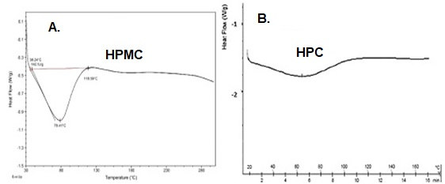

Fig. 1. Illustration of characterization of Differential Scanning Calorimetry (DSC) for A). HMPC and B). HPC polymers

Table 1: Physicochemical evaluation of different grades and vendor HPMC and HPC polymers

Name of the Polymer  (Vendor Brand Name) | Manufacturer / Distributor | Apparent viscosity | Methoxyl content | HP  content | Flow Properties |  |  |  |  | Water  by KF  (% w/w) | LOD  (%) | pH of polymer solution
 |  |  |  |  | BD (g/ml) | TD (g/ml) | CI (%) | HR | AR | Water  by KF  (% w/w) | LOD  (%) | pH of polymer solution
METHOCEL  E3 Premium LV | IFF Pharma Solutions | 3.2 mPa.s  (2% in water) | 28.7 | 8.1 | 0.43 | 0.79 | 45.8 | 1.85 | 68 | 1.1 | 1.5 | 6.9
METHOCEL™ E5 Premium LV | Dupont | 5.4 mPa.s  (2% in water) | 29.1 | 8.0 | 0.27 | 0.40 | 32.4 | 1.48 | 58 | 1.7 | 2.2 | 7.2
METHOCEL™ E15 Premium LV | Dupont | 14 mPa.s  (2% in water) | 28.5 | 8.8 | 0.28 | 0.45 | 36.8 | 1.58 | 62 | 1.7 | 2.2 | 6.7
METHOCEL™ K15 M Premium CR | IFF Pharma Solutions | 17733 mPa.s  (2% in water) | 23.0 | 9.8 | 0.27 | 0.44 | 37.5 | 1.60 | 65 | 1.7 | 2.2 | 6.9
METHOCEL™ K100 Premium LVCR | Dupont | 91 mPa.s  (2% in water) | 23.1 | 8.6 | 0.31 | 0.44 | 28.6 | 1.40 | 48 | 0.6 | 0.8 | 7.1
METHOCEL™ K100  M Premium CR | Dow | 102778 mPa.s  (2% in water) | 22.8 | 10.4 | 0.40 | 0.53 | 24.0 | 1.32 | 42 | 1.3 | 1.7 | 6.7
Benecel™ k4M Pharm XRF | Ashland India Pvt Ltd | 2919 mPa.s  (2% in water) | 23.9 | 8.1 | 0.27 | 0.43 | 37.5 | 1.60 | 65 | 3.2 | 4.3 | 7.4
Benecel™ k15M Pharm XRF | Ashland India Pvt Ltd | 19800 mPa.s  (2% in water) | 23.4 | 10.1 | 0.29 | 0.45 | 34.3 | 1.52 | 58 | 2.6 | 3.5 | 7.6
Benecel™ k100M Pharm XR | Ashland India Pvt Ltd | 116822 mPa.s  (2% in water) | 23.1 | 9.9 | 0.25 | 0.42 | 41.5 | 1.71 | 68 | 1.1 | 1.4 | 7.3
Klucel™ LF pharm | Ashland India Pvt Ltd | 101 cps  (5% in water) | - | 74.3 | 0.41 | 0.57 | 28.0 | 1.39 | 48 | 1.4 | 1.9 | 6.5
Klucel™ EF pharm | Ashland India Pvt Ltd | 430 cps  (10% in water) | - | 72.8 | 0.37 | 0.51 | 25.9 | 1.35 | 45 | 1.1 | 1.4 | 6.0
Klucel™ JF pharm | Ashland India Pvt Ltd | 205 cps  (5% in water) | - | 72.5 | 0.37 | 0.52 | 28.6 | 1.40 | 48 | 1.5 | 2.0 | 5.3
Klucel™ HF pharm | Ashland India Pvt Ltd | 2074 cps  (1% in water) | - | 74.5 | 0.31 | 0.42 | 27.3 | 1.37 | 46 | 0.6 | 0.8 | 6.9
Klucel™ GF pharm | Ashland India Pvt Ltd | 235 cps  (2% in water) | - | 74.9 | 0.37 | 0.52 | 28.6 | 1.40 | 48 | 0.7 | 0.9 | 6.0
Klucel™ MF pharm | Ashland India Pvt Ltd | 5955 cps  (2% in water) | - | 76.6 | 0.36 | 0.46 | 21.4 | 1.27 | 40 | 0.6 | 0.8 | 6.9
Note: Appearance for all the HPMC & HPC polymers observed as white to off-white amorphous free flowing tasteless & odourless powders;
HP content – hydroxypropyl content; BD- Bulk density; TD- Tapped density; CI – Carr’s Index; HR- Hauser’s Ratio; AR- Angle of repose; LOD- Loss on drying

  - Rheology Assessment

    - Flow Sweep Behavior

Flow sweep analysis demonstrated that all evaluated cellulose ether dispersions exhibited pronounced non-Newtonian, shear-thinning behavior across the investigated shear rate range, as shown in Figure 2, which is characteristic of polymeric systems in aqueous solution. At low shear rates, both hydroxypropyl methylcellulose and hydroxypropyl cellulose dispersions exhibited relatively high viscosities, arising from extensive polymer chain entanglement and intermolecular interactions. With increasing shear rate, a progressive reduction in viscosity was observed for all samples, reflecting shear-induced alignment and partial disentanglement of polymer chains in the direction of flow. Increasing polymer concentration resulted in a marked increase in viscosity across all grades, with the effect being more pronounced for higher molecular weight HPMC grades. Among the HPMC E-series grades (Methocel E3, E5, and E15) evaluated at concentrations ranging from 1% to 10% w/w, a clear concentration and grade dependent rheological response was observed. Lower-viscosity grades such as Methocel E3 and E5 exhibited comparatively lower zero-shear viscosity and a more gradual shear-thinning profile, even at higher concentrations, whereas Methocel E15 demonstrated substantially higher zero-shear viscosity and stronger shear-thinning behavior, particularly at 5% and 10% w/w. This behavior reflects increased chain entanglement density and intermolecular association associated with higher molecular weight grades. Similarly, HPMC K-series grades (Methocel K15, K100LV, and K100M), evaluated at 1% and 2% w/w, exhibited progressively higher viscosities and more pronounced shear-thinning behavior with increasing grade viscosity, with Methocel K100M showing the highest resistance to flow at low shear rates. A comparable trend was observed in the vendor comparison study of Benecel grades (K4M, K15M, and K100M), where higher-viscosity grades consistently displayed elevated zero-shear viscosity and stronger shear-dependent viscosity reduction, confirming that rheological performance was primarily governed by polymer molecular weight rather than supplier-specific differences (Moreira R et al., 2016).

In contrast to HPMC, HPC grades exhibited lower overall viscosity and a more gradual shear-thinning profile across the investigated shear rate range, as illustrated in Figure 2. This behavior is consistent with the more flexible chain architecture of HPC and its reduced propensity for intermolecular association in aqueous media. From a pharmaceutical processing perspective, the observed shear-thinning behavior of all cellulose ether grades is advantageous, as high viscosity at low shear promotes formulation stability under static conditions, while viscosity reduction at elevated shear rates facilitates processing operations such as mixing, pumping, spraying, and coating. The stronger shear-dependent viscosity reduction observed for high-viscosity HPMC grades highlights their suitability for applications requiring structural integrity at rest and rapid flow under shear, whereas the more moderate rheological response of lower-viscosity HPMC and HPC grades may be preferred where smoother flow and reduced processing resistance are desired. Overall, the flow sweep results presented in Figure 2 underscore the critical role of polymer grade, concentration, and molecular weight in tailoring rheological behavior for specific pharmaceutical formulation and processing requirements.
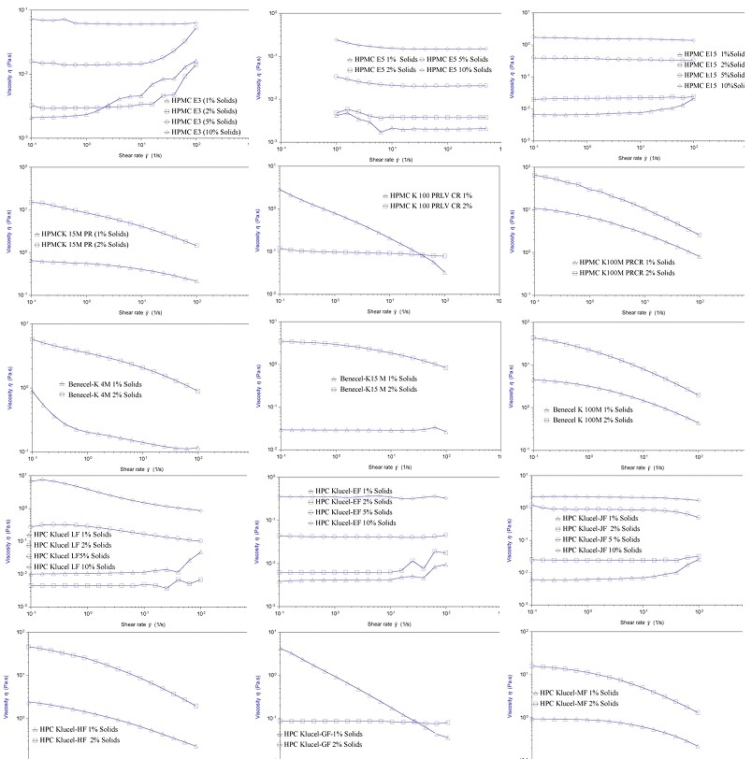
Fig. 2. Flow sweep rheological characterization of different grades of hydroxypropyl methylcellulose and hydroxypropyl cellulose at varying concentrations.

Amplitude Sweep Behavior

Amplitude sweep measurements revealed distinct differences in viscoelastic network strength, deformation tolerance, and structural stability among the evaluated cellulose ether grades, as illustrated in Figure 3. Across all samples, a linear viscoelastic region (LVR) was observed at low strain amplitudes, characterized by constant storage modulus (G′) and loss modulus (G″), followed by a progressive deviation from linearity at higher strains due to network disruption. The extent of the LVR and the strain at which modulus crossover occurred were strongly dependent on polymer type, molecular weight, and dispersion concentration. Among the HPMC Methocel E-series grades (E3, E5, and E15) evaluated over a wide concentration range (1–10% w/w), a clear grade and concentration-dependent strengthening of the viscoelastic network was evident. Lower-viscosity grades such as E3 and E5 exhibited relatively narrow LVRs and earlier onset of non-linear behavior, particularly at lower concentrations, indicating weaker intermolecular interactions and reduced resistance to deformation. In contrast, higher-viscosity grades, especially Methocel E15, displayed extended LVRs and higher critical strain values, reflecting the formation of more robust polymer networks capable of sustaining larger deformations without structural breakdown. Increasing polymer concentration further enhanced network strength, leading to higher G′ values and delayed modulus crossover, consistent with increased chain entanglement density.

A similar trend was observed for the HPMC Methocel K-series grades (K15, K100 LV, and K100M) evaluated at 1–2% w/w. As shown in Figure 3, K100M exhibited the most extended LVR and highest resistance to deformation, followed by K15M and K100 LV, in accordance with their increasing molecular weight and viscosity. Vendor comparison using Benecel K-series grades (K4M, K15M, and K100M) demonstrated comparable viscoelastic behavior, with higher-viscosity grades consistently showing broader LVRs and delayed modulus crossover, confirming that deformation tolerance is primarily governed by polymer molecular characteristics rather than supplier-specific differences. In contrast to HPMC, Klucel HPC grades (LF, EF, JF, HF, GF, and MF) exhibited comparatively narrower LVRs and earlier modulus crossover points, as shown in Figure 3, indicating weaker viscoelastic networks and reduced deformation tolerance. This behavior can be attributed to the more flexible chain architecture of HPC and its lower propensity for intermolecular association in aqueous systems. Although higher-viscosity HPC grades (e.g., MF and GF) demonstrated modest improvements in network strength compared to lower-viscosity grades (LF and EF), their overall viscoelastic robustness remained lower than that of corresponding high-viscosity HPMC grades.

From a pharmaceutical processing perspective, these amplitudes sweep results are highly relevant for operations involving high mechanical stress, such as wet granulation, extrusion, and compaction. Polymers with extended LVRs and higher critical strain values, such as high-viscosity HPMC grades, are better suited to withstand deformation without structural collapse, thereby contributing to improved granule integrity and tablet robustness. Conversely, lower-viscosity HPMC and HPC grades, while offering greater flexibility and ease of deformation, may be more appropriate for applications requiring rapid structural breakdown or lower mechanical resistance (Moreira R et al., 2016). Overall, the comparative amplitude sweep data presented in Figure 3 underscore the importance of polymer grade and concentration selection in tailoring viscoelastic performance for specific pharmaceutical formulation and processing requirements.

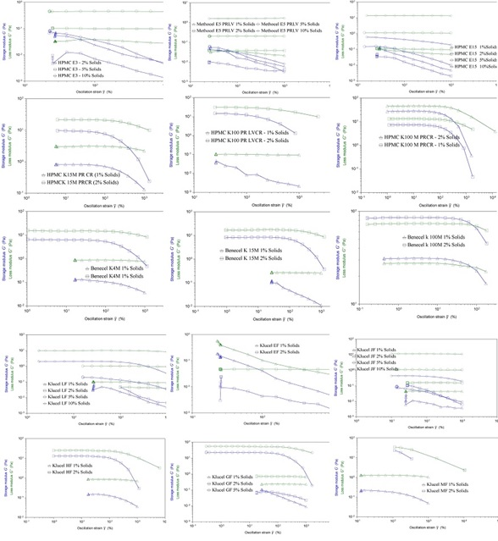
Fig. 3. Amplitude sweep rheological characterization of different grades of hydroxypropyl methylcellulose and hydroxypropyl cellulose at varying concentrations.

Frequency Sweep Behavior

Frequency sweep analysis provided insight into the concentration, molecular weight, and polymer-type-dependent viscoelastic behavior of the evaluated cellulose ether dispersions, with comparative results presented in Figure 4. Across all HPMC grades, increasing polymer concentration resulted in a systematic enhancement of elastic behavior, evidenced by an increase in storage modulus (G′) relative to loss modulus (G″). At low concentrations (1–2% w/w), Methocel™ HPMC grades from both the E-series (E3, E5, and E15) and K-series (K15, K100 LV, and K100M) behaved predominantly as viscous solutions, with G″ exceeding G′ across most of the frequency range. This response reflects limited intermolecular association and high chain mobility at lower polymer loadings. However, as concentration increased to 5-10% w/w for the E-series, a transition toward viscoelastic or elastic-dominant behavior was observed, particularly for higher-viscosity grades such as Methocel E15, where G′ became less frequency dependent and exceeded G″ over a broad frequency range, indicating the development of a more structured polymer network.

Comparable trends were observed for the Methocel K-series and Benecel™ K-series HPMC grades evaluated at 1-2% w/w. As shown in Figure 4, viscoelastic strength increased systematically with molecular weight, following the order K4M < K15M < K100M for the Benecel™ grades. Higher molecular weight grades exhibited higher modulus values, reduced frequency dependence, and earlier onset of elastic dominance, confirming the formation of highly cohesive and entangled polymer networks. These grades also demonstrated a tendency toward earlier gelation and stronger elastic behavior with increasing temperature, highlighting their suitability for applications requiring structural integrity and resistance to time-dependent deformation. The close agreement in viscoelastic trends between Methocel™ and Benecel™ grades further confirms that frequency-dependent rheological behavior is primarily governed by intrinsic polymer properties rather than vendor-specific differences. In contrast, all Klucel™ HPC grades (LF, EF, JF, HF, GF, and MF) remained viscous dominated across the tested frequency range, with G″ consistently exceeding G′, even for higher molecular weight grades, as illustrated in Figure 4. Although both moduli increased with increasing concentration and temperature, the absence of G′ dominance indicates limited elastic network formation and reduced intermolecular association compared to HPMC. This behavior is consistent with the more flexible chain architecture of HPC and its lower tendency to form structured networks in aqueous systems. From a formulation perspective, this predominantly viscous and frequency-dependent response supports the use of HPC in applications requiring rapid flow, low structural rigidity, and minimal gel formation, such as coating solutions and binders for immediate-release dosage forms (Moreira R et al., 2016). Overall, the frequency sweep results presented in Figure 4 underscore the critical role of polymer type, molecular weight, and concentration in dictating time-dependent viscoelastic behavior, providing valuable guidance for rational polymer selection in pharmaceutical formulation and processing.

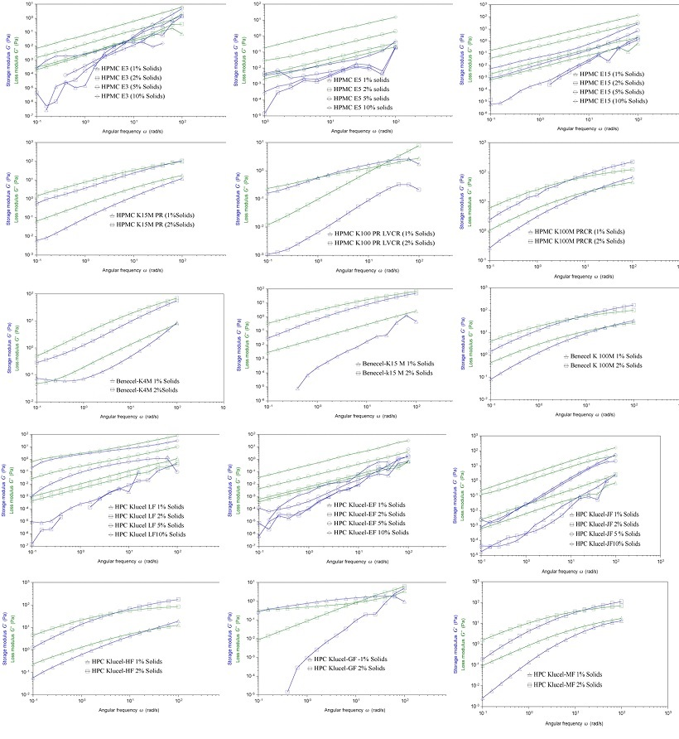
Fig. 4. Frequency sweep rheological characterization of different grades of hydroxypropyl methylcellulose and hydroxypropyl cellulose at varying concentrations.

Manufacturer-Specific Differences in Hpmc Rheology

Direct comparative analysis of Methocel™ and Benecel™ HPMC grades of equivalent nominal viscosity (e.g., K15M, K100M) revealed systematic differences in flow, amplitude, and frequency sweep behavior, despite similar Pharmacopeial specifications. In flow sweep measurements, both manufacturers’ grades exhibited pronounced non-Newtonian, shear-thinning behavior; however, Benecel™ samples consistently showed higher apparent viscosity at low shear rates, reflected in elevated zero-shear viscosity plateaus and a steeper viscosity decline with increasing shear. This suggests stronger chain entanglement and/or narrower molecular weight distribution, resulting in more structured networks at rest. Methocel™ grades, in contrast, displayed lower zero-shear viscosity and more gradual shear thinning, indicative of looser network formation and enhanced flow under low to moderate shear.

Amplitude sweep analysis further highlighted differences in network robustness. Benecel™ grades exhibited broader linear viscoelastic regions (LVRs), with G′ and G″ remaining constant over wider strain ranges and G′–G″ crossover occurring at higher strain, indicating delayed structural breakdown and stronger intermolecular associations. Methocel™ grades showed earlier LVR onset, lower critical strain, and faster modulus decay, reflecting weaker, less cohesive gel microstructures. Frequency sweep measurements corroborated these findings: Benecel™ HPMC demonstrated elastic-dominated behavior (G′ ≫ G″) with weak frequency dependence and tan δ well below unity, indicating stable, gel-like networks. Methocel™ grades displayed closer G′ and G″ values at low frequencies, stronger frequency dependence, and tan δ approaching unity, consistent with more transient, time-dependent networks. Collectively, these results indicate that, under comparable conditions, Benecel™ HPMC forms stronger, more permanent viscoelastic networks, whereas Methocel™ HPMC exhibits more flexible, flowable, and time-dependent rheological behavior, which may influence processing and formulation performance (Thoorens et al., 2013).

Influence of Rheological Properties on Critical Process Parameters (CPPs)

The observed rheological differences between Methocel™ and Benecel™ HPMC grades translate directly into critical process parameters across multiple pharmaceutical operations. Flow sweep data indicate that Methocel™ grades, with lower zero-shear viscosity and gradual shear thinning, facilitate faster wetting, more uniform dispersion, and reduced torque during mixing, supporting high-throughput or low-energy operations. In contrast, Benecel™ grades, with higher zero-shear viscosity and stronger shear dependence, require higher initial energy input but provide superior structural integrity once hydrated, enhancing stability post-mixing. During wet granulation, amplitude sweep results show that the broader linear viscoelastic regions (LVRs) of Benecel™ grades correlate with greater granule robustness and reduced fines generation, whereas narrower LVRs in Methocel™ allow controlled deformation and more plastic granulation, affecting granule size distribution and strength.
Frequency sweep analysis further demonstrates that elastic-dominated systems (G′ > G″), characteristic of Benecel™ grades, form stronger, more coherent matrices during compression, improving tablet hardness and resistance to capping, whereas Methocel™ grades offer greater particle rearrangement and compaction flexibility. Similarly, shear-thinning combined with elastic recovery influences film coating and suspension performance: Methocel™ grades, with faster relaxation and lower elasticity, support smooth atomization and sprayability, while Benecel™ grades provide higher elastic recovery, enhancing film strength and suspension stability by reducing sedimentation. Collectively, these findings highlight that polymer-specific rheological properties are critical determinants of CPPs, enabling tailored process control and optimized pharmaceutical performance.

CONCLUSION

This study demonstrates that cellulose ether polymers exhibit manufacturer-dependent rheological behavior that cannot be fully predicted by nominal viscosity alone. Combined flow, amplitude, and frequency sweep analyses revealed clear mechanistic differences between HPMC and HPC, as well as distinct rheological fingerprints between Methocel™ and Benecel™ HPMC grades of comparable Pharmacopeial viscosity. High-viscosity HPMC displayed elastic-dominated, gel-like behavior with extended linear viscoelastic regions, weak frequency dependence, and pronounced thermogelation, supporting applications in controlled-release matrices requiring structural integrity and deformation resistance. HPC remained viscous-dominated, favouring rapid flow and minimal network formation for efficient processing. Differences in zero-shear viscosity, LVR extent, and elastic dominance between Methocel™ and Benecel™ translated directly into critical process parameters across mixing, granulation, compression, and coating operations. These findings highlight oscillatory rheology as a functional tool linking excipient microstructure to process performance, providing a science-based framework for excipient selection, alternate source evaluation, and Quality by Design–driven pharmaceutical development.

ETHICS APPROVAL:

None to declare

COMPETING INTERESTS DISCLAIMER:
Authors have declared that they have no known competing financial interests OR non-financial interests OR personal relationships that could have appeared to influence the work reported in this paper.

REFERENCES

- Gurt, A., & Khonsari, M. (2024). A review of the rheological consistency of materials. Lubricants, 12, 236. doi:https://doi.org/10.3390/lubricants12070236
- Palem, C. R., Rendla, R., Nagamalli, N. K., Lekkala, V. K., & Gumudevelli, S. (2025). A comprehensive review of current trends and regulatory frameworks in generic drug development. Journal of Pharmaceutical Sciences, 1(10), 16–27. doi:https://doi.org/10.5281/zenodo.17246219
- Ricarte, R. G., & Shanbhag, S. (2024). A tutorial review of linear rheology for polymer chemists: Basics and best practices for covalent adaptable networks. Polymer Chemistry, 15, 815–846. doi: https://doi.org/10.1039/D3PY01367G
- Budai, L., Budai, M., Pápay, Z. E. F., Vilimi, Z., & Antal, I. (2023). Rheological considerations of pharmaceutical formulations: Focus on viscoelasticity. Gels, 9, 469.doi:https://doi.org/10.3390/gels9060469
- Ramli, H., Zainal, N. F. A., Hess, M., & Chan, C. H. (2022). Basic principle and good practices of rheology for polymers for teachers and beginners. Chemistry Teacher International, 4(4), 307–326. doi: https://doi.org/10.1515/cti-2022-0010
- Than, Y. M., Suriyarak, S., & Titapiwatanakun, V. (2022). Rheological investigation of hydroxypropyl cellulose–based filaments for material extrusion 3D printing. Polymers, 14, 1108. doi: https://doi.org/10.3390/polym14061108
- Furtado, L. M., Yee, M., Fernandes, R., Valera, T. S., Itri, R., & Petri, D. F. S. (2023). Rheological and mechanical properties of hydroxypropyl methylcellulose-based hydrogels and cryogels controlled by AOT and SDS micelles. Journal of Colloid and Interface Science, 648, 604–615. doi:https://doi.org/10.1016/j.jcis.2023.06.014
- Palem, C. R., Dudhipala, N., Battu, S. K., Goda, S., Repka, M. A., & Yamsani, M. R. (2015). Combined dosage form of pioglitazone and felodipine as mucoadhesive pellets via hot-melt extrusion for improved buccal delivery using a quality by design approach. Journal of Drug Delivery Science and Technology, 30, 209–219. doi:https://doi.org/10.1016/j.jddst.2015.10.017
- Palem, C. R., Gannu, R., Dudhipala, N., Yamsani, V. V., & Yamsani, M. R. (2011). Transmucosal delivery of domperidone from bilayered buccal patches: In vitro, ex vivo and in vivo characterization. Archives of Pharmacal Research, 34(10), 1701–1710. doi:https://doi.org/10.1007/s12272-011-1014-2
- Palem, C. R., Battu, S. K., Maddineni, S., Gannu, R., Repka, M. A., & Yamsani, M. R. (2013). Oral transmucosal delivery of domperidone from immediate release films produced via hot-melt extrusion technology. Pharmaceutical Development and Technology, 18(1), 186–195. doi:https://doi.org/10.3109/10837450.2012.693505
- Palem, C. R., Noolu, P., Chilukoti, V., Balguri, P. R., Nagamalli, N. K., & Gumudevelli, S. (2025). Design and evaluation of controlled-release floating metformin HCl tablets: Influence of binder and granulation process on buoyancy. Journal of Pharmaceutical Research International, 37(12), 234–244. https://doi.org/10.9734/jpri/2025/v37i127795
- Cremer, G., Danthine, S., Van Hoed, V., Dombree, A., Laveaux, A. S., Damblon, C., Karoui, R., & Blecker, C. (2023). Variability in the substitution pattern of hydroxypropyl cellulose affects its physicochemical properties. Heliyon, 9(2), e13604. doi:https://doi.org/10.1016/j.heliyon.2023.e13604
- Palem, C. R., Gumudevelli, S., Rendla, R., Srinija, G., & Gumudevelli, S. (2025). Comprehensive review on the role of dietary acid load in health and its effect on different types of diabetes. International Journal of Diabetes Research, 7(1), 45–53. doi:https://doi.org/10.33545/26648822.2025.v7.i1a.26
- Palem, C. R., Rendla, R., Lekkala, V. K., Andhi, N., Nagamalli, N. K., Battula, D., & Gumudevelli, S. (2026). Oral transmucosal delivery systems: Exploring innovative dosage forms, current industrial applications and regulatory view. International Journal of Pharmaceutical Investigation, 16(1), 1–14. doi: http://dx.doi.org/10.5530/ijpi.20260433
- Palem, C. R., Nagamalli, N. K., Santhosh, P., Lekkala, V. K., & Gumudevelli, S. (2024). Scale-up factors in the development and commercial execution of oral solid dosage forms: A current industry perspective. Journal of Pharmacology and Pharmaceutical Research, 7(1), 1–14.
- Montes, L., Rosell, C. M., & Moreira, R. (2022). Rheological properties of corn starch gels with the addition of hydroxypropyl methylcellulose of different viscosities. Frontiers in Nutrition, 9, 866789. doi:https://doi.org/10.3389/fnut.2022.866789
- Rowe, R. C., Sheskey, P. J., Quinn, M. E., & Cook, W. G. (2021). Handbook of pharmaceutical excipients (9th ed.). Pharmaceutical Press.
- Palem, C. R., Dudhipala, N. R., Goda, S., & Pokharkar, V. B. (2016). Development and optimization of atorvastatin calcium–cyclodextrin inclusion complex oral disintegrating tablets using central composite design. International Journal of Pharmaceutical Sciences and Nanotechnology, 9(2), 3170–3178. doi:https://doi.org/10.37285/ijpsn.2016.9.2.3
- Thoorens, G., Krier, F., Leclercq, B., Carlin, B., & Evrard, B. (2014). Microcrystalline cellulose, a direct compression binder in a quality by design environment: A review. International Journal of Pharmaceutics, 473(1–2), 64–72. doi:https://doi.org/10.1016/j.ijpharm.2014.06.055
- Moreira, R., Chenlo, F., Silva, C., & Torres, M. D. (2017). Rheological behaviour of aqueous methylcellulose systems: Effect of concentration, temperature and presence of tragacanth. LWT – Food Science and Technology, 84, 764–770. doi:https://doi.org/10.1016/j.lwt.2017.06.050

- Palem, C. R., Lekkala, V.K., Gumudevelli, S. (2026). Current Industry Perspective on Process Analytical Technique Tools and their Recent Development in Pharmaceutical Oral Solid Dosage Formulations. Journal of Pharmacy, 6(1), 123-142. doi: https://doi:10.31436/jop.v6i1.373.

