Land Use Change detection from Ponnani to Tavanur along the Banks of River Bharathapuzha in Kerala

ABSTRACT
Groundwater is an essential freshwater supply for the daily activities of people especially for those residing in the coastal areas. Land use change, sea-water intrusion and rapid urbanization have a significant impact on aquifer behavior in these areas. Therefore, this study analyses long-term changes in land use and groundwater levels in the Tavanur–Ponnani region of the Bharathapuzha River Basin, Kerala. Multi-temporal Landsat satellite data were used to assess land use and land cover changes using the spectral indices such as Normalized Difference Vegetation Index (NDVI) and Normalized Difference Built-up Index (NDBI). Groundwater level data from eighteen observation wells were analyzed for pre-monsoon and post-monsoon seasons from 2014 to 2024 using the Mann–Kendall test and Sen’s slope estimator. The results show a continuous decline in vegetation cover, with vegetated area reducing from 32.1 km² in 2014 to 24.9 km² in 2025, while built-up land increased from 2.2 km² to 6.91 km² during the same period. Mean NDVI values decreased s from 0.218 in 2014 to 0.19 in 2025, whereas mean NDBI values increased from −0.12 to −0.07, indicating rapid urbanization in the area. Groundwater level analysis reveals a statistically significant increase in depth to groundwater in both pre-monsoon (upto 3.38 m in well no.1) and post-monsoon seasons (up to 2.5 m in well no.2) across all observation wells. Correlation analysis revealed a strong negative relationship between NDVI and groundwater depth (r = −0.75 to −0.82) and a strong positive relationship between NDBI and groundwater depth (r = 0.73 to 0.80), confirming the influence of land use changes on groundwater .Therefore, the continuous loss in vegetation land and increase in built-up areas have significantly contributed to long-term groundwater decline in the region, emphasizing that there is a need sustainable land use planning and groundwater management in coastal river basins of Bharathapuzha.
(Key words: Land use and land cover change, Groundwater level, NDVI, NDBI, Mann–Kendall test, Correlation analysis)
Introduction
Water is one of the most essential natural resources supporting life on earth. Among the different forms of water available, groundwater plays a major role in supporting domestic, agricultural and other activities, especially in areas where surface water availability is limited. It is estimated that over 2 billion people (35% of the world population) suffer from severe water stress (Alcamo et al., 2000). Also, coastal aquifers are highly sensitive to both regional and global phenomena that include sea-level rise, storm surges, change in climatic condition, shoreline erosion, coastal flooding, etc. (Barlow, 2003). Increasing population pressure, urban expansion, and land use changes have intensified stress on groundwater resources, leading to declining water tables and reduced recharge potential.
The term "land use" describes the different ways that people use and exploit the land and its resources, including mining, logging, grazing, agriculture, and urban growth. The spatial distribution of land use land cover (LULC) is typically inﬂuenced by many factors, including agro-climatic conditions, the potential of groundwater resources, and various other factors (Nayak and Mandal, 2019; Regasa et al., 2021). Variations in groundwater levels and infiltration mechanisms are impacted by seasonal fluctuations (Kirimi et al., 2018). Therefore, for a sustainable future, it is necessary to carefully manage and monitor the impact of rapid changes in the LULC on groundwater level.

The remote sensing indices such as Normalized Difference Vegetation Index (NDVI) and Normalized Difference Built-up Index (NDBI) help extract vegetation, water bodies and built-up areas (Jothimani et.al., 2021). NDVI uses the visible and near-infrared bands to measure the density and vigour of green vegetation by comparing the amount of visible light reflected to the amount of near infrared light reflected. The NDVI lies ranges between -1 to +1 (Shah and Siyal, 2019). Normalized Difference Built-up Index (NDBI) is a valuable tool in remote sensing and geographic information systems for mapping and analysing built-up areas in urban landscapes (Chen et al., 2006). It’s providing insights into urban development patterns, land use changes, and environmental impacts, making it a valuable resource for researchers, planners, and decision-makers. The Normalized Difference Built-up Index (NDBI) uses the NIR and SWIR bands to emphasize manufactured built-up area. For urban growth, development and urban sprawl built-up mapping is an essential indicator (Shah et al., 2022).
Trend detection techniques such as the Mann–Kendall test and Sen’s slope estimator are commonly applied in hydrological studies to assess long-term changes in groundwater levels due to their robustness and suitability for non-normally distributed data (Mann, 1945; Kendall, 1975; Sen, 1968). These statistical methods have been extensively used to identify groundwater depletion trends in different climatic and hydrogeological settings, including coastal and alluvial aquifers (Birsan et al., 2005; Gocic and Trajkovic, 2013).
Despite having plenty of rainfall and water sources, not all parts of the state have access to water resources, particularly groundwater. Because of the state's distinct hydrological and geo-morphological features, various areas of the state have different groundwater potential.
Kerala is actually suffering groundwater scarcity in a number of areas despite receiving high monsoonal rainfall of about 3000 mm each year. Uncontrolled groundwater withdrawal, poor land resource management, and a gradual reduction in natural recharge capacity are the main causes of this scarcity rather than insufficient rainfall. Kerala's groundwater supplies are especially vulnerable to human activities and environmental changes because of its sandy coastal areas, shallow aquifer systems, and highly populated cities. As a result, 10 to 15% of the state are already categorized as over- exploited (CGWB,2013) in terms of groundwater availability.
Many reaches of the Bharathapuzha River Basin, which is Kerala's second longest river basin also faces the problem of groundwater depletion. High population density, quick land development, and shallow coastal aquifers are characteristics of the river's downstream section, especially between Tavanur and Ponnani. This region is well-known for its distinct hydro-geomorphological setting, which combines human activity, saltwater influence and river discharge. Seawater from the Arabian Sea often seeps into the freshwater aquifer during the summer when groundwater levels drop below a key threshold. This process, generally known as saltwater intrusion, poses a severe concern to drinking water sources, agriculture, and long-term aquifer sustainability.
In this context, the present study aims to analyse the long-term changes in land use and groundwater levels in the Tavanur–Ponnani region of the Bharathapuzha River Basin using multi-temporal satellite data and statistical trend analysis. The study integrates NDVI and NDBI with groundwater level trend analysis for both pre-monsoon and post-monsoon seasons to better understand the influence of land use transformation on groundwater availability.

MATERIALS AND METHODS
The study area comprises the stretch of the Bharathapuzha River from Tavanur to Ponnani in Malappuram district, Kerala, India. The area lies between the latitudes 10.76° and 10.85° N and longitudes 75.88° and 76.00° E (Fig. 1), with an areal extent of approximately 50 km². The region is bounded by the Arabian Sea on the West and is characterized by flat to gently sloping terrain.
The area receives an average annual rainfall of about 2940 mm, mainly during the southwest monsoon. The geology has mainly recent alluvial formations consisting of riverine alluvium, valley fill, and coastal alluvium. Groundwater occurs under unconfined conditions and is mostly extracted through open wells for domestic and agricultural purposes. The depth of shallow wells in the lateritic horizon ranges from 15 to 20 m below ground level (bgl). The water level fluctuates between 1.6 and 13.3 m bgl (CGWB, 2013).

Land use and base map
The land use and land cover map (LULC) were prepared for the years 2014, 2017, 2021 and 2025.The images required for the preparation of the maps were obtained from the USGS Earth Explorer website (earthexplorer.usgs.gov). The particulars of the Landsat images used for the preparation are given in Table 1. Supervised classification was carried out in ArcGIS software. The Landsat 8 OLI/TIRS Collectoin-2 Level-1 dataset provided the satellite images. Images with less than 20% cloud cover were downloaded. Eleven spectral bands with a 30 m spatial resolution make up the Landsat 8 OLI data set.
Seven spectral bands of the Landsat 8 were used for the preparation of land use land cover maps. Training samples were prepared for each class based on visual analysis of pixels, base map and ground truth data. Maximum likelihood classification algorithm was used for the supervised classification. The major land use classes identified include water bodies, vegetation, built-up, barren or fallow land and sandy belts.
NDVI and NDBI
NDVI (Normalized Difference Vegetation Index) and NDBI (Normalized Difference Built-up Index) were calculated to analyse vegetation change and built-up area expansion using the standard equations Eq (1) & Eq (2):
$NDVI=\frac{NIR-RED}{NIR+RED}$ (1)
$NDBI=\frac{SWIR - NIR}{SWIR+NIR}$ (2)
where NIR (Near-Infrared) = Band 5 (0.85 – 0.88 µm), Red = Band 4 (0.64 – 0.67 µm) and SWIR (Short wave Infra-red) = Band 6 (1.57 – 1.65 µm) of the Landsat-8 series.
Temporal variations in NDVI and NDBI were analysed to identify long-term land use changes. Using the spectral bands available within the Landsat datasets, NDVI and NDBI were computed directly in GEE (Google Earth Engine) through scripted operations in Google Earth Engine code editor. The spatial outputs were then exported for further GIS--based interpretation to Arc-GIS.

Groundwater level monitoring
Groundwater level data were collected from eighteen observation wells distributed across the study area. The details of the selected observation wells are given in Table 2. Depth to groundwater table was measured every 30 days using a measuring tape. The behavior of the groundwater table fluctuation along the study region was assessed by calculating the average depth to water table in the wells for a period of 11 years from 2014 to 2025.

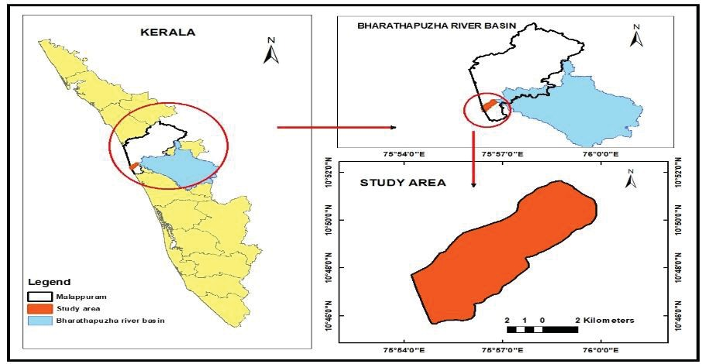
Fig.1. Study area
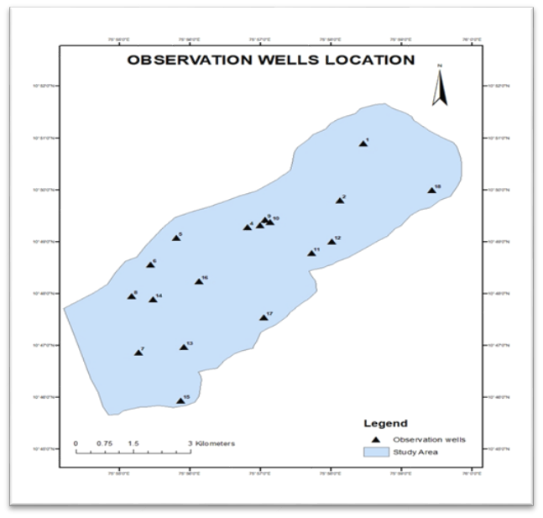

Fig. 2. Location map of observation wells

Table 1. Particulars of Landsat images used
Sl.No. | Date | Cloud cover % | Path | Row
1. | 11-02-2014 | 1.05 | 144 | 53
2. | 10-02-2017 | 11.14 | 145 | 52
3. | 05-02-2021 | 6.45 | 145 | 52
4. | 17-02-2025 | 1.63 | 144 | 52

Table 2. Details of the selected observation wells
Sl. No. | Location | No. of wells and well no. | Approx. distance from coast (km)
1. | Tavanur | 2 Nos. (1 & 18) | > 9
2. | Nariparambu | 2 Nos. (2 & 3) | > 8
3. | Chamravattom | 4 Nos. (4, 9, 10 & 11) | 5.0-5.5
4. | Purathur | 4 Nos. (5, 6, 7 & 8) | 1.0-1.5
5. | Eswaramangalam | 2 No. (12 & 14) | 4.0-4.5
6. | Ponnani | 4 Nos. (13, 15, 16 & 17) | 0.5-1.0

Statistical Analysis
The non-parametric Mann–Kendall (MK) trend test was applied to determine whether long-term, hydro-meteorological and environmental datasets exhibit monotonic trends. While the Mann–Kendall test indicates the direction of a trend, it does not provide information regarding its magnitude. So, Sen’s slope estimator was used to quantify the magnitude of groundwater level changes. Correlation measures the association between changes in one variable and changes in another, indicating whether the relationship is direct, inverse, or insignificant. Pearson’s correlation analysis was carried out in this study to evaluate the relationship between spectral indices (NDVI and NDBI) and groundwater level variations. Groundwater depth maps were prepared using IDW Interpolation in ArcGIS using the collected groundwater depth data for the respective years. Then, for the entire study area Theissen polygons were created. The average NDVI and NDBI values for each polygon was correlated with the average groundwater depth data for that polygon and analyzed.
RESULTS AND DISCUSSION
Land use and Land cover changes
The land use change analysis described how land use has changed over the years in the study area. The classified maps (Fig.3) showed that the study area underwent steady and noticeable changes during the eleven-year period (2014-2025). Table 3 explains the areal statistics of the land use change over the years. In 2014, vegetation dominated the region, covering 32.1 km² (more than half of the area), while built-up land was only 2.2 km². Water bodies occupied 10.2 km², and barren, fallow and sandy areas together are less than 4 km², indicating less human disturbance. By 2017, vegetation reduced to 30 km², while built-up land increased to 3.2 km² and barren or fallow land to 3.7 km². Water bodies showed a slight reduction from 10.2 km² to 10 km² (about 20%), whereas sandy areas remained nearly unchanged.
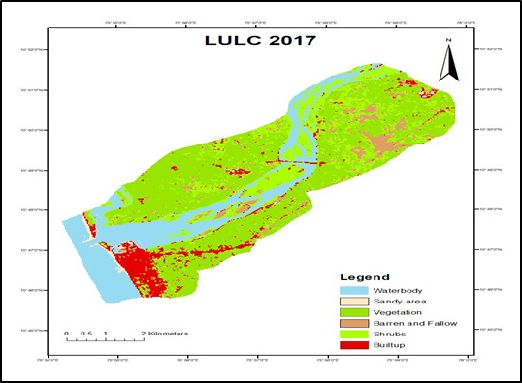
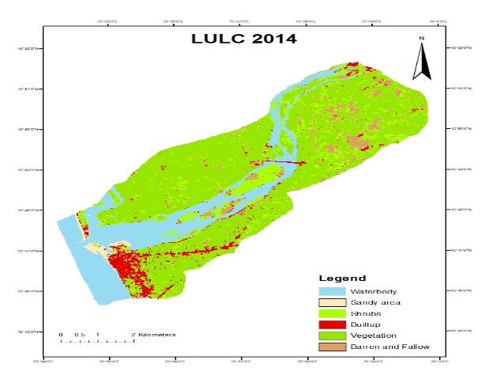

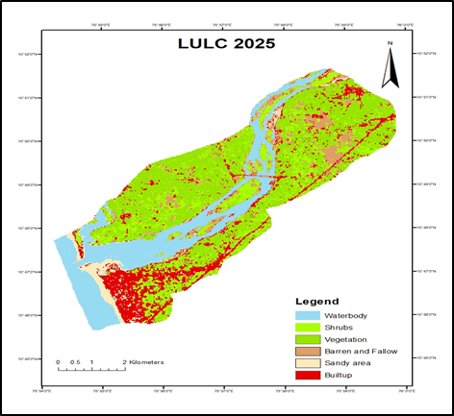
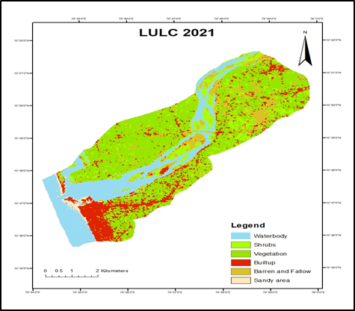

Fig. 3. Land use land cover maps of the study area

Table 3. Areal Statistics of Land Use Land Cover Maps in km²
Land Use Class | Area (km²)
Land Use Class | 2014 | 2017 | 2021 | 2025
Water body | 10.2 | 10 | 9.7 | 9.7
Built Up | 2.2 | 3.2 | 6.2 | 6.91
Vegetation | 32.1 | 30 | 26.8 | 24.9
Barren & Fallow | 2.8 | 3.7 | 4.8 | 5.7
Sandy area | 0.9 | 0.8 | 0.6 | 0.6

By 2017, vegetation reduced to 30 km², while built-up land increased to 3.2 km² and barren or fallow land to 3.7 km². Water bodies showed a slight reduction from 10.2 km² to 10 km² (about 20%), whereas sandy areas remained nearly unchanged. In 2021, vegetation declined further to 26.8 km², followed by a sharp increase in built-up land to 6.2 km² which is almost double the area from 2017. Barren and fallow land expanded to 4.8 km², while water bodies and sandy areas showed minor reductions. By 2025, vegetation decreased to 24.9 km², built-up areas increased to 6.91 km², and barren/fallow land rose to 5.7 km². Water bodies and sandy areas remained nearly stable. Overall, the data show a continuous decrease in vegetation with a corresponding increase in built-up and barren/fallow land over the study period.
The land use analysis revealed vegetation constitutes the major land use in the study area, followed by water bodies, built-up etc. This pattern proves that urbanization is one of the main reasons for land cover change in the region. These changes may likely influence the ground water recharge and availability in the region. Also, the coastal regions have a higher concentration of built-up areas, indicating a higher population density in those areas. The Tavanur-Nariparambu region which is the northern part of the study area has more vegetation other parts of the study area and the groundwater depth is less in these areas (Ameena et al., 2022).

NDVI and NDBI change analysis

The NDVI and NDBI maps analysis showed that vegetation and built-up areas changed over time from 2014 to 2025 (Fig.4 and Fig.5). The NDVI results clearly show that vegetation has been reducing throughout the years. In 2014, NDVI values were generally high across the region, with a mean value of 0.218, indicating healthy vegetation cover. Although the maximum NDVI value increased from 0.429 in 2014 to 0.477 in 2017, the spatial extent of high NDVI areas reduced, suggesting a decline in overall vegetated area.
Between 2017 and 2021, vegetation loss became more evident as the mean NDVI value decreased from 0.21 to 0.20, with reduced NDVI values observed particularly along riverbanks. This declining trend continued up to 2025, when the mean NDVI further decreased to 0.19, the lowest during study period.
The lowest NDVI values in 2025 were mainly observed near settlements and areas with exposed soil. The reduction in NDVI values suggests a decline in dense vegetation and agricultural activity, likely due to conversion of land for residential and infrastructural development. In 2014, the mean NDBI value was (−)0.12, indicating minimal built-up area and dominance of vegetation. By 2017, the mean NDBI increased to (−)0.089, and the maximum value rose from 0.117 to 0.151, reflecting an increase in built-up structures. During this period, initial clusters of urban growth appeared in the central and southern parts of the region. The increase in NDBI became more between 2017 and 2021, as the mean value continued to rise and several areas previously dominated by vegetation showed higher NDBI values. In 2025, urbanization reached its maximum, with the mean NDBI increasing to (−)0.07 and the maximum value to 0.171, the highest during the study period. Areas with high NDBI values corresponded closely with built-up zones identified in the LULC maps. Overall, the contrasting trends of declining NDVI and increasing NDBI clearly indicate that there is a transition from vegetation-dominated land to built-up land over time.

Groundwater Level Trends (Pre-monsoon and post-monsoon)

Groundwater level trend analysis for eighteen wells during the pre-monsoon and post-monsoon seasons from 2014 to 2024 indicated a continuous increase in depth to groundwater in both seasons. It is seen that the depth to the water table in the wells was relatively low during the post-monsoon and gradually rose throughout the pre-monsoon season (Ameena et al., 2022). The water levels in the observation wells varied in accordance with the regional rainfall patterns. Figures 6 and 7 shows the graph in which that groundwater depth gradually increased in almost all observation wells throughout the study period.

The MK test results showed a statistically significant increasing trend in depth to groundwater for all eighteen observation wells during both pre-monsoon and post-monsoon seasons, indicating a consistent decline in groundwater levels. Very low p-values (< 0.001) confirmed that these trends are statistically significant and not due to random variation. Sen’s slope analysis quantified the rate of groundwater decline and showed variations among wells. During the pre-monsoon season, well number 1 recorded the highest increase in depth to groundwater, with a total rise of about 3.38 m over the eleven-year period (Table 6).
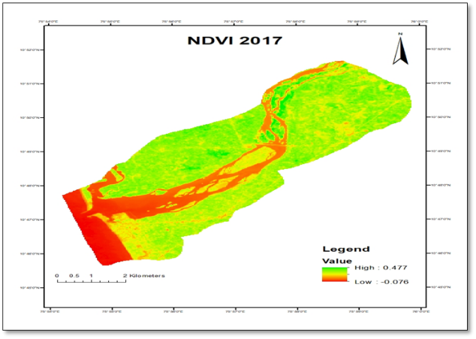
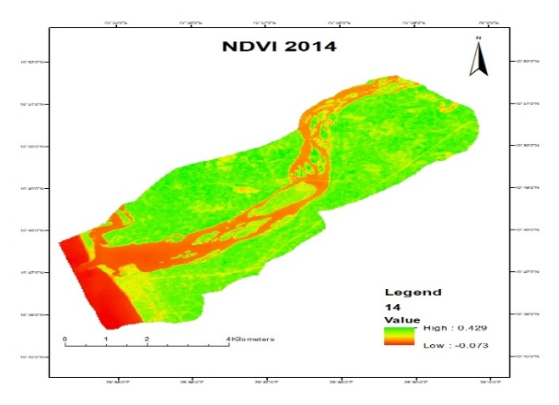
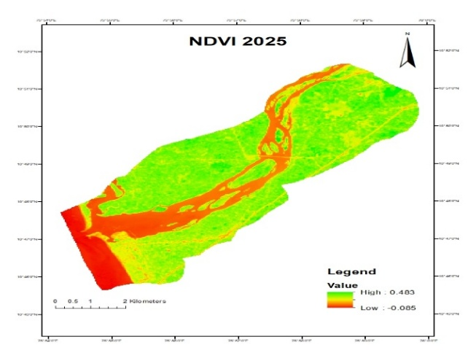
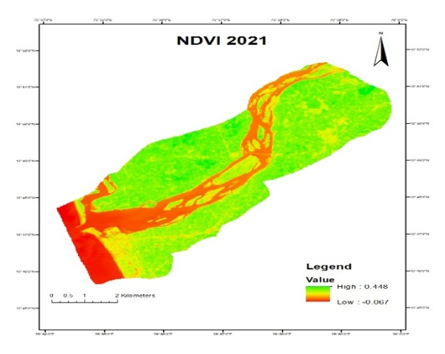

Fig. 4. NDVI maps

Table 4. NDVI Statistics
NDVI | 2014 | 2017 | 2021 | 2025
Minimum | -0.07 | -0.07 | -0.06 | -0.08
Maximum | 0.429 | 0.477 | 0.448 | 0.483
Mean | 0.218 | 0.21 | 0.20 | 0.19
Std. deviation | 0.129 | 0.124 | 0.127 | 0131

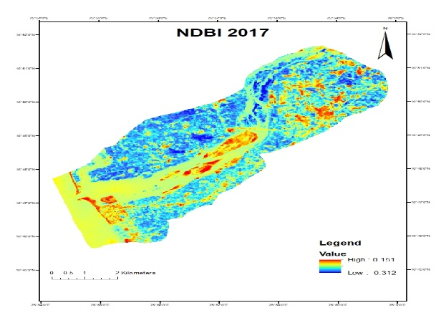
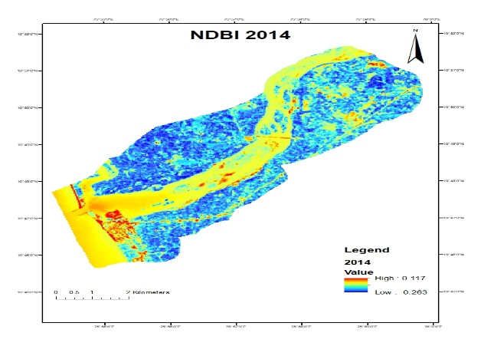

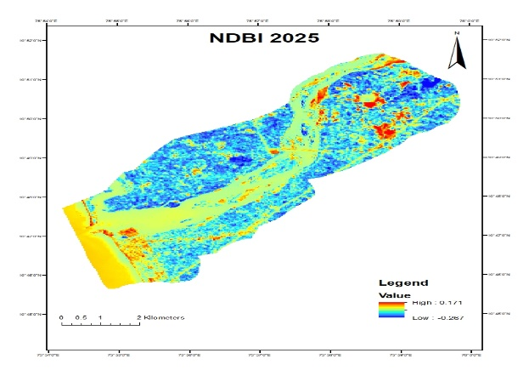
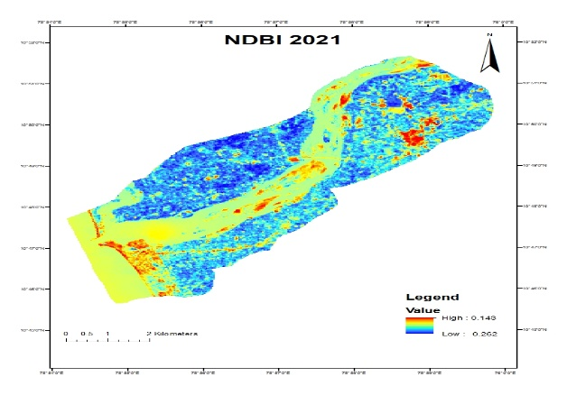

Fig. 5. NDBI maps

Table 5. NDBI Statistics
NDBI | 2014 | 2017 | 2021 | 2025
Minimum | -0.26 | -0.31 | -0.26 | -0.26
Maximum | 0.117 | 0.151 | 0.14 | 0.17
Mean | -0.12 | -0.089 | -0.107 | -0.07
Std. deviation | 0.064 | 0.072 | 0.069 | 0.066

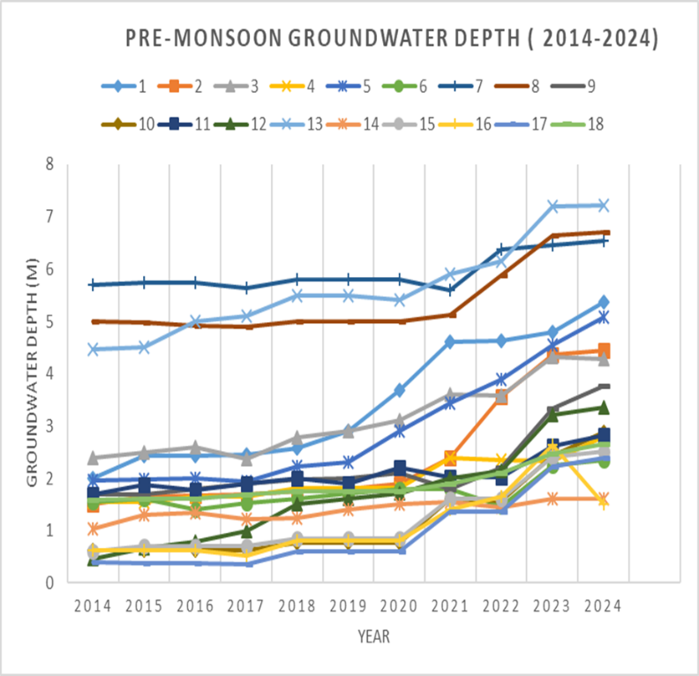

Fig. 6. Average annual variation of depth to groundwater with time (Pre-monsoon)

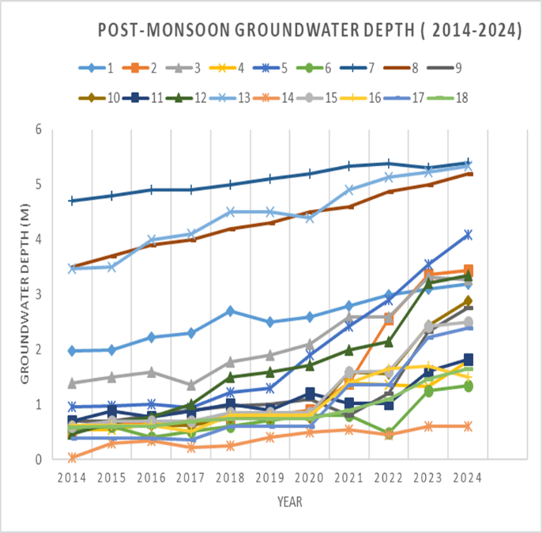

Fig. 7. Average annual variation of depth to groundwater with time (Post-monsoon)

Table 6. Pre-monsoon trend analysis
Well No. | p-value (MK Test) | Sen's Slope | Inference
1 | 3.49 × 10⁻⁵ | 0.33 | Significant Increasing Trend
2 | 2.82 × 10⁻⁵ | 0.29 | Significant Increasing Trend
3 | 6.34 × 10⁻⁴ | 0.20 | Significant Increasing Trend
4 | 6.78 × 10⁻⁴ | 0.12 | Significant Increasing Trend
5 | 1.86 × 10⁻⁴ | 0.23 | Significant Increasing Trend
6 | 1.54 × 10⁻² | 0.10 | Significant Increasing Trend
7 | 1.78 × 10⁻² | 0.08 | Significant Increasing Trend
8 | 2.13 × 10⁻³ | 0.10 | Significant Increasing Trend
9 | 5.68 × 10⁻⁴ | 0.08 | Significant Increasing Trend
10 | 5.01 × 10⁻⁴ | 0.19 | Significant Increasing Trend
11 | 4.41 × 10⁻⁴ | 0.09 | Significant Increasing Trend
12 | 2.89 × 10⁻⁵ | 0.27 | Significant Increasing Trend
13 | 1.30 × 10⁻⁴ | 0.25 | Significant Increasing Trend
14 | 2.34 × 10⁻³ | 0.09 | Significant Increasing Trend
15 | 2.80 × 10⁻⁴ | 0.15 | Significant Increasing Trend
16 | 4.46 × 10⁻³ | 0.13 | Significant Increasing Trend
17 | 1.58 × 10⁻³ | 0.18 | Significant Increasing Trend
18 | 7.86 × 10⁻⁵ | 0.07 | Significant Increasing Trend

Table 7. Post-monsoon trend analysis
Well No. | p-value (MK Test) | Sen's Slope | Inference
1 | 9.92 × 10⁻⁵ | 0.12 | Significant Increasing Trend
2 | 2.62 × 10⁻⁵ | 0.25 | Significant Increasing Trend
3 | 6.13 × 10⁻⁴ | 0.19 | Significant Increasing Trend
4 | 6.57 × 10⁻⁴ | 0.10 | Significant Increasing Trend
5 | 1.86 × 10⁻⁴ | 0.22 | Significant Increasing Trend
6 | 1.54 × 10⁻² | 0.08 | Significant Increasing Trend
7 | 1.30 × 10⁻⁴ | 0.07 | Significant Increasing Trend
8 | 2.62 × 10⁻⁵ | 0.16 | Significant Increasing Trend
9 | 5.68 × 10⁻⁴ | 0.08 | Significant Increasing Trend
10 | 5.01 × 10⁻⁴ | 0.18 | Significant Increasing Trend
11 | 4.41 × 10⁻⁴ | 0.08 | Significant Increasing Trend
12 | 2.62 × 10⁻⁵ | 0.24 | Significant Increasing Trend
13 | 1.30 × 10⁻⁴ | 0.19 | Significant Increasing Trend
14 | 1.07 × 10⁻³ | 0.04 | Significant Increasing Trend
15 | 2.24 × 10⁻⁴ | 0.11 | Significant Increasing Trend
16 | 4.33 × 10⁻³ | 0.10 | Significant Increasing Trend
17 | 1.44 × 10⁻³ | 0.17 | Significant Increasing Trend
18 | 7.66 × 10⁻⁵ | 0.06 | Significant Increasing Trend

In the post-monsoon season, the maximum increase in depth to groundwater was observed at well number 2, with a rise of approximately 2.5 m (Table 7). Both seasons exhibited similar declining trends, indicating long-term groundwater depletion across the study area.

Correlation Analysis
The correlation analysis between NDVI and pre-monsoon groundwater depth (depth to water table) showed a strong negative relationship throughout the study period. In 2014, the Pearson correlation coefficient was −0.75, indicating that higher NDVI values were associated with shallower groundwater levels. This relationship strengthened over time, reaching −0.82 by 2025, reflecting a very strong negative correlation (Table 8).
In contrast, the correlation between NDBI and pre-monsoon groundwater depth (depth to water table) showed a strong positive relationship. The Pearson correlation coefficient was 0.73 in 2014 and increased to 0.78 in 2017, 0.77 in 2021, and 0.80 by 2025. These results indicated that increasing built-up areas are consistently associated with deeper groundwater levels (Table 9).
The results show that the study area has undergone substantial land use transformation over the past eleven years. There is a continuous decline in vegetation area and the built-up area has increased about three-fold. Similar patterns of vegetation loss and urban expansion have been reported in other coastal and alluvial regions, where population growth and infrastructure development exert increasing pressure on land and water resources (Bronstert et al., 2002; Shah, 2009).
Also, the continuous decline in NDVI values from 2014 to 2025 indicate the progressive loss of green areas in the region, which is consistent with earlier studies showing that reduction in green cover adversely affects groundwater recharge processes (Scanlon et al., 2005; Mogaji et al., 2015).In contrast, the increase in NDBI values indicates in the increase in impervious surfaces which is a result of rapid urbanization in the region especially along the coastal side.. Previous studies have shown that growth of built-up areas leads to reduced infiltration and increased surface runoff, resulting in lower groundwater recharge and declining water tables (Lerner, 2002; Zha et al., 2003).
This confirms that vegetation has been systematically replaced by man-made surfaces such as buildings and construction of roads & highways in the area. Groundwater level analysis reveals a consistent increase in depth to groundwater table in both pre-monsoon and post-monsoon seasons across all observation wells which is consistent with the results of MK test.
The correlation analysis further supports the association between the change in land use and reduction in ground water level. The strong negative correlation between NDVI and groundwater depth indicates that areas with higher vegetation cover tend to maintain shallower groundwater levels, while the strong positive correlation between NDBI and groundwater depth confirms that built-up areas experience deeper water tables.
Thus, the combined results of LULC analysis, spectral indices, groundwater trend analysis, and correlation results indicates that land use transformation, particularly urban expansion at the expense of vegetation, has played a significant role in altering groundwater availability in the Tavanur–Ponnani region.

Table 8. Correlation analysis between NDVI and GWL
Year | Pearson’s co-efficient r- value | P-value | Interpretation
2014 | -0.75 | 2.93e-4 | Strong negative correlation
2017 | -0.79 | 8.11e-5 | Strong negative correlation
2021 | -0.78 | 9.65e-5 | Strong negative correlation
2025 | -0.82 | 2.48e-5 | Very strong negative correlation

Table 9. Correlation analysis between NDBI and GWL
Year | Pearson’s co-efficient r- value | P-value | Interpretation
2014 | 0.73 | 5.17e-4 | Strong positive correlation
2017 | 0.78 | 1.11e-4 | Strong positive correlation
2021 | 0.77 | 1.38e-4 | Strong positive correlation
2025 | 0.80 | 3.40e-5 | Very Strong positive correlation

COMPETING INTERESTS DISCLAIMER:
Authors have declared that they have no known competing financial interests OR non-financial interests OR personal relationships that could have appeared to influence the work reported in this paper.
REFERENCES
Alcamo, J., Henrichs, T. and Rösch, T. (2000). World water in 2025: Global modeling and scenario analysis for the World Commission on Water for the 21st Century. Hydrological Sciences Journal 45: 823–843.
Ameena, P.O.H., Varughese, A., Gilsha Bai, E.B. and Jaleena, S.S. (2022). Assessment of salt water intrusion from Ponnani to Tavanur along the banks of River Bharathapuzha in Kerala. Journal of the Indian Society of Coastal Agricultural Research 40(2): 33–47.
Barlow, P.M. (2003). Ground water in freshwater–saltwater environments of the Atlantic Coast. U.S. Geological Survey, Reston, Virginia.
Birsan, M.V., Molnar, P., Burlando, P. and Pfaundler, M. (2005). Streamflow trends in Switzerland. Journal of Hydrology 314: 312–329.
Bronstert, A., Niehoff, D. and Burger, G. (2002). Effects of climate and land-use change on storm runoff generation. Hydrological Processes 16: 509–529.
CGWB [Central Ground Water Board]. (2013). Ground water information booklet of Malappuram District, Kerala. Technical Reports: Series D, Central Ground Water Board, Kerala Region, Ministry of Water Resources, Govt. of India, Thiruvananthapuram, Kerala. 29 p.
Chen, X., Zhao, H., Li, P. and Yin, Z. (2006). Remote sensing image-based analysis of the relationship between urban heat island and land use/cover changes. Remote Sensing of Environment 104: 133–146.
Gocic, M. and Trajkovic, S. (2013). Analysis of changes in meteorological variables using Mann–Kendall and Sen’s slope estimator. Global and Planetary Change 100: 172–182.
Jothimani, M., Gunalan, J. and Duraisamy, R. (2021). Study the relationship between LULC, LST, NDVI, NDWI and NDBI in Greater Arba Minch Area, Rift Valley, Ethiopia. Atlantis Highlights in Computer Sciences 4: 183–193.
Kendall, M.G. (1975). Rank correlation methods. Griffin, London.
Kirimi, F., Thiong’o, K., Gabiri, G., Diekkrüger, B. and Thonfeld, F. (2018). Assessing seasonal land cover dynamics in the tropical Kilombero floodplain of East Africa. Journal of Applied Remote Sensing 12: 026027.
Lerner, D.N. (2002). Identifying and quantifying urban recharge: A review. Hydrogeology Journal 10: 143–152.
Mann, H.B. (1945). Nonparametric tests against trend. Econometrica 13: 245–259.
Mogaji, K.A., Lim, H.S. and Abdullah, K. (2015). Modeling groundwater recharge using remote sensing and GIS. Hydrological Sciences Journal 60: 597–615.
Nayak, S. and Mandal, M. (2019). Impact of land use and land cover changes on temperature trends over India. Land Use Policy 89: 104238.
Rahmati, O., Samadi, M., Shahabi, H., et al. (2019). Groundwater potential mapping using remote sensing and GIS. Science of the Total Environment 669: 619–631.
Scanlon, B.R., Healy, R.W. and Cook, P.G. (2005). Choosing appropriate techniques for quantifying groundwater recharge. Hydrogeology Journal 10: 18–39.
Sen, P.K. (1968). Estimates of the regression coefficient based on Kendall’s tau. Journal of the American Statistical Association 63: 1379–1389.
Shah, S.A. and Siyal, A.A. (2019). GIS-based approach for estimation of area under wheat and other major rabi crops in district Ghotki and corresponding irrigation water requirements. Acta Scientific Agriculture 3(12): 59–70.
Shah, T. (2009). Taming the anarchy: Groundwater governance in South Asia. RFF Press, Washington DC.
Wada, Y., van Beek, L.P.H. and Bierkens, M.F.P. (2010). Global patterns of groundwater depletion. Geophysical Research Letters 37: L20402.
Zha, Y., Gao, J. and Ni, S. (2003). Use of normalized difference built-up index in mapping urban areas. International Journal of Remote Sensing 24: 583–594.

