Original Research Article
A Reclassification-Based NDVI Framework for Quantifying Vegetation Greenness Across Mixed Vegetation Landscapes at Different Spatial Extents

.
ABSTRACT
Vegetation dynamics are fundamental indicators of environmental health, yet evaluating them in complex, mixed-use landscapes remains methodologically challenging. Traditional statistics are not the real representative of the pixel-level distribution of greenness in a particular area of study, which results in critical disparities in the spatial extent and density of vegetation. To overcome these limitations, this study introduces the Greenest Score (GS), a spatially explicit, area-weighted framework that reclassifies NDVI into ecologically distinct categories to quantify peak greenness intensity and coverage.
To test this framework, this study utilizes the NDVI of ten Nigerian cities across diverse bioclimatic zones for the years 2015 and 2025. The analysis shows that traditional summary statistics frequently fail to represent ecological reality. In 2015, Asaba and Ibadan exhibited comparable maximum NDVI values (0.67 and 0.83) and mean NDVI values (0.41 and 0.57), suggesting similar greenness potential. However, the GS analysis exposed a stark contrast in actual biomass: Ibadan supported 175,411 hectares of dense vegetation (56.44% of its area), while Asaba contained only 17.46 hectares (0.06%).
The GS framework also shows high performance in detecting temporal shifts invisible to central-tendency measures. Between 2015 and 2025, Asaba’s Average NDVI remained deceptively stable (0.41 to 0.42), masking a significant ecological recovery where dense vegetation expanded from 0.06% to 21.76% of the city. Additionally, Abuja’s Average NDVI decline (0.39 to 0.25), and Abuja lost approximately 112,000 hectares of moderate vegetation.

Keywords: NDVI; Greenest Score; Vegetation dynamics; Spatial heterogeneity, Statistics.

1. INTRODUCTION
Vegetation is a fundamental constituent of the biosphere, and its dynamic changes are important indicators of climate and environmental change. Monitoring these changes is essential for understanding critical global challenges, from deforestation and desertification to the impacts of droughts and wildfires (Li et al., 2023; Mariano et al., 2018).
The Normalized Difference Vegetation Index (NDVI) is a widely used spectral index for assessing vegetation greenness. It is a key tool in remote sensing, allowing scientists to analyze vegetation health, density, and coverage over an area directly from satellite or aerial imagery (Bean, 2014; Huang et al., 2020). According to Rabatel et al. (2014), NDVI leverages the spectral reflectance profile of vegetation, which shows strong absorption in the red region (RED) and high reflectance in the near infrared (NIR). NDVI values range from −1 to +1, with higher values indicating denser green vegetation.
NDVI products play an essential role in vegetation monitoring at various scales (Zhao et al., 2023). Ensuring that the evaluation of these vegetation indices is both accurate and evenly distributed is crucial, as it provides a true and reliable representation of a region’s vegetation health, spatial patterns, and ecological conditions (Brown et al., 2020; Yang et al., 2024; Latuamury et al., 2025).
However, summarizing an area with a single central-tendency statistic, such as the mean or median NDVI, can mask the existence of small but ecologically significant high-NDVI patches (Boyd et al., 2013; Huete et al., 2002). The use of summary statistics, like the mean or median, can be problematic in spatially heterogeneous areas, as they are sensitive to the large proportion of bare or built-up surfaces that may dominate urban and mixed landscapes. This is particularly true in complex, fragmented ecosystems where small, dense patches of vegetation (e.g., urban greens or fragmented forests) are ecologically important but may not significantly influence the overall mean NDVI of a large, mixed-use region (Sadeh et al., 2021). NDVI also shows saturation at high leaf-area values, which can further complicate interpretation (Gitelson & Gao, 1996; Townshend, 1983).
A common method for evaluating and analysing vegetation indices, such as NDVI, involves the use of descriptive statistics, including minimum, median, maximum, and standard deviation, to analyse and compare time series data (D’Ercole et al., 2024; Li et al., 2024; Gutiérrez-Castorena et al., 2025). These measures of central tendency and dispersion are frequently employed to assess vegetation dynamics over time. However, a significant methodological limitation arises when these statistics are used to compare different geographical areas or time series vegetation analysis (D’Ercole et al., 2024; Dey et al., 2025). The major limitation of using summary statistics, such as the mean or maximum NDVI, is that they depend heavily on how pixel values are distributed and represented. In some cases, a pixel may appear to be an outlier, but it is not necessarily an error; it simply reflects the true vegetation characteristics of that specific location.
A spatially smaller region with a dense canopy cover may exhibit a higher maximum or mean NDVI value than a larger region with more extensive, but less dense, vegetation (Gamon et al., 1995; Shabani et al., 2025). This does not mean that the smaller area is more ecologically significant than the larger one; it simply reflects differences in the spatial distribution of pixel-level radiometric properties. Therefore, direct comparisons of summary statistics across disparate locations can be misleading. This underscores the necessity of complementing simple descriptive statistics with analytical techniques that account for the spatial distribution, heterogeneity, and area-dependent context of the pixel values to enable valid cross-regional comparisons.
These limitations underscore the necessity of complementing simple descriptive statistics with analytical techniques that account for the spatial distribution, heterogeneity, and area-dependent context of the pixel values to enable valid cross-regional comparisons. Studies have shown that vegetation metrics are highly sensitive to the spatial resolution and the aggregation area used for calculation (Jiménez et al., 2022). To address these limitations, this study proposes reclassifying NDVI into five ecologically informed classes and computing a composite “Greenest Score” (GS) that emphasizes the area and intensity of the highest NDVI classes. This paper describes the GS formulation, justifies threshold choices from the literature, and demonstrates the method with a Landsat 8 case study in Nigeria.

2. material and methods

2.1 Study Area
To experiment with the idea of the Greenness score calculations, ten (10) cities in Nigeria were carefully selected based on their geographical location to represent the country’s diverse ecological and climatic gradients. Nigeria spans several bioclimatic zones, which makes it an ideal landscape for evaluating variability in vegetation greenness patterns (Ayanlade et al., 2021).
The selected cities (Abuja, Asaba, Enugu, Ibadan, Kano, Ikeja, Maiduguri, Owerri, Sokoto, and Uyo) capture the significant gradients in climate and vegetation across the country. Asaba, Enugu, Ibadan, Ikeja, Owerri, and Uyo are located in Southern Nigeria and lie within the humid tropical region (Adepoju et al., 2019), Maiduguri, Kano, and Sokoto are located in Northern Nigeria and lie within the Sudan and Sahel savanna zones (Herrmann et al., 2005), while FCT is located in the North-Central/Middle Belt part of Nigeria, which falls within the Guinea savanna (Ayanlade et al., 2021).
By incorporating cities from diverse ecological contexts, the analysis ensures that the proposed Greenest Score (GS) is tested against variations in vegetation biomass, land cover heterogeneity, and climatic seasonality.
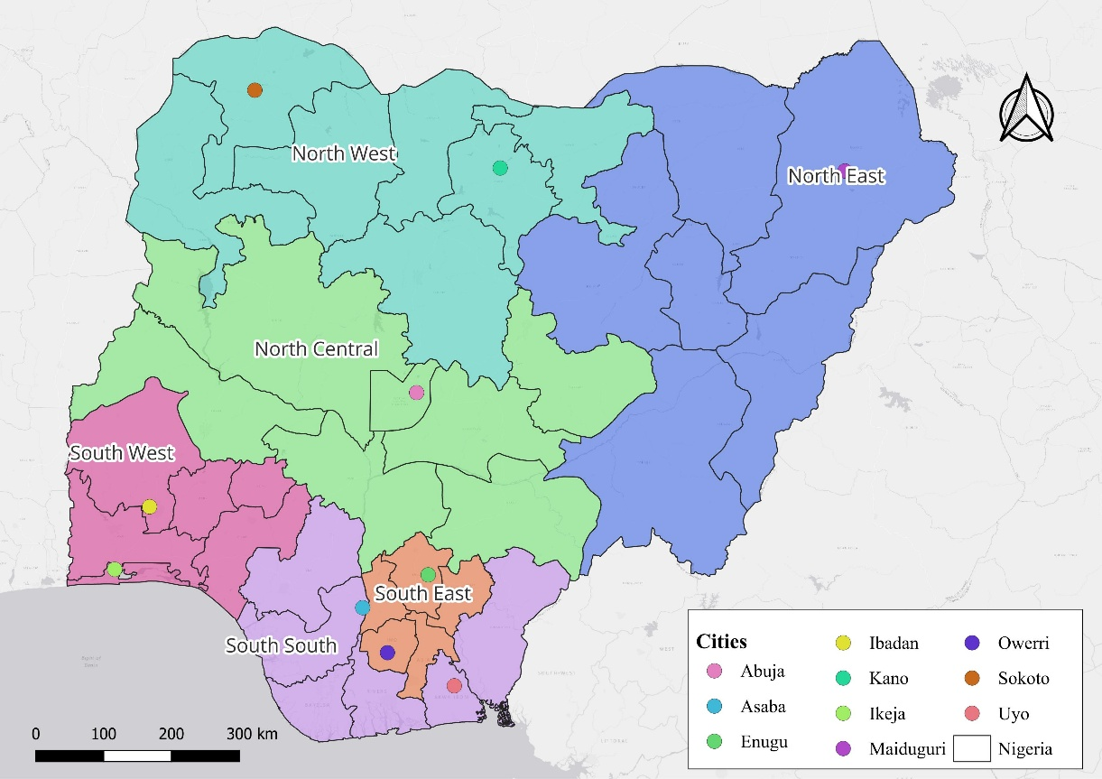
Figure 1: The Study Area map showing their geopolitical zones in Nigeria.

2.2 Methodological Flowchart
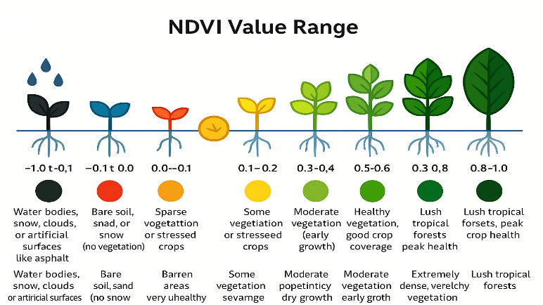
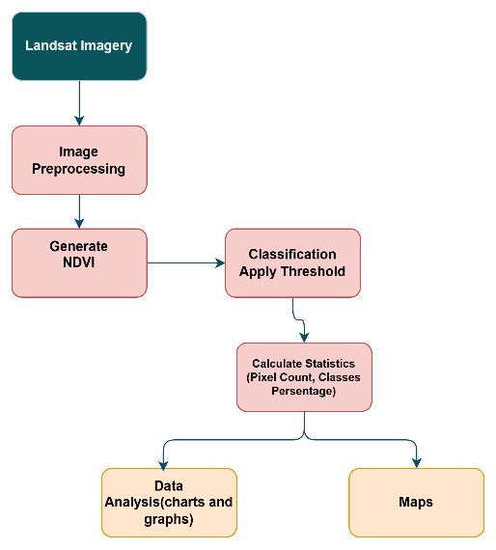
Figure 2b: Showing NDVI Classification grade
Source: https://xrtechgroup.com/what-is-ndvi-and-how-to-calculate-ndvi/

Figure 2a: Methodological Flowchart

2.3 Data Processing and Analysis
Data Preprocessing procedures included atmospheric correction, cloud masking, and the construction of a seamless composite mosaic to minimize temporal inconsistencies and residual noise (Zhang et al., 2022). A final composite image was generated for the peak greenness period of 2015 and 2025 to represent maximum vegetation expression.
Landsat 8 Operational Land Imager (OLI) imagery was used for this study; a commonly used source for regional vegetation analysis due to its consistent radiometric calibration and moderate spatial resolution (Okeke et al., 2018). The following table summarizes the key data characteristics.
Table 1: Data Source
Data | Resolution | Source | Bands Used | Purpose
Landsat 8 (OLI) | 30m | Google Earth Engine | Red (Band 4), Near Infrared (Band 5) | To calculate the NDVI of the study area

2.3.1 Normalized Difference Vegetation Index (NDVI)
The Normalized Difference Vegetation Index (NDVI) is the vegetation assessment metric used in this study. It is one of the spectral indices for analysing vegetation health, density, and coverage over an area in remote sensing applications (Bean, 2014; Huang et al., 2020). NDVI leverages the characteristic reflectance properties of vegetation, which exhibit strong absorption in the red region (RED) of the electromagnetic spectrum and high reflectance in the near-infrared (NIR) region (Pettorelli et al., 2005).
NDVI is mathematically expressed as:
$$\begin{matrix} & NDVI=\frac{NIR-Red}{NIR+Red} & & \text{(1)}\end{matrix}$$where NIR and Red are the near-infrared and red reflectance, respectively.
NDVI values range from -1 to +1, with values close to +1 indicating dense, healthy vegetation and values near zero or negative representing non-vegetated areas such as bare soils, rocks, and water. Values ranging from 0.3 to 0.6 signify moderate vegetative cover, characteristic of grassland, shrub, or crops. Values above 0.6 indicate dense vegetation, closed-canopy forest, or areas with high biomass (Rouse et al., 1973; Carlson & Ripley, 1997).
In this study, the NDVI was generated from atmospherically corrected, cloud-masked Landsat 8 imagery. The derived NDVI raster is the essential input layer for the subsequent reclassification and Greenest Score (GS) analysis.
2.3.2 NDVI Reclassification into Vegetation Classes
Reclassifying NDVI into a range of classes is the most important task in calculating the Greenest Score. The NDVI range is reclassified into the range of values as specified in Table 2. Based on this and other field studies, we adopt the following class thresholds (illustrated conceptually in Fig. 1b and summarized in Table 2): NDVI values were reclassified into five ecologically meaningful vegetation density classes following established literature and based on the characteristics of the study area (Rouse et al., 1973; Carlson & Ripley, 1997; Xue & Su, 2017).
Each pixel in the image is classified into one of these five categories. Then for any area of interest(boundary), let $f_{i}$ be the fraction of the area (or fraction of pixels) in class $i$. For example, the $f_{dense}$ is fraction of area with NDVI ≥ 0.8. In practice, we apply this reclassification to Landsat NDVI composites (at 30 m resolution) and compute $f_{i}$ by simple counting.
The Landsat imagery is preprocessed by subletting the area of interest, applying atmospheric correction, and mosaicking the scenes. After these steps, the NDVI is computed (Eq. 1). Then, using the thresholds above, the NDVI raster is classified into five distinct classes to generate the final classified imagery. Area fractions $f_{i}$ are obtained by counting pixels per class in each boundary (or whole study area). The GS metrics (Eq. 2 and 3) are then calculated. For time‐series or larger areas, the same process can be applied per year or based on the boundary.

Table 2: NDVI Range Interpretation
Class | NDVI Range | Vegetation Description | Ecological Interpretation
Bare | NDVI < 0 | Non-vegetated, such as Exposed soil, rock, or water | No greenness
Very little | 0 ≤ NDVI < 0.1 | Little to no vegetation | Minimal greenness
Sparse | 0.1 ≤ NDVI < 0.3 | Urban areas with mixed grasses/shrubs or young crops | Low photosynthetic activity
Moderate | 0.3 ≤ NDVI < 0.6 | Moderate vegetative cover, such as cropland or secondary forest | Moderate vegetation density
High to Dense | NDVI ≥ 0.6 | Dense to very dense vegetation cover | Strong vegetative growth to Peak greenness, maximum biomass
Source: Authors’ Interpretation of the Vegetation Characteristics of the Study Area
2.3.3 Greenest Score (GS) Calculation
The Greenest Score (GS) was applied to the NDVI raster generated from the Landsat Imagery Ratio calculation selected to represent the period of peak vegetation greenness within the study area (Zhang et al., 2022; Ibrahim et al., 2021). This selection ensures that vegetation signals across urban and peri‑urban environments are captured at their maximum radiometric expression, allowing a more reliable assessment of spatial variation in canopy condition.
For each Area of Interest (AOI), a suite of NDVI‑derived metrics was generated: mean NDVI, median NDVI, and normalized $GS_{w}$, TCF, and $GS_{10\%}$ (defined as the mean of the highest 10% NDVI pixels within the AOI). These metrics characterize the internal structure, distribution, and dominance of high‑greenness pixels, providing a more nuanced evaluation of vegetation patterns beyond conventional summary statistics (Ibrahim et al., 2021; Amuyou et al., 2022).
The Greenest Score is defined as a weighted sum of the class fractions, assigning a higher weight to greener classes. A simple choice is to let the class index itself serve as weight (e.g. 1=bare … 5=dense). Then the Weighted GS is:
$$\begin{matrix} & GS_{w}=\sum_{i=1}^{5}{ }i f_{i}, & & \text{(2)}\end{matrix}$$where $i=1$ for bare up to $i=5$ for dense. In this scheme, a higher $GS_{w}$ implies a larger share of high-NDVI classes. In fact, if all pixels were dense vegetation $f_{5}=1$ , $GS_{w}=5$ (the maximum); if mostly bare, $GS_{w}$ approaches 1. One can also normalize $GS_{w}$ by dividing by 5 to scale it 0–1. Equation (2) can be viewed as a coarse “average class index”, analogous to mean NDVI but less sensitive to the large bare fraction. Alternatively, one could set the weights $w_{i}$ equal to representative NDVI values of each class (e.g., the class midpoint), in which case $GS_{w}$ approximates the mean NDVI of the area (since $\sum{f_{i}}=1$). We instead use integer weights to highlight class differences, but other weighting schemes (e.g. square of class number) could further emphasize the top classes if desired.
To continue the Greenest Calculation, it is important to calculate the percentages of each class using the Top-Class Percentage (TCP) formula.
$TCP=f_{dense}$ (percentage of area in the densest class).
A higher TCP means more area at the highest greenness threshold. For example, let $NDVI_{\left(1\right)}≥NDVI_{\left(2\right)}≥…≥NDVI_{\left(n\right)}$ The NDVI values are sorted in descending order over the area of interest.
$$\begin{matrix} & GS_{p}=\frac{1}{n_{p}}\sum_{j=1}^{n_{p}}{ }NDVI_{\left(j\right)},n_{p}=\left\lceil p n/100\right\rceil , & & \text{(3)}\end{matrix}$$where $n$ is the total number of pixels is, , $p=\%$ of NDVI pixels. This directly measures the greenness of the very top fraction of the area. Like mean NDVI, it is a single index (on the NDVI scale) but restricted to high values. We consider $GS_{p}$ mainly as a descriptive indicator; in practice, to obtain a comprehensive characterization of vegetation patterns, TCP is combined with the Weighted Greenest Score $GS_{w}$ or other GS metrics. While $GS_{w}$ captures the overall distribution of greenness across all classes, TCP emphasizes the dominance of the classes using the percentage of distribution of the classes of vegetation.

3. results and discussion
The NDVI analysis for 2015 and 2025 revealed notable spatial and temporal variations in vegetation greenness across the ten selected Nigerian cities. Descriptive statistics of NDVI values indicate differences in both the mean greenness and the distribution of vegetation across urban landscapes. To complement these statistics, the reclassification-based Greenness Score (GS) framework was applied, categorizing vegetation into standardized classes ranging from low to high greenness. The GS results highlight areas of increased vegetation, as well as regions experiencing a decline in greenness over the ten-year period, providing a comprehensive overview of urban vegetation dynamics across the study sites.
3.1 NDVI Classification (2015 and 2025)
Figure 3 shows the NDVI map for 2015. The southern cities, particularly Ibadan (Fig. 3h), Enugu (Fig. 3c), and Owerri (Fig. 3e), are dominated by expansive continuous patches of moderate-to-dense vegetation. Ibadan exhibits a dense green core radiating outward. In contrast, the northern cities of Maiduguri (Fig. 3a), Kano (Fig. 3f), and Sokoto (Fig. 3j) are depicted predominantly as very little (0.0–0.1) to sparse (0.1–0.3) vegetation classes. Abuja (Fig. 3d) shows a mix of urban buildup and moderate greenness.
Temporal shifts become visually apparent in 2025 (Figure 4). Ibadan (Fig. 4h) and Owerri (Fig. 4e) retain their deep green vegetative signatures, indicating the strength of the area's dense canopy. Abuja (Fig. 4d) shows a noticeable loss of thousands of hectares of moderate vegetation. On the other hand, Asaba (Fig. 4b).
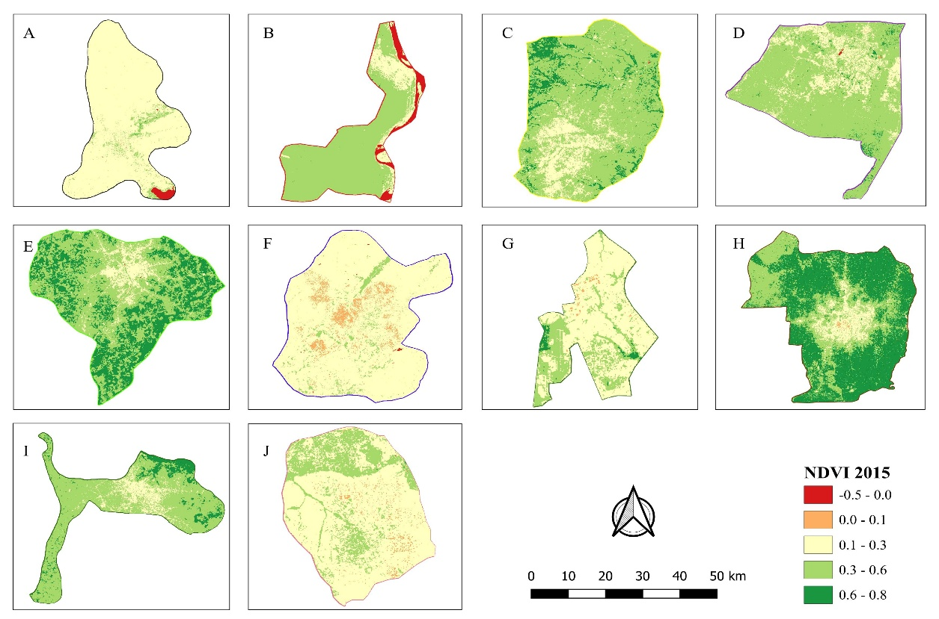
Figure 3: NDVI 2015 for (a) Maiduguri, (b) Asaba, (b) Enugu, (d) Abuja, (e) Owerri, (f) Kano, (g) Ikeja, (h) Ibadan, (i) Uyo, (j) Sokoto

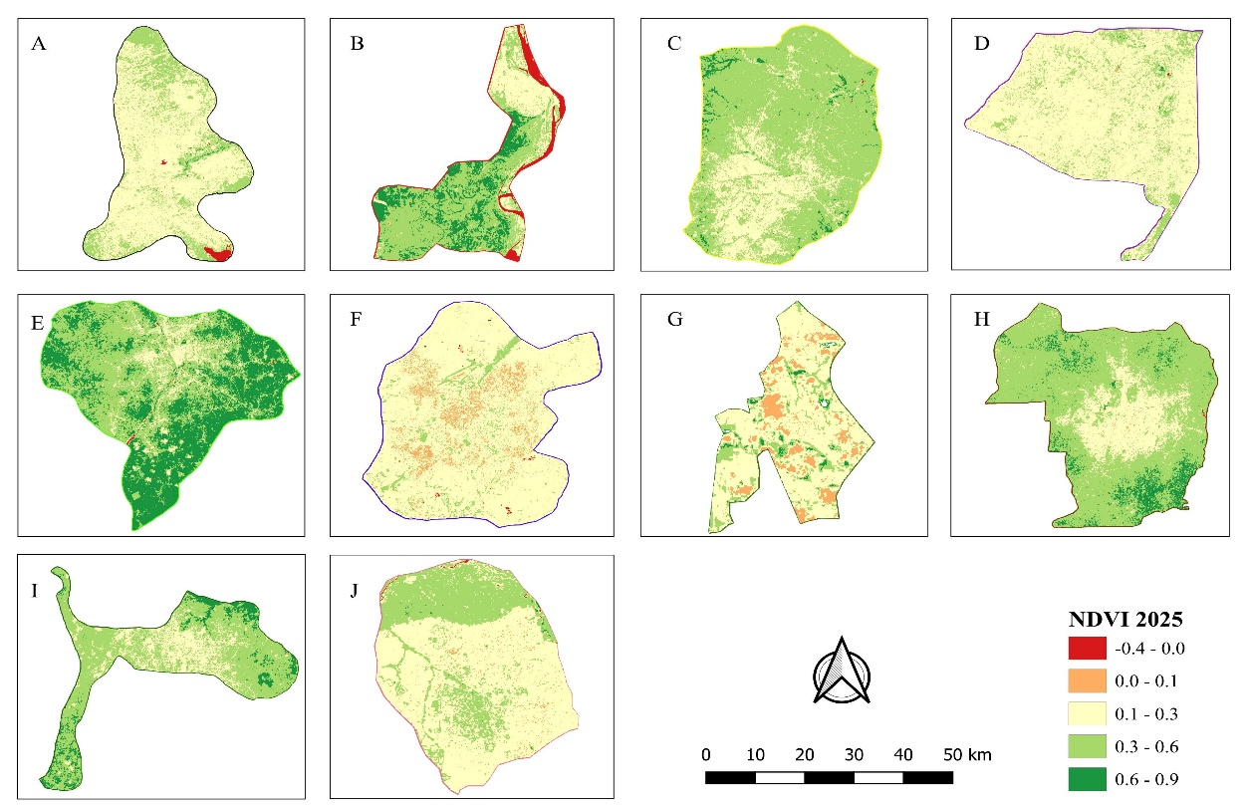
Figure 4: NDVI2025 for (a) Maiduguri, (b) Asaba, (b) Enugu, (d) Abuja, (e) Owerri, (f) Kano, (g) Ikeja, (h) Ibadan, (i) Uyo, (j) Sokoto
3.2 Traditional NDVI Statistics
In 2015, (Table 3) Ibadan and Owerri cities recorded the highest Mean NDVI values (0.57 and 0.53, respectively), indicating a high overall vegetation signal, while Kano and Maiduguri cities recorded the lowest Mean values (0.19 and 0.21, respectively), which is expected due to their arid or semi-arid climatic contexts. The Median NDVI for Ibadan (0.63) and Owerri (0.57) were particularly high, suggesting a relatively uniform distribution of moderate-to-dense vegetation across a large portion of the area. The maximum NDVI was 0.83 in both Ibadan and Enugu cities, confirming the presence of very dense, peak greenness vegetation patches in these regions. The highest degree of internal variability was indicated by the Standard Deviation (Std), which was highest in Asaba (0.19) and Ibadan (0.16), highlighting the high spatial heterogeneity and mixed land cover within these cities.
Table 4, 2025 NDVI Statistics shows that Owerri recorded the highest Mean NDVI value (0.55), followed by Ibadan (0.43), suggesting that Owerri city retained the most vigorous overall greenness of the ten cities. The lowest Mean NDVI values were again observed in Kano (0.19) and Abuja (0.25), indicating persistent low vegetation cover and a significant decrease in the overall mean for Abuja compared to 2015. Imo also showed the highest Median NDVI at 0.57. The maximum NDVI reached 1.0 in Lagos and 0.99 in Owerri, demonstrating the presence of areas of maximum spectral saturation and peak greenness in these cities. Asaba (0.23) and Owerri (0.16) exhibited the highest Standard Deviation values.
Importantly, summary statistics alone may obscure small patches of dense vegetation, reinforcing the need for complementary metrics such as GS (Jiménez et al., 2022).

Table 3: 2015 NDVI Statistics
State | Min | Max | Mean | Std | Median
Maiduguri | -0.48 | 0.68 | 0.21 | 0.08 | 0.20
Asaba | -0.21 | 0.67 | 0.41 | 0.19 | 0.51
Enugu | -0.09 | 0.83 | 0.43 | 0.13 | 0.43
Abuja | -0.23 | 0.77 | 0.39 | 0.11 | 0.39
Owerri | -0.23 | 0.75 | 0.53 | 0.13 | 0.57
Kano | -0.36 | 0.54 | 0.19 | 0.06 | 0.20
Ikeja | 0.04 | 0.76 | 0.26 | 0.13 | 0.21
Ibadan | 0.03 | 0.83 | 0.57 | 0.16 | 0.63
Uyo | 0.09 | 0.81 | 0.46 | 0.12 | 0.47
Sokoto | -0.12 | 0.63 | 0.23 | 0.09 | 0.20

Table 4: 2025 NDVI Statistics
State | Min | Max | Mean | Std | Median
Maiduguri | -0.41 | 0.77 | 0.27 | 0.08 | 0.26
Asaba | -0.31 | 0.74 | 0.42 | 0.23 | 0.48
Enugu | -0.05 | 0.88 | 0.37 | 0.11 | 0.37
Abuja | -0.16 | 0.74 | 0.25 | 0.07 | 0.24
Owerri | -0.40 | 0.99 | 0.55 | 0.16 | 0.57
Kano | -0.41 | 0.63 | 0.19 | 0.07 | 0.19
Ikeja | 0.03 | 1.00 | 0.20 | 0.13 | 0.16
Ibadan | -0.11 | 0.92 | 0.43 | 0.14 | 0.45
Uyo | 0.07 | 0.98 | 0.41 | 0.13 | 0.40
Sokoto | -0.24 | 0.67 | 0.26 | 0.11 | 0.22

3.3 Greenness Score (GS) Classification
The GS provides a more spatially honest representation of vegetation distribution by emphasizing the proportion and dominance of high-NDVI pixels. Tables and Figures 5,6,7, and 8 present the distribution of pixel percentages and hectares across the five reclassified vegetation classes for 2015 and 2025, respectively.
The 2015 and 2025 NDVI-derived greenness scores reveal substantial spatial and temporal differences in vegetation conditions across the ten Nigerian cities. In 2015, most urban centers, particularly Maiduguri (93.56%), Kano (89.87%), and Ikeja (70.45%), were predominantly characterized by NDVI values between 0.1 and 0.3, indicating extensive built-up surfaces with sparse vegetation. Cities such as Owerri, Ibadan, and Uyo exhibited more balanced greenness profiles, with moderate vegetation (0.3–0.6) accounting for between 34% and 78% of their total area. Dense vegetation (0.6–1.0) remained relatively limited across the dataset, except in vegetation-rich cities like Ibadan (56.44%) and Owerri (35.81%).
By 2025, the distribution of NDVI classes shifted markedly. Maiduguri, Abuja, Kano, and Ikeja showed substantial increases in the proportion of sparse built-up vegetation in the 0.1–0.3 range, especially Abuja, where built-up NDVI expanded from 19.56% to 83.66% of the city footprint. Conversely, several southern cities, including Asaba, Owerri, Ibadan, and Uyo, exhibited increases in moderate and dense vegetation categories. For example, Asaba’s dense vegetation rose from 0.06% in 2015 to 21.76% in 2025, while Owerri’s dense canopy expanded from 35.81% to 43.06%. These patterns indicate divergent trajectories of urban expansion and vegetation recovery across regions.
The hectare-based estimates (Tables 7 and 8) further contextualize these changes by revealing the absolute scale of vegetation gain or loss. Cities such as Abuja and Maiduguri experienced dramatic increases in the extent of sparsely vegetated urban surfaces between 2015 and 2025, reflected by shifts from 35,270.55 ha to 150,833.50 ha in Abuja and 95,644.17 ha to 74,686.95 ha in Maiduguri. Meanwhile, Ibadan and Uyo maintained extremely large areas of moderate to dense vegetation, with Ibadan’s dense vegetation still exceeding 25,000 ha in 2025 and Uyo maintaining over 12,000 ha of moderate vegetation. These spatialized hectare values emphasize that the percentage shares alone do not adequately describe ecological significance; large southern cities retain ecologically important vegetation extents despite reductions in proportional values.
Table 5: 2015 Greenness Score (Percentage)
NDVI RANGE | Range Interpretation | Maiduguri | Asaba | Enugu | Abuja | Owerri | Kano | Ikeja | Ibadan | Uyo | Sokoto
-1.0 - 0.0 | Non-vegetated areas | 1.39% | 6.55% | 0.01% | 0.06% | 0.01% | 0.07% | 0.00% | 0.00% | 0.00% | 0.01%
0.0 - 0.1 | Little to no vegetation | 0.14% | 0.75% | 0.03% | 0.12% | 0.04% | 5.56% | 0.97% | 0.20% | 0.00% | 2.25%
0.1 - 0.3 | Urban areas with sparse vegetation | 93.56% | 14.78% | 15.47% | 19.56% | 8.44% | 89.87% | 70.45% | 8.69% | 12.80% | 75.02%
0.3 - 0.6 | Moderate vegetation | 4.86% | 77.86% | 74.15% | 78.31% | 55.71% | 4.49% | 26.46% | 34.66% | 76.35% | 22.69%
0.6 - 1.0 | Dense vegetation | 0.06% | 0.06% | 10.34% | 1.94% | 35.81% | 0.00% | 2.12% | 56.44% | 10.85% | 0.03%

Table 6: 2025 Greenness Score (Percentage)
NDVI RANGE | Range Interpretation | Maiduguri | Asaba | Enugu | Abuja | Owerri | Kano | Ikeja | Ibadan | Uyo | Sokoto
-1.0 - 0.0 | Non-vegetated areas | 1.05% | 6.04% | 0.02% | 0.03% | 0.11% | 0.15% | 0.00% | 0.03% | 0.00% | 0.17%
0.0 - 0.1 | Little to no vegetation | 0.20% | 0.37% | 0.02% | 0.42% | 0.11% | 8.35% | 13.57% | 0.14% | 0.00% | 1.49%
0.1 - 0.3 | Urban areas with sparse vegetation | 73.06% | 19.04% | 25.33% | 83.66% | 9.52% | 85.05% | 70.24% | 19.35% | 22.44% | 66.08%
0.3 - 0.6 | Moderate vegetation | 25.40% | 52.80% | 71.96% | 15.78% | 47.20% | 6.45% | 14.16% | 72.15% | 67.28% | 32.08%
0.6 - 1.0 | Dense vegetation | 0.30% | 21.76% | 2.68% | 0.11% | 43.06% | 0.00% | 2.03% | 8.33% | 10.28% | 0.18%

Table 7: 2015 Greenness Score (Hectares)
NDVI RANGE | Range Interpretation | Maiduguri | Asaba | Enugu | Abuja | Owerri | Kano | Ikeja | Ibadan | Uyo | Sokoto
-1.0 - 0.0 | Non-vegetated areas | 1068.57 | 1635.48 | 9.45 | 50.85 | 60.39 | 78.57 | 0 | 86.49 | 0 | 15.84
0.0 - 0.1 | Little to no vegetation | 202.95 | 99.63 | 11.25 | 756.63 | 61.83 | 4298.49 | 627.75 | 433.35 | 0.18 | 141.66
0.1 - 0.3 | Urban areas with sparse vegetation | 74686.95 | 5156.73 | 14299.2 | 150833.5 | 5298.93 | 43767.72 | 3249 | 60148.71 | 4231.08 | 6263.1
0.3 - 0.6 | Moderate vegetation | 25967.25 | 14297.58 | 40620.51 | 28443.51 | 26278.56 | 3317.4 | 654.75 | 224231.4 | 12685.77 | 3040.38
0.6 - 1.0 | Dense vegetation | 303.12 | 5891.67 | 1511.19 | 203.49 | 23976.36 | 1.17 | 94.05 | 25892.91 | 1939.05 | 17.46

Figure 5: 2015 Greenness Score Chart
Table 8: 2025 Greenness Score (Hectares)
NDVI RANGE | Range Interpretation | Maiduguri | Asaba | Enugu | Abuja | Owerri | Kano | Ikeja | Ibadan | Uyo | Sokoto
-1.0 - 0.0 | Non-vegetated areas | 1424.97 | 1773.36 | 7.47 | 113.67 | 6.03 | 35.91 | 0 | 0 | 0 | 0.99
0.0 - 0.1 | Little to no vegetation | 139.14 | 203.49 | 15.39 | 221.85 | 20.7 | 2863.26 | 44.91 | 634.95 | 0.36 | 212.85
0.1 - 0.3 | Urban areas with sparse vegetation | 95644.17 | 4002.39 | 8734.68 | 35270.55 | 4698.45 | 46252.71 | 3269.97 | 27014.76 | 2414.43 | 7110.54
0.3 - 0.6 | Moderate vegetation | 4963.77 | 21084.48 | 41857.29 | 141176.4 | 31017.87 | 2311.56 | 1228.05 | 107732.2 | 14396.4 | 2151.09
0.6 - 1.0 | Dense vegetation | 56.79 | 17.46 | 5836.68 | 3505.5 | 19937.16 | 0 | 98.37 | 175411.4 | 2044.98 | 2.97

Figure 6: 2025 Greenness Score Chart
3.4 Statistical NDVI and Greeness Score
The comparison of NDVI statistics across the ten cities reveals a fundamental limitation in relying on descriptive statistics and central measures of tendency to evaluate vegetation conditions. This issue, often linked to the "scale effect" in landscape ecology (Wu, 2004; Chase & Knight, 2013), is evident when examining maximum values. For instance, in 2015, Enugu recorded a high maximum NDVI of 0.83, Owerri reached 0.75, and Ibadan also exhibited a maximum of 0.83 (Table 3), which would traditionally indicate that these locations are among the “greenest.” However, the hectare-level distribution reveals that the ecological relevance of these maxima varies dramatically. Enugu’s dense vegetation accounted for only 10.34% of its landscape (5,836.68 ha), while Owerri’s dense green class accounted for 35.81% (19,937.16 ha), and Ibadan’s high-NDVI footprint reached 56.44%, equivalent to a remarkable 175,411.4 ha (Table 7). Conversely, a city such as Asaba, which recorded a similarly high maximum NDVI of 0.67, had almost no dense vegetation in 2015, with only 0.06% (17.46 ha). These comparisons demonstrate that maximum NDVI acts as a single-pixel statistic that fails to capture the spatial extent of vegetation (Jensen, 2009), potentially misleading interpretations by elevating cities with isolated bright green pixels over those with expansive, continuous vegetated areas.
The mean NDVI similarly hides spatial structure, often masking the true size of the vegetation cover. In 2015, Ibadan’s mean NDVI was 0.57, only slightly higher than Uyo at 0.46 and Owerri at 0.53, suggesting comparable vegetation performance. Yet the hectare distributions illustrate enormous differences: Ibadan contained 107,732.2 ha of moderate vegetation and 175,411.4 ha of dense vegetation, far surpassing Uyo’s 14,396.4 ha and 2,044.98 ha, respectively, and Owerri’s 31,017.87 ha and 19,937.16 ha (Table 7). This discrepancy aligns with observations by Oyedepo et al. (2021), who noted that simple averaging often under-represents the massive vegetal cover along the Lagos-Ibadan corridor. Similarly, Abuja’s 2015 mean NDVI of 0.39 masked the fact that it possessed 141,176.4 ha of moderate vegetation but only 3,505.5 ha of dense vegetation, indicating a large area dominated not by lush canopy but by mid-greenness transitional vegetation. Thus, cities that appear similar in mean NDVI diverge sharply when spatial distribution is considered. This empirical evidence confirms that NDVI central-tendency statistics bias interpretation toward pixel frequency rather than ecological significance, particularly in mixed landscapes where built-up areas dominate the pixel count.
Time-series analysis further demonstrates the weakness of conventional NDVI statistics in tracking environmental change. Between 2015 and 2025, several cities experienced notable shifts in vegetation intensity and extent, but these shifts are poorly reflected in their summary metrics. For example, Asaba’s mean NDVI changed only marginally from 0.41 to 0.42 (Tables 3–4), which would imply vegetative stability. Yet the hectare coverage of dense vegetation increased dramatically from 17.46 ha to 5,891.67 ha, and moderate vegetation declined from 21,084.48 ha to 14,297.58 ha (Tables 7–8), indicating a major reorganization of vegetation structure rather than stability. Similarly, Uyo’s mean NDVI dropped slightly from 0.46 to 0.41, but its dense vegetation remained largely stable (2,044.98 ha in 2015 versus 1,939.05 ha in 2025), while moderate vegetation decreased from 14,396.4 ha to 12,685.77 ha, changes again invisible in its mean NDVI. Abuja’s example is even more striking: its mean NDVI declined from 0.39 to 0.25, suggesting severe vegetation loss; however, moderate vegetation dropped sharply from 141,176.4 ha to 28,443.51 ha, while sparse vegetation pixels expanded massively from 35,270.55 ha to 150,833.5 ha (Tables 7–8). This reflects the rapid land cover transitions and urban expansion in Abuja documented by Mshelia et al. (2024). These cases show that NDVI summary statistics obscure ecological dynamics, particularly when the proportion of built-up or sparse vegetation expands or contracts.
In contrast, the Greenness Score (GS), constructed from area-weighted NDVI classes, provides a more accurate and ecologically clear representation of vegetation patterns across space and time. In 2015, GS clearly distinguished cities by their actual greenness distribution: Ibadan, Owerri, Enugu, and Uyo ranked highest due to their large moderate and dense vegetation footprints (Figure 5), while Maiduguri, Kano, and Sokoto ranked lowest because over 75–93% of their areas fell within the low-NDVI built-up or sparse vegetation classes (Table 5). This accurately captures the "high degradation" of vegetation often found in northern forest reserves (Ahmed et al., 2022). By 2025 (Figure 6), GS captured substantial greenness gains in Asaba (dense NDVI increasing from 0.06% to 21.76%) and Owerri (dense NDVI increasing from 35.81% to 43.06%), as well as sharp declines in Abuja (dense NDVI falling from 1.94% to 0.11%, moderate declining from 78.31% to 15.78%). These city-to-city and year-to-year differences are not reflected in the min–max–mean values, which remain deceptively similar despite large shifts in vegetation distribution. The GS method, therefore, resolves the limitation of conventional NDVI analysis, the saturation and resolution issues noted by Mutanga and Skidmore (2004), by incorporating both intensity and extent. This ensures that a city with a single high-NDVI pixel does not appear “greener” than one with tens of thousands of hectares of real vegetation, enabling fair comparison among cities of different sizes (Enoguanbhor, 2023).
3.5 Comparative Analysis of NDVI Descriptive Statistics and Area-Weighted Greenness
A detailed examination of the data from 2015 to 2025 provides critical insights into the comparative greenness of Nigerian cities. This analysis demonstrates how the Greenest Score (GS) offers a more robust ranking than standard metrics like minimum, maximum, or mean Normalized Difference Vegetation Index (NDVI), consistent with established principles of urban remote sensing (Jensen, 2009).
The Limitation of Conventional Statistics Standard statistics often rank cities incorrectly by ignoring the "scale effect," a fundamental challenge in landscape pattern analysis where the size of the unit conceals the true shape size (Wu, 2004; Wu et al., 2002). A direct comparison between Ibadan and Asaba illustrates this. In 2015, Asaba’s maximum NDVI (0.67) and mean NDVI (0.41) suggested greenness comparable to Ibadan (max 0.83, mean 0.57). However, the breakdown of land area reveals a major discrepancy. Ibadan contained over 175,000 hectares of dense vegetation, whereas Asaba possessed only about 17 hectares. Relying solely on mean NDVI creates a false equivalency. This aligns with findings by Oyedepo et al. (2021), who reported that vegetal cover along the Lagos-Ibadan corridor is frequently under-characterized by simple averaging despite its vast absolute magnitude. The GS corrects this by weighing the metric by land area, correctly prioritizing Ibadan’s ecological volume.
The temporal dynamics of Abuja and Owerri between 2015 and 2025 highlight how GS tracks environmental change more effectively than mean values. Abuja experienced a collapse in moderate vegetation, dropping from roughly 141,000 ha to 28,000 ha, while built-up areas expanded by over 115,000 ha. A simple drop in mean NDVI fails to convey the severity of this transition. This trajectory is supported by Mshelia et al. (2024), whose modeling of Abuja’s land cover transitions revealed that rapid urbanization has led to a significant expansion of built-up areas at the direct expense of vegetation. In contrast, Owerri maintained stable vegetation levels. The GS captures this divergence: Abuja’s score plummets due to the massive loss of green hectares, reflecting the spatial planning challenges noted by Enoguanbhor (2023) in assessing urban patterns.
The data for Maiduguri and Kano illustrate the misleading nature of central-tendency metrics in arid, built-up environments. Both cities remained dominated by sparse or built-up land (73–93%) with consistently low mean NDVI values. While this signals poor greenness, it fails to differentiate between minor recovery and permanent degradation. Recent research by Ahmed et al. (2022) on forest reserves in the Kano region confirms that high-quality vegetation is experiencing degradation due to various pressures. Because GS accounts for the negligible hectares of high-NDVI classes in these cities, it remains low, accurately flagging them as priority zones for heat mitigation and active greening.
The cases of Enugu and Uyo demonstrate how GS distinguishes between different mechanisms of vegetation loss. Enugu lost a significant dense forest (dropping from approximately 5,800 ha to 1,500 ha), while Uyo largely maintained its moderate canopy. The GS would register a sharper decline for Enugu, highlighting the loss of high-value biodiversity. This is critical for policy, as noted by Adegun et al. (2021) in a review of green infrastructure in Nigeria, distinct strategies are needed for conserving remnant forests versus managing extensive urban tree canopies.
In cities like Sokoto, where dense vegetation is effectively negligible, relying on maximum NDVI can lead to "false positive" interpretations of greening. A high maximum value may simply reflect seasonal crops or small garden patches rather than genuine urban forestry. The GS remains low because the hectare basis is small, preventing policy misdirection. This approach addresses the saturation and resolution limitations of NDVI often cited in remote sensing literature (Mutanga & Skidmore, 2004), ensuring that limited resources are not diverted from cities with genuine restoration needs.

4. Conclusion

This study highlights the limitations of relying solely on traditional NDVI descriptive statistics, such as minimum, maximum, mean, median, and standard deviation, to evaluate urban greenness. While these metrics provide useful measures of central tendency and dispersion, they often fail to account for the spatial distribution and area coverage of vegetation, which can lead to misleading interpretations. For example, a city may exhibit a high maximum NDVI, but if that high value occurs over only a small fraction of the area, it does not represent the overall greenness of the city. Similarly, mean or median NDVI can mask the presence of small but ecologically important high-NDVI patches.
By integrating NDVI classes with their corresponding area coverage through the Greenest Score (GS), this study demonstrates a more reliable method for capturing both intensity and extent of vegetation. GS complements traditional descriptive statistics by weighting NDVI values according to their spatial significance, allowing for more accurate city-to-city and temporal comparisons. Across the analysed Nigerian cities, GS revealed substantial differences in greenness that were not apparent from central tendency measures alone, confirming the importance of considering both statistical dispersion and spatial distribution when assessing urban vegetation.

Consent
All authors declare that ‘written informed consent was obtained from the patient

References

Adegun, O. B., Ikudayisi, A. E., Morakinyo, T. E., & Olusoga, O. O. (2021). Urban green infrastructure in Nigeria: A review. Scientific African, 14, e01044. https://doi.org/10.1016/j.sciaf.2021.e01044
Adepoju, K. A., Adelabu, S. A., & Fashae, O. (2019). Vegetation response to recent trends in climate and land-use dynamics in a typical humid and dry tropical region under global change. Advances in Meteorology, 2019, Article 4946127. https://doi.org/10.1155/2019/4946127
Ahmed, S. A., Ahmed, M., Haruna, H., & Aliko, A. A. (2022). Spatio-temporal distribution of vegetation in some forest reserves of Kano Region, Nigeria. Zaria Geographer, 29(1).
Ayanlade, A., Jeje, O. D., Nwaezeigwe, J. O., Orimoogunje, O. I., & Olokeogun, O. S. (2021). Rainfall seasonality effects on vegetation greenness in different ecological zones. Environmental Challenges, 4, 100144. https://doi.org/10.1016/j.envc.2021.100144
Bean, M. (2014). The applications of NDVI in ecological research. John Wiley & Sons.
Boyd, D. S., et al. (2013). Monitoring vegetation phenology using NDVI in Southern Africa. IEEE Journal of Selected Topics in Applied Earth Observations and Remote Sensing, 6, 207–215. https://doi.org/10.1109/JSTARS.2012.2206596
Carlson, T. N., & Ripley, D. A. (1997). On the relation between NDVI, fractional vegetation cover, and leaf area index. Remote Sensing of Environment, 62(3), 241–252. https://doi.org/10.1016/S0034-4257(97)00080-8
Chase, J. M., & Knight, T. M. (2013). Scale-dependent effect sizes of ecological drivers on biodiversity: why standardised sampling is not enough. Ecology Letters, 16, 17–26. https://doi.org/10.1111/ele.12112
Enoguanbhor, E. C. (2023). Assessing urban spatial patterns within the implemented urban planned areas using GIS and remote sensing data. International Journal of Multidisciplinary Perspectives, 4(1), 87-96. https://doi.org/10.18801/ijmp.040123.14
Gitelson, A. A., & Gao, B. C. (1996). Relationships between NDVI and photosynthetic capacity in corn. International Journal of Remote Sensing, 17, 3415–3420. https://doi.org/10.1080/01431169608949084
Herrmann, S. M., Anyamba, A., & Tucker, C. J. (2005). Recent trends in vegetation dynamics in the African Sahel and their relationship to climate. Global Environmental Change, 15(4), 394–404. https://doi.org/10.1016/j.gloenvcha.2005.08.004
Huang, C., et al. (2020). Global analysis of vegetation greenness dynamics and its drivers using NDVI time series. Remote Sensing of Environment, 248, 111972.
Huete, A., et al. (2002). Overview of the radiometric and biophysical performance of the MODIS vegetation indices. Remote Sensing of Environment, 83, 195–213. https://doi.org/10.1016/S0034-4257(02)00096-2
Jensen, J. R. (2009). Remote sensing of the environment: An earth resource perspective (2nd ed.). Pearson Education India.
Jiménez, R. B., et al. (2022). Spatial resolution of NDVI: greenness exposure assessment is sensitive to spatial resolution of NDVI, aggregation area, and number of exposure quantiles. International Journal of Environmental Research and Public Health. https://www.ncbi.nlm.nih.gov/pmc/articles/PMC11649244/
Mshelia, Y. S., Onywere, S. M. E., & Letema, S. (2024). Modeling the spatial dynamics of land cover transitions and vegetation conditions in Abuja city, Nigeria. Urbanization, Sustainability and Society, 1(1), 115-132. https://doi.org/10.1108/USS-12-2023-0026
Mutanga, O., & Skidmore, A. K. (2004). Narrow band vegetation indices overcome the saturation problem in biomass estimation. International Journal of Remote Sensing, 25(19), 3999-4014. https://doi.org/10.1080/01431160310001654923
Okeke, F. I., Ndukwe, N. K., & Oturu, A. C. (2018). Cropped area mapping of Nigeria using time-series NDVI: A decision-tree threshold approach. Retrieved from https://nisngr.net/wp-content/uploads/2018/11/F.I.-OKEKE-N.K.-NDUKWE-A.C-OTURU.pdf
Oyedepo, J. A., Oluyege, D. E., & Babajide, E. I. (2021). Remote Sensing of City Extension and Vegetal Cover Changes along Lagos-Ibadan Access Strip in Nigeria. Journal of Applied Sciences and Environmental Management, 25(8), 1371-1377. https://doi.org/10.4314/jasem.v25i8.13
Rouse, J. W., et al. (1.973). Monitoring the vernal advancement and retrogradation (Green Wave effect) of natural vegetation. NASA Final Report, Greenbelt, MD, USA.
Sadeh, M., et al. (2021). Remote sensing metrics to assess exposure to residential greenness in areas with high spatial heterogeneity. Environment International, 154, 106574. https://doi.org/10.1016/j.envint.2021.106574
Thenkabail, P. S., et al. (2000). Hyperspectral vegetation indices and their relationships with agricultural crop characteristics. Remote Sensing of Environment, 71, 158–182. https://doi.org/10.1016/S0034-4257(99)00067-3
Townshend, J. R. G. (1983). Foliage density and the non-linear relationship between canopy reflectance and spectral vegetation indices. Photogrammetric Engineering and Remote Sensing, 49, 203–214.
Wu, J. (2004). Effects of changing scale on landscape pattern analysis: scaling relations. Landscape Ecology, 19(2), 125–138. https://doi.org/10.1023/B:LAND.0000021711.40074.ae
Wu, J., Shen, W., Sun, W., & Tueller, P. T. (2002). Empirical patterns of the effects of changing scale on landscape metrics. Landscape Ecology, 17(8), 761–782. https://doi.org/10.1023/a:1022995922992

