AN ASSESSMENT OF SELECT METALS IN PUTHURPADAM WETLAND AREA, MALAPPURAM DISTRICT, KERALA

ABSTRACT
Wetlands are amongst the most productive ecosystems on the Earth and provide many important services to human society. They are biologically beneficial habitats that act as a transition zone between land and water However, they are also ecologically sensitive and adaptive systems.The present study is conducted in a wetland area of Puthurpadam, Malappurram at three different locations in order to monitor the status of metal contamination in the study area. The three sites consist of a stream, paddy field, and a pond which represent significant forms, particularly in agricultural and rural settings. The study was conducted from October 2024 to March 2025. The water and soil samples were collected from all the three sites during the morning hours and plant sample was collected from the paddy field during the study period due to the absence of water at the time of cultivation. Water quality analysis was done for all the three sites, metal contamination detection was conducted by using ICP-MS method for all the water, soil and plant samples taken. Site-specific elemental distribution, Water-soil comparative analysis and Integrated contamination assessment were also recorded. The presence of lead was higher than the desired values in all the three sites and nickel at site 3 water samples. The boron shows remarkably higher values in the soil samples of all the three sites while Magnesium, Calcium and Chromium has shown slightly higher values in plant samples than the limits at site 2. In the present study, the maximum metal pollution was observed during the advent of summer season that is in the month of March. A comprehensive strategy for regular long-term monitoring of water quality of such wetlands should further be evolved into effective conservation and management programmes, bringing community participation to the forefront.
Keywords- wetland, Puthurpadam, ICP-MS, metal contamination, paddy field, water quality.
INTRODUCTION
Wetlands are amongst the most productive ecosystems on the Earth (Ghermandi et al., 2008), and provide many important services to human society (Ten Brink et al., 2012). The ecological services provided by the wetlands include flood control, groundwater replenishment, biodiversity maintenance, water purification, water conservation, etc. Among the various types of wetlands, streams, paddy fields, and ponds represent significant forms, particularly in agricultural and rural settings. Natural water contains some types of impurities whose nature and amount vary with source of water. In Kerala, the heavy metal contents in wetlands have become an important environmental index of wetland health and so the control of heavy metal pollution is key for wetland protection and restoration. Heavy metals, such as lead, arsenic, mercury, chromium, and cadmium are persistent pollutants and have their detrimental effects on the health of human being and the environment (Bhuiyan et al., 2010. Industrial activities, urbanization, and inadequate waste management practices have led to the accumulation of toxic substances in various environmental compartments, posing significant risks to the ecosystem and public health. The desirable properties of water quality should include adequate amount of dissolved oxygen, relatively low organic content, pH value near neutrality, moderate temperature, and free from excessive number of infectious agents, toxic substances and mineral matter. Existing water quality monitoring programs are not enough to yield sufficient information about the factors responsible for the degradation of water quality in fresh water systems of Kerala. Thus, an effective management strategy could be introduced based on the variation in the water quality parameters.
MATERIALS AND METHODS
Study area
The study was conducted at Puthurpadam. a wetland area in Parambilpeedika which is a rural village in Malappuram district, Kerala and is located at 9.040000°N and76.709999°E. For the purpose of this study three sites of the wetland were selected. The three sites consist of a stream, paddy field, and a pond which represent significant forms, particularly in agricultural and rural settings and it covers an area of approximately 6 acres.
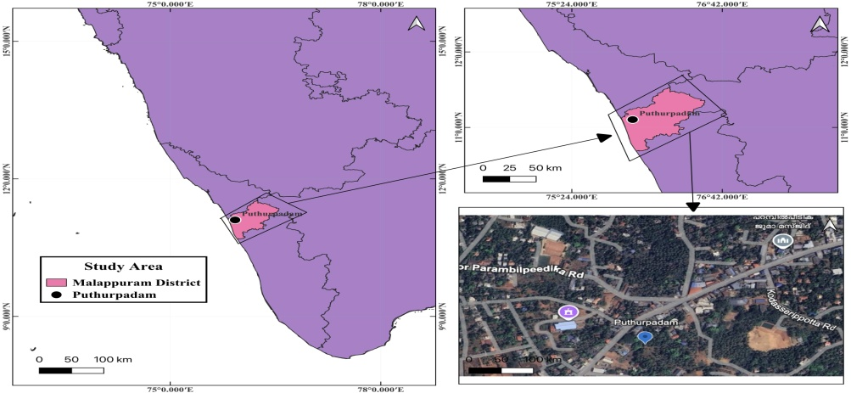
Figure 1 showing the location map of the study area

Figure 2. Site 1 stream Figure 3. Site 2 paddy field
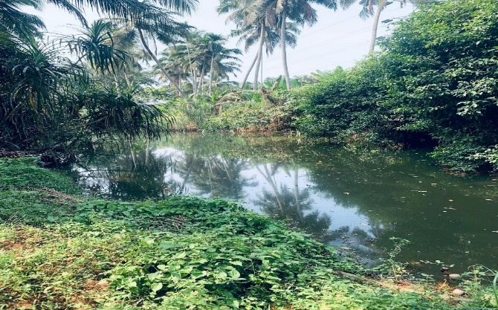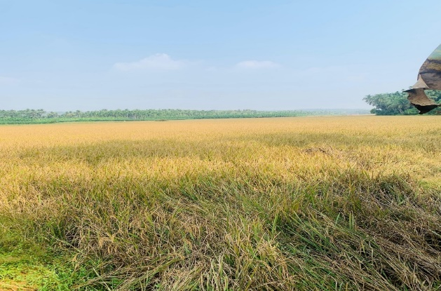
Figure 4. Site 3 pond
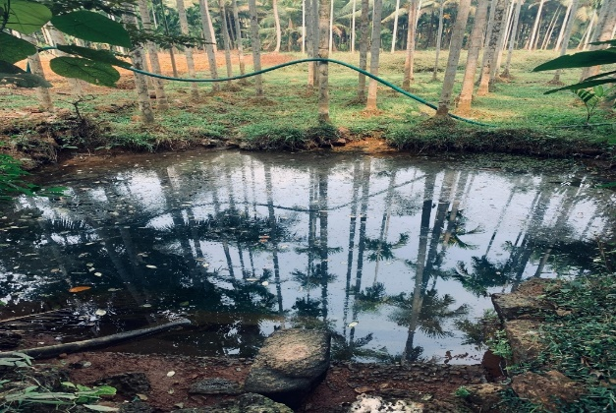
Methodology
The study was conducted from October 2024 to March 2025. The water and soil samples were collected from all the three sites and plant sample was collected from the paddy field during the study period due to the absence of water at the time of cultivation. The collection was done during the morning hours. pH, turbidity, electrical conductivity, total dissolved solids, alkalinity, total hardness, calcium hardness, magnesium hardness, calcium, magnesium, chloride, sulphate, ammonia, iron, Dissolved Oxygen (DO), Chemical Oxygen Demand (COD) and Biological Oxygen Demand (BOD) were analyzed. Heavy metal analysis was done by ICP-MS method for the water, soil and plant samples taken. The health status of the three sites were compared on the basis of Site-Specific Elemental Distribution, Water-Soil Comparative Analysis and Integrated Contamination Assessment.
Collection of the samples
Composite sampling method was adopted for collection of water samples(figure 5.) from the three sites of wetland. Sample for chemical analysis were collected in polyethylene bottles, about 20–30 cm below the surface, to avoid surface contaminants. The study was also carried out on soil samples(figure 6.), collected from different sampling sites using a stainless steel knife at surface level of about 0–15 cm in depth because it is considered to represent the average root zone for the nutrients uptake and heavy metals burden by plants. Samples were placed in clean, labeled plastic bags and marked with the location, date are noted in the field. Plant leaf sample(figure 7.) was collected from the paddy field during the study period from the month of January to March. The part of the plant mainly used is the leaf which is then shade-dried and cut into small pieces for further processing.
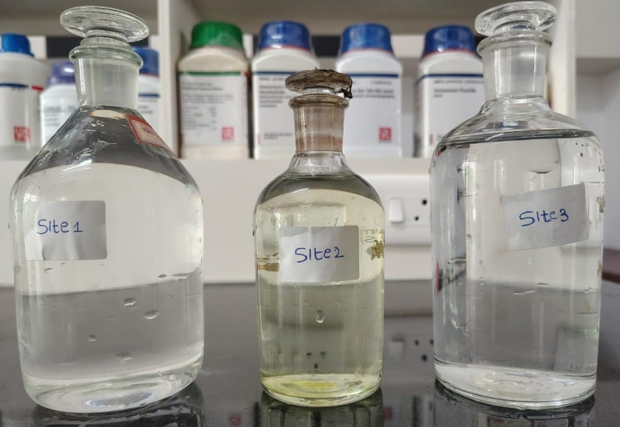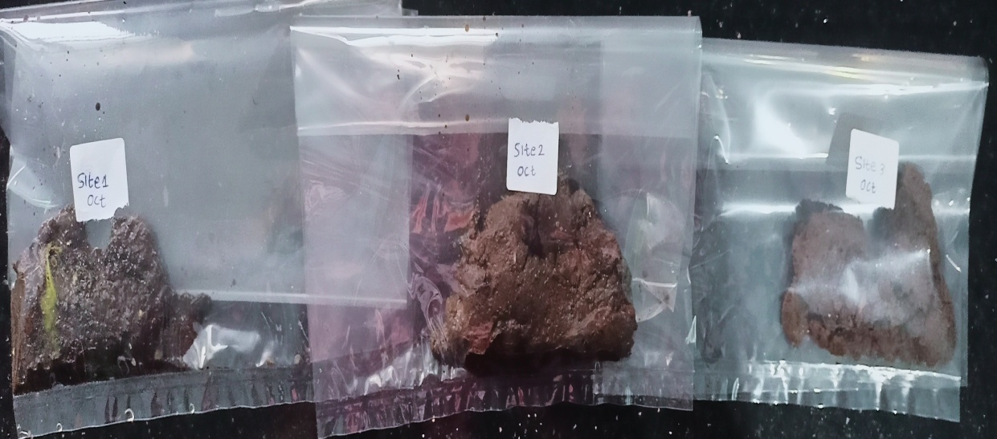
Figure 5. water samples Figure 6. Soil samples
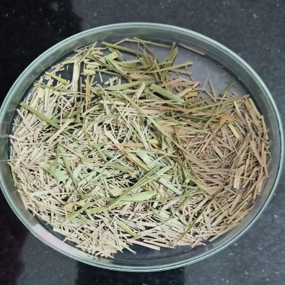
Figure 7. plant leaf sample
Heavy Metal Analysis by ICP-MS Method
The digestion method for the preparation of water samples for ICP-MS analysis, Add 25 mL of the water sample to a PTFE beaker and acidify with 2.0 mL of concentrated HNO₃ and 6.0 mL of concentrated HCl. Heat the beaker until the solution becomes clear and transparent. After cooling to room temperature, transfer the sample to a 50 mL volumetric flask. Bring the sample up to volume with distilled water. Centrifuge the sample. After check in analysis of heavy metals by ICP-MS method.
The digestion method for the preparation of soil samples for ICP-MS analysis follows Homogenize and accurately weigh 0.1 g of the soil or sediment sample into a polytetrafluoroethylene (PTFE) crucible and moisten with 3 mL of ultrapure water. Add 4 mL of an acid mixture (HF:HClO₄ = 5:1,) to the crucible, and heat the sample to 260 ˚C. Add a further 4 mL of the acid mixture and heat until emission of white smoke has ended. Add 2 mL of aqua regia (HCl:HNO₃ = 3:1) to re-dissolve the mixture. Then add 10 mL of 10% aqua regia to the extract; the sample solution should become clear and transparent. Cool the solution, add 2 mL HNO₃, transfer the sample extract to a 100 mL PTFE volumetric flask and make up to volume with distilled water. After the sample is completely cooled, add 2 mL of water and 3 mL of 30% H₂O₂ . Heat until effervescence subsides and cool the vessel. Continue to add 30% H₂O₂ in 1 mL aliquots and heating the acid-peroxide digestate until the volume is reduced. Heat at 95 ˚C ±5 ˚C without boiling for two hours. After cooling, dilute to 100 mL with distilled water. Particulates in the digestate should then be removed by filtration, by centrifugation and the sample is ready for analysis by ICP-MS.(figure 8.)
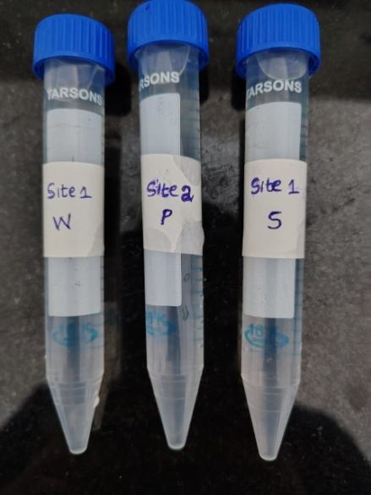
Figure 8. digested samples for ICPMS analysis
Approximately 0.3 g of paddy leaf sample is digested using a mixture of 5 mL HNO₃ and 1 mL HCl and H₂O₂ 2 mL are added in a closed vessel microwave digestion system. The samples are heated and maintained at a temperature of 200 ˚C for 15 min. After digestion, each sample is transferred to a volumetric flask (50 mL). The flask is then made up to volume with distilled water prior to analysis by ICP-MS.
RESULTS
The water parameters (Table 1) in all the three sites tested to be agreeing with the accepted values of BIS Drinking Water specification (IS:10500-2012) except the concentration of ammonium that was slightly higher in site 1 and site 3. DO was observed to be less, the BOD was Below Display Level (BDL) and turbidity was higher in all the three sites respectively.
Table 1. Water Quality Parameters of the all the three selected sites
PARAMETERS | Unit | Acceptable value – BIS Drinking Water specification (IS:10500-2012) | SITE 1 | SITE 2 | SITE 3
pH |  | 6.5-8.5 | 6.9 | 6.65 | 6.57
TDS | mg/L | 500 | 52.6 mg | 41.2 | 40.5
DO | mg/L | 6.5-8.5 | 5.94 | 5.78 | 4.71
BOD | mg/L | 1-10 | BDL | BDL | BDL
COD | mg/L | 250 | 24 | 32 | 48
TURBIDITY | NTU | 1 | 1.3 | 1.7 | 4
TOTAL ALKALINITY | mg/L | 200 | 41 | 19 | 30
CALCIUM HARDNESS AS CaCO3 | mg/L | 10-500 | 31 | 15 | 14
MAGNESIUM HARDNESS AS  CaCO3 | mg/L | 2.3-52.1 | 5 | 6 | 6
TOTAL HARDNESS AS CaCO3 | mg/L | 200 | 36 | 21 | 20
CONDUCTIVITY | µS/cm | 750 | 109.65 | 87.0 | 81.2

BDL= BELOW DISPLAY LEVEL

ICPMS ANALYSIS
Table 2. showing ICPMS analysis of water and soil sample of site 1 during the study period in mg/L.
METALS | OCT |  | NOV |  | DEC |  | JAN |  | FEB |  |  | MAR
 | W | S | W | S | W | S | W | S | W | S | W |  | S
Li | 0 .002 | 0.031 | 0.002 | 0.043 | 0.003 | 0.107 | 0.002 | 0.008 | 0.002 | 0.037 | 0.006 |  | 0.049
B | 0.278 | 26.529 | 0.202 | 17.047 | 0.228 | 38.282 | 0.287 | 40.630 | 0.209 | 11.905 | 0.077 |  | 2.040
Na | 6.274 | 94.996 | 6.164 | OR | 5.830 | 102.386 | 4.825 | OR | 4.331 | OR | 26.40 |  | 1221.89
Mg | 1.435 | 11.955 | 1.537 | 39.645 | 1.723 | 20.017 | 1.243 | 63.750 | 1.210 | 65.387 | 3.759 |  | 106.84
Al | 0.006 | 95.892 | 0.280 | 68.530 | 0.320 | OR | 0.243 | OR | 0.169 | 77.523 | 0.759 |  | 174.18
K | 0.875 | 4.964 | 0.716 | 5.110 | 0.926 | 20.017 | 0.556 | 32.584 | 0.508 | 3.444 | 0.718 |  | 15.327
Ca | 0.064 | 0.885 | 0.076 | 1.776 | 0.070 | 3.842 | 0.058 | 2.324 | 0.052 | 2.334 | 1.982 |  | 3.715
V | 0.035 | 0.073 | 0.206 | 0.046 | 0.210 | 0.106 | 0.042 | 0.105 | 0.047 | 0.086 | 0.183 |  | 0.495
Cr | 0.012 | 0.273 | 0.017 | 0.209 | 0.018 | 0.359 | 0.008 | 0.311 | 0.009 | 0.160 | 0.501 |  | 0.510
Mn | 0.026 | 0.145 | 0.013 | 0.251 | 0.009 | 0.471 | 0.013 | 0.603 | 0.015 | 0.111 | 0.051 |  | 0.830
Fe | 0.040 | 2.448 | 0.015 | 1.595 | 0.022 | 3.605 | 0.018 | 3.974 | 0.011 | 2.746 | 0.061 |  | 8.154
Ni | 0.009 | 0.041 | 0.007 | 0.032 | 0.011 | 0.069 | 0.005 | 0.082 | 0.014 | 0.078 | 0.049 |  | 0.098
Co | 0.0002 | 0.006 | 0.0002 | 0.008 | 0.0002 | 0.019 | 0.0001 | 0.029 | 0.0004 | 0.011 | 0.0003 |  | 0.026
Cu | 0.006 | 0.773 | 0.005 | 0.712 | 0.008 | 0.435 | 0.006 | 0.087 | 0.009 | 0.036 | 0.013 |  | 0.093
Zn | 0.007 | 0.053 | 0.009 | 0.044 | 0.007 | 0.066 | 0.005 | 0.019 | 0.007 | 0.009 | 0.027 |  | 0.030
As | 0.002 | 0.242 | 0.013 | 0.161 | 0.012 | 0.222 | 0.002 | 0.656 | 0.003 | 0.228 | 0.030 |  | 0.200
Sr | 0.029 | 0.325 | 0.030 | 0.356 | 0.030 | 0.039 | 0.025 | 0.570 | 0.025 | 0.025 | 0.060 |  | 0.468
Cd | 0.0006 | 0.005 | 0.0009 | 0.004 | 0.001 | 0.006 | 0.0001 | 0.055 | 0.0004 | 0.0017 | 0.001 |  | 0.006
Ba | 0.029 | 0.269 | 0.036 | 0.280 | 0.032 | 0.986 | 0.031 | 1.573 | 0.032 | 0.234 | 0.052 |  | 0.788
Pb | 0.021 | 0.211 | 0.018 | 0.175 | 0.023 | 0.198 | 0.007 | 0.109 | 0.22 | 0.082 | 0.275 |  | 0.138
OR= OVER THE RANGE

The ICPMS analysis of site 1 (table 2.)water sample during the time period of six months shows that the concentration of Na(26.404mg/L) was the highest followed by Mg(3.759mg/L) and K(0.718mg/L) in the month of March. The soil sample analysis reported the presence of high levels of Na(1221.899mg/L), Al(174.186mg/L) and Mg(106.842mg/L) respectively during the month of March. The lowest concentration was observed for Co, Cd and Li respectively during the study period for both the water and soil samples tested.

Table 3. showing ICPMS analysis of water, soil and plant sample of site 2 during the study period in mg/L.
OR= OVER THE RANGE

METALS | OCT |  | NOV |  | DEC |  | JAN |  | FEB |  |  | MAR
 | W | S | W | S | W | S | P | S | P | S | P |  | S
Li | 0.002 | 0.026 | 0.003 | 0.052 | 0.002 | 0.017 | 0.0006 | 0.111 | 0.0009 | 0.046 | 0.004 |  | 0.071
B | 0.230 | 11.307 | 0.241 | 13.864 | 0.340 | 5.619 | 0.206 | 46.265 | 0.191 | 10.881 | 0.144 |  | 37.442
Na | 5.286 | 0R | 5.827 | 72.645 | 5.472 | OR | 8.509 | OR | 8.383 | OR | 105.98 |  | 762.78
Mg | 1.460 | 38.319 | 1.550 | 45.558 | 1.265 | 23.885 | 7.615 | 88.728 | 5.091 | 69.616 | 19.44 |  | 57.802
AI | 0.323 | 52.263 | 0.377 | 65.127 | 0.296 | 31.341 | 0.802 | OR | 1.330 | 78.077 | 10.970 |  | 192.091
K | 0.875 | 3.355 | 0.898 | 7.848 | 0.344 | 1.944 | 23.085 | 13.478 | 35.490 | 5.094 | 84.682 |  | 13.316
Ca | 0.068 | 1.698 | 0.078 | 1.965 | 0.064 | 1.150 | 0.328 | 3.213 | 0.312 | 2.467 | 0.9206 |  | 2.172
V | 0.038 | 0.039 | 0.059 | 0.046 | 0.037 | 0.040 | 0.015 | 3.220 | 0.007 | 0.089 | 0.0539 |  | 0.267
Cr | 0.012 | 0.191 | 0.014 | 0.237 | 0.010 | 0.164 | 0.031 | 0.160 | 0.037 | 0.177 | 0.2063 |  | 0.403
Mn | 0.014 | 0.174 | 0.010 | 0.099 | 0.008 | 0.004 | 0.298 | 0.551 | 1.180 | 0.112 | 2.688 |  | 0.268
Fe | 0.023 | 1.426 | 0.040 | 1.286 | 0.021 | 0.086 | 0.085 | 0.331 | 0.175 | 2.462 | 1.085 |  | 5.632
Ni | 0.012 | 0.026 | 0.010 | 0.028 | 0.006 | 1.164 | 0.016 | 0.081 | 0.034 | 0.062 | 0.658 |  | 0.028
Co | 0.0002 | 0.006 | 0.0002 | 0.006 | 0.0001 | 0.021 | 0.0007 | 30.516 | 0.001 | 0.016 | 0.005 |  | 0.107
Cu | 0.011 | 0.778 | 0.009 | 0.780 | 0.006 | 0.004 | 0.056 | 0.094 | 0.015 | 0.046 | 0.101 |  | 0.100
Zn | 0.009 | 0.039 | 0.016 | 0.044 | 0.006 | 0.034 | 0.013 | 0.021 | 0.016 | 0.009 | 0.085 |  | 0.031
As | 0.002 | 0.061 | 0.0039 | 0.197 | 0.002 | 0.065 | 0.0007 | 0.785 | 0.0005 | 0.283 | 0.002 |  | 0.555
Sr | 0.0270 | 0.327 | 0.030 | 0.348 | 0.023 | 0.269 | 0.233 | 0.045 | 0.094 | 0.244 | 0.267 |  | 0.0372
Cd | 0.001 | 0.004 | 0.005 | 0.005 | 0.002 | 0.003 | 0.0002 | 0.005 | 0.0004 | 0.002 | 0.007 |  | 0.004
Ba | 0.028 | 0.186 | 0.027 | 0.398 | 0.017 | 0.179 | 0.290 | 0.550 | 0.525 | 0.370 | 0.435 |  | 0.710
Pb | 0.089 | 0.177 | 0.026 | 0.189 | 0.068 | 0.237 | 0.012 | 0.075 | 0.036 | 0.147 | 0.194 |  | 0.157
The ICPMS analysis of site 2 (table 3.)water sample during the time period of six months shows that the concentration of Na(5.827mg/L) was the highest followed by Mg(1.550mg/L) and K(0.898mg/L) in the month of November. The soil sample analysis reported (Table 2) the higher presence of Na(762.78mg/L), Al(192.091mg/L) during March and Mg(88.728mg/L) during the month of January respectively. The plant sample shows higher concentrations of K(84.682mg/L), Na(105.98mg/L) and Mg(19.44mg/L) respectively in March. The lowest concentration was observed for Cd, Co and Li during the study period for all the three samples tested.

Table 4. showing ICPMS analysis of water and soil sample of site 3 during the study period in mg/L.
METALS | OCT |  | NOV |  | DEC |  | JAN |  | FEB |  |  | MAR
 | W | S | W | S | W | S | W | S | W | S | W |  | S
Li | 0.002 | 0.022 | 0.003 | 0.096 | 0.002 | 0.028 | 0.002 | 0.113 | 0.002 | 0.048 | 0.006 |  | 0.068
B | 0.257 | 7.762 | 0.339 | 34.502 | 0.400 | 10.205 | 0.189 | 44.672 | 0.272 | 13.971 | 0.040 |  | 10.432
Na | 5.225 | OR | 6.629 | 0R | 6.439 | 109.216 | 5.479 | OR | 6.104 | 0R | 31.200 |  | 1285.569
Mg | 0.878 | 24.054 | 1.872 | 99.794 | 1.276 | 11.125 | 1.024 | 85.924 | 1.052 | 67.856 | 3.207 |  | 116.807
Al | 0.234 | 37.786 | 0.353 | 0R | 0.460 | 41.207 | 0.259 | OR | 0.318 | 95.467 | 1.012 |  | 148.993
K | 0.781 | 2.059 | 0.896 | 9.288 | 0.794 | 1.765 | 0.513 | 8.550 | 0.502 | 9.526 | 2.225 |  | 9.706
Ca | 0.045 | 1.079 | 0.097 | 3.790 | 0.061 | 0.469 | 0.062 | 3.153 | 0.057 | 2.377 | 0.192 |  | 4.302
V | 0.010 | 0.033 | 0.039 | 0.112 | 0.029 | 0.033 | 0.077 | 0.176 | 0.004 | 0.091 | 0.207 |  | 0.444
Cr | 0.015 | 0.124 | 0.013 | 0.392 | 0.011 | 0.089 | 0.011 | 0.400 | 0.009 | 0.197 | 0.708 |  | 0.333
Mn | 0.015 | 0.076 | 0.011 | 0.255 | 0.020 | 0.065 | 0.019 | 0.332 | 0.023 | 0.383 | 0.060 |  | 0.275
Fe | 0.012 | 1.052 | 0.023 | 3.735 | 0.021 | 1.00 | 0.017 | 5.616 | 0.028 | 3.281 | 0.041 |  | 5.681
Ni | 0.009 | 0.025 | 0.011 | 0.072 | 0.008 | 0.020 | 0.011 | 0.121 | 0.044 | 0.077 | 0.111 |  | 0.085
Co | 0.0003 | 0.003 | 0.0002 | 0.071 | 0.0003 | 0.002 | 0.0003 | 0.021 | 0.0003 | 0.015 | 0.025 |  | 0.013
Cu | 0.006 | 0.395 | 0.009 | 0.571 | 0.008 | 0.178 | 0.010 | 0.076 | 0.018 | 0.175 | 0.030 |  | 0.078
Zn | 0.005 | 0.023 | 0.012 | 0.044 | 0.008 | 0.012 | 0.008 | 0.018 | 0.013 | 0.015 | 0.014 |  | 0.029
As | 0.002 | 0.037 | 0.002 | 0.469 | 0.002 | 0.002 | 0.005 | 0.650 | 0.002 | 0.175 | 0.040 |  | 0.410
Sr | 0.017 | 0.193 | 0.040 | 0.574 | 0.022 | 0.112 | 0.019 | 0.456 | 0.020 | 0.328 | 0.047 |  | 0.416
Cd | 0.001 | 0.010 | 0.0005 | 0.0061 | 0.0004 | 0.002 | 0.0008 | 0.005 | 0.002 | 0.007 | 0.007 |  | 0.004
Ba | 0.025 | 0.117 | 0.037 | 0.400 | 0.027 | 0.099 | 0.028 | O.461 | 0.029 | 0.708 | 0.039 |  | 0.510
Pb | 0.041 | 0.179 | 0.028 | 0.232 | 0.012 | 0.076 | 0.026 | 0.094 | 0.087 | 0.117 | 0.226 |  | 0.314

OR=OVER THE RANGE

The ICPMS analysis of site 3 (table 4.)water sample during the time period of six months shows (Table3) that the concentration of Na(31.2mg/L) was the highest followed by Mg(3.207mg/L) and K(2.25mg/L) in the month of March. The soil sample analysis reported the higher presence of Na(1285.569mg/L), Al(148.993mg/L) and Mg(116.807mg/L) respectively during the month of March. The lowest concentration was observed for Co, Cd and Li respectively during the study period for both the samples tested.

According to the analysis, site 1 and site 3 (Table 5 & Figure 9) comparatively shows higher levels of heavy metals in water samples than in site 2 but all values occur in the range of desirable limits, except in case of lead which is slightly higher than the desired values in all the three sites and nickel only at site 3. Also site 1 and site 3 comparatively shows (Table 6 & Figure 10) higher levels of non-heavy metals in water samples mainly sodium, magnesium and potassium than in site 2 but all the values occur in the range of desirable limits.

As per the analysis, site 1 and site 3 comparatively shows (Table 7 & Figure 11) higher levels of iron in soil samples than in site 2 while high levels of cobalt and vanadium is seen in site 2 than others but all the values occur in the range of desirable limits. The analysis also recorded that site 1 and site 3 comparatively shows (Table 8 & Figure 12) higher levels of non-heavy metals like sodium, magnesium and potassium in soil samples than in site 2 but all the values falls within the range of desirable limits, except in the case of boron which shows remarkably higher values in all the three sites.

The present analysis shows that the heavy metal accumulation was least in soil, highest in water followed by plant sample. However, plant has retained heavy metals like manganese, iron and nickel from the water at site 2 which is at desirable limits while magnesium and chromium has shown slightly higher values in plant than the limits. The study also recorded the retention of non-heavy metals like sodium, magnesium and potassium from water into the plant sample, though the least level of non-heavy metals is observed in the soil sample at site 2, however calcium has shown a higher value than the limits in plant sample.
Table 5. showing the comparison of heavy metal concentration in the water samples of site 1, 2 &3
HEAVY METALS (WATER SAMPLE) | SITE 1 (MEAN) | SITE 2 (MEAN) | SITE3 (MEAN) | water desirable limits mg/L
V | 0.120 | 0.044 | 0.061 | no specific guidelines
Cr | 0.094 | 0.01 | 0.127 | no specific guidelines
Mn | 0.021 | 0.028 | 0.024 | 0.1-1.5
Fe | 0.027 | 0.009 | 0.023 | 0.1
Ni | 0.015 | 0.0001 | 0.032 | 0.0002-0.02
Co | 0.0002 | 0.008 | 0.004 | no specific guidelines
Cu | 0.007 | 0.01 | 0.013 | 0.001-0.02
Zn | 0.010 | 0.002 | 0.013 | 0.005-1
As | 0.010 | 0.026 | 0.027 | 0.01-0.1
Cd | 0.0006 | 0.002 | 0.03 | 0.0001-0.005
Pb | 0.094 | 0.061 | 0.07 | 0.001-0.05

Table 6. The comparison of non heavy metal concentration in water samples of site 1, 2 &3
NON HEAVY METALS (WATER SAMPLE) | SITE 1 (MEAN) | SITE 2 (MEAN) | SITE 3 (MEAN) | water desirable limits mg/L
Li | 0.002 | 0.002 | 0.002 | 1-100
B | 0.213 | 0.27 | 0.249 | 1-5
Na | 8.953 | 5.526 | 10.179 | 10,000
Mg | 1.817 | 1.425 | 1.551 | 100
Al | 0.296 | 0.332 | 0.439 | 200
K | 0.712 | 0.705 | 0.951 | 2
Ca | 0.383 | 0.07 | 0.085 | 200
Sr | 0.033 | 0.026 | 0.027 | 500
Ba | 0.035 | 0.024 | 0.03 | 100

Table 7. The comparison of heavy metal concentration in soil samples of site 1, 2 &3
HEAVY METALS (SOIL SAMPLE) | SITE 1 (MEAN) | SITE 2 (MEAN) | SITE 3 (MEAN) | soil desirable limits mg/kg
V | 0.151 | 0.616 | 0.148 | no guidelines
Cr | 0.303 | 0.222 | 0.255 | 10
Mn | 0.401 | 0.201 | 0.231 | 500
Fe | 3.753 | 1.870 | 3.394 | 425
Ni | 0.066 | 0.231 | 0.066 | 50
Co | 0.016 | 5.112 | 0.020 | 10
Cu | 0.356 | 0.300 | 0.245 | 50
Zn | 0.036 | 0.029 | 0.023 | 200
As | 0.284 | 0.324 | 0.290 | 20
Cd | 0.012 | 0.003 | 0.005 | 1
Pb | 0.152 | 0.163 | 0.168 | 100

Table 8. showing the comparison of non heavy metal concentration in soil samples of site 1, 2 &3
NON HEAVY METALS (SOIL SAMPLES) | SITE 1 (MEAN) | SITE 2 (MEAN) | SITE 3 (MEAN) | soil desirable limits mg/kg
Li | 0.045 | 0.053 | 0.062 | 5-50
B | 22.738 | 20.896 | 20.257 | 5
Na | 473.090 | 417.712 | 697.392 | 1000-30,000
Mg | 51.265 | 53.984 | 67.593 | 2,400-8,000
Al | 104.031 | 83.779 | 80.863 | 5000-1,00,000
K | 13.574 | 7.505 | 6.815 | 700
Ca | 2.479 | 2.110 | 2.528 | 12,000
Sr | 0.297 | 0.211 | 0.346 | 100
Ba | 0.688 | 0.398 | 0.366 | 50

Table 9. showing the concentration of heavy metals in soil-water-plant interaction at site 2
HEAVY METALS | SITE 2 WATER (MEAN) | SITE 2 PLANT (MEAN) | paddy leaf desirable limits mg/kg | SITE 2 SOIL (MEAN)
V | 0.044 | 0.0253 | 0.003 | 0.616
Cr | 0.01 | 0.0914 | 0.01 | 0.222
Mn | 0.028 | 1.388 | 0.1 | 0.201
Fe | 0.009 | 0.361 | 0.5 | 1.87
Ni | 0.0001 | 0.236 | 3 | 0.231
Co | 0.008 | 0.0022 | 0.01 | 5.112
Cu | 0.01 | 0.0573 | 20 | 0.3
Zn | 0.0026 | 0.038 | 80 | 0.029
As | 0.026 | 0.001 | 0.2 | 0.324
Cd | 0.0026 | 0.002 | 1 | 0.003
Pb | 0.061 | 0.08 | 5 | 0.163

Table 10. The concentration of non heavy metal in soil-water-plant interaction at site 2
NON HEAVY METALS | SITE 2 WATER (MEAN) | SITE 2 PLANT MEAN) | paddy leaf desirable limits mg/kg | SITE 2 SOIL (MEAN)
Li | 0.002 | 0.0006 | 1 | 0.053
B | 0.27 | 0.18 | 0.003 | 20.896
Na | 5.526 | 40.95 | 10,000 | 417.712
Mg | 1.425 | 10.71 | 0.1 | 53.984
AI | 0.332 | 4.367 | 1000 | 83.779
K | 0.705 | 47.75 | 0.3 | 7.505
Ca | 0.07 | 0.5202 | 0.3 | 2.11
Sr | 0.026 | 0.198 | 100 | 0.211
Ba | 0.024 | 0.416 | 10 | 0.398
Site-Specific Elemental Distribution of Site 1
Table 11. Site 1 Water Metal Concentrations (mg/L)
Metal | Oct | Nov | Dec | Jan | Feb | Mar
Na | 6.274 | 6.164 | 5.830 | 4.825 | 4.331 | 26.404
Mg | 1.435 | 1.537 | 1.723 | 1.243 | 1.210 | 3.759
Pb | 0.021 | 0.018 | 0.023 | 0.007 | 0.220 | 0.275

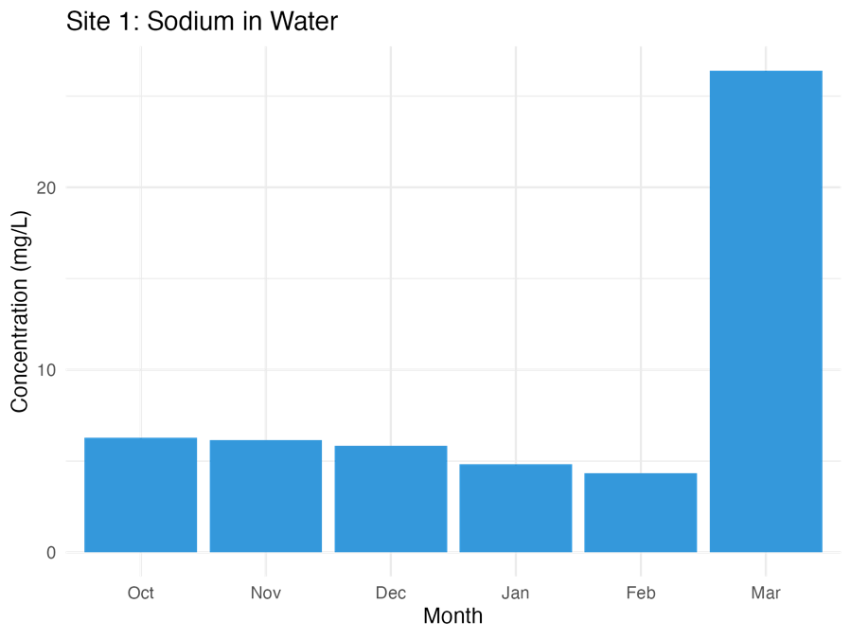
Figure 15. March shows 6× higher sodium (26.4 mg/L) than other months, suggesting winter road salt runoff

Table 12. Site 1 Soil Metal Concentrations (mg/kg)
Metal | Oct | Nov | Dec | Jan | Feb | Mar
Al | 95.892 | 68.530 | OR | OR | 77.523 | 174.186
Fe | 2.448 | 1.595 | 3.605 | 3.974 | 2.746 | 8.154
Pb | 0.211 | 0.175 | 0.198 | 0.109 | 0.082 | 0.138
Site-Specific Elemental Distribution of Site 2
Table 13. Site 2 Plant Metal Concentrations (mg/L)
Metal | Jan | Feb | Mar
K | 23.085 | 35.490 | 84.682
Na | 8.509 | 8.383 | 105.980
Co | 0.0007 | 0.0010 | 0.0050

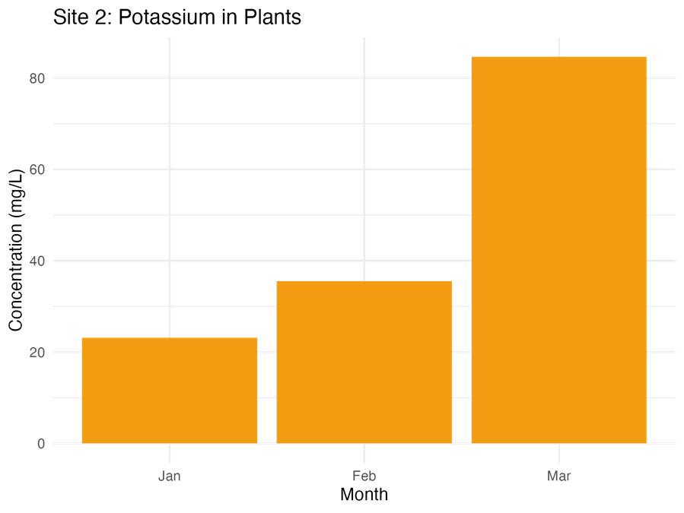
Figure 16. Industrial bioaccumulation evident with 3.7× increase from Jan-Mar (84.7 mg/L)

Table 14. Site 2 Soil Metal Concentrations (mg/kg)
Metal | Oct | Nov | Dec | Jan | Feb | Mar
Mg | 38.319 | 45.558 | 23.885 | 88.728 | 69.616 | 57.802
Al | 52.263 | 65.127 | 31.341 | OR | 78.077 | 192.091
Co | 0.006 | 0.006 | 0.021 | 30.516 | 0.016 | 0.107

Site-Specific Elemental Distribution of Site 3
Table 15. Site 3 Water Metal Concentrations (mg/L)
Metal | Oct | Nov | Dec | Jan | Feb | Mar
Na | 5.225 | 6.629 | 6.439 | 5.479 | 6.104 | 31.200
Mg | 0.878 | 1.872 | 1.276 | 1.024 | 1.052 | 3.207
Cr | 0.015 | 0.013 | 0.011 | 0.011 | 0.009 | 0.708

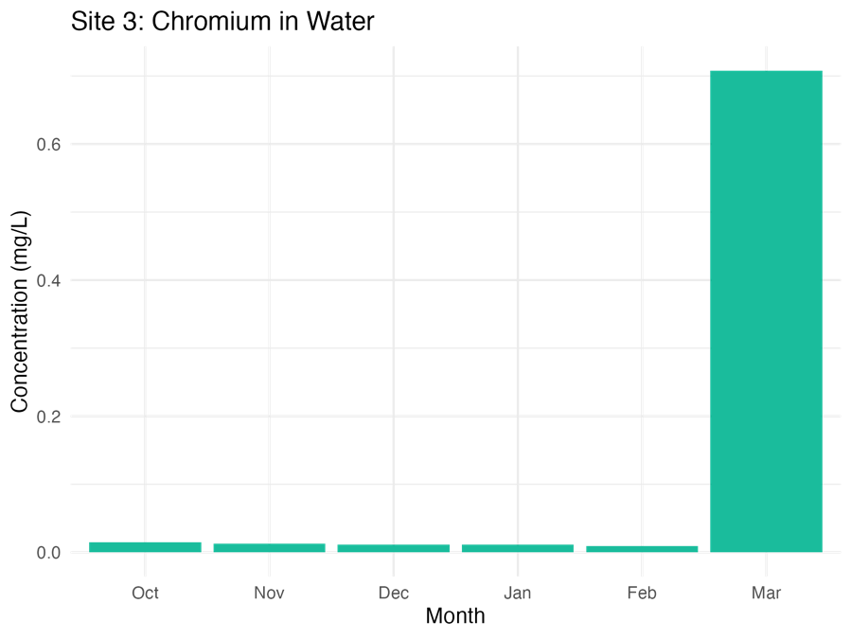 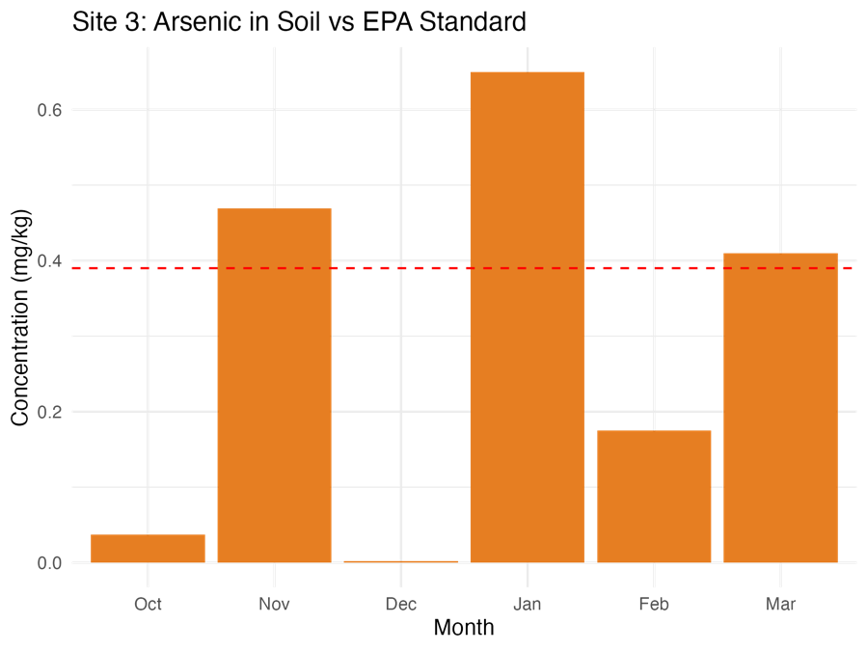 figure 17. March chromium (0.71 mg/L) exceeds EPA limits figure 18. Exceeds EPA limit (0.39 mg/kg) in Jan/Mar
Table 16. Site 3 Soil Metal Concentrations (mg/kg)
Metal | Oct | Nov | Dec | Jan | Feb | Mar
As | 0.037 | 0.469 | 0.002 | 0.650 | 0.175 | 0.410
Cr | 0.124 | 0.392 | 0.089 | 0.400 | 0.197 | 0.333
Fe | 1.052 | 3.735 | 1.000 | 5.616 | 3.281 | 5.681

Water-Soil Comparative Analysis
Table 17. Cross-Site Transfer Factors (Soil: Water Ratio)
Element | Site 1 | Site 2 | Site 3 | Scientific Interpretation
Na | 57 | 104 | 128 | Cation exchange dominance
As | 33 | 28 | 41 | Pesticide legacy at Site 3
Cr | 25 | 19 | 17 | Industrial solubility control
Pb | 8 | 5 | 6 | Moderate mobility
Integrated Contamination Assessment
Table 18. Site-Specific Risk Indices
Parameter | Site 1 | Site 2 | Site 3 | Regulatory Threshold
Water PLI | 0.45 | 0.51 | 0.68 | <1.0 (Safe)
Soil PLI | 1.8 | 2.3 | 3.1 | >3 (Critical)
Priority Metals | Pb, Al | K, Co | As, Cr | -

DISSCUSSION
The current study was carried out to examine the habitat health of the selected sites in Puthurpadam, a wetland area in Malappurram district, Kerala. Site 1 stream reveals the presence of slightly higher levels of ammonia and turbidity showing insufficient biological filtration and industrial waste discharge into water respectively while the lesser DO value indicates mild pollution in this site. Site 2, in the paddy field, the water parameters were in the limits of BIS guidelines except for higher turbidity indicating industrial waste disposal into water and lower DO value that alerts the presence of some pollutants in water. Site 3, pond revealed the presence of highest concentration of turbidity and ammonia than the other two sites showing higher cases of industrial wastewater, sewage discharge and high levels of nitrogenous waste. The lowest DO recorded indicates the presence of more waste that uses up the dissolved oxygen in water. Changes in physical and chemical parameters such as Total Dissolved Solids, pH, conductivity, Total Hardness, Nitrates were analyzed in the study sites were within the Permissible limits . The physico-chemical test of water and samples, results into the occurrence of mild pollution in the wetland area in the order of site 3 > site 1 > site 2 i.e. pond > stream > paddy field. At site 1, for a span of six months, the heavy metal concentration followed the pattern of V>Pb>Cr>Fe>Mn>Ni>Zn>As>Cu>Cd>Co. At site 2 pattern was observed as Pb>V>Mn>As>Cu>Cr>Fe>Co>Zn>Cd>Ni and in site 3, the mean concentration was recorded as Cr>Pb>V>Ni>Cd>As>Mn>Fe>Cu>Zn>Co. The results showed that the water of all the three sites were not polluted by heavy metals except for lead. The value of nickel in the water samples at site 3 was higher than the permissible limits. Heavy metals in the soil samples of site 1 for a span of six months followed the pattern of Fe>Mn>Cu>Cr>As>Pb>V>Ni>Zn>Co>Cd. At site 2 during the period of three months, the pattern was observed as.Co>Fe>V>As>Cu>Ni>Cr>Mn>Pb>Zn>Cd and in site 3, the mean concentration was recorded as Fe>As>Cr>Cu>Mn>Pb>V>Ni>Zn>Co>Cd. The highest concentration of metals in all the three sites were detected in the month of March. The results showed that the soils of all the three sites were not polluted by heavy metals. Concentration of heavy metals in the plant samples of site 2 taken for a period of three months during paddy cultivation followed the pattern Mn>Fe>Ni>Cr>Pb>Cu>Zn>V>Cd>Co>As. All the heavy metals except, chromium and manganese showed values within the permissible limits. This is in accordance with the studies that reports, most metals found abundantly in the paddy plants were nutrients like Fe, Mn, Zn, and Cu that are required for various enzyme activities and play important roles in photosynthesis and growth of the plant (Singh, J., Upadhyay, S. K., Pathak, R. K., & Gupta, V. (2011). But higher levels of Mn makes the plant Fe deficient, according to the study by Alam, S. M., 1985. The non heavy metals concentration of the waters samples of three sites during the period of six months that was found in the order of Na>Mg>K>Al>Ca>B>Ba>Sr>Li at site 1, at site 2 follows as Na>Mg>K>Al>B>Ca>Sr>Ba>Li and in the order of Na>Mg>K>Al>B>Ca>Ba>Sr>Li at site 3. According to WHO (1993), fourteen mineral elements are established as being essential for good health in drinking water. Soil samples of the three sites during the study period followed the same pattern as Na>Al>Mg>B>K>Ca>Ba>Sr>Li. Similar results were found in the soil sample collected from rice growing area that contains detectable metal content of Na, K, Mg, Ca, Fe, Zn, Pb, Cu, Cr, Mn, Ni and Ag in soil sample (Tilahun et al., 2016).High levels of Boron was observed at all the three sites which can be damaging for crops due to excessive application of fertilizers and manures. In paddy leaf samples, the presence of non-heavy metals was studied in the order of K>Na>Mg>Al>Ca>Ba>Sr>B>Li. All except, Calcium, Magnesium and Potassium showed values within the permissible limits. Similar results have been recorded by Tilahun et al., 2016, which states that the higher levels of Ca in the rice are due to the nutrient elements such as N, P, K, S, and Ca are highly mobile in the plant tissue and trans-located from old plant tissue to new plant tissue.
CONCLUSION
The study shows that the water samples of three different sites within the wetland area are mainly polluted by heavy metal Pb and reported Ni spike only at site 3 (pond). The concentration of essential non heavy metals was present within the desired limits of drinking water but the water in all the three sites cannot be used for drinking purpose due to reduced DO values, high levels of turbidity and ammonia that makes water in these sites loaded with mild pollution in the wetland. The soil samples tested from all the three sites were free from heavy metal and non-heavy metal contamination but the presence of high level of boron may reduce the crop yield at site 2 (paddy field). The plant samples taken from the site 2 containing paddy leaves showed a significant spike in Cr, Mn, Ca, Mg and K indicating weathering, erosion and are highly fertilized with manure sand organic residues. The alkaline pH is considered to be good for primary productivity. The sorption process of metals by plants is significantly affected by metal level in the type of soil and the simultaneous presence of competing metals in the soil. In the present study, the maximum metal pollution was observed during the advent of summer season that is in the month of March, which indicates a regular monitoring of the wetland area should be done during this season. A comprehensive strategy for regular long-term monitoring of water quality of such wetlands is the need of the hour.
REFERENCES
- Alam, S. M. (1985). Effects of iron and manganese on the growth of rice and on the contents of these elements in rice plants. Agronomie, 5(6), 487-490. 1194-1207.
- Asaolu, S. S. (1997). Determination of some heavy metals in 0reochromis niloticus, clar/as gariepinus and synodontis spp from the coastal water of Ondo State, Nigeria. Biological Sciences-PJSIR, 45(1), 17-19.
- Bhuiyan, M. A., Parvez, L., Islam, M. A., Dampare, S. B., & Suzuki, S. (2010). Heavy metal pollution of coal mine-affected agricultural soils in the northern part of Bangladesh. Journal of hazardous materials, 173(1-3), 384-392.
- Chabukdhara, M., Gupta, S. K., Kotecha, Y., & Nema, A. K. (2017). Groundwater quality in Ghaziabad district, Uttar Pradesh, India: multivariate and health risk assessment. Chemosphere, 179, 167-178.
- Chakrabarty, S., & Sarma, H. P. (2011). Heavy metal contamination of drinking water in Kamrup district, Assam, India. Environmental monitoring and assessment, 179, 479-486.
- Chakrabarty, S., & Sarma, H. P. (2011). Heavy metal contamination of drinking water in Kamrup district, Assam, India. Environmental monitoring and assessment, 179, 479-486.
- Chaney, R. L., Angle, J. S., McIntosh, M. S., Reeves, R. D., Li, Y. M., Brewer, E. P., ... & Baker, A. J. (2005). Using hyperaccumulator plants to phytoextract soil Ni and Cd. Z Naturforsch C, 60(3-4), 190-198.
- Ghermandi, A., Van den Bergh, J. C., Brander, L. M., De Groot, H. L., & Nunes, P. A. (2008). The economic value of wetland conservation and creation: A meta-analysis.
- Sharma, S., & Agarwal, M. (2021). The river ganga and its pollution-tourists’ perception visiting Ghats of Varanasi. Turizam, 25(2).
- Sharma, S., Nagpal, A. K., & Kaur, I. (2019). Appraisal of heavy metal contents in groundwater and associated health hazards posed to human population of Ropar wetland, Punjab, India and its environs. Chemosphere, 227, 179-190.
- Sharma, S., Rana, S., Thakkar, A., Baldi, A., Murthy, R. S. R., & Sharma, R. K. (2016). Physical, chemical and phytoremediation technique for removal of heavy metals. Journal of Heavy Metal Toxicity and Diseases, 1(2), 1-15.
- Shimbo, S., Zhang, Z. W., Watanabe, T., Nakatsuka, H., Matsuda-Inoguchi, N., Higashikawa, K., & Ikeda, M. (2001). Cadmium and lead contents in rice and other cereal products in Japan in 1998–2000. Science of the total environment, 281(1-3), 165-175.
- Shukla, A. K., & Kumar, S. Biofortification for Overcoming Zinc and Iron Malnutrition in. environmental toxicology: volume 3: environmental toxicology, 133-164
- Singh, J., Upadhyay, S. K., Pathak, R. K., & Gupta, V. (2011). Accumulation of heavy metals in soil and paddy crop (Oryza sativa), irrigated with water of Ramgarh Lake, Gorakhpur, UP, India. Toxicological & Environmental Chemistry, 93(3), 462-473.
- Tchounwou, P. B., Yedjou, C. G., Patlolla, A. K., & Sutton, D. J. (2012). Heavy metal toxicity and the environment. Molecular, clinical.
- Ten Brink, P., Mazza, L., Badura, T., Kettunen, M., & Withana, S. (2012). Nature and its Role in the Transition to a Green Economy. A TEEB report. Forthcoming www. teebweb. org and www. ieep. eu.
- Tilahun, Y. G., Sorsa, S. S., & Seifu, B. Y. (2016). Heavy Metal Contamination in Omo River, Ethiopia: Environmental and Human Health Risks. Environmental Health Insights, 18, 11786302241290068
- Upadhyay, V., Kumari, A., & Kumar, S. (2024). From soil to health hazards: Heavy metals contamination in northern India and health risk assessment. Chemosphere, 354, 141697.

