Original Research Article

Comparison of Remote Sensing derived spectral indices in Valanchery micro watershed of Kerala

ABSTRACT
Spectral indices obtained from multispectral satellite data offer a useful way to assess the temporal dynamics of land surface features. The Normalized Difference Vegetation Index (NDVI), Normalized Difference Water Index (NDWI), and Normalized Difference Built-up Index (NDBI), three important remote sensing-based spectral indices were compared for the Valanchery micro-watershed of Kerala. To guarantee consistent preprocessing and index calculation, the Google Earth Engine platform was used to handle Landsat-8 Operational Land Imager data for the years 2015, 2020, and 2023. NDBI was used to detect built-up and impermeable surfaces, NDVI was used to evaluate plant condition and greenness, and NDWI was used to look at surface moisture and water presence. The findings of the study show that over the research period, there was a visible increase in built-up areas combined with a steady increase in vegetation greenness, especially within plantation and thick vegetation classifications. Seasonal variations in surface water extent and moisture conditions were reflected in the temporal variability of NDWI results. The practicality of spectral indices in capturing localized environmental alterations was demonstrated by the integrated analysis of these indices, which showed a good correlation land use pattern. The work shows the importance of multi-temporal spectral indices and cloud-based processing usage to monitor landscape changes in micro-watersheds that are undergoing rapid urbanization.
KEYWORDS: Spectral indices, NDVI, NDWI, NDBI, Vegetation index, Google Earth Engine

- INTRODUCTION
Remote sensing products are useful in viewing, classifying and analyzing the land use changes in watersheds. Based on their resolution, electromagnetic spectrum, energy source, imaging media and number of bands these data are classified. Greater satellite data resolution will help in achieving higher degree of accuracy during classification (Zeng et al. 2020). The assessment of physical features and landscape changes over wide geographical and temporal dimensions is made possible by remote sensing. Remote sensing has become an essential tool for environmental monitoring and land surface characterization.
In order to understand the changes in land use in the Valanchery micro watershed using different spectral indices, Landsat 8 satellite images were downloaded from the USGS Earth Explorer website. Landsat 8 satellite images have two different sets of images that are from Operation Land Imager (OLI) sensor with nine bands (band 1 to 9) and Thermal Infrared sensor (TIRS) with two bands (band 10 and 11) (Roy et al., 2014). In this study, Landsat bands like red band, NIR (Near-infrared band), Green band and Short-Wave Infrared (SWIR) band were used to study the spectral indices, because they influence various surfaces to reflect or absorb light wavelengths. Landsat data is most widely used for the studies on spectral indices (Patel et al 2024; Tiwari and Kanchan, 2024). Earth surface has special spectral signatures due to their physical properties and their relationship with the electromagnetic radiation (Montero et al. 2023).
The greenness of vegetation is effectively illustrated using the near-infrared (NIR) band, as healthy green leaves strongly reflect NIR radiation (Lillesand et al., 2015). Among the various vegetation indices, the Normalized Difference Vegetation Index (NDVI) is the most widely and routinely used. Higher NDVI values are generally interpreted as indicating greater vegetation density and greenness. Huete (1988) developed an improved vegetation index that accounts for the differential extinction of red and near-infrared radiation through the vegetation canopy.
Normalized spectral indices, such as the Normalized Difference Vegetation Index (NDVI), Normalized Difference Water Index (NDWI), and Normalized Difference Built-up Index (NDBI), are commonly used among metrics derived from remote sensing because of their convenience of use, sensor-agnostic formulations, and demonstrated capability to recognize important surface features (such as vegetation, water bodies, and impervious surfaces) from multispectral imagery. Together, these indices support comprehensive assessment of surface characteristics critical to environmental change detection, land use planning, and resource management. Their integration with cloud computing platforms such as Google Earth Engine further enables scalable processing of long-term satellite. These vegetation attributes were used in various models to study surface albedo, photosynthesis, carbon budgets (Situmorang et al., 2016), study on mangroves (Kolli et al., 2022) water balance and related processes. Many studies reported that considering Landsat satellite imagery for modelling vegetation, would pave a roadmap for several spatial and temporal studies like biomass estimation, crop water requirement and crop management practice (Ramachandran et al., 2019). The urbanization trends and climate change implications lead to either an increase/decrease in vegetative cover or long-term modifications to planting and cropping techniques.
- MATERIALS AND METHODS

Study area
Valanchery micro watershed in Kerala's Malappuram district was selected as the research area for the land use and land cover classification and its relation with the spectral indices. Valanchery Micro watershed is located between latitudes 76.03°E and 76.12°E and longitudes 10.84°N and 10.97°N. Due to the development of National Highway NH66, the selected research region is rapidly getting urbanized. The total watershed area is around 76 km². The study region has a humid climate with an annual precipitation of about 2750 mm. The research area's elevation ranges from 0 to 34.31 m. Study area is depicted in Figure 1.
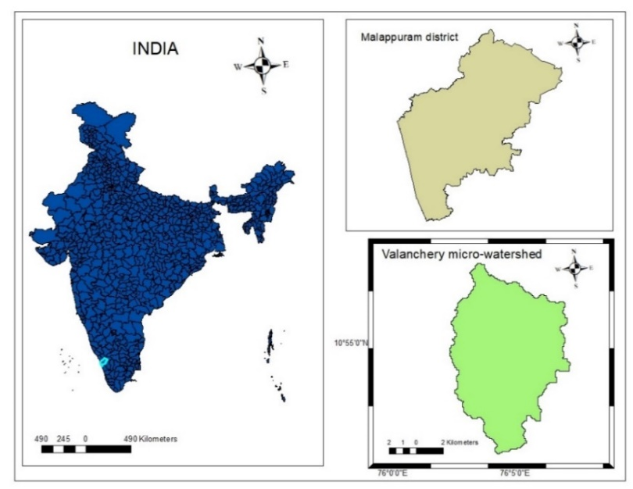

Fig. 1. Study area map of Valanchery micro watershed

  - Data used
To study on the LULC classifications and their relationship with the spectral indices, United States Geological Survey (USGS) Multi spectral Landsat data was accessed using the Google Earth Engine platform. The study was carried out for the years 2015, 2020, 2023 and the satellite imagery used had a cloud cover of less than 5%. The details of Landsat imagery used in this study are provided in the Table 1.

Table 1. Particulars of Landsat 8 image used in this study
Acquisition Date  (yyyy–mm–dd) | Landsat imagery used | Cloud Cover  (%)
2015-02-21 | LANDSAT/LC08/C02/T1_L2/LC08_145052_20150221 | 3.4
2020-02-28 | LANDSAT/LC08/C02/T1_L2/LC08_144053_20200228 | 3.3
2023-03-08 | LANDSAT/LC08/C02/T1_L2/LC08_144053_20230308 | 4.73

  - Google Earth Engine
Google Earth Engine (GEE) is a platform for planetary scale analysis and earth studies. It combines the ability to analyze data at a global scale with the multi-petabyte collection of imagery from satellites and geographical dataset (Gorelick et al. 2017). GEE can be used to analyze large-scale satellite information in a cloud-based environment. It is the computational platform for creating and evaluating spectral indices. Image filtering, cloud masking, and temporal compositing are among the standard preprocessing procedures made possible by the platform's access to harmonized, multi-temporal earth observation data from sensors like Landsat and Sentinel. In order to ensure consistent application of equations during all research periods, spectral indices were calculated using sensor-specific reflectance bands within the GEE JavaScript environment.
  - Methodology

Spectral indices
Spectral Indices are the proportional mathematical combination of various spectral bands of satellite images. Spectral indices can be used to highlight the specific features of the land surface such as vegetative cover, water cover, built-up scenario or burned areas (Shafiq et al. 2025). Spectral indices can be used for extracting some key information by concentrating on the features to be studied and minimizing the influence of other factors. The research region's vegetation state, surface moisture, and built-up surfaces were measured using spectral indices that were created from multispectral satellite photography. By applying these indices uniformly to all picture datasets, land surface features and their spatiotemporal dynamics may be compared.
Normalized Difference Vegetation Index (NDVI)
NDVI is the most commonly used vegetation index for global observation of green conditions. Healthy vegetation in general in the visible range is a good absorber of electromagnetic spectrum. Chlorophyll contained in green plants highly absorbs Blue (0.4 - 0.5 µm) and Red (0.6 - 0.7 µm) spectrum and reflects Green (0.5 – 0.6 µm) spectrum. Therefore, human eye perceives healthy vegetation as green. Healthy plants have high reflectance in Near Infrared (NIR) band between 0.7 to 1.3 µm. This is primarily due to internal structure of plant leaves. NDVI is primarily used in agriculture, ecology and environmental studies to study on the vegetation and its health (De Ocampo, 2023). The NIR and Red bands are used to calculate NDVI because of the high reflectance in NIR band and high absorption in Red band (Guha.,2021). Using following formula, Normalized Difference Vegetation Index (NDVI) is calculated
(1)
$NDVI=\frac{NIR-RED BAND}{NIR+RED BAND}$ (2)
The NDVI value varies from -1 to 1. Higher the value of NDVI, reflects high Near Infrared (NIR), indicates dense greenery. Generally, NDVI values are classified as given below:
NDVI = -1 to 0 represent Water bodies
NDVI = -0.1 to 0.1 represent Barren rocks, sand, or snow
NDVI = 0.2 to 0.5 represent Shrubs and grasslands or senescing crops
NDVI = 0.6 to 1.0 represent Dense vegetation or tropical rainforest
The NDVI value can be calculated using the Google Earth Engine Code editor by providing the above formula, in the form of a code.
Normalized Difference Built-up Index (NDBI)
NDBI identifies and maps the urban areas and built-up land using a remote sensing in a particular area. It compares the shortwave-infrared (SWIR) and near-infrared (NIR) bands using reflectance data from satellite imagery or aerial photography. NDBI is a standard method in the process of urban mapping and in the quantification of the urban growth phenomenon (Ali et al.2025). A larger positive NDBI value usually indicates built-up regions, such as roads and buildings, while a negative value indicates non-built-up areas, such as vegetation, water, and bare soil. NDBI values vary from -1 to +1.
$NDBI=\frac{(SWIR-NIR)}{(SWIR+NIR)}$ (3)
Where SWIR is Shortwave Infrared band and NIR indicate Near Infrared band

Normalized Difference Water Index (NDWI)
Delineating open water features, enhancing their visibility in remotely sensed imageries, and analyzing changes in water content over time are the main uses of NDWI. A remote sensing metric called the Normalized Difference Water Index (NDWI) is used to identify and monitor water bodies and determine the water content of plants. It makes use of the variation in reflectance values between satellite imagery's green band and shortwave infrared (SWIR) bands. Greater water content or the presence of open water are often indicated by higher NDWI readings. The efficiency of these water indices in capturing the spectral features of surface water in optical remote sensing imaging justifies its application on water resources (Pandey et al. 2024). NDWI can be sensitive to built-up areas, potentially leading to overestimation of water bodies. Buildings, highways, and industrial farms are proof of impermeable surfaces that increase absorption of shortwave radiation and decrease energy loss from longwave radiation emission (Das et al. 2021).
$NDBI=\frac{(GREEN BAND-SWIR)}{(GREEN BAND+SWIR)}$ (4)
Where, NIR-Near Infrared
- RESULTS AND DISCUSSIONS
  - Normalized Difference Vegetation Index
NDVI map (2015-2023) shows more intense green pixels in 2023 compared with 2015 (Fig. 2). From NDVI it can be seen that the maximum NDVI increased from 0.45 (2015) to 0.52 (2023) which is a clear indication that maximum green cover increased in some locations. This study reveals that the most-vegetated areas maintain the highest medians of NDVI values across years and in many cases show an upward shift in median by 2023. This indicates either improved vegetative cover condition, plantation growth or reforestation in those classes.
The peak NDVI values occurs in the plantation cropping areas followed by the dense vegetation and paddy, which means that there is an increase of vegetation in the Valanchery micro watershed. There is an increase in the NDVI from 0.45 to 0.52, which is due to the increase in plantation crops when compared with the base line period. Vegetation type and crop growth period will have an effect on the NDVI, which shows an increased trend of vegetation (Eastman et al.2013).
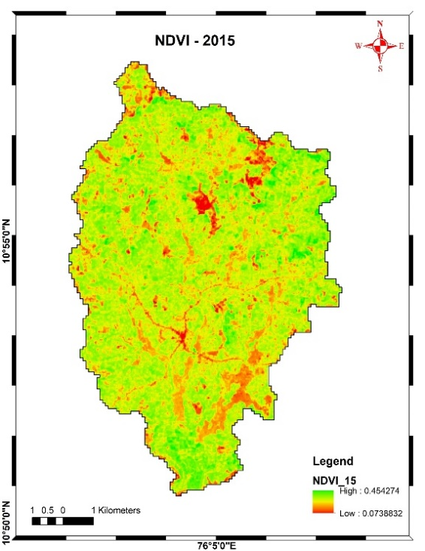
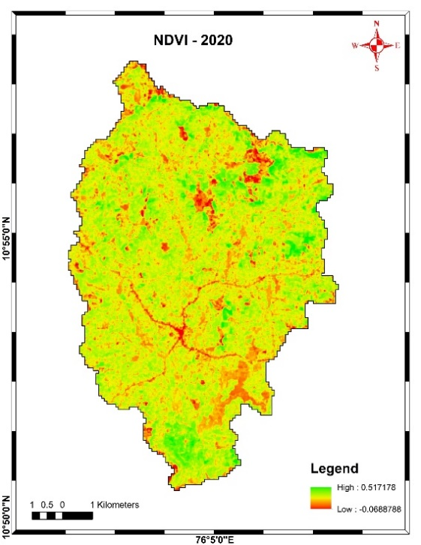
a) b)

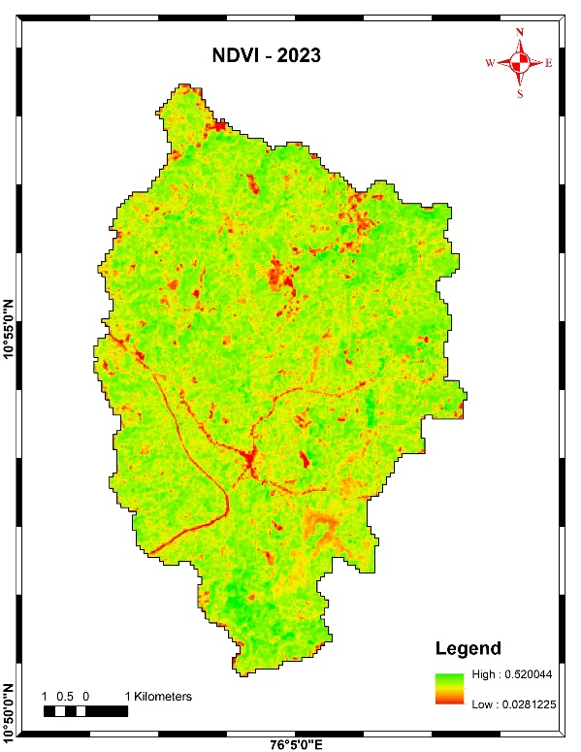
c)

Fig. 2. a) NDVI map of 2015 b) NDVI map of 2020
c) NDVI map of 2023

  - Normalized Difference Water Index (NDWI)
NDWI analysis is significant for the monitoring of water bodies, which is a combination of NIR and green band to study on the terrestrial environment while the decrease of reflectance of the water bodies. NDWI of 2020 (0.13) shows a positive value while 2015 and 2023 show mostly negative values (Fig.3). The changes in NDWI may be due to the variation of rainfall, change in the rainfall pattern and the shift of monsoon due to the climate change actions (Ali et al. 2025). Landsat image used was in the summer months to avoid cloud cover problems, due to the dryness of the surface and low stream flow, NDWI values are comparatively lower.
That implies temporal variation in surface/moisture condition, and 2020 may contain standing water. LULC classes that contain more vegetation have higher NDWI medians and narrower ranges, consistent with persistent presence of water or flooded fields. There was increase in low NDWI values which showed a decrease in surface extent of moisture, which may be due to the reduction of waterbodies.

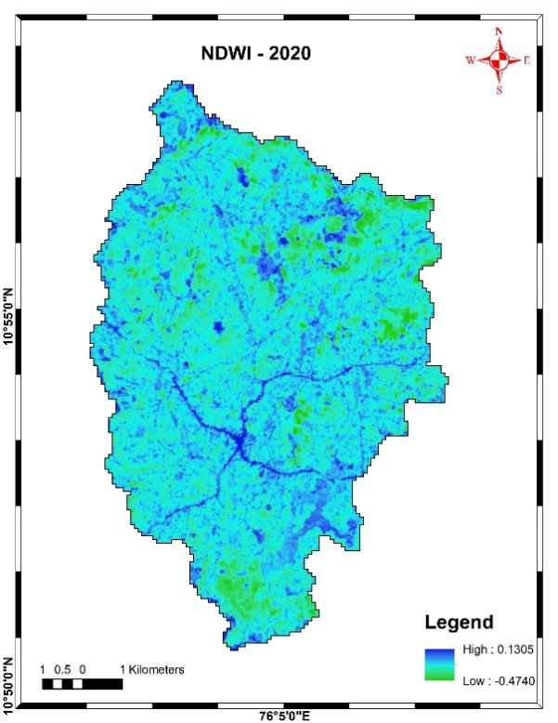
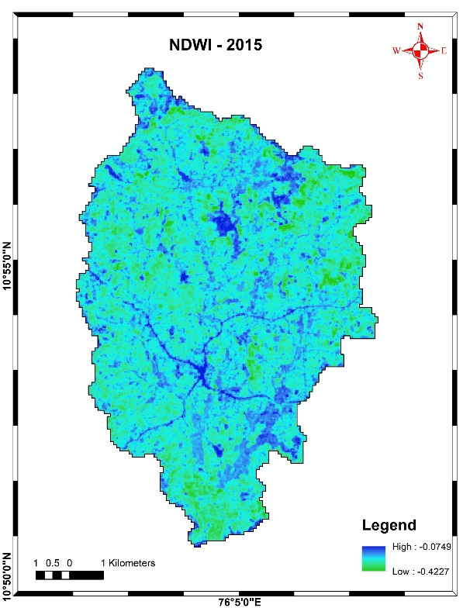
a) b)

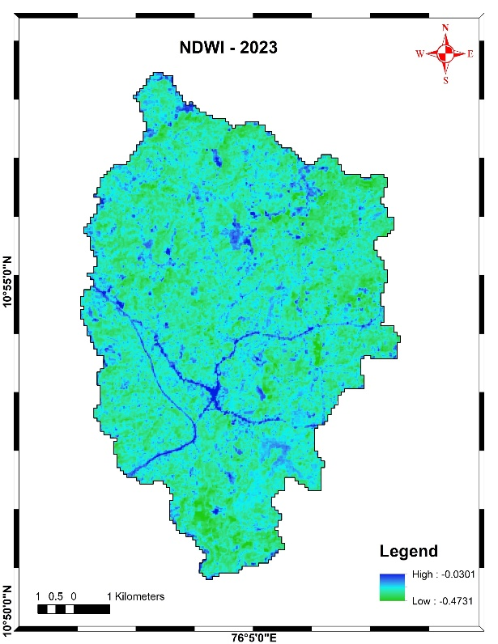
c)

Fig. 3. a) NDWI map of 2015 b) NDWI map of 2020
c) NDWI map of 2023

  - Normalized Difference Built up Index (NDBI)
The maximum NDBI values during 2015, 2020 and 2023 are almost in the same range (-0.27 to 0.22), but the spatial extent of NDBI patches increased in 2023 (Fig. 4). The patches show a higher median NDBI which corresponds to built-up pixels. The increase in NDBI extent/magnitude supports small but consistent urbanization between 2015 and 2023. When NDBI increase coincides with NDVI decrease, and NDWI decreases at the same locations, the change is very likely the conversion to impervious surface (Fig.4). There is an increase in the NDBI (0.17-0.21), which was supported by the increase in urban land use (1.18 km²). The construction of NH 66 also has an effect on the increase in the NDBI of 2023.
This study is highly important to reduce the time taken for analysis and depends on humans for the decision-making process in urban planning and management. When analyzed holistically, it can be said that the spectral indices values were related with the ongoing Land use changes. All the three important spectral indices like NDVI, NDWI and NDBI are highly related with the ongoing urbanization and its effects on the environment. These spectral indies are related to one another, based on the ongoing relationship over a decade that have implications on the decrease of vegetation and water resources with an increase in the urban cover in the Valanchery micro watershed.

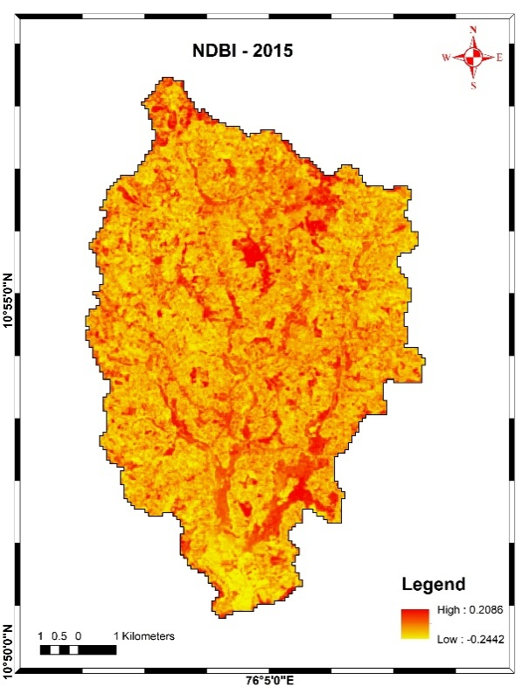
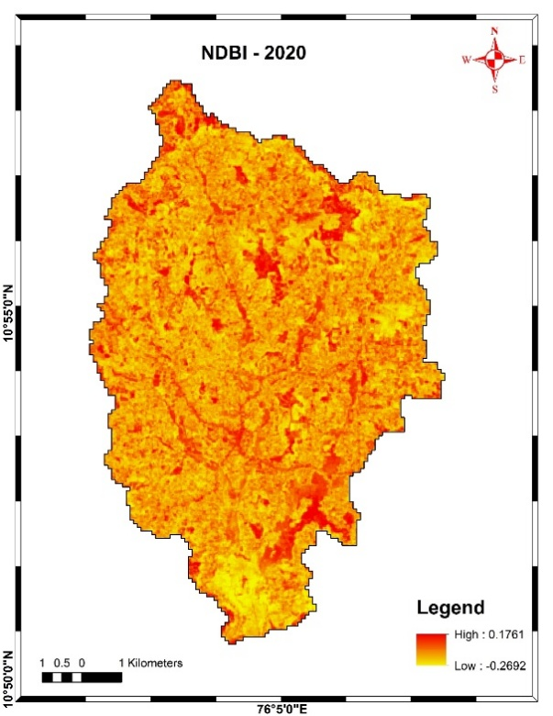
a) b)

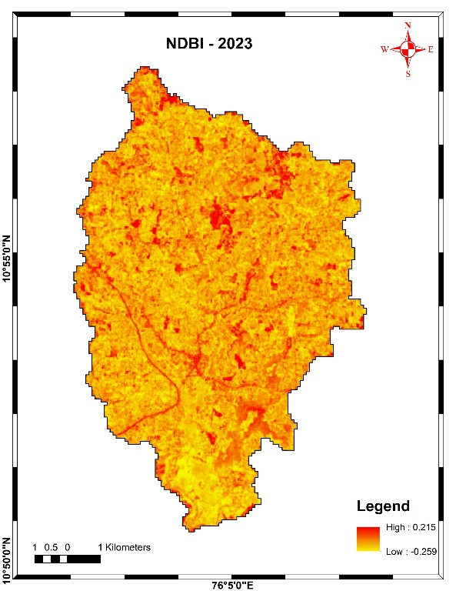
c)

Fig. 4. a) NDBI map of 2015 b) NDBI map of 2020 c) NDBI map of 2023
- SUMMARY AND CONCLUSIONS
This study used multi-temporal Landsat-8 images processed by Google Earth Engine to assess the spatiotemporal variance of NDVI, NDWI, and NDBI in the Valanchery micro-watershed. At the micro-watershed scale, the investigation showed that spectral indices are useful indicators of vegetation dynamics, surface moisture conditions, and urban growth. The maximum and median NDVI values increased significantly between 2015 and 2023, especially in the plantation, thick vegetation, and paddy land use classes. The reliability of NDVI for evaluating vegetation state and spatial variability in humid tropical environments is demonstrated by the agreement between spectral patterns. A clear temporal variation in NDWI was noted, with comparatively larger values in 2020 than in 2015 and 2023. Changes in surface moisture availability and potential transient hydrological situations, including standing water or soil moisture retention are reflected in this fluctuation. The sensitivity of NDWI to seasonal and surface conditions can be witnessed by the lower NDWI results in other years, which show decreased surface water extent during the image acquisition times. Despite comparable maximum index ranges between years, NDBI research showed a progressive increase in the geographical expanse of built-up regions between 2015 and 2023. The recorded urban expansion and infrastructural development were in good agreement with the rise in NDBI values. Conversion from vegetative or permeable surfaces to impermeable built-up land is clearly indicated by areas with higher NDBI and lower NDVI-NDWI values.
Overall, a clear view of land surface changes within the watershed has been established by the combined interpretation of NDVI, NDWI, and NDBI. The study demonstrates that spectral indices are reliable instruments for tracking environmental change, assisting with land use planning, and evaluating the effects of urbanization in quickly changing areas when used consistently with cloud-based platforms. This study underscores the need for integrated management of land and water resources to mitigate the effects on environment. To improve micro-scale landscape evaluations, future research may use more indices and higher-resolution information.
- REFERENCES
Ali, A., Hussain, B., Hissan, R.U., Al Aiban, K.M., Radulescu, M. and Magazzino, C., 2025. Examining the landscape transformation and temperature dynamics in Pakistan. Scientific Reports, 15(1), p.2575.
Das, N., Mondal, P., Sutradhar, S. and Ghosh, R., 2021. Assessment of variation of land use/land cover and its impact on land surface temperature of Asansol subdivision. The Egyptian Journal of Remote Sensing and Space Science, 24(1), pp.131-149.
De Ocampo, A.L.P., 2023, March. Normalized difference vegetation index (NDVI) estimation based on filter augmented imaging. In 2023 International Electrical Engineering Congress (iEECON) (pp. 84-88). IEEE.
Eastman, J.R., Sangermano, F., Machado, E.A., Rogan, J. and Anyamba, A., 2013. Global trends in seasonality of normalized difference vegetation index (NDVI), 1982–2011. Remote Sensing, 5(10), pp.4799-4818.
Gorelick, N., Hancher, M., Dixon, M., Ilyushchenko, S., Thau, D. and Moore, R., 2017. Google Earth Engine: Planetary-scale geospatial analysis for everyone. Remote sensing of Environment, 202, pp.18-27.
Guha, S., 2021. A long-term monthly assessment of land surface temperature and normalized difference vegetation index using Landsat data. urbe. Revista Brasileira de Gestão Urbana, 13, p.e20200345.
Huete, A.R., 1988. A soil-adjusted vegetation index (SAVI). Remote sensing of environment, 25(3), pp.295-309.
Kolli, M.K., Pham, Q.B., Thi Thuy Linh, N., Ngoc Hoai, P., Costache, R. and Anh, D.T., 2022. Assessment of change in the extent of mangrove ecosystems using different spectral indices in Google Earth Engine based on random forest model. Arabian Journal of Geosciences, 15(9), p.889.
Lillesand, T., Kiefer, R.W. and Chipman, J., 2015. Remote sensing and image interpretation. John Wiley & Sons.
Montero, D., Aybar, C., Mahecha, M.D., Martinuzzi, F., Söchting, M. and Wieneke, S., 2023. A standardized catalogue of spectral indices to advance the use of remote sensing in Earth system research. Scientific Data, 10(1), p.197.
Pandey, V., Pandey, P.K., Lepcha, P.T. and Devi, N.N., 2024. Assessment of surface water dynamics through satellite mapping with Google Earth Engine and Sentinel-2 data in Manipur, India. Journal of Water and Climate Change, 15(3), pp.1313-1332.
Patel, S., Indraganti, M. and Jawarneh, R.N., 2024. A comprehensive systematic review: Impact of Land Use/Land Cover (LULC) on Land Surface Temperatures (LST) and outdoor thermal comfort. Building and Environment, 249, p.111130.
Ramachandran, J., R. Lalitha and S. Vallal Kannan. 2019. Remote Sensing Based Greenness Modeling of Different Crops in Lalgudi Block Using Landsat 8 Image. Journal of Soils and Crops. 29(2). 232-235
Roy, D.P., Wulder, M.A., Loveland, T.R., Ce, W., Allen, R.G., Anderson, M.C., Helder, D., Irons, J.R., Johnson, D.M., Kennedy, R. and Scambos, T.A., 2014. Landsat-8: Science and product vision for terrestrial global change research. Remote sensing of Environment, 145, pp.154-172.
Shafiq, H., Hissan, R.U., Mariam, A., Ali, S., Nassani, A.A., Radulescu, M., Batool, K. and Hussain, B., 2025. Spatio-temporal assessment of urban temperature variations and landscape characteristics using spectral indices. Gondwana Research, 139, pp.148-165.
Situmorang, J.P. and Sugianto, S., 2016. Estimation of Carbon Stock Stands using EVI and NDVI vegetation index in production forest of lembah Seulawah sub-district, Aceh Indonesia. Aceh International Journal of Science & Technology, 5(3).
Tiwari, A.K. and Kanchan, R., 2024. Analytical study on the relationship among land surface temperature, land use/land cover and spectral indices using geospatial techniques. Discover Environment, 2(1), p.1.
Zaitunah, A., Ahmad, A. G., & Safitri, R. A.2018. Normalized difference vegetation index (NDVI) analysis for land cover types using landsat 8 oli in besitang watershed, Indonesia. In IOP Conference Series: Earth and Environmental Science .Vol. 126: 1, p. 012112.
Zeng, H., Wu, B., Wang, S., Musakwa, W., Tian, F., Mashimbye, Z.E., Poona, N. and Syndey, M., 2020. A synthesizing land-cover classification method based on Google Earth engine: A case study in Nzhelele and Levhuvu Catchments, South Africa. Chinese Geographical Science, 30(3), pp.397-409.

