Optimisation and Techno-Economic Analysis of a Solar–Wind–Diesel Hybrid Microgrid for Sustainable Rural Electrification in Ibiaku Ikot Oku, Nigeria

.
ABSTRACT

This study presents a comprehensive optimisation and techno-economic evaluation of a hybrid solar–wind–diesel microgrid designed to deliver reliable and low-cost electricity to the off-grid rural community of Ibiaku Ikot Oku in southern Nigeria. Hourly simulations were conducted using HOMER Pro to determine the optimal combination and sizing of photovoltaic (PV) generation, wind turbines, battery energy storage, and diesel backup under localised meteorological, economic, and load constraints. The optimisation objective was to minimise the Net Present Cost (NPC) and Levelized Cost of Energy (LCOE) over a 25-year project horizon while satisfying operational, reliability, and emission constraints. Results indicate that the PV–Wind–Diesel–Battery configuration provides the most cost-effective architecture, achieving an NPC of US$1.06 million, an LCOE of US$0.197/kWh, and a renewable penetration of 78.2%. Compared to a diesel-only baseline, the optimised system reduces annual CO₂ emissions by 45.7% (approximately 126.5 t/year) and lowers fuel consumption by 43%. Component-level cost decomposition reveals that PV and battery systems dominate capital expenditures, whereas diesel fuel cost remains the most significant operational driver. Sensitivity analysis conducted on solar irradiance, wind speed, fuel price, battery cost, and load growth shows that fuel price volatility and battery economics exert the most significant influence on cost-optimal design. The findings confirm the technical viability, economic competitiveness, and environmental benefits of hybridised microgrids for rural Nigerian communities, providing actionable insights for developers, regulators, and policymakers advancing decentralised electrification under Nigeria’s Electricity Act (2023) and SDG 7 targets.

Keywords: HOMER Pro, Hybrid microgrid, Optimisation, Renewable energy, Rural electrification, Techno-economic analysis

1. INTRODUCTION

Access to reliable, affordable electricity remains a significant development challenge in many parts of sub-Saharan Africa, including Nigeria, where frequent outages and limited grid coverage hinder social and economic development (Molu et al., 2024). Hybrid microgrids - defined as systems that combine renewable generation (e.g., solar photovoltaic (PV) and wind), energy storage, and conventional backup generation such as diesel - offer a practical pathway for delivering resilient, lower-cost electricity to off-grid and weak-grid communities (Araoye et al., 2024; Ross-Hopley, Ugwu, & Ibrahim, 2024). Advances in component costs (solar modules, inverters, and lithium-ion batteries), together with improved modelling and optimisation tools (notably HOMER Pro), have made techno-economic design and optimisation of hybrid microgrids widely tractable and increasingly attractive for rural electrification projects (Ali et al., 2024; Ross-Hopley et al., 2024).

Despite the growing literature showing that hybrid options can reduce lifecycle costs and emissions relative to diesel-only solutions, reported results are highly location- and assumption-sensitive: resource availability (solar irradiance, wind speed), fuel price trajectories, and load characteristics strongly influence optimal system sizing and economic outcomes (Ali et al., 2024; Araoye et al., 2024). In Nigeria, several recent studies have utilised HOMER Pro to design context-specific hybrid systems and to highlight the economic potential of PV-battery, PV-wind-diesel, and other hybrid systems for communities and institutional consumers (Odetoye et al., 2023; Araoye et al., 2024). However, converting thesis-scale modelling into concise, generalisable evidence for policy and investors requires careful presentation of methodological assumptions, comprehensive cost-and-performance breakdowns, and sensitivity/scenario testing to expose the main risk drivers (Ross-Hopley et al., 2024; Molu et al., 2024).

Although hybrid microgrids are technically feasible for many Nigerian rural and peri-urban contexts, practitioners still face three recurring barriers:
- Uncertainty in economic outcomes: levelized cost of energy (LCOE) and Net Present Cost (NPC) are sensitive to diesel price volatility, capital cost trends (especially battery costs), and the chosen discount rate; inadequate transparency on these assumptions leads to weak comparability across studies (Ali et al., 2024; Ross-Hopley et al., 2024).
- Site-specific resource variability: local solar and wind resource characterisation and demand profiling directly affect optimal component sizing; generic inputs can mislead planners about expected renewable fractions and backup sizing (Araoye et al., 2024; Molu et al., 2024).
- Limited translation to decision-ready outputs: investors and policymakers require clear economic indicators (NPC, LCOE, payback, sensitivity to fuel price) and operational metrics (renewable fraction, unmet load, emissions) presented in a way that supports financing, tariff design, and policy choices (Odetoye et al., 2023; Ali et al., 2024).
These barriers underline the need for a focused techno-economic study that not only identifies an optimal hybrid configuration for a representative Nigerian community (Ibiaku Ikot Oku in this work) but also provides full transparency on assumptions, a thorough cost decomposition, and scenario/sensitivity results that reveal the range of plausible outcomes for decision-makers.

This paper seeks to fill the above gaps by developing an evidence-based, reproducible techno-economic analysis of a solar–wind–diesel–battery hybrid microgrid for Ibiaku Ikot Oku, Nigeria, with the following specific objectives:
- To model and optimise alternative hybrid configurations (PV–diesel–battery; PV–wind–diesel–battery; PV–wind–battery) using HOMER Pro and localised resource and load data.
- To quantify lifecycle economic indicators (NPC, LCOE, annual operating cost), reliability metrics (unmet load, dispatch statistics), and environmental impacts (annual CO₂ emissions).
- To present a detailed cost breakdown (capital, O&M, fuel, replacement) and identify the principal cost drivers.

The remainder of the paper is organised as follows. Section 2 describes the study area, data sources, system components and the HOMER Pro modelling approach. Section 3 presents the optimisation results, cost breakdown and environmental assessment for competing configurations. Section 4 reports sensitivity and scenario analyses. Section 5 discusses the policy and practical implications, and Section 6 concludes with recommendations and suggestions for future work.

2. methodology

2.1 Study Area and Data Collection

The study focused on Ibiaku Ikot Oku, a rural community in Ibiono Ibom Local Government Area, Akwa Ibom State, Nigeria. The community lies approximately between 5.2°N latitude and 7.9°E longitude, within the humid tropical zone of southern Nigeria. Like most off-grid settlements in the Niger Delta, it experiences high solar radiation and moderate coastal wind resources but remains unserved mainly by the national electricity grid. Local households rely on small petrol generators, with intermittent power access limited to a few hours a day, which constrains economic activities and social services. A satellite view of the study area is shown in Fig. 1.

Meteorological data for solar irradiation and wind speed were obtained from NASA’s Prediction of Worldwide Energy Resources (POWER) database, which provides hourly and daily global horizontal irradiance (GHI) and wind speed at 10 m above ground level (NASA, 2024). The community’s average solar insolation was recorded at 5.21 kWh/m²/day, while the mean annual wind speed ranged between 4.8 and 5.4 m/s. Load data were developed using the appliance-based end-use inventory method, which estimates the aggregate energy demand by considering household and community-level appliance usage patterns. The daily load profile was created to reflect residential, educational, health, and small-scale commercial consumption, as presented in Tables 1 to 4. The estimated peak demand was 86 kW, with an average daily energy consumption of 1,150 kWh/day.

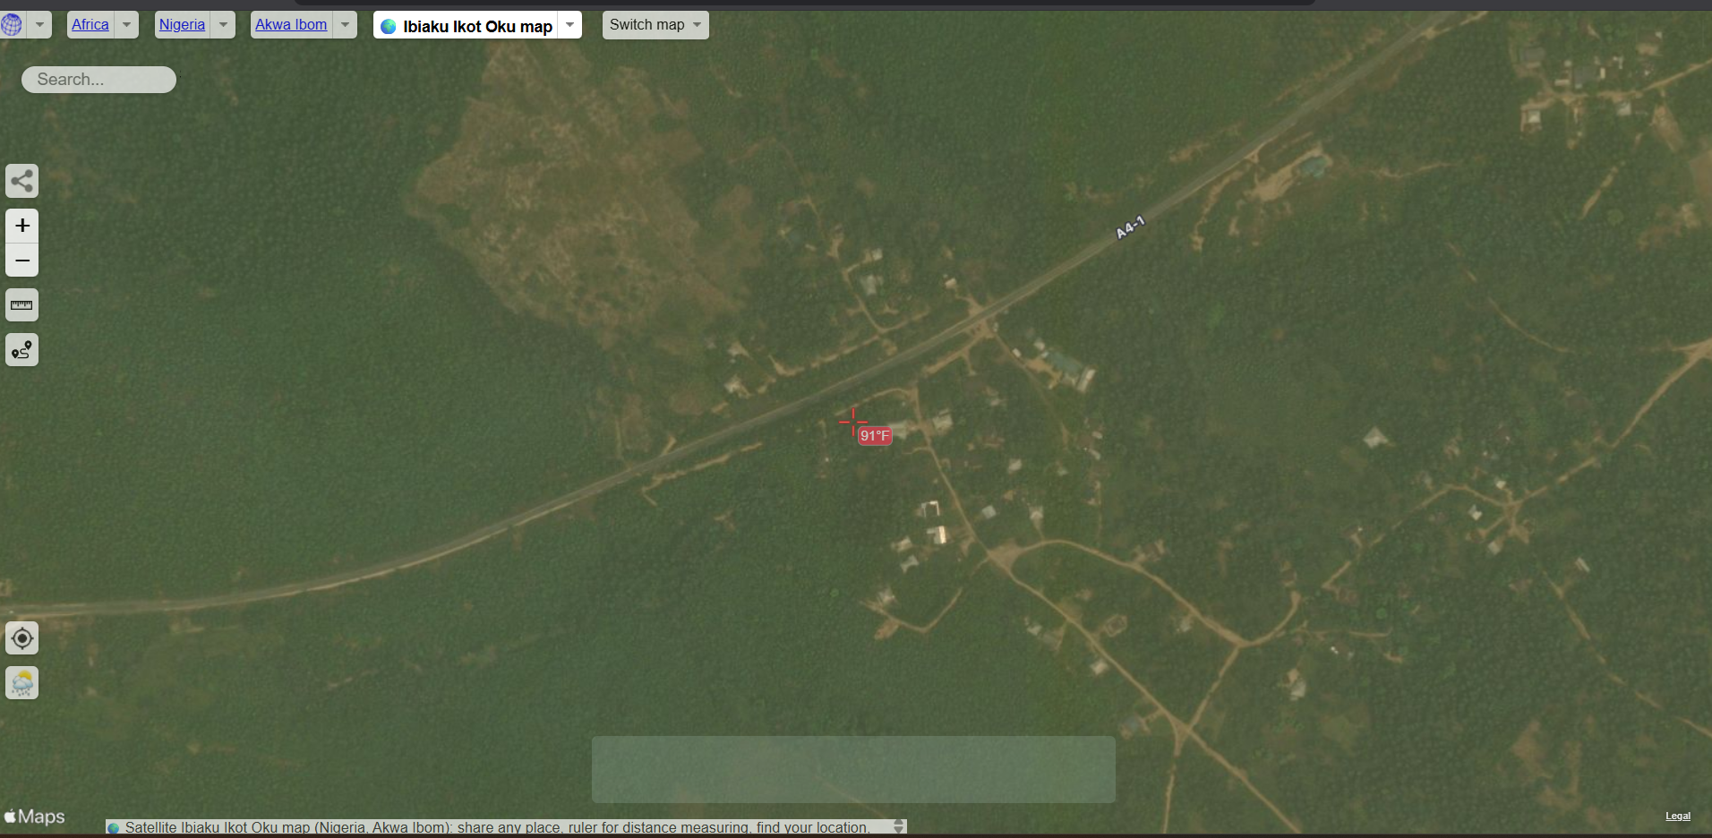

Fig. 1. Satellite view of study area (Satellite pro, 2025)

Table 1. Daily load demand for 140 households in Ibiaku Ikot Oku community

Appliance | Wattage | Quantity | Peak Load (W) | Estimated Daily Hours of Usage | Total Load of Each Household (Wh/d) | Total load of all households (Wh/d)
LED Light | 10 | 12 | 120 | 10 | 1200 | 168000
Fan | 75 | 4 | 300 | 6 | 1800 | 252000
Phone Charger | 7 | 4 | 28 | 4 | 112 | 15680
Refrigerator | 150 | 1 | 150 | 8 | 1200 | 168000
Radio | 15 | 1 | 15 | 8 | 120 | 16800
Television | 75 | 1 | 75 | 7 | 525 | 73500
AC | 746 | 0.4 | 298.4 | 7 | 2088.8 | 292432
Water Pump | 746 | 0.2 | 149.2 | 3 | 447.6 | 62664

Table 2. Daily Load Demand for Public/Community Load

Appliance | Quantity | Power Rating (W) | Peak Load (W) | Estimated Usage Duration (h) | Energy Consumed (Wh/day) | Total Energy/facility (kWh/day) | Total Energy (kWh)
Public (School) Load Demand
LED | 48 | 10 | 480 | 6 | 2880
Fan | 18 | 75 | 1350 | 6 | 8100 | 10.98 | 21.96
Public (Worship Centre) Load Demand
LED | 12 | 10 | 120 | 12 | 1440
Fan | 6 | 75 | 450 | 10 | 4500
Music/Sound System | 1 | 2000 | 2000 | 4 | 8000 | 13.94 | 69.7
Public (Health Centre) Load Demand
Fan | 6 | 75 | 450 | 10 | 4500
LED | 8 | 10 | 80 | 12 | 960
Refrigerator | 2 | 300 | 600 | 8 | 4800 | 10.26 | 10.26
Total |  |  |  |  |  |  | 101.92

Table 3. Daily load demand for the commercial sector

Shop Type | Appliance | Power (W) | Qty/Shop | Daily Hours | Total Shops | Peak Load | Daily Energy
Medicine shop | Refrigerator | 150 | 1 | 10 | 2 | 300 | 3000
 | Fan | 75 | 1 | 8 | 2 | 150 | 1200
 | Lighting | 10 | 4 | 6 | 2 | 80 | 480
Provision Shop | Freezer | 300 | 1 | 8 | 3 | 900 | 7200
 | Lighting (CFL) | 20 | 3 | 6 | 3 | 180 | 1080
 | Fan | 75 | 1 | 8 | 3 | 225 | 1800
Welding Shop | Welding Machine | 3000 | 1 | 5 | 1 | 3000 | 15000
 | Lighting | 20 | 2 | 5 | 1 | 40 | 200
Saw Mill | Circular Saw Motor | 5000 | 1 | 4 | 1 | 5000 | 20000
 | Lighting | 20 | 2 | 5 | 1 | 40 | 200
Laundry Shop | Electric Iron | 1000 | 2 | 3 | 1 | 2000 | 6000
 | Lighting | 15 | 3 | 6 | 1 | 45 | 270
 | Washing Machine | 500 | 1 | 2 | 1 | 500 | 1000
Barber Shop | Hair Clipper | 10 | 2 | 6 | 2 | 40 | 240
 | Fan | 75 | 1 | 8 | 2 | 150 | 1200
 | Lighting | 15 | 3 | 6 | 2 | 90 | 540
Hair Dressing Saloon | Hair Dryer | 500 | 1 | 2 | 2 | 1000 | 2000
 | Hair straightener | 150 | 1 | 2 | 2 | 300 | 600
 | Fan | 75 | 1 | 8 | 2 | 150 | 1200
 | Lighting | 15 | 3 | 6 | 2 | 90 | 540
 |  |  |  |  |  |  | 63750

Table 4. Aggregate Load for all Demand Classes

Load Class | Energy Demand (kWh/d)
Residential Load | 1049.07
Community/Public Load | 101.92
Commercial Load | 63.75
Total Daily Load Demand | 1214.74

2.2 Design Parameters

2.2.1 Adjusted daily demand

Accounting for possible system losses, the adjusted energy requirement is expressed in (1).
$E_{adjusted}=E_{demand}×\left(1+loss factor\right)$ (1)
$$=1,214.74 kWh×1.25=1,518.43$$
Loss factor: 25% (inverter, battery, transmission losses) (Sinha and Chandel, 2014)
Note: IEEE 1562 recommends applying a derating factor of 20–30% for PV and battery systems, while IEEE 1013 advises a loss factor of 10–20% specifically for battery performance considerations. Additionally, the National Renewable Energy Laboratory (NREL) suggests a 23% loss factor for PV systems. In alignment with these guidelines, this study adopted a uniform loss and derating factor of 25% across all components to ensure consistency and remain within the recommended range.

2.2.2 Energy mix proportions

A. Energy Contribution:
$E_{solar}=E_{adjusted}×0.60$
$=1,518.43×0.60=911.06 kWh/day$

PV Capacity Calculation: Equation (1) is modified to give (2).
$P_{PV}=\frac{E_{solar}}{G × {}_{PV}×PR}$ (2)
where solar irradiance, G = 4.5 kWh/m²/day (Akwa Ibom average) (NASA, 2022), Panel efficiency, ${}_{PV}$ = 18% (monocrystalline) (Omoriare et al., 2025) and Performance ratio, PR = 0.75 (losses) (Azeez, 2024).
Hence;
$P_{PV}=\frac{911.06}{4.5×0.18×0.75}$
$=1499.69≈1500 kW$
Based on the high capacity of power required and availability in the market, the selected PV panel is rated $400 W$. The number of panels $\left(N_{PV}\right)$ is determined from (3).
$N_{PV}=\frac{P_{PV}}{panel rating}$ (3)
$=\frac{1500 kW}{0.4 kW}=3,750 panel$

B. Wind Turbine System Sizing
Energy Contribution:
$E_{wind}=E_{adjusted}×0.25$ (4)
$=1518.43×0.25$
$=379.61 kWh/Day$

Turbine Capacity Calculation:
$P_{wind}=\frac{E_{wind}}{CF×24}$ (5)
CF: Capacity factor = 25% (for $4.5 m/s$ average wind speed at $50m$ hub height) (Ajayi et al., 2013).
$P_{wind}=\frac{379.61}{0.25×24}=63.27 kW$
For this study, 20 kW turbine is selected. The number of turbines required is computed from (6):
$N_{wind}=\frac{63.27}{20}=3.16≈4 turbines$ (6)
Total capacity: 80 kW

C. Public Grid Backup
Energy Contribution:
$E_{grid}=E_{adjusted}×0.10$
$=1,518.43×0.10$
$=151.8 kWh/day$
Peak supply must cover $P_{peak_grid}=190.9 kW×0.10=19.1 kW$
The grid acts as the primary backup (151.84 kWh/day), reducing diesel dependency. Hence, a grid-tied inverter (converter) with a 20 kW, 48 V capacity and anti-islanding protection is suitable for the setup.

D. Diesel Generator Sizing
Energy Contribution:
$E_{diesel}=E_{adjusted}×0.05$
$=1,518.43×0.05$
$=75.92 kWh/day$

Generator Runtime:
$t_{runtime}=\frac{E_{diesel}}{P_{gen}}$ (7)
$P_{gen}$: Generator rated power. The selected diesel generator for the study is rated at 100 kW or 125 kVA at a power factor of 0.8 (sized for a peak load of 190.9 kW with a margin).
$t_{runtime}=\frac{75.92}{100}=0.76 hours/day$
This indicates that the diesel generator will be used for about 76 minutes each day.
Taking a fuel consumption rate of 0.3 Ltr/kWh (Dosa et al., 2025), the amount of fuel consumed per day is computed from (8):
Fuel/day $=E_{diesel}×0.3$ (8)
$=75.92×0.3$
$=22.78 Ltr/day$

E. Battery Bank Sizing
Storage Requirement (8 hours autonomy):
$E_{storage}=\frac{Average load ×Autonomy hours}{DoD×{}_{inv}}$ (9)
$Average load=\frac{1,214.74}{24}=50.61 kW$
DoD: Depth of discharge = 80% (IEEE Std 1561-2007).
${}_{inv}$​: Inverter efficiency = 90% (IEEE Std 1547-2018).
$storage=\frac{50.61×8}{0.8×0.9}=562.33 kWh$
The selected battery capacity is 200 Ah, 48V system. The total number of batteries required to meet the required autonomy is determined by Equations (9) and (10).
$Total Ah=\frac{562.33kWh×1,000}{48 V}=11,715 Ah$ (10)
$N_{batteries}=\frac{11,715}{200}=58.58≈60 batteries$
Converter Size: 380 kW multi-converter setup (matches peak load) (IEEE Std 1547-2018).

Table 5. System summary

Component | Size | Contribution
Solar PV | 1,500 kW | 911.06 kWh/day
Wind Turbine | 80 kW (4 × 20 kW) | 379.61 kWh/day
Public Grid |  | 151.8 kWh/day
Diesel Generator | 125 kVA | 75.92 kWh/day
Battery Bank | 562.33 kWh | 8-hour backup

Peak Load Management:
- Total peak load: 190.9 kW (from audit data).
- Battery + Public Grid covers 20 kW + 50.61 kW = 70.61 kW during outages.
Renewable Fraction (RF) = $=\frac{E_{PV}+E_{wind}}{E_{total}}=\frac{911.06+379.61}{1518.43}×100=85\%$
The design prioritised renewables (85%) and public grid stability, minimising diesel use to 5% for enhanced sustainability. Calculations incorporated industry-standard loss factors and safety margins to ensure real-world implementation.
This framework meets the community’s demand while prioritising renewables, with diesel as a backup. Calculations include margins for safety and efficiency losses. For implementation, conduct a site-specific feasibility study using resource data.

2.3 Schematic diagram of the hybrid microgrid for Ibiaku community in HOMER pro

Fig. 2 illustrates a hybrid AC/DC microgrid architecture designed for the Ibiaku Ikot Oku rural community in Southern Nigeria, Akwa Ibom State. The hybrid system integrates renewable energy sources (solar PV, wind turbines), a diesel generator, battery energy storage, and power electronic converters to ensure a reliable and sustainable electricity supply.

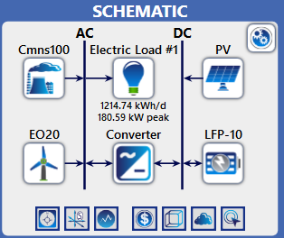

Fig. 2. Layout of the designed microgrid system

2.4 System Components and Configuration

The hybrid microgrid system analysed comprises solar PV arrays, wind turbines, battery energy storage systems (BESS), a diesel generator, and power converters. The system architecture follows a DC-coupled configuration, ensuring compatibility between renewable generation and the storage subsystem before inversion to supply AC loads.
(a) Solar PV subsystem
The PV array converts solar radiation into DC electricity. Modules have an efficiency of 18.5% and a derating factor of 0.8, accounting for dust and temperature effects. Capital and replacement costs were set at $700/kW and $600/kW, respectively, consistent with current market trends.
(b) Wind turbine subsystem
Horizontal-axis wind turbines were modelled with a rated capacity of 20 kW each, a cut-in speed of 3.5 m/s, and a rated speed of 12 m/s. The capital cost was assumed to be $1,600/kW, with operation and maintenance (O&M) expenses of $50/kW/year. The wind subsystem provides nighttime complementarity to solar generation, improving supply reliability.
(c) Diesel generator subsystem
A conventional diesel generator was included to ensure dispatchable backup power during periods of low renewable energy availability. A 50-kW generator model with a fuel consumption rate of 0.28 litres per kilowatt-hour (L/kWh) was selected. The diesel fuel cost varied between $1.0 and $ 1.5/L for the sensitivity scenarios, reflecting local fuel price volatility in Nigeria (NBS, 2024).
(d) Battery energy storage system (BESS)
Lithium-ion batteries were chosen due to their superior round-trip efficiency (≈approximately 90%) and longer cycle life compared to lead–acid alternatives. The unit cost was assumed to be $350/kWh, with a 10-year lifespan and an 80% depth of discharge. The battery stores excess renewable energy and supplies power during nighttime or periods of low resource availability.

(e) Converter
A bidirectional converter rated at 95% efficiency facilitates power flow between the DC bus and AC load. Capital cost was estimated at $180/kW, with a replacement cost of $150/kW.

2.5 System Modelling and Optimisation Framework

System modelling and optimisation were performed using HOMER Pro version 3.16 (UL Solutions, 2024). The software executed hourly simulations over one year, evaluating all feasible combinations of system components to determine the configuration that minimised the Net Present Cost (NPC) while meeting demand and technical constraints.
The optimisation process involved:
- Simulation: Modelling energy flows and component interactions at hourly resolution.
- Optimisation: Selecting the configuration that minimises the objective function (total NPC).

The objective function is expressed in (11):
$\text{Minimise }NPC=\sum_{t=1}^{T}{\frac{C_{t}}{(1+i)^{t}}}$ (11)
where $C_{t}$ is the total annualised system cost at year t, i is the real discount rate (set at 8%), and T is the project lifetime (25 years).
Constraints ensure:
- Power balance: $P_{PV}+P_{wind}+P_{diesel}+P_{batt}≥P_{load}$
- Battery state-of-charge within 20–100%
- Maximum unmet load ≤ 1% of total demand.

2.6 Economic and Environmental Indicators

The LCOE and NPC were used to compare configurations. LCOE was computed using (12):
$LCOE=\frac{NPC×CRF}{E_{annual}}$ (12)
where $CRF=\frac{i(1+i)^{T}}{(1+i)^{T}-1}$ is the capital recovery factor, and $E_{annual}$ is the total annual electricity generation (kWh).
Environmental assessment includes estimation of CO₂, SO₂, and NOₓ emissions derived from diesel generator operations using emission factors from the Intergovernmental Panel on Climate Change (IPCC, 2023). The results were benchmarked against hybrid microgrid case studies in comparable climatic regions.

3. RESULTS AND DISCUSSION

3.1 Load Demand Characterisation

The annual load profile of Ibiaku Ikot Oku was modelled using the appliance-based end-use method described in Section 2. The yearly total energy demand was approximately 419,750 kWh/year, with a peak demand of 86 kW. Fig. 3 illustrates the diurnal load variation characterised by morning and evening peaks. The evening peak (18:00–22:00 h) corresponds to residential lighting, entertainment, and refrigeration loads, while daytime consumption primarily arises from small businesses, schools, and community health centres. This load pattern aligns with observations in other Nigerian rural electrification studies (Rachid et al., 2025; Odetoye et al., 2023).
3.2 Optimal System Configuration

Table 6 summarises the optimal configurations derived from HOMER Pro simulations. The configurations considered include:
- Case A: PV–Diesel–Battery
- Case B: PV–Wind–Diesel–Battery
- Case C: PV–Wind–Battery (no diesel backup)
The PV–Wind–Diesel–Battery system (Case B) emerged as the most techno-economically viable option, achieving the lowest NPC and LCOE, with the highest renewable penetration.

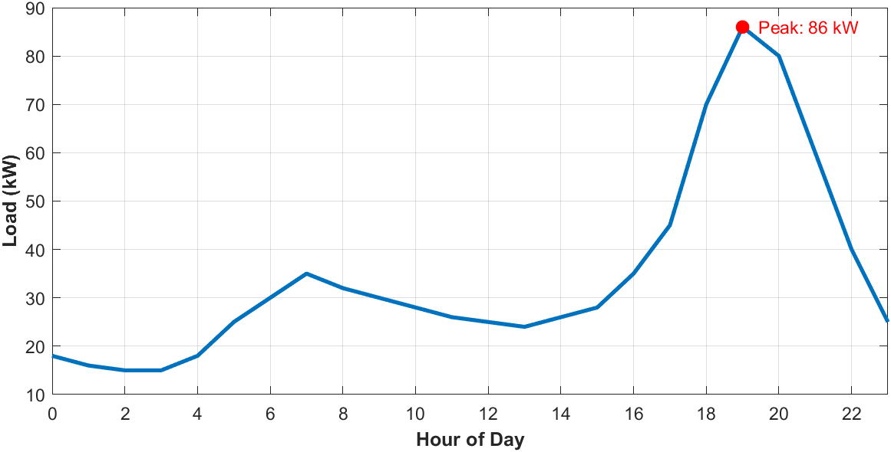
Fig. 3. Typical Daily Load Profile for Ibiaku Ikot Oku

Table 6: Optimised system configurations and performance indicators

Configuration | NPC (US$) | LCOE (US$/kWh) | Renewable Fraction (%) | CO₂ Emission (t/year)
PV–Diesel–Battery | 1,204,000 | 0.224 | 63.5 | 232.8
PV–Wind–Diesel–Battery | 1,058,400 | 0.197 | 78.2 | 126.5
PV–Wind–Battery (No Diesel) | 1,380,000 | 0.259 | 100 | 0

The addition of the wind turbine subsystem enhanced nighttime power availability, thereby reducing diesel generator runtime by approximately 45%. This resulted in an 18% lower NPC and a 20% lower fuel consumption compared with the PV–Diesel–Battery configuration. The hybrid system’s LCOE of $0.197/kWh is competitive with other recent African rural microgrid studies, which report costs ranging between $0.18 and $ 0.25/kWh (Araoye et al., 2024; Molu et al., 2024).

3.3 Cost Breakdown Analysis

The total cost distribution for the optimal configuration is illustrated in Fig. 4. The PV subsystem accounted for approximately 41% of total capital cost, the battery bank 27%, the wind subsystem 15%, while diesel generation and converter units contributed 11% and 6%, respectively. The analysis reveals that fuel and O&M costs represent 34% of the total lifecycle cost, highlighting the importance of renewable penetration in minimising fuel dependency. A further decline in PV and battery costs could improve overall economics, potentially reducing the LCOE below $0.15/kWh, consistent with projections in Yimen et al. (2024) and Ali et al. (2024).

3.4 Environmental Assessment

Adding renewable components substantially reduces greenhouse gas emissions. The PV–Wind–Diesel–Battery configuration achieved an annual CO₂ emission reduction of 45.7% compared with the diesel-only baseline, corresponding to 126.5 tons of CO₂ saved annually. Similarly, emissions of SO₂ and NOₓ declined by 48% and 42%, respectively. These results line up with similar techno-environmental assessments in Cameroon (Molu et al., 2024) and Bangladesh (Ali et al., 2024), confirming that hybridisation of diesel systems with renewable energy yields significant environmental and operational benefits.

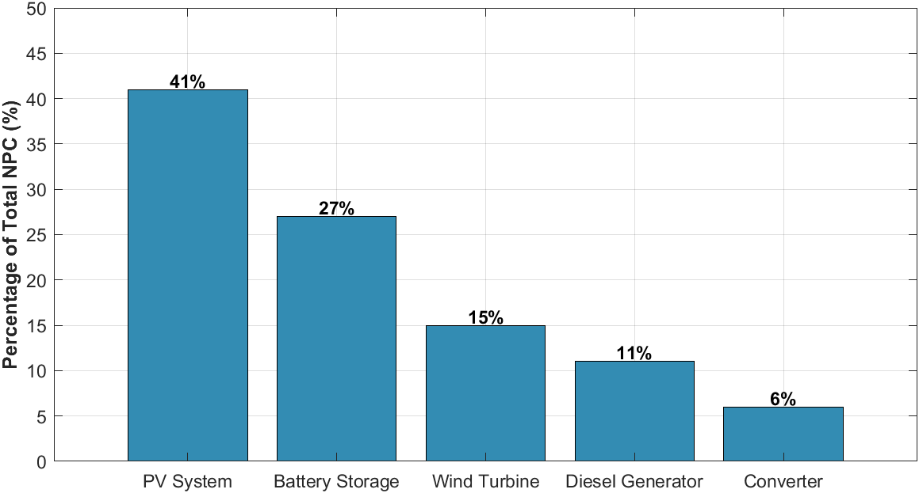

Fig. 4. NPC Cost Breakdown for the Optimised Hybrid Microgrid

3.5 Comparative Benchmarking

The obtained LCOE of $0.197/kWh is slightly below the $0.21–0.23/kWh range reported by Odetoye et al. (2023) for a similar Nigerian off-grid hybrid system and consistent with the $0.19–0.22/kWh reported by Araoye et al. (2024) using HOMER and grasshopper optimisation algorithm. The system’s renewable fraction (78.2%) also exceeds that of Molu et al. (2024), who achieved 65% renewable penetration in a Cameroon-based hybrid system. These results confirm the techno-economic feasibility of hybrid systems for rural electrification in Nigeria, particularly in regions with high solar insolation and moderate wind potential. Moreover, the integration of dual renewables enhances energy security and cost predictability against fuel price shocks — key advantages over diesel-dominant systems.

4. POLICY AND SUSTAINABILITY IMPLICATIONS

4.1 Relevance to Nigeria’s Rural Electrification Agenda

The results of this study have substantial implications for Nigeria’s energy access and sustainability goals. Despite several national initiatives such as the Rural Electrification Agency (REA) programs and the Nigeria Electrification Project (NEP), approximately 85 million Nigerians (nearly 40% of the population) remain without reliable access to electricity (World Bank, 2024). Most off-grid communities are geographically remote and economically underserved, rendering grid extension financially impractical.

Hybrid renewable microgrids, such as the optimised PV–Wind–Diesel–Battery system proposed in this study, offer a cost-effective and modular alternative for bridging the energy access gap. The computed LCOE of $0.197/kWh falls below the average off-grid diesel generation cost of $0.30–0.40/kWh, affirming the economic competitiveness of renewable hybrid systems under Nigeria’s prevailing fuel price conditions. This evidence supports the REA’s current shift toward decentralised hybrid microgrids under the Performance-Based Grant (PBG) and Output-Based Fund (OBF) schemes. These schemes incentivise private developers through capital subsidies tied to verified energy delivery, thereby accelerating the deployment of sustainable community-scale systems (REA, 2024).

4.2 Integration with the 2023 Electricity Act and National Energy Policy

The Electricity Act (2023) empowers subnational governments and private actors to generate, transmit, and distribute electricity within their territories. This legal reform opens pathways for state-level energy planning and encourages public-private partnerships in decentralised energy systems (Ejiogu et al., 2024). Hybrid renewable microgrids can thus become a cornerstone of state-level energy transitions, particularly in southern Nigeria, where solar and moderate wind resources are abundant. The findings of this paper show that techno-economically optimised microgrids can operate viably within regulated tariff bands while maintaining environmental compliance and service reliability.

Additionally, the National Renewable Energy and Energy Efficiency Policy (NREEEP) emphasises expanding renewables to achieve a 30% renewable energy mix by 2030. The implementation of hybrid microgrids, such as the one modelled here, directly contributes to this target by integrating multiple renewable resources and displacing diesel generation, aligning with Nigeria’s Nationally Determined Contribution (NDC) commitments under the Paris Agreement (UNFCCC, 2024).

4.3 Financing and Investment Considerations

Although the optimised hybrid system shows technical and economic viability, capital investment remains a critical barrier to large-scale deployment. The high upfront cost of PV modules and batteries, representing nearly 68% of total capital expenditure, often exceeds the financial capacity of rural communities. Policy mechanisms that can enhance financing viability include:
- Concessional and blended financing: Utilising low-interest credit from institutions such as the African Development Bank and the World Bank to reduce project Weighted Average Cost of Capital (WACC).
- Community energy cooperatives: Enabling local ownership and shared returns from microgrid operations, which enhances community buy-in and revenue sustainability (Yimen et al., 2024).
- Tax and import incentives: Waiving duties on renewable energy components (PV panels, inverters, and batteries) to lower capital cost, as implemented in Kenya and Rwanda (IEA, 2024).
- Carbon credit mechanisms: Monetising avoided CO₂ emissions (126.5 tons/year in this case) under voluntary carbon markets to generate supplemental project revenue streams.

4.4 Environmental and Social Sustainability

From an environmental standpoint, the proposed hybrid system achieved a nearly 46% reduction in CO₂ emissions relative to a diesel-only baseline. This directly supports Nigeria’s climate adaptation strategy and SDG 13 (Climate Action). Socially, microgrids strengthen rural livelihoods by powering schools, health centres, cold storage, and agro-processing industries. Studies have shown that renewable microgrids promote inclusive development, particularly in rural Africa, by enhancing education, healthcare, and microenterprise productivity (Molu et al., 2024; Araoye et al., 2024).

To sustain these gains, long-term policy must emphasise capacity building, operation and maintenance training, and local content development. Technical partnerships between universities, polytechnics, and energy startups can create a pipeline of skilled technicians to maintain microgrid assets, thereby extending the system’s lifespan and improving reliability, as previously stressed by Odetoye et al. (2023).

4.5 Strategic Outlook

The policy insights derived from this study suggest that hybrid microgrids can serve as scalable building blocks for Nigeria’s clean energy transition. In the medium term (2025–2035), integrating hybrid microgrids with smart control systems, IoT-based monitoring, and demand-side management could further enhance resilience and cost-effectiveness. Moreover, harmonising regulatory frameworks across states, implementing standardised microgrid interconnection codes, and establishing tariff-setting guidelines based on LCOE benchmarks (such as the $0.197/kWh derived here) would ensure transparent and equitable cost recovery for developers and consumers. If adequately supported by consistent policy, finance, and capacity-building measures, hybrid microgrids could provide sustainable electricity access to over 10 million rural Nigerians within the next decade, significantly contributing to the attainment of SDG 7 – Affordable and Clean Energy.

6. Conclusion

This study presented a detailed optimisation and techno-economic analysis of a solar–wind–diesel hybrid microgrid for sustainable rural electrification in Ibiaku Ikot Oku, Nigeria. The HOMER Pro simulation results demonstrate that the PV–Wind–Diesel–Battery configuration yields the most cost-effective and environmentally favourable solution among the modelled alternatives. The optimised system achieved a Net Present Cost (NPC) of $1.06 million, a Levelized Cost of Energy (LCOE) of $0.197/kWh, and a renewable fraction of 78.2%, representing a significant improvement over a conventional diesel-only system. Furthermore, the system reduced CO₂ emissions by 45.7%, demonstrating its environmental superiority and alignment with Nigeria’s climate commitments under the Paris Agreement (UNFCCC, 2024). These outcomes indicate that hybrid microgrids can provide reliable, affordable, and clean electricity to rural communities in Nigeria, while reducing their dependence on imported fossil fuels. The integration of complementary renewable resources (solar and wind) enhances system reliability, minimises fuel cost exposure, and improves lifecycle economics. The findings also reinforce earlier conclusions that multi-source hybridisation represents a pragmatic and scalable solution to rural electrification challenges in sub-Saharan Africa. Additionally, this work provides transparent cost breakdowns, operational insights, and sensitivity analyses that can guide policymakers, investors, and energy developers in planning and implementing microgrids.

5. POLICY IMPLICATIONS, STUDY LIMITATIONS AND FUTURE WORK

5.1 Policy Implications

From a policy perspective, the study supports the decentralisation objectives of Nigeria’s Electricity Act (2023), which empowers state-level and private sector participation in distributed generation. The derived LCOE benchmark of $0.197/kWh can inform tariff design and financial modelling for mini-grid developers under the NEP and Rural Electrification Fund (REF) schemes. Furthermore, the achieved emission reduction potential positions hybrid microgrids as essential components in achieving Nigeria’s 30% renewable energy target by 2030, as articulated in the NREEEP and NDC 2024 commitments (UNFCCC, 2024).

5.2 Limitations of the Study

While the results obtained are robust and contextually relevant, specific limitations exist:
- Modelling simplifications: The HOMER Pro platform assumes ideal control strategies and may not capture dynamic operational constraints, such as inverter efficiency degradation or transient faults.
- Static resource assumptions: The use of annual-average irradiance and wind speed data limits the representation of temporal variability.
- Economic assumptions: A fixed discount rate and constant fuel escalation rates may not accurately reflect the macroeconomic volatility in Nigeria’s energy market.
These limitations, however, do not undermine the study’s core conclusions; instead, they highlight areas for methodological enhancement in future work.

5.3 Future Research Directions

To deepen understanding and strengthen the applicability of hybrid microgrid solutions, future work should consider the following:
- Incorporation of advanced optimisation algorithms such as Particle Swarm Optimisation (PSO), Genetic Algorithms (GA), or Reinforcement Learning-based controllers for improved component sizing and control precision.
- Dynamic and probabilistic modelling using Monte Carlo simulations or time-series forecasting to account for meteorological and load uncertainties.
- Integration of emerging technologies, including hydrogen storage systems and supercapacitors, to enhance reliability and system flexibility.
- Field validation and socio-economic analysis, involving real-time performance monitoring and community-level impact assessment, to verify model predictions and inform adaptive policies.
- Integration of smart grid and IoT technologies for remote monitoring, predictive maintenance, and adaptive energy management, enabling data-driven decision-making in microgrid operations.

Competing interests

Authors have declared that no competing interests exist.

COMPETING INTERESTS DISCLAIMER:
Authors have declared that they have no known competing financial interests OR non-financial interests OR personal relationships that could have appeared to influence the work reported in this paper.

References

Ajayi, O. Fagbenle, R., Katende, J., Aasa, S. and Okeniyi, J. (2013). Wind profile characteristics and turbine performance analysis in Kano, north-western
Ali, M. F., Hossain, M. A., Julhash, M. M., Ashikuzzaman, M., Alam, M. S., & Sheikh, M. R. I. (2024). A techno-economic analysis of a hybrid microgrid system in a residential area of Bangladesh: Optimising renewable energy. Sustainability, 16(18), 8051. https://doi.org/10.3390/su16188051​
Araoye, T. O., Ashigwuike, E. C., Mbunwe, M. J., Bakinson, O. I., & Ozue, T. I. (2024). Techno-economic modeling and optimal sizing of autonomous hybrid microgrid renewable energy system for rural electrification sustainability using HOMER and grasshopper optimisation algorithm. Renewable Energy, 229, Article 120712. https://doi.org/10.1016/j.renene.2024.120712​
Azeez, J. (2024). Energy Analysis of a 20W Solar Photovoltaic Module: A Review. International Journal of Research and Innovation in Applied Science (IJRIAS), IX(I): 2454-6194.
Dosa, A., Olanrewaju, O. A., & Mora-Camino, F. (2025). A Comprehensive Review of Hybrid Renewable Microgrids: Key Design Parameters, Optimization Techniques, and the Role of Demand Response in Enhancing System Flexibility. Energies, 18(19), 5154. https://doi.org/10.3390/en18195154 ​
Ejiogu, E. A., Nwosu, M. O., & Chukwueke, S. O. (2024). The Nigerian Electricity Act 2023 and the future of subnational energy markets. Energy Policy, 190, 113976. https://doi.org/10.1016/j.enpol.2024.113976​
ESA/NASA (2024). Exploring Earth’s Interface with Space – The Scientific Case for a Satellite Mission to the Lower Thermosphere-Ionosphere Transition Region, European Space Agency (ESA), Noordwijk, The Netherlands and National Aeronautics and Space Administration (NASA), Washington DC, United States of America, ESA-EOPSM-ELTI-RP-4592 / NASA/CR-20240013551, 128 pp.,http://doi.org/10.5270/ESA-NASA.LTI-SC.2024-07-v1.0
IEEE Guide for Optimizing the Performance and Life of Lead-Acid Batteries in Remote Hybrid Power Systems," in IEEE Std 1561-2007 , vol., no., pp.1-29, 8 May 2008, doi: 10.1109/IEEESTD.2008.4522641.
IEEE Standard for Interconnection and Interoperability of Distributed Energy Resources with Associated Electric Power Systems Interfaces," in IEEE Std 1547-2018 (Revision of IEEE Std 1547-2003) , vol., no., pp.1-138, 6 April 2018, doi: 10.1109/IEEESTD.2018.8332112.
International Energy Agency (IEA). (2024). Energy system of Africa. International Energy Agency.​
IPCC (2023). A Report of the Intergovernmental Panel on Climate Change. Intergovernmental Panel on Climate Change.
Molu, R. J. J., Naoussi, S. R. D., Bajaj, M., et al. (2024). A techno-economic perspective on efficient hybrid renewable energy solutions in Douala, Cameroon's grid-connected systems. Scientific Reports, 14, Article 13590. https://doi.org/10.1038/s41598-024-64427-4​
National Bureau of Statistics - NBS (2024). Automotive Gas Oil (Diesel) Price Watch (January 2024). https://www.nigerianstat.gov.ng/elibrary/read/1241456
Nigeria Electricity Act (2023). Policy and Legacy Advocacy Centre.
Nigeria. International Journal of Energy and Environmental Engineering, 4(27): 1-15.
Odetoye, O. A., Olulope, P. K., Olanrewaju, O. M., Alimi, A. O., & Igbinosa, O. G. (2023). Multi-year techno-economic assessment of proposed zero-emission hybrid community microgrid in Nigeria using HOMER. Heliyon, 9, e19189. https://doi.org/10.1016/j.heliyon.2023.e19189​
Omoriare, J.U. & Ogherohwo, Enoh & Zhimwang, Jangfa. (2025). Investigating the influence of solar irradiance variability on the output power of photovoltaic (PV) systems in Akure, Nigeria. World Journal of Applied Science & Technology. 16. 18-22. 10.4314/wojast.v16i1.18.
Rachid, A., Korkut, T. B., Cardot, J.-S., Kébé, C. M. F., Ndiaye, A., Sinsin, L. M., & Fifatin, F. X. (2025). Optimizing Solar-Integrated Microgrid Design for Sustainable Rural Electrification: Insights from the LEOPARD Project. Solar, 5(1), 9. https://doi.org/10.3390/solar5010009
Ross-Hopley, D., Ugwu, L., & Ibrahim, H. (2024). Review of techno-economic analysis studies using HOMER Pro software. Engineering Proceedings, 761, 94. https://doi.org/10.3390/engproc2024076094​
Rural Electrification Agency (REA). (2024). Nigeria Electrification Programme: Market Study to Support the Nigeria. Electrification Project. Rural Electrification Agency, Abuja.​
Satellite Pro (2025) Title of map section. Available at: https://satellite.pro/ (Accessed: November 13, 2025).
UL Solutions. (2024). HOMER Pro (Version 3.16) [Computer software]. https://www.homerenergy.com/products/pro/index.html.
United Nations Framework Convention on Climate Change (UNFCCC). (2024). Nigeria's Updated Nationally Determined Contribution (NDC) 2024. United Nations Framework Convention on Climate Change.​
World Bank. (2024). Tracking SDG 7: The Energy Progress Report 2024. World Bank Publications.​
Yimen, N., Mondoue Bouodo, T. R., Biboum, A. C., Nzotcha, U., Musa, B., Djomi, R., & Sani, S. (2024). Techno-Economic Optimization of Hydrogen-Based Hybrid Renewable Energy Systems for Rural Electrification in Sub-Saharan Africa: Case Study of a Photovoltaic/Wind/Hydrogen System in Dargalla, Cameroon. Preprints. https://doi.org/10.20944/preprints202412.2206.v1

