Design and Implementation of an Adaptive Visual Perception Verification Platform for Amphibious Rescue Robots

Abstract：Amphibious rescue robots encounter significant environmental variations during cross-medium rescue missions, making it challenging for a single visual detection model to simultaneously meet the high-precision requirements of both aquatic and terrestrial scenes. To address this issue, this paper designs and implements an algorithm verification platform for adaptive visual perception, aiming to validate the feasibility of an “environment perception–model scheduling” adaptive pipeline. The platform adopts a modular and hierarchical architecture, integrating a rapid environment discrimination module based on the YOLO framework and two specialized object detection models. Through real-time scene judgment and dynamic model scheduling, it achieves environment-adaptive detection. In addition, the platform provides a graphical user interface and multi-dimensional performance monitoring, supporting multiple input sources such as cameras, videos, and images, thereby supporting algorithm verification in laboratory environments. Experimental results demonstrate that the platform achieves an environment classification accuracy of 92.3%, an average processing frame rate of 28.6 FPS, and a comprehensive detection accuracy improvement of 7.2% in mixed environments compared to the best-performing single model. These results effectively validate the engineering feasibility of the adaptive scheduling mechanism in terms of both accuracy and real-time performance. This platform offers a reusable verification foundation for the subsequent embedded integration and field deployment of amphibious robot visual perception systems.
Keywords：Amphibious rescue robot; Visual perception; Algorithm verification platform; Adaptive scheduling; YOLO; Simulation test

1 Introduction

Amphibious rescue robots, leveraging their unique capability for cross-medium operations in extreme disaster environments such as floods and earthquakes, have become critical equipment for enhancing search and rescue efficiency and reducing risks to rescue personnel. As a core component enabling environmental understanding and autonomous decision-making, the visual perception system's performance directly determines the robot's mission execution capability. However, aquatic and terrestrial environments exhibit significant differences in illumination conditions, texture features, target morphology, and interference factors: water surface scenes are frequently affected by reflections, wave disturbances, and low contrast, whereas land-based geological disaster scenes face challenges such as debris occlusion, fragmented terrain, and highly variable target scales. These disparities make it difficult for a single visual detection model to simultaneously maintain high accuracy and strong robustness across both scene types, underscoring an urgent need for an adaptive perception mechanism tailored for cross-medium missions.
Current related research can be categorized into the following three main threads. First, regarding the optimization of detection algorithms for specific environments, existing work has proposed specialized improved models for tasks such as underwater image enhancement and target detection [1], and obstacle recognition for land-based disaster scenes [2], significantly improving detection performance within single environments. However, such research predominantly takes a single scene as its application boundary and does not involve systematic design for environment type discrimination and dynamic model switching. Second, in the domain of amphibious robot system integration and motion control, researchers have proposed solutions such as track-bionic fin composite driving structures [3] and smooth switching control strategies based on EZMP [4], advancing the cross-medium operational capabilities of the robot body. Nevertheless, the visual perception module in these systems remains deployed as a fixed model, lacking functional support for environmental adaptation. Third, in terms of algorithm verification platforms and scheduling methodologies, existing platforms are mostly oriented toward single environments or general vision tasks [5]. A dedicated verification tool that simultaneously accommodates both aquatic and terrestrial environments and integrates environment perception with dynamic scheduling logic has yet to emerge. Consequently, the "environment discrimination–model switching" technical pathway cannot be systematically evaluated during the laboratory stage [6]. Although some studies have validated the feasibility of dynamic scheduling strategies from the perspectives of control theory [7] or reinforcement learning [8], their implementation remains highly dependent on customized platform support. Meanwhile, the dual verification paradigm combining simulation and physical experimentation [9] provides a methodological reference for the design and testing of the platform proposed in this paper. Furthermore, at the human–computer interaction level, the rationality of graphical user interface layout, the immediacy of visual feedback, and the transparency of status information directly affect experimental efficiency and user experience [10]. Research based on user comment analysis and UI design principles [11, 12] indicates that reasonable functional partitioning and high-contrast visual feedback can significantly lower the operational threshold, offering important guidance for the design of the interactive interface in this study. In summary, research on adaptive visual perception for amphibious rescue robots remains in its early stages. Existing work either concentrates on algorithm optimization within a single environment or emphasizes body structure and control, and there is a notable lack of system-level verification means that integrate environment discrimination, model scheduling, and collaborative detection into a unified framework.
To address the aforementioned research gap, this paper designs and implements an algorithm verification platform for adaptive visual perception. The platform employs a rapid environment discrimination model based on the YOLO architecture as its core decision-making unit, integrating the CSDSKA-YOLOv11n model specialized for water surface targets and the DSSKA-YOLOv8n model specialized for land-based geological hazards. Through two configurable scheduling strategies—"Hard Switching" and "Confidence‑Guided Soft Switching"—the platform achieves dynamic adaptation between environment perception and detection models. Adopting a modular, hierarchical architecture, the platform integrates a graphical user interface, multi-source input interfaces, and real-time performance monitoring modules. It aims to systematically validate the effectiveness, real-time performance, and robustness of the adaptive scheduling strategy under laboratory conditions, thereby providing a reusable verification foundation and decision-making basis for the subsequent embedded transplantation and field deployment of the algorithms onto real robotic platforms.

Methodology

2 Overall Design of the Verification Platform System
2.1 Platform Architecture

The algorithm verification platform designed in this paper adopts a hierarchical and decoupled software architecture to facilitate modular development, testing, and functional iteration. The overall platform architecture, comprises the following four layers:
User Interaction Layer: Responsible for the human-machine interaction interface, this layer encapsulates functions such as system control, input source selection, parameter configuration, real-time visualization, and historical record query. It converts user instructions into internal calls and provides real-time graphical feedback of processing results, offering a unified entry point for experimental operations.
Algorithm Scheduling Layer: Serving as the core decision-making unit of the platform, this layer consists of an environment perception module and a dynamic scheduler. The environment perception module performs binary scene classification based on the YOLO object detection framework, outputting "water surface"/"land" labels along with confidence scores. The dynamic scheduler determines which specialized detection model should be invoked based on the classification results and user-preset strategies (Hard Switching/Confidence‑Guided Soft Switching), and triggers the algorithm execution layer to perform inference. This layer fully realizes the adaptive closed-loop of "perception-decision-execution".
Algorithm Execution Layer: This layer encapsulates two types of specialized object detection models tailored for specific environments, adapted for water surface and land scenes respectively. It receives scheduling instructions, loads the corresponding model to perform forward inference, and returns detection results—including bounding boxes, categories, and confidence scores—to the upper layer. Model weights are pre-loaded and persistently reside in GPU memory via a caching mechanism, enabling millisecond-level switching.
Data Support Layer: Responsible for structured recording and persistent storage of experimental data throughout the entire workflow. This layer non-intrusively collects per-frame environment discrimination results, scheduling decisions, detection outputs, timestamps, and system performance metrics (frame rate, latency). It supports data export in JSON/CSV formats, providing a reproducible data foundation for offline analysis and algorithmic iteration.
The aforementioned architecture decomposes the adaptive perception task into four orthogonal dimensions: environment understanding, decision scheduling, model execution, and data tracking. Each layer can be independently optimized and replaced, establishing a flexible software foundation for subsequent algorithm upgrades and embedded transplantation.
2.2 Workflow

The workflow of the platform is the concrete manifestation of its adaptive scheduling logic. As shown in Fig. 1, it consists of the following five stages:
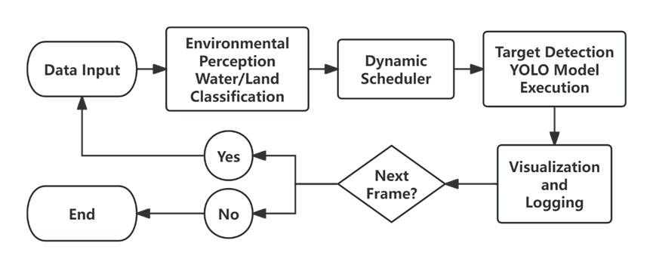
Fig. 1. Adaptive Visual Perception Verification Platform Workflow Diagram.
Data Input and Preprocessing Stage: The process commences with the user selecting an input source through the interaction layer. The platform subsequently activates the data interface layer to capture image frames continuously from a camera or video stream, or to load single/batch images. Each raw image frame is then automatically adjusted to the input size required by the algorithms, and preprocessing steps such as normalization are performed, forming a standardized tensor format ready for subsequent algorithmic processing.
Environment Perception and Decision Stage: The preprocessed image frame is fed into the environment perception module. Based on the classification confidence and a preset threshold, the dynamic scheduler determines whether to invoke the water surface or land detection model. If the "Hard Switching" strategy is adopted, the scheduler compares the confidence scores for the two classes, selects the class with a score exceeding the threshold as the current environment, and decides to invoke the corresponding specialized detection model. If the "Confidence‑Guided Soft Switching" strategy is employed, the scheduler runs both the water surface and land specialized detection models simultaneously, but outputs only the detection results corresponding to the model with the higher confidence score. This stage is critical for validating the intelligence of the platform, as it simulates the process by which a robot autonomously recognizes a scene and makes decisions.
Target Detection Execution Stage: Based on the scheduler's decision, the corresponding specialized detection model in the algorithm execution layer—either CSDSKA-YOLOv11n or DSSKA-YOLOv8n—is activated. The model performs forward propagation on the input frame, generating detection results that include target bounding boxes, category labels, and confidence scores. The platform strictly records the detection time consumption at this stage, serving as a crucial basis for evaluating the real-time performance of the algorithm.
Result Synthesis and Visualization Stage: After detection is completed, the platform fuses the environment perception result with the target detection results. Utilizing a visualization engine, the detected target bounding boxes, categories, confidence scores, along with the currently determined environment label, are overlaid and rendered onto the original image frame to generate an intuitive visualization. This result is then pushed in real-time to the central preview area of the interaction layer, providing users with immediate feedback.
Status Update and Data Logging Stage: Upon completion of processing each frame, the platform automatically updates the global status. The right-side information panel refreshes with the latest performance metrics (such as instantaneous frame rate, cumulative processed frame count, CPU/GPU utilization). The environmental decision for this frame, the algorithm used, the number of detected targets, and the timestamp are compiled as a record and appended to the historical record list at the bottom of the interaction layer. Simultaneously, the data storage layer writes this record along with its detailed performance data to log files or a memory queue in the background, ensuring complete preservation of all experimental data for subsequent performance report generation or in-depth analysis.
Through the cyclical process described above, the platform is capable of fully simulating and validating the adaptive perception workflow required by the visual system of an amphibious robot at the software level. This provides substantial preliminary verification for the integration of core algorithms into real hardware platforms.
2.3 Development and Operating Environment

The development and all testing of this platform were conducted in a unified environment to ensure result consistency. The hardware platform utilized a desktop workstation equipped with an Intel Core i5-13600KF CPU and an NVIDIA GeForce RTX 4060 GPU (8GB VRAM). The software environment was based on the Windows 11 operating system, using Python 3.8. Core algorithms were implemented based on the PyTorch 2.0.0 deep learning framework and the Ultralytics YOLO open-source library. The GUI was built using Tkinter, with GPU acceleration enabled via CUDA 11.8 and cuDNN 8.7.0. This environment established a stable foundation for algorithm verification, and all performance data presented subsequently were measured under these conditions.
3 Implementation of Core System Modules
3.1 Interactive Interface Design

To intuitively control and verify the adaptive scheduling algorithm, this platform developed a Graphical User Interface (GUI) based on Tkinter. As shown in Fig. 2, its design adopts an integrated layout consisting of a top title bar, a three-column main body (left, center, right), and a bottom status bar. This layout organically integrates functional control, core preview, status monitoring, and global status feedback. The specifics are as follows:
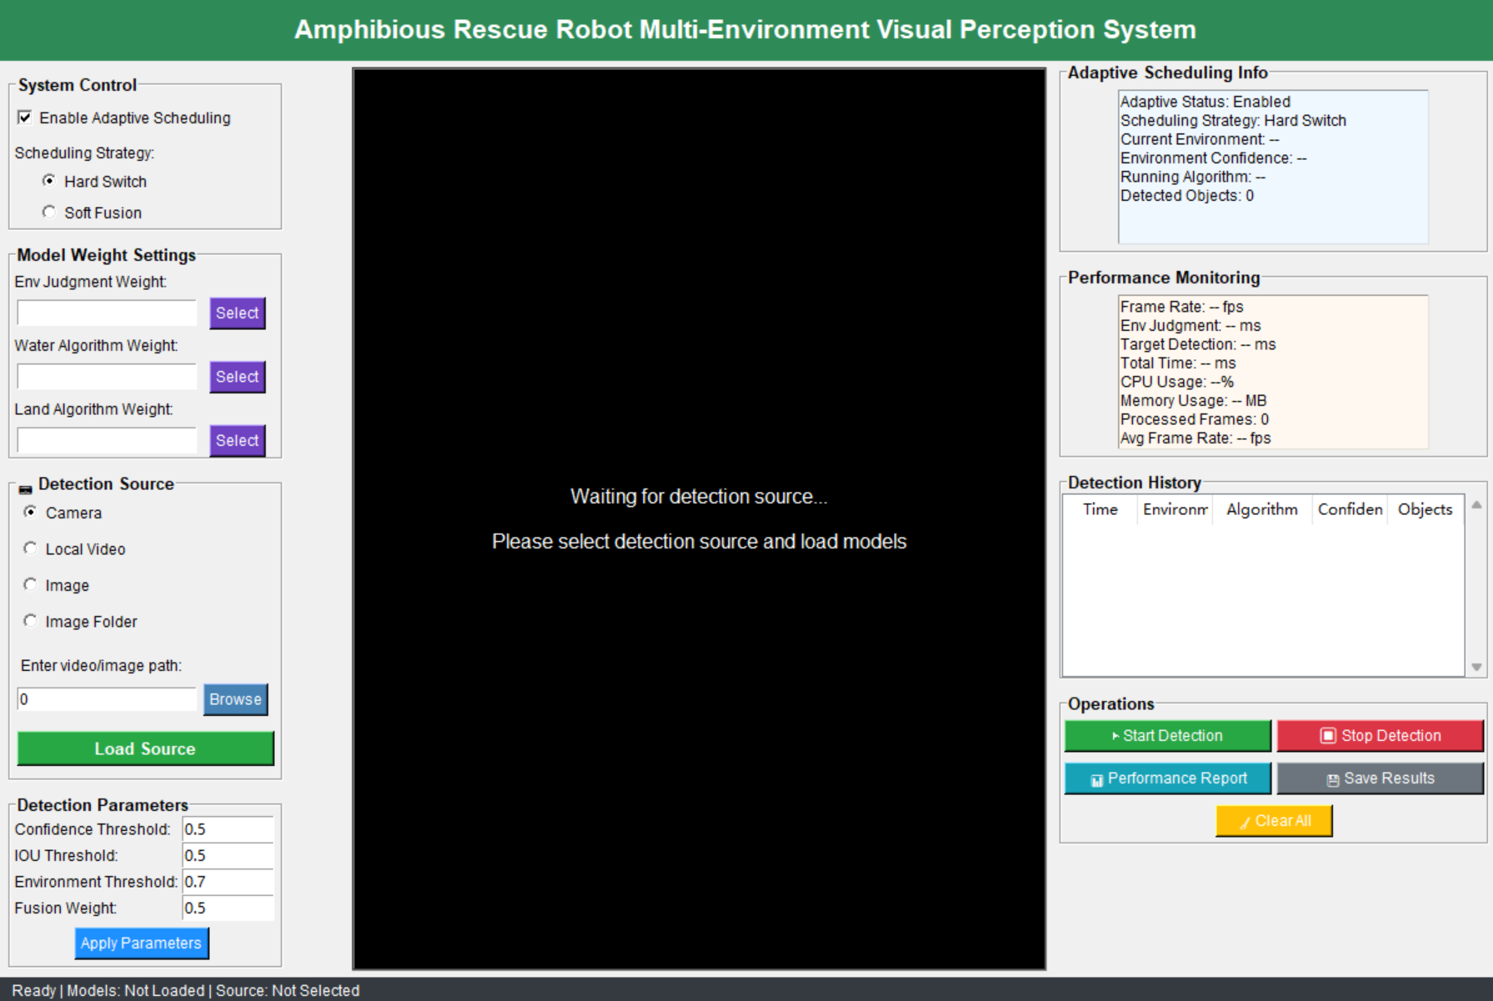
Fig. 2. Graphical user interface of the verification platform.
Left Control Area: This area integrates all input and configuration functions of the system. The top of the system control panel provides an "Enable Adaptive Scheduling" checkbox and radio buttons for selecting the "Hard Switching / Confidence‑Guided Soft Switching" scheduling strategy. The model weight management module offers three independent "Select" buttons with corresponding path display boxes for loading the pre-trained model files for "Environment Judgment", "Water Surface Algorithm", and "Land Algorithm", respectively. The detection source selection module supports four input modes—"Camera", "Local Video", "Image", and "Image Folder"—via radio buttons. The detection parameter settings module provides input boxes for four key parameters: "Confidence Threshold", "IOU Threshold", "Environment Threshold", and "Fusion Weight". This layout adheres to the hierarchical principles of UI design, avoiding functional redundancy and operational confusion, and meets the user interaction requirements for tool-based platforms [11].
Central Visualization Area: Serving as the core feedback region, its initial state displays a "Waiting to load detection source..." prompt. Once detection is initiated, this area displays the video stream or image in real time, dynamically overlaying and rendering target detection bounding boxes, category labels, and the current environment judgment result. This provides users with intuitive visual feedback on the algorithm's performance. The visualization effect references UI visual quality assessment standards [9], employing a high-contrast color scheme to ensure the clarity of detection results and prevent misinterpretation of experimental data due to visual ambiguity.
Right Monitoring and Operation Area: This area centrally displays system status and provides process control. The adaptive scheduling information panel clearly presents core runtime status in a fixed text format. The performance monitoring panel dynamically refreshes key performance indicators. The detection history record list displays recent detection records in a scrolling tabular format. The functional operation area arranges five core buttons: "Start Detection", "Stop Detection", "Performance Report", "Save Results", and "Clear Records", covering the operational needs of the entire detection workflow.
Top Title Bar and Bottom Status Bar: The top title bar displays the platform name using a high-contrast color scheme, serving as a visual identifier and providing global orientation. The bottom status bar provides real-time feedback on the platform's operational status (Ready / Detecting), model loading status, detection source type, and current frame rate. This design addresses the common issue of "lack of global status feedback" in tool-based platforms.
This interface design encapsulates the complex multi-model adaptive scheduling workflow within intuitive controls and a real-time visualized information flow. It significantly lowers the technical barrier for algorithm verification, enhances experimental efficiency and interaction experience, and aligns with the application principles of ergonomics in UI design.
3.2 Adaptive Environment Perception Module

The adaptive environment perception module serves as the decision-making core for intelligent scheduling in this verification platform. Its task is to perform real-time scene understanding on each input image frame, accurately determining whether it belongs to a "water surface" or "land" environment, and providing confidence scores for the dynamic scheduler. The complete workflow of environment perception and dynamic scheduling is illustrated in Algorithm 1.
(1) Module Design and Implementation
This module adopts an object detection model based on the YOLO framework as the environment perception model. The model is fine-tuned on a dedicated environmental classification dataset and outputs two semantic categories: "water surface environment" and "land environment". The module takes standardized RGB images as input, performs forward propagation through the network, extracts the class confidence scores from the detection head, and selects the class with the highest confidence score as the judgment result for the current environment. This design reuses YOLO's unified inference engine, eliminating the need to maintain an independent classification network and thereby reducing system complexity.
(2) Decision and Anti-Jitter Mechanism
To enhance the stability of environment judgments across consecutive frames and to reduce decision jitter in ambiguous transitional frames, the module incorporates the following two-level stabilization strategy:
- Confidence Threshold Filtering: A tunable environment judgment threshold (default: 0.7) is set. An explicit judgment is made only when the confidence score for one category exceeds this threshold. Otherwise, the system marks the current frame as an "uncertain" state and retains the judgment result from the previous frame. This filters out low-confidence noise.
- Sliding-Window Historical Smoothing: For video streams, the decision integrates the confidence history of the most recent N frames (N=5 in experiments). By calculating the average confidence within the sliding window or performing a majority vote, the final environment judgment becomes smoother and more robust, aligning with the continuity of real-world scene changes.
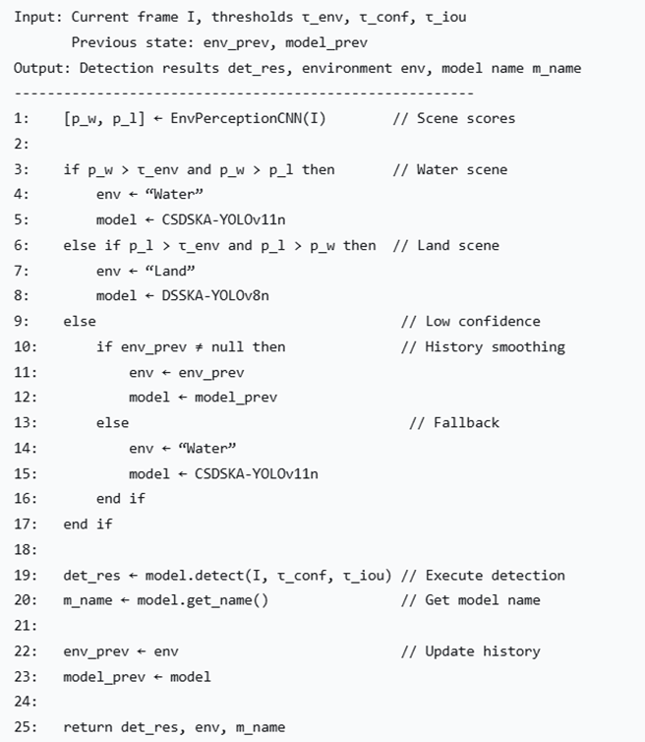
Algorithm 1: Environment judgment and model scheduling process.
3.3 Dynamic Model Scheduling Strategy

The dynamic model scheduling strategy serves as the core execution logic of the verification platform. It receives the output from the environment perception module and makes decisions on how to invoke the specialized detection models accordingly. To address scenarios of varying complexity and validate different design concepts, the platform implements two optional scheduling strategies.
(1) Hard Switching Strategy
This strategy adheres to the "perception-decision-execution" serial pipeline, aiming for the lowest latency and resource consumption. Its workflow is straightforward: once the environment perception module outputs the environment label ("water" or "land") for the current frame, the scheduler immediately halts potential computation for the other model and fully directs computational resources to the selected specialized model. This strategy is efficient and logically simple, making it suitable for scenarios where aquatic and terrestrial features are distinct and environmental changes are infrequent. However, in environmental transition zones or for frames with ambiguous features, it may lead to issues such as brief mismatches between the detection model and the actual scene due to single-frame misjudgments.
(2) Confidence‑Guided Soft Switching Strategy
To enhance decision robustness in complex and ambiguous environments, the platform provides a confidence‑guided soft switching strategy. This strategy adopts a parallel computing architecture, simultaneously running both the water surface and land specialized detection models. Rather than performing weighted fusion of detection results, the scheduler utilizes the confidence scores output by the environment perception module as the basis for model selection: when the water surface confidence exceeds the land confidence, the detection results from the water surface model are output; otherwise, the detection results from the land model are output. This strategy effectively smooths the output during environmental transitions, avoiding "flickering" caused by single-frame misjudgments.
(3) Scheduler Implementation and Optimization
The core of the scheduler is an efficient state manager and resource coordinator. It maintains the loading status of each model and employs a "model caching" mechanism: during system initialization, all necessary model weights are loaded into GPU memory and remain resident. When a strategy switch is required, the scheduler only needs to switch the logical pointers referencing the model computation graphs. This completely avoids the significant I/O overhead associated with repeatedly loading weights from disk, thereby reducing model switching latency from seconds to milliseconds. Additionally, the scheduler integrates a lightweight decision anti-jitter logic, further enhancing the stability of the system's output.
In summary, these two strategies provide the platform with flexibility, enabling researchers to conduct trade-off assessments and testing between real-time performance (Hard Switching) and robustness (Confidence‑Guided Soft Switching). This establishes critical performance benchmarks and a basis for strategic selection for future algorithm deployment on physical robotic systems.
4 System Testing and Performance Analysis
4.1 Test Environment and Data

To comprehensively evaluate the functionality of the verification platform, the effectiveness of the adaptive scheduling strategy, and its real-time performance, a systematic testing scheme was designed for this section. All tests were conducted within a unified software and hardware environment to ensure the consistency and comparability of results.
Offline evaluation of the environment perception module was performed using a self-constructed multi-environment visual perception dataset. This dataset, designed to simulate the complex scenarios that rescue robots may encounter, comprises a total of 8,000 high-quality annotated images, with 4,000 images each for aquatic and terrestrial environments. To test system robustness, the dataset encompasses the following diversities: aquatic scenes include open water, nearshore areas, docks, flood-inundated zones, etc.; terrestrial scenes cover typical geological disaster or rescue environments such as mountainous areas, road collapses, debris flow sites, and forest edges. Image acquisition considered various lighting conditions, weather conditions, and different degrees of occlusion to ensure testing comprehensiveness.
The overall performance evaluation of the adaptive scheduling strategy employed a mixed-environment video sequence containing alternating water surface and land scenes, with a total of 2,000 frames—approximately 1,000 frames each for water and land environments. All object detection models had been pre-trained on their respective domain-specific datasets; only forward inference testing was conducted in this experiment, with no fine-tuning involved.
To assess the value of adaptive scheduling, three comparative baselines were established: fixed use of the water surface model, fixed use of the land model, and random model switching. The system presented in this paper was compared against the aforementioned three baselines on the same test set. Core evaluation metrics included cross-environment comprehensive detection accuracy (mean Average Precision, mAP50-95), average processing frame rate (FPS), and system resource utilization.
4.2 Performance Metrics

To comprehensively evaluate the efficacy of this verification platform, systematic testing and analysis of its core performance metrics were conducted. All tests were completed using the previously described software/hardware environment and dataset. The main results are as follows:
In terms of scheduling decision accuracy, the environment perception module achieved an overall classification accuracy of 92.3% on a test set containing 600 independent images. The recognition accuracy for water surface scenes and land scenes was 94.1% and 90.5%, respectively. This result surpasses traditional single-feature classification methods, demonstrating that the module can provide reliable decision-making basis and ensure the correctness of subsequent scheduling.
In terms of system processing real-time performance, the platform achieved an average end-to-end frame rate of 28.6 FPS when processing mixed-environment video under the "Hard Switching" strategy. Regarding algorithm switching latency, we measured the elapsed time from the completion of environment judgment to the output of specialized model results using code instrumentation. Testing revealed that the average model scheduling latency under the "Hard Switching" strategy was 34.8 milliseconds. The computationally heavier Confidence‑Guided Soft Switching strategy achieved an average frame rate of 22.4 FPS, with a per-frame processing latency of 102.5 milliseconds. This latency stems from the parallel execution of both water surface and land models, where the inference time corresponds to the maximum of the two models' processing durations. These results satisfy the fundamental requirement of >20 FPS typically demanded for real-time visual perception in mobile robots, demonstrating the platform's potential for engineering applications on standard computing hardware.
4.3 Experimental Results Analysis & Discussion

To validate the effectiveness of the adaptive scheduling strategy proposed in this paper, we conducted comprehensive comparative experiments on the mixed-environment dataset, comparing our system employing the Hard Switching strategy against the two fixed specialized models. The comprehensive detection accuracy was evaluated using the mean Average Precision mAP50-95, a standard metric in the object detection field. The results are summarized in Table 1.
Table 1. Performance Comparison of Different Schemes on Mixed-Environment Dataset.
Testing Scheme | mAP50-95(%) | Average Frame Rate  (FPS) | Resource Usage  (GPU Memory)
Fixed Water Surface Model | 76.3 | 31.2 | 0.8GB
Fixed Land Model | 79.8 | 33.5 | 0.7GB
Random Switching Model | 74.1 | 25.8 | 1.1GB
Adaptive Scheduling Platform | 85.6 | 28.6 | 1.2GB
The experimental data clearly demonstrates that a single specialized model suffers significant performance degradation in environments it is not adapted to. For instance, the CSDSKA-YOLOv11n model, specialized for water surface targets, experienced an mAP drop exceeding 15% on a pure land dataset. Similarly, the DSSKA-YOLOv8n land model exhibited severely limited detection capability in aquatic scenes. In contrast, our verification platform, which integrates environment perception and dynamic scheduling, can automatically invoke the optimal model based on the scene. Consequently, it achieved the highest comprehensive mAP of 85.6% on the mixed-environment test set. Compared to the best-performing single fixed model's mAP of 79.8%, our platform achieved a precision improvement of 7.2%. This directly proves the core value of the adaptive scheduling mechanism in enhancing the robustness of visual perception for amphibious scenarios.
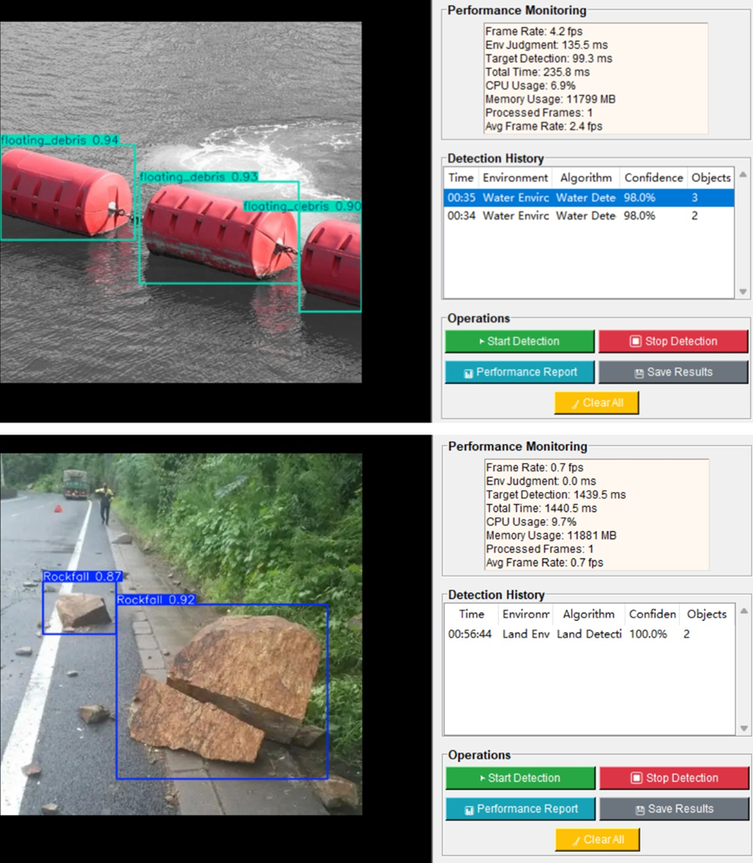
Fig. 3. Visualized Detection Results of the Adaptive Scheduling Platform.
As shown in Fig. 3, the visualized results further validate the effectiveness of the platform: in a typical water surface scene, the system correctly invoked the CSDSKA-YOLOv11n model, accurately detecting floating debris; when the scenario transitioned to a land-based geological hazard environment, the system seamlessly switched to the DSSKA-YOLOv8n model, achieving stable, high-confidence detection of a rockfall ahead. The visualized results intuitively confirm the accuracy and effectiveness of the platform's adaptive switching, which aligns closely with the practical requirements of amphibious robot visual perception.
Integrating the comprehensive performance metrics and comparative experimental results, this verification platform maintains a relatively high detection accuracy while achieving a stable average processing frame rate of 28.6 FPS. This meets the fundamental requirements for real-time visual perception in mobile robots, and the system resource consumption remains within an acceptable range. The experimental results and analysis presented above indicate that the software verification platform designed and implemented in this paper successfully validates the feasibility of the "environment judgment - model dynamic scheduling" technical pathway. It provides a solid theoretical and experimental foundation for the subsequent embedding of the algorithms into real robot hardware platforms.
5 Conclusion and Future Work

This paper has designed and implemented an adaptive scheduling-based visual perception verification platform to address the cross-environment perception requirements of amphibious rescue robots. The platform successfully integrates YOLO-framework-based rapid environment discrimination, dynamic scheduling, and dual specialized detection models. It provides a complete testing and evaluation toolkit through an ergonomically designed Tkinter-based graphical user interface. Employing a modular architecture, the platform supports multiple input sources and two scheduling strategies—Hard Switching and Confidence‑Guided Soft Switching—enabling systematic validation of adaptive visual perception algorithm performance within a laboratory environment. Experimental results demonstrate that the platform effectively validates the adaptive scheduling logic, achieving a balance between accuracy and real-time performance in a simulated environment, thereby offering a reusable verification framework for the development of amphibious robot perception systems.
The present research is currently at the laboratory simulation and verification stage. Future work can be pursued along the following dimensions to facilitate the transition of this technology toward practical applications: (1) Introduce additional disaster environment categories and corresponding specialized models to expand the system's perceptual dimensions; (2) Optimize the scheduling strategy to realize true detection-level weighted fusion, and explore fusion-based decision-making incorporating multi-sensor information such as LiDAR and IMU to enhance decision robustness in complex environments; (3) Perform lightweighting and optimization of core algorithm modules and port them to embedded platforms such as Jetson to achieve integration into real robotic systems; (4) Conduct extensive field testing to validate and iteratively improve system performance in real physical environments, further enhancing the platform's engineering practicality.

COMPETING INTERESTS DISCLAIMER:
Authors have declared that they have no known competing financial interests OR non-financial interests OR personal relationships that could have appeared to influence the work reported in this paper.

REFERENCES

[1] Vinod D, SaiKrishna PS. Development of an autonomous fog computing platform using control-theoretic approach for robot-vision applications [J]. Robotics and Autonomous Systems. 2022;155:104158.
[2] Guo S, Pan S, Shi L, Guo P, He Y, Tang K. Visual Detection and Tracking System for a Spherical Amphibious Robot [J]. Sensors. 2017;17:870.
[3] Tao H, Zhao W, Zhao L, Wang J. Research on Disaster Environment Map Fusion Construction and Reinforcement Learning Navigation Technology Based on Air–Ground Collaborative Multi-Heterogeneous Robot Systems [J]. Sensors. 2025;25:4988.
[4] Xia M, Zhu Q, Yin Q, Lu Z, Zhu Y, Luo Z. Hydrodynamic Simulation and Experiment of a Self-Adaptive Amphibious Robot Driven by Tracks and Bionic Fins [J]. Biomimetics. 2024;9:580.
[5] Duan J, Zhao H, Zhou C, Xie F, Peng Z, Pei Z, et al. Smooth switching control of air–ground amphibious robot based on EZMP and integrator initial value [J]. AIP Advances. 2025;15:035101.
[6] Sierra-García JE, Fernández-Rodríguez V, Santos M, Quevedo E. Development and Experimental Validation of Control Algorithm for Person-Following Autonomous Robots [J]. Electronics. 2023;12:2077.
[7] Ali A, Xia Y, Navid Q, Khan ZA, Khan JA, Aldakheel EA, et al. Mobile-UI-Repair: a deep learning based UI smell detection technique for mobile user interface [J]. PeerJ Computer Science. 2024;10:e2028.
[8] Wang S, Hu Y, Liu Z, Ma L. Research on adaptive obstacle avoidance algorithm of robot based on DDPG-DWA [J]. Computers and Electrical Engineering. 2023;109:108753.
[9] Duan Y, Yang LQ, Zhang T, Song ZJ, Shao FH. Automated UI Interface Generation via Diffusion Models: Enhancing Personalization and Efficiency [J]. IEEE Access. 2025;13:102456.
[10] Ren Fushen, Wang Zhongyang. Design and Implementation of Small Modular Amphibious Robot System [J]. Processes. 2024;12:2355.
[11] Chen Qiuyuan, Chen Chunyang, Hassan Safwat, Xing Zhengchang, Xia Xin, Hassan Ahmed E. How Should I Improve the UI of My App?: A Study of User Reviews of Popular Apps in the Google Play [J]. ACM Transactions on Software Engineering and Methodology. 2021;30(3):37.
[12] Chen Zhiyong. Research on the application of ergonomics in UI interface design [J]. Applied Mathematics and Nonlinear Sciences. 2024;9(1):1-17.

