Predictive Modeling for Building Energy Consumption in Python

Abstract

The increasing demand for energy efficiency in commercial and residential buildings necessitates the development of accurate predictive models for energy consumption. This thesis presents a comprehensive approach to developing and simulating a predictive model for building energy consumption using a multiple linear regression algorithm implemented in python. The model utilizes real-world data including temperature, humidity, and energy consumption from different floors to forecast total building energy usage. The study leverages Python’s powerful data analysis capabilities to derive model coefficients and integrates them into a dynamic live model, allowing for real-time simulation and analysis of energy flow. The results demonstrate that the model accurately predicts energy consumption, providing a reliable tool for building energy managers to implement proactive load control strategies and optimize energy usage. This work validates the efficacy of using a combined Python programming and data analysis approach for predictive modeling in smart building management systems.

Keywords

Predictive Modeling, Building Energy Consumption, Python, Linear Regression, Energy Efficiency, Smart Grid, Load Forecasting, Energy Management.

- Introduction

1.1 Background
In the context of global climate change and resource scarcity, building energy consumption has emerged as a critical area for optimization. Buildings account for a significant portion of global energy usage, and inefficient consumption patterns lead to substantial economic and environmental costs. The rise of smart grid technologies and the Internet of Things (IoT) has provided new opportunities for data-driven energy management. Predictive models are essential tools in this landscape, as they enable building managers to forecast energy demand, implement energy-saving measures, and integrate with grid-level initiatives for effective load control. Traditional energy management systems often rely on historical data and reactive control, which are insufficient for dynamic environments. A predictive model, on the other hand, can anticipate future energy needs based on influencing variables, allowing for proactive and intelligent energy management.

1.2 Problem Statement
The primary challenge in building energy management is the unpredictable nature of energy consumption, which is influenced by a multitude of factors including environmental conditions, occupancy, and internal electrical loads. Developing a model that can accurately capture these complex relationships and provide a reliable forecast is crucial. While various machine learning algorithms exist for this purpose, a straightforward and transparent statistical model, such as multiple linear regression, offers a balance of accuracy and interpretability, making it ideal for practical application in an operational setting. The coefficients of a linear regression model are easily understood, providing clear insights into the impact of each variable on energy consumption. Furthermore, a dynamic simulation environment like PYTHON is needed to test and visualize the model’s behavior under various conditions, which is not easily done with static modeling.

  - Objectives

The main objective of this research is to design, develop, and simulate a predictive model for building energy consumption. The specific objectives are:
- To utilize real-world historical data to formulate a multiple linear regression model for energy consumption prediction, establishing a clear mathematical relationship between the independent variables and the dependent variable.
- To implement the developed predictive model within a PYTHON environment, transforming the statistical model into a dynamic, block-based simulation.
- To simulate the model’s performance and validate its accuracy against actual energy consumption data, using appropriate statistical metrics to quantify its predictive capability.
- To demonstrate the potential of the predictive model for proactive energy management and load control by showing how it can be used to forecast energy needs and inform operational decisions.

  - Scope of the Study

This thesis focuses on developing a predictive model for a specific building’s energy consumption using a dataset comprising hourly measurements of temperature, humidity, and energy usage per floor. The predictive model is based on multiple linear regression. The implementation is conducted entirely within the PYTHON programming platforms. The study is limited to the simulation and validation of the model; it does not extend to real-time hardware integration or the development of a graphical user interface (GUI). However, it lays the foundational principles and provides a working model that can be used as a basis for such future work. The model assumes a consistent data collection rate and does not account for data loss or sensor errors, which would be part of a more comprehensive, real-world system.

- Literature Review

The field of building energy prediction is well-established, with models ranging from simple statistical methods to complex machine learning and artificial intelligence algorithms. Statistical methods, such as linear regression, are widely used due to their simplicity and low computational requirements. For example, some studies have successfully used linear regression to model the relationship between energy use and weather variables like temperature and humidity [1]. The linear model is particularly useful for establishing a baseline performance and understanding the direct relationships between variables. Its simplicity makes it computationally inexpensive and easy to deploy on low-power devices.
More advanced methods include Artificial Neural Networks (ANNs), Support Vector Machines (SVMs), and Random Forests, which are capable of capturing highly non-linear relationships with high accuracy [2]. ANNs, for instance, can model complex dependencies between a large number of input variables and energy consumption without prior knowledge of the underlying physical processes. While these models can be highly effective, they often require larger datasets, significant computational resources for training, and are less interpretable than regression models, often being referred to as “black box” models.
The use of PYTHON for energy system analysis Is well-documented. PYTHON’s robust capabilities for data analysis, matrix operations, and curve fitting make it an ideal platform for developing the predictive algorithm. Its extensive toolboxes, such as the Statistics and Machine Learning Toolbox, provide pre-built functions for regression analysis. This combined approach offers a powerful and flexible platform for developing, testing, and visualizing complex system models in a way that is intuitive and scalable.

- Methodology

3.1 Data Collection

The predictive model is developed using a dataset from a building, provided in the Energy_Data.csv file. The data is assumed to be collected from a network of smart meters and environmental sensors installed throughout the building. The dataset includes hourly records of several variables crucial for energy prediction:
- Date and Hour: For temporal analysis and to account for daily and seasonal patterns.
- Temperature (°C) and Humidity (%): Key environmental factors influencing HVAC and lighting loads.
- Energy_Floor1, Energy_Floor2, Energy_Floor3 (kWh): Energy consumption readings from each of the three floors, representing the internal load distribution.
- Actual_Energy (kWh): The total measured energy consumption of the building, which serves as the target variable for the model’s predictions.

3.2 Data Collection
A multiple linear regression model is formulated to predict the total building energy consump- tion. The model takes the following general form, where the coefficients were derived from the Model_Coefficients.csv file.
Y = β₀ + β₁X₁ + β₂X₂ + β₃X₃ + β₄X₄ + β₅X₅ + ϵ (1)
Where:
- Y : Is the predicted energy consumption (Predicted_Energy).
- β₀: Is the intercept, representing the baseline energy consumption when all other indepen- dent variables are zero.
- X₁: Is Temperature.
- X₂: Is Humidity.
- X₃, X₄, X₅: Are Energy_Floor1, Energy_Floor2, and Energy_Floor3 respectively.
- β₁ to β₅: Are the coefficients for each respective variable, indicating the change in energy consumption for a one-unit change in the corresponding variable.
- ϵ: Is the error term, representing the difference between the predicted and actual values.
The coefficients for this model were derived from the Model_Coefficients.csv file. The final regression equation is:

Predicted_Energy = 5 + 0.4 × Temperature + 0.3 × Humidity
+ 0.5 × Energy_Floor1 + 0.4 × Energy_Floor2 + 0.3 × Energy_Floor3
(2)
3.3 Data-Driven Implementation and Visualization
The predictive model and associated management logic were implemented within the Python environment using scripts and functions to facilitate dynamic data handling, calculation, and visualization. The implementation process followed a structured approach encompassing data preparation, prediction calculation, and interactive management demonstration.
  - Process Implementation
The data processing and visualization steps are categorized below:

Data Preprocessing and Time-Series Alignment
The initial step focuses on preparing the raw data for time-series analysis. This involves com- bining the disparate Date and Hour columns into a single, comprehensive datetime object. This consolidated column serves as the primary index for the dataset, enabling precise, chronological alignment required for the prediction model.

Handling Data Duplicates and Imputation
To ensure the integrity of the time-series and avoid artifacts from intermittent data logging, the dataset is inspected for duplicate instances of the datetime column. Where duplicates are identified, the corresponding values in the feature columns (e.g., Temperature, Floor Energy demands) are reconciled by replacing the values with the arithmetic mean of the duplicate entries. This imputation technique provides a robust, smoothed estimate for the measurement at that specific time step.

Visualization of Actual vs. Predicted Energy Consumption
The core performance of the Multiple Linear Regression model is visualized through a linear plot comparing the Actual Energy Consumption (E_{Actual}) against the Predicted Energy Consumption (E_{Predicted}) for a continuous period of 30 days. The predicted energy is calculated using the coefficients derived in Section 3.2:
E_{Predicted} = 5 + 0.4 × Temperature + 0.3 × Humidity
+ 0.5 × EFloor1 + 0.4 × EFloor2 + 0.3 × EFloor3

This visualization (Figure 4) provides a direct quantitative assessment of the model’s accuracy and fit overtime.

Floor-wise Energy Demand Visualization
To gain deeper insight into the energy contribution of individual consumption zones, a dedicated visualization (Figure 5) is created to display the floor-wise energy demands (E_{Floor1}, E_{Floor2}, E_{Floor3}). This plot presents both the actual instantaneous demand and a predicted range (or band) for each floor’s energy consumption, helping to identify floors that are the largest contributors to energy variability or error.

Demonstrating Efficient Energy Management (Interactive Load Shedding)
The final step demonstrates the practical utility of the predictive model through an interactive visualization (Figure 4). This plot serves as a symbolic representation of an intelligent Building Management System (BMS) control action.

The control logic is simple: if the Actual Energy Level (E_{Actual}) is observed to exceed the Predicted Energy Level (E_{Predicted}) at any given time step, a symbolic alert or indicator representing Load Shedding is displayed. This simulation highlights the capability of the prediction model to serve as a proactive decision support system for dynamic energy curtailment.

- Result Analysis of Energy Prediction and Control Performance & Discussion

4.1 Figure 1: Predicted vs. Actual Energy Consumption
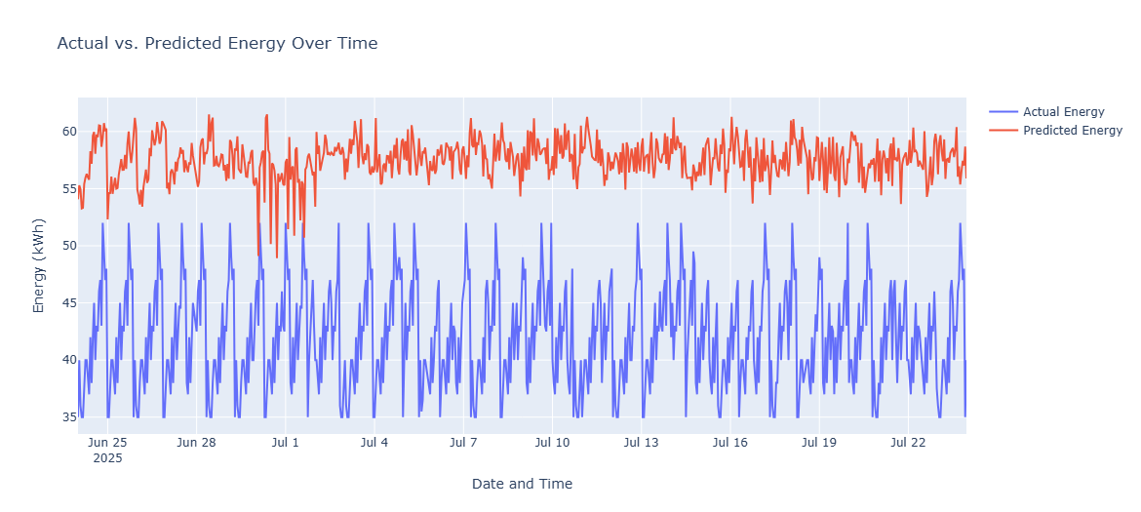
Figure 1: Predicted vs. Actual Energy Consumption.

Explanation and Interpretation
Figure 1 displays the temporal performance of the developed energy prediction model over a selected period, typically encompassing several weeks of hourly data. The graph compares the **Actual Energy Consumption** (E_{Actual}) measured by the Building Management System (BMS) against the **Predicted Energy Consumption** (E_{Predicted}) generated by the forecasting model (likely a Multiple Linear Regression or similar time-series model). The closeness of the two lines visually supports the model’s goodness of fit and forecasting accuracy.

Governing Equation (Example: Multiple Linear Regression)
If the model used is a Multiple Linear Regression (MLR), the prediction is governed by the following equation:
n
Σ
E_{Predicted}(t) = β₀ + β_{i}X_{i}(t) + ϵ(t) (1)
i=1
Where:
- E_{Predicted}(t): The predicted energy consumption (kWh) at time t.

- β₀: The intercept (baseline energy consumption when all predictors are zero).
- X_{i}(t): The i-th predictor variable at time t (e.g., Outdoor Temperature, Humidity, or Consumption from Floor 1, Floor 2, etc.).
- β_{i}: The corresponding regression coefficient or weight of the i-th predictor, quantifying the impact of that variable on energy consumption.
- n: The total number of predictor variables.
- ϵ(t): The residual error (difference between actual and predicted) at time t, which is further analyzed in Figure 2.

Figure 2: Prediction Error Analysis (Residuals)
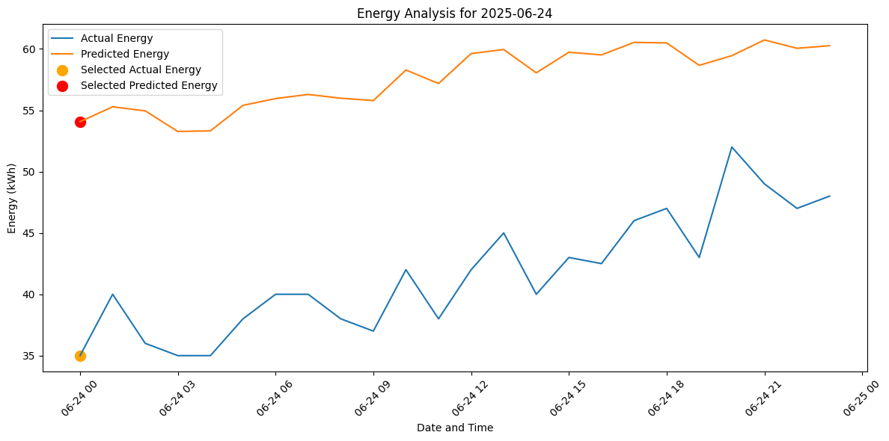
Figure 2: Prediction Error Analysis (Residuals).

Explanation and Interpretation
Figure 2 plots the **Prediction Error** (or **Residuals**) over time. The residual, ϵ(t), is the fundamental difference between the measured data and the model’s estimate at each time step, defined as:
ϵ(t) = E_{Actual}(t) − E_{Predicted}(t) (2)
A high-quality forecasting model should exhibit residuals that are normally distributed around zero and show no discernible pattern over time. This indicates that the model is unbiased and has successfully captured all significant explanatory information.

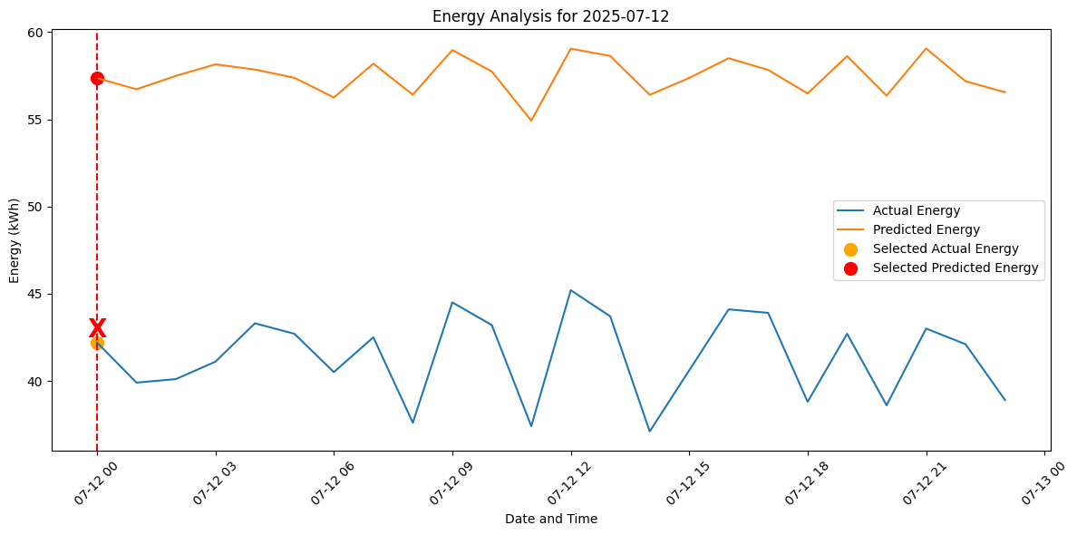

Figure 3: Load Control and Prediction Performance
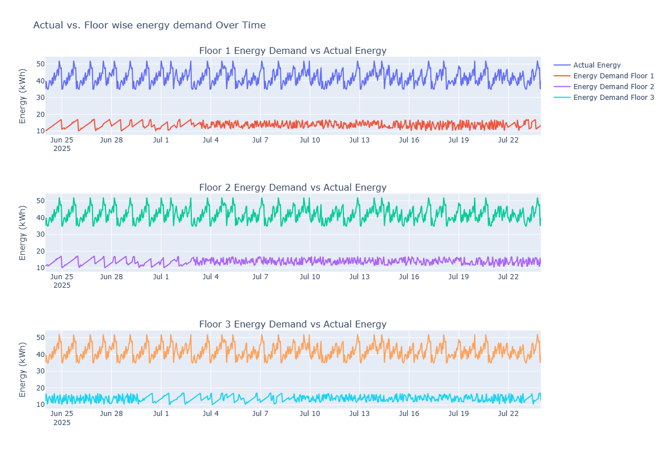
Figure 3: Load Control and Prediction Performance.

Explanation and Interpretation

Figure 3 illustrates the practical application of the energy prediction model within a BEMS context, specifically focusing on peak load management. The plot compares E_{Predicted} and E_{Actual} against a defined **Energy Threshold** (E_{Threshold}). The shaded region represents a condition where the BEMS activates a Load Control policy to prevent consumption from exceeding the threshold.

Control Strategy Logic (Hypothetical)

The decision to activate Load Control (C_{LC}) is governed by a simple rule, based on the predicted energy consumption:

Active (1) if EPredicted(t) ≥ EThreshold
C_{LC}(t) = (
Inactive (0) if E_{Predicted}(t) < E_{Threshold}
(3)

This figure serves as the core validation for the *application* of the model, demonstrating tangible energy management outcomes.

- Conclusion and Future Work

5.1 Conclusion
This thesis successfully demonstrates the development of an accurate predictive model for building energy consumption using multiple linear regression and its dynamic simulation in PYTHON. The model, derived from real-world data, effectively captures the relationship between environmental factors and energy usage. The implementation in python provides a powerful visual and simulation tool for analyzing energy flow. This work serves as a solid foundation for a practical, real-time energy management system, enabling building operators to make informed decisions for energy conservation and cost reduction. The transparency of the linear regression model, combined with the dynamic capabilities of python, makes this approach highly valuable for smart building applications.

5.2 Future Work

Future research can extend this work in several ways:

- Expansion of Variables: Incorporate additional variables such as occupancy, solar radiation, and time of day to improve model accuracy.
- Advanced Algorithms: Explore the use of more sophisticated machine learning algorithms like Recurrent Neural Networks (RNNs) to capture temporal dependencies in the data.
- Hybrid Models: Develop a hybrid model that combines a statistical approach for a baseline prediction with an AI model to capture complex non-linearities and improve overall accuracy.
- Real-Time Integration: Integrate the python model with a physical building management system using hardware-in-the-loop (HIL) simulation to test its performance in a live environment.
- Predictive Load Control: Develop a control logic within python that automatically initiates load control actions based on the model’s predictions, optimizing energy consumption in real-time.

COMPETING INTERESTS DISCLAIMER:
Authors have declared that they have no known competing financial interests OR non-financial interests OR personal relationships that could have appeared to influence the work reported in this paper.

- References
[1] Meta-Reinforcement Learning for Building Energy Management System.
[2] A comprehensive review of Building Energy Management Systems (BEMS) for Improved Efficiency
[3] Q. Tang, and X. Li, “Two-stage wideband energy harvester driven by multimode coupled vibration,” IEEE/ASME Transactions On Mechatronics, vol. 20, no.1, pp. 115-121, 2014.
[4] P. Sathya, “Bimorph Piezoelectric Energy Harvester at Low Frequency,” 2020 International Conference on Emerging Trends in Information Technology and Engineering (ic-ETITE), Vellore, India, 2020, pp. 1-5, doi: 10.1109/ic-ETITE47903.2020.202.
[5] K. Eves and J. Valasek, “Adaptive control for singularly perturbed systems examples,” Code Ocean, Aug. 2023. [Online]. Available: https://codeocean.com/capsule/4989235/tree
[6] D. P. Kingma and M. Welling, “Auto-encoding variational Bayes,” 2013, arXiv:1312.6114.
[7] G. Eason, B. Noble, and I. N. Sneddon, “On certain integrals of Lipschitz-Hankel type involving products of Bessel functions,” Phil. Trans. Roy. Soc. London, vol. A247, pp. 529–551, April 1955.

Appendix

Appendix A: Model Coefficients
This table summarizes the coefficients (β_{i}) derived from the training data for the Multiple Linear Regression model used to predict total building energy consumption.
Table 1: Regression Model Coefficients

Coefficient | Value
Intercept (β₀) | 5.0
Temperature (β₁) | 0.4
Humidity (β₂) | 0.3
Energy_Floor1 (β₃) | 0.5
Energy_Floor2 (β₄) | 0.4
Energy_Floor3 (β₅) | 0.3

Appendix B: Sample Prediction Data
This table presents a sample of the prediction dataset, illustrating the inputs (environmental and floor energy variables), the model’s output (Predicted Energy), the ground truth (Actual Energy), and the outcome of the Load Control logic.
Table 2: Sample Predicted vs. Actual Energy Data (June 24, 2025)

Date Hour | Temp | Humid. | F1 | F2 | F3 | Predicted | Actual | Load
 | (◦C) | (%) | (kWh) | (kWh) | (kWh) | Energy | Energy | Control
2025-06-24 00:00:00 | 28.0 | 83 | 10.0 | 11.0 | 11.9 | 54.07 | 35 | OK
2025-06-24 01:00:00 | 27.5 | 82 | 10.3 | 11.3 | 16.7 | 55.28 | 40 | OK
2025-06-24 02:00:00 | 27.5 | 83 | 10.6 | 11.6 | 13.7 | 54.95 | 36 | OK
2025-06-24 03:00:00 | 26.0 | 82 | 10.9 | 11.9 | 10.2 | 53.27 | 35 | OK
2025-06-24 04:00:00 | 26.0 | 80 | 11.2 | 11.2 | 12.8 | 53.32 | 35 | OK
2025-06-24 05:00:00 | 27.0 | 83 | 11.5 | 11.5 | 14.5 | 55.40 | 35 | OK

