A-Guided Improved Ant Colony Algorithm for Mobile Robot Path Planning

ABSTRACT
To address the issues of slow convergence and susceptibility to local optima in traditional ant colony algorithms for mobile robot global path planning, this paper proposes an improved ant colony algorithm. The algorithm integrates the A* algorithm to generate prior paths for pheromone differentiated initialization, designs a bidirectional A*-style heuristic factor to enhance global guidance, and introduces strict line-of-sight path smoothing post-processing to shorten paths. Through simulation experiments on 20×20 and 30×30 grid maps, with the traditional ant colony algorithm as a benchmark for comparison, the results demonstrate that: the improved algorithm achieves an average runtime of only 0.67 seconds on the 20×20 map, representing a reduction of over 73.6% compared to the traditional algorithm; the average number of iterations decreases to 5.23, and the average path length is optimized to 29.36. The algorithm also performs excellently on the 30×30 map. This study validates that the proposed improvement strategies can significantly enhance the convergence speed, solution quality, and real-time performance of path planning, providing an effective solution for efficient mobile robot navigation.
Keywords: Ant Colony Optimization; A* Algorithm; Mobile Robot Path Planning; Heuristic function improvement; Global optimal path.

INTRODUCTION
The rapid development of automation technology has continuously driven the accelerated expansion of robot applications across various fields [1]. In cutting-edge domains such as intelligent manufacturing scheduling, UAV airspace monitoring, satellite dynamic guidance, and autonomous robot exploration, trajectory planning accuracy has become a key indicator for evaluating system performance [2]. The core objective of path planning is to generate a collision-free and optimal route from a starting point to a destination for mobile robots under known environmental conditions [3].
At present, research hotspots in robot path planning include shortest path planning [4], obstacle-free collision-free path generation [5], and dynamic planning that meets real-time requirements [6], among other directions. Although the Dijkstra algorithm can guarantee the global shortest path, its search process lacks directionality due to the absence of heuristic information, which usually limits the search efficiency of the algorithm [7]. The A* algorithm can introduce heuristic information to guide the search direction and ensure the shortest path; however, in complex environments, its search space may expand significantly with a sharp increase in the number of expanded nodes, resulting in degraded computational efficiency [8]. While the RRT algorithm can efficiently obtain suboptimal solutions, its search efficiency deteriorates notably when pursuing the global optimal solution [9].
Unlike traditional algorithms that exhibit limitations when handling high-dimensional complex problems, swarm intelligence algorithms, relying on biological collective collaboration strategies, demonstrate remarkable robustness, distributed computing advantages, and superior solution space exploration efficiency in complex-scenario path planning [10]. Inspired by the foraging behavior of ants in nature, Marco Dorigo proposed the Ant Colony Optimization (ACO) algorithm in 1992 [11], introducing a novel swarm intelligence paradigm to the field of meta-heuristic optimization. Although ACO exhibits considerable adaptability in path planning tasks, its optimization process is constrained by high computational time costs, slow convergence characteristics, and premature convergence with search stagnation phenomena caused by the positive feedback mechanism of pheromones [12].
Consequently, performance improvement and convergence efficiency enhancement of ACO algorithms have become critical scientific issues urgently requiring resolution in the field of robot path planning [13]. As a typical NP-hard problem in the optimization domain, path planning's multi-objective nature precludes the direct acquisition of optimal solutions within polynomial time; feasibility of a given solution can only be verified through polynomial algorithms [14].
To address the shortcomings of the ant colony algorithm, Zheng Zhang et al. proposed a hybrid path planning framework named IACO-QDWA, which combines an improved ant colony optimization (IACO) for global path optimization and a Q-learning-enhanced dynamic window approach (QDWA) for dynamic obstacle avoidance. This framework effectively solves the problems of slow convergence, susceptibility to local optima, and delayed real-time obstacle avoidance response of traditional methods in dynamic environments [15].Mingze Li et al. presented an optimized APF-ACO algorithm. By constructing a COLREGs-compliant ship collision avoidance constraint model, improving the traditional artificial potential field (APF) method, and integrating an enhanced ant colony optimization (ACO) algorithm, the proposed method solves collision avoidance and path planning problems for ships facing both static and dynamic obstacles, while overcoming the local optimum deficiency inherent in the conventional APF [16].Haixia Wang et al. developed an improved ant colony optimization algorithm. It introduces an artificial potential field gravitational force to strengthen the heuristic function, designs adaptive pheromone update rules, and applies a triangular pruning method for path smoothing. This approach effectively alleviates slow convergence, local optimality, and excessive turning points in traditional ACO for 2D grid-based path planning of logistics robots [17].Tomitagawa et al. proposed an improved ant colony optimization (ACO) for energy-optimal path planning of indoor garbage collection robots under limited energy constraints. By jointly using path distance and garbage weight as heuristic information (visibility) and designing a multi-objective pheromone update mechanism based on travel distance and energy consumption, simulation results verify that the algorithm optimizes energy consumption while effectively controlling travel distance, significantly outperforming conventional and improved ACO algorithms that only consider a single factor [18].Yun Chen et al. introduced a path planning method for intelligent warehousing robots based on an improved ant colony algorithm. It establishes a three-color grid map to simulate unknown disturbances, optimizes the pheromone update mechanism, and accounts for path safety, length, and turning costs, while performing node removal and smoothing on the planned path. This method resolves blind search, deadlock, and slow convergence in traditional ACO for warehousing robot path planning, improving safety and accuracy [19].Pan Wu et al. proposed a two-level vehicle path planning model for multi-warehouse robots that integrates static and dynamic planning. In the static stage, a blocking factor is introduced to improve the ant colony optimization (ACO) algorithm to avoid congested nodes; in the dynamic stage, a dynamic priority mechanism is designed to adjust path strategies in real time. This model resolves various conflicts during multi-robot operation, improving efficiency and reducing operational costs [20].Yuanao Li et al. presented an improved ant colony optimization algorithm (Improved-ACO). It optimizes heuristic information calculation, introduces an enhanced Tanh function, adopts novel pheromone update and diffusion strategies, and combines a collision avoidance system with an improved B-spline curve for path smoothing. The algorithm addresses slow convergence, local optimality, and incompatibility with robot kinematic constraints in traditional ACO, enhancing the efficiency, smoothness, and adaptability of mobile robot path planning [21].Yanli Chen et al. proposed a hybrid path planning algorithm combining improved ant colony optimization and artificial potential field. By introducing a dynamic early-warning step adjustment strategy and an equipotential outer tangent circle escape method, the algorithm solves the problems of slow global path planning convergence, unreachable targets, and local minima in local obstacle avoidance for unmanned surface vehicles in complex dynamic environments, and achieves effective avoidance of both static and dynamic unknown obstacles [22].
Although existing studies have improved ant colony algorithms through dynamic evaporation factors, elitist strategies, or obstacle-density-based initialization, three common limitations persist: (1) initial pheromones lack global optimal prior knowledge, resulting in blind early-stage search and slow convergence; (2) heuristic functions rely solely on unidirectional distance estimation, causing weak global guidance and tendency to deviate from optimal paths; and (3) path smoothing lacks rigorous safety verification, potentially causing shortened paths to traverse obstacles. These issues make it difficult for algorithms to balance convergence speed and solution quality in complex environments.
To address these deficiencies, this paper proposes an A*-guided improved ant colony algorithm (A-ACO). First, A* prior paths are utilized to guide differentiated pheromone initialization, where globally optimal paths obtained by A* are employed as prior knowledge to assign high initial pheromone levels, substantially reducing search blindness and enhancing convergence efficiency. Second, a bidirectional A*-style heuristic function is designed, comprehensively considering bidirectional distance estimation from nodes to both start and goal points, significantly strengthening global guidance and search direction accuracy. Third, a strict line-of-sight safety smoothing strategy is introduced, ensuring collision-free paths through dense sampling point verification, effectively reducing path length and turning points while guaranteeing robot motion feasibility. Furthermore, elitist path differentiated pheromone enhancement and dynamic neighborhood pruning mechanisms are incorporated to better balance global exploration and local exploitation capabilities.

2.Methodlogy

Traditional Ant Colony Algorithm

2.1 Node Transition Probability
In the traditional Ant Colony Optimization algorithm, each ant makes path construction decisions based on pheromone concentrations and heuristic information between nodes. The transition probability for the $k$-th ant moving from node $i$ to node $j$ at time $t$ is defined as follows:
$$\begin{aligned}P_{ij}^{k}\left(t\right)=\left\{\begin{aligned}\frac{{\left[τ_{ij}\left(t\right)\right]}^{α}⋅{\left[η_{ij}\left(t\right)\right]}^{β}}{\sum_{rϵΩ_{k}}{{\left[τ_{ir}\left(t\right)\right]}^{α}⋅{\left[η_{ir}\left(t\right)\right]}^{β}}}, &j∈Ω_{k} \\ 0, &j∉Ω_{k}\end{aligned}\right.\#2-1\end{aligned}$$
where the heuristic function is defined as the reciprocal of the Euclidean distance between nodes:
$$\begin{aligned}η_{ij}\left(t\right)=\frac{1}{δ_{ij}}\#2-2\end{aligned}$$
In the formulas, $τ_{ij}\left(t\right)$ denotes the pheromone intensity between node $i$ and $j$ at time $t$; $η_{ij}\left(t\right)$ represents the heuristic function value, characterizing the heuristic desirability of node transition; $δ_{ij}$ indicates the Euclidean distance between node $i$ and $j$; parameters $α$ and $β$ respectively control the relative weights of pheromone and heuristic information; and $Ω_{k}$ represents the set of reachable successor nodes for ant $k$ at current node $i$.

2.2 Pheromone Update Mechanism
After each iteration is completed, the pheromone on each edge (or path segment) is updated according to the following rules:
$$\begin{aligned}τ_{ij}\left(t+1\right)=\left(1-ρ\right)⋅τ_{ij}\left(t\right)+∆τ_{ij}\left(t\right)\#2-3\end{aligned}$$
The global pheromone increment consists of the sum of pheromones released by all ants:
$$\begin{aligned}∆τ_{ij}\left(t\right)=\sum_{k=1}^{M}{{Δτ}_{ij}^{k}\left(t\right)}\#2-4\end{aligned}$$
The pheromone contribution of a single ant is inversely proportional to the quality of the path it constructs:
$$\begin{aligned}{Δτ}_{ij}^{k}\left(t\right)=\left\{\begin{aligned}Q/L_{k}, &if ant k passes through edge(i,j) \\ 0, &otherwise\end{aligned}\right.\#2-5\end{aligned}$$
Where: $ρ$ denotes the pheromone evaporation rate, with $0<ρ<1$ ; Q is a constant representing the pheromone intensity; the path length $L_{k}$ is calculated by accumulating the distances $δ_{ij}$​ between consecutive nodes on the path; and $M$ is the ant colony size. This update mechanism enables shorter paths to accumulate more pheromones, thereby guiding subsequent ants to tend to select optimal paths.

3. Improved Ant Colony Algorithm
Aiming at the problems of slow convergence, excessive redundant turns in paths, and susceptibility to local optimality of the traditional ant colony algorithm in grid-based path planning, this paper proposes an improved A*-guided ant colony optimization algorithm (A*-ACO) through improvements in pheromone initialization, heuristic function design, path post-processing, and other aspects.

3.1A*-Guided Intelligent Pheromone Initialization
The traditional ant colony algorithm adopts global uniform pheromone initialization with $τ_{ij}\left(0\right)=C$, which lacks prior guidance. This leads to significant blindness in the initial search of the ant colony, slow convergence speed, and especially a large number of invalid searches in complex grid maps.
The A* algorithm is utilized to search for a reference path from the start point $S$ to the end point $E$ in the grid map, with its node sequence denoted as $N_{A^{*}}=\{n_{1},n_{2},⋯,n_{L}\}$ (where $n1​=S$ and $nL​=E$). The corresponding path edge sequence is defined as $π_{A^{*}}=\{{(n}_{1},n_{2}),{(n}_{2},n_{3}),⋯,{(n}_{L-1},n_{L})\}$, representing the set of edges formed by consecutive nodes along the path.
This path is regarded as the "prior optimal path" for ant colony search, and differential pheromone initialization is performed: edges on the A* path are assigned a high pheromone value, while non-A* path edges are given a base pheromone value. This enables the ant colony to search towards the global optimal direction from the initial stage, significantly reducing search blindness, improving algorithm convergence speed, and decreasing the number of invalid iterations.
The fundamental pheromone initialization formula is formulated as follows:
$$\begin{aligned}τ_{ij}\left(t\right)=\left\{\begin{aligned}τ_{base}+Δτ_{A^{*}}, &if(i,j)∈π_{A^{*}} \\ τ_{base}, &otherwise\end{aligned}\right.\#3-1\end{aligned}$$
where $τ_{base}$ represents the baseline pheromone concentration (corresponding to $τ_{base}=2$ in the implementation), and $Δτ_{A^{*}}$ denotes the pheromone enhancement quantity for the A* path (corresponding to $Δτ_{A^{*}}=13$ in the implementation, yielding an initial value of 15). The condition $(i,j)∈π_{A^{*}}$ indicates that the node pair $(i,j)$ constitutes a consecutive adjacent connection within the A* prior path, where $π_{A^{*}}$ represents the edge sequence of the A* prior path (the set of edges formed by consecutive nodes).
By incorporating the prior knowledge from the A* algorithm, the pheromone initialization is upgraded from "unguided uniform distribution" to "guided differential distribution". This endows the ant colony with a clearer initial search direction, significantly improving the algorithm's convergence speed and reducing the number of invalid iterations.

3.2 Design of Bidirectional A*-Style Heuristic Factor
In traditional ant colony optimization (ACO), the heuristic factor $η_{ij}$ is usually constructed only based on the unidirectional distance from node j to the destination E (e.g., $η_{ij}=1/d(j,E)$). Such a design fails to consider the bidirectional correlation of node j with both the start $S$ and the destination $E$, resulting in weak guidance of heuristic information and making the ant colony search prone to deviating from the optimal path.
To address this limitation, a bidirectional A-inspired heuristic strategy is adopted, which comprehensively integrates the actual cost from the start to the current node and the estimated cost from the current node to the destination, forming a heuristic function with stronger global guidance. For any node $j$, its A* evaluation function is defined as the sum of the distance from the start $S$ to node $j$ and the heuristic distance from node $j$ to the destination $E$. The heuristic factor $η_{ij}$​ is set to be inversely proportional to this evaluation function. This mechanism enables ants to consider not only the local cost of the current transition but also the proximity to the destination during path selection, effectively reducing detours and improving search efficiency.
Based on the above idea, the traditional heuristic function is redefined and replaced as follows.
Basic version:
$$\begin{aligned}η_{ij}=\frac{1}{\left(γ_{1}⋅d_{Sj}+γ_{2}⋅d_{jE}+ε\right)}\#3-2\end{aligned}$$

Enhanced version:
$$\begin{aligned}η_{ij}=\frac{1}{{\left(γ_{1}⋅d_{Sj}+γ_{2}⋅d_{jE}+ε\right)}^{λ}}\#3-3\end{aligned}$$

$d_{Sj}$ denotes the Euclidean distance from node $j$ to the start $S$;
$d_{jE}$ denotes the Euclidean distance from node $j$ to the destination $E$;
$γ_{1}$,$γ_{2}$ are weight coefficients for the bidirectional heuristic terms;
$ε$ is a small positive constant to avoid division by zero;
$λ$ is the distance decay exponent.
The proposed formulation breaks through the limitation of traditional unidirectional heuristic factors by embedding bidirectional guidance (toward both start and destination) into the heuristic information. It better matches the global objective of minimizing path cost, improves the guidance accuracy of the heuristic factor, reduces invalid node selections during ant exploration, and further accelerates the convergence rate of the algorithm.

3.3 Path Safety Smoothing Post-Processing Under Strict Line of Sight (SLOS)
Paths obtained by ACO in discrete grids often exhibit zigzag turns, which are non-optimal and unfavorable for practical robot trajectory tracking. Traditional smoothing methods may cause paths to cross obstacle diagonally. To address this issue, this algorithm introduces Strict Line of Sight (SLOS) detection to ensure that the smoothed path is physically feasible.
A safe smoothing strategy combining strict line-of-sight detection and greedy shortcut search is proposed. Based on the original optimal path, starting from the start node, the algorithm searches backward from each node toward the destination. Strict line-of-sight detection is used to judge whether an obstacle-free straight connection (line of sight) exists between two nodes. If such a line of sight exists, the two nodes are connected directly (skipping all intermediate redundant nodes) to form a shortcut; otherwise, the search proceeds to the next node until all nodes are traversed. Finally, a smooth path without redundancy and collisions is obtained.
Strict Line-of-Sight Criterion
Let the coordinates of nodes $n_{1}$ ​and $n_{2}$​ be ($x_{1},y_{1})$ and ${(x}_{2},y_{2}$), respectively. Define the sampling point set:
$$\begin{aligned}Ρ=\left\{\left(x_{1}+t\left(x_{2}-x_{1}\right),y_{1}+t\left(y_{2}-y_{1}\right)\right) | t=\frac{s}{N},s=0,1,⋯,N\right\}\#3-4\end{aligned}$$
where the number of sampling points is
$$\begin{aligned}N=\left\lceil 10⋅\sqrt{{\left(x_{1}-x_{2}\right)}^{2}+{\left(y_{1}-y_{2}\right)}^{2}}\right\rceil \#3-5\end{aligned}$$
The strict line-of-sight condition is defined as:
$$\begin{aligned}SLOS\left(n_{1},n_{2}\right)=\left\{\begin{aligned}true, &if∀\left(x,y\right)∈P,G\left(round\left(y\right),round\left(x\right)\right)=0 \\ false, &otherwise\end{aligned}\right.\#3-6\end{aligned}$$
where G denotes the grid map matrix.
The smoothed path is denoted as:
$$\begin{aligned}π_{smooth}=\left\{n_{k_{1}},n_{k_{2}},⋯,n_{k_{m}}\right\}\#3-7\end{aligned}$$
where the index sequence satisfies:$k_{i+1}=max\left\{j>k_{i} | SLOS(n_{k_{i}},n_{j})=true\right\}$, $k_{1}=1$
This post-processing step minimizes path length and the number of turns while guaranteeing path safety (collision-free). The length of the smoothed path satisfies $L_{smooth}≤L_{original}$.

3.4 Differentiated Pheromone Enhancement Mechanism for Strong Elite Paths
In traditional ant colony optimization, pheromone update is mostly performed via global uniform update (all feasible paths release pheromone at the same rate) or simple elite path bonus (elite paths release a fixed multiple of pheromone). Such schemes lack targeted reinforcement on the globally optimal elite path, leading to slow pheromone accumulation and easy domination by pheromone from locally optimal paths, which makes the algorithm prone to local optima stagnation.
To tackle this issue, a differentiated pheromone update mechanism is designed, combining conventional update for ordinary paths and double-strength enhancement for elite paths. The pheromone update is divided into two components: the conventional pheromone release from all feasible paths in the current iteration, and double pheromone release from the globally optimal elite path found so far. This allows pheromone on the elite path to accumulate much faster, forming strong heuristic guidance, suppressing the influence of locally optimal paths, and driving the algorithm to converge toward the global optimum.
Standard Pheromone Update Rule
$$\begin{aligned}τ_{ij}\left(t+1\right)=\left(1-ρ\right)⋅τ_{ij}\left(t\right)+∆τ_{ij}\left(t\right)\#3-8\end{aligned}$$
The total pheromone increment is decomposed as:
$$\begin{aligned}∆τ_{ij}\left(t\right)=\sum_{m=1}^{M}{∆τ_{ij}^{m}\left(t\right)+ω_{elite}⋅∆τ_{ij}^{best}}\left(t\right)\#3-9\end{aligned}$$
where M denotes the size of the ant colony.
Contribution from the m-th ant (ordinary path):
$$\begin{aligned}∆τ_{ij}^{m}\left(t\right)=\left\{\begin{aligned}\frac{Q}{L_{m}}, &if\left(i,j\right)∈π_{m} \\ 0, &otherwise\end{aligned}\right.\#3-10\end{aligned}$$
where $L_{m}$​ is the length of the path constructed by the $m$-th ant at iteration $t$.
Contribution from the globally optimal elite path:
$$\begin{aligned}∆τ_{ij}^{best}\left(t\right)=\left\{\begin{aligned}\frac{Q}{L_{best}}, &if\left(i,j\right)∈π_{best} \\ 0, &otherwise\end{aligned}\right.\#3-11\end{aligned}$$
where $L_{best}$ is the length of the globally optimal elite path found by the algorithm up to time $t$, and $π_{best}$ denotes the edge sequence of the globally optimal elite path.
Differential weight: $ω_{elite}=2$ meaning the contribution weight of the elite path is twice that of an ordinary ant.
By reinforcing the elite strategy, the algorithm can quickly focus on neighborhoods of high-quality solutions, avoiding interference from pheromone residues on inferior paths, and significantly improving convergence accuracy.

3.5 Dynamic Neighborhood Pruning Optimization Based on Destination Distance
In traditional ant colony optimization, the neighborhood search adopts full 8-neighborhood exploration (each node in the grid map searches all 8 adjacent nodes), without any screening of neighboring nodes. When a large number of invalid nodes far from the destination exist in the neighborhood, the computational cost of ant selection increases significantly and search efficiency deteriorates. Meanwhile, full-range exploration tends to lead ants to select nodes deviating from the destination, resulting in longer path lengths.
To overcome these drawbacks, a dynamic neighborhood pruning strategy based on destination distance is proposed. For each feasible 8-neighbor node of the current node (passable and unvisited), the nodes are sorted in ascending order according to their Euclidean distance $d(j,E)$ to the destination $E$. Only the first $K$ nodes closest to the destination (in this paper, $K=5$) are retained as the effective neighborhood, while invalid nodes far from the destination are pruned. In this way, ants only perform probabilistic selection within the effective neighborhood, which reduces computational cost and improves selection effectiveness.
Candidate Neighborhood Generation
where:
${Neighbor}_{i}$ denotes the physical 8-neighborhood of node$i$;
$Tabu\left(j\right)$ is the tabu marker: $Tabu\left(j\right)=0$ indicates node $j$ is unvisited, and $Tabu\left(j\right)=1$ means node j is already in the tabu list (no repeated access allowed);
$Pass\left(i,j\right)$ is the passability judgment function between nodes $i$ and $j$.
$Pass\left(i,j\right)=1$(passable) if there is no obstacle between i and j and robot motion constraints are satisfied (e.g., grid state is 0);
$Pass\left(i,j\right)=0$ (impassable) if an obstacle exists between i and j (grid state is 1) or the node is outside the map boundary.
This dynamic neighborhood pruning optimization achieves improved search efficiency and enhanced destination guidance simultaneously. By pruning invalid neighboring nodes far from the destination, the search range is reduced from full 8-neighborhood to 5 effective neighbors, which effectively lowers the algorithm’s time complexity and makes it more suitable for path planning in large-scale complex grid maps. Meanwhile, retaining only the nearest valid nodes toward the destination ensures that each node selection by the ant colony moves closer to the goal, greatly reducing unnecessary detours. This optimizes the search process, further shortens the path length, and improves the overall quality of path planning.

3.6 Steps of the Improved Algorithm
Specific Steps of the Improved Algorithm:
Step 1
The working environment of the mobile robot is modeled using the grid method. The positions of the start point and the destination are determined, and obstacle regions (grid state set to 1) and passable regions (grid state set to 0) are marked, providing a digital environmental foundation for subsequent path search.
Step 2
Key parameters of the algorithm are initialized, including the ant colony size, pheromone evaporation coefficient $ρ$, pheromone weighting factor $α$, heuristic function weighting factor $β$, constant $Q$, and maximum number of iterations. The A* algorithm is applied to compute a prior path from the start point to the destination. A high initial pheromone value (set to 15) is assigned to edges along this prior path, while all other edges are initialized with a low pheromone value (set to 2), completing the differentiated pheromone initialization.
Step 3
All ants are placed at the start node, and the start node is added to the tabu list to prevent repeated visits by ants.
Step 4
The state transition probability of each ant is calculated using the bidirectional A-based heuristic factor*. Combined with the dynamic neighborhood pruning strategy (selecting the 5 feasible neighbors closest to the destination), the next node is selected via the roulette wheel method. The visited node is added to the tabu list. This process is repeated until the ant reaches the destination, completing a single path search.
Step 5
Record the path length, path node sequence, and number of turning points for each ant in the current iteration.
Step 6
If all ants have completed their searches in the current iteration, proceed to Step 7; otherwise, return to Step 4 to continue path construction for the remaining ants.
Step 7
Pheromone evaporation and update are performed according to the global pheromone update rule (incorporating the enhanced elite differential reinforcement mechanism, where an additional pheromone increment is superimposed on the globally optimal path). The tabu lists of all ants are cleared.
Step 8
If the current iteration number reaches the preset maximum number of iterations, or if no significant improvement in path length and quality is observed over several consecutive iterations, perform strict-line-of-sight (SLOS) based safe smoothing post-processing on the optimal path (redundant nodes are pruned and feasible straight connections are established via line-of-sight checks). The final optimized path is then output and the search terminates. Otherwise, return to Step 4 for the next iteration.

4. EXPERIMENTAL RESULTS AND DISCUSSION

4.1 Environment Modeling
Environment modeling serves as the foundation of path planning, whose core lies in abstracting a complex physical environment into a mathematically or digitally tractable model for machines. Its accuracy and adaptability directly determine the efficiency, safety, and feasibility of path planning.
The grid method is the most widely adopted modeling approach, which partitions the environmental space into equally spaced grid cells and represents environmental information using binary state flags. With a simple structure and ease of implementation, it is suitable for path planning of various carriers such as unmanned aerial vehicles, wheeled mobile robots, and automated guided vehicles (AGVs). Therefore, this paper employs the grid method for map modeling.
The grid method is a typical global path planning modeling technique, whose core idea is to discretize the mobile environment into grids, thereby transforming the robot path planning problem into a connectivity problem between grid nodes [24]. The essence of grid-based modeling is to divide the environment into regular meshes, where each cell represents a discrete spatial region and can be labeled as free space, obstacle, or other states according to its properties. If an obstacle does not fully occupy a grid cell, the cell is still treated as fully occupied. In simulations, free grids are denoted by '0' and obstacle grids by '1', abstracting the environment map into a 2D matrix G that can be conveniently processed by programs. To prevent collisions between the robot and obstacles during motion, grids containing irregular obstacles are uniformly marked as occupied. Furthermore, the obstacle contour is expanded outward based on the physical radius of the robot to form an inflated obstacle region, which sets a safety boundary. This allows the robot to be simplified as a mass point model, while taking into account both its actual size and motion safety.

4.2 Results and Analysis
To verify the performance of the A*-guided improved ant colony optimization algorithm for path planning in grid maps, simulation experiments are conducted using MATLAB 2025.

4.2.1 Experimental Verification on 20×20 Grid Map
The experimental environment is a 20×20 grid map with approximately 50 obstacles configured. The key algorithm parameters are set as follows: maximum number of iterations = 100, ant colony size = 50, $α$=1, $β$=7, $ρ$=0.9, and $Q$=1.
Ten simulation experiments were conducted for comparative analysis of three algorithms, and the improved ant colony optimization algorithm exhibits remarkable advantages in search efficiency, convergence speed and path optimization with all core performance indicators achieving the optimal results. Specifically, its average running time is 0.67 seconds, which is 73.6% shorter than that of the traditional algorithm, representing a significant improvement in real-time performance, and also superior to the 0.71 seconds of the algorithm in existing literature. The average number of iterations is 5.23, which is much lower than 8.47 of the literature-based algorithm and 14.47 of the traditional algorithm, demonstrating that the designed heuristic factor and initial pheromone allocation strategy can effectively guide the search direction of ants. The average path length is 29.36, outperforming 30.40 of the literature-based algorithm and 30.62 of the traditional algorithm, which means the improved algorithm is capable of searching for higher-quality shortest paths. From the perspective of convergence curves, the improved algorithm can rapidly converge to a suboptimal path in the early iterations, avoiding the problem of the traditional algorithm being prone to falling into local optima. Meanwhile, by virtue of A* path-based pheromone initialization and path smoothing processing, the path length is further shortened and the path safety is significantly improved.
The specific effects and results are illustrated in Figs. 1, 2, 3 and Table 1.
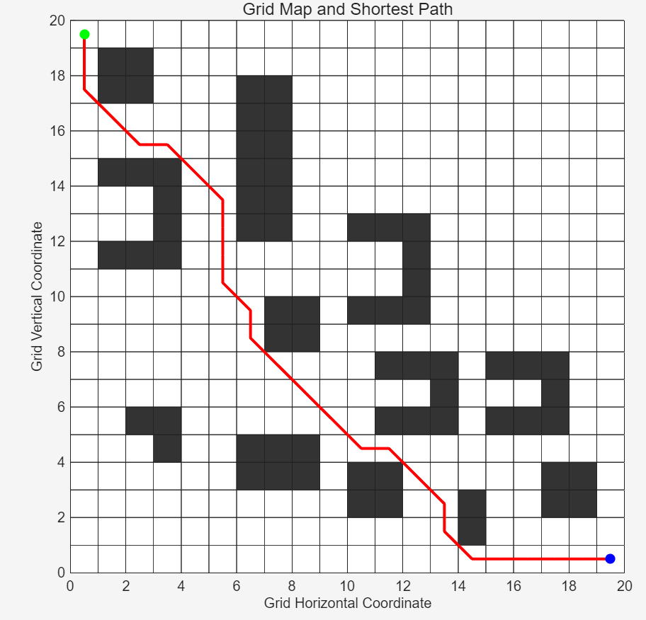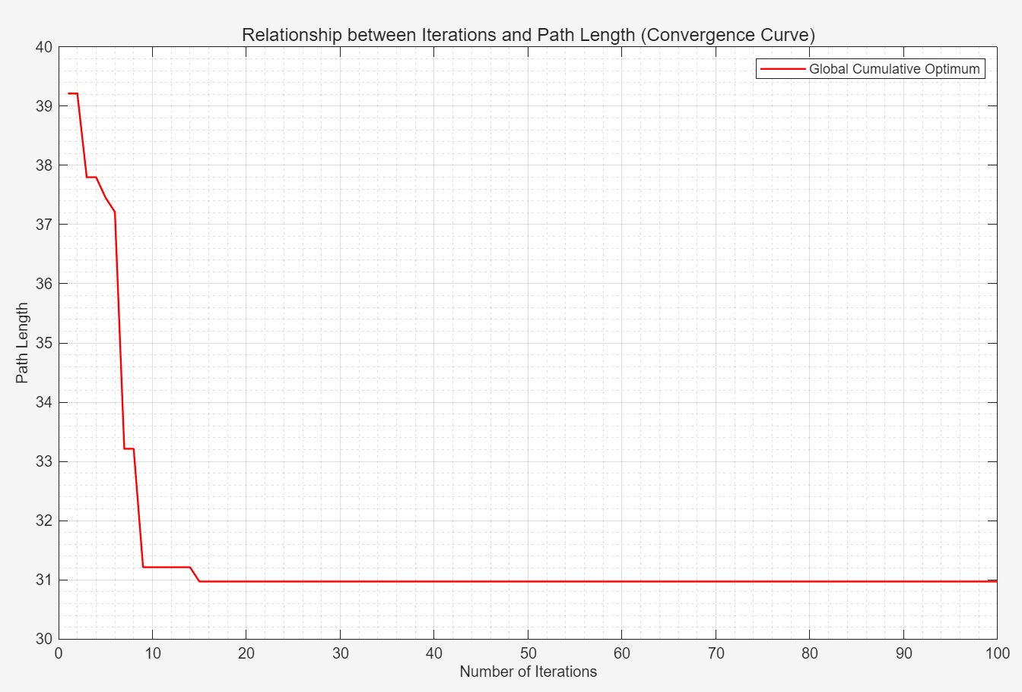
Fig. 1 Path simulation and convergence curve obtained by the traditional algorithm in the 20×20 grid environment
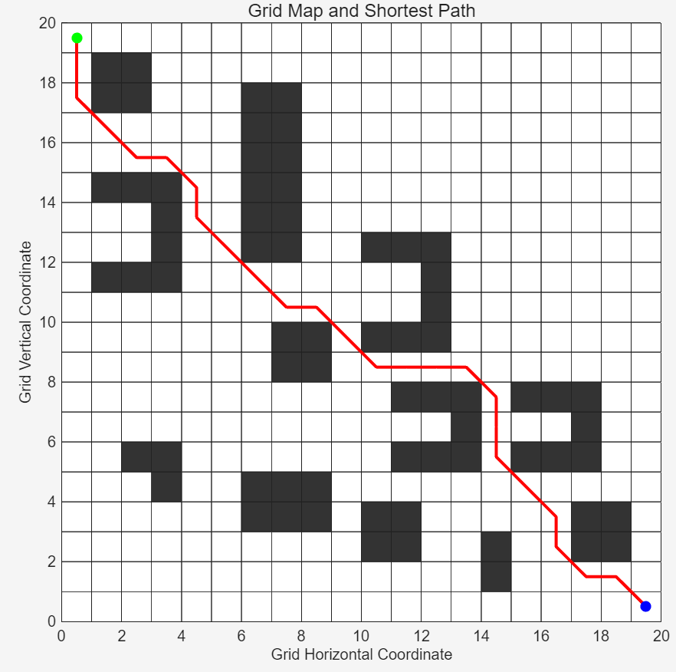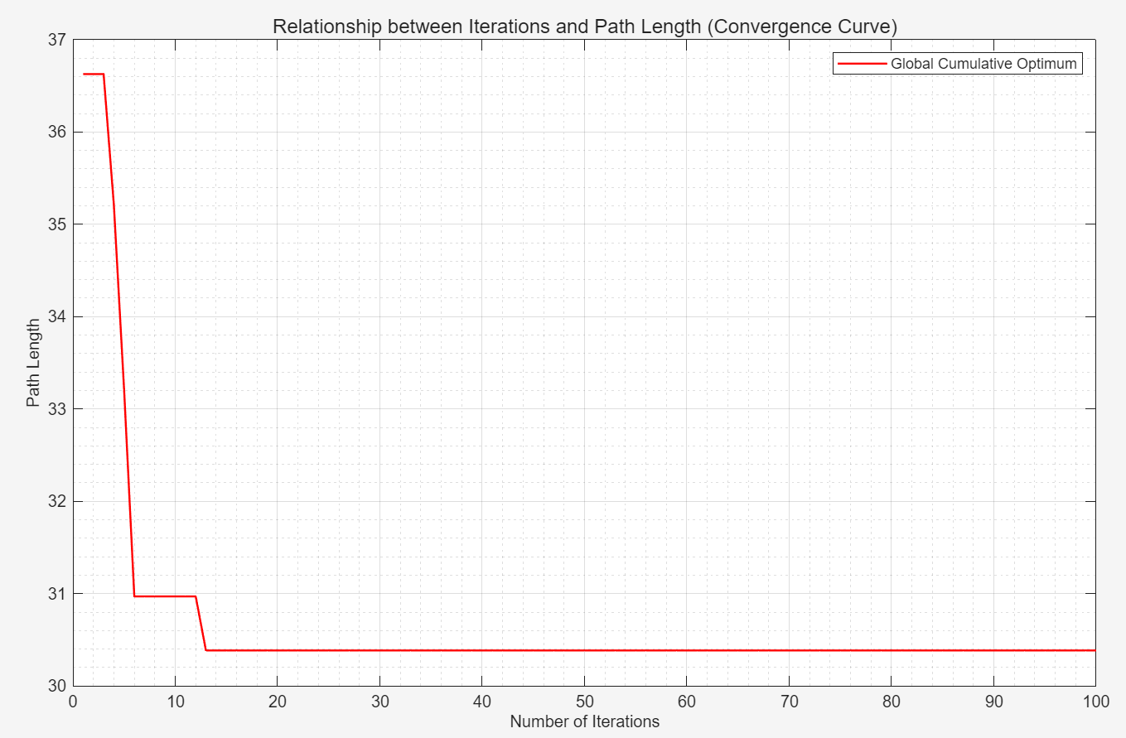
Fig. 2 Path simulation and convergence curve of Ref. [13] algorithm in 20×20 environment
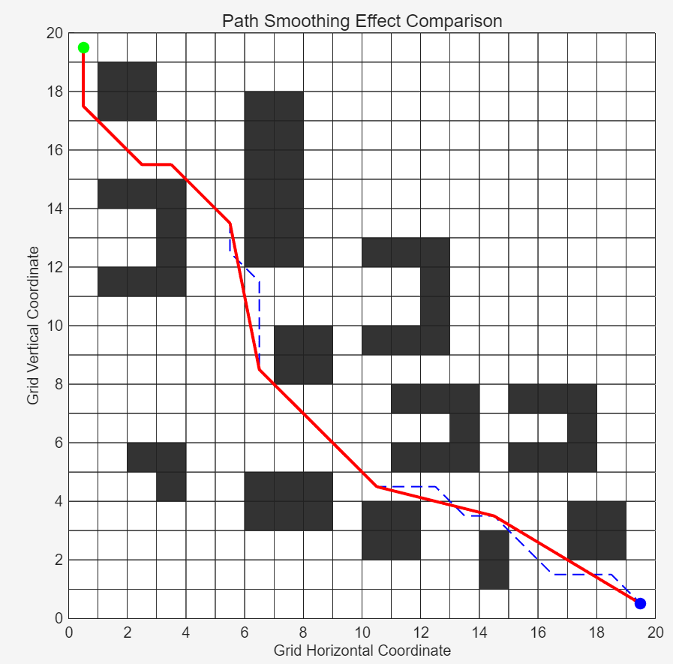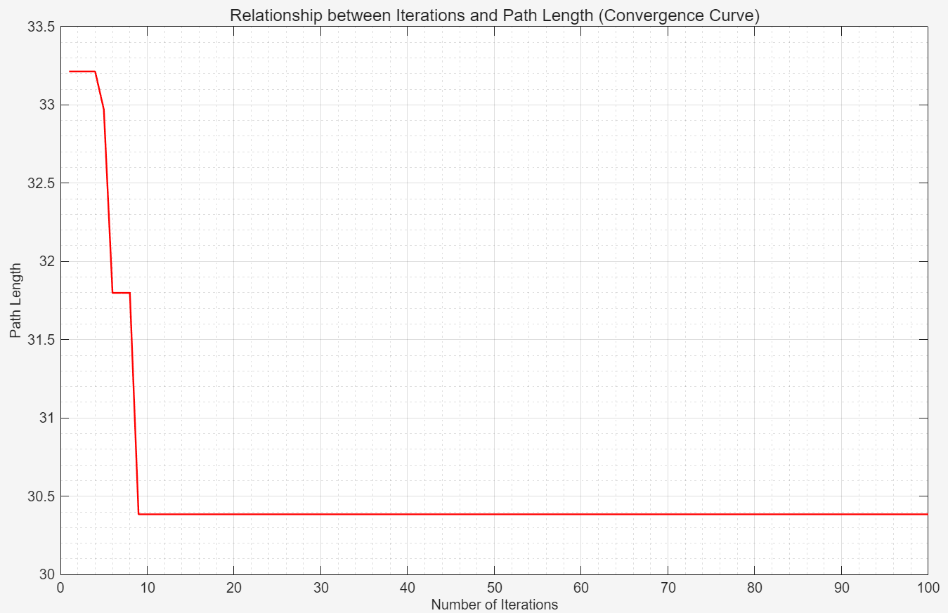
Fig. 3 Path simulation and convergence curve of the proposed algorithm in the 20×20 environment
Table 1. Simulation comparison of three algorithms in 20×20 environment
Algorithm | Average Running Time (s) | Average Path Length | Average Number of Iterations
Traditional ACO | 2.54 | 30.62 | 14.47
ACO in Ref. [13] | 0.71 | 30.40 | 8.47
Improved ACO | 0.67 | 29.36 | 5.23

4.2.2 Experimental Verification on 30×30 Grid Map
All parameters remain unchanged, and 30 simulation experiments are conducted for the three algorithms in a 30×30 grid map.
In the simulation experiments conducted on the 30×30 grid map, the A-ACO algorithm maintains the same key configuration as in the 20×20 map. After 30 repeated trials, it retains its performance advantages and demonstrates stronger adaptability to complex large-scale scenarios, with all three core indicators being optimal: the average running time is 1.0694 seconds, which is greatly reduced compared with the traditional algorithm and improved by 22.76% relative to the literature algorithm; the average path length is 41.7274, outperforming both the traditional and literature algorithms; the average number of iterations is only 9.57, which is much lower than those of the comparative algorithms.
The number of grids in this map increases by 125%, and obstacles are distributed more widely, imposing higher requirements on the algorithm. The traditional algorithm, lacking prior guidance and effective neighborhood screening, suffers from exponentially increased running time, oscillatory convergence, and redundant paths. Although the literature algorithm has been improved, it exhibits a performance attenuation rate of 95.01% and insufficient path smoothness.
By virtue of strategies such as differentiated pheromone initialization and dynamic neighborhood pruning, A-ACO achieves a performance attenuation rate of only 59.61%, with stable convergence curves and convergence within 10 iterations in all tests, showing remarkable adaptability to large-scale complex environments.
The specific effects and results are illustrated in Figs. 4, 5, 6 and Table 2.
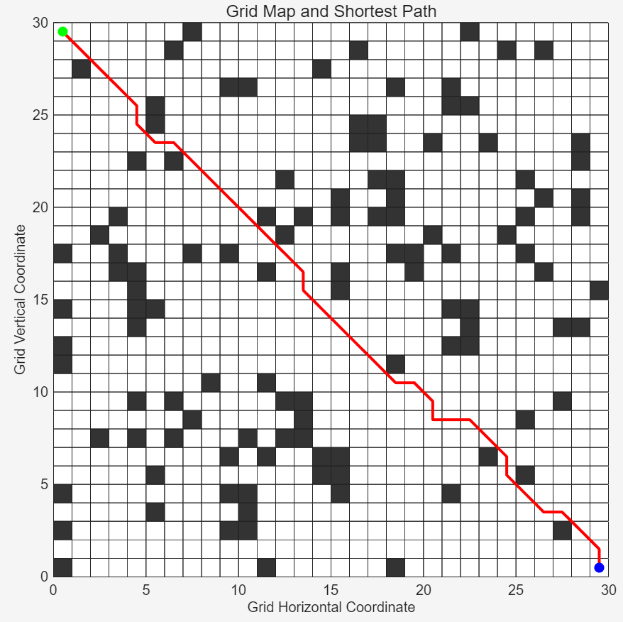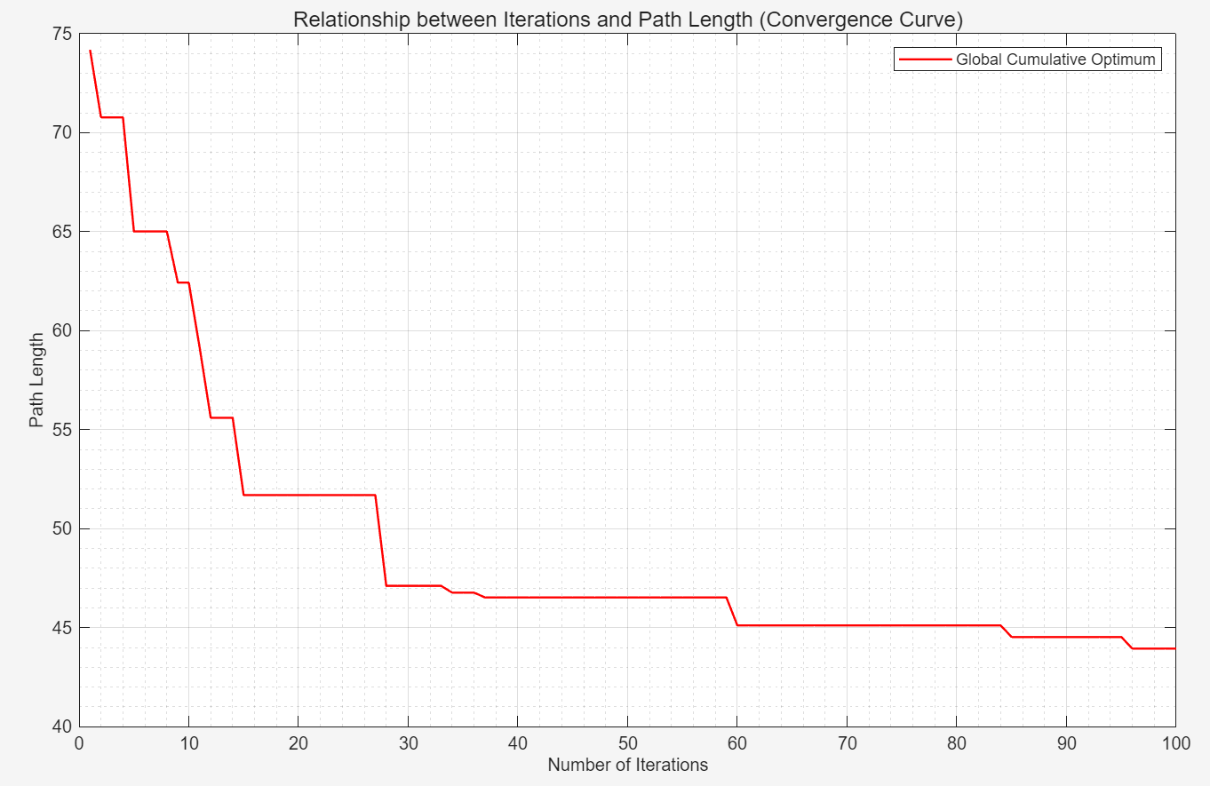
Fig. 4 Path simulation and convergence curve of the traditional algorithm in the 30×30 environment
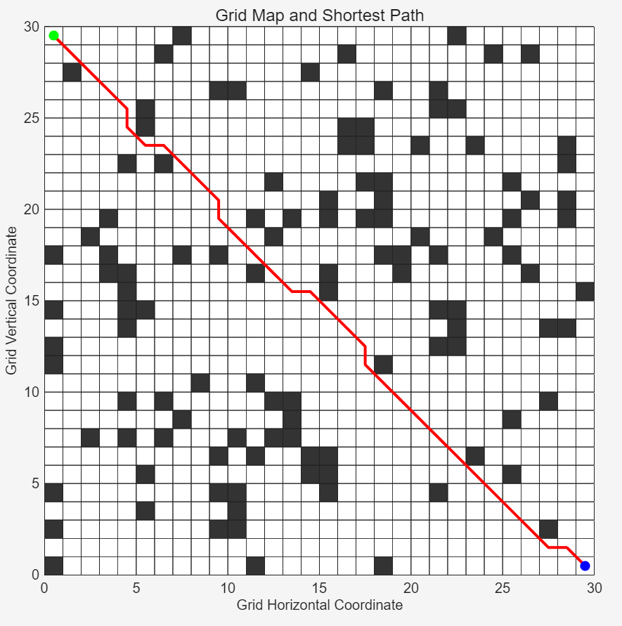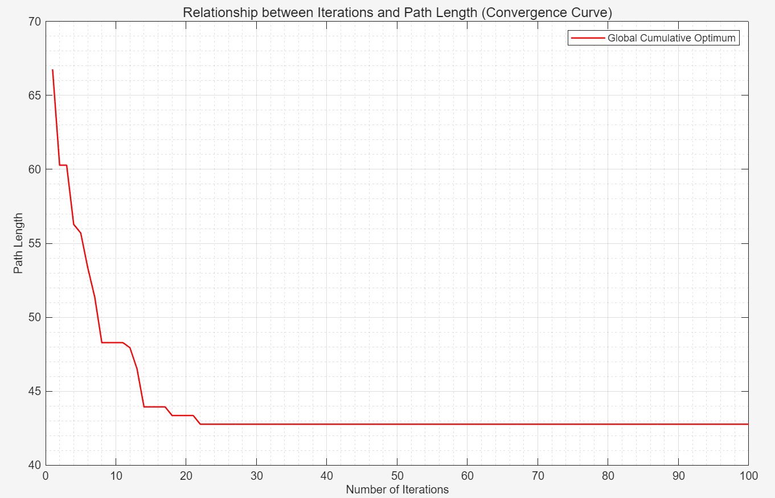
Fig. 5 Path simulation and convergence curve of the algorithm in Ref. [13] in the 30×30 environment
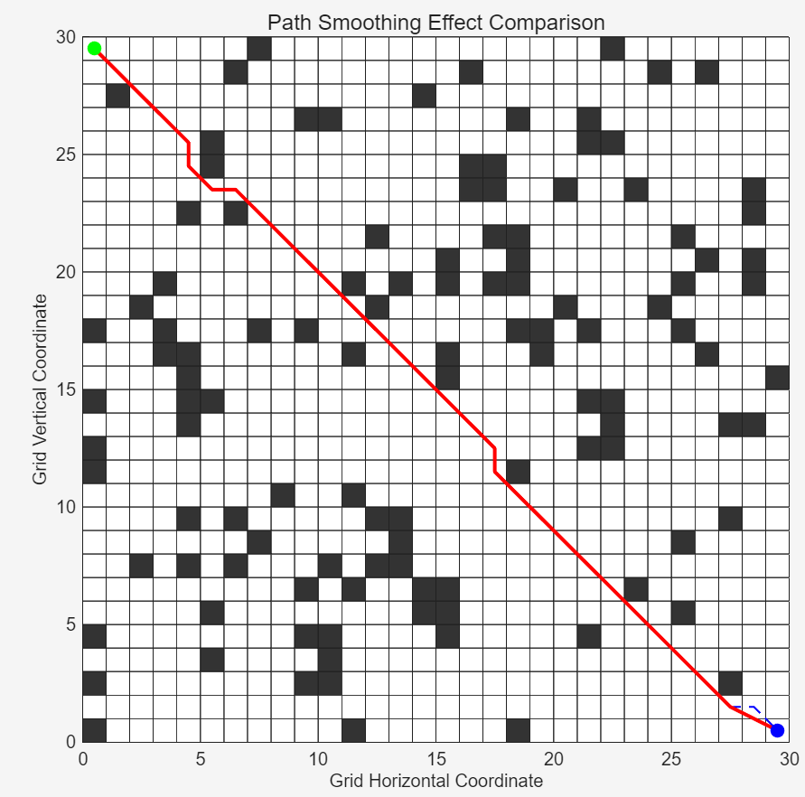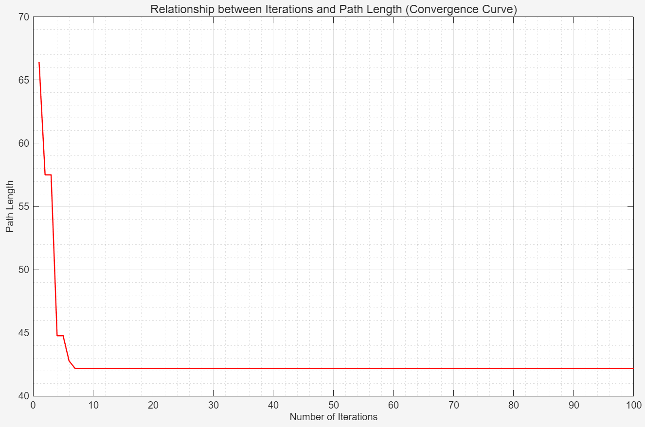
Fig. 6 Path simulation and convergence curve of the proposed algorithm in the 30×30 environment
Table 2. Simulation comparison of three algorithms in 30×30 environment
Algorithm | Average Running Time | Average Path Length | Average Number of Iterations
Traditional ACO | 12.3820 | 44.48 | 54.97
ACO in Ref. [13] | 1.3846 | 42.8281 | 14.33
Improved ACO | 1.0694 | 41.7274 | 9.57

5. CONCLUSION
To address the problems of slow convergence, proneness to local optima, and path redundancy of the traditional ant colony optimization algorithm in global path planning for mobile robots, this paper proposes an improved ant colony optimization algorithm integrated with the A* guidance strategy (A-ACO). Through five major optimization strategies, including differentiated pheromone initialization and bidirectional A*-based heuristic factor design, an efficient, stable, and engineering-practical path planning scheme is constructed. This study achieves full-process improvement, solves the inherent defects of the algorithm, and enhances its engineering application capability, providing a new approach for robot navigation in complex scenarios. In the future, the research will be extended to dynamic environments and multi-robot cooperative planning directions.

COMPETING INTERESTS DISCLAIMER:
Authors have declared that they have no known competing financial interests OR non-financial interests OR personal relationships that could have appeared to influence the work reported in this paper.

REFERENCES
[1] Antonelli, G., Fossen, T. I., & Yoerger, D. R. (2008). Underwater robotics. In Springer handbook of robotics (pp. 987-1008). Springer, Berlin, Heidelberg.
[2] Jin, Qibing, Chuning Tang, and Wu Cai. "Research on dynamic path planning based on the fusion algorithm of improved ant colony optimization and rolling window method." IEEE access 10 (2021): 28322-28332.
[3] Cherni, F., Boujelben, M., Jaiem, L., Boutereaa, Y., Rekik, C., & Derbel, N. (2017). Autonomous mobile robot navigation based on an integrated environment representation designed in dynamic environments. International Journal of Automation and Control, 11(1), 35-53.
[4] Yang, H.; Qi, J.; Miao, Y.C.; Sun, H.X.; Li, J.H. A new robot navigation algorithm based on a double-layer algorithm and trajectory optimization. IEEE Trans. Indust. Electr. 2018.
[5] Lee, H.B.; Kim, H.; Kim, H. Planning and Control for Collision-Free Cooperative Aerial Transportation. IEEE Trans. Autom. Sci. Eng. 2018, 15, 189–201.
[6] Jiang, A.; Yao, X.; Zhou, J. Research on path planning of relay obstacle avoidance of mechanical arm based on genetic algorithm. J. Eng. 2018, 16, 1579–1586.
[7] Luo, M., Hou, X., & Yang, J. (2020). Surface optimal path planning using an extended Dijkstra algorithm. IEEE access, 8, 147827-147838.
[8] Fu, B., Chen, Y., Quan, Y., Zhou, X., & Li, C. (2025). Bidirectional artificial potential field-based ant colony optimization for robot path planning. Robotics and Autonomous Systems, 183, 104834.
[9] Lv, Y.Z.; Cao, J.P. Path planning methods of mobile robot based on new neural network. In Proceedings of the 32nd Chinese Control Conference, Xi’an, China, 26–28 July 2013; pp. 3222–3226.
[10] Ma, J., Liu, Q., Yang, Z., & Wang, B. (2025). Improved Trimming Ant Colony Optimization Algorithm for Mobile Robot Path Planning. Algorithms, 18(5), 240.
[11] Dorigo, M. Optimization, Learning and Natural Algorithms. Ph.D. Thesis, Politecnico di Milano, Milano, Italy, 1992.
[12] Tao, Y., Gao, H., Ren, F., Chen, C., Wang, T., Xiong, H., & Jiang, S. (2021). A mobile service robot global path planning method based on ant colony optimization and fuzzy control. Applied Sciences, 11(8), 3605.
[13] Zhao J, Tang Y F, Jiang G P, Xu F Y, Ding J. Robot path planning based on improved ant colony optimization[J]. Journal of Nanjing University of Posts and Telecommunications (Natural Science Edition), 2019, 39(06): 73-78.
[14] Liu, Y.; Jiang, C.; Zhang, X.; Mourelatos, Z.P.; Barthlow, D.; Gorsich, D.; Singh, A.; Hu, Z. Reliability-Based Multivehicle Path Planning Under Uncertainty Using a Bio-Inspired Approach. J. Mech. Des. 2022, 144, 071701.
[15] Zhang, Z., Bai, X., Yang, H., & Zhang, S. (2026). Dynamic Path Planning via Enhanced ACO and DWA Algorithms. Applied Sciences, 16(2), 583.
[16] Li, M., Li, B., Qi, Z., Li, J., & Wu, J. (2023). Optimized APF-ACO algorithm for ship collision avoidance and path planning. Journal of Marine Science and Engineering, 11(6), 1177.
[17] Wang, H., Wang, S., & Yu, T. (2024). Path Planning of Inspection Robot Based on Improved Ant Colony Algorithm. Applied Sciences, 14(20), 9511.
[18] Tomitagawa, K., Anuntachai, A., Chotipant, S., Wongwirat, O., & Kuchii, S. (2022). Performance Measurement of Energy Optimal Path Finding for Waste Collection Robot Using ACO Algorithm. IEEE Access, 10, 117261-117272.
[19] Chen, Y., Wu, J., He, C., & Zhang, S. (2023). Intelligent warehouse robot path planning based on improved ant colony algorithm. IEEE Access, 11, 12360-12367.
[20] Wu, P., Zhong, L., Xiong, J., Zeng, Y., & Pei, M. (2023). Two-level vehicle path planning model for multi-warehouse robots with conflict solution strategies and improved ACO. Journal of Intelligent and Connected Vehicles, 6(2), 102-112.
[21] Li, Y., Cui, C., & Zhao, Q. (2025). A Comprehensive Optimization for Path Planning: Combining Improved ACO and Smoothing Techniques. Processes, 13(2), 555.
[22] Chen, Y., Bai, G., Zhan, Y., Hu, X., & Liu, J. (2021). Path planning and obstacle avoiding of the USV based on improved ACO-APF hybrid algorithm with adaptive early-warning. Ieee Access, 9, 40728-40742.
[23] Wang, L., Kan, J., Guo, J., & Wang, C. (2019). 3D path planning for the ground robot with improved ant colony optimization. Sensors, 19(4), 815.

