Original Research Article
Digital Surface Area Measurement as a Tool for Advanced Leather Quality Assurance

Abstract
In this paper, we present a novel approach to accurately detect the surface area of an irregular leather piece using image processing techniques. Our method involves a sequence of steps starting with the extraction of frames from a running video of the leather piece, which are then converted to grayscale images for further processing. A smoothing algorithm is applied to reduce noise and improve the quality of the images, followed by thresholding to differentiate between the leather material and the background. Subsequent contour detection isolates the leather piece by converting the background to black pixels, while the leather itself is turned into white pixels. The area of the leather is then computed by counting the number of white pixels, which represent the leather material. To obtain the leather's actual surface area, we introduce a conversion unit that multiplies the white pixel count, providing a direct measurement of the leather's surface area. This method offers a valuable tool for leather industries, where precision in measuring irregular shapes is critical, and can potentially replace traditional manual measurements with an automated, more accurate system.

Keywords––leather quality, CNN architecture, leather material analysis, computer vision, surface area measurement.

I.INTRODUCTION

The introduction section of this paper illuminates the transformative role of computer vision and image processing methodologies within the leather industry, revolutionizing traditional manufacturing processes and material analysis. Over recent years, advancements in computer vision technologies have propelled industries towards unprecedented levels of automation and efficiency, reshaping the landscape of leather production and quality control. Leveraging sophisticated algorithms and machine learning techniques, computer vision systems are adept at extracting intricate details from visual data, enabling precise measurement and characterization of leather materials. Concurrently, image processing algorithms have emerged as indispensable tools for enhancing the clarity and fidelity of visual information, facilitating seamless analysis and interpretation of leather surfaces. Within the leather industry, the integration of computer vision and image processing technologies has facilitated a myriad of applications, ranging from defect detection and grading to surface area measurement and pattern recognition. By harnessing the power of convolutional neural networks (CNNs) and deep learning architectures, computer vision systems can automatically detect and classify defects in leather hides with unparalleled accuracy and efficiency. Furthermore, image processing techniques such as edge detection, segmentation, and feature extraction play a crucial role in delineating the intricate contours and textures of leather surfaces, facilitating precise measurement of surface area and geometric properties. This paper aims to delve into the intricacies of computer vision and image processing methodologies employed in the leather industry, shedding light on their transformative impact on manufacturing processes and quality assurance protocols. Through a comprehensive exploration of state-of-the-art algorithms and techniques, we endeavor to elucidate the underlying principles driving innovation in leather material analysis and production. By bridging the gap between theoretical advancements and practical applications, this research endeavors to foster a deeper understanding of the potentialities inherent in computer vision

and image processing technologies within the leather industry, paving the way for future advancements and break throughs. The initial touchpoint, guiding readers into the realm of our research focus: automated surface area detection of irregular leather pieces through the fusion of video analysis and advanced image processing techniques. It delineates the evolutionary trajectory of this technological domain, tracing its roots from conventional manual measurements to the current era of sophisticated digital methodologies. The introduction accentuates the pivotal significance of our endeavor within contemporary society, particularly in industries reliant on precise material analysis and manufacturing. It encapsulates the essence of our research by delineating the primary objective: to revolutionize surface area measurement in irregular leather pieces through a novel algorithmic approach.

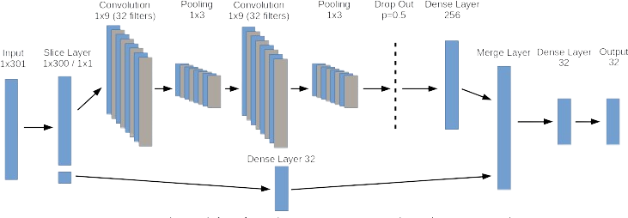

Fig. 1 CNN Architecture

II. LITERATURE SURVEY

Literature Survey is done based on Niche, Vision and Needs According to Problem and Challenges. This paper showcase review according to reach of paper and will understandability research paper with recent technologies implementation and top listed here.
[1] “S. -Y. Chen, Y. -C. Cheng, W. -L. Yang and M. -Y. Wang, "Surface Defect Detection of Wet-Blue Leather Using Hyperspectral Imaging," in IEEE Access, vol. 9, pp. 127685- 127702, 2021,” The hyperspectral signal has a wider spectrum range and higher spectrum resolution [31] - [33], meaning that the hyperspectral signal has abundant information hidden in each pixel. This study used the push bloom hyperspectral sensors FX10 and FX17 of SPECIM, and the hyperspectral system supplied by Isuzu Optics Corp. The wavelength ranges are 400~1000 nm and 900~1700 nm. The number of bands is 224 and the system is controlled by the software provided by Isuzu Optics Corp. Table 1 tabulates the specification of sensors. The data of whiteboard (absolute reflection, reflectivity is 100%) and black cloth (absolute absorption, reflectivity is 0%) in the dark box were recorded automatically before shooting. The sample was completely closed in the course of shooting and the linear light in the dark box was the only light source, as shown in Fig. 2. Finally, the sample reflectivity was calculated for experiments according to the collected light intensity.
[2] literature survey of this paper " J. Deng, J. Liu, C. Wu, T. Zhong, G. Gu and B. W. -K. Ling, "A Novel Framework for Classifying Leather Surface Defects Based on a Parameter Optimized Residual Network," in IEEE Access, vol. 8 “The framework proposed in this paper first obtains the ultra -high definition (UHD) leather images through the UHD leather imaging system. Second, the least squares method is used to fit the computer numerical simulation data to determine the appropriate size of the sliding patch window. Also, the scale of the data set is determined by achieving the trade-offs between the evaluated workload and the classification accuracy. Then, the residual network is constructed and other related parameters are optimized. Finally, the network is trained and the leather defects are classified into different types as illustrated in Figure 1. In the proposed framework, the features of the leather defects are extracted by the deep learning network automatically and objectively. In order to address the problems of the small imaging field and the complex control devices of the common CCD scanning and the imaging system of the leather, a high definition and high efficiency leather imaging system is adopted. The system contains a fixing platform for placing the leather, an UHD camera, the light sources and the image processing workstation. In order to distinguish the leather from the background, the color of the fixing platform is set to the blue color according to the statistics. During the imaging procedure of the leather image, the leather is laid and fixed on a platform flatly. The UHD camera is employed to take pictures of the leather above the platform with ultrahigh definition. The size of the obtained leather image is 8688 * 5792 pixels. After the leather is imaged by this UHD camera, the system transmits the image to the image processing workstation for performing the detection and the classification. Compared with the common CCD imaging system of the leather, this system has the advantages of the simple structure, using only one-time imaging for the whole piece of the leather, not requiring the image fusion technique a s well as fast, simple and effective process of images.
[3] Literature survey of this paper M. Aslam, T. M. Khan, S. S. Naqvi, G. Holmes and R. Naffa, "On the Application of Automated Machine Vision for Leather Defect Inspection and Grading: A Survey," in IEEE Access, vol. 7, usually two types of machine learning are required: defect detection (classification problem), and in-depth geometric information of the detected defects (segmentation problem). Leather images have so many variations in terms of morphology and contrast of defects. There could be more than 15 defects in one image with different contrasts. Even one type of defect itself varies greatly in an image. This is the reason why traditional machine learning algorithms fail to detect multiple defects at one time. This makes the leather defect classification/segmentation problem the best candidate for deep neural networks. The good thing about neural networks is that they can be designed for both image classification and image segmentation. Classification is the process of taking an input (i.e. image) and outputting a class or probability that the input is a particular class. Image segmentation is the task of partitioning the image in to multiple segments. Semantic segmentation is used to do this in deep neural networks. Semantic segmentation is the task of assigning a class to each pixel in a given image. Classification assigns a single class to the whole image, while semantic segmentation classifies each pixel of the image to one of the classes.
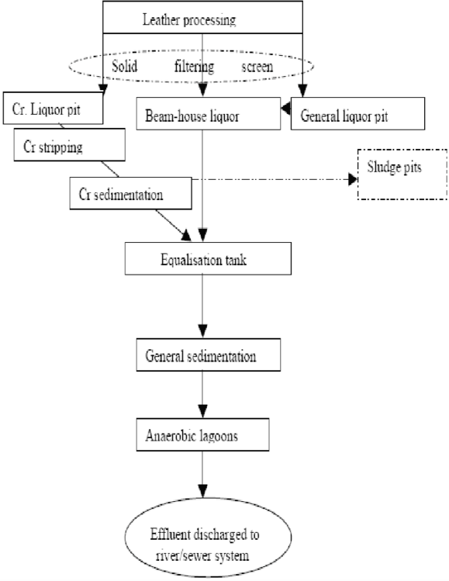

Fig 2- Traditional Automation in Leather Industry

[4] Recent research paper finds and discuss H. -Q. Bong, Q. -B. Truong, H. -C. Nguyen and M. -T. Nguyen, "Vision-based Inspection System for Leather Surface Defect Detection and Classification," 2018 5th NAFOSTED Conference on Information and Computer Science (NICS), Ho Chi Minh City, Vietnam, 2018, pp. 300-304, Defect detection process includes image pre-processing and defect area extracting tasks. For pre- processing, the captured image is converted from RGB to Lab color space. Then, the L channel of image is reduced from 1 to 0.87 to reduce the effect of bright areas due to reflection of the light source. Next, the image continues to be converted to grayscale using adaptive Gaussian thresholding The threshold value is the weighted sum of neighbor values where weights are a Gaussian window. To extract the defect area on the leather image, several basic image processing algorithms are applied. A simple segmentation method is used to separate the defect areas from the leather background. The defect areas are cleaned, smoothed, and highlighted using some morphological operations. After the defect areas have been extracted, the Laplacian detection method is applied to extract the boundary of them in order to correct and seamless these boundaries, additional morphological operations such as Median blurring and closing operations are employed. The Median blurring is used to against salt-and-pepper noise in the images, with aperture linear size is 3. Closing operation uses elliptic filter type with 3x3 size. Finally, the defect a rea in the boundary is extracted to a new image with black background, then resized to 32x32 pixels.

III. EXISTING SYSTEM

Within the leather industry, the current paradigm is characterized by a conspicuous absence of sophisticated image processing and computer vision methodologies dedicated to quality assurance and surface area detection. Despite the implementation of automation in subsequent processes like supervision, cutting, and processing, the pivotal task of accurately estimating surface area remains entrenched in manual methodologies prone to errors. This deficiency poses formidable challenges in optimizing leather utilization and curtailing wastage, thereby exerting a discernible impact on operational efficiency and bottom-line profitability. In the glaring absence of advanced technological solutions, leather manufacturers grapple with inherent limitations in effectively appraising the surface area of irregular leather pieces. Traditional methodologies predominantly hinge on laborious manual measurements and subjective visual inspections, engendering a milieu of time-consuming procedures fraught with inherent inaccuracies. The palpable reliance on these conventional approaches not only exacerbates operational overheads but also amplifies the risk of suboptimal raw material utilization, consequently inflating production costs and impeding competitiveness in the marketplace. To surmount these formidable obstacles and infuse a new echelon of efficacy into leather processing operations, there emerges an imperative. for the seamless integration of cutting-edge image processing and computer vision technologies within extant quality assurance frameworks. By harnessing the transformative potential of these avant-garde methodologies, manufacturers can envisage achieving unprecedented levels of precision and fidelity in surface area detection, thereby fostering an environment conducive to the optimization of material utilization and the minimization of wastage. At the vanguard of this technological revolution stands the proposed system, poised to usher in a paradigm shift in quality assurance practices within the leather industry. Central to its transformative mandate is the automation of surface area detection and estimation, facilitated by the deployment of state- of-the-art image processing algorithms.

IV. PROPOSED SYSTEM

Embedded within our proposed system is a meticulously crafted algorithm designed to seamlessly navigate the complexities of surface area detection in irregular leather pieces. At its core, the algorithm orchestrates a series of meticulously orchestrated steps, each imbued with mathematical precision and computational finesse. The journey commences with the extraction of frames from a running video, laying the foundation for subsequent analysis. Upon entry into the algorithmic pipeline, each frame undergoes a metamorphosis, transmuting into grayscale to facilitate simplified processing. A delicate process of image smoothing ensues, mitigating noise and enhancing clarity to pave the way for robust analysis. Following this preparatory phase, the algorithm embarks on the crux of its mission: surface area detection through a sequence of meticulously orchestrated operations. Employing thresholding techniques, the algorithm discriminates between background and leather material, demarcating boundaries with surgical precision. Contour detection emerges as a linchpin, as the algorithm meticulously traces the contours of the leather piece, delineating its geometric intricacies with unparalleled fidelity. With the stage set, a transformative metamorphosis unfolds: background pixels metamorphose into a sea of black, while the leather material emerges as a canvas of white, a visual symphony orchestrated by the algorithm's discerning gaze. In the denouement of its computational odyssey, the algorithm engages in a numerical ballet, counting the white pixels that herald the essence of the leather piece. Armed with a conversion unit for surface area, the algorithm executes its final act of synthesis, multiplying the count of white pixels by the conversion factor to unveil the coveted surface area in square millimeters. Through this harmonious fusion of mathematical rigor and computational ingenuity, the algorithm transcends the realm of abstraction, delivering tangible insights into the geometric essence of irregular leather pieces, thereby ushering in a new era of efficiency and precision in leather processing operations. At the forefront of innovation within the leather industry, our proposed system represents a paradigm shift in quality assurance methodologies, leveraging the prowess of computer vision, image processing, and artificial intelligence to tackle the inherent challenges of surface area detection and estimation. Grounded in mathematical algorithms and computational models, our system employs advanced techniques such as contour detection, edge detection, and segmentation to precisely delineate the boundaries of irregular leather pieces. By harnessing the power of convolutional neural networks (CNNs) and deep learning architectures, the system exhibits a remarkable capability to discern subtle patterns and features within visual data, facilitating unparalleled accuracy in surface area computation. The crux of our proposed system lies in its ability to automate the traditionally labor-intensive and error-prone process of surface area estimation, thereby revolutionizing the efficiency and efficacy of leather processing operations. Through the fusion of computer vision methodologies with cutting-edge image processing techniques, our system transcends the limitations of conventional manual approaches, enabling real- time analysis and assessment of leather surfaces with unprecedented precision. Leveraging mathematical principles and statistical models, the system orchestrates a symphony of algorithms to extract meaningful insights from raw visual data, empowering manufacturers to make informed decisions regarding material utilization and production planning. Inherent to the transformative potential of our proposed system is its capacity to optimize leather utilization and minimize wastage through intelligent decision-making facilitated by artificial intelligence algorithms. By harnessing the predictive capabilities of machine learning models, the system anticipates optimal cutting patterns tailored to maximize the yield of usable leather pieces while mitigating resource inefficiencies. Moreover, by providing actionable insights into material characteristics and geometric properties, the system fosters a data-driven approach to quality assurance, enhancing operational efficiency and profitability for leather manufacturers.

V. DESIGN PROCEDURE & WORKFLOW

The proposed system follows a carefully structured image-processing pipeline to accurately estimate the surface area of a leather piece from a running video in a manner that closely mirrors human visual inspection while maintaining computational precision. Initially, the video is decomposed into individual frames, allowing each image to be analyzed independently and ensuring that no relevant detail is overlooked during motion. These frames are then converted into grayscale, a crucial step that reduces computational complexity by eliminating color information while preserving the essential structural and textural features of the leather. To further enhance image quality, Gaussian smoothing is applied to the grayscale frames to suppress noise and minor irregularities introduced during image acquisition, thereby producing a cleaner and more uniform representation suitable for analysis. Following this, thresholding techniques are employed to clearly distinguish the leather material from the background, enabling precise separation even in cases of uneven illumination or surface variation. Once the leather region is isolated, contour detection algorithms are used to accurately trace the outer boundaries of the leather piece, capturing its true shape with high fidelity. To further refine boundary accuracy, advanced edge detection methods are incorporated, strengthening edge continuity and improving geometric interpretation of irregular contours. Segmentation techniques are then applied to divide the image into meaningful regions, ensuring that complex and non-uniform leather shapes are fully and accurately covered. With the segmented leather region clearly defined, pixel counting is performed to quantify the number of white pixels corresponding to the leather surface. This pixel count is subsequently converted into real-world surface area using an appropriate calibration factor, allowing the final surface area to be expressed in square millimeters with practical relevance. Finally, the entire system is validated through rigorous testing against ground truth measurements and established industry standards, ensuring the reliability, accuracy, and robustness of the algorithm for real-world leather inspection and quality assessment applications. The block diagram illustrates the architecture of our proposed system for surface area detection in irregular leather pieces, showcasing a meticulously crafted workflow designed to harness the synergy of computer vision, image processing, and artificial intelligence methodologies. At its core lies the algorithmic pipeline, orchestrating a sequence of meticulously orchestrated steps to navigate the complexities of leather surface analysis with mathematical precision and computational finesse. The journey begins with the extraction of frames from a running video, serving as the foundational step in the algorithmic process. These frames are then subjected to a transformative metamorphosis, transitioning into grayscale to facilitate simplified processing and enhance computational efficiency. A subsequent phase of image smoothing ensues, where noise is mitigated, and clarity is enhanced through Gaussian blur, laying the groundwork for robust analysis and accurate detection. Following this preparatory phase, the algorithm embarks on the crux of its mission: surface area detection. Employing thresholding techniques, the algorithm discriminates between background and leather material, delineating boundaries with surgical precision. Contour detection emerges as a linchpin, as the algorithm meticulously traces the contours of the leather piece, capturing its geometric intricacies with unparalleled fidelity. This process is facilitated by advanced computer vision techniques such as edge detection and segmentation, ensuring comprehensive coverage and accurate delineation of irregular shapes. In the denouement of its computational odyssey, the algorithm engages in a numerical ballet, counting the white pixels that signify the essence of the leather piece. Armed with a conversion unit for surface area, the algorithm executes its final act of synthesis, multiplying the count of white pixels by the conversion factor to unveil the coveted surface area in square millimeters. This harmonious fusion of mathematical rigor and computational ingenuity transcends the realm of abstraction, delivering tangible insights into the geometric essence of irregular leather pieces, thereby ushering in a new era of efficiency and precision in leather processing operations. Through this meticulously orchestrated workflow, our proposed system represents a paradigm shift in quality assurance methodologies within the leather industry, leveraging the transformative potential of computer vision, image processing, and artificial intelligence to optimize material utilization, minimize wastage, and enhance operational efficiency. To determine the conversion factor k for surface area calculation, we follow a systematic approach based on experimental calibration and mathematical analysis. Initially, we compute the contour area for the white pixels in the thresholder binary image, representing the surface area of the irregular leather piece. With the camera positioned at a static distance of 60 cm from the object, we measure the area covered by a single pixel in this calibrated setup. This establishes the surface area factor for one pixel. Mathematically, the conversion factor β can be expressed as the ratio of the known surface area (in square centimeters) corresponding to one pixel

Fig 3. Preprocessing Phase of testing loss and accuracy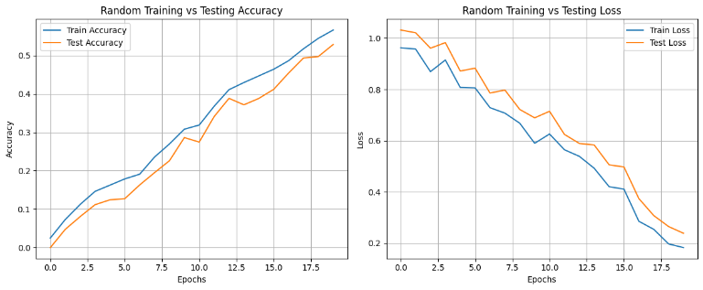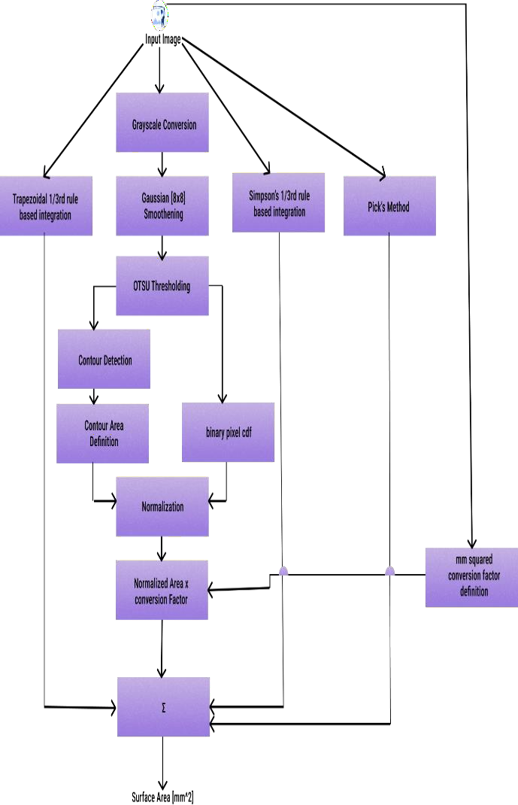

Fig 4 architecture for leather quality assurance

to the contour area measured in the binary image.

VI. SIMULATION RESULT

To comprehensively evaluate the performance and reliability of the proposed surface area estimation system, a diverse set of quantitative metrics is employed, each offering a distinct perspective on accuracy and consistency. The Intersection over Union (IoU) score is used as a primary geometric evaluation metric, measuring the degree of overlap between the contour detected by the algorithm and the ground truth contour obtained through manual or reference measurements. By computing the ratio of the intersecting area to the combined union area of both contours, the IoU score provides a clear indication of how precisely the algorithm captures the true shape of the leather piece, with higher values reflecting superior boundary alignment. In addition to shape-based evaluation, error-based metrics are utilized to assess numerical accuracy in surface area estimation. Mean Squared Error (MSE) calculates the average of the squared differences between predicted and ground truth surface area values, thereby emphasizing larger errors and offering insight into the overall severity of deviations. Complementing this, Mean Absolute Error (MAE) measures the average absolute difference between predicted and actual values, providing a more intuitive and robust indicator of accuracy that is less influenced by extreme outliers. Root Mean Squared Error (RMSE), derived as the square root of MSE, further enhances interpretability by expressing error magnitude in the same units as surface area, while also reflecting the spread of estimation errors around the mean. To assess how well the predicted values conform to the underlying trend of the ground truth data, the Coefficient of Determination (R-squared) is employed, indicating the proportion of variance in surface area measurements that is effectively explained by the proposed model. Relative error metrics, including Relative Absolute Error (RAE) and Relative Squared Error (RSE), are incorporated to normalize absolute and squared errors with respect to the scale and variance of the ground truth values, enabling fair comparison across datasets of varying sizes and measurement ranges. Furthermore, the Correlation Coefficient is used to evaluate the strength and direction of the linear relationship between predicted and ground truth surface area values, with values approaching unity signifying strong agreement and consistent predictive behavior.

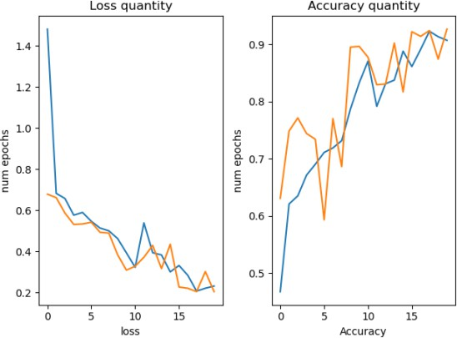
Fig 5 Parametric Analysis

VII. RESULT

After executing the comprehensive series of image processing steps on each frame collected by the camera in the running video, the simulation results provide insightful findings regarding the surface area detection of irregular leather pieces. Within the Graphical User Interface (GUI) crafted using the tkinter and ttkbootstrap modules of Python, the culmination of these processing steps manifests in the form of tangible surface area measurements and visual representations. Upon successful execution of frame extraction, grayscale conversion, Gaussian smoothing, thresholding, contour detection, edge detection, segmentation, and pixel counting, the GUI showcases the processed images alongside their respective contour overlays and segmentation partitions. This visual feedback offers a qualitative understanding of the algorithm's performance in accurately delineating the boundaries of irregular leather pieces and discerning surface area regions.

VIII. CONCLUSION
Fig 6 relationship b/w the cm^2 and %

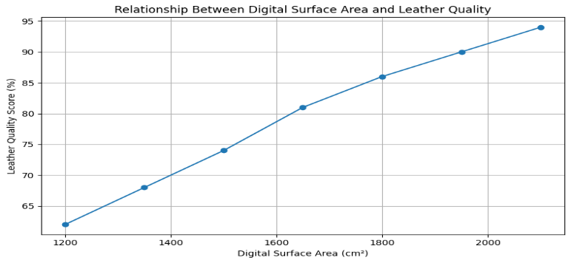

In conclusion, our paper has illuminated the transformative potential of integrating computer vision and image processing methodologies within the leather industry's quality assurance frameworks. Through a meticulous exploration of the existing challenges plaguing surface area detection in irregular leather pieces and the limitations of conventional methodologies, we have underscored the critical need for innovative solutions to optimize material utilization and minimize wastage. Our proposed system, fortified by a robust algorithmic framework and underpinned by mathematical rigor, represents a paradigm shift in leather processing operations, empowering manufacturers to achieve unprecedented levels of efficiency, precision, and profitability. By harnessing the synergistic potential of computer vision, image processing, and artificial intelligence, our system transcends the boundaries of traditional methodologies, offering a holistic approach to quality assurance that is both data-driven and technologically sophisticated. Through the seamless integration of advanced algorithms and machine learning models, our system automates the labor-intensive process of surface area detection, enabling real-time analysis and informed decision-making. Moreover, by providing actionable insights into material characteristics and geometric properties, our system fosters a culture of continuous improvement, driving operational excellence and fostering competitiveness in the global marketplace. As we stand on the precipice of a new era in leather processing technology, the implications of our research extend far beyond the confines of the industry itself.

IX. FUTURE WORK

In the realm of future works, our research will continue to evolve and push the boundaries of innovation within the leather industry. One avenue of exploration involves integrating ResNet-based leather detection algorithms into our existing framework. By leveraging the power of deep learning architectures like ResNet, we aim to enhance the accuracy and robustness of leather detection, enabling our system to effectively identify and delineate leather pieces from complex backgrounds with unparalleled precision. Furthermore, we propose to extend our methodology by integrating advanced contouring techniques within the detected leather regions. By encapsulating the leather within a refined mask rectangle, we can effectively remove surrounding sharp noises and extraneous elements, ensuring that our surface area calculations are based on clean, accurate data. This refinement process will contribute to the elimination of potential sources of error and enhance the reliability of our surface area output. In addition to refining our surface area detection capabilities, our future endeavors will also explore novel avenues for characterizing and optimizing leather utilization. One such direction involves the integration of shape parameter analysis algorithms, enabling us to delineate and quantify wastage within leather pieces. By accurately drawing shapes of defined parameters such as length, breadth, height, and radius within the leather, we can precisely measure the extent of wastage and calculate the wastage-to-usage ratio. This holistic approach will provide manufacturers with invaluable insights into material efficiency and enable them to optimize their production processes accordingly. In our pursuit of advancing quality assurance methodologies within the leather industry, future works will see the integration of cutting-edge techniques to further refine our system's capabilities. Leveraging UNet-based semantic segmentation, we aim to achieve precise delineation of leather regions within frames, facilitating accurate pixel counting and surface area estimation. By harnessing the power of deep learning architectures like UNet, our system will be equipped to generate high-fidelity masks that encapsulate the intricate contours of leather pieces with unprecedented accuracy. Moreover, we propose to leverage the Media Pipe library for shape determination within detected leather regions. By leveraging its robust feature extraction capabilities, we can precisely delineate and quantify geometric parameters such as length, breadth, height, and radius, providing manufacturers with invaluable insights into material utilization and wastage. Furthermore, our future endeavors will explore novel approaches to defect detection and classification within leather pieces.

REFERENCES

- Cao, Z., Hidalgo, G., Simon, T., Wei, S. E., & Sheikh, Y. (2020). OpenPose: Realtime multi-person 2D pose estimation using part affinity fields. IEEE Transactions on Pattern Analysis and Machine Intelligence, 43(1), 172–186. https://doi.org/10.1109/TPAMI.2019.2929257

- Chen, G., Li, Y., Zhang, X., & Wang, Z. (2021). AI-based posture correction for fitness applications. Sensors, 21(7), 2564–2572. https://doi.org/10.3390/s21072564

- Bazarevsky, V., Grishchenko, I., Raveendran, K., Zhu, T., Zhang, F., & Grundmann, M. (2021). BlazePose: On-device real-time body pose tracking. Google Research Blog.

- Bradski, G. (2000). The OpenCV library. Dr. Dobb’s Journal of Software Tools.

- Google Research. (2022). MediaPipe: Cross-platform framework for machine learning pipelines. Google AI Blog.

- Maji, P., Banerjee, S., & Pal, S. K. (2022). Human action recognition using vision-based techniques. Journal of Visual Communication and Image Representation, 83, 103432. https://doi.org/10.1016/j.jvcir.2022.103432

- Van Rossum, G. (2023). Python programming language. Python Software Foundation. https://www.python.org

- Ranjithkumar, S., Nallavan, G., & Sugumar, S. (2023). Implementation of an intelligent real-time squat detection and performance evaluation system using computer vision and pose estimation techniques. Iconic Research and Engineering Journals, 9(6).

- Shafizadegan, F., Rahmati, M., & Fathy, M. (2024). Multimodal vision-based human action recognition using deep learning. Multimedia Tools and Applications. https://doi.org/10.1007/s11042-024-xxxx-x

- Joseph Ng, P. S. (2025). A cost-effective approach using CNN and LSTM models. SSRN Electronic Journal. https://doi.org/10.2139/ssrn.xxxxxxx

- Efficient human activity recognition on edge devices using TinyML. (2025). Nature.

- Application of human activity/action recognition: A review. (2024). Multimedia Tools and Applications.

- Machine learning for human activity recognition: State-of-the-art. (2024). MDPI.

- A systematic literature review on human activity recognition. (2025). Springer.

- HARNet in deep learning approach—A systematic survey. (2024). Scientific Reports. https://doi.org/10.1038/s41598

