Review Article

Research Progress on FRP Reinforced Concrete Structures

.
ABSTRACT

Steel corrosion is a key issue that leads to the degradation of the performance and shortened service life of reinforced concrete structures, especially in harsh environments such as those in the ocean. Fibre-reinforced polymers (FRP) bars, with their advantages of light weight, high strength, and corrosion resistance, have become an ideal alternative to traditional steel bars. The research on reinforced concrete structures with FRP reinforcement has become a hot topic in the field of civil engineering. This article systematically reviews the research progress of FRP-reinforced concrete structures: In terms of bonding performance, through pull-out tests, the composition and failure mechanism of the bond between FRP bars and concrete were clarified, and the long-term durability and dynamic fatigue performance still need to be further improved; In terms of the mechanical performance of components, the mechanical characteristics, failure modes, and influencing factors of FRP-reinforced concrete beams, columns, and slabs were respectively elaborated, and the effects of reinforcement ratio, fiber addition, and mixed reinforcement on the bearing capacity, ductility, and crack control of components were clarified. The existing design methods still need to be further revised in combination with experimental results; In terms of application prospects, the substitution of steel bars with FRP bars can save engineering costs and promote green development. In harsh environment engineering, the potential is significant. Future research should focus on durability under actual service conditions, compatibility with environmentally friendly materials, structural enhancement optimization, and mechanical performance under fire conditions, providing more complete theoretical support and technical guarantees for the wide application of FRP-reinforced concrete structures.

Keywords: Fiber-reinforced composite materials, FRP bars, concrete structures, mechanical properties, influencing factors

- INTRODUCTION

Steel corrosion is an important factor leading to the degradation of the mechanical properties of reinforced concrete structures [1]. Especially for infrastructure such as buildings, bridges, dams, and offshore platforms located near or across the sea, the problem of steel corrosion is even more severe due to the influence of environmental factors. Corrosion significantly reduces the bearing capacity, ductility, and durability of the components, thereby shortening the service life of the entire structure. Therefore, the issue of corrosion prevention for reinforced concrete structures has always been a focus of attention.

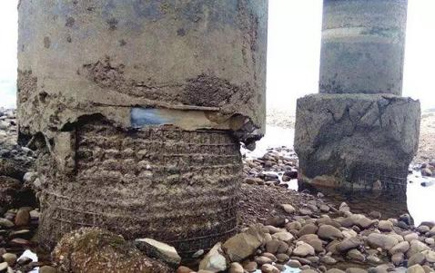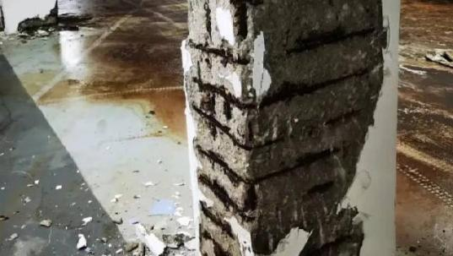
Figure 1 Structural durability issues caused by steel corrosion
Traditional corrosion prevention or mitigation measures, such as applying protective coatings to steel bars, cathodic protection, using corrosion inhibitors, and using stainless steel bars, although they have reduced the occurrence of corrosion to some extent, have not fundamentally solved this problem. Therefore, researchers have developed a new type of material - fiber-reinforced polymer (FRP) composite material bars, as an alternative to steel bars. Fiber-reinforced polymer (FRP) composite materials are engineered materials formed by combining reinforcing fibers such as glass, carbon, aramid, and basalt with polymer matrix materials such as polyester, vinyl ester, and epoxy resin through various manufacturing techniques such as winding, molding, and pultrusion. These composite materials vary depending on the type of reinforcing fiber used, resulting in different types such as glass fiber reinforced polymer (GFRP), carbon fiber reinforced polymer (CFRP), aramid fiber reinforced polymer (AFRP), and basalt fiber reinforced polymer (BFRP). FRP bars are highly regarded for their excellent longitudinal tensile strength, corrosion resistance, light weight, and anisotropic and elastic behavior until the point of fracture [2]
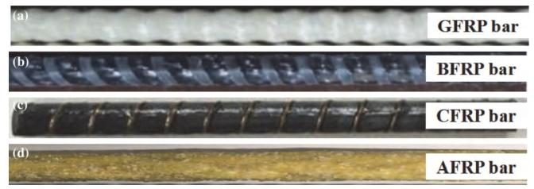
Figure 2 Types of FRP reinforcement and fibers: (a) GFRP reinforcement (b) BFRP reinforcement (c) CFRP reinforcement (d) AFRP reinforcement[2]
At present, the research on FRP-reinforced concrete structures mainly includes the studies on the mechanical and durability properties of FRP bars, as well as the interface bonding performance, and the research on the mechanical performance of FRP-reinforced components. In order to better promote the development of FRP bars and their reinforced structures, this paper systematically summarizes and organizes the current research status of FRP-reinforced concrete structures, clarifying the existing deficiencies and the research work that needs to be carried out in the future.

- Research on the Mechanical Properties of FRP Reinforcement

FRP bars are composed of multiple bundles of unidirectional fibers and matrix materials (typically resin-based), and are produced through special forming processes (such as pultrusion). They have the following advantages: 1. Low self-weight. The density of FRP is only about one quarter of that of steel, making it more advantageous in transportation, installation, and maintenance. 2. High tensile strength. FRP is made of high-strength fibers and resin matrix, and its tensile strength is much higher than that of steel, which means that FRP-reinforced concrete structures can achieve higher load-bearing capacity. 3. Good corrosion resistance. FRP has excellent corrosion resistance and can resist the erosion of water, acids, and alkalis, thus maintaining the durability of the structure even in harsh environments. 4. Good fatigue performance. FRP has excellent fatigue performance and will not easily fail under repeated tensile and compressive cyclic loads over a long period of time. [3]

Table 1 Comparison of mechanical properties between FRP bars and ordinary steel bars[4]
Item | Plain Steel Bar | CFRP Bar | AFRP Bar | CFRP Bar
Density/(t/m³) | 7～85 | 1.25～2.10 | 1.25～1.40 | 1.50～1.60
Ultimate Tensile Strength/MPa | 490～700 | 480～1600 | 1200～2550 | 600～3700
Yield Strength/MPa | 280～420
Tensile Modulus of Elasticity/GPa | 210 | 36～65 | 40～120 | 100～200
Ultimate Elongation/% | >10.0 | 1.2～3.1 | 1.9～4.4 | 0.5～1.7
Stress Relaxation/% |  | 5 | 7～20 | 1～3

Xu Xinsheng, Zheng Yongfeng, et al. [5] designed and fabricated GFRP bars, CFRP bars, and injection-type and compression-type steel sleeve anchorages, as shown in Figure 3, to solve the problem of compressive failure at the end of the tensile test. Mechanical property tests were conducted on FRP bars, including tensile strength, elastic modulus, and elongation rate, and the test results were statistically analyzed. It was clearly shown that the stress-strain of FRP bars exhibited a linear change, and the elastic modulus and elongation rate were smaller than those of steel bars. The strength-to-quality ratio and durability of FRP bars were superior to those of steel bars. The calculation methods for the standard value of the ultimate tensile strength and yield strength of FRP bars were provided, and the mechanical performance indicators for structural design were offered. You Chao, Deng Jiangdong, et al. [6] conducted tensile tests on four diameters of GFRP bars, analyzed the influence of diameter on mechanical properties, and revealed the size effect of GFRP bars: the ultimate tensile strength decreased with the increase in diameter, the displacement ductility increased with the increase in diameter, and the influence of diameter on the elastic modulus was small. Geng Lin, Xu Jiayang, et al. [7] conducted tensile tests on different diameters and rib heights of basalt fiber composite bars, and analyzed the influence on tensile strength and elastic modulus. It was clearly shown that the tensile strength of basalt fiber composite bars decreased with the increase in diameter; the elastic modulus increased first and then decreased, and the influence of the rib height of the reinforcement on tensile strength and elastic modulus was small.
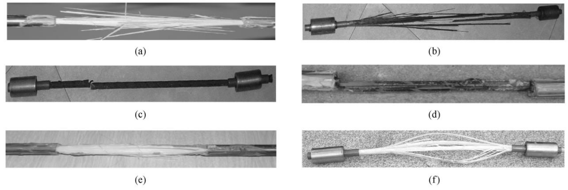Figure 3 The tensile failure mode of the FRP test specimen with injection [5]
Zhan Jiandong, Du Xiuli, et al. [8] conducted a systematic review of the long-term mechanical performance research results of FRP bars at home and abroad, focusing on analyzing the fatigue, stress relaxation, and creep fracture properties of CFRP bars and AFRP bars. It was clearly stated that the fatigue performance of CFRP bars is the best, and they can withstand 4 million cycles of load when the maximum stress is less than 87.5% of the ultimate stress; the stress amplitude and the minimum stress are the key influencing factors of the fatigue life.
Li Guanghui, Zhang Ying, et al. [9] analyzed the effects of fiber type, matrix material, diameter, heating regime, and concrete protective layer on the mechanical properties of FRP bars after high-temperature exposure. They concluded that when the temperature exceeded 400℃, the mechanical properties of various FRP bars significantly decreased and were not suitable for high-firegrade concrete structures. Zhu Deju, Xu Xufeng, et al. [10] tested the tensile and shear properties of BFRP bars and GFRP bars after different temperature treatments, finding that the tensile strength, ultimate strain, toughness, and shear strength of BFRP bars and GFRP bars increased first and then decreased with the increase in temperature, while the elastic modulus did not change significantly. They concluded that after 350℃ treatment, the tensile strength of BFRP bars decreased by 46.49% and that of GFRP bars decreased by 29.91%; BFRP bars had poorer tensile performance but better shear performance. Wang Xiaolu, Zha Xiaoxiong, et al. [11] conducted high-temperature tensile tests on GFRP bars with a diameter of 8mm in the temperature range of 10 to 500℃, obtaining the trend of ultimate strength and elastic modulus attenuation.

- Bonding test study

At present, the bonding performance between FRP bars and concrete is mainly studied through the pull-out test system. The interface bonding performance between FRP bars and concrete is a key factor determining whether the concrete members with FRP bars can exert their mechanical properties. Similar to steel bars, the bonding force between FRP bars and concrete mainly consists of chemical adhesion force, friction force and mechanical interlocking force, with only the mechanism of bond failure being slightly different. The interface failure of steel bars and concrete mainly occurs in the concrete, manifested as the interlaminar concrete being sheared and pulled out. However, the bonding performance between FRP bars and concrete depends on the interlaminar shear strength of the FRP bars [12-13].

Kun Liang and Lijie Chen [14] conducted tensile tests on basalt fiber reinforced polymer (BFRP) bars and ultra-high performance concrete (UHPC) within a temperature range of 25°C to 330°C, analyzing the influence of different UHPC strength grades and BFRP bar diameters on the residual bond strength; they used scanning electron microscopy (SEM) to reveal the degradation mechanism of bond strength due to resin softening and UHPC peeling under high temperatures; they proposed a residual bond strength prediction model considering the temperature effect, with a coefficient of determination (R²) of 0.87. It was clarified that when the resin glass transition temperature (approximately 170°C) is above, the resin softens but retains approximately 90% of the normal temperature bond strength after cooling, and the strength drops sharply at higher temperatures, indicating that the water-cement ratio of UHPC affects the peeling behavior under high temperatures, and a high water-cement ratio (0.24) has a stronger anti-peeling ability; they proposed a residual bond strength prediction model considering the temperature effect, with a coefficient of determination (R²) of 0.87. Sun-Jae Yoo and T.F. Yuan [15] studied the bond slip response of ribbed CFRP bars and UHPC after high-temperature exposure, comparing the residual bond performance differences between CFRP bars and reinforcing bars. They proposed a bond strength temperature reduction coefficient formula; it was clarified that the differences in bond performance between CFRP bars and reinforcing bars in UHPC after high temperatures follow a certain pattern, providing a reference for the design of FRP bars and UHPC structures in high-temperature environments.

Jizhong Wang [16] conducted a study on different surface treatments (sand-coated SC, spiral-wound HW, ribbed RB, indentation LN, composite treatment HWSC/INSC) of FRP bars and found that the deformation bars (HW, RB, LN) were more significantly affected by parameters such as concrete strength and protective layer thickness. The surface treatments are shown in Figure 3. The composite treatment bars had a moderate impact degree. A bond strength prediction model including surface geometric indicators (w, y) was developed, which significantly improved the prediction accuracy for single surface treatment bars and provided precise design basis for different surface type FRP bar engineering applications. Sandor Solyom [17] studied 13 different surface configurations of FRP bars (GFRP, BFRP) and found that the bond strength dispersion of sand-coated bars was related to the sand particle size and distribution, and the bond stiffness of ribbed bars was better in terms of durability; it was confirmed that the bond strength of FRP bars could still be enhanced when the concrete strength was higher than 30 MPa. F. Sayed Ahmad [18] studied the influence of smooth and sand-coated CFRP bars on the bond strength through pull-out tests, analyzing the influence of embedding length, bar diameter, and concrete age on bond strength; observing the bond failure mode. The bond strength of smooth CFRP bars in UHPFRC was close to that of sand-coated bars, and it could reach a relatively high bond strength at an early age (3 days); it was clear that the bond strength decreased with the increase of bar diameter and embedding length; it was revealed that the bond failure was the peeling of the outer layer of CFRP bars, and there was no obvious damage to the concrete; the development length of sand-coated bars was approximately 40 times the bar diameter.

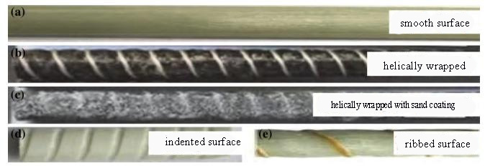
Figure 4 Surface forms of FRP reinforcement：(a) Smooth surface (b) Spiral winding (c) Spiral winding with sand coating (d)Indentation treatment (e) Ribbed treatment [2]

Ahmed [19] conducted pull-out tests on BFRP bars and GFRP bars, comparing the bond-slip curves of the two types of bars; analyzed the influence of bar diameter and embedding length on bond performance. It was clarified that the average bond strength of BFRP bars was 75% of that of GFRP bars, and both showed an extraction failure mode; established the BPE and improved BPE models for the bond-slip curve of BFRP bars; revealed that the bond strength of BFRP bars decreased with the increase in diameter and embedding length, providing data support for the engineering application of BFRP bars replacing GFRP bars. Q. Hao [20] studied the influence of rib geometric parameters (rib spacing, rib height) on bond performance, and established an empirical model for bond strength based on rib geometric parameters. Determined the optimal rib spacing (close to the bar diameter) and rib height (approximately 6% of the diameter); proposed an empirical model for bond strength considering rib geometric parameters, improving the prediction accuracy of bond strength of ribbed GFRP bars. M. Baena [21] studied the bond behavior of FRP bars with different surface treatments through pull-out tests, analyzed the influence of concrete strength on bond performance. It was found that the spiral-wound bars had the optimal bond strength due to a higher ratio of projected rib area to rib spacing; it was clarified that surface characteristics had a more significant impact on the bond performance of FRP bars in high-strength concrete; providing selection criteria for different types of FRP bars in different strength concrete applications.

Zheng Yuanshi et al. [22] compared the bonding properties of three types of FRP bars: CFRP, GFRP, and BFRP. The study found that the surface morphology of the reinforcement had the most significant impact on the bonding strength: the bonding strength of ribbed FRP bars was approximately 2.7 times that of smooth bars; increasing the bonding length would lead to a decrease in the average bonding stress; when the bonding length of smooth bars increased from 5 days to 10 days, the strength decreased by approximately 24%; the influence of concrete strength on the bonding strength was relatively small; increasing the concrete strength grade only slightly increased the bonding stress. To accurately describe the bonding behavior of the FRP bar-concrete interface, scholars have proposed various bonding-slip constitutive models. Gao Danying et al. [23] summarized the models proposed by Malvar, Cosenza, and others, and proposed a smooth and continuous four-parameter curve model. This model satisfies the boundary conditions in both the ascending and descending segments, has clear physical meaning, and is in good agreement with the experimental data.

In conclusion, the research on the adhesion of FRP bars has initially established a prediction model for the bond strength and a slip constitutive relationship that take into account factors such as the type, diameter, surface morphology, bond length, and concrete strength of the FRP bars. This provides a theoretical basis for the design of FRP-reinforced concrete structures. However, the following aspects still require further research: Long-term performance and durability: such as the degradation laws of bond performance under continuous loads, wet and dry cycles, freeze-thaw, etc.; Dynamic and fatigue performance: the bond behavior under dynamic loads such as earthquakes and fatigue loads.

- The mechanical properties of FRP-reinforced components

4.1 FRP reinforced concrete beam

Due to the low elastic modulus of FRP bars and the poor bonding performance between them and concrete, FRP-reinforced concrete beams are prone to develop wide cracks and significant deformations when subjected to loads [3].

Zhu Haitang [24] studied the influence of steel fiber layer thickness, volume fraction, and BFRP reinforcement ratio on the flexural bearing capacity and failure mode of the structure, clarifying the three types of failure modes: compression, tension, and equilibrium; a 1.0% volume fraction of steel fibers increased the bearing capacity by 22.7%, as shown in Figure 4, and a 1.65% reinforcement ratio increased by 39.4% compared to 0.56% reinforcement ratio; a calculation method for bearing capacity adapted to different failure modes was proposed. Xue Weichen [25] systematically studied the flexural performance of FRP-reinforced concrete beams, determining the three failure modes: tension, equilibrium, and compression; clarifying the correlation between the minimum reinforcement ratio and the failure mode; proposing the calculation formula for the "nominal yield strength" of FRP reinforcement, and the design suggestions were more in line with the experimental results than ACI 440.1R-01. Ge Wenjie [26] conducted static flexural tests on mixed-reinforced beams with different ratios of FRP reinforcement to steel reinforcement, and derived the bearing capacity formula, defining two nominal reinforcement ratios and three failure modes and discrimination conditions; the derived formula for the flexural bearing capacity of the reinforced beam, the theoretical value and the experimental value were in good agreement (mean value 0.94, coefficient of variation 0.08). Ruan Xiangjie [27] et al. discussed the mechanical performance of FRP-reinforced mixed-reinforced beams. The test results showed that the ultimate bending moment of the mixed-reinforced beam was approximately 91%–97% of that of the reinforced concrete beam, with limited reduction in bearing capacity, indicating the feasibility of using FRP reinforcement to replace part of the steel reinforcement. However, under the same load, its deflection and crack width significantly increased (20%–90%), which requires attention in design. The study also proposed calculation methods for bearing capacity, crack width, and deflection applicable to mixed-reinforced beams. Peng Fei and Xue Weichen [28] from the perspective of reliability, used Monte Carlo simulation to analyze the flexural bearing capacity of GFRP-reinforced concrete beams. The study found that when designed according to "GB 50608—2010", the reliability index of the tension failure beam was higher, while that of the compression failure beam was lower. The research suggested adjusting the sub-item coefficient of GFRP reinforcement material to 1.3 and improving the limit stress formula for compression failure to ensure that all failure modes reached the target reliability index (β = 3.7).

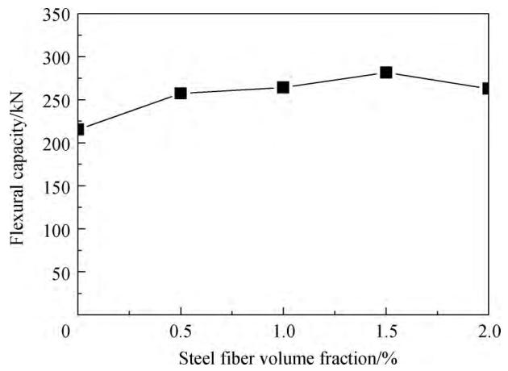
Figure 5 Comparison of flexural bearing capacity of BFRP-reinforced high-strength concrete beams with different volumes of steel fibers[25]

Zhu Hong [29] conducted experiments on simply supported beams (with 2 GFRP bars, 2 BFRP bars, and 2 ordinary steel bars each) to compare and analyze the stiffness and deflection characteristics, and revised the short-term stiffness formula. After the FRP bar beams cracked, their stiffness was significantly lower than that of the steel bar beams; the existing standards (GB 50608-2010, ACI 440.1R-06) overestimated the short-term stiffness; the revised formula introduced the strain non-uniformity coefficient to improve the prediction accuracy. Maher A. Adam [30] established an ANSYS finite element model, revised the effective moment of inertia formula; revised the effective moment of inertia formula in ACI 440.1R-06 to improve the deflection prediction accuracy under high load conditions. Amr El-Nemr [31] conducted experiments on GFRP bar concrete beams with different elastic moduli and surface shapes, evaluated the deflection and stiffness characteristics, and verified that the curvature limit of 0.005/d can effectively control the applicability; the ACI 440.1R series standards underestimated the deflection, and the ISIS M-03 and CSA S806-12 predictions were more conservative. M.S. Issa [32] studied the influence of fiber type on the flexural performance of GFRP bar beams, and steel fibers increased the ductility of the beam by 3.78 times and the bearing capacity by 56.41%; the ACI 440.1R-2015 seriously underestimated the bearing capacity of this type of beam, and the fiber reinforcement effect needs to be considered.

Ge Wenjie [33] studied the influence of ECC thickness and reinforcement type on crack width and stiffness. Replacing the tensile zone concrete with ECC can significantly control the crack width and enhance the stiffness; three formulas for discriminating failure modes and a simplified calculation method for bearing capacity were proposed. G.B. Maranan [34] studied the influence of reinforcement diameter, reinforcement ratio and anchorage system on the applicability of GFRP-reinforced geopolymer concrete beams. The bonding performance between GFRP reinforcement and geopolymer concrete was good with the sand coating; this type of beam had higher flexural bearing capacity than traditional GFRP-reinforced ordinary concrete beams; ACI 440.1R-06 and CSA S806-12 underestimated the beam strength. Dong Zhiqiang and Wu Gang [35] addressed the issue of unreasonable parameter values in the calculation of crack width for FRP-reinforced concrete beams. Based on experimental data, they verified and corrected the key parameters such as the relative bonding characteristic coefficient, strain non-uniformity coefficient, and crack expansion coefficient, and proposed a more accurate formula for calculating crack width. The corrected formula was in better agreement with the experimental values, providing a reference for the revision of the standard.

In summary, the flexural performance of FRP-reinforced concrete beams is influenced by various factors such as reinforcement ratio, concrete strength, reinforcement diameter, addition of fibers, mixed reinforcement, and application of prestress. The reinforcement ratio is the main factor affecting the failure mode of the beam. Increasing the reinforcement ratio and concrete strength can enhance the bearing capacity of the beam, reduce the crack width and deflection. Adding fibers, mixed reinforcement, and applying prestress can effectively improve the ductility of the beam. Current research focuses on the bearing capacity and deformation of FRP-reinforced beams, while research on the development and calculation of cracks is relatively lagging behind. Moreover, the flexural performance of FRP-reinforced concrete beams, FRP/steel mixed reinforcement beams, and FRP-reinforced beams under bending fatigue also require in-depth study. In terms of design theory, some national codes are based on theoretical derivation, while others are revised based on the design codes of reinforced concrete structures. Compared with experimental results, the design theory still needs further correction to ensure the accuracy of the prediction results.

4.2 FRP reinforced concrete column

The application of fiber-reinforced polymer (FRP) materials in concrete columns can be mainly divided into two categories: as internal longitudinal and transverse reinforcing bars to replace steel bars, and as external wrapping to constrain and reinforce existing concrete columns. Both types of applications aim to leverage the high strength and corrosion resistance of FRP to enhance structural performance and durability. Using FRP bars as the internal reinforcing material for concrete columns is one of the fundamental solutions to the problem of steel corrosion.

Mohammad Z. Afifi [36] used GFRP/CFRP bars as longitudinal reinforcement and GFRP/CFRP spiral bars / stirrups as transverse reinforcement. By setting variables such as reinforcement type, longitudinal reinforcement ratio, transverse reinforcement parameters (volume ratio, diameter, spacing), it was found that the mechanical behavior of GFRP/CFRP reinforced concrete columns was similar to that of reinforced concrete columns, with an average peak bearing capacity 7%-8% lower. However, the post-earthquake damage was less and the residual displacement was smaller. It was clearly shown that the FRP spiral bars with small diameter and close spacing had a better confinement effect, which could increase the ductility by 208%. Increasing the longitudinal reinforcement ratio from 1.1% to 3.2% could increase the ductility by 117%. Figure 5 shows the failure diagram. Gong Yongzhi [37] completed 5 rectangular cross-section CFRP reinforced concrete column axial compression tests. The variables included longitudinal reinforcement ratio (0.75%/1.45%) and CFRP stirrup spacing (50mm/100mm/150mm). It was pointed out that the compressive strength of CFRP longitudinal bars was only 26.6%-36.1% of the tensile strength, which had a certain improvement on the column bearing capacity, but the available strength was limited. It was confirmed that the smaller the stirrup spacing, the better the confinement effect. Zhang Bing [38] studied the axial compression performance of elliptical GFRP - concrete - steel composite hollow columns. Using a composite structure of GFRP bars, concrete and steel, the variables included GFRP bar reinforcement ratio, steel wall thickness and concrete strength grade. It was confirmed that the synergy of GFRP bars with steel and concrete could significantly improve the compressive performance and stability of the column.
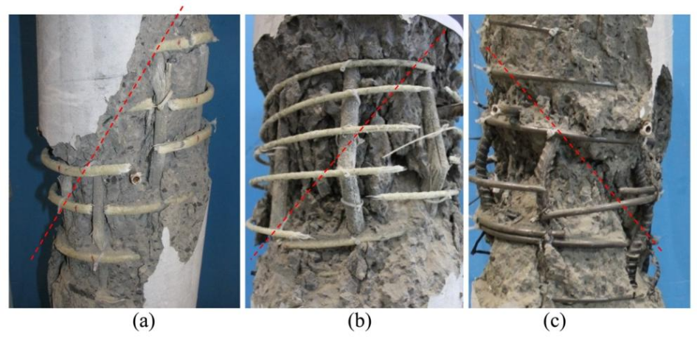
Figure 6 (a) fracture of glass fiber reinforced polymer (GFRP) spiral bars; (b) buckling and fracture of longitudinal GFRP bars; (c) buckling of longitudinal bars and fracture of spiral bars[36]

G.B. Maranan [39] studied the compression performance and the influence law of the length-to-diameter ratio of geopolymer concrete (GPC) FRP columns. He used GFRP longitudinal and transverse reinforcements. The variables included the form of transverse reinforcement (circular reinforcement / spiral reinforcement), spacing, and the column's length-to-diameter ratio. It was found that the compatibility of GPC with GFRP reinforcement was superior to that of ordinary concrete. The normalized strength of GPC FRP columns reached 97.3% (while that of ordinary concrete columns was 88.3%). Md. Jahidul Islam [40] studied the CFRP strengthening performance of low-strength recycled brick aggregate concrete (RBAC) columns. It was confirmed that continuous CFRP wrapping had a significant reinforcing effect on low-strength concrete columns. The axial bearing capacity of 10MPa grade columns increased by 72%, and that of 17MPa grade columns increased by 62%.

Qi Ligang [41] studied the seismic performance and failure mechanism of CFRP-reinforced concrete columns, with variables including the longitudinal reinforcement ratio, hoop reinforcement spacing, and axial compression ratio. It was found that CFRP-reinforced concrete columns exhibit the characteristics of "high bearing capacity and low damage", with the ultimate displacement angle reaching over 5%, and the residual displacement being only 1/3 of that of reinforced concrete columns. This confirmed that dense reinforcement (small diameter, small spacing) can delay the buckling of the longitudinal reinforcement and enhance ductility; an increase in the axial compression ratio will enhance the bearing capacity, but accelerate brittle failure.

Muhammad N. S. Hadi [42] conducted a study on the mechanical properties of circular FRP columns under various loading conditions (centrifugal / eccentric / flexural), and found that the axial bearing capacity and flexural bearing capacity of GFRP-reinforced concrete columns were slightly lower than those of reinforced concrete columns (with a reduction of 13% - 17%), but the ductility was similar (with a difference of less than 5%).

In summary, in terms of experimental research, there are not many studies on FRP-reinforced concrete compression-biased columns. Further in-depth research and analysis on their mechanical properties are needed. The eccentric compression performance of FRP-reinforced concrete columns is mainly influenced by factors such as eccentricity, longitudinal reinforcement ratio, hoop reinforcement spacing, and long-to-short ratio. The failure mechanism is related to the degree of eccentricity. Compared with axially compressed columns, in eccentric compression, FRP reinforcement can fully exert its strength. After the concrete is crushed, the tensile side of the FRP reinforcement remains in an elastic working state, which helps to delay the damage of the component. Currently, the calculation theory for the eccentric compression bearing capacity of FRP-reinforced concrete columns is not systematically provided in the code. Although some scholars have conducted research on related calculation theories based on section analysis method, deformation coordination conditions, and the force state of FRP reinforcement, their applicability still needs further verification.

4.3 FRP reinforced concrete slab

At present, the research on FRP-reinforced concrete slabs mainly focuses on the calculation of the flexural bearing capacity of the slabs and the shear failure of the slabs

Fareed Elgabbas [43] conducted a study on concrete bridge slabs, covering variables such as reinforcement type, BFRP reinforcement diameter, reinforcement ratio, and edge confinement conditions. The study found that the cracking performance of small-diameter closely-spaced BFRP reinforcements was superior to that of large-diameter widely-spaced reinforcements, with smaller crack widths. The CSA 2012 standard predicted the shear strength of BFRP reinforced slabs more accurately, while the ACI 2006 standard was more conservative. Yasmin Murad [44] investigated variables including reinforcement type, concrete mix ratio (OPC, 1% steel fiber concrete, 1% steel fiber + 2% plastic fiber concrete), and thermal exposure (heating at 700°C for 2 hours / without heating). The bonding performance of stainless steel slabs deteriorated, and the load-bearing capacity decreased by 67.3%, and the initial stiffness decreased by 71%. 1% steel fiber increased the ultimate strength by 6.5% and the ductility by 0.5%. After heating, the stiffness of the fiber-reinforced plate was greater than that of ordinary concrete plate, and the bearing capacity decreased due to the addition of plastic fibers. Y. Zheng [45] studied unidirectional plates, with variables including lateral confinement stiffness, concrete strength, reinforcement ratio, and reinforcement type. Lateral confinement caused shear buckling failure of the plate, while an unrestrained plate experienced bending failure. The arch effect was equivalent to increasing the reinforcement ratio, enhancing the shear strength, delaying crack development, and increasing the area of the concrete compression zone. Y. Zheng [46] studied bridge slabs, with variables including reinforcement type, concrete type, and BFRP reinforcement ratio. All slabs experienced shear failure. The SCC slab had a higher bearing capacity than the CVC slab, and the SCFRC slab had smaller crack width and better ductility. The performance of BFRP reinforced slabs was similar to that of GFRP reinforced slabs. K. Bouguerra [47] studied full-scale bridge slabs, including slab thickness, concrete strength, reinforcement ratio, and reinforcement type. All slabs experienced shear failure. The slab thickness, concrete strength, and reinforcement ratio were positively correlated with the bearing capacity. The compressive film effect caused by edge confinement reduced the reinforcement demand, verifying the economic applicability of FRP reinforcements in bridge slabs.

Fan Xinglang [48] conducted research based on the critical shear crack theory, taking into account the tensile stiffening effect of concrete, and established a calculation model for the punching shear bearing capacity of FRP-reinforced concrete slabs. The influence of concrete strength, column head size, reinforcement ratio, and slab thickness on the bearing capacity and ductility was analyzed. An increase in concrete strength and column head size led to a decrease in the nominal stress of the bearing capacity but an increase in ductility; an increase in reinforcement ratio and slab thickness led to an increase in the bearing capacity but a decrease in ductility. Zhang Yakeun [49] established a database of 98 FRP-reinforced concrete two-way slab punching shear tests, evaluated 14 existing calculation models, and determined the critical punching shear section coefficient through inversion analysis. It was clarified that concrete strength, FRP reinforcement ratio, elastic modulus, critical punching shear section circumference, and slab thickness are the key influencing factors. Zhang Yakeun [50] studied the effects of load position, concrete strength, and FRP reinforcement amount on the mechanical performance of slab punching shear. Concrete strength has a significant impact on the crack resistance load and ultimate punching shear bearing capacity of the slab, while the influence of FRP reinforcement ratio is relatively small.

In conclusion, the mechanical properties and failure modes of FRP-reinforced concrete slabs are similar to those of reinforced concrete slabs. The design method for FRP-reinforced bridge slabs mainly involves modifying the design method of reinforced concrete bridge slabs, but it neglects the influence of the arch effect of the bridge slab, resulting in calculated results that are much lower than the actual bearing capacity of the bridge slab. Regarding the anti-shear performance of FRP-reinforced concrete bidirectional slabs, the reinforcement ratio within the slab has a negligible effect on it.

5. Challenges and Future Directions
The following aspects still require further investigation: Long-term performance and durability: such as the degradation laws of bonding performance under continuous loads, humid heat cycles, freeze-thaw, etc. in environmental conditions; Dynamic and fatigue performance: bonding behavior under dynamic loads such as earthquakes, fatigue loads;

- Study the durability of FRP bars in actual service environments, and conduct research on the durability of FRP-reinforced components under the combined effects of multiple factors in engineering, such as the degradation laws of bonding performance under environmental conditions like humid heat cycles and freeze-thaw;

- Study the compatibility of FRP bars with environmentally friendly materials and their potential application in green buildings;

- Study the structural reinforcement performance, considering the enhancement of concrete with fiber-woven mesh to improve the performance of components;

4. Research the situation of each stressed component of the structure in the event of fire.

6. conclusion and prospectives

- Analysis of multiple factors affecting bonding performance: Fiber type, elastic modulus, bonding length, reinforcement diameter, surface characteristics, and pouring position all significantly affect the bonding performance of FRP reinforcement.

2.Replacing reinforced concrete with FRP reinforcement can save the overall cost of the project, which is of great significance for achieving social and economic benefits and promoting green development.
3.Using FRP longitudinal reinforcement and hoop reinforcement as the reinforcing bars of concrete components is effective, and the relevant design methods are also gradually improving. However, during normal use, it can cause large deflections and cracks and exhibit brittle failure characteristics.

COMPETING INTERESTS

Author has declared that no competing interests exist.

REFERENCES

- Hou, Yilie, Yinghua Zhao, and Livei Zhang. "An Experimental Study on Corroded Cfrp Strengthened Rc Columns under Repeated Loading." China Civil Engineering Journal 43, no. 06 (2010): 146-52. https://doi.org/10.15951/j.tmgcxb.2010.06.019.
- Xiaolong, WANG, SHANG Huaishuai, LU Zhaohu, XIA0 Zhenhao, and XU Shaohui. "A Review on the Bonding Performance of Frp Bars to Concrete:Mechanisms, Testing Methods,and Influencing Factors." Materials Reports 39, no. 17 (2025): 265-72. https://doi.org/10. 11896 / cldb. 24070179.
- Zehua, Huang, Zhu Shangqing, lia Ruixin, Sun Jiahui, Long linxi, and Cai Gang. "Review of Research on Fiber Reinforced Polymer （Frp）Reinforced Concrete Structures." Journal of Municipal Technology 42, no. 06 (2024): 160-73. https://doi.org/10.19922/j.1009-7767.2024.06.160.
- Xiao, FENG, GE Wenjie, CHEN Tan, and WANG Biyuan. "Current Study Status of Frp Reinforced Concrete Beams." New Building Materials 42, no. 12 (2015): 48-51.
- Xinsheng, XU, and ZHENG Yong-feng. "Hybrid Effect Analysis and Experimental Study on Mechanical Properties of the Frp Bar." Journal of Building Materials 10, no. 06 (2007): 705-10.
- Chao, You, Deng Jiaoshong, Li Minghao, and Peng Wensheng. "Experimental Study on Mechanical Properties of Gfrp Bars with Different Diameters." Guangdong Building Materials 35, no. 08 (2019): 32-36.
- Lin, GENG, XU Jiayang, and WEI Shaowei. "Experimental Research on the Mechanical Properties of Basalt Fiber Composite Bars." China Railway, no. 10 (2025): 17-22.
- Jie-dong, ZHAN, Du Xiu-li, and WANG Zuohu. "Studies on the Long Term M Echanical Properties of Frp Tendons." Composites Science and Engineering, no. 06 (2009): 77-80.
- Deju, ZHU, XU Xufeng, CUO Shuaicheng, and SHEN Yan. "Mechanical Properties of Basalt and Glass Fiber Reinforcedpolymer Tendons after Exposed to Elevated Temperatures." Journal of Hunan University(Natural Sciences) 48, no. 07 (2021): 151-59. https://doi.org/10.16339/j.cnki.hdxbzkb.2021.07.018.
- Guanghui, LI, and ZHANG Ying. "Influence Factors of Mechanical Properties of Frp Bars after Elevated Temperature Exposure." Fly Ash Comprehensive Utilization 35, no. 01 (2021): 52-56+65. https://doi.org/10.19860/j.cnki.issn1005-8249.2021.01.010.
- Xiao-lu, Wang, and Zha Xiao-siong. "Experimental Investigation into Mechanicalbehavior of Gfrp Rebars at Elevated Temperature ". Journal of South China University of Technology(Natural Science Edition) 39, no. 09 (2011): 75-81.
- Qingduo, HAO, WANG Yanlei, HOU Jilin, and OU Jinping. "Experimental Study on Bond Behavior Ofgfrp Ribbed Rebars." Engineering Mechanics, no. 10 (2008): 158-65+79.
- El Refai, Ahmed, Mohamed-Amine Ammar, and Radhouane Masmoudi. "Bond Performance of Basalt Fiber-Reinforced Polymer Bars to Concrete." Journal of Composites for Construction 19, no. 3 (2015): 04014050. https://doi.org/10.106l/ASCE)CC.1943-5614.0000487.
- Liang, Kun, Lijie Chen, and R. K. L. Su. "Bond Behavior of Basalt Fiber-Reinforced Polymer Bars (Bfrp) Embedded in Ultra-High-Performance Concrete after Elevated Temperature Exposure." Construction and Building Materials 481 (2025). https://doi.org/10.1016/j.conbuildmat.2025.141531.
- Yoo, Sun-Jae, Tian-Feng Yuan, Jin-Seok Choi, and Young-Soo Yoon. "Comparative Bond-Slip Response of Ribbed Cfrp Bar to Uhpc after Exposure to High Temperature." Construction and Building Materials 400 (2023): 132583. https://doi.org/10.1016/j.conbuildmat.2023.132583.
- Wang, Jizhong, Fangduo Xiao, Zhenyu Lai, Junlong Yang, and Songyun Tian. "Bond of Frp Bars with Different Surface Characteristics to Concrete." Structures 59 (2024). https://doi.org/10.1016/j.istruc.2023.105731.
- Solyom, Sandor, and György L. Balázs. "Bond of Frp Bars with Different Surface Characteristics." Construction and Building Materials 264 (2020). https://doi.org/10.1016/j.conbuildmat.2020.119839.
- Sayed Ahmad, Firas, Gilles Foret, and Robert Le Roy. "Bond between Carbon Fibre-Reinforced Polymer (Cfrp) Bars and Ultra High Performance Fibre Reinforced Concrete (Uhpfrc): Experimental Study." Construction and Building Materials 25, no. 2 (2011): 479-85. https://doi.org/10.1016/j.conbuildmat.2010.02.006.
- El Refai, Ahmed, Mohamed-Amine Ammar, and Radhouane Masmoudi. "Bond Performance of Basalt Fiber-Reinforced Polymer Bars to Concrete." Journal of Composites for Construction 19, no. 3 (2015): 04014050. https://doi.org/10.106l/ASCE)CC.1943-5614.0000487.
- Hao, Qingduo, Yanlei Wang, Zheng He, and Jinping Ou. "Bond Strength of Glass Fiber Reinforced Polymer Ribbed Rebars in Normal Strength Concrete." Construction and building materials 23, no. 2 (2009): 865-71. https://doi.org/10.1016/j.conbuildmat.2023.132583.
- Gu, Xingyu, Bin Yu, and Ming Wu. "Experimental Study of the Bond Performance and Mechanical Response of Gfrp Reinforced Concrete." Construction and Building Materials 114 (2016): 407-15. https://doi.org/10.1016/j.conbuildmat.2016.03.2110950-0618.
- Yuzhou, Zheng, Yang Xing, Wang Wenwei, and Zhang Yongkang. "Bond Behavior Test and Bond-Slip Constitutiverelation between Frp Rebars and Concrete." Industrial Construction 45, no. 06 (2015): 1-6. https://doi.org/10.13204/j.gyjz201506001.
- Danying, Gao, Zhu Haitang, and Xie Jingjing. "The Constitutive Models for Bond Slip Relation Betweenfrp Rebars and Concrete." Industrial Construction, no. 07 (2003): 41-43+82. https://doi.org/10.13204/j.gyjz2003.07.011.
- Haitang, ZHU, CHENG Shengzhao, GAO Danying, and LI Chuanchuan. "Experimental and Theoretical Study on the Flexural Capacity of High-Strengthconcrete Beams Reinforced with Bfrp Bars and Steel Fiber." Acta Materiae Compositae Sinica 35, no. 12 (2018): 3313-23. https://doi.org/10.13801/j.cnki.fhclxb.20180319.004. https://link.cnki.net/doi/10.13801/j.cnki.fhclxb.20180319.004.
- Wei-chen, XUE, ZHENG Qiao-wen, and YANG Yu. "Design Recommendations on Flexural Capacity of FRP-Reinforced Concrete Beams." Engineering Mechanics 26, no. 01 (2009): 79-85. .
- Wenjie, Ge, Zhang Jiwen, Dai Hang, and Tu Yongming. "Flexural Behavior of Concrete Beam with Hybrid Reinforcement of Frp Bars and Steel Bars." Journal of Southeast University(Natural Science Edition) 42, no. 01 (2012): 114-19. https://doi.org/10.3969/j.issn.1001-0505.2012.01.022.
- Xiangjie, RUAN, LU Chunhua, ZHANG Zhuangzhuang, and YAN Yongdong. "Experimental Research on Flexural Capacity of Concretebeams Reinforced with Frp and Hrb Bars ". Industrial Construction 48, no. 10 (2018): 184-89. https://doi.org/10.13204/j.gyjz201810032.
- Fei, Peng, and Xue Weichen. "Reliability-Based Design Method for Ultimate Load-Bearing Capacity Ofgfrp Reinforced Concrete Beams under Flexure." China Civil Engineering Journal 51, no. 05 (2018): 60-67. https://doi.org/10.15951/j.tmgcxb.2018.05.007.
- Hong, Zhu, Dong Zhigiang, Wu Gang, and Wu Zhishen. "Experimental Study and Theoretical Calculation on the Flexural Stiffness of Concrete Beams Reinforced with Frp Bars." China Civil Engineering Journal 48, no. 11 (2015): 44-53. https://doi.org/10.15951/j.tmgcxb.2015.11.007.
- Adam, Maher A, Mohamed Said, Ahmed A Mahmoud, and Ali S Shanour. "Analytical and Experimental Flexural Behavior of Concrete Beams Reinforced with Glass Fiber Reinforced Polymers Bars." Construction and building materials 84 (2015): 354-66. https://doi.org/10.1016/j.conbuildmat.2015.03.057O950-0618.
- El-Nemr, Amr, Ehab A Ahmed, Adel El-Safty, and Brahim Benmokrane. "Evaluation of the Flexural Strength and Serviceability of Concrete Beams Reinforced with Different Types of Gfrp Bars." Engineering Structures 173 (2018): 606-19. https://doi.org/10.1016/j.engstruct.2018.06.089.
- Issa, Mohamed S, Ibrahim M Metwally, and Sherif M Elzeiny. "Influence of Fibers on Flexural Behavior and Ductility of Concrete Beams Reinforced with Gfrp Rebars." Engineering Structures 33, no. 5 (2011): 1754-63. https://doi.org/10.1016/j.engstruct.2011.02.014.
- Ge, Wenjie, Ashraf F Ashour, Dafu Cao, Weigang Lu, Peiqi Gao, Jiamin Yu, Xiang Ji, and Chen Cai. "Experimental Study on Flexural Behavior of Ecc-Concrete Composite Beams Reinforced with Frp Bars." Composite Structures 208 (2019): 454-65. https://doi.org/10.1016/j.compstruct.2018.10.026.
- Maranan, GB, AC Manalo, B Benmokrane, W Karunasena, and P Mendis. "Evaluation of the Flexural Strength and Serviceability of Geopolymer Concrete Beams Reinforced with Glass-Fibre-Reinforced Polymer (Gfrp) Bars." Engineering Structures 101 (2015): 529-41. https://doi.org/10.1016/j.engstruct.2015.08.0030141-0296.
- Dong, Zhiqiang, and Gang Wu. "Calculation Method for the Maximum Crack Width of Frp Bar Reinforcedconcrete Flexural Member Based on Experimental Data Analysis." China Civil Engineering Journal 50, no. 10 (2017): 1-8. https://doi.org/10.15951/j.tmgcxb.2017.10.001.
- Afifi, Mohammad Z, Hamdy M Mohamed, and Brahim Benmokrane. "Axial Capacity of Circular Concrete Columns Reinforced with Gfrp Bars and Spirals." Journal of Composites for Construction 18, no. 1 (2014): 04013017. https://doi.org/10.1061(ASCE)CC.1943-5614.0000438.
- Gong, Yongzhi , Jiwen Zhang, Lizhong Jiang, and Yongming Tu "Experimental Research of the Axial Compressionconcrete Columns Reinforced with Cfrp." Industrial Construction 40, no. 07 (2010): 67-70. https://doi.org/10.13204/j.gyjz2010.07.019. https://link.cnki.net/doi/10.13204/j.gyjz2010.07.019.
- ZHANG, Bing, Guisen FENG, Weils WEI, Ningyuan ZHANG, Qianbiao ZHANG, and Xiamin HU. "Behavior of Elliptical Gfrp-Concrete-Steel Double-Skintubular Columns under Axial Compression." Journal of Building Structures 40, no. S1 (2019): 185-91. https://doi.org/10.14006/j.jzjgxb.2019.S1.024. https://link.cnki.net/doi/10.14006/j.jzjgxb.2019.S1.024.
- Maranan, G.B., A.C. Manalo, B. Benmokrane, W. Karunasena, and P. Mendis. "Behavior of Concentrically Loaded Geopolymer-Concrete Circular Columns Reinforced Longitudinally and Transversely with Gfrp Bars." Engineering Structures 117 (2016): 422-36. https://doi.org/10.1016/j.engstruct.2016.03.036.
- Islam, Md Jahidul, Md Shahjalal, Md Muniruzzaman, Hasiba Afrin Eema Bachu, and Abdullah Miah. "Behavior of Recycled Brick Aggregate Concrete Column Retrofitting with Carbon Fiber Reinforced Polymer under Concentric and Eccentric Loading." Thin-Walled Structures 216 (2025). https://doi.org/10.1016/j.tws.2025.113763
- QI, Ligang, Chaoran LIU, Ying ZHOU, Yan YANG, Yiqiu LU, Guowen XU, and Zebin HAN. "Experimental Research on the Seismic Performance of Cfrp-Reinforced Concrete Columns." Journal of Vibration and Shock 44, no. 10 (2025): 224-32. https://doi.org/10.13465/j.cnki.jvs.2025.10.024.
- Hadi, Muhammad NS, Hogr Karim, and M Neaz Sheikh. "Experimental Investigations on Circular Concrete Columns Reinforced with Gfrp Bars and Helices under Different Loading Conditions." Journal of Composites for Construction 20, no. 4 (2016): 04016009. https://doi.org/10.1061/(ASCE)CC.1943-5614.0000670.
- Elgabbas, Fareed, Ehab A Ahmed, and Brahim Benmokrane. "Experimental Testing of Concrete Bridge-Deck Slabs Reinforced with Basalt-Frp Reinforcing Bars under Concentrated Loads." Journal of Bridge Engineering 21, no. 7 (2016): 04016029. https://doi.org/10.1061/(ASCE)BE.1943-5592.0000892.
- Murad, Yasmin, Abbad Taha Mustafa Zayed, and Hanady Almahmood. "Flexural Behaviour of One-Way Slabs with Stainless Steel and Fibre Reinforced Concrete under Elevated Temperature." Results in Engineering (2025): 107630. https://doi.org/10.1016/j.rineng.2025.107630
- Zheng, Yu, CH Li, JB Yang, and Can Sun. "Influence of Arching Action on Shear Behaviour of Laterally Restrained Concrete Slabs Reinforced with Gfrp Bars." Composite Structures 132 (2015): 20-34. https://doi.org/10.1016/j.compstruct.2015.05.0280263-8223.
- Zheng, Yu, Lingzhu Zhou, Lipeng Xia, Yuanbin Luo, and Susan E Taylor. "Investigation of the Behaviour of Scc Bridge Deck Slabs Reinforced with Bfrp Bars under Concentrated Loads." Engineering Structures 171 (2018): 500-15.
- Bouguerra, K, EA Ahmed, S El-Gamal, and Brahim Benmokrane. "Testing of Full-Scale Concrete Bridge Deck Slabs Reinforced with Fiber-Reinforced Polymer (Frp) Bars." Construction and building materials 25, no. 10 (2011): 3956-65. https://doi.org/10.1016/j.conbuildmat.2011.04.028
- Xing-lang, FAN, GU Sheng-jie, JIIANG Jia-fei, and WU Xi. "Computational Method of Punching-Shear Capacity Ofconcrete Slabs Reinforced with Frp Bars." Journal of Zhejiang University(Engineering) 54, no. 06 (2020): 1058-67. https://doi.org/10.3785/.issn.1008-973X.2020.06.002.
- Ya-kun, ZHANG, HOU Li-li, ZHANG Xiao-lei, and LI Zuo-biao. "Study on Punching Shear Capacity Model of Frp Reinforced Two-Way Concrete Slab." Water Resources and Power 41, no. 01 (2023): 124-28. https://doi.org/10.20040/j.cnki.1000-7709.2023.20220526.
- Yakun, Zhang, Zhu Haitang, and Hou Lili. "Punching Behavior of Concrete Two-Way Slabs Reinforcedwith Frp Bars under Concentrated Loading." Industrial Construction 42, no. 12 (2012): 30-34. https://doi.org/10.13204/j.gyjz2012.12.034.

