EIGENVALUE ANALYSIS OF REINFORCED CONCRETE BRIDGE DECKS USING FINITE ELEMENT METHOD: ASSESSING DYNAMIC BEHAVIOR AND STRUCTURAL RELIABILITY

ABSTRACT
This study presents a probabilistic assessment of the dynamic behavior and structural reliability of reinforced concrete bridge decks using finite element-based eigenvalue analysis. The governing free vibration problem was formulated through mass and stiffness matrices, and the resulting generalized eigenvalue equation was solved to obtain natural frequencies and mode shapes as functions of structural parameters. A detailed finite element model was developed in ANSYS CAE 2025, and reinforced concrete bridge decks with thicknesses of 200 mm, 225 mm, and 250 mm were analyzed under AASHTO LRFD (2020) design loading. Variations in eigenvalues were evaluated as quantitative indicators of stiffness degradation and dynamic sensitivity. To explicitly account for uncertainties in material properties, geometric dimensions, and boundary conditions, a Monte Carlo simulation framework was implemented. Random variables were modelled using appropriate probability distributions, and a frequency-based limit state function was defined by comparing computed natural frequencies against prescribed serviceability thresholds. Structural reliability indices and probabilities of failure were estimated from repeated stochastic realizations of the eigenvalue problem. The results demonstrate that thinner bridge decks exhibit larger eigenvalue dispersion and increased sensitivity to high-frequency excitation, leading to reduced reliability margins. Conversely, increased deck thickness produces lower eigenvalue variability, reduced intrinsic stresses, and improved reliability indices. The 250 mm deck consistently exhibited the most stable modal response and the lowest probability of failure. The proposed integration of eigenvalue analysis with Monte Carlo–based reliability assessment provides a rigorous mathematical framework for vibration-based structural health monitoring and reliability-oriented design of reinforced concrete bridge decks subjected to dynamic loading.
KEYWORDS: Eigenvalue, FEA, Natural Frequency, Modal Analysis, Dynamic Behavior, Maximum Principal stresses, Steel, Reinforced Concrete, Bridge Deck.
- INTRODUCTION
Reinforced concrete bridge decks are essential components of highway bridge systems, directly influencing structural safety, serviceability, and user comfort. Throughout their service life, bridge decks are continuously exposed to dynamic actions from moving traffic, environmental effects, and material degradation [1]. These actions can induce vibrations that accelerate cracking, stiffness loss, and long-term deterioration if not adequately controlled. Understanding the dynamic behavior of reinforced concrete bridge decks is therefore critical to ensuring their reliability and durability. The dynamic response of a bridge deck is governed by its mass, stiffness, geometry, and boundary conditions, which collectively define its natural frequencies and mode shapes [2]. Changes in these modal properties often reflect variations in structural condition, such as cracking, reinforcement corrosion, or geometric modification. Eigenvalue-based modal analysis provides a practical means of quantifying these characteristics and has become a valuable tool for evaluating vibration performance and detecting early signs of structural degradation.
Conventional bridge assessment methods largely rely on visual inspection and deterministic design provisions, which may not adequately capture global dynamic behavior or inherent uncertainties in material properties and loading conditions [3]. Advances in finite element modeling now allow for detailed simulation of bridge deck dynamics under realistic conditions. When combined with probabilistic methods, such as Monte Carlo simulation, these models offer a more robust framework for evaluating structural reliability by explicitly accounting for uncertainty.
This study applies finite element eigenvalue analysis to investigate the dynamic behavior of reinforced concrete bridge decks with varying thicknesses and assesses their structural reliability using Monte Carlo simulation. By linking modal characteristics with probabilistic performance measures, the study aims to provide practical insights for vibration-based structural health monitoring and reliability-oriented bridge deck design.
- BACKGROUND OF STUDY
2.1 Modal Analysis of Reinforced Concrete Bridge Decks
Modal analysis has been a foundational tool in structural dynamics since the late twentieth century, enabling engineers to quantify how structures vibrate under dynamic actions by identifying natural frequencies, mode shapes, and damping ratios. Early comparative studies on bridge dynamic characteristics demonstrated the broad interest in experimental and numerical techniques to extract modal parameters from forced, free, or ambient vibration data, highlighting the importance of modal techniques for evaluating bridge dynamic behavior and validating analytical models [4]. Over the past few decades, advances in computational capability and sensing technology have facilitated the integration of finite element methods (FEM) with experimental modal identification approaches such as Operational Modal Analysis (OMA), frequency domain decomposition, and fast Fourier transform methods [5]. This integration has enriched the historical development of modal analysis by allowing engineers to more accurately simulate and verify the dynamic characteristics of reinforced concrete bridges under real operating conditions, providing critical benchmarks for structural design and health assessment [6].
The relevance of modal analysis in reinforced concrete bridge engineering has grown significantly due to its ability to detect changes in dynamic behavior that correlate with damage or degradation. Changes in stiffness due to deterioration, repair, or environmental effects manifest as shifts in natural frequencies and mode shapes, making modal parameters effective indicators in structural health monitoring (SHM) systems. Researchers have shown that dynamic characteristics extracted through OMA and FEM can be used not only to assess current structural conditions but also to update numerical models for improved predictive accuracy [7]. The widespread use of modal analysis in SHM reflects its continued relevance for ensuring the safety and longevity of reinforced concrete bridges, enabling early damage detection and quantified evaluation of structural performance before visible defects emerge [8].

2.2 Formulation of Modal Analysis of Reinforced Concrete Bridge Deck
Eigenvalue based modal analysis involves transforming the dynamic equilibrium equations of a reinforced concrete bridge deck into a free vibration problem to determine its natural frequencies and corresponding mode shapes [9]. The bridge deck is discretized using the Finite Element Method (FEM), and its dynamic behavior is governed by the global mass and stiffness matrices. By neglecting external forces and damping effects, the vibration characteristics of the bridge deck can be obtained through eigenvalue analysis, which provides critical insight into its dynamic behavior and structural reliability [10].
Mathematically, the FEM-discretized governing equation of motion of the reinforced concrete bridge deck is expressed as:
$M_{d}{\ddot{u}}_{d}\left(t\right)+ K_{d}u_{d}\left(t\right)=0$ (1)
where;
$M_{d}=$The global mass matrix of the bridge deck
$K_{d}=$The global stiffness matrix of the bridge deck
$u_{d}=$The displacement vector of the bridge deck
For eigenvalue analysis, damping effects are neglected, as they have negligible influence on natural frequencies and mode shapes.
Assuming a harmonic displacement response, the displacement vector can be written as:
$u_{d}\left(t\right)= Φ_{d}e^{iωt}$ (2)
Substituting Equation (2) into Equation (1) yields the standard eigenvalue problem
$\left(K_{d}- ω^{2}M_{d}\right)Φ_{d}=0$ (3)
Non-trivial solutions of Equation (3) exist only when the determinant of the coefficient matrix is zero, expressed as:
$det\left(K_{d}- ω^{2}M_{d}\right)=0$ (4)
Solving Equation (4) produces a set of eigenvalues $ω_{n}^{2}$ and corresponding eigenvectors $Φ_{d},n,$ which represent the natural frequencies and mode shapes of the reinforced concrete bridge deck, respectively. The natural frequencies are obtained as:
$f_{n}= \frac{ω_{n}}{2π}$ (5)
where;
$f_{n}=$The natural frequency of the bridge deck for the nth mode
$ω_{n}=$The circular natural frequency
The dynamic displacement response of the bridge deck can then be expressed using modal superposition as:
$u_{d}\left(t\right)= \sum_{n=1}^{N}{Φ_{d,n}q_{n}(t)}$ (6)
where;
$Φ_{d,n}=$The mode shape of the nth vibration mode
$q_{n}\left(t\right)=$The generalized modal coordinate
2.3 Monte Carlo Reliability Analysis for Eigenvalue Based Bridge Deck Assessment
Monte Carlo Simulation (MCS) is employed to quantify the structural reliability of reinforced concrete bridge decks by accounting for uncertainties in material properties, geometric parameters, and boundary conditions that influence the dynamic response [11]. In eigenvalue-based analysis, variations in these parameters lead to changes in natural frequencies and mode shapes, which are used as performance indicators for reliability assessment.
The vector of uncertain parameters governing the bridge deck dynamic behavior can be defined as:
$X=[E_{c},ρ_{c},h,v,k_{s}]$ (7)
where;
$E_{c}=$The Elastic Modulus of concrete
$ρ_{c}=$Material density
$h$ = The deck thickness
$v$ = Poisson’s ratio
$k_{s}=$Support stiffness/boundary condition variability
Each parameter is modelled as a random variable with a prescribed probability distribution
For each Monte Carlo realization, the FEM-discretization eigenvalue equation of the bridge deck is expressed as:
$\left(K_{d}\left(X_{i}\right)- ω_{n,i}^{2}M_{d}\left(X_{i}\right)\right)Φ_{d,n,i}=0$ (8)
where;
$X_{i}=$The ith random sample
$ω_{n,i}=$The natural circular frequency for the nth mode
$Φ_{d,n,i}=$The corresponding mode shape
The natural frequency is computed as:
$f_{n,i}= \frac{ω_{n,i}}{2π}$ (9)
Structural reliability is evaluated by defining a limit state function based on modal performance. Failure is assumed to occur when the natural frequency drops below an allowable threshold due to stiffness degradation or damage [12].
$g\left(X_{i}\right)= f_{n,i}- f_{n,lim}$ (10)
where;
$f_{n,lim}=$The minimum acceptable natural frequency for safe operation
Failure condition:
$g\left(X_{i}\right) ≤0$ (11)
A total of N independent simulations is performed by sampling the random variables:
$X_{i} \sim fX\left(X\right), i=1,2,…, N$ (12)
The probability of failure is estimated as:
$P_{f}= \frac{1}{N} \sum_{i=1}^{N}{I [g\left(X_{i}\right) ≤0]}$ (13)
Where $I(∙)$ is the indicator function:
$I= \left\{\begin{aligned}1, g\left(X_{i}\right) ≤0 \\ 0, g\left(X_{i}\right) ≤0 \end{aligned}\right.$ (14)
The structural reliability index is computed as:
$β= -Φ^{-1}\left(P_{f}\right)$ (15)
Where;
$Φ^{-1}\left(∙\right)$ = The inverse standard normal cumulative distribution function
- METHODOLOGY
The deck section proposed is of reinforced concrete material, having varied thicknesses of 200 mm, 225 mm, and 250 mm, with a breadth span of 14.6m (divided into four lanes each 3.65m) and length of 600m, supported on a UB 254 mm x 146 mm x 37 kg steel girder (Material to EN 10025-2:2004, Dimension and properties to BS4-1: (2005) of equivalent length of slab 600m [13]. The proposed section is assumed symmetrical about a horizontal plane. The strength limit state is considered for the design, with loads being represented by applied moments and the resistance by the moment carrying capacity. The bridge deck considered in this work was governed by AASHTO LRFD (2020) Bridge Design. Finite Element Analysis as coded in ANSYS CAE 2025 software was used to evaluate the natural frequencies in bridge deck using Modal analysis approach. This is a pictorial representation of the breath span of the bridge deck.[14] [15]
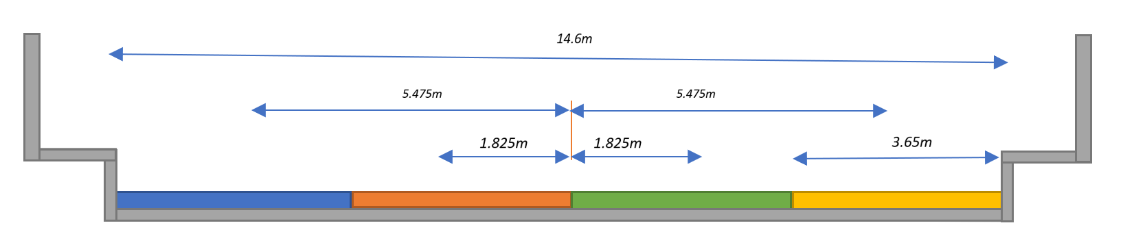
Figure 1: Pictorial representation of the breadth span of the reinforced concrete bridge deck [16]

3.1 Load Analysis
The AASHTO LRFD (2020) Specifications contain several live load components that are combined and scaled to generate design live loads. The components include: HL-93 load model was introduced in the AASHTO LRFD Bridge Design Specifications, which is a widely adopted design code for highway bridges in United States, and other similar countries worldwide [16].

(i) Highway Live Load (HA Load)
The HL-93 live load consists of three components:
Design Truck (HS20 Truck) = 284 kN Live Load [3.6.1.2] LRFD (2020)
Design Tandem (H20 Truck) = 142 kN
Design Lane Load = 9.6 kN/m
Design Lane Load acting on 3.65 m lane width = 3.65 m X 9.6 kN/m = 34.96 kN
Surface area of the deck = 3.65 m X 0.225 m = 0.73 m²
Live load acting on the bridge deck = $\frac{34.96 kN}{{0.73m}^{2}}$ = 47.89 kN/m²
These three components, the design truck, design tandem, and design lane load, are combined to create the HL-93 live load model
Taking into consideration: environmental loads, construction loads, and so on.
(ii) Dead Load
Unit weight of reinforced cement concrete = 25kN/m³
Unit weight of Asphalt = 22kN/m³
Load pattern definitions
Weight of bridge deck = 25kN/m³ x 0.200m = 5.0 kN/m²
Weight of asphalt = 22kN/m³ x 0.05m = 1.1 kN/m²
Pedestrians = 5kN/m²
Total sum of Dead load = 11.1 kN/m²
Taking into consideration: environmental loads, construction loads, and so on.
The Dead load will be approximated = 12kN/m²
The AASHTO LRFD Bridge Design Specification design load:
Design Load = 1.2D + 1.6L [3.4.1.1.2] AASHTO LRFD (2020)
Where:
D represents the dead load
L represents the live load
The load factors of 1.2 and 1.6 are specific to the AASHTO LRFD code and may vary in other LRFD design codes
Design Load = 1.2[12] + 1.6[47.89] = 14.4 + 76.624 = 91.024 kN/m²
Table 1: ABAQUS Material Properties Input Data Model
Material | Density (kg/m³) | Youngs Modulus (GPa) | Yield Stress (N/mm²) | Poisson | Strain
Concrete | 2400 | 40 | 30 | 0.2 | 0.0035
Steel | 7800 | 210 | 460 | 0.3 | 0.0022

3.2 Experimental Data for the Reinforced Concrete Bridge Modal Analysis
Some tests were carried out on five (5) typical simple-span bridges in Massachusetts, USA by Biggs and Suer, (1956). Results obtained from the tests includes Maximum observed amplitude of vibration and Damping coefficients for the evaluated bridges [17].

Table 2: Maximum Observed Amplitudes of Vibration [17]
Bridge | Natural Frequency | Truck Velocity (mph) | Max. Amplitude
Townsend-Main | 3.8 | 29.3 | 0.30
Gilbertville | 4.0 | 30.5 | 0.33
Townsend-South | 4.2 | 25.5 | 0.40
Ware | 5.2 | 17.9 | 0.18
Conway | 6.0 | 35.0 | 0.27

Table 3: Damping Coefficients [17]
Bridge | Type | Damping Coefficient (S)
Townsend-Main | Stringer | 0.020
Gilbertville | Girder | 0.007
Townsend-South | Girder | 0.007
Ware | Girder | 0.008
Conway | Stringer | 0.024

3.3 Monte Carlo Reliability Analysis of the Reinforced Concrete Bridge Deck
The reliability levels were calculated using the Monte Carlo reliability limit state equations (7-15) and the deterministic and statistical parameters of Table 4 as coded in PYTHON 2024 software [18].
Table 4: Parameters of the Stochastic Model for the Reinforced Concrete Bridge Deck
S/No | Design Variables | Unit | Distribution Type | COV. | E(xi) | S(xi)
1 | Compressive strength of concrete ($f_{cu}$) | $$N/{{mm}^{2}}$$ | Lognormal | 0.150 | 30 | 4.5
2 | Steel strength ($f_{yk}$) | $$N/{{mm}^{2}}$$ | Lognormal | 0.15 | 350 | 52.5
3 | Span (L) | $$mm$$ | Normal | 3.0 | 600000 | 30000
4 | Breadth (b) | $$mm$$ | Normal | 0.073 | 14600 | 730
5 | Depth (d) | $$mm$$ | Normal | 0.001 | 200 | 10
6 | Depth (d) | $$mm$$ | Normal | 0.001125 | 225 | 11.25
7 | Depth (d) | $$mm$$ | Normal | 0.00125 | 250 | 12.50

- RESULTS AND DISCUSSION
4.1 General

The bridge deck was analyzed using ANSYS CAE 2025 software with respect to properties of Townsend-South bridge as it has similar physical properties to the modelled bridge. A nonlinear analysis based on Finite Element methods was carried out in this work with respect to modal and natural frequencies. The varied bridge deck thicknesses of 200mm, 225mm, and 250mm were subjected to calculated design load of 91.024 kN/m². The Finite Element nonlinear analysis of the bridge decks follows a non-linear strain pattern and are also discussed below.
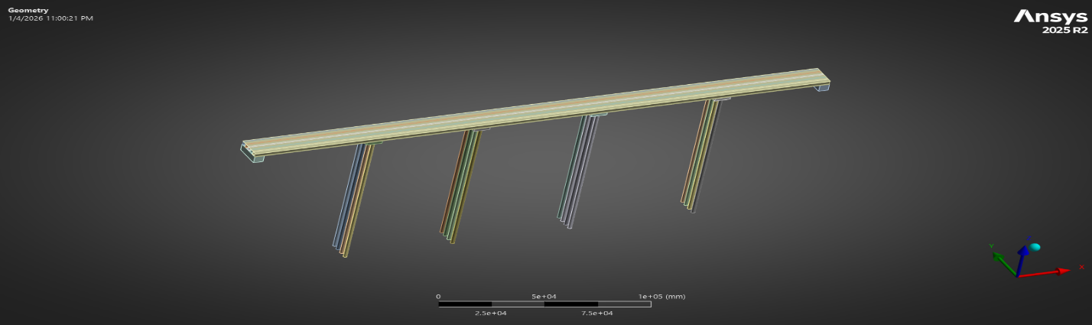
Figure 2: Modelled bridge deck with piers, beams, and abutments in ANSYS CAE 2025 R2

4.1.1 MODAL ANALYSIS IN ANSYS CAE 2025 SOFTWARE

Natural frequency and Modal Shape of the Reinforced Concrete bridge decks

The bridge decks under the specified Design loading suffered intrinsic stresses due to the mechanical properties of the concrete and steel materials and the boundary condition of the deck; the non-linear Finite Element modal analysis considering a nonlinear perturbation step perpendicular load, resulting in numerous mode shapes with different natural frequencies for each bridge deck. These results imply that the deck thickness serves as a damper to the applied loads on the bridge deck. This is simply because the increase in deck thickness brings about the reduction in intrinsic stresses in the bridge deck. The 200mm deck has the highest natural frequency of 5.6411Hz, while the 225mm deck and 250mm deck had natural frequency values of 3.6532Hz and 3.4235Hz respectively. These natural frequency values at the various bridge deck thicknesses are within the acceptable limits as it is greater than 2.5Hz (EN 1990, Clause 3.4.1(4)) [13]. The mode shapes assess the potential for yielding or failure, with natural frequency values representing the material's strength indicating a higher risk of deformation or structural compromise.
The Mode Shape obtained through Finite Element analysis were used to assess the structural integrity and failure prediction of the bridge deck under loading scenarios at different deck thicknesses. The natural frequencies at various points within the structure were estimated based on the applied loads and material properties of the deck.
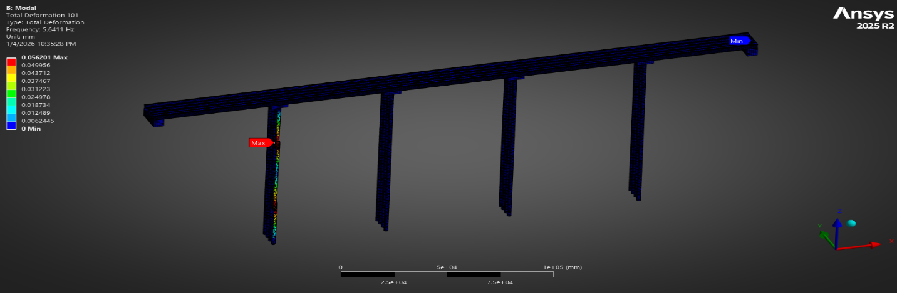
Figure 3: Modal Shape with the highest Natural Frequency of bridge deck at 200mm thickness
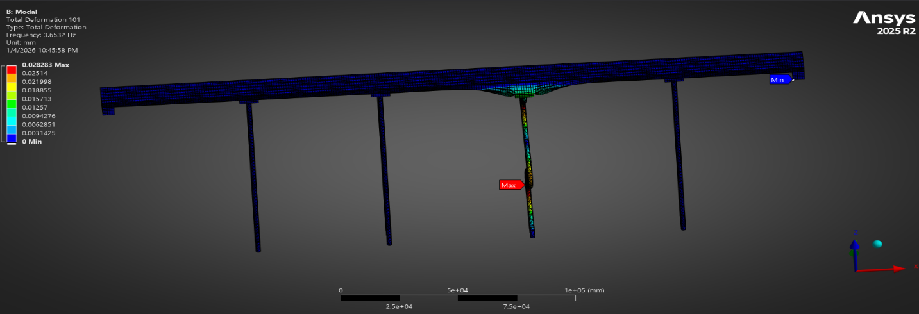
Figure 4: Modal Shape with the highest Natural Frequency of bridge deck at 225mm thickness
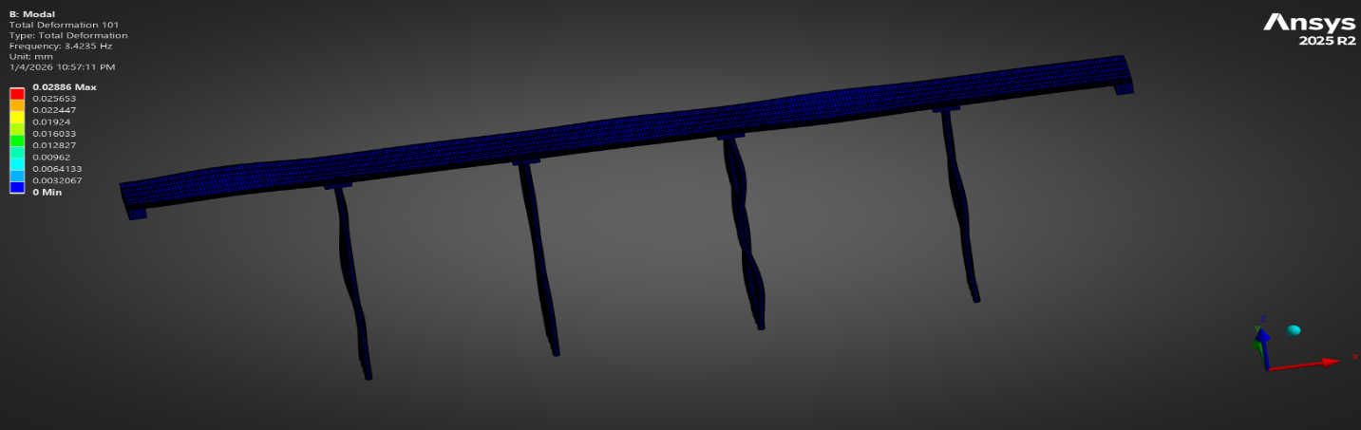
Figure 5: Modal Shape with the highest Natural Frequency of bridge deck at 250mm thickness
Below are the graphical representations of the natural frequencies of 100 mode shapes each of 200mm, 225mm, and 250mm bridge decks obtained from the ANSYS 2025 R2 software analysis. The natural frequencies derived from the bridge analysis indicates that an increase in deck thickness decreases the vibration of the bridge which in turn has a dominant effect in reducing the natural frequency of the bridge.
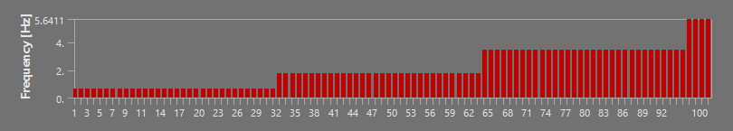
Figure 6: Plot of Mode shapes and corresponding natural frequencies for 200mm bridge deck thickness

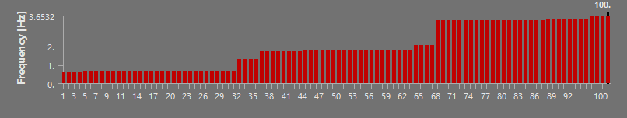
Figure 7: Plot of Mode shapes and corresponding natural frequencies for 225mm bridge deck thickness

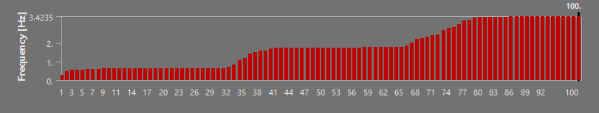
Figure 8: Plot of Mode shapes and corresponding natural frequencies for 250mm bridge deck thickness
- Eigenvalues of the Reinforced Concrete bridge decks
The transformation of the derived natural frequencies into eigenvalues [$λ= {\left(2πf_{n}\right)}^{2}$] provides critical insights into the spectral characteristics of the bridge decks across different thicknesses. The finite element nonlinear analysis reveals that the eigenvalues bandwidth expands as deck thickness decreases; specifically, the 200 mm deck exhibits markedly higher eigenvalues in the high-order modal regions compared to the 225 mm and 250 mm configurations. While the fundamental eigenvalues remain relatively consistent across all thicknesses in the lower-order modes (1–30), the 200 mm deck demonstrates significant upward eigenvalues shift in higher modes, suggesting that the reduction in modal mass for thinner sections outweighs the corresponding reduction in flexural stiffness within this regime. From a structural reliability perspective, these results indicate that thinner bridge decks may be susceptible to a broader range of high-frequency excitations, requiring precise modal tuning to mitigate resonance risks from transient traffic loads. In contrast, the 250 mm deck maintains a more stabilized and lower eigenvalues profile, indicating a more predictable dynamic performance and potentially higher structural reliability due to its reduced sensitivity to high-eigenvalues spectral components.
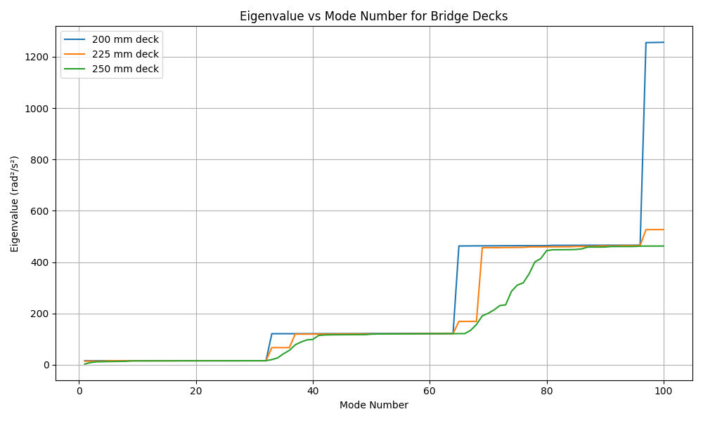
Figure 9: Modal analysis of the reinforced concrete bridge decks with respect to Eigenvalue

4.1.2 Monte Carlo’s Reliability Analysis of the Reinforced Concrete Bridge decks

The Monte Carlo’s reliability plot illustrates the variation of the structural reliability index ($β$) as a function of the deck’s dynamic characteristics, specifically highlighting the sensitivity of safety margins to changes in natural frequency and bridge deck thickness. The results indicate that as the deck thickness increases from 200 mm to 250 mm, the reliability maintains a more stable profile across the higher frequency bands, suggesting that the added mass and stiffness provide a more robust buffer against failure modes induced by dynamic loads. Conversely, the thinner 200 mm deck exhibits a sharper decline in $β$ within certain high-frequency regimes, reflecting an increased probability of failure $\left(P_{f}\right)$ where $P_{f}= Φ(-β)$. This behavior underscores a critical trade-off in bridge design: while thinner decks may offer material efficiency, they often result in a reduced reliability index when subjected to complex modal excitations.
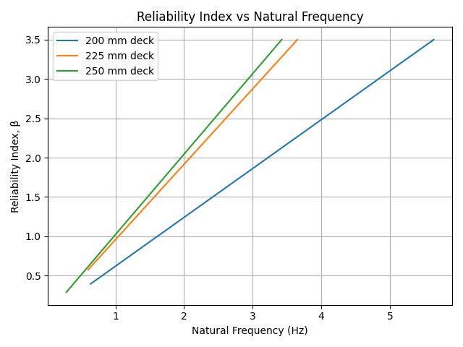
Figure 10: Structural reliability of the reinforced concrete bridge decks with respect to Natural Frequency

The plot illustrates the probabilistic assessment of the bridge deck’s structural integrity, complementing the deterministic eigenvalue analysis. The result reveals an inverse logarithmic relationship, where the probability of failure decreases significantly as the natural frequency increases, indicating that stiffer modal responses are associated with higher structural safety margins. Notably, the 200 mm deck maintains a consistently higher $P_{f}$ across the frequency spectrum compared to the thicker alternative, reaching a failure probability an order of magnitude higher (approximately 10⁻¹) at lower frequencies. In contrast, the 250 mm deck exhibits the most rapid decline in $P_{f}$, suggesting that the increased structural depth provides a more reliable performance against dynamic instability.
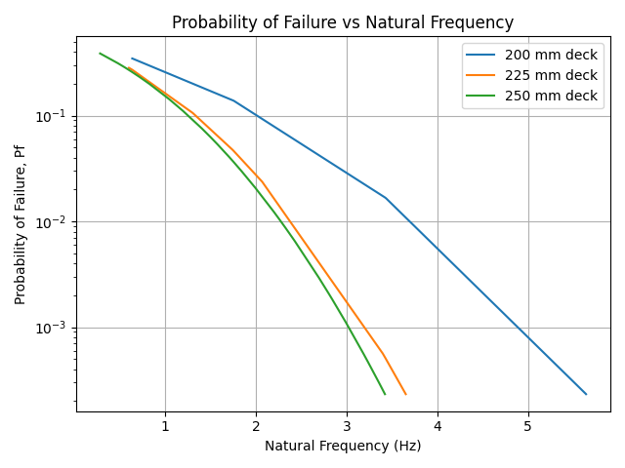
Figure 11: Structural probability of failure of the reinforced concrete bridge decks over time

5.0 CONCLUSIONS AND RECOMMENDATION

5.1 Conclusions
This study successfully evaluated the structural integrity of reinforced concrete bridge decks by integrating finite element-based eigenvalue analysis with Monte Carlo reliability assessments. The research findings lead to the following conclusions:
- The nonlinear finite element analysis accurately captured the modal properties (natural frequencies and mode shapes) of the bridge decks. The results confirm that shifts in these dynamic parameters serve as sensitive indicators of changes in the deck's physical properties, providing a non-destructive framework for structural health monitoring.
- The study demonstrated that deck thickness significantly influences dynamic performance. It was observed that the 200 mm deck exhibited the highest natural frequency (5.64 Hz), suggesting that reduced modal mass in thinner sections increases frequency response but also leads to higher sensitivity to high-frequency excitations. Conversely, the 250 mm deck maintained a more stable frequency profile, acting as a damper that reduces intrinsic stresses.
5.2 Recommendations
Based on the results of this research, the following recommendations are proposed for bridge design and maintenance:
- It is recommended that the standard thickness for reinforced concrete bridge decks be increased to at least 225 mm or 250 mm. This adjustment improves the structural safety margin by reducing the probability of failure and minimizing the impact of random vibrations during the service life.
- Engineers and infrastructure managers should adopt eigenvalue-based modal analysis as a primary tool for early damage detection. By tracking shifts in natural frequencies, potential structural compromises can be identified before visible cracks emerge, allowing for more cost-effective maintenance strategies.

COMPETING INTERESTS DISCLAIMER:
Authors have declared that they have no known competing financial interests OR non-financial interests OR personal relationships that could have appeared to influence the work reported in this paper.

REFERENCE
[1] Ibrahim, A., Abdelkhalek, S., Zayed, T., Qureshi, A. H., & Mohammed Abdelkader, E. (2024). A comprehensive review of the key deterioration factors of concrete bridge decks. Buildings, 14(11), 3425.

[2] Chen, Y., Tong, J., Li, Q., Xu, S., & Shen, L. (2024). Application of high-performance cementitious composites in steel-concrete composite bridge deck systems: a review. Journal of Intelligent Construction, 2(2), 1-23.

[3] Xu, B., Zhang, L., Zhang, W., Deng, Y., & Wong, T. N. (2024). Data-driven modal decomposition methods as feature detection techniques for flow fields in hydraulic machinery: a mini review. Journal of Marine Science and Engineering, 12(5), 813.

[4] Coviello, C. G., & Sabbà, M. F. (2025). A Comprehensive Experimental Study on the Dynamic Identification of Historical Three-Arch Masonry Bridges Using Operational Modal Analysis. Applied Sciences, 15(19), 10577.

[5] Mansour, S., Rizzo, F., Giannoccaro, N. I., La Scala, A., Sabbà, M. F., & Foti, D. (2024). Essential dynamic characterization of a historical bridge: integrated experimental and numerical investigations. Journal of Civil Structural Health Monitoring, 14(1), 85-102.

[6] Mostafaei, H. (2024). Modal Identification Techniques for Concrete Dams: A Comprehensive Review and Application. Sci, 6(3).

[7] Bianconi, F. (2023). Automated OMA and Damage Detection: an Opportunity for Smart SHM Systems.

[8] Elsisi, A., Zamrawi, A., & Emad, S. (2025). A Comprehensive Review of Structural Health Monitoring for Steel Bridges: Technologies, Data Analytics, and Future Directions. Applied Sciences, 15(22), 12090.

[9] Bozyigit, B., & Acikgoz, S. (2022). Determination of free vibration properties of masonry arch bridges using the dynamic stiffness method. Engineering Structures, 250, 113417.

[10] Ghaemifard, S., & Ghannadiasl, A. (2025). A Review of Moving-Load Dynamic Problems: Specialized Modeling for Beam and Plate Vibrancy. Journal of Vibration Engineering & Technologies, 13(5), 280.

[11] Cardoso, M. L., Alencar, G., & Santos da Silva, J. G. (2025). Analysis methodology for dynamic structural behaviour modelling of highway bridges based on Monte Carlo simulations (MCS) considering vehicle-pavement-bridge interaction. International Journal of Structural Integrity, 16(1), 187-213.

[12] Tirado Gutiérrez, R. J. (2025). Evaluation of structural reliability. Review of design methodologies and seismic performance evaluation of reinforced concrete structures (Doctoral dissertation, Universitat Politècnica de Catalunya).

[13] European Committee for Standardization. (2002). Eurocode: Basis of structural design (EN 1990:2002). CEN.
[14] American Association of State Highway and Transportation Officials. (2020). LRFD bridge design specifications (9th ed.). American Association of State Highway and Transportation Officials. ISBN 978-1-56051-738-2.

[15] ANSYS, Inc. (2025). ANSYS (Version 2025 R2) [Computer software]. https://www.ansys.com

[16] Abejide, K., Mohammed, J. K., Lawan, A., Aliyu, I., & Abejide, O. S. (2023). A Density Approach for Damage Identification on Reinforced Concrete Bridge Decks. Reliability Engineering and Resilience, 5(2), 1-20.

[17] Biggs, J. M., & Suer, H. S. (1956). Vibration Measurements on Simple-Span Bridges, Highway Res. Board Bull, 124.

[18] Python Software Foundation. (2025). Python (Version 3.14) [Computer software]. https://www.python.org

