Original Research Article

Calibration of Selected Industry-Standard Gas Viscosity Correlations for Niger Delta Gas System

.
ABSTRACT

Accurate prediction of natural gas physical properties such as gas viscosity is crucial for reliable reservoir engineering calculations, fluid flow calculations, and production and processing design. Gas viscosity is best determined through laboratory experiment, but studies have shown that the process is expensive, time-consuming and tedious. This has led to the development of many correlations. However, the widely accepted correlations developed from global datasets often fail to represent the unique behavior of the natural gas system from the Niger Delta Basin, while the ones developed using the dataset from the region did not explore the possibility of improving their accuracy through model calibration techniques. Thus, this study aimed to optimize some widely used viscosity correlations for Nigerian gas systems using model calibration techniques.
To achieve this, a nonlinear least squares fitting with scipy.optimize.curve_fit, a method in Python programming that uses the Levenberg-Marquardt algorithm, was used. 5,511 experimental PVT data points were obtained from Niger Delta gas fields and processed. The Carr-Kobayashi-Burrows (modified by Dempsey and Standing) and Lee-Gonzalez-Eakin correlations were selected and evaluated using Mean Absolute Error (MAE), Root Mean Squared Error (RMSE), and Coefficient of Determination (R²) as statistical metrics.
The result showed a better prediction performance through model calibration as the MAE and RMSE tend to 0.0 from 0.001014 and 0.001327, 0.001310 and 0.001315 for the Carr et al.-Dempsey-Standing and Lee-Gonzalez-Eakin correlations, respectively while the R² approximates to 1.0 from 0.877897 and 0.880114. Region-specific correlations such as the one proposed by Azubuike et al. with an R² of 0.58025 exhibited moderate accuracy but were outperformed by the calibrated models.
This study concludes that while global correlations provide a useful starting point, calibration using regional data significantly enhances their accuracy and reliability for the Niger Delta.

Keywords: Natural Gas, Gas Viscosity, Niger Delta, Correlation Calibration, Model Validation.

1. INTRODUCTION

Natural gas possesses physical properties whose knowledge must be gained to understand and predict the behavior of gas reservoirs and solve problems related to natural gas reservoir engineering. These properties include apparent molecular weight (Ma); specific gravity (γ_{g}), gas compressibility factor (z); gas density (ρ_{g}), specific gas volume (v); isothermal gas compressibility coefficient (c_{g}), gas formation volume factor (B_{g}), gas expansion factor (E_{g}) and viscosity (µ).
It is important to understand these properties in the study of reservoirs and the design of optimum production systems because their accurate prediction is central to the design, development, and optimization of petroleum reservoirs. The physical properties of interest in this study are the gas viscosity (μ_{g}), which is fundamental thermodynamic and transport property required for material balance calculations, gas flow in pipes, well analysis, reservoir simulation, and production forecasting [1].
Sampling and measuring the gas viscosity has many inherent difficulties. The industry standard method of measuring this property is through laboratory experiments; nevertheless, studies have shown that this experimental process is quite expensive and time-consuming [2, 3]. This approach has led to the development of numerous implicit and explicit correlations for z-factor and viscosity.
According to Ahmed [1], gas viscosity is described completely as a function of pressure, temperature, and gas composition as expressed in equation 1 and is not often measured in the laboratory because its precise value can be determined empirically. Londono et al. [4] expressed gas viscosity as a function of density, pressure, molecular weight, and temperature.

1

Standard industry correlations [5, 6, 7], among many others, have gained worldwide industry applicability in reservoir and production engineering for gas viscosity. However, these correlations were originally developed using data from distant regions that are geologically, geochemically, geographically, and thermodynamically different in characteristics compared to the Niger Delta region. Using these correlations without adjusting the parameters to match the properties of gas deposits in this region may introduce errors in the analysis of Nigerian gas reservoirs. Researchers such as Ohirhian and Abu [8], Anyiador et al. [9] and Azubuike et al. [10] have attempted to develop different empirical correlations that are more suited for Niger Delta gas reservoirs. Therefore, this study is carried out to calibrate and validate the industry-accepted standard correlations for gas viscosity using empirical PVT data from the Niger Delta, to improve the accuracy of the existing standard gas property prediction correlations and ensure their reliability in petroleum engineering decision making in Niger Delta Basin.
Carr et al. [5] developed the popularly known Carr-Kobayashi-Burrows correlation for estimating natural gas viscosity as a function of gas gravity, temperature, and pressure. This correlation used a two-step technique to estimate hydrocarbon gas viscosity. This includes the determination of the gas viscosity at atmospheric conditions and the adjustment of the estimated viscosity at atmospheric pressure to desired temperature and pressure conditions using a second correlation. They created a graphical correlation, which is a function of reduced pressures and temperatures from their experimental data. The gas viscosity can therefore be estimated using graphical correlations or using equations derived from these figures. Al-Nasser and Al-Marhoun [11] claimed that simplicity and corrections for the existence of non-hydrocarbon gases such as CO₂, N₂, and H₂S are the main advantages of the Carr-Kobayashi-Burrows correlation. The correlation is applicable to gases with a temperature range of 100 and 300°F and a specific gravity of 0.55 and 1.22. Dempsey [6] obtained his equation from the Carr-Kobayashi-Burrows correlation viscosity ratio chart.
Standing [12] developed expressions that account for the presence of H₂S, CO₂, and N₂ in natural gas at one atmospheric pressure. A combination of Standing's and Dempsey's equations makes the estimation of gas viscosity more convenient [11]. Jossi et al. [13] developed the Jossi-Stiel-Thodos gas viscosity correlation for pure gases such as methane, ethane, propane, butane, pentane, nitrogen, oxygen, carbon dioxide, sulfur dioxide, and argon. The Jossi-Stiel-Thodos correlation for gas viscosity is expressed as function of reduced density: Their correlation is applicable for values of reduced density below 2.0 and has an average absolute error of 4%.
Based on the Starling and Ellington equation, Lee et al. [7] developed the widely acceptable and simple semi-empirical equation for predicting natural gas viscosity known as the Lee-Gonzalez-Eakin correlation.
The Lee-Gonzalez-Eakin correlation has a standard deviation of 2.7% and a maximum deviation of 8.99%. Lee et al. [7] pointed out that the correlation is less accurate for gases with specific gravities greater than 1.0 and cannot be used for sour gases. In 1970, Gonzalez et al. [14] revised Lee et al. correlation for pressure ranges between 100 and 8000 psia and temperature ranges between 100 and 340°F, and it can be used in the presence of carbon dioxide for concentrations up to 3.2 mol%. Over practically wide ranges of temperature, pressure, and gas composition, ^{[4]} optimized some of the existing correlations (Jossi-Stiel-Thodos and Lee-Gonzalez-Eakin) and also presented new approaches for predicting viscosity and density of natural gas. They developed a large-scale database that meets the applicability of various models for gas viscosity and density. The optimized Jossi et al. and Lee et al. have average absolute errors of 4.43% and 2.29%, respectively, compared to the 5.26% and 3.34% obtained from their original form when used with their developed database. The new implicit gas viscosity correlation developed by Londono et al. has an average absolute error of 3.05% and works well for both pure gases and gas mixtures over a wide range of pressure, temperature, and molecular weight. Sutton [15] combined the Lucas equation with the Lee-Gonzalez-Eakin correlation to develop a new correlation for estimating gas viscosity as a function of P_{pr}, T_{pr}, P_{pc}, T_{pc}, and M_{a}. Using about 5881 data points, he recorded a standard deviation of 4.9 and an average absolute error of 4.2%.
While the accuracy of existing gas viscosity correlations was questioned due to the limited amount of data, Al-Nasser and Al-Marhoun [11] developed a new correlation that is applicable over a wide range of gas specific gravity (up to 1.55) with fewer coefficients. They claimed that the model is simple and more accurate than existing models. They also built a model using Artificial Neural Networks (ANN) in order to compare its results with those obtained from the new correlation. They predicted gas viscosity using the existing correlations (Carr et al.– Dempsey– Standing, Jossi-Stiel-Thodos, Dean and Stiel, Lee-Gonzalez-Eakin, and Sutton correlations) and pointed out most of these correlations gave high errors with the large dataset used for this study. They optimized these correlations using the linear and non-linear regressions to improve their accuracy. Despite this, their new correlation and ANN model outperform the improved existing correlations. Heidaryan and Jarrahian [16] optimized the K, X, and Y parameters of the Lee-Gonzelez-Eakin correlation through multiple regression analyses on temperature, density, and molecular weight. Yang et al. [17] derived a new model for gas viscosity based on the kinetic theory of gases as a function of temperature and density. To develop a model that is simple, fast, accurate, and directly applicable to CO₂-bearing gas samples, they optimized their model parameters using a large experimental database. In their study, they showed that the gas viscosity increases with the increase of density as well as the increase of temperature in the low-density region and that gas viscosity increases with the decrease of temperature in the high-density region.

1.1 Limitations of Existing Correlations in the Niger Delta Context
Despite being reported as accurate and reliable on a global scale, the applicability of these correlations has been found to be less accurate to the Niger Delta gas reservoirs. These inaccuracies can be a result of variation in data quality and quantity used in the development of the model, different geological settings, gas composition, and pressure-temperature conditions.
1.2 Studies on Gas Viscosity Correlation for the Niger Delta Region
According to Ohirhian and Abu [8], the Carr-Kobayashi-Burrows correlation gave, on average, an absolute error that ranged from 0.00 to 10.68% for Nigeria's natural gas system, while the Lee-Gonzalez-Eakin correlation even gave higher absolute errors. Based on this claim, they developed a new equation for estimating the viscosity of Nigerian natural gas under reservoir conditions of 144–4100 psia and 130–220°F. Using experimental PVT data of associated gas reservoirs sourced from renowned oil and gas companies in Nigeria, their developed correlation for gas viscosity gave an average absolute error of 1.55%, a maximum absolute error of 4.878%, and a standard deviation of 1.29. To also test for universal applicability of the developed correlation, the developed correlation was used to solve two problems for which solutions by the Carr-Kobayashi-Burrows correlation were available in textbooks and calculated equal values [18, 19]. Anyiador et al. [9] evaluated gas viscosity correlations for the Niger Delta gas reservoirs. The following correlations: Dempsey, 1965; Lee et al., 1966; Londono et al., 2002; and Ohirhian and Abu, 2009, were evaluated using statistical analysis, the Multiple Statistical Optimization Model (MULSON), and performance plots of 319 experimental PVT data obtained from Niger Delta gas reservoirs. Dempsey's correlation was ranked best with the numerical value of 0.705 and the best performance plot. They reported that their work is valid for a data range of 1.4 ≥ Tr ≥ 1.90 and 0.2 ≥ Pr ≥ 10.08, and based on the analyzed Dempsey correlation for the Niger Delta region, they developed charts of viscosity against pseudo-reduced pressure and temperature as well as viscosity ratio versus pseudo-reduced pressure and temperature.
Azubuike et al. [20] researched the applicability of existing gas viscosity correlations for high-pressure and high-temperature (HPHT) gas reservoirs. To justify their claim that existing correlation models were derived using experimental data at low to moderate pressure and temperatures and that using the extrapolation approach is not reliable, they presented a comparative study of some existing gas viscosity correlations (Dempsey, 1965; Lee et al., 1966; and Ohirhian and Abu, 2009) against gas viscosity at 6000–14000 psia and 270–370°F experimentally determined in the laboratory using a capillary electromagnetic viscometer. Their research showed that ^{[8]} outperform other evaluated correlations for the temperature of 270°F with the relative mean error of -5.22 and absolute mean error of 8.752, while ^{[6]} predicts gas viscosity better for 370°F with a relative mean error of -16.88 and absolute mean error of 16.88. They concluded that the comparative study proved that the existing gas viscosity correlations commonly used in the industry are not very reliable at HPHT conditions and that the oil and gas industry needed new gas viscosity correlations that can predict gas viscosity in the HPHT region better. Azubuike et al. [10], at HPHT conditions (above 10,000 psia and 300°F), developed a comprehensive model that predicts the viscosity of natural gas using Microsoft Excel Solver as the development tool. They obtained 154 data sets from the Niger Delta region of Nigeria and carried out quantitative and qualitative assessments to evaluate the degree of accuracy of the developed model to the experimental data relative to existing empirical correlations. They reported that, using the same data, the developed gas viscosity correlation outperformed other selected existing correlations and gave an average mean error of 3.4443, a coefficient of correlation of 0.9556, and a rank of 2.004. Their developed correlation depends on temperature (°R), pressure (psia), and gas density (lb/ft³), and it is applicable to 1.8 ≤ Tr ≤ 3.0 and 10 ≤ Pr ≤ 20.
Azubuike and Ikiensikimama [21] acted on the reports of many scholars that intelligent predictive models like Artificial Neural Network (ANN) and Adaptive Neuro-fuzzy System (ANFIS) give better accuracy compared to empirical models. They developed a model that predicts gas viscosity at HPHT conditions (above 10,000 psia and 300°F) using an artificial neural network (MATLAB ANN tool) on 154 laboratory-measured data from the Niger Delta. They divided the data into training, validation, and testing datasets in a 3:1:1 ratio and assessed the accuracy of the new model compared to the existing empirical correlations. The ANN gas viscosity model outperformed other models, having a correlation coefficient (R) of 0.995, a mean absolute error of 4.3416, and a rank of 2.4639. Fortune and Mbachu [22] developed a natural gas viscosity prediction model using support vector machines (SVMs). The MATLAB SVMs module was employed in building the model using 332 data sets from the Niger Delta region of Nigeria. Quantitative and qualitative assessments were employed to evaluate the accuracy of the model for both artificial neural networks (ANNs) and some of the existing empirical correlations. The new SVM gas viscosity model gave an excellent prediction when compared to other natural gas viscosity models, with a mean relative error of 1.0937 and a rank of 1.0934. It also gave the best forecast over the artificial neural network model, which has a mean relative error of 2.6126 and a rank of 1.0937.

2. material and methods

2.1 Selection of industry-standard correlation
Carr-Kobayashi-Burrows correlation (modified by Dempsey and Standing) and Lee, Gonzalez, and Eakin correlation were selected for evaluation based on their sound theoretical basis and recommendations from research works reviewed in the study area.
2.2 Data Acquisition and Processing
The datasets used in this study comprise gas reservoir parameters (5,511 data points) experimentally obtained from fields in the Niger Delta basin. The datasets were subjected to data cleaning, preprocessing, feature engineering, and feature selection before applying to evaluate the original correlations and optimized. Table 1 shows the descriptive statistics of the processed dataset for gas viscosity and Figures 1 and 2 visualize the relationships existing in the datasets. The dataset was then divided into training and testing dataset in ratio of 80/20. Python programs were written for each correlation to compute the gas viscosity.

Table 1: Descriptive Statistics for Gas Viscosity Dataset
Variable | Count | Mean | Std | min | 25% | 50% | 75% | Max
Temp (°R) | 5511 | 639 | 13.28 | 618 | 626.40 | 639 | 651.60 | 660.0
Pressure (psia) | 5511 | 2264.7 | 1012.47 | 514.7 | 1389.7 | 2264.7 | 3139.7 | 4014.7
Tpr | 5511 | 1.6877 | 0.0351 | 1.632 | 1.6544 | 1.6876 | 1.7209 | 1.7431
Ppr | 5511 | 3.4266 | 1.5319 | 0.778 | 2.1027 | 3.427 | 4.7505 | 6.0745
Z-Factor | 5511 | 0.8424 | 0.0375 | 0.775 | 0.8145 | 0.836 | 0.8683 | 0.9417
Gas Viscosity | 5511 | 0.0179 | 0.0038 | 0.012 | 0.0144 | 0.0175 | 0.0212 | 0.0257
Gas Density | 5511 | 8.4648 | 3.7516 | 1.657 | 5.1668 | 8.797 | 11.840 | 14.8700
Mol. Wt | 5511 | 19.3160 | 1.073e-12 | 19.316 | 19.316 | 19.316 | 19.316 | 19.3163
Atm. Viscosity | 5511 | 0.0118 | 1.958e-04 | 0.012 | 0.0116 | 0.0118 | 0.0120 | 0.0121

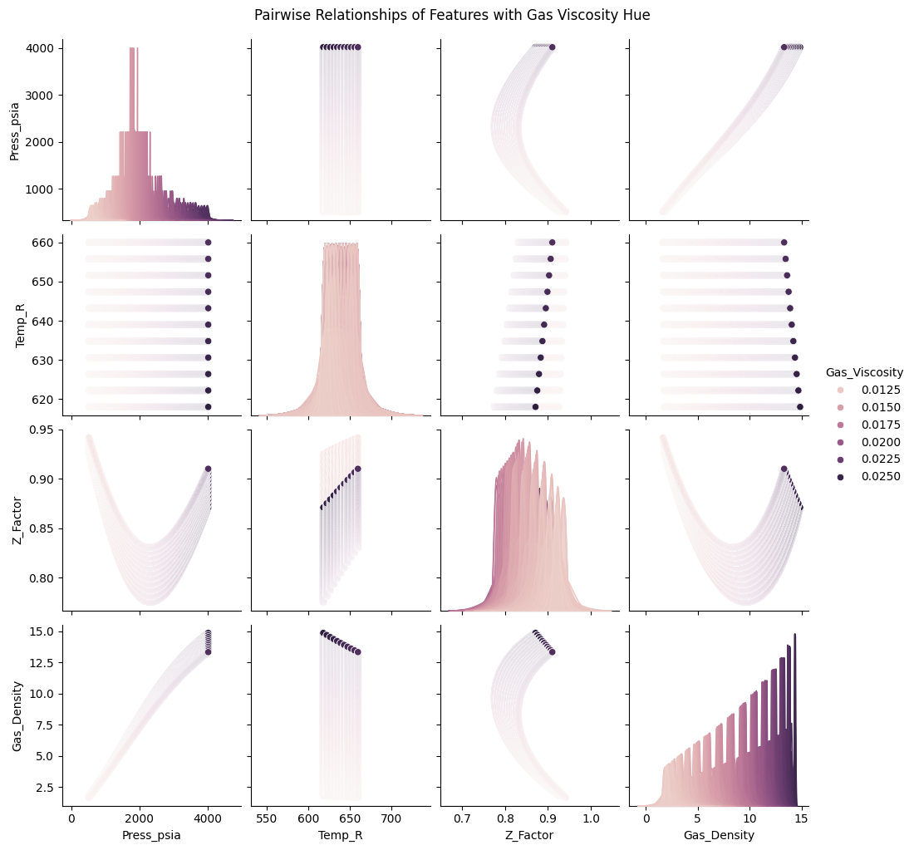
Figure 1: Pairwise Relationship of Features for Gas Viscosity Dataset
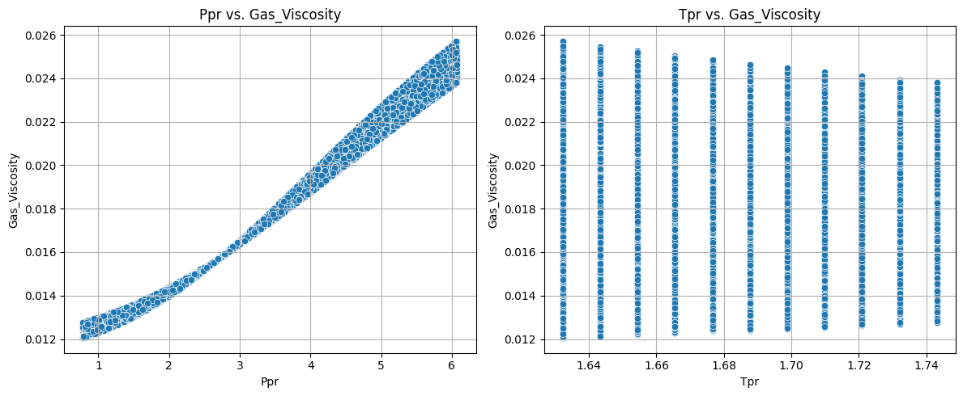
Figure 2: Cross-plot Relationship Between Ppr, Tpr, and Gas Viscosity

2.3 Model Calibration: Curve Fitting (Regression-Based Calibration)
The collected field data from the study area were fitted into the selected existing correlation equations using nonlinear regression analysis. To achieve this, a function used for nonlinear least squares fitting called “curve_fit” inside the scipy library submodule “scipy.optimize,” used for model optimization, will be used to optimize model parameters.
Curve_fit uses a non-linear least squares approach to internally fit a model to a given dataset. It does so by minimizing the least square error between the predicted model value and observed field data, and it is very effective for models whose output depends on several parameters.
2.4 Model Performance Metric Evaluation
To validate and quantify the accuracy of the calibrated correlation equations, the following statistical metrics were used:

2.4.1 Mean Absolute Error (MAE)
It measures the mean value of the differences in predictions without paying attention to their direction. For a better statistical model, it is required to have as minimal MAE as possible (close to zero is preferred).

2
Where $y_{i}=$ $the true value$; $ӯ=the predicted value$

2.4.2 Root Mean Squared Error (RMSE)
It tells how concentrated the data is around the line of best fit. It is very sensitive to large errors and good to use if the dataset has a lot of outliers. The lower the RMSE (i.e., close to zero), the better the prediction.

3

2.4.3 Coefficient of determination, ${(R}^{2}$ score)
This tells how well the data fits the model (the goodness of fit). It ranges between values of zero and one. The value of 1 represents perfect prediction, while 0 implies that the model does no better than the mean. An R² value less than 0 implies worse than the mean.
Mathematically, the coefficient of determination can be found using:

4
$SS_{regression}$is the sum of squares due to regression i.e.
$SS_{total}$is the total sum of squares i.e.
$f_{i} is$the mean of the predicted value(s).

The evaluation procedure compared the performance of unmodified industry-standard correlations, calibrated correlation equations for the region, and the developed machine learning models.
3. results and discussion

The performance metric summary obtained for selected correlations are shown in Table 2. The Carr et al.-Dempsey-Standing correlation has the high coefficient of determination (R² = 0.877897) with low mean absolute error (MAE) of 0.001014 and root mean square error (RMSE) of 0.001327. The Lee-Gonzalez-Eakin also shows a high R² of 0.880114, an RMSE of 0.001315 and an MAE of 0.00131. This implies relatively good predicting power.

Table 2 Performance Metrics for Selected the Gas Viscosity Correlations
Correlation | MAE | RMSE | R²
Carr et al.-Dempsey-Standing | 0.001014 | 0.001327 | 0.877897
Lee-Gonzalez-Eakin | 0.001310 | 0.001315 | 0.880114

Figures 3 (a-b) showed the actual versus predicted gas viscosity for the evaluated model. The plots showed that there is deviation between the actual and the predicted values.

(a) (b)
Figure 3(a-b): Actual Versus Predicted Gas Viscosity
(a) Carr et al.-Dempsey-Standing Correlation (b) Lee-Gonzalez-Eakin Correlation

3.1 Calibrated Gas Viscosity Correlations
Table 3 showed the performance metrics for the calibrated and validated model. The table showed that the prediction accuracy of the correlations was greatly increased. The calibrated and validated models demonstrated significant improvement in accuracy compared to their original forms (Table 3), outlining the performance metrics for the optimized Carr et al.-Dempsey-Standing and Lee-Gonzalez-Eakin correlations. Replacing the coefficients in each correlation by the values obtained through the calibration and validation process (i.e. model optimization process), the coefficients a₀ to a₁₅ in equation 5 below given by Dempsey [6]
$In\left[T_{pr}\left(\frac{μ_{g}}{μ_{1}}\right)\right]=a_{0}+a_{1}P_{pr}+a_{2}P_{pr}^{2}+a_{3}P_{pr}^{3}+T_{pr}(a_{4}+a_{5}P_{pr}+a_{6}P_{pr}^{2}+a_{7}P_{pr}^{3}+T_{pr}^{2}\left(a_{8}+a_{9}P_{pr}+a_{10}P_{pr}^{2}+a_{11}P_{pr}^{3}\right)+{T_{pr}^{3}(a}_{12}+a_{13}P_{pr}+a_{14}P_{pr}^{2}+a_{15}P_{pr}^{2})$ 5

where T_{pr} = pseudo-reduced temperature of the gas mixture, °R
Ppr = pseudo-reduced pressure of the gas mixture, psia
$a_{0} to a_{15}$ = coefficients of the equations

can be replaced with the following values to obtain a more accurate prediction for gas viscosity:

a₀ = 91.4775917777; a₁ = -107.4217748829; a₂ = 35.5431074981;
a₃ = -3.3342750901; a₄ = -163.6733863001; a₅ = 191.0335685249;
a₆ = -62.4996387484; a₇ = 5.8410089218; a₈ = 97.6547235155;
a₉ = -113.1129624657; a₁₀ = 36.7059840310; a₁₁ = -3.4190284761;
a₁₂ = -19.3223868796; a₁₃ = 22.3090355383; a₁₄ = -7.1937758482;
a₁₅ = 0.6681258658.

Table 3: Performance Metrics for the Calibrated and Validated Gas Viscosity Correlations
Correlation | MAE | RMSE | R²
Optimized Carr et al.-Dempsey-Standing (Training) | 0.0000250000 | 0.0000290000 | 0.9999400000
Optimized Carr et al.-Dempsey-Standing (Validation) | 0.0000250000 | 0.0000290000 | 0.9999390000
Optimized Lee-Gonzalez-Eakin (Training) | 0.0000006100 | 0.0000007500 | 0.9999999600
Optimized Lee-Gonzalez-Eakin (Validation) | 0.0000006124 | 0.0000007501 | 0.9999999606

Similarly, the numerical constants K, X and Y expressed in equation 6 by Lee-Gonzalez-Eakin [7] can be replaced with the optimized values (equations 7, 8 and 9) as follows:

$μ_{g}={10}^{-4}K exp\left[X{\left(\frac{ρ_{g}}{62.4}\right)}^{Y}\right]$ 6

where $K=\frac{(9.4+0.02M_{a})T^{1.5}}{209+19M_{a}+T}$, $X=3.5+\frac{986}{T}+0.01M_{a}$, $Y=2.4-0.2X$
$ρ_{g}$= gas density at reservoir pressure and temperature, lb/ft³; T = reservoir temperature, °R
M_{a} = apparent molecular weight of the gas mixture, lb/lb-mole

$K=\frac{(9.05459 + 0.000314M_{a})T^{1.513196}}{273.41738+22.24694M_{a}+T}$ 7
$X=3.583696+\frac{959.33534}{T}+0.015478M_{a}$ 8
$Y=2.54243-0.223175X$ 9

3.2 Performance of Region-Based Correlations
The Azubuike et al. [11] correlation developed for gas viscosity using a dataset from the Niger Delta basin was evaluated against the experimental dataset and compared with the performance of selected industry-standard correlations and their optimized versions (Figure 4).
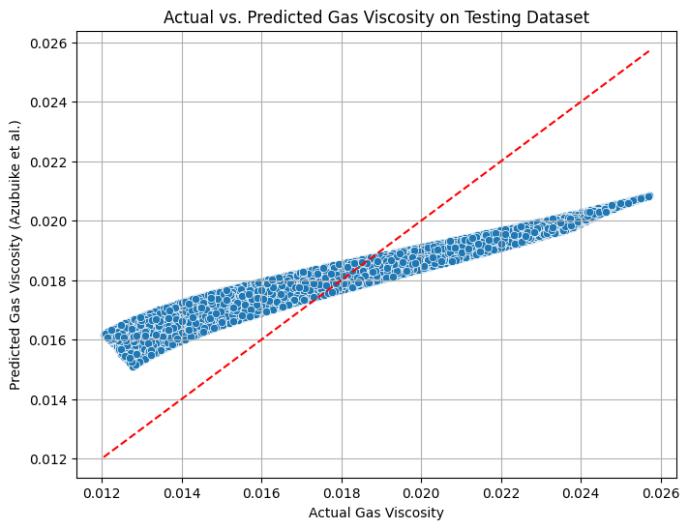
Figure 4: Actual Versus Predicted Gas Viscosity for Azubuike et al. ^{[10]}
The Azubuike et al. correlation gave a relatively fair but less acceptable accuracy with coefficients of determination of 58.025%, mean absolute error of 0.246%, and root mean squared error of 0.216%. The original and optimized Carr et al.-Dempsey-Standing and Lee-Gonzalez-Eakin correlations outperformed the Azubuike et al. correlation.
Figures 5(a-c) visualize the quick comparison of the original and optimized selected industry standard gas viscosity correlations and the region-specific correlation.

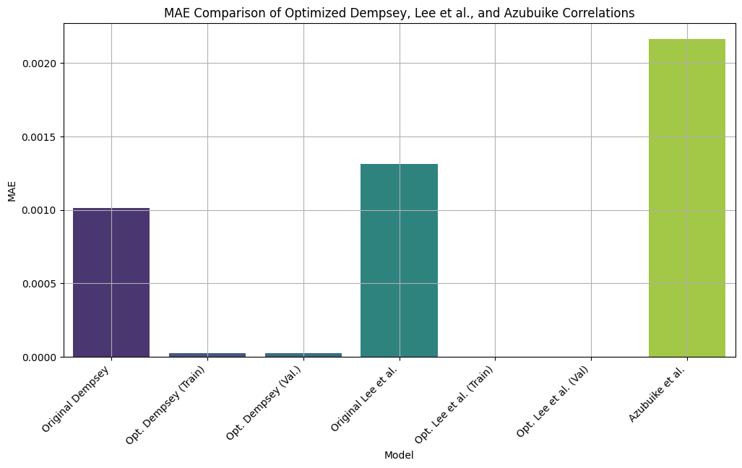
Figure 5a: MAE Comparison of the Original and Optimized Model and Azubuike Correlation
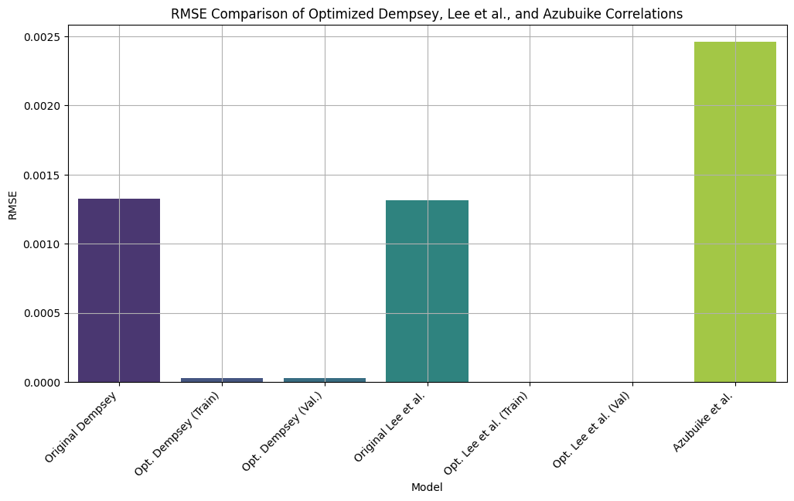
Figure 5b: RMSE Comparison of the Original and Optimized Model and Azubuike Correlation

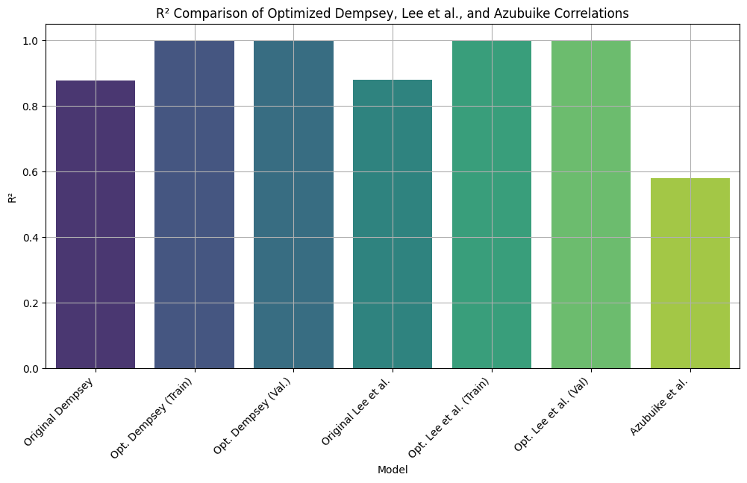
Figure 5c: R² Comparison of the Original and Optimized Model and Azubuike Correlation

The results obtained from the evaluation of industry-standard correlations for predicting gas viscosity using Niger Delta gas field PVT data vividly showed regional deviations from the known global models. The considered correlations (Lee–Gonzalez–Eakin and Carr et al.–Dempsey–Standing) performed practically well, with coefficient of determination values above 0.87 and lower mean absolute error and root mean squared error (Figures 6a-c). This depicts that the coefficients of the parameters used in these models are good representatives globally but still give room for optimization to suit regional gas compositions.
The viscosity model developed in this study, was greatly improved through the calibration and validation process. The gas viscosity correlations attain near-perfect accuracies, with the coefficient of determination $R^{2}≈0.9999$ and very low RMSE and MAE values depicting the effectiveness of parameter recalibration or optimization in improving the predictive reliability of the model.
In comparison, the region-specific correlations developed by Azubuike et al. [10] was outperformed by the original and modified selected correlations. This highlights that while region-specific models have relevance, their predictive strength may depend on the representativeness and quantity of the dataset used in their development.

4. Conclusion

This research work successfully calibrated and validated globally accepted industry-standard correlations for predicting natural gas viscosity using Niger Delta field PVT data. The results showed that:
- The performance of the selected industry standard correlations gave relatively high errors which make their suitability for predicting gas property in the Niger Delta basin limited without modification.
- Optimized gas viscosity correlations achieved near-perfect accuracy with zero error.
- Although Azubuike et al. [10] correlation gave moderate predictions, the modified and originally selected correlations outperformed it. This implies that the region-based models still require model refinement.

AcknowledgEments

The authors gratefully acknowledge and appreciate Department of Petroleum Engineering, University of Ibadan, Ibadan, Nigeria for the facilities made available during the course of this work

References

1. Ahmed, T. (2001). Reservoir engineering handbook (2nd Edition). London, Gulf Professional Publishing. pp.29-74.
2. Okoro, E. E., Dike, H., Igwilo, K. C., & Mamudu, A. O. (2017). Measurement of the Best Z-Factor Correlation Using Gas Well Inflow Performance Data in Niger-Delta. International Journal of Applied Engineering Research, 12(12), 3507–3522.
3. Ekechukwu, G. K., & Orodu, O. D. (2019). Novel mathematical correlation for accurate prediction of gas compressibility factor. Natural Gas Industry B, 6(6), 629–638.
4. Londono, F. E., Archer, R. A., & Blassingame, T.A., (2002). Simplified Correlations for hydrocarbon Gas Viscosity and Gas Density-validation and correlation of Behaviour using a large-scale Database. SPE 75721, Calgary, Canada.
5. Carr, N. L., Kobayashi, R., & Burrows, D. B. (1954). Viscosity of hydrocarbon gases under pressure. Journal of Petroleum Technology, 6, 47–55.
6. Dempsey, J. R. (1965). Computer routine treats gas viscosity as a variable. Oil and Gas Journal, 141.
7. Lee, A. L., Gonzalez, M. H., & Eakin, B. E. (1966). The viscosity of natural gases. Journal of Petroleum Technology, 18(8), 997–1000.
8. Ohirhian, P. U., & Abu, I. N. (2008). A new correlation for the viscosity of natural gas. Advanced Materials Research, 62(64), 474-483.
9. Anyiador, O. M., Ikiensikimama, S. S., & Azubuike, I. I. (2015). Evaluation of viscosity correlation for Niger Delta gas reservoir. International Journal of Science and Engineering Investigations, 4(46). ISSN: 2251-8843.
10. Azubuike, I. I., Ikiensikimama, S. S., & Orodu, O. D. (2019). Predictive tool for high pressure high temperature gas viscosity. American Journal of Engineering Research (AJER), 8(3), 177-187.
11. Al-Nasser, K. S., & Al-Marhoun, M. A. (2012). Development of New Gas Viscosity Correlations. SPE International Production and Operations Conference and Exhibition Held in Doha Qatar, 14–16 May 2012, 1(SPE 153239). https://doi.org/10.2118/153239-MS
12. Standing, M. B. (1977). Volumetric and phase behavior of oil field hydrocarbon system (pp. 125-126). SPE.
13. Jossi, J. A., Stiel, L. I., & Thodos, G. (1962). The viscosity of pure substances in the dense gaseous and liquid phases. AIChE Journal, 8(1), 59–62.
14. Gonzalez, M. H., Eakin, B. E., & Lee, A. L. (1970). Viscosity of natural gases. API Monograph on API Research Project 65.
15. Sutton, R. P. (2005). Fundamental PVT Calculations for associated and gas/condensate natural gas system. Paper SPE 97099, presented at the SPE Annual Technical Conference and Exhibition, Dallas, Texas.
16. Heidaryan, E., and Jarrahian, A. (2012). Natural gas viscosity estimation using density based models. The Canadian Journal of Chemical Engineering, 91(6), 1183–1189. https://doi.org/10.1002/cjce.21715
17. Yang, X. H., Zhang, S., & Zhu, W. (2017). A new model for the accurate calculation of natural gas viscosity. Natural Gas Industry B.
18. Katz, D. L. (1959). Handbook of natural gas engineering. McGraw-Hill.
19. Ikoku, C. U. (1992). Natural gas production engineering. Krieger Publishing Company. pp 24-65.
20. Azubuike, I. I., Ikiensikimama, S. S., & Orodu, O. D. (2016). Gas viscosity measurement and evaluation for high pressure and high temperature gas reservoir. International Journal of Science and Engineering Investigation, 5(54), July. ISSN: 2251-8843.
21. Azubuike, I. I., & Ikiensikimama, S. S. (2020). Modeling gas viscosity of high-pressure high temperature conditions using artificial neural network. American Journal of Engineering Research, 9(5), 1–9.
22. Fortune A.A & Mbachu I.I., (2022). Modeling Natural Gas Viscosity for Niger Delta Region Using Support Vector Machine (SVM) Algorithm. International Journal of Research in Engineering and Science, 10(3), 51-61

