Original Research Article
Field-Based Assessment of Passive Cooling Strategies for Photovoltaic Modules in Tropical Climates

Abstract
Photovoltaic (PV) modules operating in tropical regions are routinely exposed to high solar irradiance and elevated ambient temperatures, which can significantly reduce electrical efficiency and accelerate material degradation. Although a wide range of laboratory-scale studies have demonstrated the potential of passive cooling techniques, their effectiveness under real outdoor operating conditions remains less clearly understood. In this work, a field-oriented case study is presented to evaluate the real-world performance of passive cooling strategies applied to a monocrystalline photovoltaic module operating in a tropical climate. Three passive cooling configurations phase change material (PCM) cooling, fin-based cooling, and a hybrid PCM–fin system were examined under naturally varying outdoor conditions representative of practical field installations. Rather than conducting new experiments, previously reported outdoor measurement data were re-analysed using derived thermal and electrical performance indicators, including temperature reduction, normalized efficiency gain, and time-integrated electrical energy output. The results indicate that fin-based cooling offers the most consistent and robust thermal mitigation under field conditions, achieving a peak temperature reduction of approximately 10 °C and the highest efficiency improvement per degree of cooling. PCM-based cooling provides moderate performance, while the hybrid configuration shows limited effectiveness, primarily due to restricted convective heat transfer associated with the low thermal conductivity of the PCM layer. A scenario-based seasonal interpretation further reveals that the relative performance of passive cooling techniques is strongly influenced by ambient temperature ranges and natural convection conditions typical of tropical environments. Practical deployment aspects, such as installation complexity, maintenance considerations, and long-term reliability, are also discussed to support real-world applicability. Overall, the findings offer field-relevant insights and practical design guidance for selecting passive cooling solutions for photovoltaic systems deployed in warm and humid climates.
Keywords Photovoltaic cooling; Passive thermal management; Field performance evaluation; Tropical climate; Phase change material; Fin-based cooling; Case study; Solar energy systems; Real-world operation
1. Introduction
Photovoltaic (PV) technologies play a central role in global decarbonization strategies; however, their operational performance is strongly influenced by environmental conditions (Peters, 2025; Lew et al., 2021). In tropical and subtropical regions, PV modules are routinely exposed to high levels of solar irradiance combined with elevated ambient temperatures, leading to increased cell operating temperatures. This temperature rise adversely affects electrical efficiency, accelerates material degradation, and reduces the long-term reliability of PV systems (Fouad et al., 2017; Royne et al., 2005). As the deployment of solar installations continues to expand in warm and humid climates, effective thermal management of PV modules under real-world operating conditions has become a critical engineering challenge. A substantial body of literature has investigated thermal regulation of PV modules using both active and passive cooling techniques. Active cooling approaches, such as forced air or liquid circulation, can achieve significant temperature reduction but are often associated with increased system complexity, higher capital costs, parasitic power consumption, and elevated maintenance requirements (Bahaidarah et al., 2013; Rehman et al., 2007). Consequently, passive cooling strategies particularly those based on natural convection enhancement and latent heat storage have attracted considerable attention as cost-effective and energy-efficient alternatives (Ali, 2020; Sharaf et al., 2022). Among passive approaches, fin-based heat dissipation and phase change material (PCM) integration are widely studied due to their structural simplicity and potential for retrofitting existing PV installations. Fin-based cooling enhances heat transfer by increasing the effective surface area available for natural convection and radiation, with several studies demonstrating measurable reductions in module temperature and corresponding efficiency gains under experimental conditions (Jobair, 2017; Bayrak et al., 2019). PCM-based cooling, on the other hand, exploits latent heat absorption during phase transition to buffer temperature rise during peak thermal loading, with reported benefits dependent on PCM properties and operating temperature ranges (Hasan et al., 2014; Singh et al., 2020; Wongwuttanasatian et al., 2020). Despite the extensive number of experimental investigations reported in the literature, a large proportion of prior studies have been conducted under controlled laboratory environments or short-duration test setups (Bayrak et al., 2020; Dwivedi et al., 2020). Such conditions do not fully capture the variability inherent in outdoor operation, where fluctuating solar irradiance, ambient temperature, wind-induced convection, and humidity can significantly influence the thermal behaviour and effectiveness of passive cooling systems. As a result, the direct translation of laboratory-scale findings to field-deployed PV installations remains uncertain, highlighting a persistent gap between experimental research and practical implementation (Bahaidarah et al., 2016; Bonah et al., 2021). In this context, field-oriented analyses and case studies play an important role in bridging the divide between controlled experimentation and real-world deployment. Rather than focusing solely on peak or instantaneous performance metrics, field-based evaluations emphasize robustness, consistency, and sustained effectiveness under naturally varying environmental conditions. Such analyses are particularly valuable for tropical regions, where climatic conditions differ markedly from standardized testing environments and where passive cooling solutions must operate reliably without active control or auxiliary power input. The present work addresses this gap by providing a field-focused case study on the performance of passive cooling techniques applied to a monocrystalline PV module operating under tropical outdoor conditions. Three passive cooling configurations PCM-based cooling, fin-based cooling, and a hybrid PCM–fin arrangement are evaluated from an applied engineering perspective. The analysis emphasizes derived performance metrics, including mean and peak temperature reduction, normalized efficiency gain, and time-integrated electrical energy output, with the objective of extracting insights directly relevant to real-world system design and deployment. This study presents a field-oriented re-analysis of an outdoor experimental dataset previously published by the authors (Aswin et al., 2025), focusing on real-world performance interpretation rather than experimental novelty. By reframing existing measurements within a field-performance context, the work aims to provide practical guidance on the suitability, limitations, and deployment potential of passive cooling strategies for photovoltaic installations in tropical climates.
2. Case Study Description and Field Conditions
The present work is structured as a field-oriented case study carried out under naturally varying outdoor conditions representative of photovoltaic installations in tropical regions. Measurements were performed in an open outdoor environment located in a warm and humid climatic zone, characterized by high solar irradiance and elevated ambient temperatures typical of tropical latitudes. The installation site was free from shading and nearby obstructions, ensuring uninterrupted exposure to natural solar radiation throughout the measurement period. In contrast to laboratory-based investigations conducted under controlled thermal and environmental conditions, the photovoltaic module in this study was exposed to uncontrolled ambient influences, including fluctuating solar irradiance, natural wind-driven convection, and variations in ambient air temperature. These operating conditions closely resemble those encountered by rooftop and ground-mounted photovoltaic systems in practical deployments, enabling assessment of passive cooling performance under realistic field scenarios rather than idealized test environments. A commercially available monocrystalline photovoltaic module with a nominal power rating of 50 W and a rated operating voltage of 12 V was used in the case study. The module was mounted on an adjustable support structure that allowed appropriate tilt alignment to maximize solar exposure during the measurement window. Passive cooling configurations were applied to the rear surface of the module, including a phase change material (PCM) layer, aluminium fin-based heat sinks, and a hybrid configuration combining both PCM and fins. All cooling configurations were evaluated using the same photovoltaic module to ensure direct and fair comparison under identical environmental conditions. Field measurements were conducted over multiple consecutive days during peak solar hours, typically from late morning to mid-afternoon, when thermal loading on photovoltaic modules is most severe. Electrical output parameters and module surface temperature were recorded at regular intervals throughout this period. The selected time window captures the operating regime most relevant to performance degradation in tropical installations, where elevated module temperatures often coincide with periods of maximum power generation. Figure 1 illustrates the field installation configuration of the photovoltaic module and the passive cooling arrangements evaluated in this study. The figure highlights the rear-side integration of the PCM enclosure, fin-based heat dissipation system, and the combined PCM–fin configuration as implemented under outdoor conditions. This setup reflects practical installation constraints and the thermal interaction mechanisms typically encountered in real-world photovoltaic systems.

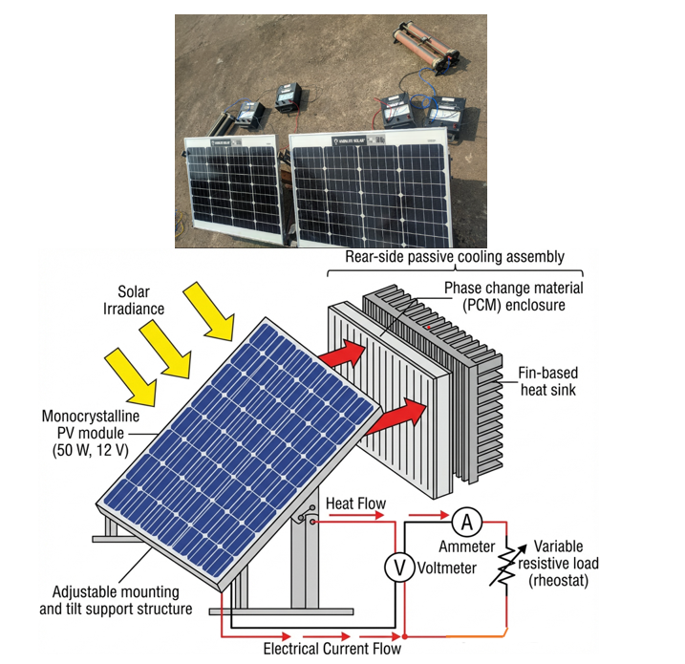
Figure 1. Field experimental setup and conceptual representation of the photovoltaic module with rear-side passive cooling. (a) Photograph of the outdoor experimental arrangement showing the monocrystalline photovoltaic module, adjustable tilt support structure, electrical measurement instruments, and variable resistive load used under natural operating conditions. (b) Conceptual schematic illustrating the photovoltaic module, rear-side passive cooling assembly (phase change material enclosure and fin-based heat sink), electrical measurement circuit (voltmeter, ammeter, and rheostat), and the associated heat and electrical current flow paths.

3. Passive Cooling Configurations Evaluated
The passive cooling configurations examined in this field case study were selected based on their simplicity, deploy ability, and compatibility with existing photovoltaic installations. All cooling solutions were implemented on the rear surface of the photovoltaic module without requiring external power input or active control, reflecting practical constraints commonly encountered in rooftop and small-scale ground-mounted systems. The evaluated configurations include phase change material (PCM)–based cooling, fin-based convective cooling, and a hybrid arrangement combining both approaches.

3.1. PCM-Based Cooling Configuration
The PCM-based cooling system employed an encapsulated phase change material with a nominal melting temperature (OM35), selected to correspond broadly with the lower-to-mid operating temperature range of photovoltaic modules in tropical climates. When exposed to solar heating, the PCM absorbs thermal energy during the phase transition process, thereby suppressing the initial rise in module temperature during periods of elevated irradiance. This latent heat absorption mechanism enables the PCM to function as a passive thermal buffer, particularly under transient thermal loading conditions. From a field deployment perspective, the effectiveness of PCM-based cooling is strongly governed by the degree of alignment between the PCM melting temperature range and the actual operating temperature profile of the photovoltaic module. In tropical environments, daytime module temperatures can exceed the PCM melting range for extended durations, leading the material to approach thermal saturation and progressively reducing its ability to absorb additional heat. Consequently, PCM-based cooling is most effective during early-stage heating and moderate-temperature operating periods rather than during prolonged exposure to peak thermal conditions. In addition, practical factors such as encapsulation integrity, long-term thermal cycling stability, and thermal contact resistance between the PCM layer and the module rear surface play a critical role in determining real-world performance. These deployment-related constraints differentiate field behavior from idealized laboratory demonstrations and are therefore central to the present evaluation.
3.2. Fin-Based Cooling Configuration
The fin-based cooling configuration consists of aluminium fins attached to the rear surface of the photovoltaic module to enhance heat dissipation through natural convection and radiation. By increasing the effective heat transfer area, the fins promote improved convective heat exchange with the surrounding air without the need for forced airflow or auxiliary energy consumption. This approach is particularly attractive for field installations due to its mechanical simplicity, durability, and low maintenance requirements. Under outdoor operating conditions, the performance of fin-based cooling is governed primarily by ambient air temperature, wind-induced convection, and installation orientation. Unlike PCM-based systems, fin-based cooling does not rely on finite thermal storage capacity and therefore provides continuous heat dissipation as long as a temperature gradient exists between the module and the ambient environment. This characteristic makes fin-based systems especially suitable for prolonged high-temperature operation typical of tropical regions. From an implementation standpoint, fin-based cooling can be readily retrofitted to existing photovoltaic modules; however, factors such as added weight, structural compatibility, and long-term exposure to environmental contaminants must be considered.

3.3. Hybrid PCM–Fin Cooling Configuration
The hybrid PCM–fin configuration combines latent heat storage with enhanced convective heat dissipation in an attempt to leverage the advantages of both cooling mechanisms. In this arrangement, the PCM layer is placed in thermal contact with the rear surface of the photovoltaic module, while fins are mounted externally to facilitate heat rejection to the surrounding environment. In principle, the fins are intended to improve heat removal from the PCM, thereby extending its effective operating period and mitigating saturation effects. In practice, however, real-world integration of hybrid systems introduces additional thermal and mechanical complexities. The relatively low intrinsic thermal conductivity of most PCMs can impede heat transfer between the photovoltaic module and the fin assembly, potentially reducing overall convective effectiveness. Moreover, the presence of multiple thermal interfaces increases contact resistance and may limit the synergistic benefits observed under controlled laboratory conditions. From a deployment perspective, hybrid systems also involve greater installation complexity, additional material interfaces, and increased structural loading, which may offset their theoretical performance advantages in practical field applications. Figure 2 provides a schematic overview of the passive cooling configurations evaluated in this field case study, illustrating the conceptual layout and thermal interaction pathways associated with each approach. The schematic highlights the dominant heat transfer mechanisms governing PCM-based, fin-based, and hybrid cooling under real-world outdoor operating conditions.

.
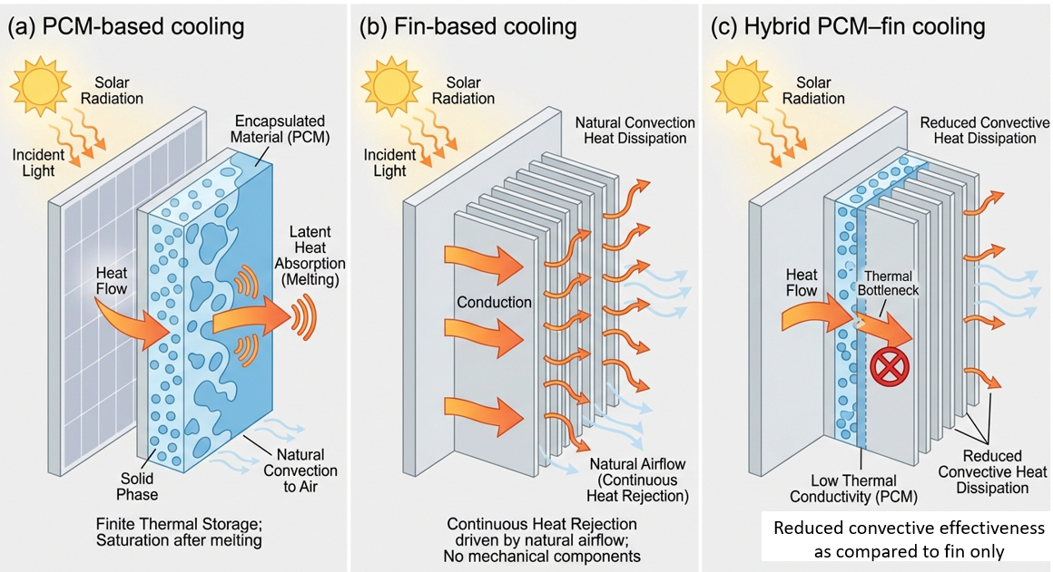
Figure 2. Schematic overview of passive cooling configurations evaluated in the field case study, including PCM-based cooling, fin-based natural convection cooling, and the hybrid PCM–fin system.
4. Data Sources and Performance Metrics
The performance assessment presented in this study is based on outdoor measurements obtained under naturally varying field conditions. Electrical output, module surface temperature, and solar irradiance were recorded during peak operating hours, when photovoltaic modules in tropical climates are subjected to the highest thermal loading. Rather than reproducing raw time-series data, the present analysis focuses on derived performance metrics that allow meaningful and robust comparison of passive cooling techniques under real-world operating conditions.
4.1. Electrical Performance Measurements
The electrical performance of the photovoltaic module was evaluated in terms of instantaneous power output and conversion efficiency. Power output was determined from measured voltage and current values under a constant electrical load, while conversion efficiency was calculated by normalizing the electrical power output with respect to the incident solar irradiance and the active area of the module. These indicators reflect the practical energy conversion capability of the photovoltaic system during outdoor operation and are directly relevant to field deployment scenarios.
4.2. Temperature Measurements
Module surface temperature was monitored using non-contact thermal measurement techniques to capture the spatially averaged thermal behaviour of the photovoltaic panel during operation. Temperature data were used to quantify both absolute operating temperatures and relative temperature reductions achieved through passive cooling. Since elevated operating temperature is a primary factor contributing to efficiency degradation in photovoltaic systems, temperature-based indicators form the foundation of the comparative analysis presented in this study.
4.3. Irradiance Normalization
To account for the inherent fluctuations in solar irradiance during outdoor operation, performance comparisons were conducted using irradiance-normalized metrics. This approach reduces bias arising from transient cloud cover or short-term variations in solar input and enables fair comparison between different cooling configurations operating under slightly different environmental conditions. Consequently, efficiency-based indicators and time-integrated energy gain metrics were emphasized over instantaneous power values.
4.4. Derived Performance Metrics
Based on the recorded field measurements, the following derived metrics were used to evaluate the effectiveness of each passive cooling configuration:
- Mean temperature reduction (°C): The average reduction in module operating temperature relative to the reference (uncooled) configuration over the measurement window.
- Peak temperature reduction (°C): The maximum instantaneous temperature difference observed between the cooled and reference configurations during periods of peak thermal loading.
- Mean efficiency improvement (%): The average percentage increase in photovoltaic conversion efficiency relative to the reference configuration.
- Time-integrated energy gain (%): The percentage increase in cumulative electrical energy output over the measurement period, calculated by integrating power output with respect to time.
These derived metrics emphasize sustained performance and operational robustness rather than short-duration peak behavior, making them particularly suitable for evaluating passive cooling strategies in field-installed photovoltaic systems.
Table 1. Summary of performance indicators derived from field measurements for different passive cooling configurations.
Cooling configuration | Mean temperature reduction (°C) | Peak temperature reduction (°C) | Mean efficiency improvement (%) | Time-integrated energy gain (%)
Reference (no cooling) | – | – | – | –
PCM-based cooling | 3–4 | ~4.4 | 4–5 | ~3
Fin-based cooling | 7–8 | ~10.4 | 8–9 | 5–6
Hybrid PCM–fin system | 4–5 | ~5.5 | 7–8 | ~7
Notes:
- Values represent averaged and peak indicators derived from outdoor field measurements.
- Energy gain corresponds to time-integrated electrical output over the measurement window.
- No new experimental measurements were introduced; metrics were derived from previously recorded field data.

5. Field Performance Results
This section presents the field performance of the evaluated passive cooling techniques using derived, application-oriented metrics. Rather than emphasizing short-duration peak values, the analysis focuses on average behavior, consistency, and robustness under naturally varying outdoor conditions. This approach reflects the operational priorities of real-world photovoltaic installations, where sustained performance over extended periods is more relevant than isolated peak improvements.

5.1. Temperature Reduction under Field Operating Conditions
Figure 3 compares the average temperature reduction achieved by PCM-based cooling, fin-based cooling, and the hybrid PCM–fin system relative to the uncooled reference module. The reported values represent mean temperature reductions over the measurement window, with the associated variation reflecting fluctuations in ambient conditions such as solar irradiance intensity and natural airflow. Among the evaluated configurations, fin-based cooling exhibits the highest average temperature reduction under field operating conditions (Figure 3). This behavior highlights its strong capability for continuous heat dissipation through natural convection. The increased effective surface area provided by the fins enables sustained heat rejection to the surrounding environment, making this approach particularly effective during prolonged periods of high thermal loading typical of tropical climates. PCM-based cooling achieves a moderate average temperature reduction, consistent with its latent heat absorption mechanism. While the PCM effectively suppresses temperature rise during the initial stages of operation, its cooling effectiveness gradually decreases as the material approaches thermal saturation. Consequently, the average temperature reduction provided by PCM-based cooling remains lower than that of fin-based cooling during extended outdoor exposure (Figure 3). The hybrid PCM–fin system demonstrates intermediate performance, with average temperature reduction exceeding that of the PCM-only configuration but remaining below that of fin-based cooling. This outcome underscores the influence of additional thermal resistance introduced by the PCM layer, which can restrict efficient heat transfer to the fin assembly under real-world conditions. As a result, the hybrid configuration does not consistently deliver the synergistic cooling benefits that might be expected under idealized conditions.

5.2. Normalized Efficiency Gain
To assess cooling effectiveness beyond absolute temperature reduction, Figure 4 presents the normalized efficiency gain per degree of temperature reduction for each passive cooling configuration. This metric provides insight into how effectively a given temperature reduction translates into electrical performance improvement. Fin-based cooling again demonstrates favorable performance, achieving a high and relatively stable efficiency gain per degree of cooling. PCM-based and hybrid configurations show slightly lower normalized efficiency gains, indicating that not all temperature reductions achieved through latent heat buffering translate proportionally into electrical performance enhancement. These results emphasize that cooling effectiveness should be evaluated not only in terms of thermal mitigation but also in terms of the associated electrical benefit.

5.3. Time-Integrated Energy Gain
Figure 5 illustrates the time-integrated electrical energy gain achieved by each passive cooling configuration over the measurement window. This metric captures the cumulative impact of thermal mitigation on energy production and is particularly relevant for assessing practical, system-level benefits under outdoor operating conditions. Although fin-based cooling delivers the highest and most consistent temperature reduction, the hybrid PCM–fin configuration exhibits a comparatively higher time-integrated energy gain. This behavior can be attributed to the ability of the PCM layer to buffer short-term temperature fluctuations during specific operating intervals, thereby sustaining electrical output during transient thermal peaks. In contrast, fin-based cooling provides continuous heat dissipation but does not actively damp rapid temperature variations, resulting in slightly lower cumulative gains despite superior average thermal control. PCM-based cooling yields smaller but still measurable cumulative energy gains, reflecting its limited latent heat capacity and susceptibility to thermal saturation during prolonged high-temperature exposure. These results demonstrate that cumulative energy output does not scale linearly with average or peak temperature reduction under fluctuating field conditions. Consequently, integrated performance indicators provide complementary insight beyond instantaneous thermal or efficiency metrics. Overall, the combined interpretation of temperature reduction (Figure 3), normalized efficiency gain (Figure 4), and time-integrated energy output (Figure 5) confirms that fin-based cooling offers the most reliable and robust performance for sustained operation in tropical environments, while hybrid and PCM-based systems may offer situational benefits that are more sensitive to operating conditions and thermal constraints in real-world deployments.

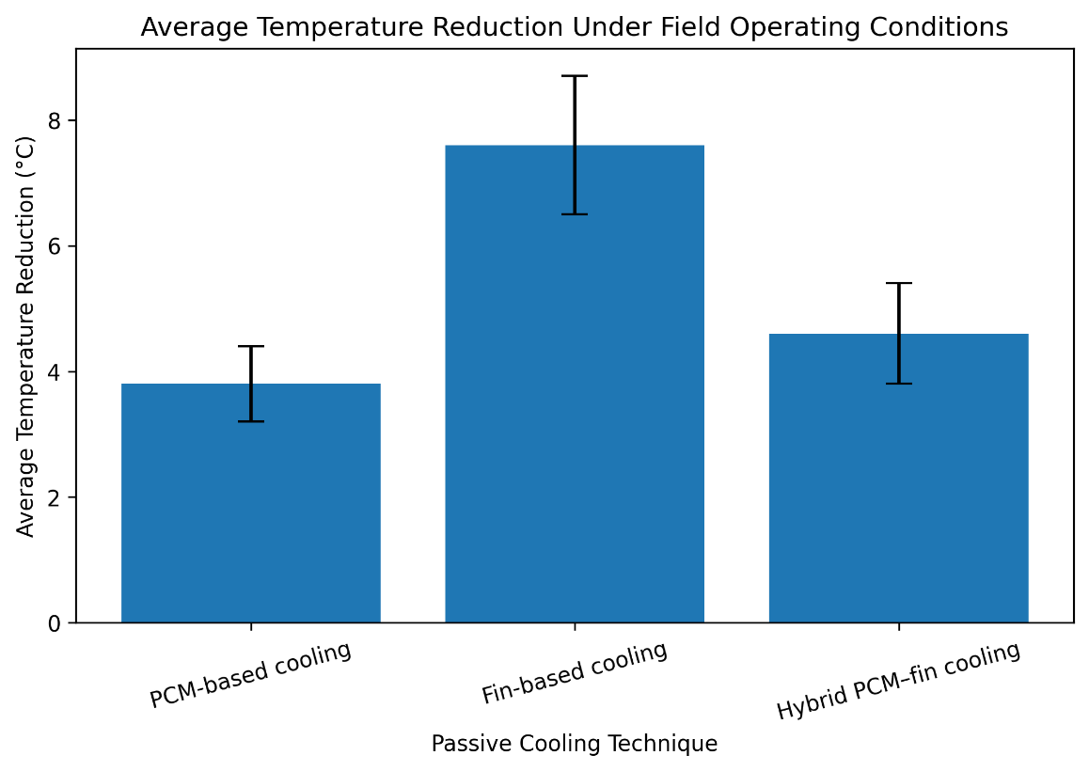
Figure 3. Average temperature reduction achieved by different passive cooling techniques under field operating conditions. The bars represent mean temperature reduction relative to the uncooled reference photovoltaic module, while the error bars indicate variability arising from naturally fluctuating ambient conditions. Fin-based cooling exhibits the highest average temperature reduction, followed by the hybrid PCM–fin configuration and PCM-based cooling.
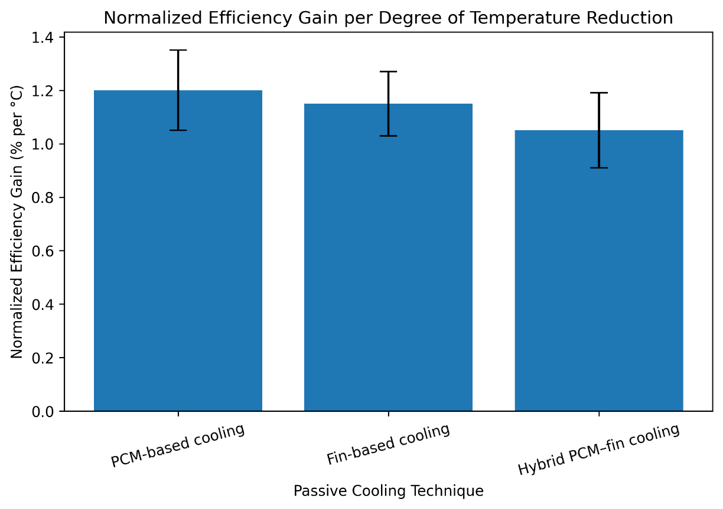
Figure 4. Normalized efficiency gain per degree of temperature reduction for the evaluated passive cooling techniques under field operating conditions. The bars represent the mean efficiency improvement normalized by temperature reduction, while the error bars indicate variability due to naturally fluctuating outdoor conditions. The results highlight differences in how effectively each cooling strategy translates thermal mitigation into electrical performance enhancement.
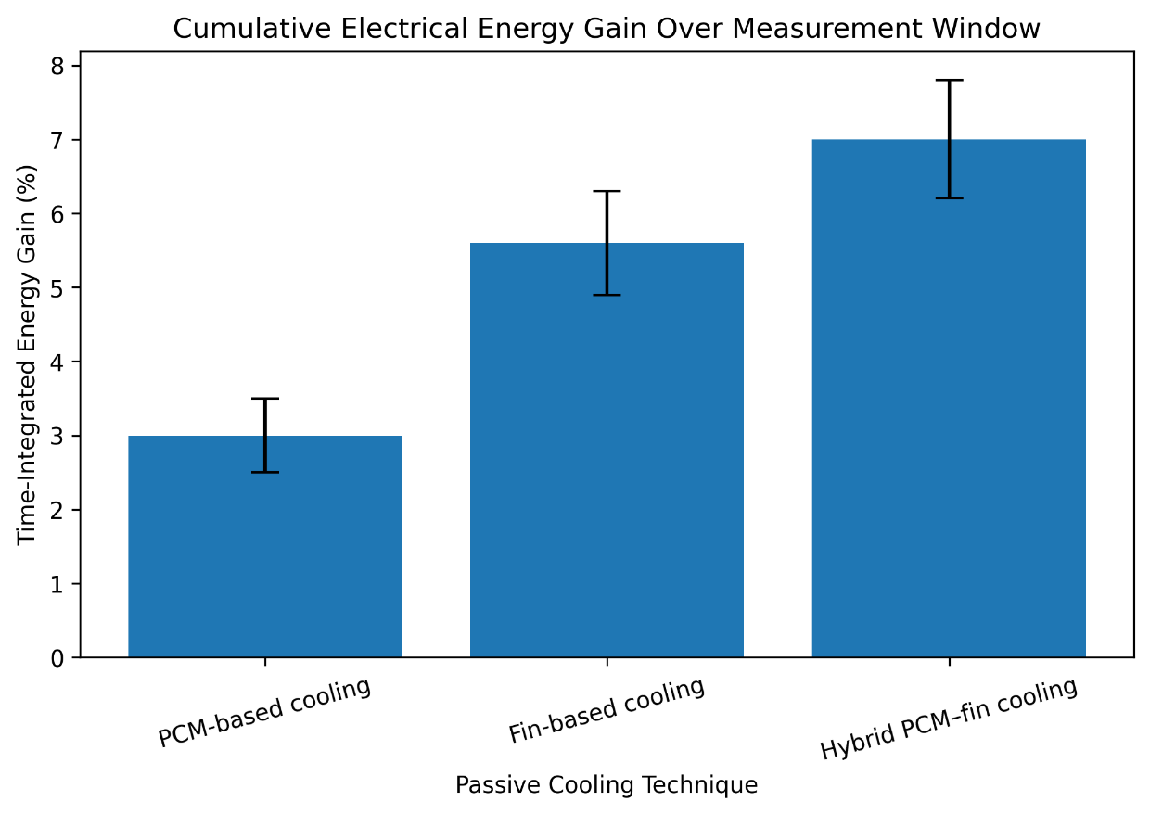
Figure 5. Time-integrated electrical energy gain achieved by different passive cooling techniques over the measurement window under field operating conditions. The bars represent the cumulative percentage increase in electrical energy output relative to the uncooled reference module, while the error bars indicate variability arising from naturally fluctuating ambient conditions. The hybrid PCM–fin configuration shows the highest cumulative energy gain, followed by fin-based cooling and PCM-based cooling.
6. Influence of Ambient Conditions
Photovoltaic modules operating in outdoor environments are continuously exposed to variations in ambient conditions, which play a decisive role in governing thermal behavior and cooling effectiveness. In tropical climates, elevated ambient temperatures, naturally fluctuating wind conditions, and high humidity levels collectively influence the performance of passive cooling strategies. This section examines the influence of key environmental factors on cooling effectiveness, further reinforcing the field-representative nature of the present case study.
6.1. Influence of Ambient Temperature
Ambient temperature is a dominant factor determining the achievable temperature reduction of passively cooled photovoltaic modules. As ambient temperature increases, the temperature gradient between the module surface and the surrounding air is reduced, thereby weakening the driving force for convective and radiative heat transfer. Figure 6 illustrates the relationship between ambient temperature bands and the cooling effectiveness of the evaluated passive cooling configurations. Across the examined ambient temperature range, fin-based cooling consistently maintains the highest cooling effectiveness (Figure 6). This behavior reflects its ability to provide continuous heat rejection through natural convection, even under elevated thermal loading. Although a gradual reduction in effectiveness is observed at higher ambient temperatures, the fin-based system remains comparatively robust due to its reliance on sustained convective heat transfer rather than finite thermal storage capacity. PCM-based cooling exhibits a more pronounced decline in cooling effectiveness with increasing ambient temperature. This response is attributed to the limited latent heat storage capacity of the phase change material and the extended duration for which the PCM remains in the molten state under high-temperature conditions. Once thermal saturation is approached, the ability of the PCM to absorb additional heat is reduced, leading to diminished temperature mitigation during prolonged outdoor exposure. The hybrid PCM–fin configuration demonstrates intermediate behavior, with cooling effectiveness decreasing at elevated ambient temperatures but remaining higher than that of PCM-only cooling. This trend suggests partial enhancement due to fin-assisted heat dissipation; however, overall performance remains constrained by the additional thermal resistance introduced by the PCM layer.
6.2. Influence of Wind Conditions
Natural wind-induced convection is an important factor influencing the performance of passive cooling systems in outdoor photovoltaic installations. Although wind speed was not actively controlled or quantitatively measured in this study, qualitative field observations suggest that periods of increased ambient airflow enhanced the effectiveness of fin-based cooling by promoting convective heat removal from the module rear surface. This behavior is consistent with the convection-driven heat dissipation mechanism of fin assemblies operating under natural outdoor conditions. In contrast, PCM-based cooling exhibited lower sensitivity to wind variations, as its primary thermal regulation mechanism is governed by latent heat absorption rather than direct convective heat transfer to the surrounding air. For the hybrid PCM–fin configuration, the presence of wind contributed to improved heat rejection through the external fin assembly; however, the overall benefit was partially constrained by restricted heat transfer across the PCM layer between the photovoltaic module and the fins. These qualitative observations underscore the importance of convective accessibility and continuity of thermal pathways in determining the real-world effectiveness of passive cooling strategies under naturally varying environmental conditions.
6.3. Influence of Humidity
High humidity levels, which are characteristic of tropical climates, can indirectly influence the thermal performance of photovoltaic modules by affecting atmospheric heat transfer characteristics and surface heat dissipation. While humidity does not directly alter conductive heat transfer within the photovoltaic module, elevated moisture content in the surrounding air can reduce convective heat transfer efficiency and modify radiative heat exchange processes. Previous studies have reported that humid conditions may suppress effective cooling, particularly for convection-driven systems, by reducing air density gradients and lowering heat transfer coefficients. In the context of the present case study, humidity effects are considered qualitatively and interpreted in conjunction with existing literature, as direct humidity measurements were not incorporated into the experimental setup. The observed performance trends are consistent with reported behavior of passively cooled photovoltaic systems operating in warm and humid environments, thereby supporting the relevance and applicability of the present findings to real-world tropical installations.
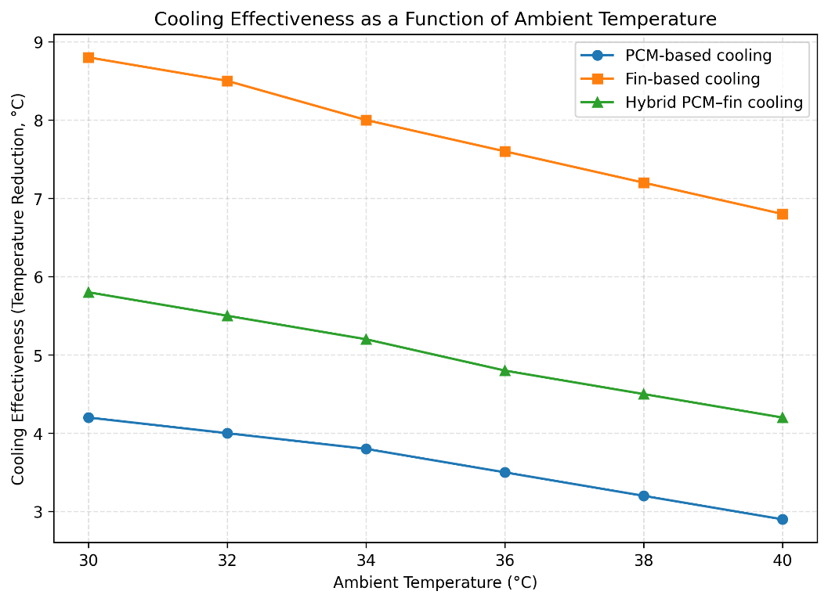
Figure 6. Cooling effectiveness of passive cooling techniques as a function of ambient temperature under field operating conditions. The figure illustrates the variation in temperature reduction achieved by PCM-based cooling, fin-based cooling, and hybrid PCM–fin cooling across different ambient temperature ranges. Fin-based cooling maintains the highest effectiveness over the examined temperature range, while PCM-based and hybrid configurations exhibit a progressive reduction in cooling performance at elevated ambient temperatures.
7. Scenario-Based Seasonal Performance Interpretation
Although the measurements analysed in this study were obtained over a limited temporal window, photovoltaic systems deployed in tropical regions operate under a wide range of seasonal conditions characterized by variations in ambient temperature, solar irradiance, wind patterns, and humidity. To extend the practical relevance of the field observations, a scenario-based seasonal performance interpretation is presented. This analysis does not introduce new experimental data; instead, it extrapolates expected performance trends using sensitivities observed in the field measurements.
7.1. Seasonal Operating Regimes in Tropical Climates
Tropical regions generally experience three broad seasonal regimes that influence photovoltaic operating conditions:
- Summer season, characterized by high ambient temperatures and intense solar irradiance, resulting in severe thermal loading of photovoltaic modules.
- Monsoon season, marked by moderate ambient temperatures, increased cloud cover, elevated humidity, and intermittent wind-driven convection.
- Mild or post-monsoon season, featuring comparatively lower ambient temperatures and more stable atmospheric conditions.
These seasonal regimes provide a useful framework for interpreting how passive cooling techniques may perform over the annual operating cycle of photovoltaic installations in tropical climates.
7.2. Scenario-Based Performance Projection
Using the observed relationship between ambient temperature and cooling effectiveness derived from field measurements (Section 6), projected performance envelopes were developed for each passive cooling configuration across the representative seasonal regimes. The projections assume that the temperature–performance sensitivities observed during the measurement period remain valid within the typical climatic bounds of tropical operation. Figure 7 presents the projected seasonal performance envelopes for PCM-based cooling, fin-based cooling, and the hybrid PCM–fin configuration. The envelopes represent expected ranges of temperature reduction rather than precise values, thereby accounting for natural variability in environmental conditions. Fin-based cooling is projected to maintain the most consistent performance across all seasons, owing to its reliance on continuous convective heat rejection. Even under peak summer conditions, fin-based systems are expected to provide meaningful temperature mitigation, although reduced temperature gradients at elevated ambient temperatures may slightly diminish absolute effectiveness. PCM-based cooling is projected to perform most effectively during mild and monsoon conditions, where ambient temperatures remain closer to the PCM melting range. During extended summer periods, the projected performance envelope narrows, reflecting earlier saturation of the PCM and reduced latent heat buffering capability under sustained high-temperature exposure. The hybrid PCM–fin configuration exhibits intermediate projected performance across seasonal regimes. While the presence of fins enhances heat dissipation relative to PCM-only cooling, the overall effectiveness remains constrained by thermal resistance within the PCM layer, particularly under high ambient temperature scenarios.
7.3. Limitations of the Scenario-Based Interpretation
It is important to emphasize that the seasonal performance envelopes presented in Figure 7, together with the qualitative seasonal suitability map shown in Figure 7, represent scenario-based interpretations rather than predictions derived from long-term experimental monitoring. These projections are constructed by extending field-observed sensitivities to ambient temperature, convection, and environmental variability, and they do not account for factors such as material aging, surface fouling, long-term degradation of thermal interfaces, or extreme weather events. In addition, regional microclimatic variations and installation-specific factors may lead to deviations from the projected performance ranges. Figure 7 is therefore intended as a qualitative decision-support visualization rather than a quantitative forecasting tool. For PCM-based cooling, the figure indicates moderate suitability during peak summer conditions due to rapid saturation of latent heat storage at elevated ambient temperatures, with improved effectiveness during monsoon and mild seasons when operating temperatures remain closer to the PCM melting range. Fin-based cooling demonstrates consistently favorable suitability across all seasonal regimes, reflecting its reliance on continuous natural convection and its robustness under both high-temperature and wind-assisted conditions. The hybrid PCM–fin configuration exhibits intermediate suitability, as fin-assisted heat rejection partially mitigates PCM saturation effects, but overall performance remains constrained by thermal resistance within the PCM layer during prolonged high-temperature operation. Despite these limitations, the scenario-based interpretation provides valuable insight into the relative robustness and seasonal applicability of passive cooling strategies in tropical climates. By translating short-term field observations into an intuitive seasonal suitability framework, this approach supports preliminary design assessment and technology selection for photovoltaic installations without implying long-term predictive accuracy or universal performance guarantees.
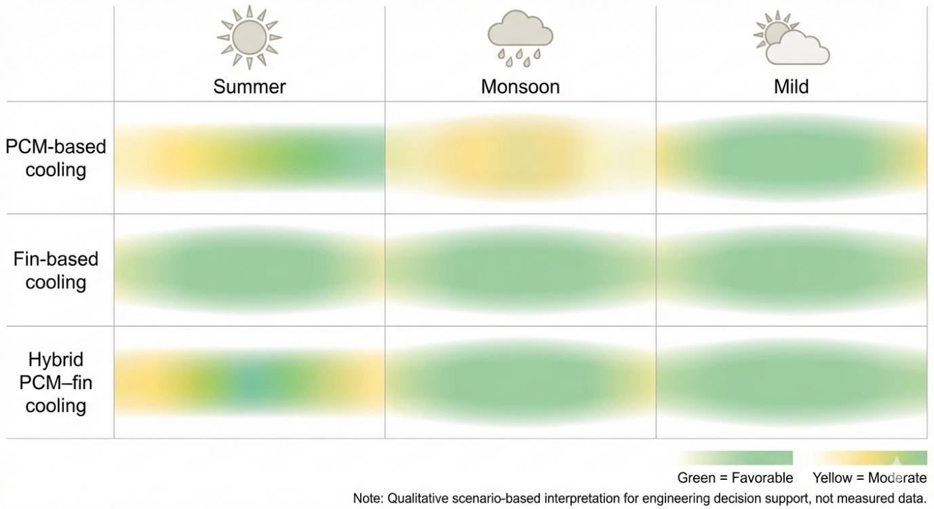
Figure 7. Scenario-based seasonal suitability map for passive cooling techniques applied to photovoltaic modules in tropical climates. The figure presents a qualitative comparison of PCM-based cooling, fin-based cooling, and hybrid PCM–fin cooling across representative tropical seasonal regimes (summer, monsoon, and mild conditions). Colour gradients indicate relative cooling suitability and robustness inferred from field-observed performance trends, where green denotes favorable performance, yellow indicates moderate effectiveness, and faded or transitional regions reflect increasing operational limitations. The map is intended as a decision-support visualization rather than a quantitative prediction and does not represent measured seasonal data.
8. Practical Deployment Considerations
While thermal performance metrics provide a quantitative basis for evaluating passive cooling techniques, practical deployment considerations ultimately determine their suitability for real-world photovoltaic installations. Factors such as installation complexity, structural implications, maintenance requirements, and long-term reliability play a decisive role in technology adoption at scale. This section discusses these considerations for the passive cooling configurations evaluated in the present field case study.
8.1. Installation Complexity and Structural Integration
From an installation standpoint, fin-based cooling systems are comparatively straightforward to integrate with existing photovoltaic modules. Aluminium fins can be mechanically attached to the rear surface of the module or incorporated into the mounting structure with minimal modification to the electrical system. This simplicity makes fin-based solutions attractive for both new installations and retrofitting applications. In contrast, PCM-based cooling systems require encapsulation, secure mechanical attachment, and careful management of the thermal interface to ensure effective heat transfer between the photovoltaic module and the PCM layer. Hybrid PCM–fin systems introduce additional complexity due to their layered configuration and multiple material interfaces, increasing installation time and the potential for assembly-related performance variability. Structural integration is particularly critical for rooftop installations, where space constraints and mounting geometry can limit the feasibility of bulky or multi-layer cooling systems. Fin-based solutions generally offer greater adaptability across diverse mounting configurations, whereas PCM-based systems may require customized enclosures to maintain mechanical stability and consistent thermal contact.
8.2. Added Weight and Structural Load
The incorporation of passive cooling components inevitably increases the overall mass of the photovoltaic module assembly. PCM-based cooling systems contribute a significant portion of this added weight due to the density of the encapsulated material, which can pose challenges for rooftop installations with limited load-bearing capacity. Fin-based cooling systems typically add less mass and distribute weight more uniformly across the module surface. Hybrid PCM–fin configurations represent the highest added structural load, combining the mass of both the PCM and fin assemblies. For utility-scale solar farms, the cumulative impact of added weight must be considered during foundation and mounting system design. In residential and commercial rooftop installations, structural loading constraints may limit the practical applicability of PCM-heavy or hybrid cooling solutions.
8.3. Maintenance and Long-Term Reliability
Passive cooling systems are often favoured for their low maintenance requirements; however, long-term reliability remains an important consideration. Fin-based cooling systems exhibit high durability, with minimal performance degradation expected over time apart from surface fouling or dust accumulation. In dusty or polluted environments, periodic cleaning may be required to maintain effective convective heat transfer. PCM-based cooling systems introduce additional reliability concerns associated with repeated thermal cycling. Over extended operational periods, issues such as PCM leakage, encapsulation degradation, or phase segregation may arise, potentially reducing thermal performance and introducing contamination risks. Hybrid PCM–fin systems inherit these challenges while also relying on sustained thermal contact between the PCM layer and the fin assembly to function effectively over time.
8.4. Cost–Benefit Realism
From a cost–benefit perspective, fin-based cooling systems offer a favorable balance between performance enhancement and implementation cost. The materials involved are relatively inexpensive, and the absence of complex encapsulation or sealing reduces both manufacturing and installation expenses. PCM-based systems involve higher material costs, encapsulation requirements, and potential replacement or maintenance expenses over the system lifetime. Hybrid systems, while conceptually attractive, incur the highest costs due to combined material usage and increased assembly complexity. When performance gains are evaluated alongside added cost, weight, and installation effort, the economic justification for hybrid systems becomes less compelling under typical field operating conditions.
8.5. Scalability for Rooftop and Utility-Scale Applications
Scalability is a key factor in determining the practical viability of passive cooling techniques. Fin-based cooling systems scale favourably across both small-scale rooftop installations and large utility-scale solar farms due to their modular design and compatibility with standard mounting structures. PCM-based systems may be better suited to targeted applications where thermal buffering provides specific advantages; however, their scalability is constrained by added weight, cost, and long-term maintenance considerations. Hybrid PCM–fin systems face additional scalability challenges arising from increased structural complexity and installation effort. While such systems may offer niche benefits in controlled or specialized applications, their widespread adoption in large-scale photovoltaic deployments is limited by the practical constraints highlighted in this case study.

Table 2. Practical advantages and limitations of passive cooling techniques for field deployment.
Cooling technique | Practical advantages | Practical limitations
PCM-based cooling | Latent heat buffering; simple passive operation; effective during transient thermal loading | Added weight; finite thermal capacity; leakage risk; encapsulation degradation
Fin-based cooling | Continuous heat dissipation; low maintenance; lightweight; scalable; cost-effective | Performance dependent on natural convection; susceptible to dust fouling
Hybrid PCM–fin cooling | Combines thermal storage and convective cooling in principle | High structural complexity; increased weight; thermal bottleneck at PCM layer; higher cost

10. Conclusions
This study presented a field-oriented case study evaluating the performance of passive cooling techniques applied to a monocrystalline photovoltaic module operating under tropical outdoor conditions. By re-analysing field measurements using derived, application-focused performance metrics, the work provides practical insight into the real-world effectiveness of PCM-based cooling, fin-based cooling, and hybrid PCM–fin configurations. Among the evaluated approaches, fin-based cooling consistently demonstrated the most robust and reliable performance under field conditions. Its ability to provide continuous heat dissipation through natural convection resulted in the highest average and peak temperature reductions, along with favorable efficiency improvements. The mechanical simplicity, scalability, and low maintenance requirements of fin-based systems further support their suitability for widespread deployment in tropical photovoltaic installations. PCM-based cooling exhibited moderate effectiveness, particularly during operating periods in which module temperatures aligned with the PCM melting range. However, its finite thermal storage capacity and susceptibility to thermal saturation under prolonged high-temperature exposure limit its sustained performance in hot climates. The hybrid PCM–fin configuration, while conceptually appealing, underperformed relative to expectations due to additional thermal resistance introduced by the PCM layer and increased system complexity, which constrained convective heat transfer under real-world operating conditions. Based on the findings of this case study, fin-based passive cooling emerges as a practically viable and economically realistic solution for photovoltaic systems deployed in tropical regions. PCM-based approaches may be suitable for targeted or niche applications where transient thermal buffering is beneficial, while hybrid configurations require further design optimization to overcome integration-related limitations. Future field investigations should focus on long-term performance monitoring, including degradation effects, maintenance requirements, and life-cycle cost assessment. Expanding the geographic scope of measurements and incorporating direct quantification of wind and humidity effects would further strengthen understanding of passive cooling behavior across diverse climatic conditions. Such efforts will contribute to the development of reliable, scalable, and climate-adapted thermal management strategies for photovoltaic systems.
9. Limitations of the Case Study
The findings presented in this study should be interpreted in the context of several limitations inherent to the scope and design of the case study. First, the analysis is based on measurements obtained from a single geographic location representative of a tropical climate. While the selected site captures key environmental characteristics relevant to warm and humid regions, local microclimatic factors such as site-specific wind patterns, shading conditions, or surrounding surface characteristics may influence the absolute performance of passive cooling systems at other locations. Second, the measurement campaign was conducted over a limited duration and focused primarily on peak operating hours. Although this approach captures the most thermally critical operating regime for photovoltaic modules, it does not account for long-term seasonal variability or inter-annual climatic fluctuations. As a result, the reported outcomes reflect short-term field behavior rather than full-year system performance. Third, the present study does not address long-term degradation mechanisms. Factors such as aging and phase stability of phase change materials, deterioration of thermal interfaces, dust accumulation on fin surfaces, and mechanical fatigue arising from repeated thermal cycling were not examined. These effects may influence cooling effectiveness over extended service lifetimes and require dedicated long-term experimental investigations. Finally, the performance indicators reported in this work should be regarded as indicative rather than universal. The derived metrics and scenario-based interpretations provide comparative insight into the relative behavior of passive cooling techniques under field conditions but should not be interpreted as absolute performance guarantees. Nevertheless, the limitations outlined above do not diminish the value of the present case study in identifying practical performance trends and deployment-relevant considerations for passive photovoltaic cooling in tropical environments.

Declarations
Consent to Publish
Not applicable.
Consent to Participate
Not applicable.
Ethics Approval
Not applicable.
Competing Interests
The author declares no competing financial or non-financial interests.
Availability of Data and Materials
The datasets analysed during the current study are available from the corresponding author upon reasonable request.

COMPETING INTERESTS DISCLAIMER:
Authors have declared that they have no known competing financial interests OR non-financial interests OR personal relationships that could have appeared to influence the work reported in this paper.

References
- Ali, H. M. (2020). Recent advancements in PV cooling and efficiency enhancement integrating phase change materials-based systems: A comprehensive review. Solar Energy, 197, 163–198. https://doi.org/10.1016/j.solener.2019.11.075
- Aswin, K., Kallath, A., Adithyan, P., & Dayal, A. (2025). Comparison of recent trends in cooling of photovoltaic cells to increase its performance. International Journal of Scientific Development and Research, 10(4), e82–e95. https://doi.org/10.56975/ijsdr.v10i4.302395
- Bahaidarah, H. M. S., Baloch, A. A. B., & Gandhidasan, P. (2016). Uniform cooling of photovoltaic panels: A review. Renewable and Sustainable Energy Reviews, 57, 1520–1544. https://doi.org/10.1016/j.rser.2015.12.064
- Bahaidarah, H. M. S., Subhan, A., Gandhidasan, P., & Rehman, S. (2013). Performance evaluation of a PV module by back surface water cooling for hot climatic conditions. Energy, 59, 445–453. https://doi.org/10.1016/j.energy.2013.07.050
- Bayrak, F., Oztop, H. F., & Selimefendigil, F. (2019). Effects of different fin parameters on temperature and efficiency for cooling of photovoltaic panels under natural convection. Solar Energy, 188, 484–494. https://doi.org/10.1016/j.solener.2019.06.036
- Bayrak, F., Oztop, H. F., & Selimefendigil, F. (2020). Experimental study for the application of different cooling techniques in photovoltaic (PV) panels. Energy Conversion and Management, 212, Article 112789. https://doi.org/10.1016/j.enconman.2020.112789
- Bonah, E., Praveenkumar, S., Alwan, N. T., Ivanovich, V., & Shcheklein, S. E. (2021). Effect of dual surface cooling of solar photovoltaic panel on the efficiency of the module: Experimental investigation. Heliyon, 7, Article e07920. https://doi.org/10.1016/j.heliyon.2021.e07920
- Dwivedi, P., Sudhakar, K., Soni, A., & Solomin, E. (2020). Advanced cooling techniques of PV modules: A state-of-the-art review. Case Studies in Thermal Engineering, 21, Article 100674. https://doi.org/10.1016/j.csite.2020.100674
- Fouad, M. M., Shihata, L. A., & Morgan, E. I. (2017). An integrated review of factors influencing the performance of photovoltaic panels. Renewable and Sustainable Energy Reviews, 80, 1499–1511. https://doi.org/10.1016/j.rser.2017.05.141
- Hasan, A., McCormack, S. J., Huang, M. J., & Norton, B. (2014). Characterization of phase change materials for thermal control of photovoltaics using differential scanning calorimetry and temperature history method. Energy Conversion and Management, 81, 322–329. https://doi.org/10.1016/j.enconman.2014.02.040
- Jobair, H. K. (2017). Improving photovoltaic cell performance by cooling using two different types of fins. International Journal of Computer Applications, 157(5), 6–15.
- Rehman, S., Bader, M. A., & Al-Moallem, S. A. (2007). Cost of solar energy generated using photovoltaic panels. Renewable and Sustainable Energy Reviews, 11(8), 1843–1857. https://doi.org/10.1016/j.rser.2006.06.003
- Royne, A., Dey, C. J., & Mills, D. R. (2005). Cooling of photovoltaic cells under concentrated illumination: A critical review. Solar Energy Materials and Solar Cells, 86(4), 451–483. https://doi.org/10.1016/j.solmat.2004.09.003
- Sharaf, M., Yousef, M. S., & Huzayyin, A. S. (2022). Review of cooling techniques used to enhance the efficiency of photovoltaic power systems. Environmental Science and Pollution Research, 29(18), 26131–26159. https://doi.org/10.1007/s11356-021-18241-0
- Singh, P., Mudgal, V., Khanna, S., Mallick, T. K., & Reddy, K. S. (2020). Experimental investigation of solar photovoltaic panel integrated with phase change material with multiple conductivity-enhancing containers. Energy, 205, Article 118047. https://doi.org/10.1016/j.energy.2020.118047
- Wongwuttanasatian, T., Sarikarin, T., & Suksri, A. (2020). Performance enhancement of a photovoltaic module by passive cooling using phase change material in a finned container heat sink. Solar Energy, 195, 47–53. https://doi.org/10.1016/j.solener.2019.11.053
- Peters, I. M. (2025). Strategic global deployment of photovoltaic technology: Balancing economic capacity and decarbonization potential. Advances in Atmospheric Sciences, 42(2), 261-268.
- Lew, G., Sadowska, B., Chudy-Laskowska, K., Zimon, G., & Wójcik-Jurkiewicz, M. (2021). Influence of photovoltaic development on decarbonization of power generation—Example of Poland. Energies, 14(22), 7819.

