Original Research Article
An Overview of Informal Finance: Mapping the Research Landscape using Bibliometric Analysis

Abstract
Informal finance mechanisms have proved its worth in providing essential credit delivery, saving and investment needs, and catering as a risk-sharing mechanism, more visible, in areas where there is limited reach of its formal counterpart. The study conducts a bibliometric analysis of 191 articles published from 1990 to 2024 to map the evolution of informal finance using the Web of Science database. Utilizing the Biblioshiny package for performance and VOSviewer application for science, the study covers the current trend of publications, nationwide contributions, institutional affiliation, the influential authors, and thematic clusters related to the field of informal finance. The results of the study reveal a steady increase of study in the related topics of informal finance in scholarly output post 2016, thus reflecting its rising importance in the financial inclusion processes, and developmental debates. Economies such as China and the United States are found to be the major contributors of literatures, while Cornell University, the World Bank, and the University of London were found as the leading institutions of research in the field. Thematic analysis indicates that the current study in informal finance has shifted from micro-level studies to macro-level studies, demonstrating a scholarly progression from theoretical concepts to practical measurements in current scenario. Despite these progressions, we find persistence of regional concentrations, limiting geographical coverage on these financial developments particularly from Africa and Latin America. The study further emphasizes the need for critically examining the interaction of informal financial practices as an advocate of financial inclusion, and promoting sustainable economic development.
Keywords: Bibliometric analysis; finance; financial development; informal finance; science mapping
- Introduction
Informal finance acts as the cornerstone to financial awareness and accessibility in most parts of the world, more so in areas where access to formal banking is limited or constrained. Informal finance arrangements are presented as the arrangements that are unstructured, unregulated, and unrecorded, by regulative agencies. These systems are found to operate outside the scope of the formal (Bouman, 1995). It provides necessary access to savings and credit for consumption, investment, and entrepreneurship, while also serving as an important tool for managing risks (Beck et al., 2009). These include heterogenous sets of savings and credit arrangements among family, friends, relatives, moneylenders, fund-associations, rotating savings and credit associations, accumulating savings and credit associations, among others. What makes it more than mere substitutes for formal finance to many, is its deeply rootedness in social and cultural sphere (Banerjee & Duflo, 2001; Allen et al., 2012). The outreach of the informal form of finance is especially visible in developing or underdeveloped economies. In developing and underdeveloped economies, it is a strong tool to boost the local economy by extending savings and credit requirements to rural households, women, the marginalized communities, and small enterprises (Madestam, 2014). These arrangements help built resilience, thereby contributing towards the broader development goals of financial inclusivity.
Despite these strengths, it faces persistent challenges. Some major challenges include the exorbitant rate of interest, the lack of regulations, and the absence of consumer protection, which often expose borrowers to situations leading towards debt traps and exploitation (Adams & Fitchett, 1992). Its fragmented nature and scalability limitations have also raised questions about its long-term role as an agent in promoting financial development (Jain, 1999). The co-existence of these informality with the formal structure has also posed regulatory and policy dilemmas in integrating these mechanisms without undermining their flexibility and adaptability. These issues give rise to several key questions: 1. How has research on informal finance developed and evolved? 2. Which countries, institutions, and authors have played the most influential roles in shaping this field? 3. What thematic areas and intellectual structures defined current research?
To answer these questions, this study conducts a bibliometric analysis of publications on informal finance. By examining publication trends, institute level contributions, country-level contributions, thematic clusters, and influential works, the study provides an overview of how the field has developed and highlights directions for future research.
- Literature Review
The presence of informal financial arrangements predates the establishment of the formal financial system globally. Throughout history, we find evidence of communities' mutual reliance to meet their basic individual and household needs (Lee & Persson, 2016; Ojong, 2018). These arrangements, which were originally established on interpersonal relationships, familial bonds, and shared geographic proximity, have in present times evolved into unique structures promoting financial aid that helps individuals adapt to dynamic market change (Bouman, 1990).
2.1 Conceptual Background of Informal Finance
Informal finance is most commonly known as non-institutionalized finance, in most scholarly contexts, a title used for labelling something that does not come under the ambit of informal finance. It involves financial contracts or agreements, which occur outside the regulations of a recognised formal authority (Adams & Fitchett, 1992; Sile, 2015). These agreements are built on personal relationships and closeness, rather than on legal terms. Involving a complex web of individual and group settings, it establishes informational and time-cost advantages, proving to be a powerful tool for extended reach and effective delivery (Sile, 2015). Unlike the formal structure, here, personal connection is valued higher than legal status, while social accountability takes over bureaucratic accountability (Meyer & Nagarajan, 1992; Aliber, 2015).
  - Arguments in Support of Informal Finance
Informal financial systems have always been a major source of credit in contexts where formal institutions are inaccessible and ineffective especially among the households and small businesses without collateral, existing credit histories, or adequate resources to approach banks (Morduch, 1999). These systems usually involve minimal paperwork (Mowl, 2016), lower transaction costs (Guirkenger, 2008), and flexible entry and exit options (Ardener, 2014) which make borrowing easier. Because of this flexibility, informal finance often becomes the main option when formal credit is unavailable or too slow to meet urgent needs (Mpofu & Sibindi, 2022; Toka & Asha, 2019). These arrangements also reflect local priorities and are closely tied to cultural and social systems. They are commonly organized around community savings and investment needs and are supported by strong organizational practices (Bouman, 1979). In countries such as India, they are embedded in networks of trust, reciprocity, and social cohesion (Jain & Mansuri, 2003). In addition to lending, they provide mechanisms for negotiation and settlement in cases of default (Fitri, 2006). Group-based systems strengthen social ties among poorer households and act as risk-sharing tool (Fitri, 2006). They also serve as safety nets in times of crisis, reducing household vulnerability and giving members a sense of ownership and participation (Kharisma et al., 2020).
Informal finance is also closely linked to financial inclusion. It extends basic services such as savings, loans, insurance, and payments to groups left outside the reach of formal institutions. For low-income households, it helps cover consumption needs and social obligations, while for wealthier groups it provides stability and supports social standing (Kabuya, 2015). These systems also help spread financial knowledge, support skill development, and contribute to empowerment (Lukwa et al., 2022). By serving the unbanked and underbanked, they fill important gaps in access to financial services (Banerjee & Duflo, 2001).
2.3 Arguments against Informal Finance
Despite its advantages, informal finance also faces notable limitations. In the absence of regulatory oversight, individuals engaging in informal financial transactions may be susceptible to fraud, exploitation, or predatory lending practices. Informal lending is often associated with exorbitant interest rates and resorted to coercive collection practices, leading borrowers into cycles of debt and poverty (Sharma & Zeller, 1997). Unlike formal finance, which is recognized at the macro level, informal finance typically operates on a micro level. It is attributed as small-scale, relying heavily on personal relationships and social networks. While this can be beneficial in fostering trust and flexibility, it also restricts access to credit for individuals outside those networks. The informality of financial transactions limits their scalability and ability to reach underserved populations (Beck et al., 2007).
Given both the opportunities and challenges associated with informal finance, there is a need to examine how research in this area has evolved systematically. A bibliometric approach provides a structured way to map the field, identify influential contributors, and analyze the main themes and intellectual structures shaping ongoing debates.
- Methodology
For the bibliometric analysis, this study examined informal finance-related literature published between 1990 and 2024, sourced from the Web of Science (WoS) database (retrieved on 26/07/25). WoS is recognised worldwide as one of the most prestigious and authoritative academic databases, renowned for prioritizing quality over quantity in its indexing standards. At the same time, offering a multifaceted and a comprehensive view on informal finance. The study's rigorous search process incorporated carefully selected keywords to identify relevant literature on informal finance; thereafter, necessary exclusion and inclusion criteria were applied to ensure a comprehensive and precise acquisition of relevant literature.
An initial search was conducted using the set of keywords related to informal finance, ("Informal Finance" OR "Informal Lending" OR "Indigenous Finance" OR "Community based Finance" OR "ROSCA" OR "ASCA" OR "Daily Collectors" OR "Money Lender" OR "Fund Associations" OR "Pawn Lender" OR "Borrowing from Friends" OR "Borrowing from Family" OR "Borrowing from Relatives"). This initial search returned a total of 4030 records. To maintain consistency and academic relevance, the dataset was refined to include only peer-reviewed journal articles, reducing the number to 3744 records. The scope of the analysis was further restricted to articles published between 1990 and 2024, yielding 3697 records. To align the study with relevant disciplines, only articles indexed under the following WoS categories- Economics, Development Studies, Business, Business Finance, and Management were retained. This step narrowed the dataset to 219 records. The search was limited to articles published in the English language, resulting in 217 articles. A thorough manual review was conducted, ensuring inclusion of thematically relevant articles in the final dataset. After completing the above stages, a final corpus of 191 high-qualities and thematically appropriate articles was established for bibliometric analysis.
This study employs a bibliometric methodology, combining performance analysis and science mapping to investigate the field of informal finance. This approach aligns with already established frameworks in bibliometric research (Donthu et al., 2021; Ozturk et al., 2024). The current study, through descriptive and network analyses, provides a bibliometric outline of the research front on informal finance. The performance analysis, conducted using the Biblioshiny package, is used to uncover information on the publications per year, the country's scientific production, documents by source, affiliation, information on relevant authors, and authors' production over time. Science mapping analyses conducted using VOSviewer provide information on co-authorship by countries, co-occurrence by keywords, documents by citation, and co-citation by authors. Therefore, Performance analysis accounts for the contributions of research constituents, whereas science mapping focuses on the relationships between research constituents.
- Analysis and Results
The analysis and results conducted using performance analysis and science mapping are presented in this section.
  - Performance Analysis
    - Analysis of Publication by Year
From 1990 to 2024, research on informal finance shows a clear upward trajectory, moving from minimal annual outputs in the 1990s to steady growth after the mid-2000s. Early peaks occurred in 1999, 2007, and 2011, but the most significant expansion began after 2016, culminating in a record high of 19 publications in 2023 before a slight decline to 16 in 2024. This trend can be attributed to several pivotal global developments, the global diffusion of the Grameen Bank model (Morduch, 1999), financial crisis (Harrisss-White, 2009), adoption of UN sustainable development goals (Yap et al., 2023) and Covid-19 pandemic (Guo et al., 2022; Sarkar et al., 2025) which has renewed the scholar and policy attention towards informal credit and resilience. Figure 1 shows period-wise distribution of research paper publications from 1990 to 2024.
Figure 1: Period-Wise Distribution of Research Paper Publication (1990-2024).

Source: Authors’ own analysis compilation (based on the data retrieved from WoS)
    - Analysis by country’s scientific production
Among the top ten countries in terms of scientific production, China ranked first with 114 publications, followed by the United States with 95 publications. These two countries accounted for the majority of the total output recorded among the leading nations. Figure 2 illustrates the distributions of scientific production by countries, showing that in Asia, scientific production on informal finance is highly concentrated, with China alone accounting for the vast majority of publications (114), far outpacing India (14) and Vietnam (9). The concentration of high publications in certain regions highlights the imbalance in knowledge production. China demonstrates strong research funding, state-driven priorities, and international visibility (Degryse & Ongena, 2016; Li & Hiwatari, 2025). Europe demonstrates a more balanced distribution of output. While the United Kingdom leads with 41 publications, other countries such as France (17), Germany (14), Belgium (11), and Italy (11) are found to contribute significantly, suggesting a collaborative and regionally shared research capacity. Where Asia exhibits a China-centric concentration of knowledge production, Europe reflects a more distributed pattern of contributions across multiple countries.
Figure 2: Top 10 countries with the most scientific productions

Source: Authors’ own analysis compilation (based on the data retrieved from WoS)
    - Analysis of Documents by source
The data identifies the top eight journals contributing to research in the field. World Development ranks first with 15 publications, indicating its leading role in disseminating relevant studies. The Journal of Development Economics follows with 11 publications, while Emerging Markets Finance and Trade holds third place with 8 publications. Both the Journal of Development Studies and the Journal of International Trade and Economic Development contribute seven publications each. The China Agricultural Economic Review accounts for six publications, and both the International Review of Financial Analysis and the Journal of Banking & Finance record five each. Figure 3 exhibits top journals contributing studies on informal finance.
Figure 3: Top journals contributing studies on informal finance

Source: Authors’ own analysis compilation (based on the data retrieved from WoS)
    - Analysis by Institutional Affiliation
Figure 4 highlights the list of institution contributing to the research of informal finance. Based on institutional affiliations, Cornell University and the World Bank recorded the highest contributions, each with seven publications, highlighting their prominent role in advancing research within the field. The University of London followed with six publications. At the same time, Hunan University, Peking University, and the University of Wisconsin System each produced five, reflecting active engagement from both Western and Asian institutions. Aston University, Colorado State University, Colorado State University System, and KU Leuven each contributed four publications, indicating a steady but comparatively moderate research output. Institutional contributions to informal finance research are globally distributed but regionally uneven, North America leads, Europe follows with multiple mid-level contributors, and Asia shows rising but concentrated participation through Chinese universities.

Figure 4: List of top 10 affiliations

Source: Authors’ own analysis compilation (based on the data retrieved from WoS)
    - Analysis by Authors
In this field, the top 10 most prolific authors are led by Besley, T., Nguyen, B., and Turvey, C. G., each with four publications. Notably, Nguyen, B., achieved the highest fractionalized count (3.5), reflecting a greater individual contribution to their publications compared to Besley, T., and Turvey, C. G., who both recorded a fractionalized count of 1.67. The next group of contributors includes Baland, J. M., Kong, R., Lemay-Boucher, P., Mallik, R., Ongena, S., and Tsai, K. S., each with three publications. Within this group, Mallik, R., holds the highest fractionalized count (3.0), followed by Tsai, K.S. (2.5), indicating a stronger share of authorship in their collaborative works. Kong, R., and Ongena, S., each have a fractionalized count of 1.33, while Baland, J. M., and Lemay-Boucher, P., both stand at 1.17. An, J. F., ranks tenth with two publications and a fractionalized count of 1.25 (Figure 5). Figure 6 presents the publication patterns of the top 10 contributing authors in the studied field, showing both the number of articles and citation impact over the years.
Figure 5: Top 10 most relevant authors

Sources: Authors’ own analysis compilation (based on the data retrieved from WoS)
Figure 6: Author's Production over time
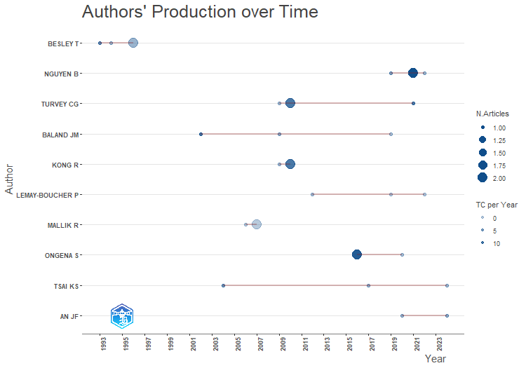
Source: Authors’ own analysis compilation (based on the data retrieved from WoS)
  - Science Mapping
    - Analysis of Co-authorship by Countries
The country co-authorship network map shows patterns of global research collaboration in the field of informal finance. The frequency and interconnection of informal finance research are shown by the co-authorship network in Figure 7. With the largest nodes, China, the United States, and the United Kingdom stand out as the leaders in this field. China establishes the role of a major contributor to the literature in informal finance, followed by the United States. The link strength indicates the most collaborations between these two countries. The visualization establishes the roles of China, the United States, and England as the major scientific collaborators while clearly showing the significant and more recent rise of China as the leading power in global research. The United States, with its central position and high number of linkages, acts as a consistent and crucial bridge connecting different collaborations over time. Smaller nodes such as France, Australia, and Germany show their active contributions in this research field. Similarly, nodes such as India and Vietnam indicate the emerging and expanding knowledge contributions in the underdeveloped countries. Figure 7 depicts the dynamic multinational partnership advancing the field of informal finance, via research initiatives and collaborations, aligning practices worldwide towards financial inclusion.

Figure 7: Network visualisation map of Co-authorship among Countries
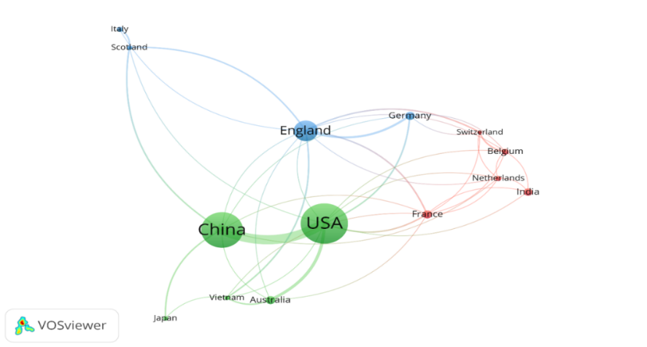
Source: Authors’ own analysis compilation (based on the data retrieved from WoS)
    - Analysis of Co-occurrence by keywords
The co-occurrence of keywords in the network map shows global research collaborations in informal finance based on their themes. The analysis indicates the co-occurrence based on keywords as the unit of analysis. For the visualization, keywords with at least 10 occurrences were studied, which showed a total of 27 keywords. As shown in figure 8, the term “informal finance” is central to the present network of current research, it connects several different areas that are crucial to comprehending the multidimensional nature of informal finance such as “access”, “growth”, “constraints”, “determinants”, among others. The co-occurrence of keywords based on the temporal overlay visualization reveals the evolution of research topics within the field of informal finance. The colour of each node represents a clear progression in research focus over time. Early research (Blue/Purple) includes fundamental concepts like "economics," "rotating savings", "credit associations", and "roscas", indicating that foundational research focused on defining and understanding mechanisms of informal finance. This is followed by keywords like "informal finance", "growth", "constraints", "risk", and "investment" represented by green nodes, suggesting that the research community consolidated these concepts, exploring the primary functions and challenges of informal financial systems. The most recent and emerging research trends are highlighted in yellow colour, and include keywords like "access", "impact", "entrepreneurship", "innovation", "economic growth", and "performance", pointing to a recent emphasis on the broader macroeconomic impacts and outcomes of informal finance. In essence, the temporal overlay shows a scholarly progression from descriptive studies of traditional informal financial instruments to a more analytical focus on their role in driving economic development.

Figure 8: Co-occurrence Map Keywords
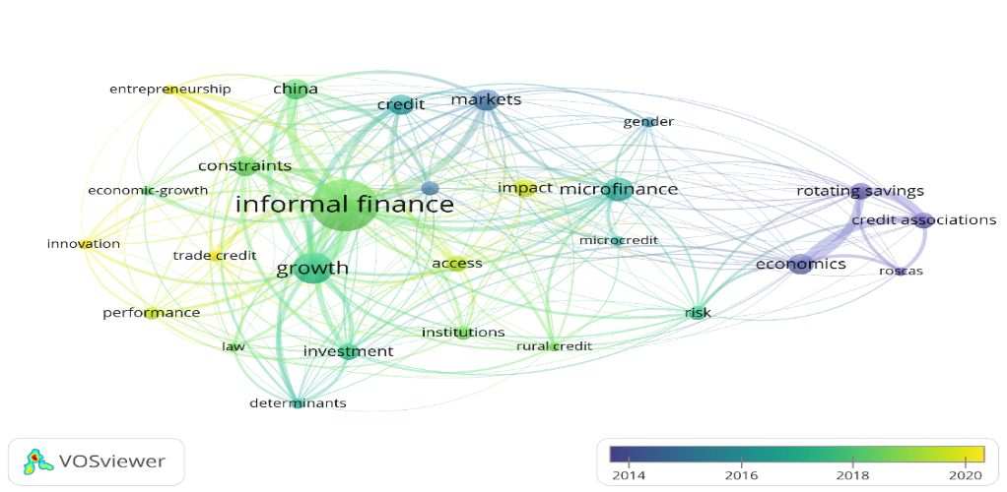
Source: Authors’ own analysis compilation (based on the data retrieved from WoS)
    - Analysis of Citation by Documents
Figure 9 shows the high-impact documents published in the field of informal finance. For the temporal visualization, research studies with a minimum of 20 citations were used, which gave a threshold limit of 80 documents, out of the 191 documents under study. In this visualization, the node size is proportional to citation impact, and the colour of the node corresponds to the publication year. This allows for the identification of influential works over time.
Figure 9: Overlay visualization of documents based on citation frequency
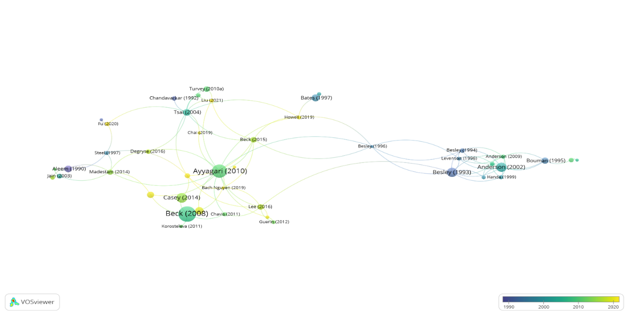
Source: Authors’ own analysis compilation (based on the data retrieved from WoS)
The top ten publications from 1990 to 2024 in the field of informal finance and related fields are detailed in Table 1.
Table 1: Top 10 high-impact articles are based on their citation frequency.
Articles | Authors | TC | TC/year
Financing patterns around the world: Are small firms different? | Beck, T., Demirguc-Kunt, A., & Maksimovic, V. (2008). | 621 | 34.50
Formal versus informal finance: Evidence from China | Ayyagari, M., Demirguc-Kunt, A., and Maksimovic, V. (2010). | 469 | 29.31
Trust and the provision of trade credit. | Wu, W. F., Firth, M., & Rui, O. M. (2014) | 353 | 29.42
Bank lending constraints, trade credit, and alternative financing during the financial crisis: Evidence from European SMEs | Casey, E., & O'Toole, C. M. (2014). | 253 | 21.08
The economics of rotating savings and credit associations | Besley, T., Coate, S., & Loury, G. (1993). | 247 | 7.48
On the mystery of capital and the myths of Hernando de Soto- What difference does legal title make? | Gilbert, A. (2002). | 240 | 10.00
The economics of roscas and intrahousehold resource allocation. | Anderson, S., & Baland, J. M. (2002). | 236 | 9.83
What causes firms to hide output? The determinants of informality. | Dabla-Norris, E., Gradstein, M., & Inchauste, G. (2008). | 188 | 10.44
Corporate resilience to banking crises: The roles of Trust and Trade Credit | Levine, R., Lin, C., & Xie, W. S. (2018). | 158 | 19.75
What constrains financial inclusion for Women? Evidence from Indian microdata | Ghosh, S., & Vinod, D. (2017). | 158 | 17.56
Note. * Total Citation
Source: Authors’ compilation (based on the data retrieved from WoS)
    - Analysis of Co-citation by Authors
The network visualization map displays an author co-citation network, revealing the intellectual structure of a particular research field by grouping scholars who are frequently cited together. Figure 10 displays the co-citation network for the most prominent authors and includes authors with a minimum of 30 citations.

Figure 10: Top 10 Co-cited authors
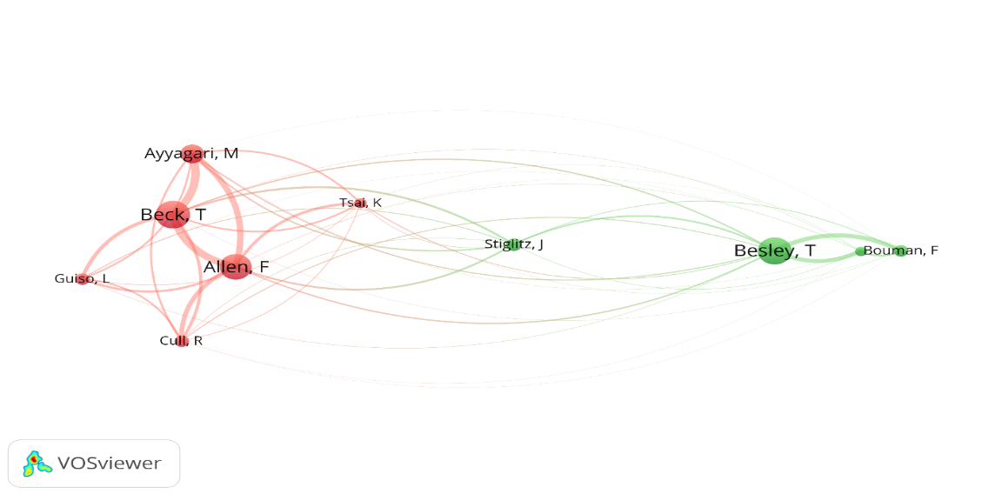
Source: Authors’ own analysis compilation (based on the data retrieved from WoS)
In the network visualization, the size of an author's node corresponds to their total link strength, while a line connecting two authors indicates a co-citation link, meaning a third document has cited these authors together. The leading authors based on total link strength are Beck, T. (92 citations, 350 TLS), Allen, F. (85, 340), Ayyagari, M. (63, 279), Besley, T. (91, 219), Cull, R. (38, 170), Guiso, I. (38, 149), Stiglitz, J. E. (42, 133), Tsai, K. S. (33, 124), Anderson, S. (31, 107), and Bouman, F. J. A. (38, 105). The network's clusters reveal the intellectual communities, and the thickness of the connecting lines indicates the strength of the links between them.
A glance at their scholarly works reveals that the authors co-cited in the red cluster focus on trade-offs between formal and informal finance, investigating institutions, legal systems, and the impact of financial development. On the other hand, the authors that co-cited in green clusters concentrate on the microeconomic theories that explain how informal financial markets function, and focuses on the role of social networks, trust, and mechanisms in informal financial arrangements, particularly in developing and rural areas.
- Discussion
Over the years, research on informal finance has steadily grown, reflecting a growing recognition of its importance as both a practical and theoretical complement to formal financial systems. From 1990 to 2024, the number of publications was seen to rise consistently, with a notable acceleration after 2016 and a peak in 2023 (Figure 1). This upward trend is not merely a quantitative increase, it reflects a qualitative shift in the perception of informal finance. The growth suggests that the field is moving beyond foundational, descriptive studies toward more nuanced, policy-oriented analyses that address the complex interplay between formal and informal financial sectors.
Performance analysis by affiliation revealed that institutions such as Cornell University, the World Bank, and the University of London lead the studies on informal finance (Figure 4), illustrating the intermingling of academic inquiry and policy-oriented research. In the meanwhile, the study found that sources like the World Development, Journal of Developments Economics, and Emerging Markets Finance and Trade (Figure 3) contributed the highest number of studies on informal finance and its related field. The geographical distribution of research highlights significant asymmetries. China and the United States together produce nearly half of the global output (Figure 2). China's prominent contribution reflects its reliance on community-based financial practices, such as rotating savings and credit associations, rural credit cooperatives, and other informal arrangements, alongside active state policies promoting financial inclusion. In contrast, the United States' influence is largely driven by its strong academic institutions, well-developed funding networks, and leadership in global development finance debates. The UK, France, Germany, Australia, and India are found to make meaningful scholarly contributions on the subject (Figure 7).
However, the Asia, Africa, and Latin America regions, where informal finance is deeply rooted in everyday life of its population remain underrepresented. This imbalance points to a disconnect between where informal finance is most prevalent and where scholarly attention is concentrated. It raises concerns about knowledge production, as theories and policy debates may be disproportionately shaped by institutions in the Global North, even though the Global South is the primary context for these studies. This reflects a well-documented "big city bias" in access to finance and, by extension, in financial research, where central, well-resourced institutions tend to dominate the production of knowledge (Lee & Luca, 2018).
The co-authorship among countries analysis suggests this "big-city bias" may be reducing. For instance, the emergence of India and Vietnam as expanding nodes (Figure 7) indicates a positive trend toward the decentralization of research activity. Growing international collaboration helps mitigate the risks of a detached research agenda by fostering knowledge co-creation between scholars from developed and developing nations. This collaborative dynamic is crucial for blending theoretical concepts with practical contextual understanding. The analysis of citation by documents (Table 1) reveals two dominant pillars: empirical macro-level work comparing formal versus informal finance (Beck et al., 2007; Ayyagari et al., 2010), and the micro-theoretical work on the mechanics of informal institutions like ROSCAs (Besley et al., 1993; Baland & Anderson, 2002).
A time-based analysis of keyword co-occurrence offers deeper insights into the thematic evolution of the informal finance and its related field (Figure 8). Keywords content allows us to reconstruct the likely intellectual trajectory of the research front, moving from foundational concepts to contemporary policy debates. This evolution can be conceptualized in three overlapping phases. The earliest research emphasized theorizing the economic mechanism of informal finance in the early 1990s. This was followed by a shift in the mid-2000s towards studies aiming at measuring the impact of informal finance and comparisons with the formal system. A more recent shift can be seen in refining policy applications with a focus on financial inclusion, gender constraints, trust, and resilience, demonstrating a scholarly progression from theory to measurement and finally to targeted policy relevance.
The bibliometric evidence demonstrates both the consolidation and the unevenness of informal finance research. On the one hand, the field has established clear thematic clusters, influential scholars, and strong institutional bases, signaling growth. On the other hand, it remains geographically concentrated, which has implications for policy relevance and inclusivity. Addressing these imbalances could broaden the field, enrich theoretical perspectives, and ensure that informal finance research continues to evolve in a way that reflects its global diversity and practical importance.
The bibliometric study reveals a field in dynamic transition, charting the evolution of informal finance. The research landscape is defined by a dual intellectual architecture, comprising macro-level empirical work on the financial system and the foundational micro-level exploration of the mechanisms of informal institutions. The literature's clear trajectory from describing mechanisms, to measuring impact, and now to refining policy applications, marks it as an essential field of study.
- Conclusion, Limitations and Way Forward
Amidst the imperfect market system in underdeveloped and emerging economies, informal financing arrangements have gained traction as an alternative to the formal financial system (Linh et al., 2020; Schreiner, 2001) as evident in the yearly publications. Informal financing arrangements functions both as a complementary and as a substitute in most economies (Madestam, 2014). The linkage of the formal and informal is construed to be horizontally or vertically linked. Horizontal link provides evidence on the substitutive role of the informal market, particularly in the absence of the formal market. The vertical linkage involves a more complementary and coordinated relationship (Batini et al., 2010). To necessitate a more complementary economic development, Ghate (2000) suggests linking the formal finance with micro and informal finance. The informal sector has the ability to channelize funds faster when required, and has a greater outreach and flexibility. On the other hand, the formal sector, though rigid, has the upper hand in channelizing funds from the whole economy to the needy for reasonable interest. The amalgamation would result in a more effective instrument of finance, where the perks of the informal and formal can be utilized (Ghate, 2000).
This study has some limitations that need to be acknowledged. The study is carried out using the WoS database, leaving out similar works in the field in other databases, and region-specific studies on informal finance. Bibliographic approach although useful for mapping broad patterns, rely heavily on counts of publications and citations, which sometimes fail to capture the depth of qualitative research or the contextual differences of operation of informal finance practices across communities. Future research can overcome these limitations, by incorporating multiple databases, and adopting mixed perspectives, allowing for more comprehensive research on the topic. Researchers may focus on the evolution of these arrangements in recent times, at the same time, may conduct studies on their adaptation and response to technological changes, especially mobile banking and digital credit. Informal finance arrangements have become integral part of finance and development studies in current scenario; however, its relevance depends on its documentation from the perspective of the lived experiences of its users, which in turn will allow for a more holistic policy formulation, thus promoting financial inclusion and fostering sustainable economic development.
Competing Interest
The Authors declare that there is no competing interests.
Declaration on AI Usage
The authors declare that artificial intelligence (AI) tools were used only to assist in improving language, grammar, and readability of the manuscript.
References
- Bouman, F. J. A. (1995). Rotating and accumulating savings and credit associations: A development perspective. World Development, 23(3), 371-384.
- Beck, T., Demirgüç-Kunt, A., & Pería, M. S. M. (2009). Banking services for everyone? Barriers to bank access and use around the world. World Bank Economic Review, 22(3), 397–430.
- Banerjee, A. V., & Duflo, E. (2001). Poor economics: A radical rethinking of the way to fight global poverty. New York: Public Affairs.
- Allen, F., Qian, J., & Qian, M. (2012). China's financial system: Opportunities and challenges. NBER Working Paper No. 17828.
- Madestam, A. (2014). Informal finance: A theory of moneylenders. Journal of Development Economics, 107, 157–174.
- Adams, D.W., & Fitchett, D.A. (Eds.). (1992). Informal Finance in Low-Income Countries (1st ed.). Routledge. https://doi.org/10.4324/9780429034572
- Jain, S. (1999). Symbiosis vs. crowding-out: The interaction of formal and informal credit markets in developing countries. Journal of Development Economics, 59(2), 419–444.
- Lee, S., & Persson, P. (2016). Financing from family and friends. The Review of Financial Studies, 29(9), 2341-2386. https://www.jstor.org/stable/44014929
- Ojong, N. (2018). Trust, cultural norms, and financial institutions in rural communities: The case of Cameroon. Review of Social Economy, 76(1), 19-42. https://doi.org/10.1080/00346764.2017.1300316
- Bouman, F. (1990). Informal rural finance: An Aladdin's lamp of information. Sociologia Ruralis, 30(2), 155-173. https://doi.org/10.1111/j.1467-9523.1990.tb00407.x
- Sile, I.C. (2015). Determinants of Informal Finance Use in Kenya. Research Journal of Finance and Accounting, 6(21), 6-19.
- Meyer, R. L., & Nagarajan, G. (1992). An assessment of the role of informal finance in the development process (No. 996-2016-77859).
- Aliber, M. (2015). The importance of informal finance in promoting decent work among informal operators: A comparative study of Uganda and India (Working Paper No. 66). International Labour Organization, Social Finance Programme.
- Morduch, J. (1999a). The microfinance promise. Journal of Economic Literature, 37(4), 1569-1614. https://www.jstor.org/stable/2565486
- Mowl, A. J. (2016). The Technology of Lending: Informal Credit Contracts (unpublished). NSE-IFMR Finance Foundation Financial Deepening and Household Finance Research Initiative. http://foundation. ifmr. co. in/the-technology-of-lending-informal-credit-contracts.
- Guirkenger, C. (2008). Understanding the coexistence of formal and informal credit markets in Piura, Peru. World Development. 36(8), 1436-1452.g https://doi.org/10.1016/j.worlddev.2007.07.002
- Ardener, S. (2014). Credit unions and Money Clubs (ROSCA). Anthropology Today, 30(4). https://rai.onlinelibrary.wiley.com/doi/10.1111/1467-8322.12118
- Mpofu, O., & Sibindi, A. (2022). Informal finance: A boon or bane for African SMEs? Journal of Risk and Financial Management, 15, 270. http://dx.doi.org/10.3390/jrfm15060270
- Toka, A. S., & Asha, A. A. (2019). Challenges and contributions of informal finance to the livelihoods of rural households in Gamo Gofa Zone, Ethiopia. Journal of Agricultural Extension and Rural Development, 11(5), 94-105.
- Bouman, F. J. A. (1979). The ROSCA: Financial technology of an informal savings and credit institution in developing economies. Savings and Development, 3(4), 253-276. https://www.jstor.org/stable/25829714
- Jain, S., & Mansuri, G. (2003). A little at a time: The use of regularly scheduled repayments in microfinance programs. Journal of Development Economics, 72, 253-279. https://doi.org/10.1016/S0304-3878(03)00076-2
- Fitri, R. (2006). Informal Finance and Poverty Alleviation: A Grassroots Study of Small Farmers' Credit in West Sumatra, Indonesia. [Doctoral dissertation, Massey University]. Massey University Repository.
- Goedecke, J., Guerin, I., D'Espallier, B., & Venkatasubramanian, G. (2018). Why do financial inclusion policies fail in mobilizing savings from people with low incomes? Lessons from rural South India. Development Policy Review, 36(1). http://dx.doi.org/10.1111/dpr.12272
- Kharisma, B., Remi, S. S., Hadiyanto, F., & Saputra, A. D. (2020). The economics of rotating savings and credit associations (ROSCAs) and poverty in Indonesia. Economia, 16(1), 100-111. http://dx.doi.org/10.21831/economia.v16i1.30308
- Kabuya, F. I. (2015). The rotating savings and credit associations (ROSCAs): Unregistered sources of credit in Local communities. IOSR Journal of Humanities and Social Science, 20(8), 95-98. https://doi.org/10.9790/0837-20849598
- Lukwa, A. T., Wayas, F O., Lambert, E. V., & Alaba, O. A. (2022). Can informal savings groups promote food security and social, economic, and health transformations, especially among women in urban Sub-Saharan Africa: A narrative systematic review. Sustainability 14(3153). https://doi.org/10.3390/su14063153
- Sharma, M., & Zeller, M. (1997). Repayment performance in group-based credit programs in Bangladesh: An empirical analysis. World Development, 25 (10), 17331-1742.
- Beck, T., Demirguc-Kunt, A., & Martinez Peria, M. S. (2007). Reaching out: Access to and use of banking services across countries. Journal of Financial Economics, 85(1), 234-266.
- Donthu, N., Kumar, S., Mukherjee, D., Pandey, N., & Lim, W. M. (2021). How to conduct a bibliometric analysis: An overview and guidelines. Journal of Business Research, 133, 285-296. https://doi.org/10.1016/j.jbusres.2021.04.070
- Ozturk, O., Kocaman, R., & Kanbach, D. K. (2024). How to design bibliometric research: An overview and a framework proposal. Review of Management Science, 18, 3333-3361. https://doi.org/10.1007/s11846-024-00738-0
- Harriss-White, B. (2009). Globalisation, the financial crisis and petty production in India’s socially regulated informal economy’. Global Labour Journal.
- Yap, S., Shan Lee, H., & Xin Liew, P. (2023). The role of financial inclusion in achieving finance related sustainable development goals (SDGs): a cross-country analysis. Economic research-Ekonomska istraživanja, 36(3).
- Guo, F., Huang, Y., Wang, J., & Wang, X. (2022). The informal economy at times of COVID-19 pandemic. China Economic Review, 71, 101722.
- Sarkar, O. T., Hasan, M. A., & Saha, S. K. (2025). Resilience in the informal economy amidst the COVID-19 crisis: the experience of street vendors in Dhaka, Bangladesh. Urban, Planning and Transport Research, 13(1), 2502001.
- Degryse, H., Lu, L., & Ongena, S. (2016). Informal or formal financing? Evidence on the co-funding of Chinese firms. Journal of Financial Intermediation, 27, 31-50.
- Li, H., & Hiwatari, M. (2025). Formal and informal finance in china and its relationship to household wealth: an empirical analysis based on micro data. SN Business & Economics, 5(7), 78.
- Lee, N., & Luca, D. (2018). The big-city bias in access to finance: Evidence from firm perceptions in almost 100 countries. Journal of Economic Geography, 19(1), 199-224. https://doi.org/10.1093/jeg/lbx047
- Ayyagari, M., Demirgüç-Kunt, A., & Maksimovic, V. (2010). Formal versus informal finance: Evidence from China. Review of Financial Studies, 23(8), 3048–3097.
- Besley, T., Coate, S., & Loury, G. (1993). The economics of rotating savings and credit associations. The American Economic Review, 83(4), 792-810. https://www.jstor.org/stable/2117579
- Baland, J. M. & Anderson, S. (2002). The economies of Roscas and intrahousehold resource allocation. The quarterly Journal of Economics, 117, 963-995. https://doi.org/https://doi.org/10.1162/003355302760193931
- Linh, T.N., Tuan, D.A., Trang, P.T., Lai, H.T., Anh, D.Q., Cuong, N.V., & Lebailly, P. (2020). Determinants of farming households’ credit accessibility in rural areas of Vietnam: A case study in Haiphong city, Vietnam. Sustainability, 12(11), 1-16 http://dx.doi.org/10.3390/su12114357
- Schreiner, M. (2001). Informal finance and the design of microfinance. Development in Practice, 11(5), 637-640. https://www.jstor.org/stable/4029431
- Batini, N., Kim, Y.B., & Lotti, E. (2010, February). Informal labour and credit markets: A survey (International Monetary Fund Working Papers No. 42). https://www.imf.org/en/Publications/WP/Issues/2016/12/31/Informal-Labour-and-Credit-Markets-A-Survey-23611
- Ghate, P. (2000). Linking finance with micro and informal finance. The Bangladesh Development Studies, 26 (2), 201-215. https://www.jstor.org/stable/40795617
- Sinha, P., & Navin, N. (2021). Performance of self-help groups in India. Economic and Political Weekly, 56(3), 36-43.

