Effects of Governmental debt on Nigerian economic growth, with a focus on the relative contributions of domestic and external debt

Abstract
Public debt has emerged as a vital fiscal instrument in rising economies such as Nigeria, where chronic income shortages necessitate borrowing to fund growth. While public debt may boost economic growth when handled properly, excessive accumulation might jeopardize macroeconomic stability due to debt overhang and crowding out effects. This research experimentally investigates the short- and long-run effects of governmental debt on Nigerian economic growth, with a focus on the relative contributions of domestic and external debt. Using yearly time-series data from 1990 to 2023, the study applies the Autoregressive Distributed Lag (ARDL) bounds testing method. The findings support the existence of a long-run link between public debt and economic growth. Empirical evidence suggests that domestic debt has a positive and statistically significant effect on long-run economic development, but external debt has a positive but insignificant effect, lending credence to the debt overhang theory. In the short-run, government spending, inflation, labour force, and capital formation all have a negative impact on growth. The analysis indicates that effective debt composition and management are critical for Nigeria's sustained economic growth.

INTRODUCTION
Public debt is a major policy challenge in emerging economies, particularly resource-rich countries like Nigeria. It is a crucial tool for funding infrastructure, promoting growth, and closing budgetary shortfalls. Excessive debt accumulation, on the other hand, might discourage private investment, raise debt service costs, and destabilise macroeconomic performance. Public debt refers to the liabilities accumulated by the government through borrowing, which includes all outstanding bonds and obligations that have yet to be fulfilled (Nymphas et al., 2023). Fiscal shortages, which arise when revenue fails to meet expenditure obligations, typically prompt governments to borrow. The primary goal of such borrowing is to finance critical infrastructure and development projects, particularly in environments with low domestic savings (Ikwuo et al., 2024). Borrowing can occur domestically or externally; domestic debt refers to cash obtained inside the national economy, whereas external debt comes from other nations and international financial organisations.
Nigeria's strong reliance on crude oil as its principal income source, combined with a chronically low revenue-to-GDP ratio, has made regular borrowing an important budgetary strategy (Kenneth, 2022). The country's susceptibility to oil price volatility underscores the critical need to diversify its income source. Government development initiatives and policies place significant financial demands (Sani & Nwite, 2021), and the buildup of public debt has a direct impact on fiscal sustainability and macroeconomic credibility (Central Bank of Nigeria [CBN], 2022). In recent years, debt payment has absorbed an alarming amount of Nigeria's earnings, reaching 96% in 2023 (National Bureau of Statistics [NBS], 2024). Persistent fiscal deficits, infrastructure funding requirements, and external shocks have increased governmental debt (Adeola & Evans, 2018). Excessive borrowing, if not handled well, can cause debt hardship and macroeconomic instability. Key indices of debt sustainability include the debt-to-GDP ratio, debt service-to-revenue ratio, and external obligation structure (Ighodaro, 2019). While well-managed debt may spur growth, excessive amounts frequently need fiscal retrenchment to ensure stability.
Nigeria's state debt has increased dramatically over the last three decades, owing to persistent fiscal deficits, volatile oil prices, and foreign economic disturbances. Despite the debt reduction gained by the Paris Club Agreement in 2005 and 2006, debt levels have continued to rise due to growing domestic and external borrowing. This expansion has taken place under fluctuating economic performance, currency rate volatility, and inflationary pressures. Nigeria's external debt increased from ₦2.33 billion in 1981 to ₦53.2 trillion in 2023, leading to a total national debt of ₦91.4 trillion, up from ₦40.9 trillion in 2022. The debt portfolio comprises both internal instruments like as Treasury bills, FGN bonds, Sukuk, and green bonds, as well as external loans from multilateral and bilateral organisations including International Monetary Fund (IMF), World Bank, African Development Bank (AfDB), and the Paris Club (CBN, 2023).
Fiscal policies at the federal and provincial levels have also fueled debt growth. According to Oniha (2022), the state debt increased from ₦39.56 trillion in December 2021 to ₦41.60 trillion in early 2022. This was mostly due to fresh domestic borrowings to pay the budget deficit, Eurobond issuances, and loans from overseas creditors. Weak income mobilisation and recurring budget deficits have exacerbated the situation. Although Nigeria's debt-to-GDP ratio is still relatively modest by worldwide standards, the high debt-service-to-revenue ratio creates a severe sustainability issue (CBN, 2021; World Bank, 2022). The country's low tax-to-GDP ratio further limits income collection, making borrowing a common part of fiscal management. Unless changes in spending efficiency, revenue diversification, and fiscal discipline are enacted, state debt will continue to endanger Nigeria's macroeconomic stability (Ejinkonye, et al., 2025)
When responsibly handled, government borrowing may encourage economic growth by funding vital areas such as infrastructure, healthcare, and education, therefore generating jobs and increasing productivity (Kobayashi, 2015). Borrowing in unfavourable conditions or at high interest rates, on the other hand, can be unproductive, resulting in rising debt-service costs and crowding out productive spending. Despite a substantial dependence on borrowing to spur development in Nigeria, economic growth has been slow, and debt levels have risen above sustainable levels. The government continues to spend a disproportionate share of its revenue to debt payment, leaving insufficient budgetary flexibility for necessary expenditures in infrastructure like as transport networks, hospitals, and power generation (Akabueze, 2018). This outcome reflects inefficiencies in debt utilization and undermines the developmental intent of borrowing.
External shocks, revenue volatility, and institutional flaws all add to Nigeria's macroeconomic difficulties. In Q4 2023, the total public debt was ₦87.91 trillion (about $114.35 billion) according to the NBS (2024). The COVID-19 pandemic worsened fiscal pressures, as increased government spending on healthcare and social protection expanded the debt burden (World Bank, 2020).
Given Nigeria's expanding public debt profile, a fundamental policy question is whether public borrowing promotes macroeconomic growth or has become a restraint on development. Understanding the macroeconomic implications of the rising debt burden is critical for evidence-based policymaking and the development of long-term fiscal solutions. Effective debt management is critical not just for preserving fiscal stability and investor confidence, but also for ensuring that borrowing promotes inclusive and long-term growth.
As a result, the purpose of this study is to empirically investigate the short-run and long-run effects of public debt on economic growth, and to assess the relative impact of external and domestic debt on economic growth. To achieve these objectives the study relied on Autoregressive Distributed Lag Model (ARDL) given its capability to estimates short-run and long-run impact effectively. The rest of the paper is divided into four Sections. The next Section contains the Literature Review, and this is followed in Section 3 by Methodology, while Section 4 contains the results, and finally the concluding section.

LITERATURE REVIEW
The empirical evidence on the relationship between public debt and economic growth in Nigeria is complicated and often contradictory. Most studies agree that the influence of public debt on growth is determined on its composition, whether domestic or external, as well as the efficiency with which borrowed funds are used. For example, Alagba and Eferakeya (2019) discovered that local debt considerably boosts economic growth, but international debt has a lesser or insignificant influence. Similarly, Ajayi and Adewusi (2020) and Ejinkonye et al. (2025) found that domestic debt has a positive effect on GDP but external debt has a negative effect, emphasising the necessity of wise management of foreign loans. Nymphas et al. (2023) also found that when fiscal management is effective, both foreign and domestic loans may boost GDP, implying that debt's impact is primarily determined by its productive use.
Several studies have found that excessive debt buildup might stifle growth due to debt overhang and crowding-out effects. Okorie and Cookey (2020) discovered that development stocks had a negative but large influence on growth, whereas Treasury bonds had a favourable but small effect. Similarly, Ekperiware et al. (2022) and Abdulmumin (2022) discovered conflicting results, with domestic debt having both bad and positive consequences over time, and external debt limiting or supporting growth depending on management quality.Elom-Obed et al. (2017) and Eke and Akujuobi (2020) found that both domestic and overseas loans have a detrimental impact on economic growth due to corruption, misuse of money, and ineffective debt management. Veronica (2021) and Abdulkarim and Saidatulakmal (2021) confirmed that high debt servicing ratios significantly reduce growth, implying a debt overhang problem, and advised Nigeria to diversify its revenue base and strengthen public institutions to ensure better use of borrowed funds.
Further data from Gobna et al. (2022) shown that debt sustainability is critical in deciding growth outcomes; whereas public debt-to-oil revenue ratios have a negative effect, debt-to-non-oil revenue ratios can favourably influence growth in the long run.Oladotun and Olanipekun (2024) expanded on this point, demonstrating that while domestic debt boosts private consumption, it also decreases production, whereas external debt may promote investment if well managed. Egbetunde (2012) demonstrated a bidirectional causal link between debt and growth, implying that responsible borrowing and transparency may transform public debt into an economic development instrument.
METHODOLOGY
Theoretical Framework
This research is based on the Debt Overhang Theory, which is supported by the Keynesian and Neoclassical Growth Theories. These theories describe the dynamic link between public debt and economic growth in both the short and long run.
Krugman (1988) and Sachs (1989) created the Debt Overhang Theory, which states that when a country's debt load grows too high, the expected cost of future debt payment serves as a tax on investment. High debt levels deter both local and international investors since some of the additional output created will be utilised to repay creditors rather than benefiting the economy. As a result, debt buildup over a certain level can stifle long-term growth by diminishing investment efficiency and productivity. This idea directly supports the study's primary purpose, which is to investigate the short- and long-term consequences of public debt on economic development. In the short run, modest borrowing can boost growth by funding productive spending, but in the long run, excessive debt can create a debt overhang, limiting economic performance.
The theory also lays the groundwork for determining the relative influence of external and domestic debt on economic development. External debt is frequently linked with higher repayment and exchange-rate risks, making it more likely to result in a negative debt-overhang impact than domestic debt, which can be serviced in local currency and is less vulnerable to foreign exchange volatility. Thus, the Debt Overhang framework explains why the growth effects of external and domestic borrowing may differ, satisfying the second objective of the study.
In addition to this viewpoint, the Keynesian Theory of Public Debt claims that government borrowing may promote aggregate demand, production, and employment when resources are underutilised (Keynes, 1936). Borrowing to finance productive investment may thus have a positive short-term impact on GDP, consistent with expansionary fiscal policy. In contrast, the Neoclassical Growth Theory (Solow, 1956) emphasises capital accumulation and productivity as the primary drivers of long-term growth. According to this viewpoint, chronic or excessive debt discourages private investment and lowers capital creation, resulting in a slowdown in long-term economic growth.
To summarise, these theories explain the dual nature of the public debt's impact on economic performance. While Keynesian principles support the possible short-run benefits of borrowing for productive spending, the Debt Overhang and Neoclassical frameworks emphasise the hazards of excessive indebtedness on long-run growth sustainability. This comprehensive theoretical framework provides a solid platform for examining both the temporal (short- and long-run) and structural (external vs domestic) features of public debt's influence on Nigerian economic growth.
The growth-debt model derived the Neoclassical growth framework, augmented with the Debt overhang and keynesian theories is given as:
Y = f (K,L,D) (1)
Where:
Y - Economic Growth
f - Function
K - Capital stock
L - Labour force
D - Public debt

Model Specification
As shown in the theoretical framework above, the empirical model of this study arose from the theoretical assumption. The study's model is adapted from the works of Abdulkarim and Saidatulakmal (2021); Abdulmumin (2022). From equation 1, the below model is specified to achieve the objectives of the study:
GD = f (ED, DD, LF, GF) (2)
Augmenting the model to accommodate other control variables, equation 3.2 becomes:
GD = f (ED, DD, LF, GF, GE, EX, IN) (3)
The model in its econometrics form becomes:
lnGD_{t} = ∞₀ + ∞₁lnED_{t} + ∞₂lnDD_{t} + ∞₃LF_{t} + ∞₄lnGF_{t} + ∞₅lnGE_{t} + ∞₆lnEX_{t} + ∞₇IN_{t} + U_{t} (4)
Transforming equation 3.4 into Autoregressive Distributed Lag (ARDL) model, equation 3.4 becomes:
$∆GD=a_{0}+ \sum_{i=1}^{n}{a_{1}}∆ln{GD}_{t-i}+ \sum_{i=1}^{n}{a_{2}}∆ln{ED}_{t-i}+ \sum_{i=1}^{n}{a_{3}}∆ln{DD}_{t-i}+ \sum_{i=1}^{n}{a_{4}}∆{LF}_{t-i}+ \sum_{i=1}^{n}{a_{5}}∆ln{GF}_{t-i}+ \sum_{i=1}^{n}{a_{6}}∆ln{GE}_{t-i}+ \sum_{i=1}^{n}{a_{7}}∆{IN}_{t-i}+ \sum_{i=1}^{n}{a_{8}}∆ln{EX}_{t-i}+ \sum_{i=1}^{n}{B_{1}}ln{GD}_{t-i}+ \sum_{i=1}^{n}{B_{2}}ln{ED}_{t-i}+ \sum_{i=1}^{n}{B_{3}}ln{DD}_{t-i}+ \sum_{i=1}^{n}{B_{4}}{LF}_{t-i}+ \sum_{i=1}^{n}{B_{5}}ln{GF}_{t-i}+ \sum_{i=1}^{n}{B_{6}}ln{GE}_{t-i}+ \sum_{i=1}^{n}{B_{7}}{IN}_{t-i}+ \sum_{i=1}^{n}{B_{8}}ln{EX}_{t-i}+ U_{t}$ (5)

Where:
GD - Real GDP
DD - Domestic debt
ED - External debt
LF - Labour force
GF - Gross fixed capital formation
GE - Government expenditure
EX - Exchange rate
IN - Inflation rate
U_{t} - Error term
a and B - are the parameters to be estimated
Ln- Natural logarithm
∆- is the first difference operator and is the drift component.
The expression with summation sign (a₁ - a₈) represents the short-run dynamics of the model, while the coefficients (B₁ - B₈) represent long-run relationship.
Estimation Technique and Data
To achieve objectives of the study, the study used the ARDL bounds testing approach developed by Pesaran & Shin, (1999) and Pesaran, Shin, & Smith, (2001) as an estimating technique. This method was chosen because of its adaptability in a small sample research and its usefulness for variables of varying order of integration, whether integrated as I(0), I(1), or mutually cointegrated. Furthermore, the ARDL estimates the long run and short run simultaneously without losing long run information, and it does not suffer from endogeneity (Pesaran, Shin, & Smith, 2001).
The study employed GDP growth rate, public debt, domestic debt, external debt, gross fixed capital formation, government expenditure, labour force, exchange rate and inflation. The data are sourced from CBN Statistical Bulletin, Debt Management Office (DMO), NBS, and World Bank. The ED, DD, and GE are captured in billions of Naira, while the GF is captured in United State of America (US) Dollar. The IN, EX, and LF are captured in percentages, while GD is captured in millions of US Dollar.
RESULTS AND DISCUSSION
Descriptive Analysis
A graph showing changes in the variables of the study over time is shown as part of the trend analysis. It shows a link between the public debt and economic growth in Nigeria.
Figure 1: Trend Analysis of the Variables
GROSS DOMESTIC PRODUCT EXTERNAL DEBT
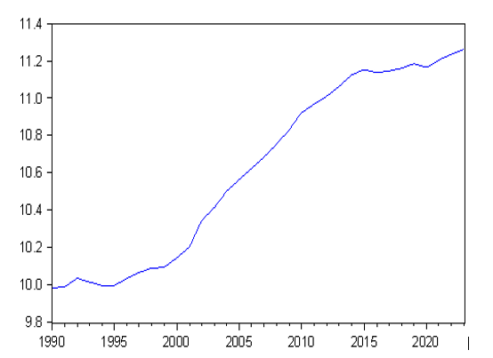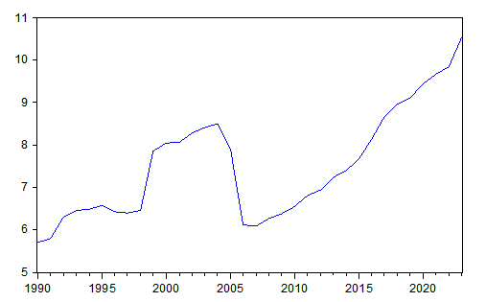

DOMESTIC DEBT GOVERNMENT EXPENDITURE
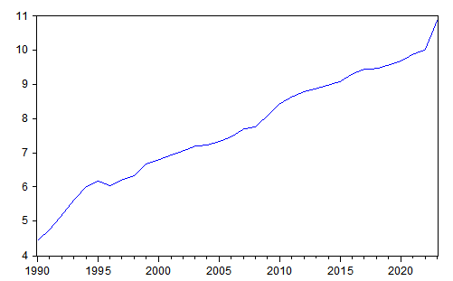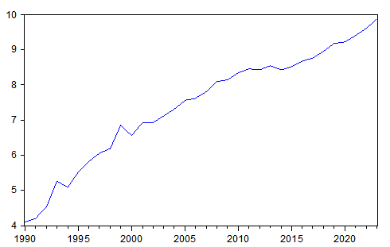

GROSS FIXED CAPITAL FORMATION INFLATION RATE
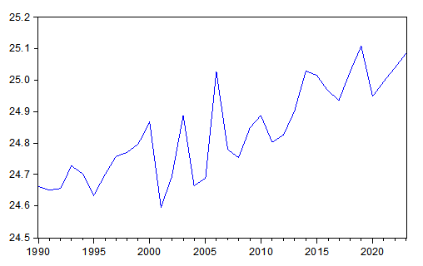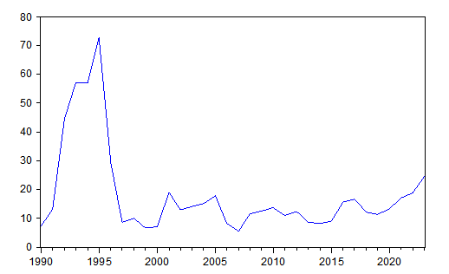
LABOUR FORCE EXCHANGE RATE
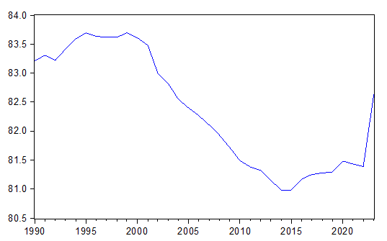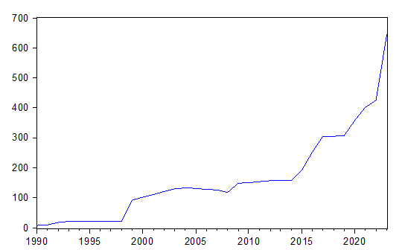
Source: Author’s graph based on the data employed

Economic growth proxied by real GDP seems to increase steadily over time. It started at around 21,680 million dollars in 1990 and increased to approximately 77, 936 millon dollars by 2023. This indicates consistent growth in GDP over the years. External shows an upward trend from 1990 to 2005, then fall sharply around 2007 and also continue to increase from around 2008 to 2023. This suggests a growing external debt stock by the government. The domestic debt and government expenditure showed an upward trends, suggesting that bulk of government expenditure have been financed through debt. On the other hand, the gross fixed capital formation showed an irregular trend with is not good for the economy as capital formation is expected to grow to steadily to influence economic growth. However, inflation showed a downward trend after it peaked around 1995 to 2019. Then it continued rising from 2020. This trend implies that price are not stable in the country which affect investors’ confidence. Labour force participation rate continued to decline around 2001 to 2015, then started rising. This trend suggest a high rate of unemployment in the country. Meanwhile the exchange rate had continue to increase since 1990. This trend shows that the country is an import dependent economy.

The Correlation Analysis
Table 1 extends to assess the level of association among the variables used for measurement. We shall look at the correlation between dependent variables and explanatory factors in this context.
Table 1: The Correlation Matrix
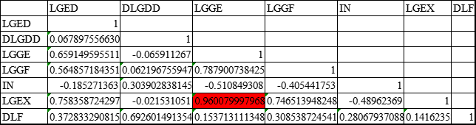
Source: Author’s computation

A strong correlation exists between variables GE and EX, as the correlation matrix is greater than 0.8, indicating potential multicollinearity. Consequently, a further diagnostic method, the Variance Inflation Factor (VIF), was employed.

Table 2: The Variance Inflation Factor
Variable | Coefficient | VIF
LGED | 0.0019 | 4.4583
DLGDD | 0.0061 | 2.6935
LGGE | 0.0066 | 22.5037
LGGF | 0.0929 | 3.0025
IN | 4.5600 | 1.7226
LGEX | 0.01638 | 28.4627
DLF | 0.034 | 3.6774
Source: Author’s computation

The VIF results indicated severe multicollinearity between variables GE and EX, as the VIF is greater than 5 for both. Consequently, the exchange rate was excluded to mitigate multicollinearity while preserving theoretical consistency. Although EX may influence GD through external sector channels, GE is retained in the model due to its direct fiscal linkage with public debt and its central role in growth theory.

Testing for Stationarity
The analysis of the data's characteristics must be crucial prior to entering into a cointegration analysis. It is important to examine stationarity in economic time series data, given that traditional econometric methodologies presume such a consistency even if it is often not the case. Consequently, standard statistical tests may not be appropriate, and the conclusions drawn could be flawed and misleading.
Table 3: The Results of Unit Roots Test
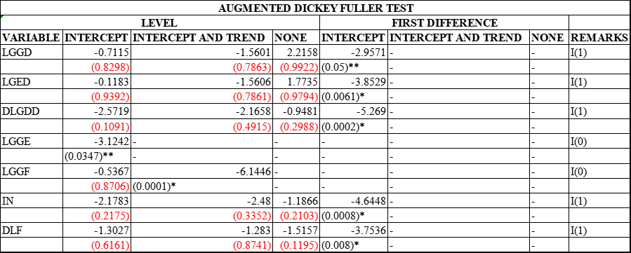
Source: Author’s computation
Where: “*” indicates significance at 1% and “**” indicates significance at 5%.
Using the Augmented Dickey-Fuller (ADF) test, the trends of all variables were utilised to run unit root tests to determine the stationarity of the variables. Table 3 displays the results of the unit root testing. According to the results of the stationarity test, only two variables (GE and GF), were stationary at a level, and all other variables became stationary at a first difference.

ARDL Bound Test
Table 4: Null Hypothesis: No Long-run Relationships among the Variables
Test Statistic | Value | K
F-statistic | 7.1164 | 6
Critical Value Bounds
Significance | I(0) Bound | I(1) Bound
10% | 2.12 | 3.23
5% | 2.45 | 3.61
1% | 3.15 | 4.43
Source: Author’s computation

The results of the bound test are shown on the table above. From equation (3.4), the F-statistic of the cointegration test was 7.1164. The result exceeds both the lower and upper critical bounds at the 10% , 5%, and 1% levels of significance, respectively. It shows there is a cointegration between the variables, which means they can be associated with an ongoing relationship. Thus, the explanatory variables employed will have an impact on economic growth in the long run.

Estimated Long-Run and Short-Run Results
Table 5: Estimated Long-Run Coefficients Using the ARDL Approach (2,0,0,0,1,0,2,0)

Variable | Coefficient | Std. Error | t-Statistic | Prob.
Lag of dependent variable
LGGD(-1) | 0.9617 | 0.0423 | 22.7629 | (0.0000)*
Independent
LGED | 0.0062 | 0.0053 | 1.1553 | 0.2623
DLGDD | 0.1152 | 0.0443 | 2.6022 | (0.0175)**
DLF | -0.0891 | 0.0301 | -2.9557 | (0.0081)*
DLF(-1) | -0.0401 | 0.035 | -1.1581 | 0.2612
IN | -0.0008 | 0.0007 | -1.2563 | 0.2243
IN(-1) | 0.0007 | 0.0006 | 1.2669 | 0.2205
LGGE | -0.0408 | 0.0294 | -1.3891 | 0.1809
LGGE(-1) | 0.0137 | 0.0274 | 0.5023 | 0.6212
LGGE(-2) | 0.0478 | 0.0305 | 1.5679 | 0.1334
LGGF | -0.067 | 0.054 | -1.2422 | 0.2293
LGGF(-1) | -0.0952 | 0.05606 | -1.6989 | 0.1057
C | 4.2677 | 1.8756 | 2.2754 | (0.0347)**
Short run Run Coefficients
Variable | Coefficient | Std. Error | t-Statistic | Prob.
D(DLF) | -0.0891 | 0.0151 | 5.9008 | (0.0000)*
D(IN) | -0.0008 | 0.0003 | -2.5494 | (0.0196)**
D(LGGE) | -0.0408 | 0.0186 | -2.4274 | (0.0416)**
D(LGGE(-1)) | -0.0479 | 0.0197 | -2.4274 | (0.0253)**
D(LGGF) | -0.0671 | 0.0329 | -2.0377 | (0.0558)***
COINTEQ | -0.0382 | 0.0047 | -8.096 | (0.0000)*
R-Squared 0.9986 |  | Adjusted R-squared 0.9978
F-statistic 1209.694 |  | Prob(F-statistic) 0.000000
Source: Author’s computation
Where: “*” indicates significance at 1%, “**” indicates significance at 5% and “***” indicates significance at 10%.

Table 6: Post Estimation Tests
Test | Probability
Normality | 1.1295
Serial Correlation | 0.2607
Linearity | 0.3816
Heteroskedasticity | 0.1255
CUSUM | Stable
CUSUMQ | Unstable
Source: Author’s computation

Discussion of the Results
The results of this statistical analysis have significant implications for Nigeria's economic growth, particularly in the context of the country's public debt. The research employs a meticulous approach, incorporating rigorous methods such as unit root assessments, cointegration examinations, multicollinearity test and the utilisation of the Autoregressive Distributed Lag (ARDL) model. These approaches contribute to the trustworthiness of the results and provide a thorough understanding of the associations under consideration. The investigation discerns the existence of an enduring connection among the variables under scrutiny.
In the short run, the gross fixed capital formation has a negative and significant effect on the real value of GDP in Nigeria. This finding is not consistent with the a-priori expectation of the study. The negativity may reflect that capital are being employed for non-productive activities in the country which will impede growth. This result was corroborated with the findings of Abdulmumin (2022).
The labour force has a negative and significant effect on the real value of GDP in Nigeria. This finding is not consistent with the a-priori expectation of the study. This may implies that in the short run labour exact less efforts in production as they look for alternative jobs to augment their low pay This result was corroborated with the findings of Abdulmumin (2022).
Meanwhile the inflation rate has a negative and significant effect on GDP. This is in tandem with the a-priori expectation. This implies inflation rate discourages savings and investment which in turn impede economic growth. The findings is not in line with the result of Veronica, (2021) which found that the inflation rate had a positive and significant impact on economic growth in the short run.
The government expenditure has a negative and significant effect on GDP. This is not in tandem with the a-priori expectation. This may implies that government expenditure is not channelled towards productive activities.
Also the lag of government expenditure has a negative and significant effect on GDP. This is not in tandem with the a-priori expectation. This may implies that government expenditure in the past period is not channelled towards productive activities.
In the long run, the lag of the dependent variable has a positive and significant effect on the real value of GDP in Nigeria. The positive sign reflect that output in the previous period are being utilized well in the production process in the country which will improve economic growth in the current period. This result was corroborated with the findings of Elom-Obed et al., (2017).
The external debt has a positive and insignificant effect on the real value of GDP in Nigeria. This finding is not consistent with the a-priori expectation of the study. The Debt Overhang Theory suggests that when external debt becomes excessive, it discourages investment and reduces long-run economic growth due to heavy debt servicing and exchange rate pressures. Thus, the insignificant effect implies that external debt has no effect on economic growth in Nigeria. This result was not corroborated by the findings of Abdulmumin (2022) and Ikwuo et al., (2024), which found that the effect was positive and significant.
The domestic debt has a positive and significant effect on the real value of GDP in Nigeria. This finding is consistent with the a-priori expectation of the study. Keynes posits that domestic debt is generally less risky because it is serviced in local currency and does not expose the economy to foreign exchange volatility. Therefore, the positive effect implies that when domestic debt are being put into good use, it improve economic growth. This result was corroborated with the results of Abdulkarim and Saidatulakmal (2021); Ejinkoye et al., (2025); Ajayi and Adewusi (2020).
The inflation rate has a negative and insignificant effect on the real value of GDP in Nigeria. The insignificant effect means inflation has no effect on economic growth in Nigeria in the longrun. This result was corroborated with the results of Eke and Akujuobi (2021).
The lag of inflation rate has a positive and insignificant effect on the real value of GDP in Nigeria. The insignificant effect means the lag of inflation has no effect on economic growth in Nigeria in the longrun. This result negate the findings of Veronica, (2021), which found that the lag of inflation rate had a negative and significant effect on economic growth.
The government expenditure has a negative and insignificant effect on the real value of GDP in Nigeria. The insignificant effect means government expenditure has no effect on economic growth in Nigeria. This might be due to large government spending on unproductive activities.
The lag of government expenditure has a positive and insignificant effect on the real value of GDP in Nigeria. The insignificant effect means the lag of government expenditure has no effect on economic growth in Nigeria. This might be due to previous government spending on unproductive activities.
The second lag of government expenditure has a positive and insignificant effect on the real value of GDP in Nigeria. The insignificant effect means the second lag of government expenditure has no effect on economic growth in Nigeria. This might be due to previous government spending on unproductive activities.
However, the gross fixed capital formation has a negative and insignificant effect on the real value of GDP in Nigeria. The insignificant effect means the gross fixed capital formation has no effect on economic growth in Nigeria The result may be due to capital are being employed for non-productive activities in the country. This result negate the findings of Abdulkarim & Saidatulakmal (2021), which found that gross fixed capital formation had a positive and significant impact on economic growth.
Also the lag of gross fixed capital formation has a negative and insignificant effect on the real value of GDP in Nigeria. The insignificant effect means the gross fixed capital formation has no effect on economic growth in Nigeria The result may be due to previous capital are being employed for non-productive activities in the country.

CONCLUSION AND RECOMMENDATIONS
Conclusion
This study delved into the impact of public debt on economic growth in Nigeria using a comprehensive analysis of time series data spanning from 1990 to 2023. The findings shed light on several key factors influencing Nigeria's economic growth.
In the long run, the government spending, inflation, gross fixed capital formation, lag of gross fixed capital formation, labour force, lag of labour force, and inflation rate all had negative effects on economic growth. The labour force was the only statistically significant variable, showing that labour shirking lower Nigeria's real GDP. Domestic debt, lag of GDP, lag of inflation rate, and the lags of government expenditure, on the other hand, had positive impact. The lag of GDP and domestic debt were statistically significant and significant implying that increases in domestic borrowing and previous economic growth improve economic performance when properly managed.
In the short term, all variables had a negative and significant impact on GDP. This implies that only inflation rate was in tandem with the a-priori expectation, while other variables showed opposite effect. The error correction term was negative but small, indicating a slow rate of adjustment to long-run equilibrium. This suggests that short-run disequilibria may not be properly addressed in succeeding periods, highlighting Nigeria's slow macroeconomic stabilisation processes.
The analysis shows that, in both the short and long run, Nigeria's economic growth is more responsive to debt composition, capital creation efficiency, and labour productivity than to government spending or inflation. The insignificant effect of external debt lends support to the debt overhang concept, which states that excessive foreign borrowing may crowd out productive investment and impede long-term growth. Domestic debt, on the other hand, had a positive impact since it is a relatively advantageous financing tool for internal growth when managed properly. The poor and minor error correcting mechanism suggests that Nigeria's economy lacks the structural resilience to recover quickly from short-term shocks.

Recommendations
Based on the research findings, the following policy recommendations are proposed to enhance economic growth in Nigeria:
1. The government should guarantee that both domestic and external borrowings are focused into productive and growth-promoting sectors such as infrastructure, industry, and technology, rather than recurrent spending.
2. Given its insignificant long-term effect, Nigeria should reduce its reliance on external borrowing and prioritise concessional loans with favourable terms, while enhancing debt management transparency.
3. Policymakers should address structural inefficiencies that reduce investment returns. Encourage private sector involvement and reduce infrastructure bottlenecks to increase gross fixed capital formation productivity.
4. The government should channel its expenditure towards productive spending and reduce spending on unproductive activities.
5. The short-term negative impact of the labour force emphasises the importance of skill development, technical education, and improved working conditions in order to increase labour productivity.
6. Due to the slow rate of adjustment, better fiscal and monetary cooperation is required to stabilise inflation, exchange rates, and public spending, allowing for faster convergence towards long-run equilibrium.
7. Since domestic debt boosts growth, Nigeria should continue to strengthen its domestic financial markets, improve debt instruments, and increase transparency in order to attract local investors.

COMPETING INTERESTS DISCLAIMER:
Authors have declared that they have no known competing financial interests OR non-financial interests OR personal relationships that could have appeared to influence the work reported in this paper.

References
Abdulkarim, A., & Saidatulakmal, M. (2021). Effect of public debt on economic growth in Nigeria. International Journal of Economics and Financial Management, 10(1), 30–40. https://doi.org/10.56201/ijefm.v10.no1.2025.pg30.40

Abdulmumin, A. (2022). Public debt and national development: A fiscal sustainability perspective. Fiscal Policy Institute.

Adeola, A., & Evans, O. (2018). Public debt, economic growth, and institutional quality in Africa: A panel analysis. Journal of Economic Studies, 45(5), 878–897.

Ajayi, O. T., & Adewusi, D. G. (2020). Impact of public debt on economic growth in Nigeria. International Journal of Economics and Financial Management, 5(3), 45–56.

Alagba, G., & Eferakeya, I. (2019). The impact of domestic and external debt on Nigeria’s economic growth. Asian Journal of Economics and Empirical Research, 6(2), 67–74.

Akabueze, B. (2018). Nigeria’s public debt management and fiscal sustainability. Budget Office of the Federation.

Central Bank of Nigeria. (2021). Annual statistical bulletin 2020. Author.

Central Bank of Nigeria. (2022). Annual economic report 2021. Author.

Central Bank of Nigeria. (2023). Statistical bulletin: Public finance statistics 2023. Author.

Egbetunde, T. (2012). Public debt and economic growth in Nigeria: Evidence from Granger causality. Journal of Economics and Sustainable Development, 3(9), 1–9.

Eke, C. I., & Akujuobi, A. B. C. (2020). Public debt and economic growth in Nigeria. International Journal of Academic Research in Economics and Management Sciences, 9(2), 43–56.

Eke, C. I., & Akujuobi, A. B. C. (2021). Inflation, public debt, and economic growth in Nigeria. Journal of Economics and Finance, 12(1), 15–27.

Ejinkonye, R. C., Madubuike, K. O., Adiga, D. L., & Mazeli, E. N. (2025). Effect of public debt on economic growth in Nigeria. International Journal of Economics and Financial Management, 10(1), 30–40. https://doi.org/10.56201/ijefm.v10.no1.2025.pg30.40

Ekperiware, M. C., Okorie, N. O., & Afolabi, T. A. (2022). Domestic and external debt and their impact on economic growth in Nigeria. Cogent Economics & Finance, 10(1), 210–227.

Elom-Obed, O. F., Odo, S. I., & Ojei, O. (2017). Public debt and economic growth in Nigeria. Journal of Economics and Sustainable Development, 8(20), 45–56.

Gobna, J. E., Yakubu, M., & Danladi, J. D. (2022). Debt sustainability and economic growth in Nigeria. African Development Review, 34(1), 88–101.

Ighodaro, C. A. U. (2019). Public debt and debt sustainability indicators in Nigeria. Journal of Economics and Sustainable Development, 10(12), 34–45.
Ikwuo, A., Josiah, F. O., Abagha, J. U., Okoegwu, E., & Nkwagu, L. C. (2024). Public debt and economic growth in Nigeria. IOSR Journal of Humanities and Social Science, 29(4), 50–57. https://doi.org/10.9790/0837-2904025057.

Ikwuo, O. U., Akpobasa, G., & Ede, C. (2024). Public debt servicing and economic growth in Nigeria. Journal of Economics and Policy Studies, 11(2), 34–49.

Kenneth, O. E. (2022). Fiscal dependence and public debt in Nigeria. International Journal of Development Finance, 7(2), 102–116.

Keynes, J. M. (1936). The general theory of employment, interest and money. Macmillan.

Kobayashi, K. (2015). Public debt overhang and economic growth: A theoretical perspective. Journal of Economic Dynamics and Control, 51, 250–264.

Krugman, P. (1988). Financing vs. forgiving a debt overhang. Journal of Development Economics, 29(3), 253–268.

National Bureau of Statistics. (2024). Nigerian public debt report, Q4 2023. Author.

Nymphas, C., Adegboye, A., & Yusuf, S. (2023). Fiscal sustainability and debt dynamics in African economies. Journal of Development Economics and Policy, 15(2), 44–63.

Okorie, G. C., & Cookey, A. E. (2020). The impact of public debt on Nigeria’s economic performance. IOSR Journal of Economics and Finance, 11(1), 22–31.

Oladotun, O. M., & Olanipekun, D. B. (2024). Public debt, consumption, and investment dynamics in Nigeria. Journal of African Macroeconomic Studies, 6(1), 1–18.

Oniha, P. (2022). Nigeria’s public debt management strategy and recent developments. Debt Management Office.

Pesaran, M. H., & Shin, Y. (1999). An autoregressive distributed-lag modelling approach to cointegration analysis. Econometrics and Economic Theory in the 20th Century, 371–413.

Pesaran, M. H., Shin, Y., & Smith, R. J. (2001). Bounds testing approaches to the analysis of level relationships. Journal of Applied Econometrics, 16(3), 289–326.

Sachs, J. D. (1989). The debt overhang of developing countries. In G. Calvo et al. (Eds.), Debt, stabilization and development (pp. 80–102). Basil Blackwell.

Sani, U., & Nwite, B. O. (2021). Government expenditure, debt servicing, and fiscal sustainability in Nigeria. African Journal of Economic Policy, 28(2), 67–84.

Solow, R. M. (1956). A contribution to the theory of economic growth. Quarterly Journal of Economics, 70(1), 65–94.

Veronica, B. E. (2021). Impact of public debt on economic growth in Nigeria (1990–2019). Advances in Economics and Business, 9(1), 1–10. https://doi.org/10.13189/aeb.2021.090101

World Bank. (2020). Nigeria economic update: Rising to the challenge. World Bank Group.

World Bank. (2022). Nigeria public finance review: Fiscal adjustment for better and sustained results. World Bank Group.

