Linear Time Series Forecasting of Groundnut Area, Production and Productivity: A Comparative Assessment of ARIMA and ARIMA-ANN Hybrid Models

ABSTRACT
This study examines the time series behavior of groundnut area, production, and productivity in Surguja district, Chhattisgarh, over a 56-year period from 1966–67 to 2021–22. Secondary data were sourced from the EPWRF India Time Series, ICRISAT District-Level Data, the Directorate of Economics and Statistics, and the Directorate of Agriculture, Chhattisgarh. Time series plots and statistical tests, including the Augmented Dickey-Fuller (ADF) test, indicated non-stationarity in the original series, which was addressed through first-order differencing. ARIMA models were then fitted, with ARIMA (0,1,0) selected for area and production, and ARIMA (0,1,1) for productivity, based on minimum AIC and BIC values. Residual analysis and BDS tests confirmed the absence of nonlinear components, suggesting that hybrid ARIMA-ANN models were unnecessary. The ARIMA models alone provided accurate forecasts, as reflected by low RMSE and MAPE values, demonstrating their adequacy for predicting groundnut parameters in Surguja district.

Keywords: ARIMA, ARIMA-ANN, Mean Absolute Percentage Error (MAPE), Root Mean Square Error (RMSE), Forecasting.

Introduction
Oilseeds are agricultural crops grown mainly for obtaining edible oils and have been associated with human civilization since early history. They form an essential component of the global agricultural system due to their nutritional and economic importance. In recent years, world oilseed production has shown consistent growth, reaching over 630 million tonnes during 2021–22. India holds a prominent position in global oilseed cultivation, ranking among the leading producers and contributing a significant share to total world output. India cultivates a diverse range of oilseed crops, including mustard, groundnut, sesame, soybean etc. National oilseed production has steadily increased from around 31 million tonnes in 2018–19 to nearly 38 million tonnes in 2021–22, reflecting improvements in both productivity and cultivation area. States such as Rajasthan, Maharashtra, Madhya Pradesh, and Gujarat are major contributors.
In Chhattisgarh, oilseeds are important cash crops that support farmers’ livelihoods, with favourable agro-climatic conditions offering potential for increased production and income. Beyond oil extraction, by-products like oil cakes are used in food processing, cosmetics, textiles, pharmaceuticals, and as substrates for bioactive compounds, enzymes, antibiotics, and edible mushrooms. Among these crops, groundnut, linseed, mustard, and soybean are particularly significant due to their adaptability, economic value, and industrial applications.Chhattisgarh is in a very good situation to produce oilseeds, which are crucial to the state's agricultural development. Oilseeds constitute one of the most important cash crop of Chhattisgarh. The culinary, cosmetic, textile and pharmaceutical industries can use oilseed cakes as substrates to produce bioactive substances (proteins, dietary fiber and antioxidants) with positive health effects. Additionally, they can provide as substrates for the synthesis of antibiotics, enzymes or mushrooms (Ancuţa and Sonia, 2020). The major Oilseeds include Groundnut, Linseed, Mustard and Soyabean etc.
Groundnut is one of the most important oilseed crops cultivated in India. Commonly known as peanut (Arachis hypogaea), it belongs to the legume family. Owing to its economic and nutritional significance, groundnut is often referred to as the “king of oilseeds” in the country. The crop is particularly valued for its high protein content, which ranges from 24-36%. In addition, groundnut contains a substantial proportion of oil, generally varying between 40-53 %, making it a major source of edible oil.During 2021–22, groundnut was cultivated in Chhattisgarh over 24,965 ha during both kharif and rabi seasons, with a total production of 42.4 thousand tonnes and an average productivity of 1,725 kg ha⁻¹. Surguja district contributed significantly, accounting for 10.81% of the total area and 9.97% of groundnut production in the state.Few studies have analyzed growth trends and future prospects of oilseed area and production in the Surguja division of Chhattisgarh. Forecasting using linear and nonlinear statistical models is essential for identifying trends and supporting informed planning and sustainable development. Bishoyi and Patra (2021) forecasted groundnut production in Odisha (1970–71 to 2020–21) using ARIMA models, demonstrating the effectiveness of time-series techniques in agricultural prediction. Chouksey (2021) applied ARIMAX models to forecast groundnut yield and production in Surguja district, Chhattisgarh, incorporating weather variables as exogenous inputs. The ARIMAX (1,1,1) and (1,1,0) models provided the lowest RMSE for yield and production, respectively. Kumar et al. (2020) identified suitable ARIMA models for analyzing groundnut area, yield, and production in Andhra Pradesh, highlighting the utility of ARIMA models for agricultural planning and policy formulation. Pratiwi, W.A. et al. (2025) conducted a study aimed at assessing and comparing the effectiveness of ARIMA and RNN models in predicting daily gold futures closing prices. The research evaluates forecasting performance using accuracy measures such as RMSE and MAPE, with the objective of determining the most suitable method in terms of accuracy, consistency, and responsiveness to market trends and seasonal patterns. Harshit M., et al. (2025) conducted a study highlighting sugarcane as a key commercial crop in Eastern Uttar Pradesh, playing a vital role in both agricultural earnings and industrial growth. The research utilized the ARIMA time series model to estimate future patterns in sugarcane cultivation area, production, and yield based on historical data from 1960 to 2022 covering 15 districts. Forecasts were extended to 2035 to address uncertainties related to climate change and market instability. Over the study period, the average cultivated area was 343.46 thousand hectares, growing at an annual rate of 0.69%. Mean production reached 12,633.05 thousand tonnes, with an average yield of 44.81 tonnes per hectare. Model performance assessed through RMSE and R² demonstrated strong forecasting accuracy and confirmed ARIMA’s suitability for agricultural planning and decision-making.

Materials and Methods
Surguja district in Chhattisgarh is the subject of the study, which covers 56 years, from 1966–1967 to 2021–2022. Utilisation has been made of secondary data regarding the groundnut crop's area, production, and productivity throughout this time. ICRISAT District-Level Data, the Directorate of Agriculture, Chhattisgarh, the Economic and Political Weekly Research Foundation (EPWRF) India Time Series, and the Directorate of Economics and Statistics were among the reliable sources from which the data were gathered.

ARIMA Model
The Autoregressive Integrated Moving Average (ARIMA) model is the most widely used approaches for analyzing non-stationary time series data. Unlike traditional regression models, the ARIMA model explains a variable,$r_{t}$, in terms of its past (lagged) values as well as stochastic error terms. While this makes the forecasting process more complex, it often provides a better representation of the data series and can result in more accurate predictions. Pure AR or MA models include only autoregressive or moving average components, respectively. However, ARIMA models combine autoregressive (AR), integration (I)—which represents differencing to achieve stationarity—and moving average (MA) components. The standard notation for an ARIMA model is ARIMA (p, d, q), where p represents the autoregressive part's order, d the degree of differencing, and q the moving average part's order. The general formulation of an ARIMA model can be expressed as:

If wt
=∇^{d}r
=(1−B)^{d} r
then

wt=φ1wt−1+φ2wt−2+....+φpwt−p+εt−θ1εt−1−θ2εt−2−.....−θqεt−q
t
t

If {W_{t}} follows the ARMA (p, q) model, and {r_{t}} is an ARIMA (p, d, q) process. For practical purposes, we can take is usually d = 1 or 2 at most.

ANN Model
An Artificial Neural Network (ANN) is a nonlinear, adaptive, and nonparametric modeling approach inspired by the way the human brain processes information. Because of their flexibility and lack of strict assumptions—such as the requirement of linear relationships—ANNs are widely applied in various fields. Typically, an ANN consists of multiple layers, including an input layer, one or more hidden layers, and an output layer. Each neuron (or unit) operates based on two main components: an input function, which calculates the weighted sum of incoming signals, and an activation function, which determines the neuron’s output. The net input to a neuron iii is computed as:
𝑛𝑒𝑡 𝑖𝑛𝑝𝑢𝑡_{𝑖}=∑ _{𝑖}𝑤_{𝑖j}* 𝑜𝑢𝑡𝑝𝑢𝑡_{j} + 𝜇₁

In an artificial neural network, $w_{ij}$ represents the weight connecting neuron $j$ to neuron $i$, while ${\text{output}}_{j}$ denotes the signal from neuron $j$, and $μ_{i}$ is the threshold for neuron $i$. The threshold acts as a baseline input when no other signals are present. If a weight $w_{ij}$ is negative, it is classified as inhibitory, as it reduces the net input to the neuron; otherwise, it is excitatory, enhancing the net input. Each neuron processes its net input using an activation function to produce its output. Various nonlinear functions have been employed as activation functions. The threshold function is particularly useful when inputs and outputs are binary encoded, while sigmoid functions are also commonly used to introduce smooth nonlinearities in the network’s response.

ARIMA -ANN Hybrid Methodology
The hybrid approach models a time series $y_{t}$ as comprising both linear and nonlinear components. This method follows the Zhang (2003) hybrid framework, in which the relationship between the linear and nonlinear components can be represented as:
𝑦_{𝑡}=𝐿_{𝑡}+𝑁_{𝑡}
In the hybrid approach, $L_{t}$and $N_{t}$represent the linear and nonlinear components of the time series, respectively. In this study, the linear component is modeled using the ARIMA model, while the nonlinear component is captured using an Artificial Neural Network (ANN). The methodology follows three steps. First, the ARIMA model is fitted to the linear part of the series, and the resulting predictions are denoted as $\hat{L}$. Second, the residuals from the ARIMA model, $e_{t}=y_{t}-\hat{L}$, are tested for nonlinearity using the BDS test. Once nonlinearity is confirmed, these residuals are modeled and forecasted using ANN. Finally, the predicted linear and nonlinear components are combined to obtain the overall forecast.
yˆt= Lˆ + Nˆ

here, 𝐿^ and ⌃𝑁 represents the predicted linear and nonlinear component respectively. Although the ARIMA-ANN Hybrid model was explored, the absence of nonlinear structure in ARIMA residuals, as confirmed by the BDS test, rendered hybrid modeling unnecessary.

Accuracy of Models

Models are evaluated and compared based on the lowest values of Mean Absolute Percentage
Error (MAPE) and Root Mean Square Error (RMSE).
$$RMSE= \sqrt{\frac{\sum_{i=1}^{N}{{(Y_{i}-\hat{Y_{i}})}^{2}}}{N}}$$

$$MAPE=\frac{1}{N}\left|\frac{Y_{i}-{\hat{Y}}_{i}}{Y_{i}}\right|$$

Results and Discussion

The analysis began by calculating summary statistics and generating time series plots to understand the behavior of the data. The summary statistics of the groundnut area, production, and productivity time series indicate that the data is heterogeneous. The time series plot from 1966 to 2021 (Figs.1–3) shows a positive trend, suggesting non-stationarity, which was further confirmed by the Augmented Dickey–Fuller (ADF) test (Table 2). The summary measures of central tendency and variability served as a preliminary step for time-series modeling and forecasting.

Table.1: Time series summary statistics for groundnut area, production and productivity

Statistic | Area | Production | Productivity
Observations | 56 | 56 | 56
Mean | 5.55 | 5.61 | 973.47
Median | 5.35 | 4.6 | 1021.67
Mode | 5.00 | 2.60 | 583.33
Standard Deviation(SD) | 2.12 | 3.18 | 310.72
Minimum | 1.95 | 1 | 370.37
Maximum | 8.99 | 11.68 | 1610
Skewness | -0.12 | 0.33 | -0.06
Kurtosis | -1.4 | -1.4 | -1.141
coefficient of variation | 38.1 | 56.6 | 31.9

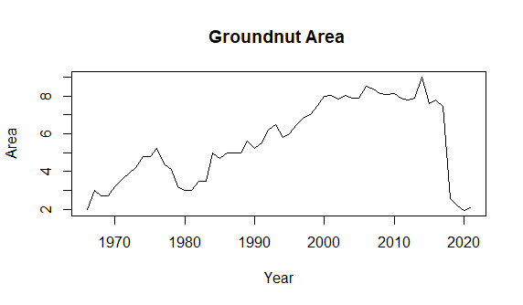

Fig.1: A time series plot of the groundnut area

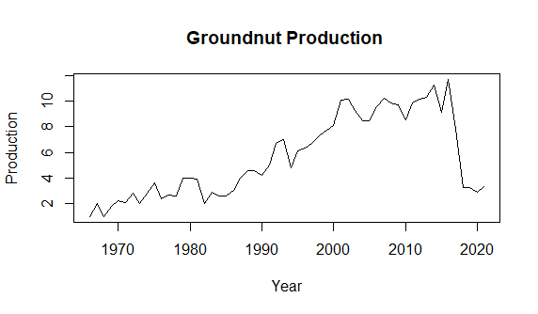

Fig.2: A time series plot of the groundnut production

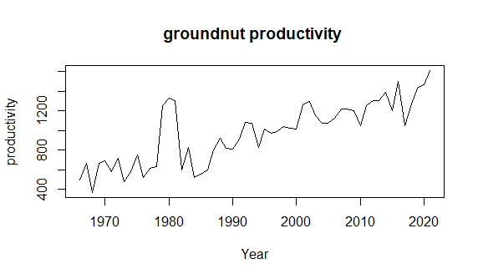

Fig.3: A time series plot of the groundnut productivity

Table.2: Stationarity and White Noise Autocorrelation Tests for Groundnut Area, Production, and Productivity Time Series
Statistics | Area | Production | Productivity
ADF Test | -1.3358 | -0.66367 | -4.2425
p-value | 0.8424 | 0.9681 | 0.12

In this study, the stationarity of the time series data was initially assessed using the Augmented Dickey–Fuller (ADF) test. Results from the ADF test (Table 2) indicated that the series exhibited autocorrelation, suggesting that past values in the series are correlated with current values. This autocorrelation implies that the series is not strictly stationary and may contain trends or other patterns that violate the assumptions of many time series models.
To further investigate the stationarity properties of the data, additional evaluation was conducted using Autocorrelation Function (ACF) and Partial Autocorrelation Function (PACF) plots (Figs. 4–6). The ACF plot illustrates the correlation between the series and its own lagged values across different time lags, helping identify the presence of autocorrelation over multiple periods. The PACF plot, on the other hand, measures the correlation between the series and its lags after removing the effects of shorter lags, which is particularly useful for identifying the appropriate order of autoregressive models.
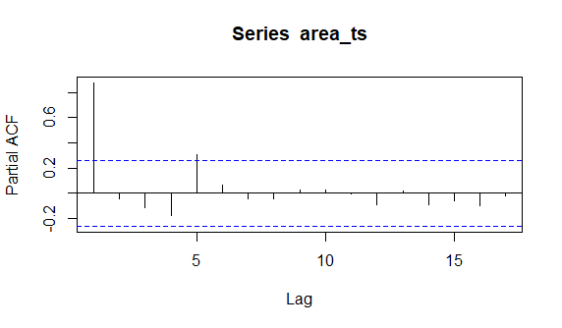
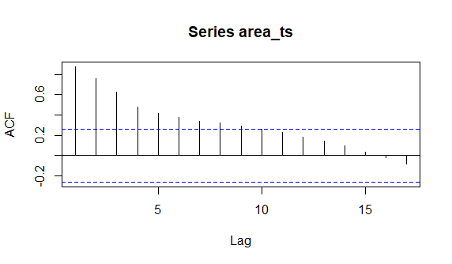
By combining the results of the ADF test with the visual insights from the ACF and PACF plots, a more comprehensive understanding of the series’ stationarity and temporal dependencies was obtained. This multi-step approach ensures that subsequent time series modeling and forecasting are based on appropriately transformed data, reducing the risk of misleading results caused by non-stationarity.

Fig.4: ACF and PACF Plots for the Groundnut Area Time Series.
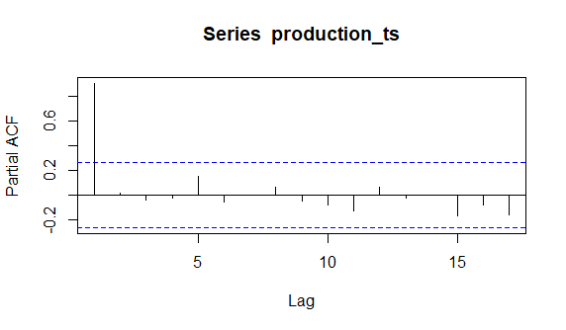
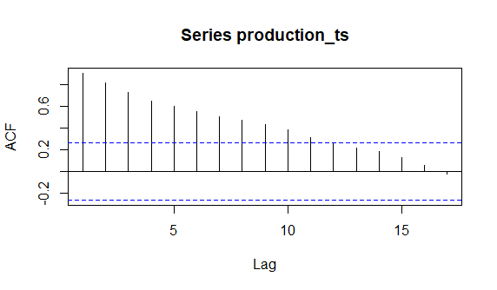

Fig.5: ACF and PACF Plots for the Groundnut Production Time Series

Fig.6: ACF and PACF Plots for the Groundnut Productivity Time Series
After applying first-order differencing, the time series became stationary, and autocorrelation effects were removed. The most appropriate ARIMA models for groundnut area, production, and productivity were selected based on the lowest Akaike Information Criterion (AIC) and Bayesian Information Criterion BIC values. For model development, 80% of the data was used for parameter estimation through maximum likelihood, while the remaining 20% served as holdout data for model validation. Model performance was assessed using error metrics such as MAE, RMSE, and MAPE (Table 3).

Table.3: Summary of best ARIMA model for area, production and productivity of groundnut time series.
Statistics | Area | Production | Productivity
ARIMA Model | (0,1,0) | (0,1,0) | (0,1,1)
RMSE | 0.8157 | 1.2272 | 188.88
MAE | 0.4368 | 0.8428 | 135.5457
MAPE | 10.6217 | 20.3446 | 16.00587
After fitting the ARIMA models, residual analysis (Figs.7–9) showed that the residuals from ARIMA (0,1,0) for area and production, and ARIMA (0,1,1) for productivity, exhibited predominantly linear patterns. This linearity was further confirmed by the BDS test results (Tables.4–6).
BDS test: The BDS test (Brock–Dechert–Scheinkman test) is a statistical test used in time series analysis to determine whether a series is independently and identically distributed (i.i.d.), and it is commonly applied to detect nonlinearity or hidden dependence in data. Developed by William Brock, W. Davis Dechert, and José Scheinkman, the test evaluates the null hypothesis that the data are i.i.d. against the alternative that they exhibit dependence or nonlinear structure. It is often used after fitting linear models such as ARIMA to examine whether the residuals still contain nonlinear patterns; if the test statistic is statistically significant, the null hypothesis is rejected, indicating the presence of nonlinearity or serial dependence.
In this study, since hybrid models are most effective when both linear and nonlinear components coexist, and the residuals exhibited only linear behavior, a hybrid modeling approach was considered unnecessary. Therefore, ARIMA models alone were deemed sufficient for forecasting groundnut area, production, and productivity.
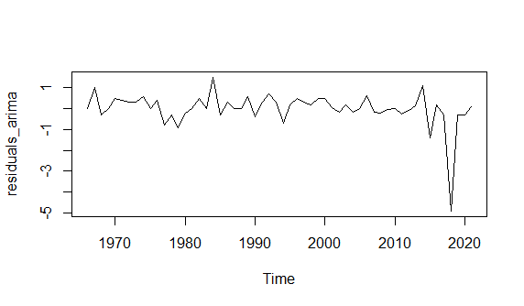

Fig.7: Residual Plot of the ARIMA Model for Groundnut Area Time Series
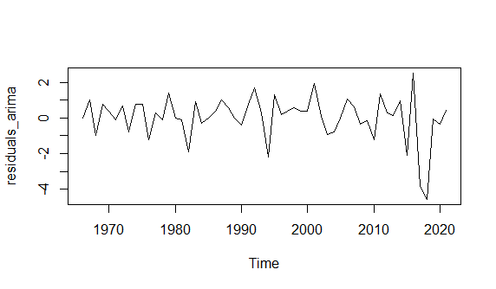

Fig.8: Residual Plot of the ARIMA Model for Groundnut Production Time Series
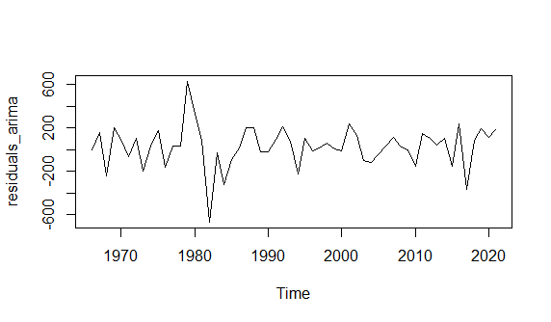

Fig.9: Residual Plot of the ARIMA Model for Groundnut Productivity Time Series

Table.4: BDS Test for Nonlinearity in ARIMA Residuals of Groundnut Area (Embedding Dimensions 2 and 3).
Standard  Normal | Dimension(m=2) |  | Dimension(m=3)
Standard  Normal | Statistic | Probability | Statistic | Probability
0.4115 | -0.7780 | 0.4366 | -0.4359 | 0.6629
0.8231 | -0.059 | 0.9529 | 0.224 | 0.8227
1.2346 | -0.0582 | 0.9536 | -0.0235 | 0.9813
1.6462 | -0.5426 | 0.5874 | -0.4419 | 0.6586

Table.5: BDS Test for Nonlinearity in ARIMA Residuals of Groundnut Production (Embedding Dimensions 2 and 3).

Standard  Normal | Dimension(m=2) |  | Dimension(m=3)
Standard  Normal | Statistic | Probability | Statistic | Probability
0.6188 | 0.4599 | 0.6456 | 0.8161 | 0.4145
1.2376 | 1.7082 | 0.0876 | 1.5852 | 0.1129
1.8564 | 3.4817 | 0.0005 | 3.2319 | 0.0012
2.4752 | 4.0783 | 0 | 4.0681 | 0

Table.6: BDS Test for Nonlinearity in ARIMA Residuals of Groundnut Productivity
(Embedding Dimensions 2 and 3).
Standard  Normal | Dimension(m=2) |  | Dimension(m=3)
Standard  Normal | Statistic | Probability | Statistic | Probability
94.1046 | -0.6624 | 0.5077 | -0.8289 | 0.4072
188.2093 | -0.8144 | 0.4154 | -0.0856 | 0.9318
282.3139 | -0.1996 | 0.8418 | 0.7462 | 0.4556
376.4185 | -0.2123 | 0.8319 | 0.3132 | 0.7541

Tables 4–6 report the BDS test results for nonlinearity in the residuals of the ARIMA models fitted to groundnut area, production, and productivity. Most p-values are greater than 0.05, indicating that the residuals are independently and identically distributed (i.i.d.) and do not exhibit significant nonlinear dependence.
Therefore, the groundnut area, production, and productivity time series for Surguja district were analyzed using ARIMA models, considering the linear characteristics of the data. Among the models evaluated, ARIMA (0,1,0) for area and production, and ARIMA (0,1,1) for productivity, provided the most accurate forecasts, as indicated by lower RMSE and MAPE values compared to other competing models. The predicted and forecasted values obtained from these ARIMA models are presented in Figures 10, 11, and 12.
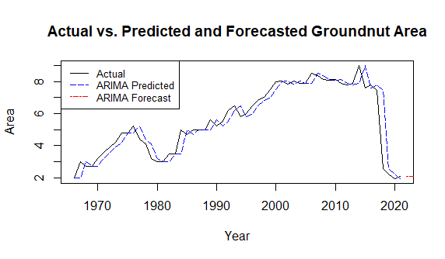

Fig.10: Actual vs. predicted and forecasted values for Groundnut Area time series

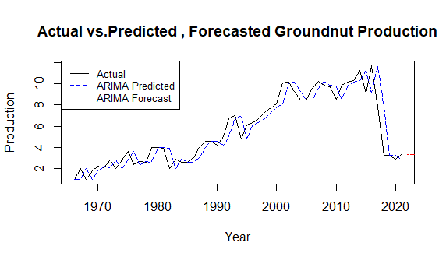

Fig.11: Actual vs. predicted and forecasted values of for Groundnut Production time series
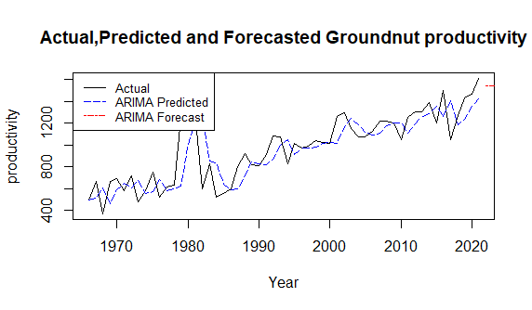

Fig.12 Actual vs. predicted and forecasted values for Groundnut Productivity time series

The figures present the comparison of actual, ARIMA predicted, and forecasted values of groundnut area, production, and productivity over the study period. The predicted values generated using the ARIMA model closely follow the actual observations, indicating a good model fit and satisfactory predictive performance.
For groundnut area and production, an overall increasing trend is observed over the years, followed by a sharp decline in the most recent period. The ARIMA model successfully captures these fluctuations and trend movements. The forecasted values suggest stabilization or slight variation in the upcoming years.
In the case of productivity, a steady upward trend is visible with moderate fluctuations. The predicted values align well with the actual data, demonstrating the reliability of the model. The forecast indicates a continued gradual improvement in productivity in the near future.
Overall, the close agreement between actual and predicted values confirms the adequacy of the ARIMA model for short-term forecasting of groundnut area, production, and productivity.
Conclusion

The time series analysis of groundnut area, production, and productivity in Surguja district from 1966–67 to 2021–22 revealed predominantly linear patterns after first differencing. The ARIMA (0,1, 0) model effectively captured the trends in area and production, while ARIMA (0,1,1) was most suitable for productivity. Residual analysis and the BDS test confirmed the absence of nonlinear components, indicating that hybrid ARIMA-ANN models were unnecessary for groundnut forecasting. The ARIMA models alone provided accurate predictions with low RMSE and MAPE values, demonstrating their adequacy for forecasting groundnut parameters. In contrast, for crops like mustard and linseed, which exhibited both linear and nonlinear patterns, hybrid models outperformed ARIMA alone, highlighting the importance of selecting forecasting methods based on the underlying data structure.

COMPETING INTERESTS DISCLAIMER:
Authors have declared that they have no known competing financial interests OR non-financial interests OR personal relationships that could have appeared to influence the work reported in this paper.

References

- Ancuţa, P. and Sonia, A. 2020. Oil press-cakes and meals valorization through circular economy approaches. Appl. Sci. ;10:7432. doi: 10.3390/app10217432.
- Bishoyi, B.S. and Patra, C. 2021. Groundnut production forecasting in Odisha using ARIMA model. The Pharma Innovation Journal. 10(11): 285-288.
- Chouksey,N. 2021. Forecasting of yield and production of groundnut using ARIMAX. The Pharma Innovation Journal; SP-10(11): 529-533.
- Kumar, G.A., Mohammed Akhtar, P. and Dhanunjaya, S. 2020 (a). Forecasting Area,
Yield, And Production In Anantapur District: Case of Groundnut Crop Using – R. International Journal of Mathematics Trends and Technology (IJMTT) – Volume 66 Issue 8.
- Mishra, H., Supriya, K. R., Kumar, M., & Gautam, S. (2025). Modelling and Forecasting of Sugarcane (Saccharum officinarum L.) Area, Production and Yield in Eastern Uttar Pradesh using ARIMA: A Data-Driven Approach to Sustainability. Environment and Ecology, 43(1A), 210-221.
- Pratiwi, W. A., Rizki, A. F., Notodiputro, K. A., Angraini, Y., & Mualifah, L. N. A. (2025). The Comparison of Arima and Rnn for Forecasting Gold Futures Closing Prices. BAREKENG: Jurnal Ilmu Matematika dan Terapan, 19(1), 397-406.
- Sahu, P., Chouksey, N. and Kumar, P. 2025. Forecasting of area production and productivity of mustard by Hybrid model. International Journal of Statistics and Applied Mathematics 10(1):49-58.
- Zhang, Peter.2003.Time series forecasting using a hybrid ARIMA and neural network model. Neuro computing 50(2003) 159 – 175.10.1016/S0925-2312(01)00702-0.
- http://data.icrisat.org/dld/(Directorate of Economics and Statistics, ICRISAT-District Level Data)
- https://agriportal.cg.nic.in/agridept/AgriEn/Default.aspx(Directorate of Agriculture, Chhattisgarh)
- https://data.desagri.gov.in/website/crops-apy-report-web(Directorate of Economics and Statistics)

