Multi-Functional Agricultural Machine with Hybrid Semi-Automation:
A Step towards Sustainable Farming Techniques

Abstract: The research aims to develop a single-pass integrated machine that can simultaneously cut crops, spray pesticides, and sow seeds, replacing the need for separate machinery. The primary objectives are to minimize overall operating time and achieve significant labour savings for small to medium-sized farm operations. By utilizing a single power unit for all three functions, the goal is to enhance fuel efficiency and reduce cultivation costs. The ultimate aim is to boost agricultural productivity by offering a user-friendly, adaptable, and energy-efficient solution. The machine is designed by combining various mechanisms powered by a single unit. A single DC motor operates both the seed feeder and the crop harvesting mechanisms simultaneously. This motor is powered by a rechargeable dry battery unit. To accommodate different field operations, the machine has two modes: high and low. The seed sowing mechanism employs a rotational drum feeder to ensure a consistent and measurable seed output, while the crop harvesting mechanism utilizes the reciprocating motion of cutter blades. All these components are mounted on a compact frame, making the machine easy to operate, transport, and handle in the field. This compact design reduces costs while enhancing versatility for various operations. Optimizing the power source and size makes the machine cost-effective and easy to handle, appealing to farmers with small plots and limited annual incomes. Additionally, it helps farmers increase their profits by eliminating the need to rent expensive machinery. This core innovation offers a low-cost solution, particularly beneficial for countries like India, where over 60% of the population relies on agriculture. Farmers are the backbone of the Indian economy, yet their per capita income remains very low. As modern agriculture increasingly depends on machinery, the high cost often makes it unaffordable for small farmers. This innovative, low-cost machine provides an accessible solution that can help small farmers enhance their profitability.
Keywords: Multipurpose Agriculture Machine, Seed Sowing Mechanism, Crop Harvesting Mechanism
- Introduction
Many farming operations in today's agriculture depend on machinery, and small farmers cannot afford the high cost of such equipment. This creative low-cost machine solution offers farmers an economical option that will boost small farmer’s profits. The hybrid semi-automated multi-functional agricultural machine offers a practical solution by combining multiple functions into one unit.
India is an agricultural country due to lots of factors, such as almost 45% to 50% workforce of the total workforce is associated with the agricultural activities. From the overall GDP of India 15% to 20% GDP contribution is made by the agricultural sector [1]. India is also a major agricultural product exporter in the current time, which also feeds the highest population of any country. From a geographical perspective, India has diverse soil types, and monsoons help to make it an agricultural country [2].
In India, the per capita income of farmers is very low. According to the data of the National Statistical Office (NSO) survey in year of 2019, the per capita income from a farmer household is 10,000 Indian rupees [3]. Understand it is family income, not individual income, and in today's time, it's much less and also compared to other professions. This just due to less education among farmers, monsoon conditions, trade limitations, less infrastructure for farmers, and the use of high-cost machinery for agricultural activities. All these factors are responsible for the poor condition of farmers in India.
Primarily for agricultural activities, the machinery like tractors, power tillers, cultivators, rotavators, harrows, seed drill and planter, sprayer, crop cutter, reaper are mainly used. All of that machinery, if a farmer purchased it in India, would cost more than 30 Lacs for an average machine specification. This is a huge cost, and hence, in India, very few farmers purchase this machinery. A major farmer population rent his kind of machine from another outsourced supplier [4]. This will be a frequent and repetitive requirement in each crop cycle. Farmers spend a lot of money to rent this machine. If the crop fails, farmer have to manage a lot of these expenses from their pocket. Even small farmers avoid using this machine and do almost all the work manually, but it reduces the efficiency of the farmer and that reduces the income from the crop. So, this machinery is a must-essential requirement in today's agricultural activities.
From the above-listed machinery, three pieces of machinery are essential in farming operations. The Reaper Machine for crop cutting operation in the final crop cycle operation, the Sprayer machine for application of pesticides, herbicides, fungicides during crop development time and the Seed planter during seed planting in the initial stage of farming crop cycle. If any, this all-farming operation is done with a single machine, which will cover 25% farming operations [5].
In the system of this machine, three farm operations are integrated in a single unit. The major operations carried out on the farm are seeding, crop harvesting and pesticide spraying. These three operations require different machinery in today’s farming. The cost of all machinery is too high for small and medium-income farmers are not able to purchase this machinery, and hence they rent this type of machinery for every crop. This rent increase the cost for the farmers it leading to expensive costs for farmers. This will reduce the overall profits of the farmers, and the per capita income of farmers continuously remains low in the current high-influence market conditions.
To build this multifunctional machinery, the design is the primary major concern because costly equipment will increase the machine cost, and high-cost machinery is ultimately a failure of the objective of this machine. To make sure the machinery cost is as minimal as possible, the design of the machine is done in such a way that it uses minimum power sources and high-cost machine parts to make sure the final cost of the machine is minimal. The working principle of machine is shown in Figure 1.
.
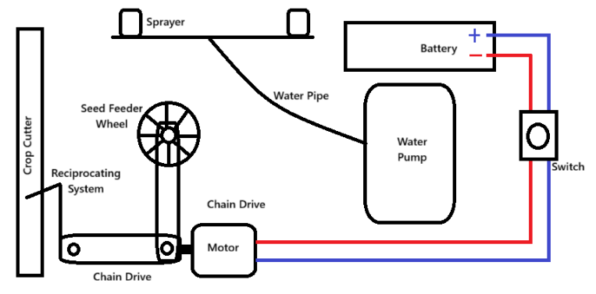
Figure 1 working Methodology of the machine
- An overview of the literature
The integration of multiple farming operations into a single machine has been explored in various studies. One such study aimed to address labor shortages in agricultural activities by designing a machine that uses an engine connected to a pulley and belt drive mechanism to power its functions, primarily seeding and soil penetration [6]. Although the machine shows promise, it has limitations, such as the lack of solar energy harnessing through solar panels, wireless control systems, and controlled seeding parameters. Further research has investigated the feasibility of integrating multiple farming operations, such as reaping, spraying, and ploughing, into a single, portable unit [7].
A solar-powered prototype weighing approximately 8-10 kg was developed to optimize resource utilization and reduce manual labor requirements [7]. The machine demonstrates potential for enhancing agricultural productivity while minimizing environmental impact. However, its performance is currently limited by its small motor and power unit, necessitating further design refinements and upgrades. Recent studies have further demonstrated the feasibility of integrating multiple farming operations into a single working unit [8]. For instance, a machine powered by a 12V battery was developed to perform distinct tasks, including grass cutting, seed sowing, and water sprinkling [9]. To overcome manpower shortages, the equipment is powered by solar energy, which powers DC motors and pumps via a 12-volt battery. It combines planting, ploughing, and spraying activities into a single system, allowing many agricultural tasks to be completed rapidly and affordably. [10]
Another study successfully integrated planting, harvesting, tilling, and spraying into a single unit, concluding that this multifunctional approach can streamline agricultural processes [8]. Future enhancements, such as the incorporation of AI for improved decision-making and adjustable blade spacing, have been identified as potential areas for further development. The design and research of a multi-functional intelligent shared seeding machine based on Internet Plus are proposed. Utilizing the Internet of Things as the core, a structure is adopted, and a creatively integrated seeding wheel combining disc-type and sharp mouth-type digging is introduced [11]. The development of multipurpose agricultural machines has also been driven by the need to reduce costs associated with seed feeding, pesticides, and field preparation [12]. A machine was designed to perform multiple tasks, such as soil digging, seed planting, and watering, using a battery-powered motor and chain drive system [12].
However, the use of a lightweight motor requires less power to operate but results in higher battery consumption, necessitating frequent recharging. Small and medium-scale farmers face significant challenges, including low production, expensive machinery requirements, high input costs, and the impact of globalization [13]. To address these issues, a machine was developed that integrates multiple tools, such as a weeder, tiller, plough, and levelling tool, into a single unit [13]. This compact equipment is designed to be tractor-independent, reducing costs and making it more accessible to small-scale farmers. A versatile agricultural machine is used for seed sowing, fertilization, and pesticide spraying, watering, ploughing, and cutting. It is powered by a tractor power take-off system, which eliminates the need for direct fuel use while lowering operational expenses and maintenance. This mechanized system provides a clean, efficient, and user-friendly solution that helps farmers accomplish several field duties effectively. [14].
In addition, multipurpose agriculture machines have been developed to reduce human effort, process multiple operations simultaneously, minimize labor costs, and decrease time consumption in agricultural activities [15] [16]. A single-unit machine was developed to integrate various functions, including sowing, spraying, weeding, and ploughing, thereby enhancing efficiency and productivity in farming operations [16]. Similarly, another study developed an autonomous vehicle capable of performing various farming tasks, including soil digging, seed sowing, soil levelling, and water spraying, which can cater to the needs of small-scale farmers who cannot afford expensive machinery [17] [18]. Recent studies have focused on designing and developing specialized farm vehicles capable of performing multiple tasks, including seed sowing, ploughing, and water sprinkling [19].
These machines aim to leverage automation to minimize human intervention in agricultural processes, providing cost-effective solutions for small-scale farmers. A study on multipurpose agriculture machines aimed to design and fabricate a cost-effective, easy-to-operate machine that reduces labor costs and saves operation time, combining multiple operations into a single mechanical unit [20]. Future improvements were identified, including replacing the petrol engine with a more environmentally friendly option and incorporating fertilizer application [20].
India, being an agricultural country, relies heavily on this sector for livelihoods, with approximately 50% of the workforce engaged in agricultural activities, contributing 15-20% to the country's GDP [21] [22]. However, the majority of farmers in this sector are less educated and face significant challenges, including poor financial conditions, dependence on others for machinery, and labor shortages due to migration. The agricultural process is further hindered by the need for multiple manpower, leading to increased time and effort consumption for individual farming activities. To address these issues, the development of cost-effective, efficient, and multi-functional agricultural machinery is essential to support the farming community and enhance productivity.
- Design considerations

  - Force Estimation for Furrow Opener
Table 1 Design Parameters for Furrow Opener [23]
Parameter | Value
Blade width | 0.055 m
Penetration depth | 0.050 m
Cutting area, A | 0.055 × 0.050 = 0.00275 $m^{2}$
Blade angle | 135°
Effective cutting Angle | 45°
Soil resistance k | Sandy Loam 78${kN/m}^{2}$ & Loam 280 ${kN/m}^{2}$
Mounting bolts | 2 × M6 bolts
Material & Cutting-edge | Mild steel & Flat Edge
Vertical bar cross-section | 25 mm × 6 mm = 0.00015 m²
$F_{d}$ = Draft Force (Force required to cut the soil) (N)
The horizontal “draft” force $F_{d}$ needed to pull a furrow opener through the soil can be estimated as
$F_{d}=F_{c }× Cos(θ^{°})$ ……….……............... (1)
$F_{d}=F_{c }× Cos({45}^{°})$ Also
$F_{c}=k × A$ ………………………. (2)
$k$ = Soil’s specific cutting resistance (${kN/m}^{2}$),
A = Projected Cutting Area ($m^{2})$
For a narrow blade of width w and penetration depth d:
A = w × d ………………………. (3)
W = Width of Blade = 55 mm = 0.055 m
d = Blade Penetration Depth = 50 mm = 0.050 m
Projected Cutting Area A can be derived as follows.
A = w × d = 0.00275 m²………………………. (4)

    - Cutting Force $F_{c}$
The vertical force is avoided since the whole machine is mounted on a frame with wheels.
Soil Type | k (kN/m²) | A (m²) | $F_{c}$ = k × A (N)
Sandy loam | 78 | 0.00275 | 214.5
Loam | 280 | 0.00275 | 770.0
    - Draft Force $F_{d}$
$F_{d}= F_{c }× 0.707$………………………. (5)
Soil Type | $F_{d}$ = (N)
Sandy loam | 214.5 × 0.707 = 151.6 N
Loam | 770.0 × 0.707 = 544.4 N
    - Force per M6 Bolt
Assuming equal load distribution across 2 bolts.
$F_{bolt}= \frac{F_{d}}{2}$ ………………………. (6)
Soil Type | $F_{bolt}$ = (N)
Sandy loam | 151.6 / 2 =75.8 N
Loam | 544.4 / 2 = 272.2 N
M6 bolts in shear can often withstand more than 1200 N of strain. As a result, both situations fall well inside acceptable boundaries.
    - Stress on the vertical support bar
$σ=\frac{F_{d}}{0.00015}$ ………………………. (7)
Soil Type | Stress ($Pa$) | Stress (MPa)
Sandy loam | 151.6 / 0.00015 = | 1.01 MPa
Loam | 544.4 / 0.00015 = | 3.63 MPa
Mild steel has a yield strength of 250 MPa and a maximum of 3.63, hence the vertical bar is structurally fit for the purpose. [24].
Table 2 Calculations Result for Furrow Opener
Parameter | Sandy Loam | Loam
Cutting Area | 0.00275 m² | 0.00275 m²
Cutting Resistance$F_{c }$ | 214.5 N | 770.0 N
Draft Force $F_{d }$ | 151.6 N | 544.4 N
Force per M6 Bolt | 75.8 N | 272.2 N
Stress on Vertical Bar | 1.01 MPa | 3.63 MPa
Material Safety Margin | > 250 times | > 60times
  - Design Estimation for Seed Feeder
Table 3 Design Parameters for Seed Feeder
Parameter | Value / Description
Seed Type | Granular seeds
Seed Spacing | 50 mm (0.05 m)
Field Speed | 2.5 m/s (Human Walking Speed)
Motor RPM | 60 RPM High and 30 RPM Low
Drive Sprocket | 14 teeth
Driven Sprocket | 44 teeth
Gear Ratio | 14:44 → 0.318
Feeder Shaft Dia. | 10 mm (High-Speed Steel)
Feeder Shaft Length | 350 mm
Impeller Dia. | 101.6 mm
Impeller Thickness | 28 mm
Impeller Type | Curved blade impeller
Seeding System | Single-row, gravity-fed
Fedder Weight | 0.500 Kg
Fedder distance on the shaft from the driving end | 0.222 Meter

    - Required Seed Drop rate
To achieve 50 mm spacing at 2.5 m/s speed
Seeds/ Sec = 2.5/0.05 = 50 Seeds / Sec (target seed delivery rate)
    - Seeds per Revolution
To drop 50 seeds /S at 0.318 rev / S & 0.159 rev / S
Seeds/rev = 50 / 0.318 = 157…………………… (8)
Seeds/rev = 50 / 0.159 = 314 ………………...… (9)
To meet the required seed rate, the impeller must release ~157 seeds per revolution. With 10 blades, each blade must meter ~15–16 seeds per pass.
    - Torque on Feeder Shaft
$T_{shaft}=2Nm× \frac{44}{14}$ …….…………………..… (10)
$T_{shaft}=$ 2 × 3.14 = 6.28 Nm
Assuming motor torque = 2 Nm, the gear ratio amplifies the torque to 6.28 Nm at the feeder shaft. This value is used to check torsional stress.
    - Torsional Shear Stress
$τ=\frac{16×T_{Shaft}}{π × d^{3}}$= 320 MPa…….…………..… (11)
This stress is well below the yield strength of high-speed steel (700–1000 MPa), confirming that the shaft won’t fail under torsion.
    - Bending Stress from Impeller Load
Bending Moment = 0.5 × 9.81 × 0.222 = 1.09 Nm
$σ=\frac{32 x M}{π × {0.01}^{3}}$ = 111 MPa
  - Design Estimation for Chain and Sprocket
Table 4 Design Parameters for Chain and Sprocket [25]
Parameter | Value / Description
Driver Sprocket | $T_{1}=$14 teeth, PCD = 60 mm
Driven Sprocket | $T_{2}$= 44 teeth, PCD = 175 mm
Chain Pitch (p) | ½ inch (12.7 mm)
Centre Distance (C) | 368 mm
Gear Ratio | 44/14 = 3.14
Speed Ratio | 175 / 60 = 2.917
Driven RPM (N) | (60/2.917) =20.56 RPM (High)  (30/2.917) = 10.28 RPM (Low)

    - Chain Length
Using the chain length formula
$L= \frac{2C}{p}+ \frac{T_{1}+T_{2}}{2}+ \frac{{{(T}_{1}- T_{2})}^{2}}{4π×C/p}$ …….…………… (12)
$L=$57.9 + 29 + 2.5 = 89.4
Use 90 Links of ½” Pitch chain.
    - Chain Speed (Linear Velocity)
$v= \frac{π×D×N}{60}$ …….…………………… (13)
Where D = pitch circle diameter of drive sprocket
$v_{high}= \frac{π × 0.06 × 60 RPM}{60}$ = 0.188 m/s
$v_{low}= \frac{π × 0.06 × 30 RPM}{60}$ = 0.094 m/s
    - Power Transmission
$w= \frac{2πN}{60}$ …….…………………… (14)
$ω_{high}= \frac{2π×60}{60}$, $ω_{high}=6.28 {rad}/s$
$ω_{low}= \frac{2π×30}{60}$ , $ω_{low}=3.14 {rad}/s$$ω_{high}= 6.28 rad/s$
$P= \frac{T×ω}{1000}$ …….…………………… (15)
T = 6.28 Nm (From Equation 10)
$P_{high}= \frac{T×6.28}{1000}$ = 0.0394 Kw=39.4W
$P_{low}= \frac{T×3.14}{1000}$ = 0.0197 Kw=19.7W
This is safe under the limit as per ANSI #40 chain.
    - Chain Tension Force
$F= \frac{T}{r}$
$r= \frac{D}{2}$ = (0.06/2) = 0.03
$F= \frac{6.28}{0.03}$ = 209.3 N …….…………… (16)
This is the force the chain must transmit – Safe for ANSI #40 chain.
  - Design Estimation for Crop Cutter
Table 5 Design Parameters for Crop Cutter [26]
Parameter | Value / Description
Motor RPM | 60 (Max) & 30 (Min)
Cutter Type | Crank-driven reciprocating cutter
Crank radius (r) | 29 mm = 0.029m
Stroke length | 2 × Crank Shaft = 2 × 29 = 58 mm
Blade Mass (m) | 1.5 kg
No of Blade | 15
Material | Alloy Steel

    - Angular Velocity of Crank
$ω_{high}= \frac{2π×60}{60}$, $ω_{high}=6.28 {rad}/s$
$ω_{low}= \frac{2π × 30}{60}$ , $ω_{low}=3.14 {rad}/s$$ω_{high}= 6.28 rad/s$
    - Linear Velocity of Cutter
$v= ω × r$ …….…………… (17)
$$v_{high}= 6.28 × 0.029= 0.182 m/sec$$
$v_{low}= 3.14 × 0.029=0.091 m/sec$
    - Cutter Acceleration
a = $ω^{2} × r$ …….…………………… (17)
$$a_{high}= {6.28 }^{2}× 0.029= 1.145 m/\sec^{2}$$
$a_{low}= {3.14}^{2} × 0.029=0.286 m/\sec^{2}$
    - Inertial Force on Cutter
F = $m × a$ …….…………………… (18)
$$F_{high}= 1.5 × 1.145= 1.72 N$$
$F_{low}= 1.5 × 0.286=0.43 N$
    - Crop Cutting Force Estimate
Assuming,
Shear force per blade = 10 N
Active blade per stock = 5
Total crop force = 10 × 5 = 50 N
Total Force is as follows.
$$F_{high}=50+1.72= 51.72 N$$
$F_{low}= 50+0.43=50.43 N$
    - Power Required
$P= \frac{F×v}{1000}$…….…………………… (19)
$P_{high}= \frac{51.72 x 0.182}{1000}$ $P_{high}= 0.0094 Kw$ = 9.4 W
${ P}_{low}= 0.0046 Kw$ $P_{low}= \frac{50.43 x 0.091}{1000}{ P}_{low}= 0.0046 Kw$ = 4.6 W
This shows that the power required by the cutter is well within the range that is provided by the motor through the chain drive mechanism [27].
  - Design Estimation for Sprinkler
Table 6 Design Parameters for Sprinkler
Parameter | Description / Assumption
Field Speed | 2.5 m/s (same as seed feeder)
Nozzle Count | 2 nozzles (adjustable)
Nozzle holding bar length | 1029 mm
Spray Width | 0.3 meter
Flow Rate per Nozzle | 4.5 L/min
Spray Pressure | 120 PSI (8.3 bar)
Spray Angle | 80° fan (standard flat fan nozzle)
    - Nozzle Placement Optimization [28]
To maximize uniform coverage, nozzles are placed 515 mm apart (centre on the 1029 mm bar) and Spray overlap with an 80° angle and a 0.3 m spray width per nozzle, overlap ~10–15% to avoid gaps. This gives a total effective spray width of 0.6 m.
    - Area covered per minute
Area/min = Field Speed × Spray Width
= 2.5 m/sec × 0.6 × 60 = 90${m }^{2}/ min$ ……… (20)
    - Application Rate (Litre/hrs.)
$Application Rate= \frac{45×10000}{90}=500l/{hrs}$ .… (21)
At 120 psi, flat fan nozzles typically produce medium to fine droplets, which is good for coverage and penetration. The risk of drift in windy conditions requires considering drift-reducing nozzles or a shielded spray bar if needed.
We used the height adjustment bar, having a 940 mm length, for our nozzle bar fixing, which will provide height adjustment for windy conditions [29].
Spray width considering height adjustment as follows.
Spray width = 2×h×tan $\frac{θ}{2}$ …….……………… (22)
Here, h = nozzle height above ground & θ is spray angle (80°) [30]
Nozzle Height (mm) | Spray Width (m)
300 mm | 2 × 0.3 × 0.8390 | 0.5034
600 mm | 2 × 0.6 × 0.8390 | 1.0068
900 mm | 2 × 0.9 × 0.8390 | 1.5102
  - Design Estimation for Wheels
Table 7 Design Parameters for Wheels
Parameter | Description / Assumption
Weight of Machine | 15 Kg
Wheels | 2 Nos – 200mm Diameter
Trolley Wheels | 2 Nos – 5-inch trolley wheels
Wheel Shafting | 10 mm Diameter
Drive of Motor | Manual
    - Loan Distribution on Wheels
Assuming an even load across 4 wheels.
Load per Wheel = 15 kg / 4 = 3.75 kg
Force per Wheel = 3.75 × 9.81 = 147.15 N
    - Rolling Distance per revolution
$C= π×X$…….……………… (22)
$$C_{Main Wheel}=3.142 × 200=628.3 mm$$
$$C_{Trolley Wheel}=3.142 × 127=398.0 mm$$
    - Rolling Resistance
Assuming,
Coefficient of rolling resistance $μ$ = 0.02
$F_{Rolling}= μ×N$ = 0.02 × 147.15 = 2.943 N per Wheel
So total rolling force = 4 × 2.943 = 11.772 N
This is the force the operator must overcome to keep the machine rolling- very low and easily manageable.
    - Shafting of wheel Strength
Shafting of wheel face bending and torsional shear force during motion.
Assumption,
Material – High Steel – Yield Strength = 600 MPa
Diameter = 10 mm = 0.01 m = 0.005 m (radius)
    - Polar moment of inertia:
$J=\frac{π}{32}× d^{4}$
$= \frac{π}{32} × {0.001}^{4}=9.82×{10}^{-10}m^{4}$ ……… (23)
    - Torque Calculation:
Wheel Radius = 100 mm = 0.1 m
Total Resistance = 11.772
T = F × r = 11.772 X 0.1 = 1.177 N ………… (24)
    - Shaft Shear Stress
$τ= \frac{T×r }{j}$ = 6MPa …….……………… (25)
- 3D CAD Model
For the design of the Hybrid Semi automated Multi-Functional Agricultural Machine, parametric 3D software design is used. Figure 3 to Figure 8 are the 3D CAD models of machine respectively and Figure 8 shows the 3D CAD assembly of Machine.
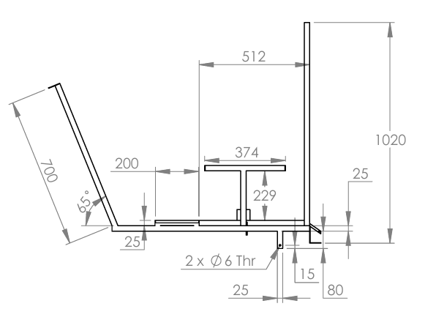

Figure 2 Body Structure
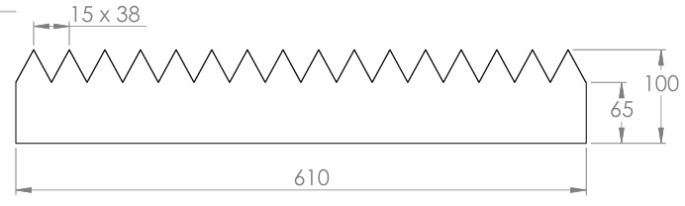
Figure 3 Crop Cutter
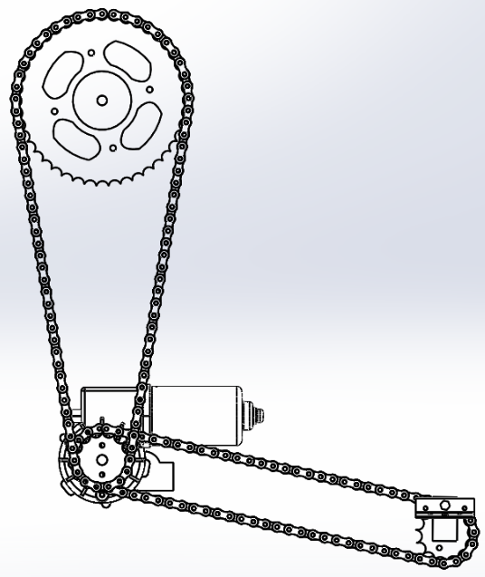
Figure 4 Chain and Sprocket Drive System
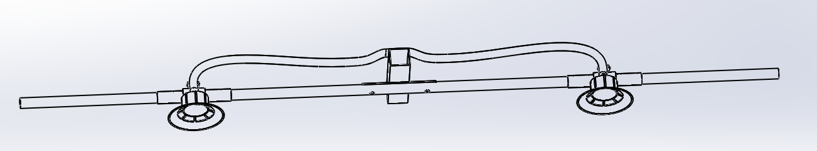
Figure 5 Sprinkler Mechanism
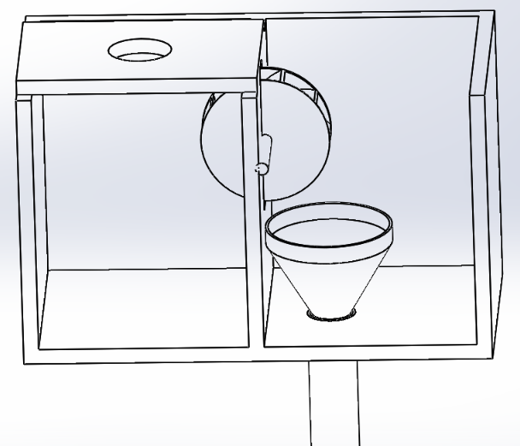
Figure 6 Seed Storage and Feeding Mechanism
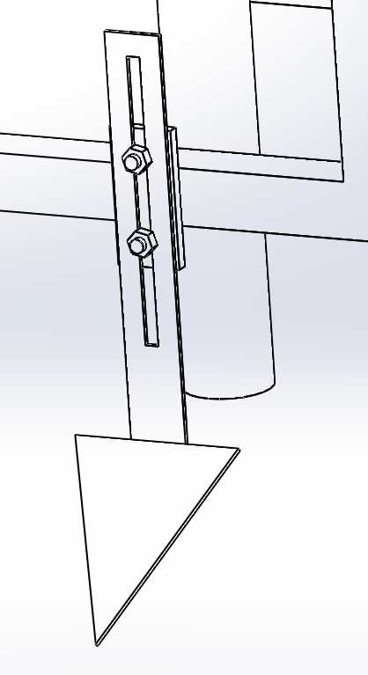
Figure 7 Furrow Opener Mechanism
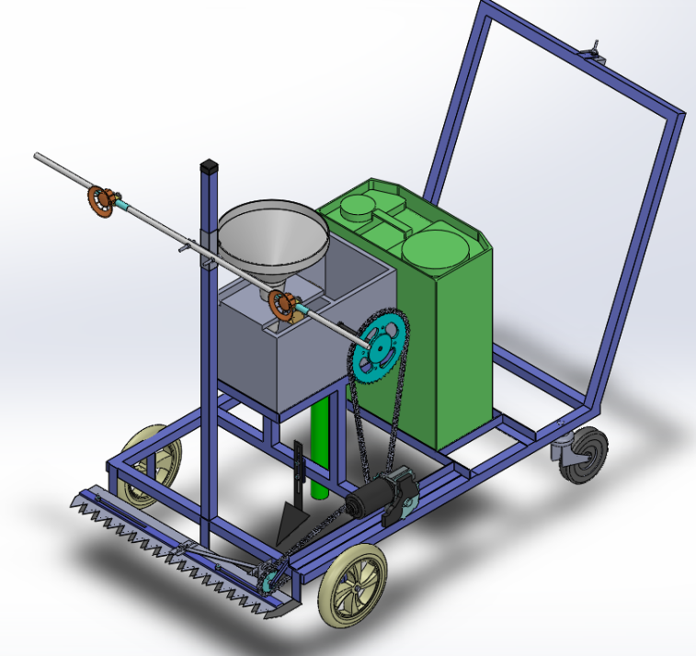
Figure 8 3D CAD Assembly Model of Machine
- Constructional Details
For the construction of the Hybrid Semi automated Multi-Functional Agricultural machine following parts are used.
Table 8 Bill of Materials
Sr. No. | Part Name | Material | Qty
1 | Body Structure | MS | 1
2 | Wheel _A | Rubber | 2
3 | Wheel _B | Nylon | 2
4 | Crop Cutting Blades | Spring Steel | 2
5 | Water Spray Pump | Standard | 1
6 | Seed Storage Box | Wooden | 1
7 | Battery | Standard | 1
8 | Wiper Motor | Standard | 1
9 | Small Sprocket | CI | 3
10 | Big Sprocket | CI | 1
11 | Nozzle Bar Clamp | MS | 1
12 | Nozzle Spray holding | MS | 1
13 | Rubber Bushing Pad | Rubber | 1
14 | Nozzle holding clamp | MS | 2
15 | Nozzle Spray | Plastic | 2
16 | Seed Tube | Rubber | 1
17 | Furrow Opener | SS | 1
18 | Seed Feeder Shaft | WPS | 1
19 | Funnel | Plastic | 2
20 | Hinges | SS | 4
21 | Cutter Sprocket Shafting | WPS | 1
22 | Chain Link | CI | 1
23 | Two-way toggle switch | Standard | 1
24 | Nut-Bolt | Standard | 1 Set
- Working Machine
This Hybrid Semi automated Multi-Functional Agricultural Machine is manually operated and designed and fabricated as a multipurpose machine used in seed sowing, sprinkling, fertilizing, and crop cutting shown in the Figure 9 . When driven in the forward direction, the furrow opener opens the soil to make space for seeding, and power is provided through the battery to run the motor.
The motor is connected with two separate systems through a chain and sprocket drive. One with the crop cutting mechanism and another with the seed feeding mechanism. The crop-cutting mechanism is used to cut the ready crop, while the seeding mechanism is used when a new crop needs to be put in the field. The motor is controlled with a two-way toggle switch at two different speeds.
A sprinkler is used to spray pesticides; liquid fertilizer is an entirely separate unit built into the system. It’s had its own 4.5 litres per hrs. Water pump with two sprinkler outputs. When sprinkling is required, this pump can be started to start the sprinkling process. This sprinkler system has lots of flexible mechanisms used for height adjustment, spray angle adjustment, and spray width adjustment capability.
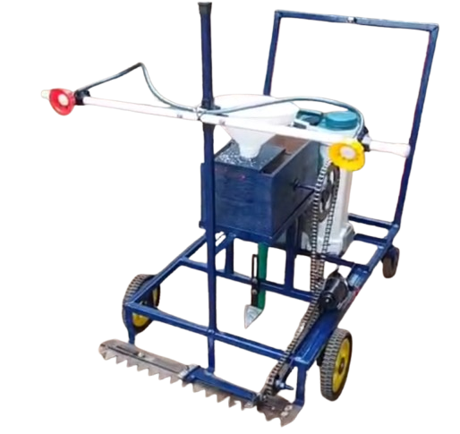
Figure 9 Working Model of Machine
- Performance Evaluation
  - Grass Cutter Performance Evaluation
Different performance levels are offered by the grass cutters now on the market. The grass cutting method uses a push mower with a cutting width of 610 mm, or 2 feet.
Total Distance = Area / Machine Width
= 43500 Sq. Feet / 2 Feet = 21780 Feet
Speed = 2 miles / 1 hrs. = 5280 Feet / 60 minutes
= 176 Feet / Minute
Time required to cover the entire 1 Acre field
= 21780 Feet / (176 Feet / Minute) = 123.75 Minutes
At the same speed, this is better than the machine available in the market.
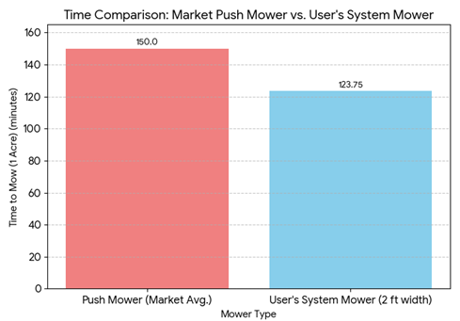
Figure 10 Comparison of Push Mower and Our Machine
  - Sprinkler Performance Evaluation
According to our design and calculation,
We can cover 1029 mm, which means 3.38 feet.
Total Distance = Area / Machine Width
= 43500 Sq. Feet / 3.38 Feet = 12887 Feet
Speed = 2 miles / 1 hrs. = 5280 Feet / 60 minutes = 176 Feet / Minute
Time required to cover the entire 1 Acre field
= 12887 Feet / (176 Feet / Minute) = 73.24 Minutes
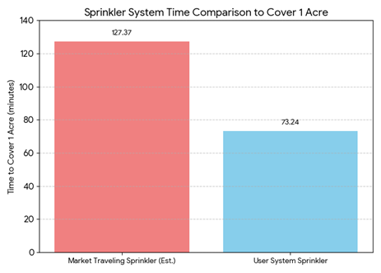
Figure 11 Comparison of Market Sprinkler and Our Machine
  - Furrow Opener Performance Evaluation
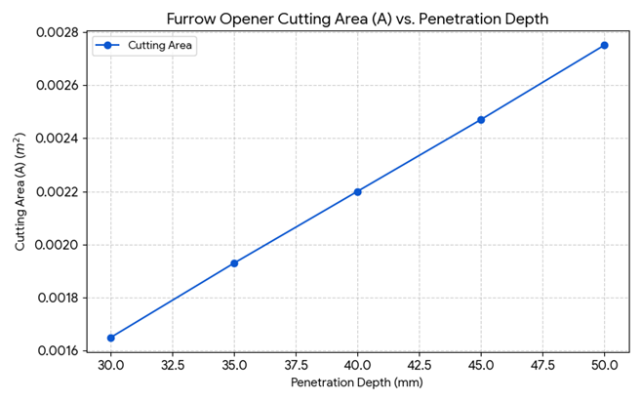
Figure 12 Furrow Opener Cutting Area vs. Penetration Depth
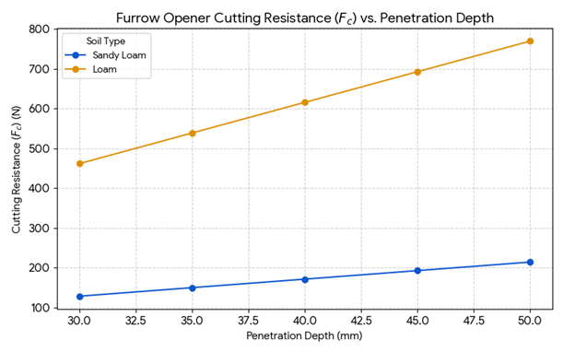
Figure 13 Furrow Opener Cutting Resistance vs. Penetration Depth
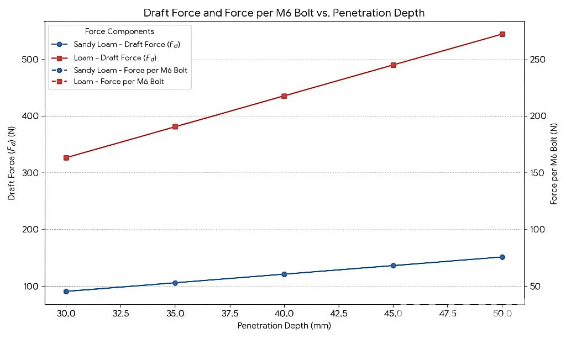
Figure 14 Draft Force vs. Penetration Depth
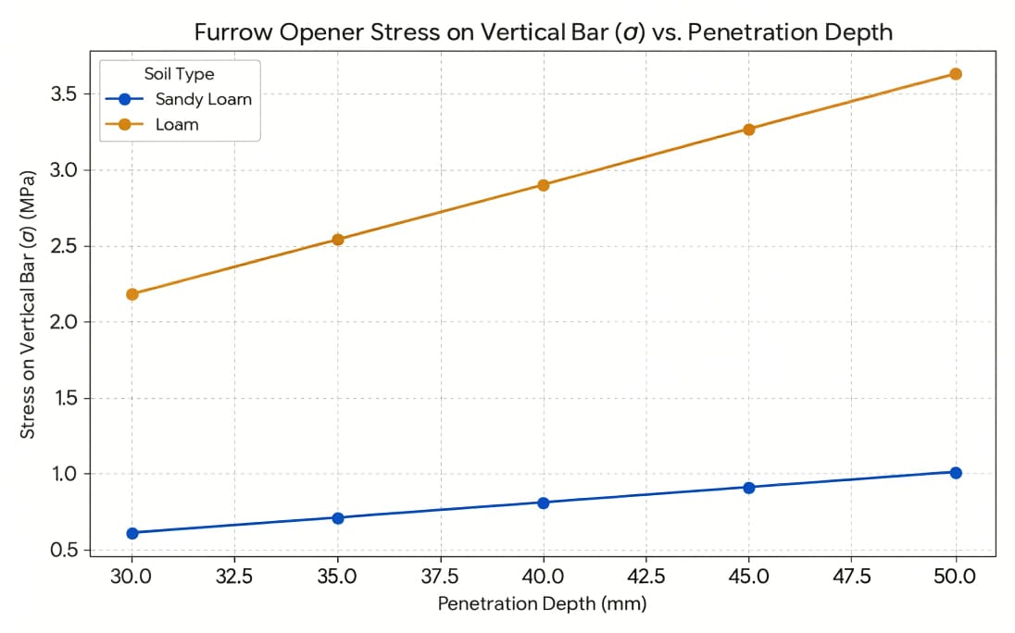
Figure 15 Stress on vertical bar vs. Penetration Depth
This analysis concludes that the proposed multi-functional agricultural system successfully meets its core objectives regarding both operational efficiency and structural integrity, as demonstrated by the component performance evaluations. The system's calculated speed of 2 mph allows the Grass Cutter component, despite its smaller 2-foot width, to achieve a time of 123.75 minutes per acre, marking a notable 17% improvement over the average market push mower. This high travel speed also grants a significant advantage to the Sprinkler System, which is calculated to cover 1 acre in just 73 minutes and 24 seconds.
While commercial sprinkler systems prioritise slow water application, the proposed system’s rapid mechanical coverage time is substantially faster than the estimated travel time of a typical commercial travelling irrigator, confirming its efficiency in terms of field traverse. Furthermore, the Furrow Opener Performance validates the system’s structural robustness. The analysis identified the worst-case scenario as operating in Loam soil at the maximum 50 mm depth, requiring a peak Draft Force of 544.4 N. This maximum load translates to a relatively low stress on the vertical bar of only 3.63 MPa, confirming that the component is highly durable and operates well within safe structural limits across all tested soil conditions. Overall, the data strongly support the viability of the design, which is both mechanically efficient in time-critical tasks and structurally sound under maximum operational loads.
- Advantages
This Hybrid Semi automated Multi-Functional Agricultural Machine has the following advantages.
- This machine helps to reduce the requirement of labour in the farm field for agricultural activities.
- Small-scale farmers with a small land area will utilize this machine to save the additional expense of renting this machinery from others.
- It can combine 3 major agricultural processes in a single unit that can cover almost 25% agricultural activities.
- It will save time and increase efficiency by automating the process.
- Future Scope
This Hybrid Semi automated Multi-Functional Agricultural Machine has the following possible future scopes.
- Putting bigger wheels can improve the vehicle's movement in a very uneven farm field.
- A battery is used that can handle the crop that has weak plants by the crop harvesting mechanism, but if you want to cover a wide range of crops, the material and design of the crop harvesting can be improved.
- A solar panel can be added to recharge the battery and make the machine more autonomous.
- Automation can be done in seed feeding to make it more reliable and controlled.
- Conclusion
In conclusion, this machine is a versatile operation capable. Based on the design, the overall output of the machine will fulfil the needs of small and medium farmers, as they are not capable of buying expensive machinery. The cost of the machine is very less that a small farmer can afford it, and with the use of this machine farmer can easily cover it cost in a year by saving labour cost, expensive machine rent cost and cover major activities with minimal effort.
References
A. Meman and Hemlata Sinha., "Automated Pesticides Sprayer: A Technological Solution for Precision Farming," Journal of Harbin Engineering University, vol. 45, no. 3, March 2023.
A. Mande, Shereen Gawande, Mohil Lanjewar and Morvi Kohad, "Multipurpose Agriculture Machine," International Journal of Advanced Research in Electrical, Electronics and Instrumentation Engineering, vol. 6, no. 2, 2020.
B. S. Y and Cariappa A B., "Design of Sprinkler for Agricultural Purpose," International Advanced Research Journal in Science, Engineering and Technology, vol. 8, no. 6, June 2021.
M. N. K, Khare S,, Singh S and Dabur M., "Multipurpose Agriculture Machine," International Journal of Advances in Science Engineering and Technology, vol. 5, no. 1, 2017.
J. S. Kamble and Dr. Sushil Kumar Singh, "Design and Analysis of Multi Purpose Cutting Machine for Agriculture," International Research Journal of Engineering and Technology, vol. 7, no. 7, 2020.
J. Hedau, Shubham Dixit,, Tanmay Dhurde, Nitesh Gharatkar and Ritik Shende, "Design and Fabrication of Multipurpose Agricultural Machine," International Journal For Research in Applied Science and Engineering Technology, vol. 11, no. 4, 2023.
S. Rai, Navneet Rai and Deepesh Yadav, "Multipurpose agriculture machine," International Journal of Creative Research Thoughts, vol. 9, no. 7, 2021.
J. N, Navya A, Yashas Hejjigi K M, Prashantha M C and Sourabh S Hegde, "Design And Fabrication of Multipurpose Agriculture Machine," International Journal of Creative Research Thoughts, vol. 12, no. 5, 2024.
N. Dande, Komal Khule, Shivam Vadaskar, Tushar Rathod and Prof S. S. Patil, "Multipurpose Equipment Used for Agricultural Processes," International Journal of Innovative Research in Technology, vol. 11, no. 10, 2025.
R. Manivannan, R. Rajasekar, B. Mathan, S. Jagan Kumar and M. Gurum, "Modelling and analysis of agriculture three-in-one machine using solar power," Materials Today: Proceedings, vol. 64, no. 1, pp. 506-510.
J. Zhang, Z. Zhao and G. Chi, "The design and research of multi-functional intelligent sharing seeding machine based Guangzhou," in International Conference on Artificial Intelligence and Electromechanical Automation (AIEA), 2021.
G. Gangaraju, Dr. R T. Sarath Babu and Dr. M. Lakshmikantha Reddy, "AGRICULTURE MULTI-PURPOSE MACHINE," International Journal of Research and Analytical Reviews, vol. 10, no. 2, April 2023.
N. Ashwin.A, Nair Gokul.G, Nair Sudheeshkumar.S, Nishad Vishal.H and Vaishali S. Kumbhar, "Design and Fabrication of Multipurpose Agricultural Machine," International Research Journal of Engineering and Technology, vol. 7, July 2020.
R. Jeyakumar, N. Ramachandran, J. Ajay Aravind and M. Ajithkumar, "Development and conception of versatile agricultural machine," Materials Today: Proceedings, vol. 37, no. 2, pp. 2582-2586, 2021.
S. Sujitha, M. N T and V. G R, "Solar Powered Multi-Functional Agricultural Robot," in International Conference on Knowledge Engineering and Communication Systems (ICKES),, Chickballapur, India,, 2022.
M. A. Shindkar, Mr. Abhishek Shinde and Mr. D Ubale , "Design and Fabrication of Multi-purpose Agriculture Machine," International Research Journal of Engineering and Technology, vol. 10, no. 10, 2023.
H. Chadalavada, N. Bharath Kumar, P. Shaila Srujan and O. Lakshmi Nar, "Solar-powered semi-automated multipurpose agriculture machine," Materials Today: Proceedings, vol. 46, pp. 3469-3473, 2021.
P. H. Mehta, Sahil Patel, Akshat Ghataliya, Yash Shah and Devesh V, "Design and Fabrication of Multipurpose Agricultural Machine," Journal of Emerging Technologies and Innovative Research, vol. 8, no. 4, April 2021.
S. Kirtane, Ansh Notani, Ali Dalvi, Sumit Waghmare and Prathamesh Kasar, "Multipurpose Agriculture Machine," Journal of Emerging Technologies and Innovative Research, vol. 11, no. 3, March 2024.
Dilip Radkar, Goraksh Choughule, Abhijeet Desai, Prathamesh Gawand, Pradip Bade and Yogesh Chaudhari, "Multipurpose Agriculture Machine," International Research Journal of Engineering and Technology, vol. 8, no. 5, 2021.
A. Gopala, E Elavendhan, S Tarun and Lakshmi Sankard, "Design, Development and Fabrication of Multipurpose Agricultural Machine," in AIP Conference Proceedings · December 2020, 2020.
B. S. Y and Cariappa A B, "Design of Sprinkler for Agricultural Purpose," International Advanced Research Journal in Science, Engineering and Technology, vol. 8, no. 6, June 2021.
M. K. Singh, G. S. Tiwari, A. K. Mehta,, Ajay Kumar Sharma, S. M. Mathur and R. K. Rathod, "Development and Optimization of Furrow Opener for Planting of Seed Spices," International Journal of Current Microbiology and Applied Sciences, vol. 9, no. 5, 10 May 2020.
X. Zhang, Hongwen Li, Ruicheng Du and Shaochun Ma, "Effects of key design parameters of tine furrow opener on soil seedbed properties," International Journal of Agricultural and Biological Engineering, vol. 9, no. 3, May 2016.
P. K. Reddy and C.Raghunathareddy, "Design and Analysis of Chain Sprockets," International Journal & Magazine of Engineering, Technology, Management and Research, vol. 7, no. 3, March 2020.
M. Kadam, Shankar Thombare, Sunil Aswale and Ajit Kamble, "Design and Development of "Crop Cutter"," Journal of Product Design, Quality Engineering and Technology, vol. 3, no. 3, September 2018.
Charwak, Mukul Kumar, Saurabh Kumar, Manish Kumar and Karthik S N, "Design and Fabrication of Crop Cutting Machine," vol. 8, no. 6, June 2019.
M. Sahil and Abdul Wahid Anwar, "Design of Water Sprinkler System In EPANET," Ghulam Ishaq Khan Institute of Engineering Sciences and Technology, January 2021.
K. Samanta, Talha Khalid and Tanmoy Majhi, "Design and implementation of efficient sprinkler irrigation systems," International Journal of Agriculture and Nutrition, vol. 6, no. 2, 2024.
P. Paul, Akshay Chachare, Chirag Bhoir, Pravin Khare and Tejas Davande, "Design and Development of Multipurpose Pesticides Sprinkler and Fertilizer Spreader Machine," vol. 9, no. 3, 25 February 2021.
A. Kumar, Jeevan Gowda, Nitesh prasad, Chethan and Dr. Shamanth V, "Design and Fabrication of Multipurpose Agricultural Machine," Journal of Emerging Technologies and Innovative Research, vol. 5, no. 10, 2024.

