BACCILLUS Sp. KITA AND BACCILLUS SPHAERICUS OP6 CONTROL SIGNIFICANTLY FUSARIUM Sp. AN IMPORTANT PATHOGEN ON JATROPHA (Jatropha curcas) IN MALI

.
ABSTRACT

Aims: This study aimed to evaluate the biocontrol potential of Bacillus sp. Kita and Bacillus sp. OP6 against Fusarium sp., a major pathogen affecting Jatropha curcas in Mali.
Study Design: Randomized complete block design with six treatments: Fusarium (F); Bacillus sp Kita (K); Bacillus sp.OP6 (OP6); K + F; OP6 + F: Control (C) and three replications.
Place and Duration of Study: Conducted at the greenhouse research area of the LaboREM-Biotech, Faculty of Sciences and Techniques, USTTB, Mali. Methodology: Fusarium sp. was isolated from diseased Jatropha leaves and identified morphologically. Bacillus strains were tested in vitro for antagonistic activity and in vivo for plant growth promotion. Treatments included Fusarium alone; Bacillus strains alone, combinations, and control. Growth parameters were measured and analyzed using SAS software.
Results: Bacillus sp. Kita and OP6 significantly inhibited Fusarium growth in vitro (>70% inhibition). In vivo, co-inoculation with Bacillus strains improved seed germination, leaf number, plant height, and biomass compared to Fusarium-only and control treatments. Statistical analysis confirmed significant differences (P < .05) among treatments.
Conclusion: Bacillus sp. Kita and OP6 exhibit strong biocontrol and plant growth-promoting properties, offering a sustainable alternative to chemical pesticides for managing Fusarium in Jatropha cultivation

1. INTRODUCTION

In Africa, mainly in Mali, the culture of the Jatropha is confronted with many problems among which, the attacks of insect pests and the fungal diseases (Mignon et al., 2012); Abubakar, 2021) which attack the various organs of the plant (roots, stems, leaves and fruits thus reducing its productivity or causing even his death. Different producers in production areas reported plant mortality during field visits. According to Sanou (Sanou, 2015), this mortality constitutes a shortfall in terms of production of seeds, oil and cash income. Studies on pathogens of Jatropha curcas have been carried out in different regions of the world, including Mexico and Korea (Espinoza-Verduzco et al., 2012; Kwon et al.: 2012). The isolation and identification of certain pathogenic microorganisms responsible for rots such as the genus Fusarium have been found on both the crown, the roots and the leaves of Jatropha (Sanou, 2015; Mignon et al., 2012).

To control these pathogens, farmers start using chemical pesticides which are dangerous for human health and the environment (Nandhini et al., 2021; Pathak et al., 2022). It is therefore necessary to find an alternative to the use of these chemicals (Nasiru et al., 2015; Nasiru et al., 2018). In the same time, several researchers showed that certain endophytes and rhizosphere microorganisms are capable of producing a large number of essential substances and secondary metabolites such as antibiotics, enzymes, modulators, anticancer drugs which can be used as biological pesticides to control insect pests and microbial pathogens (Rabiey et al., 2019; Ghosh et al., 2020; Karthiba et al., 2010) Biological control by bacterial antagonists seems to be a solution that is both beneficial and respectful to the environmental (Ghosh et al., 2020; Dicko et al., 2021; Kassogué et al., 2016). It meets economical, toxicological and ecological requirements. In the natural environment, the rhizosphere of healthy plants harbors bacteria capable to protect plants against phytopathogenic fungi in a sustainable manner. That is why the objectives of this work are to isolate Fusarium from a diseased plant part and antagonists of the isolated Fusarium, from the endosphère or rhizosphere soil of healthy plants and then show the potentiality of the isolated antagonists to control the isolated Jatropha phytopathogenic Fusarium.

2. material and methods

2.1 Study area
To determine the pathogenicity of a pathogenic fungus newly isolated on Jatropha curcas cultivated in Kati (Mali), an experiment was conducted in vitro and in vivo in a greenhouse under artificial conditions at the Laboratory of Research in Microbiology and Microbial Biotechnology (LaboREM-Biotech), Faculty of Sciences and Techniques; University of Sciences, Techniques and Technologies of Bamako in Mali.

2.2 Jatropha varieties
In this study, jatropha (Jatropha curcas) varieties the most cultivated in Mali used were obtained from the ″Institute d’Economie Rural (IER)″ du Mali.

2.3 Isolation of the pathogenic fungus
For pathogens isolation, Jatropha leaves showing disease symptoms were collected from fields in Kita (Mali). The diseased parts were cut into small fragments with a sterile scalpel. They were then disinfected by soaking in 5% sterile bleach for 5 minutes, then rinsed five times with sterile distilled water. Pathogens were isolated on Rose Bengal solid medium containing chloramphenicol as antibacterial, and incubated at 25ºC for four days. All the grown fungus colonies were purified, before identification using the method described by [4].

2.4 Pathogenicity test of isolated fungus strains
To verify the postulate of Koch. Each fungus isolate was used to inoculate healthy Jatropha leaves. The inoculated Jatropha leaves were incubated and observed each days for disease development. Isolates showing typical disease on the healthy leaves were selected and considered as pathogens.

2.5 Selection of antagonist bacterial strain
The effect of some bacterial strains against mycelial growth was studied by the direct confrontation method. The technique used is that described by Benhamou and Chet (1997) modified by Berber et al. (2009). This technique consists of placing in the same Petri dish (85 mm in diameter) containing the medium at 5 cm along a diametral axis) the pathogen and the biological control agent. Incubation is performed at 25°C in the dark for six days. Control dishes containing only the pathogen were incubated under the same conditions.

To determine the rate of inhibition of the mycelial growth of the pathogen caused by the antagonist agent, daily measurements of the colony diameter were taken. The rate of growth inhibition is calculated according to the following formula (Hewish et al, 1968)
$$GI\%=\frac{DGC-DGP}{DGC}X100$$
DGC : Diameter growth of the control, DPA : Diameter growth of the pathogen in presence of the antagonist, GI : Growth Inhibition of the fungus mycelium.

2.6 Effect of antagonists Bacillus sp. OP6 and Bacillus sp. Kita on the activity of the growth of Jatropha plants in presence of isolated Fusarium sp.

2.6.1 Inoculum preparation

Bacillus sp. Kita and Bacillus sp. OP6 strains were inoculated each in 250 ml flasks containing 100 ml of liquid nutrient broth medium. The vials were incubated at 37 ° C with shaking at 200 rpm for 7 days. After incubation, the different cultures were centrifuged at 10,000 rpm for 15 minutes to separate the pellet from the supernatant. For each strain, the inoculum was adjusted to 1,108 bacteria per ml by estimating them by spectrophotometry (ie OD = 0.1 at 600 nm). To prepare the adhesive inoculum, gum arabic was added to the pellet / supernatant mixture (1: 1) to obtain a final concentration equivalent to 2% gum to fix the bacteria well on the seeds (Babana et al., 2012).

2.6.2 Experimental design

In this experiment, we used a complete randomized bloc design (Figure 1). The hours of shunshine represent the blocking factor, which gave us three blocks. The bacteria isolates (with high antifungal activities, Bacillus sp. Kita and Bacillus sp.OP6, the fungus and the different combinations bacteria-fungus represent the six treatments studied. Each treatment was replicated four times. Five of each treated Jatropha seeds were seeded directly in a plastic pot filled with 10 kg of soil at 2 cm depth. To avoid confusion between the yellowing associated with disease development and that due to malnutrition, recommended dose of NPK fertilizer was applied to each plant. After germination, the young plants were thinned to one per pot. These pots were watered every day at 1/9 of the maximum retention capacity of the substrate.

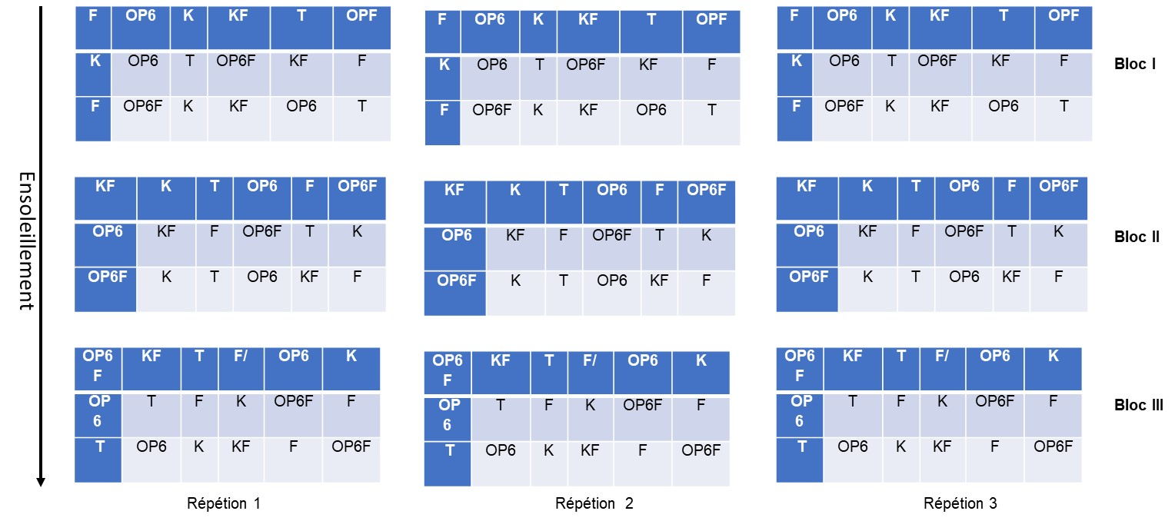
Figure 1. Experimental design in blocks with random distribution of the treatments in each block (3 blocks, 6 treatments and 3 repetitions).

2.6.2.1 Data collection
The number of germinated seeds was noted for one to two weeks. In the second month after sowing, the plants were removed and the various agronomic parameters: number of leaves, leaf width and length; the length of roots, stem size, fresh weight of aboveground and belowground biomass were determined and recorded.

2.6.2.2 Data analysis
Analysis of variance was performed for each parameter (antagonists bacteria and pathogen fungus) according to the General Linear Model (GLM) procedures using SAS software (version 9.2). Whenever the Fisher test indicates a significant effect at a probability of 0.05, Fisher's Protected Least Significant Difference (LSD) test was used to compare the means.

3. results and discussion

3.1 Results
3.1.1 Fungal pathogen of Jatropha curcas isolation and identification
Twelve (12) fungi were isolated from different parts of Jatropha plants, sampled in different fields investigated in Kita (Mali). Based on the ability of one fungus isolate to produce the disease on the Pourghere (Jatropha curcas) leaves (Figure 2), this fungal isolate was retained as the main Jatropha disease pathogen in fields in Kita.

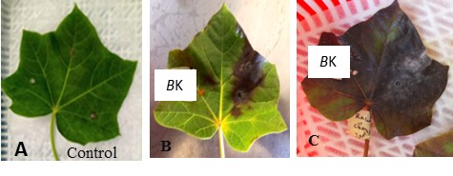
Figure 2. Reproduction of disease observed in field by the retained fungal isolate: Control (A); pathogenic fungus, 3 after inoculation (B) and the pathogenic fungus 7 after inoculation (C).

Based on the macroscopique, microscopique characteristiques, the retained fungal isolates was identified as Fusarium (Figure 3). A molecular identification to confirm precisely the identity of the fungal isolate is ongoing.
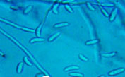
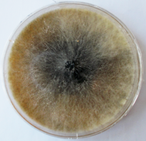

- (B)
Figure 3. Macroscopique (A) and microscopic (B) characteristics of the Fusarium isolate

3.2 Effect of antagonist bacteria on the aerial growth of Fusarium sp. Kita isolate

Bacillus sp. Kita showed strong inhibitory activity against the fungal pathogen with a zone of inhibition greater than 70% in vitro.

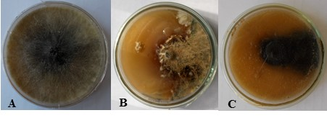

Figure 4. Effect of Bacillus sp. Kita on the growth of Fusarium sp. Pathogen on Jatropha curca: (A) Fusarium sp., B and C (Fusarim sp., and Bacillus sp. Kita).
Table 1. Analysis of variance for Jatropha percentage germination (%Germ), leaf number (Ln), plant height (Ph), root length (Rl), leaf fresh weight (lfw) and root fresh weight
 |  |  | Mean squares
Sources of variation | Df | %Germ | Ln | Ph | Rl | Lfw | Rfw
Treatments | 5 | 4.68** | 158,40*** | 121,13*** | 115,60*** | 46,63** | 73,33**
Repetitions | 1 | 0.26ns | 0,75ns | 1,08ns | 1,92ns | 2,08ns | 0,40ns
Df= Degree of freedon; %Germ = Percentage of germination; degree of freedom; Ln: Leaf number, Ph: Plant height, Rl: Root length; Lfw: Leaves fresh weight; Rfw: Root fresh weight; **Very significant; ***Highly significant; ns not significant

The analysis of data in table 2 showed that the best germination rates were observed then the Fungus is present. Jatropha plants treated with the combination of Bacillus sp. Kita and Fusarium sp., give the highest leaf number, and the treatment with Fusarium alone showed the lowest leaf number. Plant height was greater with the mixture of combinaisons of Bacillus sp. Kita and Fusarium sp., and Bacillus sp.OP6 + Fusarium sp. treatments, while it was low with. Observation of the root condition of transplanted plants with the K + F mixture showed the best result compared to other treatments. While the root condition of plants transplanted only with Fusarium showed poor root growth. The weight of the fresh aerial parts of the plants was high with the OP6 treatment and low with that of Fusarium. The weight of the fresh underground part was high with the K treatment and low with that of Fusarium.

Table 2. Effect of antagonist treatments on the percentage germination (%Germ), leaf number (Ln), plant height (Ph), root length (Rl), leaf fresh weight (lfw) and root fresh weight of Jatropha plants
Treatments | %Germ | Ln | Ph | Rl | Lfw | Rfw
K | 3.33bc | 31c | 54b | 37b | 195,5b | 25,3a
F | 4.61a | 20f | 36d | 21e | 83,4e | 9,7d
K+F | 3.83ab | 46a | 55a | 45a | 121,15d | 24,4b
OP6 | 3.00c | 35b | 54b | 33d | 203,8a | 18,5b
OP6+F | 3.50abc | 26e | 55a | 35c | 192b | 18,6c
Control | 1.50d | 28d | 45c | 35c | 165,8c | 25,1 a
F=Fusarium sp; K= Bacillus sp. Kita; OP6=Bacillus sp.; T=Control

For plants inoculated with the pathogenic Fusarium sp., compared to the control, a high sensitivity to the pathogen was observed as well as an inhibition of Jatropha plant growth was observed. Plants inoculated with Fusarium sp. and treated with Bacillus sp. OP6 or Bacillus sp. Kita, showed had a greater vegetative development compared to those of the control (non-inoculated and non-treated) (Figure 5).

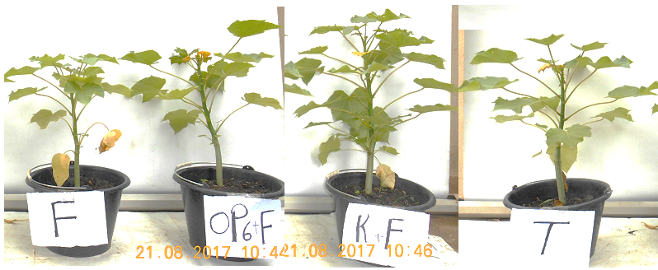

Figure 5. Effect of the bacteria Bacillus sp. OP6 and Bacillus sp. Kita (K), on the growth of jatropha plant infected with the pathogenic Fusarium

3.2 Discussion
The pathogenicity or virulence test of the pathogenic fungus, Fusarium sp., tested on healthy jatropha leaves showed total rotting of jatropha leaves in less than a week. This result is consistent with those of Nwogwugwu et al., (2022) who isolated Five genera (Curvularia, Colletotrichum, Fusarium, Lasiodiplodia, and Oidium) of which were confirmed as pathogenic on J. curcas. The symptoms expressed after leaf inoculation correlated with the symptoms described in the literature (Zarafi and Abdulkadir 2013; Wu et al., 2024). Experiments in different jatropha leaves of these tests recording the severity of symptoms would be useful to determine the best conditions that influence pathogenicity; (Hernández-Cubero et al., 2017) demonstrated this. Bacillus sp. OP6 showed a strong antagonistic activity on Fusarium sp. with an inhibition zone in Petri dishes greater than 70%. This result is significantly higher than that obtained by Ghorri, (2015) who used fungal isolates to control Fusarium sp. with an inhibition rate around 65%. However, this result is lower than that of Hamel, (2016) who obtained in this work an inhibition rate of 100% on Fusarium spp., with Trichoderma spp. after four days of incubation. The differences observed in these cases may be due to the fact that they used fungi as biocontrol agents, while bacteria were used in this study. The observed differences showed also that the control efficacy vary with the biocontrol fungus used. Bacillus sp. Kita isolated from Jatropha curcas and Bacillus sp. OP6 from the bacterial collection of the LaboREM-Biotech, positives for most of the FCP properties, managed to significantly inhibit the pathogenic Fusarium tested in this study. Amaresan et al. (2013) confirmed that several strains of Bacillus have a suppressive effect against some phytopathogens. The antifungal activity of the Bacillus strains may be due to the production of extracellular enzymes, as well as the production of phytohormones Dicko et al., 2018; Babana et al., 2011). Indeed, the Bacillus sp. Kita isolated from the Jatropha curcas plant is capable of producing enzymes as catalase, oxidase, protease and amylase. According to Sriwati et al. (2023), Khan et al. (2018), and Yadav et al. (2018); these enzymes are responsible the control of the pathogen’s growth through the degradation of its cell wall. Various studies have explained the abundance of Bacillus species in ecosystems, by their ability to produce various bioactive substances and enzymes, they are therefore an important link in biological chains (Dicko et al., 2018; Nantoumé et al., 2023; Ouattara et al., 2023). During this greenhouse experiment, diseased jatropha plants co-inoculated with the pathogen and Bacillus sp. OP6 or Bacillus sp. Kita were better compared to the control as well as those inoculated with only the pathogen, Fusarium sp. Aboton et al. (2015) proved this during the study on agromorphological evaluation and selection of the best accessions of Jatropha curcas L. introduced in Benin.

4. Conclusion

Jatropha curcas varieties cultivated in Mali, were very susceptible diseases caused by Fusarium sp. These Jatropha varieties were the most appreciated by biofuel producers and smallholder farmers in Mali, mainly in Kita, where these varieties were most cultivated. Two Bacillus sp. strains (Bacillus sp. Kita and Bacillus sp. OP6) with high biocontrol activities were identified in Mali. It appeared through this research results that these two Bacillus strains, mainly Bacillus sp. Kita, inhibited Fusarium sp. growth and improved Jatropha germination and growth. These bacteria can be used to formulate a biopesticide to improve Jatropha growth and production.

References

Abubakar, M. N. (2021). An overview of Jatropha curcas pests, diseases and management in North Western Nigeria. International Journal of Science and Research Archive, 3(1), 56–61.
Ahoton, L. E., Quenum, F., & Mergeai, G. (2011). Évaluation agromorphologique et sélection des meilleures accessions de Pourghère (Jatropha curcas L.) introduites au Bénin. International Journal of Biological and Chemical Sciences, 5(4), 1619–1627.
Amaresan, N., Kumar, K., Sureshbabu, K., & Madhuri, K. (2014). Plant growth-promoting potential of bacteria isolated from active volcano sites of Barren Island, India. Letters in Applied Microbiology, 58(2), 130–137.
Babana, A. H., Bathily, H., Samaké, F., Traoré, D., & Dicko, A. H. (2011). Microbiological control of bacterial soft rot caused by Bacillus pumilus Od23 on potato in Mali. British Microbiology Research Journal, 1(3), 41–48.
Dicko, A. H., Babana, A. H., Kassogué, A., Fané, R., Nantoumé, D., Ouattara, D., Maiga, K., & Dao, S. (2018). A Malian native plant growth promoting actinomycetes-based biofertilizer improves maize growth and yield. Symbiosis. https://doi.org/10.1007/s13199-018-0555-2
Dicko, A. H., Nantoumé, D., Ouattara, D., Kassogué, A., Fané, R., Mallé, I., Doumbia, B., & Babana, A. H. (2021). Screening of rice endophytic natives biofertilizers with plant growth-promoting characteristics. African Journal of Agricultural Research, 17(10), 1336–1342.
Espinoza-Verduzco, M. A., Santos-Cervantes, M. E., Fernandez-Herrera, E., Espinoza-Mancillias, M. G., Aliciachaez-Medina, J., Bermudez-Alvarez, E. M., Martinez-Ayala, A. L., Mendez-Lozano, J., & Leyva-Lopez, N. E. (2012). First report of Alternaria alternata (Fr.) Keissler causing inflorescence blight in Jatropha curcas in Sinaloa, Mexico. Canadian Journal of Plant Pathology, 34(3), 455–458.
Ghorri, S. (2015). Isolement des microorganismes possédant une activité anti-Fusarium (Thèse).
Ghosh, S. K., Chaudhary, M., & Manjunatha, N. A. K. (2020). Endophytes: A potential bio-agent for plant protection. In Chakravarthy (Ed.), Innovative Pest Management Approaches for the 21st Century (pp. 273–297). https://doi.org/10.1007/978-981-15-0794-6_14
Hamel, R., Liégeois, F., Wichit, S., Pompon, J., Diop, F., Talignani, L., ... Missé, D. (2016). Zika virus: Epidemiology, clinical features and host-virus interactions. Microbes and Infection, 18(7–8), 441–449.
Hernandez, L., Ampofo, P., Montes, J. M., & Voegele, R. T. (2017). Identification of pathogenic fungi and preliminary screening for resistance in Jatropha curcas L. germplasm. European Journal of Plant Pathology, 149(2), 325–336.
Karthiba, L., Saveetha, K., Suresh, S., Raguchander, T., Saravanakumar, D., & Samiyappan, R. (2010). PGPR and entomopathogenic fungus bioformulation for the synchronous management of leaffolder pest and sheath blight disease of rice. Pest Management Science, 66(5), 555–564.
Kassogué, A., Dicko, A. H., Traoré, D., Fané, R., Valicente, F. H., & Babana, A. H. (2016).Bacillus thuringiensis strains isolated from agricultural soils in Mali tested for their potentiality on plant growth promoting trait. British Microbiology Research Journal, 14(3), 1–7.
Khan, N., Martínez-Hidalgo, P., Ice, T. A., Maymon, M., Humm, E. A., Nejat, N., Sanders, E. R., Kaplan, D., & Hirsch, A. M. (2018). Antifungal activity of Bacillus species against Fusarium and analysis of the potential mechanisms used in biocontrol. Frontiers in Microbiology, 9, 2363. (doi.org in Bing)
Kwon, J.-H., Choi, O. O., Kim, J.-H., & Kwak, Y.-S. (2012). First report of anthracnose disease on Jatropha curcas caused by Colletotrichum gloeosporioides in Korea. Journal of Phytopathology, 160(5). https://doi.org/10.1111/j.1439-0434.2012.01890.x
Mignon, T. J., Declerck, C. D. H., Savery, S., de Haveskercke, P. J., Winandy, S., & Mergeai, G. (2012). Principal disease and insect pests of Jatropha curcas L. in the Lower Valley of the Senegal River Marieke. Tropicultura, 30(4), 222–229.
Nandhini, A., Muthukumar, H., & Gummadi, S. N. (2021). Chlorpyrifos in environment and foods: A critical review of detection methods and degradation pathways. Environmental Science: Processes & Impacts, 23, 1255–1277.
Nantoumé, D., Kassogué, A., Dao, S., Dicko, A. H., Ouattara, D., Mallé, I., Doumbia, B., Fané, R., Faradjia, F. A., Diarra, O., Coulibalily, M., Dembelé, C., Hamadoun, A., & Babana, A. H. (2023). Endophytic bacteria-based biostimulant improved rice (Oryza sativa L.) growth and production in Mali. South Asian Journal of Research in Microbiology, 17(1), 41–50.
Nasiru, A. M., Salau, I. A., & Muhammad, A. S. (2018). In vitro efficacy of fungicides concentration on mycelia radial growth of Phomopsis viticola. In Proceedings of the Sixth Biennial National Conference of the Forest and Forest Products Society (pp. 263–269). Usmanu Danfodiyo University, Sokoto.
Nasiru, A. M., Shehu, K., Mani, U., & Yerima, M. B. (2015). In vivo evaluation of fungicides on Fusarium equiseti foliar blight of Jatropha curcas L. International Journal of Agriculture and Environment Research, 1(1), 79–87.
Nwogwugwu, J. O., Adewale, D. B., Batcho, A. A., Osunlaja, O. A., & Ekpo, E. N. (2022). Occurrence and pathogenicity of fungal genera on Jatropha curcas L. in Southwestern Nigeria. Journal of Plant Pathology, 104, 295–303.
Ouattara, O., Dao, O., Dicko, A. H., Kassogué, A., Nantoumé, D., Mallé, I., Bagayogo, M. W., Koné, S., Doumbia, B., Faradji, F. A., Diallo, K. A., Diarra, O., Samaké, S., Fané, R., Coulibalily, M., Dembelé, C., & Babana, A. H. (2023). A Malian rice seed endophyte bacteria control efficiently the growth of Xanthomonas oryzae pv. oryzae and Xanthomonas oryzae pv. oryzicola. South Asian Journal of Research in Microbiology, 17(2), 1–9.
Pathak, V. M., Verma, V. K., Rawat, B. S., Kaur, B., Babu, N., Sharma, A., Dewali, S., Yadav, M., Kumari, R., Singh, S., Mohapatra, A., Pandey, V., Rana, N., & Cunill, J. M. (2022). Current status of pesticide effects on environment, human health and its eco-friendly management as bioremediation: A comprehensive review. Frontiers in Microbiology, 13, 962619. https://doi.org/10.3389/fmicb.2022.962619
Rabiey, M., Hailey, L. E., Roy, S. R., Grenz, K., Al-Zadjali, M. A. S., Barrett, G. A., & Jackson, R. W. (2019). Endophytes vs tree pathogens and pests: Can they be used as biological control agents to improve tree health? European Journal of Plant Pathology, 155(3), 711–729. https://doi.org/10.1007/s10658-019-01814-y
Sanou, H. (2015). Étude sur les causes de la mortalité chez le pourghère Jatropha curcas (pp. 1–53).
Sriwati, ., Maulidia, V., Intan, N., Oktarina, H., Syamsuddin, Khairan, K., Skala, L., & Mahmud, T. (2023). Endophytic bacteria as biological agents to control fusarium wilt disease and promote tomato plant growth. Physiological and Molecular Plant Pathology, 125, 101994.
Wu, L., Hwang, S.-F., Strelkov, S. E., Fredua-Agyeman, R., Oh, Bélanger, R. R., Wally, O., & Kim, Y.-M. (2024). Pathogenicity, host resistance, S-H and genetic diversity of Fusarium species under controlled conditions from soybean in Canada. Journal of Fungi, 10(5), 303. https://doi.org/10.3390/jof10050303
Yadav, V., Singh, H., Singh, A., Hussain, I., & Singh, N. (2018). Salicylic acid induced changes on some physiological parameters symptomatic for oxidative stress in maize (Zea mays L.) grown under cinnamic acid stress. Russian Agricultural Sciences, 44(1), 9–17. (doi.org in Bing)
Zarafi, A. B., & Abdulkadir, I. D. (2013). The incidence and severity of Jatropha dieback disease in Zaria, Nigeria. Archives of Phytopathology and Plant Protection

