Original Research Article
Early-Stage Selection of Drought-Tolerant Rice Seedlings Using PCA Under Mannitol-Induced Stress

ABSTRACT
Drought stress is a major limitation to rice productivity, and its increasing frequency under changing climatic conditions necessitates the identification of drought-tolerant genotypes. Present study revealed the mannitol induced drought response of 20 rice genotypes at the seedling stage. After 21 days stress imposition parameters were analyzed. An increased root elongation but contrastingly decreased root dry weight due to altered carbon allocation was reported in 1% mannitol treated seedlings. While a marked reduction in root and shoot growth and chlorophyll content, reflecting impaired cell expansion and reduced photosynthetic efficiency in 2% mannitol. Furthermore the principal component analysis was used to screen the genotypes which explained 53.8% of the total variation, and separated genotypes into tolerant, moderately tolerant, and susceptible groups. Genotypes Vandana, FL478, Binnaful, and Katakchikon consistently maintained superior root performance, biomass retention, and physiological stability under stress, whereas IR29, AC-35678, IC-516366, Ravana, and Kangri were highly sensitive. Overall, the integrated evaluation of morphological and physiological traits proved effective for early-stage drought screening and identified promising donor genotypes for rice drought-tolerance breeding programs.

INTRODUCTION
Rice is a primary staple food for more than half of the world’s population and contributes over 75% of the caloric intake in several developing countries (Rahman and Zhang, 2016). Global rice production reached approximately 787.3 million tons in 2021 (FAO, 2024) largely due to advances in agrotechnologies and genetic improvement. However, enhancing rice tolerance to environmental stresses remains crucial for sustaining productivity under changing climatic conditions (Dhankher & Foyer, 2018). Rice is predominantly cultivated in warm and humid regions, where climate-related extremes such as flooding and drought frequently disrupt plant growth and development, leading to substantial yield losses worldwide. At present, more than one-third of the global rice-growing area is affected by drought stress, including 33% in developing countries, 25% in developed countries and 42% in underdeveloped regions (FAO, 2014). There are growing concerns about whether the current rate of rice production growth in certain regions of the world, along with existing technologies, will be sufficient to meet the projected global demand for rice by 2050 (Samal et al., 2022).

India experienced an exceptional drought during the 2022 monsoon season, marked by a pronounced rainfall deficit across the Gangetic plains between July and August. This event led to an estimated 5% reduction in the area under rice cultivation and a projected decline of about 6.3 million tons in rice production (USDA, 2022). Notably, nearly 68% of India’s cultivable land is susceptible to drought and moderate to severe droughts recur across the country every three to four years (Rao et al., 2019). Between 2002 and 2016, India alone faced six major drought episodes (Kala et al., 2017), while the 2014-2015 drought caused a 4.7% reduction in total agricultural output and severely disrupted the livelihoods of approximately 330 million farming households during 2015–2016 (Bhatt et al., 2024).
The impacts of drought are especially pronounced in vulnerable states such as Chhattisgarh, Jharkhand, and Odisha, where average production losses reached nearly 40%, resulting in economic damages estimated at around USD 800 million (Bhandari et al., 2007). Recurrent droughts not only reduce crop yields but also influence farmers’ decisions regarding investment in agricultural inputs and discourage the adoption of improved technologies, thereby constraining productivity growth and income enhancement (Ward et al., 2018). At a broader scale, droughts intensify economic instability, deepen rural poverty, increase indebtedness, and pose serious threats to national food and nutritional security. For example, the drought of 2014 caused economic losses of nearly USD 30 billion and contributed to a 1.7% decline in India’s GDP (Carpena et al., 2019).
Screening rice genotypes for drought tolerance at the seedling stage provides a rapid, reliable, and cost-effective means to differentiate drought-adaptive lines early in the breeding pipeline. Early drought responses influence plant establishment, root development, and physiological resilience, which are predictive of later performance under water deficit (Blum, 2011). The use of mannitol to induce osmotic stress creates a controlled simulation of drought conditions, allowing clear discrimination between tolerant and sensitive genotypes without field variability (Verslues et al., 2006). Combining seedling screening with advanced phenotyping and physiological assessments improves the accuracy and efficiency of identifying superior genotypes for breeding programmes (Swamy et al., 2012). Developing drought-tolerant rice varieties through these methods can enhance yield stability under water-limited conditions and reduce production risks for farmers in drought-prone environments, contributing to sustainable food security (Singh et al., 2025).
Material and Method
The experiment was conducted at department of Plant Physiology, College of Basic Sciences and Humanities, GBPUA&T, following a factorial completely randomized design (CRD) using two factors and three replications with 20 rice genotypes. The genotypes were obtained from Indian Institute of Rice Research, Hyderabad and screened at seedling level for drought tolerance in hydroponic panel. Before commencement of experiment seeds were surface sterilized using sodium hypochlorite (NaOCl) and incubated for 48 hours to promote uniform germination. Pre-germinated seeds were transferred to hydroponics panel having Hoagland solution (Yoshida et al, 1976) for 5 days and then stress was imposed for 21 days which was comprised two drought stress level (1 and 2% mannitol). To maintain the pH, the solution was checked every day and replaced if the pH shifted too far.
The shoot length (SL) and root length (RL) were measured using a scale in centimeters whereas seedling dry weight was measured in (mg) using digital weighing balance and for total chlorophyll was estimated by following formula using DMSO method described by Hiscox et al, 1979 .
Total chlorophyll= $\frac{\left(20.2X A645)+(8.02XA663\right)X V}{Weight \left(g\right)X 1000}$
To determine the significance of treatment effects, data were subjected to statistical evaluation using analysis of variance. Data processing and preliminary analyses were carried out in Microsoft Excel, while graphical representation and Pearson’s correlation analysis among measured traits were performed using OriginPro software.
Result
3.1 Effect of mannitol simulated drought stress on root length and root weight
Mannitol-induced drought stress at 1% and 2% concentrations significantly affected root length and root dry weight across rice genotypes, with distinct genotypic variations in response. At 1% mannitol, root length increased in the majority of genotypes compared to the control, with marked enhancement observed in FL478 (76.4%), Vandana (70.8%), Kangri (60.0%), IC-516366 (51.85%), Binnaful (51.40%), and Morishal (42.22%) (Fig 1 and 2). Moderate increases were also recorded in AUS 301 (35.96%) and NICRA 16 (36.88%), whereas reductions in root length were noted in genotypes such as IET-18716 (18.60%), AC-35678 (19.35%), Katakchikon (14.29%), and NICRA 17 (23.77%). In contrast, root dry weight declined in all genotypes at 1% mannitol, with reductions ranging from 4.94% in NICRA 16 and 15.60% in AC 85 to more pronounced decreases in AC-35678 (44.80%), IET-18716 (41.15%), and FL478 (39.01%), indicating differential allocation towards root elongation rather than biomass accumulation.
At 2% mannitol, root length decreased in most genotypes; however, FL478 (55.73%), Vandana (60.0%), and Binnaful (44.43%) maintained higher root length relative to the control. Root dry weight exhibited substantial reductions across all genotypes at this concentration, with the highest declines observed in Vandana (78.06%), Kangri (77.69%), IR29 (76.17%), NICRA 17 (75.72%), and Binnaful (75.44%). The combined response of enhanced or maintained root length along with reduced root dry weight under mannitol stress highlights contrasting root adaptation strategies among genotypes, with FL478, Vandana, and Binnaful showing superior performance across both stress treatments.
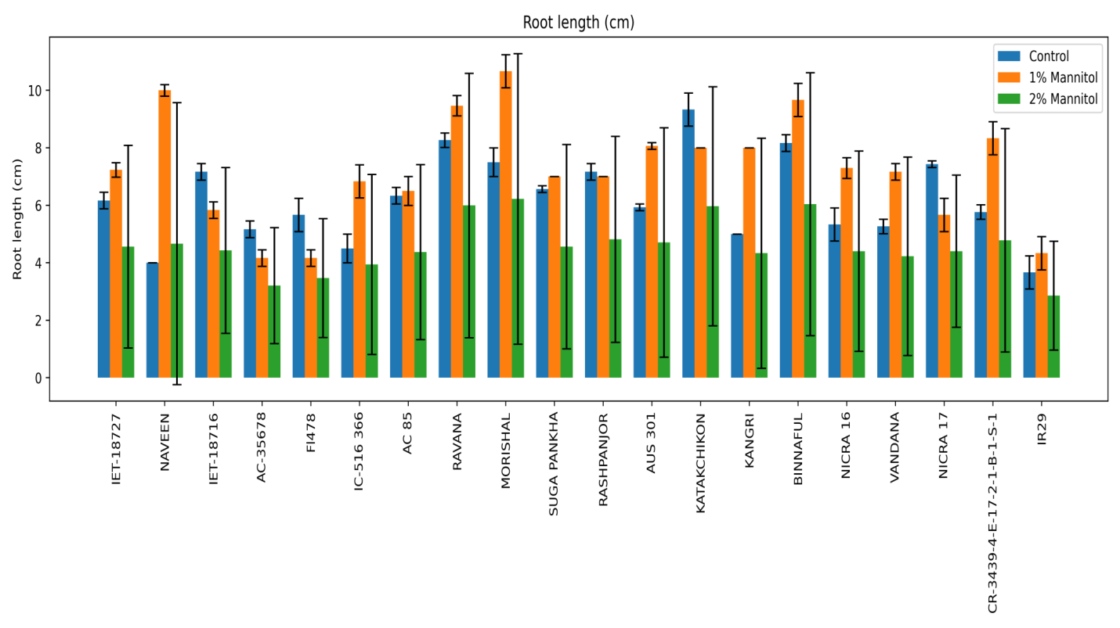
Fig. 1: Effect of Mannitol simulated drought stress on root length (cm) in different rice genotypes
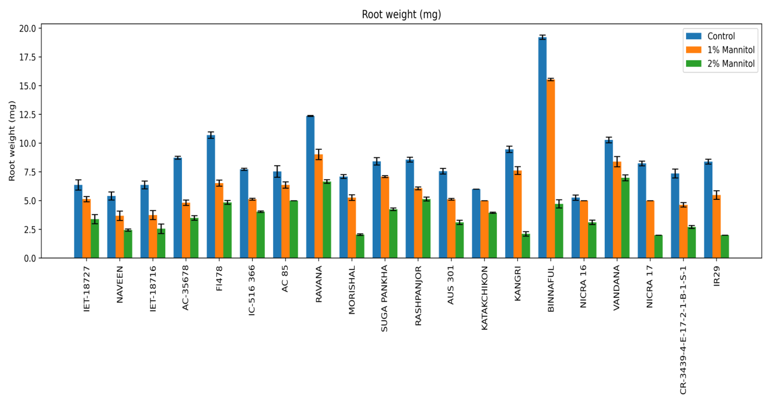
Fig. 2: Effect of Mannitol simulated drought stress on Root dry weight (RDW) in different rice genotypes
3.2 Effect of mannitol simulated drought stress on shoot length and shoot weight
Mannitol-induced drought stress at 1% and 2% concentrations caused significant reductions in shoot length and shoot dry weight across rice genotypes, with clear genotypic differences in sensitivity. At 1% mannitol, shoot length declined in all genotypes, with relatively lower reductions observed in FL478 (12.28%), Binnaful (14.40%), Kangri (23.02%), Katakchikon (29.25%), and Ravana (28.88%), while pronounced decreases were recorded in IR29 (77.12%), Suga Pankha (55.18%), Rashpanjor (50.86%), and CR-3439-4-E-17-2-1-B-1-S-1 (47.99%) (Fig 3 and 4). Correspondingly, shoot dry weight also decreased at 1% mannitol, with comparatively smaller reductions in Rashpanjor (13.49%), AUS 301 (14.55%), Katakchikon (16.34%), Ravana (16.72%), and Binnaful (17.11%), whereas higher losses were observed in FL478 (29.10%), Morishal (31.20%), and NICRA 17 (29.15%).
At 2% mannitol, shoot length exhibited further reductions across all genotypes, with the highest decreases recorded in IR29 (84.19%), Rashpanjor (75.70%), Morishal (70.43%), Vandana (71.96%), and CR-3439-4-E-17-2-1-B-1-S-1 (69.85%). Genotypes such as Kangri (43.33%), Ravana (48.92%), Katakchikon (52.38%), and Binnaful (50.29%) showed relatively lower reductions in shoot length at this concentration. A similar trend was observed for shoot dry weight at 2% mannitol, where reductions ranged from 26.38% in Katakchikon and 30.47% in AC 85 to pronounced declines in FL478 (66.54%), IET-18727 (58.22%), AC-35678 (57.88%), and Morishal (56.04%). Overall, genotypes exhibiting comparatively lower reductions in both shoot length and shoot dry weight across mannitol treatments indicate better shoot growth maintenance under osmotic stress conditions.
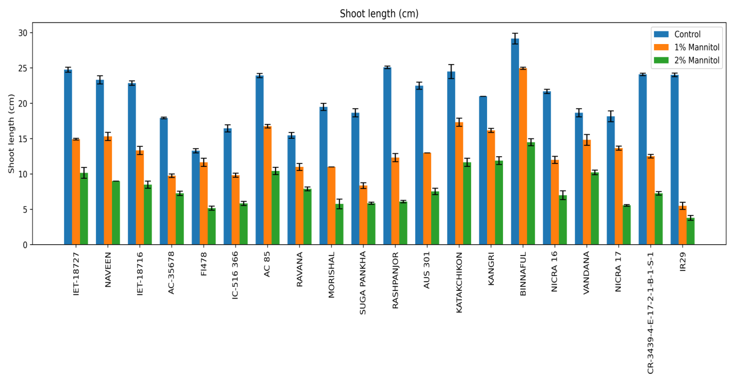
Fig. 3: Effect of Mannitol simulated drought stress on shoot length (cm) in different rice genotypes

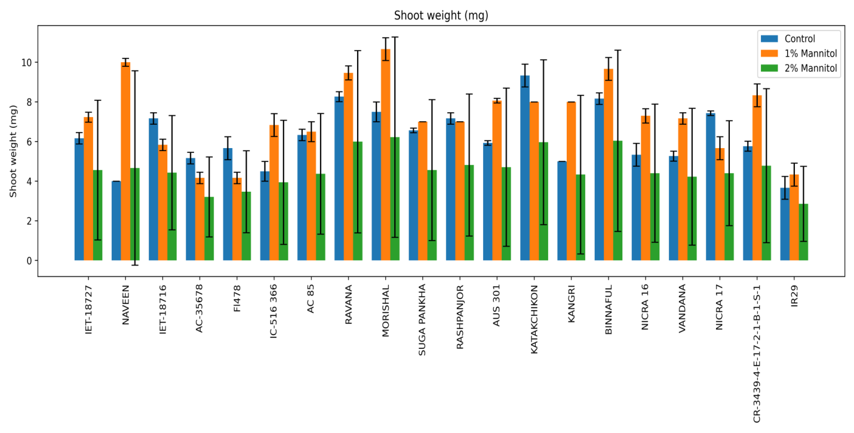
Fig. 4: Effect of Mannitol simulated drought stress on Shoot dry weight (mg) in different rice genotypes
3.3 Effect of Mannitol simulated drought stress on Total Chlorophyll Content
At 1% mannitol, relatively lower reductions in total chlorophyll content were recorded in AUS 301 (25.99%), IET-18716 (50.57%), Ravana (65.38%), Morishal (67.76%), Katakchikon (70.53%), IET-18727 (70.91%), CR-3439-4-E-17-2-1-B-1-S-1 (70.91%), Suga Pankha (75.79%), and NICRA 16 (78.29%), indicating better chlorophyll retention under mild stress. In contrast, higher reductions were observed in FL478, IC-516366, Rashpanjor, and Binnaful, reflecting greater sensitivity even at moderate stress. At 2% mannitol, chlorophyll content declined sharply across most genotypes. Comparatively lower reductions were observed in Kangri (52.03%), NICRA 16 (62.01%), IET-18727 (76.10%), CR-3439-4-E-17-2-1-B-1-S-1 (76.10%), IR29 and Naveen (84.54%), IC-516366 (83.47%), and Katakchikon (89.18%). In contrast, severe reductions (>90%) were recorded in Rashpanjor, NICRA 17, FL478, Binnaful, Morishal, AC-35678, AUS 301, Ravana, and Suga Pankha, indicating pronounced chlorophyll degradation under higher stress intensity.
The response of rice genotypes to mannitol stress demonstrates that 1% mannitol allows superior physiological performance compared to 2% mannitol. At 1% mannitol, several genotypes maintained comparatively higher total chlorophyll content, indicating better preservation of the photosynthetic apparatus and greater tolerance to osmotic stress. This level of stress enabled clear differentiation among genotypes based on their ability to retain chlorophyll, reflecting active adaptive mechanisms rather than injury responses. In contrast, exposure to 2% mannitol resulted in extensive chlorophyll degradation in most genotypes, with reductions exceeding 90% in several cases, suggesting impaired photosynthetic functioning and reduced metabolic activity. The improved chlorophyll retention and discernible genotypic variation observed at 1% mannitol highlight its suitability for identifying better-performing drought-tolerant genotypes, whereas 2% mannitol imposes excessive stress that masks inherent tolerance differences.
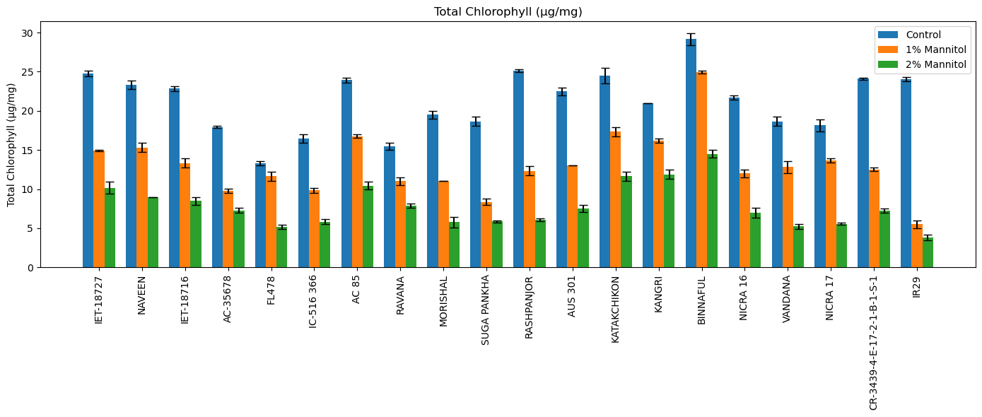
Fig. 5: Effect of Mannitol simulated drought stress on Total Chlorophyll Content (µg/mg FW) in different rice genotypes
3.4 Principal component analysis
To screen the genotypes against mannitol induced drought, Principal component analysis (PCA) was used as software based integrated approach which effectively summarized the multivariate response of rice genotypes by integrating morphological, biomass, and physiological traits. Out of two principal components PC1 was mainly associated with drought tolerance–related traits, including superior root performance, biomass retention, and physiological stability, whereas PC2 represented secondary variation in growth and stress sensitivity. The principal components explained 53.8% of the total variation, with PC1 accounting for 38.8% and PC2 for 15.0%. Based on PCA scores and biplot clustering (Fig. 4.6), genotypes were grouped into three distinct clusters. The tolerant group, located on the positive side of PC1, comprised Vandana, FL478, Binnaful, and Katakchikon. The clustering of Vandana (tolerant check) with FL478 and Binnaful corroborates results from individual trait analyses, indicating superior adaptive responses under drought stress. Genotypes in this cluster consistently maintained better root growth, higher biomass, and improved physiological performance across stress levels. An intermediate cluster near the origin included AUS 301, Morishal, AC 85, NICRA 16, Suga Pankha, Rashpanjor, CR-3439-4-E-17-2-1-B-1-S-1, and IET-18716, reflecting moderate drought tolerance with stable performance under mild stress but reduced resilience under severe stress. In contrast, the susceptible cluster on the negative side of PC1 comprised IR29, AC-35678, IC-516366, Ravana, and Kangri, which exhibited pronounced reductions in growth, biomass, and physiological traits under stress.
By integrating multiple morphological, biomass, and physiological traits into a reduced number of principal components, PCA effectively captured the complex, multivariate nature of drought responses under mannitol-induced stress. The strong concordance between PCA grouping and trait-level performance confirms that drought tolerance can be accurately predicted at the seedling stage, thereby accelerating selection efficiency, reducing time and resource requirements, and enabling rapid advancement of promising genotypes without the necessity of prolonged field evaluation up to crop maturity.

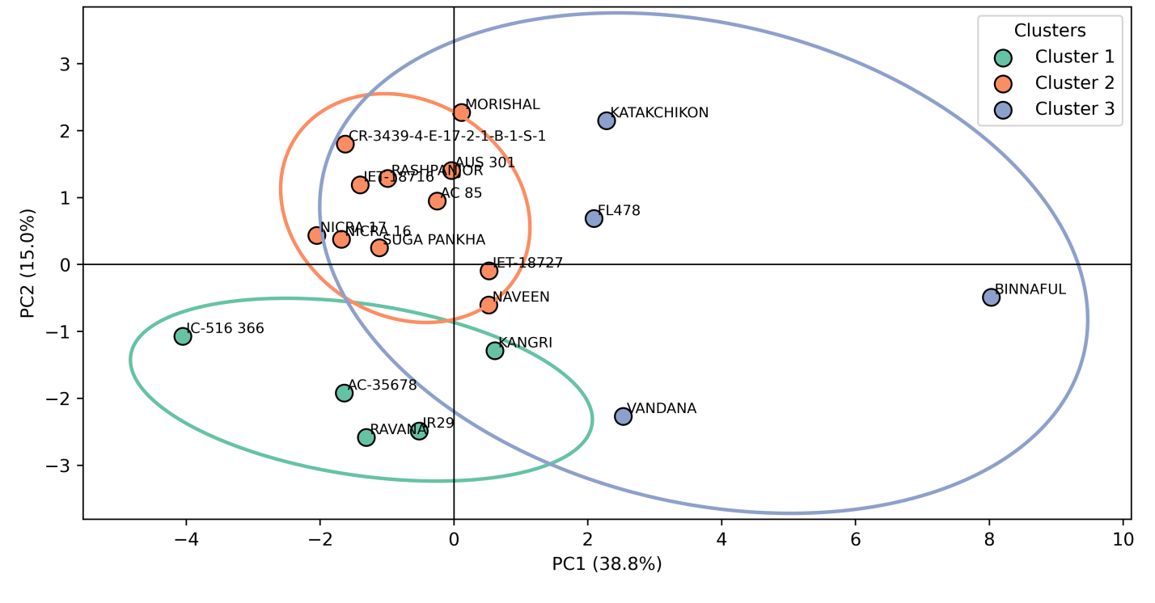

Fig. 6: Principle component analysis based selection of rice genotypes under mannitol-simulated drought stress
Discussion
These trends witnessed in our study for root length and root weight align with earlier reports showing that mild drought can stimulate root elongation (≈15–40%) as an adaptive water-foraging response, whereas severe stress leads to marked inhibition (30–60%) due to reduced turgor, hydraulic conductance, and carbon availability (Kim et al., 2020; Maurel and Nacry, 2020). The substantial reductions observed at 2% mannitol are consistent with declines reported under prolonged water deficit in rice (Veronica et al., 2024). The transient increase in root length at 1% mannitol observed in select genotypes supports the concept of drought avoidance through enhanced root elongation under moderate stress (Jarin et al., 2024). Additionally, drought stress suppresses cell division while maintaining cell elongation, resulting in enhanced axial root growth without substantial biomass gain (Yamaguchi & Sharp, 2010). The observed decrease in root dry weight may also reflect reduced lateral root formation and secondary growth, which contribute significantly to total root biomass but have limited influence on primary root length (Koevoets et al., 2016). The observed reduction in shoot length under osmotic stress is attributable to decreased cell turgor and restricted cell expansion, processes highly sensitive to plant water status. Consistent with earlier reports, moderate drought typically reduces shoot elongation by 20–35%, while severe stress can cause declines exceeding 50% in sensitive genotypes (Li et al., 2023). The concomitant decrease in shoot dry weight reflects reduced photosynthetic carbon assimilation caused by drought-induced stomatal closure and limited CO₂ availability (Chaves et al., 2009; Farooq et al., 2009). Previous studies have reported biomass reductions ranging from 25–60% under moderate to severe drought, depending on genotype and stress intensity (Kumar et al., 2025).
The observed decline in chlorophyll content under mannitol stress is consistent with earlier reports showing that osmotic and drought stress accelerate chlorophyll degradation through oxidative damage, impaired chlorophyll biosynthesis, and destabilization of thylakoid membranes. Mannitol-induced stress has been reported to reduce chlorophyll content by 40–70% under moderate stress and by >80–90% under severe stress in rice (Hassan et al., 2025). Severe drought-induced chlorophyll losses of 70–95%, accompanied by reduced photosystem II efficiency and net photosynthesis, have also been documented (Kumar et al., 2021). The high percentage reductions observed at 2% mannitol in the present study closely align with these findings, confirming chlorophyll content as a sensitive indicator of drought stress severity in rice. The clear separation of genotypes into tolerant, moderately tolerant, and susceptible groups is consistent with previous drought screening studies in rice and confirms the utility of PCA as an effective tool for integrating multiple traits and identifying promising donor genotypes for drought-tolerance breeding (Kim et al., 2020).
Conclusion
Multivariate analysis through PCA effectively integrated the traits like root traits, shoot growth, chlorophyll content and clearly separated genotypes into tolerant, moderately tolerant, and susceptible groups. However, overall study revealed significant genotypic variation in rice responses to mannitol-simulated drought stress across morphological and physiological traits. Genotypes such as Vandana, FL478, Binnaful, and Katakchikon consistently maintained better root performance, root and shoot growth, and physiological stability under stress, identifying them as drought-tolerant, while IR29, AC-35678, IC-516366, Ravana, and Kangri were highly sensitive.

Declaration of competing interest
The authors declare that there are no conflicts of interest regarding the publication of this paper.
References
Bin Rahman, A.R. and Zhang, J., 2016. Flood and drought tolerance in rice: opposite but may coexist. Food and Energy Security, 5(2), pp.76-88.
Dhankher, O.P. and Foyer, C.H., 2018. Climate resilient crops for improving global food security and safety. Plant, cell & environment, 41(5), pp.877-884.
Samal, P., Babu, S.C., Mondal, B. and Mishra, S.N., 2022. The global rice agriculture towards 2050: An inter-continental perspective. Outlook on Agriculture, 51(2), pp.164-172.
U S Department of Agriculture. Rice outlook: August 2022. 2022. Retrieved from: https://ers.usda.gov/publications/pub-details?pubid¼104481.

Bhatt SC, Singh VK, Singh MM. Perspectives of drought in Bundelkhand, Central India; causes, effects, and mitigation: A review. In: Ghute BB, Diwate P, editors. Geospatial technologies for integrated water resources management. Switzerland: Springer; 2024. p. 103–14.

Rao CS, Kareemulla K, Krishnan P, Murthy GRK, Ramesh P, Ananthan PS, et al. Agro-ecosystem based sustainability indicators for climate resilient agriculture in India: a conceptual framework. Ecol Indic 2019;105:621–33.

Kala CP. Environmental and socioeconomic impacts of drought in India: Lessons for drought management. Appl Ecol Environ Sci 2017;5(2):43–8.

Bhandari H, Pandey S, Hardy B. Economic Costs of drought and rice farmers’ coping mechanism: A cross-country comparative analysis. Los Ba~nos: International Rice Research Institute; 2007. p. 203.

Ward PS, Makhija S. New modalities for managing drought risk in rainfed agriculture: Evidence from a discrete choice experiment in Odisha, India. World Dev 2018;107:163–75.

Carpena F. How do droughts impact household food consumption and nutritional intake? A study of rural India. World Dev 2019;122:349–69.

Blum, A., 2011. Drought resistance–is it really a complex trait?. Functional Plant Biology, 38(10), pp.753-757.
Verslues, Paul E., Manu Agarwal, Surekha Katiyar‐Agarwal, Jianhua Zhu, and Jian‐Kang Zhu. "Methods and concepts in quantifying resistance to drought, salt and freezing, abiotic stresses that affect plant water status." The Plant Journal 45, no. 4 (2006): 523-539.
Swamy, B.M. and Kumar, A., 2012. Sustainable rice yield in water short drought prone environments: conventional and molecular approaches. Irrigation systems and practices in challenging environments. INTECH Publishers, Croatia, pp.149-168.
Singh, S.K., Katara, J.L., Parameswaran, C., Jagadev, P.N., Bastia, D.N., Jeughale, K. and Samantaray, S., 2025. Assessment of Drought Tolerance Degree (DTD) method as a reliable tool for early-stage screening for drought tolerance in indica rice. BMC Plant Biology, 25(1), p.1630.
Hiscox, J.D. and Israelstam, G.F., 1979. A method for the extraction of chlorophyll from leaf tissue without maceration. Canadian journal of botany, 57(12), pp.1332-1334.
Kim, Y., Chung, Y.S., Lee, E., Tripathi, P., Heo, S. and Kim, K.H., 2020. Root response to drought stress in rice (Oryza sativa L.). International journal of molecular sciences, 21(4), p.1513.
Maurel, C. and Nacry, P., 2020. Root architecture and hydraulics converge for acclimation to changing water availability. Nature plants, 6(7), pp.744-749.
Veronica, N., Srinivas, T. and Suneetha, Y., 2025. Response of Diverse Rice Genotypes to High Temperature Stress During the Reproductive Phase. Archives of Current Research International, 25(11), pp.313-320.
Jarin, A.S., Islam, M.M., Rahat, A., Ahmed, S., Ghosh, P. and Murata, Y., 2024. Drought stress tolerance in rice: physiological and biochemical insights. International Journal of Plant Biology, 15(3), pp.692-718.
Yamaguchi, M., Valliyodan, B., Zhang, J., Lenoble, M.E., Yu, O., Rogers, E.E., Nguyen, H.T. and Sharp, R.E., 2010. Regulation of growth response to water stress in the soybean primary root. I. Proteomic analysis reveals region‐specific regulation of phenylpropanoid metabolism and control of free iron in the elongation zone. Plant, Cell & Environment, 33(2), pp.223-243.
Koevoets, I.T., Venema, J.H., Elzenga, J.T.M. and Testerink, C., 2016. Roots withstanding their environment: exploiting root system architecture responses to abiotic stress to improve crop tolerance. Frontiers in plant science, 7, p.1335.
Li, Y., Hassan, M.A., Zhu, Q., Fang, W., Yi, Y., Duan, S., Yu, H. and Wang, S., 2024. Evaluation of Drought Resistance and Quality of Different Rice Hybrid Combinations. Journal of Ecological Engineering, 25(7), pp.371-383.
Chaves, M.M., Flexas, J. and Pinheiro, C., 2009. Photosynthesis under drought and salt stress: regulation mechanisms from whole plant to cell. Annals of botany, 103(4), pp.551-560.
Hassan, A.A., Elsherif, A.I. and Kalboush, Z.A., 2025. Exploring resistance-related physiological and molecular responses of rice genotypes against blast disease: Unraveling defense mechanisms and implications for breeding. Physiological and Molecular Plant Pathology, 136, p.102569.
Food and Agriculture Organization of the United Nations (2024) FAOSTAT: Statistical Database. Available at: https://www.fao.org/faostat/en/ (Accessed: 23 January 2026).
Farooq, M., Wahid, A., Lee, D.J., Ito, O. and Siddique, K.H., 2009. Advances in drought resistance of rice. Critical Reviews in Plant Sciences, 28(4), pp.199-217.
Kumar, V., Singh, V., Gupta, A., Gupta, V. and Singh, G.P., 2025. Multivariate analysis of drought stress indices to assess bread wheat (Triticum aestivum L.) germplasm under rainfed conditions. INDIAN JOURNAL OF GENETICS AND PLANT BREEDING, 85(04).
Kumar, N., Chhokar, R.S., Meena, R.P., Kharub, A.S., Gill, S.C., Tripathi, S.C., Gupta, O.P., Mangrauthia, S.K., Sundaram, R.M., Sawant, C.P. and Gupta, A., 2022. Challenges and opportunities in productivity and sustainability of rice cultivation system: a critical review in Indian perspective. Cereal research communications, 50(4), pp.573-601.

