Identification, characterization and optimization of media, temperature, and in-vitro management for anthracnose pathogen in fishtail palm (Caryota mitis) in West Bengal, India

ABSTRACT
Fishtail (Caryota mitis), resembling goldfish tails, is a popular ornamental plant often attacked by anthracnose disease.The study described disease symptoms, pathogen isolation, pathogenicity, and identification, along with evaluations of growth medium, temperature effects, growth characteristics, biomass production, and fungicide efficacy. The causal pathogen was identified as Colletotrichum manihotis based on conidial dimensions and cluster analysis. Among four growth media, Potato dextrose agar (PDA) was ideal for mycelial growth, with 28°C being the optimal temperature. C. manihotis exhibited whitish, cottony growth on PDA, OMA (Oat meal agar), and CDA (Czapek’s dox agar) but not on MEA (Malt extract agar). For biomass production, Potato dextrose broth (PDB) was optimal at 24°C and 28°C. Among tested fungicides, Difenoconazole 25% EC was more effective, completely inhibiting mycelial growth at 100 ppm with an EC₅₀ value of 13.3 ppm, compared to Mancozeb 50% WP, which required 400 ppm with an EC₅₀ value of 38.5 ppm.
Keywords: fishtail palm, anthracnose, isolation, identification, media, temperature
INTRODUCTION
The fishtail palm (Caryota mitis), is a captivating palm species widely utilized in ornamenting and charming the landscapes globally, renowned for its medium-sized green leaves intricately divided resemble the elegant tails of goldfish (Sarwar et al., 2020). Despite aesthetic appeal, the palm is susceptible to various diseases viz. Wilt caused by Fusarium oxysporum (Bhanwar wt al.,2016), brown leaf spot caused by Fusarium equisetii (Ashfaq et al., 2017), dieback and canker caused by Botryosphaeria ribis (Pereira et al., 2023), several leaf spots caused by Lasiodiplodia sp. (Zhu et al., 2015), Pestalotia and Pestalotiopsis sp. (Sarwar et al., 2020, Bhanwar et al., 2012), and bacterial blight caused by Acidovorax avenae (Nelson, 2009), a common challenge among ornamental palm varieties. These diseases can significantly reduce the plant's vitality, hinder its growth, diminish its overall visual allure and commercial value (Nelson, 2009). In the recent past, the fishtail palm in West Bengal was encountered a severe threat of anthracnose type of disease. Neither the symptoms of the disease were studied earlier nor its causal agent was identified after its isolation. As the associated causal pathogen of this disease in fishtail plant was not isolated, obviously, identification of suitable medium and temperature for its growth, production of biomass and determination of EC₅₀ to some common fungi were not made. Based on abovementioned research gaps on this particular disease at the study location, especially in the eastern region and as a whole in India, the objectives of the present study were set as to study disease symptoms, isolate and identify the causal agent by morphological characters, screen the suitable cultural medium and temperature required for its optimum growth, biomass production and find out its EC₅₀ against the selected fungicides.

MATERIALS AND METHODS

Collection of diseased samples and isolation of pathogen

Diseased leaf samples of fishtail palms were collected from Pallishree Nursery, Arambag, Hooghly, West Bengal (22⁰53’ N, 87⁰78’ E), India and brought immediately to the Mycology Laboratory of the Department of Plant Pathology, Bidhan Chandra Krishi Viswavidyalaya, Mohanpur, Nadia, West Bengal, India. The pathogen of the disease was isolated following the methodology used by Thilagam et al. (2018) with a little modification. The leaves displaying disease symptoms were cut into small pieces, surface sterilized with 0.1% HgCl₂ for 30-45 seconds, washed with 5 – 6 times with sterilized distilled water, blotted for the excess water, placed on the water agar medium in petri plates, incubated at 28±1°C until hyphal growth was observed; a small bit of hyphal growth was transferred onto the fresh PDA slant. The fungus was allowed to grow for 6 - 7 days in PDA slants. Full grown pure cultured slants were stored in refrigerator at 5⁰C for further experimental use.

Identification of the pathogen

Slides were prepared from diseased parts for morphometric studies. Microphotographs were taken using a Karl Zeis Phase Contrast Microscope. Conidia and conidiophores dimensions were measured with AxioVision software. The fungus was initially identified at the genus level (Sutton, 1981) and then the species level by comparing the dimensions of the conidia of this genus with morphometric characteristics of conidia other species (Sangpueak et al., 2018) following the nearest neighbour method of cluster analysis.

Effect of different culture media and temperatures on the radial growth and colony morphology

Four different culture media viz. Potato dextrose agar (PDA), Malt extract agar (MEA), Oat meal agar (OMA) and Czapek’s dox agar (CDA) (Devi et al., 2018) and three different temperatures viz. 21⁰C, 24⁰C, and 28⁰C were assessed for their effect on the radial growth. For this purpose, 20 ml of each of the sterilized media was poured into sterilized petri plates (90 mm dia) and allowed them to solidify. Each plate was inoculated at the centre with 5 mm diameter fungal mycelial disc, kept in incubators, ran at above mentioned three temperatures, for 10 days depending on growth behavior of fungus. The radial growth and colony morphology were recorded from the front and back side of petri plates. Radial growth data were subjected to 2 factors analysis.

Biomass production of fungi

Four growth media viz. Potato dextrose broth (PDB), Oat meal broth (OMB), Malt extract broth (MEB) and Czapek’s dox broth (CDB) and three temperatures viz. 21⁰C, 24⁰C, and 28⁰C were considered with three replications. 40 ml broth of above mentioned four media were taken into 250 ml conical flasks and inoculated with a 5 mm mycelial disc taken from active growing tip region of 6 days old culture. Both the flasks and plates were incubated at above mentioned three temperatures. The conical containing broths were incubated for 6 days. After 6 days the mycelial mat formed by fungi on 4 growth media were collected and filtered separately through previous dried and pre-weighted Whatman No. 1 filter paper. Filter paper containing the fungal mass was then kept in drier for drying at 65⁰C-70⁰C for 96 hours to a constant weight. Weighing was repeated till constant weight was obtained. 2 factor analysis was done for fungal dry biomass production.

Fungicide sensitivity analysis

In vitro sensitivity of seven concentrations viz. 0, 10, 25, 50, 100, 200, 400, 800 µl/ml of two fungicides viz. Mancozeb 50% WP and Difenoconazole 25% EC were tested following the poisoned food technique (Vanani et al., 2024). 20 ml of the fungicide poisoned PDA medium was poured into each sterilized Petri plate. Control plates were maintained by the addition of same volume of PDA medium in the Petri plates without the addition of any fungicide. Then 5 mm mycelial discs were cut out from the periphery of the actively growing cultures with the help of sterilized cork borer and placed at the centre of the Petri plates. Plates were incubated at 28±2⁰ C temperature in BOD till the fungal growth covers the entire Petri plate used as control (Golakiya et al., 2020). Each treatment was replicated three times with suitable control. Radial growth was recorded and percent reduction in mycelial growth over control was worked out. The EC₅₀ for each fungicide was determined by plotting the log value of concentrations against the probit values of percent inhibition (Ren et al., 2020). A regression equation (Y = a + bx) was derived and examined for fitness. Each treatment was replicated three times, and significance levels were compared with the simple correlation coefficient (r) at 5% or 1%. Percent inhibition of radial growth was calculated using the formula

Radial growth in control (C) – Radial growth in treatment (T)
Percent inhibition = –––––––––––––––––––––––––––––––––––––––––––––––– X100
Radial growth in control (C)

RESULTS AND DISCUSSIONS

Symptoms of the disease

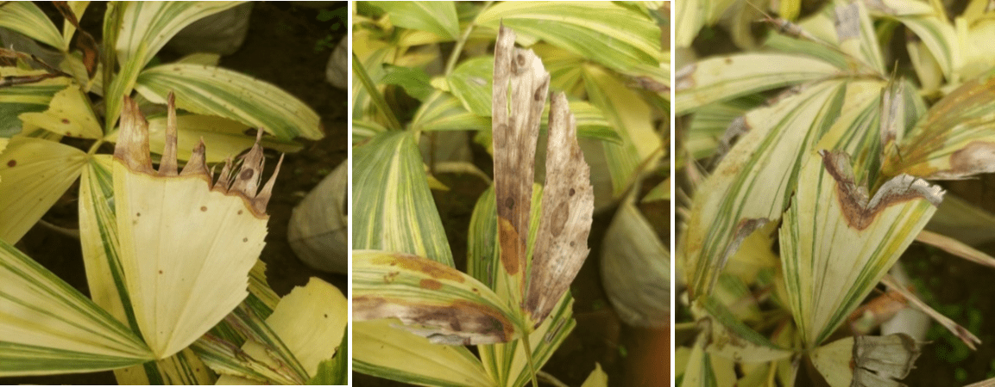
The disease manifests initially at the leaf margin or as small spots on the leaf blade. The symptoms progress downward, resulting in the drying and straw-colored appearance at the margin of leaves (Fig 1). A noticeable demarcation, appearing as a brown color, distinguishes the affected tissue from the healthy areas. The spots may merge, leading to the complete drying of the leaf. Notably, minute dot-like structures (acervuli) are frequently observed on the dried tissues.

Figure 1: Anthracnose symptoms on leaves of fishtail palm

Isolation and pathogenicity establishment of pathogen

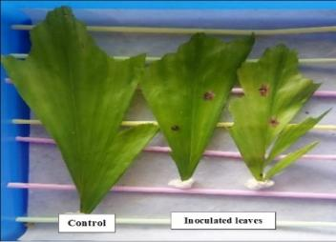
The pathogenicity of the isolated fungal pathogen was established by inoculating the detached leaf under laboratory conditions. The inoculated leaf produced similar symptoms (Fig 2) as observed in the nursery. The fungal pathogen was re-isolated in purified form from the inoculated diseased leaf and compared it with the initially isolated fungal culture. Both the isolated pathogens were same. Thus, the pathogenicity of the isolated fungal pathogen was established (Xu et al., 2017).

Figure 2: Pathogenicity establishment of Colletotrichum sp. of fishtail under laboratory condition

Morphological descriptions and identification of the pathogen

Slides prepared from diseased parts as well as from pure culture were used for morphometric studies. The fungus produced short, cylindrical, guttulated (3-4 in number), hyaline aseptate conidia with one end rounded and the other tapered (Fig 3). Conidia were 8.79 to 15.89 μm in length and 2.74 to 4.49 μm in breadth. The conidia were produced from acervuli bearing setae (Fig 4). Acervuli measured 180.46 to 244.7 μm in length and 160.88 to 190.39 μm in width, with 10-20 setae having 3-5 septa. Setae had a length of 28.77 to 54.83 μm, a base width of 1.23 to 3.41 μm, a middle width of 2.91 to 5.85 μm, and a tip width of 0.41 to 1.54 μm.
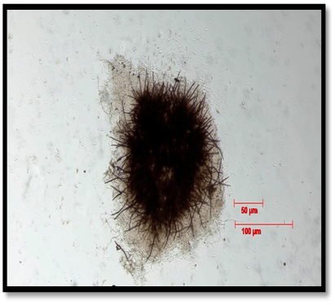
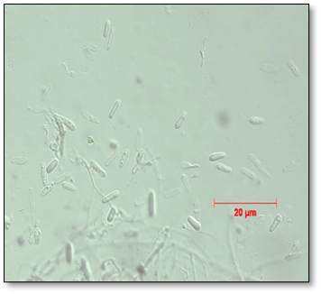
Figure 4: Microscopic view of acervuli bearing setae and conidia produced by Colletotrichum manihotis.

Figure 3: Microscopic view of conidia produced by Colletotrichum manihotis.

The anthracnose-causing pathogen associated with fishtail palm closely resembled Colletotrichum species based on conidial characteristics. Dimensions of spore of various Colletotrichum species were considered for hierarchical cluster analysis (Fig 5) (Salotti et al., 2022) and using the nearest neighbor method (Grahovac et al., 2012), aligned the fishtail palm isolate with C. manihotis whose conidia were short, cylindrical, hyaline, guttulated (3-4), and aseptate (Ehui et al., 2019). Comparison of dimensions place it within the range of various Colletotrichum species, but single linkage hierarchical analysis pinpointed a close match with C. manihotis, with spore length and breadth at 8-15μm x 4-6μm) (Table 1). Thus, the fishtail palm-infecting Colletotrichum sp. was identified morphologically similar as C. manihotis.
Control
Control
Table 1: Dimensions of conidia and acervuli of Colletotrichum sp. (obtained from fish tail palm) grown as pure culture on PDA medium

Pathogen Name | Conidial length (µm) | Conidial width (µm) | Acervuli length (µm) | Acervuli width  (µm) | Setae  length  (µm) | Base width of setae (µm) | Mid width of septa (µm) | Tip width of septa (µm)
Colletotrichum sp. | 8.79-15.89 | 2.74-4.49 | 180.46-244.7 | 160.88-190.39 | 28.77-54.83 | 1.23-3.41 | 2.91-5.85 | 0.41-1.54
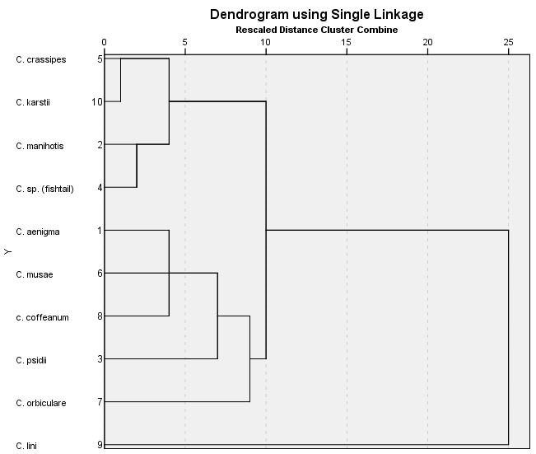

Figure 5: Dendrogram based on conidial characteristics of Colletotrichum manihotis obtained from fishtail palm

Effect of different culture media, temperature and culture media x temperatures on radial growth

The effect of 4 growth media viz. PDA, CDA, OMA and MEA and three different temperatures viz. 21⁰C, 24⁰C, and 28⁰C were assessed for their sole and interaction effects (Table 2) on the radial growth performance of Colletotrichum manihotis at 9 different dates. The radial growth of the fungus irrespective of temperature when examined, it was found significantly enhanced in all dates of observation except the day 9. At 8th day of observation, out of the 4 media tested PDA medium appeared to be superior to OMA, MEA and CDA media. PDA medium was found to be very ideal growth medium than MEA and OMA media. Lokare and Fatima (2021), in a similar experiment, showed that PDA medium promoted the fastest mycelial growth of Colletotrichum gloeosporioides causing anthracnose of mango followed by CDA. Similarly, Thangeswari et al. (2024), Bhagat et al. (2022) and Soltani et al. (2014) also showed that PDA served as the most favorable medium for mycelial growth of different Colletotrichum species. Majumdar and Mandal (2019), reported PDA and OMA as favorable media for mycelial growth and sporulation respectively of C. gloeosporoides causing banana anthracnose. The laboratory study was conducted by Joshi et al. (2024) to know the best nutrient media for the growth and sporulation of the pathogen. Out of twelve different nutrient media were selected and tested for the growth of pathogen, Potato dextrose agar and carrot dextrose agar media were proved to be best media for growth and sporulation of Colletotrichum capsica.

The radial growth of the fungus irrespective of media when examined, it was found significantly enhanced in all dates of observation. Out of 3 temperatures tested, the radial growth was significantly highest and lowest at 28⁰C and 21⁰C respectively. However, the performance of the radial growth of the fungus at 24⁰ C looked intermediate. At day 9, the tested fungus covered the entire diameter of the Petri plates at all the temperatures viz. 21⁰C, 24⁰C and 28⁰C. In the present experiment, out of 3 temperatures tested, the radial growth was significantly highest and lowest at 28⁰C and 21⁰C respectively. This finding was in agreement with the findings of Pandey et al. (2012), Soltani et al. (2014), Sajili et al. (2017), Prajapati et al. (2015) who identified 28°C as the most suitable temperature for mycelial growth of different Colletotrichum species.

When the interaction of the said 4 media and 3 temperatures on the radial growth performance of the fungus C. manihotis was studied at different dates of observations, the significant differences were also noted in all dates of observation. At day 8, both 24⁰C and 28⁰C temperatures were better than 21⁰C for radial growth. PDA medium was the best medium at 21⁰C, 24⁰C and 28⁰Cn followed by OMA, MEA and CDA medium. At 28⁰C, full plate radial growth was observed in all the media tested at day 9. Among the temperatures tested, the fungus exhibited significantly higher and lower radial growth at 28°C and 21°C respectively, with intermediate growth observed at 24°C.

Table 2: Effect of media*temperature on radial growth (cm) of Colletotrichum manihotis at different dates of observations

 | D1 | D2 | D3 | D4 | D5 | D6 | D7 | D8 | D9
Media | T1 (21^{O}C)
PDA | 0.83 | 1.93 | 3.37 | 4.23 | 5.33 | 5.97 | 7.30 | 8.90 | 9.00
CDA | 0.87 | 1.67 | 2.93 | 3.37 | 4.27 | 5.37 | 6.30 | 7.23 | 8.83
OMA | 0.53 | 2.17 | 3.33 | 4.07 | 5.00 | 5.77 | 7.03 | 8.07 | 9.00
MEA | 0.67 | 1.67 | 2.47 | 3.40 | 4.83 | 5.57 | 6.53 | 7.77 | 8.94
Temperature mean irrespective of media | 0.73 a | 1.86 a | 3.03 a | 3.77 a | 4.86 a | 5.57 a | 6.79 a | 7.99 a | 8.94 a
Media | T2 (24ºC)
PDA | 1.07 | 2.43 | 3.40 | 4.67 | 5.80 | 6.70 | 7.87 | 8.97 | 9.00
CDA | 1.03 | 2.07 | 3.13 | 3.70 | 4.73 | 5.70 | 6.77 | 7.57 | 8.91
OMA | 1.13 | 2.37 | 3.30 | 4.10 | 5.63 | 6.33 | 7.43 | 8.73 | 9.00
MEA | 1.13 | 2.17 | 3.53 | 3.90 | 5.07 | 6.03 | 7.03 | 8.03 | 9.00
Temperature mean irrespective of media | 1.09 b | 2.26 b | 3.34 b | 4.09 b | 5.31 b | 6.19 b | 7.27 b | 8.32 b | 8.98 a
Media | T2 (28ºC)
PDA | 2.63 | 3.73 | 4.73 | 5.87 | 6.77 | 7.90 | 8.87 | 9.00 | 9.00
CDA | 2.13 | 3.07 | 4.20 | 4.87 | 5.87 | 6.73 | 7.23 | 8.13 | 9.00
OMA | 2.43 | 3.67 | 4.57 | 5.77 | 6.53 | 7.27 | 8.50 | 8.97 | 9.00
MEA | 2.43 | 3.47 | 4.37 | 5.23 | 6.17 | 6.97 | 8.03 | 8.77 | 9.00
Temperature mean irrespective of media | 2.41 c | 3.48 c | 4.47 c | 5.43 c | 6.33 c | 7.22 c | 8.16 c | 8.72 c | 9.00 a
Media mean irrespective of temperature
PDA | 1.51 b | 2.70 c | 3.83 c | 4.92 d | 5.97 d | 6.86 d | 8.01 d | 8.95 d | 9.00 b
CDA | 1.34 a | 2.27 a | 3.42 a | 3.98 a | 4.95 a | 5.93 a | 6.77 a | 7.64 a | 8.92 a
OMA | 1.37a | 2.73 c | 3.73 b | 4.64 c | 5.72 c | 6.46 c | 7.66 c | 8.59 c | 9.00 b
MEA | 1.41 a | 2.43 b | 3.46 a | 4.18 b | 5.35 b | 6.19 b | 7.20 b | 8.19 b | 9.00 b
SEm±for temperature | 0.02 | 0.02 | 0.02 | 0.03 | 0.02 | 0.03 | 0.03 | 0.03 | NS
CD_{.05} for temperature | 0.04** | 0.08** | 0.07** | 0.08** | 0.06** | 0.07** | 0.07** | 0.09** | -
SEm+- for media | 0.02 | 0.02 | 0.03 | 0.04 | 0.02 | 0.03 | 0.03 | 0.04 | NS
CD_{.05} for media | 0.05** | 0.05** | 0.08** | 0.09** | 0.07** | 0.08** | 0.08** | 0.10** | -
SEm+- for temp*media | 0.04 | 0.04 | 0.05 | 0.07 | 0.05 | 0.06 | 0.06 | 0.07 | NS
CD.05 for temp*media | 0.09** | 0.09** | 0.13** | 0.16** | 0.12** | 0.14** | 0.14** | 0.18** | -

D = Days; PDA = Potato dextrose Agar; OMA = Oat meal Agar; MEA = Malt extract agar; CDA = Czapek’s dox Agar; SEm = Standard error of mean; CD = Critical difference; ** = Significance at 0.01%; NS = non-significant
Growth characteristics or colony morphology of Colletotrichum manihotis
Colletotrichum manihotis from fishtail when grown on four different media with three temperature regimes, the differences in colony morphology were observed in 21⁰C, 24⁰C and 28⁰C temperatures and media (Table 3). The fungus produced whitish, cottony and fluffy mycelial growth in all the media at 21⁰C and 28⁰C whereas at 24⁰C whitish thick, cottony, fluffy mycelial growth was observed in PDA, CDA and OMA media but in MEA media the fungus produced very thin mycelial growth (Fig 6).
At the back side of Petri plates, it produced whitish thin mycelial growth in CDA media. In PDA the fungus produced whitish, thick, cottony mycelial growth whereas yellowish white thick mycelial growth and light brownish thick mycelial growth in OMA and MEA media respectively at 21⁰C whereas at 24⁰C The fungus produced whitish and yellowish white thick mycelial growth in CDA and OMA media respectively but in PDA and MEA media whitish and yellowish white thin mycelial growth was observed. At 28⁰C PDA, CDA and MEA were covered by whitish, thick mycelial growth but light yellowish, thin mycelial growth was observed in OMA media (Fig 7).
The growth characteristics of Colletotrichum musae isolates were studied by Ranjitham et al. (2011) on seven different solid media and blakish white coloured colonies were observed on PDA medium and OMA medium. . Grahovac et al. (2012) showed that Colletotrichum isolates formed velvety, gray colonies with slightly wavy margin on PDA medium. At the beginning, the mycelium was snow-white and with culture aging it became pale gray. The underside of the colony was cream coloured or pale gray to tan, never dark, which is in agreement with C. acutatum colony appearance described by Strandberg and Chellemi (2002).
According to Admassie et al. (2015), colony colour of Colletotrichum isolates was divided into 3 groups whitish, gray and black to white. Three Colletotrichum isolates were whitish, three were gray and the remaining one was black to white colony colour.

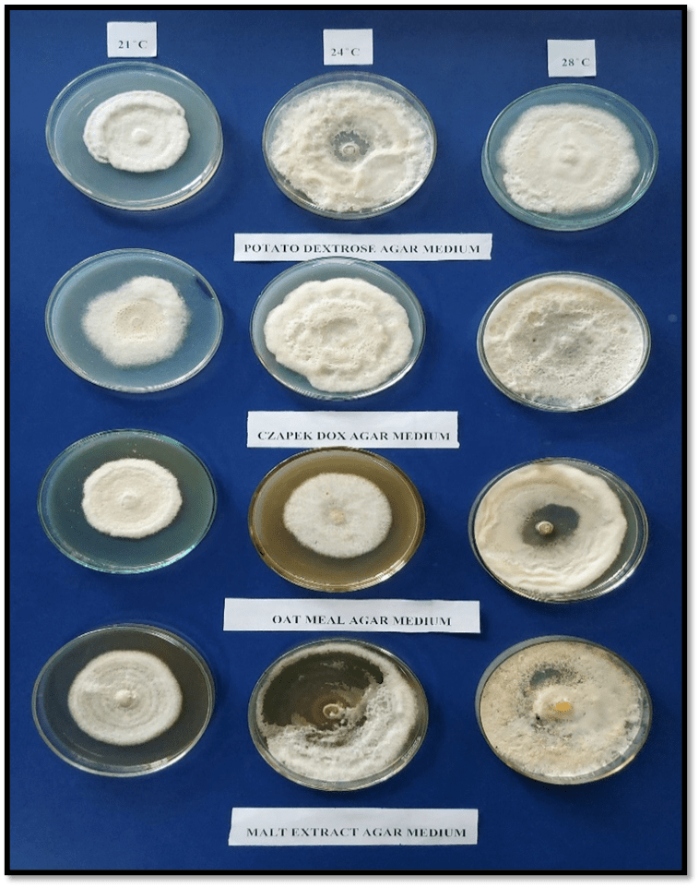
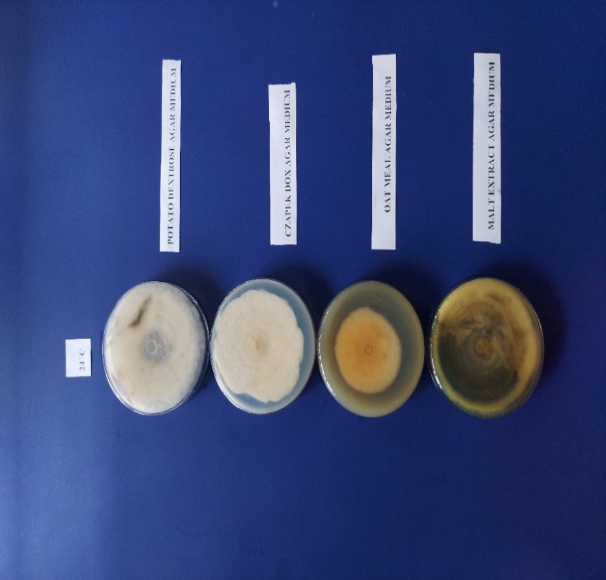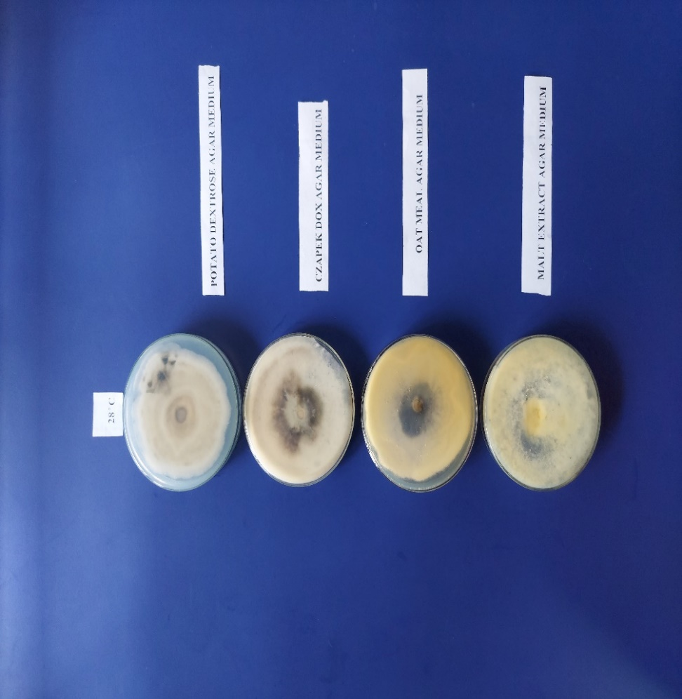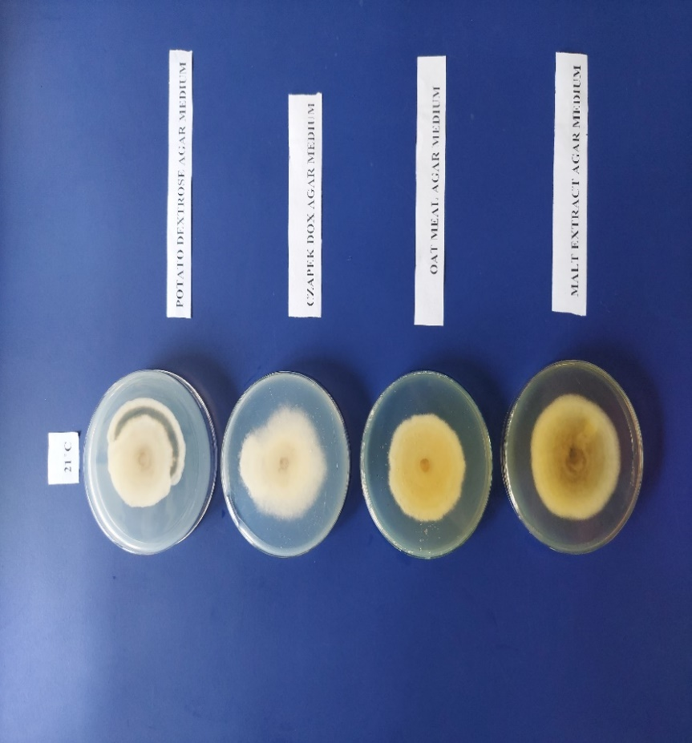

Figure 7: Colony morphology of Colletotrichum manihotis in different media at different temperature (Back side).
Figure 6: Colony morphology of Colletotrichum manihotis in different media at different temperature (Front side).

Table 3: Colony characteristics of Colletotrichum manihotis in different media at different temperatures
Growth media | Colony morphology  (Front side) | Colour of colony  (Front side) | Colony morphology (Back side) | Colour of colony (Back side)
21⁰C
PDA | Very thick, cottony, appressed growth with irregular margin. | Whitish. | Thick cottony mycelial growth. | Whitish with a blackish ring.
CDA | Cottony fluffy mycelial growth. | Whitish. | Thin cottony mycelial growth. | Whitish.
OMA | Cottony thick mycelial growth with concentric rings with irregular margin. | Whitish. | Thick mycelial growth. | Yellowish whitish.
MEA | Thick, cottony growth with concentric rings towards the margin. Margin is irregular. | Whitish. | Thick mycelial growth. | Light brownish white colour.
24⁰C
PDA | Thick, cottony, fluffy mycelial growth with irregular margin. | Whitish. | Thin mycelial growth. | Whitish.
CDA | Thick, cottony growth with irregular margin and more fluffiness compared to other media. | Whitish. | Thick mycelial growth with concentric rings towards centre. | Whitish.
OMA | Fluffy uniform growth of mycelia. | Whitish growth with yellowish centre. | Thick mycelial growth. | Yellowish white.
MEA | Very thin mycelial growth surrounding the point of inoculation with regular margin. | Whitish. | Very thin mycelial growth. | Yellowish.
28⁰C
PDA | Fluffy mycelial growth with concentric rings and margin is irregular. | Whitish. | Thick mycelial growth with a circle at the centre. | Greyish white.
CDA | Compressed, cottony mycelial growth with regular margin. | Whitish. | Thick mycelial growth with dark coloured centre. | Whitish colour with blackish centre.
OMA | The mycelia surrounding the point of inoculation are very thin, non-fluffy and appressed to the medium. Beyond this zone the mycelia are thick, fluffy and cottony. | Whitish. | Very thin growth at the surrounding the point of inoculation. Beyond this zone the mycelial growth is cottony. | Light yellowish.
MEA | Thin appressed mycelial growth with regular margin. | Whitish mycelia with yellow centre. | Thin mycelial growth. | Whitish.

Effect of media, temperature and media*temperature on biomass production of Colletotrichum manihotis irrespective of temperatures

The effect of 4 growth media viz. PDB, CDB, OMB and MEB on the biomass production of Colletotrichum manihotis irrespective of temperatures at 6 days (Fig 8). Out of 4 media tested, the PDB medium was found better than other 3 media for the production of fungal dry biomass after 6 days of inoculation (Udhayakumar et al., 2010, Sandhya et al., 2005, Juarez et al., 2000) whereas CDB, OMB and MEB media were found at par in dry biomass production performance among themselves (Table 4).

Figure 8: Effect of media on biomass production (g) of Colletotrichum manihotis irrespective of temperatures at 6 days after inoculation
Table 4: Effect of media on biomass production (g) of Colletotrichum manihotis irrespective of temperatures at 6 days after inoculation.
Growth media | Biomass (g)
PDB | 0.303b
CDB | 0.221a
OMB | 0.204a
MEB | 0.242a
SEm± | 0.012
CD_{0.5} | 0.035

PDB = Potato dextrose broth; CDB = Czapek’s dox broth; OMB = Oat meal broth; MEB = Malt extract broth; SEm = Standard error of mean; CD = Critical difference
The effect of 3 temperatures viz. 21⁰ C, 24⁰ C and 28⁰ C on the biomass production of Colletotrichum manihotis irrespective of 4 growth media viz. PDB, CDB, OMB and MEB considered was studied and dry fungal biomass was recorded up to 6 days after inoculation (Fig 9). It was evident that there is no significant effect of temperatures on the dry biomass production of tested fungus Colletotrichum manihotis (Table 5).

Figure 9: Effect of temperatures (⁰C) on biomass production (g) of Colletotrichum manihotis irrespective of media at 6 days after inoculation
Table 5: Effect of temperatures (⁰C) on biomass production (g) of Colletotrichum manihotis irrespective of media at 6 days after inoculation
Temperatures (⁰C) | Biomass (g)
21 | 0.24a
24 | 0.24a
28 | 0.25a
SEm± | NS
CD_{0.5} | -

SEm = Standard error of mean; CD = Critical difference
When the interaction of 4 media viz. PDB, CDB, OMB and MEB and 3 temperatures viz. 21⁰C, 24⁰C and 28⁰C on the fungal biomass production of Colletotrichum manihotis was studied at 6 days after inoculation, it was found significant (Table 6). PDB at 28⁰C and 24⁰C exhibited the higher value in fungal dry biomass production as compared to other media and temperatures examined (Fig 10).
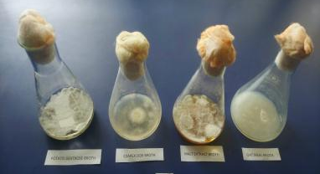
Figure 10: Growth of Colletotrichum manihotis on 4 broth media (PDB, CDB, OMB and MEB)
Table 6: Effect of media*temperatures on biomass production (g) of Colletotrichum manihotis, at 6 days after inoculation .
Growth media | Biomass (g)
21ºC
PDB | 0.291
CDB | 0.202
OMB | 0.194
MEB | 0.241
24⁰ C
PDB | 0.315
CDB | 0.214
OMB | 0.192
MEB | 0.241
28⁰ C
PDB | 0.312
CDB | 0.243
OMB | 0.224
MEB | 0.255
SEm± | 0.031
CD_{0.5} | 0.090

PDB = Potato dextrose broth; CDB = Czapek’s dox broth; OMB = Oat meal broth; MEB = Malt extract broth; SEm = Standard error of mean; CD = Critical difference
Fungicide sensitivity analysis

Mancozeb 50% WP exhibited mycelial growth inhibition of the pathogen of 20.1%, 32.4%, 64.3%, 72.3%, and 88.2% at concentrations of 10, 25, 50, 100 and 200 ppm, respectively, achieving complete inhibition at 400 ppm and above (Fig 11). Conversely, Difenoconazole 25% EC demonstrated inhibition percentages of 44.5%, 63.2%, and 81.2% at concentrations of 10, 25 and 50 ppm, respectively, with complete inhibition observed at 100 ppm (Fig 12) and above (Table 7). Difenoconazole 25% EC proved superior to Mancozeb 50% WP against the anthracnose-causing pathogen, C. manihotis. The EC₅₀ values against the pathogen were determined to be 38.5 ppm for Mancozeb 50% WP and 13.3 ppm for Difenoconazole 25% EC (Table 8). Gao et al. (2017), in an in-vitro experiment, showed that systemic fungicide difenoconazole is more effective in inhibiting mycelial growth of Colletotrichum acutum than mancozeb. Mahesh et al. (2020) screened different chemicals under in-vitro for the management of Colletotrichum gloeosporioides causing anthracnose of pomegranate. Among different systemic fungicides evaluated, difenoconazole 25 EC has completely inhibited mycelial growth of Colletotrichum gloeosporioides.

Table 7: Percent mycelia growth inhibition of Colletotrichum manihotis by two fungicides over control

Fungicides used | Percent growth inhibition over control at
Fungicides used | 0 ppm | 10 ppm | 25 ppm | 50  ppm | 100 ppm | 200 ppm | 400 ppm | 800 ppm
Mancozeb 50% WP | 0 | 20.1 | 32.4 | 64.3 | 72.3 | 88.2 | 100 | 100
Difenoconazole 25% EC | 0 | 44.3 | 63.2 | 81.2 | 100 | 100 | 100 | 100

Table 8: Regression and simple correlation of toxicity of Colletotrichum manihotis against two fungicides and determination of EC ₅₀

Fungicides used | Chemical name | Regression equation (RE) | Simple correlation (r) | EC₅₀ (ppm)
Indofil M-45 | Mancozeb 50% WP | Y= 1.5312x + 2.5736 | 0.98* | 38.5
Score 25 EC | Difenoconazole 25% EC | Y= 1.4596x + 3.36 | 0.99* | 13.3

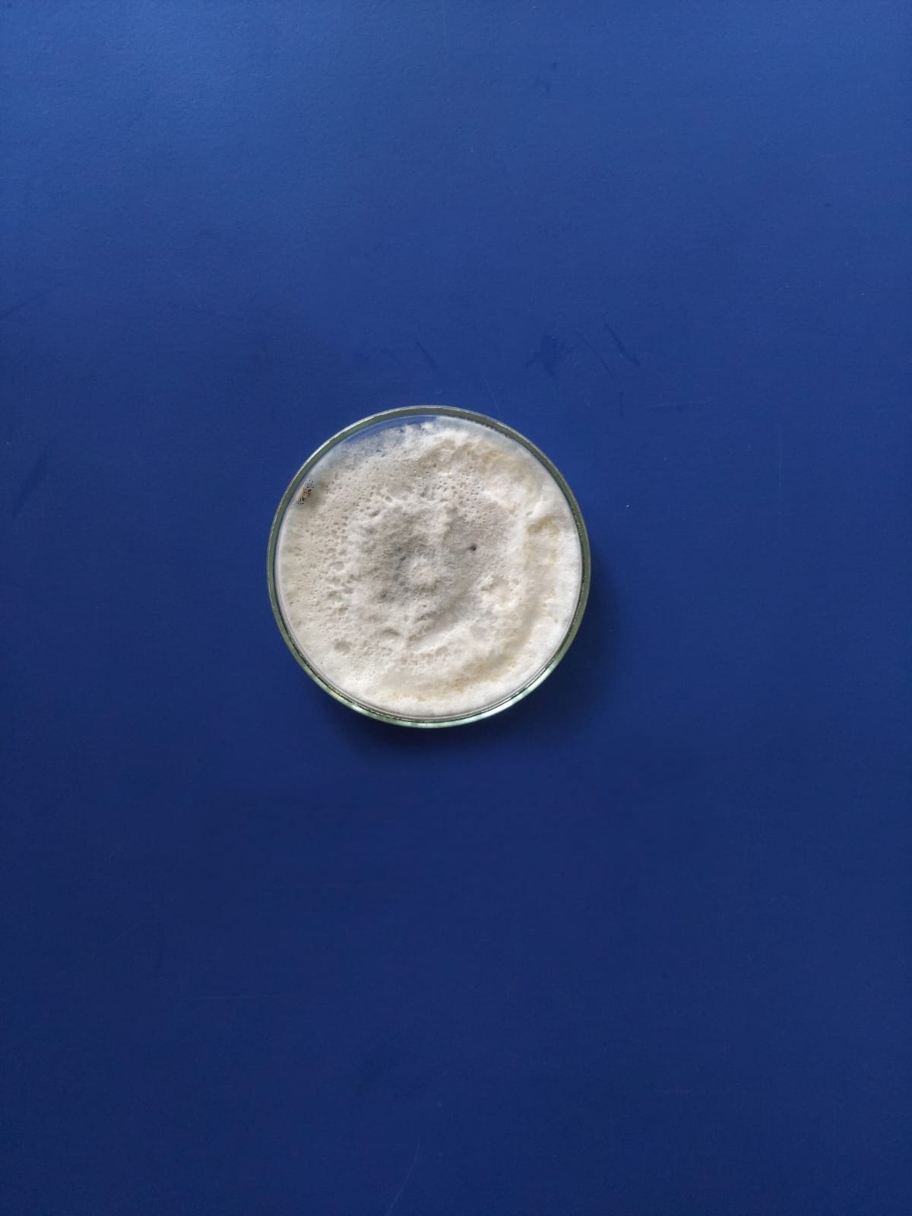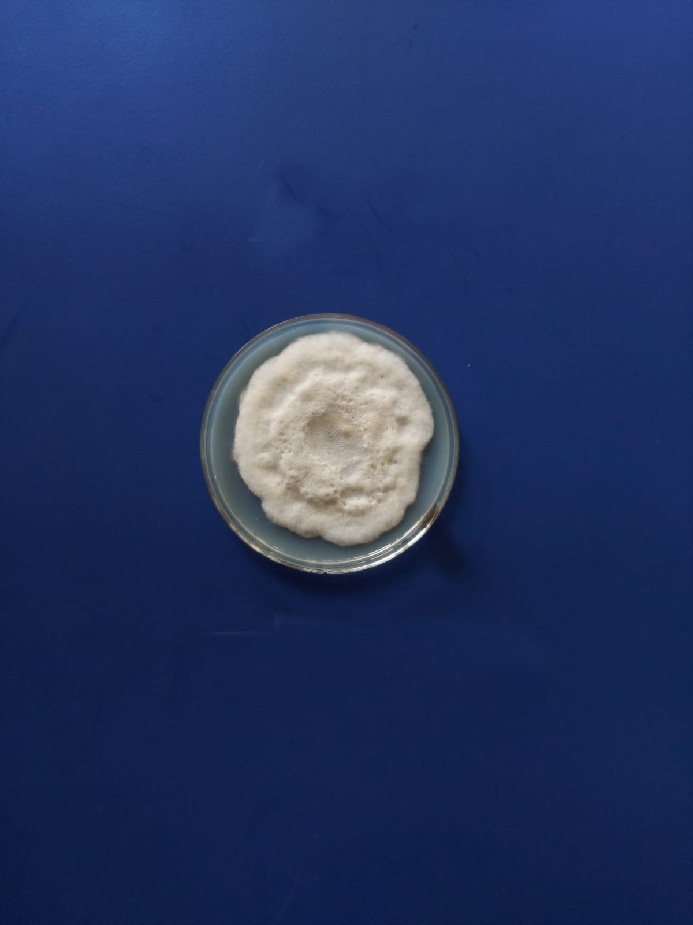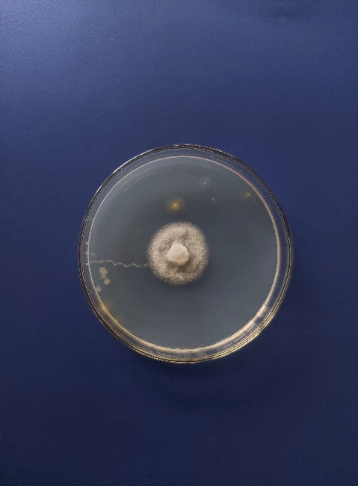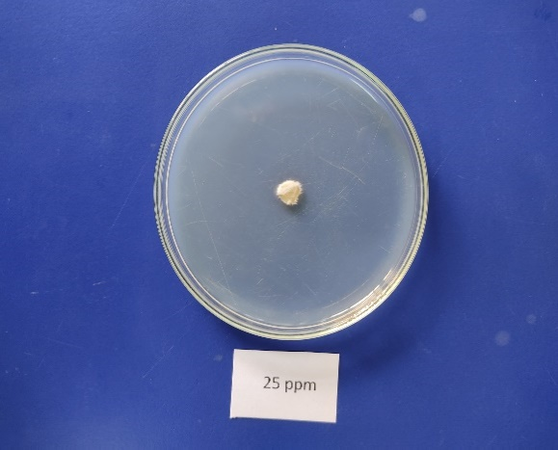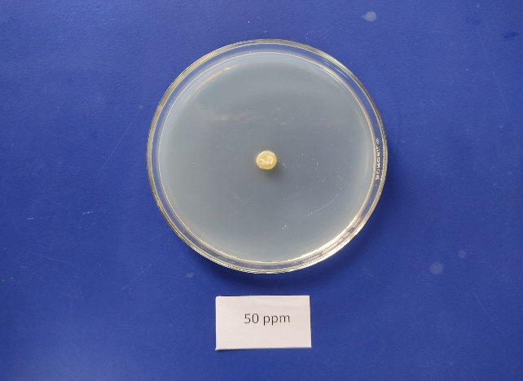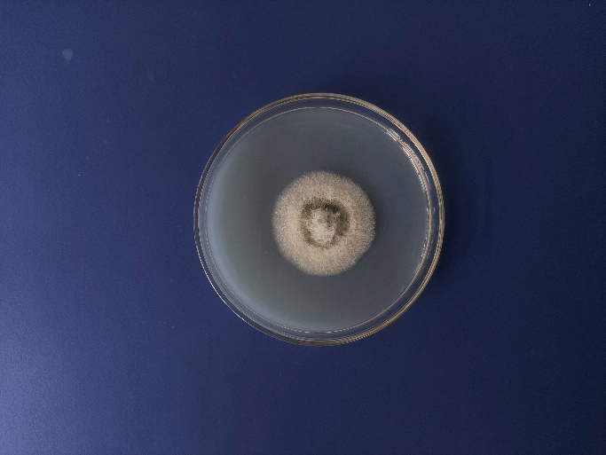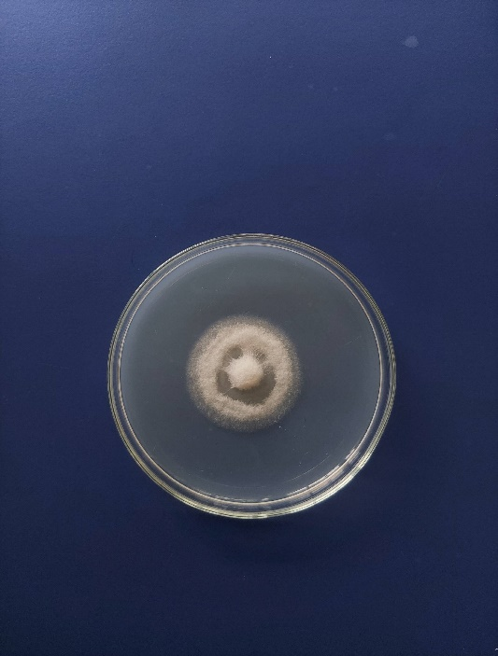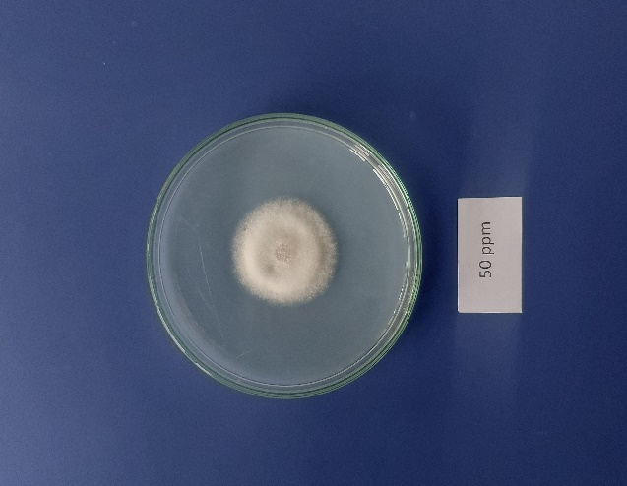

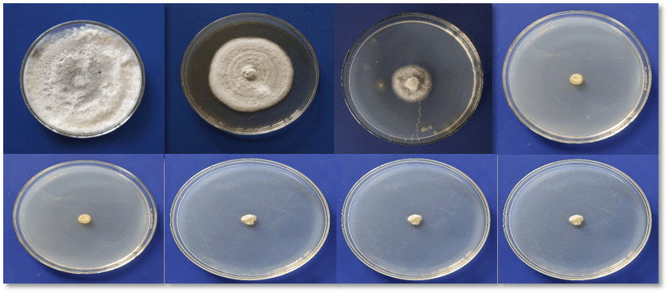
Figure 11: Percent growth inhibition of Colletotrichum manihotis by 7 concentrations of Mancozeb

Figure 12: Percent growth inhibition of Colletotrichum manihotis by 7 concentrations of Difenoconazole

CONCLUSION

The pathogen causing serious anthracnose disease on the leaves of fishtail palm has been identified as Colletotrichum manihotis based on spore dimensions and cluster analysis. PDA medium proved to be the most favorable medium for its mycelial growth followed by OMA, MEA and CDA medium. The pathogen exhibited varying radial growth at different temperatures, with 28°C and 21°C promoting the highest and lowest growth respectively and Potato dextrose broth (PDB) was found better than CDB, OMB and MEB media for the production of fungal dry biomass after 6 days of inoculation. Difenoconazole 25% EC demonstrated superior to Mancozeb 50% WP in antifungal activity compared, with concentration-dependent inhibition percentages and EC₅₀ values of 38.5 ppm and 13.3 ppm respectively.

REFERENCES

Admassiea M, Handisob S, Alemua A. 2015. Physiological and Morphological Studies of Colletotrichum capsici under Different Culture Media Temperature and Light Regimes. International Journal of Environmental Sciences. 6(3):78-86.
Ashfaq M, Anjum MA, Hafeez R, Ali A, Haider MS, Ali M, Chattha MB, Ahmad SR, Ahmad F, Khan F, Sajjad M. 2017. First report of Fusarium equiseti causing brown leaf spot of fishtail palm (Caryota mitis) in Pakistan. Plant Disease. p.840.
Bhagat S, Singh SK, Choudhary S, Singh R, Singh VB, Singh AK, Vaid A. 2022. Studies on the Effect of different Media on the Mycelial Growth of Colletotrichum lindemuthianum. Biological Forum. 14(4):143-145.

Bhanwar RR, Prahlad Singh PS, Thakur AK, Sajeevan Kumar SK. 2012. Identification and characterization of Pestalotiopsis spp. causing leaf spot of fishtail palm in India.

Bhanwar RR, Singh P, Thakur AK. 2016. First Report of Wilt Disease Caused by Fusarium oxysporum spp on Fishtail Palm in India. Journal of Pure & Applied Microbiology. 10(3).

Devi KS, Misra DK, Saha J, Devi PS, Sinha B. 2018. Screening of suitable culture media for growth, cultural and morphological characters of Pycnidia forming fungi. International Journal of Current Microbiology and Applied Sciences. 7(08):4207-4214.

Ehui KJ, Toure HM, Kouame KG, Abo K, Kone D. 2019. Pathogenic characterization and morphocultural structuring of populations of Colletotrichum gloeosporioides Penz manihotis, the causal agent of cassava anthracnose, in Ivory Coast. Journal of Animal and Plant Science. 40(1): 6514-6525.

Gao YY, He LF, Li BX, Mu W, Lin J, Liu F. 2017. Sensitivity of Colletotrichum acutatum to six fungicides and reduction in incidence and severity of chili anthracnose using pyraclostrobin. Australasian Plant Pathology. 46:521-528.

Golakiya B, Akbari LF, Marakna NM. 2020. In vitro evaluation of different fungicides against pomegranate anthracnose caused by Colletotrichum gloeosporioides. International Journal of Chemical Studies. 8:3669-3674.
Grahovac M, Inđić D, Vuković S, Hrustć J, Gvozdenac S, Mihajlović M, Tanović B. 2012. Morphological and ecological features as differentiation criteria for Colletotrichum species.
Joshi R, ST Y, DS A, Chavan SS. 2024. Influence of Different Culture Media on Growth and Sporulation of Colletotrichum capsici. International Journal of Environment and Climate Change. 14(2):555-561.
Juarez M, Juarez D, Russo VM. 2000. Growth and protein content in Colletotrichum circinans, Fusarium solani and Rhizoctonia solani in liquid culture. Biologia plantarum. 43:577-582.

Lehner MS, Paula Júnior TJ, Silva RA, Vieira RF, Carneiro JE, Schnabel G, Mizubuti ES. 2015. Fungicide sensitivity of Sclerotinia sclerotiorum: A thorough assessment using discriminatory dose, EC₅₀, high-resolution melting analysis, and description of new point mutation associated with thiophanate-methyl resistance. Plant Disease. 99(11):1537-1543.

Lokare P, Fatima S. 2021. Effect of different solid media on the growth of Colletotrichum gloeosporioides (PENZ.) PENZ. & SACC. Causing anthracnose disease of mango (Mangifera indica L.). International Journal of Botany Studies. 6(3): 611-615.
Mahesh M, Venkataravana P, Narasa Reddy G, Devaraja R. 2020. In vitro evaluation of different fungicides against Colletotrichum gloeosporioides causing anthracnose of pomegranate. Journal of Entomology and Zoology Studies. 8(4):642-645.
Majumdar N, Mandal NC. 2019. Influence of culture media on mycelial growth, sporulation and spore size of quiescent pathogen Colletotrichum gloeosporioides isolated from banana. Pharma Innovation. 8(5): 385-390.
Nelson S. 2009. Bacterial Leaf Blight of Fishtail Palm. College of Tropical Agriculture and Human Resources. Honolulu, USA
Pandey A, Yadava LP, Manoharan M, Chauhan UK, Pandey BK. 2012. Effectiveness of cultural parameters on the growth and sporulation of Colletotrichum gloeosporioides causing anthracnose disease of mango (Mangifera indica L.). Journal of Biological Sciences. 12(4):123-133.
Pereira DS, Phillips AJ. 2023. Botryosphaeriaceae on palms—A new species of Neodeightonia, N. chamaeropicola, and new records from diseased foliage of ornamental palms in Portugal. Phytotaxa: 627(1):1-64.

Prajapati RK, Singh SR, Gangwar RK. 2015. "Effect of climate change on plant diseases in Bundelkhand zone leading to changing in cropping pattern." 120-138.
Ranjitham Thangamani P, Kuppusamy P, Peeran MF, Gandhi K, Raguchander T. 2011. Morphological and physiological characterization of Colletotrichum musae the causal organism of banana anthracnose. World Journal of Agricultural Sciences. 7(6):743-754.
Ren L, Wang SF, Shi XJ, Cao JY, Zhou JB, Zhao XJ. 2020. Characterisation of sensitivity of Colletotrichum gloeosporioides and Colletotrichum capsici, causing pepper anthracnose, to picoxystrobin. Journal of Plant Diseases and Protection. 127:657-666.
Sajili MH, Wahida WN, Badaluddin NA, Khandaker M, Mohammed S, Kadir J. 2017. Influence of Culture Media, Temperature and pH on Colletrotrichum gleosporioides, Isolated from Carica papaya in Besut, Terengganu, Malaysia. Journal of Agrobiotechnology. 8(2): 49-55.
Salotti I, Ji T, Rossi V. 2022. Temperature requirements of Colletotrichum spp. belonging to different clades. Frontiers in Plant Science. 13:953760.
Sandhya C, Binod P, Nampoothiri KM, Szakacs G, Pandey A. 2005. Microbial synthesis of chitinase in solid cultures and its potential as a biocontrol agent against phytopathogenic fungus Colletotrichum gloeosporioides. Applied biochemistry and biotechnology. 127:1-15.

Sangpueak R, Phansak P, Buensanteai N. 2018. Morphological and molecular identification of Colletotrichum species associated with cassava anthracnose in Thailand. Journal of Phytopathology.166(2): 129-142.

Sarwar MK, Naheed R, Ijaz S, Ul Haq I. 2020. Fungal diseases of Lady palm (Rhapis excelsa) and Fishtail palm (Caryota mitis). Etiology and Integrated Management of Economically Important Fungal Diseases of Ornamental Palms. 237-249.
Soltani J, Haghighi MY, Nazeri S. 2014. Light, temperature, and aging dependent vegetative growth and sporulation of Colletotrichum gloeosporioides on different culture media. Journal of Medicinal Plant Research. 8(4): 208-216.
Strandberg JO, Chellemi DO. 2002. Limb dieback of flowering dogwood caused by Colletotrichum acutatum. In Proceedings of the Florida State Horticultural Society. pp. 259-262.Sutton BC. 1981. The Coelomycetes. Fungi imperfecti with pycnidia, acervuli and stromata. Commonwealth Mycological Institute. Kew, UK, pp. 696.
Thangeswari S, Deivamani M, Paramasivam M, Indra N, Latha TKS, Govindan K, Sasikumar K. 2024. Effect of Nutritional and Environmental Conditions on Growth of Colletotrichum gloeosporioides Causing Anthracnose of Anthurium. Journal of Experimental Agriculture International. 46(9):890-898.

Thilagam R, Kalaivani G, Hemalatha N. 2018. Isolation and identification of phytopathogenic fungi from infected plant parts. International Journal of Current Pharmaceutical Research.10(1): 26-28.

Udhayakumar R, Rani SU. 2010. Effect of pH levels, carbon and nitrogen sources on the mycelial growth and bio-mass production of Colletotrichum gloeosporioides (Penz.) Penz. and Sacc.

Vanani KD, Rakholiya KB, Purushotham P. 2024. Prospecting the Effectiveness of Fungicides and Bioagents against Colletotrichum gloeosporioides (Penz.) Penz &Sacc. Journal of Advances in Biology & Biotechnology. 27(2):216-225.

Xu S, Christensen MJ, Li Y. 2017. Pathogenicity and characterization of Colletotrichum lentis: A causal agent of anthracnose in common vetch (Vicia sativa). European Journal of Plant Pathology. 149:719-731.
Zhu H, Qin WQ, Liu L, Yan W. 2015. First report of leaf spot of clustering fishtail palm (Caryota mitis) caused by Lasiodiplodia jatrophicola in China. Plant disease. 99(7):1038-1038.

