Case report

External Beam Radiation Therapy in Mediastinal Metastasis of
Refractory Papillary Thyroid Carcinoma: A Case Report

Abstract

External beam radiation therapy (EBRT) for mediastinal metastasis of papillary thyroid carcinoma is challenging because of the radioresistance of the cancer cells and surrounding vital organs. A 45 year-old male was diagnosed with mediastinal metastasis of refractory papillary thyroid carcinoma based on positron emission tomography/computed tomography (PET/CT) Scan result. Histopathological examination could not be performed because the patient refused to undergo biopsy and/or surgical resection. He received EBRT to prevent airway obstruction and improve his symptoms. The total radiation dose was 50 Gy. One year after radiation therapy, the evaluation showed a good local and clinical response with no late toxicities.

Keywords: Mediastinal metastasis, refractory papillary thyroid carcinoma, EBRT, VMAT

- Introduction

Mediastinal metastasis is rare in papillary thyroid carcinoma and may cause severe complications and poor prognosis (Makiuti et al., 1984; Yasuda et al., 2019). However, the effective treatment for mediastinal metastasis remains controversial and challenging (Marrama et al., 2019). Surgical resection and/or radioactive iodine therapy usually unsatisfactory, thus multidisciplinary collaboration is needed to improve the effectiveness of therapy and quality of life in this case.

The role of EBRT for papillary thyroid carcinoma is still controversial. External beam radiation therapy is not generally used in patients with papillary thyroid carcinoma (Schwartz et al., 2009; Cortes-Mateus et al., 2018). According to American Thyroid Association (ATA) guidelines, a bulky tumor mass is one cause of radioiodine resistance, and EBRT is recommended for locoregional control and symptomatic palliation when radioiodine resistance occurs (Ringel et al., 2025).

This case report showed the effectiveness of EBRT with mild side effect in a patient with mediastinal metastasis of refractory papillary thyroid carcinoma.

- Case Presentation

A 45-year-old male was referred to the Radiation Oncology Department for evaluation of mild dyspnea, especially when walking quickly, which had been present for one month. He was diagnosed with papillary thyroid carcinoma pT2N1M0 two years ago based on histopathological examination. He underwent total thyroidectomy and radical neck dissection, followed by radioactive iodine therapy with a cumulative dose of 250 mCi, as well as adequate hormone suppression therapy. He had a history of moderate hypertension without routine medication.

Routine examinations every 6 months showed that the serum levels of TgAg were <10 ng/mL. However, his most recent serum TgAg level was 1,113 ng/mL, his TSH level was 220.4 µIU/mL, and the evaluation of whole-body scan (WBS) showed no uptake. He then underwent PET/CT scan that revealed a hypermetabolic anterior mediastinal mass measuring 6.7x4.4x4.3 cm with a maximum standardized uptake value (SUVmax) of 29.4.

The patient was referred for EBRT. The anterior mediastinal mass was treated using the volumetric modulated arc therapy (VMAT) technique (Figure 1). The total radiation dose was 50 Gy in 25 fractions over five weeks. The treatment volumes consisted of the gross tumor volume (GTV): gross tumor; the clinical target volume (CTV): 0.5-1 cm from the GTV; and the planning target volume (PTV): 0.3 cm from the CTV.

After 15 sessions of radiation therapy (30 Gy), the patient's dyspnea improved. During radiation therapy, the patient only experienced mild dysphagia (grade 1), which was alleviated with general medications. Blood pressure was evaluated daily and routine antihypertensive medication was administered.

A follow-up evaluation was performed 6 months after radiation therapy, revealing that the serum level of TgAg had decreased to 415 ng/mL. One year later, a PET/CT scan showed that the size of the anterior mediastinal mass and SUV had decreased compared to the PET/CT scan before radiation therapy (3.0x2.4x2.2 cm vs. 6.7x4.4x4.3 cm and 11.6 vs. 29.4, respectively; see Figures 3a and 3b). The serum TgAg level had also decreased to 150 ng/mL. Based on these results, the patient was recommended for targeted therapy with tyrosine kinase inhibitor to control his disease, as well as routine evaluations of the TgAg serum level and PET/CT scan every 6 months.
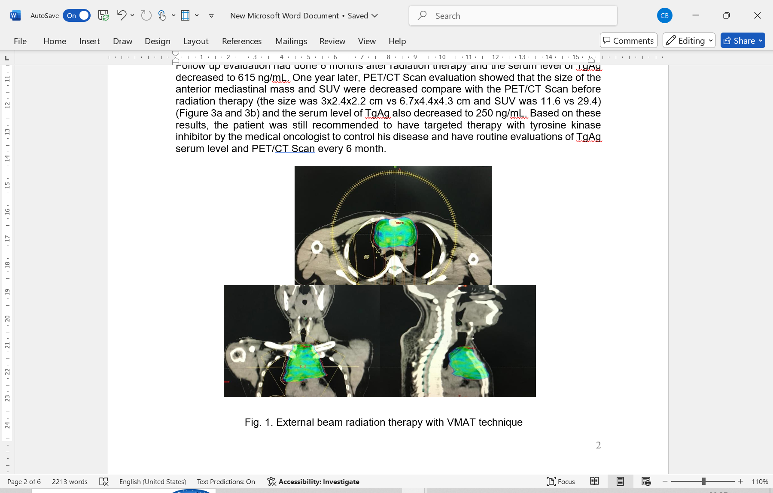

Fig. 1. EBRT with VMAT technique
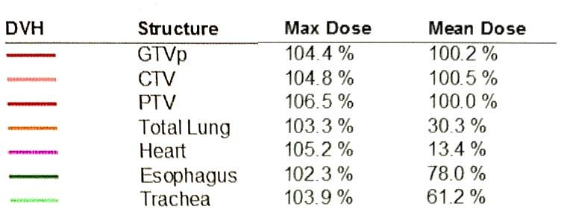

Fig. 2. Dose volume histogram (DVH)

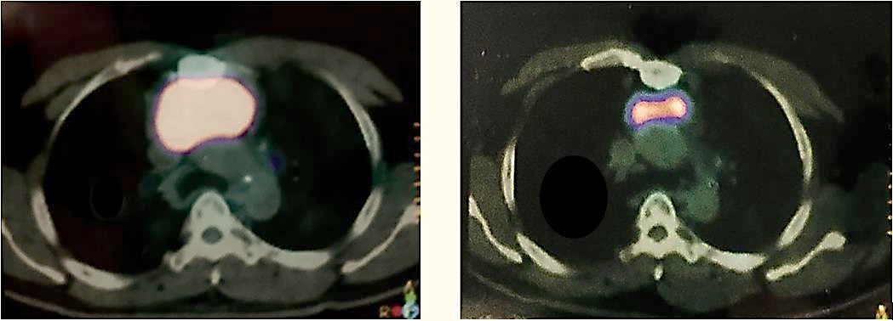
Fig. 3a. PET/CT Scan Fig. 3b. PET/CT Scan
(before radiation therapy) (1 year after radiation therapy)

- Discussion

Papillary carcinoma is the most common type of well-differentiated thyroid carcinoma. Because of its characteristics, this type of carcinoma is minimally invasive. However, it can easily spread to other organs due to its tendency to invade lymph nodes. About 11% of patients with papillary thyroid carcinoma present with metastasis outside the neck region and mediastinum (Somasundar, 2020). Papillary thyroid carcinoma occurs more frequently, peaking in incidence in patients aged 30-50 years. The prognosis is excellent with appropriate treatment. However, about 5% of patients will develop metastases that are difficult to treat with standard therapies.

The standard definitive therapy for patients with differentiated papillary thyroid carcinoma is surgical resection followed by radioactive iodine therapy to detect and eradicate any residual cancer cells, along with thyroid-stimulating hormone suppressive therapy (Somasundar, 2020). Throughout tumor progression, cellular dedifferentiation can occur, which is usually accompanied by more aggressive cancer growth and metastasis. It can also result in the loss of the ability to accumulate iodine (He et al., 2025). These conditions make tumor cells resistant to standard therapeutic modalities. The prognosis is better when metastasis is radioiodine avid than when it is radioiodine non-avid. In this case, other therapy options must be considered because a failure to respond to radioactive iodine indicates that the cancer is more aggressive (Busaidy et al., 2012).

Evaluation with PET/CT scan plays an important role in refractory papillary thyroid carcinoma that cannot be examined with routine WBS because of radioiodine non-avidity. In such cases, 18F-fluorodeoxyglucose (FDG) is retained by cancer cells with high glucose uptake, which are missed by iodine scintigraphy (Wimmer et al., 2020).

The role of EBRT in differentiated papillary thyroid carcinoma is still controversial due to the lack of literature about these cases. However, in clinical practice, EBRT is indicated for bulky, unresectable tumors; residual tumors after surgery; tumors without radioactive iodine uptake; postoperative serum Tg levels of at least 1 ng/mL; and patients with a high likelihood of microscopic residual disease (Ringel et al., 2025).

The incidence of mediastinal metastasis in papillary thyroid carcinoma has been reported to range from 2.7% to 22% (Smith et al., 2012; Wang et al., 2013; Moritani, 2016). In this case report, the diagnosis of mediastinal metastasis was determined based on the PET/CT scan result showing a hypermetabolic anterior mediastinal along with a very high TgAg level and the patient's history of papillary thyroid carcinoma.

The routine evaluation of the (WBS) showed no uptake of radioactive iodine in the mediastinal mass. This condition indicated radioactive iodine-refractory papillary thyroid carcinoma, which could not be managed with standard radioactive iodine therapy. The patient's primary complaint, due to the bulky mediastinal tumor, could pose a serious clinical challenge with a poor prognosis if not properly treated. The patient refused surgical resection as the main therapy. Therefore, other therapeutic options had to be considered. In this case, EBRT could be the first therapeutic option to prevent airway obstruction and relieve the patient's symptoms (Cortes-Mateus et al., 2018; Terezakis et al., 2009). Several studies have recommended total radiation doses of 40–66 Gy for cases of radioactive iodine-refractory, unresectable thyroid carcinoma (Cortés-Mateus et al., 2018; Busaidy et al., 2012). However, there are no literature reports on similar cases regarding the role of EBRT in mediastinal metastasis of refractory papillary thyroid carcinoma. A radiation total dose of 50 Gy in 25 fractions was delivered to the patient in this case. The considerations in administering this radiation dose were the patient's medical history of uncontrollable moderate hypertension, and the planned tyrosine kinase inhibitor targeted therapy after the patient has completed radiation therapy. With a total radiation dose of 50 Gy, we could minimize the radiation dose to the heart. Thus, the risk of radiation toxicity to the heart could be reduced, and the patient's blood pressure could be controlled. However, tyrosine kinase inhibitor targeted therapy has the most common side effect of high blood pressure, which could worsen the patient's hypertension. For these reasons, the total radiation dose for this patient must be carefully considered to achieve an effective radiation response while minimizing toxicities.

The volumetric modulated arc therapy (VMAT) technique was used to deliver a homogeneous radiation dose to the target volume while minimizing the radiation dose to the heart and lungs. Figure 2 shows that the mean dose to the heart was 6.7 Gy (13.4% of the total dose) and to the total lungs was 15.15 Gy (30.3% of the total dose). These results indicate that the radiation doses to the heart and lungs were within tolerance levels. Therefore, radiation toxicities to these organs could be minimized. During radiation therapy, the patient only complained of mild dysphagia (grade 1).

The patient had no complaints at the one-year evaluation post-EBRT. Although the maximal radiation dose could not be delivered, an effective clinical response was achieved with no late radiation toxicities occurring in this patient. This can be seen in the PET/CT scan evaluation results, which show a reduction in tumor size and SUVmax, as well as a decreased level of TgAg serum nine months after EBRT.

- Conclusion

The role of EBRT in the management of papillary thyroid carcinoma remains controversial, and no large-scale studies have yet been conducted to evaluate its effectiveness.

In several cases, especially for unresectable or bulky tumors that are surrounded by vital organs, EBRT could be an effective therapeutic option for locoregional control and symptomatic palliation.

For very large tumors, however, EBRT may be ineffective, and severe toxicities may occur. Therefore, we must consider the tumor's size and location, as well as the patient's overall health, to ensure an effective response to EBRT. The use of EBRT should be carefully considered in relation to the associated benefits and radiation toxicities.

This case showed that administering radiation with a total dose of ≥50 Gy may provide an optimal therapeutic response while paying attention to the patient's general condition and comorbidities. Long-term follow-up is necessary to evaluate the effectiveness of EBRT as well as any late side effects.

Consent

Patient written consent has been collected and preserved by the author.

Ethical Approval

Not applicable.

Competing Interests

Nothing to declare.

COMPETING INTERESTS DISCLAIMER:
Authors have declared that they have no known competing financial interests OR non-financial interests OR personal relationships that could have appeared to influence the work reported in this paper.

References

Busaidy, N. L., Cabanillas, M.E. (2012). Differentiated thyroid cancer: management of patients with radioiodine nonresponsive disease. Journal of Thyroid Research. Article ID 618985.
Cortes-Mateus, K. S., Holub, K., Racca, F., Grau, J. J., Capdevila, J. (2018). Concurrent palliative external radiotherapy with sorafenib or doxorubicin for bulky differentiated thyroid carcinoma: A case report. Oncology Letters, 16, 4085-89.
He, Y., Tang, Z., Xu, M., & Huang, T. (2025). Dedifferentiation and Redifferentiation of Follicular-Cell-Derived Thyroid Carcinoma: Mechanisms and Therapeutic Implications. Biomedicines, 13(12), 2982.
Makiuti, M., Yagawa, K. Thyroid microcarcinoma. (1984). Clin Endocrinol, 32, 727-36.
Marrama, E., Aprile, V., Nesti, A., Bacchin, D., Materazzi, G., Lucchi, M. (2019). Mediastinal lymph node metastases in thyroid cancer: surgery without limits. Curr Chall Thorac Surg, 1, 26.
Moritani S. (2016). Impact of superior mediastinal metastasis on the prognosis of papillary thyroid cancer. Endocrine Journal, 63(4), 349-57.
Ringel, M. D., Sosa, J. A., Baloch, Z., Bischoff, L., Bloom, G., Brent, G. A., et al. (2025). 2025 American Thyroid Association Management Guidelines for Adult Patients with Differentiated Thyroid Cancer. Thyroid®, 35(8), 841-985.
Schwartz, D. L., Lobo, M. J., Ang, K. K., Morrison, W. H., Rosenthal, D. I., Ahamad, A., et al. (2009). Postoperative external beam radiotherapy for differentiated thyroid cancer: Outcomes and morbidity with conformal treatment. Int J Radiat Oncol Biol Phys, 74, 1083-91.
Smith, V. A., Sessions, R. B., Lentsch, E. J. (2012). Cervical lymph node metastasis and papillary thyroid carcinoma: does the compartment involved affect survival? Experience from the SEER database. J Surg Oncol, 106, 357-62.
Somasundar, P. S. (2020) Papillary thyroid carcinoma. https://emedicine.medscape.com/article/282276-overview.
Terezakis, S. A., Lee, K. S., Ghossein, R. A., Rivera, M., Tuttle, R. M., Wolden, S. L., et al. (2009). Role of external beam radiotherapy in patients with advanced or recurrent nonanaplastic thyroid cancer: Memorial Sloan-Kettering Cancer Center experience. Int J Radiat Oncol Biol Phys, 73, 795-801.
Wang, L. Y., Versnick, M. A., Gill, A. J., Lee, J. C., Sidhu, S. B. (2013). Level VII is an important component of central neck dissection for papillary thyroid cancer. Ann Surg Oncol, 20, 2261-65.
Wimmer, I., Pichler, R. (2020). FDG PET in thyroid cancer. In: Thyroid cancer-advances in diagnosis and therapy.
Yasuda, M., Osaki, T., Fukuich, Y., Kobayashi, K., Iwata, T., So, T. (2019). Anterior mediastinal tumor as a solitary lymph node metastasis of occult thyroid carcinoma. Journal of Surgical Case Report, 2, 1-3.

