Method Article

A Quality by Design: Scientific Approach to Develop and Validate a Laser-Based Analytical Method for Particle Size Distribution of Dapagliflozin Propanediol

.
ABSTRACT

Particle size, shape, and distribution of the active pharmaceutical ingredient (API) significantly influence the physicochemical and biopharmaceutical performance of dosage forms. The development of particle size analytical methods with diverse particle characteristics remains challenging. Only a limited number of studies have reported a Quality by Design (QbD) based framework for developing laser diffraction particle size methods beyond conventional trial-and-error approaches. This study aims to establish a QbD-based, structured, science-driven and risk-based methodology for the development and validation of a laser diffraction analytical method to determine the particle size distribution (PSD) of Dapagliflozin Propanediol. The work also highlights how the Analytical Quality by Design (AQbD) approach emphasizes predefined objectives, comprehensive understanding of analytical processes and effective control of variability to ensure method robustness, reliability and regulatory compliance. Prior knowledge of the API and drug product was utilized to construct an Ishikawa (cause-and-effect) diagram and to support Failure Mode and Effects Analysis (FMEA) for method risk assessment. The Analytical Target Profile (ATP) was defined to ensure accurate determination of Dv10, Dv50 and Dv90 values within predefined acceptable relative standard deviation limits (Dv10 ≤ 15%, Dv50 ≤ 10% and Dv90 ≤ 15%). Dispersant type, sonication time, stirrer speed and percentage of obscuration were identified as critical method parameters during risk assessment. A Design of Experiments (DoE) approach was employed to optimize these critical parameters within defined operational ranges. Fusion QbD software (version 9.9.2 SR3) was used to develop a face-centered central composite design (FCCCD) to evaluate and demonstrate the interactive effects of critical method variables, particularly stirrer speed and sonication time on particle size. Method development was performed in accordance with ICH Q8–Q10 and ICH Q14 guidelines, while method validation followed ICH Q2 and EP 2.9.31/USP <429>. The developed method demonstrated excellent precision with repeatability (Dv10- 9.96%, Dv50- 5.01% and Dv90 -11.56%) and reproducibility across analysts and instruments. Overall, the QbD-based strategy provided enhanced method understanding and control, resulting in a robust and reliable analytical procedure for particle size characterization of Dapagliflozin Propanediol.

Keywords: Dapagliflozin Propanediol, drug subatance, active pharmaceutical ingredient (API), Particle Size Distribution, wet dispersion, Malvern Mastersizer 3000, method validation, robustness, Quality by Design (QbD), Failure Mode and Effects Analysis (FMEA), Design of Experiments (DoE), Analytical Target Profile (ATP).

1. INTRODUCTION

In the current regulatory scenario, agencies strongly emphasize the implementation of Quality by Design (QbD) principles to ensure scientifically justified, pre-designed and robust analytical method development [1, 2 and 3]. Achieving this requires a thorough scientific understanding of the chemical and physicochemical properties of the active pharmaceutical ingredient (API) as well as the drug product. Such knowledge is essential to ensure the intended pharmacological performance of the API, align the analytical method with formulation objectives and support suitability for manufacturing controls [4]. Regulatory bodies, including the European Medicines Agency (EMA) and U.S. Food and Drug Administration (FDA) emphasize the use of scientifically justified, validated and product-specific analytical methods as the basis for establishing appropriate product specifications and effective manufacturing controls [5].
The objective of this paper is to present a comprehensive QbD-based study conducted by Analytical Research and Development for the development and validation of a robust particle size distribution method for Dapagliflozin Propanediol. Dapagliflozin Propanediol belongs to the BCS Class III category and uses in the treatment of type 2 diabetes. Dapagliflozin is a selective inhibitor of the renal sodium–glucose cotransporter-2 (SGLT-2), which reduces renal glucose reabsorption and increases urinary glucose excretion, resulting in an anti-hyperglycemic effect. Dapagliflozin is administered by the oral route in the form of tablet [6].
Study presents a systematic and science-based approach for the development and validation of a reliable and reproducible analytical method for particle size distribution that consistently meets predefined performance criteria. The laser diffraction technique was selected for this study due to its high suitability for routine analysis of drug substances, granules and suspensions, offering rapid measurement, high reliability, and excellent reproducibility.
The Analytical Quality by Design (AQbD) framework was applied to establish a systematic, science-driven and risk-based approach for developing a robust analytical method [7, 8]. Method development began with defining the Analytical Target Profile (ATP), specifying required performance characteristics such as reproducibility, precision and reportable particle size parameters (Dv10, Dv50 and Dv90). Critical Quality Attributes (CQAs) and potential Critical Method Parameters (CMPs) were identified using prior knowledge, structured risk assessment tools, including the Ishikawa (cause-and-effect) diagram and Failure Mode and Effects Analysis (FMEA) [9]. These assessments helped to identify key factors affecting particle size distribution, such as dispersant selection, sonication time and obscuration level.
A Design of Experiments (DoE) approach was subsequently applied to evaluate and optimize these parameters, establishing a proven acceptable range to ensure method robustness [10]. Fusion QbD software (version 9.9.2 SR3) was used for planning the Face-Centered Central Composite Design (FCCCD). The QbD framework enhanced overall method understanding, supported lifecycle management, and ensured consistent performance during routine analysis, ultimately enabling a well-controlled and reliable analytical procedure.
The developed method was successfully validated in accordance with ICH Q2 (R2) and USP/EP chapter <429>/2.9.31 requirements [11, 12 and 13].

2. material and methods

2.1. Materials

Dapagliflozin Propanediol (API) was used for analytical method development and validation. Various analytical-grade dispersants, including purified water, methanol, acetone, ethyl acetate, sunflower oil and cyclohexane were evaluated during method optimization to select the most suitable dispersant.
2.2 Instrumentation

Particle size distribution was determined using a Laser Diffraction Particle Size Analyzer (Make: Malvern Mastersizer 3000 Ultra Plus). The instrument was equipped with:
- Accessories Hydro MV(medium volume) wet sample dispersion Unit system
- Software (Xplorer v5.20) for data acquisition and analysis
- Scattering detector array with forward, side, and backscatter capability
- Fusion QbD software (version 9.9.2 SR3) for Face-Centered Central Composite Design (FCCCD)
The instrument was calibrated using manufacturer-supplied reference standards before analysis.

2.3 Laser Diffraction Measurement Conditions And Sample Preparation

Measurement conditions for particle size distribution of Dapagliflozin Propanediol using the Malvern Mastersizer 3000 (Ultra Plus) were systematically established [14]. The analysis was conducted in wet dispersion mode using cyclohexane as the dispersant medium. The particle refractive index (RI) was set to 1.614, the dispersant refractive index (RI) to 1.426, and the sample absorption value to 0.010. The obscuration level was maintained between 20% and 30% to ensure accurate light scattering and optimal signal intensity, while the circulation speed was controlled at 3000 rpm to maintain consistent suspension flow. After allowing a 2-minute stabilization period and achieving the target obscuration level, each measurement was carried out for 10 seconds and followed by a 10-second background measurement to ensure baseline stability [15, 16].

2.3.1 Sample Preparation

For sample preparation, 150 mg of Dapagliflozin Propanediol was transferred into a glass-stoppered test tube, followed by the addition of 20 mL of cyclohexane. The mixture was sonicated for 2 minutes to achieve uniform dispersion. The resulting suspension was then introduced drop wise into the measurement cell until the target obscuration range was reached.

2.4 Data Evaluation

The most frequently reported Dv10, Dv50, and Dv90 are considered for study. The Dv50 value, also referred to as the median particle size, represents the particle diameter below which 50% of the total sample volume is present. Similarly, Dv90 indicates that 90% of the particle population lies below this size, while Dv10 denotes the size below which 10% of the particle population exists. The subscript “v” specifies that these values correspond to a volume-based particle size distribution.

2.5 Analytical Quality By Design (AQbD) Approach For Method Development And Validation

The study successfully applied QbD principles to develop and optimize a particle size analysis method for Dapagliflozin Propanediol under varied operational conditions [15]. This approach included defining the Analytical Target Profile (ATP), identifying Critical Quality Attributes (CQAs), and performing risk assessments using tools such as Ishikawa diagrams and FMEA. Each element of the QbD framework was intentionally incorporated during method development, ensuring that the final procedure is accurate, robust and reproducible [17].

2.5.1 Critical Quality Attributes

Critical Quality Attributes (CQAs) presented in Table 1 were identified to ensure that the developed particle size method consistently provides accurate and reliable particle size distribution for Dapagliflozin Propanediol. The primary CQAs included the particle size distribution parameters Dv10, Dv50 and Dv90, as these values describe the fine, median, and coarse fractions of the particle population. Additional attributes such as distribution span, acceptable obscuration range, appropriate refractive index settings, and the degree of sample dispersion were also documented as critical due to their significant influence on method repeatability, precision, and overall robustness. Establishing and controlling these CQAs supports method reliability throughout its lifecycle, ensures batch-to-batch consistency during routine analysis, and aligns with regulatory expectations for particle-size-driven API performance [18].

Table 1. Critical Quality Attributes (CQAs)

CQA | Description | Rationale / Importance
Dv10 (Fine) | Particle diameter below which 10% of the sample volume exists. | Indicates the proportion of fine particles, critical for flow, dissolution, and potential segregation of powder
Dv50 (Median) | Particle diameter below which 50% of the sample volume exists. | Represents the central tendency of particle size, used for batch-to-batch comparison and regulatory control.
Dv90 (coarse) | Particle diameter below which 90% of the sample volume exists. | Reflects the coarse particle fraction, impacts uniformity, dissolution of final drug substance.
Particle Size Distribution (PSD) Span | (Dv90 – Dv10) / Dv50 | Measures distribution width; crucial for establishing batch consistency and process control.
Obscuration Range | Percentage of laser obscuration during analysis. | Ensures optimal measurement conditions; too low or high obscuration affects on results accuracy.
Refractive Index Selection | API and dispersant refractive index used in Mie theory calculations. | Accurate refractive index is essential for precise PSD determination.
Dispersion State (Agglomerate Control) | Ability to maintain uniform dispersion during measurement. | Prevents aggregation that can skew PSD data.

2.5.2 Analytical Target Profile

The Analytical Target Profile (ATP) defined the performance requirements and measurement criteria necessary to ensure the analytical method’s suitability for its intended purpose. The ATP served as the foundation for method development by specifying the desired reproducibility, precision and reportable particle size distribution results. The key ATP elements used to guide the optimization of the laser diffraction particle size method of Dapagliflozin Propanediol are summarized in Table 2.

Table 2. Analytical Target profile (ATP) established for the laser Light Diffraction analysis of Dapagliflozin Propanediol

ATP | Target | Justification | Specification
Product/Sample | Determine the particle size of Dapagliflozin Propanediol | Development and validation of a laser light diffraction particle size distribution method for Dapagliflozin Propanediol. | Not Applicable
Analytical technique | Laser light diffraction particle size analysis | Measurement of the particle size distribution. This measure carried out using wet mode and well suited for routine measurements of particle size of Dapagliflozin Propanediol | Not Applicable
Instrument | Malvern Mastersizer 3000 Ultra Plus, equipped with Hydro MV wet sample dispersion Unit system and Software (Xplorer v5.20) for data acquisition and analysis | The angular scattering intensity data is analysed to calculate the size distribution of the particles responsible for creating the scattering pattern, using Mie theory or Fraunhofer diffraction of light scattering. The particle size is reported as the volume-equivalent sphere diameter. | Not Applicable
Application | Particle size distribution determination | Developed method should be able to determine the Dv10, Dv50 and Dv90 particle size distribution values in Dapagliflozin Propanediol during routine analysis. | Not Applicable
CAAs | Dv10, Dv50 and Dv90 | Laser light diffraction particle size allows for a robust and reliable determination of the distribution values for Dv10, Dv50 and Dv90. These should meet their formal and commonly accepted quality criteria. | Dv10 RSD ≤15% Dv50 RSD ≤10% Dv90 RSD ≤ 15%
Obscuration Range | 20% to 30% | Obscuration is a measure of the percentage of emitted  laser light that is lost by scattering or absorption. For the sample containing larger particles, particle size is stable  over a much wider obscuration range | Between 20% to 30%
Method validation | Precision, reproducibility and repeatability | Validation of the method was carried out by following ICH Q2 and EP 2.9.31/USP <429>. Method demonstrated excellent precision, with repeatability (RSD %) and reproducibility across analysts and instruments [12] | Dv10 RSD ≤15 %; Dv50 RSD ≤10 %, Dv90 RSD ≤15 %

2.5.3 Risk-Management Methodology

A risk-based approach was employed to identify method parameters that could impact key analytical attributes such as repeatability, reproducibility, and precision. During the development of the laser-based particle size method, an Ishikawa (fishbone) diagram (Fig. 1) and Failure Mode and Effects Analysis (FMEA) were used to identify potential sources of variability and highlight areas requiring tighter control to ensure reliable results [19]. The fishbone diagram demonstrates how various method variables influence the quality of particle size distribution and helps in identifying Critical Method Attributes (CMAs) as well as Critical Process Parameters (CPPs) that may introduce significant risk and therefore require close monitoring.
Additionally, Failure Mode and Effects Analysis (FMEA) was conducted to prioritize failure modes that required further evaluation. For each identified failure mode, risk-reduction strategies were developed based on the calculated Risk Priority Number (RPN), which is obtained by multiplying Severity (S), Occurrence (O), and Detectability (D). An RPN score greater than 30 was considered indicative of a high-risk condition. The criteria used for RPN calculation are summarized in Table 3. The FMEA approach provided a structured and systematic method for analyzing complex analytical steps, enabling the development of a focused and effective risk-mitigation strategy.

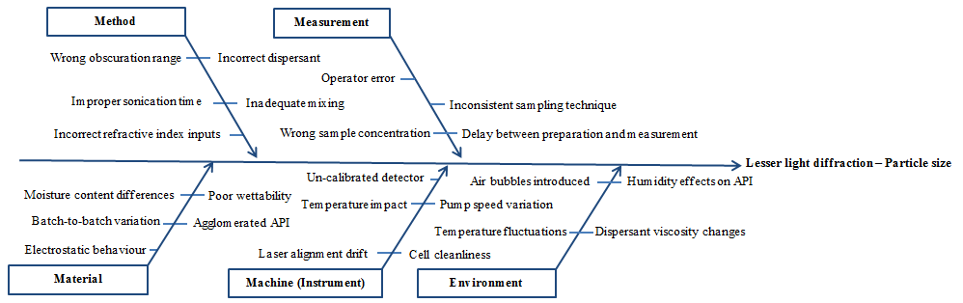

Fig. 1. Ishikawa diagram depicting cause-and-effect relationship on the potential CAAs of laser light diffraction

Table 3. Criteria used for Risk Priority Number (RPN) calculation

 | Score | Criteria
Severity (S) | 1(very low)  2 (low)  3(average)  4(high)  5(very high) | No impact on method quality  No impact on method quality  Noticeable impact to method quality, but can be recovered by reprocessing.  Definite impact to method quality that may require attention.  Very severe effect, require particular attention
Occurrence (O) | 1 (unlikely)  2 (remote)  3 (occasional)  4 (moderate)  5 (likely) | Negligible risk which does not require attention.  Failure only seen once or twice.  Failure potential has been noted.  Moderate probability occurrence.  Highly severe effect which require utmost attention.
Detection (D) | 1 (very low)  2 (low)  3 (average)  4 (high)  5 (very high) | Easily detectable; negligible risk which do not require attention.  Good detectability: possess minor risk which can be corrected.  Detectable; risk which can be corrected.  Not easily detectable; risk require attention.  Very difficult detectable; risk which require immediate attention.

2.5.4 Optimization of the particle size analysis method parameters

Most suitable dispersant for particle size analysis is one in which the particles remain physically and chemically stable, without dissolving, swelling, or interacting with the medium. To select an appropriate dispersant, multiple measurements were performed under identical instrument conditions using various dispersant media, including water; mid-polar solvents such as methanol, acetone, and ethyl acetate; and non-polar dispersants such as sunflower oil and cyclohexane. The resulting data were evaluated for sample stability, any time-dependent changes in particle size, and measurement variability [20]. The %RSD was calculated to confirm the repeatability and reliability of the method. The observations from the dispersant screening study are presented in the Table-4.

Table 4. Results of the dispersant screening study

S. No. | Dispersant | Observation
1 | Water (Polar/Hydrophilic media) | Dapagliflozin Propanediol exhibits amphiphilic properties; therefore, polar solvents were initially evaluated as dispersants. However, the sample partially dissolved in water during sonication due to its slight solubility, making water unsuitable as a dispersant.
2 | Mid polar (Methanol (Protic), acetone (Aprotic), and ethyl acetate (Aprotic)) | Mid-polar solvents with moderate dielectric constants were also evaluated due to the amphiphilic nature of Dapagliflozin propanediol. However, the compound was soluble in methanol, sparingly soluble in acetone, and slightly soluble in ethyl acetate, therefore, these protic and aprotic mid-polar solvents were not suitable as dispersants.
3 | Non-polar (Low dielectric constant) | Dapagliflozin Propanediol is insoluble in Sunflower oil, hence it was evaluated as dispersant, but percentage obscuration decreased with the time due to high viscosity of sunflower oil. Hence sunflower oil is not suitable dispersant.
4 | Cyclohexane | Dapagliflozin Propanediol is insoluble in Cyclohexane and it is low viscous solvent, hence it was evaluated as dispersant, stable obscuration with measurement data is observed. Hence Cyclohexane is selected as dispersant.

To establish the optimal stirrer speed, multiple measurements were performed under identical instrument conditions at 2000, 2500, and 3000 rpm. Particle size data at each speed were assessed for stability, repeatability, and the absence of any time-dependent downward drift. The optimum speed was selected based on consistent dispersion, low %RSD values, and no evidence of shear-induced particle degradation. The finalized stirrer speed ensured uniform sample circulation and accurate particle size measurement.
Particle size measurement time and laser obscuration level were also systematically evaluated as part of the method optimization process. Multiple measurements were performed under identical instrument conditions to understand how these parameters influence method repeatability, stability, and overall reliability. Measurement time was assessed to determine the minimum duration required to achieve stable particle size readings without introducing unnecessary variability. Similarly, different obscuration levels were tested to identify the optimal range that provides sufficient signal intensity while preventing detector saturation or excessive noise. The collected data were reviewed for consistency, absence of drift and acceptable %RSD values across repeated measurements. This systematic evaluation ensured the selection of appropriate measurement time and obscuration settings contributing to a robust, precise, and reproducible analytical method aligned with the predefined Analytical Target Profile (ATP).

2.5.5 Method Validation

The ICH Q2 guideline recommends to established specificity, linearity, range, accuracy, precision, and robustness during analytical method validation. However, because particle size analysis is a physical characterization technique, therefore, only method precision, intermediate precision, and robustness were evaluated for the developed laser diffraction method.
For laser light diffraction method, precision was assessed in terms of repeatability and intermediate precision, including analysis by a second analyst, and expressed as percentage relative standard deviation (%RSD). The acceptance criteria for precision were set at %RSD ≤ 10% for the central value of the particle size distribution (Dv50). For the distribution limits (Dv10 and Dv90), a slightly higher variability of ≤ 15% was considered acceptable. For particle sizes below 10 µm, these acceptance limits may be doubled to account for increased measurement variability. The %RSD acceptance criteria in accordance with the USP general chapter are summarized in Table 5 [12].
Table 5. Acceptance criteria for precision

Particle size | % RSD of Dv10 | % RSD of Dv50 | % RSD of Dv90
Above 10 μm | ≤ 15 % | ≤ 10 % | ≤ 15 %
Below 10 μm | ≤ 30 % | ≤ 20 % | ≤ 30 %

3. results and discussion

3.1 Quality by Design Particle Size Development

3.1.1 Risk-Management Methodology

A comprehensive risk assessment was conducted to evaluate quality risks and identify method parameters that could influence precision, reliability, reproducibility and compliance with the predefined Analytical Target Profile (ATP) provided in Table-2. The assessment employed an Ishikawa (fishbone) diagram in combination with Failure Mode and Effects Analysis (FMEA) to systematically identify and rank potential sources of variability. Based on the Ishikawa analysis provided in figure-1, potential causes related to materials, methods, instruments, measurements, and environmental factors were identified. In the context of laser diffraction analysis, environmental factors such as humidity, temperature, sample transfer and moisture content were considered noise factors, while method-related parameters including dispersant selection, obscuration range, sonication time and stirrer speed were classified as experimental factors. Subsequently, FMEA was applied to rank these variables using Risk Priority Numbers (RPNs), calculated from severity, occurrence, and detectability scores [21]. The Critical Method Variables (CMVs) were identified based on their final RPN values, as summarized in Tables -6. For the laser diffraction method, stirrer speed and sonication power exhibited the highest RPN scores and were therefore selected for further investigation using Design of Experiments (DoE) [22]. A response surface methodology was employed to establish a mathematical relationship between CMVs and method performance, enabling optimization within defined ranges to enhance method robustness and reliability. The remaining failure modes, characterized by lower severity, occurrence, and detectability scores, were considered non-critical and adequately controlled through appropriate mitigation strategies.

Table 6. Failure mode and effect analysis for establishing Critical Method Variables CMVs

Failure Mode | Failure Effect | Severity (S) | Cause(s) of Failure | Occurrence (O) | Process Control | Detection (D) | RPN* score | Recommended action (s)
Material: Dispersant | Dispersant application has to be appropriate | 4 | Sample dissolution; non- uniformed; inappropriate viscosity; opaque; same refractive index to the sample; chemical incompatibility with the instrument | 3 | Check the literature for information on dispersant properties | 2 | 24 | Choose an appropriate dispersant.
Method: sample preparation | Sample pre-treatment has to be appropriate. | 4 | Amount of sample | 2 | Check the method developed. | 3 | 24 | Selection of the liquid; Wetting the sample as it is placed in the liquid; Adding energy to de-agglomerate the particles; Stabilizing the mixture using appropriate chemical agent; and appropriate agitation, and sonication.
Equipment: detector | Equipment does not work | 2 | Thermal difference: results in “beam steering”, where a larger signal reaches the inner or low angle detectors | 1 | Equipment qualification/calibration | 1 | 2 | Qualification and/or calibration of the system.
Equipment: optics | Equipment does not work | 1 | Optical model artefact peaks: are associated with the complex refractive index | 1 | Equipment qualification/calibration | 1 | 1 | Qualification and/or calibration of the system. Change the red or blue lights.
Measurement: Scattering mode | Wrong measurement | 2 | Inappropriate scattering mode | 3 | Check the method measurement | 1 | 6 | Selection of an appropriate mode Mie theory or Fraunhofer approximation.
Measurement: Stirrer speed | Wrong stirrer speed | 5 | Low speed, larger particles could be setting, and fine particles are being sampled disproportionately. | 4 | Check the method measurement | 3 | 60 | Choose the suitable stirrer speed for each type of sample
Measurement: Sonication power | Wrong sonication power | 5 | Sonication during the analysis can produce differences in particle size. Excessive ultrasonic energy can cause primary particulate to fracture in some case. | 5 | Check the method measurement | 3 | 75 | Choose a suitable sonication power before starting the analysis.
Measurement: obscuration setting | Amount of sample | 3 | Inadequate range of obscuration | 3 | Check the sample concentration | 3 | 27 | To determine appropriate obscuration.

3.2 Optimization of the Particle Size Analysis Method

3.2.1 Optimization stable dispersion

The dispersant screening study showed that the choice of dispersant had a significant impact on dispersion stability and the precision of particle size measurements. Polar and mid-polar solvents such as water, methanol, acetone, and ethyl acetate exhibited partial solubility or interaction with Dapagliflozin Propanediol, leading to unstable dispersions over time and making precision evaluation unsuitable. Although ethyl acetate provided comparatively better stability among the mid-polar solvents, its interaction with the API limited its applicability for consistent particle size analysis. Sunflower oil, a non-polar medium with higher viscosity, showed no interaction with the API and minimal bubble formation; however, its high viscosity hindered effective dispersion and resulted in poor suspension stability. In contrast, cyclohexane, a non-polar and low-viscosity dispersant, demonstrated no solubility or interaction with the API, low bubble formation, and stable dispersion throughout the measurement period. Additionally, cyclohexane produced highly reproducible particle size results, with low %RSD values for Dv10, Dv50 and Dv90 all within acceptable limits. Based on dispersion stability and measurement precision, cyclohexane was therefore selected as the most suitable dispersant for laser diffraction particle size determination of Dapagliflozin Propanediol [23]. The results of the dispersant screening study are summarized in Table 7.

Table 7. Results of the dispersant screening study

Dispersants | Polarity / Type | Solubility / Interaction with API | Viscosity Suitability | Bubble Formati-on | Stability Over Time | %RSD (Precision Check)
Water | Polar / Hydrophilic | Slightly Soluble/ interaction | Suitable | Low | Not Stable | Not applicable
Methanol | Mid-polar / Protic | Soluble/ interaction | Suitable | Low | Not Stable | Not applicable
Acetone | Mid-polar / Aprotic | Sparingly soluble /interaction | Suitable | Low | Not Stable | Not applicable
Ethyl acetate | Mid-polar / Aprotic | Slightly soluble/ interaction | Suitable | Low | Stable | Not applicable
Sunflower oil | Non-polar / Low dielectric | Not soluble /No interaction | Moderate (higher viscosity) | Very low | Not Stable | Not applicable
Cyclohexane | Non-polar | Not soluble /No interaction | Suitable | Low | Stable | Dv10 RSD 1.31% Dv50 RSD 3.73% Dv90 RSD 4.27%

3.2.2 Optimization Stirrer speed

The impact of stirrer speed on particle size distribution was assessed at 2000, 2500, and 3000 rpm. At 2000 rpm, higher Dv10, Dv50, and Dv90 values were recorded, suggesting insufficient dispersion due to inadequate shear forces. Increasing the stirrer speed to 2500 rpm resulted in a substantial reduction in particle size, while further improvement and stabilization were observed at 3000 rpm. Although variability remained higher for Dv50 and Dv90 (%RSD of 47.1% and 28.2%, respectively), the overall trend demonstrated enhanced dispersion uniformity at higher speeds. Importantly, no evidence of shear-induced particle damage was observed at 3000 rpm. Therefore, a stirrer speed of 3000 rpm was selected as optimal to ensure uniform sample circulation, effective dispersion, and reproducible particle size measurements. Data tabulated as below in Table-8

Table 8. Stirrer Speed Study Data (Stirrer Speed (RPM) Vs. Particle Size (µm))

Measurement in µm | Stirrer speed (RPM) |  |  | Mean | ±SD. | %RSD
Measurement in µm | 2000 | 2500 | 3000 | Mean | ±SD. | %RSD
D_{V}(10) | 4.11 | 3.38 | 3.47 | 3.65 | 0.39 | 10.90
D_{V}(50) | 21.13 | 10.34 | 9.60 | 13.7 | 6.5 | 47.1
D_{V}(90) | 48.62 | 35.0 | 28.0 | 37.2 | 10.5 | 28.2

3.2.3 Particle size Measurement time

The effect of measurement time on particle size distribution was evaluated to assess method reliability and repeatability. Measurements were recorded at 0, 5, 10, and 15 minutes, mean standard deviation and %RSD were calculated for Dv10, Dv50 and Dv90. The Dv10 values remained highly consistent across all time points, with a low %RSD of 2.86%, indicating excellent stability of the fine particle fraction and minimal influence of measurement time on smaller particles. The Dv50 and Dv90 values showed slightly higher variability, with %RSD values of 6.81% and 6.84%, respectively; however, these values are within acceptable limits for particle size analysis and do not indicate any systematic drift over time. The absence of a continuous increase or decrease in particle size with prolonged measurement time suggests that no particle agglomeration, sedimentation, or shear-induced attrition occurred during the analysis. Overall, the results demonstrate that the selected measurement time provides reliable and reproducible particle size data, confirming the robustness of the method with respect to measurement duration and supporting its suitability for routine analysis. The results of measurement time screening study are summarized in Table 9.

Table 9. Measurement Time Study Data (Measurement Time Vs. Particle Size (µm))

Measurement in µm | Measurement Time (in Minutes) |  |  |  | Mean | ±SD. | %RSD
Measurement in µm | 0 | 5 | 10 | 15 | Mean | ±SD. | %RSD
D_{V}(10) | 3.47 | 3.29 | 3.36 | 3.50 | 3.41 | 0.0975 | 2.86
D_{V}(50) | 9.60 | 8.32 | 8.39 | 8.59 | 8.73 | 0.5944 | 6.81
D_{V}(90) | 21.00 | 18.40 | 18.30 | 18.50 | 19.05 | 1.3026 | 6.84

3.2.4 Optimization of sonication time

The sonication time study clearly shows that particle size measurements are highly dependent on adequate dispersion of the sample. Without sonication, the observed particle sizes were extremely large, indicating strong agglomeration. As sonication time increased a marked reduction in Dv10, Dv50, and Dv90 values was observed, confirming effective breakdown of agglomerates and improved dispersion. However, extended sonication did not result in further consistent size reduction and instead led to increased variability, suggesting instability in the dispersed system. These findings emphasize that an optimized and controlled sonication time is essential to obtain reproducible and meaningful particle size results. The results of sonication time screening study are summarized in Table 10.

Table 10. Sonication time Study Data (Sonication time Vs. Particle Size (µm))

Measurement (µm) | Time of sonication (in Minutes) |  |  |  |  | Mean | ±SD. | %RSD
Measurement (µm) | 0 | 1 | 2 | 3 | 5 | Mean | ±SD. | %RSD
D_{V}(10) | 5.62 | 4.60 | 4.34 | 4.07 | 4.18 | 4.56 | 0.6241 | 13.68
D_{V}(50) | 26.50 | 12.40 | 10.90 | 10.70 | 11.00 | 14.30 | 6.8531 | 47.92
D_{V}(90) | 177.0 | 24.70 | 20.90 | 23.70 | 26.60 | 54.58 | 68.4658 | 125.44

3.2.5 Optimization of Obscuration

In laser diffraction analysis, a minimum obscuration level of approximately 5% and a maximum of about 35% are generally recommended, although the optimal obscuration depends on the sample and its particle size. Smaller particles scatter a greater proportion of incident light and therefore require lower obscuration levels, whereas larger particles scatter less light and may require higher obscuration. Improper obscuration settings can lead to multiple scattering, in which light is scattered by more than one particle, resulting in an underestimation of particle size. According to USP <429> guidelines, recommended obscuration ranges are 5–15% for particles below 20 µm and 5–35% for particles above 20 µm. Based on these guidelines and experimental evaluation of sample concentration, the obscuration level for this study was maintained between 20% and 30% to ensure accurate light scattering and optimal signal intensity.

3.2.6 Optimization of Laser Diffraction Method Using Design of Experiments (DoE)

The interactive effects of the critical method variables, namely stirrer speed and sonication power, on the particle size distribution parameters (Dv10, Dv50 and Dv90) were evaluated using a Face-Centered Central Composite Design (FCCCD) developed with Fusion QbD software (version 9.9.2 SR3). This experimental design enabled systematic assessment of both individual and combined influences of these variables on particle size outcomes. The selected experimental factors and their corresponding levels applied in the FCCCD study are summarized in Table 11.

Table 11. Experimental Factors and Levels Used In the FCCCD for Critical Method Variables

 | Levels
Process parameters (CMVs) | -1 | 0 | +1
Sonication Time (X) | 0 | 2 | 5
Stirrer speed (Y) | 2000 | 2500 | 3000
Response (CCAs) | Dv10
Response (CCAs) | Dv50
Response (CCAs) | Dv90

All surface plots collectively demonstrate the interactive effects of the critical method variables stirrer speed and sonication time on particle size distribution parameters (Dv10, Dv50, and Dv90). The response surfaces show a clear trend of decreasing particle size with increasing stirrer speed and sonication time up to an optimum region, indicating improved dispersion efficiency and effective breakdown of agglomerates. At lower levels of these variables, insufficient energy input resulted in larger particle sizes and higher variability, reflecting incomplete dispersion. Conversely, excessively high levels did not yield further significant reductions and in some regions, suggested potential instability or re-agglomeration, highlighting the importance of operating within a controlled design space. The smooth curvature and well-defined optimum zones observed in the surface plots confirm a significant interaction between the variables and validate the suitability of the response surface methodology. Overall, the surface plots provide strong scientific evidence for the selected operating ranges, supporting method robustness, reproducibility and consistent particle size measurement in alignment with the QbD framework.

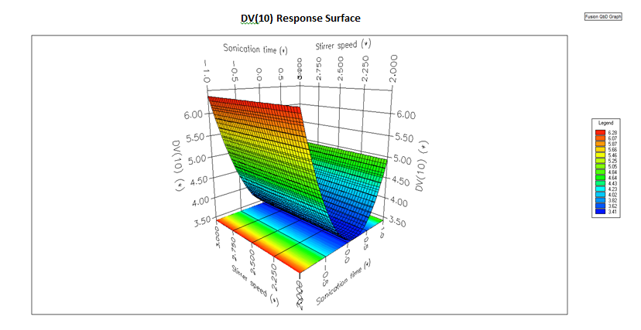
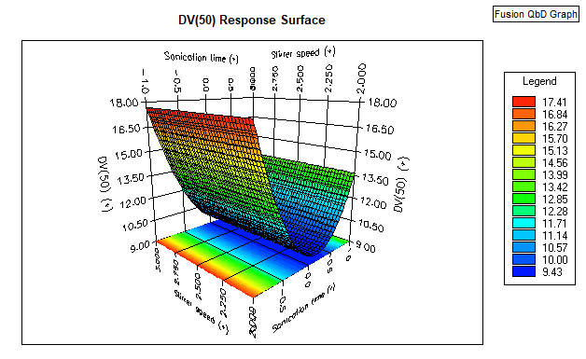
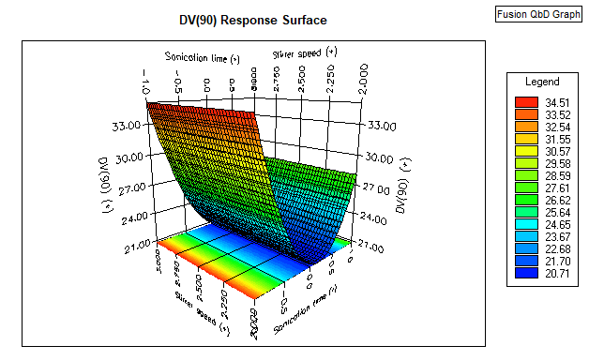
Fig. 2. Three-dimensional response surface and respective contour plots reflecting the effect of stirrer speed and sonication time on D values. Key: stirrer speed (rpm) (-1) 2000, (0) 2500, and (1) 3000; sonication time (min.) (-1) 0, (0) 2, and (1) 5

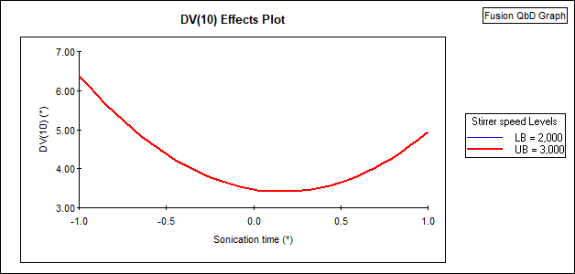

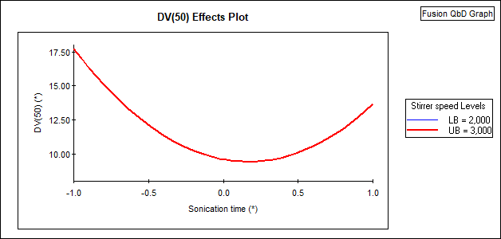

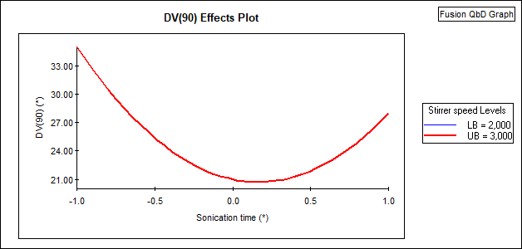

Fig. 3. Effect plot (Interaction plot) reflecting the effect of stirrer speed and sonication time on D values.

4.0 Method Validation

Validation of the developed particle size determination method for Dapagliflozin Propanediol focused on method precision, intermediate precision, and robustness. The method demonstrated consistent and reliable particle size distribution results across replicate measurements and was validated in accordance with ICH Q2 (R2) guidelines.
According to USP guidelines, the acceptance criteria for repeatability in particle size distribution measurements are typically defined as %RSD ≤ 10% (n = 6) for the central tendency of the distribution (Dv50). For the distribution limits for Dv10 and Dv90, a slightly higher variability of %RSD ≤ 15% (n = 6) is generally acceptable. For particle sizes below 10 µm, these acceptance limits may be increased, up to twofold, to account for the inherently higher variability associated with fine particle measurements [13].

4.1 Method Precision

Method precision was assessed using six replicate measurements of the Dapagliflozin Propanediol sample under optimized wet-dispersion conditions. The particle size distribution results were consistent across all replicates, with %RSD values within acceptable limits, demonstrating good repeatability of the method. The %RSD data obtained from the six measurements are presented in Table 12.

Acceptance criteria: The % RSD of Dv10 particle size values should not be more than 30, for Dv90 particle size values should not more than 15 and Dv50 particle size values should not more than 10.

Table 12. Method precision

Sample ID | Particle Size (µm)
Sample ID | Dv10 | Dv50 | Dv90
Precision -1 | 7.92 | 19.1 | 41.2
Precision -2 | 7.72 | 18.8 | 44.5
Precision -3 | 7.30 | 18.4 | 44.3
Precision -4 | 6.75 | 17.0 | 33.4
Precision -5 | 5.96 | 17.1 | 39.8
Precision -6 | 7.32 | 17.5 | 35.3
Mean | 7.16 | 18.0 | 39.8
SD | 0.713 | 0.902 | 4.593
% RSD | 9.96 | 5.01 | 11.56

4.2 Intermediate precision

Intermediate precision was assessed on different days by different analysts using six replicate measurements of the Dapagliflozin Propanediol sample under optimized wet-dispersion conditions. The particle size parameters Dv10, Dv50 and Dv90 were evaluated. The results showed good agreement between measurements, with %RSD values within acceptable limits, indicating satisfactory reproducibility and reliability of the method. The summarized %RSD results for intermediate precision, along with the cumulative %RSD values obtained by both analysts, are presented in Tables 13 and 14. Overall, these findings confirm the excellent repeatability and intermediate precision of the developed particle size determination method.

Acceptance criteria: The % RSD of Dv10 particle size values should not be more than 30, for Dv90 particle size values should not more than 15 and Dv50 particle size values should not more than 10.

Table 13. Intermediate precision

Sample ID | Particle Size (µm)
Sample ID | Dv10 | Dv50 | Dv90
Precision -1 | 5.63 | 16.1 | 39.0
Precision -2 | 5.78 | 16.9 | 40.0
Precision -3 | 7.34 | 18.6 | 43.3
Precision -4 | 5.29 | 15.3 | 36.2
Precision -5 | 7.34 | 19.3 | 42.6
Precision -6 | 7.46 | 18.7 | 36.9
Mean | 6.47 | 17.5 | 39.7
SD | 1.007 | 1.615 | 2.90
% RSD | 15.56 | 9.23 | 7.30

Table 14. Cumulative %RSD of method precision and intermediate precision

 | Sample ID | Particle Size (µm)
 | Sample ID | Dv10 | Dv50 | Dv90
Analyst-1 | Precision -1 | 7.92 | 19.1 | 41.2
Analyst-1 | Precision -2 | 7.72 | 18.8 | 44.5
Analyst-1 | Precision -3 | 7.30 | 18.4 | 49.3
Analyst-1 | Precision -4 | 6.75 | 17.0 | 33.4
Analyst-1 | Precision -5 | 5.96 | 17.1 | 39.8
Analyst-1 | Precision -6 | 7.32 | 17.5 | 35.3
Analyst-2 | Precision -1 | 5.63 | 16.1 | 39.0
Analyst-2 | Precision -2 | 5.78 | 16.9 | 40.0
Analyst-2 | Precision -3 | 7.34 | 18.6 | 43.3
Analyst-2 | Precision -4 | 5.29 | 15.3 | 36.2
Analyst-2 | Precision -5 | 7.34 | 19.3 | 42.6
Analyst-2 | Precision -6 | 7.46 | 18.7 | 36.9
Mean |  | 6.82 | 17.7 | 40.1
SD |  | 0.906 | 1.274 | 4.44
% RSD |  | 13.28 | 7.20 | 11.07

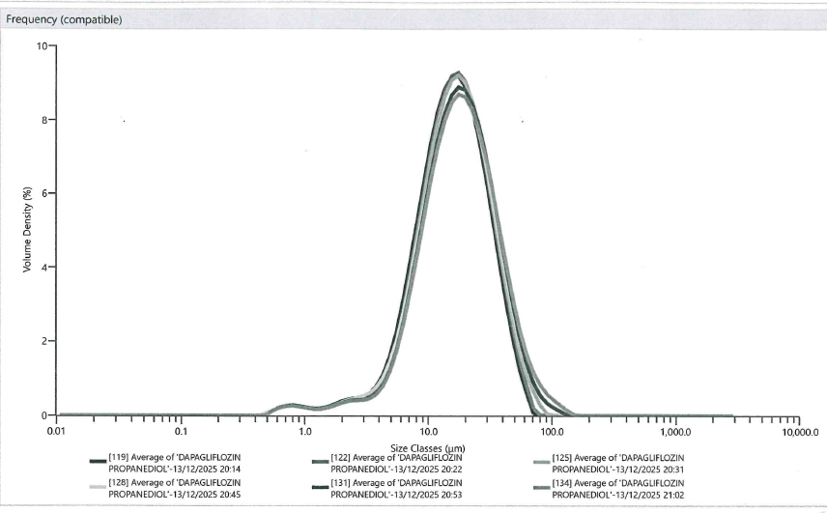

Fig.4. Comparative Overlay of Particle Size Distribution Curves

4.3 Robustness

Robustness was evaluated by introducing small deliberate variations in analytical parameters, including stirrer speed (±300 rpm), and obscuration range (within 5% of established range 20–30%). These changes did not significantly affect the PSD results, with residual error remaining below 1%, confirming the method’s reliability and ruggedness.

4.3.1 Robustness-1 (Change in stirrer speed to 2700 rpm)

Robustness-1 was performed by changing the stirrer speed from 3000 rpm to 2700 rpm while keeping all other parameters constant. Particle size values Dv10, Dv50, and Dv90 for six replicates are presented in Table 15 with cumulative averages and %RSD confirming the method’s robustness.

Table 15. Cumulative %RSD of method precision and Robustness-1

Parameter | Sample ID | Particle Size (µm)
Parameter | Sample ID | Dv10 | Dv50 | Dv90
Method precision | Precision -1 | 7.92 | 19.1 | 41.2
Method precision | Precision -2 | 7.72 | 18.8 | 44.5
Method precision | Precision -3 | 7.30 | 18.4 | 49.3
Method precision | Precision -4 | 6.75 | 17.0 | 33.4
Method precision | Precision -5 | 5.96 | 17.1 | 39.8
Method precision | Precision -6 | 7.32 | 17.5 | 35.3
Change in RPM  (2700 RPM) | Robustness-1 | 6.21 | 17.2 | 39.8
Change in RPM  (2700 RPM) | Robustness-1 | 7.54 | 18.4 | 38.1
Change in RPM  (2700 RPM) | Robustness-1 | 7.40 | 19.0 | 40.5
Change in RPM  (2700 RPM) | Robustness-1 | 8.23 | 20.4 | 46.2
Change in RPM  (2700 RPM) | Robustness-1 | 5.88 | 16.1 | 36.9
Change in RPM  (2700 RPM) | Robustness-1 | 7.05 | 17.2 | 35.0
Mean |  | 7.11 | 18.0 | 40.0
SD |  | 0.763 | 1.201 | 4.78
% RSD |  | 10.73 | 6.67 | 11.95

4.3.2 Robustness-2 (Change in stirrer speed to 3300 rpm)

Robustness-2 was performed by changing the stirrer speed from 3000 rpm to 3300 rpm while keeping all other parameters constant. Particle size values Dv10, Dv50 and Dv90 for six replicates are presented in Table 16 with cumulative averages and %RSD confirming the method’s robustness.

Table 16. Cumulative %RSD of method precision and Robustness-2

Parameter | Sample ID | Particle Size (µm)
Parameter | Sample ID | Dv10 | Dv10 | Dv10
Method precision | Precision -1 | 7.92 | 19.1 | 41.2
Method precision | Precision -2 | 7.72 | 18.8 | 44.5
Method precision | Precision -3 | 7.30 | 18.4 | 49.3
Method precision | Precision -4 | 6.75 | 17.0 | 33.4
Method precision | Precision -5 | 5.96 | 17.1 | 39.8
Method precision | Precision -6 | 7.32 | 17.5 | 35.3
Change in RPM  (3300 RPM) | Robustness-2 | 5.64 | 14.5 | 31.8
Change in RPM  (3300 RPM) | Robustness-2 | 5.11 | 14.8 | 35.6
Change in RPM  (3300 RPM) | Robustness-2 | 6.02 | 15.5 | 33.9
Change in RPM  (3300 RPM) | Robustness-2 | 6.67 | 16.5 | 36.7
Change in RPM  (3300 RPM) | Robustness-2 | 6.79 | 17.7 | 41.7
Change in RPM  (3300 RPM) | Robustness-2 | 5.71 | 15.5 | 35.8
Mean |  | 6.58 | 16.9 | 38.3
SD |  | 0.891 | 1.537 | 5.16
% RSD |  | 13.54 | 9.09 | 13.47

4.3.3 Robustness-3 (change in obscuration range to 20-25%)

Robustness-3 was assessed by determining the particle size for six replicates while varying the obscuration range from 20% to 25%, keeping other parameters constant. Particle size values Dv10, Dv50 and Dv90 for six replicates are presented in Table 17 with cumulative averages and %RSD confirming the method’s robustness.

Table 17. Cumulative %RSD of method precision and Robustness-3

Parameter | Sample ID | Particle Size (µm)
Parameter | Sample ID | Dv10 | Dv10 | Dv10
Method precision | Precision -1 | 7.92 | 19.1 | 41.2
Method precision | Precision -2 | 7.72 | 18.8 | 44.5
Method precision | Precision -3 | 7.30 | 18.4 | 49.3
Method precision | Precision -4 | 6.75 | 17.0 | 33.4
Method precision | Precision -5 | 5.96 | 17.1 | 39.8
Method precision | Precision -6 | 7.32 | 17.5 | 35.3
Change in  obscuration range to 20–25% | Robustness-3 | 6.30 | 15.7 | 34.5
Change in  obscuration range to 20–25% | Robustness-3 | 6.70 | 16.3 | 35.8
Change in  obscuration range to 20–25% | Robustness-3 | 6.89 | 16.8 | 37.7
Change in  obscuration range to 20–25% | Robustness-3 | 6.53 | 17.1 | 39.9
Change in  obscuration range to 20–25% | Robustness-3 | 6.97 | 17.5 | 40.5
Change in  obscuration range to 20–25% | Robustness-3 | 7.04 | 17.9 | 43.2
Mean |  | 6.95 | 17.4 | 39.6
SD |  | 0.563 | 0.996 | 4.63
% RSD |  | 8.10 | 5.72 | 11.69

4.3.4 Robustness-4 (change in obscuration range to 25-30%)
Robustness-4 was assessed by determining the particle size for six replicates while varying the obscuration range from 30% to 25%, keeping other parameters constant. Particle size values Dv10, Dv50 and Dv90 for six replicates are presented in Table 18, with cumulative averages and %RSD confirming the method’s robustness.

Table 18. Cumulative %RSD of method precision and Robustness-4

Parameter | Sample ID | Particle Size (µm)
Parameter | Sample ID | Dv10 | Dv10 | Dv10
Method precision | Precision -1 | 7.92 | 19.1 | 41.2
Method precision | Precision -2 | 7.72 | 18.8 | 44.5
Method precision | Precision -3 | 7.30 | 18.4 | 49.3
Method precision | Precision -4 | 6.75 | 17.0 | 33.4
Method precision | Precision -5 | 5.96 | 17.1 | 39.8
Method precision | Precision -6 | 7.32 | 17.5 | 35.3
Change in  obscuration range to 25–30% | Robustness-4 | 7.19 | 18.2 | 37.5
Change in  obscuration range to 25–30% | Robustness-4 | 7.53 | 17.4 | 34.8
Change in  obscuration range to 25–30% | Robustness-4 | 7.55 | 17.2 | 35.2
Change in  obscuration range to 25–30% | Robustness-4 | 5.39 | 15.0 | 35.8
Change in  obscuration range to 25–30% | Robustness-4 | 6.72 | 16.4 | 34.4
Change in  obscuration range to 25–30% | Robustness-4 | 6.93 | 16.6 | 34.3
Mean |  | 7.02 | 17.4 | 38.0
SD |  | 0.738 | 1.136 | 4.88
% RSD |  | 10.51 | 6.53 | 12.84

5. Conclusion

In this study, a systematic and science-driven Analytical Quality by Design (AQbD) approach was successfully applied to develop and validate a robust laser diffraction method for particle size distribution of Dapagliflozin Propanediol. The method was developed by defining a clear Analytical Target Profile (ATP), identifying Critical Quality Attributes (Dv10, Dv50, and Dv90), and conducting a comprehensive risk assessment using Ishikawa (cause-and-effect) diagrams and Failure Mode and Effects Analysis (FMEA). Critical Method Variables, particularly stirrer speed and sonication power, were identified and optimized using a Face-Centered Central Composite Design (FCCCD) implemented through Fusion QbD software.
The optimized method demonstrated excellent precision, intermediate precision, and robustness under varied experimental conditions and complied with the requirements of ICH Q2(R2), USP <429>, and EP 2.9.31. The QbD framework enabled enhanced method understanding, effective control of variability, and establishment of a proven acceptable operating range, ensuring consistent and reliable particle size measurements throughout the method lifecycle.

The validation study confirmed strong method performance. For method precision, the %RSD values were 9.96% for Dv10, 5.01% for Dv50, and 11.56% for Dv90. For intermediate precision, the %RSD values were 15.56% for Dv10, 9.23% for Dv50, and 7.30% for Dv90, while cumulative %RSD values between analysts were 13.28% for Dv10, 7.20% for Dv50, and 11.07% for Dv90.

Robustness was evaluated under four different experimental conditions. Under robustness condition 1, the %RSD values were 10.73% for Dv10, 6.67% for Dv50, and 11.95% for Dv90. Under robustness condition 2, the %RSD values were 13.54% for Dv10, 9.09% for Dv50, and 13.47% for Dv90. For robustness condition 3, the %RSD values were 8.10% for Dv10, 5.72% for Dv50, and 11.69% for Dv90, while robustness condition 4 yielded %RSD values of 10.51% for Dv10, 6.53% for Dv50, and 12.84% for Dv90. In all cases, the %RSD values remained within acceptable limits, confirming the robustness of the developed particle size determination method.

Overall, this QbD-based analytical strategy provides a scientifically justified, regulatory-compliant, and lifecycle-oriented approach for particle size characterization of Dapagliflozin Propanediol. The methodology described in this work can be readily extended to other drug substances where particle size plays a critical role in physicochemical performance and biopharmaceutical behavior.

Disclaimer (Artificial intelligence)

The author(s) hereby declare that no generative AI technologies, including Large Language Models (such as ChatGPT, Copilot, etc.) or text-to-image generation tools, were used in the writing, editing, data analysis, or preparation of this manuscript. All content has been entirely conceived, written, and reviewed by the author(s). Article design based on the original analytical data available with CTX Lifesciences. Pvt. Ltd.

Consent (where ever applicable)

It is not applicable

Ethical approval (where ever applicable)

It is not applicable

COMPETING INTERESTS DISCLAIMER:
Authors have declared that they have no known competing financial interests OR non-financial interests OR personal relationships that could have appeared to influence the work reported in this paper.

References

- Sangshetti JN, Deshpande M, Zaheer Z, Shinde DB, Arote R. Quality by design approach: Regulatory need. Arabian Journal of chemistry. 2017 May 1;10:S3412-25. https://doi.org/10.1016/j.arabjc.2014.01.025

- ICH Guideline Q8 (R2): Pharmaceutical Development, Eur. Med. Agency. (2009). International Council for Harmonization of Technical Requirements for Pharmaceuticals for Human Use.
- ICH Guideline Q14: Analytical Procedure Development, (2023). International Council for Harmonisation of Technical Requirements for Pharmaceuticals for Human Use.
- Zi Hong Mok, Science Direct (2024): The effect of particle size on drug bioavailability in various parts of the body. https://doi.org/10.1016/j.pscia.2023.100031
- ICH Guideline Q6A: Specifications (1999): Test Procedures and Acceptance Criteria for new Drug Substances and new Drug Products: Chemical Substances. International Council for Harmonization of Technical Requirements for Pharmaceuticals for Human Use.
- Australian Product information,published by Australia's government authority, Therapeutic Goods Administration (TGA), https://www.tga.gov.au/sites/default/files/auspar-dapagliflozin-as-propanediol-monohydrate-220328-pi.pdf
- Shiwei Yang 1,2,3,* , Xingming Hu 1,3, Jinmiao Zhu 1,3,*, Bin Zheng 1,3 ,Wenjie Bi 1, XiaohongWang 1, JialingWu 1,Zimeng Mi 1 and YifeiWu 1,(2025): Aspects and implementation of Pharmaceutical Quality by Design from Conceptual Frameworks to Industrial Applications,
https://doi.org/10.3390/pharmaceutics17050623
- A. Mascia1 · A. M. Cirafici1 · A. Bongiovanni2 · G. Colotti3 · G. Lacerra4 · M. Di Carlo2 · F. A. Digilio5 · G. L. Liguori4 · A. Lanati6 · A. Kisslinger(2020): A failure mode and effect analysis (FMEA)-based approach for risk assessment of scientific processes in non-regulated research laboratories, https://doi.org/10.1007/s00769-020-01441-9
- ICH Guideline Q9 (R1): Quality Risk Management (2021): International Council for Harmonisation of Technical Requirements for Pharmaceuticals for Human Use

- D.C. Montgomery, Design and Analysis of Experiments Eighth Edition. Arizona State University, 8th ed., Wiley, arizona, 2013.

- ICH Harmonised Guideline Q2(R2): Validation of Analytical Procedures (2022). International Council for Harmonisation of Technical Requirements for Pharmaceuticals for Human Use.

- USP-NF, <429>Light Diffraction measurement of particle size, (2021) 1–5.

- Ph.Eur. 6.6 General Chapter 2.9.31, “Laser Diffraction Measurement of Particle Size,” (EDQM, Strasbourg, France) p. 5103.

- Mastersizer 3000 User Manual, Malvern Instruments Ltd. (2013) 1–182. (www. malvern.com).

- Elene De Cleyn 1, René Holm 2 3, Guy Van den Mooter 1(2019), Size Analysis of Small Particles in Wet Dispersions by Laser Diffractometry: A Guidance to Quality Data https://doi.org/10.1016/j.xphs.2018.12.010

- Eman Z. Dahmash, Ali Al-khattawiID*, Affiong Iyire, Hamad Al-Yami, Thomas J. Dennison,Afzal R. Mohammed*(2018), Quality by Design (QbD) based process optimisation to develop functionalized particles with modified release properties using novel dry particle coating technique, 10.1371/journal.pone.0206651

- Yu LX, Amidon G, Khan MA, Hoag SW, Polli J, Raju GK, Woodcock J. Understanding pharmaceutical quality by design. The AAPS journal. 2014 Jul;16:771-83. 10.1208/s12248-014-9598-3

- Zhang L, Mao S. Application of quality by design in the current drug development. Asian journal of pharmaceutical sciences. 2017 Jan 1;12(1):1-8. 10.1016/j.ajps.2016.07.006

- Riccardo Deidda, Serena Orlandini, Philippe Hubert, Cedric Hubert(2018): Title: Risk-based approach for method development in pharmaceutical quality control context: A critical review https://doi.org/10.1016/j.jpba.2018.07.050

- Anne Virden,Method Development for Laser-Diffraction Particle-Size Analysis, Malvern Instruments

- Bashir Salah , Mohammed Alnahhal , Mujahid Ali (2023): Risk prioritization using a modified FMEA analysis in industry 4.0, https://doi.org/10.1016/j.jer.2023.07.001

- Shilpa R. Mandpe, Vishal R. Parate and Jitendra B. Naik (2022): Experimental design approach, screening and optimization of system variables, analytical method development of flurbiprofen in nanoparticles and stability-indicating methods for high-pressure liquid chromatography, https://doi.org/10.1186/s43094-022-00426-4

- White Paper by Malvern Instruments : A basic guide to particle characterization

Definitions, Acronyms, Abbreviations

QbD | Quality by Design
AQbD | Analytical Quality by Design
FMEA | Failure Mode and Effects Analysis
ATP | Analytical Target Profile
Dv | Distribution Volume
DoE | Design of Experiments
ICH | International Council for Harmonisation of Technical Requirements for Pharmaceuticals for Human Use
EP | European Pharmacopoeia
USP | United States Pharmacopeia
API | Active Pharmaceutical Ingredient
EMA | European Medicines Agency
FDA | Food and Drug Administration
FCCCD | Face-Centered Central Composite Design
CQAs | Critical Quality Attributes
PSD | Particle Size Distribution
CMAs | Critical Method Attributes
CPPs | Critical Process Parameters
RPN | Risk Priority Number
CAA | Critical Analytical Attributes
RSD | Relative Standard Deviation
SD | Standard Deviation
μm | Micrometer or micron
CMVs | Critical Method Variables
RPM | Rotation Per Minute

