Case Report

Management of a Broken Local Anesthetic Needle in the Mandibular Ramus: A Case Report and Literature Review

.
ABSTRACT

Aims: To report a clinical case of a fractured local anesthetic needle located in the mandibular ramus region and to describe the surgical management performed with the aid of an image intensifier. Additionally, this report discusses diagnostic strategies, surgical considerations, and preventive measures, emphasizing the importance of accurate localization to ensure safe removal and minimize neurological complications.
Presentation of Case: A 31-year-old male patient was referred for removal of a fractured anesthetic needle located on the lingual aspect of the left mandibular ramus after unsuccessful retrieval attempts. Imaging examination revealed a 23.5 mm fragment positioned near the entrance of the mandibular canal. Surgical removal was performed under local anesthesia and intravenous sedation using an image intensifier for real-time localization. The fragment was successfully removed without intraoperative complications.
Discussion: Needle fracture during dental anesthesia is rare but potentially serious. Accurate localization is essential to prevent fragment migration and neurological injury. Imaging modalities such as CBCT and fluoroscopy play an important role in safe retrieval.
Conclusion: The use of an image intensifier enabled precise localization and safe removal of the fractured needle, minimizing surgical risks and potential neurological complications.

Keywords: broken needle, fracture, wrong technique, intensifier

- INTRODUCTION

Needle fracture during dental local anesthetic injections, though rare, is a significant and potentially serious complication. Several challenges and concerns arise due to the potential complications and critical anatomical complexities unique to the head and neck region. Although local anesthesia is widely used in dental practice, needle fractures during this procedure are relatively rare.¹ The International Organization for Standardization has set standards for disposable stainless-steel needles, and as a result, most needle fractures are now due to avoidable factors rather than material defects.² Abrupt movements were the most common cause of fractures,³ and other contributing factors included bent needles, changing needle direction while it was still in the tissue, and structural fatigue from repeated use.⁴ The use of fine, short needles, especially for inferior alveolar nerve blocks, is also a contributing factor.⁵ Needle fractures during surgery can severely harm patients and quick removal of broken needle fragments is vital to prevent infection and tissue damage,⁶ and are generally symptomatic and show signs of inflammation, pain, and purulent discharge.⁷ The fragments are usually located in the pterygomandibular space or deep spaces of the head and neck,^{6,8} and other locations include the maxillary oral spaces, buccal and lingual aspects of the mandible, and intraosseous areas.⁹ If a needle fractures and cannot be removed immediately by the clinician, a prompt referral to a maxillofacial specialist is required for further management.¹⁰ Various intraoperative methods can be used to locate the fragment, including radiography, fluoroscopy, endoscopy, neuronavigation, metal detectors, magnifying glasses, and operating microscopes have been used.^{3,11} The following study presents a case where a fractured needle from a third molar extraction surgery was successfully removed. The dentist who broke the needle made two unsuccessful attempts to remove it. With the help of radiographic equipment, a maxillofacial surgeon was able to accurately locate and remove the needle during mouth opening, using reference points for guidance.

- PRESENTATION OF CASE

A 31-year-old male patient was referred by a general dentist for the removal of a foreign body (fractured anesthetic needle) located on the lingual side of the left mandibular ramus with paresthesia on the left edge of the tongue following the attempted needle removal surgery performed. The needle was located near the mandibular ramus, specifically in the retromolar region, slightly inclined horizontally relative to the mandibular ramus. It was positioned lingually. The superior tip of the needle near the opening of the mandibular canal on the posterior cortical surface, approximately 2 mm away. The needle measured approximately 23.5 mm in length, with the opposite tip positioned about 1.5 mm from the internal oblique ridge. There was 6.8 mm of soft tissue in this area, and 6mm of soft tissue height was measured from the crest of the alveolar ridge of the distal root of extracted third molar. The surgical removal of the fractured anesthetic needle was performed in a hospital setting under local anesthesia and sedation, using an image intensifier (Siemens- Siremobil Compact C, Germany). The patient was informed about the risk of paresthesia in the lower lip and on the left side of the tongue, after the surgery due to the proximity of the foreign body to the nerves in this region. This paresthesia could be temporary, or, in rare cases, permanent. The patient was placed in the dorsal decubitus position and underwent intravenous sedation. Intraoral and extraoral antisepsis was performed with PVPI, and surgical drapes were placed. Infiltration with 2% Mepivacaine (1:100,000) was administered on the left side of the mandible. Access to the left ascending mandibular ramus was achieved, followed by buccal and lingual gingival detachment. The tissue dissection was carried out in layers. The fractured anesthetic needle was removed from the lingual side of the left mandibular ramus with the assistance of the image intensifier. Hemostasis was achieved, and sutures were placed.

- DISCUSSION

Adequate training in retrieval techniques and knowledge of issues such as excessive force, incorrect needle size, and reuse is important for preventing complications. It is essential to uphold high standards of practice and continuously educate oneself on the proper handling of needles to ensure safety.⁶ However, sometimes the needle may break. In such cases, locating the site of the broken fragment and its potential movement to deeper levels poses a challenge in managing the complication. An image intensifier was used in the present case to safely locate and remove the fractured needle. If a broken suture needle is clinically visible or fully embedded after breakage, it may be retrieved immediately using a hemostatic forceps ¹² However, if the fragment is not visible in the oral cavity, it can be removed with the assistance of a simple magnet,¹³ or by using fluoroscopy. ¹⁴ In the present case, a surgical opening was made to access the area, and the broken needle was successfully removed with the aid of a hemostatic forceps. CBCT can accurately detect the fragment,¹⁵ but in the present case, the image intensifier precisely identified the fragment, resulting in a more efficient surgical process and reduced time in the operating room. In some cases, however, the presence of essential structures such as nerves and arteries, or the movement of the fragment to deeper areas, may restrict surgical access and make the removal procedure more complex. Due to the risk of severe complications from migrating fractured needle fragments, surgical removal should be undertaken as soon as possible, preferably under general anesthesia, although local anesthesia may also be used.^{16,17} Accurate location of the fragment and a thorough understanding of local anatomy are critical to avoid complications from unsuccessful removal attempts.¹⁸ Palpation of the tissue and trying to remove the needle without seeing are not recommended, as these actions can make the fragment move,^{19,20} and patients should avoid mandibular movements until the fragment is removed.⁶ Managing broken needle fragments requires an immediate response, technical expertise, and a comprehensive understanding of anatomical structures. Prompt detection and removal are important to reduce risks and prevent complications. Healthcare professionals must prioritize patient safety and maintain clear communication to effectively address both the physical and emotional aspects of the procedure.

- CONCLUSION

The use of the image intensifier proved to be a successful choice, assisting in the removal of the fractured needle found near the lingual aspect of the mandibular ramus in the retromolar area, close to the entrance of the mandibular canal, reducing the risk of damage to surrounding tissues.

Competing interests

The authors declare that there is no conflict of interest regarding the publication of this article.

Consent

All authors declare that ‘written informed consent was obtained from the patient (or other approved parties) for publication of this case report and accompanying images. A copy of the written consent is available for review by the Editorial office/Chief Editor/Editorial Board members of this journal.

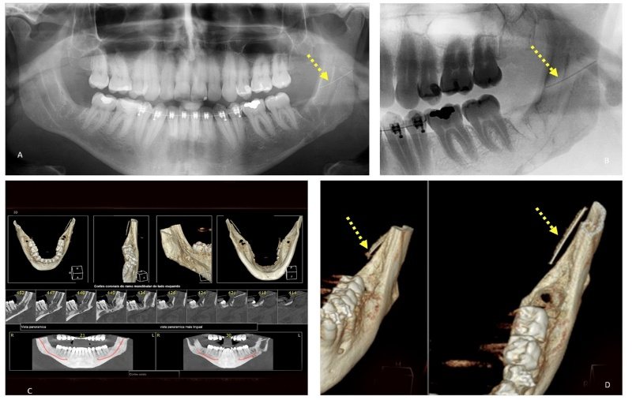
Fig 1. Pre-surgical Planning. A. Needle location by panoramic X-ray. B. Needle location using the image intensifier C. Needle location using CT scan D. Needle location using 3D reconstruction of CT scan.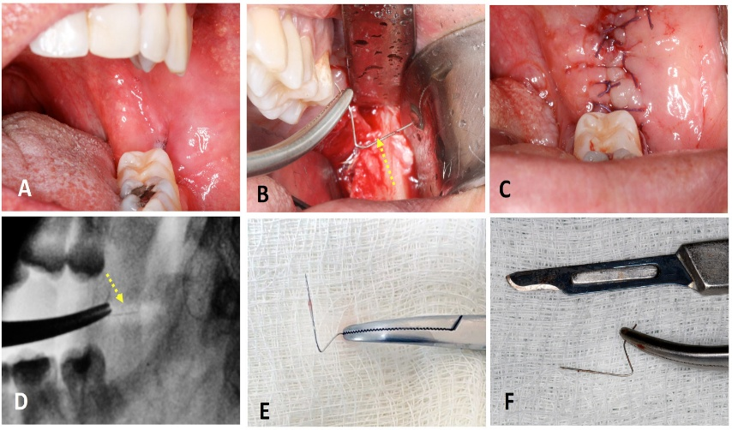

Fig 2. Surgical procedure. A – Surgical site before access. B - Grasp the needle with hemostatic forceps. C – Sutures. D - Grasp recorded by image intensifier. E – Needle. F - Needle removed compared to a scalpel blade.

References

- Acham S, Truschnegg A, Rugani P, Kirnbauer B, Reinbacher KE, Zemann W et al. Needle fracture as a complication of dental local anesthesia: recommendations for prevention and a comprehensive treatment algorithm based on literature from the past four decades. Clin Oral Investig 2019; 23:1109-1119.
- Pogrel MA. Broken local anesthetic needles: a case series of 16 patients, with recommendations. J Am Dent Assoc 2009; 140:1517-1522.
- Augello M, von Jackowski J, Gratz KW, Jacobsen C. Needle breakage during local anesthesia in the oral cavity--a retrospective of the last 50 years with guidelines for treatment and prevention. Clin Oral Investig 2011; 15:3-8.
- Crouse VL. Migration of a broken anesthetic needle: report of a case. S C Dent J 1970; 28:16-19.
- Chrcanovic BR, Menezes Junior DC, Custódio ALN. Complication of local dental anesthesia – a broken needle in the pterygomandibular space. Braz J Oral Sci 2009; 8:159–162.
- Sandre LB, de Paula ESE, Izidro AER, Neto WMP, da Costa Moraes CA, da Rosa

ELS. Observational and descriptive analysis of broken dental needles: a case series. Oral Maxillofac Surg 2023; 27:433-443.

- Seon S, Lee BS, Choi BJ, Ohe JY, Lee JW, Jung J et al. Removal of a suture needle: a case report. Maxillofac Plast Reconstr Surg 2021; 43:22.
- Altay MA, Jee-Hyun Lyu D, Collette D, Baur DA, Quereshy FA, Teich ST et al. Transcervical migration of a broken dental needle: a case report and literature review. Oral Surg Oral Med Oral Pathol Oral Radiol 2014;118: e161-165.
- Dilworth D, Byrne H, Kearns G. Broken needle: a rare complication of inferior alveolar nerve block - a report of two cases. Br Dent J 2022; 233:621-624.
- Thompson M, Wright S, Cheng LH, Starr D. Locating broken dental needles. Int J Oral Maxillofac Surg 2003; 32:642-644.
- Laskin DM. Diagnosis and treatment of complications associated with local anaesthesia. Int Dent J 1984; 34:232-237.
- Cohen R. The removal of an imbedded broken suture needle by a simple magnet. J Pediatr 1963; 63:164-165.
- Sencimen M, Bayar GR, Gulses A. Removal of the retained suture needle under C-arm fluoroscopy: a technical note. Dent Traumatol 2010; 26:527-529.
- Aktop S, Gocmen G, Ozturk ME, Gonul O, Varol A. A Rare Case of a Lost Suture Needle during Third Molar Surgery. Case Rep Dent 2015; 2015:372153.
- Catelani C, Valente A, Rossi A, Bertolai R. Broken anesthetic needle in the pterygomandibular space. Four case reports. Minerva Stomatol 2013; 62:455-463.
- Sahin B, Yildirimturk S, Sirin Y, Basaran B. Displacement of a Broken Dental Injection Needle into the Perivertebral Space. J Craniofac Surg 2017;28: e474- e477.
- Nezafati S, Shahi S. Removal of broken dental needle using mobile digital C-arm. J Oral Sci 2008; 50:351-353.
- Bhatia S, Bounds G. A broken needle in the pterygomandibular space: report of a case and review of the literature. Dent Update 1998; 25:35-37.
- McDonogh T. An unusual case of trismus and dysphagia. Br Dent J 1996; 180:465- 466.

