SURGICAL PROTOCOLS ASSOCIATED WITH ADJUVANT THERAPIES IN THE TREATMENT OF OSTEONECROSIS OF THE JAWS: A NARRATIVE LITERATURE REVIEW

.
ABSTRACT

Aims: To compare the effectiveness of surgical protocols with or without adjuvant therapies in the treatment of osteonecrosis of the jaws.
Study design: Narrative literature review with a systematized search strategy.
Place and Duration of Study: Studies published from 2020 onward were selected from the PubMed and Google Scholar databases.
Methodology: Clinical studies involving patients diagnosed with MRONJ and treated surgically, with or without adjuvant therapies, were included. Case reports, case series and randomized clinical trials published in English were analyzed. Data regarding type of treatment, disease stage and healing outcomes were extracted and descriptively compared.
Results: Ten studies comprising 238 treated cases of MRONJ were included. Among 108 cases treated with isolated surgical procedures, 86 (79.63%) achieved complete healing. Among 130 cases treated with surgery combined with adjuvant therapies, including low-level laser therapy, photodynamic therapy, concentrated growth factors, pharmacological preparation with pentoxifylline and tocopherol, and topical ozone therapy, 127 cases (97.69%) achieved complete healing.

Conclusion: Surgical treatment combined with adjuvant therapies demonstrates higher effectiveness in achieving complete healing and reducing recurrence rates when compared with isolated surgical approaches, even in advanced stages of MRONJ.

Keywords: Medication-related osteonecrosis of the jaws; MRONJ; Surgical treatment; Adjuvant therapy; Bisphosphonates.

1. INTRODUCTION

Medication-related osteonecrosis of the jaws (MRONJ) is a severe complication characterized by the presence of exposed necrotic bone in the maxillofacial region for a period longer than eight weeks, representing a challenging condition for healthcare professionals. This potentially serious adverse effect results from the use of antiresorptive and antiangiogenic agents and may lead to chronic pain, dysfunction, infection, and facial disfigurement, thereby directly affecting the quality of life of affected individuals [1–3]. The prolonged use of these medications has become increasingly frequent in dental practice, particularly among patients with disorders of bone metabolism and malignant neoplasms. Bisphosphonates, in particular, act by inhibiting osteoclast activation and inducing apoptosis, thus reducing bone resorption. However, the need for bone-level oral rehabilitation in these patients raises concerns regarding the risk of developing MRONJ. The etiopathogenesis of this condition has not yet been fully elucidated, although its occurrence is known to be associated with a combination of systemic and local risk factors [2,4].
The first report of bisphosphonate-induced osteonecrosis of the jaw was described by Marx in 2003 [5], and since then, numerous studies have been conducted to better understand this condition and its clinical implications [9]. Although the use of these drugs is associated with significant adverse effects, their safety and efficacy are well documented in clinical trials and review studies, demonstrating benefits in survival and quality of life among oncology patients with skeletal involvement. Consequently, these agents remain the first-line therapeutic option for the management of osteopenia, osteoporosis, and bone-related malignancies, such as multiple myeloma and breast, prostate, and bronchogenic carcinomas [4–6]. In the oncological setting, administered doses tend to be higher, particularly in the treatment of breast cancer, prostate cancer, or metastatic disease. In contrast, in the management of osteological conditions, prescriptions aim primarily at fracture prevention; however, evidence indicates possible complications associated with the prolonged oral use of bisphosphonates, as well as angiogenesis inhibitors and denosumab [4,5].
In 2014, the American Association of Oral and Maxillofacial Surgeons (AAOMS) revised the terminology previously known as bisphosphonate-related osteonecrosis of the jaw (BRONJ) to medication-related osteonecrosis of the jaws (MRONJ). According to this updated definition, MRONJ is diagnosed when the following criteria are met: current or previous treatment with antiresorptive or antiangiogenic agents; exposed bone or bone that can be probed through an intraoral or extraoral fistula in the maxillofacial region persisting for more than eight weeks; and no history of radiation therapy or metastatic disease affecting the jaws [2]. Among dental procedures capable of triggering MRONJ are tooth extractions, dental implant placement, and periodontal, periapical, and endodontic surgical procedures [2,4,5]. Tooth extraction is the most prevalent predisposing factor, accounting for approximately 52% to 61% of reported cases [7,8].
Also in 2014, the AAOMS established a staging system for MRONJ, consisting of four categories: stage 0, characterized by clinical symptoms without bone exposure, with progression to higher stages occurring in approximately 50% of cases; stage 1, defined by exposed bone without associated clinical symptoms; stage 2, characterized by exposed bone accompanied by pain, edema, inflammation of adjacent soft tissues, or secondary infection; and stage 3, which includes the features of stage 2 plus at least one of the following findings: pathological fracture, extraoral or oroantral fistula, or radiographic evidence of osteolysis extending to the inferior border of the mandible or the floor of the maxillary sinus [2].
Therapeutic management is determined according to the stage of the disease. Patients considered at risk do not require specific treatment, and preventive education is recommended. In stage 0, management involves the use of systemic medications such as analgesics and antibiotics. In stage 1, quarterly clinical follow-up is recommended, along with the use of antibacterial mouth rinses and reassessment of the need for continuation of bisphosphonate therapy. In stage 2, in addition to symptomatic pain management and antibiotic therapy, tissue debridement is indicated to reduce irritation and control infection. In stage 3, treatment includes antibiotic therapy, pain control, and surgical procedures such as debridement or resection of the affected area, aiming to achieve long-term improvement of infectious and painful conditions [2,6].
Scientific literature, including systematic reviews and AAOMS guidelines [6], emphasizes that complete healing in MRONJ must meet specific clinical criteria—namely, intact mucosa and absence of symptoms for at least eight weeks—as well as radiographic criteria, including confirmation of the absence of sequestra and evidence of bone regeneration through cone-beam computed tomography (CBCT) and conventional radiographs [9,10].

2. material and methods

2.1 Study Design
This narrative review was developed using a systematized search strategy, with a PICO-formulated research question aimed at identifying the most appropriate treatment for osteonecrosis of the jaws in a population of patients diagnosed with and undergoing treatment for this condition. The intervention analyzed consisted of surgical treatments, while the comparison involved surgical treatments associated with adjuvant therapies. The outcome assessed was the healing rate, classified as complete or incomplete, allowing a comparative analysis of the effectiveness of the available therapeutic approaches.
2.2 Research Question
The research question was formulated using the PICO strategy:
2.2.1 Population: Patients diagnosed with MRONJ undergoing surgical treatment.
2.2.2 Intervention: Isolated surgical treatment.
2.2.3 Comparison: Surgical treatment associated with adjuvant therapies.
2.2.4 Outcome: Complete or incomplete healing.
2.3 Search Strategy
The search was conducted in the PubMed and Google Scholar databases using the following terms: MRONJ AND surgical treatment OR MRONJ AND low-level laser therapy OR MRONJ AND ozone therapy OR MRONJ AND adjuvant therapy OR MRONJ AND tocopherol OR MRONJ AND antibiotic therapy.
2.4 Eligibility Criteria
Clinical studies published from 2020 onward, written in English, including case reports, case series and randomized clinical trials involving surgical treatment of MRONJ, with or without adjuvant therapies, were included. Studies addressing osteoradionecrosis, literature reviews and systematic reviews were excluded.

3. results and discussion

A total of 10 scientific articles with diverse methodologies addressing medication-related osteonecrosis of the jaws (MRONJ) were analyzed, involving different therapeutic approaches according to the stage of the disease. The search conducted in the PubMed database yielded 64 articles, of which only 16 were included after application of the exclusion criteria. In the Google Scholar database, of the 250 articles initially identified, only 14 met the established criteria and were included in the review.
After title and abstract screening of 30 references, 18 were excluded according to the predefined exclusion criteria, resulting in 12 remaining articles. Full-text reading and analysis led to the exclusion of two additional studies: the first due to data inconsistencies, such as discrepancies in the total number of patients within a specific study group and unclear reporting of disease stages; and the second because the patient had previously undergone radiotherapy, which contradicted the diagnostic criteria established by the American Association of Oral and Maxillofacial Surgeons (AAOMS). To illustrate the study selection process, a flowchart was developed (Fig. 1), and the articles included in this review are described in Table 1.

Fig. 1. Flowchart of the study selection process

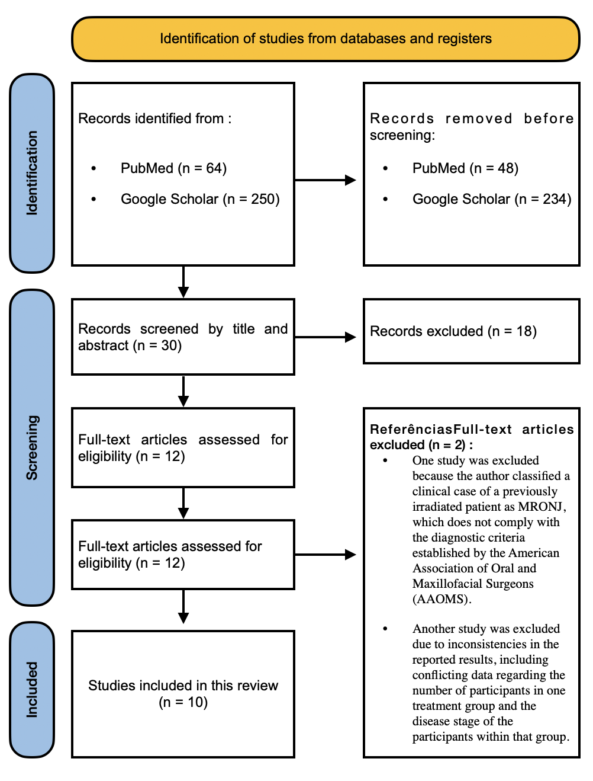

Table 1. Summary of included studies evaluating surgical treatment alone and surgical treatment combined with adjuvant therapies for MRONJ
Author, year | Cases | Stage | Treatment | Healing with Surgical Treatment Alone | Healing with Combined Surgical Treatment + Adjuvant Therapies
Del Pilar Rodríguez-Sánchez et al., 2020 | Case report (1 case) | 2 | Surgery, antibiotics, and low-level laser therapy | Not performed | Yes – Complete healing
Matsuda et al., 2020 | Case report (1 case) | 3 | Surgery and antibiotics | Not performed | Yes – Complete healing (100%)
Meltem Ozden et al., 2020 | Clinical trial (28 cases) | 2 and 3 | Test group (n = 14): Surgery + CGF (concentrated growth factor); Control group (n = 14): Surgery alone | Control group: complete healing in 8 of 14 cases – 57.14% | Test group: complete healing in 11 of 14 cases – 78.57%
Almeida et al., 2021 | Case report (1 case) | 2 | Curettage + low-level laser therapy + aPDT | Not performed | Yes – 100%
Reinert et al., 2021 | Case report (1 case) | 2 | Surgery, antibiotics, and low-level laser therapy | Not performed | Complete healing – 100%
Varidel & Wong, 2022 | Case report (1 case) | 3 | Surgery and antibiotics | Not performed | Complete healing – 100%
Colapinto et al., 2023 | Clinical trial (202 cases) | 1 | Test group: pentoxifylline (PTX) and tocopherol (vitamin E) + surgery (n = 108); Control group: surgery alone (n = 94) | Control group: complete healing in 78 of 94 cases at 6 months – 82% | Test group (PTX): complete healing in 108 cases – 100%
Kolodziejwski et al., 2024 | Case report (1 case) | 3 | Surgery and antibiotics | Not performed | Complete healing – 100%
Vescovi et al., 2024 | Case report (1 case) | 3 | Antibiotics, surgical treatment, and laser therapy | Not performed | Complete healing – 100%
Deliberador et al., 2024 | Case report (1 case) | 3 | Surgery and ozonized gel | Not performed | Complete healing – 100%

These studies provided a comprehensive overview of the therapeutic approaches employed, contributing to a better understanding of the surgical strategies adopted. In total, 238 treated cases were analyzed. Among these, 108 cases underwent strictly surgical procedures, of which 86 (79.63%) achieved complete healing. Regarding surgical cases associated with adjuvant therapies, 130 cases were treated, of which 127 (97.69%) achieved complete healing. These percentages represent pooled descriptive data and do not constitute statistical inference.
Fig.2. Percentage of complete healing achieved with isolated surgical treatment and with surgical treatment combined with adjuvant therapies.

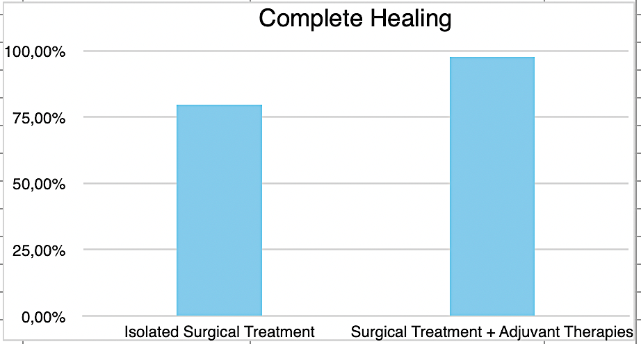

This literature review consists of a narrative review with a systematized search strategy, structured according to PRISMA parameters to ensure organization and transparency in the study selection process. Only clinical case reports, case series, and clinical trials were included, with the objective of comparing the effectiveness of isolated surgical treatments and surgical treatments associated with adjuvant therapies in the clinical practice of dental surgeons managing medication-related osteonecrosis of the jaws (MRONJ).
Promising results regarding the combination of therapies for the treatment of MRONJ have been reported in the literature, such as the case report by Del Pilar Rodríguez-Sánchez et al. [11], which described a stage 2 patient with maxillary bone lesions following the use of zoledronate. The patient was treated with surgical curettage, antibiotic therapy, and low-level laser therapy (LLLT), resulting in complete mucosal healing within two months and no recurrence after 12 months of follow-up.
This combination of therapies highlights the effectiveness of an integrated approach in disease control, as also supported by the study of Reinert et al. [12], which suggests that surgical intervention combined with LLLT is more effective, particularly when conservative treatment fails to reduce the extent of osteonecrotic lesions.
The effectiveness of concentrated growth factors (CGF) associated with surgical treatment was evaluated by Yüce et al. [13] in comparison with isolated surgical treatment (sequestrectomy, curettage, and primary closure), indicating no statistically significant difference between the methods. Nevertheless, the authors emphasized the potential and promising benefits of CGF, with complete healing rates of 78.6% for the CGF group and 57.1% for the isolated surgery group. Almeida et al. (2021) [14] also described a case report, observing complete regression of the lesion after curettage of the necrotic bone and application of 12 sessions of antimicrobial photodynamic therapy (aPDT), once again highlighting the association of therapeutic modalities, particularly the use of low-level laser therapy.
Kolodziejwski et al. [15] reported the case of a 53-year-old patient with Crohn’s disease undergoing treatment with infliximab, who developed stage 3 MRONJ associated with a pathological mandibular fracture. Initially treated with antimicrobial photodynamic therapy (aPDT) and antibiotic therapy, the patient subsequently progressed to fracture, requiring surgical reconstruction. This case illustrates the complexity of MRONJ management and underscores the need for individualized therapeutic approaches, especially in patients with significant comorbidities.
In an extensive systematic review covering the period from 2007 to 2020, with a pooled analysis of 1,137 patients, Di Fede and colleagues [16] concluded that conservative surgery combined with adjuvant therapies appears to be more effective and safer in the early stages of the disease. However, this broad review of the literature also revealed that the association of therapies proved to be more effective in more advanced stages of MRONJ.
Matsuda et al.[17] presented a case report of a 67-year-old woman diagnosed with MRONJ, who was initially treated with conservative therapy, antibiotics, and sequestrectomy, without success. At a later stage, at 70 years of age, she underwent a second intervention consisting of left hemimandibulectomy without reconstruction, followed by spontaneous mandibular regeneration. Despite some points requiring careful consideration, this represents one of the few reported cases of spontaneous regeneration following hemimandibulectomy.
It is noteworthy that most authors cite sequestrectomy, curettage of necrotic bone, and smoothing of sharp bony edges as standard surgical procedures aimed at minimizing tissue trauma [18,19]. Vescovi [20] observed synergistic effects from the combination of piezoelectric surgery, Er:YAG laser surgery, and Nd:YAG laser photobiomodulation in the treatment of MRONJ related to denosumab use, producing a promising clinical outcome characterized by minimal postoperative discomfort and absence of recurrence. However, as this represents an isolated case, further studies are required.
Deliberador [20] reported a case of MRONJ occurring three months after implant removal. The patient discontinued alendronate after four years of use. Curettage was performed, followed by application of blue®m oral gel at the site every eight hours, in addition to antibiotic therapy. The patient was instructed to continue applying the gel to the affected area every eight hours for 15 days. After this period, the patient returned with complete healing. Colapinto et al. [21] investigated the association of surgical treatment with pharmacological preparation using pentoxifylline and tocopherol, achieving 100% complete mucosal healing and a reduction in recurrences, which were observed in the control group treated only surgically over a follow-up period exceeding seven years. However, the success rate of this combined approach was associated with stage 1 disease and therefore showed a more favorable prognosis. Isolated surgical treatment, although widely used, carries the risk of worsening bone exposure, particularly in stage 3 cases, where the extent of necrosis is greater. Even less aggressive approaches, involving removal of only necrotic bone and sharp bony edges without the application of growth factors, may limit tissue regeneration. The literature reinforces that surgery alone, without adjuvant therapies, is not sufficient to prevent recurrences or promote complete healing, especially in patients with risk factors such as continuous bisphosphonate use or comorbidities (e.g., diabetes mellitus, corticosteroid use) [21].
The results obtained in this review should be interpreted with caution due to the heterogeneity of the analyzed studies, particularly with respect to the different stages of medication-related osteonecrosis of the jaws, the variety of therapeutic approaches employed, and the distinct follow-up periods, which limit direct comparisons among the evaluated protocols. This limitation is largely attributable to the scarcity of controlled and randomized clinical trials that would allow a more robust comparative analysis.

4. Conclusion

Medication-related osteonecrosis of the jaws (MRONJ) remains a significant challenge in dentistry, with considerable failure rates reported in studies involving larger sample sizes. Treatment should be individualized, depending on the stage of the disease and patient-specific conditions. The combination of surgical intervention with adjuvant therapies demonstrates greater effectiveness in achieving complete healing as well as in preventing recurrences during long-term follow-up, even in more advanced stages of the disease.

Consent

Not applicable.

Ethical approval

Not applicable.

Definitions, Acronyms, Abbreviations

AAOMS – American Association of Oral and Maxillofacial Surgeons
aPDT – Antimicrobial Photodynamic Therapy
BRONJ – Bisphosphonate-Related Osteonecrosis of the Jaw
CBCT – Cone-Beam Computed Tomography
CGF – Concentrated Growth Factors
LLLT – Low-Level Laser Therapy
MRONJ – Medication-Related Osteonecrosis of the Jaws
PRISMA – Preferred Reporting Items for Systematic Reviews and Meta-Analyses
PTX – Pentoxifylline

References

[1]
Hinchy NV, Jayaprakash V, Rossitto RA, Anders PL, Korff KC, Canallatos P, et al. Osteonecrosis of the jaw – prevention and treatment strategies for oral health professionals. Oral Oncol. 2013;49(9):878–886.

[2]
Ruggiero SL, Dodson TB, Fantasia J, Goodday R, Aghaloo T, Mehrotra B, et al. American Association of Oral and Maxillofacial Surgeons position paper on medication-related osteonecrosis of the jaw—2014 update. J Oral Maxillofac Surg. 2014;72:1938–1956.

[3]
Capocci M, Romeo U, Guerra F, Mannocci A, Tenore G, Annibali S, et al. Medication-related osteonecrosis of the jaws (MRONJ) and quality of life evaluation: a pilot study. Clin Ter. 2017;168(4):e253–e257.

[4]
Otto S, Pautke C, Van den Wyngaert T, Niepel D, Schiødt M. Medication-related osteonecrosis of the jaw: prevention, diagnosis and management in patients with cancer and bone metastases. Cancer Treat Rev. 2018;69:177–187.

[5]
Marx RE. Pamidronate (Aredia) and zoledronate (Zometa) induced avascular necrosis of the jaws: a growing epidemic. J Oral Maxillofac Surg. 2003;61(9):1115–1117.

[6]
Ruggiero SL, Dodson TB, Aghaloo T, Carlson ER, Ward BB, Kademani D. American Association of Oral and Maxillofacial Surgeons’ position paper on medication-related osteonecrosis of the jaws—2022 update. J Oral Maxillofac Surg. 2022;80(5):920–943.

[7]
Hellstein JW, Adler RA, Edwards B, Jacobsen PL, Kalmar JR, Koka S, et al. Managing the care of patients receiving antiresorptive therapy for prevention and treatment of osteoporosis. J Am Dent Assoc. 2011;142(11):1243–1251.

[8]
Russell RG, Watts NB, Ebetino FH, Rogers MJ. Mechanisms of action of bisphosphonates. Osteoporos Int. 2008;19(6):733–759.

[9]
Momesso GAC, Lemos CAA, Santiago-Júnior JF, Faverani LP. Medication-related osteonecrosis of the jaws (MRONJ): a critical review and treatment planning. In: IntechOpen; 2020.

[10]
Fliefel R, Tröltzsch M, Kühnisch J, Ehrenfeld M, Otto S. Treatment strategies and outcomes of bisphosphonate-related osteonecrosis of the jaw (BRONJ). Int J Oral Maxillofac Surg. 2015;44(5):568–585.

[11]
Del Pilar Rodríguez-Sánchez M, Statkievicz C, de Mello-Neto JM, Toro LF, Bassi APF, Garcia VG, et al. Effectiveness of low-level laser, antibiotic and surgical therapy in MRONJ: a case report. J Lasers Med Sci. 2020;11(1):98–103.

[12]
Kolodziejwski WT, Rosa CAL, Guimarães AM, da Silva PQM, de Araujo MR. Mandibular fracture in medication-associated osteonecrosis following infliximab therapy: a case report. Spec Care Dentist. 2024;44(6):1558–1563.

[13]
Varidel A, Wong E. Conservative management of severe MRONJ with pathological fracture. J Craniofac Surg. 2022;33(3):e329–e333.

[14]
Almeida MVDC, Moura AC, Santos L, Gominho L, Cavalcanti UDNT, Romeiro K. Photodynamic therapy as an adjunct in MRONJ: a case report. J Lasers Med Sci. 2021;12:e12.

[15]
Reinert CP, Pfannenberg C, Gatidis S, la Fougère C, Nikolaou K, Hoefert S. Imaging of MRONJ in conservative treatment. Front Oncol. 2021;11:700397.

[16]
Di Fede O, Canepa F, Panzarella V, Mauceri R, Del Gaizo C, Bedogni A, et al. Treatment of MRONJ: a systematic review with pooled analysis. Int J Environ Res Public Health. 2021;18(16):8432.

[17]
Matsuda S, Yoshida H, Shimada M, Yoshimura H. Spontaneous regeneration of the mandible following hemimandibulectomy for MRONJ. Medicine (Baltimore). 2020;99(33):e21756.

[18]
Kim JW, Kim SJ, Kim MR. Current trends in adjuvant therapies for MRONJ. Medicina. 2023;59(9):1688.

[19]
Vescovi P, De Francesco P, Giovannacci I, Leão JC, Barone A. Combined laser and piezoelectric surgery for MRONJ. Dent J (Basel). 2024;12(8):261.

[20]
Deliberador TM, Stutz C, Sartori E, Kluppel L, de Freitas RM. Treatment of MRONJ with topical active oxygen gel. Clin Cosmet Investig Dent. 2024;16:249–254.

[21]
Colapinto G, Goker F, Nocini R, Albanese M, Nocini PF, Sembronio S, et al. Pentoxifylline and tocopherol protocol for MRONJ. J Clin Med. 2023;12(14):4662.

