Original Research Article

Effect of Different Types of Stools on Working Posture, Discomfort, and Productivity in Dentistry

.
ABSTRACT

Objective: This study evaluated different stools on working posture, discomfort and productivity during cavity preparations.
Methods: The response variables were muscle contraction, risk of developing musculoskeletal disorders in the upper limbs, compliance with ergonomic posture requirements, angular deviation from the neutral position of the neck and trunk, perception of discomfort and productivity. Independent variables were type of stool and arch. Class I tooth preparations were performed on arch simulator plates during 90-minutes per period. For each experimental condition, 10 postural assessment periods were used (N=60 postures). Two-way parametric and non-parametric ANOVA with Tukey’s post-test were performed (α=0.05).
Results: There was no significant interaction between stool and arch for any evaluated variable (p=0.449–0.915). There was higher muscle contraction during work with conventional stool for the lumbar region (p<0.001), better angular deviation from the neutral position of trunk (p<0.001) and better compliance with ergonomic posture requirements (p=0.004) when working on the lower arch. It was also observed an increased perception of discomfort in the thigh region with the saddle seat (p<0.001).
Conclusion: The different types of stools influenced only muscle contraction and perceived discomfort. The conventional stool increased lumbar region muscle contraction, while the saddle seat produced greater discomfort in the thigh region. Procedures performed on the upper arch were associated with reduced compliance with ergonomic posture requirements and greater angular deviation of the trunk.

Keywords: Occupational health; Ergonomics; Muscle Contraction; Dentistry; Dental equipment.

1. INTRODUCTION

Musculoskeletal disorders are among the most common occupational risks for dentists [1-10], and their prevalence ranges from 63–93% in this population [11], with complications causing decreased productivity and performance, compromised quality of life, absenteeism, and early retirement from the profession [12]. Inadequate and static postures adopted for long periods of time are considered the main risk factors for the development of these disorders [3-7,9,10,13-15] and may result in contraction of the muscles of the cervical and upper thoracic spine, pressure in the lumbar region, weakening of the spinal discs, muscle necrosis, and other significant structural damage [1,3,15,16].
Ergonomic strategies have been proposed to prevent these disorders, including the selection of dental equipment that allows dentists to work with balanced and neutral postures [5,6,9,14,17]. As the equipment that supports the dentist throughout sitting work, dental stools have a great influence on posture and can induce the adoption of certain harmful postural patterns [13]. A poorly designed stool with insufficient lumbar support or inadequate adjustment contributes to muscle fatigue and low back pain [5], in addition to deleterious effects on blood circulation in the lower extremities [18].
The conventional stool, the first type of seat proposed for dental work [19], is commonly used by dentists. This stool features a geometrically shaped seat and lumbar backrest, height adjustment, and a wheeled base [19,20]. However, these characteristics do not always favor the adoption of appropriate postures. Consequently, modifications to seat and back designs have been proposed to promote the maintenance of healthier postures [15]. Thus, the saddle seat and the SeatBall were introduced. The saddle seat has a horse saddle–style seat and a structure with a five‑wheel rotation system, while the SeatBall consists of an inflatable sphere made of non‑toxic vinyl material (Swiss ball) supported on a metal wheeled base [20,21].
Although saddle seats and SeatBalls have been proposed as alternatives for improving the posture of dental surgeons, few studies have verified whether they meet the goals for which they were developed. Therefore, studies that simultaneously evaluate the effect of different types of stools on working posture using different evaluation methods could make a significant contribution to the field of occupational health in Dentistry.
This study aimed to evaluate the effect of different types of dental stools on working posture in Dentistry, measured by muscle contraction, risk of developing musculoskeletal disorders in the upper limbs, compliance with ergonomic posture requirements, and angular deviation from the neutral position of the neck and trunk, as well as discomfort and productivity during simulated Class I tooth preparations.

2. material and methods

2.1 STUDY DESIGN
This was an experimental laboratory study approved by the Research Ethics Committee of São Paulo State University (Unesp), School of Dentistry, Araraquara (CAAE Registry No. 50721221.2.0000.5416). Dependent variables were: 1) muscle contraction of the abdominal, lumbar, and lower body regions, 2) risk of developing musculoskeletal disorders in the upper limbs, 3) compliance with ergonomic posture, 3) angular deviation from the neutral position of the neck and trunk, 4) perception of discomfort, and 5) productivity. Independent variables were the type of stool at three levels (Conventional Stool, Saddle Seat, and SeatBall) and worked arch at two levels (upper and lower).
To evaluate muscle contraction, surface thermography was employed. Because this technique captures thermal changes in the skin, preliminary tests were conducted to determine the execution time of Class I tooth preparations required for accurate recording, establishing a period of 90 minutes. The work posture adopted during this period was therefore considered the sampling unit in this study. For each experimental condition, 10 periods of postural assessment were carried out (N = 60 postures, totaling 90 hours of simulated preparation). The order of stool use and tooth preparations in the different arches was randomized.

2.2 DENTAL STOOLS
To perform the procedure, the operator used the conventional dental stool, saddle seat, and SeatBall. The conventional dental stool consists of a backrest for lumbar region and a flat seat that allows the hips and legs to be angled at approximately 90° (Figure 1a). The saddle seat is angled and does not have a backrest (Figure 1b). The SeatBall does not have a backrest, and its seat is formed by a Swiss ball on a rotating structure (Figure 1c).
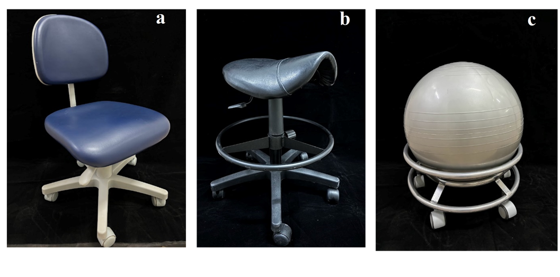
Fig. 1. Dental Stools (a: conventional; b: Saddle seat; c: SeatBall)
2.2 SIMULATED CAVITY PREPARATIONS
Simulated Class I tooth preparations for composite resin were performed using a 1014 spherical diamond bur (Kg Sorensen) at low speed and replaced after every eight preparations. To enable these preparations to be carried out for 90 minutes, upper and lower arch simulator plates were used. These plates were made of polyester crystal resin and filled with type III dental stone, each containing eight designs that reproduced the shape of a Class I preparation (Figure 2). The plates were fitted to the corresponding arch of a dental mannequin (brand MOM – Manequins Odontológicos Marília), specifically designed for simulating procedures at the laboratory level. After the completion of the eight tooth preparations, the simulator plate was replaced with another containing new Class I preparation designs, continuing until a total of 90 minutes of work was achieved.
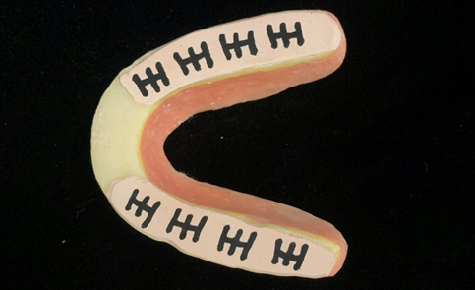
Fig. 2. Arch simulator plate filled with type III plaster
2.3 SURFACE THERMOGRAPHY
To assess muscle contraction surface thermography was employed. The thermographic images were evaluated by a properly calibrated researcher (ρ_{abdomenR}=0.918, ρ_{abdomenL}=0.899, ρ_{lumbar}=0.990, ρ_{thighR}=0.936, ρ_{thighL}=0.939). To acquire these images, a FLIR C3 infrared camera (FLIR Systems, USA) with Thermidas version 1.0 was used. This camera has a 320 × 240 element array detector and thermal sensitivity of <0.10°C, with an accuracy of ±2°C at a temperature of 25°C. The camera comes with the manufacturer’s calibration and uses a skin emissivity value of 0.98. Thermal images were acquired with the operator standing, dressed in a top and shorts, 5 min after entering the data collection room with an ambient temperature of 22–24°C. The distance between the camera positioning point and the operator was 1m [18]. Following the recommendations adapted from Pedreira et al. (2016) [22], images of body areas were obtained at two different times: before starting work with each stool (T0) (Figure 3a), and after completing the work (T90) (Figure 3b).
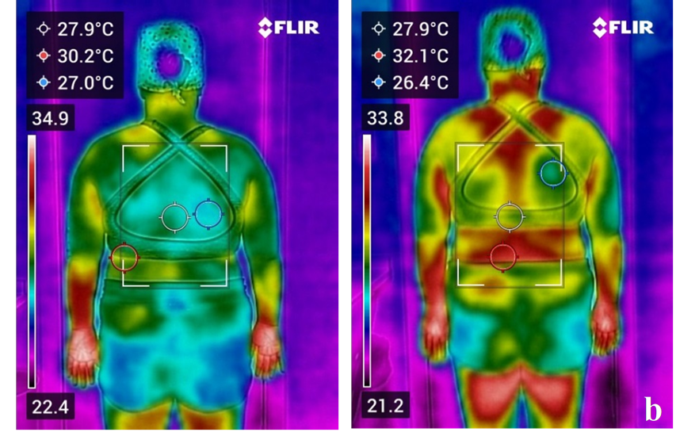
Fig. 3. Surface thermography image (a: pre-work, T0; post-work, T90)
To control the influence of external factors on thermography, one collection was established per day, in the morning, and without physical activity 24h before the collection.
The temperature of each selected region was obtained using the free thermography software FLIR Thermal Studio (Teledyne FLIR LLC, Wilsonville, OR, USA), with an emissivity factor of 0.98. This software determines body temperature based on the value obtained in the chosen indicator area. To analyze muscle contraction, the difference in maximum area temperature (ΔT), expressed in °C, was calculated between the end of the work period (T90) and before the start of work with each stool (T0) [23,24].
2.4 Recording of working postures
Working postures were recorded to assess the risk of developing musculoskeletal disorders, compliance with ergonomic posture requirements, and angular deviation of the neck and trunk during simulated tooth preparations. Three digital cameras (GoPro Hero 4 – GoPro Inc., San Mateo, CA, USA) positioned on tripods at previously delimited points [25] recorded the entire procedure. The most frequently adopted working posture in each period was used for assessment.
2.5 RAPID UPPER LIMB ASSESSMENT (RULA)
The risk of developing musculoskeletal disorders was assessed by a properly calibrated researcher (κ=0.828) using the RULA method [26]. This method uses an individual’s posture assessment diagram and three score tables to assess the exposure to risk factors for the development of musculoskeletal disorders. After the assessment, a final risk score was obtained, which varied between 1–7 (scores 1–2: low risk; 3–4: medium risk; 5–6: high risk; and 7: very high risk).
2.6 COMPLIANCE ASSESSMENT OF DENTAL ERGONOMIC POSTURE REQUIREMENTS (MODIFIED CADEP)
Compliance with ergonomic posture requirements was assessed by a properly calibrated researcher (ρ=0.738) through visual examination of the footage using the modified CADEP, proposed by Garcia et al, 2018 [27], with the exclusion of items 1, 2, 3, and 14. Each item received a score based on its classification, with 1 point assigned to an appropriate item, zero for inadequate, and 0.5 for partially adequate items. At the end of the assessment, all the items were summed up, totaling a maximum of ten points.
2.7 aNGULAR DEVIATION OF THE NECK AND TRUNK
The measurement of angular deviations from the neutral position of the neck and trunk was assessed by a properly calibrated researcher (ρneck=0.861, ρtrunk=0.892) using Software for Postural Assessment (SAPO), version 0.69 (Biomechanics and Motor Control Laboratory of the Federal University do ABC – UFABC, São Bernardo do Campo, São Paulo, Brazil. Available at: http://pesquisa.ufabc.edu.br/bmclab/sapo/) [28].
2.8 Perception of Discomfort
The perception of discomfort was assessed using the Visual Analog Scale (VAS) [29]. The beginning of the scale (point zero) represented the absence of discomfort, while the end (point ten) represented maximum discomfort. At the end of each 90‑minute period of simulated preparation, the operator marked a vertical line on the scale to indicate the level of discomfort perceived. The distance from the zero point to the operator’s mark was then measured with a millimeter ruler.
2.9 Productivity
To calculate the productivity, the quality of the cavity preparations was assessed using the modified Class I Cavity Preparation Assessment (COCA) method [30]. A calibrated researcher evaluated the preparations by considering their designs (κ=0.619), depths (κ=0.780), and roundness (κ=0.636). For preparation to be considered in the productivity calculation, it must receive the “adequate” classification in the three criteria considered. After evaluating the preparations, the productivity value was obtained by dividing the number of preparations classified as adequate over 90-min.
2.10 Statistical analysis
Descriptive statistical analyses were performed, and the assumptions of normality and homoscedasticity were verified. Two-way analysis of variance (ANOVA) and Tukey’s post-test were performed for the variables muscle contraction, risk of developing musculoskeletal disorders, compliance with ergonomic posture requirements, angular deviation from the neutral position of the neck and trunk, and productivity. For the discomfort variable, a two-way non-parametric ANOVA was performed using the Tukey’s post-hoc test. The significance level adopted was 5%.
3. results and discussion

3.1 RESULTS
The mean, standard deviation, and summary of the two-factor ANOVA of muscular contraction, RULA, compliance with ergonomics posture requirements, angular deviation of neck and trunk and productivity during tooth preparation in the different arches, according to the type of stool used, are shown in Table 1.
Table 1. Mean, standard deviation, and summary of the two-factor ANOVA of muscular contraction, RULA, compliance with ergonomics posture requirements, angular deviation of neck and trunk and productivity during tooth preparation in different arches, according to the type of stool used.
Stool | Arch
 | Upper |  | Lower
Muscular contraction of the right abdomen
Conventional | 2.15 | ±1.71 | 1.23 | ±1.36
Saddle Seat | 1.76 | ±2.10 | 1.14 | ±1.72
Seatball | 2.55 | ±2.23 | 1.29 | ±1.10
Muscular contraction of the left abdomen
Conventional | 2.03 | ±1.48 | 1.17 | ±1.16
Saddle Seat | 1.60 | ±1.91 | 0.99 | ±1.84
Seatball | 2.21 | ±2.28 | 1.14 | ±1.46
Muscular contraction of the lumbar spine
Conventional | 2.16 | ±1.09 | 1.96 | ±1.32
Saddle Seat | 0.60 | ±1.33 | -0.36 | ±1.96
Seatball | 1.07 | ±1.55 | 0.37 | ±1.10
Muscular contraction of the posterior region of the right thigh
Conventional | 2.14 | ±1.35 | 1.40 | ±0.90
Saddle Seat | 1.44 | ±1.33 | 1.50 | ±1.37
Seatball | 0.71 | ±1.55 | 0.90 | ±0.81
Muscular contraction of the posterior region of the left thigh
Conventional | 2.18 | ±1.22 | 1.55 | ±0.90
Saddle Seat | 1.45 | ±1.25 | 1.67 | ±1.15
Seatball | 1.11 | ±1.27 | 0.91 | ±1.28
Rapid Upper Limb Assessment
Conventional | 5.20 | ±1.03 | 5.10 | ±1.10
Saddle Seat | 4.70 | ±0.95 | 4.90 | ±0.99
Seatball | 4.90 | ±1.20 | 5.40 | ±1.26
Compliance Assessment of Dental Ergonomic Posture Requirements
Conventional | 7.00 | ±1.41 | 8.30 | ±0.82
Saddle Seat | 7.45 | ±0.90 | 7.65 | ±0.70
Seatball | 6.85 | ±1.13 | 7.65 | ±0.53
Angular Deviation of the neck
Conventional | 62.54 | ±5.83 | 64.22 | ±10.00
Saddle Seat | 69.37 | ±8.17 | 62.55 | ±8.91
Seatball | 70.13 | ±7.24 | 63.92 | ±8.12
Angular Deviation of the trunk
Conventional | 5.68 | ±2.73 | 2.00 | ±2.13
Saddle Seat | 5.07 | ±2.52 | 2.01 | ±1.44
Seatball | 5.61 | ±2.21 | 3.66 | ±2.61
Productivity
Conventional | 0.23 | ±0.06 | 0.23 | ±0.07
Saddle Seat | 0.25 | ±0.55 | 0.27 | ±0.04
Seatball | 0.24 | ±0.06 | 0.24 | ±0.05
ANOVA for muscular contraction of the right abdomen: stool (F=0.361, p=0.698, π=0.105), arch (F=4.275, p=0.043, π=0.528), and stool x arch (F=0.168, p=0.846, π=0.075); Two-way ANOVA for muscular contraction of the left abdomen: stool (F=0.272, p=0.763, π=0.091), arch (F=3.607, p=0.063, π=0.462), and stool x arch (F=0.089, p=0.915, π=0.063); Two-way ANOVA for muscular contraction of the lumbar spine: stool (F=9.701, p<0.001, π=0.977), arch (F=2.835, p=0.098, π=0.380), and stool x arch (F=0.367, p=0.695, π=0.106); Two-way ANOVA for muscular contraction of the posterior region of the right thigh: stool (F=3.129, p=0.052, π=0.578), arch (F=0.257, p=0.614, π=0.079), and stool x arch (F=0.813, p=0.449, π=0.182); Two-way ANOVA for muscular contraction of the posterior region of the left thigh: stool (F=2.670, p=0.078, π=0.508), arch (F=0.441, p=0.509, π=0.100), and stool x arch (F=0.642, p=0.530, π=0.152). Two-way ANOVA for RULA score: stool (F=0.681, p=0.511, π=0.159), arch (F=0.500, p=0.483, π=0.107), and stool x arch (F=0.375, p=0.689, π=0.107). Two-way ANOVA for Compliance of Dental Ergonomic Posture Requirements: stool (F=0.938, p=0.398, π=0.204), arch (F=9.354, p=0.004, π=0.858), and stool x arch (F=1.641, p=0.203, π=0.332). Two-way ANOVA for the angular deviation of the neck: stool (F=1.058, p=0.354, π=0.226), arch (F=3.234, p=0.078, π=0.423), and stool x arch (F=1.693, p=0.194, π=0.341); Two-way ANOVA angular deviation of the trunk: stool (F=1.199, p=0.309, π=0.251), arch (F=23.468, p<0.001, π=0.997), and stool x arch (F=0.711, p=0.496 π=0.164). Two-way ANOVA productivity: stool (F=1.039, p=0.361, π=0.222), arch (F=205, p=653, π=0.073), and stool x arch (F=0.150, p=0.861 π=0.072)
It was observed statistical significance only for the “arch” factor for the right abdomen, with work on the upper arch presenting higher muscle contraction (upper arch, 95% confidence interval [CI]= 1.43–2.87; lower arch, 95% CI = 0.72–1.72). For the lumbar region it was observed statistical significance for the “stool” factor (p<0.001), with higher muscle contraction during the use of the conventional stool (conventional stool, 95% CI = 1.72–2.39; saddle seat 95% CI = -0.42–0.66; Seatball, 95% CI = 0.29–1.15).
For the risk of developing musculoskeletal disorders and productivity, there was no statistical interaction between the “stool” and “arch” factors nor for each factor when considered alone.
For compliance with ergonomic posture requirements and angular deviation from the neutral position of the neck and trunk, there was no significant interaction between “stool” and “arch”, only for the “arch” factor when considered alone. Work on the lower arch showed better compliance with ergonomic posture requirements (upper arch, 95% CI=6.68-7.52, Lower arch IC95%=7.60-8.14) and better angular deviation from the neutral position (upper arch, 95% CI = 4.57–6.34; lower arch 95% CI = 1.76–3.35).
The summary of the non-parametric ANOVA of the perception of discomfort in the thoracic, lumbar and thigh regions is shown in Figure 4.
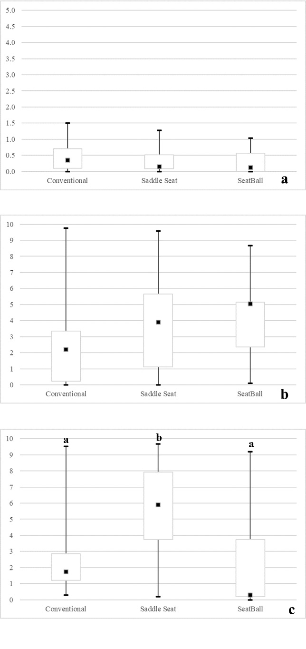
Fig. 4. Boxplot of the perception of discomfort in the thoracic region (a), lumbar region (b) and thigh region (c) according to the type of stool used
a. Non-parametric ANOVA: stool (F=1.426, p=0.249, π=0.293), arch (F=0.161, p=0.690, π=0.068), and stool x arch (F=0.017, p=0.983, π=0.052); b. Non-parametric ANOVA: stool (F=2.391, p=0.101, π=0.462), arch (F=0.002, p=0.965, π=0.050), and stool x arch (F=0.199, p=0.820, π=0.079); c. Non-parametric ANOVA: stool (F=9.278, p<0.001, π=0.971), arch (F=0.001, p=0.980, π=0.050), and stool x arch (F=1.184, p=0.314, π=0.249). Tukey’s post-hoc test: equal letters indicate statistical similarity
There was no significance interaction between “stool” and “arch”, nor for each factor when considered alone for thoracic and lumbar regions. Furthermore, no statistical interaction was observed between “stool” and “arch” for thigh region, only for the “stool” when considered alone. Higher discomfort was observed in this region during tooth preparations using the saddle seat (p<0.001).
3.2 DISCUSSION
Considering the high risk of musculoskeletal disorders that dentists face daily from their training phase onward, several strategies have been proposed to improve posture and promote health in this population. One such strategy is the use of ergonomic equipment, including dental stools, which have undergone several modifications as part of ergonomic efforts to prevent musculoskeletal disorders among dentists [14,15]. Therefore, this study aimed to evaluate the effects of different types of dental stools on working posture, discomfort, and productivity in dentistry using simulated Class I tooth preparations.
There was no significant interaction between dental arch and stool type for any of the evaluated outcomes, including muscle contraction across regions, risk of developing musculoskeletal disorders, compliance with ergonomic posture requirements, or angular deviation from the neutral position of the neck and trunk. However, when the stool factor was analyzed independently, increased muscle contraction in the lumbar region was observed during work with the conventional stool. According to the ergonomic posture requirements proposed by Porto (1994) [19], operators should sit on a conventional stool with the spine upright and supported by a lumbar backrest, resulting in a 90° angle between the torso and thighs. Gadge and Innes (2007) [31] noted that this configuration may promote instability and increase pressure on the lumbar spine, thereby contributing to the development of lower back pain. This occurs because such positioning tends to encourage a kyphotic posture, which elevates intradiscal pressure, increases the load on the back muscles, and creates an overall unstable working position. In contrast, the structural characteristics of the saddle seat and SeatBall facilitate a more neutral spinal alignment. The saddle seat positions the hips at approximately a 60° angle relative to the seat surface, promoting anterior pelvic tilt, restoration of the spine’s natural curvature, and maintenance of lumbar lordosis [3,5,6,8,13]. The SeatBall, through continuous proprioceptive stimulation, helps stretch and strengthen the paravertebral muscles, supporting the spine in an upright posture, improving muscular balance, and enhancing resistance [21]. Emerging evidence also suggests that combining ergonomic stools with the use of dental loupes and the application of ergonomic training may be promising strategies to improve working posture and reduce muscle activity during clinical procedures [5, 32, 33].
Regarding the arch factor, procedures performed on the upper arch were associated with higher muscle contraction in the right abdomen, greater angular deviation of the trunk from the neutral position, and lower compliance with ergonomic posture requirements. Similar findings have been reported in the literature, with greater neck angular deviation observed during preclinical work on the upper arch [31, 32]. This may be attributed to the inherent difficulty of visualizing the upper arch, particularly its posterior regions, where adequate direct vision is challenging to achieve, even when the occlusal plane is positioned perpendicular to the ground [26,36]. Consequently, operators may adopt more rigid and constrained postures [3], leading to increased angular deviation of both the neck and trunk.
Gandavadi et al. (2007) [3] noted that dentists spend a substantial time of their working day with the trunk inclined forward between 19° and 54°. Because the modified CADEP incorporates spinal alignment into its final posture score [26], the greater trunk deviation observed during upper-arch procedures may also have contributed to lower compliance with ergonomic posture requirements. Dable et al. (2014) [5] and Garcia-Vidal et al. (2019) [33] reported better posture when the use of an ergonomic stool was combined with dental loupes, because this combination may facilitate a more upright posture compared to the use of each equipment in isolation [33]. Therefore, it is possible that different results might have been observed in the present study if loupes had been included, as they assist with visualization challenges and promote better working posture [5, 33].
Notably, the stools evaluated in this study did not influence the risk of developing musculoskeletal disorders. This contrasts with the findings of Gandavadi et al. (2007) [3] and Dable et al. (2014) [5], that reported lower risk scores when operators used a saddle seat compared with a conventional stool. According to Gandavadi et al. (2007) [3], the saddle seat promotes anterior pelvic tilt, helping maintain slight lumbar lordosis, and allows adjustment of hip and knee angles so that the seated posture more closely resembles standing, thereby supporting healthier spinal alignment. In contrast, conventional stools tend to position the operator in posterior pelvic tilt, leading to lumbar kyphosis, a configuration commonly associated with poor working posture. An important contextual factor may help explain the difference between our findings and previous studies. At São Paulo State University, School of Dentistry of Araraquara, students complete a one-year theoretical and practical Ergonomic in Dentistry course integrated with their Dentistry I training. During this period, they learn and repeatedly practice ergonomic sitting postures while performing preclinical procedures. It is possible that this prior knowledge and reinforcement of proper ergonomic techniques mitigated the influence of stool type on the risk of developing musculoskeletal disorders in the present study. This highlights the importance not only of developing and implementing ergonomic devices in dental practice, but also of ensuring that students and clinicians receive consistent ergonomic education and training [5].
With regard of discomfort, the saddle seat was associated with notable discomfort in the thigh region. One plausible explanation is that since the operator in this study had been trained exclusively on a conventional stool during dental course, transitioning to an ergonomic stool may have introduced unfamiliar postural demands that influenced the results [4]. Additionally, the long-term comfort of any seat depends on its ability to distribute load effectively, support the musculoskeletal system, and allow variations in posture and pressure distribution while maintaining adequate support [31]. In line with this, another study reported greater lower-limb discomfort when participants used a saddle seat compared with a conventional seat. This supports the notion that the specific geometry of the saddle design encourages an anterior pelvic tilt, thereby increasing pressure on the ischial tuberosities and shifting more weight onto the lower limbs. Such changes may reduce local blood circulation and contribute to discomfort in these regions [31]. On the other hand, Dable et al. (2014) [5] observed that the saddle seat promoted more comfort when compared to the conventional stool without magnification system. Nonetheless, prolonged sitting becomes uncomfortable on any type of stool, although the duration of exposure may influence the perceived level of discomfort [31]. Therefore, incorporating periodic breaks between patients, adequate training about adjusting the features of dental stools to obtain maximal ergonomic benefits and using magnification is advisable to help mitigate these effects [5,31].
Finally, productivity was not influenced by the stool and arch factors simultaneously or by each factor in isolation. Despite this, the literature suggests that a more comfortable worker is a more productive worker, so when individual comfort is compromised, productivity is reduced [31]. To the best of our knowledge, there is no other study that evaluates the impact of different types of dental stools in dental productivity, which limits the comparation of our results. However, Gadge and Innes (2007) [31] observed the impact of saddle seat and conventional stool in the productivity of office workers by evaluating typing net speed and accuracy and concluded that the different types of stools do not significantly impact this variable. These results may suggest that productivity may be more related to manual dexterity than the type of stool used.
To our knowledge, this is the first study to use thermography to evaluate the influence of different dental stools on muscle contraction across multiple body regions. Thermography is a noninvasive imaging method [18] that allows assessments to be conducted without the discomfort or potential movement restriction associated with surface electromyography electrodes, enabling participants to adopt more natural working postures [36]. This technique detects physiological changes through variations in skin temperature [37], making it possible to infer muscle activity since increased muscle contraction generates greater heat emission at the skin surface [18,33].
The design and methodology of this study were intentionally structured to control biases related to individual postural habits and to isolate the effects of the independent variables on the outcomes evaluated. Although limiting the study to a single operator may appear to be a weakness, this approach was chosen to reduce interindividual variability and ensure a more controlled preliminary assessment of the influence of dental stools. Given the scarcity of research employing thermography in this context, these findings offer a meaningful contribution to the field of Occupational Health and provide a foundation for future investigations. Nevertheless, additional studies involving larger and more diverse samples, as well as alternative methodological approaches, are recommended to deepen the understanding of how dental stools affect posture, muscle activity, and work performance.

4. Conclusion

It can be concluded that:
1. The use of a conventional stool promoted significant variation in muscle contraction in the lumbar region.
2. In the upper arch, there was less compliance to the ergonomic posture requirements, significant angular deviation from the neutral trunk position, and significant variation in muscle contraction in the right abdominal region.
3. Using the saddle seat caused significant discomfort in the thigh region.
4. Productivity was not influenced by the stools used or the arc worked.

Consent

All authors declare that ‘written informed consent’ was obtained from the patient (or other approved parties) for publication of this study and accompanying images.

Ethical approval

All authors hereby declare that all experiments have been examined and approved by the appropriate ethics committee and have therefore been performed in accordance with the ethical standards laid down in the 1964 Declaration of Helsinki.

References

1. Hardage JL, Gildersleeve JR, Rugh JD. Clinical work posture for the dentist: an electromyographic study. J Am Dent Assoc. 1983;107(6):937-939. doi:10.14219/jada.archive.1983.0372
2. Parsell DE, Weber MD, Anderson BC, Cobb GW Jr. Evaluation of ergonomic dental stools through clinical simulation. Gen Dent. 2000;48(4):440-444.
3. Gandavadi A, Ramsay JR, Burke FJ. Assessment of dental student posture in two seating conditions using RULA methodology - a pilot study. Br Dent J. 2007;203(10):601-605. doi:10.1038/bdj.2007.1047
4. Haddad O, Sanjari MA, Amirfazli A, Narimani R, Parnianpour M. Trapezius muscle activity in using ordinary and ergonomically designed dentistry chairs. Int J Occup Environ Med. 2012;3(2):76-83.
5. Dable RA, Wasnik PB, Yeshwante BJ, Musani SI, Patil AK, Nagmode SN. Postural Assessment of Students Evaluating the Need of Ergonomic Seat and Magnification in Dentistry. J Indian Prosthodont Soc. 2014;14(Suppl 1):51-58. doi:10.1007/s13191-014-0364-0
6. De Bruyne MA, Van Renterghem B, Baird A, Palmans T, Danneels L, Dolphens M. Influence of different stool types on muscle activity and lumbar posture among dentists during a simulated dental screening task. Appl Ergon. 2016;56:220-226. doi:10.1016/j.apergo.2016.02.014
7. Tran V, Turner R, MacFadden A, Cornish SM, Esliger D, Komiyama K, et al. A dental stool with chest support reduces lower back muscle activation. Int J Occup Saf Ergon. 2016;22(3):301-304. doi:10.1080/10803548.2016.1153223
8. Plessas A, Bernardes Delgado M. The role of ergonomic saddle seats and magnification loupes in the prevention of musculoskeletal disorders. A systematic review. Int J Dent Hyg. 2018;16(4):430-440. doi: 10.1111/idh.12327
9. López-Nicolás M, García-Vidal JA, Medina-Mirapeix F, Sánchez-Onteniente JP, Berná Mestre JD, Martín-San Agustín R, et al. Effect of different ergonomic supports on muscle activity of dentists during posterior composite restoration. PeerJ. 2019;7:e8028. doi: 10.7717/peerj.8028
10. De Bruyne M, Danneels L, Braet V, Van De Sijpe E, Vanwijnsberghe M, Verhenne L, et al. Do stool types have an influence on cervicothoracic muscle activity and cervicothoracic posture among dentists/dental students? Appl Ergon. 2021;97:103519. doi: 10.1016/j.apergo.2021.103519
11. Chenna D, Pentapati KC, Kumar M, Madi M, Siddiq H. Prevalence of musculoskeletal disorders among dental healthcare providers: A systematic review and meta-analysis. F1000Res. 2022;11:1062. doi:10.12688/f1000research.124904.2
12. Presoto, CD, Garcia, PPNS. Risk Factors for the Development of Musculoskeletal Disorders in Dental Work. Journal of Education, Society and Behavioural Science. 2016;15(4), 1–6. doi: 10.9734/BJESBS/2016/25838
13. Gouvêa GR, Vieira WA, Paranhos LR, Bernardino ÍM, Bulgareli JV, Pereira AC. Assessment of the ergonomic risk from saddle and conventional seats in dentistry: A systematic review and meta-analysis. PLoS One. 2018;13(12):e0208900. doi:10.1371/journal.pone.0208900
14. García-Vidal JA, López-Nicolás M, Sánchez-Sobrado AC, Escolar-Reina MP, Medina-Mirapeix F, Bernabeu-Mora R. The Combination of Different Ergonomic Supports during Dental Procedures Reduces the Muscle Activity of the Neck and Shoulder. J Clin Med. 2019;8(8):1230. doi:10.3390/jcm8081230
15. Huppert F, Betz W, Maurer-Grubinger C, Holzgreve F, Fraeulin L, Filmann N, et al. Influence of design of dentist's chairs on body posture for dentists with different working experience. BMC Musculoskelet Disord. 2021;22(1):462. doi: 10.1186/s12891-021-04334-1
16. Valachi B, Valachi K. Mechanisms leading to musculoskeletal disorders in dentistry. J Am Dent Assoc. 2003;134(10):1344-1350. doi: 10.14219/jada.archive.2003.0048
17. Valachi B, Valachi K. Preventing musculoskeletal disorders in clinical dentistry: strategies to address the mechanisms leading to musculoskeletal disorders. J Am Dent Assoc. 2003;134(12):1604-1612. doi: 10.14219/jada.archive.2003.0106
18. Lasanen R, Malo MKH, Airaksinen O, Karhu J, Töyräs J, Julkunen P. Infrared thermography reveals effect of working posture on skin temperature in office workers. Int J Occup Saf Ergon. 2018;24(3):457-463. doi: 10.1080/10803548.2017.1336299
19. Porto FA. The dental office. São Carlos: Scritti; 1994; 152p
20. Bertolaccini GS. 2017. Design, Ergonomics and Health: a proposal for the dental surgeon's postural interface [Master's Dissertation in Design]. Faculty of Architecture, Arts and Communication of Bauru/Unesp.
21. Ribeiro EP. 2009. Postural analysis verified through biophotogametry after using the seatball in dentists at Cais Nova Era [Physiotherapy Course Completion Work]. State University of Goiás – ESEFFEGO.
22. Pedreira AA, Wanderley FG, Sa MF, Viena CS, Perez A, Hoshi R, et al. Thermographic and clinical evaluation of 808-nm laser photobiomodulation effects after third molar extraction. Minerva Stomatol. 2016;65(4):213-222.
23. Priego Quesada JI, Carpes FP, Bini RR, Salvador Palmer R, Pérez-Soriano P, Cibrián Ortiz de Anda RM. Relationship between skin temperature and muscle activation during incremental cycle exercise. J Therm Biol. 2015;48:28-35.
24. Priego Quesada JI, Carpes FP, Salvador Palmer R, Pérez-Soriano P, Cibrián Ortiz de Anda RM. Effect of saddle height on skin temperature measured in different days of cycling. Springerplus. 2016;5:205.
25. Pazos JM, Wajngarten D, Dovigo LN, Garcia PPNS. Implementing magnification during pre-clinical training: Effects on procedure quality and working posture. Eur J Dent Educ. 2020;24(3):425-432.
26. McAtamney L, Nigel Corlett E. RULA: a survey method for the investigation of work-related upper limb disorders. Appl Ergon. 1993;24(2):91-99.
27. Garcia PPNS, Wajngarten D, Campos JADB. Development of a method to assess compliance with ergonomic posture in dental students. J Educ Health Promot. 2018;7:44.
28. Ferreira EA, Duarte M, Maldonado EP, Burke TN, Marques AP. Postural assessment software (PAS/SAPO): Validation and reliabiliy. Clinics (Sao Paulo). 2010;65(7):675-681.
29. Hawker GA, Mian S, Kendzerska T, French M. Measures of adult pain: Visual Analog Scale for Pain (VAS Pain), Numeric Rating Scale for Pain (NRS Pain), McGill Pain Questionnaire (MPQ), Short-Form McGill Pain Questionnaire (SF-MPQ), Chronic Pain Grade Scale (CPGS), Short Form-36 Bodily Pain Scale (SF-36 BPS), and Measure of Intermittent and Constant Osteoarthritis Pain (ICOAP). Arthritis Care Res (Hoboken). 2011;63 Suppl 11:S240-S252.
30. Wajngarten, D, Pazos, JM, Neves, T. da C, Garcia, PPNS. Development and Validation of Class I Preparation and Restoration Quality Assessment Methods. J Adv Med Med Res. 2021;33(11), 18–23.
31. Gadge K, Innes E. An investigation into the immediate effects on comfort, productivity and posture of the Bambach saddle seat and a standard office chair. Work. 2007;29(3):189-203.
32. Pazos JM, Mota GM, Verri ED, Gomes GGC, Regalo SCH, Garcia PPNS. Effect of Different Types of Dental Stools on Muscle Activity During Execution of Preclinical Procedures. Eur J Dent Educ. 2025 Apr 22. doi: 10.1111/eje.13102.
33. García-Vidal JA, López-Nicolás M, Sánchez-Sobrado AC, Escolar-Reina MP, Medina-Mirapeix F, Bernabeu-Mora R. The Combination of Different Ergonomic Supports during Dental Procedures Reduces the Muscle Activity of the Neck and Shoulder. J Clin Med. 2019 Aug 15;8(8):1230. doi: 10.3390/jcm8081230.
34. Pazos JM, Regalo SCH, de Vasconcelos P, Campos JADB, Garcia PPNS. Effect of magnification factor by Galilean loupes on working posture of dental students in simulated clinical procedures: associations between direct and observational measurements. PeerJ. 2022;10:e13021.
35. Garcia PPNS, Pinelli C, Derceli JR, Campos JADB. Musculoskeletal disorders in upper limbs in dental students: exposure level to risk factors. Braz. J. Oral Sci [online]. 2012; 11(2): 148-153.
36. Sancibrian R, Gutierrez-Diez MC, Redondo-Figuero C, Llata JR, Manuel-Palazuelos JC. Using infrared imaging for assessment of muscular activity in the forearm of surgeons in the performance of laparoscopic tasks. Proc Inst Mech Eng H. 2019;233(10):999-1009.
37. Colim A, Arezes P, Flores P, Vardasca R, Braga AC. Thermographic differences due to dynamic work tasks on individuals with different obesity levels: a preliminary study. Comput. Methods Biomech. Biomed. Eng.: Imaging Vis. 2020;8 (3); 323–333.

