AGE-SPECIFIC PATTERNS OF OVARIAN CANCER INCIDENCE IN UZBEKISTAN (2016–2024): NATIONAL TRENDS, REGIONAL HETEROGENEITY, AND AGE-SPECIFIC RATES

Abstract
Background. Age significantly influences the risk and outcomes associated with ovarian cancer; however, contemporary age-specific profiles from Central Asia are rarely documented.
Objective. The primary aim of this research is to offer a comprehensive analysis of national trends, regional disparities, and age-dependent incidence rates of ovarian cancer in Uzbekistan from 2016 to 2024. Attaining this objective enables a meaningful contribution to the domains of epidemiology and public health policy.
Methods. We conducted a retrospective analysis utilising population-based registry data, organised by year, region, and five-year age groups. Age-specific crude rates (CR per 100,000) were calculated, and the temporal variations of these rates were analysed through log-linear models, with trends summarised as the Annual Percentage Change (APC). Additionally, the distribution of broad age groups (0–19, 20–39, 40–59, 60–79, 80+) across different years and regions was compared using Pearson’s χ² test.
Results. The demographic burden has shifted towards older populations. Between 2016 and 2024, the proportion of individuals aged 60–79 increased from 24.0% to 43.6%, representing a 19.6 percentage point increase. Conversely, the proportion of those aged 40–59 declined from 57.3% to 42.0%, reflecting a decrease of 15.3 percentage points. These annual variations were statistically significant (p < 0.001). Regional disparities in age structure were considerable (p < 0.001), with the 40–59 and 60–79 age groups consistently being the most prevalent. The chronic rate (CR) increased with age; by 2024, it reached 40.76 in women aged 70–74 and 44.71 in women aged 75–79, while comparatively lower rates were observed among younger female cohorts.
Conclusion. The findings of this study underscore the significant ageing trend and the heterogeneous age structures of ovarian cancer across Uzbekistan. These insights are crucial for health policymakers and practitioners, as they emphasise the necessity of prioritising diagnostic procedures and capacity building for older women, thereby improving the efficacy of healthcare services.

Keywords: ovarian cancer; age structure; age-specific incidence; crude rate; APC; Uzbekistan.

Introduction
Ovarian cancer continues to be a leading cause of mortality within gynecologic malignancies, chiefly due to diagnoses at advanced stages and the lack of a comprehensive screening test that provides definitive evidence of mortality benefit for the general population. Global data reveal significant geographic variations in both incidence and mortality rates, indicative of disparities in demographic factors, reproductive histories, and access to specialised oncological gynaecological services. [1–4].
Age continues to be the primary factor affecting both incidence and prognosis. Across all regions, the age-specific incidence rate escalates markedly after menopause and reaches its zenith among older women; the precise timing and magnitude of this peak fluctuate in accordance with the population structure and the distribution of risk factors. [2–5]. Hormonal and reproductive factors, including parity, oral contraceptive use, and breastfeeding, as well as endometriosis and genetic susceptibility, all contribute to this pattern. [5,6]. Diagnosis based on symptoms—such as abdominal distension, early satiety, pelvic pain—is common; however, these symptoms are non-specific and often encountered in primary care, which can delay definitive investigation and referral to specialists. [7–9].
Long-term randomised trials have not demonstrated a decrease in mortality through general population screening methods, such as transvaginal ultrasound and/or CA-125 algorithms. This finding underscores the policy emphasis on the prompt evaluation of symptomatic women rather than on mass screening initiatives. [7–9]. In this context, health service planning benefits from direct examination of age-specific crude rates (CR) and shifts in the distribution of cases across age groups, even when age-standardised rates (ASR) are used for international comparisons [2,3,10].
Current registry-based descriptions from Central Asia are limited. Consequently, we characterised national age-specific profiles for ovarian cancer in Uzbekistan from 2016 to 2024, quantified temporal changes, and evaluated regional heterogeneity utilising harmonised indicators appropriate for service planning- including age distribution, case rate (CR), and age-period-cohort (APC) analysis.

Materials and Methods

Study design and data sources
We conducted a retrospective, population-based descriptive–analytical study using aggregated, de-identified counts of newly diagnosed ovarian cancer in women from 2016 to 2024. Data were organised by calendar year, administrative region (the Republic of Karakalpakstan, Tashkent city, and 12 provinces), and five-year age groups; the case definition adhered to national cancer registry standards (ICD-10 C56).

Population denominators
Female population denominators by region and age group were used to calculate CR (per 100,000). Mid-year estimates were preferred; end-of-year figures were used when mid-year denominators were unavailable. Small gaps in denominators were filled using linear interpolation between adjacent years.

Measures
We summarised the age structure using five broad categories (0–19, 20–39, 40–59, 60–79, 80+). Primary endpoints were age-specific CR by five-year bands and changes over time. ASR is referenced for context but not used as the primary outcome for planning.

Statistical analysis
Differences in broad age-group distributions across years and regions were assessed with Pearson’s χ² tests. Temporal trends in age-specific CR were evaluated using log-linear models, ln(CR) ~ year; slopes were summarised as Annual Per cent Change (APC, %/year) with 95% confidence intervals (CI). For sparse strata, estimates were interpreted with caution. Two-sided tests used α=0.05.

Results

National age structure and its evolution
Between 2016 and 2024, cases were concentrated among individuals aged 40–59 and 60–79. A clear ageing shift took place: the 60–79 share increased from 24,0% in 2016 to 43,6% in 2024 (+19.6 percentage points), while the 40–59 share decreased from 57,3% to 42,0% (-15.3 points); the 20–39 share fell from 15,0% to 10,6% (-4.4 points). The annual differences in age distribution were statistically significant (χ² test, p < 0.001). The dominance of the 40–59 and 60–79 age groups remained consistent each year, and no year saw younger ages (<40) account for more than a minor fraction of cases. (Table 2; Figure 1.)

Regional heterogeneity in age structure
Regions varied markedly in their age composition (p < 0.001). A typical pattern was the dominance of ages 40–59 and 60–79, although the extent of this dominance varied. Tashkent city demonstrated a particularly concentrated profile, with 87.3% of cases in the combined 40–59 and 60–79 age groups. This aligns with an urban case mix skewed towards postmenopausal ages. Most provinces also showed high proportions from these two groups, generally ranging from about three-quarters to nine-tenths of all cases. (Table 1.)

Age-specific crude incidence levels
The age-specific incidence demonstrated a consistent increase with advancing age, characterised by a more pronounced upper tail in the later years. In 2024, the CR values reached 40.76 for the 70–74 age group and 44.71 for the 75–79 age group. Middle-aged cohorts exhibited moderate levels- for example, 17.57 for ages 50–54 and approximately 17.13 for ages 55–59 to 60–64- while younger women consistently displayed low rates (≤ 1.84 in the 30–34 age group). Relative to 2016, the most significant absolute increases were observed in older cohorts: +26.11 in the 70–74 age group and +36.72 in the 75–79 age group. Conversely, the 40–44 age group experienced a decrease of -2.06 during this period. The oldest cohort (80+) also experienced an increase, from 4,49 in 2016 to 15,67 in 2024. (Table 3; Figures 2–3).

Temporal trends (APC) in age-specific incidence
Log-linear trend models showed the steepest positive APC in the age groups 70–79 and 80+, while changes in the under-40 age group were minimal and often not significant. Within the 40–59 age range, trajectories were flat, mainly slightly negative, aligning with the redistribution of burden from the 40–59 to the 60–79 age group. Visual inspection confirmed that the rank order of age bands by CR remained monotonic every year—older ages had higher CR—without an indication of a secondary peak at younger ages. (Figures 4–5.)

Robustness checks
Pooling ages 70–74 and 75–79 reduced uncertainty without changing the main pattern of higher incidence among older women. Removing boundary years slightly lowered APC magnitudes but kept the trend the same (older ages increasing, midlife stable, younger ages low and steady). Recomputing without denominator interpolation caused minimal differences in mid-period CR estimates.

Discussion
The Uzbek national profile indicates a consistent shift of ovarian cancer burden towards older women, with regionally diverse age structures. This aligns with global patterns where postmenopausal women experience the highest incidence, influenced by reproductive histories, hormonal factors, and the organisation of specialist services [2–6]. Given that large trials have shown no mortality benefit from population screening, focusing on optimising symptom-based pathways and improving access to specialist assessments remains crucial [7–9].
Practically, health systems should implement rapid evaluation for postmenopausal women with persistent abdominal or pelvic symptoms, increase availability of transvaginal ultrasonography and tumour markers at primary and district levels, and ensure prompt referral to higher-volume oncogynecologic centres—where adherence to guidelines and surgical outcomes are better [9–12]. Monitoring a select set of indicators (age-specific CR, broad age-group shares, APC) can offer actionable feedback on pathway efficiency and help reduce regional disparities.

Strengths and limitations
Strengths include nationwide coverage over nine years and harmonised metrics directly relevant to service planning. Limitations consist of aggregation (lacking stage or histotype detail), instability in small groups at extreme ages, and possible regional variation in registration completeness. These constraints prevent causal inference and highlight the need for individual-level linkage to evaluate trends in stage at diagnosis and histologic subtype.

Conclusion
Between 2016 and 2024, Uzbekistan observed a discernible rise in ovarian cancer cases among the elderly female population, particularly those aged 70 and above. In contrast, younger women exhibited consistently lower incidence rates, while middle-aged women maintained stable or slightly decreasing patterns. Although regional variations are present, they do not alter the prevailing national trend. These insights are valuable for enhancing diagnostic strategies and resource allocation to more effectively support the needs of older women, taking regional disparities into account.

Ethics and data availability
Aggregated, de-identified registry data were utilised; no individual-level identifiers were involved. Data are available on reasonable request, subject to approvals.

References
1. World Cancer Report 2020. Lyon: International Agency for Research on Cancer; 2020.
2. Bray F., Colombet M., Mery L., et al. Cancer Incidence in Five Continents, Vol. XI (CI5). IARC Scientific Publication No. 166. Lyon: IARC; 2017.
3. Sung H., Ferlay J., Siegel R.L., Laversanne M., Soerjomataram I., Jemal A., Bray F. Global cancer statistics 2020: GLOBOCAN estimates of incidence and mortality worldwide. CA Cancer J Clin. 2021;71:209–249.
4. Arnold M., Karim-Kos H.E., Coebergh J.W.W., et al. Ovarian cancer incidence and mortality patterns and trends. Int J Cancer. 2014;134:1133–1143.
5. Torre L.A., Trabert B., DeSantis C.E., et al. Ovarian cancer statistics, 2018. CA Cancer J Clin. 2018;68:284–296.
6. Reid B.M., Permuth J.B., Sellers T.A. Epidemiology of ovarian cancer: a review. Cancer Biol Med. 2017;14:9–32.
7. Menon U., Gentry-Maharaj A., Burnell M., et al. Ovarian cancer screening and mortality in the UKCTOCS trial: long-term follow-up. Lancet. 2021;397:2182–2193.
8. Buys S.S., Partridge E., Black A., et al.; PLCO Project Team. Effect of screening on ovarian cancer mortality: the PLCO trial. JAMA. 2011;305:2295–2303.
9. Goff B.A., Mandel L.S., Drescher C.W., et al. Development of an ovarian cancer symptom index. Cancer. 2007;109:221–227.
10. Ahmad O.B., Boschi-Pinto C., Lopez A.D., et al. Age Standardisation of Rates: A New WHO Standard. GPE Discussion Paper Series No.31. Geneva: WHO; 2001.
11. Cress R.D., O’Malley C.D., Leiserowitz G.S., et al. Survival and treatment of ovarian cancer: does rural–urban residence matter? Cancer. 2010;116(14):3737–3745.
12. Bristow R.E., Chang J., Ziogas A., Anton-Culver H. Adherence to treatment guidelines and impact of hospital volume in ovarian cancer. J Clin Oncol. 2013;31(28):3562–3569.

Table 1. Age structure of cases by region (aggregated age groups), 2016–2024.
Regions | 0–19,  N = 207 ¹ | 20–39,  N = 1 069 ¹ | 40–59,  N = 4 027 ¹ | 60–79,  N = 2 716 ¹ | 80+,  N = 131 ¹ | p²
Tashkent City | 22 (1,4%) | 116 (7,4%) | 712 (45,6%) | 652 (41,7%) | 61 (3,9%) | <0,001
Andijan Region | 20 (3,2%) | 77 (12,2%) | 333 (52,8%) | 198 (31,4%) | 3 (0,5%) | <0,001
Bukhara Region | 14 (2,5%) | 50 (8,8%) | 297 (52,1%) | 203 (35,6%) | 6 (1,1%) | <0,001
Jizzakh Region | 17 (6,2%) | 57 (20,9%) | 119 (43,6%) | 79 (28,9%) | 1 (0,4%) | <0,001
Kashkadarya Region | 20 (3,4%) | 83 (14,0%) | 291 (49,1%) | 190 (32,0%) | 9 (1,5%) | <0,001
Navoi Region | 1 (0,5%) | 33 (17,6%) | 102 (54,3%) | 52 (27,7%) | 0 (0,0%) | <0,001
Namangan Region | 14 (2,8%) | 69 (13,7%) | 274 (54,4%) | 144 (28,6%) | 3 (0,6%) | <0,001
Samarkand Region | 25 (3,9%) | 100 (15,5%) | 292 (45,1%) | 222 (34,3%) | 8 (1,2%) | <0,001
Surkhandarya Region | 22 (4,8%) | 104 (22,5%) | 218 (47,2%) | 110 (23,8%) | 8 (1,7%) | <0,001
Syrdarya Region | 3 (1,6%) | 33 (17,9%) | 96 (52,2%) | 51 (27,7%) | 1 (0,5%) | <0,001
Tashkent Region | 19 (2,0%) | 126 (13,3%) | 442 (46,7%) | 343 (36,3%) | 16 (1,7%) | <0,001
Fergana Region | 17 (2,1%) | 99 (12,0%) | 430 (52,3%) | 268 (32,6%) | 8 (1,0%) | <0,001
Khorezm Region | 5 (1,4%) | 57 (16,0%) | 191 (53,5%) | 101 (28,3%) | 3 (0,8%) | <0,001
Karakalpakstan | 8 (2,0%) | 65 (15,9%) | 230 (56,1%) | 103 (25,1%) | 4 (1,0%) | <0,001
¹ (n, %)
² Pearson’s chi-squared test

Table 2. Dynamics of the age structure of cases by year (aggregated age groups), 2016–2024.
Years | 0–19,  N = 207 ¹ | 20–39,  N = 1 069 ¹ | 40–59,  N = 4 027 ¹ | 60–79,  N = 2 716 ¹ | 80+,  N = 131 ¹ | p-value²
2016 | 20 (2,8%) | 108 (15,0%) | 413 (57,3%) | 173 (24,0%) | 7 (1,0%) | <0,001
2017 | 27 (3,5%) | 125 (16,1%) | 385 (49,6%) | 225 (29,0%) | 14 (1,8%) | <0,001
2018 | 23 (2,8%) | 109 (13,1%) | 445 (53,7%) | 241 (29,1%) | 11 (1,3%) | <0,001
2019 | 21 (2,5%) | 98 (11,5%) | 449 (52,8%) | 267 (31,4%) | 15 (1,8%) | <0,001
2020 | 23 (2,8%) | 124 (14,9%) | 430 (51,6%) | 243 (29,1%) | 14 (1,7%) | <0,001
2021 | 27 (2,7%) | 132 (13,4%) | 490 (49,7%) | 324 (32,9%) | 12 (1,2%) | <0,001
2022 | 25 (2,4%) | 139 (13,5%) | 490 (47,4%) | 363 (35,1%) | 16 (1,5%) | <0,001
2023 | 21 (2,1%) | 114 (11,5%) | 450 (45,4%) | 387 (39,1%) | 19 (1,9%) | <0,001
2024 | 20 (1,8%) | 120 (10,6%) | 475 (42,0%) | 493 (43,6%) | 23 (2,0%) | <0,001
¹ (n, %)
² Pearson’s chi-squared test

Table 3. Age-specific crude incidence rates (CR, per 100,000) by year, 2016–2024.
Age group | 2016 | 2017 | 2018 | 2019 | 2020 | 2021 | 2022 | 2023 | 2024
0-4 | 0,19 | 0,06 | 0,00 | 0,00 | 0,23 | 0,16 | 0,10 | 0,10 | 0,10
5-9 | 0,14 | 0,20 | 0,27 | 0,33 | 0,13 | 0,31 | 0,12 | 0,12 | 0,12
10-14 | 0,46 | 0,37 | 0,36 | 0,57 | 0,34 | 0,40 | 0,52 | 0,46 | 0,31
15-19 | 0,66 | 1,36 | 1,08 | 0,62 | 0,93 | 1,00 | 0,98 | 0,76 | 0,80
20-24 | 1,19 | 1,34 | 1,04 | 1,42 | 1,26 | 1,61 | 1,83 | 1,30 | 1,32
25-29 | 1,62 | 0,89 | 1,07 | 0,75 | 1,44 | 1,12 | 1,59 | 1,02 | 0,91
30-34 | 2,42 | 2,74 | 2,01 | 2,14 | 2,24 | 2,79 | 2,11 | 1,60 | 1,84
35-39 | 2,91 | 4,62 | 4,03 | 2,73 | 3,89 | 3,71 | 4,11 | 4,04 | 3,94
40-44 | 7,94 | 7,11 | 7,27 | 8,04 | 6,52 | 7,24 | 7,55 | 6,14 | 5,88
45-49 | 10,01 | 9,67 | 9,78 | 10,98 | 10,27 | 10,71 | 11,41 | 9,35 | 9,23
50-54 | 15,86 | 14,83 | 19,09 | 13,97 | 13,96 | 17,90 | 16,67 | 17,03 | 17,57
55-59 | 16,21 | 13,80 | 15,77 | 17,96 | 17,42 | 18,39 | 17,30 | 16,59 | 17,13
60-64 | 21,56 | 24,55 | 26,67 | 25,34 | 21,53 | 30,82 | 27,54 | 27,02 | 25,22
65-69 | 15,35 | 17,78 | 15,80 | 16,79 | 15,38 | 19,39 | 16,50 | 21,43 | 24,93
70-74 | 14,65 | 19,04 | 16,75 | 27,35 | 18,22 | 14,73 | 25,68 | 28,14 | 40,76
75-79 | 7,99 | 15,44 | 18,25 | 12,45 | 12,76 | 7,71 | 23,70 | 17,42 | 44,71
80+ | 4,49 | 8,53 | 6,48 | 8,51 | 7,48 | 9,04 | 11,39 | 13,52 | 15,67

Figure 1. Age structure of cases by year (aggregated age groups, proportions, %).
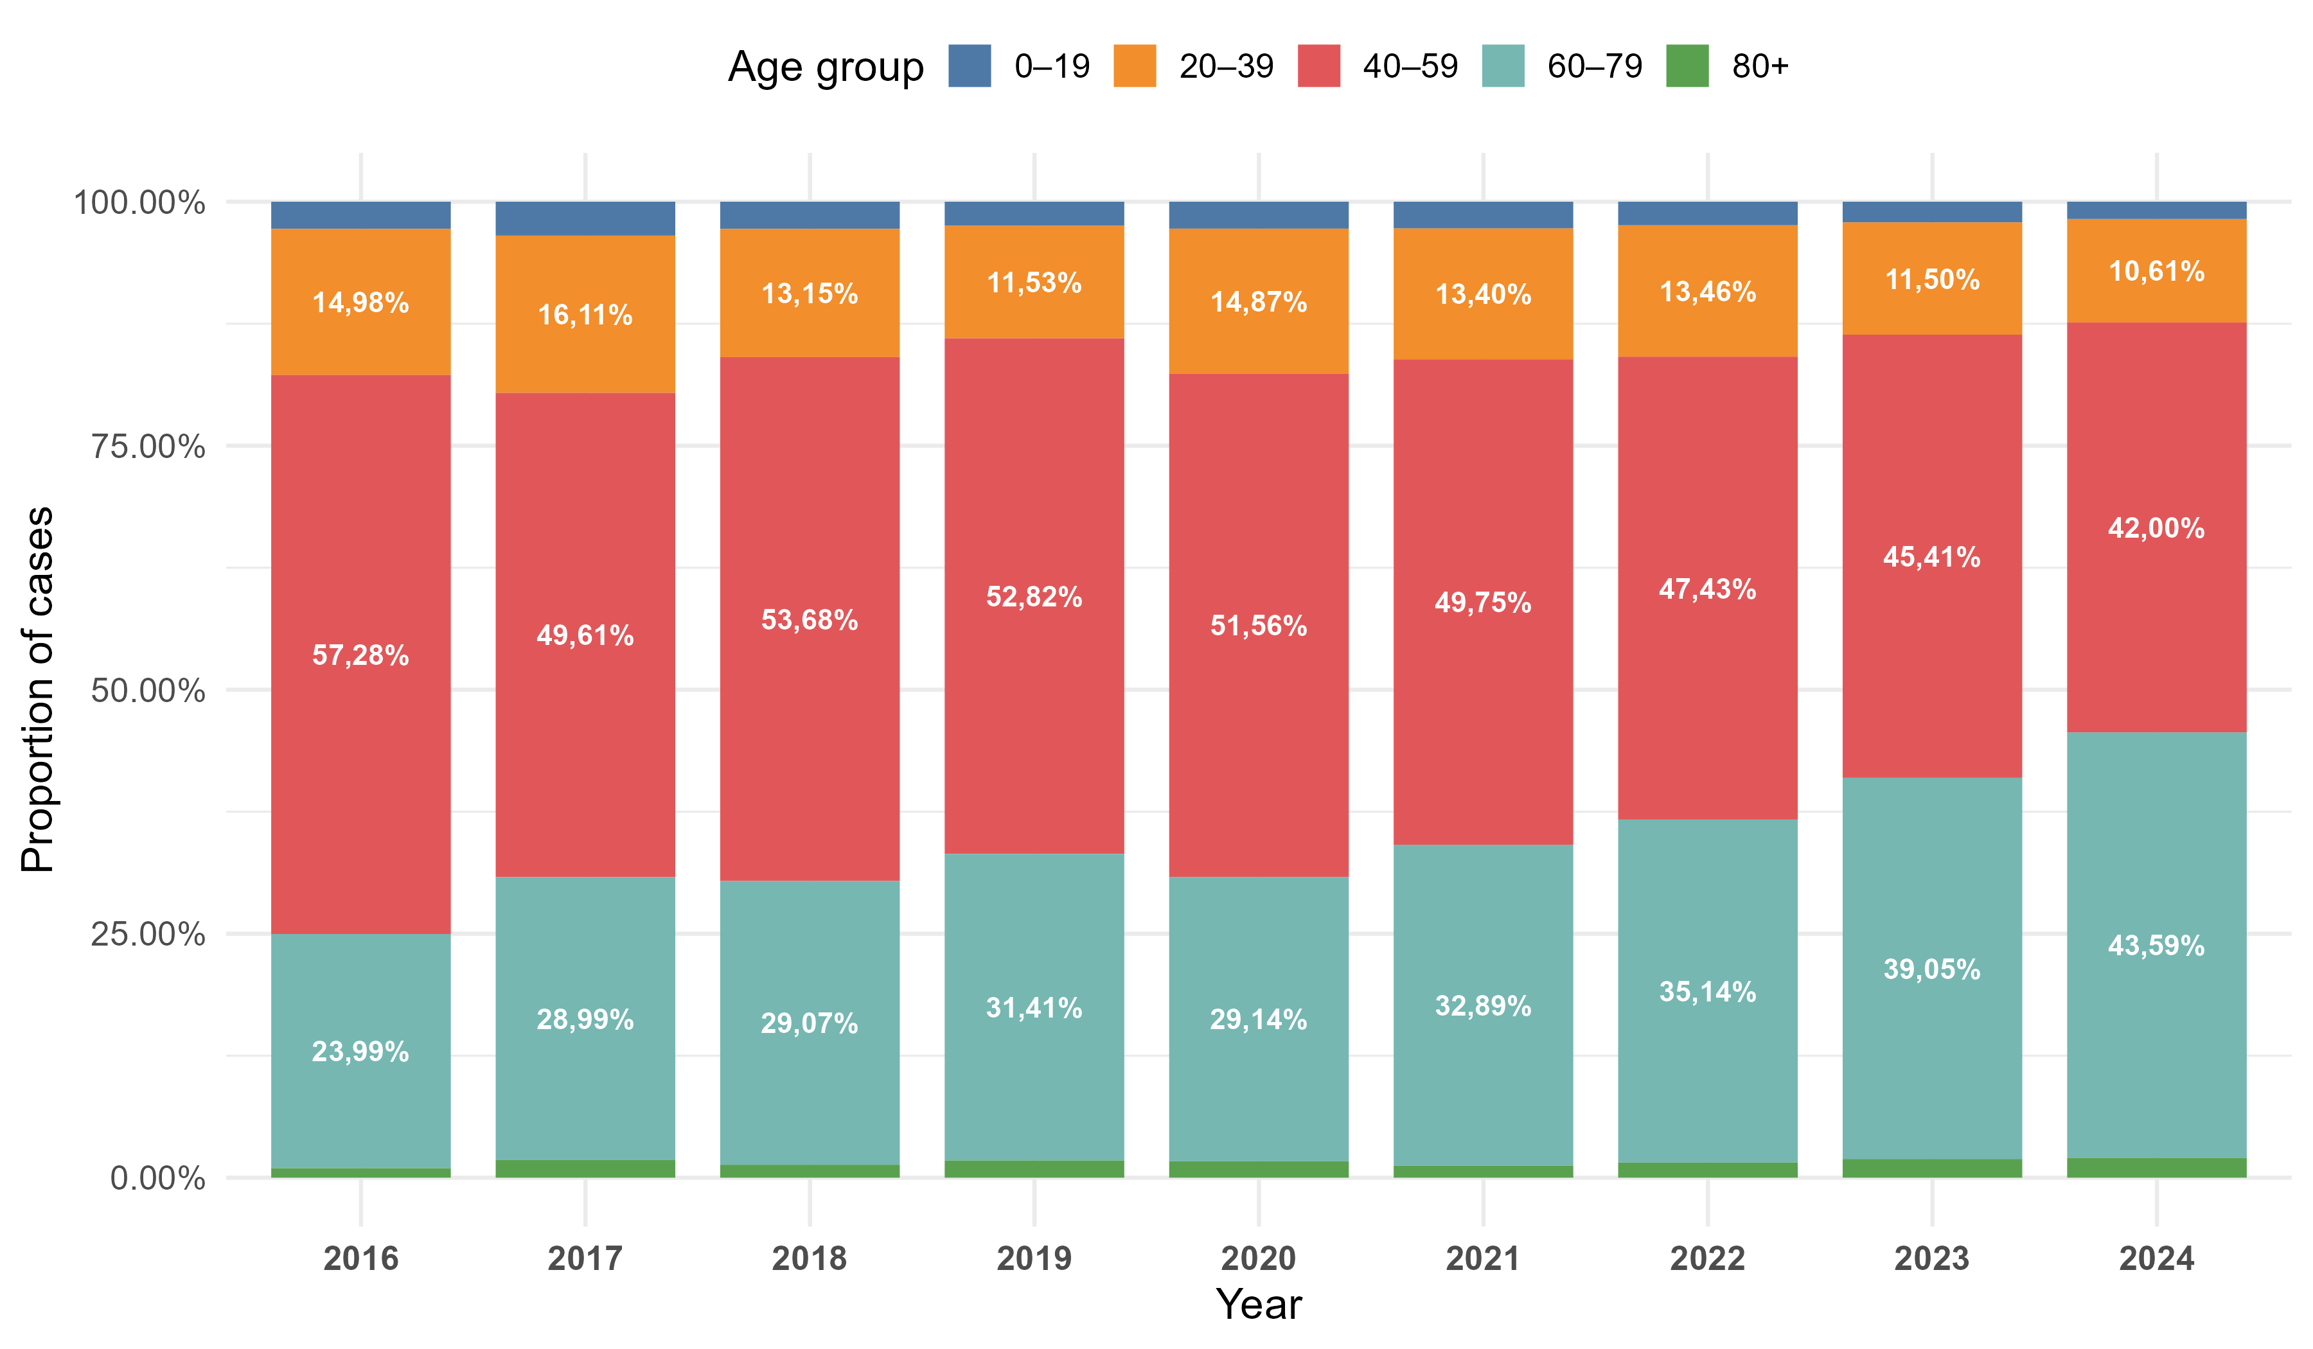
Figure 2. Crude incidence rates by age group, cumulative for 2016–2024.
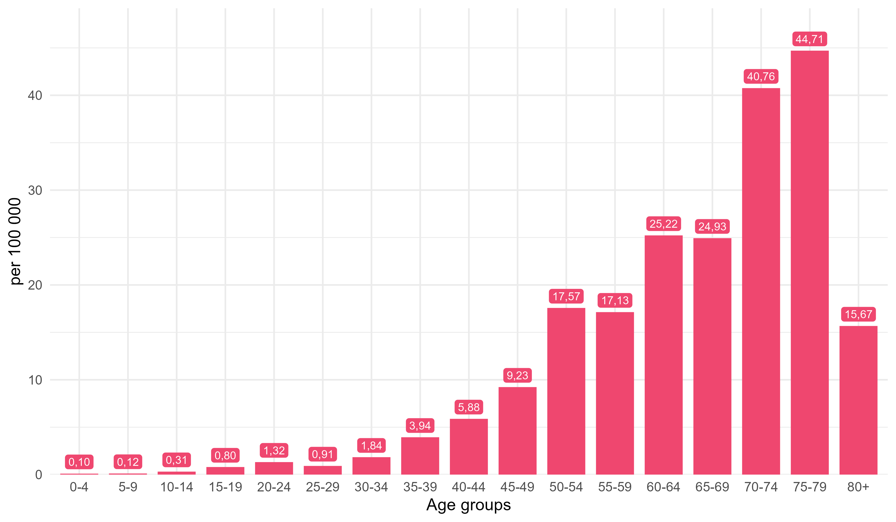
Figure 3. Crude incidence rates by age group, 2016–2024.

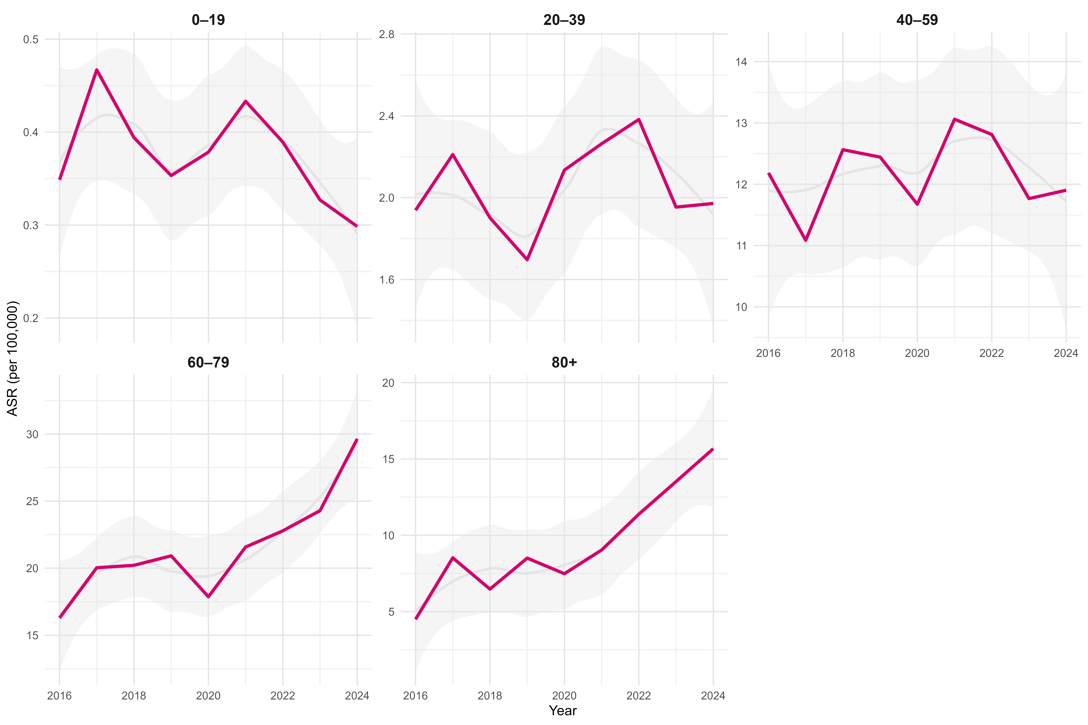

Figure 4. Average annual change in incidence rates by age group, 2016–2024.
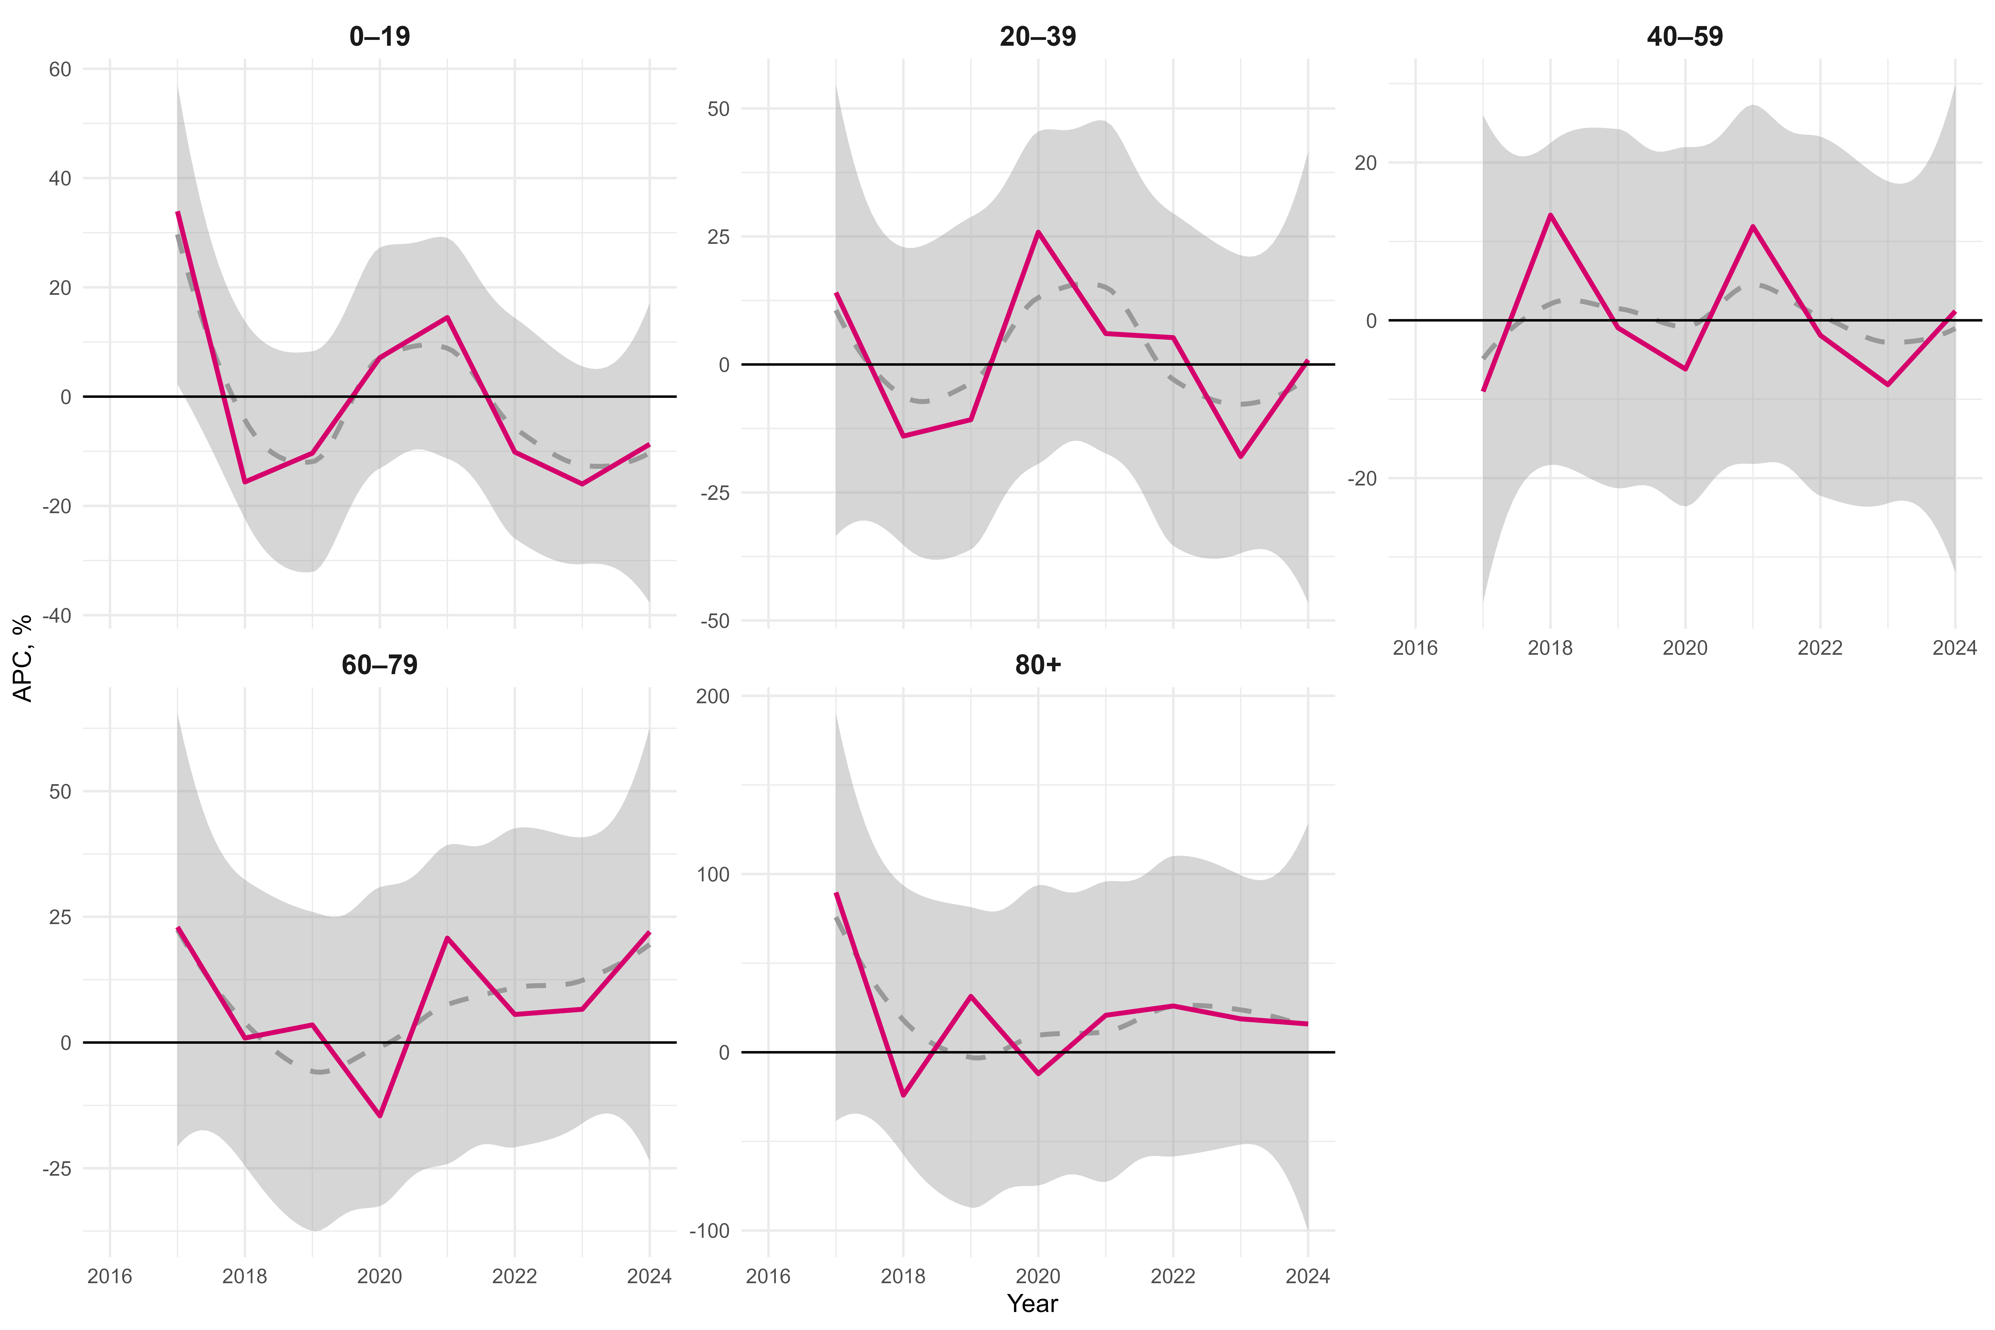

Figure 5. Average annual change in incidence rates by age group, cumulative for 2016–2024.
